CHAPTER-I
Introduction
Indigenous chickens Gallus domesticus belong to a group of local unimproved breeds commonly found in developing countries and may include mixed breeds resulting from uncontrolled breeding (Say, R.R., 1987). These indigenous chickens are also known as village, traditional chickens and backyard chickens are reared for meat and eggs for domestic consumption. These birds are very hardly and can survive on scavenging without any supplementary feeding.
In a developing country like Bangladesh, poultry production in rural areas is of great importance as a main supplies of eggs, meat and a source of income. Scavenging village chickens have cultural, social, nutritional, economic and sanitary functions in daily life.
In developing country like Bangladesh, egg production is mainly dependent upon traditional extensive production system using native breeds (Ani I., 1990). Indigenous breeds are used to overcome the nutritional deficiencies in certain countries (Robert JA. 1992) and additionally have better adaptability to local climatic conditions (Romanov MN. et al., 1996) in comparison with exotic breeds. In tropical countries Aseel, Naked neck, Desi and Fayoumi are reared as backyard chickens mainly for the source of protein and income. Among these breeds Naked neck originated from Hungary (Grobbelaar JAN. et al., 2010) is getting popularity in sub-continental countries. Naked Neck chicken are breed of chicken that naturally do not have feathers on the neck and considered to be one of the local chicken genetic resources in Indonesia. Naked Neck chicken allegedly came from Transylvania, Romania and spread all over the world brought by the Dutch East India Company around the 17th century (Ramsey et al., 2000). According to Islam &Nishibori (2009), Naked Neck chicken had a good heat regulation mechanism, good adaptation to tropical environments and low nutrient requirement, and resistant to disease, as well as superior compared to the normal fluffy chickens in terms of growth, egg production, egg and meat quality. For example, in South Africa, based on Norris et al., (2007) studies showed that the growth rate of Naked Neck chicken was better (0.169 kg/week) compared with Venda chicken (0.138 kg/week) which is local chicken in South Africa.
Aseel is also a recognized indigenous ecotype and used either as a backyard poultry in the rural areas or as a game bird. However, Aseel breed is indigenous to Bangladesh and close to extinction. They have greater robustness, disease resistance and well adaptability to local environment and also popular for its higher body weight, vigor, alertness and fighting behavior (Horst P. et al., 1988). Despite these things, there rearing is getting less popularity due to its poor egg production though it can be improved through better housing and proper nutrition (Ndegwa JM. et al., 1997; Okeno TO. et al., 2011). More than 16 varieties and hundreds of strains of Aseel Chicken are indigenous to Pakistan (Khan, University of Agriculture, Faisalabad). Aseel Chickens are well known for their excellent meat producing qualities and are among the ancestors of the White Cornish (Platt, 1925; Dohner, 2001) and Plymouth Rock (Platt, 1925), the parents of the modern day broiler. Although various researchers described Aseel as a poor egg producer (Platt, 1925; Dohner, 2001; Pan, 2009), yet it has shown promising results after genetic improvement in India where genetically improved lines and backyard strains like CARI-Nirbheek and CARI-Shayama have been developed from Aseel (ICAR, 2004). The Central Avian Research Institute (CARI) reports 92 eggs per annum from Aseel with an average egg weight of 52 g (www.icar.org/cari/native.html) vs. 33 eggs per annum from unimproved Aseel Chicken in Bangladesh (Huqueet al., 1999; Bhuyianet al., 2005).
The major predators of indigenous chickens in the rural area are foxes, a kind of wild cat (Felischaus), mongooses and human thieves. Colibacillosis (both single and mixed infections) had a contributory role in the death (28%) of birds. In additionSalmonellosis, Newcastle disease and internal parasites contributes to the next highest (14, 11and 10%) proportional mortalities (P.K Biswas et al., 2006).
The constraints for improving productivity are related to breeds unsuitable for the environment and to diseases , bad management , lack of supplementary feeding and predators.
Keeping this in view, the objective ofthis study was to investigate the egg production performance in crossbreeds resulting from F1 and F2 generation of Assel and Naked neck chicken.

CHAPTER-II
Materials and Method
Study area:
The study was conducted atBabupur village in the Naogaon district, northern area of Bangladesh.
Study design and animal selection:
Cross breeds resulting from F1 and F2 generation of Assel and Naked neck chicken were used in this study. Age and weight of each chicken were recorded at the laying of 1st egg for calculating the age and weight at sexual maturity. Egg production of the chickens were recorded daily from the onset of lay up to one year. For calculating the daily average feed intake of Naked neck chicken and its cross breed daily feed intake were recorded.
Data analysis:
Data of most of the parameters studied were unequal. Therefore statistical analysis of the collected data was performed by Microsoft Excel Program 2007. Data were sorted and checked the integrity before exporting to STATA for statistical analysis. The set level of significance was ≤0.05. A value of p<0.05 was considered significant in all statistical tests at confidence interval 95%.

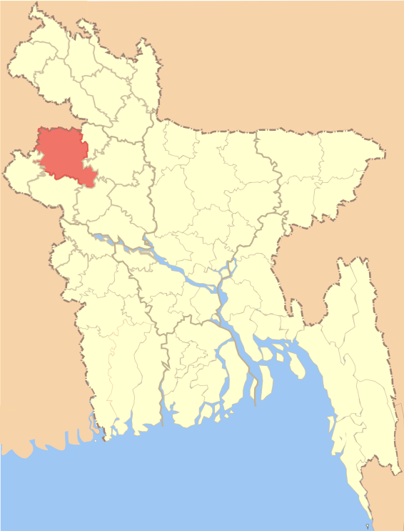
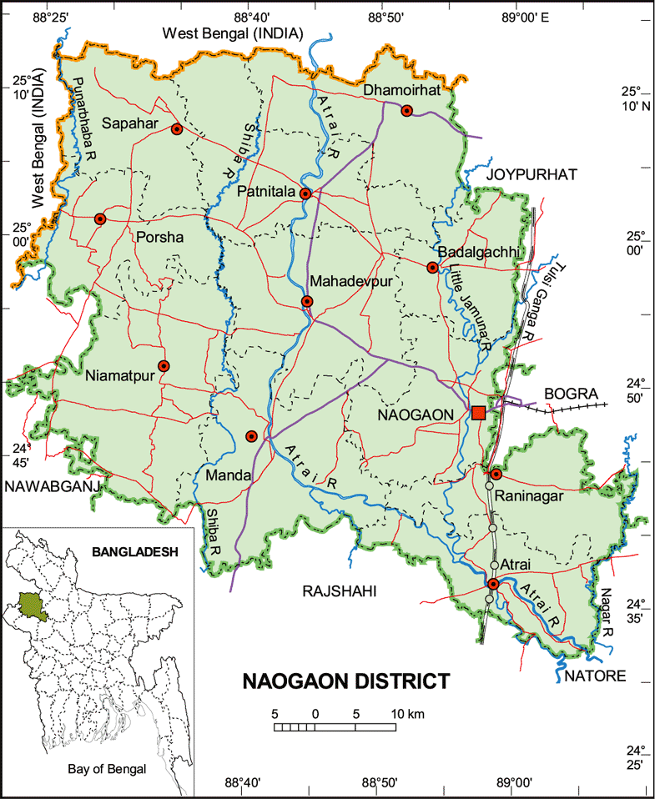

Fig1: Map of Naogaon District

CHAPTER-III
Results and discussion
The daily feed intake of this chicken were recorded from sexual maturity upto one year and calculated the daily average feed intake of F1 generation of Naked Neck chicken was 80kg and F2 generation of Naked Neck chicken was 77 kg respectively. It can be say that good management may enhance the productivity of Naked Neck chicken.
During rearing in a confinement system the chicks were fed with a balance diet from Bangladesh Rural Advancement Committee (BRAC), containing 20% CP and 2850 Kcal, ME/Kg of feed.
Table 1: Statistical analysis of feed intake of F1 and F2 generation on NNC
Generation | Maximum | Minimum | Mean | Median | Mode | STD | p-value
F1 | 82 | 80 | 81 | 81.5 | 81,5 | 3.45 | 0.202
F2 | 80 | 72 | 77 | 77.5 | 80 | 3.22 | 0.179

The p- value of test in F1 generation is 0.202 .According to the p-value of t-test 0.202 means, there were no difference in different chickens. The p-value of test F2 generation is 0.179. According to the p-value of t-test 0.179 means, there were no difference in different chickens.

The chickens were allowed for scavenging around the homestead and in the neighborhood for a period of two hours in the morning and evening respectively. Therefore they were provided supplementary feeding in day shelters between two scavenging periods, continuing for six to seven hours. The supplementary feed ingredients were collected from a local market.

Table 2: The composition of the supplemented feed
Ingredients | Composition by levels of supplementary feed |  |  | DM basis chemical composition
 | 15g | 30g | 45g | ME(kcal/kg) | CP(%)
Maize | 7.5 | 15 | 22.5 | 3650 | 11.6
Paddy rice | 4.5 | 9.0 | 13.5 | 1550 | 14
Broken rice | 1.2 | 2.4 | 3.6 | 2300 | 8
Soya. meal | 1.2 | 2.4 | 3.6 | 2640 | 55.5
Oyester shell | 0.6 | 1.2 | 1.8 | - | -

Source of chemical composition: Sohaet al (1999);European table of energy values for poultry feed stuffs, Rahmanet at (1997).
The highest rate of lay was obtained from the group of highest level of supplementation. Here, the results indicate that the hens were biologically influenced with the level of supplementation. Ahmed and Islam (1985) reported a significant improvement in egg production with a provision of supplementary feed. Rashid et al (1995) had similar findings in a case of ducks, which is in agreement with the findings of the present study. It has been reported that crossbreeding with improved breeds and the provision of supplementary feed significantly improved body weight both in chickens (Ahmed and Islam, 1985) and ducks (Rashid, 1995). Result of the present study indicate that heterosis of the improved crossbreed were expressed with a supplemented nutritional condition both in body weight and egg production. But the levels of supplementation are yet to be ascertained.

Table 3: Statistical analysis of egg production of F1 and F2 generation of NNC/year/hen
Generation | Maximum | Minimum | Mean | Median | Mode | STD | p-value
F1 | 134 | 120 | 127.8 | 128 | 128 | 5.02 | 0.209
F2 | 155 | 109 | 138.7 | 140 | 140 | 9.79 | 0.237

The p- value of test in F1 generation is 0.209 .According to the p-value of t-test 0.209 means, there were no difference in different chickens. The p-value of test F2 generation is 0.237. According to the p-value of t-test 0.237 means, there were no difference in different chickens.
The annual average egg production of F1 generation of Naked neck chicken was 128 per hen per year and F2 generation of Naked neck chickens was 140 per hen per year respectively. Tareq (1992) found that the egg production of NNC was 129 per hen per year under rural condition. Here, it was found that the egg production of Naked neck chickens were slightly differ. This might be due to lack of genetic potentiality of the base population from where the Naked neck chicken pullets were collected.

Fig 2: Graphical presentation of average egg production/ hen in F2 generation.
The above graph shows that hens of farm2 produced more egg per year, then the hens of farm 1, hens of farm 5, hens of farm 3, hens of farm 4, hensof farm 6 respectively. The average egg production peryear of hens of different farms in F2 generation according to serial were 144.4, 149.2, 136.8, 132.6, 138.6, 130.6.
Table 4: Statistical analysis of body weight (kg) of F1 and F2 generation of NNC
Generation | Maximum | Minimum | Mean | Median | Mode | STD | p-value
F1 | 1.6 | 1.5 | 1.56 | 1.6 | 1.6 | 1.5 | 0.242
F2 | 1.8 | 1.3 | 1.53 | 1.5 | 1.5 | 0.14 | 0.247

The p- value of test in F1 generation is 0.242 .According to the p-value of t-test 0.242 means, there were no difference in different chickens. The p-value of test F2 generation is 0.247. According to the p-value of t-test 0.247 means, there were no difference in different chickens.

Fig 3: Graphical representation of average weight of chicken in F2 generation at the time of laying.
The above graph shows that average body weight of the chickens of farm1 at the time of laying were more than other farm.
The average age and weight at sexual maturity of Naked neck chickens were obtained 159.63 days and 1.3kg respectively. Sazzad (1992) observed that the age and weight at sexual maturity of Naked neck chickens were 155.5 days and 1.25kg respectively. The present study showed early sexual maturity than the result of Baruaet al (1998) who obtained the age at sexual maturity of Naked neck chickens were 225 days.. The early sexual maturity may be obtained due to the supplied of balanced feed.

CHAPTER-IV
Conclusion
Crossbreed chicken are in general found to have a heterotic effect, which means that crosses of two breeds perform better than their parent breeds they origin from. Results of this study revealed that the performance of Assel and Naked neck chicken in terms of egg production, average age and body weight at sexual maturity and feed consumption. The egg production performance of F2 generation is better than F2 generation. Average feed consumption more in F1 generation than F2 generation.

Limitation
- Small sample size
- Short duration of study
- Financial problem
- Communication problem

References

Ahmed, S. and M.N. Islam, 1985.Backyard poultry development in 100 villagessponsored byBangladesh Agricultural University and UNICEF.Bangladesh proceedings of the first Nationalconference of Bangladesh Animal HusbandryAssociation.133-138.
Barua, A., 1992. A study on the performances of Rhode Island Red, indigenous chickensandtheir crossbred chickens with or without extra feeding under the rural condition of Bangladesh.
Grobbelaar, J. A. N., Sutherland, B., &Molalakgotla, N. M. (2010).Egg production potentials of certain indigenous chicken breeds from South Africa. Animal Genetic Resources/Resources génétiquesanimales/Recursosgenéticosanimales, 46, 25-32.
Horst, P. (1988).Native fowl as reservoir for genomes and major genes with direct and indirect effects on productive adaptability. Proc. XVIII World's Poult.Cong., 1988.
Horst, P., 1988. Native fowl as a reservoir for genomes and major genes with direct and indirecteffects on productive ability. Proc. 18th World’s Poultry Congress. (Nagoya), 99-104.
Huque, Q.M.E., 1999. Results (unpublished) on the performances of Naked Neck and itscrosses with different high yielding exotic breeds of chickens (RIR, WLH, Fayoumi) reared inboth cage and scavenging condition. Seminar and International Poultry Show.p-79.
M.Sc.Thesis, Department of Poultry Science, Bangladesh Agricultural University.
Merat, P., 1986. Potential usefulness of Na (Naked neck) gene in poultry production.World’sPoultry Science Journal 42:124-142.
Okeno, T. O., Kahi, A. K., & Peters, K. J. (2012).Characterization of indigenous chicken production systems in Kenya. Tropical animal health and production, 44(3), 601-608.
Rahman, M., P.Sorensen, H.A.Jensen and F.Dolberg, 1997.Exotic hens under semi scavengingconditions in Bangladesh. Livestock Research for Rural Development Vol. 9 (No.3):1-11.
Rashid, N., A. Barua, S.M. Bulbul, 1995. A study on the performance of Khaki Champbell, Deshiand Khaki Champbell x Deshi ducks with and without extra feeding under rural condition ofBangladesh. Asian Australatian Journal of Animal Science. 8:375-378.
Romanov, M. N., Wezyk, S., Cywa-Benko, K., &Sakhatsky, N. I. (1996).Poultry genetic resources in the countries of Eastern Europe–history and current state. Poultry and Avian Biology Reviews, 7(1), 1-29.
Say, R. R. (1987). Manual of poultry production in the tropics.
Sazzad, M.H., 1992. Comparative study on egg production and feed efficiency of differentbreeds of poultry under intensive and rural conditions in Bangladesh. Livestock Research forRural Bangladesh.Vol.4(No.3):65-69.

Acknowledgement
I would like to express the deepest sense of gratitude and sorts of praises to the Almighty,the creator and supreme ruler of the universe who had bestowed upon me to do this work successfully.
The author express his sincere gratitude,humble respect heartfelt thanks to my internship supervisor, Prof. Md. Akhtar-Uz-Zaman, Department of Dairy and Poultry Science, Chittagong Veterinary and Animal Sciences University for his scholastic guidance, kind cooperation ,sincere help, valuable suggestion, inspiration who was involved with this study from its inception. I ever remain greatful to him.
I would like to thanks BSDO, Panitolaupazilla.
Last but not least, the author extended his appreciation to his parents.
The Author

Biography
I am SouravSen,Intern student of Chittagong Veterinary and Animal Sciences University. I am native to Chittagong. I have completed my Secondary School Certificate with GPA-5.00 from R.K.R High School and Higher Secondary School Certificate with GPA-5.00 from B.N College Chittagong. My favourite hobby is reading books and I want to be an honest person. I am interested in find out new techniques for the development of veterinary science.

