ASSESMENT OF ANIMAL WELFARE ISSUES IN CATTLE MARKET , CHITTAGONG, BANGLADESH

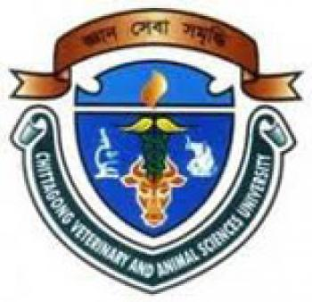
…………………………
Signature of Supervisor

DR. MD SAIFUL BARI
Assistant Professor
Department of Dairy and Poultry Science
Chittagong Veterinary and Animal Sciences University
Khulshi, Chittagong-4225, Bangladesh

ASSESMENT OF ANIMAL WELFARE ISSUES IN CATTLE MARKET , CHITTAGONG, BANGLADESH

…………………………
Signature of Author
Md Abdullah Al Mamun
Roll no : 11/35, Reg no:00684
Intern ID:G-61
Session:2010-2011
A Production Report of Submitted in partial satisfaction of the requirements for the degree
Of
Doctor of Veterinary Medicine
Faculty of Veterinary Medicine
Chittagong Veterinary and Animal Sciences University
Khulshi, Chittagong-4225, Bangladesh
November-2017
Table of contents
- Abstract…………………………………………………………………………………...4
- Introduction....................................................................................................................5-7
- Materials and methods…………………………………………………………………..7
- Result …………………………………………………………………………………8-9
- Discussion……………………………………………………………………………10-11
- Conclusion ……………………………………………………………………………...11
- Acknowledgement …………………………………………………………………….12
- References ………………………………………………………………………………13
- Biography ………………………………………………………………………………14

Abstract
The study was conducted to observe the actual condition of animal welfare issues during transportation, handling, and marketing of livestock animal specially cattle. A total of 200 cattle were examined at Sagorika Cattle market, Chittagong during the period of November 2017. The frequency of injuries and the transportation method was assessed. The data of different types of injuries (skin abrasion, tail injury, leg injury, head injury, wound) was collected from market directly by visual observation and palpation method. The frequency of injuries (46.5% out of 200 cattle) are 60 skin abrasion(64.5%, n=93), 5 leg injury(5.37%,n=93), 6 head injury(6.45%, n=93), 10 tail injury(10.75%,n =93), 12 wound (12.9%,n=93). Most of the injuries were occurred for the disobeying the rules of animal welfare during transportation and handling.

Keywords: Cattle, Injury, Animal Welfare, Transportation

Introduction
Animals play many vital roles in the lives of people all over the world. Nearly half the world’s population is involved in agriculture and livestock are important for food, for labor and for income. Millions of people keep animals as companions and enjoy the existence of wildlife and these can help their physical and psychological health. Throughout our history and throughout the world, humans have had a close relationship with the living world and many feel a natural affinity to other animals. Even people in cities who rarely see animals benefit from animal products and from biological diversity. In most countries of the world there are cultural traditions on humane treatment of animals, including in religious teachings. Animals matter to people.

According to a report of World Society for the Protection of Animals (WSPA) world’s poorest people’s approximately 650 million of the 1 billion poorest people on earth depend completely on animals for their livelihoods and the whale watching industry alone generates $2.1 billion dollars and employs 13,000 people around the world. Animal systems occupy 45 percent of the global land area; generate output valued at $1.4 trillion, and account for between 60 and 70 percent of the total global agricultural economy. These systems employ more than 1.3 billion people globally and directly support the livelihoods of 830 million food-insecure people around the world. In the process, the systems contribute 17 percent of the global kilocalorie consumption and 33 percent of the global protein consumption. ii People in developed countries, comprise about 20% of the world population and consume 80% of world production of milk and dairy products and 66% of world beef production.iii The total contributions from domesticated animals, while not approaching the proportions derived from plants, are still quite large, providing approximately 34% of human food protein and 16% of food energy supply (Rowshan Jahan Farhana, 2011).

In Bangladesh, the animals (specially Cattle, Goat, poultry) are reared traditionally in rural areas. But the livestock farming is increased rapidly. As the animals are reared in house the people are closely contacted with animals. So there is very close and friendship relation is present between animals and human.

Cattle is the most popular livestock animal in Bangladesh for it’s meat and milk production. In Bangladesh, the total cattle population is about 24 million (BBS-2011). Most of the animals are cattle in the livestock market. The cattle marketing is depended on intermediaries or broker. The most of the people are not aware of animal welfare.
But Animal welfare (AW) is a relatively new topic which is just beginning to attract attention in Bangladesh. The transports of farm animals for meat production in Bangladesh are mostly done by foot or in best cases by vehicle, usually during long distances. In addition, the road transport conditions involve high stocking densities, poor ventilation on the animals’ underside, high humidity and temperatures, and crude forms of animal restraint, including the tying legs together, which may increase the risk of muscle injury, fatigue and stress. Moreover 16-18 cattle are loaded in a truck and it is obvious from visual inspection that there is overcrowding in relation to the surface area available for each animal (Alam et al. 2008). It takes normally 16-18 hour to reach Chittagong at Sagorica cattle market, sometimes due to strike, traffic jam or other problem this time is getting prolonged. These transport vehicles are open-top, no cushion is applied around the side to protect the injury. The animals are tied to the vehicles' sides to control their movement and ropes are secured at the neck, legs or nose. This condition leads to respiratory problems, discomfort, rubbing injuries, abrasion and laceration injuries from rubbing against the vehicle wall (Alam et al. 2010a). Skin injuries can also be associated with the down grading of meat and loss of skin value (Minka and Ayo 2007). The tail injuries occurred due to tail twisting, which is one of the methods to control the movement of animals such as cattle and water buffalo (Gregory et al. 2009). Loading and unloading can be two of the most stressful stages during animal transportation (Kober 2011). Inappropriate behavior by the animal handlers has often been observed, particularly at the time of unloading, involving the frequent use of sticks, which might explain some of the skin injuries. The animals don’t get proper handling and care in the cattle market

Giving active consideration to animal welfare involves understanding the needs of individual animals, promoting care and reducing mistreatment. This does not mean that any person or any country is giving animals rights or elevating the status of animals above humans. Rather, it means that we ask questions – increasingly important to millions of people around the world– about how our actions affect animals and how we can reduce animal suffering. The World Organization for Animal Health (OIE) says that “The use of animals carries with it an ethical responsibility to ensure the welfare of such animals to the greatest extent practicable.

In the local cattle markets of Bangladesh, most of the cattle imported from India by illegal way. So the cattle were transported a very long distance to arrive market. During transportation, the cattle are being faced different types of cruelty by men. Starvation, skin abrasion, nose injury, tail injury, leg injury, diseased animal transportation and marketing are the common cruelty can be seen in the cattle market.
In this study the following objectives will be fulfilled-.
- To observe the actual animal welfare condition in market
- To concern the people about animal welfare and to reduce the cruelty and mismanagement.

Materials and methods
Study area: livestock market in Bangladesh (Sagorika in Chittagong). The markets were selected because they were large by national standards with a high proportion of their throughput coming from India.
Study period: the study was conducted at November 2017
Animal examinations : All 200 cattle underwent full body examination. There were 200 imported cattle (Hariana 142, Exotic non descriptive[ND] 21) and 37 cattle of local breed. The animals have a history to travel a long journey by truck and walking. It made a heavy stress on them. During travelling they were not provided feed and water properly. So that the cattle were very weak physically. During truck or other vehicle transportation, the animals were densely arranged. So the different types of injuries were seen for ill transportation. Specially the skin abrasion, tail injury is very common because of contacting with hard and rough vehicle wall. found 93 injured cattle out of 200 cattle. Then the injuries are detected in the animals by direct observation. I had found 60 skin abrasion, 5 leg injury, 6 head injury, 10 tail injury, 12 wound fresh wound, wound with infection.
Result
There are moves to improve the welfare image of the export trade in Bangladesh to help sustain this important source of dietary protein. The animal welfare problems include ulceration and bleeding where ropes are secured in the noses, broken tails, and skin lacerations and grazing. Many of the injuries were recent injuries and were probably due to contact with the inner walls of the vehicles during transport. Some could be corrected through better awareness amongst the stock handlers. It will be difficult to identify the source of the problem. That concern is no longer valid in those countries that have introduced cattle passports, as passports now allow an adequate level of traceability. Instead, this concern has been replaced by worries about transmission of disease within markets
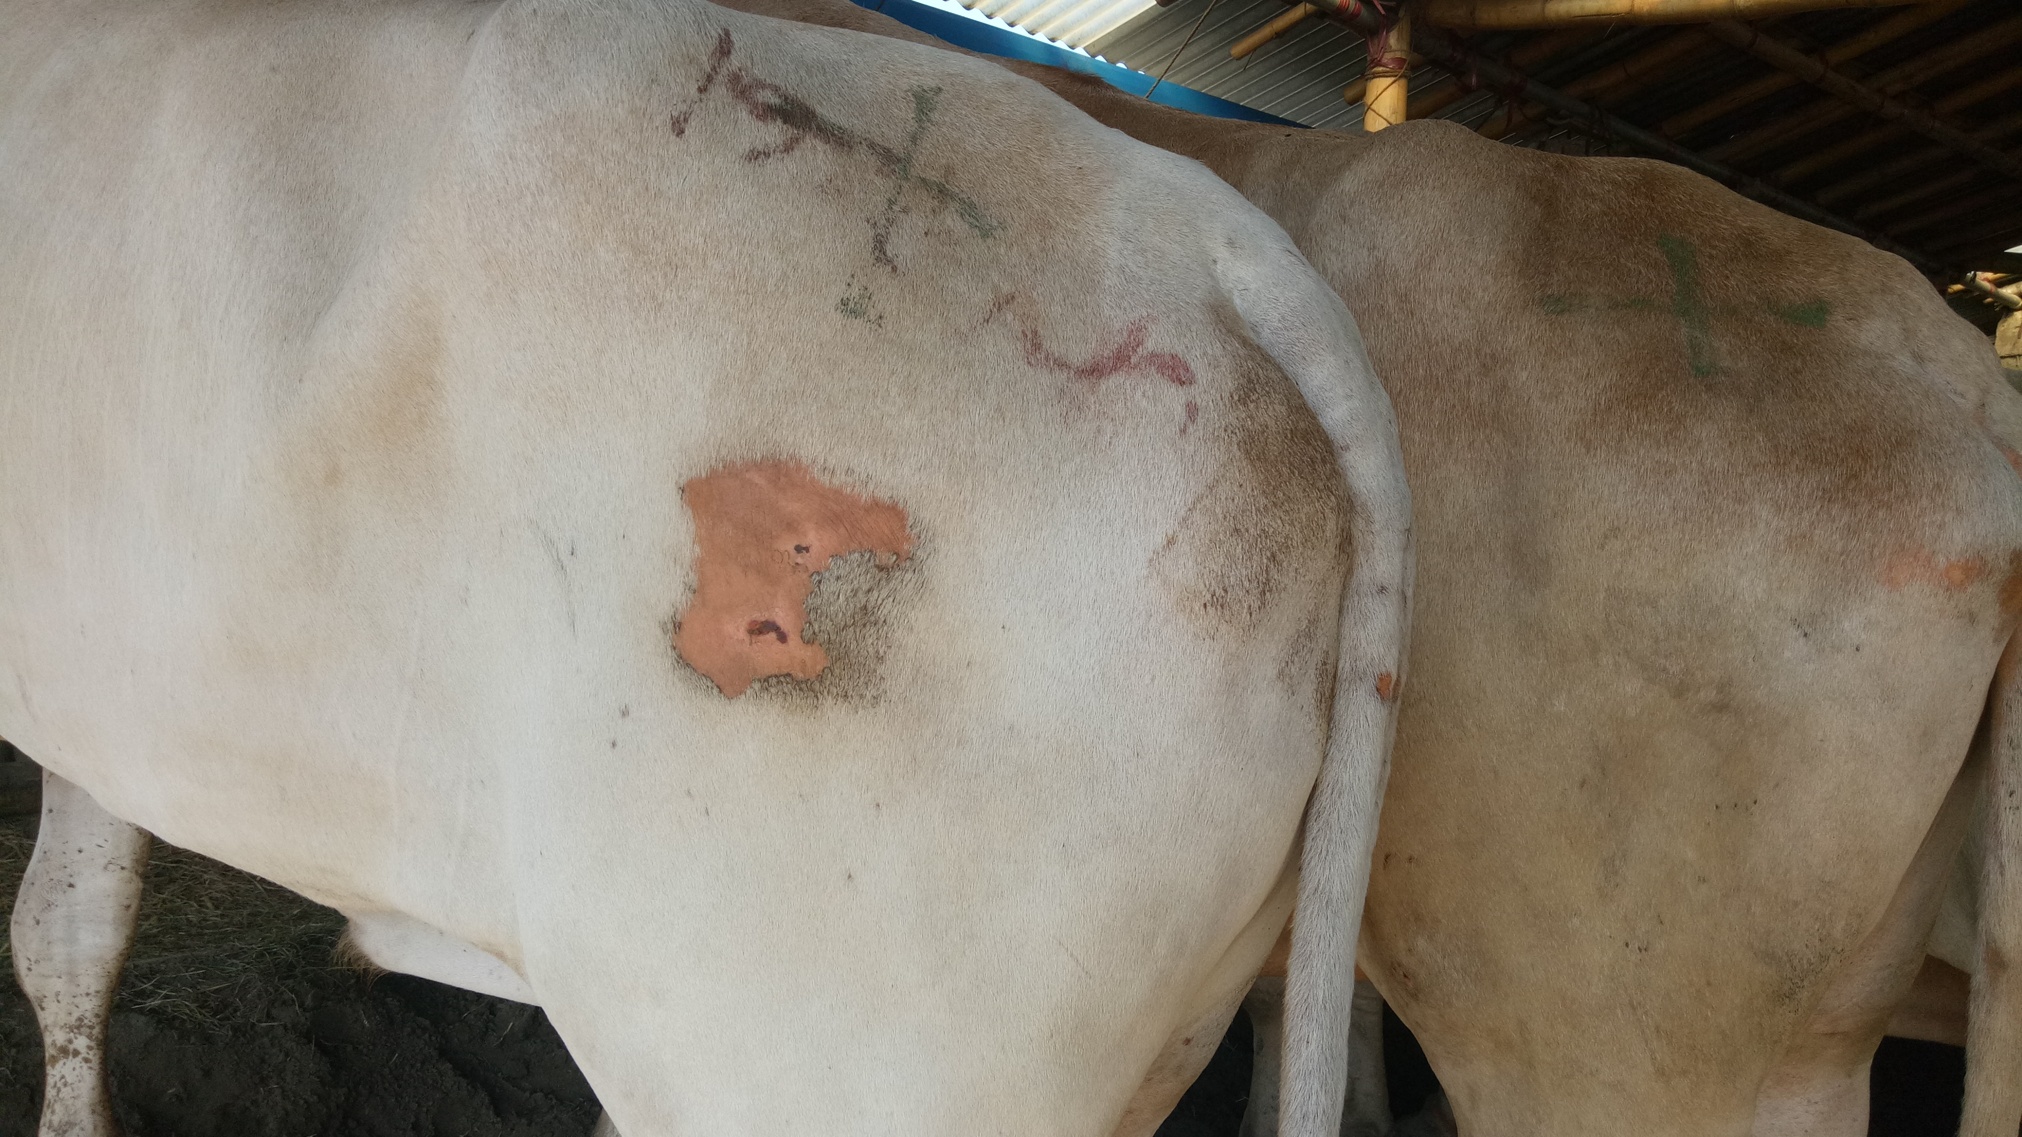
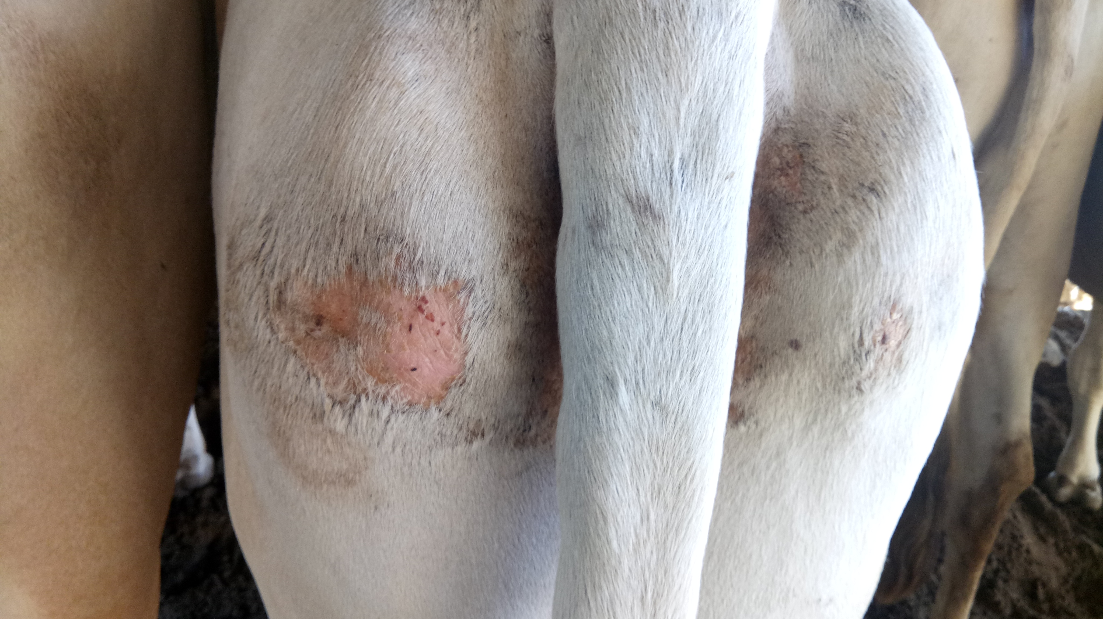
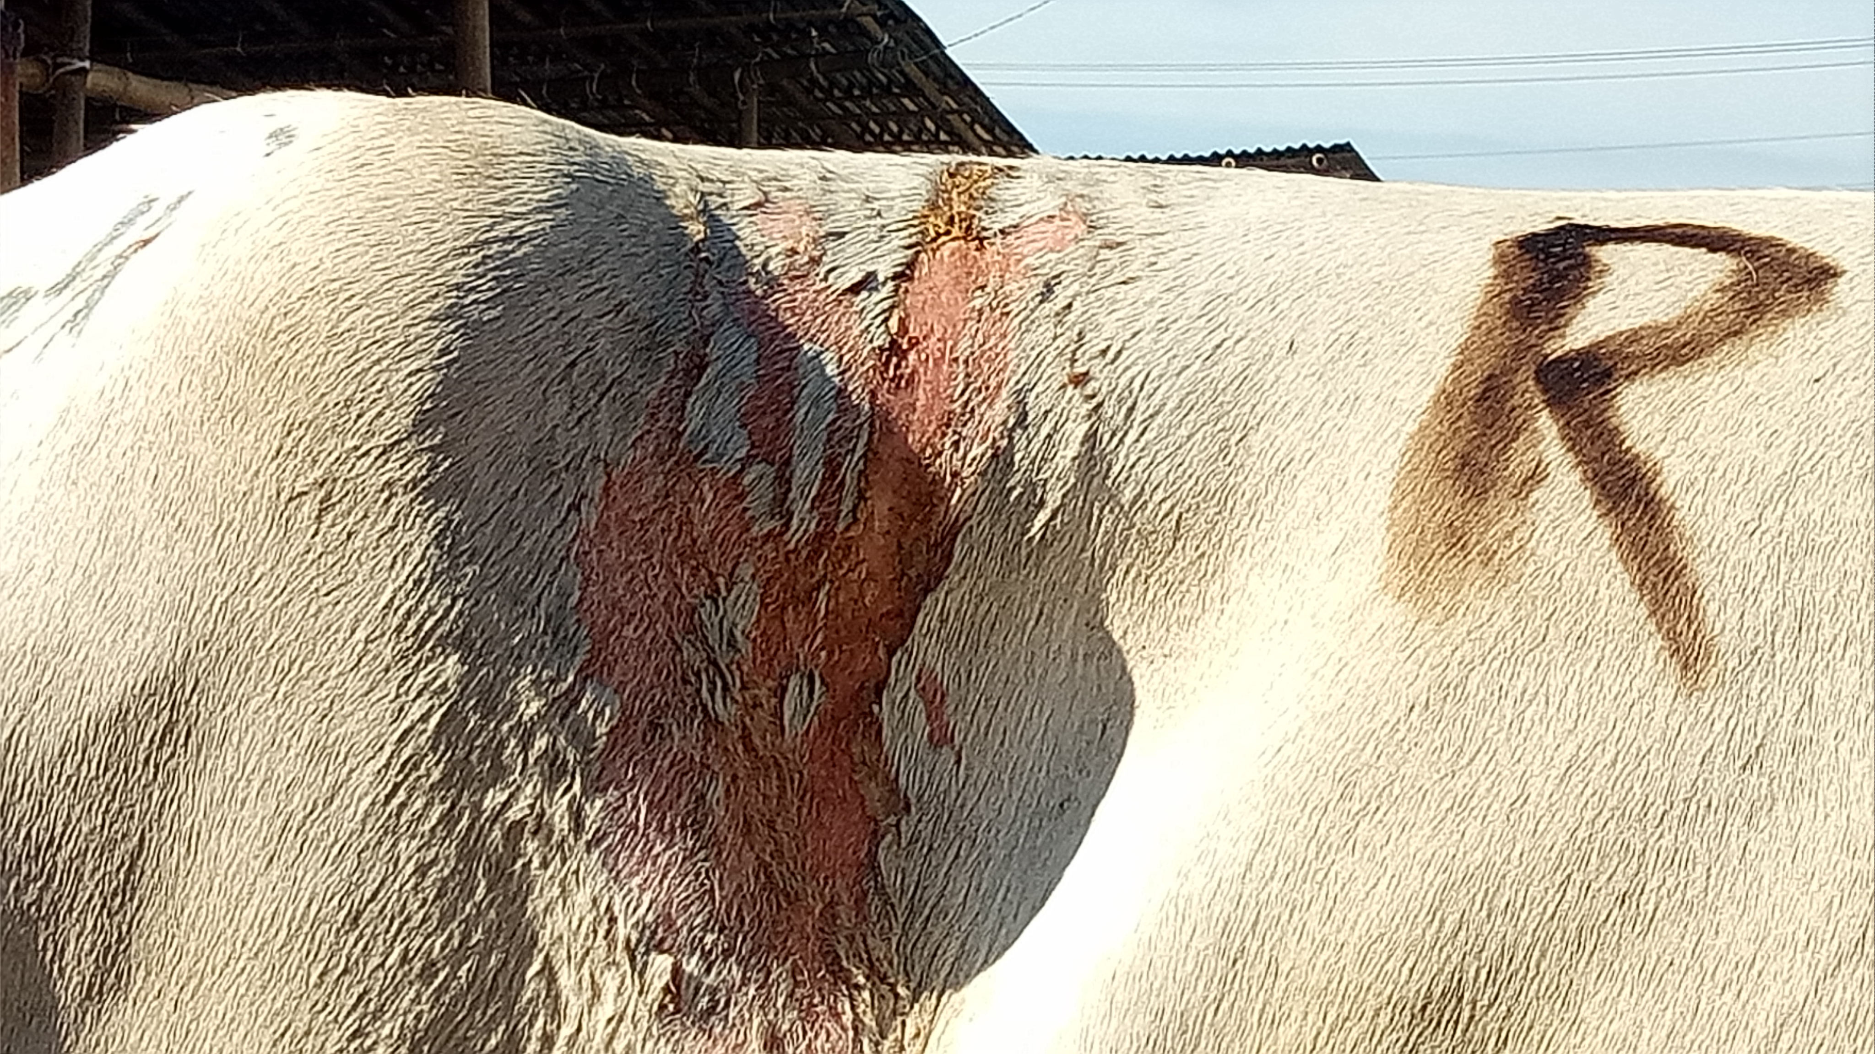

Tail injury
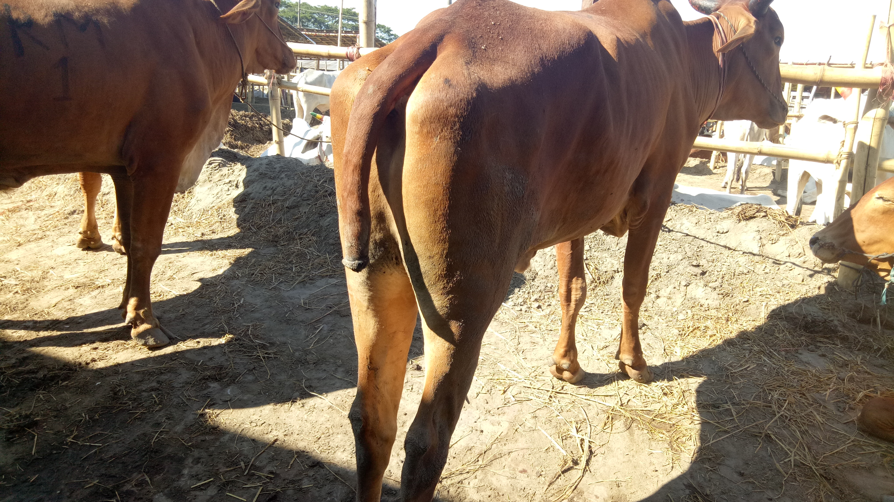
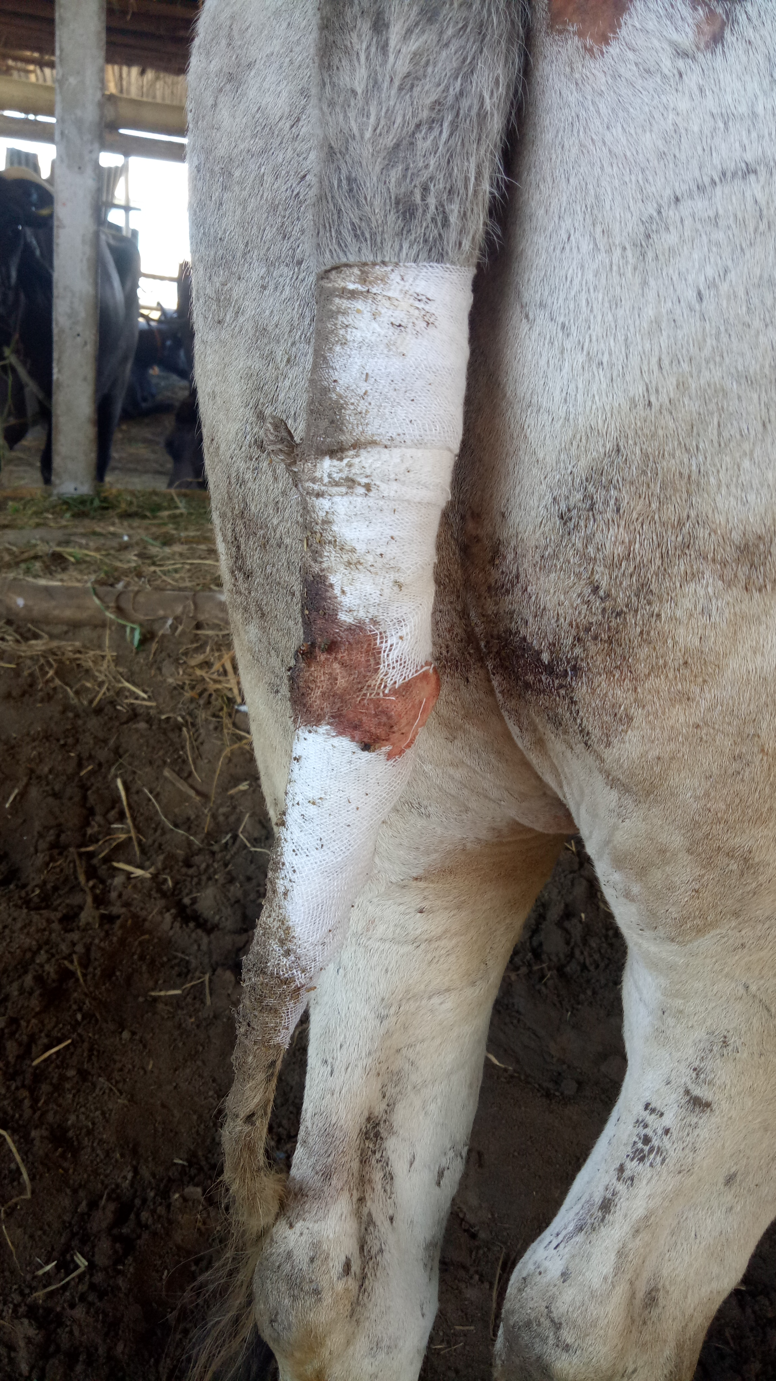
Skin Abrasion in thigh region Wound
Skin Abrasion in hip region
Skin Abrasion in lumber region
Tail injury

Tail injury
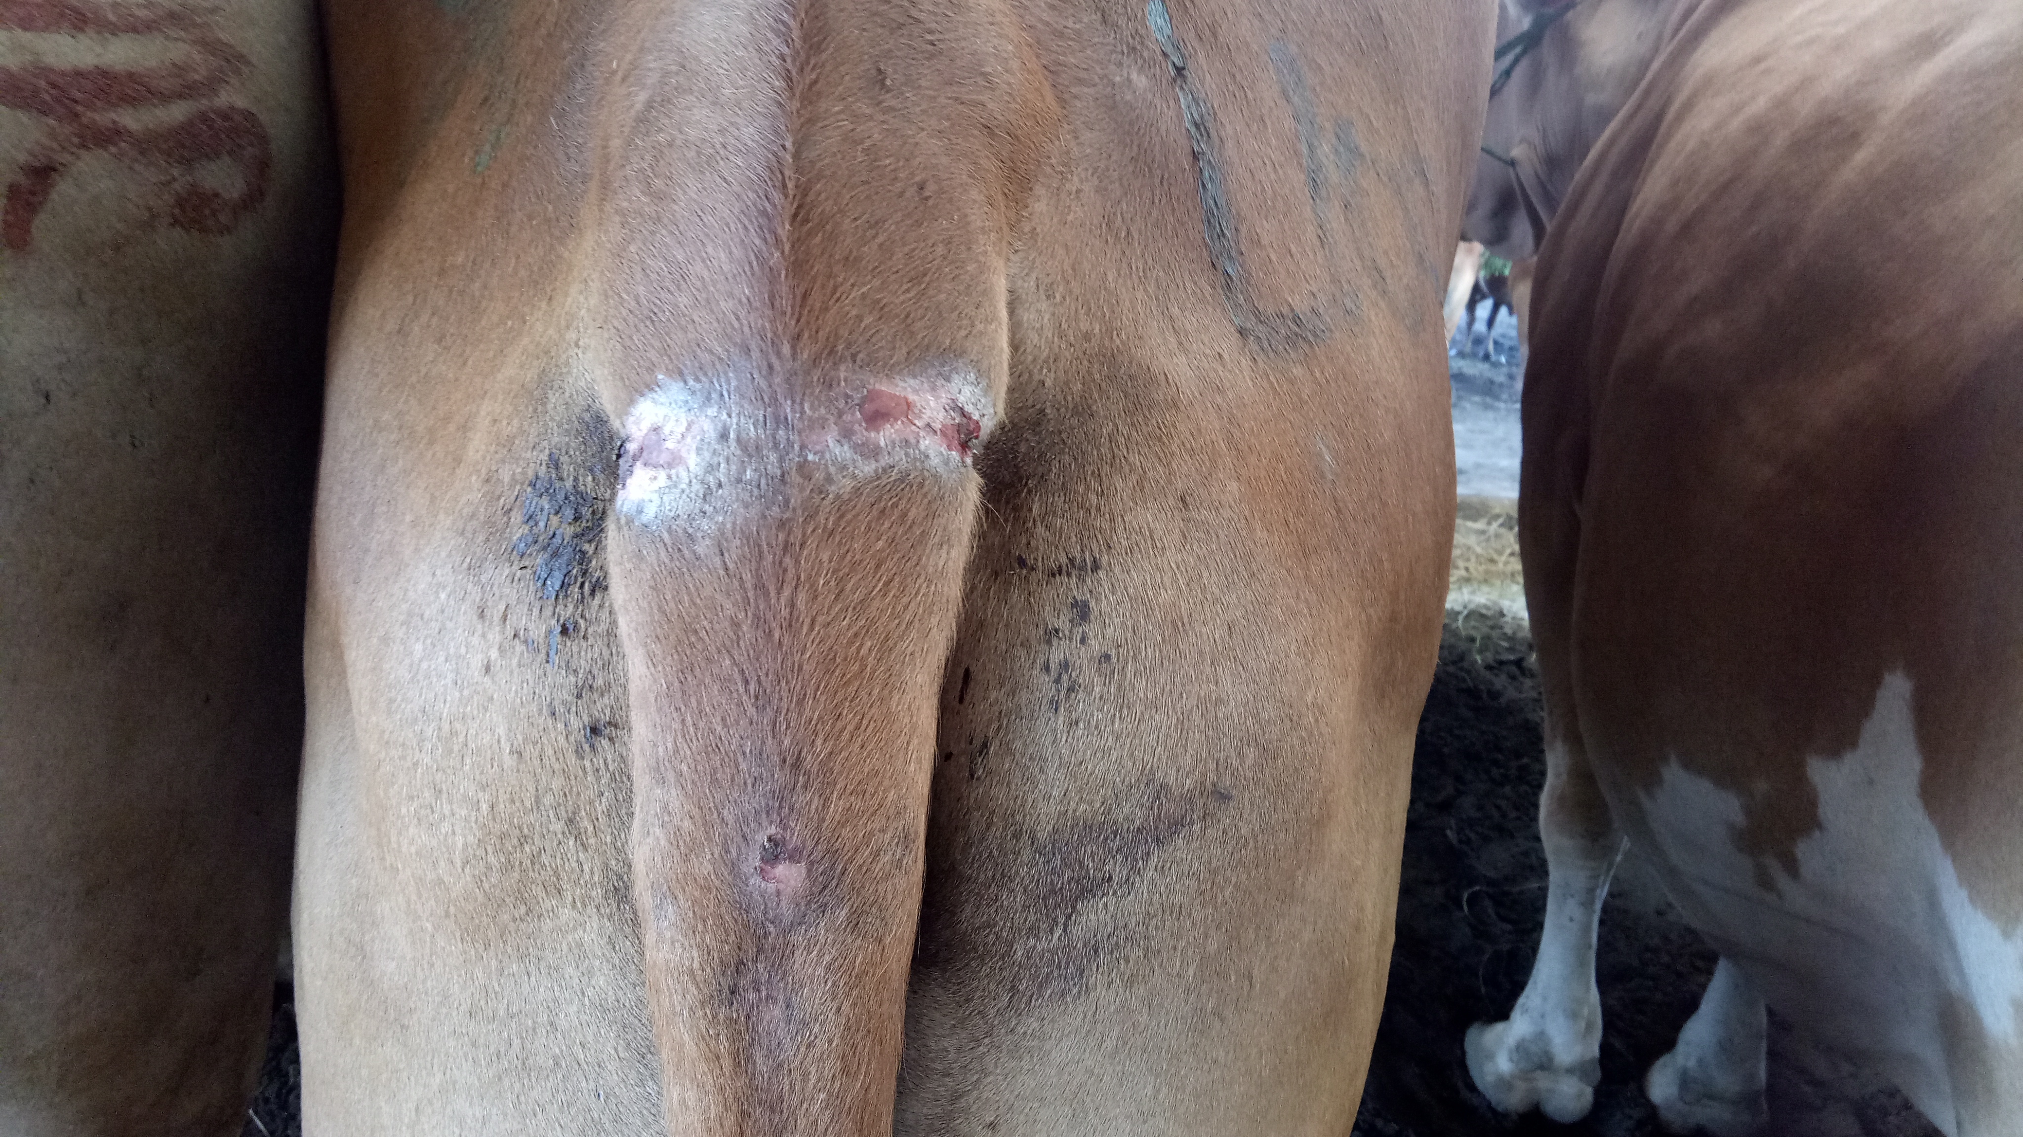
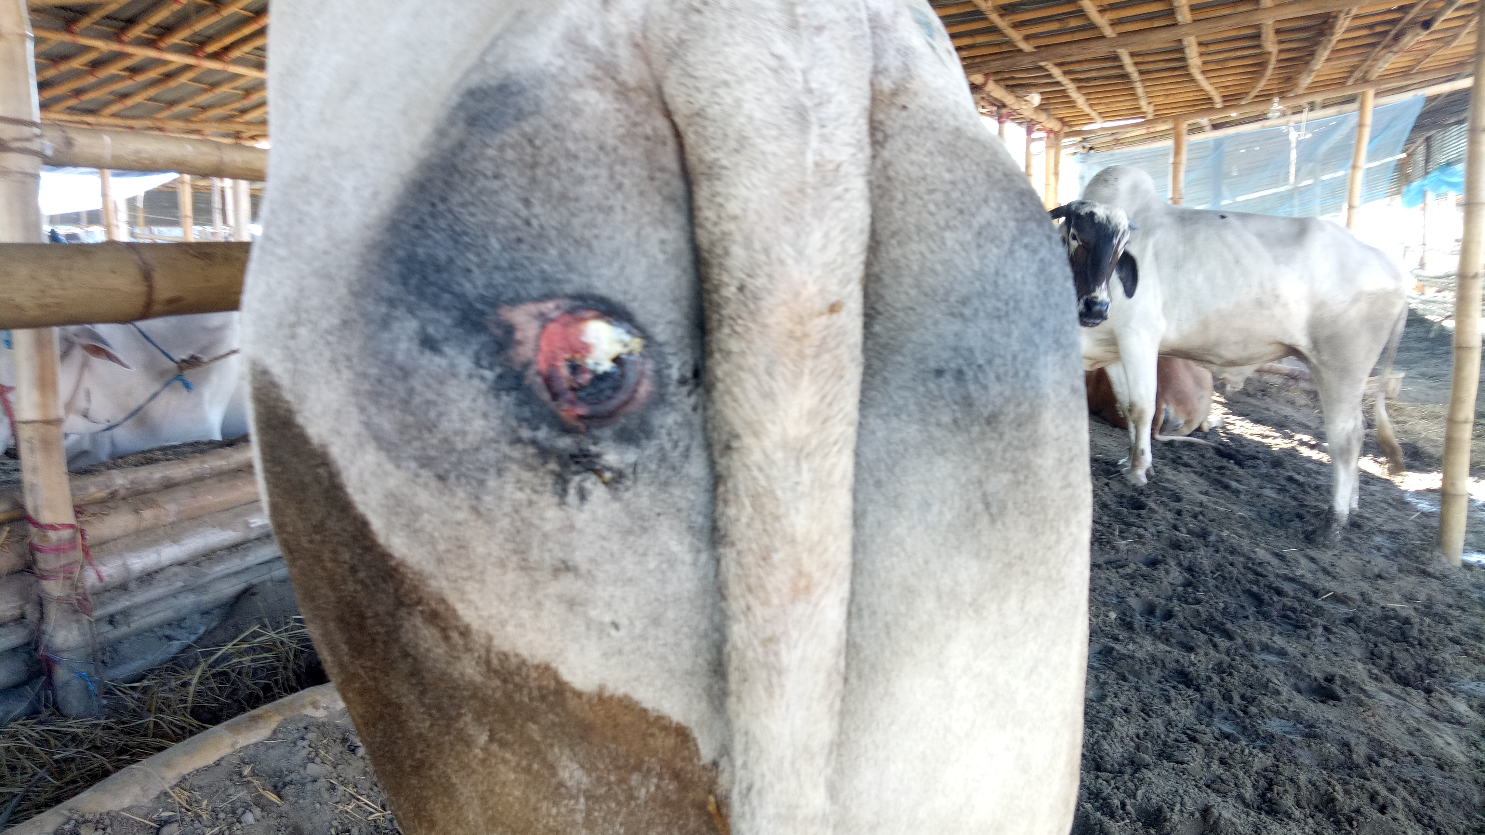
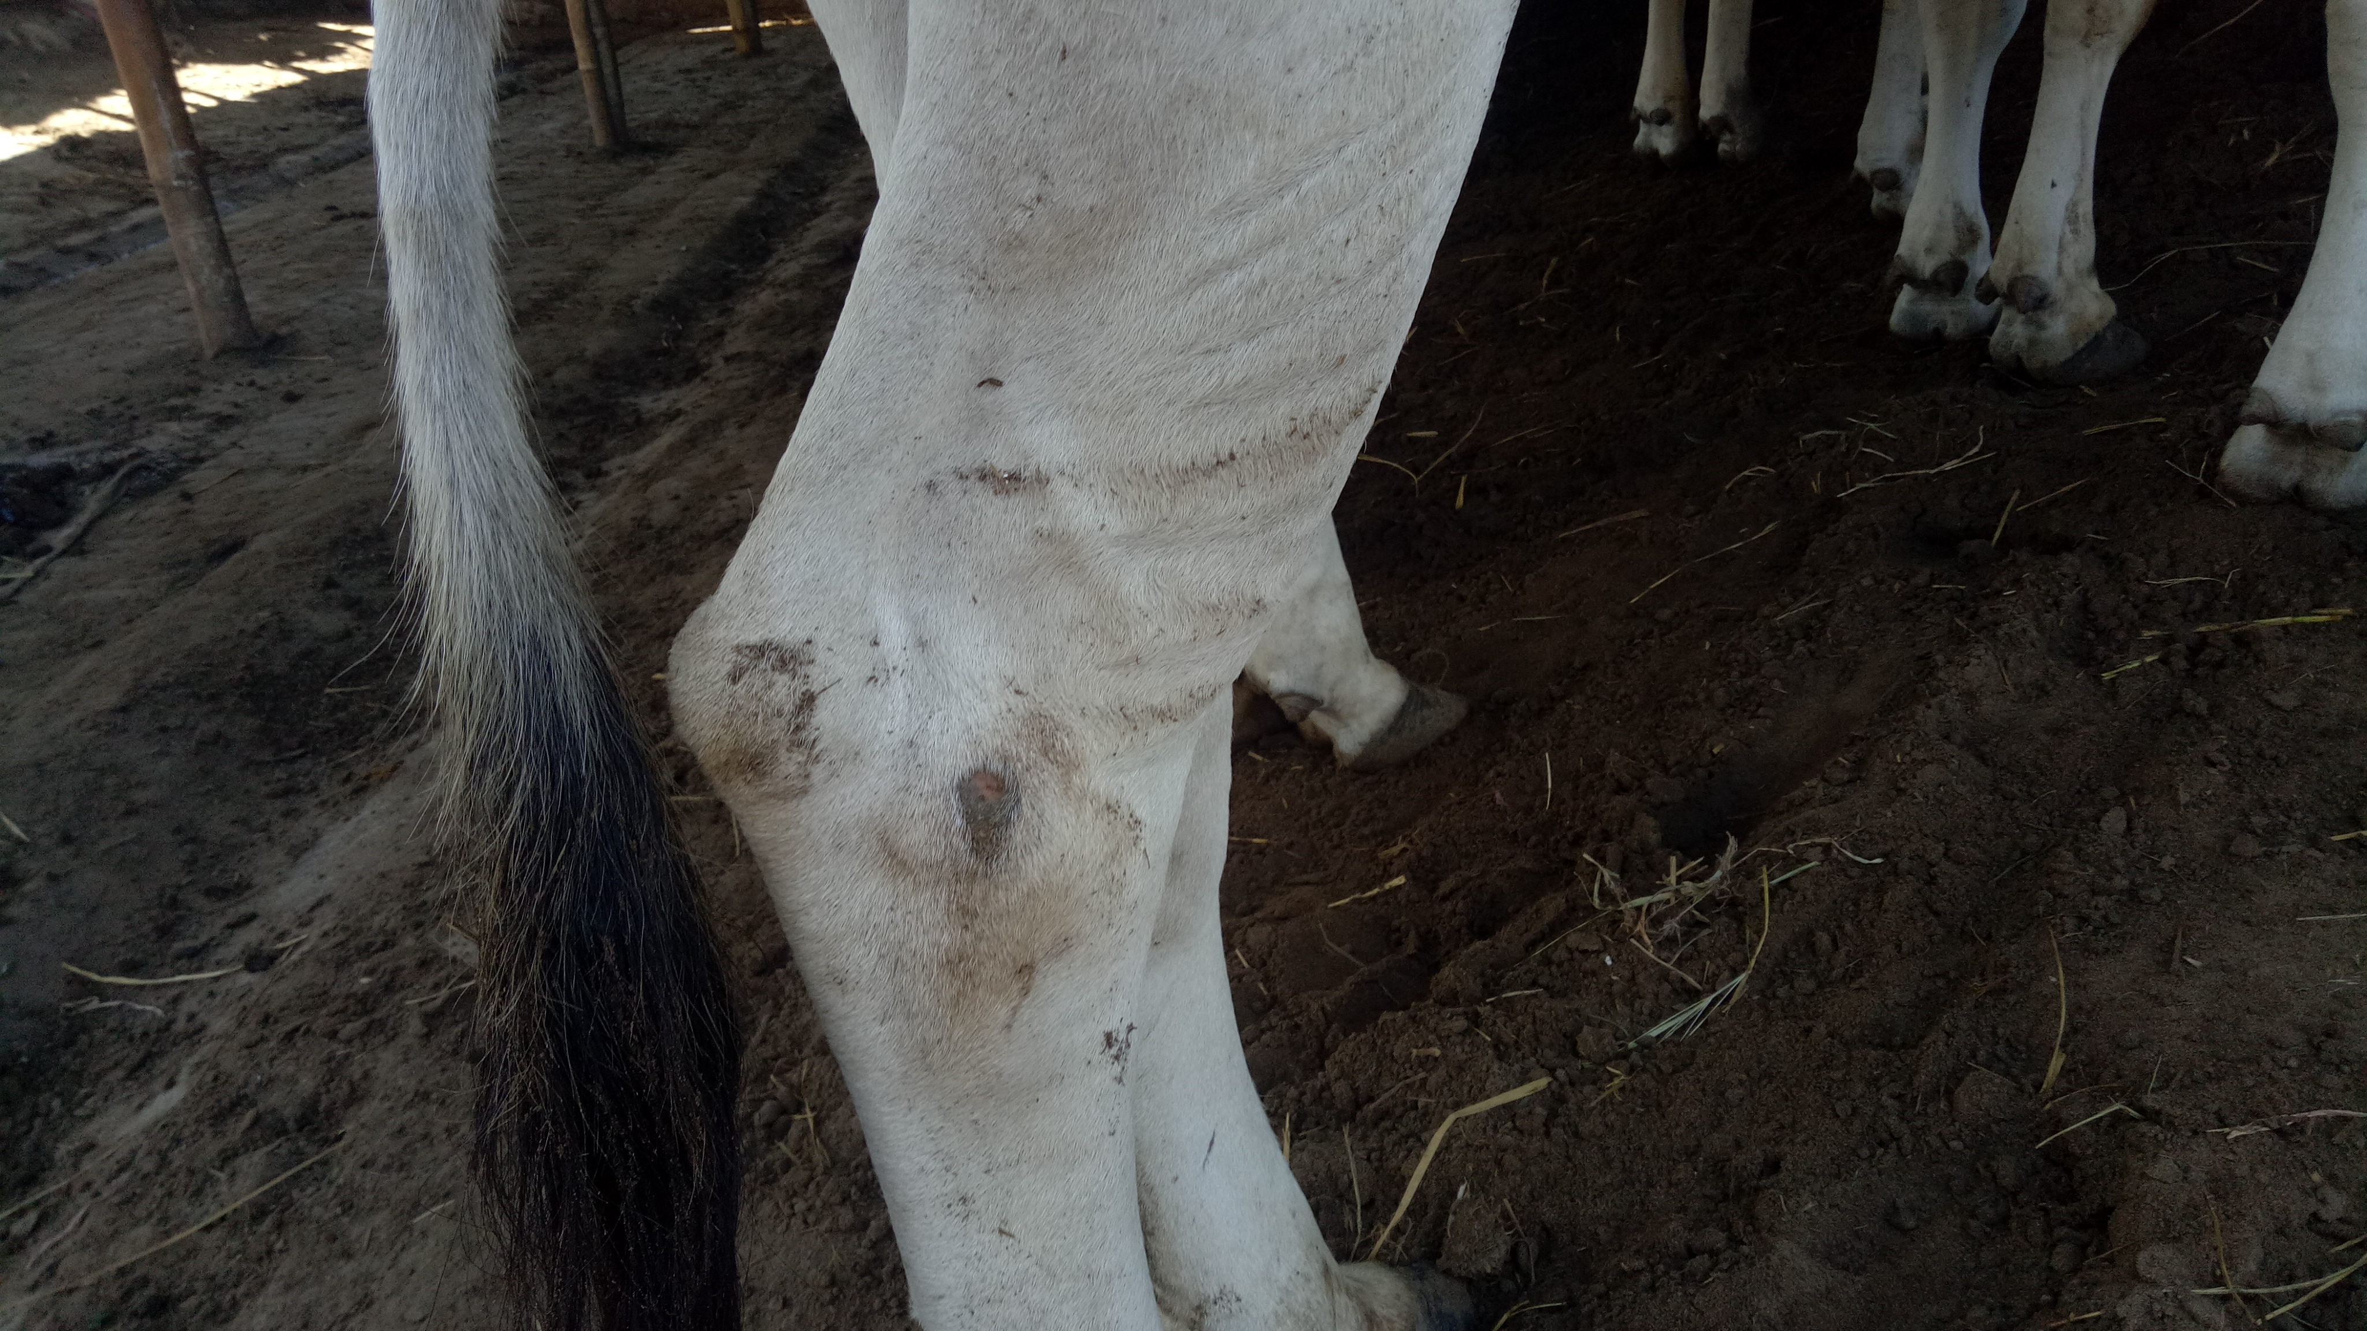
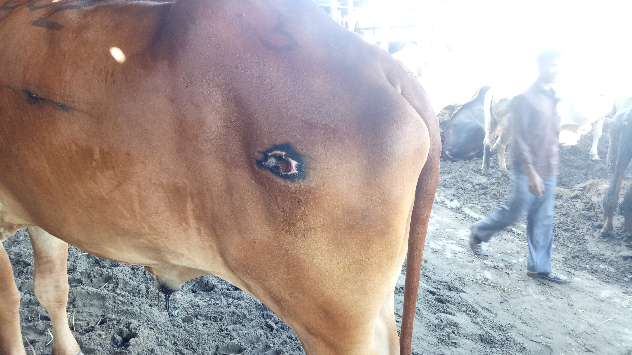

Deep Wound with infection
Leg injury
Wound with infection

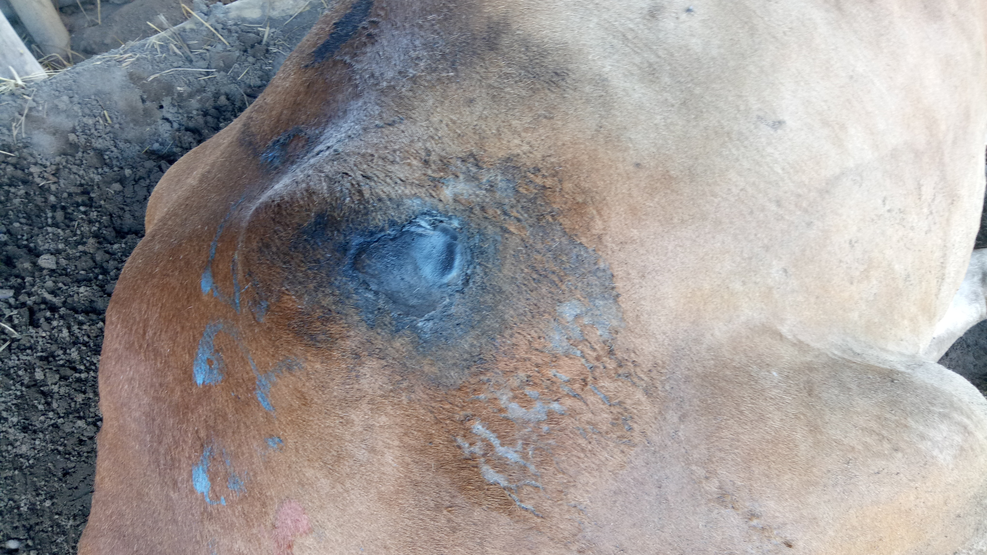
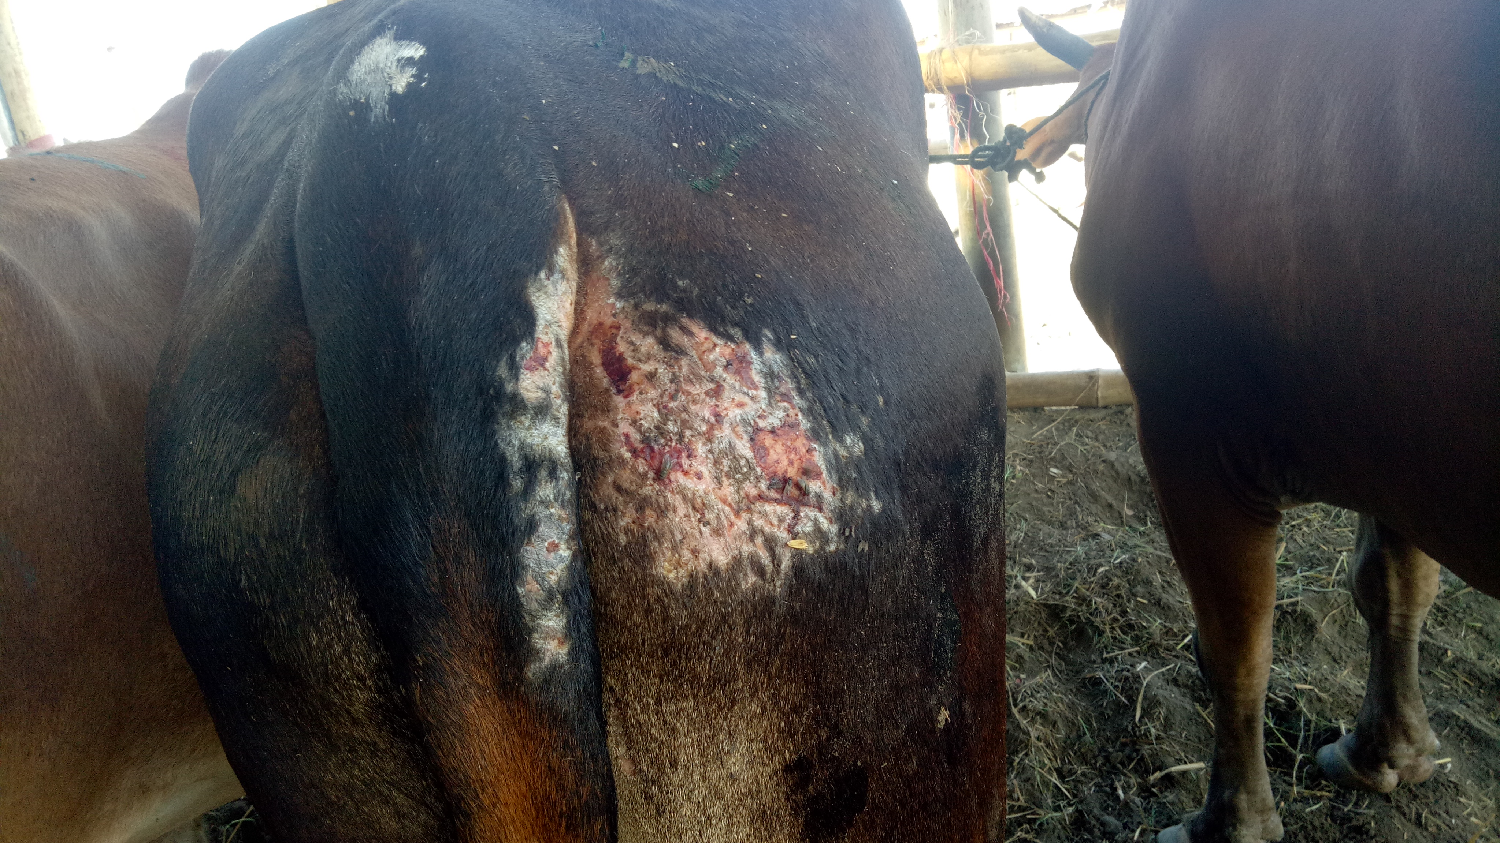
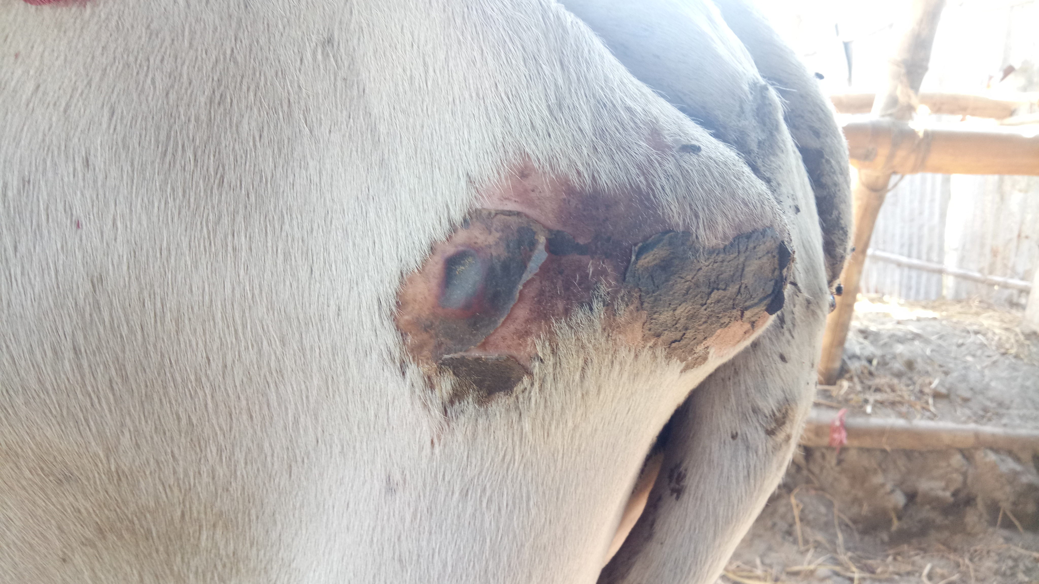

Wound
Wound in hip region
Wound in hip region

Table -1
Examined cattle | Injured cattle | Skin abrasion | Tail injury | Head injury | Leg injury | Wound
Sum | 93, n=200 | 60 | 10 | 6 | 5 | 12
Percentage | 46.5% | 64.5% | 10.75% | 6.45% | 5.37% | 12.9%

found 93 injured cattle out of 200 cattle ( overall injury 46.5%, n=200), 60 skin abrasion(64.5%, n=93), 5 leg injury(5.37%,n=93), 6 head injury(6.45%, n=93), 10 tail injury(10.75%,n =93), 12 wound (12.9%,n=93). Most of the injuries were occurred during transportation.

Discussion
Most of the cattle examined in this study were castrates imported from India where they would have been used as draught animals. The cattle were mainly Hariana, and the exotic animals included the Gir breed from India, Bhutan or Nepal. Local cattle in Bangladesh were, by comparison, small animals, less suitable for draught purposes. Local cattle in Bangladesh were, by comparison, small animals, less suitable for draught purposes. Another common cause for nose injury is piercing nose rope to control the animal during transportation and drought process. The tail injury is occurred frequently for picking the tail roughly for walking the cattle quickly. Very large percentage of cattle are injured by skin abrasion. This is why for ill transportation. The vehicle was densely loaded by cattle. The vehicle is usually used truck, Nosimon,korimon etc. No space to relax or move in the vehicle. The rough body and wall of the vehicle causes skin abrasion. The straw with grain is laid on a patch of hard ground and 4 or 5 animals that are tied together are driven around the area using a stick and tail twisting. Tail twisting is used when getting the group started and the slowest member of the group is likely to receive the most tail twisting. At livestock markets, tail twisting is used when loading and
unloading trucks and when trying to get a fallen or recumbent animal to stand. Tail also injured for the very narrow space provided to it. The leg injury occurred during loading and unloading to the vehicle. The vehicle is upperlift to the ground. So the animal could not lift on it easily. The head injury occurred due to fighting with other cattle. Different types of wounds occurred due to the piercing of hard objects in the vehicle. This study showed that injuries were quite common in livestock cattle market. Forty six point five percent of the cattle were injured had moderate to severe injury.
‘Animal Rights’ and ‘Animal Welfare’ is a philosophy of allowing non human animals to have the basic rights. Unnecessary pain, cruelty is prohibited against animals. It has religious prohibition also. “ A good deed done to an animal is as meritorious as a good deed done to a human being, while an act of cruelty to an animal is a bad as an act of cruelty to a human being”.-Prophet Mohammed(sm). In Bangladseh, a new law is passed by parliament that “ Physical, chemical, or environmental torture causes physical or mental pain to animals. The draft law is implemented. Ten thousand taka or six months jail or both for conducting animal cruelty and fifty thousand taka or two years prison or both for maiming or poisoning animal.”- 20 February 2017. The old law was – “ The cruelty to animal act, 1920.” But the implementation of the laws is not satisfactory. No supervision cell is active much to ensure animal welfare in the practical field.

Conclusion
Based on the information reviewed in this paper it is suggested that the following should be considered as future research and development aims. The place of livestock markets in society needs to be considered in an open-minded manner. The stock holder of cattle should have morality to ensure the animal welfare. They should be concerned of animal rights, cruelty of animal, save animal transportation and marketing system. The government should ensure the implementation of law against the cruelty of animal.

Acknowledgement

The author wishes to acknowledge the immeasurable grace and profound kindness of Almighty “ALLAH” the supreme authority and supreme ruler of universe, who empowers the author to complete the work successfully.
The author feels proud in expressing his deep sense of great gratitude and indebtedness to respected teacher and tutor DR. S Bari, Assistant Professor, Department of Dairy and Poultry, Faculty of Veterinary Medicine, Chittagong Veterinary and Animal Sciences University for his trustworthy and scholastic supervision.

References
Alam MR, Gregory NG, Jabbar MA, Uddin MS, Kibria ASMG, Silva-fletcher A (2010a). Skin injuries identified in cattle and water buffaloes at livestock markets in Bangladesh. Veterinary Record, 167: 415-419.
Alam MR, Uddin MS, Kibria ASMG, Jabbar MA, Hassan MM, Sultana S (2008). Animal transport and slaughter: an animal welfare in Bangladesh. Proceedings of the Fifth Annual Scientific Conference of Chittagong Veterinary and Animal Sciences University, Chittagong, Bangladesh, 24-33.
Gregory NG, Benson T, Mason CW (2009). Cattle handling and welfare standards in livestock markets in the UK. Journal of Agricultural Science and Technology, 147: 345-354.
Kober AKMH (2011). Histological study of adrenal gland and its response to the transportation stress in chicken (Gallus domesticus), United Graduate School of Agricultural Science, Tokyo University of Agriculture and Technology, Japan Ph D thesis, 12-16.
Kober AKMH, Aoyama M, Tsukahara N, Sugita S (2011). The effects of acute transportation stress on the adrenal gland of the domestic chicken (Gallus domesticus). Animal Behaviour and Management, 47: 97-103.
Minka NS, Ayo, JO (2007). Effects of loading behavior and road transport stress on traumatic injuries in cattle transported by road during the hot-dry season. Livestock Science, 107: 91-95.
Alam MR, Gregory NG, Uddin MS, Jabbar MA, Chowdhury S, Debnath NC (2010b). Frequency of nose and tail injuries in cattle and water buffaloes at livestock markets in Bangladesh. Animal Welfare, 19: 295-3
Kober AKMH, Bari MS, Rakib MR, Ali MS (2014), Injuries of cattle and buffaloes during transportation and slaughter at Chittagong city corporation of Bangladesh, Bangladesh journal of animal science, 2014.43(1): 74-77

Biography
This is Md. Abdullah Al Mamun from Birganj, Dinajpur. He completed his Secondary School Certificate (SSC) examination in 2007 with GPA-5.00 from Golapganj High school, Birganj, Dinajpur and Higher Secondary Certificate (HSC) examination in 2009 with GPA 5.00 from Syedpur Cantonment Public School and College, Nilphamari. Currently he has been doing his internship program which is the compulsory of DVM degree under the Faculty of Veterinary Medicine, Chittagong Veterinary and Animal Sciences University . His favorite hoppy is reading newspaper and doing social work. He feels massive interest in the commercial dairy farm and poultry farm.

