Chapter I
Introduction
Broiler industry is the one of the fastest growing sectors in Bangladesh. Approximately 375 million number broilers chicken meat is currently produced in Bangladesh. Poultry chicken meat production increased from 366.265 million to 375.0 million during the year 2015 to 2016. Per capita availability also increased from 90 gm to 120gm during the same year (Raha, 2017). Broiler rearing is more feasible in rural areas, whereas its high demand in urban areas. Commercial poultry producers are suffering from economic loss due to error in management, adverse climatic or environmental conditions, disease and stress. Both genetic and environmental factor had resulted in an increased sensitivity of poultry to stressors that affect both physiological and biochemical status of the bird. Transportation stress not only affects the chicken birds but also decrease the quality of chicken (Jayaprakash et al., 2016).
The term stress is very familiar to most poultry traders. However, there is no universal definition for stress. One definition states that stress is any situation that elicits the biological stress mechanism of an animal. Another broader definition states that stress is any biological response elicited when an animal perceives a threat to its homeostasis. When a stressor is actually causing a negative impact on well-being of an animal, this can be defined as distress. To perceive how long- term stress can eventually cause a negative impact on the well being of an animal, it is necessary to understand the physiological processes an animal undergoes when it is confronted with a stressor (Virden and kidd, 2009).
Transport may involve individual and large group of animals. During transportation, animal interact with the physical facilities around them and the biotic environment which consists of both nonspecific and stockpersons. Loading poultry onto transport vehicle, movement is accomplished by more attractive route; proving more space, better lighting, and better response of animal to handling (Lengkey et al., 2013).
Transportation of poultry is a complicated multifactorial stressful and traumatic event and is considered a major stressor for farm animal and might have deleterious effects on health, well being, performance, and ultimately product quality. During transportation of poultry by land they are exposed to environmental stresses including heat, noise, motion and social regrouping (Lengkey et al., 2013)
There is evidence that journey duration can affect chicken mortality, Besides, the fitness of the birds and the quality of the journey (pre- and post-transport handling and the environmental conditions) must also be taken into account (Cockram, 2007). The type of handling system e.g. loose crates and the manner in which the birds are handled can increase the risk of injury (Bayliss and Hinton, 1990). The variability in DOA and injury rates suggests that there are multiple risk factors that can affect the risk of DOA and injury (Nijdam et al., 2004). Therefore, the present study was undertaken with the following objectives:

- To assess body weight loss and different types of injuries and mortality rate during broiler transportation.
- To know the different aspects of management of poultry during transportation.

Chapter II
Materials and Methods
2.1 Selection of the study area
The study was conducted at August, 2017 to October at two commercial broiler farms (Farm A and Farm B) of Chittagong district where transportation occur from farm to market. The main reasons of selecting this farm was that there was regular transportation of birds to meet demand of customers.

2.2 Study populations
The study population was compound of total 1795 chickens originating from two broiler farms.

2.3 Data collection
Data regarding dead on arrival (DOA) of birds, laceration and dislocation of wings, legs, body weight before and after marketing and stocking density during transportation were recorded by using preset questionnaire. The risk factors during transportation were also identified by visual observation and palpation.

2.4 Transportation system
At approximately 4-5 weeks of age, chickens reached the 'target' weight for marketing. Before transportation for slaughter, food is withdrawn for 12-18 hours and water for 6 hour. Humane handling of the birds is done and they are carried (fig: 3) to lairage. They are then transferred and stacked onto a van. The container modules are metal frame type containing 2 to 3 compartments (fig: 2). During transportation the birds already have wound, fractures, dislocations and laceration of wing and toe and this process adds significantly to their pain. Once on the van, the chickens, which have spent their entire lives in shed, are then exposed to traffic noise and this time they also suffer from extreme temperature.

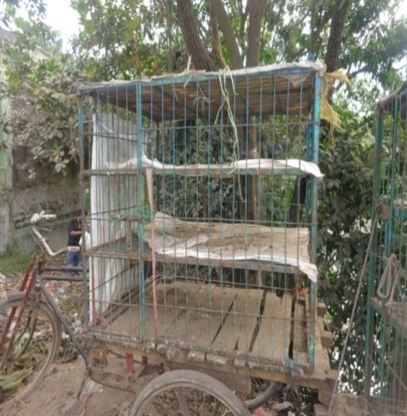
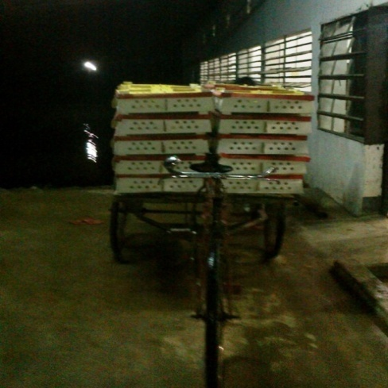
Fig 2: Vehicles used for transportation of broiler;
Fig 1: Day old chick transportation at night
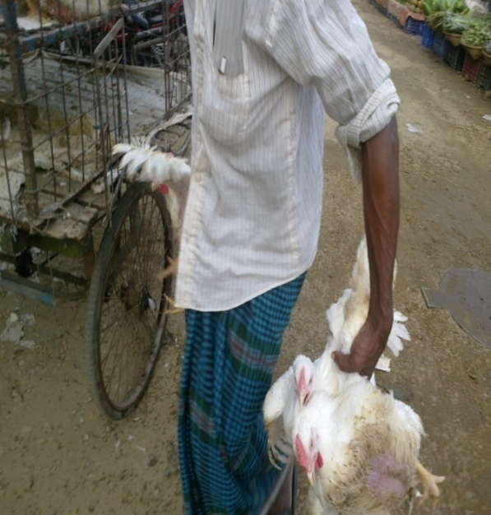

Fig 3: Carrying them in bunches on hand

Fig 3: Carrying them in bunches on hand

During transportation rough handling, overcrowding in sunlight leads to heat stroke and death. When the vehicle arrives at the market, chickens are manually removed from the crates. Then the number of dead bird, injuries like dislocation, fractures, laceration of wing and leg of each van were recorded where injury were markedly visible. On the other hand overcrowding leads to death which mainly depends on the ambient temperature of surroundings.

2.4 Different types of injuries:
Different sort of injuries in the body area were inspected or observed carefully among the chicken. For example, dislocation, laceration of wing and leg were observed. Besides, Body weight loss also observed. The different types of injuries and their complications were examined closely and defined using inspection and palpation methods of examination of animal were used to assess the physical condition of bodily injured chicken.

Dislocation
Dislocation means displacement from their normal position of bones meeting at a joint such that there is complete loss of contact of the joint surfaces which results loss of body weight carrying capacity. In chicken it is mostly found at the knee joint (fig: 4 & 5)
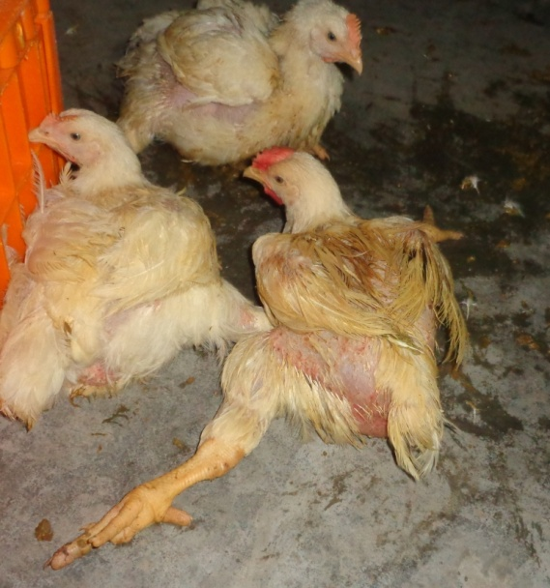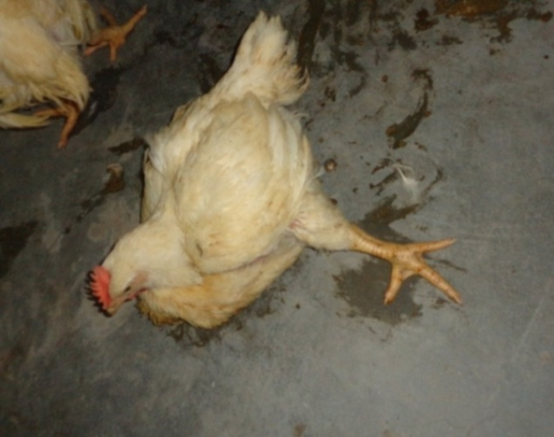
Fig 4: Dislocation of leg

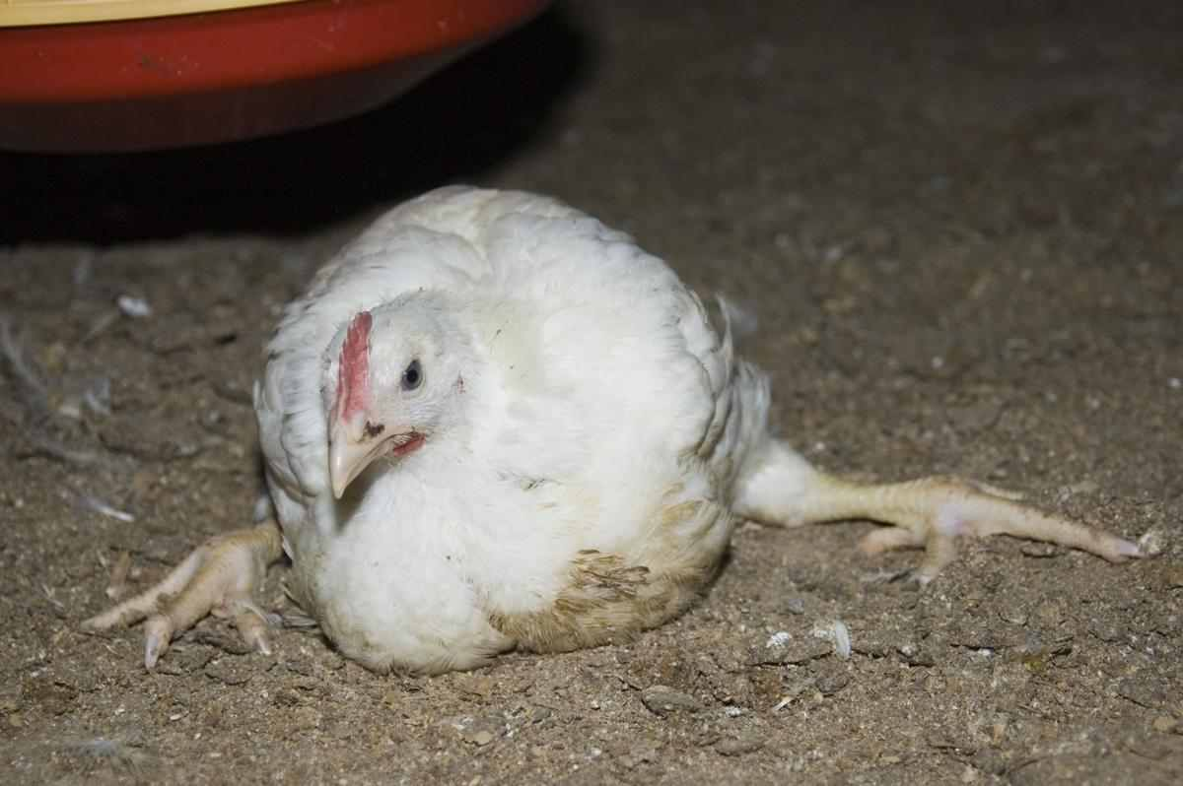
Fig 5: Dislocation of leg

Laceration
Laceration is a type of injury in which skin is torn, cut, or punctured (an open wound), or where blunt force trauma causes a contusion (a closed wound). In pathology, it specifically refers to a sharp injury which damages the dermis layers of the skin. This type of injury is occurred due to presents of sharp object in the crates of van which leads to injury of leg & wing. This laceration also occurred by sharp nails due to overcrowding of chicken (fig: 6)
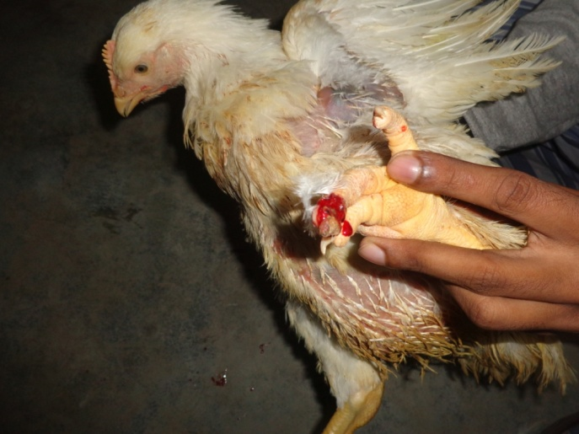
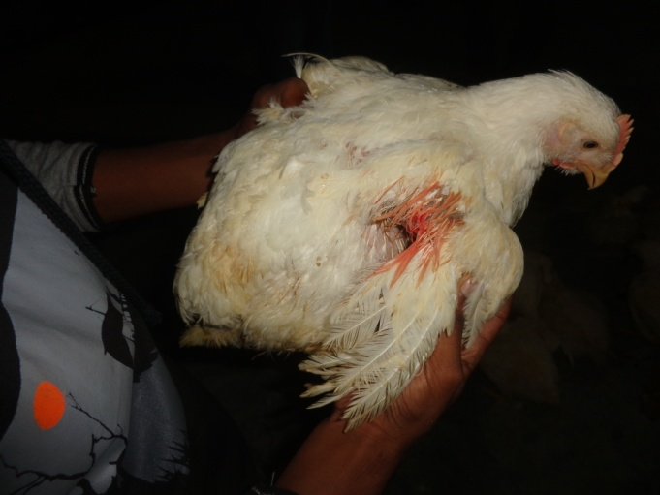
Fig 6: Laceration of leg & wing

Swelling
Swelling is a transient abnormal enlargement of a body part or area not caused by proliferation of cells. This type of enlargement was recorded (fig: 7).
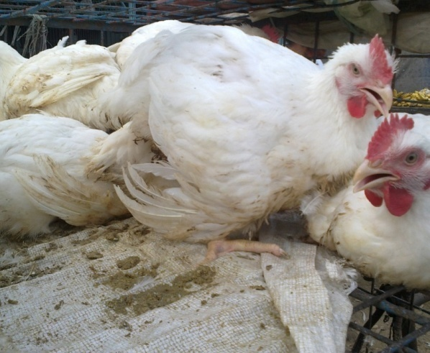
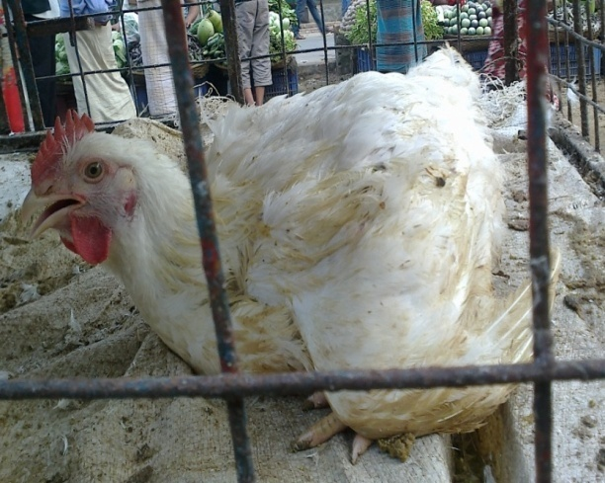

Fig 7: Swelling of wing

Possible cause of injuries
The possible cause of the injuries was recorded either in the rough handling, cage metal friction, sharp objects friction, uneven floor surface, overcrowding during transportation, unstable transport system, were the inflecting factors to cause broiler injury. This list of possible causes were developed and evaluated by observing the animals, asking questions and discussing with the traders and the animal handlers.

Dead on arrival birds
These birds are mainly found after transportation due to heat stress, overcrowding, less ventilation or previously occurrence of disease. This dead on arrival percentage was highest at the summer season if transport at daylight The DOA bird’s percentage was collected by interviewing who was involved during transportation previously (fig: 8)
Fig 8: Transportation of broiler at mid day leads to mortality;

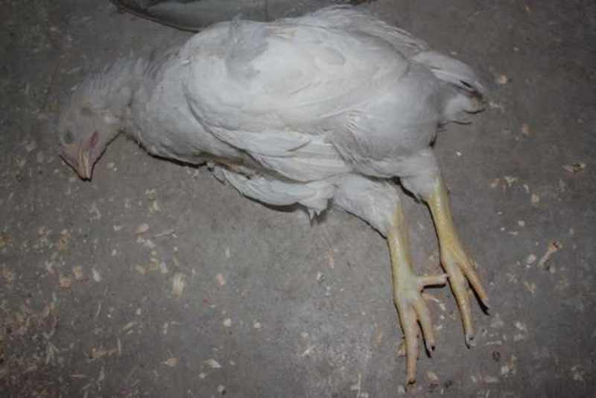
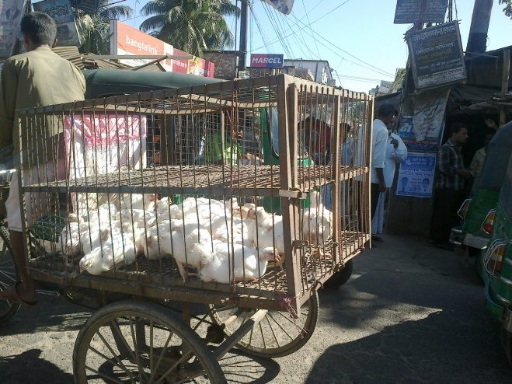

Chapter III
Results & Discussion
The result for mortality, live weight loss, number of injured birds along with transportation distance is presented in Table-1. Factors associated with DOA and injured percentages (dislocation of wing, dislocation of leg, laceration of wing & leg) of broilers per flock were identified. Ambient temperature, holding method, number of broilers in the flock, mean body weight before and after transportation, space allowance in crates, transport time and lairage time and others possible association with the DOA percentage of broilers was also recorded. Season, moment of transport, and ambient temperature associated with the bruises percentage of broilers were also considered.
Table 1: Total no. of injured and dead birds during transportation to the market (n=1795)
Flock | No. of chicken marketing | Transportation distance (Km) | No. of injured birds | No .of DOA
A | 250 | 12 | 88 | 0
 | 350 | 18 | 112 | 1
 | 195 | 15 | 90 | 0
B | 300 | 10 | 98 | 0
 | 350 | 7 | 110 | 1
 | 350 | 12 | 115 | 1
A=1st broiler flock containing 795 chicken; B=2nd broiler flocks containing 1000 chicken;
From the mentioned above table it can be said that when large no. of chicken is marketed the injure percentage also increases in same manner.
However, in these studies, risk factors were only identified and the sizes of their effects were not quantified. Knowledge of the magnitude of effects is necessary to establish the reduction of DOA birds or injured percentage of broilers that could be obtained by removing or reducing these risk factors (Virden et al., 2009).

Relation of injured percentage with journey distance
During transportation injury rate also closely related with the size of the flock that is transported and the distance of market. During transportation when large amount of bird transported for long distance the more number of injured birds also increase. In my study transportation of 350 birds at a distance of 18 km which leads to injury of 16 birds. On the other hand when 195 birds were transported at a distance of 7 km there were leads injury of 2 birds that findings are agreed by the result of Petracci et al., (2005). When transporting of poultry for 4 hours or more vehicles should be equipped with mechanical ventilation systems. But in our country it is still not practiced.

Graph 1: Frequency of injury in relation of journey distance;
From the graph we may compare and got a point that large number of birds when transported for long distance (≥15 km) leads to increase in the injured percentage. For DOA and corrected injured percentages, catching and transporting during day time were found to be risk factor. Moreover, the increased percentage of bruises such as laceration may have resulted from higher activity of broilers during daytime.
Table 2: Type of injuries and total no. of DOA with percentage (n=1795)
Types of injuries | Total injured | Percentage (%)
Dislocation of wing | 260 | 14.5
Dislocation of leg | 220 | 12.3
Laceration of wing | 95 | 5.3
Laceration of leg | 38 | 2.2
DOA | 3 | 0.17

From the above table we see that within the injured birds dislocation of wing percentage was more than the other parameters. This result in concordant with Verecek et al., (2005).
Relation of weight loss with journey distance:
Rough handling, uneven floor of crating and long time transport are known as stressors. Apart from stress caused by these factors, broilers suffer metabolic exhaustion due to feed and water withdrawn for a longer period of time. As a result broilers may lose live weight, glycogen stores may be depleted and hyperthermia can occur during lairage that might likely contribute to weight loss which agreed by Simoes et al., (2009) where they observed decreased body weight in broilers during transport period 30. 90 and 180 min which were 2.11%, 3.03% and 4.82% respectively that is also supported by Karaman et al., (2009) who observed significant reduction in body weight of broiler chicken during transportation.
Birds of lower initial body weight (<2.0 kg) lost 40, 60 and 102 g of body weight on journeys of 1, 2 and 3 hours duration, respectively. For heavier birds (>2.0 kg), the corresponding figures were 90, 130 and 135 gm, respectively. These results are agreement with various reports such as Aral et al., (2014); Ondrasovicova et al., (2008).

Table 3: During transportation loss of mean body weight:
Duration of transport(hr) | Before journey mean body weight(kg) | Loss of mean body weight(gm)
1 | < 2.0 | 40
 | ≥ 2.0 | 90
2 | < 2.0 | 60
 | ≥2.0 | 130
3 | <2.0 | 102
 | ≥2.0 | 135

From the above table we can compare and get point duration of journey and longer feed withdrawal time responsible for loss of body weight.

Graph 2: Relationship between journey time and live weight loss

Relation of temperature with transportation
Both low and high temperatures increase the DOA percentage. In our data collection it was found that transportation during daylight results more DOA than other time of day. A good cause for this increase rate of mortality might be thermal stress agreed by (Petracci et al., 2005).
During a normal summer journey of 3h, with an ambient temperature of 27°C or more temperature cause hyperthermia which is profound and may become life threatening that is similar with Abeyesinghe et al., (2001). So, value of temperature may be a part of the explanation for mortality both at high and low temperatures.
The interaction between ambient temperature and transport time resulted in a greater increase of injury and DOA due to long duration of transportation of poultry by road across various ecological and climatic zones imposed many stressors such as thermal changes, acceleration, motion, vibration, fasting, withdrawal of water, social disruption, noise and internal vehicle thermal microenvironment (Abeyesinghe et al., 2001).
The percentage of DOA and injured birds is more than would have been expected from the separate effects of ambient temperature between 15 and 25°C and transport at time that is agreed by Dadgar et al., (2017) Webster et al., (1992) observed that broilers transported in an open transport vehicle would be thermally comfortable when the having ambient temperature between 18 and 26°C. In our transportation the temperature is maintained within 28- 30°C which is slightly more than recommended range.
The European Food Safety Authority, (2010) recommended that the upper temperature limit in a transport container for broilers should be 24-25°C, assuming a relative humidity of 70% or higher. The lower temperature limit for broilers in containers should be 5°C.

Stocking density during transportation
As a homoeothermic animal bird has ability to cope up with environmental changes that depends on stock density. The stock density is usually determined by total live bird weight and depends on both sex and age of the birds to be transported. An increase of the stocking density of broiler during transportation likely results in an increase of the environmental humidity, due to water evaporation from the respiratory tract, skin, and excreta. Under these circumstances, heat loss will be more difficult, which can lead to hyperthermia that was findings of several researches Petracci et al., (2005). In our experiment revealed that the birds transported at low stocking density exhibited higher live weight loss than those held at the medium or high densities (1.92 vs. 1.70 and 1.61%). This could be due to the fact that a broiler producing heat would lose 0.22% of its body weight per hour. In our country during transportation stocking density is not considered. This leads to increase the injury, temperature & humidity ultimately leads to death. The space allowances recommended for poultry in transport by EU Regulation 1/2005 are as follows:
Table 4: Stocking density during transportation
Weight of broiler | Stocking density during transportation  (cm² / kg) | EU recommended space (cm² / kg)
<1.6 kg | 180-200 | 220-240
1.6 to <2 kg | 160 | 200-226

Relation of dead on arrival of bird with journey time:
In my study birds were found exposed to extreme hot & cold weather, packed tightly into cages without the ability to stand or move comfortably that’s leads suffering, slow death that is supported by Saundercock et al., (2006) who reported that rapidly growing strains of broiler exhibited an increased susceptibility to stressors Vecerek et al., (2006) observed that short journey caused less mortality (0.15 %) compared than long journey (0.86 %). This dead on arrival percentage was mainly highest at summer season due to excessive heat, overcrowding, heat stress. In this experiment there was found 0.167% dead on arrival birds that supported by Warriss et al., (2009) who reported that journey length has long been recognized as an important factor in broiler DOAs.

Chapter IV
Conclusion
There is an intimate association between management and injury during transportation which can be considered to reduce stress in broiler. Management parameters like stocking density in lairage, feed and longer water withdrawal period, increased distance between farm and slaughter area turns to increase the injured percentage. In our study increased ambient temperature showed responsible for mortality of chicken. Injury on leg and wing occurred when more chicken were transported within a small space. Heat stress during summer was reported to increase percentage of DOA. Chicken also experienced a dislocation, laceration, swelling of wing and serious injuries of leg. These findings might contribute to the understanding of the welfare scenario of chicken at selected markets of Bangladesh during transport and these scenarios clearly indicate the potential scope and need for undertaking intensive focus oriented research and development initiative on prevailing animal welfare issues in Bangladesh.

Recommendation and future perspectives:
Greater attention should be paid in handling methods of chicken in Bangladesh during transport. Nutritional manipulations are an easy and cheap way to reduce stress. Most widely applied supplements used in recent days to prevent stress during transport of broiler which are based on amino acid, vitamins and minerals may be added in diet of broiler. Besides, all kinds of management should be done to reduce stress in broiler.

References
Abeyesinghe SM, Wathes CM, Nicol CJ and Randall JM. 2001. The aversion of broiler chickens to concurrent vibrational and thermal stressors. Applied Animal Behaviour Science, 73: 199-215.
Aral S, Walker D. 2014. Tie strength, embeddedness, and social influence: A large-scale networked experiment. Management Science, 60(6): 1352-1370.
Arikan MS, Akin AC, Akcay A, Aral Y, Sariozkan S, Cevrimli MB, Polat M. 2017. Effects of Transportation Distance, Slaughter Age, and Seasonal Factors on Total Losses in Broiler Chickens. Revista Brasileira de Ciência Avícola, 19(3): 421-428.
Aral Y, Aydin E, Demir, P, Akin AC, Cevger Y, Kuyululu ÇYK, Arikan MS. 2013. Consumer preferences and consumption situation of chicken meat in Ankara Province, Turkey. Turkish Journal of Veterinary and Animal Sciences, 37(5): 582-587.
Azman MA, Dalkilic B. 2006.Poultry by-product meal in the diet of broiler chicks. Indian Journal of Poultry science. 83(8): 873- 875.
Bayliss PA, Hinton MH. 1990. Transportation of broilers with special reference to mortality rates. Applied Animal Behaviour Science, 28: 93-118.
Burkholder KM, Thompson KL, Einstein ME, Applegate T J, Patterson JA. 2008. Influence of stressors on normal intestinal microbiota, intestinal morphology, and susceptibility to Salmonella enteritidis colonization in broilers. Poultry Science, 87(9): 1734-1741.
Cockram MS. 2007. Criteria and potential reasons for maximum journey times for farm animals destined for slaughter. Applied Animal Behaviour Science, 106(4): 234- 243.
Dalley S, Baker CJ, Yang X, Kettlewell PJ, Hoxey R. 1996. An investigation of the aerodynamic and ventilation characteristics of poultry transport vehicles: Part 3, Internal flow field calculations. Journal of Agricultural Engineering Research, 65: 115-127.
Dadgar S, Lee ES, Leer TLV, Burlinguette N, Classen HL, Crowe TG, Shand PJ. 2017. Effect of microclimate temperature during transportation of broiler chickens on quality of the pectoralis major muscle. Poultry science, 89(5): 1033-1041.
Elrom K. 2001. Handling and transportation of broilers; welfare, stress, fear and meat quality: Part V: Transport to the slaughterhouse. Part VI: The consequences of handling and transportation of chickens. Israeli Journal of Veterinary Medicine, 56: 1-3.
European Food Safety Authority 2004. The welfare of animals during transport. The European Food Safety Authority Journal, 44: 1-36.
European Food Safety Authority Panel on Animal Health and Welfare (AHAW). 2001. Scientific Opinion concerning the welfare of animals during transport. European Food Safety Authority Journal, 9(1): 73-76.
European Food Safety Authority Panel on Animal Health and Welfare (AHAW), 2010. Scientific Opinion on the influence of genetic parameters on the welfare and the resistance to stress of commercial broilers. European Food Safety Authority Journal, 8(7): 1666.
Fayemi PO, Muchenje V, Yetim H, Abdulatef A. 2016. Targeting the pains of food insecurity and malnutrition among internally displaced persons with nutrient synergy and analgesics in organ meat. Food Research International, 8(3): 123-125.
Gregory NG. 1994. Pre slaughter handling, stunning and slaughter. Meat Science, 36: 45-56.
Hoxey RP, Kettlewell PJ, Meehan AM, Baker CJ, Yang X. 1996. An investigation of the aerodynamic and ventilation characteristics of poultry transport vehicles: part-I, full scale measurements. Journal of Agricultural Engineering Research, 65: 77-83.
Hunter RR, Mitchell MA, Matheu C. 1997. Distribution of 'dead on arrivals' within the bio-load on commercial broiler transporters: correlation with climate conditions and ventilation regimen. British Poultry Science, 38: 7-9.
Hunter RR, Mitchell MA, Carlisle AJ, Quinn, AD, Kettlewell, PJ, Knowles TG, Warriss PD. 1998. Physiological responses of broilers to pre-slaughter lairage: effects of the thermal micro-environment. British Poultry Science, 39: 53-54.
Jayaprakash G, Sathiyabarathi M, Robert MA, Tamilmani T. 2016. Transportation stress in broiler, 5(2):806-809.
Karaman M. 2009. Effect of transport time on body performance of broilers during
transport to slaughter house. Poultry science, 8:1555-1557.
Lengkey HA, Siwi JA, Balia RL. 2013, The effect of various starter dosages on kefir quality, 8(2): 560-565.
Mitchell MA, Kettlewell PJ. 2009. Welfare of poultry during transport–a review. In Poultry Welfare Symposium, 2(1): 90-100.
Mitchell MA, Carlisle AJ, Hunter RR, Kettlewell PJ. 2003. Weight loss in transit: an issue in broiler transportation. Poultry Science, 101(52): 673-678.

Mitchell MA, Kettlewell PJ. 1998. Physiological stress and welfare of broiler chickens in transit. Poultry science, 77(12):1803-1814.
Nijdam E, Arens P, Lambooij E, Decuypere E, Stegeman JA. 2004. Factors influencing bruises and mortality of broilers during catching, transport, and lairage. Poultry Science, 83(9): 1610-1615.
Ondrašovičová O, Saba L, Šmirjáková S, Vargova M, Ondrašovič M, Matta S, Wnuk W. 2008. Effects of vehicle-road transport on blood profile in broiler chickens. Medycyna Weterynaryjna, 64(3): 292-293.
Rahman M. 2003. Growth of poultry industry in Bangladesh: Poverty alleviation and employment opportunity. In: Proceedings of the 3rd International Poultry Show and Seminar, Organized by World’s Poultry Science Association, Bangladesh Branch, Dhaka, Bangladesh, 3(1): 1-7.
Raha SK. 2017. Poultry Industry in Bangladesh: Present status and future potential, 2(3): 545-547.
Petracci M, Bianchi M, Cavani C. 2005. Preslaughter factors affecting mortality, liveweight loss, and carcass quality in broiler chickens. In Proc. XVII Eur. Symp. Qual. Poult. Meat, Doorwerth, The Netherlands, 104-107.
Sandercock. DA, Hunter RR., Mitchell MA. and Hocking PM. 2006. Thermoregulatory capacity and muscle function integrity are compromised in broilers compared with layers at the same age or body weight. British Poulty Science, 47: 322-329.
Simões GS, Oba A, Matsuo T, Rossa A, Shimokomaki M, Ida EI. 2009. Vehicle thermal microclimate evaluation during Brazilian summer broiler transport and the occurrence of PSE (Pale, Soft, Oxidative) meat. Brazilian Archives of Biology and Technology, 52: 195-204.
Virden WS, Kidd MT. 2009. Physiological stress in broilers: Ramifications on nutrient digestibility and responses. Journal of Applied Poultry Research, 18(2): 338-347.
Veerkamp CH. 1986. Good handling gives better yield. Misset International
poultry, 2: 30-33.
Warriss PD. 2009. The effects of live animal handling on carcass and meat quality. Meat science: an introductory text, 6(2): 97-112.

Appendix
Questionnaire

Time of marketing: ………………………………………………………………..

Transported by: ……………………………………………………………………

Cage size: ……………………………………………………………………………

Stocking density: …………………………………………………………………..

No. of chicken transport: …………………………………………………………

Distance from farm to market: …………………………………………………..

Total number of injured birds: ……………………………………………………

Types of injuries: ……………………………………………………………….....

Total number of dead on arrival: ………………………………………………….

Body weight before journey: …………………………………………………….

Body weight after journey:………………………………………………………

Feed and water withdrawal time…………………………………………………

Journey time: ……………………………………………………………………….

Acknowledgement

These are few lines of acknowledgement can never substitute the deep appreciation that I have for all those without whose help, support and inspiration this dissertation would not have taken its present shape.
The author is ever grateful and indebted to the Almighty Allah, the creator and soul authority of universe, who enabled me to complete this work successfully.

The author express his deepest sense of gratitude, sincere appreciation and profound regards to authors reverend teacher, Dr. Mukti Barua, Assistant Professor of the Dept. of Animal Science and Nutrition, Chittagong Veterinary and Animal Sciences University for her scholastics guidance, uncompromising principles, sympathetic supervision, valuable advice, constant inspiration, radical investigation and constructive criticism in all phases of this study and preparing the manuscript

He also acknowledges to the farmer of Chittagong area for their co-operation in collecting the data. The author expresses his sincere gratitude to all teaching and non teaching staff members of dept of Animal science and Nutrition for their support.

Sincere thanks to all of his Friends and well Wishers for their help, encouragement and inspiration during the study period and preparing this report.

The Author

