Chapter 1: Introduction
Antibiotics have been widely used as a feed additive to increase broiler’s performance and control of diseases (Chen et al.,2009). However, increasing concerns regarding overuse of antibiotics and bacterial resistance has encouraged extensive investigation into alternatives for sub-therapeutic antibiotics in feeds. Furthermore, use of probiotics, prebiotics and organic acids replacing antibiotics has increased in present time. Probiotics act by competitive exclusion, lower gut pH, produce bacteriocins, lysozyme and peroxides, and stimulate the immune system (Grashorn, 2010). Addition of probiotics containing live yeast to livestock feed has been shown to improve the nutritive quality of feed and performance of animals (Martin et al., 1989; Glade and Sist, 1998). Probiotics are viable single or mixed cultures of microorganisms that, when given to animals or humans, beneficially affect the host by improving the properties of the normal microflora (Kyriakis et al., 1999; Lee et al., 2008). They have been used as an alternative to antibiotics and their efficiency in animals has been widely discussed (O’Sullivan, 2001; Siriken et al., 2003; Park et al., 2005). Saccharomyces cerevisiae yeast originated from malted grains fermentation also known as ''baker’s yeast'' is one of the important commercialized types of yeast, has long been fed to animals (Rezaeipur et al., 2012) is enriched in biologically important proteins, B-complex vitamins, trace minerals and several unique ‘plus factors’. Other significant beneficial factors involved the enhancement of phosphorus availability (Glade and Biesik, 1986; Brake, 1991; Moore et al., 1994) and nutrient utilization by animals (Thayer et al., 1978; Erdman, 1989 and Pagan,1990), reduction in cases of disease infection (Line et al., 1997) and improvement of feed efficiency (Onifade and Babatunde,1998). Some studies have confirmed the effects of yeast culture in increasing concentrations of commensal microbes or suppressing pathogenic bacteria (Stanley et al., 2004). Mannan-oligosaccharide and 1, 3/1,6 β-glucan are components of the yeast cell wall that have been reported to modulate immunity (Shashidhara and Devegowda, 2003), promote growth of intestinal microflora (Spring et al., 2000), and increase growth (Parks et al. 2001). Feeding of yeast to chicks improves body weight gain and feed/gain ratio (Onifade et al., 1998). Supplementation of broiler feeds with 2.0% yeast improved performance parameters, serum enzyme activities and enhanced the maintenance of electrolyte homeostasis in broiler chickens (Aluwong et al., 2013). On the other hand addition of 1.5% of dietary Saccharomyces cerevisiae could also improve the performance, blood constituents and carcass characteristics of broiler chicks (Paryad and Mahmoudi, 2008).This study was, therefore carried out to investigate the effects of different levels of Saccharomyces cerevisiae (baker’s yeast) on the growth performance and serological indices of broiler chickens.

Chapter 2: Materials and Methods
Experimental layout
A total of 120 (one hundred twenty) day-old Arbor acres strain broiler chicks were randomly allotted into four dietary treatments T₀ (control), T₁ (1% yeast), T₂ (1.5 % yeast) and T₃ (2 % yeast) consisting of 3 replicates (10 birds in each replication).
Ration formulation and management
Iso-caloric and iso-nitrogenous diets were formulated for two phases (starter and finisher). All pens were bedded with rice husk and equipped with feeders and drinkers. Fresh feed and fresh water was supplied adlibitum. The birds were vaccinated against Newcastle Disease (Ranikhet) and Infectious Bursal Disease (Gumboro).
Table 1: The chemical composition of Saccharomyces cerevisiae
Composition
Dry matter % | 93
ME (kcal/kg) | 1990
Crude protein % | 44.4
Crude fat % | 1
Crude fiber % | 2.7
Ca % | 0.12
P % | 1.4

Recording of data
Performance data (feed intake, weight gain and feed conversion ratio) was taken weekly. Dressing percentage and dressed carcass mass were also recorded at 35 days.
Blood and serum collection
Blood was collected from 6 (2 birds from each replicate) birds which were randomly selected. Serum was collected and stored under (-20 ºC) until assayed.
Biochemical profiling of serum
Serum enzymes (aspartate transaminase, AST; Alanine transaminase; ALT), glucose, total protein, triglyceride, calcium, cholesterol and creatinine were determined using standard kits.
Statistical analysis
Data was incorporated in Microsoft excel sheet (2007) and analyzed using one-way ANOVA of SPSS v.16 for windows . A P value of <0.05% was accepted as significant level.

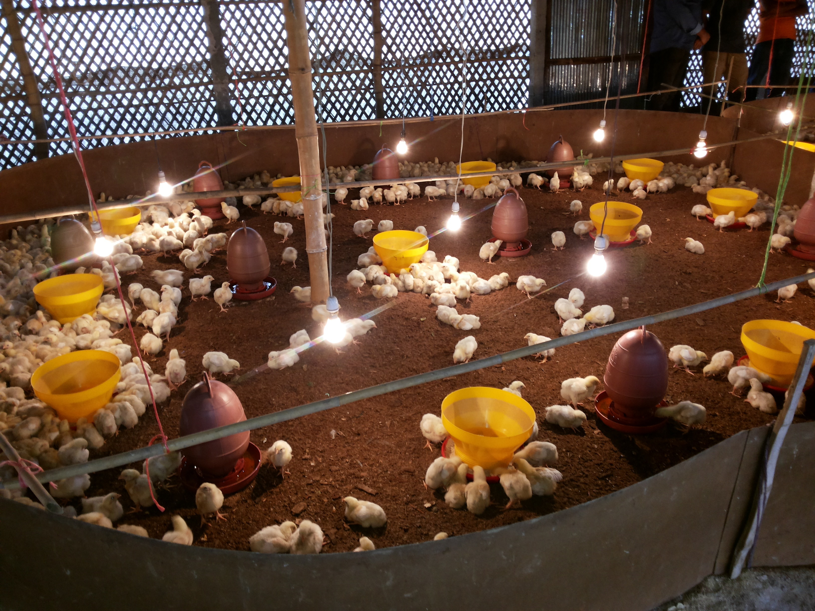
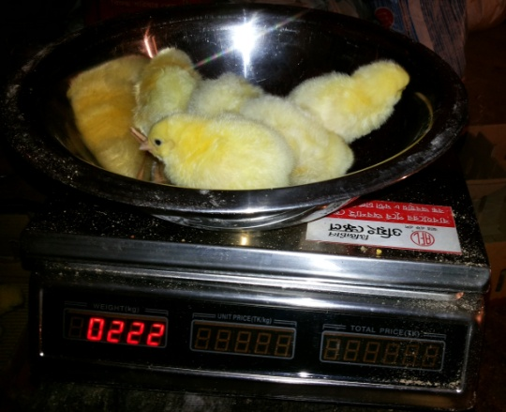

Figure 2: Brooding of chicks.
Figure 1: Weighing of Day old chicks.
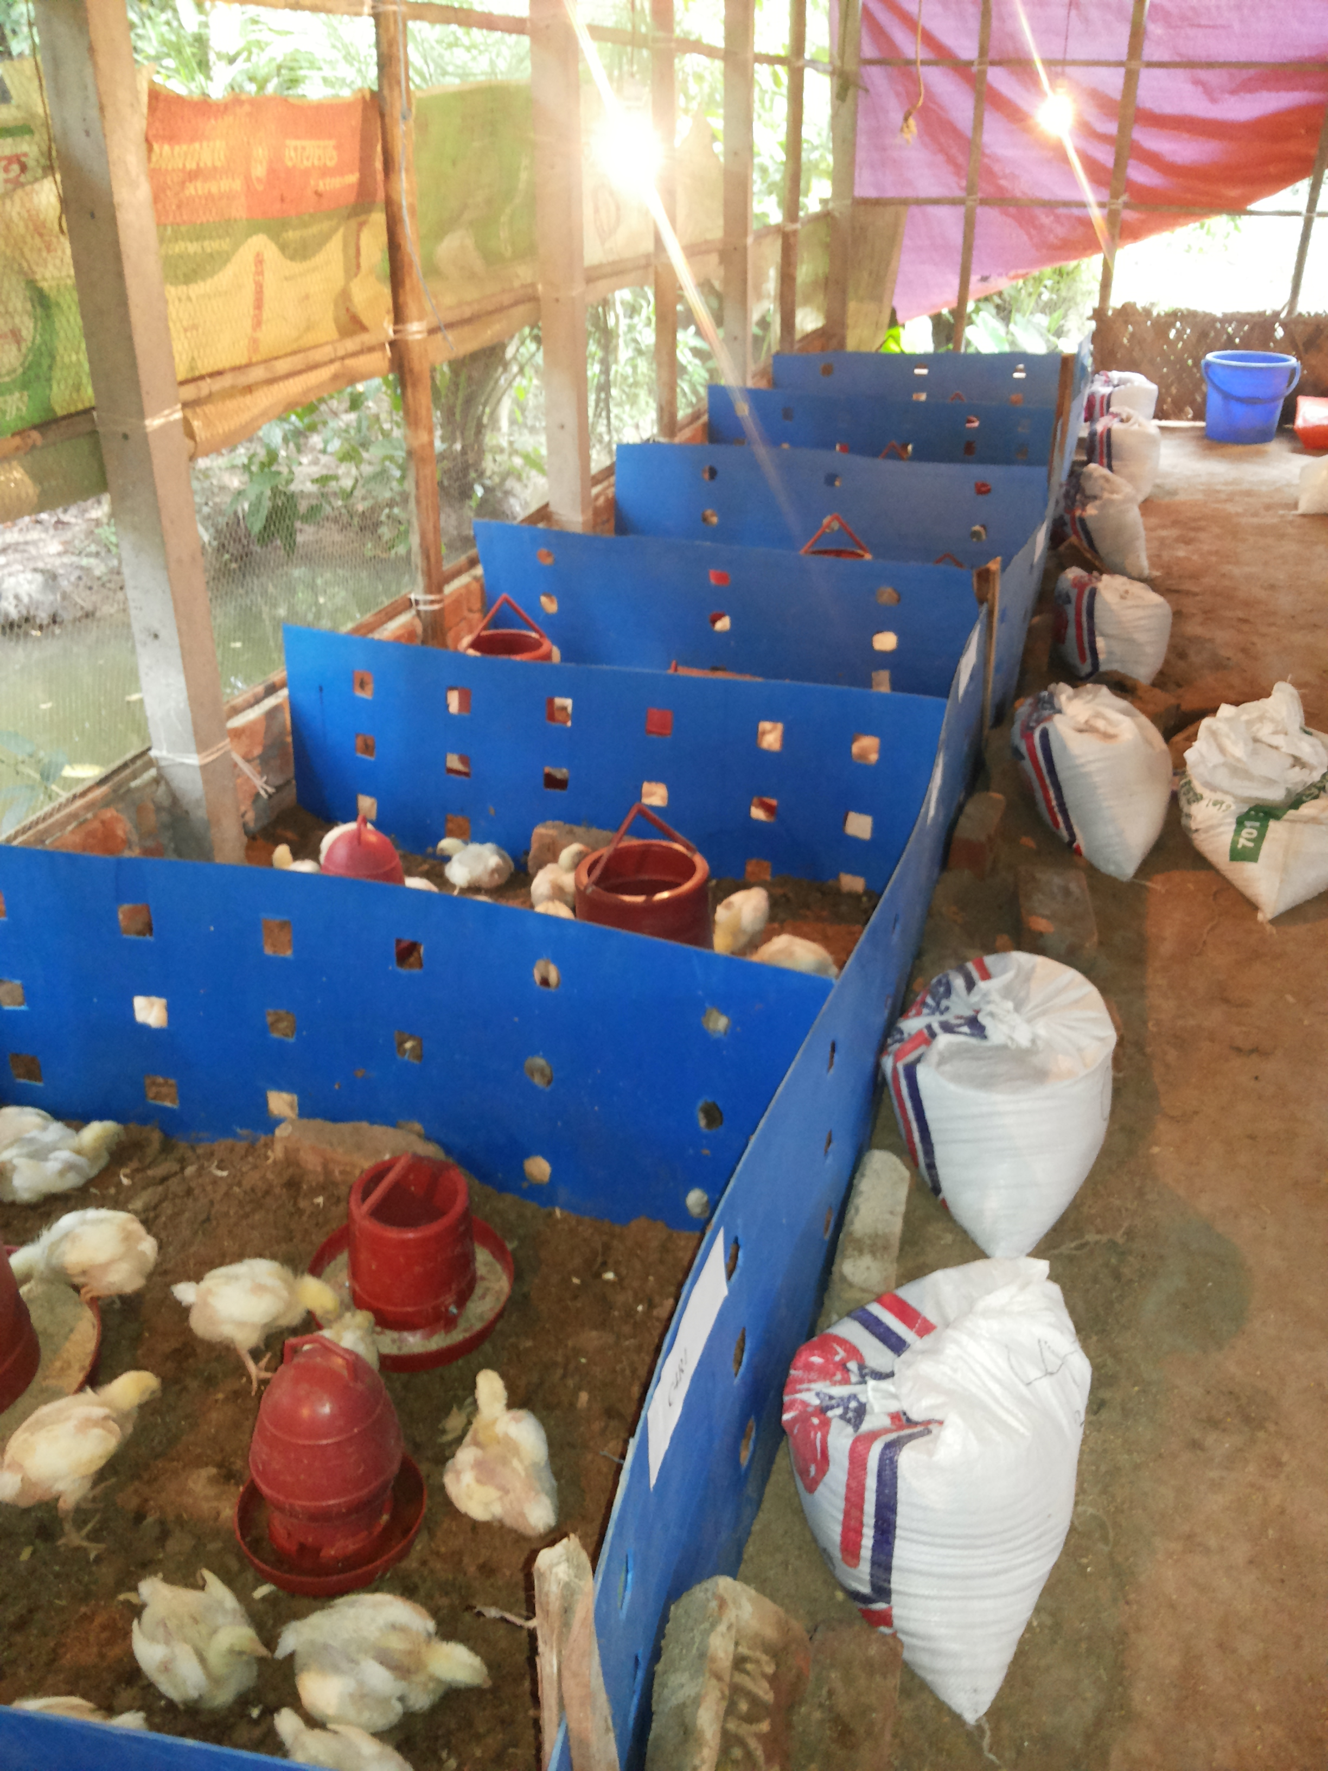
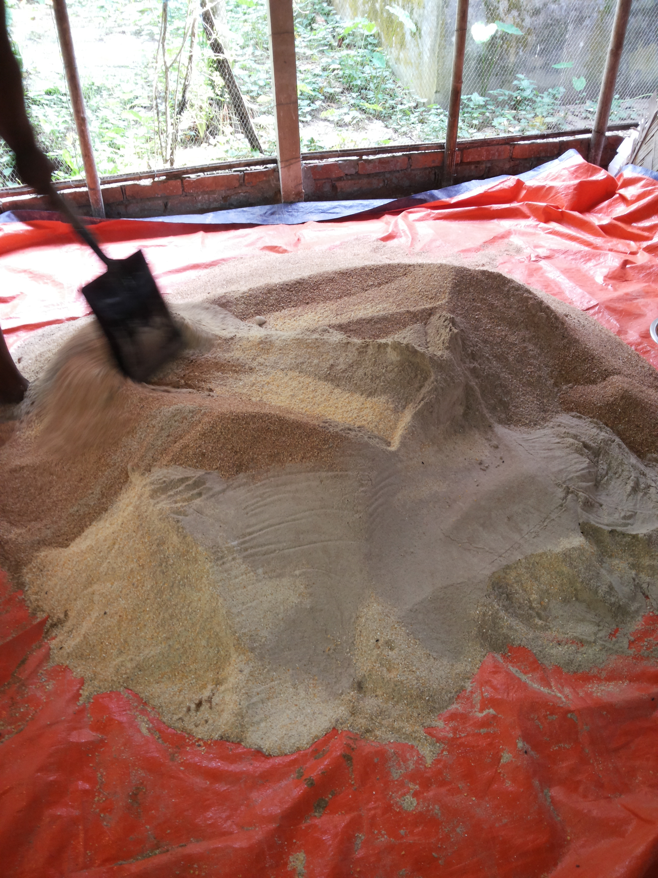

Figure 4: Replication of birds.
Figure 3: Mixing of feed.

Chapter 3: Results
The results showed that use of 2% yeast on had significant effect (P<0.05) on feed intake at first 3 weeks of broiler but not at finishing stage. Feed intake during first 21 days of age was also significantly increased in group fed 2% yeast. However, feed intake was found higher in T₀ group (control) at 5 weeks of age, which was not significant. Significant differences were also observed in the values of the weight gain of the broiler on the different dietary treatments at first 3 weeks period. However, 1% yeast created meaningful differences in body weight gain (P<0.05) at 2 and 3 weeks of rearing. Highest body weight gain was found in T₃ (2% yeast) group at finishing stage (4 and 5 weeks) which was not significant. Effect of three treatments on feed conversion ratio (FCR) of broilers significantly (P<0.05) differed at finishing stage. A significant improve FCR (1.58) was obtained in T₃ group fed 2% yeast at finishing stage. Use of 2% yeast had significant effect (P<0.05) on dressing percentage at finisher stage of broiler. Dressing percentage was significantly increased in the group of birds fed 2% yeast. Mortality rate was not varied significantly (P>0.05) between treatments but lower mortality rate was found in T₃ group.

Table 2: Feed intake (FI), body weight gain (BWG), feed conversion ratio (FCR), mortality, and dressing percentage of broiler fed diets formulated with yeast from 1st to 35th days
Parameters | Age  (Day) | Dietary Treatments (Mean ± SE) |  |  | P value
 |  | T₁ | T₂ | T₃
Feed intake (gm/day) | 1-7 | 161.67± 0.88^{b} | 150.50 ± 1.32ª | 221.23 ± 0.91^{d} | 0.00
 | 8-14 | 372.30 ± 0.91^{c} | 354.93 ± 1.33^{b} | 396.50 ± 1.32^{d} | 0.00
 | 15-21 | 629.37 ± 0.26^{b} | 553.90 ± 0.64ª | 652.00 ± 7.57^{c} | 0.00
 | 22-28 | 1059.3 ± 51.09 | 1031.0 ± 17.06 | 1031.0 ± 45.54 | 0.66
 | 29-35 | 1509.0 ± 46.77 | 1567.0 ± 48.75 | 1506.7 ± 53.72 | 0.22
Body weight gain  (gm / day) | 1-7 | 89.83± 0.15^{b} | 87.20 ± 0.10ª | 94.40 ± 0.25^{c} | 0.00
 | 8-14 | 248.37 ± 1.13^{d} | 209.80 ± 0.82ª | 233.93 ± 0.64^{c} | 0.00
 | 15-21 | 457.40 ± 0.46^{c} | 438.83 ± 0.84ª | 451.93 ± 0.97^{b} | 0.00
 | 22-28 | 685.77 ± 0.73^{ab} | 695.60 ± 20.29^{ab} | 733.17 ± 39.88^{b} | 0.07
 | 29-35 | 934.87 ± 40.15 | 927.67 ± 24.81 | 953.90 ± 37.49 | 0.82
FCR  (Feed: Gain) | 1-7 | 1.80 ± 0.01^{b} | 1.72 ± 0.02ª | 2.35 ± 0.003^{d} | 0.00
 | 8-14 | 1.50 ± 0.006ª | 1.69 ± 0.01^{c} | 1.69 ± 0.008^{c} | 0.00
 | 15-21 | 1.37 ± 0.003^{b} | 1.26 ± 0.003ª | 1.44 ± 0.02^{c} | 0.00
 | 22-28 | 1.55 ± 0.08 | 1.48 ± 0.04 | 1.41 ± 0.10 | 0.56
 | 29-35 | 1.62 ± 0.05ª | 1.69 ± 0.01^{ab} | 1.58 ± 0.05ª | 0.03
Dressing Percentage | 35 | 63.17 ± 0.44ª | 65.67 ± 0.44^{b} | 66.67 ± 0.88^{b} | 0.03
Mortality | 35 | 8.33 ± 1.67^{ab} | 3.33 ± 1.67^{ab} | 1.67 ± 1.67ª | 0.06

[Data represent means± SE of 10 birds per replicate group from day1 to 35 days; ^{a,b,c}Means bearing different superscripts within a row differ significantly at P<0.05, P<0.01, and P<0.001].

Effect of yeast on serum biochemical parameters of broiler
The results of biochemical parameters as a further measure of the response of chickens to different dietary treatments are presented in Table 3. Serum concentrations of glucose, total protein, cholesterol, creatinine, triglyceride, calcium, AST and ALT were not significantly affected by the treatments. Serum glucose (289.77mg/dl) and protein (4.77 gm/L) were found higher in T₃ groups compared to other dietary groups. At 35th day’s cholesterol (97.40 mg/dl), creatinine (0.37 mg/dl) and triglyceride (92.43 mg/dl) in serum were found lower in T₄ groups in comparison with other groups. There was an increase level of serum calcium (8.43 mg/dl) found in T₂ group (1.5 % yeast) that is not significant (P<0.05). In this study, no significant differences (P> 0.05) were observed between control group and yeast supplemented groups in the activity of AST and ALT.
Table 3: Effect of yeast on serum biochemical parameters of broiler
Parameters | Dietary Treatments (Mean ± SE) |  |  |  | P value
 | T₀  (Control) | T₁ | T₂ | T₃
Glucose (mg/dl) | 263.60 ± 3.95 | 230.60 ± 1.93 | 250.43 ± 6.28 | 289.77 ± 34.75 | 0.20
Total Protein (gm/L) | 4.63 ± 0.24 | 4.46 ± 0.43 | 4.49 ± 0.21 | 4.77 ± 0.09 | 0.84
Cholestrol (mg/dl) | 105.97 ± 1.54 | 112.17 ± 17.17 | 109.27 ± 6.31 | 97.40 ± 6.27 | 0.57
Creatinine (mg/dl) | 0.43 ± 0.03 | 0.43 ± 0.03 | 0.40 ± 0.00 | 0.37 ± 0.03 | 0.36
Triglyceride (mg/dl) | 112.90 ± 25.38 | 101.30 ± 5.55 | 119.83 ± 37.05 | 92.43 ± 7.73 | 0.84
Calcium (mg/dl) | 7.61 ± 0.13^{ab} | 7.83 ± 0.10^{ab} | 8.43 ± 0.82^{b} | 6.48 ± 0.42ª | 0.09
AST (mmol/dl) | 227.07 ± 7.74ª | 227.10± 3.78ª | 236.87± 5.61^{ab} | 249.37± 5.27^{b} | 0.08
ALT (mmol/dl) | 3.93 ± 0.09 | 10.70 ± 3.57 | 6.90 ± 2.01 | 7.80 ± 3.70 | 0.43

[Data represent means± SE of 10 birds per replicate group from day1 to 35 days; ^{a,b,c}Means bearing different superscripts within a row differ significantly at P<0.05, P<0.01, and P<0.001]
Chapter 4: Discussion
Growth performance of broiler chickens fed on different proportion of yeast
The results showed that feed intake were significantly (P<0.05) differ between dietary treatment at 1 to 3 weeks of broiler but not at finishing stage. Feed intake at first 3 weeks of age were significantly increased in T₃ (2% yeast). This is similar to the findings of Aluwong et al. (2013) and Nath et al. (2016), but contradicted to the findings of Al-Monsour et al. (2011) who reported that yeast level did not significantly affect feed intake during the first three weeks of life. However, feed intake was found higher in T₀ group (control) at 5 weeks of age which was not significant. This is in accordance with the findings of Nath et al. (2016) and Adebiyi et al. (2012) but contradictory with the findings of Saied et al. (2011) and Paryad and Mahmoudi (2008).
Al-Mansour et al. (2011) reported that yeast levels did not significantly affect body weight gain at first three weeks of life. However, 1% yeast created a meaningful differences in body weight gain (P<0.05) at 2 and 3 weeks of rearing that is similar to the results of Shareef and Al-Dabbagh (2009). Highest body weight gain was found in T₃ (2% yeast) group at finishing stage (4 and 5 weeks). This is in agreement with the findings of Aluwong et al. (2013) who reported that body weight gain was increased by the addition of 2% yeast which was statistically different between groups over the experimental period.
The result of the present study is in agreement with the finding of Aluwong et al. (2013), who reported a significant improvement in feed conversion ratio in yeast supplemented broilers, but with inconsistent results. Improvement in feed conversion ratio might be due to efficient ileal digestibility of nutrients (Sahane 2001 and Pelicia et al. 2004).
The present results suggested that the inclusion of different levels Saccharomyces cerevisiae in broiler chick’s ration affect significantly dressing percentage. The present findings were in agreement with previous findings (Nath et al., 2016; Paryad and Mahmoudi, 2008; Zhang, 2006; Kannan et al., 2005).
Dressing percentage was significantly increased in dietary treatment 3 where yeast was added at a rate of 2% when compared to other treatment groups. Mortality rate were not varied significantly between treatments but lower mortality rate was found in dietary treatment 3. Shareef and Al-Dabbagh (2009) found zero mortality in broilers fed different levels of yeast.
Serum biochemical profiles of broiler
Concentrations of glucose, total protein, cholesterol, creatinine, triglyceride, calcium, AST and ALT in serum of broilers were not significantly affected by the treatments. Serum glucose level were found higher at 35th days in dietary treatment 3 compare to control which in agreement with the findings of Aluwong et al. (2012). In another study, Paryad and Mahmoudi (2008) found that addition of 1.5% yeast had significantly increase plasma total protein, albumin, globulin, HDL, total WBC, and lower heterophil to lymphocyte ratio, plasma cholesterol and triglycerides in broilers. At present study, we found no adverse effect on health status of broiler due to use yeast in ration. In present study, yeast supplementation have no significant effect (P>0.05) total proteins in serum of broiler chickens which in agreement with the findings of Aluwong et al. (2012). Shareef and Al-Dabbagh (2009) also found that addition of yeast (Saccharomyces cerevisiae) at a rate of 1.5, 2 and 2.5 was responsible for a significant (P<0.05) increase of total serum protein and glucose levels. An insignificant decrease of serum cholesterol, triglyceride and creatinine were found in diet 3 compare to other diet. This finding is in accordance with the findings of Shareef and Al-Dabbagh (2009) and Aluwong et al. (2012) who stated that yeast supplementation has been responsible for the reduction of serum cholesterol and triglyceride level.
In present study, no significant differences (P> 0.05) were observed between control and yeast supplemented groups in the activity of AST and ALT which is in accordance with the findings of Panda et al. (2000). In another study, Osman et al. (2007) showed that addition of L. plantarum and B. infantisto diets fed to rats decreased ALT activity. The differences in the enzymatic activity may be due to animal species and probiotic interventions. Any abnormal increase in serum levels of AST and ALT may imply liver damage (Yalcin et al., 2012); therefore, the relatively stable levels of AST may be associated with hepato-protective effects of the yeast probiotic.

Limitations
- The distance of farm from CVASU was long. So, continuous monitoring was not possible during rearing period.
- Number of birds were small for sampling.

Conclusion
Supplementing broiler feeds with baker’s yeast improved performance indices of broiler chickens and serum biochemical profiles. So, farmers can easily use yeast in broiler ration as a growth promoter instead of antibiotics. Further investigation is required to determine the optimum dose for yeast in order to enhance production efficiency in broiler chickens.

References
Adebiyi OA, Makanjuola BA, Bankole TO, Adeyori AS (2012). Yeast Culture (Saccharomyces cerevisae) Supplementation: Effect on the Performance and Gut Morphology of Broiler Birds. Global Journal of Science Frontier Research Biological Sciences, 12 (6): 32-36.
Al-Mansour S, Al-khalf A, Al-Homidan, Fathi MM (2011). Feed efficiency and blood hematology of broiler chicks given a diet supplemented with yeast culture. International Journal of Poultry Science, 10 (8): 603-607.
Aluwong T, Raji MA, Hassan BF, Kawu MU, Dzenda T, Ayo JO (2013). Effect of Different Levels of Supplemental Yeast on Performance Indices and Serum Biochemistry of Broiler Chickens. The Open Conference Proccedings Journal, (Suppl 1-M7): 41-45.
Brake J (1991). Lack of effect of all live yeast culture on broiler, breeders and progeny performance. Poultry Science, 70: 1037-1039.
Chen KL, Kho WL, You SH, Yeh RH, Tang SW, Hsieh CW (2009). Effects of Bacillus subtilis var. natto and Saccharomyces cerevisiae mixed fermented feed on the enhanced growth performance of broilers. Poultry Science, 88: 309-315.
Erdman JW (1989). Phytic acid interactions with divalent cations in Foods and Gastrointestinal tract. In: Dintizisand F.R., Laszlo J. A. (Eds.):Mineral Absorption in Monogastric Gastrointestinal Tract. Plenum Press, New York, NY.pp: 161-170.
Glade MJ, Biesik LM (1986). Enhanced nitrogen retention in yearling horses supplemented with yeast culture. Journal of Animal Science, 62: 1635.
Glade MJ, Sist MO (1998). Dietary yeast culture supplementation enhances urea recycling in equine large intestine. Nutrition Reproduction Interaction, 37: 11-17.
Grashorn MA (2010). Use of phytobiotics in broiler nutrition:an alternative to feed antibiotics. Journal of Animal and Feed Sciences, 19: 338-347.

Kannan M, Karunakaran R, Balakrishnan V, Prabhakar TG (2005). Influence of Prebiotics Supplementation on Lipid Profile of Broilers. International Journal of Poultry Science, 4 (12): 994-997.
Kyriakis SC, Tsiloyiannis VK, Vlemmas J, Sarris K, Tsinas AC, Alexopoulos C, Janseqers L (1999). The effect of probiotic LSP 122 on the control of post-weaning diarrhoeas syndrome of piglets. Research in Veterinary Science, 67: 223-228.
Martin SA, Nisbet BJ, Dean RG (1989). Influence of a commercial yeast supplement on the in vitro ruminal fermentation. Nutrition Reproduction Interaction, 40: 395-403.
Moore BE, Newman KE, Spring P, Chandler FE (1994). The effect of yeast culture (Yea Sace 1026) in microbial populations’ digestion in the cecum and colon of the equine. Journal of Animal Science, 72: 1.
Nath BK, Hossain MA, Bari MS, Barua M, Islam K, Chanda GC (2016). Growth performance and Serum biochemical responses of commercial broilers fed diets containing Rubber seed and Yeast. Asian Journal of Poultry Science, 10: 96-103.
Osman N, Adawi D, Ahme S, Jeppsson B, Molin C (2007). Endotoxin and D-galactosamine-induced liver injury improved by the administration of Lactobacillus, Bifidobactrerium and blueberry. Digestive and Liver Disease, 39: 849-856.
O’Sullivan GC (2011). Probiotics. British Journal of Surgery, 88: 161-162.
Onifade AA, Babatunde GM, Afonja SA, Ademola SG, Adesina EA (1998). The effect of a yeast culture addition to a low-protein diet on the performance and carcass characteristics of broiler chickens. Poultry Science, 77 (Suppl. 1): 44 (Abstract).
Onifade AA, Odunsi AA, Babatunde GM, Olorede BR, Muma E (1999). Comparison of the supplemental effects of Saccharomyces cerevisiae and antibiotics in low-protein and high-fiber diets fed to broiler chicken. Archives of Animal Nutrition, 52: 29–39.
Pagan JD (1990). Effect of yeast culture supplementation on nutrient digestibility in mature horses. Journal of Animal Science, 68:1.
Panda AK, Reddy MR, Ramarao SV, Raju MVLN, Praharaj NK (2000). Growth, carcass characteristics, immunocompetence and response to Escherichia coli of broilers fed diets with various levels of probiotic. Archiv Fur Geflugelkonde, 64: 152-156.
Paryad A, Mahmoudi M (2008). Effect of different levels of supplemental yeast (Saccharomyces cerevisiae) on performance, blood constituents and carcass characteristics of broiler chicks. African Journal of Agricultural Research, 3 (12): 835-842.
Pelicia K, Mendes AA, Saldanha ES, Piazzolante C,Takahanshi S (2004). Probiotic and probiotic utilization in diets for free range broiler chickens. Brazillian Journal of Poultry Science, 92: 99-104.
Rezaeipour V, Fononi H, Irani M (2012). Effects of dietary L-threonine and Saccharomyces cerevisiae on performance, intestinal morphology and immune response of broiler chickens. South African Journal of Animal Science, 42: 266-273.
Sahane MS (2001). Mannan-oligosaccharides in poultry nutrition, Mechanism and benefits, Proceedings of Altech’s 17th Annual symposium. Lyons T.P., Jacques K.A. (Eds.), Nottingham University Press, 65-77.
Shareef AM, Al-Dabbagh ASA (2009). Effect of probiotic (Saccharomyces cerevisiae) on performance of broiler chicks. Journal of Iraq Veterinary Sciences, 23(1): 23-29.
Shashidhara RG, Devegowda G (2003). Effect of dietary mannan-oligosaccharide on broiler breeder production traits and immunity. Poultry Science, 82: 1319–1325.
Siriken B, Bayran I, Onol AG (2003). Effects of probiotics: alone and in a mixture of Biosac plus Zinc Bacitracin on the caecal microflora of Japanese quail. Research in Veterinary Science, 75: 9-14.
Spring P, Wenk C, Dawson KA, Newman KE (2000). The effects of dietary mannan-oligosaccharides on cecal parameters and the concentrations of enteric bacteria in the ceca of Salmonella challenged broiler chicks. Poultry science, 79: 205–211.

Stanley VG, Gray C, Daley M, Krueger WF, Sefton AE (2004).An alternative to antibiotic-based drugs in feed for enhancing performance of broilers grown on Eimeria spp. infected litter. Poultry Science, 83:39–44.
Thayer RH, Burkitt RF, Morrison RD, Murray EE (1978). Efficiency of utilization of dietary phosphorus by caged turkey breeder hens fed rations supplemented with live yeast culture. Oklahoma Agricultural Experiment Station, Stillwater. Res, MP-103, 173-181.
Yalcin S, Uzunoglu K, Duyum HM, Eltan O (2012). Effects of dietary yeast autolysate (Saccharomyces cerevisiae) and black cumin seed (Nigella sativa L.) on performance, egg traits, some blood characteristics and antibody production of laying hens. Livestock Science, 145:13-20.

Acknowledgement
All the praises are due to the Almighty Allah. The creator and supreme authority of the universe that made the author enable to complete this production report.
The author would like to express her deep sense of gratitude to Professor Mohammad Abdul Halim, Dean, Faculty Of Veterinary Medicine (FVM) , Chittagong Veterinary and Animal Sciences University (CVASU).
The author expresses her sincere gratitude, heartfelt respect and immense indebtedness to her supervisor Dr. Babu Kanti Nath, Assistant Professor, Dept. of Dairy and Poultry Science, FVM, CVASU.
Finally, by no means least, the author is really very much greatful to all her teachers, friends and her parents who have inspired her in various ways.

Brief Biography
I am Fatiha Emnoor Eima, daughter of Farid Ahmed Khan and Shamima Farid Lucky. I have completed my Secondary School Certificate (SSC) examination from Mohora S.K.Q Girls High school (2008), Chittagong and then Higher Secondary Certificate (HSC) examination from Chittagong Govt. Women’s College (2010), Chittagong. Then I got admitted in Doctor of Veterinary Medicine (DVM) course under CVASU. I have interest to work with Institute of Epidemiology, Disease Control and Research (IEDCR) in Bangladesh.

