CHAPTER-I
GENERAL INTRODUCTION
Broiler is an important part of commercial poultry sector. The modern meat chicken is a fast growing, highly efficient and can rapidly fulfill the shortage of protein requirement of the country, as it can be produced within a very short time compared to other meat producing animals. Broiler production provides employment and regular income within the shortest time possible due to its fastest body growth and shorter production cycle and low initial investment. Broiler chickens can play an important role to reduce the shortage of huge protein requirement in the country. Broiler meat is considered as a major source of high quality animal protein, required for body growth and mental development of an individual.
At present, broiler farming is being popular both in urban and rural areas. It has encouraged the people of different sections such as small farmers, landless laborers and educated unemployed as well as for industrialists to establish broiler farms on small & large scale. The growth performance of broiler bird might simply be a function of increased feed intake. Feed consumption followed similar trend to that of weight gain. According to Asghar et al, (2000) and Zahid-Ud-Din et al, (2001), low cost of production and higher returns are the key factors for higher profit in broiler farming. Many people are now being encouraged in this enterprise, as maximum return can be achieved shortly by investing minimum capital in broiler production (Sarker et al., 2001).
Now-a-days, broiler industry has brought about revolutionary changes and extended tremendously during the last couple of decades across the globe. The body weight gain of the broiler strains has been markedly increased and the feed utilization has been strongly improved with the advancement of new technology applied in poultry nutrition as well as in genetics development. This progress in breeding and nutrition has resulted in broiler strains having higher performances today than ever before (Bogdangnov, 1990).
The major concept of the broiler industry is to increase the productivity of the broiler carcass to gain higher profit with low investment. The genetic contribution of the broiler chicken as well as non-genetic factors such as age of slaughter, sex, nutrition and management practices are equally responsible to boost the birds performances (Hossain et al., 2011; Kurcubic et al., 2006; Nikolova & Pavlovski, 2009; Marcato et al., 1920; Shahin and Abdelazeem, 2005); Shahin & Elazeem, 2005; Traits et al., 2012). Considering this view, the present study was undertaken to find out the suitable strain and the performances of broiler chickens which give the higher meat yield and better profit under commercial farming condition.
CHAPTER-II
MATERIALS AND METHODS
The present study was undertaken to investigate the rearing management practices of broiler farm at Hathazari Upazilla, Chittagong, Bangladesh.
2.1 Study area and objectives:
The study was conducted at the different commercial broiler farms of Hathazari Upazilla, Chittagong. The study area was selected as part of my internship program to complete internship production report. The necessary data of the farms were taken when I was under internship placement at Hathazari Upazilla from 1st March 2017 to 6th April 2017. During this period, I surveyed the farms and collected data with a questionnaire by observing the farm activities directly from the ten commercial broiler farms available in the areas.
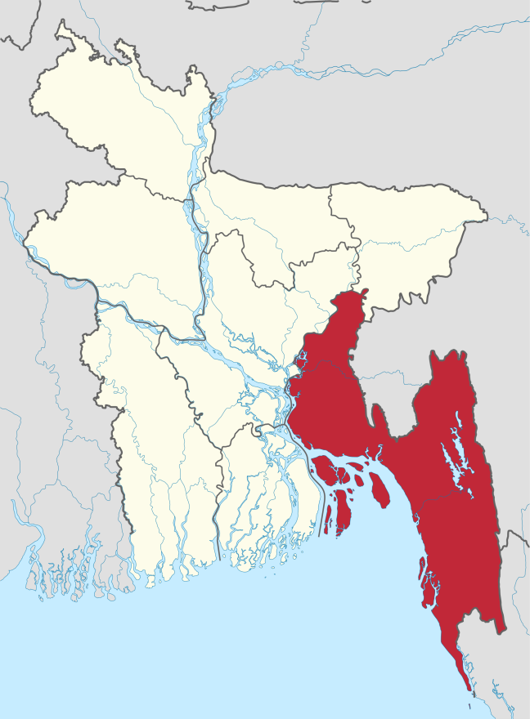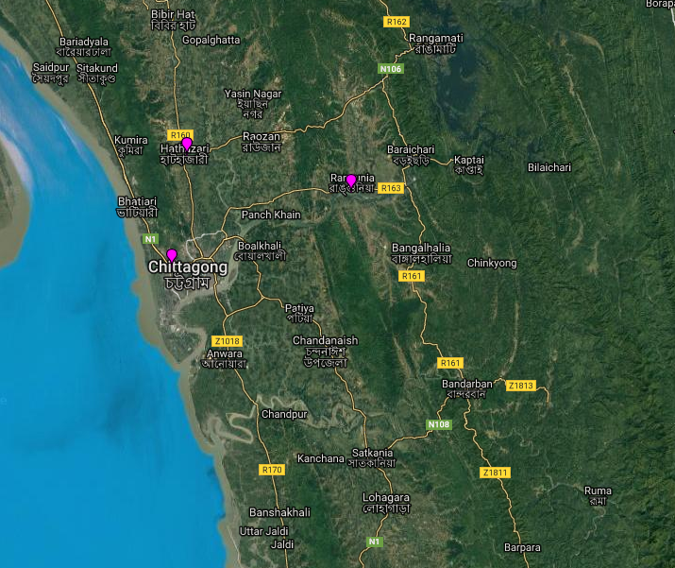
Fig 1: Geographical location of study area

2.2 Farm selection:
Ten commercial broiler farms of the study areas were selected randomlyfor this study. The farm was consists of five Cobb 500 strains and five Lohmann broiler strains. The name of broiler farms, location, broiler strain and number of broiler rearing in the farms are shown below in Table 1.

Table 1: Names of commercial broiler farms and its location
Farms no. | Name of the farms | Name of strains | No. of broilers reared | Location
F1 | Janoprio Poultry Farm | Cobb 500 | 900 | Hathazari, Ctg
F2 | Bhai Bhai Poultry Farm | Cobb 500 | 1200 | Hathazari, Ctg
F3 | Rubel Poultry Farm | Cobb 500 | 1000 | Hathazari, Ctg
F4 | Khaza Poultry Farm | Cobb 500 | 3500 | Hathazari, Ctg
F5 | Jesan Poultry Farm | Cobb 500 | 1400 | Hathazari, Ctg
F6 | Bismillah Poultry Farm | Lohmann | 500 | Hathazari, Ctg
F7 | Rahmania Poultry Farm | Lohmann | 2000 | Hathazari, Ctg
F8 | Md.Jaker Poultry Farm, | Lohmann | 1000 | Hathazari, Ctg
F9 | Mohammadia Poultry Farm | Lohmann | 1000 | Hathazari, Ctg
F10 | M/S Harun Poultry Farm. | Lohmann | 3000 | Hathazari, Ctg

2.3 Data collection:
A questionnaire (shown in the Appendix) was developed to collect data from the selected farms. The collected data were shown in Table 2.

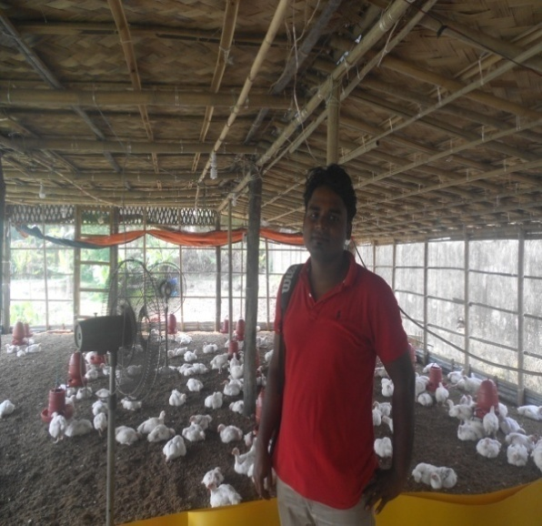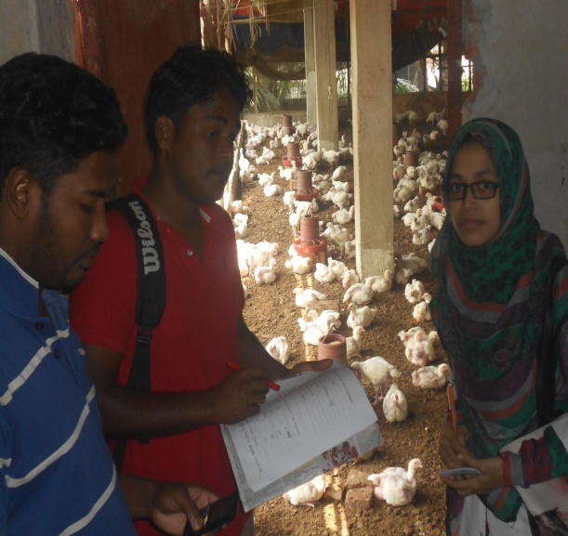
Fig 2: Observation of Management Fig 3: Collection of data

2.4 Source of day-old chick (DOC) collection:
The farmers collected DOC from the different local breeder hatchery to execute their poultry farming business. These were CP Breeders Co. Ltd, Aman Breeders Co. Ltd, Gesan Breeders Co. Ltd, Kazi Breeders Co. Ltd, M. M. Agha Breeders Co. Ltd etc., are the main source of DOC. All the farm size ranges from 600 sq.ft to 4000 sq.ft. The price of DOC very often varies ranging from 16Tk (minimum) to 75Tk (maximum), as reported by the farm owners.

2.5 Housing, feeding, watering and brooding management of the chicks:
The chicks were reared in the floor system at the open sided housing condition from day-old to marketing age. The chicks were brooded 3 to 7 days with chick guard and hoover equipped with electric bulb. The floor space per bird was given

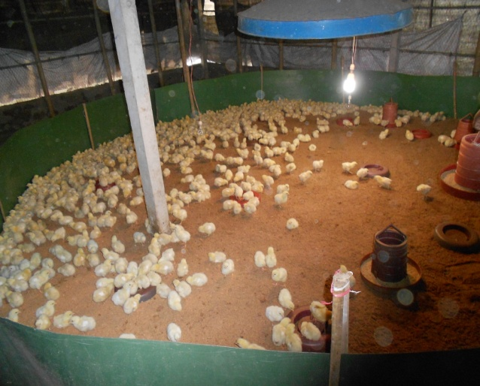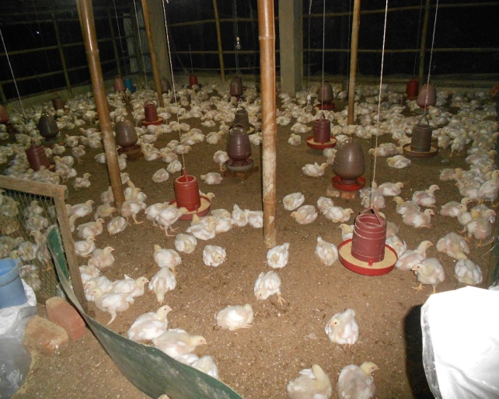
Fig 4: Brooding of DOC Fig: Feeding and Watering system

1 to 1.25 square feet. Birds were fed readymade broiler diet ad libitum collected from the different local feed companies (A1 Feed Co. Ltd, Aman Feed Co. Ltd, Paragon Feed Co. Ltd, Nourish Feed Co. Ltd). Fresh, clean drinking water was provided the birds all the rearing time. Pellet feed was preferred most of the time to feed their broiler. The price of the feed varies from 42Tk to 44Tk per kg.

Parameters | Farms(F1…..F10)
 | Cobb 500 |  |  |  |  | Lohmann
 | F1 | F2 | F3 | F4 | F5 | F6 | F7 | F8 | F9 | F10
Farm Size (sq.ft) | 1200 | 1500 | 1200 | 4000 | 1600 | 600 | 2500 | 1300 | 1200 | 3000
Farm capacity (bird no.) | 1000 | 1200 | 1000 | 3500 | 1500 | 600 | 2200 | 1200 | 1000 | 3000
No. of birds reared | 900 | 1200 | 1000 | 3500 | 1400 | 500 | 2000 | 1000 | 1000 | 3000
Feed price (Tk/kg) | 43 | 43 | 43.5 | 42.5 | 43 | 43 | 43 | 43 | 42 | 43
Mortality rate | 3% | 2% | 10% | 2% | 3% | 2% | 5% | 3% | 15% | 10%
Rearing length (days) | 32 | 32 | 32 | 32 | 32 | 32 | 32 | 32 | 32 | 32
Amount of feed intake upto selling period (kg) | 2955 | 3750 | 3103 | 8785 | 3391 | 1263 | 5909 | 2812 | 2948 | 7734
Body weight (Kg/b) | 2.4 | 2.5 | 2.3 | 2.4 | 2.4 | 2.5 | 2.2 | 2 | 2.2 | 1.9
Floor per bird (sq.ft/b) | 1.2 | 1.25 | 1.2 | 1.2 | 1.1 | 1.1 | 1.2 | 1 | 1.2 | 1
Selling cost(Tk/kg) | 105 | 115 | 121 | 110 | 115 | 122 | 133 | 128 | 137 | 130
Table 2: Data collection from ten commercial broiler farms

2.6 Vaccination and medication:
All the chicks were vaccinated against particular diseases, and some medication was also provided the birds for their proper growth and development during the rearing period by the farmers (Tables 3, 4).
Table 3: Vaccination schedule maintain by farmer
Day of vaccination | Vaccine against disease | Trade name | Dose and route
4-6 | Newcastle | RaniVax Plus, Izovac New L, Cevac New L | 1 drop per eye or drinking water
10-12 | Infectious Bursal Disease(IBD) | GumboMed, Izovac Gumboro 2 | 1 drop per eye or drinking water
17-19 | Infectious Bursal Disease(IBD) | GumboMed, Izovac Gumboro 2 | 1 drop per eye or drinking water
21-24 | Newcastle | RaniVax Plus, Izovac New L, Cevac New L | 1 drop per eye or drinking water

Table 4: Vitamin supplement schedule maintain in broiler farm
Days | Generic name | Dose
1-5 | Multi-vitamin | 1gm/3-5 Liter water
8-12 | B complex | 1gm/2-3 Liter
16-22 | Vitamin-e, Selenium, Biotin, Zinc | 1ml/1-3 Liter
25-30 | Multi-vitamin and Amino acid | 1ml/1-3 Liter

2.7 Disease incidence and medication:
Farmers were faced diseases problems with the birds while rearing those at their farming condition. These were assumed to be bacterial, viral, fungal or parasitic infections. The birds were seemed to be affected by the various diseases namely colibacillosis, salmonellosis, infectious coryza, newcastle disease, infectious bursal disease, brooder pneumonia, coccidiosis etc., as per the sign and syndromes shown by the birds recorded in the farms. Farmer himself or registered veterinarian gives the treatment of these cases. Treatment is given by the mainly on the clinical signs and symptoms or by post mortem findings.
2.8 House preparation:
The broiler house was prepared by washing and cleaning before entering the birds into the farms. For this purpose, different commercial disinfectant agents are used in the maximum farms (Table 5). This chemical agent was mainly applied for washing the farm floor, drinker, feeder, hover, chick guard, foot wash, hand wash in different concentrate.
Table 5: Different commercial disinfectant used by farmers in broiler farm:
Trade name | Generic name | Dose
Timsen | Quaternary ammonium compound | 1ml/3-5 Liter
FAM 30 | Iodine | 1ml/2-4 Liter
GPC 8 | Quaternary ammonium and Glutaraldehyde | 1ml/1-2 Liter

2.9 Statistical analyses:
The collected data were analyzed after coding, decoding, summarized while locating at the CVASU campus with the correspondence of supervisor. Simple statistical methods such as mean and percentage etc. were used to analyze the collected data.
2.10 Calculation of production data:
a. Feed intake of broiler chicken: Feed intake is measured from day one up to day thirty. It is calculated for one farm by total feed intake in farm is divided by total number of live birds. And finally estimate as mean value for finding the average value.
b. Body weight of broiler chicken: Body weight is collected from the broiler farm during selling time. Here only mean value of bird’s weight is estimated for each farm.
c. Feed Conversion Ratio (FCR): FCR is measured for one farm by the total feed intake (kg) is divided by the total body weight (kg).
d. Mortality: Mortality rate is calculated by percentage for record of each farm.
e. Cost-benefit analyses: Data on cost benefit analyses of broiler chickens were assessed from the various costs represent by the individual farm.

CHAPTER-III
RESULTS

Growth performances and mortality of broiler chickens of two broiler strains
Feed intake of broiler chickens: The average feed intake (FI) of broilers of two broiler strains rearing in the different commercial farms was shown in the Table 6. The result showed that Cobb 500 consumed a little bit more feed than the Lohman strains on day 30. Cobb 500 feed consumption ranges from 2.9 to 3.6 kg/b while Lohmann strains 2.9 to 3.3 kg/b, respectively, as observed in our current study (Table 6). The average FI of Cobb 500 and Lohmann was 3.1 and 3.04, respectively.
Table 6: Feed intake (FI) of broiler chickens at 30 days
Strains | Farms-----
 |  | F1 | F2 | F3 | F4 | F5 | Average
Cobb 500 | FI (kg/b) | 3.6 | 3.1 | 3.0 | 2.9 | 2.9 | 3.1
Lohmann | Farm ----- | Farm 6 | Farm 7 | Farm 8 | Farm 9 | Farm 10 | -
 | FI (kg/b) | 3.2 | 3.3 | 3.0 | 2.9 | 2.8 | 3.04

Body weight of broiler chickens: The average body weight (BW)of broilers of two broiler strains rearing in the different commercial farms was shown in the Table 7. The result showed that Cobb 500 gained a little bit more body weight than the Lohman strains on day 30. Cobb 500 BW ranges from 2.3 to 2.5 kg/b while Lohmann strains 1.9 to 2.5 kg/b, respectively, as observed in our current study (Table 7). The average BW of Cobb 500 and Lohmann was 2.4 kg and 2.16 kg, respectively.

Table 7: Body weight (BW) of commercial broiler chickens of two different strains at 30 days

Strains | Farm -- | F1 | F 2 | F 3 | F 4 | F 5 | Average
Cobb 500 | BW (Kg/b) | 2.4 | 2.5 | 2.3 | 2.4 | 2.4 | 2.40
Lohmann | Farm-- | Farm 6 | Farm 7 | Farm 8 | Farm 9 | Farm 10
 | BW (Kg/b) | 2.5 | 2.2 | 2 | 2.2 | 1.9 | 2.16

Feed Conversion Ratio (FCR): The feed conversion ratio (FCR) of the ten broiler farms of two strains was measured as observed on day 30. The FCR values of Cobb 500 broiler strain were 1.47, 1.50, 1.54, 1.57, 1.59 and Lohmann strains farms being 1.41, 1.42, 1.45, 1.38 and 1.52, respectively (Fig. 6). The average FCR value of Cob500 broiler strain was 1.53 whereas the FCR of Lohmann strain being 1.44 on days 30. The value indicates that Lohmann broiler strain is more efficient in converting feed to meat than that of Cobb 500 strain.

Figure 6: Comparative FCR of two commercial strain farms

Mortality: The mortality (%) recorded for Cobb 500 broiler strains are 3%, 2%, 10%, 2%, 3% and the Lohmann strain are 2%, 5%, 3%, 15% and 10%, respectively. The average mortality (%) recorded for Cobb 500 was 4.0% while the mortality (%) for Lohmann was 7 %. The result of mortality implies that Lohmann broiler strain had higher mortality than the Cobb 500 strain in this study. The comparative mortality rate of ten commercial broiler farms of two broiler strains are shown graphically through Figure 7.

Figure 7: Comparative mortality rate of ten commercial broiler farms

Cost benefit analyses of two commercial broiler strains:
The data of cost benefit analyses of two broiler strains are shown in Table 8. The data showed that profit of per kg live bird was higher for Cobb 500 broiler farms than that of Lohmann farms. The production cost was also lower in the Cobb 500 farms than that of Lohmann broiler farms. The higher production cost and deceased body weight gain might be a reason for low profitability of Lohmann broiler.

Table 8: Cost benefit analysis of commercial broiler farms of two strains
 | Cobb 500 Farms |  |  |  |  |  | Lohmann farms
Parameters/Items | F1 | F 2 | F 3 | F 4 | F5 | Av. | F6 | F7 | F8 | F9 | F10 | Av.
Live weight (kg/b) | 2.4 | 2.5 | 2.3 | 2.4 | 2.4 | 2.40 | 2.5 | 2.2 | 2 | 2.2 | 1.9 | 2.16
Feed cost (Tk/kg) | 43 | 43 | 43.5 | 42.5 | 43 |  | 43 | 43 | 43 | 42 | 43
A). Feed cost (Tk/kg live weight) | 60.65 | 54.85 | 65.21 | 45.35 | 44.74 |  | 36.9 | 60.79 | 62.3 | 66.2 | 64.8
Day-old chick cost (TK / bird ) | 16 | 38 | 70 | 29 | 25 |  | 21 | 70 | 72 | 55 | 42
B). Day-old chick cost (Tk/kg live bird) | 6.67 | 15.2 | 30.4 | 12 | 10.4 |  | 8.4 | 31.8 | 36 | 25 | 22.1
Other cost (Tk/kg live wt) | 5.49 | 4.9 | 5.6 | 2.5 | 4.57 |  | 7.14 | 6.22 | 8.04 | 7.65 | 6.96
C).**Other cost (Tk/kg live weight) | 5.49 | 4.9 | 5.6 | 2.5 | 4.57 |  | 7.14 | 6.22 | 8.04 | 7.65 | 6.96
D).Total production cost (Tk / kg live wt.) [A+B+C] | 72.81 | 74.95 | 101.21 | 59.85 | 59.71 | 73.71 | 52.44 | 98.81 | 106.34 | 98.85 | 93.86 | 90.1
E). Bird selling (Tk /kg live bird) | 105 | 115 | 121 | 110 | 115 |  | 122 | 133 | 128 | 137 | 130
Profit (Tk/kg live bird) [E-D] | 32.19 | 40.05 | 19.79 | 50.15 | 55.29 | 39.58 | 69.56 | 34.19 | 21.6 | 38.15 | 36.14 | 33.09

[**Other costs include vaccine, medication, labour, electricity, water, transport, bulb/wire etc.; Detailed calculation was shown in the Appendix Table]

CHAPTER- IV
DISCUSSION
The aim of this study was to focus on the productivity and assessing of economic profitability of comparing two commercial broiler strains and also their management system in Hathazari Upazilla, Chittagong. Traditionally, the salient criteria for estimating the performance of the broiler strains have been growth rate and feed conversion efficiency, and less frequently, carcass yield and composition (Cahaner et al., 1987; Cabel & Waldroup, 1991; Smith & Pesti, 1998; Rezaei et al., 2004). Some strains might show higher mortalities and a great variation in final body weight than others due to several factors (strains, sex, feed, disease incidences, environmental condition and so on). However, a bit differences were observed in the live weight and average body weight gain between the two broiler strains rearing under the farming conditions of the Hathazari, Chittagong in this recent study. Cobb 500 broiler strain achieved heavier body weight and higher weight gain than the Lohmann strain. The improved body weight gain of this strain, possibly due to higher feed intake including several other factors . Our results are in agreement with the reports of several other previous researchers (Gonzales et al., 1998; Sarker et al., 2001 & 2002; Abdullah et al., 2010), who found similar variations in rearing different strains under experimental conditions. The differences of the live weight and weight gain of the broiler strains might be explained by different factors, for example, genotype, feed, sex, strains, environmental conditions, climatic effects and so on. Gonzales et al. (1998) found strain effects among several strains of birds in live weight. Korver et al. (2004) reported that genotype migt affect the body weight of different broiler strains. Genetic variation of the strains amongst other factors might give rise to body weight variation between two individual birds. So it is assumed that more weight gain of Cobb 500 broiler strain might arise from the genetic make-up during the embryonic stage, which can lead to having different growth potential, and it may be possible owing to the strain effect, and some other factors might be involved herewith.
The Cobb 500 broiler strain had higher profit than the Lohman strain as observed in this study. The increased profitability of Cobb 500 broiler strains might be a result of higher body weight gain and lower production cost. The cost-benefit assessment of a poultry enterprise is often determined by the level of risk to which the reared flocks are exposed to bio-security measures (Ament et al. 1993; Davidson et al. 1999; Vaillancourt 2001). Apart from these, the profit margin in poultry production depends mainly on feed utilization, cost of day-old chicks and efficient management of such resources as land, day laborers and appliances (Nworgu and Egbunike 2000). Studies on the financial dynamics of smallholder farms, poultry production and profits can be increased by the use of appropriate feed, capital, vaccines and adoption innovative approaches (Alabi and Aruna 2005; Nahamya et al. 2006; Nworgu 2007).

CHAPTER-V
CONCLUSION

For the study it may be concluded that Cobb 500 broiler strain had better body weight, low mortality and higher profit than the Lohmann strain. It implies that Cobb 500 has good potentials to be reared profitably under farming condition.

CHAPTER-VI
LIMITATIONS AND RECOMMENDATIONS

- Further studies could be undertaken focusing the large number of commercial broiler farms.
- More than two strains can be taken into consideration.
- Data should be collected from the reliable sources.
- Precise and informative questionnaire should be developed.
- Study should be conducted in wide geographical location.
- Careful attention should be given while collecting data.

CHAPTER-VII
REFERENCES

Abdullah, A.Y., Al-Beitawi, N.A., R. joup, M.M., Qudsieh, R.I. and Ishmais, M.A., 2010. Growth performance, carcass and meat quality characteristics of different commercial crosses of broiler strains of chicken. The journal of poultry science, 47(1), pp.13-21.
Alam, J., Sayeed, A., Rahman, A., Yasmin, F. and Begum, J., 1998. An economicstudy on poultry farms in Bangladesh. Bangladesh journal of livestock research, 2(1-5), pp.61-174.
Alabi RA & Aruna MB. 2005. Techinical efficiency of family poultry production in Niger-delta, Nigeria. J. Cent . Eur. Agric. 6(4): 531-538.
Ament AJ, Jansen J, van de Giessen A &Notermans S. 1993. Cost-benefit analysis of a screening strategy for Salmonella enteritidisin poultry. Vet. Quart. 15(1), 33-37.
Bogdangnov, G.A. 1990. Feeding of Farm Animals: 105-494, Russia.
Bogosavljevic-Boskovic, S., Kurcubic, V., Petrovic, M.D. and Radovic, V., 2006. The effect of sex and the rearing system on carcass composition and cut yields of broiler chickens. Czech Journal of Animal Science, 51(1), p.31.
Cabel, M.C. and Waldroup, P.W., 1991. Effect of dietary protein level and length of feeding on performance and abdominal fat content of broiler chickens. Poultry science, 70(7), pp.1550-1558.
Cahaner, A., Dunnington, E.A., Jones, D.E., Cherry, J.A. and Siegel, P.B., 1987. Evaluation of two commercial broiler male lines differing in efficiency of feed utilization. Poultry Science, 66(7), pp.1101-1110.
Davidson S, Gallipan D, Eckert TE, Ziegler AF &Eckroade RJ. 1999. Economic analysis of an outbreak of avian influenza, 1997-1998. J. Am. Vet. Med. Assoc. 214(8): 1164-1167.
Gonzales, E., Buyse, J., Takita, T.S. and Decuypere, E., 1998. Metabolic disturbances in male broilers of different strains. 1. Performance, mortality, and right ventricular hypertrophy. Poultry Science, 77(11), pp.1646-1653.
Haque and Chowdhury, 1994, Current Ststus of Poultry and Marketing System of Bangladesh, Agricultural Research Project – 2.
Hossain, M.A., Suvo, K.B. and Islam, M.M., 2013. Performance and Economic Suitability of Three Fast Growing Broiler Strains Raised Under Farming Condition in Bangladesh. International Journal of Agricultural Research, Innovation and Technology, 1(1-2), pp.37-43.
Korver, D.R., Zuidhof, M.J. and Lawes, K.R., 2004. Performance characteristics and economic comparison of broiler chickens fed wheat-and triticale-based diets. Poultry science, 83(5), pp.716-725.
Marcato, S.M., Sakomura, N.K., Kawauchi, I.M., Barbosa, N.A.A. and Freitas, E.C., 2006. Growth of body parts of two broiler chicken strains. In EPC 2006-12th European Poultry Conference, Verona, Italy, 10-14 September, 2006. World's Poultry Science Association (WPSA).

Nahamya FH, Mukiibi-Muka G, Nasinyama GW &Kabasa JD. 2006. Assessment of the cost effectiveness of vaccinating free range poultry against Newcastle disease in Busedde sub-county, Jinja District, Uganda. Livestock Res. Rural Dev. 18(11)
Nikolova, N. and Pavlovski, Z., 2009. Major carcass parts of broiler chicken from different genotype, sex, age and nutrition system. Biotechnology in animal husbandry, 25(5-6-2), pp.1045-1054.
Nworgu FC &Egbunike GN. 2000. Performance and nitrogen utilization of broiler chicks fed full fat extruded soybean meal and full fat soybean. Trop. Anim. Prod. Invest. J. 3: 47-54.
Nworgu FC. 2007. Economic importance and growth rate of broiler chickens served fluted pumpkin (Telfariaoccidentalis) leaves extract. Afr. J. Biotechnol. 6(2): 167-174.
Olawumi, S.O., Ogunlade, J.T. and FajemilehinS.O., 2016. Production traits of broiler chicken strains fed ad libitum and raised on deep litter system in the humid tropics. Animal Research International, 9(1).
Rezaei, M., Moghaddam, H.N., Reza, J.P. and Kermanshahi, H., 2004. The effects of dietary protein and lysine levels on broiler performance, carcass characteristics and N excretion. International Journal of Poultry Science, 3(2), pp.148-152.
Sarker, M.S.K., Islam, M.A., Ahmed, S.U. and Alam, J., 2002. Profitability and meat yield traits of different fast growing broiler strains in winter.
Sarker, M.S.K., Islam, M.A., Ahmed, S.U. and Alam, J., 2002. Profitability and meat yield traits of different fast growing broiler strains in winter.
Shahin, K.A. and AbdElazeem, F., 2005. Effects of breed, sex and diet and their interactions on carcass composition and tissue weight distribution of broiler chickens. Archiv fur Tierzucht, 48(6), p.612.
Vaillancourt JP. 2001. How do you determine the cost-benefit of a biosecurity system? Dept. of Farm Animal Health and Resource Management, North Carolina State Univ., USA. 10 pp.
Zahir-ud-Din, M.F., Durrani, F.R., Chand, N. and Ahmed, J., 2001. Status of broilers produced in Swat, Pakistan. Livestock Research for Rural Development, 13(3), pp.67-71.

CHAPTER-VIII
APPENDIX

A SAMPLE OF QUESTIONNAIRE Farm No: ---------
Date: ----------
Collection of data from Broiler Farm in Hathazari Upazilla, Chittagong:
1. Farm name: ______________________________________________________
2. Farmer name: _____________________________________________________
3. Location: ________________________________________________________
4. Farm size: _______________________________________________________
5. Farm capacity: ____________________________________________________
6. No. of rearing birds: ________________________________________________
7. Price of day one chick: ______________________________________________
8. Company name: ___________________________________________________
9. Strain of DOC: ____________________________________________________
10. Vaccination schedule:______________________________________________
11. Vaccine detail:____________________________________________________
12. Any Vitamin supplement supply:
a. Yes b. No
13. If supply, which types of vitamin are supplies? Along with their dose, date, age, generic name, trade name, price and volume
14. Disease incidence: a. Yes b. No
15. If yes, what types of disease are found?
16. Diagnosis of disease done?--by
a. Clinical signs and symptoms b. Post mortem findings
17. Treatment given by farmer___________________________________________
18. Mortality rate: ____________________________________________________
19. Rearing length (age)_________________________________________________
2o. Amount of feed intake during selling (Kg):_______________________________
21. Selling cost___________________________________________________Tk/kg
22. Housing system: (Direction)__________________________________________
23. Presence of any farm beside this farm:
a. Yes b. No
24. If yes, how distance from this farm? ___________________________________
25. Disposal system of dead bird/waste product:
a. Burying method b. Burning method d. pit e) Others
26. Any bio-security measures taken: _____________________________________
27. Any disinfectant used: a. Yes b. No
28. If used, what types of disinfectant are used?
29. Gap between two subsequent batchesof rearing broiler ____________________
30. Rearing system__________floor/slat/cage/others________?
31. Litter type ___________ Rice husk/saw dust/sand/ash/treated litter?
32. Floor space per bird_____________________________________________sq.ft
33. Type of housing _____________________________________open/close/others?
34. Selling system of broiler __________________________live/dressed/processed?
35. Number of tools used for the rearing of birds_____________________________
i) Feeder ii) Drinker iii) thermometer iv) Hygrometer v) Balance vi) Scraper vii) Belcha viii) Brooder/hover/canopy ix) Chick guard x) paper xi) others.

Table 9: Detail Cost Benefit analysis of cob 500 broiler farms
Parameters/Items | Farm 1 | Farm 2 | Farm 3 | Farm 4 | Farm 5
Live weight (kg/b) on the last day of trial 30days | 2.4 | 2.5 | 2.3 | 2.4 | 2.4
No. of birds’ survivability / treat. | 873 | 1176 | 900 | 3430 | 1358
Feed intake (kg/b) on 30 d | 3.6 | 3.1 | 3 | 2.9 | 2.9
Feed cost (Tk/kg) on an average | 43 | 43 | 43.5 | 42.5 | 43
Total Feed intake (kg) | 2955 | 3750 | 3103 | 8785 | 3391
Total Feed cost (Tk) | 127065(43×2955) | 161250 | 134980 | 373362 | 145813
Total live weight (kg) of birds per treatment | 2095.2(2.4×873) | 2940 | 2070 | 8232 | 3259.2
A). Feed cost (Tk/kg live weight) | 60.65(127065/2095.2) | 54.85 | 65.21 | 45.35 | 44.74
Day-old chick cost (TK / bird ) | 16 | 38 | 70 | 29 | 25
B). Day-old chick cost (Tk/kg live bird) | 6.67(16/2.4) | 15.2 | 30.4 | 12 | 10.4
Other costs include:
i) Vaccination cost | 2500 | 4000 | 2500 | 10000 | 4000
ii) Medication cost | 1000 | 2000 | 1000 | 3000 | 2000
iii) Disinfectant cost | 500 | 500 | 500 | 1000 | 1000
iv) Bulb & wire cost | 500 | 500 | 500 | 1000 | 1000
v) Water & Electricity cost | 1000 | 1000 | 1000 | 1500 | 700
v) Labour cost | 5000 | 5000 | 5000 | 1000 | 5000
vi) Transport cost | 1000 | 1500 | 1000 | 3000 | 1200
Total other cost (Tk) [ i…..vi] | 11500 | 14500 | 11500 | 20500 | 14900
Other cost (Tk/kg live wt) | 5.49(11500/2095.2) | 4.9 | 5.6 | 2.5 | 4.57
C). Other cost (Tk/kg live weight) | 5.49 | 4.9 | 5.6 | 2.5 | 4.57
D).Total production cost (Tk / kg live wt.) [A+B+C] | 72.81 | 74.95 | 101.21 | 59.85 | 59.71
E). Selling live bird market price (Tk /kg live bird) | 105 | 115 | 121 | 110 | 115
Profit (Tk/kg live bird)[E-D] | 32.19 | 40.05 | 19.79 | 50.15 | 55.29
Table 10: Detail Cost benefit analysis of Lohmann broilers of five farms
Parameters/Items | Farm 6 | Farm 7 | Farm 8 | Farm 9 | Farm 10
Live weight (kg/b) on the last day of trial 30days | 2.5 | 2.2 | 2 | 2.2 | 1.9
No. of birds’ survivability / treat. | 588 | 1900 | 970 | 850 | 2700
Feed intake (kg/b) on 30 d | 3.2 | 3.3 | 3 | 2.9 | 2.8
Feed cost (Tk/kg) on an average | 43 | 43 | 43 | 42 | 43
Total Feed intake (kg) | 1263 | 5909 | 2812 | 2948 | 7734
Total Feed cost (Tk) | 54309(43×1263) | 254087 | 120916 | 123816 | 332562
Total live weight (kg) of birds per treatment | 1470(2.5×588) | 4180 | 1940 | 1870 | 5130
A). Feed cost (Tk/kg live weight) | 36.9(54309/1470) | 60.79 | 62.3 | 66.2 | 64.8
Day-old chick cost (TK / bird ) | 21 | 70 | 72 | 55 | 42
B). Day-old chick cost (Tk/kg live bird) | 8.4(21/2.5) | 31.8 | 36 | 25 | 22.1
Other costs include:
i) Vaccination cost | 2000 | 10000 | 4500 | 4000 | 11000
ii) Medication cost | 1000 | 4000 | 2500 | 5500 | 6000
iii) Disinfectant cost (iosan& phenyl) | 500 | 1000 | 600 | 700 | 1200
iv) Bulb & wire cost | 500 | 1000 | 800 | 1000 | 1500
v) Water & Electricity cost | 500 | 1000 | 1000 | 1000 | 1000
v) Labour cost | 5000 | 6000 | 5000 | 600 | 12000
vi) Transport cost | 1000 | 3000 | 1200 | 1500 | 3000
Total other cost (Tk) [ i…..vi] | 10500 | 26000 | 15600 | 14300 | 35700
Other cost (Tk/kg live wt) | 7.14(10500/1470) | 6.22 | 8.04 | 7.65 | 6.96
C). Other cost (Tk/kg live weight) | 7.14 | 6.22 | 8.04 | 7.65 | 6.96
D).Total production cost (Tk / kg live wt.) [A+B+C] | 52.44 | 98.81 | 106.34 | 98.85 | 93.86
E). Selling live bird market price (Tk /kg live bird) | 122 | 133 | 128 | 137 | 130
Profit (Tk/kg live bird)[E-D] | 69.56 | 34.19 | 21.66 | 38.15 | 36.14

BIOGRAPHY

I am Pran Gopal Rudra from Chittagong; Bangladesh. I was born on 25th August, 1992. I completed my S. S. C in 2008 from Fatehpur Multilateral high school; Chittagong and H. S. C in 2010 from Chittagong University College; Chittagong. At present, I am continuing internship programme in Chittagong Veterinary and Animal Sciences University.

