BIOGRAPHY
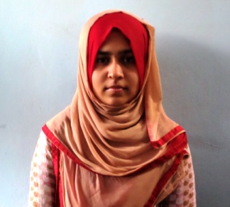
Jannatul Noor, daughter of Abu Jafor Md. Shale Chy and Noor Anowara Akter. She passed Secondary School Certificate (SSC) examination from Kornofully Peper Mills High School and College, Kaptai, Chittagong in 2006 and then Higher Secondary Certificate (HSC) examination from Feni Zia Mohila College,Feni in 2008. She enrolled his internship program for Doctors of Veterinary Medicine (DVM) Degree in Chittagong Veterinary and Animal Sciences University (CVASU), Bangladesh. She has immense interest to work in Genetics and Animal Breeding Improvement in Bangladesh.

