CHAPTER 1
INTRODUCTION
Bangladesh is agriculture based subtropical country. Livestock is an important sub-sector of agriculture which plays an important role to promote human health and poverty alleviation. About 20% of the people directly depends on the livestock sector and thus contributes around 16.5% to the country GDP (DLS, 2009). The cattle production is an important part of livestock. Farmers rear cattle mainly for draft purpose but also as a means of economic upliftment from sale of milk..

Nowadays ,the factors associated with fertility failure of dairy cows become a burning issue (Alam M. G. S.,1983). Reproductive efficiency is a major factor in the profitability of a dairy enterprise through its effect on the annual milk production of the herd and the cost of herd depreciation. Many dairy herds do not achieve their targets for reproductive performance and incur substantial economic opportunity cost. Poor conception rate in lactating dairy cows ranks as one of the most limiting factors to dairy profitability. Artificial insemination (AI) is the most widely used tools in animal breeding for genetic improvement of farm animals. AI was first introduced in Bangladesh from 1959 by using liquid semen of HYV breed for cattle development( M.M. Uddin et al.,2014).Most of the cattle in Bangladesh are indigenous type (Bos indicus) with some cross breeds along with pure breeds,for examples sindhi,sahiwal,jersy,Holstein Friesian etc. nowadays ,cross breeds number is uplifting country wide day by day with the spread of artificial insemination practices (Rahman et al.,1998).But unfortunately conception rates to AI in developing countries are below 50% thus defaulting on the main objective of most farmers in the developing world of having their cows give one calf per year. Conception rates decreased to 45% for cows inseminated at spontaneous estrus and 35% for cows receiving a timed AI (Lucy, 2001). Although the causes have not yet been fully described, the fertility of dairy cows is declining worldwide (Thatcher et al. 2005; Lucy, 2001). Also, this problem is more exaggerated in high producing cows than in low milkers (Lopez, 2004; Lucy, 2001). Yet, in the Ethiopian central Highlands where the average milk yield is rarely over 10 liters per day in . Zebu x Friesian lactating dairy cows (Lobago et al. 2007), the mean number of services per conception for these crossbred cows has increased from 1.6 in early 1980s to 4.0 in early 2000s (Wubet,2005). The risk factors for this progressive decline in the fertility of the crossbred dairy cow’s overtime have not been very well known. However, efficient reproductive performance of dairy cows after the voluntary waiting period depends on several factors including body condition status,lactation satus, parity number, good oestrus detection, insemination technique, quality semen and a healthy uterine environment,good farm managment (Noakes et al., 2002 )

Body condition score (BCS) is an indicator of the nutritional status of the cow and exerts a mark influence on fertility (Butler and Smith 1989; Randel ,1990). Generally, it is reported that poor reproductive performance is associated with poor body condition. A study shows that cows with body condition score less than 2.5 were at risk of subclinical endometritis 4.5 times those with body condition score greater than 2.5 and thus had poor reproductive performance (Belachew Bacha & Fekadu Gudeta Regassa 2009). Butler and Smith (1989) reported that CR is inversely proportional to milk yield. The reduced fertility is associated with negative energy balance resulting from the failure of cows to keep pace with the energy demand for high milk production, especially during the early lactation stage. CR tended to increase with increased parity number (Chung et al., 2001).

Out of the various factors that affect the fertility of CR, semen characteristics are also the major factors that influence conception rate in cattle. In Bangladesh the conception rate is 45.33% and 57.33% in cattle (Das et at., 2002). The low conception rate and other fertility indices after AI can be affected by health status of the bull, semen collection, preservation, and transportation procedure and processing of semen during AI gun loading, proper heat detection and AI at correct time, insemination in friendly uterine environment and keeping the AI record. Capacity of AI technician and insemination technique is also plays a major role for poor fertility indices (Samsuddin et al., 1997).

OBJECTIVES

1. To find out the factors affecting conception rate in different cross breed dairy cows.
2. To determine the frequency of different bull’s semen used for conducting AI in dairy cows.
3. To determine the frequency of different reproductive disease condition in dairy cows.
4. To evaluate the semen quality that used for AI of dairy cows.

CHAPTER 2
MATERIALS AND METHODS

2.1 Study area
A cross sectional study was conducted at Dhamrai Upazila that is located about 40 kilometers North West of the capital city Dhaka. Dhamrai is an urban area with full resource of livestock. There have different commercial dairy farm and also many small to medium sized
(N=4-10) household dairy farms. As CCBDF (Central Cattle Breeding and Dairy Farm) is not far from Dhamrai upazilla ,so uses of different cross breed bull’s semen is very much available that help us to upgrade indigenous type dairy breed.

2.2 Study population and design
To perform this cross sectional study, we collected some reproductive informations of four genotype dairy cow (HF75%, LxFxL, SLxF, SLxSL) from different household farm and AI centre of Upazilla Veterinary Hospital (UVH), Dhamrai, Dhaka.

2.3 Data collection
We had collected data from September 2016 to August 2017 about service number per cow, their lactation status, parity number, milk production/cow/day, BCS of cow at the time of AI of different genotype dairy cows from record sheet of AI service at UVH and data was collected from small to medium sized household farm through structured questionnaire by face to face interview. Body condition scoring on a grading scale of 1 to 6 (1 = very thin; 2 = thin; 3 = satisfactory; 4 = good; 5 = very good; 6 = fat) of the inseminated cow was recorded. By questionnaire we got information about the diseases condition such as retain placenta, dystocia, mastitis and abortion occurrence rate in four genotype dairy breed. Besides this we had also collected data about the frequency of different batch of semen used for conducting AI in dairy cows in Dhamrai Upazilla.

2.4 Evaluation of semen quality
We had collected four genotype frozen semen straw (HF75%,LxFxL,SLxF,SLxSL) from District AI centre, Khulshi, Chittagong for microscopic evaluation of semen quality .Due to lack of laboratory facilities at UVH, Dhamrai we couldn’t able to determine the quality of semen there, so we collected same batch of frozen semen straw from Chittagong. After collection of frozen semen straw ,we rapidly performed microscopic test such as determination of number of live and dead spermatozoa, enumeration of spermatozoa by Haemocytometer method, determination of normal and abnormal spermatozoa. At the laboratory of Department of genetics and animal breeding of Chittagong Veterinary and Animal Sciences University we had performed microscopic evaluation of semen quality.

Figure 1: Map of study area (Dhamrai Upazilla, Dhaka)
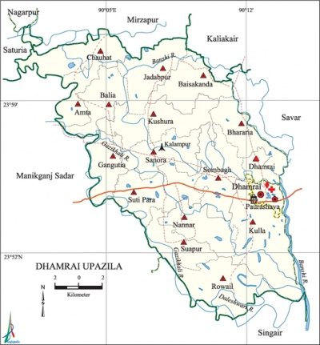

2.5 Data Analysis
All the data that were collected from record book and also from interview of farmer (service number, lactation status, parity number,BCS at AI and different disease conditions) and findings of microscopic evaluation of semen were entered into MS excel (Microsoft office excel-2007, USA) and descriptive analysis was done.

The formula applied for measuring the CR is given below:
Number of animal bred that have not come back in heat after 21 days

Conception rate = x 100
Number of animal bred

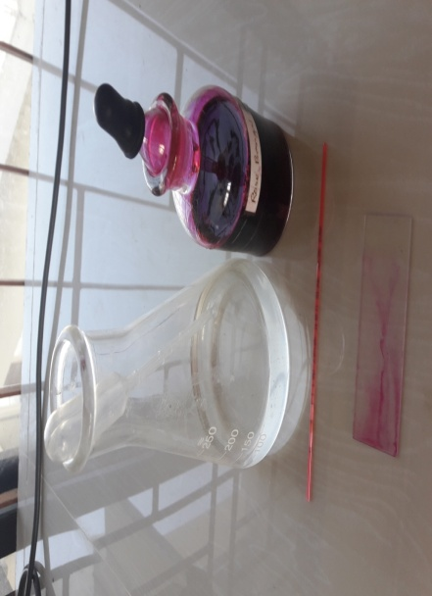
Figure 2: Images of laboratory work during semen evaluation
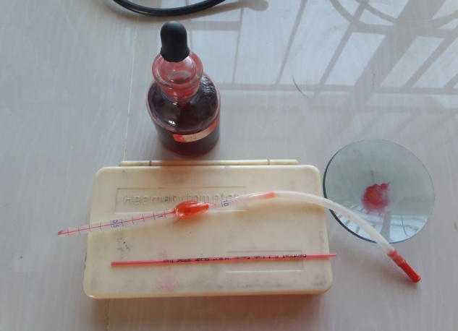

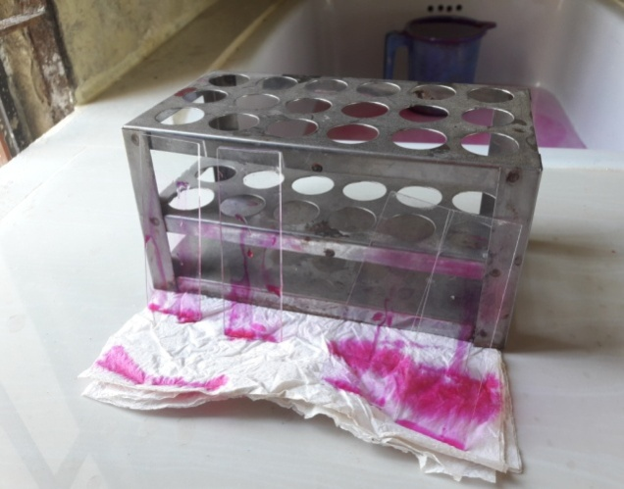
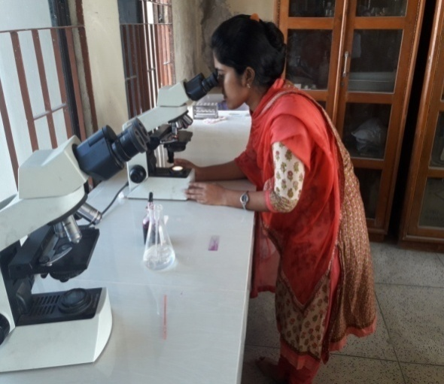
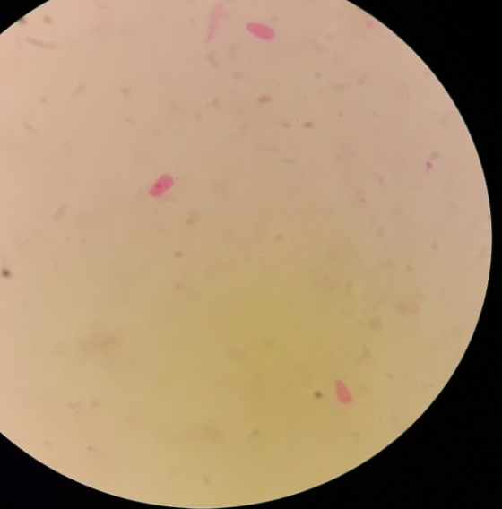
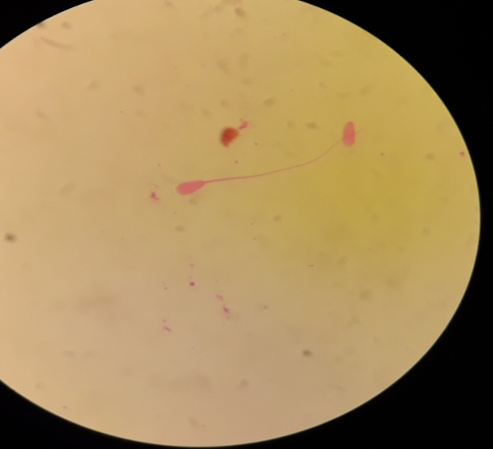
Haemocytometer with diluting fluid to determine the spermatozoa concentration (million/ml)
Physiological buffer with rose Bengal stain for determination of abnormal spermatozoa (%)
Microscopic observation of slide
Staining of slide with Rose Bengal stain
Abnormal spermatozoa (loose head)
Normal spermatozoa

CHAPTER 3
RESULTS

3.1 Frequency of semen used in AI
Out of total 377 cows for conducting AI, the mostly used semen is LxFxF (33.95%) and the least used semen is SLxF (13%).

Table no 1: Frequency of semen used in AI of dairy cows
SL NO | Batch name of semen | NO. of animal(N=377) | %
1 | HF75% | 85 | 22.55
2 | LxFxF | 128 | 33.95
3 | SLxF | 49 | 13
4 | SLxSL | 115 | 30.5

3.2 Frequency of different reproductive diseases in cross breed dairy cows
Among 100 cows from each group of four genotype of cross breed cows the retain placenta is mostly prevalent in LxFxF genotype dairy cows (14%) and the least commonly found in SLxSL genotype (1%). Dystocia most commonly found in SLxF genotype (24%) whereas least found in SLxSL genotype (2%).Abortion occurred mostly in HF75% genotype (4%) and we didn’t found any abortion case in SLxF and SLxSL genotype dairy cows. Mastitis most commonly found in HF75 %( 42%) genotype whereas least in SLxSL genotype (14%).

Figure 3: Frequency of different disease occurrence in four genotypic cross breed dairy cows

3.3 Factors affecting conception rate related to semen quality
The highest number of live spermatozoa found in frozen semen of LxFxF genotype (90%) and the least is 85% in SLxSL genotype .Spermatozoa concentration is highest in SLxSL (1300million/ml) and the lowest in SLxF genotype (1000 million/ml).The highest abnormal spermatozoa found in SLxF genotype (50%) whereas the lowest is 20% found in SLxSLgenotype.
Table no.2: Microscopic evaluation of frozen semen of different genotypic bull.
SL NO. | Semen batch name | Live spermatozoa (%) | Spermatozoa concentration(million/ml) | Abnormal spermatozoa (%)
1 | HF75% | 87 | 1200 | 30
2 | LxFxF | 90 | 1100 | 38
3 | SLxF | 87 | 1000 | 50
4 | SLxSL | 85 | 1300 | 20
3.4 Factors affecting conception rate related to cow
3.4(I) Number of service:
During 1st service of cow conception rate(CR) is highest in SLxSL genotype (30%) and lowest in HF75% (15%) ,in 2nd service highest CR in SLxSL (50%) whereas lowest CR in SLxF (20%),in 3rd service highest CR in LxFxF(60%) whereas lowest CR in HF75%(30%) and in 4th service SLxSL(80%), whereas least is LxFxF (50%).

Figure 4: Number of service that affect Conception rate of dairy cows

3.4(II) Number of parity:
In 1st parity the highest conception rate (41.6%) in SLxSL, lowest CR(20%) in HF75% and in 2nd parity the highest CR (75%) in SLxSL, (25%) in HF75% and in 3rd parity the highest CR rate (50%) in both LxFxF and SLxF, lowest CR (37.5%) in SLxSL. At the 4th or more than 4th parity the highest CR(50%),rest of the three genotype have same CR (33.33%).

Figure 5: Number of parity that affect the Conception rate of dairy cows

3.4(III): Health status of cow at the time of AI
At BCS 3, the highest CR is 40% both in LxFxF and SLxF whereas HF75% genotype has no CR at BCS 3.The highest CR (75%) in SLxSL genotype at BCS 4, and the lowest CR (12.5%) in SLxF at BCS 4 .Unfortunately there is no CR at BCS 6 in any cross breed cow.

Figure 6: Body Condition Score of cow during AI that affects the Conception rate

3.4(IV) Status of milk production of cow
The highest CR (66.66%) found in SLxSL at the level of 8 to 10 liter milk production whereas the lowest CR (20%) found both in LxFxF and SLxF at the level of 5 to 7 liter milk production. At the level of 1 to 4 liter milk production, there is no CR in LxFxF genotype cow.

Figure 7: Level of milk production of cow that affect the Conception rate of crossbreed dairy cows

CHAPTER 4
DISCUSSION

The major constraints of reduced efficiency of dairy cattle in Bangladesh are low conception rate, high number of services per conception, prolonged calving to first service interval, prolonged days open and poor heat detection (Alam and Ghosh, 1988; Shamsuddin et al., 2001). Siddiqui et al. (2013) reported that Body Condition Scores (BCS), heat detection signs, months of AI, semen quality and their interactions had the greatest effects on first service conception rate in cows. Cow’s fertility was significantly affected by the factors parity number, number of service, milk yield, semen quality, AI technician, inseminating bull, repeat breeding syndrome, reproductive diseases.

A study in Bangladesh showed that the overall Conception Rate (CR) in nondescript local zebu cattle received insemination with frozen semen was 57.7% (Mollah et al., 2015). This is in agreement with the study done by Khan (2008) who found 59.3% conception rate in cows that received AI using frozen semen. We found the different conception rates in different breeds. In our study average conception rate is 33.65%,42%,32.83%,50.71% found in HF75%,LxFxF,SLxF,SLxSL respectively. Conception rate was the highest (64%) in native cattle and intermediate (57%) in Friesian cross and the lowest (53%) in Sahiwal cross (Shamsuddin et al. 1997). Hence breed influence in conception rate was observed. The service per conception was different (for Local cows 2.27, for Friesian Cross 1.56 and for Sahiwal Cross 1.79). Animals with 1-2 service showed conception rate 62.4% and animals with 3 and more services showed conception rate 50%,may be concluded that the overall conception rate is 59.3% (Shamsuddin et al. 1997).Mollah (2015) reported that the conception rate in cows that received 2nd and 3rd service was significantly (p<0.05) higher than that of 1st service,this study support our present study because in 1st service highest conception rate is 30% and 50% in 2nd service whereas 60% ,80% CR in 3rd and 4th service respectively. Shamsuddin et al. (2001) who obtained 54.9% first service conception rate using frozen semen in Bangladesh. Moreover, Freer (1981) recorded a conception rate of 43 and 76% for cows inseminated artificially at first and second cycle, respectively. The variation in conception rates among studies might be due to variations in semen (chilled vs. frozen) and breed of cattle (local zebu vs. temperate breed) used in different studies as Habib et al. (2010) reported that CR depends on different genetic and non-genetic factors as reproductive health of the cow, semen quality, time of insemination, efficiency of inseminator etc.

The conception rate in cows was influenced by the parity. The higher conception rate in cows at 1st and 2nd parity than that of cows at 3rd to 5th parity(Mollah et al.,2015) .Another study observed that the conception rate of cows delivered 2nd and 3rd calves (parity 1 and 2) was higher than other parities in Red Chittagong cows ( Mufti et al. (2010).Our study partially support previous study due to at the time of 1st parity the highest CR is 41.6 %, in 2nd parity the highest CR is 75% whereas at the 50%,at the both 3rd and 4th parity. According to parity the conception rate also different in different genotype breed. In our study overall highest CR is 29.58%, 37.33%, 37.08%, 51.02% in HF75%, LxFxF, SLxF, SLxSL respectively. Barcellos et al. (1996) reported a higher conception rate in multiparous cows than that in primiparous cows. Than et al. (2001) reported an increased conception rate with advancing parity from parity 2 up to 6, and then declined at parities 7 and 8 .The differences in conception rates with respect to parities among studies might be due to differences in breeds of cows and semen donar used and feeding practice, general and reproductive management, disease condition and agro-climatic condition of countries where the investigations were conducted (Mollah et al., 2015).

Daily milk yield has a noticeable stimulus on conception rate of animals. A study showed that the significantly (p<0.05) higher conception rate was in cows yielding 1.5-3.0 L milk day than cows yielding <1.0 L day (Mollah et al., 2015).Our study partially support above study because in our study lowest CR is 20% in that cow producing 5 to 7 liter milk/day and the highest CR is 66.66% in that cow producing 8 to 10 liter milk/day. Similarly, Shamsuddin et al. (2001) obtained lower conception rates in low yielding (<1.0 L) cows than that of high yielding (>1 to 16 L) cows counterpart. The positive effect of high milk yield on conception rate may be explained by the fact that the high yielding cows received more attention, received balanced feed and were reared under good management (Shamsuddin et al., 2001)

Body Condition Scoring (BCS) reflect the feeding practice of the animals. The relationship between body condition score and production was strong, but, even after adjusting for yield, an unfavorable relationship still exists between body condition score and fertility (Pryce et al., 2001). Providing adequate quantity of balanced diet to animals will help to gain good BCS resulting in satisfactory conception rate. Higher conception rate in cows with good BCS than that in cows with poor BCS has been documented by (Shamsuddin et al., 2001) in Bangladesh. The CR is lower (36%) when cows are inseminated at BCS of 1.0 –2.0 than at 3.5–5.0 (64%) (Shamsuddin et al., 2001). A study reported that cow with good BCS with supplying roughage, concentrate and grazing have highest CR (67.2%) than poor BCS with supplying only roughage have CR is 50%(Mollah et al., 2015).In our study highest CR (75%) in SLxSL genotype at BCS 4 whereas the lowest CR (12.5%) at BCS 5 in SLxF genotype. Our study didn’t agree with above study may be due to different breed and location. Lopez-Gatius (2013) reported that poor nutrition or the loss of the body reserves (negative energy balance) affects the fertility of cows. The cows deficient in adequate quantity of balanced feed had reduced pituitary responsiveness to a GnRH challenge (Nolan et al., 1988). Thus providing feed with combination of roughages, concentrate and grazing in the present study might have contributed to proper functioning of reproductive hormones resulting in good conception rate. Body condition score could be used as a management and selection tool to improve reproductive performance

Semen quality also determine the CR of dairy cow. Under microscope we found different abnormalities of spermatozoa such as head defects, tail defects, cytoplasmic droplets (proximal and distal) and loose heads. Our study showed that the overall the highest abnormal spermatozoa (50%) in SLxF and lowest (30%) in HF75%, the highest concentration of sperm(1200 million/ml) present in HF75% whereas the lowest (800 million /ml) in SLxSL genotype cow. Spermatozoa quality, concentration varies with different breed. Mean sperm concentration varied between 1423.8 and 1613.8 106 million ⁄ ml in the B. indicus bulls and between 1190.9 and 1306.6 106 million ⁄ ml in the B. Taurus bulls and was significantly higher in the B. indicus bulls for each season. Spermatozoa with cytoplasmic droplets 18.4% vs. 15.1% in B. taurus and B. indicus, respectively. The percentage of sperm head abnormalities was higher in B. taurus than in B. indicus from 6.4 to 19.3% and from 2.3 to 4.0%, respectively. Tail defects are 2.3 to 2.8% and from 2.1 to 2.9% in B. taurus and B. indicus respectively. Consequently, the total percentage of sperm defects was also affected by genotype that B. taurus showed higher values than B. indicus (Koivisto et al., 2009) . These findings, which are in agreement with previous reports (Igboeli and Rahka 1971; Rekwot et al. 1987; Sekoni et al. 1988; Silva et al. 1991), emphasize the better adaptation of B. indicus bulls to tropical conditions compared with B. taurus bulls.

The incidence of retention of fetal membrane, and abortion was found to be 14.35% and 11.25% respectively, dystocia (5.12%) (Khan et al., 2016), which partially support our study because in this study incidence of retain placenta highest (14%) found in LxFxF . Approximately 5 per cent of dairy cows are affected by retained fetal membranes. (Berry et al., 2007).The incidence of abortions, dystocia was significantly higher in HF crossbred cattle than in Jersey cross which was found to be 5.66% vs. 2.74%, 6.13% vs. 1.92%, and respectively (Khan et al., 2016). But in our study highest dystocia (24%) found in SLxF and abortion highest is (4%) found in HF75%. Cases of RB, anestrus, RFM, and abortion were highest in 1st to 3rd parity followed by 4-5th parity group, and minimum was reported in heifers. The prevalence of abortion was highest (5.12) in 2nd calving and the lowest (1.36%) in heifer, 1st calving, 6th calving, and >7th calving. Similarly, retained placenta (4.5%), was higher in 2nd parity, mastitis (2.8%) was highest in 3rd parity. A study in Ethiopia reported the major productive health problems in the dairy cows as clinical mastitis (19.3%), abortion (9.05%), dystocia (7.75%), and retained placenta (7.32%) (Tesfaye and Shamble, 2013).But in our study highest incidence of mastitis (42%) in HF75% .Genotype had a significant effect (p<0.05) on abortion, dystocia, retention of placenta. Higher incidence of the reproductive problem in HF cross than the Jersey cross is due to less adoptability of HF cross cattle under subtropical hill ecosystem, high milk production, and low plane of nutrition. Local × Sahiwal genotype has incidence of retain placenta (4.6%) where in our study the incidence of retain placenta is 14%,12%,5%,2% found in LxFxF,HF75%,SLxF,SLxSL respectively. Milk production is maximum up to 3rd parity after that it starts declining. Due to high milk production, animals becomes in negative energy balance. As the poor farmers could not afford the high cost of concentrate feed, the productive animals fail either to return to cyclicity resulting prolonged calving to conception interval leading to anestrus or it may result into endocrine disturbances leading failure of ovulation, failure of fertilization, early embryonic mortality resulting in Repeat breeder cow. The usual practice in this part of the country is to cull the animal after 6th parity due to less milk production. The culled animals are being slaughtered and used as beef. Therefore, very less incidence of reproductive disorders after 6th parity was reported. The negative effect of dystocia on lactation performance is comparable with mastitis or lameness (Dematawena and Berger,1997;Rajala-Schultz et al.,1999;Rajala-Schultz and Grohn,1999) .The average incidence of dystocia was 10.8%, and varied from 16 to 8% in primiparous and multiparous dams, respectively(Dematawena and Berger,1997;Berry et al.,2007) .

CHAPTER 5
CONCLUSION
Among different factors, factors related to cow (service number, parity, BCS, milk yield, reproductive diseases) and quality of semen used in AI and associated factors mostly affect the conception rate of dairy cows. From the results of the study we can see that cow having good BCS, high yielding milk production per day and during her second parity highest conception rate will be obtained. Among all the factors associated with cow including less prevalence of reproductive diseases the highest CR found in SLxSL genotype cow. Although semen quality is better in HF75% bull than SLxSL bull, the highest CR observed in SLxSL genotype. If semen quality is improved and maintain associated factors, there may be a chance of better conception rate in SLxSL genotype cattle. However, there is still need of more research for increasing CR of all cross breed dairy cows in order to make smallholder dairy farming more profitable at the subsistence farming conditions of Bangladesh.

CHAPTER 6
LIMITATIONS

1. We cannot observed other factors that affect the CR of cows such as factors associated
with AI, efficiency of AI technician, season, heat detection etc.
2. Study area includes only one Upazilla that can not significantly represent the whole
country.
3. Study period was short.

ACKNOWLEDGEMENTS

All praises are due to the almighty Allah, the Creator and Supreme Authority of the universe, who enable the author to complete this assignment.
I am grateful to my teacher and supervisor Dr. Omar Faruk Miazi, Associate Professor and Head, Department of Genetics & Animal Breeding, Chittagong Veterinary and Animal Sciences University for his valuable suggestions and guidance.
I am also grateful to Professor Dr. Goutam Buddha Das, Vice Chancellor, Chittagong Veterinary and Animal Sciences University who have inspired me in various ways for successful ending of the Study
I would like to thanks Professor Md. Abdul Halim, Dean, Faculty of Veterinary Medicine, Chittagong Veterinary and Animal Sciences University for his inspiration.
I express my sincere gratitude to the internship coordinator, Professor Dr.A.k.M. Saifuddin, Director, External Affairs, Chittagong Veterinary and Animal Sciences University, for his constant inspiration and valuable suggestion for completion of the report work.
I would like to special thanks to Md.Enamul HaqHazary, Scientific Officer, District Artificial Insemination Centre, Khulshi, Chittagong for assist me in microscopic evaluation of semen.
Finally, by no means least, I am really very much grateful to all of my teachers, friends, my parents, kiths and kins for their continuous inspiration to accomplish the study.

The Author

