STUDY ON PHENOTYPIC AND REPRODUCTIVE CHARACTERIZATION OF TURKEY (Meleagris gallopavo) IN CHITTAGONG, BANGLSDESH.
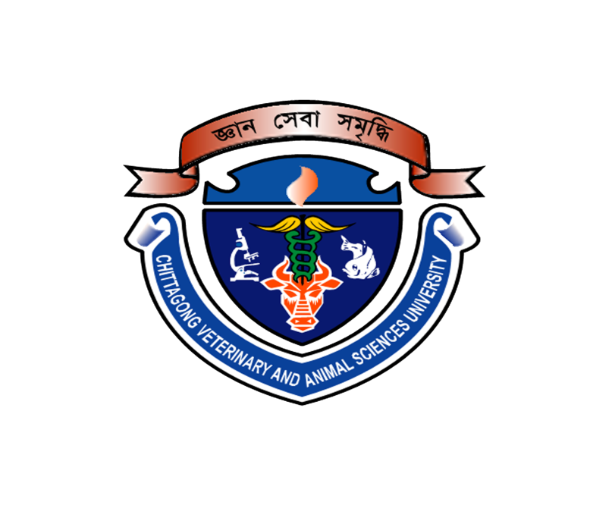
A production report submitted as per approved style and contents

Signature of Supervisor
Dr. Omar Faruk Miazi
Associate Professor
Department of Genetics and Animal Breeding
Chittagong Veterinary and Animal Sciences University

Signature of Author
Kanchan Kumar Roy
Roll No: 12/21
Reg. No: 00741
Intern ID: B-20

Faculty of Veterinary Medicine
Chittagong Veterinary and Animal Sciences University
Khulshi, Chittagong-4225, Bangladesh
December, 2017

