Chapter 1 : Introduction

Mammary gland tumors are benign or malignant masses that develop in breast tissue, usually affect older female dogs. These tumors usually occur in unspayed females or in dogs that were spayed later in life. Approximately 50% of breast tumors in dogs are malignant; an individual dog may have both benign and malignant tumors. P53 gene frequently altered known as “mutated” and is over expressed (over expression is a situation in which the gene produces too much of its effect or products; suspected that many cancers are caused by over expression of certain genes (Merriam-Webster Medical Dictionary). C-erb B2 gene frequently over expressed in cancer. Mutations of BRCA-1 reported in some dog mammary tumors. Since all mammary tumors contain hormonal receptors, their development may be linked to estrogen or progesterone hormones (Rutteman et.al.,1993). Circumstantial evidence incriminates hormone treatment with progesterone and estrogen in combination, prolactin, and growth hormone. Dogs given progesterone to prevent heat cycles are at a greater risk of developing mammary tumors. The risk of developing mammary tumors is directly related to the number of heat cycles (Knapp et.al.,2003). If the dog is spayed before the 1st heat cycle, the risk is as low as 0.05% . Relative risk increases to 8% after one heat cycle and to 26% after a second heat cycle (Kang JH, Lee JY, Mo IP, Lee WG et.al., 2007). Early-onset obesity in female dogs may increase risk for breast tumor development.
Mainly unspayed female dogs are more and more susceptible than spayed one. Olders are more susceptible than youngers. It occurs rarely in males. Toy and miniature poodles, Pug breed, English springer spaniels, Brittanys, English setters, Boxers, English pointers, German shepherd, Maltese, Doberm and Yorkshire terriers are reported to have an increased risk of developing mammary tumors compared to others. Median aged bitch about 10.5 years (range, 1–15 years of age) dogs are more susceptible. It is uncommon in dogs less than 5 years of age.
A swelling develops in one or more mammary glands or in adjacent tissue. The mammary glands closest to the hind legs are most commonly affected. The number, size and shape vary depending on the time of diagnosis. Some benign masses can also be found during physical examinations. Mammary masses that are severely inflamed and ulcerated or that cause a fever may resemble to mastitis and are probably malignant (Soremno KU, Worley DR, Goldschmidt H, 2013). With very advanced tumors, clotting disorders can develop with bleeding from the teeth gums, nostril, skin, vulva or other superficial surfaces. Occasionally lameness can occurs if the tumor has spread to bone (Kang JH, Lee JY, Mo IP, Lee WG, Chang DW, et al., 2007).
Laboratory tests may be normal but are often recommended prior to biopsy or surgery. X-rays of the lungs and an ultrasound may be recommended to check for spread of the tumour especially if a malignancy is suspected (Birchard SJ, 1995). X-rays or a specialized bone scan can be done to determine whether the tumor has spread to bone. Aspiration of the mass with a fine needle helps to identify whether the tumor is benign or malignant (Nimwegen van S, Kirpensteijn J, 2012). Similar aspirations of nearby lymph nodes may help to detect metastasis. If the mass is really a tumor, small pieces may be removed for analysis by a pathologist. For small well-defined tumors, veterinarian may recommend proceeding directly to surgery to remove the mass with subsequent submission of the tissue to a pathologist ( Birchard SJ, 1995 ).
Objectives of the study :
1) To know the appropriate surgical options for the correction of mammary gland tumors in bitch.

Chapter2: Materials & Methods
This clinical study was undertaken at Veterinary College & Research Institute, Namakkal, Tamil Nadu to know the appropriate surgical options for the correction of mammary tumors in an unspayed bitch during the period of 8th to 22th May 2017. Physical condition, behavior, posture, gait, salivation, nasal discharge, abdomen, locomotive etc were observed by visual examination. Examination of different parts and system of the body of the animal were examined by using procedure of palpation, percussion. The temperature, pulse and respiratory rate were recorded. Diagnosis was done on the basis of owner’s complaint, clinical history, clinical signs and symptoms. The clinical findings recorded are, Hard solid mass located between multiple adjacent glands, slightly movable - implies benign behavior, superficial loss of tissue on the surface of the skin over the mammary tissue. The owner of the dog noted that the condition persists for last 3 months. Clinical examination exhibited normal temperature, respiration and pulse rate. The behavior of the animal was normal and appetite was also satisfactory. All blood parameters was also normal. After observing the X-ray report, it was decided to perform surgery. Surgical options may include: lumpectomy, simple mastectomy, regional mastectomy, unilateral or bilateral mastectomy (Allen SW et.al., 1998). In my study, based on the clinical findings and X-ray report I have done regional mastectomy to solve the problem because X-ray report shows that the tumor is located between multiple adjacent glands. And this is the best way for the correction of this types of tumor in unspayed bitch.
Type of surgical excision for mammary tumors depending on location and extent
Tumor type | Surgical excision
Less than 5mm, encapsulated, movable | Lumpectomy
Multiple adjacent glands or between glands | Regional mastectomy
Numerous tumors throughout the chain | Unilateral mastectomy
Numerous tumors in both chain | Bilateral mastectomy
Fixed to underlying tissue | Radical mastectomy
An elliptical incision of the skin and subcutaneous tissue around the mammary gland
Cranial portion of the skin is elevated by the scissors and traction is applied Caudally
The whole tumor content is grasped by thumb forceps and totally excised by sharp scalpel
Surgical wound lavage with saline solution
Suturing of muscle and fascia by catgut
Suturing of skin by simple interrupted suture method using nylon
Active suction drains is used for management of dead space.
Chapter 3 : Case presentation
A four years old Pug breed dog weighing 25 kg was brought to the Clinics, VC&RI, Namakkal with a history of hard swelling in and around the mammary gland. The owner of the dog noted that the condition persists for last 3 months. Clinical examination exhibited normal temperature, respiration and pulse rate. The behavior of the animal was normal and appetite was also satisfactory. All blood parameters was also normal. After observing the X-ray report, it was decided to perform surgery to solve the problem.
3.1. Causes :
Unknown; likely hormonal
3.2. Clinical findings :
- Tumor located between multiple adjacent glands.
- Superficial loss of tissue on the surface of the skin over the mammary tissue, frequently with inflammation known as ulceration.
- Slightly movable - implies benign behavior.

3.3. Restraining and Anesthesia :

Analgesia with opioid groups was provided intravenously in dogs undergoing regional mastectomy i (Savvas I et.al., 2006). Pre-emptive administration of NSAID ( meloxicam 0.2 mg/kg, sc ly) and postoperative administration of ketamine (700 μg/ kg, iv) followed by a 6 hour ketamine (10 μg/kg) at a constant rate provide adequate analgesia during post mastectomy in dogs (.Nakagawa K, Miyagawa Y, Takemura N, Hirose H, 2007). S/C infiltration of local anesthetics ( lidocaine 4 mg/ kg body weight ) continuously ensure a good postoperative analgesia in dogs (Tsioli V et al., 2008).
3.4. Surgical technique :
For regional mastectomy an elliptical incision of the skin and subcutaneous tissue around the mammary glands involved, with 1-2cm margins of healthy tissue, down to the pectoral musculature, abdominal oblique and rectus fascia is made. The cranial portion of the skin is elevated and traction is applied caudally. Skin elevation was assisted by the use of scissors. The underlying muscle and fascia is not involved and the glands are loosely adherent the mammary chain is stripped from the tissues only by gentle traction. Hemorrhage is controlled by thermocautery. Caudal superficial epigastric vessels was ligated at the level of the gland 5 and the external pudendal vessels that connect the gland 5 caudally with the perivulvar tissues. The whole tumor mass is grasped by thumb forceps and excised caudally. Surgical wound lavage with warm saline solution following excision.
Suturing of muscle and fascia using the conventional technique was accomplished by absorbable sutures to decrease dead space and tension (Karayannopoulou M et.al.,2006 ). Skin edges are undermined and advanced to the center of the wound with simple interrupted continuous walking sutures using an absorbable monofilament suture material followed by a continuous subcuticular pattern using a similar suture material. Skin closure is achieved by placement of simple interrupted sutures using monofilament nylon. Active drains is used for the management of dead space ( Karayannopoulou M et.al.,2006).
Skin closure technique is accomplished by inserting an active suction drain within the surgical wound and by closing the skin with widely placed tension relieving mattress sutures using monofilament nylon; these sutures are preplaced in the skin along the total length of the incision and are tightened following placement (Papazoglou LG et.al., 2006). Absorbable walking subcutaneous sutures are not used with this technique. Simple interrupted sutures are placed inside each mattress suture are used to complete the skin closure. The drain exit is close to the incision and is secured to the skin with a Chinese finger trap suture pattern and covered by a soft pad secured in place with a stockinette bandage placed around the inguinal region for the protection of the incision and drain device (.Kazakos G et.al., 2006). The reservoir bag of the active drain is secured under the stockinette bandage.
3.5. Post operative care :
After surgery, sufficient fluid replacements, antibiotics and anti-inflammatory drugs were given for 5 days to combat toxemia. Antibiotics Amoxicillin ( Intamox® ) 3ml was injected intramuscularly and anti-inflammatory ( Melonex® ) 2ml was injected intramuscularly daily for 5 days. 250 ml of RL saline was given intravenously daily for 5 days. Boric acid was applied on the operation site for soothing and coating action.
Figure 1.1 : Tumor located between multiple adjacent glands.
Figures
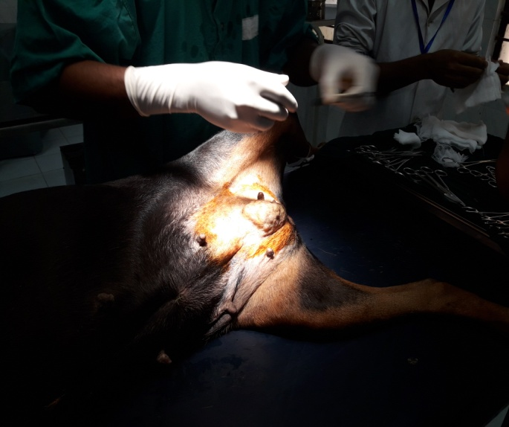 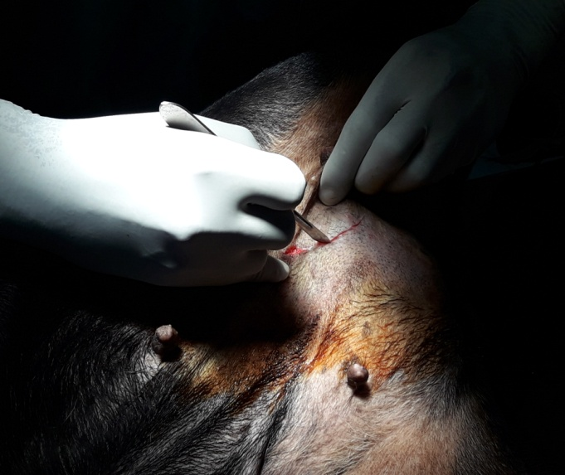
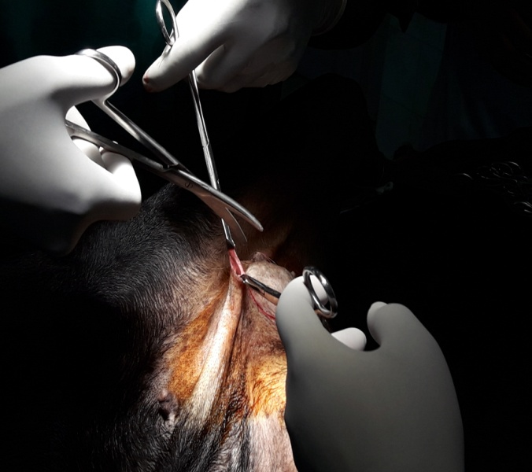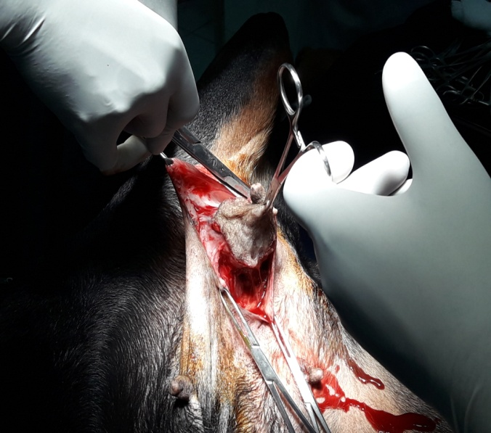
Figure 1.1 : Tumor located between multiple glands.
Figure 1.3 : Round incision of the skin along the border of the tumor.
Figure 1.2 : A small incision is made along the tumor.
Figure 1.4 : Total excision of the skin above the tumor.

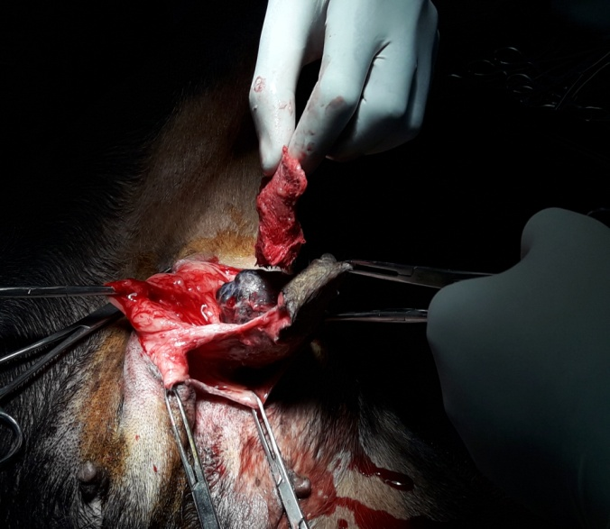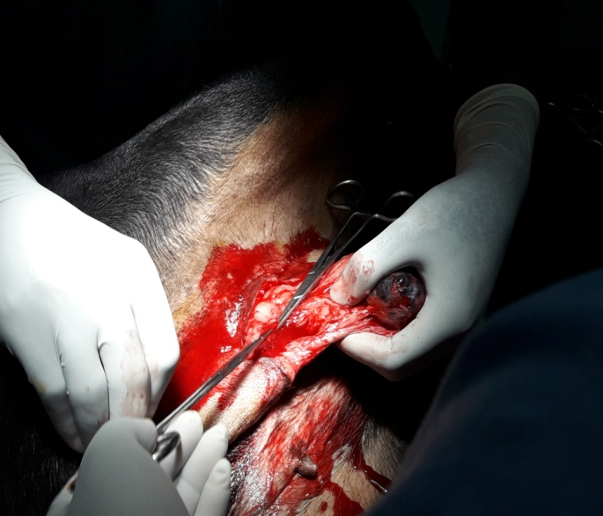
Figure 1.5 : Tumor is exposed after the excision of skin over the tumor.
Figure 1.6 : Cutting of whole tumor mass by using scissors.
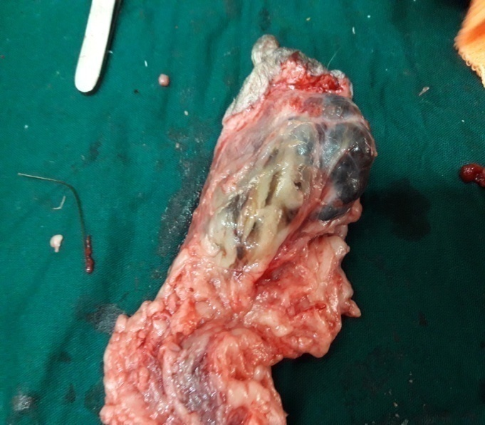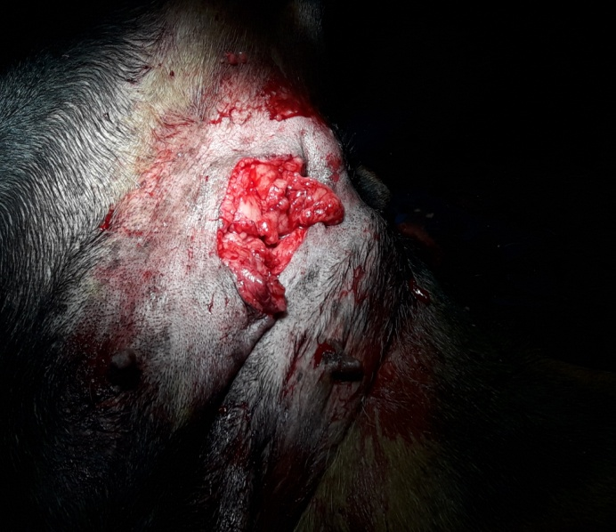
Figure 1.8 : Condition after removal of tumor.
Figure 1.7 : Excised tumor.

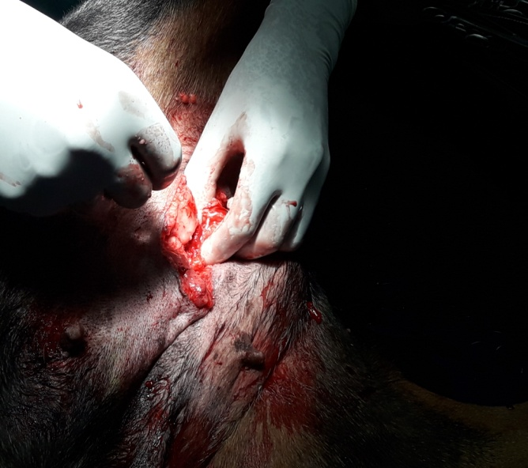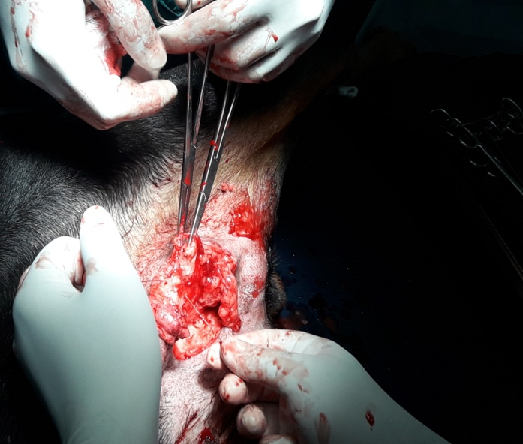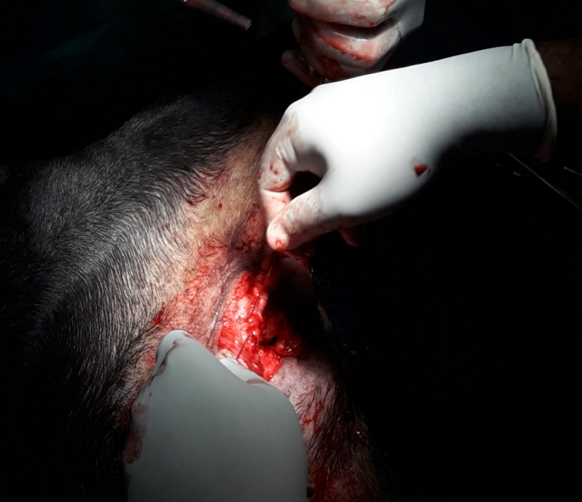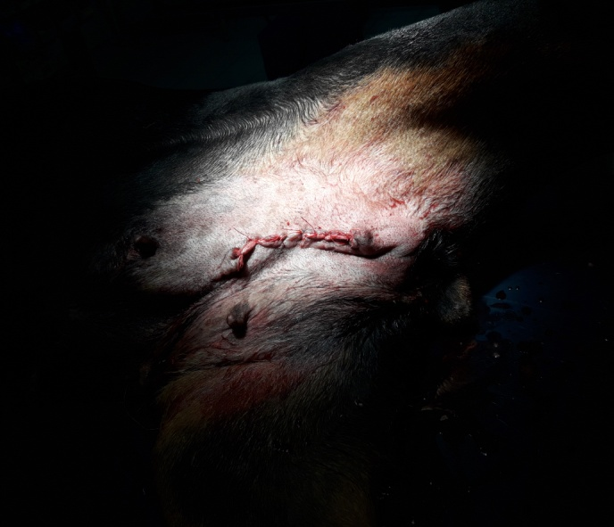
Figure 1.9 : Suturing of muscle & fascia by using catgut.
Figure 1.10 : Suturing of skin by using nylon
( simple interrupted suture method ).
Fig 3.2 : A small sized incision is made over the tumor
Fig 3.1 : Tumor located between gland 4&5 may be removed by regional mastectomy of glands 3,4,5

Chapter 4 : Discussion

A mammary gland tumor is a growth in the area of any or several teats. It could appear as a hard or soft lump in the mammary gland area. At first, it will be covered with skin and hair. If advanced it could burst and look like an abscess. Mammary gland tumors is a very common issue in female canine. My study was conducted on 4 years of old Pug dog breed having mammary tumor in multiple adjacent glands. The best and most used treatment for tumor is surgery. In the present case I have done regional mastectomy considering the location and extent of the tumor. As the tumor is located in between multiple glands, regional mastectomy is the best surgical method to solve this problem. This approach was described by Stratmann N, Failing K, Richter A, Wehrend A, 2008 and was found to be useful to remove this types of tumors. In some cases chemotherapy may be recommended if the lab test determined as tumor is high grade, aggressive, more invasive & not able to be completely removed by surgery. However, according to the Ohio State University Veterinarian Medical Center, there is no proven efficacy of chemotherapy for canine mammary tumors. Radiation therapy may be recommended for certain types of cancers but it is an uncommon practice (Soremno KU, Worley DR, Goldschmidt H, 2013).
The symptoms of the tumor was a solid mass or multiple swellings. The tumors are easyly detected by palpating the mammary glands. Tumors occurs in between teats 4 and 5. The masses were fleshy in color and hard. I found ulceration near the affected teats, it is an indication of advanced cancer. After analyzing the X-ray report it was decided to perform regional mastectomy to correct the problem.

Analgesia with opioid groups was provided intravenously in dogs undergoing regional mastectomy incisions (Savvas I et.al., 2006). Pre-emptive administration of NSAID ( meloxicam 0.2 mg/kg, sc ly) and postoperative administration of ketamine (700 μg/ kg, iv) followed by a 6 hour ketamine (10 μg/kg) at a constant rate infusion seems to provide adequate analgesia post mastectomy in dogs (.Nakagawa K, Miyagawa Y, Takemura N, Hirose H, 2007). Local S/C infiltration with lidocaine as a continuous infiltration shows promise in providing postoperative analgesia in dogs (Tsioli V et al., 2008).
In my study, I performed skin closure technique with a active suction drain versus dogs with conventional closure with a active suction drain and dogs with conventional closure without a active suction drain. This approach was described by Lynch AM et al,. (2011). It was demonstrated that duration of surgery was significantly shorter for dogs with only skin closure technique. Bandage were changed at regular intervals. Active drains were removed within 1 -3 days after surgery as soon as the fluid collection in the reservoir bag is minimal (Karayannopoulou M et.al., 2006).
Early ovariohysterectomy in dogs has been definitely demonstrated to prevent the risk of tumor development but the role of concurrent or post mastectomy ovariohysterectomy is still unclear (Angus W et al., 1976). In my study I also didn’t do any post mastectomy ovariohysterectomy. In another study shows that concurrent or post mastectomy ovariohysterectomy had no effect on survival ( Knapp W et al., 2003). However, other authors demonstrated improved survival when ovariohysterectomy is performed in less than 2 years before or at the same time with regional mastectomy (Soremno KU, Shofer FS, Goldschmidt M, 2000). Young animals are benefited from concurrent ovariohysterectomy to prevent development of new benign tumors and to achieve a decrease of active mammary tissue allowing for an easier later regional mastectomy (Rutteman GR, Misdorp W, 1993).

.
Limitations
1) Due to short duration of my placement , I was unable to follow up my case.
2) It was not possible to know about the recovery period of the dog and actual risk factors associated with my case.
Conclusion

Mammary tumor was seen more commonly in adult dogs compared to young one. Female were commonly affected. In my study I observed that, the tumor was located in between 4 & 5 mammary glands and is slightly ulcerated and freely moveable. I correct the problem by doing regional mastectomy because it is the one and only type of mastectomy when tumor is located in between multiple adjacent glands. Amoxicillin was used as post operative drug to prevent secondary bacterial infection. Boric acid was applied to produce soothing & coating effects on lesions. Meloxicam was used to combate the adverse body reactions.

References
Allen SW, Mahaffey EA. (1989). Canine mammary neoplasia: prognostic indicators and response to surgical therapy. J Am Anim Hosp Assoc 25: 540- 546.
Bartels KE, Ferguson HR, Gillette E and Ferguson HL. (1978). Simultaneous bilateral mastectomy in the dog. Vet Surgery, 7: 97-102.
Birchard SJ (1995). Definitive surgical treatment for cancer. In: Kirk’s Current Veterinary Therapy XII. Bonagura JD, Philadelphia, Saunders.
Coveney EC, O Dwyer PJ, Geraghty JC and O Higgins NJ. (1993). Effect of closing dead space on seroma formation after mastectomy – a prospective randomized clinical trial. Eur J Surg Oncol, 19: 143-146.
Chang SC, Chang CC, Chang TJ and Wong ML. (2005). Prognostic factors associated with survival two years after surgery in dogs with malignant mammary tumors: 79 cases (1998-2002). J Am Vet Med Assoc 227:1625-1629.
Kang JH, Lee JY, Mo IP, Lee WG and Chang DW, et al., (2007). Secondary malignant lymphoedema after mastectomy in two dogs. J Small Anim Pract 48: 579-583.
Lee AH, Swaim SF and Henderson RA. (1986). Surgical drainage. Comp Cont Educ Pract Vet, 8: 94-103.
Lynch AM, Bound NJ, Halfacree ZJ and Baines S. (2011). Postoperative haemorrhage associated with active suction drains in two dogs. J Small Anim Pract 52: 172-174.
Marconato L, Romanelli G, Stefanello D, Giacobini C and Bonfanni U, et al., (2009). Prognostic factors for dogs with mammary inflammatory carcinoma: 43 cases (2003-2008). J Am Vet Med Assoc 235: 967-972.
MacEwen EG, Hayes AA, Harvey HJ, Patnaik AK and Mooney S, et al., (1984). Prognostic factors for feline mammary tumors. J Am Vet Med Assoc 185: 201-204.
Nimwegen van S, Kirpensteijn J. (2012). Specific disorders. In: Veterinary Surgery Small Animal. Tobias KM, Johnston SA, St Louis Elsevier.
Nakagawa K, Miyagawa Y, Takemura N and Hirose H. (2007). Influence of preemptive analgesia with meloxicam before resection of the unilateral mammary gland on postoperative cardiovascular parameters in dogs. J Vet Med Sci 69: 939-944.
Patsikas MN and Dessiris A. (1996a). The lymph drainage of the mammary glands in the bitch: a lymphographic study. Part I: The 1st, 2nd, 4th and 5th mammary glands. Anat Histol Embryol 25: 131-138.
Patsikas MN and Dessiris A. (1996b). The lymph drainage of the mammary glands in the bitch: a lymphographic study. Part II: The 3rd mammary gland. Anat HistolEmbryol25:139-143.
Patsikas MN, Karayannopoulou M, Kaldrymidou E, Papazoglou LG and Papadopoulou PL, et al., (2006). The lymph drainage of the neoplastic mammary glands in the bitch: a lymphographic study. Anat Histol Embryol 35: 228-234.
Rutteman GR and Misdorp W. (1993). Hormonal background of canine and feline mammary tumours. J Reprod Fertil Suppl47: 483-487.
Soremno KU, Worley DR and Goldschmidt H. (2013). Tumors of the mammary gland. In: Small Animal Clinical Oncology. Withrow SJ, Vail DM, Page RL (5th Edition), St Louis, Elsevier.
Stone EA (2000). Mammary gland neoplasia. In: Saunders Manual of Small Animal Practice. (2nd Edition), Birchard SJ, Sherding RG, Philadelphia, WB Saunders Co.
Sarrau S, Jourdan J, Dupuis-Soyris F and Verwaerde P. (2007). Effects of postoperative ketamine infusion on pain control and feeding behaviour in bitches undergoing mastectomy. J Small Anim Pract 48: 670-676.
Savvas I, Papazoglou LG, Kazakos G, Anagnostou T and Tsioli V, et al., (2008). Incisional block with bupivacaine for analgesia after celiotomy in dogs. J Am Anim Hosp Assoc 44: 60-66.
Soremno KU, Shofer FS and Goldschmidt M. (2000). Effect of spaying and timing of spaying on survival of dogs with mammary carcinoma. J Vet Intern Med 14: 266-270.
Stratmann N, Failing K, Richter A and Wehrend A. (2008). Mammary tumor recurrence in bitches after regional mastectomy. Vet Surg 37: 82-86.
Tuohy JL, Milgram J, Worley DR and Dernell W. (2009). A review of sentinel lymph node evaluation and the need for its incorporation into veterinary oncology. Vet Comp Oncol 7: 81-91.
Taylor GN, Sahestari L, Williams J, Mays WA and Angus W, et al., (1976). Mammary neoplasia in a closed beagle colony. Cancer Res 36: 2740-2743.

Acknowledgements
All praises are due to Almighty “ Allah '' who has created everything of the nature & who enable me to complete this study. I feel pleasure to express my deepest sense of gratitude and indebtedness to my honourable supervisor Professor Dr. Mohammad Lutfur Rahman, Ph D (Japan) Post Doc. (Japan), dept of Anatomy & Histology, Chittagong Veterinary & Animal Sciences University for his scholastic guidance, valuable suggestions, constant inspiration & encouragement throughout the entire period of my study.
I would like to express my deep sense of gratitude and thanks to Dr. P. Sankar, Assistant Professor, dept of Clinics, Veterinary College & Research Institute, Namakkal-637001. I would like to thank my friend Md. Nazmul Islam and others of 17th batch, Faculty of Veterinary Medicine, Chittagong Veterinary & Animal Sciences University, Chittagong.

Biography
I am Hameem Mollick Meem, son of Mohsin Mollick & Kamrun Nahar. My home district is Comilla. I passed my SSC examination from Comilla Zilla School, Comilla in 2008 holding CGPA 5.00 and HSC from Comilla Victoria College, Comilla in 2010 holding CGPA 5.00. I am a student of 17th batch, Session 2010-2011 and now I am an Intern student under the faculty of Veterinary Medicine. In my future I would like to work in the field of Medicine & Surgery.

