INTRODUCTION

A persistent right aortic arch (PRAA) is a congenital heart defect. It accounts for 95% of cases of vascular ring anomalies in the dog (Hedlund & Fossum, 2008). This malformation causes extraluminal compression of the esophagus, leading to form secondary megaesophagus (Hedlund & Fossum, 2008; Kyles, 2007). The main clinical sign of PRAA is regurgitation when the patient starts eating solid foods because they cannot progress through the narrow oesophagus (Hedlund & Fossum, 2008;Kyles,2007;Muldoon et al., 1997;Rodrigues et al.,2007). Consequently food accumulates in the esophagus in front of the heart and causes the esophagus to stretch. If the inability to swallow solid food persists long enough, the puppy or kitten does not gain weight and does not develop well. Aspiration pneumonia may develop and can complicate the disease (Hedlund & Fossum,2008;Kyles,2007;Muldoon et al.,1997;Rodrigues et al.,2007). If the animal left untreated, it may die quickly.

When the heart is developing in the fetus, certain structures are supposed to grow while others disappear. The aorta is the main artery that takes blood from the left side of the heart and to the body. Two different structures in the fetus can develop to become the aorta: the right and left aortic arches. Normally, the left aortic arch forms the aorta, and the right aortic arch disappears prior to birth. If the right aortic arch persists and forms the aorta, blood flow is normal but the aorta and some of its nearby vessels can affect the esophagus (the tube that connects the mouth to the stomach).The esophagus becomes trapped between the aorta, the base of the heart, and the ductus arteriosus (Rebecca, 2011).

Chest and abdominal x-rays are usually recommended in puppies and kittens with clinical signs, to check for a dilated esophagus and evidence of pneumonia. Laboratory tests may also be done if pneumonia or infection is suspected. A procedure called an esophagram may be done, in which the animal swallows food mixed with barium to outline the esophagus and identify the location of the narrowing of the esophagus. Sometimes the esophagram is done under fluoroscopy (a video x-ray procedure) so that the motility of the esophagus can also be evaluated. If another congenital heart defect is suspected in addition to the PRAA, then an echocardiogram (heart ultrasound) with Doppler capabilities may be done. These latter tests may require referral of a veterinary specialist (Rebecca, 2011).

The only treatment for PRAA is surgical dissection and removal of the ductus arteriosus to free up the esophagus. If the ductus is patent (contains blood), then it is also tied off (ligated). If the patient has pneumonia, the pneumonia must be treated first and the animal stabilized before surgery can be done (Rebecca, 2011).

The present report describes a case of a dog diagnosed with PRAA and treated surgically.

CASE DESCRIPTION

A four-month old French Bulldog weighing 1.6 kg was brought to the Teaching Veterinary Hospital, Khon Kaen University, Thailand with a history of vomiting immediately after eating every time. Clinical examination of the dog exhibited mild depression, lethargy and regurgitation. The temperature, heart rate and pulse rate of the animal was normal. The animal was checked for CBC, Creatinine, Blood parasite, ALT and recommended for X-ray of chest and abdomen.

Diagnosis
The result of blood test revealed that the animal had mild anaemia. Radiographic examination of the thorax, using barium sulphate as contrast medium, showed an esophageal stricture immediately dorsal to the base of the heart. The esophagus was dilated cranial to the obstruction (Figure 1). A diagnosis of persistent right aortic arch was established on the clinical and radiological findings. Surgical correction was advised and permission was taken from the owner to perform the surgery.

Restraining and Anesthesia
The animal was subjected to fasting for 12 hours for solid and 6 for water. The area of intended incision was clipped, shaved and soaked with tincture iodine and alcohol (Figure 2). The animal was placed in left lateral recumbent position (Figure 3). The anesthetic protocol was consisted of sedation with diazepam (0.2 mg/kg) intravenously, propofol (6 mg/kg) associated with fentanyl (0.04 mg/kg) intravenously in the same syringe for induction. Maintenance was made with isoflurane. Fluid therapy was instituted with ringer’s lactate and distilled water at the ratio of 1:1. Oxygen was delivered through a cuffed endotracheal tube.

Surgical Procedure
A thoracotomy was performed through 4th left inter-costal space (Figure 4). A draper was placed over the area of site of surgery (Figure 5) and a 3-inch long vertical incision was made along the skin (Figure 6) and separated from the subcutaneous layer (Figure 7). The muscles were then incised (Figure 8) and bleeding was checked in every step by using electric cauterize (Figure 7). The left lung lobe was retracted in a caudo-ventral direction to prevent it interfering with the view of the operating field (Figure 9). It was immobilized with a compress moistened in saline. Mediastinal pleura was identified and incised. Then ductus arteriosus was identified by the tip of a surgical instrument locating left lateral to esophagus, between the more ventral pulmonary artery and the more dorsal aorta and pulled up (Figure 10). The ductus arteriosus was ligated with no. 2-0 Polyglactine 910 (synthetic multifilament absorbable suture). Two ligatures were given on the ductus arteriosus leaving a small gap between them (Figure 11). Then the ductus arteriosus was dissected between two ligatures (Figure 12). The area was checked for bleeding and the cut ends were put on right position. Then another fibrous band was identified (Figure 13), ligated and dissected which was developed around the esophagus (Figure 14). The thoracotomy was closed by simple interrupted suture on the pleura and muscles of thorax using 2-0 Polyglactine 910 (Figure 15). Then subcuticular suture was given using 3-0 Polyglactine (Figure 16). Before this, the lung was inflated and expanded to eliminate the pneumothorax and re-establish negative pressure between the pleura. Finally simple interrupted sutures were given to the skin using 3/0 Supramid (Figure 17). A povicep solution was applied over the suture line and covered with a gauge. The animal was then monitored for a period of 1 hour to regain its sense and to observe any complication immediately after surgery.

Post-operative Care
After surgery, medication was given to the puppy. To maintain electrolyte balance Diluted ringer’s lactate was continued through intravenous route for one hour. Antibiotic Cefovecin (Convenia) was administered subcutaneously as a single dose of 0.15 ml and Tremadol was administered subcutaneously at 0.2 ml twice daily for 3 days to relief pain. The owner was advised to keep the pet uprise during feeding and gruel diet. After surgery, the physical examinations including taking temperature, respiration and heart rate recorded for one hour. No complication was noted and the animal had an uneventful recovery. On the day 18th the suture was removed and it was noticed that the wound had healed completely.

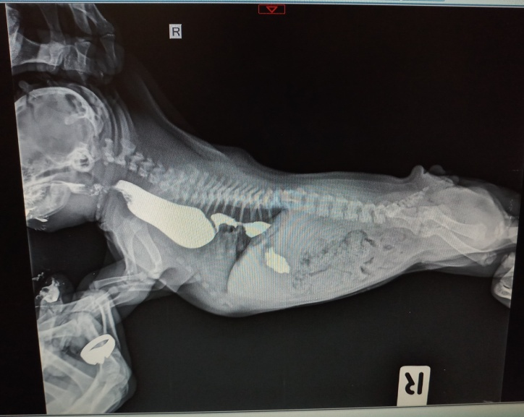
Fig 1: Radiograph showing dilatation of esophagus as obstructed due to Persistent Right Aortic Arch
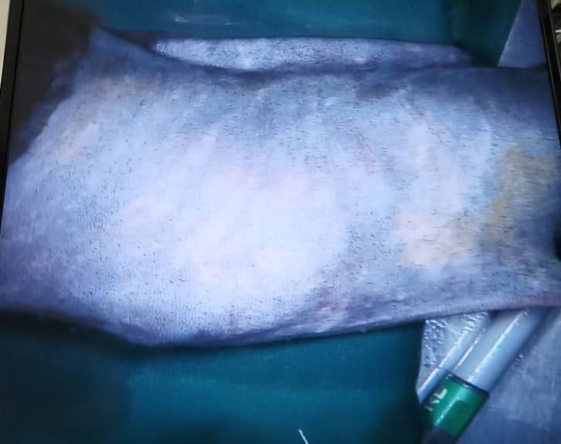
Fig 2: Clipping and Shaving of the site of operation and soaking with tincture iodine and alcohol
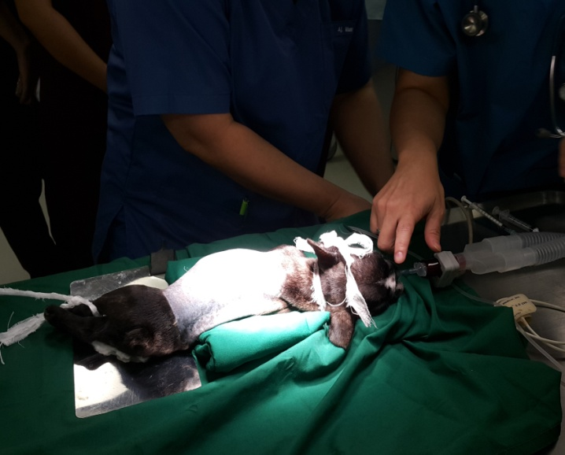
Fig 3: Restraining and induction of anesthesia
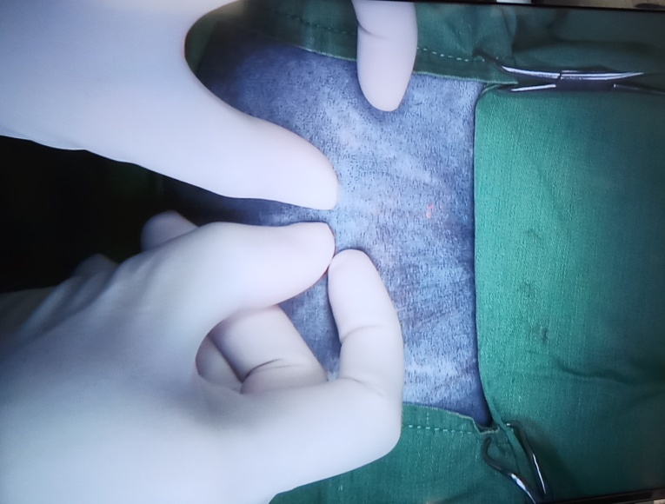
Fig 4: Measuring the 4th intercostals space for incision

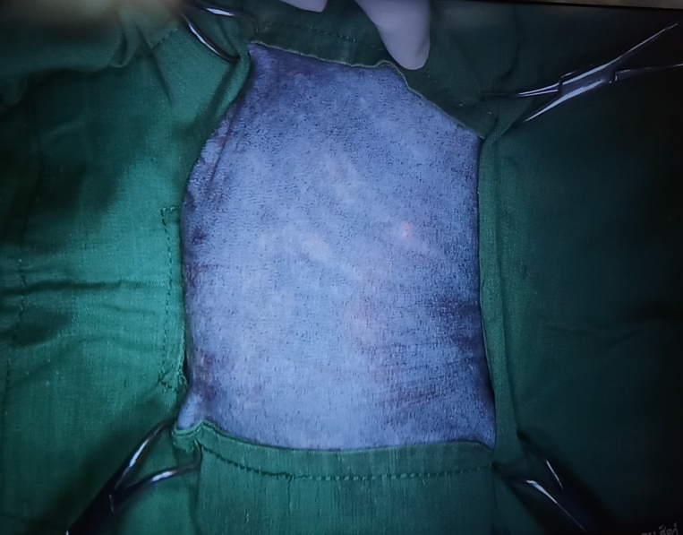
Fig 5: Placing a draper over the area of surgery

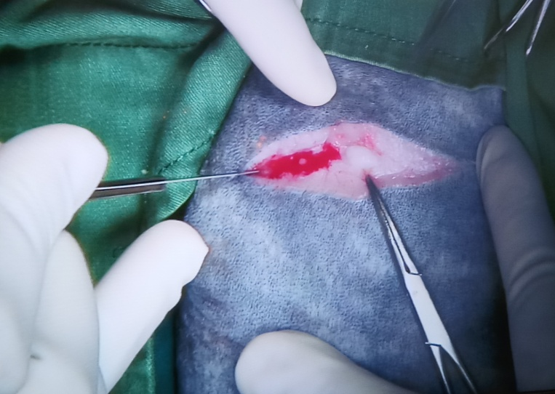
Fig 6: Vertical incision made on left 4th intercostals space
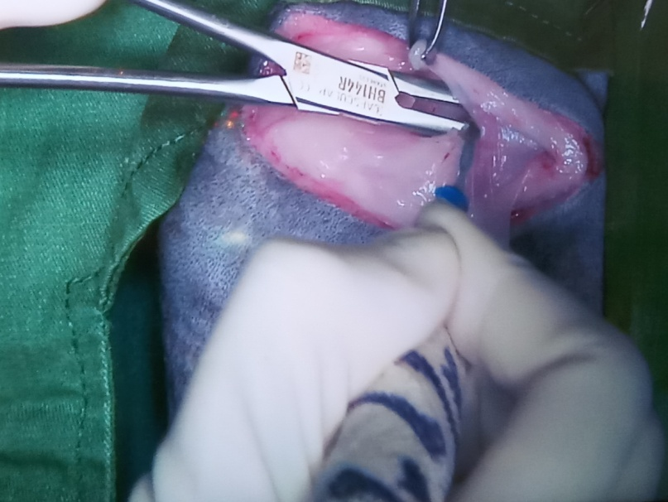
Fig 7: Separation of subcutaneous fat and bleeding check by using electric cautarizer
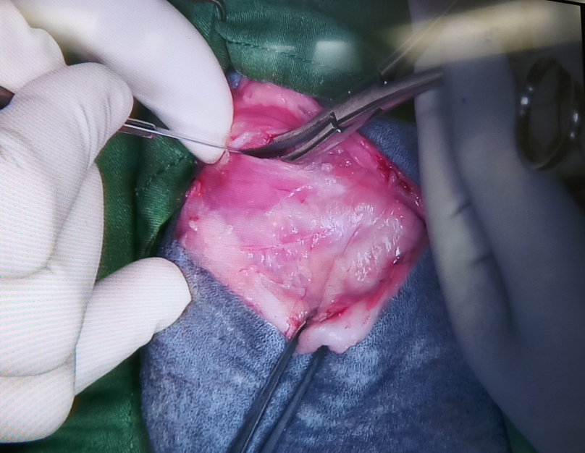
Fig 8: Incision on the muscle
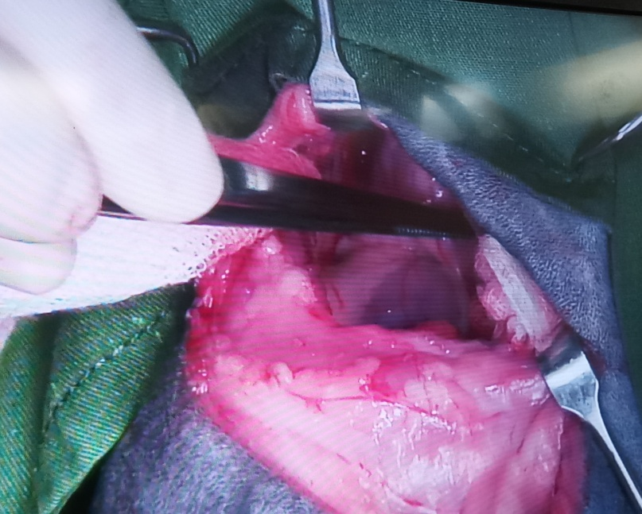
Fig 9: Retraction of the left lung lobe and searching of ductus arteriosus
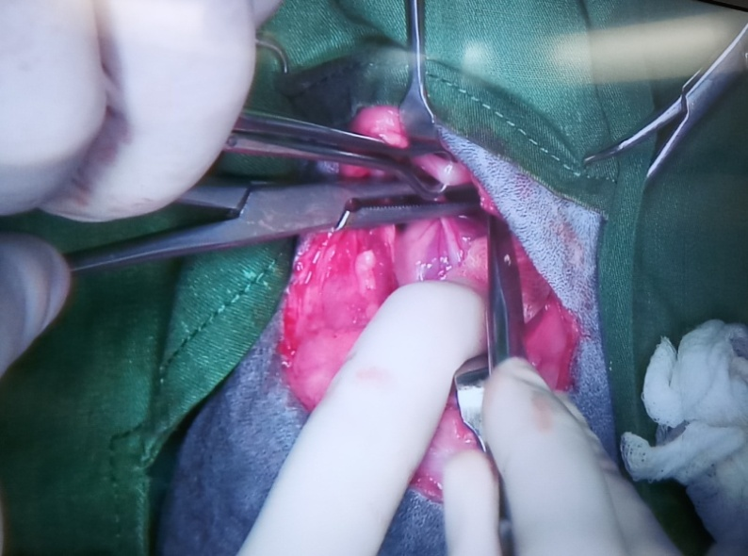
Fig 10: Identifying and pulling up ductus arteriosus
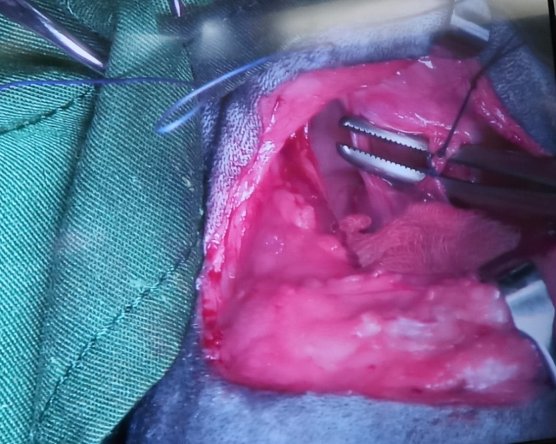
Fig 11: Double ligature made on ductus arteriosus
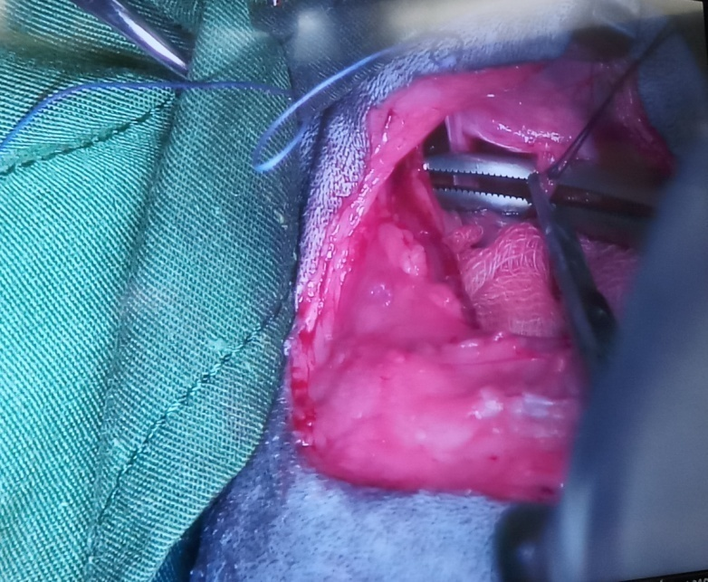
Fig 12: Dissection of ductus arteriosus in between two ligatures
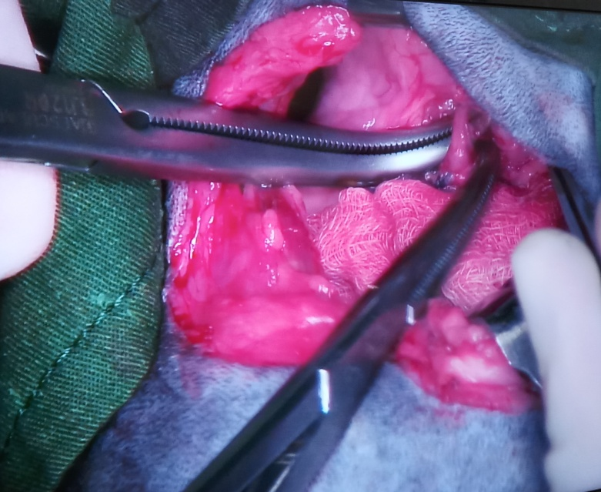
Fig 13: Identification of fibrous band

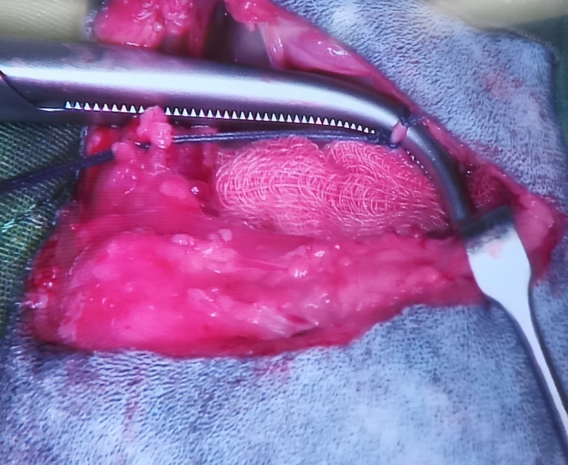
Fig 14: Ligation and dissection of fibrous band
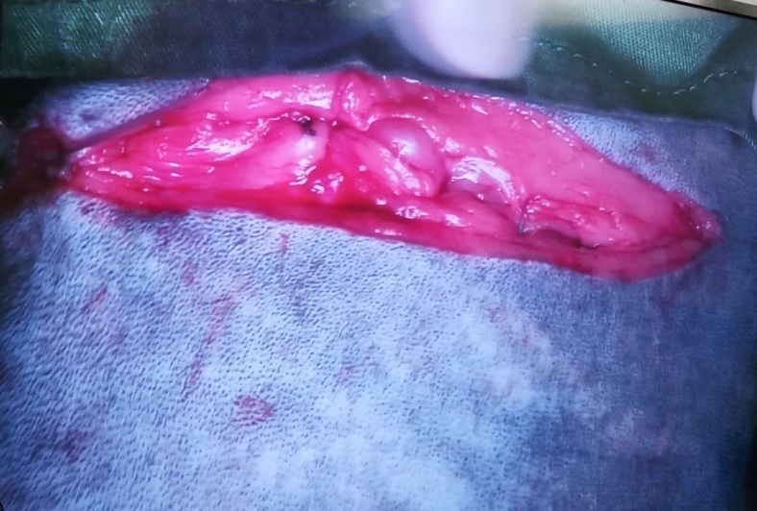
Fig 15: Simple interrupted suture given on muscle
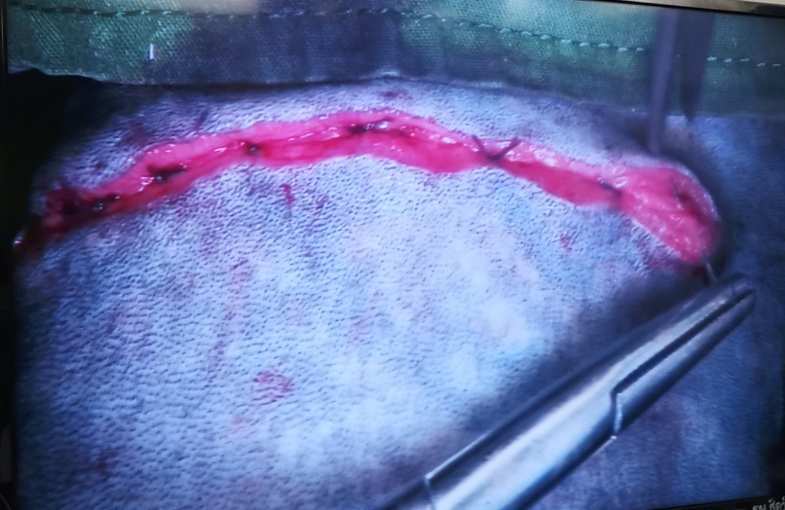
Fig 16: Subcuticuler suture
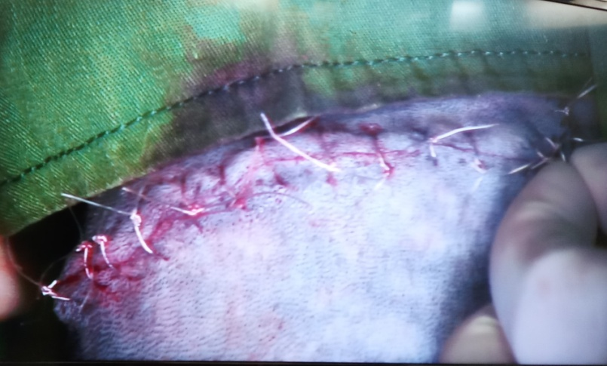
Fig 17: Simple interrupted suture given on skin

DISCUSSION

Persistent right aortic arch and retention of the left ligamentum arteriosum are the most common vascular ring anomaly in both dogs and cats (Hurley et al., 1993; Mears and Jenkins, 1997; Muldoom et al.,1997; Ingh and Sipman, 1974; McCandlish et al.,1984). Other vascular ring anomalies consisting of double aortic arch, left aortic arch and right ligamentum arteriosum, persistent left or right subclavian arteries, ductus arterious with normal aortic arch, persistent right dorsal aorta, and aberrant intercostal arteries have been reported rarely (Hurley et al.,1993; Ingh and Sipman,1974; McCandlish et al.,1984; Aultman et al.,1980;Holt et al.,2000;Minami et al.,1981;Sipman and Gaag,1981). Dogs with a vascular ring anomaly usually have histories of postprandial regurgitation of solid foods after weaning. They typically are stunted, thin and unthrifty. The breed, age, history and clinical signs of the dog in this case were consistent with reports in the literature (Hurley et al.,1993; Muldoom et al.,1997;Vangundy,1989; Ellison,1980) .

A tentative diagnosis was made on the basis of history, physical examination, and a contrast oesophagram with megaoesophagus and constriction of the oesophagus at the base of the heart. The results of oesophagraphy will not distinguish PRAA from less common vascular ring anomalies. Endoscopic examination of the oesophagus is usually considered unnecessary when evaluating vascular ring anomalies (Mears and Jenkins, 1997). However, as reported by Hurley et al. (1993), the oesophagus of dogs that have PRAA can be characteristically seen endoscopically as a terminating blind pouch near the heart base. Medical treatment of PRAA (e.g. liquid diets and supportive care) has been shown to be unrewarding (Vangundy,1989; Ellison,1980). Long-term results are poor because the oesophageal construction remains and oesophageal dilation worsens with time (Ellison, 1980). Thus, surgical ligation and division of the ligamentum arteriosum is the recommended method of treatment. The ultimate goal of surgical treatment is alleviation of the obstruction and resultant clinical signs (Vangundy,1989;Ellison,1980; Fingeroth,1993;Holmberg and Presnell,1979). In this case, the ligamentum anteriousum was identified, ligated and transacted, and the underlying esophagus was freed of any residual extramural fibrous bands. Some authors have suggested that age at the time of surgical correction of PRAA is an important factor in long-term prognosis (Muldoom et al.,1997;Helphrey,1975; Ellison,1980;Berry et al.,1984). Early surgical intervention has been recommended, because it was thought that oesophageal dilation and motility disorders would worsen and possibly become irreversible if surgery were delayed (Muldoom et al., 1997). However, Shires and Liu (1981) stated that dogs <2 months old at the time of surgical correction had a lower survival rate than did older dogs. In the present case, the dog was 4 months old at the time of surgical correction and the long-term results were satisfactory. Long-term results of studies on PRAA have indicated different outcomes. Shires and Liu (1981) stated that only 9 % dogs did not have any long-term clinical abnormalities or complications. Muldoom et al.(Muldoom et al.,1997) have, however, reported that 92% dogs did not regurgitate at the time of long-term follow-up. Our dog also responded well to surgical correction, and did not regurgitate in uprise feeding position, and gained weight gradually. This could be the result of recognizing PRAA more easily than previously, treating the cases earlier before the development of more serious complications, and giving more attention to the dissection of perioesophageal fibrous bands.

REFERENCES

Aultman, S. H., J. N. Chambers, and W. A. Vestre. "Double aortic arch and presistent right
aortic arch in two littermates: surgical treatment [Puppies]." Journal American
Animal Hospital Association (1980).

Berry, A. P., G. J. Brouwer, and B. J. Tennant. "Persistent right aortic arch in a kitten." The
Veterinary record 114.14 (1984): 336-337

Fingeroth, J.M.: Surgical diseases of the esophagus. In: Slatter DH, ed, Textbook of small
animal surgery. 2nd ed. WB Saunders Co, Philadelphia, 1993; 538-544

Hedlund C.S. & Fossum T.W. 2008. Anomalia de anéis vasculares In: Fossum T.W. (Ed).
Cirurgia de pequenos animais.3.ed. São Paulo: Elsevier, pp.405-408.

Holmberg, D. L., and K. R. Presnell. "Vascular ring anomalies: case report and brief review."
The Canadian Veterinary Journal 20.3 (1979): 78.

Holt, David, et al. "Esophageal obstruction caused by a left aortic arch and an anomalous
right patent ductus arteriosus in two German Shepherd littermates." Veterinary
Surgery 29.3 (2000): 264-270.

Hurley, K., et al. "Left aortic arch and right ligamentum arteriosum causing esophageal obstruction in a dog." Journal of the American Veterinary Medical Association 203.3 (1993): 410-412.
Kyles A.E. 2007. Esôfago. In: Slatter D. (Ed). Manual de cirurgia de pequenos animais. 3.ed.
São Paulo: Manole, pp.573-592.

Linde‐Sipman, JS van der, and I. van der Gaag. "Vascular Ring Caused by a Left Aortic
Arch, Right Ligamentum arteriosum and Part of the Right Dorsal Aoarta in a Cat."
Transboundary and Emerging Diseases 28.7 (1981): 569-573.

McCandlish, I. A., A. S. Nash, and A. Peggram. "Unusual vascular ring in a cat: left aortic
arch with right ligamentum arteriosum." The Veterinary record 114.14 (1984):
338-340.

Mears, Erick A., and Christine C. Jenkins. "Canine and feline megaesophagus." Compendium
on Continuing Education for the Practicing Veterinarian 19.3 (1997): 313-326.

Minami, K., et al. "Left Aortic Arch, Retro-Esophageal Aortic Segment, Right Descending
Aorta and Right Patent Ductus Arteriosus-A Very Rare “Vascular Ring”
Malformation." The Thoracic and cardiovascular surgeon 34.06 (1986): 395-397.

Muldoon, M. M., S. J. Birchard, and G. W. Ellison. "Long-term results of surgical correction
of persistent right aortic arch in dogs: 25 cases (1980-1995)." Journal of the
American Veterinary Medical Association 210.12 (1997): 1761-1763.

Rebecca E. Gompf, DVM, MS, DACVIM (Cardiology) / Copyright c 2011 by Saunders, an imprint of Elsevier Inc. All rights reserved.
Rodrigues B.A., Lamberts M., Muccillo M.S., Martins J.M., Ferreira M.P., Scherer S., Bruns
C.F.L. & Lampert M. 2007. Persistência de arco aórtico direito em fêmea da raça
american staffordshire terrier tratada cirurgicamente com sucesso: relato de caso.
Clínica veterinária. (12)67: 32-40.

Shires, P. K., and W. Liu. "Persistent right aortic arch in dogs: a long term follow-up after
surgical correction." The Journal of the American Animal Hospital Association
(USA) (1981).
Turgut, K. "Veteriner klinik laboratuvar teşhis." Bahçıvanlar Basım Sanayi AŞ. Konya 885
(2000).

ACKNOWLEDGMENTS

The author is ever grateful and indebted to the immeasurable grace and profound kindness of Almighty “GOD” the soul authority and supreme ruler of universe, who enabled her to complete the work successfully.

The author feels proud in expressing his deepest sense of gratitude, sincere appreciations, indebtedness to respected teacher and supervisor Dr. Himel Barua, Associate Professor, Department of Microbiology and Veterinary Public Health, Chittagong Veterinary and Animal Sciences University for his ingenuous and scholastic supervision, constant inspiration, providing valuable suggestions, necessary corrections to report writing and for affectionate help in completion of this report.
The author would like to express her deepest sense of respect and affection to the honorable Vice Chancellor Prof. Dr. Gautom Buddha Das and Dean Prof. M. A. Halim, Faculty of Veterinary Medicine, Chittagong Veterinary and Animal Sciences University.
The author expresses her sincere gratefulness and thanks to Prof. Dr. AKM Saifuddin, Director, External Affairs (CVASU) for his valuable suggestions for completion of this report.

The author is ever indebted to her beloved parents for their sacrifices, blessing and inspiration to get her in this position. She is also grateful to all of her teachers, friends and well wishers for their help, encouragement and inspiration during the study period.

The Author
November, 2017

BIOGRAPHY

I am Umme Nazifa Alam, daughter of Mr. Md. Monjur Alam and Mrs. Bibi Fatema Alam. I passed Secondary School Certificate examination in 2008 from BMS Girls’ High School, Chittagong followed by Higher Secondary Certificate examination in 2010 from Agrabad Mahila College, Chittagong. Now I am an intern veterinarian under the Faculty of Veterinary Medicine in Chittagong Veterinary and Animal Sciences University.

In the future I would like to work as a veterinary practitioner and do research on clinical animal diseases in Bangladesh.

