Table of Contents
List of Table 2
List of Figure 2
Abstract 3
Chapter One 4
Introduction 4
Chapter Two 7
Materials and Methods 7
2.1 Study area & Study period 7
2.2 Study design and animal selection 7
2.3 Data collection and questionnaire design 7
2.4 Clinical Examination 8
2.5. Sample collection and processing: 8
2.6 Analysis of Serum Biochemical Parameters 9
2.7. Statistical Analysis 9
Chapter Three 10
Result 10
Table 1 Number of outbreaks, morbidity, mortality and case fatality rates in different regions in Banskhali Upazila, Chattogram. 10
Figure 5: Geographical Map 12
3.3. Serum Biochemical Values of LSDV-Infected and Uninfected Cattle 12
Table 2 Serum biochemical values of LSDV-Infected and Uninfected Cattle 13
Chapter Four 14
Discussion 14
Chapter Five 16
Conclusion 16
Chapter Six 17
Limitations 17
QUESTIONNAIRE 18
REFERENCES 19
Acknowledgement 22
Biography 23

List of Table
Table 1: Number of outbreaks, morbidity, moratlity and case fatality rates in different regions in Banskhali Upazila, Chattogram…………………………………………12

Table 2:Serum biochemical values of LSDV-Infected and Uninfected Cattle…...15

List of Figure
Figure 1 : Nodules on whole body……………………………………………………..9

Figure 2 : Blood collection from lumpy skin diseased animal…………………………10

Figure 3 : Biochemical test……………………………………………………………..10

Figure 4 : Result of parameters…………………………………………………………10

Figure 5 : Geographical map……………………………………………………………14

Abstract
This study investigated the current circumstances of Lumpy Skin Disease in cattle at Banskhali Upazila, Chattogram over a two month of internship period. Lumpy Skin Disease is an infectious disease of cattle with significant economic importance and has spread out in Asia like Bangladesh, India, etc region. LSD re emerges once again in this country as an important threat to livestock health and dairy industry in Bangladesh by outbreaks this year 2020. This clinical report aimed to study epidemiology of LSD in 2019, using data on reported outbreaks in Banskhali region with the aid of Upazila Veterinay Hospital, Banskhali. Descriptive statistics were computed on population at risk, number of cases, morbidity and mortality rate. It was assessed by the number of reported outbreaks across different unions with the help of temporal and spatial distribution of LSD in this area. The total morbidity rate was 12.53% and mortality rate was 0.121 % . Although the rate was vulnerable but the farmers has gone through a economic loss. This study was also carried out to determine the changes in serum biochemical values of cattle naturally infected with LSDV. For this study, blood samples were obtained from clinically affected animals and healthy animals (n = 15 positive group, n = 15 control group) .Serum hepatic and renal damages markers were measured by auto-analyzer. The results of serum biochemical analysis showed that the level of aspartate amino-transferase, alanine aminotransferase were below than normal range however it was not significant difference for liver cell damage. But alkaline phosphatase and albumin concentrations were markedly increased and creatinine concentration was decreased in serum from infected animals. These findings may help in developing effective treatment for LSDV infection.

Keywords: Lumpy Skin Disease (LSD), Epidemiology, Morbidity, Mortality, Serum, Biochemical.

Chapter One

Introduction
Livestock plays an important role in the economy of Bangladesh. About 83.9 percent of total households in the country own livestock. Total cattle, goat and buffalo population in the country are 24.86 million, 26.1 million and 1.485 million, respectively (Livestock economy,2017-2018), whereas the population of these livestock species in Banskhali Upazila, Chattogram is 0.123 million, 0.034 million and 0.004 million, respectively (UVH, Banskhali, Chattogram, Bangladesh, 2019).There are many number of livestock farms in our country .But in the last year and recently , an emerging disease has been reported in Bangladesh which is Lumpy Skin Disease. Bangladesh has now encountered the second consecutive year’s outbreak of LSD. The first outbreak occurred in 22/07/2019 was reported to the Department of Livestock Services (DLS, 2019).
Lumpy skin disease (LSD) is a viral disease of cattle caused by lumpy skin disease virus (LSDV). The causative agent is a member of the Capripoxvirus genus in the poxviridae family(Buller et al., 2005). LSDV has double-stranded DNA genome, which encodes 30 homologous of poxviral proteins known to be structural or nonstructural and it is antigenically and genetically closely related to sheep pox virus (SPPV) and goat pox virus (GTPV) with nucleotide sequence identities of 96% between species (Tulman et al.,2001).
Clinical disease is seen in cattle and wildlife animals such as the Arabian oryx and water buffalo, but does not naturally infect sheep and goats (Davies and Otema, 1981). The disease is characterized by fever, nodules (2 to 5 cm in diameter) on the skin and mucous membrane lesions in the respiratory and gastro-intestinal tracts, and enlarged superficial lymph nodes.It has an important economic impact on the cattle industry due to loss in milk production and condition, infertility, abortion, damaged hides, and sometimes death because of secondary bacterial infections (Carn, 1993). Mortality rates in naïve population of cattle may reach 5% whereas morbidity rates vary from 3 to 80%. It is thought that LSDV is transmitted among cattle by biting insects (such as mosquitoes, flies and ticks that include species from the Glossina, Muscidae, and Tabanidae families, in additionto some species of Hard tick) (Lubinga et al., 2014).
LSD has been reported in most countries in most of Africa, parts of the Middle East and Turkey. Since 2015, the disease has spread to most of the Balkan countries, the Caucasus and the Russian Federation, Where the disease continue to spread. From 2019, several outbreaks of LSD have been reported by Members in South and East Asia (OIE, 2019). It has been occurred because of global climatic changes, vectors and trade movement in animals and animal products.
Clinical lesions can be confused with Bovine Herpes Virus 2 infections, insect bites, dermatophilosis and bovine besnoitiosis. And so, laboratory diagnosis is needed. Laboratory diagnosis can be performed by using serological and molecular techniques and virus isolation by cell cultures (OIE, 2010).
To control LSD, the implementation of strict quarantine, restriction of animal movements, reactivate vaccination, isolation and slaughter of affected though it is not available in our country, proper disposal of carcasses, cleaning and disinfection of the premises and insect control should be needed. Although vaccination with live attenuated strains of CPPV has been shown to be an effective control method for endemic countries like Bangladesh.
Pathognomonic mechanism of viral disease involves implantation of virus at the portal of entry, replication at that site, spread to target organs, and spread to sites of shedding of virus into the environment. Viral disease occurs when the virus replicates in essential cells and damages organ function indirectly.
This study was carried out to explore epidemiological investigation and biochemical changes in cattle caused by Lumpy Skin Disease Virus (LSD) in the Banskhali Upazila, Chattogram by which detection of risk factors and some control measures like herd management, vaccination program can be taken. As LSD has been seemingly found in Chattogram District and outbreak occurred. Although this virus could infect all breeds of cattle irrespective of age and sex, but Bos tauras are found more susceptible than Bos indicus (Gumbe, 2018).Yet, there is no research investigation conducted to find out risk factors, role of vectors and transmission in Bangladesh. In endemic areas morbidity is usually 10% and mortality ranges between 1 and 3% (Davies, 1991). In Banskhali Upazila, by assessing the epidemiological data; the total morbidity rate recognized 1.93% and mortality rate was less than morbidity rate. Geographical distribution map shows the case outbreak of LSD in this upazila by which immediate control measures, treatment against LSD can be taken. Awareness program among farmers in different unions can be raised and that they can be minimized economic loss of livestock population.
Significant changes can be observed in serum biochemical values when cellular, organ damage occurs. There have been few studies conducted on pathogenesis of LSD in cattle. Additionally, there is limited information in the literature about about serum biochemical findings of cattle naturally infected with LSDV (Tuppurainen et al., 2005). Serum biochemical parameters can be a useful tool for evaluating animal health and help better understanding the pathogenesis of the disease.
Upazila veterinary Hospital is the best source of information about animal diseases and their prevention and treatment. People from different remote areas come to Banskhali Veterinary Hospital to get utility of their animals. By appraising this report, a part of strategy can be taken about Lumpy Skin Disease Virus (LSDV) in upazila.
Therefore, my study was concentrated on Banskhali Upazila with the following objectives:
- To know the morbidity and mortality rate of LSD in cattle and also have information about the geographical distribution of outbreak of LSDV so that they can be aware about this disease and may give a scientific evidence for Lumpy Skin Disease Virus in Upazila veterinary hospital.
- To know the pathogenesis of the disease.
- To ameliorate the animal health and minimize economic loss of farmers.

Chapter Two

Materials and Methods

2.1 Study area & Study period
The study area was Banskhali Upazila under the district of Chattogram. The study was carried out in Upazila Veterinary Hospital (UVH), Banskhali, Chattogram district during my internship placement from October 13, 2019 to December 20, 2019.
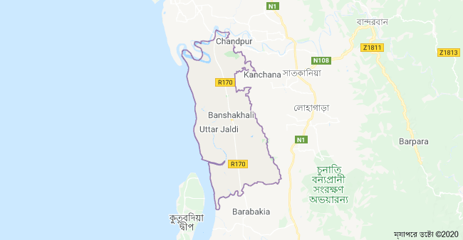

2.2 Study design and animal selection
The animals were selected from Banskhali Upazila Veterinary Hospital which brought into from different areas around Banskhali. Firstly, a total number of cattle were recorded through preset questionnaire survey and the number of data of clinically suspected lumpy skin diseased were recorded.

2.3 Data collection and questionnaire design
Domesticated ruminants (cattle) those who brought to Banskhali Upazila Veterinary Hospital were considered to be reference population. In study periods about 212 cattle were treated in Upazila Veterinary Hospital due to different diseased condition. Among them total lumpy skin disease affected cattle were 15 and healthy cattle were 15 (Positive group =15, Control group =15).
The required information for the lumpy skin disease was collected directly from the owner of the animal through a structured questionnaire. The questionnaire was filled up by repeated questioning to the owners. The questionnaire includes following information such as: Demographic information (age, sex, body weight, breed, color, and species), socio-economic status of the farmer (farmers occupation, monthly income), patient data (duration of illness, history of deworming , number of infected animal, body condition), management system (type of feed supplied, housing pattern, type of floor, vaccination, hygienic measurement), and owner complain .The farm owner reported that there was a marked reduction in milk production(40% less milk).
Lumpy skin disease was diagnosed by physical examination, laboratory diagnosis and clinical findings of diseases condition.

2.4 Clinical Examination
- The cattle had fever (above 40 °C) for more than two days.
- Skin lesions and lesions in the mucous membranes of the mouth, lacrimation, nasal discharge.
- Skin lesions (2to 6 cm diameter nodules) occurred mostly in the area of neck, back and whole body. Mammary gland and teat lesions were also observed in some of the cows.
- Burst of nodules, edematous swelling in their limbs and exhibit lameness.
- Enlarged superficial lymph nodes.

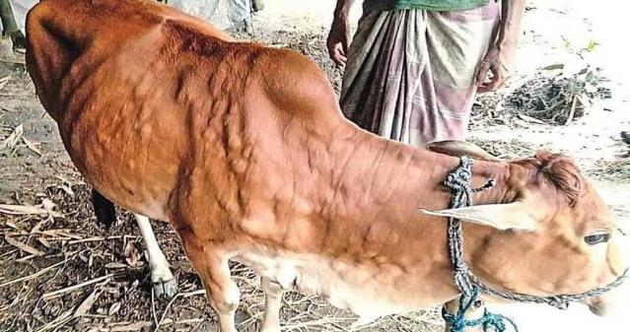
Figure 1: Nodules on whole body

2.5. Sample collection and processing:
Blood samples were collected aseptically from the jugular vein using sterile 5 ml syringe and 21 G needles. From each cattle five mililitres(ml) of blood was collected. The syringe containing blood was kept in a standing position until clot formation and serum was harvested by decanting according to (Mozaffor et al., 2010). 1.5 ml micro centrifuge tubes were used for transferring and shipping of the harvested sera into laboratory through cold box.
Serum sample were stored at -20°C until perform the biochemical analysis. A total of 30 (15 = positive group, 15= control group) blood samples were collected.

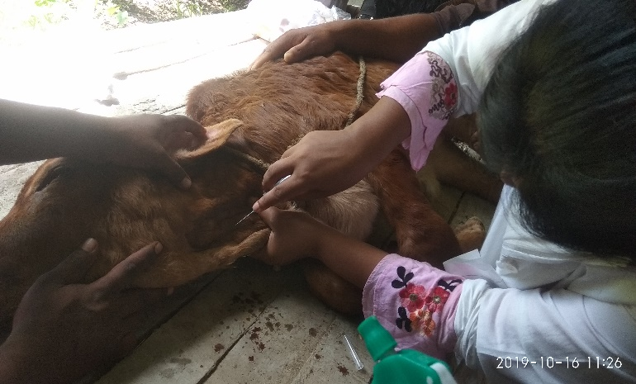
Figure 2: Blood collection from lumpy skin diseased animal

2.6 Analysis of Serum Biochemical Parameters
Biochemical analyses were performed using an auto-analyzer (CVASU biochemical lab). Creatinine, albumin, alanine aminotransferase (AST), aspartate aminotransferase (ALT), alkaline phosphatase were analyzed.
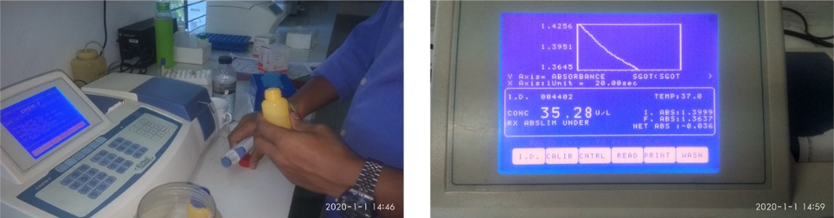
Figure 3: Biochemical Test Figure 4: Result of parameters

2.7. Statistical Analysis
Data collected were entered into Excel-2007 and the results were expressed as mean ± standard deviations. Differences between the LSDV-infected and healthy groups were calculated by using the two-sample t-test. P< 0.05 was considered to be statistically significant.

Chapter Three

Result

Table 1 Number of outbreaks, morbidity, mortality and case fatality rates in different regions in Banskhali Upazila, Chattogram.
Table 1 shows number of outbreaks, morbidity, mortality and case fatality rates in different unions of Banskhali Upazila. Population at risk refers to the number of susceptible cattle in herds where at least one case was reported.
Unions | Population at risk | No. of affected animal | Morbidity rate% | No. of dead animal | Mortality rate % | Case fatality %
Pukuriya | 11958 | 80 | 0.66% | 2 | 0.02 | 2.5
Sadanpur | 8548 | 52 | 0.60% | 0 | 0 | 0
Khakhanabad | 13073 | 83 | 0.63% | 0 | 0 | 0
Baharchora | 14337 | 87 | 0.60% | 0 | 0 | 0
Kalipur | 12901 | 94 | 0.72% | 0 | 0 | 0
Kathariya | 15247 | 95 | 0.62% | 0 | 0 | 0
Boilchori | 12272 | 74 | 0.60% | 0 | 0 | 0
Saral | 13826 | 92 | 0.66% | 2 | 0.01 | 2.1
Jaldi Pourasava | 12183 | 79 | 0.64% | 1 | 0.008 | 1.26
Gandhamara | 11289 | 105 | 0.93% | 0 | 0 | 0
Shilkup | 10545 | 96 | 0.92% | 0 | 0 | 0
Chambol | 10917 | 99 | 0.91% | 1 | 0.009 | 1
Shekerkhil | 6781 | 86 | 1.2% | 0 | 0 | 0
Puichori | 5853 | 113 | 1.93% | 2 | 0.034 | 1.7
Chanua | 7789 | 71 | 0.91% | 3 | 0.04 | 4.2
Total |  | 1306 | 12.53% | 11 | 0.121% | 12.76%
Source: Upazila Veterinary Hospital, Banskhali

LSD outbreaks were reported at the Upazila level from August to December, 2019. During this period, 1306 cases were recorded and 11 recorded deaths attributed to LSD. The total morbidity, mortality and case fatality rates were 12.53%, 0.121% and 12.76% respectively (Table-1).
Spatial distribution of LSD
The distribution of LSD at the upazila and union (regional) level was mapped (Fig. 1) to represent the spatial patterns of outbreaks (August 2019 to December 2019). There was a significant difference between number of outbreaks by region, the highest number of affected animals were reported at Puichori region about 113 and morbidity rate was 1.93%.

Temporal distribution of LSD
15 unions under Banskhali Upazila experienced outbreaks of LSD in 2019. High incidences of LSD outbreaks were reported in August to October, 2019 while the lowest incidence was reported in November to December, 2019.
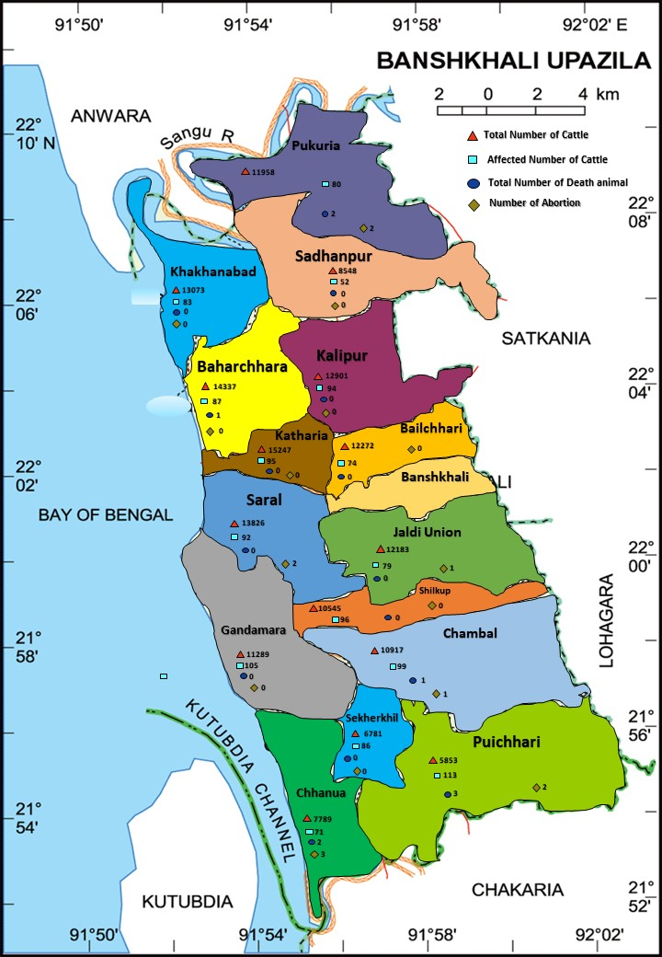

Figure 5: Geographical Map
Figure 5 shows the geographical distribution of LSD outbreaks in Banskhali Upazila.

3.3. Serum Biochemical Values of LSDV-Infected and Uninfected Cattle
Serum biochemical values obtained from cattle naturally infected with LSDV and healthy cattle are given in Table 2. Whereas the creatinine concentration as well as the serum AST, ALT and Creatinine concentration were decreased (P< 0.05), the alkaline phosphatase (ALP) and albumin level were markedly increased (P≤ 0.05).

Table 2 Serum biochemical values of LSDV-Infected and Uninfected Cattle
Mean ± SD of the biochemical profiles in LSDV infected cattle and in healthy cattle.
Parameters | LSDV infected group | Control group | P values
ALT(U/L) | 21.72 ± 12.79 | 27.88 ± 10.11 | P=0.64
AST (U/L) | 73.492 ±21.60 | 92.50 ± 22.59 | P=0.88
ALP(U/L) | 87.2 ± 82.12 | 32.8 ± 3.66 | P=0.047
Creatinine(mg/dl) | 0.53± 0.19 | 1.10± 0.61 | P=0.007
Albumin (g/dL) | 3.56 ± 0.87 | 3.27 ± 0.26 | P = 0.004
Keynote: AST= Aspartate amino-transferase, ALT= Alanine aminotransferase, ALP= Alkaline pho

Chapter Four

Discussion
The study was carried out to find out the case outbreak and morbidity, mortality rate on Lumpy skin disease in the cows of Banskhali upazila, Chattogram, Bangladesh.To understand the spatial epidemiology of lumpy skin disease (LSD) outbreaks in Banskhali, we described the geographic and temporal occurrence of LSD and analyzed the data by using collected data between August and December, 2019. Lumpy skin disease is considered to be the most precious disease of livestock industries through worldwide. There is gigantic variation in the morbidity and mortality rates of LSD outbreaks. It depends on these factors: geographic location and climate; the management conditions; the nutritional status and general condition of the animal; breed of cattle affected; immune status; population levels and dissemination of putative insect vectors in the various habitats; virus virulence. The morbidity rate for LSD are ranges from 0.60 to 0.90%. However, the morbidity rates are considered more usual. Higher rates have been encountered in epizootics in Shekerkhil, Puichori union and the Sadanpur although so far much lower rates may occur during the same epizootic. In addition, high morbidity and mortality rates 1.93 % and 0.04%. From the report by (OIE, 2019), generally, morbidity rates of LSD varies between 10 and 20% and mortality rates of 1 to 5% are considered usual. There is another study reported that morbidity and mortality rates detected were 12.3% and 6.4% (Şevik & Doğan, 2017). The first outbreak in Bangladesh was reported to the Department of Livestock Services (DLS) on 22/07/2019. Cases occurred in three upazilas (Anowara, Karnofuli, and Patiya) in Chattogram district of Chattogram division. An investigation revealed 66 cases in cattle with LSD clinical signs of 360 susceptible animals (attack rate of 18%) and no deaths. Samples were collected and tested positive for Capripoxvirus by real-time PCR at the DLS Central Disease Investigation Laboratory (CDIL).
This study also focused on serum biochemical changes in Lumpy skin diseased affected cattle in Banskhali Upazila, Chattogram, Bangladesh.Serum biochemical references of cattle naturally infected with LSDV are scanty. The measurement and evaluation of the biochemical profile may be helpful in elucidating the pathogenesis and prognosis of the disease. Significant changes occur in the blood biochemical parameters of the animals exposed to viral diseases (Nikolay et al.,2013). Additionally, Nikolay et al., reported that changes in the level of serum ALT, AST, and total protein could be used as prognostic markers of the course of the bovine leukaemia virus infection.Biochemical indicators can be helpful in understanding the course of the disease. Therefore, this study was designed to investigate changes that may occur in serum enzyme activities in cattle infected with LSDV.
LSDV-infected cattle in the current study had normal level of AST and ALT was determined in infected cattle. ALT and AST ratio was 1:0.29 which in normal value. So, there is no evidence of fatty liver syndrome or hepatocyte damage. But some studies have reported that higher AST concentrations and a slightly insignificant increase in ALT was determined in LSDV infected cattle (Sevik et al., 2016;El-Mandrawyet al., 2018)
ALP is an enzyme in the cells lining the biliary ducts of the liver, and its concentration increases with biliary disease, intrahepatic cholestasis, and infiltrative diseases of the liver (Lim, 2014). We determined a significant increase in the level of ALP concentrations in infected cattle, which seems contrary to previous study that suggests that ALP concentrations are not changed in LSDV-infected cattle (Aburtarbush, 2015). Therefore, the increase in the level of ALP in LSDV-infected cattle can be related to the hepatic injury produced by the presence of the virus in the liver. This finding is in agreement with a previous study that reported that pox lesions can be seen in the liver (Bowden et al., 2008).
Decreased creatinine concentration was seen in all affected cattle with abnormal creatinine concentration measurement. Anorexia, liver cirrhosis and loss of muscle mass, which are known to occur in LSD infection, result in reduced serum creatinine levels. It has been reported that low creatinine concentrations was also observed in LSDV infected cattle (Abutarbush, 2015). On the contrary, another report revealed that an increase in creatinine concentration may reflect a reduction of the glomerular filtration rate ( Gowdaet al., 2010; Samra & Abcar, 2012)
Also, albumin concentrations rose slightly (Table 2). This can be explained by the dehydration of cattle. Fever, anorexia and lethargy are commonly observed clinical signs in LSDV-infected cattle. Therefore, dehydration can develop after the onset of the clinical signs produced by LSD (Scott et al., 2003).

Chapter Five

Conclusion
The study was carried out to find out the morbidity and mortality rate on LSD in the cattle of the Banskhali Upazila, Chattogram, Bangladesh. Lumpy skin disease is an important transboundary disease of cattle and has recently spread out in Asia. It is the outcomes of interaction of various factors associated with the risk factors, pathogens, vectors and the environment. Although the overall prevalence of Lumpy skin disease in cattle was relatively lower in the study area. The findings from this study will be used as a baseline for further epidemiological studies for the development of sustainable programs towards the control of LSD in Banskhali along with Bangladesh. This study also focused on biochemical changes in LSD infected cattle. Although enough published data are not available for the serum biochemistry of LSDV-infected cattle. As a conclusion, serum biochemistry analyses suggest that LSD causes liver damage and renal damage in cattle. This study provided information to a better understanding of pathogenesis of the disease and findings of the study may give further discernment to improve control and treatment strategies in LSDV infection.

Chapter Six

Limitations
Being an undergraduate student, I have faced some problems during the study period. The study period was short, 15 cases have been included for serum biochemical test. Moreover, due to small number of sample size, study results may not be accurate. The diagnostic test has not been possible to validate with PCR analysis or other good standard method and small number of biochemical tests may not give possible way to find out the actual pathogenesis of this disease.

QUESTIONNAIRE
1. Name of the farm: ________________________________________________________________
2. Owners name: ____________________________________________________________
3. Location: ________________________________________________________________
4. Cow I.D: ________________________________________________________________
5. Age: _____________________ 6. Sex: ________________
7.Body weight: ______________
6. Breed: __________________________________________________________________
7. Parity: 1/2/3/4/above 4 _____________________________________________________
8. Clinical signs: a. __________________________________________________________
b.___________________________________________________________
9. Physical Examination: a. Temperature: _______________________
b. Mucous membrane: _________________
c. Urination: __________________________
d. Defecation: ________________________

REFERENCES

Abutarbush S. M. Hematological and serum biochemical findings in clinical cases of cattle naturally infected with lumpy skin disease. Journal of Infection in Developing Countries. 2015;9(3):283–288. doi: 10.3855/jidc.5038.

Bowden T. R., Babiuk S. L., Parkyn G. R., Copps J. S., Boyle D. B. Capripoxvirus tissue tropism and shedding: a quantitative study in experimentally infected sheep and goats. Virology. 2008;371(2):380–393. doi: 10.1016/j.virol.2007.10.002.

Buller R. M., Arif B. M., Black D. N., et al. Family poxviridae. In: Fauquet C. M., Mayo M. A., Maniloff J., Desselberger U., Ball L. A., editors. Virus Taxonomy: Classification and Nomenclature of Viruses. Eighth Report of the International Committee on Taxonomy of Viruses. San Diego, Calif, USA: Elsevier Academic Press; 2005. pp.

Carn V. M. Control of capripoxvirus infections. Vaccine. 1993;11(13):1275–1279. doi: 10.1016/0264-410X(93)90094-E.

Davies F. G (1991) Lumpy skin disease of cattle: a growing problem in Africa and the Near EastWorld Animal Review. 1991; 68:37–42.

Davies F. G., Otema C. Relationships of capripox viruses found in Kenya with two Middle Eastern strains and some orthopox viruses. Research in Veterinary Science. 1981;31(2):253–255.

DLS, Situation Report: Lumpy Skin Disease in Bangladesh Background, 2019. 174 https://fscluster.org/sites/default/files/documents/sitrep_lsd_20191210.pdf (accessed May 175 16, 2020).

El-Mandrawy, S. A., & Alam, R. T. (2018). Hematological, biochemical and oxidative stress studies of lumpy skin disease virus infection in cattle. Journal of Applied Animal Research, 46(1), 1073-1077.

Gowda, S., Desai, P. B., Kulkarni, S. S., Hull, V. V., Math, A. A., & Vernekar, S. N. (2010). Markers of renal function tests. North American journal of medical sciences, 2(4), 170.

Gumbe, A. A. F. (2018). Review on lumpy skin disease and its economic impacts in Ethiopia. J Dairy Vet Anim Res, 7(2), 39-46.

Irons P. C., Tuppurainen E. S. M., Venter E. H. Excretion of lumpy skin disease virus in bull semen. Theriogenology. 2005;63(5):1290–1297.

Lim, T. K. (2014). Viola odorata. In Edible Medicinal and Non Medicinal Plants (pp. 795-807). Springer, Dordrecht.

Lubinga J. C., Tuppurainen E. S. M., Coetzer J. A. W., Stoltsz W. H., Venter E. H. Evidence of lumpy skin disease virus over-wintering by transstadial persistence in Amblyomma hebraeum and transovarial persistence in Rhipicephalus decoloratus ticks. Experimental and Applied Acarology. 2014;62(1):77–90. doi: 10.1007/s10493-013-9721-7.

Nikolay S., Dimitrinka Z., Ivanka S., Nikolina R., Teodora M. Investigation of some hematological and blood biochemical parameters in cattle spontaneously infected with bovine leukosis virus. Macedonian Veterinary Review. 2013;36(2):107–110.

Office International des Epizooties (OIE) Lumpy Skin Disease, Chapter 2.4.14 OIE Terrestrial Manual. Paris, France: Office International des Epizooties; 2010.

OIE, LUMPY SKIN DISEASE Aetiology Epidemiology Diagnosis Prevention and 153 Control References, (2017), 154 https://www.oie.int/fileadmin/Home/eng/Animal_Health_in_the_World/docs/pdf/Disease 155 _cards/LUMPY_SKIN_DISEASE_FINAL.pdf (accessed May 17, 2020).

Samra, M., & Abcar, A. C. (2012). False estimates of elevated creatinine. The Permanente Journal, 16(2), 51.

Scott Ferguson, N. D., Dicken Weatherby, N. D., & Press, V. M. (2003). Blood Chemistry and CBC Analysis: Clinical Laboratory Testing from a Functional Perspective.

Şevik, M., & Doğan, M. (2017). Epidemiological and molecular studies on lumpy skin disease outbreaks in Turkey during 2014–2015. Transboundary and Emerging Diseases, 64(4), 1268-1279.

Şevik, M., Avci, O., Doğan, M., & İnce, Ö. B. (2016). Serum biochemistry of lumpy skin disease virus-infected cattle. BioMed Research International, 2016.

The Food and Agriculture Organization of the United Nations (FAO) Emergence of Lumpy Skin Disease (LSD) in Europe. Vol. 33. Rome, Italy: The Food and Agriculture Organization of the United Nations (FAO); 2015.

Tulman, E. R., Afonso, C. L., Lu, Z., Zsak, L., Kutish, G. F., & Rock, D. L. (2001). Genome of lumpy skin disease virus. Journal of virology, 75(15), 7122-7130.

Tuppurainen E. S. M., Oura C. A. L. Review: lumpy skin disease: an emerging threat to Europe, the Middle East and Asia. Transboundary and Emerging Diseases. 2012;59(1):40–48. doi: 10.1111/j.1865-1682.2011.01242. x.

Tuppurainen E. S. M., Venter E. H., Coetzer J. A. W. The detection of lumpy skin disease virus in samples of experimentally infected cattle using different diagnostic techniques. Onderstepoort Journal of Veterinary Research. 2005;72(2):153–164.

Acknowledgement
I Would like to express the deepest sense of gratitude and sorts of praises to the God, the creator and supreme ruler of the Universe who had bestowed upon me to do this work successfully.
The author is also grateful to honorable professor Dr. Abdul Ahad , Dean, Faculty of Veterinary Medicine of Chattogram Veterinary and Animal Sciences University and professor Dr. A.K.M. Saifuddin, Director of External Affairs, Chattogram Veterinary and Animal Sciences University for arranging this type of research work as a compulsory part of this internship programme.
The author expresses her sincere gratitude, humble respect heartfelt thanks to my internship supervisor, Associate Professor Dr. Pankaj Chakraborty, Department of Medicine and Surgery, Chattogram Veterinary and Animal Sciences University for his scholastic guidance, kind cooperation, sincere help, valuable suggestions, inspiration, who was involved with this study from its inception. I ever remain greatful to him.
Special thanks to Dr. Samaranjan Barua, Upazila Livestock Officer, Sabuj Kanti Nath and Shuvo kanti Das , Livestock Extension Officer and Agin Chakroborty, Banskhali Upazilla Veterinary Hospital, for their co-operation in data analysis.
Last but not least, the author extended her appreciation to her parents, all patient owner and all well-wishers.

Biography
I am Karabi Barua, daughter of Mr. Nihar Kusum Barua and Mrs. Minati Barua. I passed my Secondary School Certificate (SSC) examination from Banskhali Govt. Girls’ High School, Chattogram in 2012 and Higher Secondary Certificate (HSC) examination from Chattogram college, Chattogram in 2014. I enrolled for Doctor of Veterinary Medicine (DVM) degree in Chattogram Veterinary and Animal Sciences University (CVASU), Chattogram, Bangladesh in 2014-2015 session. At present I am doing my internship program which is compulsory for awarding my degree of DVM from CVASU. In the near future, I would like to work and have massive interest in Zoo and Wild Animal Medicine.

