CHAPTER 1: INTRODUCTION
Fungi have either unicellular or multicellular structures and are classified according to their morphology into filamentous fungi, dimorphic fungi and yeasts (Sidrim JJC et al, 2004). The most common pathogenic fungi isolated from dogs belong to the filamentous group especially yeasts from the genus Malassezia, particularly Malassezia pachydermatis (Machado MLS et al, 2004). Malassezia pachydermatis is a slightly elongated oval or bottle shaped yeast measuring 1-2x2-4 µm. It is a unipolar budding yeast and reproduces via bud fission in which the bud detaches from mother cell by septum (Matousek and Cambell, 2002). Predisposing factors includes excessive sebum production, accumulation of moisture, damage of epidermis and concurrent dermatoses. The lipids and cells of stratum corneum protect the skin against invasion by microorganism. When epidermal layer is disrupted secondary bacterial and yeast infection occurs. Environmental factors like high temperature and humidity can be a cause of proliferation of Malassezia pachydermatis (Bond and Lyod, 1996). Clinically severe itching, self-mutilation and typical musty odour will be emanated from affected dogs, The distribution of lesions are commonly seen in ventral neck, axilla, inguinal, medial thigh, interdigital, perianal, perigenital, hock and ear pinna (Bond et al, 2000). Skin will be erythematous, scaly, excoriated with hairless patches and dry or greasy coat. Often papules, pustules or epidermal collaret are seen because of secondary bacterial infection (C. Jayanthy et al, 2015).
The study was undertaken with the objectives to diagnose and to determine the prevalence of Malassezia pachydermatis in dog prevalent in Madras Veterinary College. A total of 22 clinical samples were collected from dogs with clinical suspicion of Malassezia pachydermatis presented to Madras Veterinary College Teaching Hospital. Skin scraping from scales and crusts were collected with blunt scalpel and tape smear collected from affected areas. The age, breed, sex, living conditions and clinical data of the animal were recorded. This information can be helpful to canine practitioners as well as dog owners concerned.

The main objectives of this study:
- To know the prevalence of Malassezia pachydermatis in dog.
- To isolate and diagnose Malassezia pachydermatis.
- To know the influence of age, breed, and sex on the prevalence of Malassezia dermatitis.
- To study clinical signs caused by Malassezia pachydermatis on the skin.

CHAPTER 2: MATERIALS AND METHODS

2.1 Study area and study period:
The present study was conducted at Dermatology unit at Madras Veterinary College located in Chennai city which is the capital of Tamilnadu province. The duration of study was April 25, 2017 to April 27, 2017.
2.2 Sample Collection:
A total of 22 samples (9 from males and 13 from females) were collected from the dog accused with skin disease. Samples (skin scraping and tape smear) were collected using blunt scalpel and cellophane tape from lesions.
2.3 Data collection:
The necessary information such as age, sex, body weight, breed, color, species, duration of illness, history of deworming, number of infected animal, management system and owners complain for the diagnosis of disease was collected directly from the owner of animal through providing questionnaire.
2.4 Diagnosis:
Malassezia pachydermatis in suspected dogs were diagnosed by physical examination, clinical findings and laboratory diagnosis of disease condition.
2.4.1 Physical examination:
The animals were examined using dermatological examination techniques of close inspection, palpation, parting of hair and skin, hair consistency, shedding of hair, skin odor, skin color and itch reflex (Karl and Schwartzman, 1964). The findings of physical examination were recorded.
    - Clinical examination:

- Musty odour, moderate to intense pruritus is seen.
- Alopecia was present.
- Affected skin became lichenified, hyperpigmented and hyperkeratinized in chronic cases.
2.4.3 Laboratory examination
Laboratory examination of skin scrapings and tape smear were done for isolation and identification of Malassezia pachydermatis. Each collected sample from skin scraping was kept on the glass slide containing one drop of liquid paraffin and then examined under microscope. Each collected sample from smear was set on a drop Indian Ink on a glass slide.

    - Procedure

At first skin scraping was taken from the suspected dog with blunt scalpel
↓
The scraping was placed on glass slide containing one drop of liquid paraffin
↓
Examined under microscope in 10 X and then 40 X
↓
Negative for parasites

After that tape impression taken from the suspected area
↓
Stained with Indian ink
↓
Yeast overgrowth is confirmed by finding more than 1 round to oval budding yeasts per high power field (100X)

2.5 Treatment:
The affected dogs were treated with Ketoconazole, Povidon Iodin solution administered topically, Injection Vitamin A injected intramuscularly for 2-4 weeks until lesions resolve.

CHAPTER 3: RESULT
Among the 22 dogs examined, 7 (31.81%) were found to be infested with Malassezia pachydermatis in which 3 (33.33%) were males and 4 (30.77%) were females (Table 1 and Table 2).

Table 1: Prevalence of Malassezia pachydermatis in dog:
Total No. of Dogs | No. of positive Dogs | Prevalence
22 | 7 | 31.81%

Table 2: Occurrence of Malassezia pachydermatis in dogs by age, sex and breed:
Parameters | No. of Dogs | No. of positive dogs | Prevalence
Age | <3 year (N=12) | 4 | 33.33%
 | >3 – 6 year (N=6) | 2 | 33.33%
 | >6 -10 year (N=4) | 1 | 25%
Sex | Male (N=9) | 3 | 33.33%
 | Female (N=13) | 4 | 30.77%
Breed | Pure breed (N=12) | 6 | 50%
 | Non descriptive (N=6) | 1 | 16.67%
 | Cross breed (N=3) | 0

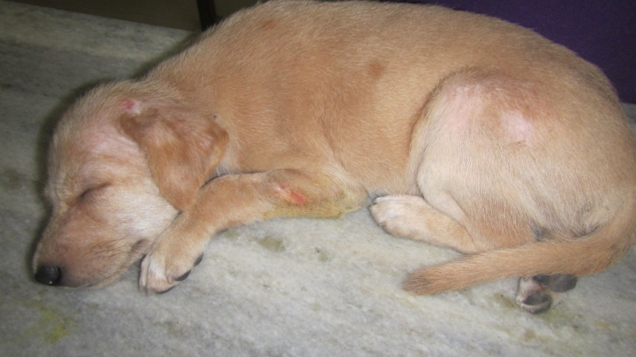
Figure 1: Dog affected by Malassezia pachydermatis
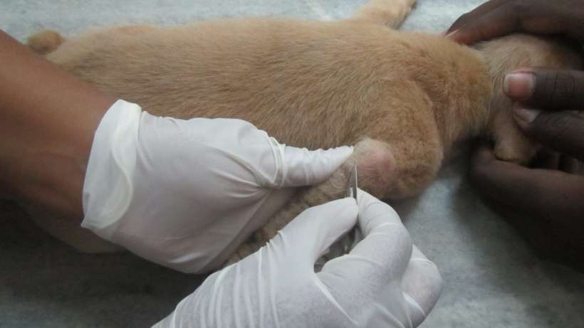
Figure 2: Collection of sample (skin scraping)

In figure-1 clinical signs were moderate pruritus, alopecia, lichenification and hyperpigmentation of skin. For laboratory test skin scrapings was collected from elbow region of affected dog (figure-2).

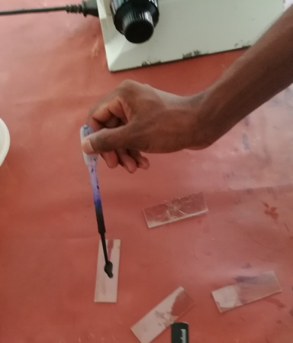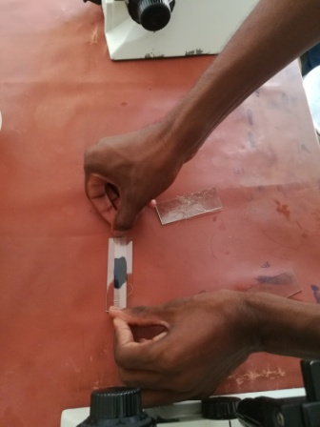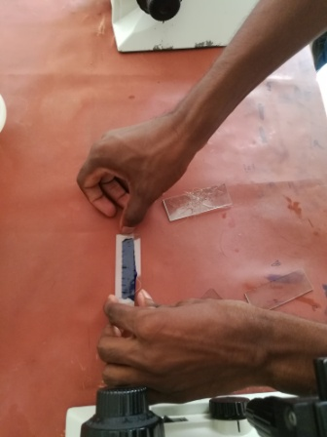
(a) (b) (c)
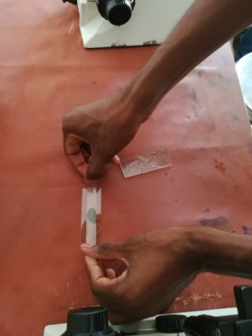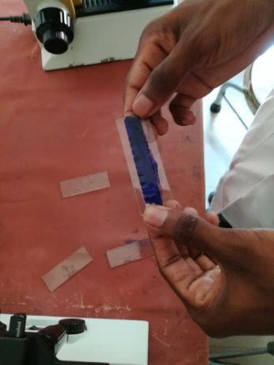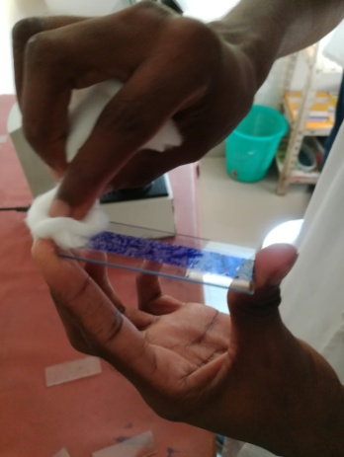
(d) (e) (f)
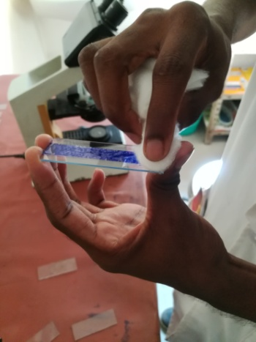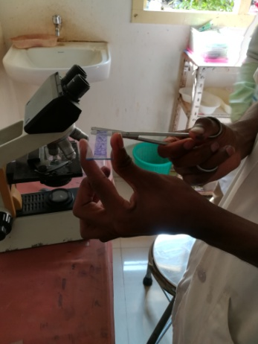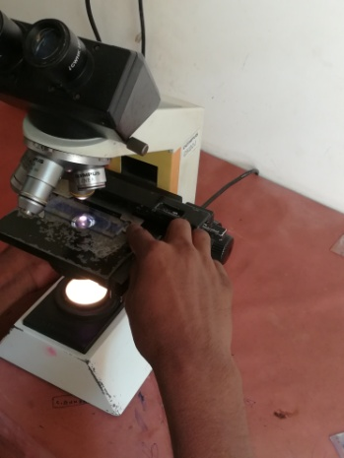
(g) (h) (i)

Figure 3: Staining of collected sample (Tape smear).

For visualization of Massezia pachydermatis the gradual procedures of staining was shown in figure 3(a-i).

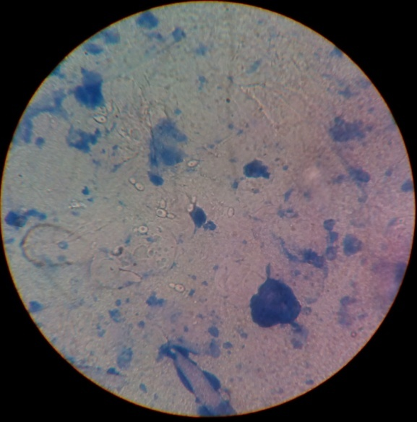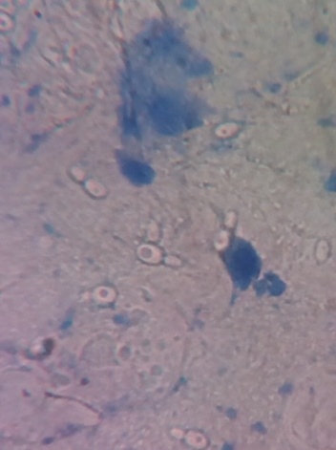
Figure 4: Malassezia pachydematis under microscope.

Budding yeast of Malassezia pachydermatis was visible( ) through 100X magnification under microscope (figure-4).

CHAPTER 4: DISCUSSION
Factors associated with proliferation of Malassezia pachydermatis and its transformation from commensal to pathogenic microorganism are poorly understood, however, most likely they reflect the disturbances of physical, chemical or immunological mechanism limiting microbiological colonisation of skin (Morris 1999; Matousek et al. 2003; Cafarchia et al. 2005). Sex , breed and age of the animal are considered important physiological factors of predisposition to infection.
In terms of sex there were no significant differences in prevalence of Malassezia dermatitis (Nardoni et al. 2004). However, some authors reported higher predisposition of male dogs to otitis associated with Malassezia infection compared to female dogs (Chaudhary and Mirakhur 2002). Relatively higher prevalence of Malassezia pachydermatis was found in samples taken from male dogs (45.2%) than in females (35.2%) (Conkova E. et al. 2011). They explained this fact by the assumption that androgens cause higher production of sebum, which is one of the predisposing factors for development of latent infection. The results of my study show higher prevalence of Malassezia pachydermatis in male dogs (33.33%) than in females (30.77%).

Plant et al. (1992) found no correlation between Malassezia dermatitis and the age of animals. Jeong et al. (2005) recorded high (63%) prevalence in dogs 1–3 years old. Kiss et al. (1997) reported high (63%) prevalence of Malassezia yeasts in otitis of animals at 2–5 years old. According to Conkova E. et al. (2011) the risk group seems to be the group of geriatric animals, with 63.3% prevalence of Malassezia infection. My study revealed that young dogs upto 3 years of age were more susceptible (33.33%) to Malassezia pachydermatis which is similar to result of Jeong et al. (2005).

Many studies confirm natural presence of Malassezia in dogs with apparently healthy skin (Cafarchia et al. 2005; Nardoni et al. 2007).

Prevalence of Malassezia yeasts in dogs with clinical signs of otitis in the study of Conkova E.et al. (2011) was relatively low (44.8%). Similar prevalence (40%) was found in samples taken from dogs with apparently normal ear canal (Hajsik et al. 1985). In dogs with otitis, slightly higher prevalence (57.1%) was reported by Cafarchia et al. (2005), whereas in the above mentioned study of Hajsik et al. (1985), the pathogen was isolated in 72% of animals with otitis. Long and narrow canal, pendulous ears and increased production of sebum in the canal of some breeds (Spaniels) are considered to be important predisposing factors for infection (Carloti 1991; Masuda et al. 2000).

Prevalence of Malassezia pachydermatis varies among the breeds. There are studies showing high sensitivity of certain breeds, like Basset Hound, Dachshund, Cocker Spaniel, West Highland White Terrier, Poodle and Australian Silky Terrier (Plant et al. 1992; Bond et al. 1996), in other studies, on contrary, majority of dogs with positive isolates were crossbreeds (Cafarchia et al. 2005). According to my study the prevalence in pure breed (50%) is higher than non descriptive breed ( 16.67%).

Malassezia pachydermatis is the most frequent yeast isolated in dogs. Knowledge of factors predisposing to the development of infection may be a valuable attribute of an appropriate diagnostic approach. Higher prevalence of Malassezia infection in male, young dogs, particularly during the season with increased air humidity may be expected.

LIMITATION
- The sample size was small in number due to lack of duration at Dermatology Unit in Madras Veterinary College.
- Direct exposure to the animal was limited due to large number of students.
- The scope of discussion with relevant teachers was not sufficient.

CONCLUSION
This study shows that Malassezia pachydermatis is one of the major problems in dogs of Chennai city. The prevalence was higher in young dogs upto 3 years of age and also higher in male than female. Predisposing factors for development of clinical signs of infection include excessive production of sebum, and/or decreased quality of sebum (seborrhoea), accumulation of moisture in the body coat of animal. Samples collected from tape smear stained by Indian ink are helpful for faster diagnosis as well as for their early treatment and management.

REFERENCES
Bond, R. and Lloyd, D.H., 1996. Factors affecting the adherence of Malassezia pachydermatis to canine corneocytes in vitro. Veterinary dermatology, 7(1), pp.49-56.
Bond, R., Saijonmaa‐Koulumies, L.E.M. and Lloyd, D.H., 1995. Population sizes and frequency of Malassezia pachydermatis at skin and mucosal sites on healthy dogs. Journal of small animal Practice, 36(4), pp.147-150.
Cafarchia, C., Gallo, S., Romito, D., Capelli, G., Chermette, R., Guillot, J. and Otranto, D., 2005. Frequency, body distribution, and population size of Malassezia species in healthy dogs and in dogs with localized cutaneous lesions. Journal of veterinary diagnostic investigation, 17(4), pp.316-322.
Carlotti, D.N., 1991. Diagnosis and medical treatment of otitis externa in dogs and cats. Journal of small animal practice, 32(8), pp.394-400.
Chaudhary, M. and Mirakhur, K.K., 2002. Studies on occurrence of canine otitis. Indian Veterinary Journal (India), 79, pp.748–749.

Čonková, E., Sesztáková, E., Páleník, Ľ., Smrčo, P. and Bílek, J., 2011. Prevalence of Malassezia pachydermatis in dogs with suspected Malassezia dermatitis or otitis in Slovakia. Acta Veterinaria Brno, 80(3), pp.249-254.
Girão, M.D., Prado, M.R.D., Brilhante, R.S.N., Cordeiro, R.A., Monteiro, A.J., Sidrim, J.J.C. and Rocha, M.F.G., 2004. Viability of Malassezia pachydermatis strains maintained in various storage mediums. Revista da Sociedade Brasileira de Medicina Tropical, 37(3), pp.229-233.
Hajsig, M., Tadic, V. and Lukman, P., 1985. Malassezia pachydermatis in dogs: significance of its location. Vet Arhiv, 55, pp.259-266.
Jeong, A.Y., Hoh, W.P., Jeong, H.H., Eom, K.D., Lee, K.W. and Oh, T.H., 2005. Efficacy of itraconazole in 18 cases of Malassezia dermatitis in dogs. J Vet Clin 22(2), pp.90-93.
Machado, M.L.D.S., Appelt, C.E. and Ferreiro, L., 2004. Dermatófitos e leveduras isolados da pele de cães com dermatopatias diversas. Acta scientiae veterinariae. Porto Alegre, RS. Vol. 32, n. 3 (2004), pp. 225-232.
Mason, K.V. and Evans, A.G., 1991. Dermatitis associated with Malassezia pachydermatis in 11 dogs. The Journal of the American Animal Hospital Association (USA), 27. pp. 13-20.
Masuda A., Sukegawa T., Mizumoto N., Tani H., Miyamoto T., Sasai K., Baba E., 2001. Study of lipid in the ear canal in canine otitis externa with Malassezia pachydermatis. Journal of veterinary medical science, 62(11), pp.1177-1182.
Matousek, J.L., Campbell, K.L., Kakoma, I., Solter, P.F. and Schaeffer, D.J., 2003. Evaluation of the effect of pH on in vitro growth of Malassezia pachydermatis. Canadian journal of veterinary research, 67(1), pp.56.
Morris, D.O., 1999. Malassezia dermatitis and otitis. Veterinary Clinics of North America: Small Animal Practice, 29(6), pp.1303-1310.
Nardoni, S., Mancianti, F., Corazza, M. and Rum, A., 2004. Occurrence of Malassezia species in healthy and dermatologically diseased dogs. Mycopathologia, 157(4), pp.383-388.
Nardoni, S., Dini, M., Taccini, F. and Mancianti, F., 2007. Occurrence, distribution and population size of Malassezia pachydermatis on skin and mucosae of atopic dogs. Veterinary microbiology, 122(1), pp.172-177.
Patterson A.P., Frank L.A., 2002. How to diagnose and treat Malassezia dermatitis in dogs. neoplasia, 1(2), pp.5.
Plant, J.D., Rosenkrantz, W.S. and Griffin, C.E., 1992. Factors associated with and prevalence of high Malassezia pachydermatis numbers on dog skin. Journal of the American Veterinary Medical Association, 201(6), pp.879-882.
Prado, M.R., Brilhante, R.S., Cordeiro, R.A., Monteiro, A.J., Sidrim, J.J. and Rocha, M.F., 2008. Frequency of yeasts and dermatophytes from healthy and diseased dogs. Journal of veterinary diagnostic investigation, 20(2), pp.197-202.

ACKNOWLEDGEMENT
All the praises are due to the Almighty Allah. The creator and supreme authority of the universe that made the author enable to complete this clinical report. The author would like to express her deep sense of gratitude to Professor Mohammad Abdul Halim, Dean, Faculty Of Veterinary Medicine (FVM) , Chittagong Veterinary and Animal Sciences University (CVASU).The author expresses her sincere gratitude, heartfelt respect and immense indebtedness to her supervisor Dr. Mohammad Lutfur Rahman, Professor, Department of Anatomy and Histology, FVM, CVASU.
Finally, by no means least, the author is really very much greatful to all her teachers, friends and her parents who have inspired her in various ways.

The Author

BRIEF BIOGRAPHY

I am Fatiha Emnoor Eima, daughter of Farid Ahmed Khan and Shamima Farid Lucky. I have completed my Secondary School Certificate (SSC) examination from Mohora S.K.Q Girls High school (2008), Chittagong and then Higher Secondary Certificate (HSC) examination from Chittagong Govt. Women’s College (2010), Chittagong. Then I got admitted in Doctor of Veterinary Medicine (DVM) course under CVASU. During my internship programme I got a short term research on Clinical Diagnosis and Prevalence of Malassezia pachydermatis in suspected dogs at Madras Veterinary College, Chennai, India.

