CHAPTER 1: INTRODUCTION

Livestock is the second enterprise after traditional crop agriculture in Bangladesh. About 36% of protein requirement of the people of Bangladesh is fulfilled by livestock (Ali et al., 2011). There are about 23.8 million cattle, 1.47 million buffaloes and 25.7 million goats in Bangladesh (DLS 2015-16). These animals are important for good quality meat, milk, leathers and a source of income to farmers. Livestock is an integrated part of our farming system and plays an important role in the traditional economy of Bangladesh. Contribution of Livestock in Gross Domestic Product (GDP) is 1.66% (DLS 2015-16).

Among the various constraints to cattle, buffaloes and goats production, diseases are the most important which degraded the productivity of these animals (Sarker et al.,1999). Surgical disorders are serious abnormal condition in animals and may cause fatality if not treated in time. Various violences and accidents hinder growth, performance and economic value (Hossain.; et al., 1986). Surgical affection like umbilical hernia, atresia ani, navel ill, myiasis, dog bite wound, abscess cause great loss to the farmers of Bangladesh (Hossain et al., 1986). External violence produces open wounds in the skin and the incidence is common in ruminants (Nooruddin and Dey.; 1990).

Healing of wound is one of the most complex biological events in living objects (Gillitzer and Goebeler.; 2001) and wound may lead to serious consequences (Mashhood et al., 2006).

Wounds due to dog bite in different livestock species are one of the most common types of traumatic injuries. Most cases are commonly occurring in domestic animals like cattle, sheep and goats even in dogs and cats. Female and younger animals are the frequent victims of dog bite (Islam et al.; 2016)

Myiasis is a condition where open wounds are infested with larvae of diptera flies. These infestations may cause annoyance to animals and disruption of normal habits including feeding and resting. The condition may cause loss of milk, meat and wool production. Myiasis also affects the quality of hides (Mc Kelvie et al., 1993)

Fracture of bones is a feature of accidental surgical affection where ribs are more vulnerable. Falling from high altitudes, external violence, road accident, fighting are common causes of (Duan et al., 2013).

Atresia ani is the failure of the anal membrane to break down to make an anal orifice. It has been reported a most frequently encountered surgical affection in calves (Hossain et al., 1986; Das and Hashim, 1996; Samad.; 2008). Anal atresia affects males and females with equal frequency (Das and Hashim.; 1996). Perineal inspection reveals the absence of anus. Clinical study suggests that along with indigenous calves, a considerable number of crossbred calves also suffer from various congenital diseases like atresia ani (Das and Hashim.; 1996).

Navel ill is a condition in which the Navel portion of the calf is infected by bacteria's contamination of umbilicus following parturition. The infection spreads via the umbilical cord. (Ganga Naik et al.; 2011)

The predisposition to obstructive urolithiasis in male ruminants involves a combination of anatomic and dietary factors. Uroliths in male ruminants most frequently lodge in the distal sigmoid flexure, near the insertion of the retractor penis muscle, or in the vermiform appendage (urethral process) of small ruminants.¹ Both of these are areas of narrowed urethral diameter. Urethral obstruction at these sites may result in local rupture of the urethra or urinary bladder rupture. Urolithiasis can also cause significant economic losses due to urethral obstruction; rupture of the urethra or bladder or death (Parker.; 1981).

However, the database information on occurrence of various surgical disorders in animal is not well organized in different geographic locations. A comprehensive database survey is necessary to establish a base line information for future study of the surgical disorders in animal at hill tracts. Besides this as a part of internship placement at Faridpur Sadar upazila a wide range of surgical affections occur in this area. Upazila Veterinary Hospital (UVH) in Faridpur sadar, Faridpur is one of the most important and reliable source of information about the various surgical affections in goats and cattle in the study area.

Therefore as a prevalence of surgical affections have been realized. Considering these important surgical demands the present study was undertaken and designed with the following objective:

1. To estimate prevalence of surgical affections in Cattle & Goat at Faridpur sadar upazila veterinary hospital, Faridpur.

2. To investigate the distribution of different surgical affections according to age, sex and breed of cattle

CHAPTER 2: MATERIALS AND METHODS

2.1 Study area and duration
The study was conducted in Faridpur Sadar upazila of Faridpur district from 2nd March 2017 to 6th April 2017 and 5 July 2017 to 4 August 2017.
2.2 Study population and case classification
The clinical study was the epidemiological investigation of different types of surgical affections in cattle and goats. A total number of 79 cattle and 117 goats of various ages, sexes and breeds were examined clinically for identifying of different types of surgical affections. The data about the species, age, sex, breed etc were recorded from examination of each animal and history taken from the owner of animal.
2.3 Data collection and case identification
The data were collected in preformed questionnaire . Owner of the patient were asked to know the history of surgical affections and the affected and non-affected animals examined to confirm the affections. The clinical examination was done by visual inspection of gait, posture of cattle, and palpation of the affected area, needle pricking and percussion of the organs. Sex, breed and age were considered as variables for analyzing data. Distribution of surgical affections among variable was done by history and clinical examination. Following criteria are observed to detect various surgical affections in cattle and goat:
2.3A. Detection of abscess in the study area:
In general the clinical case of abscess in the study area was detected by observing the following clinical findings:
1. Presence of localized painful inflammatory swelling at the1st stage.
2. Pus may discharge if the abscess is ruptured or after exploratory needle puncture at the later stage.

2.3B. Detection of navel ill in the study area:
In general the clinical case of navel ill in the study area was identified by observing the following clinical findings.
Presence of painful inflammatory swelling and discharge of pus from the umbilicus.

2.3C. Detection of myiasis wound in study area:
In general the clinical case of myiasis wound in the study area was identified by observing the following clinical findings.
1. Presence of hole/ cavity within the skin membrane / organ surface.
2. Presence of maggots within the wound cavity.

2.3D. Detection of dog bite wound in study area:
In general the clinical case of dog bite wound in the study area was identified by observing the following clinical findings.
1. History of dog bite.
2. Lacerated and deep wound in the bite area.

2.3E. Detection of reducible umbilical hernia in study area :
In general the clinical case of umbilical hernia in the study area was diagnosed by observing the following clinical findings:
1. Presence of hernial ring on palpation
2. Persence of hernial content.
3. Reducible and no inflammatory sings.

2.3F. Detection of Fracture in study area: In general the clinical case of Fracture in the study area was identified by observing the following clinical findings:
1. Presence of severe pain on palpation. Crepitus sound produced during manipulation.
2. Lameness detected.

2.3G. Detection of Atresia ani:
In general the clinical case of Atresia ani in the study area was identified by observing the following clinical findings:
1. Abscent of anal opening.
2. Exploratory puncture in the anal area revealed early feces.

2.3H. Detection of Urolithiasis: In general the clinical case of Urolithiasis in the study area was identified by observing the following clinical findings:
1. Dysuria, dribbling during urination.
2. Pain on palpation.
3. Presence of blood in urine.

2.4 Data analysis
The prevalence of surgical affections in the affected area was calculated by following
Formula:

Prevalence = (Number of surgical affected animal ÷ Total examined animal) × 100
The data collected from each patient were entered into MS excel (Microsoft office excel-2007, USA). Data management and descriptive analysis was done in Excel.
CHAPTER 3: RESULTS

The clinical study was conducted with 79 Cattle and 117 goats affected with various types of surgical affections. The result of the study was presented in the table- 1, 2, 3, 4, 5, 6 & 7

Table-1: The overall Prevalence of various surgical affections in cattle & goat:

Species | No. of animal examined | No of affected animals | Prevalence %
Cattle | 79 | 22 | 27.84
Goat | 117 | 63 | 53.85

Table-1 represented that the overall Prevalence of different types of surgical affections was 27.84 % in cattle out 22 surgical cases and 53.85 % in goat out of 63 surgical cases respectively, under Faridpur sadar upazila.

Table-2: The overall Prevalence of surgical affections based on age, sex and breed in Cattle:

Species | Total no of affected animal | Age (Year) | No of Case | Freq. % | Sex | No of Case | Freq. % | Breed | No of case | Freq. %
Cattle | 22 | 0 to 1 | 13 | 59.10 | Male | 13 | 59.0 | Indigenous | 16 | 72.72
 |  | 1 to 2 | 09 | 40.90 | Female | 09 | 40.90 | Cross | 06 | 27.27

Table-2 represented that among all surgical affections cattle recorded on the basis of sex, breed and age. The highest Prevalence was 59.0% in male, 72.72 % in indigenous and 59.10% at the age of 0 to 1 year respectively under Faridpur sadar upazila.

Table-3: The overall Prevalence of surgical affections based on age, sex and breed in goat:

Species | Total no of affected animal | Age (Year) | No of Case | Freq. % | Sex | No of Case | Freq. % | Breed | No of case | Freq. %
Goat | 63 | 0-1 | 36 | 57.14 | Male | 53 | 84.12 | Black Bengal | 48 | 76.19
 |  | 1-2 | 18 | 28.57 | Female | 10 | 15.87 | Jamunapari | 15 | 23.80
 |  | 2-3 | 09 | 14.28

Table-3 represented that among all surgical affections in goat recorded on the basis of sex, breed and age. The highest Prevalence was 84.12% in male, 76.19 % in Black Bengal and 57.14 % at the age of 0 to 1 year respectively under Faridpur sadar upazila.

Table-4: Clinical occurrence of different types of surgical affections in Cattle:

Species | Name of surgical affection | No of affected cases | Prevalence %
Cattle | Dog bite wound | 4 | 18.18
 | Abcess | 2 | 9.09
 | Myiasis wound | 4 | 18.18
 | Navel ill | 7 | 31.81
 | Umbilical hernia | 2 | 9.09
 | Fracture | 1 | 4.45
 | Atresia ani | 2 | 9.09
Total |  | 22 | 100

Table-4 represented that the highest Prevalence of surgical affections was recorded Navel ill 31.81% in cattle, followed by Myiasis wound, Dog bite wound 18.18% in cattle, Umbilical hernia, Abcess, Atresia ani 9.09%, Fracture 4.45%.

Table-5: Clinical occurrence of different types of surgical affections in goat:

Species | Name of surgical affection | No of affected cases | Prevalence %
Goat | Dog bite wound | 11 | 17.45
 | Abcess | 4 | 6.36
 | Myiasis wound | 7 | 11.1
 | Castration | 24 | 38.0
 | Urolithiasis | 13 | 20.63
 | Fracture | 3 | 4.76
 | Atresia ani | 1 | 1.58
Total |  | 63 | 100

Table-5 represented that the highest Prevalence of surgical affections was recorded Castration 24% in goat, followed by Urolithiasis 20.63%, Dog bite wound 17.45%, Myiasis wound 11.1%, abscess 6.36%, Fracture 4.76%, Atresia ani 1.58%.

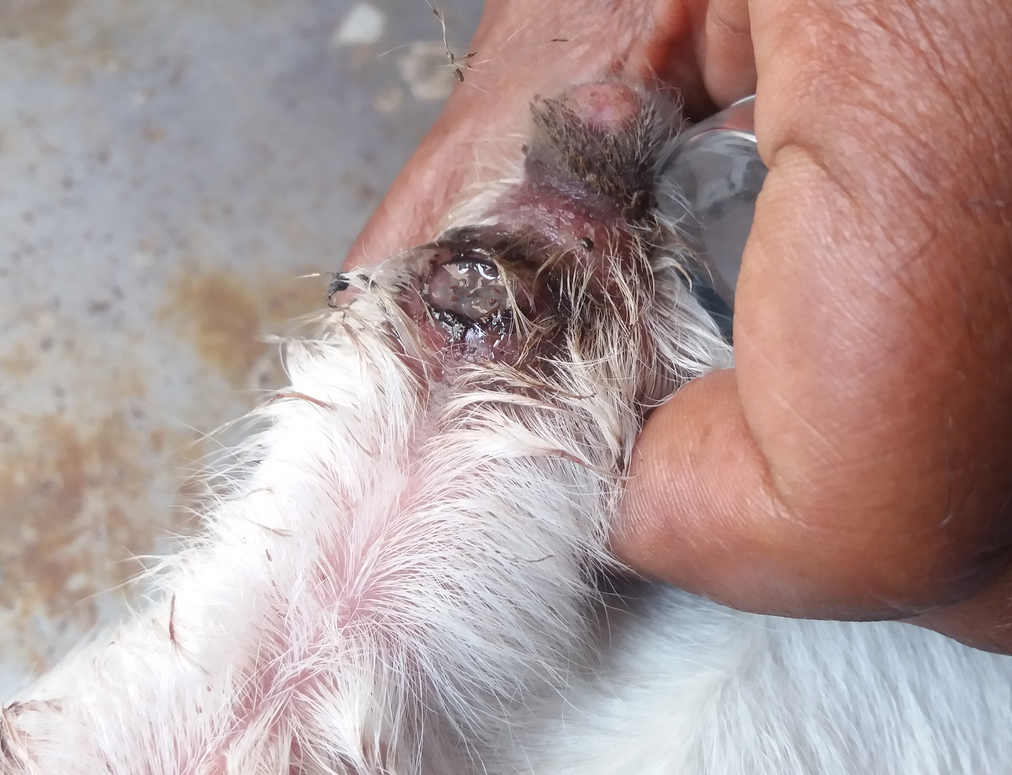

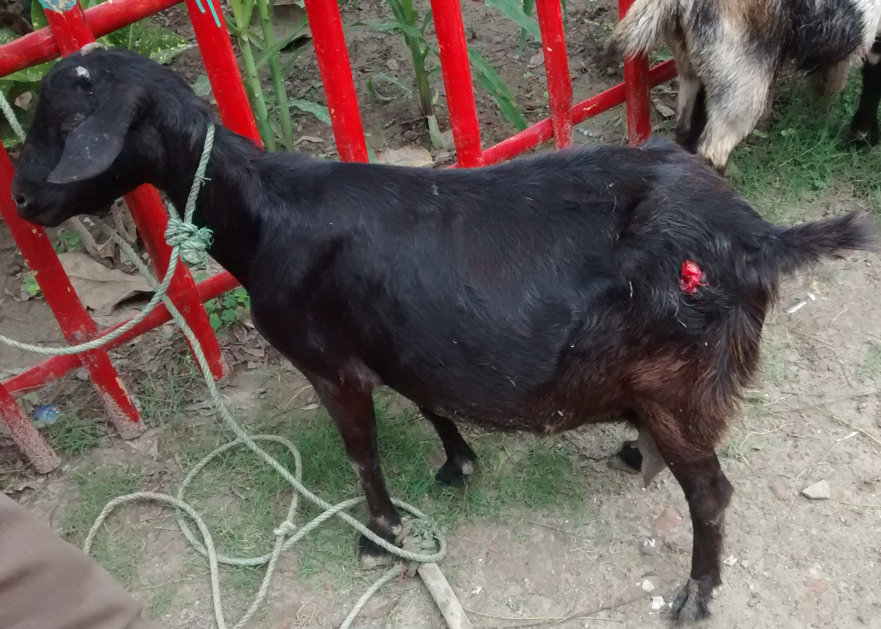

Fig.2 Dog bite wound in Black Bengal goat
Fig.1 Myiasis wound in umbilicus of a calf

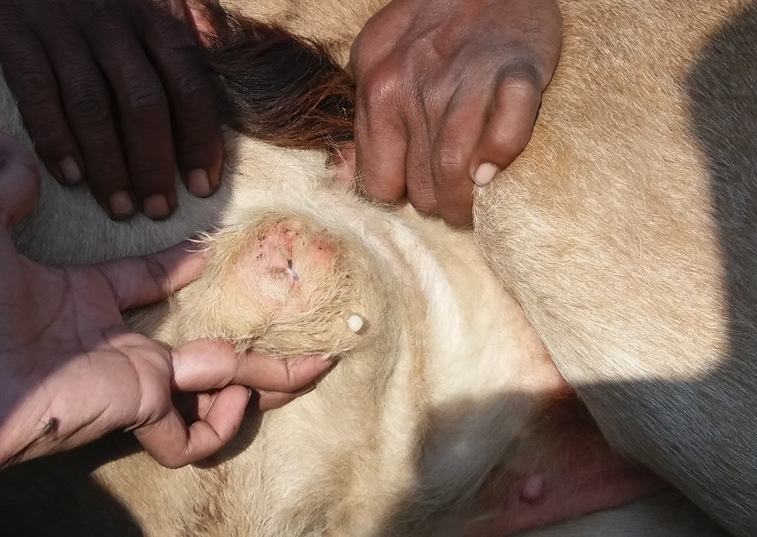
Fig.3 Navel ill in calf
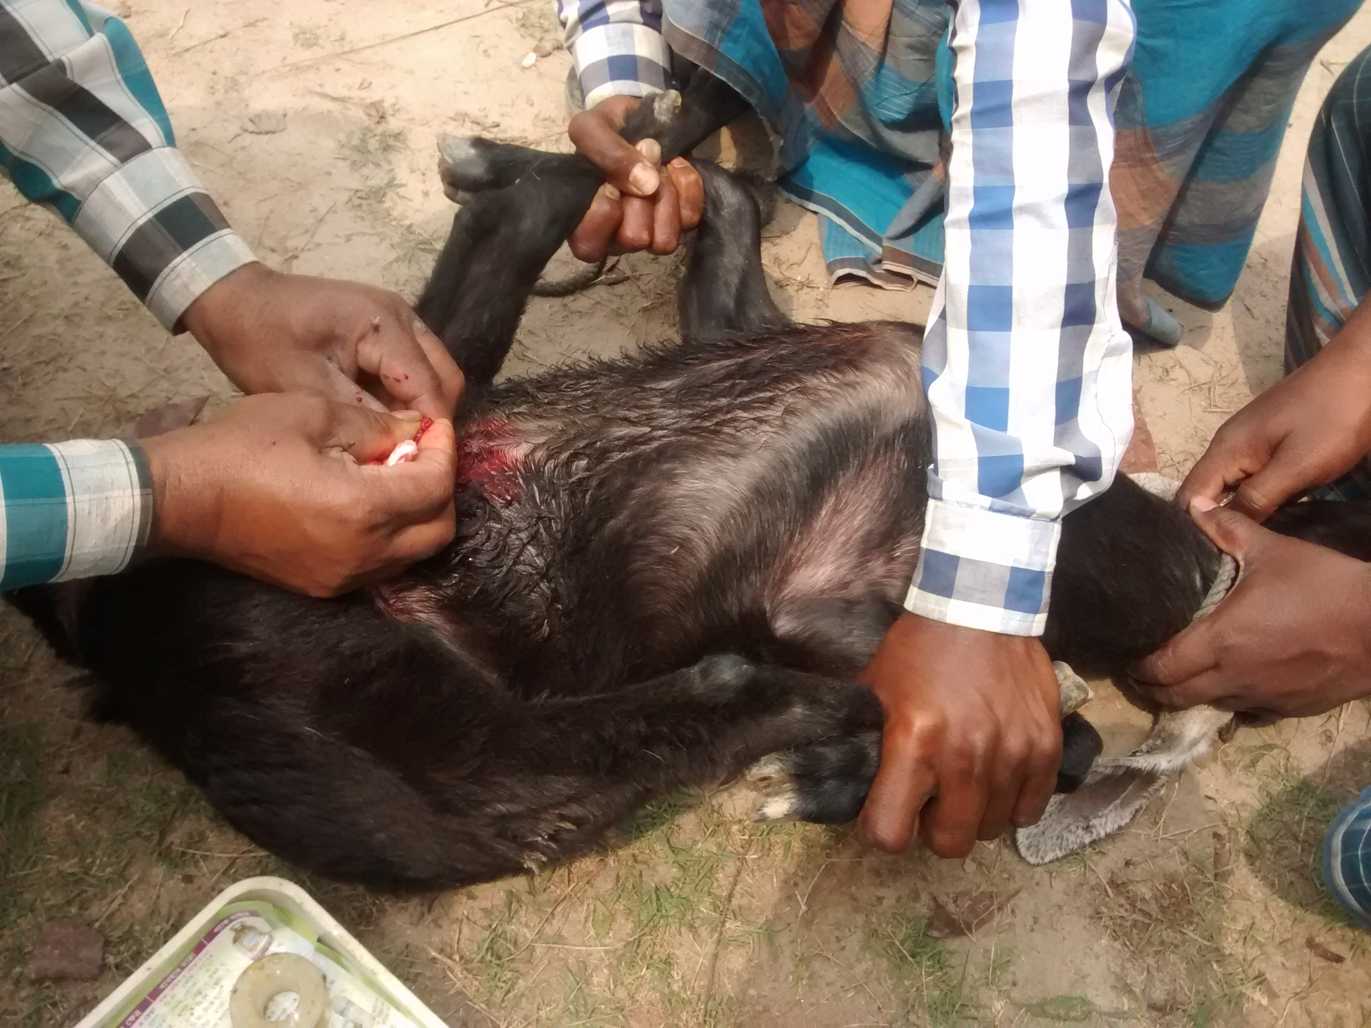

Fig.4 Urolithiasis in goat

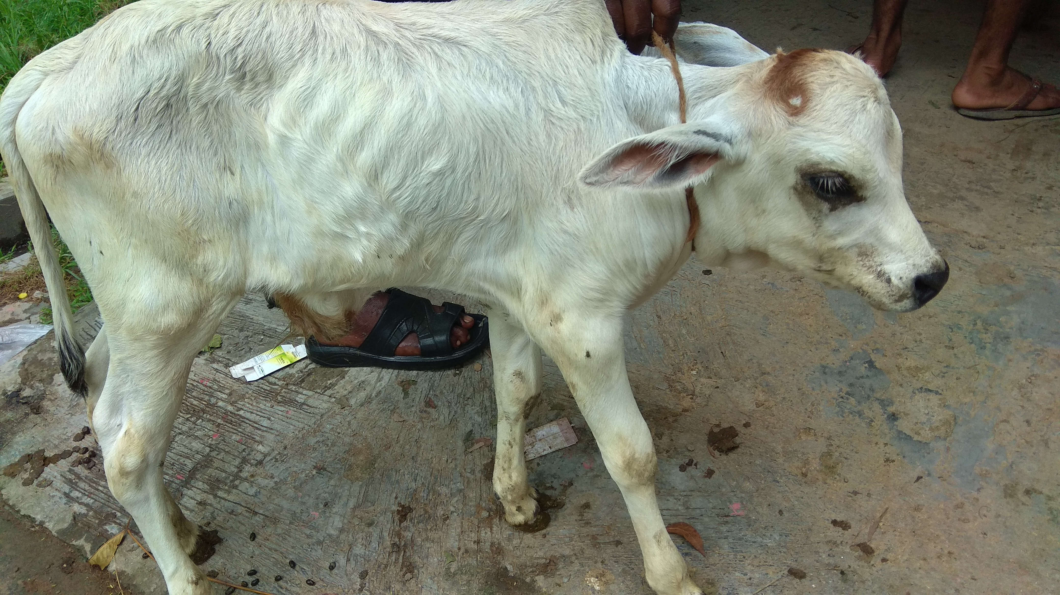

Fig.5 Umbilical hernia in Calf

Fig.6 Atresia ani calf
Table-6: Frequency of different variables (Age, sex, breed) with their different surgical affections in Cattle.

Name of the surgical affection with total no. | Age (yrs) | No. of cases | Frequency  % |  | Breed | No. of cases | Frequency % | Sex | No. of cases | Frequncy %
Dog bite wound  (n = 4) | 0 to 1 | 3 | 75.00 |  | Indigenous | 3 | 75.00 | Male | 2 | 50
 | 1 to 2 | 1 | 25.00 |  | Cross | 1 | 25.00 | Female | 2 | 50
Abcess  (n = 2) | 0 to 1 | 1 | 50.00 |  | Indigenous | 1 | 50.00 | Male | 1 | 50
 | 1 to 2 | 1 | 50.00 |  | Cross | 1 | 50.0 | Female | 1 | 50
Myiasis wound  (n = 4) | 0 to 1 | 3 | 75.00 |  | Indigenous | 3 | 75.00 | Male | 1 | 25
 | 1 to 2 | 1 | 25.0 |  | Cross | 1 | 25.00 | Female | 3 | 75
Navel ill  (n = 7) | 0 to 1 | 7 | 100 |  | Indigenous | 4 | 57.14 | Male | 5 | 71.42
 | 1 to 2 | 0 | 0 |  | Cross | 3 | 42.85 | Female | 2 | 28.57
Umbilical hernia(n= 2) | 0 to 1 | 0 | 0 |  | Indigenous | 2 | 100 | Male | 2 | 100
 | 1 to 2 | 2 | 100 |  | Cross | 0 | 0 | Female | 0 | 0
Fracture  (n = 1) | 0 to 1 | 0 | 0 |  | Indigenous | 1 | 100 | Male | 1 | 100
 | 1 to 2 | 1 | 100 |  | Cross | 0 | 0 | Female | 0 | 0
Atresia ani  (n = 2) | 0 to 1 | 2 | 100 |  | Indigenous | 2 | 100 | Male | 1 | 50
 | 1 to 2 | 0 | 0 |  | Cross | 0 | 0 | Female | 1 | 50

Table-6: Represented that out of 7 cases of Navel ill, the highest Prevalence was recorded in male 50%, 75.00% in 0 to1 years and 75% in indigenous breed respectively on the basis of sex, age, breed.
Out of 4 cases of Myiasis wound, the highest Prevalence was recorded in female 75%, 75.00% in 0 to 1 years and 75% in indigenous breed respectively on the basis of sex, age and breed.
Out of 4 cases of Dog bite wound, the highest Prevalence was recorded in in 0 to 1 years, 75.00% in indigenous breed and 50% in male respectively on the basis of sex, age and breed.
Out of 2 cases of Abcess, the highest Prevalence was recorded 50% % in 0 to 1 years, 50% in indigenous breed and 50% in female respectively on the basis of sex, age and breed.
Out of 2 cases of Umbilical hernia, the highest Prevalence was recorded 100% in 1 to 2 years, 100% in indigenous breed and 100% in male respectively on the basis of sex, age and breed.
Out of 2 cases of Atresia ani, the highest Prevalence was recorded Atresia ani in 0 to 1 years, 100% in indigenous breed and 50% in male respectively on the basis of sex, age and breed.
Out of 1 cases of fracture, the highest Prevalence was recorded 100% in 1 to 2 years, 100% in indigenous breed and 100% in male respectively on the basis of sex, age and breed.
Table-7: Frequency of different variables (Age, sex, breed) with their different surgical affections in Goat.

Name of the surgical affection with total no. | Age (yrs) | No. of cases | Freq.  % | Breed | No. of cases | Freq. % |  | Sex | No. of cases | Freq. %
Dog bite wound  (n = 11) | 0 to 1 | 3 | 27.27 | Black Bengal | 9 | 81.81 |  | Male | 7 | 63.63
 | 1 to 2 | 6 | 54.54 | Jamunapari | 2 | 18.18 |  | Female | 4 | 36.36
 | 2 to 3 | 2 | 18.18
Abcess  (n = 4) | 0 to 1 | 1 | 25 | Black Bengal | 3 | 75 |  | Male | 2 | 50
 | 1 to 2 | 2 | 50 | Jamunapari | 1 | 25 |  | Female | 2 | 50
 | 2 to 3 | 1 | 25
Myiasis wound  (n = 7) | 0 to 1 | 3 | 42.85 | Black Bengal | 5 | 71.42 |  | Male | 3 | 42.85
 | 1 to 2 | 2 | 28.57 | Jamunapari | 2 | 28.57 |  | Female | 4 | 57.14
 | 2 to 3 | 2 | 28.57
Castration  (n = 24) | 0 to 1 | 24 | 100 | Black Bengal | 19 | 79.16 |  | Male | 24 | 100
 | 1 to 2 | 0 | 0 | Jamunapari | 5 | 20.83 |  | Female | 0 | 0
 | 2 to 3 | 0 | 0
Urolithiasis  (n= 13) | 0 to 1 | 3 | 23.07 | Black Bengal | 9 | 69.23 |  | Male | 13 | 100
 | 1 to 2 | 6 | 46.15 | Jamunapari | 4 | 30.76 |  | Female | 0 | 0
 | 2 to 3 | 4 | 30.76
Fracture  (n = 3) | 0 to 1 | 1 | 33.33 | Black Bengal | 2 | 66.66 |  | Male | 3 | 100
 | 1 to 2 | 2 | 66.66 | Jamunapari | 1 | 33.33 |  | Female | 0 | 0
 | 2 to 3 | 0 | 0
Atresia ani  (n = 1) | 0 to 1 | 1 | 100 | Black Bengal | 1 | 100 |  | Male | 1 | 100
 | 1 to 2 | 0 | 0 | Jamunapari | 0 | 0 |  | Female | 0 | 0
 | 2 to 3 | 0 | 0

Table-7: Represented that Out of 24 cases of Castration is the highest Prevalence was recorded 100% in 0 to 1 years, 79.16% in black Bengal goat respectively on the basis of age and breed.
Out of 13 cases of Urolithiasis, the highest Prevalence was recorded 46.15% in 1 to 2 years, 69.23% in black Bengal goat and 100% in male respectively on the basis of sex, age and breed.
Out of 11 cases of Dog bite wound, the highest Prevalence was recorded 54.54% in 1 to 2 years, 81.81% in black Bengal goat and 63.63% in male respectively on the basis of age and breed.
Out of 7 cases of Myiasis wound, the highest Prevalence was recorded 42.85 % in 0 to 1 years, 71.42% in black Bengal goat and 57.14 % in female respectively on the basis of age and breed.
Out of 4 cases of abscess, the highest Prevalence was recorded 50 % in 1 to 2 years, 75% in black Bengal goat and 50 % in male respectively on the basis of age and breed.
Out of 3 cases of Fracture , the highest Prevalence was recorded 66.66% in 1 to 2 years, 66.66% in black Bengal goat and 100 % in male respectively on the basis of age and breed.
Out of 1 cases of Atresia ani, the highest Prevalence was recorded 100% in 0 to 1 years, 100% in black Bengal goat and 100 % in male respectively on the basis of age and breed.

CHAPTER 4: DISCUSSION

The status of animal health depends on surgical affections, infectious diseases, gynaecological
affairs and so on. Among them surgical affections are the front line problems of farmers (Samad, 1998). There is indeed a need for identification of common surgical problems that reduce the fitness and efficiency of cattle and goat hinder profitability of poor farmers. Therefore, the study was aimed to find out the prevalence of surgical problems.

In this study the prevalence of navel ill was 31.81% in cattle which represented the highest occurrence among the surgical affections. These finding were more than the earlier report of (Noman et. al 2013) who reported 6.3% in faridpur area and (Rahman.; et al 1972) reported 9.5% in Mymensingh area. Navel ill is found to be higher in male cattle (71.42%) compared to that in females. This finding is in more than the previous work of Sarkar (2012), who reported 15.07% prevalence of navel ill in Pabna- Sirajgonj.
The prevalence of Urolithiasis was 20.63% in goat which is higher than the earlier report of (Alam et. al 2015) who recorded in 1.02% in Gazipur area and (Noman et. al 2013) who reported 0.5% in faridpur area. The prevalence of Urolithiasis is higher due to insufficient green grass with too much concentrate is provided. Vitamin A deficiency and concentrate diet predispose to urolithiasis (Singh et al., 1980; Ahmed et al., 1990).
The prevalence of dog bite wound was 18.18% in cattle and 17.45% in goat. This observation supports the report of (Islam et al.; 2016) recorded 14% in cattle , 25.7% in goat. Dog bite wound is higher in female animals than male, this observation supported by the report of (Islam et al.; 2016) recorded 14.2% in female goat.
In this study the prevalence of myiasis wound was 18.18% in cattle and 11.1% in goat. These finding were more than the earlier report of (Noman et. al 2013) who reported 3.4% in cattle and (Alam et. al 2015) reported 2.05% in goat. the prevalence of myiasis was found to be higher in females. It is important to mention that vulva and perineal region become traumatized during parturition and appear to be common sites for maggot infestation in female animals (Sarkar, 2012).
The prevalence of abscess was 9.0 9% in cattle and 6.36% in goat. These finding were more than the earlier report of (Samaddar et al.; 2016) who reported 0.83% in cattle and 0.95%
in goat and where (Arju et al.; 2014) reported 0.32% in Cattle.

In this study the prevalence of umbilical hernia was 9.0 9% in cattle, which is supported by the findings of (Noman et. al.; 2013) who reported 3.7% in faridpur area, while (Sarker et al.; 2013) reported that 2.4% in Cattle.
In this study the prevalence of Atresia ani was 9.0 9% in cattle and 1.58% in goat. These finding were more than the earlier report of (Noman et. al.; 2013) who reported 0.4% in cattle and 0.95% in goat and where (Sarker et al.; 2014) reported 0.5 % in Cattle.
In this study the prevalence of fracture was 4.45% in cattle and 4.76% in goat which supported by the findings of (Samaddar et al.; 2016) , who reported 4.42% in goat and 0.23% in Cattle. Where (Sarker et al.; 2014) reported that 1.2% in Cattle.
In this study the prevalence of castration was 24% in goat. These finding were more than the earlier report of (Alam et. al 2015) who reported 0.81% .

LIMITATIONS

The number of clinical cases of different surgical affections in this study was small (85 cases). So, analysis of data is not significant. The diagnosis of different surgical affections were only based on inspection and clinical signs. Diagnostic facility such as X-ray machine for fracture diagnosis is not available in Upazila veterinary hospital.

CONCLUSIONS
The most common cause of disability in animals are the surgical affections, which may be curable if appropriate measures are taken in time. The present study revealed that the highest prevalence of surgical affections was in male indigenous cattle age of 0 to 1 year age and in goat highest prevalence was found in male Black Bengal goat of 0 to 1 year age. The highest prevalence of surgical affections was recorded in cattle was Navel ill and in goat were Castration, Urolithiasis.

REFERENCES

Ali MH, Bhuiyan MKJ and Alam MM (2011). Retrospective epidemiologic study of diseases in
ruminants in Khagrachari Hill Tract District of Bangladesh. Bangladesh Journal of
Veterinary Medicine 9: 145-153.

Alam MA, Amin MR, Paul TK, Saha TK, Rahman MK and Rizon MK (2015). Prevalence of
clinical diseases and disorders of goats at Upazila Livestock Development Center,
Kapasia, Gazipur, Asian Journal of Medical and Biological Research, 1 (1): 47-52

Arju MT, Samaddar K, Rahman MM , Haq MM, Rana MS, Juyena NS, Hasan MR (2014) .
Surgical affections: A comparative scenario of Chittagong region International Journal of
Natural and Social Sciences 1: 37-44

Das BR and Hashim MA (1996). Studies of surgical affections in calves Bangladesh
Agricultural University, Mymensingh. Bangladesh Veterinary Journal, 30 26-33

Duan J, Lee Y, Jania C, Gong J, Rojas M, Burk L, Willis M, Homeister J, Tilley S, Rubin J
and Deb A (2013). Rib fractures and death from deletion of osteoblast βcatenin in adult
mice is rescued by corticosteroids. Plos One, 8: 55757.

DLS (2015-16 ). Annual Report of Directorate of Livestock Services, Bangladesh.

Ganga NS, Ananda KJ, Kavitha RB, Kotresh AM, Shambulingappa BE, Patel SR 2011: Navel
ill in new born calves and its successful treatment. Veterinary World 4 326-327.
Gillitzer R, Goebeler M 2001: Chemokines in cutaneous wound healing. Journal of Leukocyte
Biology 69 513-521.

Hossain MA, M Shaidullah and MA Ali, 1986. A report on surgical diseases and reproductive
disorders recorded at the Veterinary Hospital of Bangladesh Agricultural University,
Mymensingh. Bangladesh Veterinary Journal, 20: 1-5.

Samaddar K, Rahman MM , Haque Z, Mia MH, Kundu P, Rahman MA (2016) . An overview of
surgical diseases of food animals in the coastal areas of Bangladesh International Journal of
Natural and Social Sciences, 3(2): 46-59

Islam KMF, Hossain MI, Jalal S, Quader M N, Kumar S, Islam K, Shawn AI and Hoque A
(2016). Investigation into dog bite in cattle, goats and dog at selected veterinary hospitals
in Bangladesh and India, Journal of Advanced Veterinary and Animal Research, 3(3): 252-
258.

Mashhood AA, Khan TA and Sami AN (2006). Honey compared with 1% silver sulfadiazine
cream in the treatment of superficial and partial thickness burns. Journal of the Pakistan
Association Dermatologist, 16: 14-19.

Millikan L (1999). Myiasis. Clinics in Dematologic, 17 191-195.

Noman ASM, Juyena NS, Alam MM, Ferdousy RN, Paul S and Haq MM, PREVALENCE OF
SURGICAL AFFECTIONS OF CATTLE IN AARONG DAIRY AREA OF PABNA
Progressive Agriculture 24(1 & 2): 85 – 92, 2013

NU Sarker, K Samaddar, MM Haq and MM RahmanSurgical affections of cattle in the milk-
shed areas of Bangladesh, The Bangladesh Veterinarian (2014) 31(1): 38 - 45

Nooruddin M and Dey AS (1990). Further study on the prevalence of skin disease in domestic
ruminants in Bangladesh. Bangladesh Veterinarian, 4: 5-9.

Parker BN (1981). Urolithiasis in calves and lambs. The Veterinary Record, 108: 545-6.

Rahman MA, Ali KM, Rahman A 1972: Incidence of diseases of cattle in Mymensingh.
Bangladesh Veterinary Journal 6 25-30.

Samad MA 1998: Veterinary clinician guide. Bangladesh Agricultural University Campus,
Mymensingh. Lyric-Epic Prokasoni. pp. 23-45.
Sarker MAS, MA Hashim, MB Rahman and H Begum, 1999. Studies on bovine lymphadenitis
syndrome. Bangladesh Veterinarian,10: 6-8.

Sarkar, N. U. 2012. Prevalence of surgical affections of cattle in milk vita area of Pabna-
Sirajgonj. Bangladesh Agricultural University, Mymensingh. The Bangladesh Veterinarian
(2014) 31(1): 38 – 45
Sarker NU, Rahman MM, Rana MS, Islam MT and Rima Uk (2013). Prevalence of surgical
diseases of cattle in stall-fed and free-range cattle in Bangladesh. Bangladesh Veterinarian,
30: 62-69.

Singh NP, Somvanshi R 1980: Urolithiasis in bovine in Tarai. A pathoanatomical study. Indian
Journal of Animal Health 19 19-23.

ACKNOWLEDGEMENTS

The author wishes to acknowledge the immeasurable grace and profound kindness of Almighty “GOD” the supreme authority and supreme ruler of universe, who empowers the author to complete the work successfully.

The author gratefully admits the help of Dr. Pravash Chandra sen, Veterinary Surgeon and Dr. Md. Mizanur Rahman, Upazila Livestock Officer, Upazila Veterinary Hospital, Faridpur sadar, Faridpur for their cordial supervision, scholastic guidance, and valuable suggestion during the entire period of the study.

The author feels proud in expressing his deep sense of great gratitude and indebtedness to respected teacher and tutor Professor Dr. Mohammad Belayet Hossain (Department of Physiology Biochemistry & Pharmacology Faculty of Veterinary Medicine, Chittagong Veterinary And Animal Sciences University) for his trustworthy and scholastic supervision.

BIOGRAPHY

I am Md. Ali Murtaza, son of Mr. Iqbal Hossen and Mrs. Rokeya Mahmuda. I passed Secondary School Certificate examination in 2007 (G.P.A-4.88) followed by Higher Secondary Certificate examination in 2009 (G.PA-4.40). Now I am an intern veterinarian under the Faculty of Veterinary Medicine in Chittagong Veterinary and Animal Sciences University. In the future I would like to work as a veterinary practitioner and do research on clinical animal diseases in Bangladesh.

