TABLE OF CONTENTS
Contents page
LIST OF TABLES……………………………………………………………...……ii
LIST OF FIGURES……………………………………………………………...…..ii
ACKNOWLEDGEMENTS……………………………………………………....... iii
LIST OF ABBREVIATION…………………………………………………….......iv
ABSTRACT……………………………………………………………………….....1
CHAPTER I
INTRODUCTION……………………………………………………………........2-4
CHAPTER II
MATERIALS AND METHODS
2.1. Location and Duration of Study………………………………………...........5
2.2. Study population…………………………………………………………..…..5
2.3. Case definition……………………………………………………………...….6
2.4. Clinical examination of CPV Infection…………………………………..…...6
2.4.1.Data Collection…………………………………………………….........…...6
2.4.2.Clinical Sings & Symptoms……………………………………………..........6
2.4.2. a.Enteritis form……………………………………….……………..............6
2.4.2. b. Myocarditis form…………………………………….…………...............7
2.5. Medication…………………………………………………………….……... .8
2.6. Data Analysis………………………………………………………….…..…..8
CHAPTER III
RESULTS…………………………………………………………………….........9-12
CHAPTER IV
DISCUSSION………………………………………………………………...... ..13-14
CHAPTER V
CONCLUSION………………………………………………………….……........ ..15
REFERENCES……………………………………………………………..........16-18
Annex..……………………………………………………………………..............19
BIOGRAPHY………………………………………………………...……...……..20

LIST OF TABLES

Table No | Contents | page
Table 1 | Drugs were used in CVASU and VCRI-MVC in treatment of CPV Infection.
Table 2 | Prevalence of CPV Infection according to different risk factors at CVASU
Table 3 | Prevalence of CPV Infection according to different risk factors at VCRI-MVC.
Table 4 | Comparison of CPV Infection between CVASU, Bangladesh and VCRI-MVC, India.
Table 5 | Different clinical signs observed among the CPV Infection in dogs.

LIST OF FIGURES

Figure no. |  | Contents | Page
Fig-1 | Study area
Fig-2 | Clinical signs of CPV affected dogs.
Fig- 3 | Frequency distribution percentage of CPV infection based on different risk factors in CVASU and VCRI-MVC.

Acknowledgements
The author bends his head to the Almighty who is omnipotent, omniscient and omnipresent for His endless blessing to conduct clinical report work for the fulfillment of the requirement for the degree of Doctor of Veterinary Medicine (DVM).
The author desires to express his earnest gratefulness and profound appreciation to the following persons for the accomplishment of this dissertation.

The author convening his gratitude and great appreciation to the honorable internship supervisor Prof. Dr. Sharmin Chowdhury, Dept. of Pathology and parasitology, Chittagong Veterinary and Animal Sciences University, for her valuable guidance, suggestion, supervision and encouragements during the entire period of this study to complete this clinical report.

Grateful to Cecilia Joseph Professor and Head, Dept. of clinics, Madras Veterinary College, Chennai 600007, for her suggestion and co-operation in outlining the report work.

The author expresses his thankfulness to Dr. Shivaraman, Assistant Professor, at VCRI, India for his admirable co-operation for performing this report work.

The author expresses his thankfulness to the other teachers, elder brothers of Masters, well-wishers for their co-operation and instructive suggestions.

Last but not least, the author is profoundly grateful to the Father and mother for their endless sympathies, kind co-operation, sacrifices and prayers.

Author
November , 2017

LIST OF ABBREVIATION

Symbols | Abbreviation
CPV | Canine parvovirus
CVASU | Chittagong Veterinary and Animal Sciences University
DNA | Deoxyribonucleic Acid
et al. | And his associates
F | Degree Fahrenheit
GS | German shepherd
MVC | Madras Veterinary College
VCRI | Veterinary college and Research Institute
% | Percentage
> | Greater than
< | Less than

ABSTRACT
Canine parvovirus (CPV) infection is the most highly infectious and contagious viral disease in dogs. A comparative study on canine parvovirus infection among the hospitalized dogs at CVASU (Chittagong Veterinary and Animal Sciences University) in Bangladesh and VCRI-MVC (Veterinary College and Research Institute-Madras Veterinary College) in India was conducted between January 2017 and May 2017. A total of 50 hospitalized dogs at CVASU and 110 hospitalized dogs at VCRI-MVC of different breeds were clinically examined for the diagnosis of CPV Infection. Tentative diagnosis was performed on the basis of history of illness and clinical symptoms expressed by the dogs. The clinical signs was observed among the CPV infected dogs were blood with diarrhoea (91.42%), vomition (94.59%) and dehydration (severe 84.28%, moderate 20.0% and mild 8.0%). Age, sex, breeds of different dog and vaccination status were also considered for risk factors analysis. The overall prevalence of CPV infection was higher in VCRI-MVC (45.45%) than CVASU (42%).The prevalence of CPV was varied significant (P<0.05) among different age, vaccinated and non-vaccinated dog. Highest prevalence 52.94% was found in 1-3 months, 36.67% in 4-6 months and 33.33% in > 6 months old dogs respectively. Highest prevalence was observed in non-vaccinated (60%) compared to vaccinated (8.8%) dogs at CVASU, Bangladesh. In VCRI-MVC, India rate of infection also varied significantly (P<0.05) according to different age groups (81.82%, 38.18%, 9.09% among 1-3 months, 4-6 months and > 6 months respectively) and 14.29% in vaccinated and 64.71% in non-vaccinated groups. Significant (P<0.05) variation also observed in different breeds of dogs 61.9%, 60.0%, 37.14%, 29.17% and 40.0%, among Indigenous, GS, Rottweiler, Spitz and Doberman respectively. The current study was based on hospitalized patients, so a comprehensive study including all the dog population is required to precisely conclude about the prevalence and risk factors of CPV infections both in Bangladesh and India.

Key Words: CPV,CVASU, VCRI-MVC,Prevalence.

CHAPTER-I
INTRODUCTION
Canine parvovirus (CPV) infection is an infectious and highly contagious viral illness that affects dogs. The name ‘Parvovirus’ originated from the Latin word “Parvus” which means small. It is a non-enveloped virus having a single stranded DNA genome belonging the family of Parvoviridae(Appel et al., 1978).CPV is genetically and antigenically unrelated to canine minute virus (CnMV), formerly known as canine parvovirus type 1 (CPV-1), which is responsible for neonatal death in dogs (Tattersall et al., 2005). Dogs of all age groups are susceptible but puppies of age less than 3 months are highly susceptible than adults (Beheraet al., 2015). Thisvirus causes high morbidity (100%) and frequent mortality up to 10% in adult dogs and 91% in pups(Appel et al., 1978). Canine parvovirus (CPV) emerged in the late 1970s, probably from feline panleukopenia virus via genetic mutations and evolution (Tattersall et al., 2005). It has been stated that Doberman, Rottweiler and German shepherd (GS) dogs are more susceptible to Parvovirus infection than other breeds (Ling et al., 2012). Unvaccinated puppies aged between six weeks and six months are at greatest risk of developing CPV related disease(Godsall et al., 2010) .

Transmission of the infection can be occurred by direct or indirect ingestion or exposure to fecal materials from infected dogs. The virus is shed through the feces ofinfected dogs within 4-5 days of exposure and also persists during the period of illness. After clinical recovery the patient can remain in infective stage for several months under good environmental condition (Uzuegbu, 2015). CPV is commonly resistant to physical and chemical inactivation. So it has been identified remaining viable in the extracellular state for months and even years (Appel et al., 1978). After exposure to virus, adult dogs may remain apparently healthy but act as a carrier for the transmission of the virus to the susceptible dogs. After penetration through the oral and nasal route, the virus replicates in gastroenteric associated lymphoid tissues and it is disseminated by infected leukocytes to the germinal epithelium of the crypts of the small intestine which may lead to diarrhea (Decaro et al., 2008).

The virus manifests clinical signs in two different forms: 1.intestinal form 2.cardiac form (Greene, 2013).The most common form of the disease is enteritis. It is characterized by vomition, diarrhea and dehydration, weight loss, anorexia, brownish or bloody and foul smelling diarrhoea and in severe cases fever (Pollock et al., 1993). The course of illness is also highly variable depending on the infectious dose of the virus and clinical signs usually develop from 3 to 5 days following infection and typically persist for 5 to 7 days (Fletcher et al., 1979). The less common form is the cardiac form which attacks the heart muscles of very young puppies, often leading to death. Within infected pups70% usually dies in heart failure by 8 weeks of age and the remaining 30% gets pathological changes which may result in death many months or even years later. The most dramatic manifestation of CPV-2 myocarditis is the sudden death in young pups usually about 4 weeks of age (Mochizuki et al., 1996)
The clinical manifestation of CPV infection depends on the age and immune status of the dogs, virulence of the virus, dose of the virus and pre-existing or concurrent parasitic, bacterial or viral infections (McAdaragh et al., 1982). Factors that predispose toparvovirus infection in puppies are lack of protective immunity, intestinal parasites, overcrowded, unsanitary, and stressful environmental conditions (Hoskins, 1997). Effective vaccination is required for the prevention of CPV infection. Both modified live (ML) and inactivated parvovirus vaccines have been used to protect susceptible pups. Puppies get protection during the first few weeks of their life through colostrum. The duration of immunity depends on how much colostrum a puppy has received in its first 2-3 days of life (Gore et al., 2004).

The prevalence of CPV was reported as 77-80.4% in Thailand, 82.9% in Korea and 6% in Lithuania (Grigonis et al., 2002). Prevalence of CPV infection differs from one geographical area to another with the different antigenic variants. In Africa, CPV strains 2a, 2b and 2c have been reported in several countries including Tunisia, Nigeria, Republic of South Africa, Kenya, Zambia, Zimbabwe (Mwalongo et al.). The outbreak of CPV disease in dogs was also reported in Belgium and France (1977), Thailand, USA (1978), Portugal, Pakistan, Italy, Spain, Germany(Lamm and Rezabek, 2008) . In India 1st outbreak of CPV infection was reported in Madras (1981) and in Bombay (1985)(Haque and Arfa, 2012) . Though diarrhea is one of the most common clinical features faced by the pet practitioners, in Bangladesh, there is no published literature on CPV in dogs (Islam et al., 2014).

With the background mentioned above this study was undertaken with the following specific objectives:

- To estimate the Prevalence of CPV infection at CVASU in Bangladesh and at VCRI-MVC in India.
- To evaluate the associated risk factors of CPV infection.
- To compare, CPV infection along with its associated risk factorsbetween CVASU, Bangladesh and VCRI -MVC , India

CHAPTER-II
Materials and Methods
2.1. Location and duration of study
The study was conducted at Chittagong veterinary and Animal Sciences University (CVASU) Bangladesh, at veterinary college and research institute (VCRI) and Madras veterinary college (MVC) hospital in India during the month of January 2017 to march 2017 (60 days) and April 2017 to May 2017 (30 days), respectively.
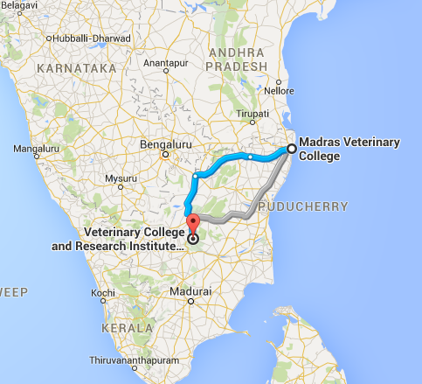
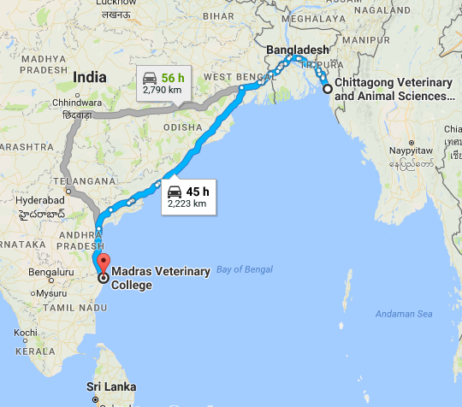

Fig 1- Study area
2.2. Study population
The hospitalized dogs were considered as study population. In CVASU and VCRI-MVC about 50 and 110 dogs of different breeds (indigenous and exotic breed i.e. Spitz, Pug, Doberman, Rottweilerand GS) were clinically examined respectively during the study period.
Total no of dogs were separated into different categories such as age, sex, breed and vaccination status.

2.3. Case Definition
Diagnosis was made by anamnesis and clinical signs observed. In CPV infection the main clinical signs were high fever (104-105˚F), vomition, blood with diarrhea.If a dog showed a signs of high fever, vomition, blood with diarrhea, anemia, dehydration, it was suspected as a CPV infection. Anemia was detected by pale mucous membrane. The degree of dehydration was estimated by skin fold test.
2.4. Clinical examination of Canine Parvovirus Infection
2.4.1. Data collection
Questionnaire was developed according to age, sex, breed, history of vaccination, clinical history and data were collected by interviewing owner. Rectal temperature, heart rate and respiration rate of the sample dog was measured. Skin fold test was performed to estimate the degree of dehydration. Then the clinical signs and symptoms were observed carefully. All the clinical signs and symptoms were separately recorded for each clinical case.
2.4.2.. Clinical signs and symptoms
The disease is occurred in two forms-
1. Intestinal form (Enteritis)
2.Cardiac form(Myocarditis)
The following clinical Signs were observed while treating the Patients -
2.4.2.a.Enteritis Form
- Symptoms appear within 3 to 5 days after exposure including depression,loss of appetite.
- High fever (above 104˚F).
- Vomition.
- Bloody diarrhea are often seen, feces are generally light grey or yellow gray and may be streaked with blood.
- Severe anemia.
- If the animal is not treated,finally death occur within a few days due to hypovolumic shock and also associated with secondary bacterial sepsis.
2.4.2.Cardiac Form
It is usually seen in younger puppies less than 8 weeks of age.
- Dyspnea, crying and retching finally death occurs within 24 hours.
- Sometimes diarrhea and death occurs without showing cardiac signs.
- Cardiac failure, sudden death.
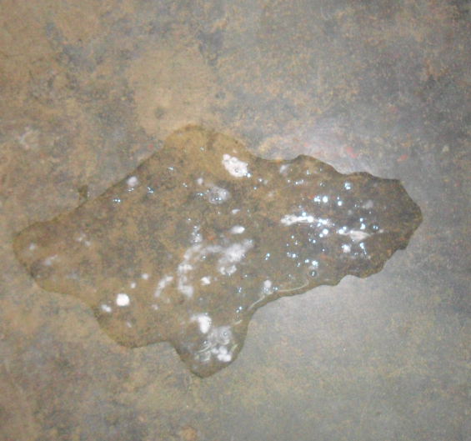
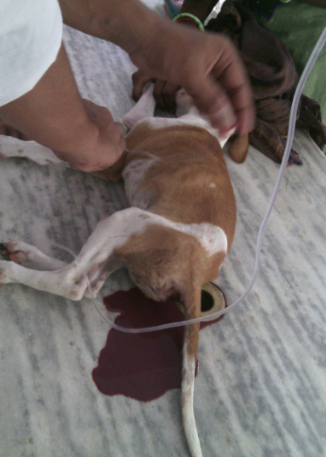
a.Bloody diarrhea b. Vomition

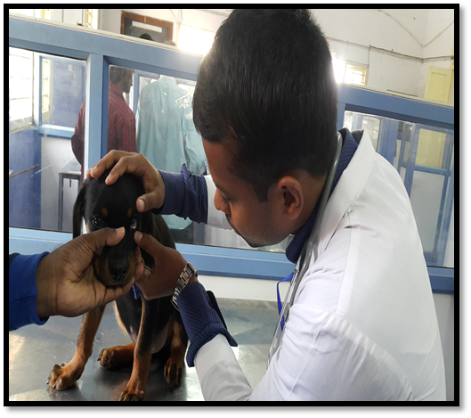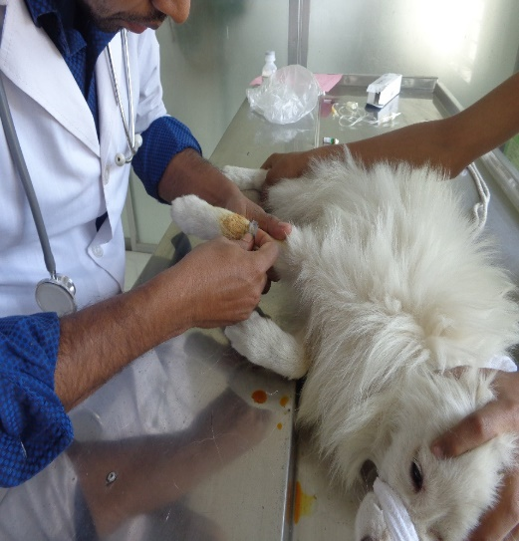
C. Severe anemia(pale mucous membrane) d. Administration of drugs.

Fig 2-Clinical signs of Canine Parvovirus affected dog

2.5. Medication
There is no specific treatment for the disease. Antibiotic was administered to prevent secondary bacterial infection. Supportive treatment – electrolytes were administered for rehydration to prevent hypovolumic shock, anti-emetics was administered to prevent vomition.
Table-1:Drugs were used in CVASUand VCRI-MVC in treatment of CPV
Infection.
Treatment | CVASU, Bangladesh | VCRI , MVC , India
1.Electrolytes | Normal saline (NS) | Ringer’s lactate ( RL)
2.Antibiotic | Cephalosporin | Amoxicillin and Cloxacillin
3.Anti-emetics | Emistst | Ondensetron
4.Other | Neotak | Pantoprazole

2.6. Statistical Analysis
All the data including categorical variables –age, sex, breed, vaccination status, dehydration, bloody diarrhea and diagnosiswereentered into MS excel (Microsoft Office Excel-2010). Then the data was cleaned, coded, recodedand finally analyzed using statistical software STATA Version-11 (STATA Corporation, College Station, Texus). Prevalence was calculated according to different categories of the explanatory variables. To identify the association between a categorical explanatory variable with the outcomes (Occurrence of CPV infection), Chi-square (ᵪ²) test was performed. The association was regarded as significant if the P value was < 0.05 and highly significant when p value was 0.01.

CHAPTER-III
Results
In CVASU among the 50 clinically sick dogs, 21 were found positive for CPV infection. Prevalence of different risk factors (age, sex, breed, vaccination status, dehydration and diarrhea) associated with CPV disease is summarized in Table-2.
Table 2-Prevalence of CPV Infection according to different risk factors at CVASU
Variables | Category level | No of observation  (N=50) | Positive Case | Proportionate Prevalence  % | P value
Age | 1-3 month | 17 | 9 | 52.94 | 0.073
 | - Month | 30 | 11 | 36.67
 | >6 month | 3 | 1 | 33.33
Sex | Male | 28 | 11 | 29.29 | 0.661
 | Female | 22 | 10 | 45.45
Breed | Indigenous | 18 | 10 | 55.55 | 0.202
 | GS | 11 | 5 | 45.45
 | Rottweiler | 9 | 3 | 33.33
 | Spitz | 9 | 2 | 22.22
 | Doberman | 3 | 1 | 33.33
Vaccination | Yes | 16 | 3 | 18.75 | 0.161
 | No | 34 | 18 | 52.94

The study revealed that, the overall prevalence of CPV infection during the study period at CVASU in Bangladesh was 42%.The prevalence of CPV infection in different age group differed insignificantly (P<0.05) and these were 52.94% for 1-3 months, 36.67% for 4-6 months and 33.33% for above 6 months of ages. Between two different sexes the prevalence was found higher in female (45.45%) than male (29.29%), however the relationship was not significant statistically. Among the breeds the rate of infections were encountered as 33.33% in Doberman, 22.22% in Spitz, 33.33% in Rottweiler, 45.45 % in GS, 55.55% in Indigenous in which were differed insignificantly (P>0.05). While considering vaccination status against CPV there observed a substantial difference (P<0.01) in occurrence of CPV infection which were 18.75% in vaccinated dogs and 52.94% in non-vaccinated dogs.

At VCRI-MVC, in India-110 dogs were studied, of which 50 were found positive. The risk factors (age, sex, breed and vaccination status) that might have influenced the prevalence of CPV infection are summarized in Table-3.
Table 3- Prevalence of CPV Infection according to different risk factors in VCRI-MVC.

Variables | Category level | No of Observation (N=110) | positive  case | Proportionate  Prevalence % | P value
Age | 1-3 month | 33 | 27 | 81.82 | 0.000
 | 4-6 month | 55 | 21 | 38.18
 | >6 month | 22 | 2 | 9.09
Sex | Male | 59 | 30 | 50.85 | 0.222
 | Female | 51 | 20 | 39.22
Breed | Indigenous | 21 | 13 | 61.90 | 0.06
 | GS | 25 | 15 | 60.00
 | Rottweiler | 35 | 13 | 37.14
 | Spitz | 24 | 7 | 29.17
 | Doberman | 5 | 2 | 40.00
Vaccination | Yes | 42 | 6 | 14.29 | 0.000
 | No | 68 | 44 | 64.71

The estimated prevalence of CPV disease at VCRI-MVC in India was 45.45%. Prevalence was significantly differed (P<0.05) according to age groups, it was 81.82% for 1-3 months, 38.18% for 4-6 months, and 9.09% for above 6 months. Between male and female, prevalence was not statistically significant (P<0.05) where 50.85% male, and 39.22% females were affected. Among the breeds of dog, prevalence was significantly varied; (P<0.05) 60.00% for GS, 61.90% for Indigenous, 37.14% for Rottweiler, 29.17% for Spitz and 40% for Doberman. Moreover vaccinate
14.29% and Non-vaccinated 64.71% dogs were significantly (P<0.05) affected with CPV infection.
Table-4: Comparison on prevalence of CPV Infection between CVASU, Bangladesh and VCRI-MVC, India.
Variables | Category level | Proportionate prevalence %  (CVASU, Bangladesh) | Proportionate prevalence %  (VCRI MVC , India ) | P value
Age | 1-3 month | 52.94 | 81.82 | 0.610
 | 4-6 month | 36.67 | 38.18 | 0.242
 | >6 month | 33.33 | 9.09 | 0.023
Sex | Male | 29.29 | 50.85 | 0.779
 | Female | 45.45 | 39.22 | 0.389
Breed | Indigenous | 55.55 | 61.90 | 0.010
 | GS | 45.45 | 60.00 | 0.460
 | Rottweiler | 33.33 | 37.14 | 0.035
 | Spitz | 22.22 | 29.17 | 0.291
 | Doberman | 33.33 | 40.00 | 0.348
Vaccination | Vaccinated | 8.8 | 14.29 | 0.226
 | Non-vaccinated | 60.0 | 64.71 | 0.227

Table 4 represents the data of comparative study of CPV associated risk factors. It was revealed that the prevalence of different risk factors associated with CPV infections was insignificant (P> 0.05) between CVASU and VCRI-MVC.
Table-5: Different clinical signs observed among the CPV Infection in dogs.
Variables | Category | No of Observation (N) | Positive case | %
Bloody  Diarrhea | Yes | 70 | 64 | 91.42
 | No | 90 | 7 | 7.78
Vomition | Yes | 74 | 70 | 94.59
 | No | 86 | 1 | 1.16
Dehydration | Severe | 70 | 59 | 84.28
 | Moderate | 40 | 8 | 20
 | Mild | 50 | 4 | 8
Study revealed that in 91.42% blood with diarrhea, 94.59% vomition and 84.28% Severe, 20.0% moderate, 8.0% mild dehydration were recorded in CPV infection (positive) in dogs.

a. Age wise prevalence b. Sex wiseprevalence

- Age wise prevalence b. Sex wise prevalence

c. Breed wise prevalence d. Vaccination wise prevalence
Fig- 3:Frequency distribution percentage of CPV infection based on different risk factor In CVASU and VCRI-MVC.

CHAPTER-IV
Discussion
We estimated an overall prevalence of CPV infection in suspected dogs in CVASU as 42%. The result is in agreement with a previous reports from Bangladesh where prevalence of CPV in street dogs, at Mymensingh metropolitan city was estimated as 30.0% (Islam et al., 2014). Overall prevalence of CPV infection in suspected dogs in VCRI-MVC, India was 45.45%. Similar findings were reported previously where prevalence was 40.8% (Behera et al., 2015).
Prevalence of CPV infection is higher in India than Bangladesh .This might be due to presence of endemic infection in the population under study at VCRI-MVC in India.
Prevalence of CPV infection was higher among 1-3 months of age group than other age groups (table-2,3) which support the study conducted by Vivek, ( 2011). Younger puppies (≤ 3 months) are mostly affected which might be due to the affinity of the virus being multiply rapidly at intestinal crypt cells at the weaning age along with higher mitotic index. Prevalence of CPV infection below 3 months of age was insignificantly higher in VCRI, MVC than CVASU (Fig-3.a).

In CVASU, prevalence of CPV infection was slightly higher in female (45.45%) compared with male (29.29%). The study was in agreement with Islam et al., (2014). Oppositely male dogs were more susceptible (50.85%) than the female (39.22%) at VCRI-MVC (Table 3), supported with Umar et al., (2015). The susceptibility of male was higher in CPV infection (India) however in Bangladesh female was more susceptible (Fig-3.b). It might be due to most of the Indian people kept female for breeding purpose than Bangladeshi people.
Breed wise distribution shown that prevalence of CPV disease was more in local indigenous breeds than exotic breeds at CVASU. Among the exotic breeds Spitz, GS, Doberman were more susceptible (Table-2). Among the breeds in VCRI-MVC, The occurrence of CPV infectionis significantly higher in local indigenous than the exotic breeds (Table-4) which supported by published papers (Shukla et al., 2009). This study also exposed that among the exotic breeds, GS, Doberman were higher in susceptibility than the other breeds due to inherited immunodeficiency. It was supported by previous reports (Singh et al., 2013) where CPV infection was highest in Indigenous (55.55%), followed by German shepherd (45.45%). In CVASU, Spitz was more susceptible (Fig-3.c) might be due to its small size & most preferable breed in Bangladeshi people. In MVC-VCRI local indigenous dogs were higher susceptible due to higher population density of this breed, poor vaccination and lack of awareness. Among exotic breeds GS, Doberman were highly susceptible.
In non-vaccinated dogs the prevalence was higher compared to vaccinated ones (plate-3.d). The findings is in agreement with published report (Godsall et al., 2010) where unvaccinated puppies aged between six weeks and six months were at greatest risk of developing CPV infection. The higher prevalence of CPV infection in non-vaccinated dogs might be due to lack of protective immunity. In vaccinated dogs there was presence of CPV infection might be occurred due to, incomplete or ineffective primary vaccination course, or failure of vaccination.
The study was performed on the basis of tentative diagnosis by observing clinical signs and symptoms. The main clinical signs of CPV disease are blood with diarrhea, vomition, dehydration. The study findings were in agreement with Thomson and Gagnon, (1978); Prittie,(2004).

In 91.42% and 94.59% CPV positive dogs, there were presence of blood with diarrhea and vomition (Table-5). Similar finding was also reported previously by Thomson and Gagnon,(1978).
84.28% CPV positive dogs had severe dehydration (Table-5) which is supported by previous study (Laforcade et al., 2003).

CHAPTER-V
CONCLUSION
Canine Parvovirus is an infectious and highly contagious viral disease of dogs. Dogs of all age groups are infected but puppies age less than 3 months are highly susceptible than adults. Both male and female are affected with CPV infection. Both indigenous an exotic breeds (German shepherd, Doberman, Spitz, Rottweiller), are susceptible in CPV infection. The rate of infection is high in non-vaccinated than vaccinated dogs. Due to the short duration of the study period the sample size of current study was not sufficient. CPV infection was mainly diagnosed by taking clinical history from owner and by observing the clinical findings. If confirmatory diagnosis was done then the result would be more precise. The current study was based on hospitalized patients, so a comprehensive study of all the dog population is required to identify the actual prevalence and risk factors of CPV infections both in Bangladesh and India.

REFERENCES

Appel, M., Cooper, B., Greisen, H., Carmichael, L., 1978. Status-Report-Canine Viral-Enteritis. Amer Veterinary Medical Assoc 1931 N Meacham Rd Suite 100, Schaumburg, Il 60173-4360.
Appel, M., Scott, F., Carmichael, L., 1979. Isolation and immunisation studies of a canine parco-like virus from dogs with haemorrhagic enteritis. The Veterinary Record105, 156-159.
Behera, M., Panda, S., Sahoo, P., Acharya, A., Patra, R., Das, S., Pati, S., 2015. Epidemiological study of canine parvovirus infection in and around Bhubaneswar, Odisha, India. Veterinary World8, 33-37.
Decaro, N., Desario, C., Elia, G., Martella, V., Mari, V., Lavazza, A., Nardi, M., Buonavoglia, C., 2008. Evidence for immunisation failure in vaccinated adult dogs infected with canine parvovirus type 2c. Microbiologica-Quarterly Journal of Microbiological Sciences31, 125-130.
Fletcher, K., Eugster, A.K., Schmidt, R., Hubbard, G., 1979. Parvovirus infection in maned wolves. Journal of the American Veterinary Medical Association175, 897-900.
Godsall, S., Clegg, S., Stavisky, J., Radford, A., Pinchbeck, G., 2010. Epidemiology of canine parvovirus and coronavirus in dogs presented with severe diarrhoea to PDSA PetAid hospitals. Vet Rec167, 196-201.
Gore, T.C., Lakshmanan, N., Duncan, K.L., Coyne, M.J., Lum, M.A., Sterner, F.J., 2004. Three-year duration of immunity in dogs following vaccination against canine adenovirus type-1, canine parvovirus, and canine distemper virus. Veterinary therapeutics: research in applied veterinary medicine6, 5-14.
Greene, C.E., 2013. Infectious diseases of the dog and cat. Elsevier Health Sciences.
Grigonis, A., Mačijauskas, V., Zamokas, G., 2002. Examination of liver functions in dogs with parvovirus enteritis. Veterinarija ir Zootechnika T17, 39.
Haque, S., Arfa, T., 2012. Epidemeological Study Of Parvo Gastroenteritis and its Managementby Different Concentrations of Fluid in Pups. Indian Journal of Canine Practice Volume4, 83.
Hoskins, J.D., 1997. Update on canine parvoviral enteritis. Veterinary medicine (1985)(USA).
Islam, M.R., Islam, M.A., Rahman, M.S., Uddin, M.J., Sarker, M.A.S., Akter, L., Alam, E., 2014. Prevalence of Canine Parvovirus Infection in Street Dogs in Mymensingh Municipality area, Bangladesh. Microbes and Health3, 5-6.
Laforcade, A.M., Freeman, L.M., Shaw, S.P., Brooks, M.B., Rozanski, E.A., Rush, J.E., 2003. Hemostatic changes in dogs with naturally occurring sepsis. Journal of Veterinary Internal Medicine17, 674-679.
Lamm, C.G., Rezabek, G.B., 2008. Parvovirus infection in domestic companion animals. Veterinary Clinics of North America: Small Animal Practice38, 837-850.
Ling, M., Norris, J.M., Kelman, M., Ward, M.P., 2012. Risk factors for death from canine parvoviral-related disease in Australia. Veterinary microbiology158, 280-290.
McAdaragh, J., Eustis, S., Nelson, D., Stotz, I., Kenefick, K., 1982. Experimental infection of conventional dogs with canine parvovirus. American journal of veterinary research43, 693-696.
Mochizuki, M., Horiuchi, M., Hiragi, H., San Gabriel, M.C., Yasuda, N., Uno, T., 1996. Isolation of canine parvovirus from a cat manifesting clinical signs of feline panleukopenia. Journal of Clinical Microbiology34, 2101-2105.
Mwalongo, O., Shahada, F., Bigambo, M., Gwakisa, P., Lankester, F., Prevalence of Canine Parvovirus in Domestic Dogs around Serengeti National Park (Tanzania).
Pollock, R.V., Coyne, M.J., 1993. Canine parvovirus. Veterinary Clinics of North America: Small animal practice23, 555-568.
Prittie, J., 2004. Canine parvoviral enteritis: a review of diagnosis, management, and prevention. Journal of Veterinary Emergency and Critical Care14, 167-176.
Shukla, P., Gupta, D., Kumar, B., 2009. Epidemiology on canine parvovirus infection. Indian Journal of Veterinary Research18, 42-44.
Singh, D., Verma, A.K., Kumar, A., Srivastava, M., Singh, S.K., Tripathi, A.K., Srivastava, A., Ahmed, I., 2013. Detection of canine parvovirus by polymerase chain reaction assay and its prevalence in dogs in and around Mathura, Uttar Pradesh, India. Am. J. Biochem. Mol. Biol3, 264-270.
Thomson, G., Gagnon, A., 1978. Canine gastroenteritis associated with a parvovirus-like agent. The Canadian Veterinary Journal19, 346.
Umar, S., Ali, A., Younus, M., Maan, M.K., Ali, S., Khan, W.A., Irfan, M., 2015. Prevalence of Canine Parvovirus Infection at Different Pet Clinics in Lahore, Pakistan. Pakistan J. Zool47, 657-663.
Uzuegbu, O., 2015. A Case Report on Suspected Parvoviral Enteritis in a Dog.
Vivek, V., 2011. Molecular epidemiology of canine parvovirus in Southern India. MVSc thesis. Pondicherry University, Puducherry.

Annex
Questionnaire

Case no- | Date-

1. Name of the Hospital: ....………………………………….....
2. Name of the Owner: …………………………………………
3. Owner Address: ……..……………………………………….
4. Age of the dog: 1-3 months / 4-6 months / above 6 months.
5. Sex: Male / Female.
6.Name of the breed: Indigenous / Exotic (Spitz / Lhasa / Doberman / German shepherd).
7. Vaccination Status: Yes / No
8. Fever: Yes / No.
9. Bloody diarrhea: present / absent.
10. Dehydration level: Severe / Moderate / Mild.
11.Vomition: present / absent
12. Diagnosis: Canine parvovirus infection - Positive / Negative.
13. Medication: …………………………………………………..

BIOGRAPHY

I am Nipul Bairagi, son of Nikhil Ranjan Bairagi and Sabita Rani Bairagi. I passed Secondary School Certificate examination in 2008 (G.P.A-5.00) followed by Higher Secondary Certificate examination in 2010 (G.P.A-5.00). Now I am an intern veterinarian under the Faculty of Veterinary Medicine in Chittagong Veterinary and Animal Sciences University. In future I would like to work as a veterinary practitioner and do research on zoonotic diseases in Bangladesh.

