STUDY ON NITRATE POISONING OF CATTLE AT GAIBANDHA, BANGLADESH.
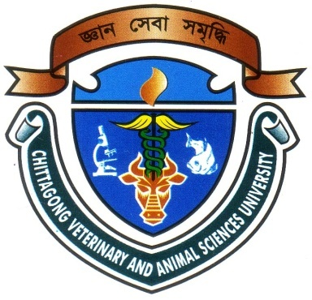

A Clinical Report Presented in Partial Fulfillment of the Requirement for the Degree of Doctor of Veterinary Medicine (DVM)

A Report submitted

By

Intern ID: D-31

Roll No: 12/35

Reg. No: 763

Session: 2011-2012

Faculty of Veterinary Medicine

Chittagong Veterinary and Animal Sciences University

Khulshi, Chittagong-4202

OCTOBER, 2017
IV

STUDY ON NITRATE POISONING OF CATTLE AT GAIBANDHA, BANGLADESH.

A Clinical Report Submitted as per approved style and content

--------------------------  (Signature of Author)  S M Ahosanul Alam Rajon  Roll No: 12/35  Reg. No: 763  Intern ID: D-31  Session: 2011-2012 | -------------------------------  (Signature of Supervisor)  Professor Dr. AMAM Zonaed Siddiki  Department of Pathology & Parasitology

Chittagong Veterinary and Animal Sciences University

Khulshi, Chittagong-4202
OCTOBER, 2017
IV

