CHAPTER-1
INTRODUCTION
Fracture is the discontinuation of the bony continuity with or without displacement of fragments (Jenny, 1970; Denny, 1993). Among lameness problems Caprine long bone fractures and degenerative joint diseases are most common. Trauma is the most common cause of fractures in animals and is usually due to direct impact from automobile injury, falling from height, bite or kick (O’Conner, 2005; Harvey et al., 1991; Denny, 1993, Hosgood and Hoskins, 1998). Frightened or weary goat can be got captured by the limb leading to serious fractures or dislocations (Smith and Sherman, 2009). The curiosity and climbing instincts of goats fracture secondary to struggling, trauma from dog attacks are common causes of limb bone fractures in goats.
In most cases, the clinical signs associated with fractures are lameness, pain, local swelling, abnormal posture, and crepitating sound on palpation, abnormal mobility of involved bone, fever, anemia, shock, and neurological deficit. Although all of the above signs do not always occur in all fractures, combinations of these signs are always present (Kumar, 2004; O’Conner, 2005). These make a tentative diagnosis of the problem but radiography is confirmatory (Denny, 1993). Clinical examination should be performed correctly for diagnosis of the fracture. For correct diagnosis, more appropriate diagnostic method is needed such as radiographs, and computed tomography (Fossum et al., 2007). These methods help to diagnose the patient having the bone fracture. After confirmative diagnosis, the appropriate treatment has to be selected. Fastest healing and the anatomical reconstruction of the structure is the ultimate aim of fracture repair (Aron, 1998; Shahar, 2000).
Reduction, retention, and immobilization are the basic principles of fracture management. Reduction of long bone fractures can be achieved by closed and open methods. Reduction by the open method is associated with additional soft tissue trauma, periosteal stripping, and disturbance of hematoma at the site of fracture (Johnston et al., 1999). The primary aim of fracture treatment is to achieve the fastest possible healing and enable the patient to function normally by allowing early walking (Aron, 1998; Shahar, 2000). For this, the aim is to produce anatomical unity between the joints above and below the fractured bone and functioning of the extremity (Piermatei and Flo, 1997).
In order to repair the fractures, many methods had been used like the lag screw, intramedullary pin, bone plate and screw, external skeletal fixation, interlocking pin as well as cross pin are mostly used worldwide (Perren, 2002; Horstman et al., 2004). Among them Intramedullary pinning is one of the most common used techniques for the repair of long bone fractures. Intramedullary pinning acts primarily as internal splint of medullary canal of long bone that shares loading with bones maintain axial alignment of the fracture and resists bending forces in all directions applied to the bone (Beale, 2004). Open fractures of the limb and all unstable fractures along with all other types of fractures peculiar to diaphysis of femur and humerus should be managed by open reduction and internal fixation (Denny, 1993).
Inadequate technique of Steinmann pin placement with improper seating in the distal fragment or instability of the fracture will lead to the complication of pin migration, the most common problem associated with intramedullary pinning. It is seen in animals where there is instability at the fracture site, allowing the fracture to collapse over the pin, or where there is sufficient motion to cause loosening of the pin at its distal aspect. If the pin loosens, the fracture will usually distract or collapse and angulate (Sissener, 2007). The pin may penetrate the skin through the site of initial insertion and create a tract for infection. The Steinmann pin should never be allowed to protrude through the skin when it is used for an intramedullary fixation. If this occurs, the pin should be removed and replaced immediately with a larger pin or some other form of fixation that will adequately stabilize the fracture (Olmstead et al., 1995). Simply reinserting the same pin after it has penetrated through the skin is not adequate treatment; this may serve only to be the focus for an infectious process, and the pin will usually begin backing out again several days later. If pin migration is a problem, it is evidence of instability at the fracture site and should be corrected immediately. Instability of the fracture, especially of the femur, will allow the formation of rotational deformities, usually an external rotation of the proximal fragment as a result of the pull of the iliopsoas muscle (McLaughlin, 1999). This complication is very common and can be seen on the lateral radiograph, which shows a femoral head that faces cranially. It will produce an abnormality in gait and should be prevented (Vasseur et al., 1984).
There is very little information available regarding long bone fractures in goat. Though there is a good number of caprine long bone fracture cases and lot of referral cases of long bone fracture are regularly coming in SAQTVH but very few research was conducted to measure the incidence. Still conventional technique (external coaptation) is performed in fracture management. So, it is needed to evaluate the outcome of internal fixation technique as well to provide knowledge of success rate of intramedullary pinning to the field veterinarian of Bangladesh and to see the complication of intramedullary pinning, if any.

CHAPTER-2
MATERIALS AND METHODS
2.1. Study area & duration:
The present case study was carried out at SAQ Teaching Veterinary Hospital, Chittagong Veterinary and Animal Sciences University, Bangladesh, during the period of internship.
2.2. Signalment and history of the case:
4 months old, Jamunapari intact male goat weighing 16kg was presented with the history of fighting with another goat and gets injured in right forelimb.
2.3. Clinical examination and diagnosis:
Clinical examination was made by direct distant & close examination to see the gate, posture, swelling & also to assess the crepitation and nature of fracture. Preoperative radiograph was taken to determine the fracture location and accurate diagnosis was made by using C-R X-Ray. Radiographic examination revealed right short oblique proximal diaphyseal complete fracture of humerus. Hematology (hemoglobin, total leukocyte count and differential leukocyte count) and serum biochemistry (calcium, magnesium and phosphorus) was done (Table-1 & 2). Based on clinical examination, radiographic picture and Fracture Patient Assessment Score (FPAS) without any concurrent neurological, metabolic or infectious diseases the case was selected for internal fixation with intramedullary pins with or without wiring.

2.4. Surgical procedure:
Patient preparation:
Fasting of patient was ensured 12 hours prior to surgery. The animal was restrained physically by the assistants and operation site was clipped, shaved and make sterile by using Tincture Iodine followed by 75% alcohol.
Anesthesia:
Sedation of the patient was performed with Diazepam (inj. Sedil; Square pharmaceuticals) at a dose rate of 0.4 mg/kg, intravenously. Local infiltration of anesthesia was done at the operation region using 2% lidocaine HCl (inj. Jasocaine; Jason pharmaceuticals) at a dose of 4 mg/kg body weight.
Operation technique in Humerus:
A straight cranio-lateral 4-5 cm skin incision was given over the shaft of humerus. The fascia was separated by blunt dissection. The triceps and brachialis muscles were retracted caudally, and the biceps, superficial pectoral and brachiocephalicus muscles were retracted cranially. The radial nerve was protected by the brachialis muscle. The fracture fragments were then exposed using hohmann retractor. Retrogade intramedullary pinning technique was followed in this case. Intramedullary pin of 70–80% of the medullary diameter was directed proximally toward the craniolateral cortex until it exits through the greater tubercle, after which it is withdrawn proximally until the distal pin tip was flushed with the fracture. The pin is directed distally in the marrow cavity to pass along the caudomedial cortex of the saft and anchors well down in the medial condyle, at least the level of the epicondyle. During insertion of the pin into the distal segments, the two segments were hold firmly in the reduced position with one or two self locking bone holding forceps. In order to ensure passage of the bone down into the medial condyle, the bone fragments are bowed slightly medially at the fracture site. For anchorage of the pin proximal to the supratrochlear foramen, it was allowed to follow the center of the medullary canal until resistance is felt, then driven slightly farther to secure bone anchorage without entering the foramen. The pin is usually cut as close to the bone as possible, leaving just enough pin protruding to allow removal after healing into the proximal fracture segment via the fracture site. The fracture fragments were then stabilized using 18G 2 cerclage wires.

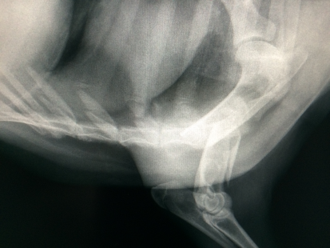
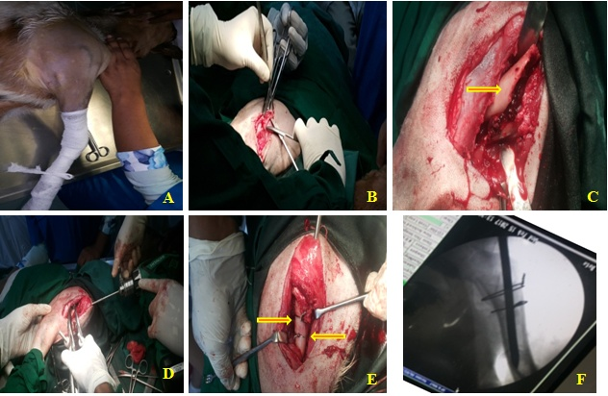
G
F
E
D
C
B
A
Figure-1: A) Radiograph before surgery. B) Preoperative preparation of surgical site. C) Skin incision and blunt dissection of surgical area. D) Exposed bone fragments. E) Introduction of intramedullary pin. F) Ancillary fixation by two cerclage wire. G) PO C-arm radiographic view.

Post-operative care:
The patient was treated postoperative by broad spectrum antibiotic (Inj. SP Vet; ACME laboratories LTD), antihistaminic (Inj. Histavet; ACI animal health) and NSAID ( Inj. Melvet; ACME laboratories LTD). The operated site was sealed with benzoin seal and the owner was advised to restrict the movement of the animal.
The case was monitored PO day 7, day 45 and day 280. Both clinical examination and radiographic examination were done.
Patient evaluation:
Immediate after operation C-Arm X-Ray was taken and it showed implant in-situ. To evaluate the patient status post operative patient monitoring was done on day 7, 45 and 280. It was revealed that on day 7 complete healing of the surgical site, mild weight bearing and implant in situ. On day 45 full weight bearing was noticed, bone healing noticed and implant in situ. On day 280 bone remodeling was noticed on radiographic examination of the bone.

CHAPTER-3
RESULTS AND DISCUSSION
Routine examination and serum biochemistry of blood showed that all the blood parameters were normal in range (table 1, and 2).
Table-1: Routine examination of blood
Name of the test | Results | Normal range
Haemoglobin | 8 | 8-12 g/dl
ESR (Wintrobe tube method) | 0 | 0 mm in 1st hour
Total count of RBC | 7.3 | 8-18 million/cumm
Total count of WBC | 9.5 | 4-13 thousand/cumm
PCV | 28 | 22-38%
Differential count for WBC
Lymphocytes | 70 | 50-70%
Neutrophils | 20 | 30-48%
Eosinophils | 5 | 1-8%
Monocytes | 5 | 0-4%
Basophils | 0 | 0-1%

Table-2: Serum biochemical test
Name of the test | Results | Normal range
Magnesium | 3.12 | 1.8-2.3 mg/dl
Calcium | 9.89 | 9.7-12.4 mg/dl
Phosphorous | 4.4 | 4.2-9.1 mg/dl

Gradually improved weight bearing was observed on PO days. Surgical wound was also healed on PO day 7 and stitches were removed on the same day with no wound complication. Secondary bone healing was noticed on PO day 45, fracture alignment with bone remodeling was noticed on day 280.
PO management is very important to prevent PO complications. Pin loosening, pin migration and seroma formation are very common complications in this IMP technique (Denny and Butterworth, 2007; Arun et al, 2011). However, infection and non-union may also be common complications in open fracture. Appropriate pin selection is very important for pin loosening and pin migration. Selection of appropriate pin depends on the size of the IMP cavity, the bone to be repaired, the fracture configuration and application of ancillary methods of fixation. Pin diameters of 2.5 mm to 4.8mm are suitable for use in most goats and it should be big enough to fill at least 60 to 70% of the medullary cavity at its narrowest point.
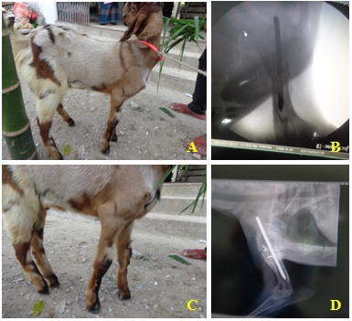
Figure-2: A) Weight bearing noticed after 7 days. B) Radiograph after 7 days. C) 45 days of post-operative with full weight bearing. D) Radiograph after 45 days (fracture gap reduce, soft calus formation).

Figure-3: A) Radiograph after 280th days (remodeling of calus).

Fracture management by combination of intramedullary pinning and circlage wiring provides good results in long bone fractures in animal. In this study we have found satisfactory result without any post-surgical complications as we desired. One study of Awatif et al., 2006 found successful immobilization of femoral fractures in goat using Kirchner intramedullary pinning. Shnian et al., 1995 reported successful management of femur fracture in 164 dogs by using intramedullary pinning. There are many external and internal splints which are used to immobilize the fractures in small animals, but only the internal splints are successfully suitable for femoral fractures such as intramedullary pins and bone plates (Slatter, 1995).

CHAPTER-IV
CONCLUSION
The present case came with the history of lameness and clinical sign of swelling, pain and non weight bearing condition. It was diagnosed by close inspection and then confermative diagnosis by C-R X-Ray. The case was decided for correction with intramedullary pinning with cerclage wire. Internal fixation using intramedullary pin has wide application in the fracture management in animals. It can be successfully used in treating long bone. Routine clinical evaluation facilitated the proper timely healing. The healing period was about eight weeks in this case.
The present case study suggests the intramedullary pining was found to be an easy and effective method for the management of long bone fracture in animal.

REFERENCES
Denny H.R, (1993); A guide to canine and feline orthopedic surgery. Blackwell scientific Publication, Oxford.
Kumar A. (2004); Veterinary surgical techniques. Vikas publishing house PVT Ltd. New Delhi; 185-197.
O’Conner J.J.D (Ed) (2005); Dollars veterinary surgery. General, operative and regional. Satish kumar jain, Dariya ganj. New Delhi, 110002 India; 813-818.
Jenny J, (1970); Orthopedic notes. Unpublished, University of Pennsylvania.
Leonard E.P. (1971); Orthopedic survey of the dog and cat, 2nd Ed., W.B Saunders, Philadelphia; 90-94.
Johnston A.L. and Decamp C.E, (1999); External skeletal fixation. Vet Clin North Am Small Anim Pract, 29(5): 1135-1152.
Aron D.N. (1998): Practical techniques for fractures. In: Bojrab M.J. (ed.): Current Techniques in Small Animal Surgery. 4th ed. Philadelphia. 934–941.
Shahar R. (2000): Relative stiffness and stress of type I and type II external fixators: Acrylic versus stainlesssteel connecting bars-a theoretical approach. Vet. Surg., 29, 59–69.
Piermatei D.L., Flo G.L. (1997): Handbook of Small Animal Orthopaedics and Fracture Repair. Saunders Company, USA. 68–95.
Perren SM. Evolution of the internal fixation of long bone fractures. The scientific basis of biological internal fixation: choosing a new balance between stability and biology. J Bone Joint Surg Br 2002;84:1093-1110.
Horstman CL, Beale BS, Conzemius MG, Evans RR. Biological osteosynthesis versus traditional anatomic reconstruction of 20 long-bone fractures using an interlocking nail: 1994-2001. Vet Surg 2004;33:232-237.
Fossum TW, Cheryl SH, Johnson AL, Schulz KS, Seim HB III, Willard MD, Bahr A, Carroll GL. Small animal surgery. 3rd ed. Mosby: Elsevier; 2007.
Beale, B. (2004): Orthopedic Clinical Techniques Femur Fracture Repair. Clinical Techniques in Small Animal Practice, 19, 134-150.
M.E.M.S. Awatif, O.S. Ali, H.M. Shnain. (2006): Kirschner intramedulary pinning for femoral fractures in caprine. Surgery Journal 1 (2-4): 75-77.
Denny and Butterworth, 2007; A Guide to Canine and Feline Orthopaedic Surgery.
Harvey et al., 1991: Small animal surgery J.B.Lippencott. Company, Philadelphia.
Slatter, D., 1995 Pocket companion to textbook of small animal surgery musculoskeletal system. 118-530.
Smith, C.M. and Sherman, D.M. 2009. Goat Medicine (2nd Ed.). Wiley-Blackwell, p 870.
Thomas Sissener BA MS DVM CertSAS DipECVS MRCVS, Principles of intramedullary pinning techniques in small animal practice.

BIOGRAPHY

I am Farhana Islam Zummy, passing Secondary School Certificate (SSC) examination from Silver Bells kindergarden & Girls High School, Halisohor, Chittagong in 2009 and then Higher Secondary Certificate (HSC) examination from Hazi Mohammad Mohsin College, Chittagong in 2011. I enrolled her internship program for Doctors of Veterinary Medicine (DVM) Degree in Chittagong Veterinary and Animal Sciences University (CVASU), Bangladesh. I have immense interest to work in veterinary field.

