Chapter 1: Introduction

Animal skin is exposed to attack by many kinds of parasites and each species has a particular effect on the skin; that can be mild or severe. In this regard, most of the ecto parasitic infestations produce irritation and sensitization of the skin. The reaction of the skin to these ecto parasites living in or on the skin results in inflammation, edema and an attempt to localize the foreign body, toxin or excretory products of the parasite. These reactions are often allergic and cause itching and burning sensation (Scott et al., 2001). Canine demodicosis is a common, non-contagious, parasitic disease of dog is caused by sensitivity to Demodex sp and overpopulation of Demodex canis as the hosts immune system is unable to keep the mites under control. Demodex is a genus of mite in the family Demodicidae. However, other species such as, Demodex injai (a large bodied mite) and Demodex cornei(a short bodied mite), may also be involved (Tater et al.,2008). Demodex canis occurs naturally in the hair follicles of most of the dogs. In most cases, these mites never cause problems. However, in certain situations, such as an underdeveloped or impaired immune system, intense stress, or malnutrition, the mites can reproduce rapidly thus causing symptoms in sensitive dogs that range from mild irritation and hair loss on a small patch of skin and cause severe to widespread inflammation, secondary infection, and in rare cases can be a life-threatening condition. Small patches of demodicosis often correct themselves over time because of the dog's immune system. Canine demodicosis is classified as localized (CLD) or generalized (CGD) according to the extent of the disease, as the course and prognosis of the two types of demodicosis are vastly different. Typically both types of demodicosis start during puppyhood (3 to 18 months), but adult onset demodicosis (AOD) can also occur. The AOD is a generalized demodicosis even more difficult to treat than juvenile demodicosis. (Maite et al., 2005). Canine Localized Demodecosis (CLD) is a benign disease, and the presence of secondary pyoderma and pruritis is rare which represents approximately 90% of all cases of canine demodicosis. It is characterized by the presence of less than five circular alopecic areas with more or less inflamed skin lesions. Most cases resolve spontaneously within 8 weeks. It is not necessary to use acaricidal treatment. Even most of the time acaricidal treatment should be avoided because they generally do not alert course of the CLD, but can induce development of resistance and can mask the eventual progression into a generalized form in predisposed dogs. In approximately 10% of the cases, evolution towards generalized form is unavoidable, whether or not an acaridical therapy had been initiated. The treatment of CLD should be conservative. Canine generalized demodicosis is actually one of the most severe canine skin diseases and one of the most frustrating diseases to treat, and the prognosis is guarded. Euthanasia was common until ten years ago, but veterinarians can offer today alternative available therapies. CGD is characterized by the presence of five or more alopecic areas, a whole body are being affected or demodicosis involving two or more feet. Although spontaneous resolutions of CGD occur in up to 50% of cases in dogs less than 1.5 years, and the prognosis for CGD is uncertain. Most cases of CGD involve a secondary bacterial skin infection, which needs administration of systemic antibiotics for several weeks concomitantly with the acaricidal treatment. Adult onset generalized demodicosis (AOD) is rare, but when it occurs, it can be a serious problem. AOD appears first time in dogs, aged more than 4 years. AOD has been diagnosing in dogs suffering from internal diseases, endocrine diseases, malignant neoplasia, or treatment with immune suppressive drugs. (Maite et al., 2005). Canine demodicosis mainly transmitted through direct contact. This mite can be found in the deeper skin surface of the dog. The mites are transferred directly from the mother to the puppies within the first week of life. Transmission of the mites is by direct contact only. That is, the mother and the puppy must be physically touching as the parasite cannot survive off of the animal. This is important because it means the kennel or bedding area does not become contaminated and therefore the environment needs not to be treated. Lesions of demodectic mange if present, usually appear first around the puppy's head, as this is the area which is most in contact with the mother. Virtually every mother carries and transfers mites to her puppies. Most puppies are immuned to the mite's effects and display no clinical signs or lesions. A few which are not immuned, these puppies that develop full-blown cases of mange. The demodectic mite spends its entire life on the dog. Eggs are laid by a pregnant female, hatch, and then mature from larvae to nymphs then to adults. The life cycle is believed to take 20-35 days. (Foster et al., 2008). In Bangladesh, there is a few number of studies have found in literature about canine demodicosis. Therefore the present study was aimed to diagnose, treatment and management of canine demodicosis.

Chapter 2: Case presentation
2.1 Case history
A two years old male Great dane dog bearing weight 18kg was brought by the owner to the Madras Veterinary College Hospital, TANUVAS in India. This case was confirmed as canine demodicosis on the basis of clinical history, clinical signs and laboratory diagnosis.
2.2 Clinical signs
At my first day of observation, there was a body temperature of (101 F), hair loss noticed around the eye, neck, trunk and abdomen. There were also crust formation, red skin and also a greasy moist appearance was first noted sign. There was no itching present in the first day of observation. After 2 days of my study the hair loss over entire coat was noticed and also the skin was crusty and inflamed, mild itching also noticed on that day. It was due to secondary bacterial infection.

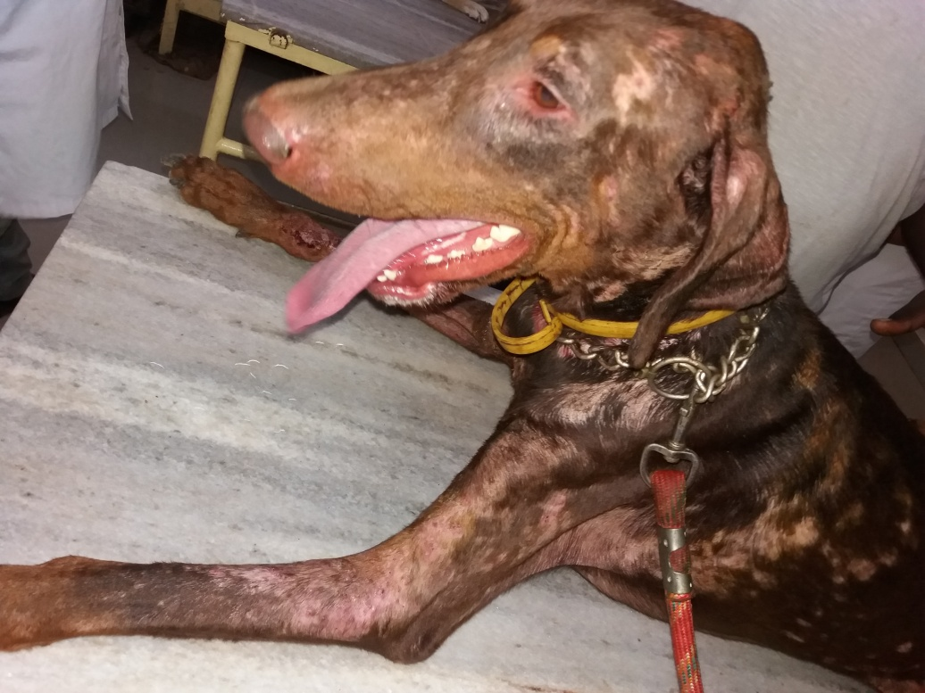
Figure 1: Crusty lesion around eye and mouth.
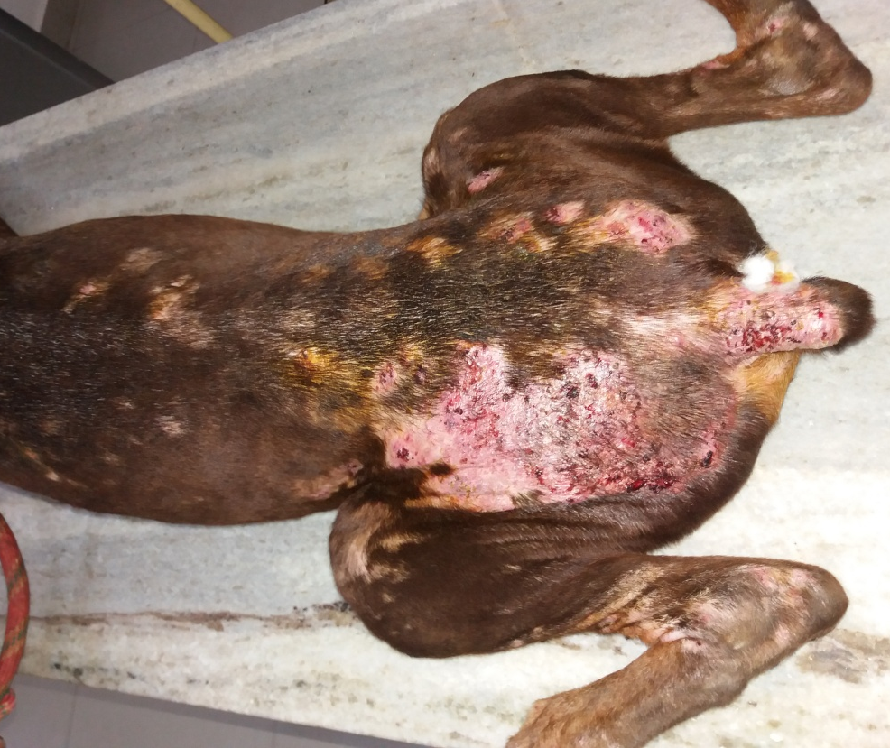
Figure 2: oozing of fluids from the lesion

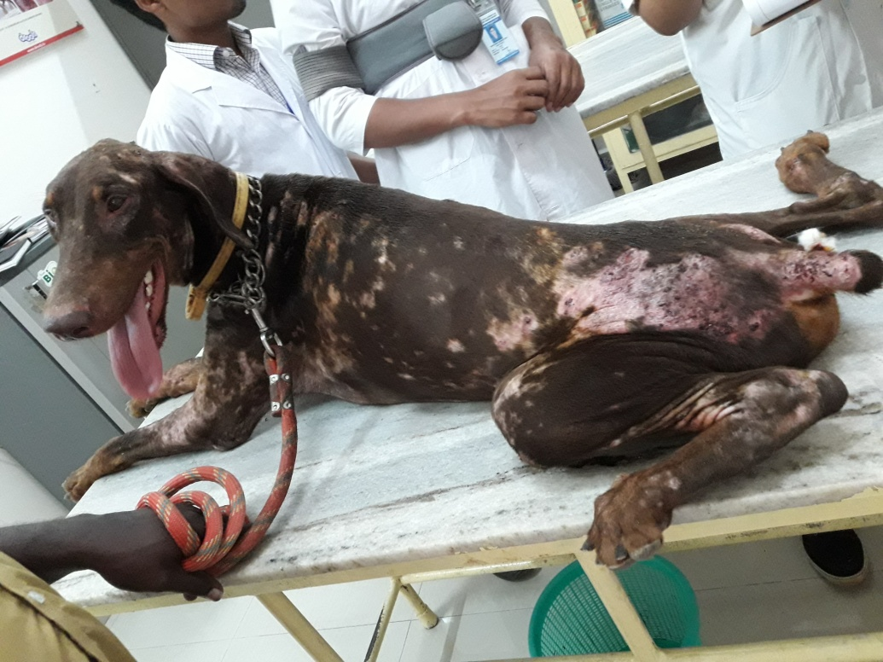
Figure 3: Lesion on dorsal surface of the body
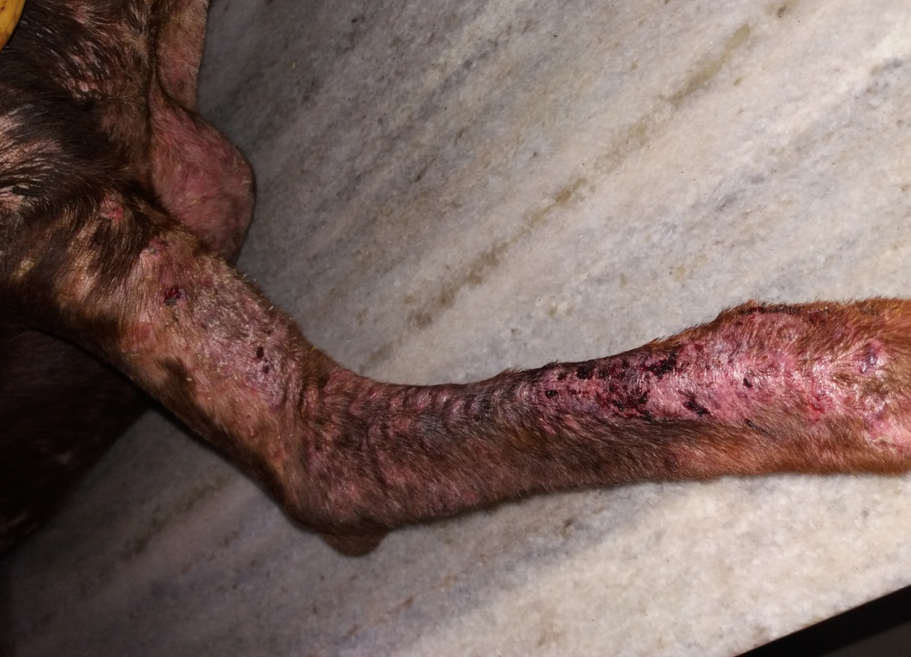
Figure 4: Alopecia and redness of the skin on leg.
2.3 Sample collection:
Demodectic mange was suspected in a dog, it could be usually be confirmed by a skin scrapping. So for the confirmatory diagnosis we had collected skin scrapping from head, neck and leg of the dog with the sterile surgical blade. The area of the affected skin was squeezed firmly to extrude the mites from the hair follicles and the skin scrapping was deep and extensive. The scrapping was taken until capillary bleeding was seen. The scrapping was taken on a slide where a drop of paraffin was added. Blood sample also collected from the cephalic vein for hematological assessment.
2.4 Lab diagnosis:
2.4.1 Microscopic work:
After taking the skin scrapping on the slide, paraffin was added and a uniform smear was made with the help of a cover slip. After preparation of slide, it was placed under a compound microscope at 10x magnification.
2.4.2 Blood
Collected blood sample were divided into two parts. One part was added with anticoagulant (EDTA) and the rest was kept without anticoagulant. A thin smear also made for examination. And these samples were sent to Biochemistry and physiology laboratory of Madras Veterinary College for complete blood count. Liver function tests and mineral profile tests were also performed.

2.5 Treatment:
For killing the causative parasite, the dog was treated with anthelmintic (Ivermectin), for 3 weeks. Antihistaminic (Pheneramine maleate) was also given. The body of the dog was washed with chlorhexidine shampoo.
2.6 Considerations before treatment
Demodicosis is more common in purebred dogs and also in certain breeds (Shar-pei, Great Dane) but any dog can be susceptible. A hereditary predisposition has been observed in some breeding kennels. Then elimination of affected or carrier dogs(both parents and sibling) from the breeding programs greatly reduces or eliminate the incidence of CGD in that population. Age, short hair, poor nutrition, estrus, parturition, stress, endo parasites, and debilitating diseases are other predisposing factors suggested for demodicosis. There is a consideration during the use of ivermectin. It should not be used in the breed collies and other similar breeds.

Figure 6: Blood collection
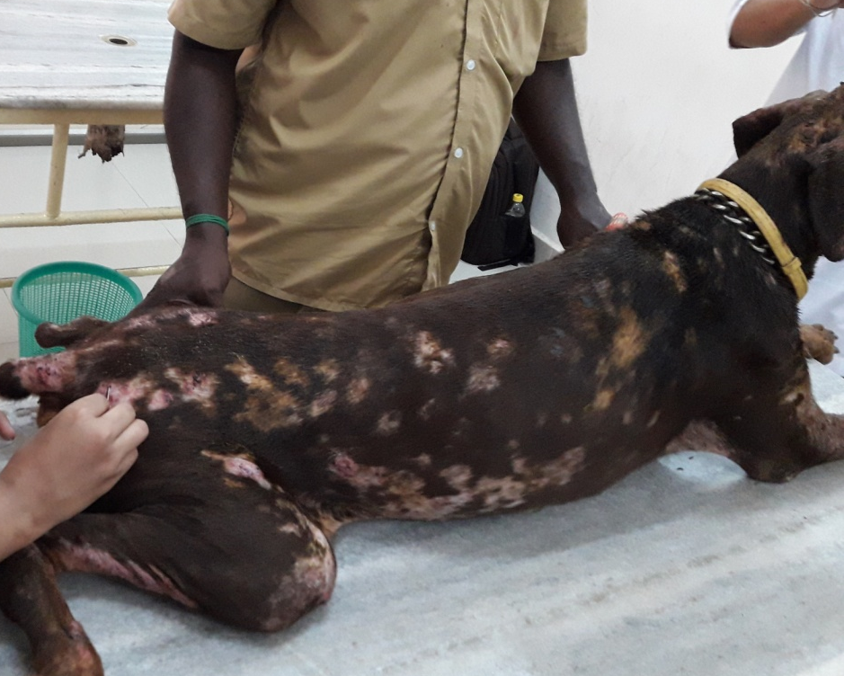

Figure 5: Sample collection (skin scrapping)

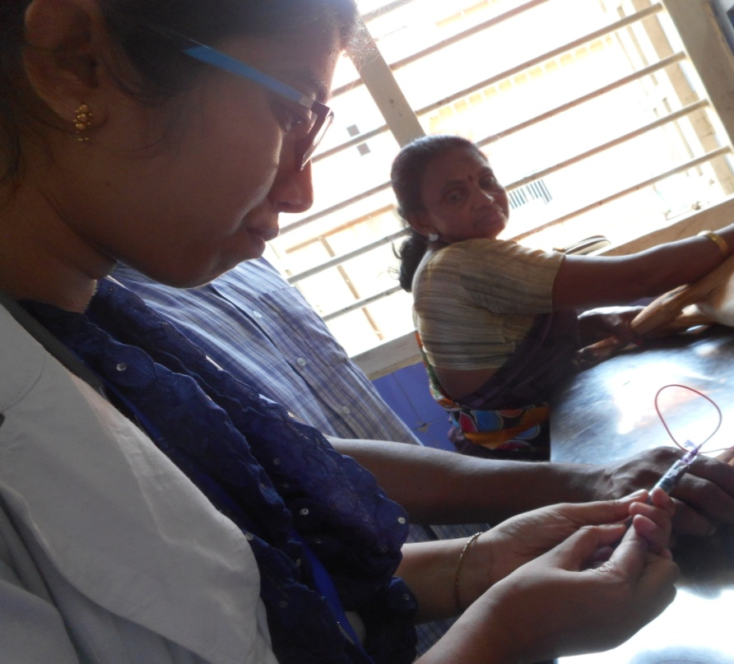

Figure 6: Blood collection

Figure 7: Preparation of slide with liquid paraffin
Figure 8: Microscopic examination of skin scrapping

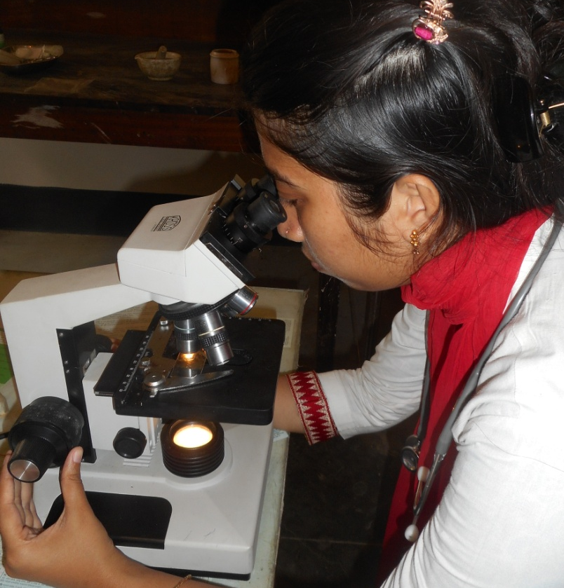
Chapter 3: Results
3.1 Microscopic examination
After setting under the microscope at 10x magnification, the examination showed the presence of elongated, cigar shaped mite with body divisible into head, thorax bearing four pairs of short and stumpy legs and abdomen bearing transverse striations. The morphology confirmed it to be Demodex canis.

3.2 Blood parameter
In blood parameter there was a significant increase in the total leukocyte count (TLC). Specially the neutrophil and basophile was increased, but the level of lymphocyte was normal.
3.3 condition of dog
After 14 days of treatment, the dog’s condition was gradually improved and finally cured after one month. But it left some alopecic patch in the dog’s body.

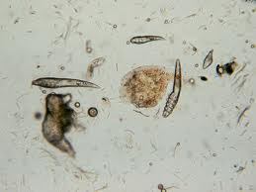

Figure 9: Cigar shaped Demodex canis detected under microscope (10x magnification)

Blood parameter:
Table 1: Blood parameter of the case.
Parameters | Unit | Diagnosed value | Ref. value
Glucose | Mg/dl | 105 | 65-118
Total protein | g/dl | 4.8 | 5.4-7.1
BUN | Mg/dl | 29 | 19-34
TLC | thousand/dl | 45 | 6-18
TEC | Million/dl | 6.5 | 5-9
PCV | % | 30 | 37-55
SGOT | U/L | 40 | 26-43
SGPT | U/L | 59 | 25-97

Chapter 4: Discussion

In this study we described about the two forms of demodicosis, these are localized and generalized, which is also supported by the previous studies (Horne, 2010). In the localized form, the lesions were found in not more than six focal areas of the body. But in case of generalized form, the lesions were shown throughout the body. The juvenile onset form typically present before the dog reaches one year of age. Young patients may present with localized or generalized disease. Patient with localized demodicosis may not to be treated. If treatment is recommended, topical therapy can be administered to the affected area (Horne, 2010). Adult onset demodicosis is usually seen in adult dogs, aged 4 years or older. It is important to inform the client that an underlying cause often exists and to look for concurrent disease before treating the patient for demodicosis. The prevalence of demodicosis in adult dog is based on the immune status. The mite is normally reside in the body but when the immune suppression occurs it may cause clinical condition (Arora et al., 2013) which is also mentioned in my study.
Mortality and morbidity vary with the age of the dog. The youngs are more susceptible than the adult. This mite is normally present in small numbers in the skin of healthy dogs, but when a dog’s immune system becomes weakened, the mites can overgrow and cause disease and inflammation of the skin. The prevalence is also higher in the male dog than the female dog. 51% in male and 49% in female dogs (Nayak et al., 1997) and in male dogs (55.5%) than bitches (44.5%) (Mahato et al., 2005).
The underlying causes of adult demodicosis include diabetes mellitus, hyperadrenocorticism (either naturally occurring or iatrogenic due to gluco corticoid administration), neoplasia, treatment with immune suppressive agents, hypothyroidism, heart worm disease, intestinal parasitism and leishmaniasis. To identify an underlying cause, a thorough history should be obtained and a complete physical examination should be performed (Izdebska, 2010).

According to my study the clinical sign was included such as hair loss around eye, neck, trunk and abdomen. There were also crust, red skin and greasy moist appearance was first noted sign. There were no itching upto any secondary bacterial infection.
Although the demodicosis are usually distinctive in fully susceptible animal but this can be confused with some other skin diseases. In Taiwan, (Chen, 1995) reported that the demodectic dog showed major clinical sign as mild pruritis. In addition, other clinical signs were alopecia and dry scaling on ventral surface of abdomen and all four limbs, ventral aspect of neck and around eyes of the affected dog. While the study from the United Kingdom (Chesney, 1999) indicated that the early skin’s sign had first been observed at a mean age of about 7 months and the major clinical sign were alopecia and scaling.
The diagnostic approach for Demodex canis infestation is superficial skin scrapping or using tape preparation techniques (Mason, 1993; Patterson, 2008; Guaguere et al., 2008). However the author prefers the skin scrapping instead of tape smear. Because in case of skin scrapping the sample was adequate in amount to find a positive result. It reduces the chance of getting a false positive result.
The bitch transmits the Demodex mite to her pup within the days of birth. Mites invade the pup’s skin and hair, feeding on cells, then sebumasque epidermal debris with extraordinary numbers of mites, and this process results in alopecia and erythema. (Nash, 2006)
Demodex canis inhabits primarily in the hair follicles on the head usually in the peri orbital regions, and on the cheeks and upper lip. Only when the level of infection is high, these mites are to be found in other skin regions. It is often in the case that once follicles have degraded, the mites colonize into other skin layers. They have even been found in the lymphatic and digestive systems.
Demodex canis spends all four stages of its life cycle on the skin, residing in hair follicles and to a lesser extent in sebaceous glands. The developmental cycle starts with the larva hatching from a fusiform egg then the six-legged larva molts and becomes an eight-legged nymph. This nymph turns into molts to produce a mite in the final adult stage . The mite completes its life cycle is about three weeks. Mites in all stages can be found in a dog’s hair follicle and potentially in the lymphatic system, bloodstream and other organs. Mites in this extra cutaneous locations are dead and have been moved by lymph or blood drainage. (Nash, 2006)
During the microscopic examination of the skin scrapping, I found cigar shaped Demodex canis which (Figure 7) contains eight legs. According to the morphology, the size of demodex canis which includes its body length: (165-265) micrometer, body width; (33-43) micrometer and the ratio of length to width is (5.3-5.6). (Izdebska, 2010)
The complete blood count revealed mild normocytic, normochromic anemia. The chemistry panel revealed mildly elevated ALP consistent with prior steroid therapy and a mild hyperglobulinemia. A thyroid profile revealed a low total T4, low free T4 by equilibrium dialysis and a high TSH level consistent with the diagnosis of hypothyroidism. (Coyner, 2005).
In my study the treatment was done by the ivermectin injection which is effective in this case and this was also used in also some other studies. (Izdebska, 2010 ; Arora et al., 2013; Horne, 2010). In terms of therapy, always identify and treat any underlying immunosuppressive diseases. All intact dogs with generalized demodicosis should be neutered, especially intact females, as pregnancy or estrus may stimulate a prolapse. Predisposition for generalized demodicosis also seems to have a genetic basis in dogs, so affected animals should not be bred. Localized demodectic lesions may resolve spontaneously. (Coyner, 2005).
Ivermectin is the common and first choice of drug in many dermatological cases because it is easy to administer and reasonably priced. An injectable form of ivermectin is administered. The recommended dose is 300-600 microgram/kg body weight. Ivermectin drug should not be used in ivermectin sensitive breeds (example: collie, Shetland sheep dog, Australian shepherd, old English sheep dog). (Horne, 2010).

In other studies some other drugs are also used for the treatment of canine demodicosis these are doramectin, selamectin, abamectin, moxidectin, milbemycin, amitraz etc. Doramectin is a long acting ivermectin that has been used as a doses of 600 microgram/kg body weight once weekly. Doramectin drug should not be used in ivermectin sensitive breeds (example: collie, Shetland sheep dog, Australian shepherd, old English sheep dog (Horne, 2010).
Milbemycin oxime can be expensive for treating in large breed dogs. It may improve client compliance through its ease of administration. Milbemycin oxime may be an alternative choice for breed sensitive to ivemectin drugs. Doses are to be .5-2 mg/kg orally. Reactions typically of ivermectin toxicity have been observed in 2 of 5 Collies treated with single doses of 5 mg/kg. It is possible that some Collies sensitive to SML can not tolerate highly dosage of milbemycin oxime. This drug is relatively safe, but expensive. (Maite et al., 2005)
Moxidectin also used in canine demodicosis. A cure rate of 89% was obtained following daily oral administration of 0.4 mg/kg. Mean duration of treatment was 20-22 weeks. Information on moxidectin toxicity is limited in dogs. This drug has many real advantages over ivermectin in dogs. Both drugs seem to deliver a very wide margin of safety in breeds not at risk, and probable equivalent therapeutic efficacy and cost at similar dosages. But, both drugs offer the same risk for idiosyncratic reactions in Collies when utilized at off-label doses. (Maite et al., 2005).
Amitrazis currently the only treatment approved by the food and drug administration for canine generalized demodicosis. Bathing with a benzoyl peroxide shampoo before dipping may be beneficial for its keratolytic effect and follicular flushing activity. (Horne, 2010).
Amitraz protocol for its use may vary from country to country. It is applied as a 250-750 ppm solution (0.025% - 0.075% of water) to the dogs in the entire body every week. It is indicated to clip medium and long hair coats prior to treatment and dipping to be continued for at least 2 treatments after negative scrapping has been obtained.

Treatment should be preceded by a shampoo such as benzoyl peroxide applying some hours before in order to remove crust, debris, and bacteria. The amitraz solution should be prepared in fresh for each application. Be careful and minimize human exposure. Contact with the dog must be avoided until the coat is dry.
During the course of treatment, clinical improvement and dramatic reduction in recovery of live mites was observed at 4 weeks after initiation of treatment with afoxolaner. All four dogs were clear of clinical lesions, and were negative for live mites in all skin scrapping sites at 8 and 12 weeks after the initial treatment. (Chavez, 2016)
In this study a course of broad spectrum antibiotic therapy was used to check the secondary bacterial infection which is responsible for pruritis. This is also used in other studies. (Arora et al., 2013)

Conclusion

In conclusion, a few important points should be repeated. The mites are transferred from the mother to offspring in the first few days of life. The first sign of hair loss usually does not occur until after four months of age. Demodectic mange in dogs is usually curable or controllable with persistent treatment, except in rare cases with very immune suppressed individuals. The effective treatment is Ivermectin.

References

Ali, M. H., Begum, N., Azam, M. G., Roy,B. C.2011. Prevalence and pathology of mite infestation in street dogs at Dinajpur municipality area. Journal of the Bangladesh Agricultural University, 9(1): 111–119.

Arora, N., Vohra, S., Singh, S., Potliya, S., Lather, A., Gupta,A., Arora, D., Singh,D. 2013. Therapeutic Management of Chronic Generalized Demodicosis in a Pug. Advances in Animal and Veterinary Sciences, 1 (2S): 26 – 28.

Chen, C. 1995. A short-tailed demodectic mite and Demodex canis infestation in a Chihuahua dog. Veterinary Dermatology, 6(4) : 227-9.

Gunaseelan, L.,Bhavya,S.,Kumar,S. K.,Balachandran,C. 2011. Influencing factors for mange mite infestation of dogs in Chennai city, Tamilnadu. Journal of Veterinary and Animal Sciences,7:247–249.

Izdebska,J.N. 2010. Demodex sp. (Acari, Demodecidae) ademodicosis in dogs: characteristics, symptoms, occurrence ,Bull Veterinary Institution Pulawy, 54:335-338.

Lemarie, S.L., Horohov,D.W. 1996. Evaluation of interleukin-2 production and interleukin-2 receptor expression in dogs with generalized demodicosis. Veterinary Dermatology,15:75-89.

Miller, W.H., Griffin, C.E., Campbell, K.L. 2013. Parasitic skin disease In: Muller and Kirk’s small animal dermatology. Elsevier,7: 284–342.

Mueller, R.S. 2004. Treatment protocols for demodicosis: an evidence–based review. Indian Veterinary journal,77: 883–886.

Paradis, M., Laperriere, E. 1992. Efficacy of daily ivermectin treatment in a dog with amitraz–resistant, generalized demodicosis.Veterinary dermatology, 3:85–88.

Singh, S., Chhabra, M.B. 1992. Comparative efficacy ofivermectin and fenvalerate against sarcoptic mange in pigs. Indian Veterinary Journal, 69:1037–1040.

Tamura, Y., Kawamura, Y., Inoue, I., Ishino,S. 2001. Scanning electron Microscopy description of a new species of Demodex canis spp. Veterinary Dermatology, 12 : 275-278.

Tater, K.C., Patterson,A.P. 2008. Canine and Feline Demodicosis. Veterinary Medicine, 103(8) : 444-461.

Zivicnjak,T. 2005. A retrospective evaluation of efficiency in therapy for generalized canine demodicosis. Veterinary Archives, 75(4):303–310.

Acknowledgements
The author wishes to acknowledge the immeasurable grace and profound kindness of Almighty “GOD” the supreme authority and supreme ruler of universe, who empowers the author to handle the case and to complete the case report successfully.
The author wishes to express his deep sense of gratitude and thanks to DR.Bibek Chandra Sutradhar, Professor , Department of Medicine and Surgery, Faculty of Veterinary Medicine of Chittagong Veterinary and Animal Sciences University for his skillful supervision and guidance to make this report.
The autor would like to thank to the Director of External affairs, Professor. Dr. A.K.M. Saifuddin, Dept. of Physiology, Biochemistry and Pharmacology, Chittagong Veterinary and Animal Sciences University
The author also grateful to the entire faculty members of department of Dermatology in Madras Veterinary college, TANUVAS, Chennai, India for their cordial information and help at the time of handling the case.
Finally the author expresses thanks and warmest sense of gratitude to her parents and all well-wishers.

The author,
October, 2017

Biography
Intern Doctor of Veterinary Medicine
Chittagong Veterinary and Animal Sciences University
E-mail: kaberycvasu17@gmail.com
Mobile: +8801863347809

Personal Profiles:
Name: Kaberi Talukder
Father’s name: Pranesh Chandra talukder
Mother’s name: Khela Rani Talukder
Permanent address: Vill: Gangadharpur, Thana: Jamalgonj
Zilla: Sunamgonj.
Date of birth: 31st October, 1994
Nationality: Bangladeshi
Religion: Hindu
Blood group: B+

Academic Qualification:

Name of the Examination/  Course | Educational Institution | Educational Board | Year of passing | Grade
SSC | Agrabad Balika Bidyalay | Chittagong | 2009 | 5.00(out of 5)
HSC | Govt. Hazi mohammad Mohsin College | Chittagong | 2011 | 5.00(out of 5)
DVM | Chittagong Veterinary and Animal Sciences University | CVASU | ----- | -------

My Goal:
As a human being, I have a long cherished dream to serve my nation through my knowledge, creativity and profession. As a veterinarian, I think I have a great opportunity to fulfill my dream by developing my career in the field as a veterinary practitioner. By dealing as a veterinary surgeon, I would be able to expand and spread my knowledge also.
I have also a high interest in Medical Research, Wildlife Conservation and Eco health approach.

