CHAPTER 1: INTRODUCTION

Bangladesh is a developing country and livestock plays an important role in the development of the traditional economy of Bangladesh. The contribution of livestock in Gross Domestic Product is about 16.2% in Bangladesh (BBS, 2008). Most of the people in this country are economically unhealthy and for that reason they are unable to start large scale livestock farming. Even the poor people can’t afford buying a few cattle for rearing in backyard farming. So, they would like to prefer goat to cattle or other livestock in backyard farming. Generally, poor farmers and distressed women raise goat with very little capital investment. So goat is called poor man’s cow. There are about 14.7 million goats in Bangladesh (Parvez et al., 2014). Although goat rearing is easy, less expensive, less laborious and highly profitable business, it is being fatally hampered due to many managemental and disease problems. Common diseases of goats are Peste Des Petits Ruminant, goat pox, pneumonia, enterotoxemia, tetanus, brucellosis, metritis, mastitis, conjunctivitis, diarrhea and parasitic gastroenteritis. Mastitis also affects sheep, cattle and buffalo (Ameh and Tari, 1999). Mastitis caused by multiple organisms (such as Streptococcus, Staphylococcus, pseudomonas, Pasteurella, Escherichia coli, Enterobacter, Klebsiella etc) is the inflammation of mammary glands with physical, chemical and microbiological changes characterized by an increase in somatic cells, especially leukocytes in the milk and by the pathological changes in the mammary tissue. There are two form of mastitis: 1) clinical mastitis and 2) sub-clinical mastitis. In the clinical mastitis mammary glands become swollen, firm, and painful at palpation, and the milk contains small clots (Pisoni et al., 2009). Mastitis refers to inflammation of mammary gland characterized by physical, chemical and usually bacteriological changes in milk and pathological changes in the udder. Clinical mastitis may acute, sub acute and chronic (gangrenous). The symptoms of clinical mastitis include only minor alterations in the milk and the affected quarter such as clots, flakes or discolored secretion. The affected become slightly swollen and tender. Acute mastitis cases are characterized by sudden onset, pain, heat, swelling, redness and reduced as well as altered milk secretion from affected halves. Most consistently observed clinical signs of abnormal secretion are clots, flakes or watery milk. Depending upon severity and the causative agent, acute mastitis cases may have significant systemic involvement characterized by fever, depression, and weakness. In its most severe form it can be fatal (Shearer et al., 2006). Gangrenous mastitis is occurred as common clinical form of mastitis in goats (Samad, 2008). Yet gangrenous mastitis is one of the most difficult forms of mastitis to be managed clinically, whereas in very severe cases, the gangrene may lead to toxemia and loss of animal life (Ribeiro et al., 2007). In subclinical mastitis, there are no obvious clinical manifestations such as abnormal milk, udder swelling etc. Instead there is an increase in somatic cell counts of the milk(>200000) (Radostis et al., 1999). Mastitis is recognized as the most important and costly disease of dairy animals worldwide but also posses the risk for the transmission of milk borne zoonotic diseases (Samad, 2008). The annual prevalence of clinical mastitis in small ruminant is generally lower than 5% but it may increase sporadically, where as the prevalence of sub clinical mastitis has been estimated at 5-30% (Contreras et al., 2007). In USA the prevalence of acute clinical mastitis in last 10 years ranged from 0% to 2% (Contreras et al., 1999). The Prevalence of both clinical and subclinical mastitis was 36.4% (White et al., 1999). Several risk factors for instance milker and the process of milking, management practice, feeding, number of days not lactating, number of lactation per day and geographical locality may influence the type and frequency of isolation of organisms causing mastitis in animals (Gomes et al., 2014). Predisposing factors such as poor management and hygiene, teat injuries and faulty milking machines are known to be hasten the entry of infectious agents and the course of the disease (Majic et al., 1993). Economic consequences of mastitis, clinical or sub-clinical, include reduced milk yield, poorer quality milk, increased culling rate and increased cost of veterinary services and medicine. Dairy farmers in Bangladesh are not always aware of the best practices to control mastitis (Rahman et al., 2009).Clinical mastitis in goat diagnosed by clinical examinations and diagnosis of subclinical mastitis depends on various test procedures including microbial examination, somatic cell count, and California mastitis test (McDougall et al., 2002; Wakwoya et al., 2006; Contreras et al. 2007).Although there are many published mastitis studies in cattle, studies of mastitis in goats in Bangladesh are scared (Koop et al.,2016). Therefore, the present clinic-epidemiological study on goat mastitis attempted to fill up the scientific gaps and contribute new information to the scientific literature. Consider this the current study was conducted to meet the following objectives:

- To describe common clinical findings of goat mastitis.
- To estimate and distribute the proportionate prevalence of clinical mastitis by different factors.
- To describe antimicrobials prescribed against clinical goat mastitis.

CHAPTER 2: MATERIALS AND METHODS

A cross sectional study was conducted at the Upazilla Livestock Development Centre (ULDC) Rangunia, Chittagong(during March to September) and Shahedul Alam Quadery Teaching Veterinary Hospital (SAQTVH), Khulshi, Chittagong(during January to September) for investigating in clinical goat mastitis. The ULDC is an institution where animals from different unions of Rangunia Upazilla brought for treatment and it is located in village setting about 35 kilometers far from Chittagong metro. The treatment is given by the Government Veterinary Surgeon (VS) mostly and sometimes veterinary field assistant and compounder also prescribe drugs in the absence of veterinary surgeon. The techniques which were followed for case investigation are quite conventional. Whereas, SAQTVH is located exactly in downtown Chittagong and established within the Chittagong Veterinary and Animal Sciences University (CVASU) campus. Domestic species like cattle, sheep, chicken, duck and especially goats were mostly handled animal species here. Patients are facilitated by modern techniques from physical inspection to treatment intervention process. Animals are handled by the final year veterinary students, intern veterinary doctors and veterinary surgeons with the soul guidance of clinical faculty of the Department of Medicine and Surgery of CVASU. All the goats that suffered from mastitis were brought for the treatment to the ULDC and SAQTVH during the study period were included for the cross sectional study. A semi-structured questionnaire was administered to the goat farmers with a view to collecting data on farmer’s demography, farm composition, animal level data(breed, age, parity, pregnancy status, weight, Body Condition Score: BCS, stage of lactation, weaning time etc) and management history (rearing system, flooring system, farm size of the goats). Observable clinical signs of mastitis and drugs prescribed were also recorded in the sheet. All the data obtained through the study were entered into Microsoft Office Excel- 2007, USA. Data were cleaned and checked their integrity before exporting to STATA version -13(STATA Corporation, 4905, Lakeway River, College Station, Texas 77845, USA) for statistical analysis. Descriptive analysis was carried out on the data originated from the study. The results were expressed in frequency number, percentage, mean, median, minimum and maximum, 95% confidence interval and correlation coefficient.

CHAPTER 3: RESULTS

3.1. Distribution of clinical sign of goat mastitis
A total of 15 cases of goat suffering from mastitis were confirmed by observing clinical sign like swollen udder (33.3%), hot udder (46.7%), painful udder (60%), hard udder (33.3%), cold udder (6.7%), yellowish milk (26.7%), watery milk(46.7%), bloody milk(66.7%), cheesy flakes in milk (46.7%) and white milk (6.7%)(Table 1),
Table 1: Frequency distribution of recorded clinical signs of mastitic goats (N=15)
Signs/changes | N | % | 95% CI
Swollen | 5 | 33.3 | 11.8 - 61.6
Hot | 7 | 46.7 | 21.3-73.4
Pain | 9 | 60 | 32.3 - 83.7
Hard | 5 | 33.3 | 11.8 - 61.6
Cold | 1 | 6.7 | 0.2 - 31.9
Yellowish milk | 4 | 26.7 | 7.8 - 55.1
Watery milk | 7 | 46.7 | 21.3-73.4
Bloody milk | 10 | 66.7 | 38.4 - 88.2
Cheesy flakes in milk | 7 | 46.7 | 21.3 -73.4
White milk | 1 | 6.7 | 0.2 - 31.9

Pictures of clinical goat mastitis
3.2. Proportionate prevalence of goat mastitis in relation to different factors
Figure 2: Bloody milk secretion from udder
Figure 1: Bloody milk secretion from udder
Figure 3: Gangrenous udder
Figure 4: Swelling of udder
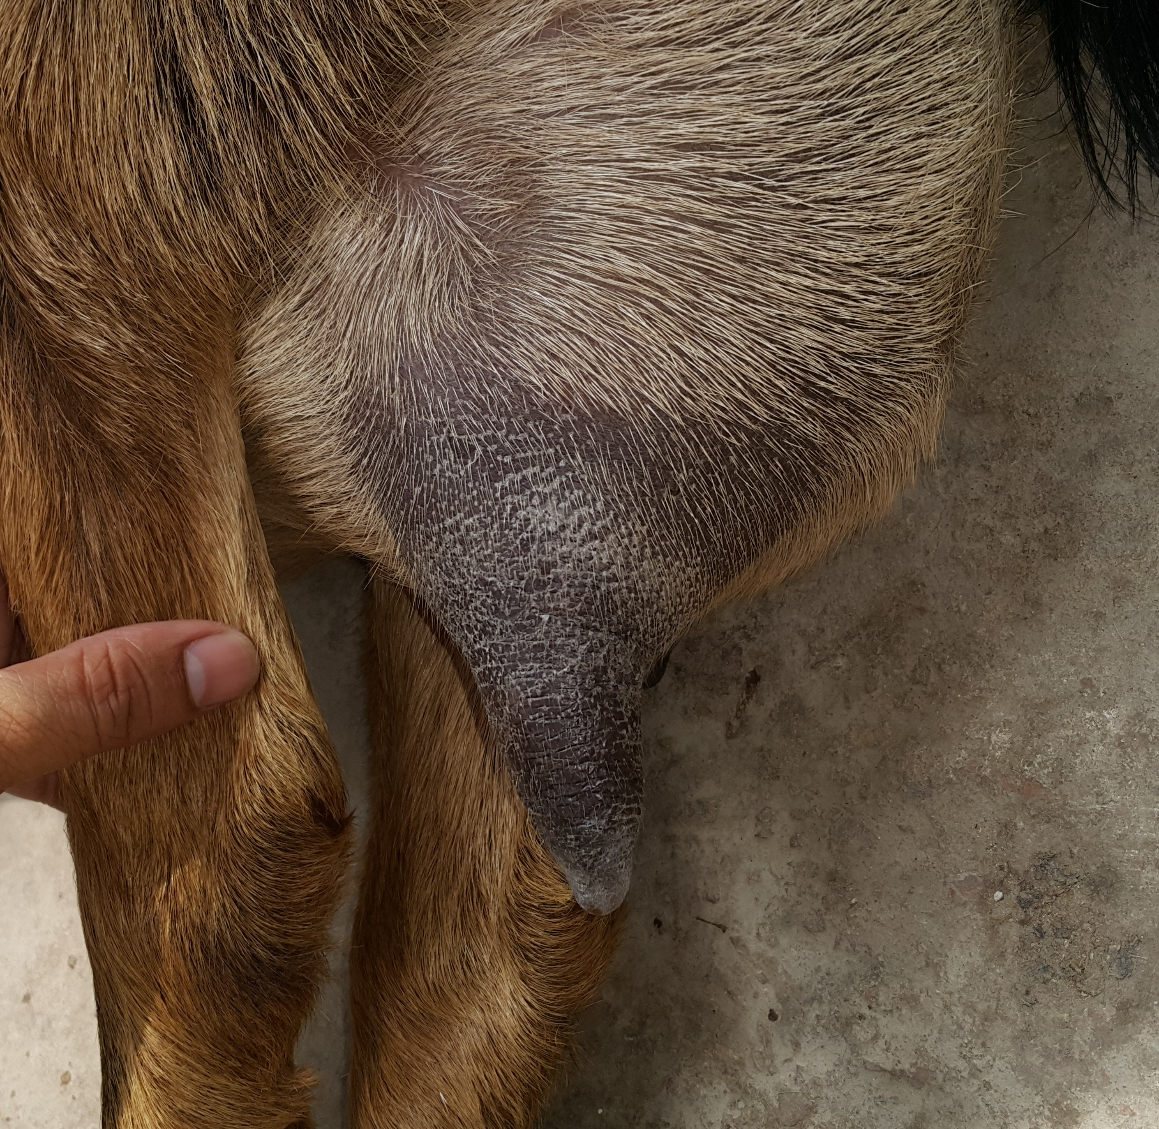
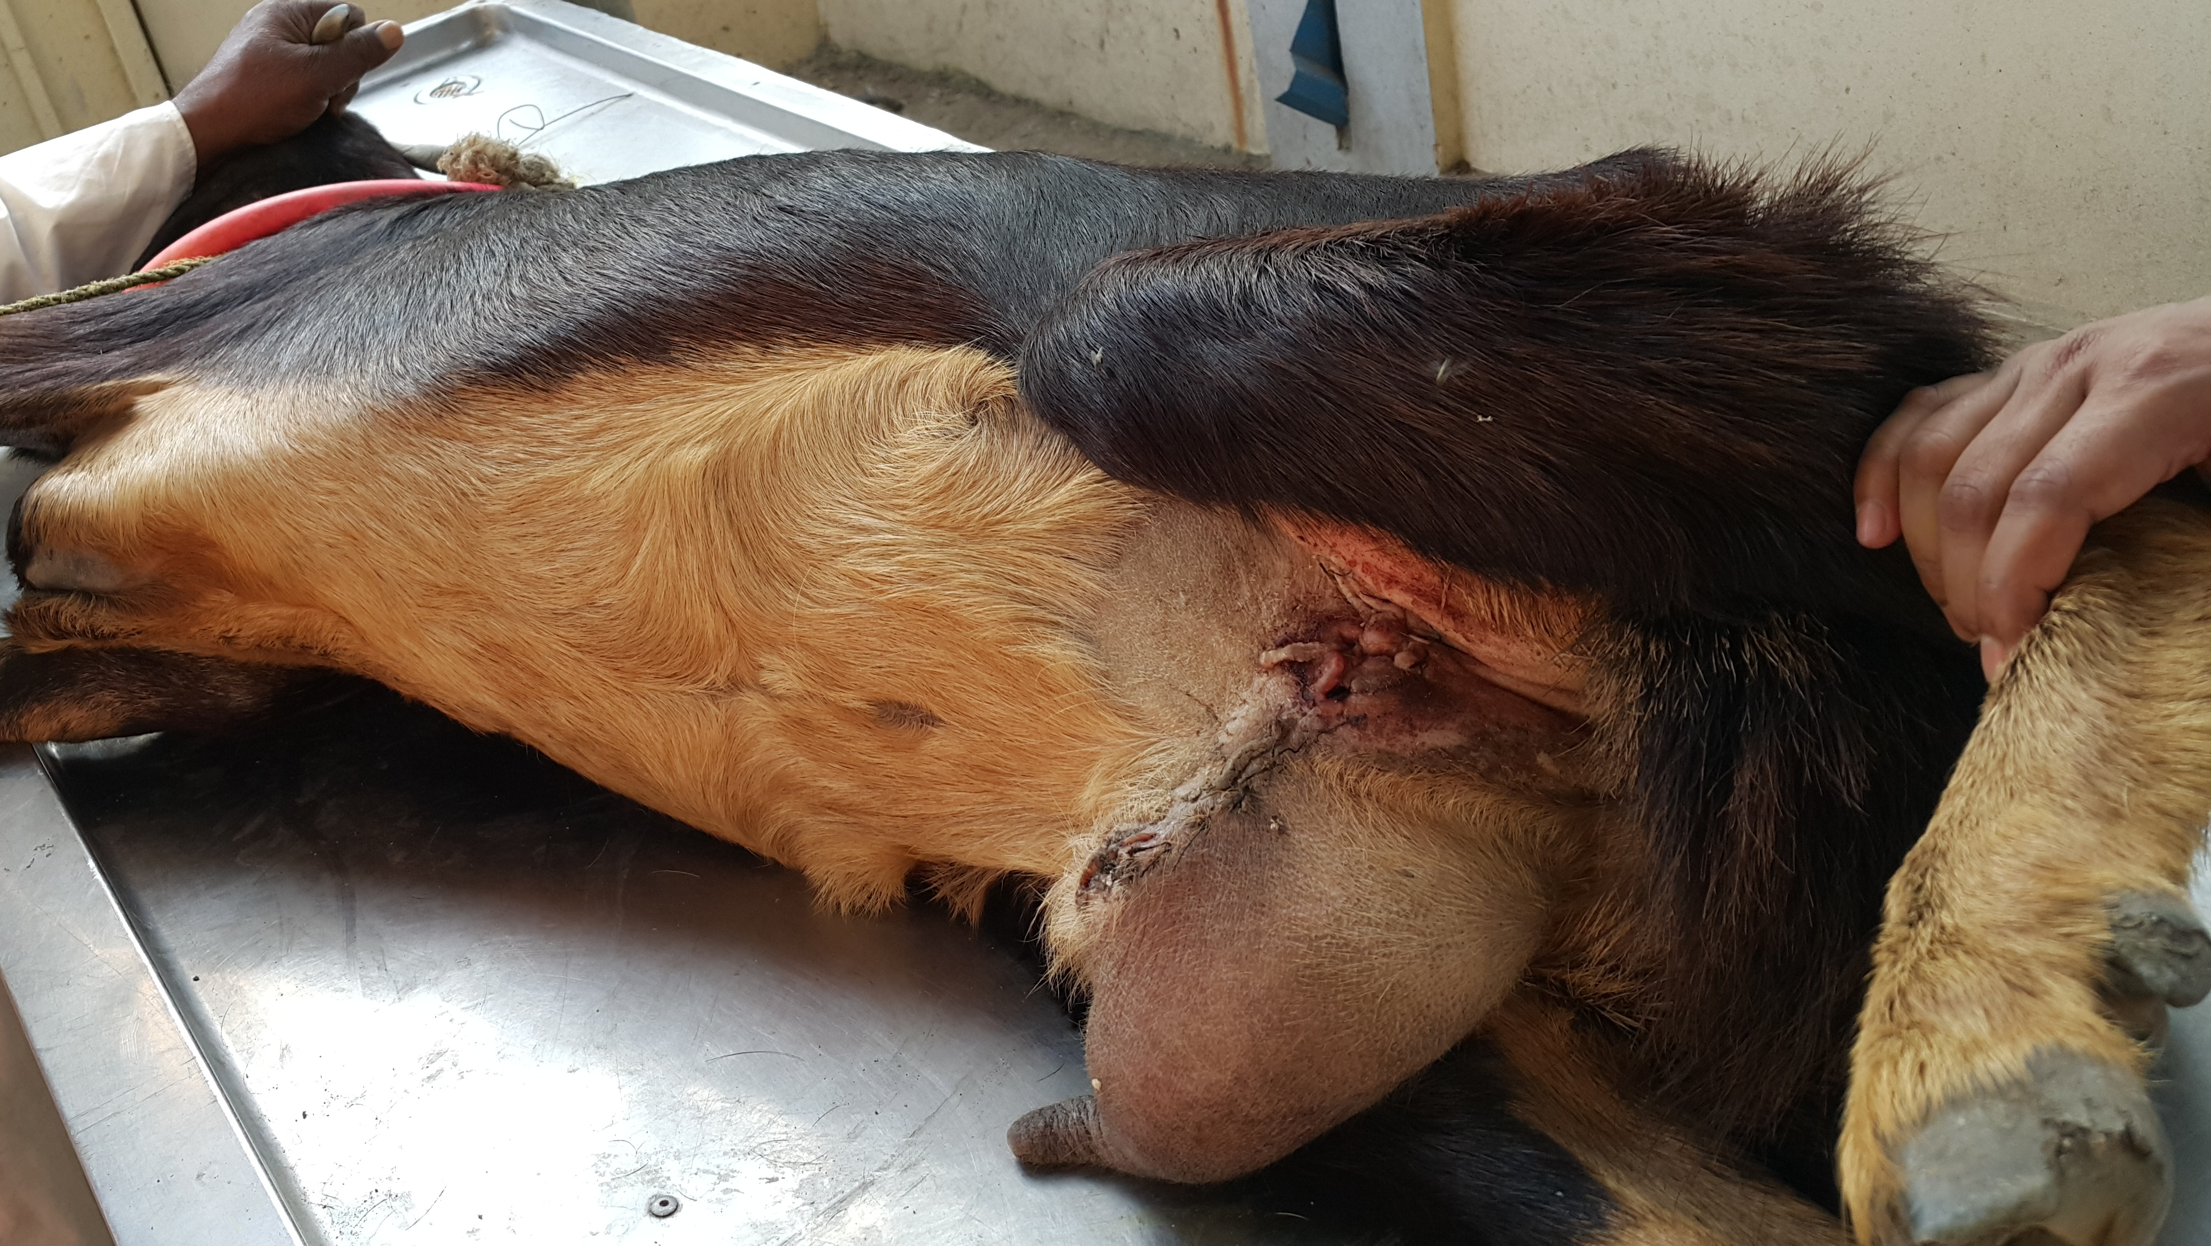
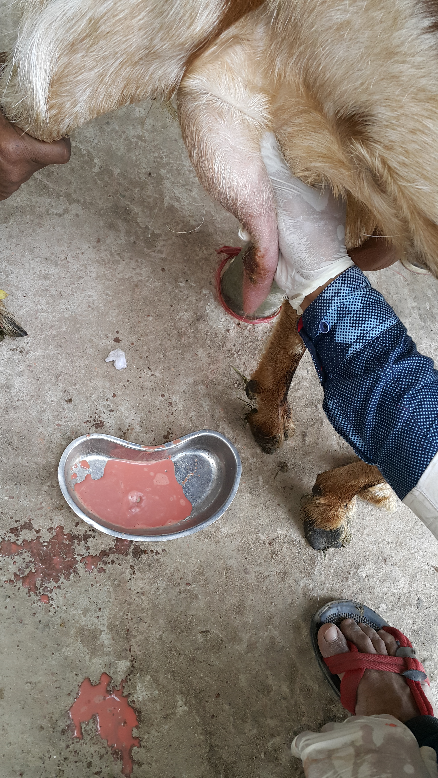
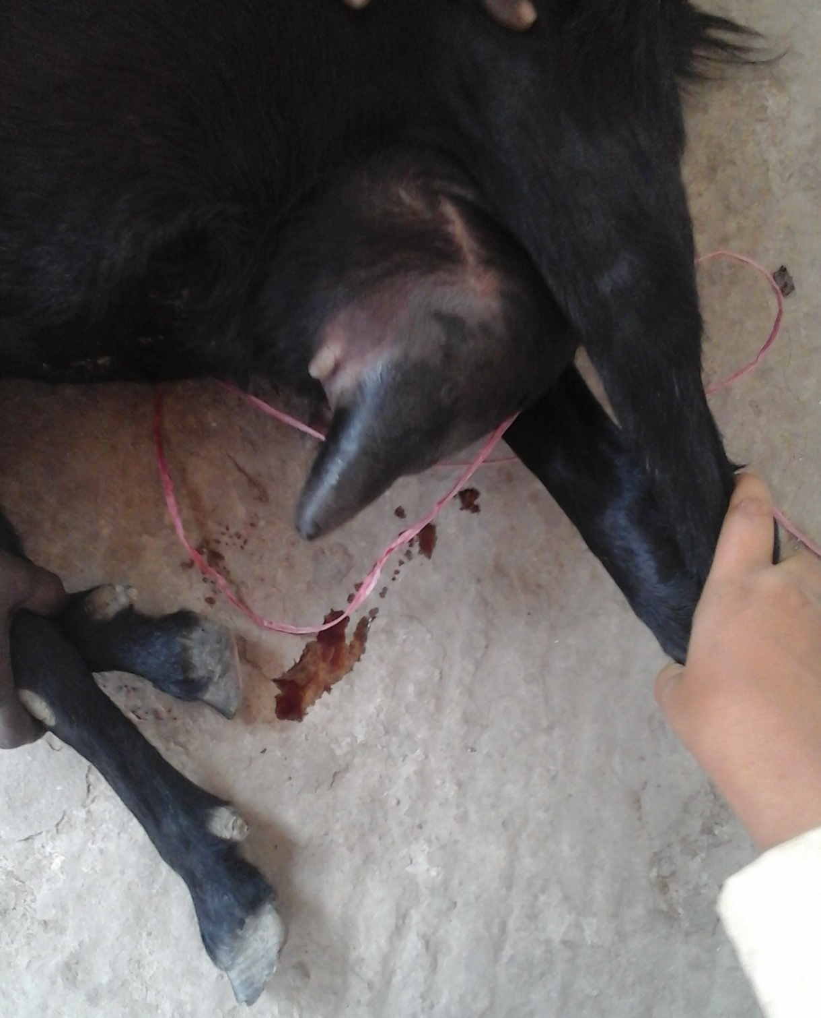

The proportionate prevalence of clinical mastitis was higher(n=10, 66.7%) in cross breed goat than in Jamnapari(n=1, 6.7%) and Black Bengal goat (n=4, 26.7%). The proportionate prevalence of clinical goat mastitis in adult goats(N=9, 60%) was higher than in younger goats(N=6, 40%). The proportionate prevalence of clinical goat mastitis was higher in goats with single parity (n=8, 53.3%) than in goats with multiple parities (6.7%-26.7%). The proportionate prevalence of clinical goat mastitis was 46.7%(n=7) in recently calved goats and 53.3%(n=8) in lactating goat (non pregnant ) (Table 2). The proportionate prevalence of clinical goat mastitis according to other factors were given in details in Table 2.
Table 2: Distribution of clinical goat mastitis by different factors (N=15)
Factor | Category | N | % | 95% CI
Breed | Black Bengal goat | 4 | 26.7 | 7.8 - 55.1
 | Jamnapari | 1 | 6.7 | 0.2 - 31.9
 | Cross | 10 | 66.7 | 38.4 - 88.2
Age (Year) | Young (1-1.5 y) | 6 | 40 | 16.3 -67.7
 | Adult (> 1.5 y) | 9 | 60 | 32.3 - 83.7
Parity | 1 | 8 | 53.3 | 26.6 -78.7
 | 2 | 4 | 26.7 | 7.8 - 55.1
 | 3 | 1 | 6.7 | 0.2 - 31.9
 | 4 | 2 | 13.3 | 1.7 -40.5
Pregnancy | Recently parturient | 7 | 46.7 | 21.3-73.4
 | Non pregnant(lactating) | 8 | 53.3 | 26.6 -78.7
Weight | 22-36 | 13 | 86.7 | 59.5 -98.3
 | 37-51 | 1 | 6.7 | 0.2 - 31.9
 | 52-66 | 1 | 6.7 | 0.2 - 31.9
Body condition score(Lumber score system) | First | 0 | 0
 | Second | 6 | 40 | 16.3 - 67.7
 | Third | 9 | 60 | 32.3 – 83.7
 | Fourth | 0 | 0
 | Fifth | 0 | 0
Stage of lactation(week) | First | 8 | 53.3 | 26.6 -78.7
 | Second | 4 | 26.7 | 7.8 - 55.1
 | Third | 3 | 20 | 4.3 -48.1
Weaning time(Days) | 30-50 | 10 | 66.7 | 38.4 - 88.2
 | 51-71 | 3 | 20 | 4.3 -48.1
 | 72-92 | 2 | 13.3 | 1.7 -40.5
Rearing system | Intensive | 5 | 33.3 | 11.8 - 61.6
 | Semi intensive | 7 | 46.7 | 21.3-73.4
 | Free range | 2 | 13.3 | 1.7 -40.5
 | Tethered | 1 | 6.7 | 0.2 - 31.9
Grazing system | Plane land | 7 | 46.7 | 21.3-73.4
 | Low land | 0 | 0
 | Cut and carry | 8 | 53.3 | 26.6- 78.7
 | Hilly Area | 0 | 0
Flooring system | Earth | 5 | 33.3 | 11.8 - 61.6
 | Brick | 8 | 53.3 | 26.6 -78.7
 | Slate | 1 | 6.7 | 0.2 - 31.9
 | Wood | 1 | 6.7 | 0.2 - 31.9
Farm size | 1-6 | 11 | 73.3 | 44.9 - 92.2
 | 7-12 | 4 | 26.7 | 7.8 - 55.1

3.3. Antimicrobials prescribed against goat mastitis
Antimicrobials in different combinations were generally prescribed against clinical goat mastitis in this study. The antibiotics included gentamycin, oxytetracycline, amoxicillin, cloxacillin, penicillin, streptomycin and ceftriaxone (Table 3)
Table 3: Antimicrobial prescribed against clinical goat mastitis (N=15)
Types | N | % | 95% Confidence  Interval | Drug withdrawal period(days)
Gentamicin | 4 | 26.7 | 7.8 - 55.1 | 40
Oxytetracycline | 1 | 6.7 | .2 - 31.9 | 28
Amoxicillin and cloxacillin | 7 | 46.7 | 21.3-73.4 | Amoxicillin(25)  Cloxacillin(15)
Procaine penicillin  and benzyle penicillin and Streptomycin | 2 | 13.3 | 1.7 -40.5 | Procaine Penicillin(20)  Benzyle Penicillin(30)  Streptomycin(9)
Ceftriaxone,amoxicillin and cloxacillin | 1 | 6.7 | .2 - 31.9 | Ceftriaxone(0)  Amoxicillin(25)  Cloxacillin(15)

3.4. Relation between feed provided and goat age/weight/BCS
There was no positive relationship of the feed provided with either age or weight or BCS of goats (Table 4)
Table 4: Relationship between amount feed provided and age/BCS/weight
Feed type | Age | BCS | Weight
Concentrate | 0.4 | 0.34 | 0.7
Roughage | 0.4 | 0.2 | 0.5

3.5. Farmer’s demography
The age of goat farmers ranged from 21-60 years old (average 36). Only two farmers had no education. The average goat farm size was 1-11 (Table 5).
Table 5: Demographic status of goat farmers
Variable | category | Mean | Median | Min – Max | N(%)
Age |  | 35.6 | 35 | 21-60
Education | Up to Class 5 |  |  |  | 5(33.3)
 | Class 5 to 10 |  |  |  | 8(53.3)
 | No education |  |  |  | 2(13.3)
Farm size |  | 3 | 4.7 | 1-11

CHAPTER 4: DISCUSSION

Mastitis is one of the most significant economic diseases in goats which causes loss of milk production, downgrade of milk quality and the increase kid mortality. So it is very important to prevent dairy goats from mastitis. The important findings of the study have been discussed in this section. Swollen, hard and painful udder, cold and hot udder, different colors of milk, blood tinged milk and cheesy flakes in milk noted in the current study (Table 1) were also commonly reported in many previous studies (Koop et al., 2015; Hossain et al., 2016). In mild clinical mastitis clots and flakes found in milk and in moderate clinical mastitis clots and flakes in milk along with swelling of affected quarter was found (Taponen et al., 2006). These findings are specific to diagnose mastitic case correctly as Burvenich et al.(2003) stated that increased firmness, swelling, watery milk with clots or flakes are often a first indication of mastitis. This study diagnosed all of the cases as acute mastitis with little chronic mastitis. The proportionate prevalence of clinical goat mastitis was high in cross bred, adult goat, recently calved, semi-intensive rearing system and goat house with brick made in the present study (Table 2). Body immunity of cross breed might not have as good as Black Bengal and Jamnapari goats along with pendulous udder and more milk production and unhygienic farm management condition. Barbosa et al. (2002) also recorded higher frequency of mastitis in cross breed goats. Many factor such as more kid production, longer milk production period etc might have put extra pressure on adult goats which could reduce their immunity and thus infectious agent could easily affect to have mastitis which is supported by (Ali et al 2010; Amin et al., 2013)).In this study the prevalence of clinical mastitis at first stage of lactation is higher than second and third stage of lactation. In does and ewes, number of lactations and mastitis incidence and prevalence are positively correlated (Bergonier et al., 2003). Another study reported that in pregnant and lactating animal the amount of milk production is reduced due to lower amount of prolactin release and lower nutritional level because fetus takes a great part on nutrition. Moreover, low milk production is less prone to mastitis (Kader et al., 2002; Sederevicius et al., 2006). Poor hygienic condition and faulty milking practice might have contributed more goat mastitis in this system. Other study also supported this result ((Majic et al., 1993). Proper cleaning of brick-made floor of goat house is difficult and therefore house remains dirty and un-hygienic which could be the reason for more occurrence of goat mastitis in this study which is also narrated by (Wakwoya et al., 2006). Multiple antibiotics in different combinations were prescribed in the present study which may be due to the fact of multiple pathogens involved with mastitis, development of drug resistance and producing synergistic and potentiation effect. However, it looks like a kind blind treatment without knowing types of pathogens and antimicrobial sensitivity pattern. Most of the goat farmers had some level of education in this study which is true for poor goat farmers in this region.

LIMITATIONS

Differential diagnosis was not performed. So, some mastitis cases might have mixed up with other udder problem (such as Udder edema). However, recorded clinical signs in this study were sufficient to qualify mastitis. This study did not differentiate classes of mastitis (acute, sub-acute, chronic and gangrenous mastitis) which was one of the limitations. Non-mastitic cases were not recruited for the present study which limits to conduct a case control study to determine potential risk factors associated with the occurrence of mastitis. Information bias could have introduced as epidemiological data recording was fully relied on farmers’ response. The extrapolation of the result to the general goat population was another limitation as the sample size was not selected based on statistical assumptions and random selection. Moreover, the sample size was poor. The treatment of mastitis was neither followed any protocol nor pathogen-specific and hence there is likely chance of developing antimicrobial resistance.

CONCLUSION & RECOMMENDATION

Swollen, hot, painful udder, bloody, watery milk and cheesy flakes in milk were common observable signs which are helpful for clinical diagnosis in resource poor setting. The proportionate prevalence of mastitis was high in cross bred, adult goat, recently calved goat, semi-intensive rearing system and goat house made of brick in the present study. Therefore, overall hygienic status of goat rearing in relation to these particular factors should be improved to reduce occurrence of mastitis cases. Goat farmers’ training on improved goat rearing might help in reducing incidence of goat mastitis in future. Mastitis treatment was basically based on the experience of the veterinarians rather than pathogen specific. Mastitis treatment protocol needs to be developed assessing, predominating pathogens and their antibiogram.

REFERENCES
1. Ameh, J. A., and I. S. Tari. "Observations on the prevalence of caprine mastitis in relation to predisposing factors in Maiduguri." Small Ruminant Research 35.1 (1999): 1-5.
2.Contreras, A., Sierra, D., Sánchez, A., Corrales, J., Marco, J., Paape, M., Gonzalo, C., 2007. Mastitis in small ruminants. Small Ruminant Research 68, 145-153.
3.Parvez, M., Faruque, M., Sutradhar, B., Rahman, M., Mannan, A., Khatun, R., 2014. Clinical diseases and manifestations of goats and cattle recorded at teaching veterinary hospital in Chittagong Veterinary and Animal Sciences University. Bangladesh Journal of Veterinary Medicine 12, 73-81.
4.Pisoni, G., Zadoks, R., Vimercati, C., Locatelli, C., Zanoni, M., Moroni, P., 2009. Epidemiological investigation of Streptococcus equi subspecies zooepidemicus involved in clinical mastitis in dairy goats. Journal of dairy science 92, 943-951.
5.Bozhilov B (1970). Aetiology of bacterial mastitis of goats in Khaskova district. Veterinary Medicine. 7:31-36.
6. Samad MA (2008). Animal Husbandry and Veterinary Science. Volume 2, 1st edn., LEP No. 11, BAU Campus, Mymensingh, Bangladesh.
7. Radostis OM, CC Gay, DC Blood and KW Hinchcliff, 1999. Veterinary Medicine. A Textbook of the diseases of cattle, sheep, pigs, goats and horses. W. B. Saunders Co., Phila-delphia, Pennsylvania.

8. BBS, 2008. Statistical year book on Bangladesh. Bangladesh Bureau Statistics, Ministry of Planning, Dhaka.
9. Gomes V, Matazo MP, da Costa e Silva CP, Baldacim VAP, Novo SMF, Baccili CC, Benites NR (2014).
10. Rahman MA, Bhuiyan MMU, Kamal MM and Shamsuddin M (2009). Prevalence and risk factors of mastitis in dairy cows. TheBangladesh Veterinarian 26: 54-60.
11. Majic B, Jovanovic BV, Ljubic Z and Kukovics S (1993). Typical problems encountered in Croatia in the operation of goats milking machines. Proceedings of the 5th Internacional symposium on machine milking of small ruminants. Budapest, Hungary. pp. 377-379.
12. Ribeiro MG, Lara GHB, Bicudo SD, Souza AVG, Salerno T, Siqueira AK, Geraldo JS (2007). An unusual gangrenous goat mastitis caused by Staphylococcus aureus, Clostridium perfringens and Escherichia coli co-infection. Brazilian Journal of Veterinary and Animal Science, 59: 810-812.
13. Shearer, Jan K., and B. Harris Jr. "Mastitis in dairy goats." (2006).
14. McDougall, S., Pankey, W., Delaney, C., Barlow, J., Murdough, P.A., Scruton, D., 2002. Prevalence and incidence of subclinical mastitis in goats and dairy ewes in Vermont, USA. Small Rumin. Res. 46, 115–121.
15. Hussain SS (1999). Sustainable genetic improvement of economic traits of Black Bengal goats through selective and cross breeding. Bangladesh Agricultural University Research Progress, 10: 72-80.
16. Dodd, F.H., 1985. Progress in mastitis control. Kiel. Milchwirtsch, Forschungsber. 37, 160±163
17. Ameh, J.A., Addo, P.B., Adekeye, J.O., Cyang, E.O., 1993. Prevalence of clinical mastitis and intrammary infections in Nigeria goats. Prey. Med. 17, 4±46.
18. East, N.E., Birnie, E.F., Farver, T.B., 1987. Risk factors associated with mastitis in dairy goats. Am. J. Vet. Res. 48, 776±779.
19. Ali Z, G Muhammad, T Ahmad, R Khan, S Naz, H Anw-ar, FA Farooqi, MN Manzoor and AR Usama, 2010. Prevalence of caprine subclinical mastitis, its etiologi al agents and their sensitivity to antibiotics in indige-nous breeds of Kohat, Pakistan. Pak J Life Sci, 8: 63-67

20. Bergonier D, Cramoux R, Rupp R, Lagriffoul G, BerthelotX. Mastitis of dairy small ruminants. Vet Res. 2003;34 (5):689–716.
21. Kader MA, Samad MA, Saha S and Taleb MA (2002). Prevalence and etiology of sub-clinical mastitis with antibiotic sensitivity to isolated organisms among milch cows in Bangladesh. Indian Journal of Dairy Science 55: 218-223.
22. Sederevicius A, Balsyte J, Lukauskas K, Kazlauskaite and Biziulevicius GA (2006). An enzymatic cow immunity-targeted approach to reducing milk somatic cell count: A comparative field trial. Food and Agricultural Immunology 17 1-7.
23. Koopa,∗, Md. Nurul Islamb, Md. Mizanur Rahmanb, Momena Khatunc,Jinnat Ferdousb, Md. Abu Sayeedb, Shariful Islamb, Md. Ahaduzzamanb, Sazeda Akterb,Abdul Mannand, Mohammad Mahmudul Hassane, Ravi Dissanayakef,Md. Ahasanul Hoqueb,(2015). Risk factors and therapy for goat mastitis in a hospital-basedcase-control study in Bangladesh
24. Suvi Taponen a, *, Heli Simojoki a , Maarit Haveri a , Helle D. Larsen b , Satu Pyo¨ra¨la¨ a(2006). Clinical characteristics and persistence of bovine mastitis caused by different species of coagulase-negative staphylococci identified with API or AFLP
25. Christian Burvenich*, Valérie Van Merris, Jalil Mehrzad, Araceli Diez-Fraile, Luc Duchateau(2003) Severity of E. coli mastitis is mainly determined by cow factors
26. Contreras, A., M. J. Paape, and R. H. Miller. "Prevalence of subclinical intramammary infection caused by Staphylococcus epidermidis in a commercial dairy goat herd." Small Ruminant Research 31.3 (1999): 203-208.
27. White, E. C., and L. S. Hinckley. "Prevalence of mastitis pathogens in goat milk." Small Ruminant Research 33.2 (1999): 117-121.
28. Wakwoya A, Molla B, Belihu K, Kleer J and Hildebrantdt G (2006). A cross-sectional study on the prevalence, antimicrobial susceptibility patterns and associated bacterial pathogens of goat mastitis. International Journal of Applied Research in Veterinary Medicine 4: 169-176.
29. Hossain, S., et al. "Impact of clinical mastitis in dairy farming at Keshabpur Upazilla in Jessore in Bangladesh." Bangladesh Journal of Veterinary Medicine 14.1 (2016): 59-64.
30. Amin, M. A., M. A. Samad, and AKM Anisur Rahman. "Bacterial pathogens and risk factors associated with mastitis in Black Bengal goats in Bangladesh." Bangladesh Journal of Veterinary Medicine 9.2 (2013): 155-159.

ACKNOWLEDGEMENTS

The author wishes to acknowledge the immeasurable grace and profound kindness of Almighty “ALLAH” the supreme authority and supreme ruler of universe, who empowers the author to complete the work successfully.
The author doesn’t have adequate words to express deepest sense of gratitude, respect and immense indebtedness to his honorable teacher and internship supervisor, Md. Ahasanul Hoque, Professor of Veterinary Epidemiology, Dept. of Medicine and Surgery, Faculty of Veterinary Medicine, Chittagong Veterinary and Animal Sciences University for his scholastic guidance, sympathetic supervision, valuable advice, continuous inspiration, radical investigation and constructive criticism in all phases of study.
The author would like to express his heartfelt gratitude and respect to the honorable teacher Prof. Md. Abdul Halim, Dean, Faculty of Veterinary Medicine and Dr. A. K. M. Saifuddin, Director of External Affairs, Chittagong Veterinary and Animal Sciences University for continuing this internship programme and finally special thanks to honorable senior brother Dr. Md. Harun Rashid, MS fellow in Epidemiology, Chittagong Veterinary and Animal Sciences University for his helping hand during my clinical training at Teaching Veterinary Hospital, Chittagong Veterinary & Animal Sciences University.
Finally the author extended his appreciation to his parents, all patient owners and all well-wishers.

The Author

BIOGRAPHY

I am Mohammad Yusuf Munna, Son of Mr. Saidul Hoque and Mrs. Jaithun Nour Begum. I passed Secondary School Certificate examination in 2008 followed by Higher Secondary Certificate examination in 2010. Now I am an intern doctor under the Faculty of Veterinary Medicine in Chittagong Veterinary and Animal Sciences University. In future, I want to develop me as a veterinary practitioner by dealing as veterinary surgeon. I have immense interest to work in the field of Large and Small Ruminant Medicine.

Mohammad Yusuf Munna
Intern Doctor
Chittagong Veterinary and Animal Sciences University
E-mail: yusufmd48@gmail.com

