Chapter 1: Introduction
Bangladesh is an agricultural country and livestock is the part and parcel of this agriculture. At present most of the people depend on the income from livestock and livestock products. Both in rural and urban areas, about 80% of people directly or indirectly related with livestock or livestock farming in Bangladesh due to its profitable criteria. Livestock plays great role in Gross Domestic Product (GDP) which is about 2.50% (BBS, 2011-2012). Livestock is also popular in the sense that it meets up the demand of nutrition and plays a role of livelihood in a developing country like Bangladesh. The total livestock of Bangladesh is 288.57 million and cattle population is 23.9 million (BBS, 2012). Though the no. is partially satisfactory, the economic benefit from this population is not so satisfactory due to some constraints in rearing. These constraints may be nutrition, genetics, poor management or any disease. In Bangladesh, the main causes of loss in livestock sector are poor management and diseases especially different reproductive diseases of dairy cattle which results in poor reproductive performance (Alam et al., 2014).

Congenital disorders in calves have been increasing alarmingly with the increase of crossbred animals. Inguinal hernia, umblical hernia, atresia ani and umbilical abscess are among the major congenital disorders causing mortality in calves.Hernia is the protrusion of an organ or tissue through an opening that may be caused by a tear in the abdominal wall or it may be a natural opening like inguinal canal (Jettennavaretal., 2010). Hernias may be congenital or acquired, but in bovine a inguinal hernia is very uncommon specially in female calves. Acquired inguinal hernias may be of traumatic origin or may results from management practices in the development of young bulls (Chuang et al., 2000). Traumatic inguinal hernias have occurred in bulls that have become entangled when attempting to jump fences. In these cases increased intra-abdominal pressure allows the intestines to perforate the peritoneum near the vaginal ring and descend through the inguinal canal alongside the spermatic cord. The intestine frequently becomes strangulated.Multiple births and shortened gestation lengths are two important risk factors for congenital hernias in calves (Hermann et al., 2001).

Genetic or environmental factors or their interactions cause congenital defects and these anomalies are abnormalities of structure or functions present at births (Leipold et al., 1983).The most common inguinal hernia is acquired and non-traumatic in origin. This management-induced hernia occurs primarily in beef bulls over three years of age and is the result of feeding practices in young bulls. This congenital defect may be dangerous if not treated in appropriate time. The affected calves may only be salvaged through successful herniorrhaphy (Samad et al., 2002). Many factors e.g., suture materials, suture pattern, degree of protrusion; body circumference, ring diameter etc. determine the success of herniorrhaphy (Peacock and Van Winkle, 1976). Suture materials are selected on the basis of their physical and biological properties, condition of the wound and healing characteristics of the tissue to be opposed. Polypropylene is one of the potent secured knotable, flexible synthetic non-absorbable suture materials frequently used in human practice. Horizorital mattress and purse string suture patterns with catgut and silk are widely practiced in Bangladesh (Rahman et al., 2001). The modified suture pattern (myomattress) is an overlapping suturing technique that provides adequate support to the suture line (Knecht et al., 1987). If the degree of protrusion, body circumference and ring diameter of hernial swelling are large, appropriate suture material and pattern is to be needed to close the hernial ring (Wion, 1957).
There is no data concerning comparison between the open and closed methods of herniorrhaphy in calves. Ligation of the hernial sac, use of clamps, suturing of the hernial sac and radical operation are normally performed to correct the umbilical hernia, although open herniorrhaphy is the most common method of veterinary treatment (O'Connor, 1980). Ready contact with the floor and licking by the cows may increase the risk of susceptibility of infection in open herniorrhaphy. So thatpost-operative complications like stitch abscess, hemorrhage, myiasis, peritonitis, recurrence etc. may be observed (Fretz et al., 1983). Once recurrence occurs, the prognosis is not satisfactory in maximum cases, which ultimately leads to death of the animal.

1.2. Objectives
- To correctproperly inguinal hernia for saving the life of calves.
- To observe the post-operative complications and their management.

Chapter 2: Case presentation

2.1. Case history
A female cross breed calf of only five days of agewas brought to the SAQ teaching veterinary hospital, CVASU with history of large swelling in inguinal region. Clinical history revealed improper urination and defective defecation after birth. Various clinical parameters (respiratory rate, heart rate and rectal temperature) were recorded prior to operation and at different post-operative periods (3rd, 7th and 10th). The values recorded before operation was considered as control and these values were compared with the experimental values obtained at different post-operative days.

2.2. Clinical examination of calf
2.2.(a). Diagnosis of hernia
Anamnesis suggested that the calf was suffering from it after birth that was noticed by owner as it was increasing gradually in size. The affected animal was placed in dorsal recumbency and the contents were pushed back into the abdomen. Clinical examination revealed that the swelling was firm, non-painful on palpation.
2.2.(b). Measurement of hernial swelling
The protrusion of hernial swelling was the length from its neck to the fundus and was measured in inches with a measuring scale. Circumference of the swelling was taken at the level of its body and was measured in inches with a measuring tape. In measuring it was 7.5 inches in length and 7.6 inches in width and finally diagnosed as congenital inguinal hernia under this observation.
2.3. Anaesthesia
After restraining the animal in dorso-lateral recumbancy, proper shaving was done at inguinal region and over the herniated part. As a pre-anesthetic, Diazepam (Sedil 2%; Square Pharmaceuticals, Bangladesh) at a dose rate of 0.4 mg/kg was administered intravenously to sedate the animal and 0.9% sodium chloride fluid was administered intravenously o stabilize the animal. Later, 2% lidocaine hydrochloride (Jasocaine® Jason Pharmaceuticals Ltd., Dhaka, Bangladesh) as the dose rate 1ml/cm was infiltrated through ring block.

2.4. Suture materials
Prolene was used for closing hernia ring, chromic catgut (Surgigut®, Huaiyin Medical Instruments Co. Ltd., China) no. 2 were used for internal suturing and silk was used for skin suturing.
2.5. Surgical management
After aseptic preparation of surgeon and surgical site, open technique was performed. A straight incision is performed on the herniated part through the skin and subcutaneous tissue. There was adhesion of the hernial content. The content was separated by blunt finger dissection. After complete separation of the contents, urinary bladder and intestine were revealed. These contents were given inside back through the ring. Then extra part of hernia sac wasremoved. Hernial ring were closed by horizontal mattress using prolene and after that purse string suture was also given.Sub-cutaneous suture was performed by catgut and skin was closed by silk.

2.6. Post-operative management
The animal was treated postoperatively with Penicillin-Streptomycin (SP-Vet®, Acme Pharmaceuticals Ltd., Bangladesh) at a dose rate of 30,000 IU/kg for the penicillin and 10 mg/kg Streptomycin, Analgesic-meloxicam (Melovet®, Techno Pharmaceuticals Ltd., Dhaka, Bangladesh) at the rate of o.5mg/kg body weight and antihistaminic Pheneramine Maleate (Histavet®, ACI Pharmaceuticals Ltd., Bangladesh) at the rate of 0.5mg/kg body weight for 5 days.

Chapter 3: Results

An uncommon rare congenital disease (Inguinal hernia) of calf was corrected by herniorrhaphy using sterilized prolene with a horizontal mattress pattern. After removal of extra covering of hernia sac, final closure of skin was done with non-absorbable silk. However, inguinal hernia can be life threatening, if the calf is not treated early.

Post-operative and mobile follow-up revealed successful recovery with proper urination on 2nd days, 10th days and 14th days of operation.

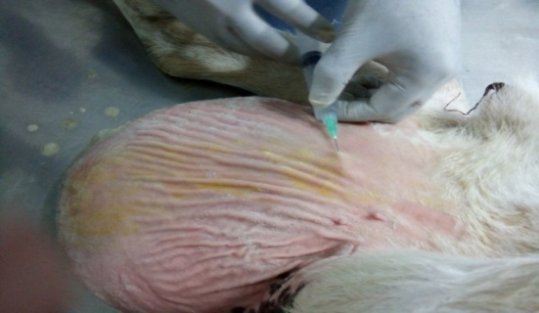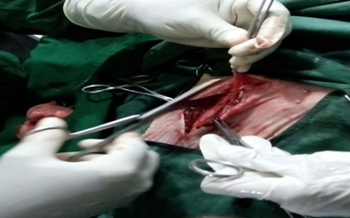
Figure(a): Local anaesthesia by ring block Figure(b): Blunt dissection

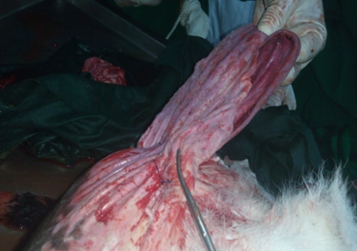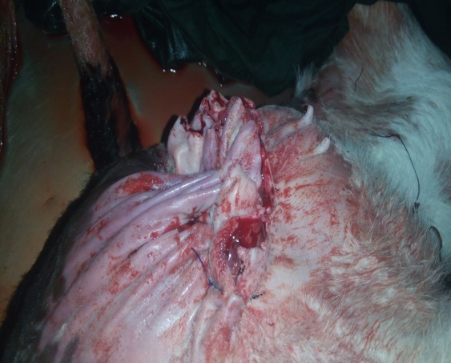
Figure(c): Excess skin Figure(d): After removing of excess skin

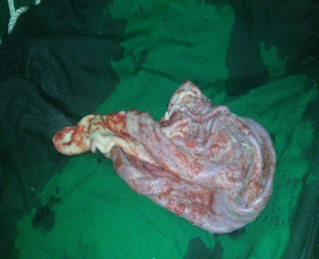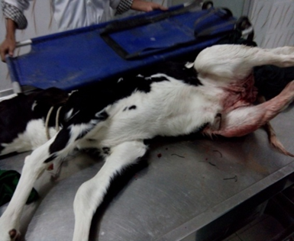
Figure(e): Removed excess skin Figure(f): After surgery
Chapter 4: Discussion

The present study was designed to present a case presentation on an inguinal hernia case in a calf in SAQ Teaching Veterinary Hospital (CVASU). Hernia cases are common in calves occurring with a high incidence rate which is observed in the SAQTVH. Although umblical hernia is common in calves but in some cases inguinal hernia may be occurred in association with femoral hernia or abdominal hernia. This inguinal hernia is a type of congenital affection which is supported by Priester et al., 1970. Inguinal hernia is found uncommon in the hospital data in calves which was also reported by Dr. J. D. Wheat, 1952 stated that although inguinal hernia is not common in the bull, it is a condition which requires diagnosis and surgical treatment if the bull is to be kept as a herd sire. In the present case, the affected animal was a crossbreed calf of fifteen days that is also emphasized by Zhigachev, 1983 as in cattle the condition is comparatively more frequent in Holstein-Friesian breed and similar findings reported by Priester et al., 1970 thatInguinal hernia is one of the major congenital affections in animal particularly in bovine. It also occurs in foals and pups. The affected calf was female with shows similarity with a study by Md. Salim et al., 2015 that reported Among 30 affected calves, 63.33% were male and 36.67% were female.

In the study revealed that the calf was in normal body condition but decreased appetite was complained by the owner and the swelling with ring found in inguinal region that was suggestive to the duty doctors as inguinal hernia as tentative diagnosis. But this diagnosis based on clinical signs is sometime confused in some instances (Keown 1998, Purohit et al. 1983). Mean body circumference of the inguinal swelling in the study was measured 7.5 inches in length and 7.6 inches in width and finally diagnosed as congenital inguinal hernia under this observation can be compared with the study carried by Md. Salim et al., 2015 that said in the study with 30 hernial cases in two groups wherethe diameter of hernial ring was 4.74 cm in group-I calves while that in the Group-II calves was 2.41 cm. These values were statistically significant (p<0.05). Mean body circumference of the umbilical swelling in the group-I calf was 17.72 cm in contrast to group-II calves where this value was 13.99 cm. These values were statistically significant (p<0.05) which shows some dissimilarity with the measurements in the present study.
For restraining the animal in dorso-lateral recumbancy pre-anesthetic, Diazepam was administered to sedate the animal and sodium chloride fluid was administered to stabilize the animal. Later, 2% lidocaine hydrochloride was infiltrated through ring block which was associated with the study carried out by Edmondson, 2008 which concluded local or regional anesthesia is safe and effective and is still the most desirable procedure in many situations. The present study indicates that local infiltration anaesthesia with sedation is quite sufficient for performing the surgical repair. Diazepam (0.4 mg/kg) was used intravenously as a sedative in this study, which was cheap in comparison with xylazine and also produced satisfactory results. Infiltration of local anaesthesia with 2% lidocaine was also satisfactory for anaesthesia of the inguinal region. Positioning on dorsal recumbency of the animal on a surgical table was found to be important to facilitate reduction of the hernial contents and herniorrhaphy. This recumbence was suitable for open herniorrhaphy.

Surgical treatments of hernia were performed by open and closed techniques also supported by Md. Salim et al., 2015 where in the study the calves were randomly classified into two groups; group-I (n=15), group-II (n=15), which were treated by open and closed herniorrhaphy, respectively. In calves, because of the rate of adhesions and infection of internal structures, the open technique was performed otherwise closed technique was applied (Sutradhar et al., 2009). If the hernia ring size is so wide measuring > 2 inches, special precaution is required at the time of suturing (Jahromi et al. 2009).In the presented case, hernial ring was >7.6 inches in width and that type of hernia was corrected by using a horizontal mattress pattern reported similarity with Jahromi et al. 2009. Herniorrhaphy used in case of present study for closingof hernia ring with sterilized silk or nylon or prolene to suture in hernia ring and the excess part was removed to avoid further complication and for proper healing was also considered in a study by Monsang et al,. 2014.

In post-operative care Penicillin-Streptomycin at a dose rate of 30,000 IU/kg and 10 mg/kg streptomycin, analgesic-Meloxicam at the rate of o.5mg/kg body weight and antihistaminic Pheneramine Maleate at the rate of 0.5mg/kg body weight were administered for 5 days.after follow-up revealed successful recovery. The recovery rate can be compared with the study by Md. Salim et al., 2015 out of 30 operated calves, only 33.34% recovered with minimum complications and (6.67%) cases recurred.

Conclusion
The presented congenital inguinal hernia was successfully reduced by herniorrhaphy with successful recovery (proper urination and defecation) revealed during follow up at 14th days of post-surgery. So, this life threatening congenital defect can be cured by open method of herniorrhaphy.

Image Gallery

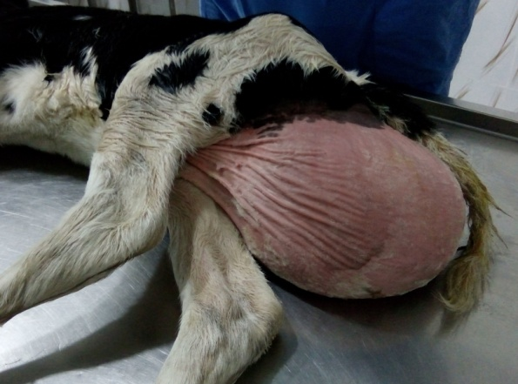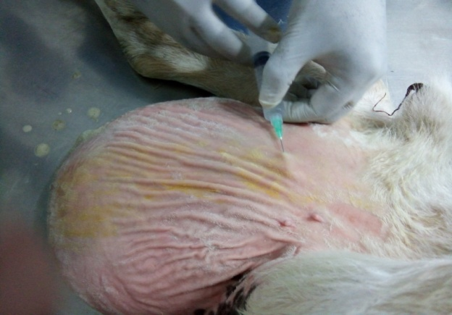
Figure 4(a):Clipping and shaving for aseptic surgery
Figure 4(b):Localanaesthesia by ring block
Ff

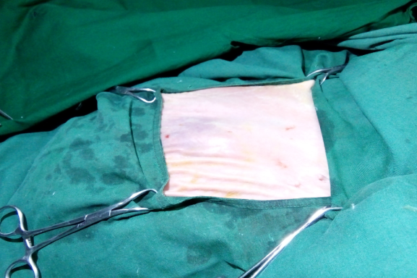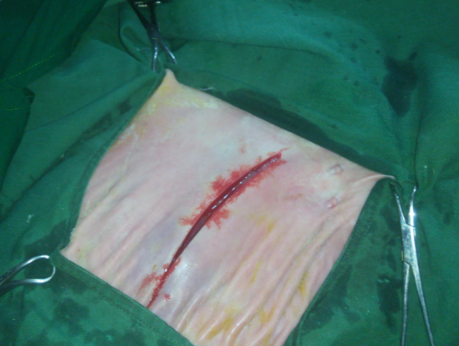
Figure 4(d): Straight incission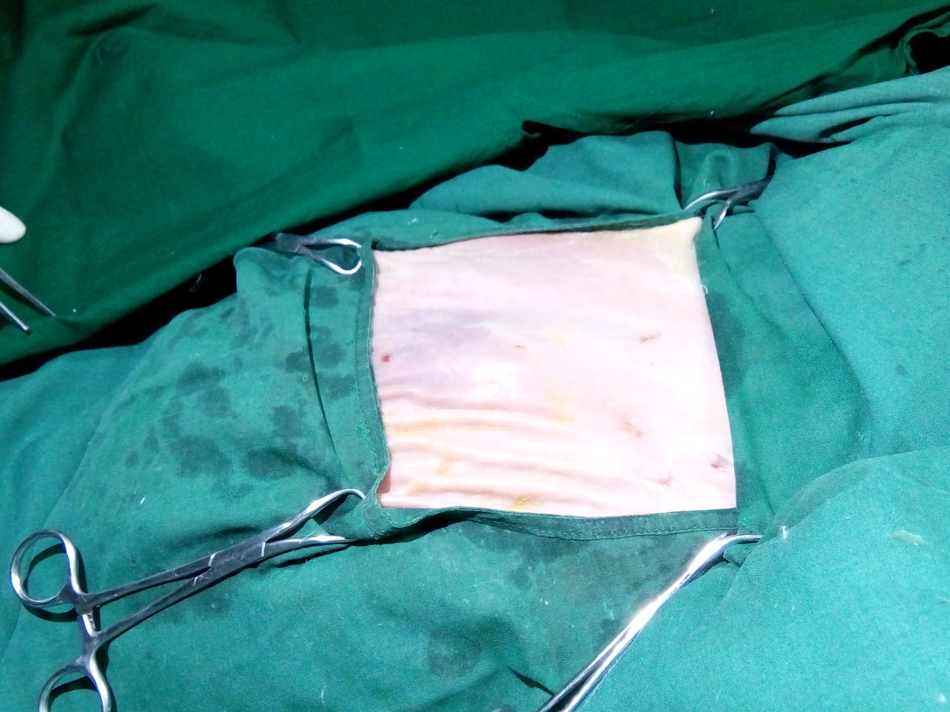

Figure 4(c): Aseptic surgical site

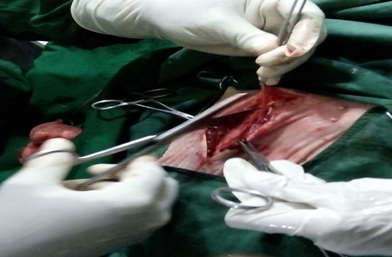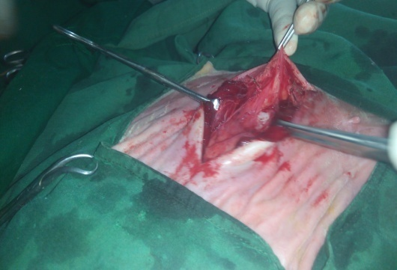
Figure 4(e): Blunt dissection

Figure 4(f): Deformed muscle

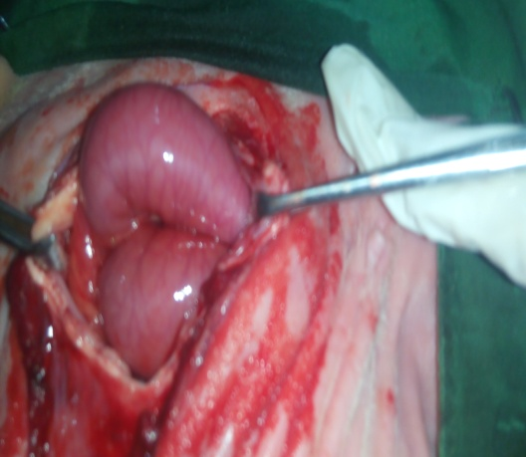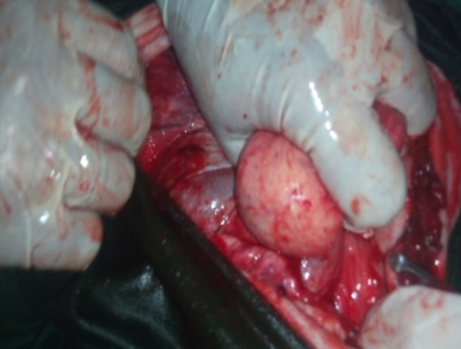
Figure 4(g): Intestinal part

Figure 4(h): Urinary bladder

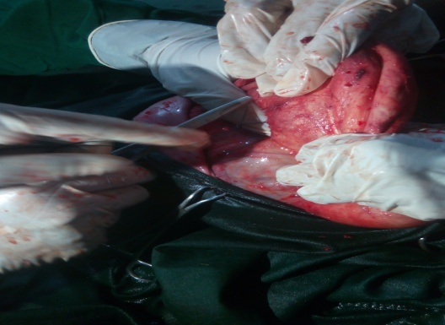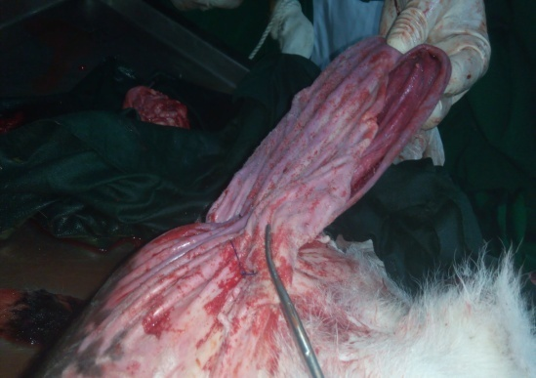
Figure 4(i): Herniorrhaphy by prolene

Figure 4(j): Excess skin

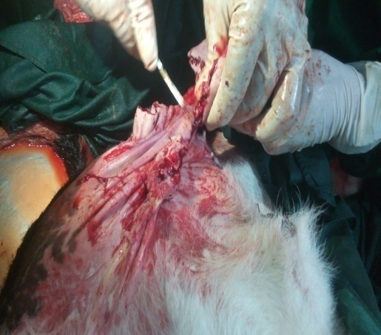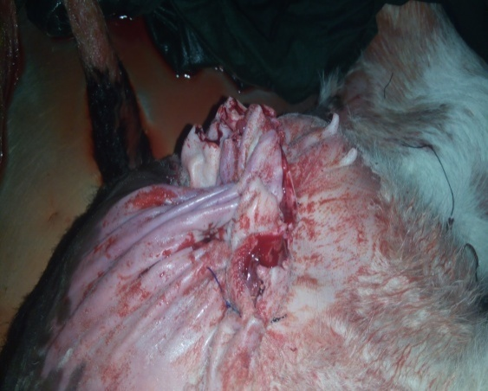
Figure4(l): After removing of excess skin

Figure 4(k): Removing of excess skin

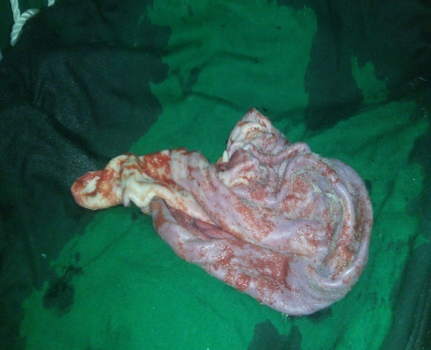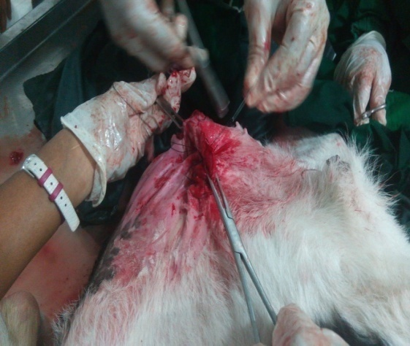
Figure 4(m): Excess skin removed

Figure 4(n): Purse-string suture

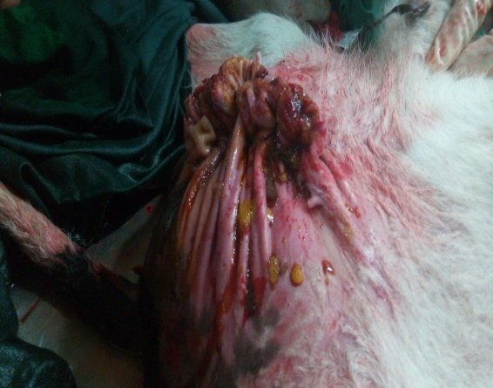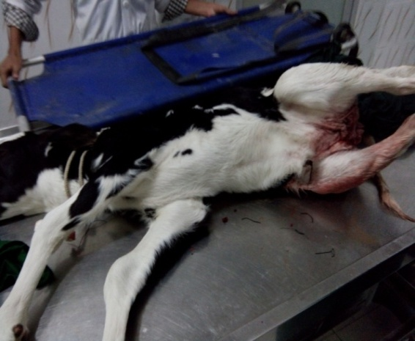
Figure 4(o): Suture line sealed with povidin iodine

Figure 4(p): After surgery

References
Alam, A., Bhuiyan, MU., Parvin, SM., Bari, FY., 2014. Prevalance of reproductive diseases and its associated risk factors in cross breed dairy cows.1(1): 71-79

BBS, 2007.Statistical Year book of Bangladesh.Bangladesh Bureau of Statistics, Statistics Division and Ministry of Planning. Government of People’s Republic of Bangladesh.

Chuang, ST., Chen, L.P. and Chan, PWJ., 2000. Umbilical hernia and infection in calves. Taiwan Journal of Veterinary Medicine and Animal Husbandry 70: 85-92.

Dennis, SM., and Leipold, HW.,1968. Congenital hernias in sheep. Journal of American Veterinary Medical Association.152: 999–1003.

Das, BR., and Hashim, MA., 1996.Studies on surgical diseases in calves. Bangladesh Veterinary Journal 30: 53-57.

Field, JR., 1988. Umbilical hernia with abomasal incarceration in a calf. Journal of American Veterinary Medical Association, 192: 665-666.

Freeman, DE., Orsini, JA., Harrison, LW., Muller, NS and Leitch, M., 1988. Complication of umbilical hernias in horses: 13 cases (1972-1986). Journal of American Veterinary Medical Association 190: 804-807.

Fretz , PB., Hamilton, GF., Barber, S.M., and Ferguson, JG., 1983.Management of umbilical hernia in cattle and horses. Journal of American Veterinary Medical Association, 183: 550-552.

Hayes, HM., 1974. Congenital umbilical and inguinal hernias in cattle, horses, swine, dogs and cats: Risk by breed and sex among hospital patients. American Journal for Veterinary Research, 35: 839–842.
Keown, GH.,1988. Textbook of large animal surgery. Ed. FW Oehme Baltimore London.
Kumar, RVS., 2001. Repair of umbilical hernia involving rumen in a cross bred calf. Indian Journal of Veterinary Surgery, 22: 134.
Leipold HW., Huston, SM., 1983. Bovine congenital defects. Advanced Veterinary Science and Compendium Medicine, 27: 197-271.
Priester, WA., Glass, AG and Waggoner, N.S., (1970). Congenital defects in domesticated animal: general consideration. American Journal of Veterinary Research 31: 1871-1879.
Peacock, EE Jr and Van Winkle, W., 1976. Wound repair. Surgery Gynecology and Obstetrics 14: 07-10.
Pugh, DG.,2002. Sheep & Goat Medicine. Philadelphia: Sounders,.104–105.
Salim, MD., Islam, MS., Juyena, NS., 2015. Prevalence of hernia and evaluation of herniorrhaphy in calves. International Journal of Natural and Social Sciences. 2(4): 35-43
Samad, MA., Islam, MA., and Hossain, M.A., 2002. Patterns of occurrence of calf diseases in the district of Mymensingh in Bangladesh. Bangladesh Veterinary Journal 36: 01-05.
Sutradhar, BC., Hossain, MF., Das BC., Kim, G. and Hossain, MA., 2009: Comparison between open and closed methods of herniorrhaphy in calves affected with umbilical hernia. Journal of Veterinary Science 10: 343-347.

ACKNOWLEDGEMENT

The author wishes to acknowledge the immeasurable grace and profound kindness of Almighty “ALLAH” the supreme authority and supreme ruler of universe, who empowers the author to handle the case and to complete the case report successfully.

The author wishes to express his deep sense of gratitude and thanks to DR. Md. Masuduzzaman, Professor of the department of pathology and parasitology, Faculty of Veterinary Medicine of Chittagong Veterinary and Animal Sciences University for his skillful supervision and guidance to make this report.

The author is also grateful to DR. Tuli Dey, Lecturer of the department of medicine and surgery, CVASU for her supports and instructional guidelines to make this report.

Finally the author expresses thanks and warmest sense of gratitude to his parents and all well-wishers.

The author,

November, 2017

BIOGRAPHY

My-self Nazmul Islam, the author of this case report would like to introduce as Intern. DR of Chittagong Veterinary and Animal Sciences University (CVASU) have passed four years academic career in faculty of veterinary medicine and attended several clinical training programs on Veterinary Medicine in Bangladesh and India. As a student of Veterinary science, the main mission and vision of my life is to do something better and creative job by dint of my academic knowledge and experience, for the development of livestock as well as development of the economic condition of our country. This case report on congenital inguinal hernia is the first step to fulfill my dream. I strongly assure that I have done all the works furnished here in this report and I hold entire responsibility of the information given here which are collected from different books, journal and websites.

