CHAPTER 1: INTRODUCTION

The skin is the largest organ of the body. It plays an important role in different functions such as the perception of heat, cold, pressure, pain and itch immune protection. It also acts as a barrier between the animal and the environment. The first domesticated faithful animal, dog in the world is prone to many bacterial, parasitic and fungal skin diseases. The common dermatological cases are Malassezia dermatitis, Demodicosis, Scabies, Mite infestation, Canine atopic dermatitis, Cutaneous adverse food reaction, Flea allergic dermatitis, Allergic contact dermatitis and Tick infestation etc. Dermatitis caused by the yeast Malassezia pachydermatis is common in dogs, are extremely pruritic and may occur in conjunction with concurrent or predisposing diseases such as allergic dermatitis or endocrinopathy (Daniel, 1999). One of the most common skin diseases in dog is demodicosis caused by the mites of various Demodex species. Generally, three types of Demodex mites are found in dogs namely Demodex canis, the long-bodied Demodex injai and the short bodied mite (Mueller et al., 2012). Demodex canis, which inhabits on the hair follicle, is mainly responsible for canine demodicosis than others (Plant et al., 2011; Ravera et al., 2013). Sarcoptic mange is a highly contagious, intensely pruritic and potentially zoonotic skin disease condition of animals. It is caused by infestation of the skin by a mite, Sarcoptes scabiei var. canis (Anita and Peter, 2008) which burrows into its hosts epidermis. Canine atopic dermatitis is a type of dermatitis where pruritus is the characteristic sign of feet, face, ears, flexural surfaces of the front legs, axillae, and abdomen are the most frequently affected areas and primary lesions consist of erythematous macules, patches, and small papules (Moriello, 2001). Cutaneous adverse food reactions (CAFRs) comprise both food hypersensitivities (mediated by the immune system) and food intolerances (not involving the immune system) (Bloom, 2011). In flea allergic dermatitis, patient will present with at least one of the four common cutaneous reaction patterns indicative of pruritus and inflammation, head/neck/pinnal pruritus with excoriations, self-induced alopecia, miliary dermatitis, and/or eosinophilic lesions (including eosinophilic plaques, eosinophilic granulomas, and indolent ulcers (Diesel, 2017). Allergic contact dermatitis although the cause is still unknown as its ubiquitous in nature and the clinical presentation may be a localized dermatitis to systemic hypersensitivity and also systemic drug-related flexural exanthema possibly due to the presence of many metal compounds (Krawiec and Gaafar, 1975). Tick infestations are associated with decreased productivity, loss of blood and blood proteins, transmission of diseases, debilitation, and even death. Feeding sites on the host vary with the tick species. Ticks are associated with an acute paralytic syndrome called Tick Paralysis. This disease is characterized by ascending paralysis and may lead to death if the tick is not removed before the paralysis reaches the respiratory muscles. Diagnosis is based on identification of the species (Smith et al., 2011).

The diagnostic protocols may be followed for the investigated dermatological disorders are skin scrapping, coat brushing, food trial, drug response trial, woods lamp techniques, tape smearing and further more the specific causal agent can be characterized by molecular techniques. Generally diagnosis is based on compatible historical and clinical information, as well as rulling out other causes of pruritus (S Rahman, 2013).

The treatment protocol includes topical therapy like ketoconazole/miconazole shampoo, cypermethrin shampoos, spray, topical benzyl benzoate etc. and parenteral therapy includes ivermectin, dexamethasone, antibiotic preparation to prevent the secondary bacterial infection and antihistaminic preparation. Some antifungal preparation to prevent the fungal diseases (Samad, 2008)

This study is carried out with the objectives of determining the prevalence of dermatological problems in dogs of Chennai area. This information can be helpful to canine practitioners as well as dog owners to be concerned. In our country dogs, cats, rabbits and guinea pigs are often purchased as a pet, and most often children are involved with them. Considering the above mentioned facts the present study was designed to find out the prevalence of dermatological problem in hospitalized dogs at Madras Veterinary College (MVC), Chennai, India.

The main objectives of this study were
- To know the prevalence of dermatological cases at Madras Veterinary clinics.
- To isolate and diagnose the species of different causal agent which cause dermatological disorder in dog.
- To study the clinical signs and the gross changes caused by the different causal agent on the skin.

CHAPTER 2: MATERIALS AND METHODS

2.1 Study area and study period
The present study was conducted at Dermatology unit under department of clinics in Madras Veterinary College, located in Chennai city which is the capital of Tamilnadu Province. The duration of the study was May 8 to May 22, 2017.

2.2 Sample collection
This study was conducted with hospitalized dogs (N=220) accused with skin diseases. Skin scraping samples were collected from the hospitalized dogs. Samples (hair and scrapings) were collected with blunt scalpel blade just behind the extending margin in the infected area.

2.3 Data Collection
The required informations such as age, sex, body weight, breed, color, duration of illness, history of deworming, number of infected animals, body condition, management system (Type of feed supplied, housing pattern, type of floor, vaccination, hygienic measurement) and owner complaint were collected directly from the owner of the animal for the diagnosis with providing a questionnaire.

2.4 Diagnosis

Dermatological problems were diagnosed by physical examination, laboratory diagnosis and clinical findings of diseases condition.

2.4.1 Clinical Examination

Among 220 dogs, 91% of affected dogs (n= 200) showed clinical signs i.e. Maculo-papular-pustular eruption, where 86% (n=190) of dogs show the signs of pruritis and 77% shows the signs of scaling. The other important clinical findings showed by affected dogs are Alopecia (63%), Cutaneous swellings (61%), Pigmentation (57%), Otitis (48%), Abnormal odour (36%) and Visible ectoparasites (22%) respectively (Graph 1).

2.4.2 Physical Examination
A complete physical examination was performed. A good dermatologic examination requires very close inspection of the entire hair coat and skin under strong lighting; flashlights were used to examine the skin of animals. It is important to examine the ventrum of the animal, where many primary lesions and cutaneous parasites were found. Clinical lesions were described in a variety of ways. On closer inspection, lesions were described as primary or secondary. Primary lesions include macules or patches (no elevated areas of discoloration); papules or plaques (elevated lesions, the latter coalescing); pustules, vesicles, or bullae (fluid-filled lesions); wheals (flat-topped, steep-walled, solid elevations of the skin arising from histamine release); or nodules or tumors (large solid elevations of the skin). Secondary lesions include epidermal collarettes (late stage of a pustule), scars, excoriation (areas of self-trauma), erosions or ulcers (loss of the epidermis), fissures, lichenification (increased thickening and hyper-pigmentation of the skin), and calluses.

Graph 1: Graphical Presentation of percentage of clinical signs for dermatological disorder

2.4.3 Diagnostic test
Laboratory examination of skin samples were done for isolation and identification of causal agent on the basis of morphology.

Graph 2: Graphical Presentation of different diagnostic technique used for dermatological disorder

Among the laboratory test, multiple and deep skin scrapping test was done for 100 cases. Other test which is done for diagnosis are Cytology (40), Coat brushings (50), woods lamp technique (50), Haematology (30), Food trial (20), response to drug trial (20) and dermato-histopathology (70) (Graph 2).

2.4.4 Procedure
Multiple and deep skin scrapping test: At first skin scraping was taken from the clinically suspected animal with blunt scalpel blade, then scraping was placed on glass slide containing one drop of liquid paraffin and examined under microscope in10X and then 40X (Pereira et al., 2012).

Cytology: Tape impression- staining with Indian ink/diff. Quick stain. Yeast overgrowth is confirmed by the finding of more than 2 round to oval, budding yeasts per high power field (100X) (Pereira et al., 2012).
.
Coat brushings: Coat brushings were examined under microscope at 10X and classified ectoparasites on the basis of their morphology (Anita and Peter, 2008).

Woods lamp technique: Skin to be examined should not have been recently washed or had any makeup, deodorant or moisturizing cream applied, as these can fluorescence causing a false positive result. Gentle facial skin cleansing may be required. Wood lamp is turned on to warm up for about a minute. Room lights are turned off and window shades drawn or black drape used to completely darken the surroundings. After waiting to adapt to the dark, the skin is examined with wood lamp for a few seconds. The lamp is held about 10-30 cm away from the skin. In 50 - 60% of Microsporum canis infections there will be greenish fluorescence which runs along the hair shafts (Anita and Peter, 2008).

Hematology: Blood taken from the patient and go for CBC which Includes White Blood Count, Red Blood Count and indices, and Platelet count. Slides are examined for cell morphology, parasites and abnormal cells (Anita and Peter, 2008).
Food trial: Feed a novel protein or hydrolyzed protein diet exclusively for a minimum of 8 weeks. A novel protein diet contains a protein source foreign to dog’s immune system. Within 6-8 weeks expect to see improvement in food allergy symptoms, and up to 12 weeks to see complete resolution of signs. If a “break” in the diet should occur, the diet trial should be extended to allow adequate time for the signs associated with food allergy to subside (2-8 weeks). If clinical signs of allergic dermatitis resolve during the hypoallergenic diet trial, ideally, the patient should be re-challenged with their original diet to confirm the improvement was related to the hypoallergenic diet (Keith A. Hnilica, 2016).
Response to drug trial: To maximize safety and efficacy, clinical trials were conducted in four separate phases. Phase I trials were initial tests on a small group to determine treatment safety, dose range, and potential side effects (Torre and Shahriari, 2017). Phase II trials are conducted on a larger group of people to determine treatment efficacy. Phase III trials involve the randomized and controlled multicenter study of even larger populations to determine and confirm the effectiveness of the treatment or drug in question (Sedgwick, 2014). Lastly, Phase IV studies typically occur after marketing of the product and assess the long-term adverse events and effects in varying populations.

Dermato-histopathology: Skin histopathology is the most frequently used and important test for dermatological disorder diagnosis. In a histopathology, a sample of affected skin was collected and prepared slides for observation under the microscope (Anita and Peter, 2008).
2.5 Treatment
The affected dogs were treated subcutaneous injection of Ivermectin (59%) @0.2-0.4mg/kg B.wt S/C sid and repeat after 15 days. 1% Ketoconazole/ miconazole shampoos (18%) and systemic antifungal drugs (16%) were used to combat fungal infection. Benzyl peroxide shampoos (45%) were used for bathe so that hair was opened. Topical 2.5% Benzyl benzoate (14%) was used for non burrowing mite infestation. Dexamethasone (23%) was indicated Intra-muscularly in case of canine atopic dermatitis and Allergic contact dermatitis to combat the infection. Similarly, Pheniramine maleate (14%) and antibiotics (20%) was indicated in affected dogs to combat allergic reaction and secondary bacterial infection. Cypermethrin shampoos were used (23%) for ectoparasitic infestation.

Graph 03: Graphical Presentation of different treatment for dermatological disorder

2.6 Prevention & Control
- Primary cause(s) are to be ruled out, removed & corrected.
- Deficiency, if any, should be corrected with supplemental arrangement.
- High calcium & protein containing diets are useful.
- Vitamin A preparations are indicated.
- Quarantine bedding materials and utensils.

CHAPTER 3: RESULTS

The present study was conducted at Dermatology unit under department of clinics in Madras Veterinary College, Chennai with hospitalized dogs (N=220) accused with skin diseases. Among the 220 dogs examined, 40 (18.18%) were found to be infected with Malassezia dermatitis, 45 (20.45%) were found to be infected with Demodicosis, 45 (20.45%) were found to be infected with Scabies, 10 (4.55%) were found to be infected with Mite infestation, 5 (2.27%) were found to be infected with Canine atopic dermatitis, 15 (6.81%) were found to be infected with Cutaneous adverse food reaction, 20 (9.10%) were found to be infected with Flea allergic dermatitis, 10 (4.55%) were found to be infected with Allergic contact dermatitis and 30 (13.64%) were found to be infected with Tick infestation (Graph 4).

Graph 4: Graphical Presentation of different dermatological disorder diagnosed

Table 1: Prevalence of dermatological disorder in dog
Total no. of dogs | Name of the Disease | No. of positive dogs | Prevalence
220 | Malassezia dermatitis | 40 | 18.18%
 | Demodicosis | 45 | 20.45%
 | Scabies | 45 | 20.45%
 | Mite infestation | 10 | 4.55%
 | Canine atopic dermatitis | 05 | 2.27%
 | Cutaneous adverse food reaction | 15 | 6.81%
 | Flea allergic dermatitis | 20 | 9.10%
 | Allergic contact dermatitis | 10 | 4.55%
 | Tick infestation | 30 | 13.64%

PHOTO GALLERY

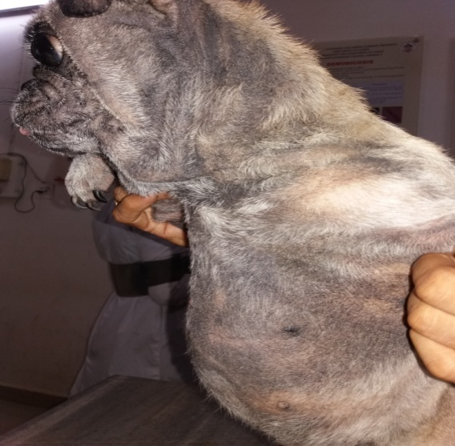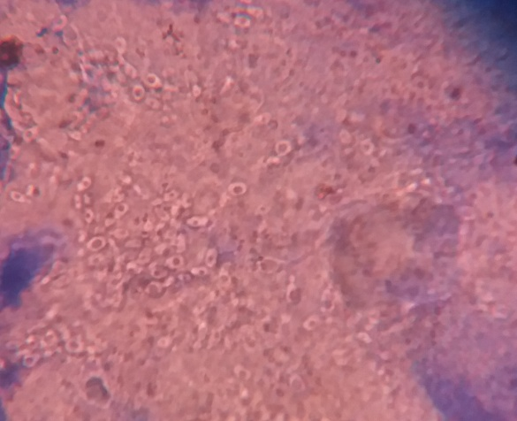
Fig 1: Malassezia dermatitis affected Dog
Fig 2: Malassezia pachydermatis under microscope

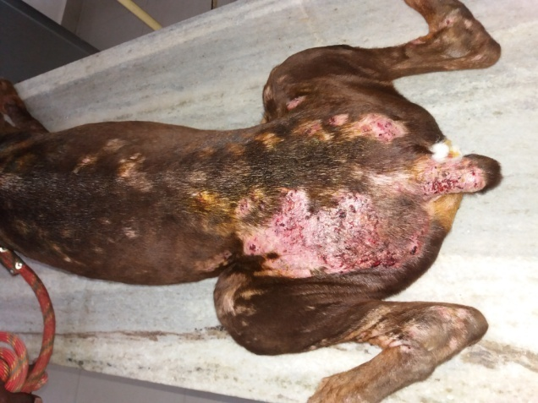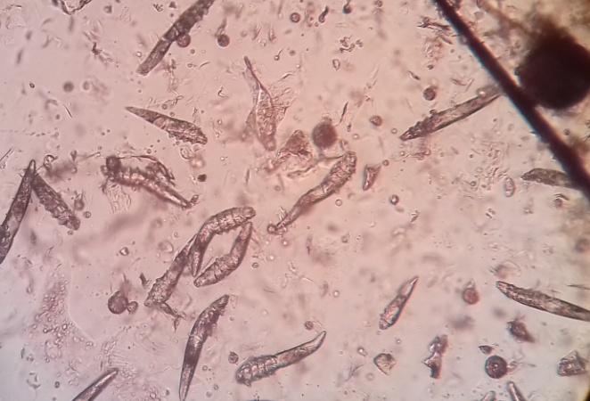
Fig 4: Demodex sp under microscope
Fig 3: Demodicosis affected Dog

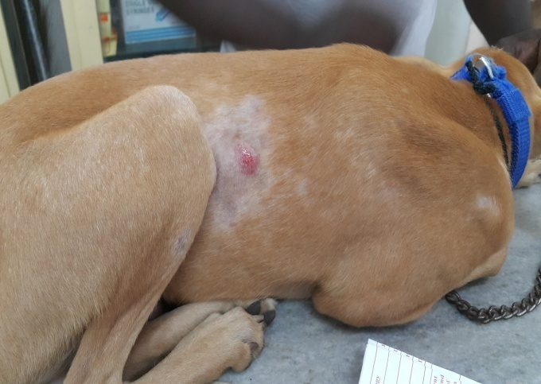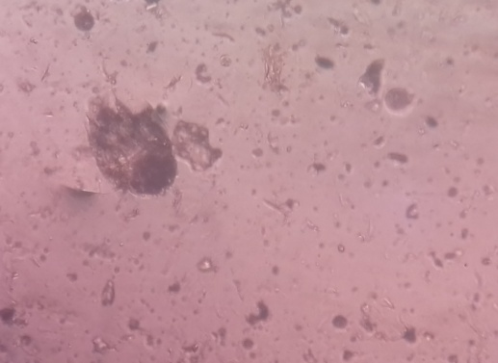
Fig 6: Sarcoptes scabiei under microscope
Fig 5: Scabies affected Dog

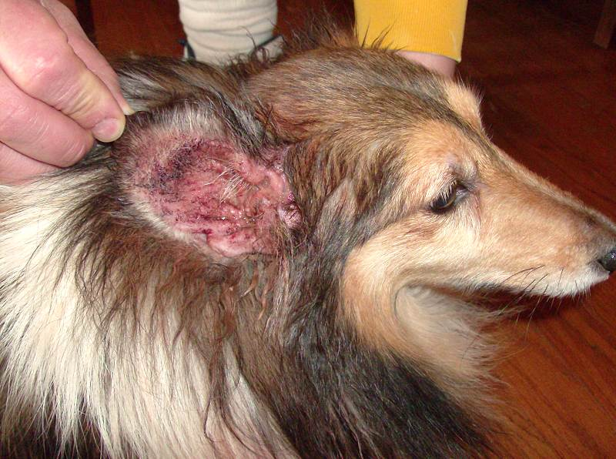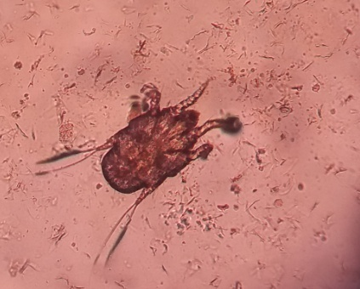
Fig 8: Otodectes cyanotis under microscope
Fig 7: Ear mite infestation in dog

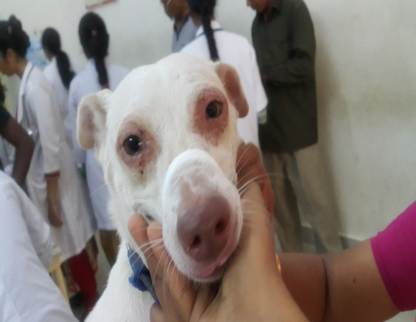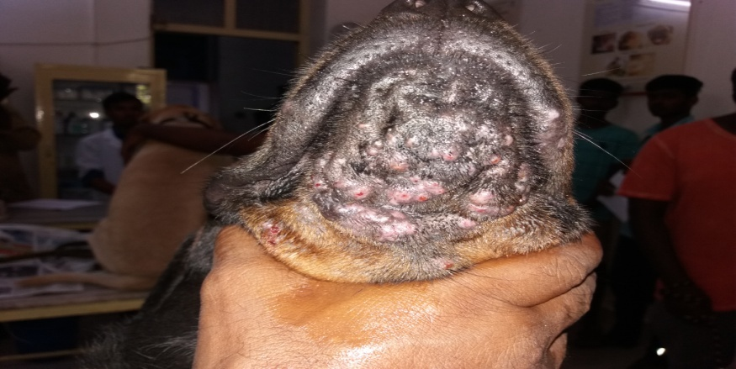
Fig 10: Cutaneous adverse food reaction in dog
Fig 9: Canine atopic dermatitis in Dog

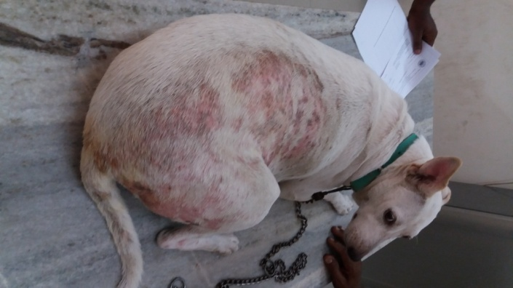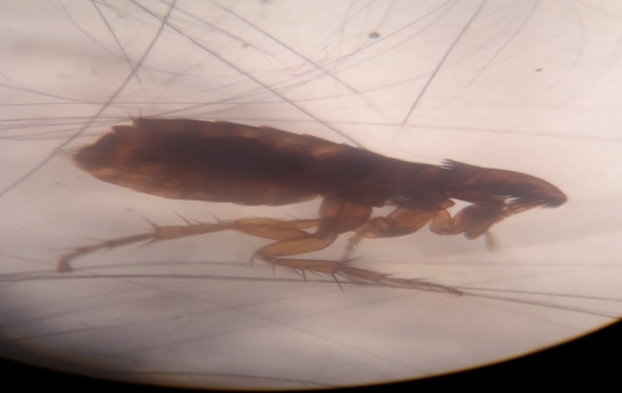
Fig 11: Flea allergic dermatitis in Dog
Fig 12: Flea under microscope

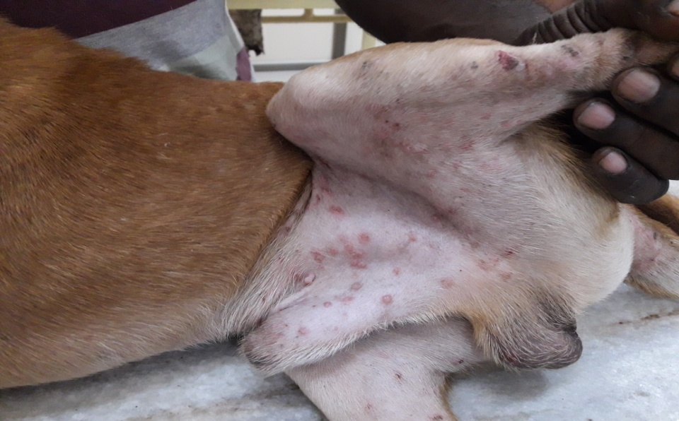
Fig 13: Contact allergic dermatitis affected Dog

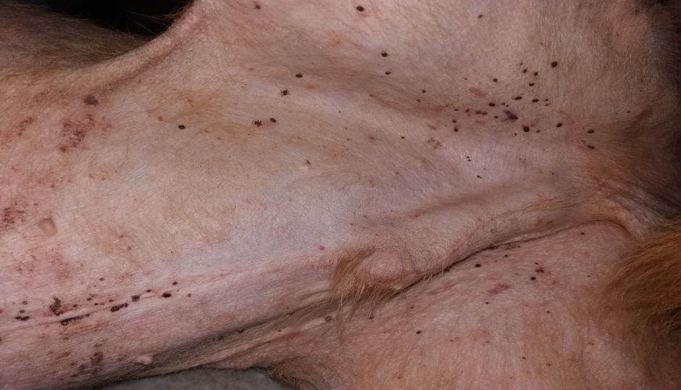
Fig 14: Tick infestation in Dog

CHAPTER 4: DISCUSSION

In this study prevalence of Malassezia dermatitis at Madras Veterinary College, Chennai, India was found 18.18%. However, this finding is far lower than the finding of Nardoni, S et al., (2004), who conducted a study where the presence of Malassezia spp. yeasts was 63.4%, investigated in dermatological specimens of 224 dogs. In this study, prevalence of canine demodicosis was to be found 20.45%. However, this finding is higher than the finding of Gunaseelan et al., ( 2011), who conducted a retrospective study in 3055 samples in Chennai city, India and the prevalence rate was found to be 10.5%. This might be due to poor management, poor body condition, lack of health treatment and improper nutrition. The prevalence of ear mite infestation was to be found 4.55%. One study was done to investigate the prevalence and pathology of mite infestation in the street dog at Dinajpur municipality area, Dinajpur, Bangladesh, using simultaneous clinical and histopathological examination and identification. A total of 48 street dogs were examined, among them 30 (62.5%) were infested with one or more species of mites (Ali et al., 2011). According to Radostits et al., (2007) and Soulsby (1982) well fed animals can better withstand parasite infestations than animals on an inadequate diet, which can influence the level of immunity. In agreement with this in the present study the prevalence of mange mites was significantly higher in poor condition animals than that was observed in good body condition animals. In this study, the prevalence of canine atopic dermatitis was found 2.27% where one study revealed that, the prevalence of atopic dermatitis in dogs relative to all other diagnoses (cutaneous and non-cutaneous disease), all other skin diseases, and other pruritic skin diseases. In a recent study, in the US, 8.7% of the dogs were diagnosed with atopic/allergic dermatitis (Hillier et al., 2001). In case of cutaneous adverse food reaction the prevalence was to be found 6.81% which is almost similar to the study which was done in Italy. The prevalence of AFRs in dogs with dermatological signs was 12%. Total 130 dogs are taken in this study where only 12% shown positive for cutaneous adverse food reaction (Proverbio, D et al., 2010). In this study, the prevalence of flea allergic dermatitis was to be found 9.10%. In Greece, Fleas were identified after being collected from 129 dogs and 38 cats of random breed, sex and age. All these animals, infested with fleas (71.3%). A recent study in a rural community in northeastern Brazil estimated the tick infestation rate on dogs to be 58.8% (Dantas-Torres et al., 2009). In this study, veterinarians were asked to select animals to examine at random without prior knowledge of whether the dog was carrying a tick or not. This suggests that many dogs carry ticks without their owners' knowledge and thus tick attachment to dogs and the potential risk for undiagnosed tick-borne diseases may be much higher than previously thought.

LIMITATIONS

I was unable to collect data from expected number of cases due to very short time rotation at Dermatology Unit at Madras Veterinary College. Due to small number of sample size, study results may not represent the accurate figures.

CONCLUSION

Dermatological disorders were the leading group of diseases detected, and they are encountered very commonly in the community. Therefore, the definition of dermatological disorder prevalence has an important role in planning both preventive and therapeutic healthcare services. The opinion that many regional factors, such as socioeconomic status, personal habits, cultural differences, climate and heredity, influence the prevalence of dermatological disorder is supported by studies demonstrating that disease distributions can differ according to the region examined. Population-based studies should be performed to reliably define the prevalence of dermatological disorder. However, studies evaluating applications to hospital outpatient clinics also provide valuable information about the prevalence of dermatological disorder. Public health policies should be implemented in order to manage this problem rationally.

REFERENCES

Ali, M. H., et al. "Prevalence and pathology of mite infestation in street dogs at Dinajpur municipality area." Journal of the Bangladesh Agricultural University 9.1 (2011): 111-120.
Anita Patel and Peter Forsythe. Small Animal Dermatology. 2008: 7-13
Bloom, Paul. "Cutaneous adverse food reactions in dogs: Something new to chew on." (2011): 289.
Daniel O. Morris DVM . Malassezia Dermatitis and Otitis. Veterinary Clinics of North America: Small Animal Practice; 29. 6 (1999):1303-1310.
Dantas-Torres, Filipe, et al. "Ectoparasite infestation on rural dogs in the municipality of São Vicente Férrer, Pernambuco, Northeastern Brazil." Revista Brasileira de Parasitologia Veterinária 18.3 (2009): 75-77.
Diesel, Alison. "Cutaneous Hypersensitivity Dermatoses in the Feline Patient: A Review of Allergic Skin Disease in Cats." Veterinary Sciences 4.2 (2017): 25.
Gunaseelan, L., et al. "Influencing factors for mange mite infestation of dogs in Chennai city." (2011).
Hillier, Andrew, and Craig E. Griffin. "The ACVD task force on canine atopic dermatitis (I): incidence and prevalence." Veterinary immunology and immunopathology 81.3 (2001): 147-151.

Keith A. Hnilica. Small Animal Dermatology - E-Book: A Color Atlas and Therapeutic Guide, 2016:202.
Krawiec, D. R., and S. M. Gaafar. "A comparative study of allergic and primary irritant contact dermatitis with dinitrochlorobenzene (DNCB) in dogs." Journal of Investigative Dermatology 65.2 (1975): 248-251.
M. A. Samad. Animal Husbandry and Veterinay Science, Vol. 2, 2008: 1107, 1109-1111.
Moriello, Karen A. "Feline atopy in three littermates." Veterinary dermatology 12.3 (2001): 177-181.
Mueller RS, Bensignor E, Ferrer L, Holm B, Lemarie S, Paradis M and Shipstone MA .Treatment of demodicosis in dogs: 2011 clinical practice guidelines. Vet. Dermatol., 23(2012): 86-96.
Nardoni, S., et al. "Occurrence of Malassezia species in healthy and dermatologically diseased dogs." Mycopathologia 157.4 (2004): 383-388.
Pereira AV, Pereira SA, Gremião ID, Campos MP, Ferreira AM. Comparison of acetate tape impression with squeezing versus skin scraping for diagnosis of canine demodicosis. Aust Vet J.2012;90(11):448-450.

Plant, Jon D., Elizabeth M. Lund, and Mingyin Yang. "A case–control study of the risk factors for canine juvenile‐onset generalized demodicosis in the USA." Veterinary dermatology 22.1 (2011): 95-99.
Proverbio, D., et al. "Prevalence of adverse food reactions in 130 dogs in Italy with dermatological signs: a retrospective study." Journal of Small Animal Practice 51.7 (2010): 370-374.
Radostits OM, Gay CC, Hinchcliff KW, Constable PD. A text book of the diseases of cattle, sheep, pigs, goats and horses. 10. Edinberg: Saunders; 2007:1608–1612.
Ravera, Iván, et al. "Small Demodex populations colonize most parts of the skin of healthy dogs." Veterinary dermatology 24.1 (2013): 168.
S. Rahman. Small And Laboratory Medicine, 2nd edition, 2013: 239-241.

Sedgwick, Philip. "What are the four phases of clinical research trials?." BMJ: British Medical Journal (Online) 348 (2014).

Smith, F. D., et al. "Prevalence, distribution and risk associated with tick infestation of dogs in Great Britain." Medical and veterinary entomology 25.4 (2011): 377-384.
Soulsby EG. Helminthes, arthropods, and protozoa of domesticated animals. 7. Philadelphia: Bailer Tindall; 1982:475–491.
Torre, K., and M. Shahriari. "Clinical trials in dermatology." International Journal of Women's Dermatology (2017).

ACKNOWLEDGEMENTS

The author wishes to acknowledge the immeasurable grace and profound kindness of Almighty “GOD” the supreme authority and supreme ruler of universe, who empowers the author to complete the work successfully.
The author doesn’t have adequate words to express deepest sense of gratitude, respect and immense indebtness to his honorable teacher and internship supervisor, Dr. Sharmin Akter, Lecturer, Dept. of Medicine and Surgery, Chittagong Veterinary and Animal Sciences University for her scholastic guidance, sympathetic supervision, valuable advice, continuous inspiration, radical investigation and constructive criticism in all phases of study.
The author would like to express her heartfelt gratitude and respect to the honorable teacher Prof. Md. Abdul Halim, Dean, Faculty of Veterinary Medicine and Dr. A. K. M. Saifuddin, Director of External Affairs, Chittagong Veterinary and Animal Sciences University for continuing this internship programme and finally special thanks to honourable teacher Dr. Sandhya Bhabani, Assistant professor, Madras Veterinary College for her helping hand during my clinical training at dermatology unit of Madras Veterinary College.
Finally the author extended his appreciation to his parents, all patient owners and all well-wishers.

The Author

BIOGRAPHY

I am Sreekanta Biswas, Son of Mr. Subhash Chandra Biswas and Mrs. Sanchita Rani Biswas. I passed secondary School Certificate examination in 2008 followed by Higher Secondary Certificate examination in 2010. Now I am an intern doctor under the Faculty of Veterinary Medicine in Chittagong veterinary and Animal Sciences University. In future, I want to develop me as a veterinary practitioner by dealing as veterinary surgeon. I have immense interest to work in the field of Small Animal Medicine.

Sreekanta Biswas
Intern Doctor
Chittagong Veterinary and Animal Sciences University
E-mail: sreekanta92@yahoo.com

