Study on Prevalence, Diagnosis and Treatment of Dermatological disorders in hospitalized dogs at Madras Veterinary College (MVC), Chennai, India.

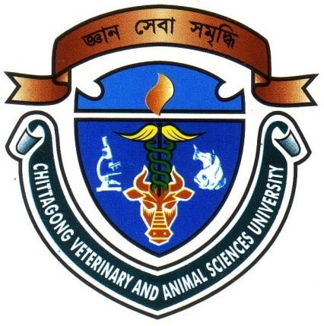

By:
Sreekanta Biswas
Roll No: 12/22; Reg No: 00742
Intern ID: C-21
Session: 2011-12

A clinical report submitted in partial satisfaction of the requirements for the degree of

Doctor of Veterinary Medicine (DVM)

Faculty of Veterinary Medicine
Chittagong Veterinary and Animal Sciences University
Khulshi, Chittagong-4225, Bangladesh
November, 2017

Study on Prevalence, Diagnosis and Treatment of Dermatological disorders in hospitalized dogs at Madras Veterinary College (MVC), Chennai, India.

A clinical report submitted as per approved style and content by

----------------------------------
Signature of Supervisor
(Dr. Sharmin Akter)
Lecturer
Department of Medicine and Surgery
Chittagong Veterinary and Animal Sciences University
Date:

Faculty of Veterinary Medicine
Chittagong Veterinary and Animal Sciences University
Khulshi, Chittagong-4225, Bangladesh
November, 2017

Table of Contents
Contents | Page No.
Table of Contents | iii
List of Figures | iv
List of Table | v
List of Graphs | v
Abstract | vi
Chapter 1: Introduction | 1-3
Chapter 2: Materials and methods | 4-9
2.1 Study area and study period | 4
2.2 Sample collection | 4
2.3 Data collection | 4
2.4 Diagnosis | 4
2.4.1 Clinical examination | 4
2.4.2 Physical examination | 5
2.4.3 Diagnostic test | 6
2.4.4 Procedure | 6-8
2.5 Treatment | 8
2.6 Prevention and control | 9
Chapter 3: Results | 10-15
Photo Gallery | 12-15
Chapter 4: Discussion | 16-17
Limitations | 18
Conclusion | 19
References | 20-22
Acknowledgements | 23
Biography | 24

List of figures
Figure No. | Title | Page No.
Figure 1 | Malassezia dermatitis affected Dog | 12
Figure 2 | Malassezia pachydermatitis under microscope | 12
Figure 3 | Demodicosis affected Dog | 12
Figure 4 | Demodex sp under microscope | 12
Figure 5 | Scabies affected Dog | 13
Figure 6 | Sarcoptes scabiei under microscope | 13
Figure 7 | Ear mite infestation in Dog | 13
Figure 8 | Otodectes cyanotis under microscope | 13
Figure 9 | Canine atopic dermatitis affected Dog | 14
Figure 10 | Cutaneous adverse food reaction affected Dog | 14
Figure 11 | Flea allergic dermatitis affected Dog | 14
Figure 12 | Flea under microscope | 14
Figure 13 | Contact allergic dermatitis affected Dog | 15
Figure 14 | Tick infestation in Dog | 15

List of table

Table No. | Title | Page No.
Table 1 | Prevalence of Dermatological disorders in Dog | 11

List of Graphs

Graph No. | Title | Page No.
Graph 1 | Graphical Presentation of clinical sign for dermatological disorder | 5
Graph 2 | Graphical Presentation of different diagnostic technique for dermatological disorder | 6
Graph 3 | Graphical Presentation of different treatment for dermatological disorder | 8
Graph 4 | Graphical Presentation of different dermatological disorder | 10

ABSTRACT

The skin, sometimes known as the Integumentary system is, in fact, the largest organ of the body. It performs many functions that are important in maintaining homeostasis in the body. The skin also protects the body from physical damage and bacterial invasion. A study was conducted in hospitalized dogs at Madras Veterinary College (MVC), Chennai, India to measure the prevalence, diagnosis and treatment of dermatological disorders from May 8 to May 22, 2017. Total 220 cases were observed and recorded, that had a dermatological problem. Among the Clinical signs, pruritus (86%), alopecia (63%), scaling (77%), maculo-papular-pustular lesion (91%) were the most common presenting sign showed by dogs. A diagnosis or recommendation for treatment was made on the basis of the presenting clinical signs and physical examination and various diagnostic tests were performed. In this study, most of the cases were diagnosed by multiple and deep skin scrapings (100 cases) and by dermato-histopathology (70 cases). The most common dermatological disorder was diagnosed are Malassezia dermatitis, Demodicosis, scabies and Tick infestation accounted for the majority of the diagnoses. In most of the cases, Ivermectin (59%) were used which is followed by Benzyl peroxide shampoos (45%), Dexamethasone (23%), Cypermethrin shampoos (23%), antibiotics (20%), Ketoconazole/ miconazole shampoos (18%), systemic antifungal drugs (16%), topical Benzyl benzoate (14%) and Pheniramine maleate (14%).

Keywords: Dermatological disorder, prevalence, pruritus, dermato-histopathology,
treatment.

