ACKNOWLEDGEMENT
All praises are due to “Almighty Allah” who enabled the author to complete this report successfully.
The author express his deep sense of gratitude, heartfelt respect and immense indebtness to his beloved teacher & supervisor DR.Towhida Kamal, Lecturer, Department of Pathology and Parasitology, Chattogram Veterinary and Animal sciences University for his valuable advice, scholastic guidance, suggestions, inspiration and who was involved with this report through its inception.
I would like to express my deep sense of gratitude and thanks to Professor Dr. Abdul Ahad, Dean, Faculty of Veterinary Medicine, Chattogram Veterinary and Animal Sciences University for his valuable suggestion & inspiration.
The author wishes to express his gratitude to the Director of External Affairs Professor Dr. A.K.M Saifuddin, Chattogram Veterinary and Animal Sciences University, for his supervision and kind co-operation during the period of internship
I also express thank to my friends for their help and co-operation during the tenure of writing of this report. The author is immensely grateful to all of them, although it is not possible to mention every one by name.

The Author
September , 2020

Abstract

The coronavirus pandemic has engulfed the nations of the world for the first five months of 2020. It has also sparked fears of an impending economic crisis and recession. Social distancing, self-isolation and travel restrictions have lead to a reduced workforce across all economic sectors and caused many jobs to be lost. Schools have closed down, and the need for commodities and manufactured products has decreased. The COVID-19 pandemic has resulted in over 4.3 million confirmed cases and over 290,000 deaths globally. In response to this global outbreak, I tried to summarise the socio-economic effects of COVID-19 on individual aspects of the world economy.
Keywords: Coronavirus pandemic, Economic Crisis, COVID-19, Socio-economic effects

Chapter 1
Introduction
The outbreak of COVID-19 (the disease caused by Severe Acute Respiratory Syndrome Coronavirus 2 (SARS-COV-2)) has had a detrimental effect on global healthcare systems with a ripple effect on every aspect of human life as we know it. The World Health Organization (WHO) officially declared the SARS-CoV-2 outbreak a Public Health Emergency of International Concern on January 30, 2020 and a global pandemic on March 11, 2020. Countries were urged by WHO to adopt strict social distancing and quarantine measures to avoid virus spread and to protect public health (World Health Organization).Since its formal identification in Wuhan China in December 2019. Bangladesh detected its first confirmed coronavirus case on 8 March. As of this writing, the number of confirmed cases in Bangladesh is more than 1,65,618, and the virus has claimed more than 2096 lives. After the first case was detected, the Bangladeshi government closed education institutions and encouraged all non-essential businesses to move their activities online. It initially declared a nationwide public holiday until April 4 which has been subsequently extended to August 6. In an attempt to understand the turmoil effect on the economy, There are tried to summarize the Socio-economic impact of COVID-19 on individual sector across the world.

Chapter 2

Impact of COVID-19

2.1. Agriculture:
The resilience of the agricultural sector has been tested by the COVID-19 outbreak. A global crash in demand from hotels and restaurants has seen prices of agricultural commodities drop by 20% (Jayashree Bhosale). Countries around the world have imposed a number of protective measures this includes social distancing, avoiding unnecessary travel, and a ban on congregations. This will have pronounced implications for perishable goods such as meat and vegetables. Furthermore, markets have gone a step further by shutting down floor trading which has impacted the ability to exchange commodities.

2.2. Education:
COVID-19 has affected all levels of the education system, from pre-school to tertiary education. Different countries have introduced various policies, ranging from complete closure in Germany and Italy to targeted closure in the United Kingdom for all but the children of workers in key industries (Gov.UK). Additionally, over 100 countries have imposed a nationwide closure of educational facilities including Bangladesh. UNESCO estimates that close to 900 million learners have been affected by the closure of educational institutions.( Educational Disruption and Response. UNESCO; 2020).COVID-19 has also influenced the undergraduate education (Alsafi Z., Abbas A-R, 2020) the most significant impact is on the postgraduate research community with research into many non-COVID related topics being placed on hold.
2.3. Finance industry:
COVID-19 has affected communities, businesses and organizations globally, inadvertently affecting the financial markets and the global economy. Uncoordinated governmental responses and lockdowns have led to a disruption in the supply chain. In Bangladesh, lockdown restrictions significantly reduced the production of goods from factories, while quarantine and self-isolation policies decreased consumption, demand and utilisation of products and services (Sheikh Islam, Yash Divadkar, 2020).

2.4. Healthcare:
The COVID-19 pandemic has caused an unprecedented challenge for healthcare systems worldwide. In particular, the risk to healthcare workers is one of the greatest vulnerabilities of healthcare systems worldwide. Considering most healthcare workers are unable to work remotely, strategies including the early deployment of viral testing for asymptomatic and/or frontline healthcare staff is imperative. High healthcare costs, shortages of protective equipment including N95 face masks, and low numbers of ICU beds and ventilators have ultimately exposed weaknesses in the delivery of patient care (Abdullah Mamun 4 February, 2020)

2.5. Food sector:
The food sector, including food distribution and retailing, has been put under strain as a result of people panic-buying and stockpiling food . This has led to increased concerns about shortages of food products such as long-life milk, pasta, rice and tinned vegetables. Tens of millions of people in our country have recently lost their scope of earning for the daily basic necessities of life amid the corona virus crisis. With reductions in sources of earning, the number of people, including families with children, going hungry is rising at an alarming rate and represents a troubling development in one of the poorest countries of the world. In an effort to address the situation, “the prime minister of Bangladesh has directed the authorities to prepare lists of underprivileged people like beggars, day-laborers, rickshaw-van pullers, transport workers, restaurant workers, hawkers, and tea-stall owners, who run their families on daily basis income, and provide them with food aid,” said a March 29 notice of the Ministry of Disaster Management and Relief. The ministry has also called on the affluent sections of society, aid groups, and NGOs interested in providing support, to carry out aid work in a coordinated manner with district and local administrations (Shohel Mamun, 30th March, 2020)
2.6. Sports industry:
Largest sporting events come to view in 2020. Football's much anticipated Euro 2020 tournament has been postponed for 12 months while play-offs have been postponed till June 2020 at the earliest (sport-by-sport look at the global impact of COVID-19 | the Independent news). The international Olympic committee was committed to staging the Tokyo 2020 Olympics this summer without delay. However, they have now made the decision to postpone the games to 2021, a decision that is supported by athletes and their respective nations (UEFA.com; 2020); (The Guardian Sport, 7th April 2020).
Chapter 3
The status of Bangladesh at COVID-19 Crisis:
3.1. Present situation of Bangladesh:
Test related data
Total Sample Tested | 892,152
Tested last 24hrs | 15,672
Total Death | 2,197
Total Recovered | 80,838
Total Positive | 172,134
The above data was issued by the IEDCR, as of 8 July 2020

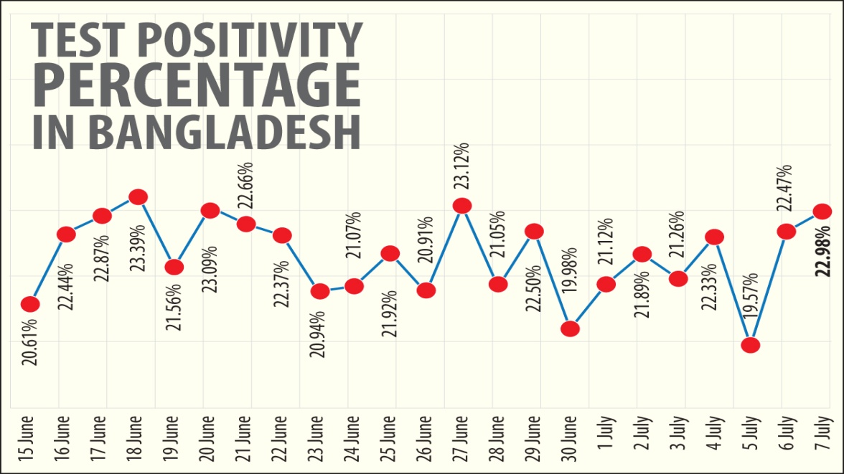
3.2 Economical Impact:
The global health crisis caused by COVID-19 has hit Bangladesh's economy hard and jeopardized the country's impressive achievements in poverty reduction. According to the study, among the 100.22 million people at high risk of economic and health vulnerabilities, 53.64 million are extremely poor. These people earn less than 160 Taka (€1.7, $1.9) a day.In a more recent study conducted until May 26, more than half of these extreme poor people told that they have run out of money. If these people come out of their homes out of hunger, there is no scope for physical distancing and hygiene maintenance. Bangladesh's manufacturing sector has also suffered a huge blow, especially the ready-made garments sector, which accounts for around 80% of the country's total export earnings. At least 4 million workers depend on the textile industry for their livelihood. After the pandemic hit Europe and the US, the industry experienced a reduction in exports of as much as 84% in April 2020 compared with that of the previous year. More than 1,000 factories have been closed and 2.19 million workers lost their jobs, according to the NGO study (Zobaer Ahmed; 10th June, 2020). Even though garment factories were allowed to continue operating under the country's lockdown, an estimated one million garment workers, or one-quarter of the workforce, were laid off due to declining orders for export (NPR 8th April,2020).On 5 April, Prime Minister Sheikh Hasina announced a stimulus package amounting to some US$8bn (The New Indian Express,6th April 2020)
3.3 Bangladesh Government Response:
On 17 March, when Bangladesh had 8 confirmed cases, the government closed all schools, for the remainder of March. Dhaka University was also closed for the same period (TBS Report 16 March, 2020). On 23 March, when Bangladesh had 33 confirmed cases, the government declared a ten-day nationwide holiday for the period 26 March – 4 April, ordering all public and private offices to be closed, with the exception for emergency services. People have been asked to practice social distancing and stay at home. Public transport would be limited and advice was given to avoid them (. The Daily Star, 23 March 2020) The measure has been described as a "lockdown" by the media, ([Tara Donaldson, 25 March 2020), (Al Jazeera, 13 April 2020) albeit a "relaxed" one (Ina Ahmed, Shakhawat Liton , 9th April, 2020).
The government asked the Army to ensure social distancing.( Business Standard, 23 March 2020). ABC News Australia reported that 290 teams of soldiers were deployed across the country, that streets were empty in the capital Dhaka and the roadside shops were closed. It also said that thousands of people left Dhaka for their home villages.( ABC News ,28th March 2020).
On 9 April, Bangladesh imposed a 'complete lockdown' on the Cox's Bazar District where the majority of the Rohingya refugee camps are located. "No entry, no exit – until the situation improves", said the government directive (The Straits Times, 9 April 2020)
3.4 COVID-19 transmission rate in Bangladesh:
In previous times, the COVID-19 transmission rate in Bangladesh was two, which meant that two people could be infected with the virus from one person. However, the transmission rate of COVID-19 in the country fell as time passed. As of 26 June, the transmission rate of the coronavirus disease in the country is 1.05, which is a very good sign.
Health Minister Zahid Malik said that the situation in Bangladesh improved as the growth rate of infections slowed down and the doubling period of infections got longer and that the minimum number of COVID-19 tests performed daily in the country was also improved to 15,000. He also said that, on 3 July, the maximum growth rate of infections in the country fell to 2.5% the day after the number of COVID-19 cases exceeded 150,000. As of 3 July, Bangladesh sees a growth rate of infections less than 2.5%.

3.5 Curve flattening:
Health Minister Zahid Malik announced that Bangladesh started flattening the coronavirus curve on 23 June as thousands of tests were performed every day in the country to improve the situation and that the coronavirus curve flattened on the last eight days of June and the first six days of July. He also believed that excessive testing in Bangladesh caused the COVID-19 curve to flatten. On 26 June, three days after the curve started flattening, a record of 18,498 samples was tested in the country, which was above the minimum number of tests performed every day.Some health experts believed that Bangladesh succeeded in flattening the curve, slowing down the growth rate of infections and extending the doubling period of infections.

Chapter 4
Conclusion
With fears of a new recession and financial collapse, times like these call for resilient and strong leadership in healthcare, business, government and wider society. Immediate relief measures need to be implemented and adjusted for those that may fall through the cracks. Medium and longer term planning is needed to re-balance and re-energise the economy following this crisis. A broad socioeconomic development plan including sector by sector plans and an ecosystem that encourages entrepreneurship is also needed so that those with robust and sustainable business models can flourish. It is prudent that governments and financial institutions constantly re-assess and re-evaluate the state of play and ensure that the ‘whatever it takes’ promise is truly delivered.

Chapter 5
References
- Abdullah Mamun 4 February, 2020, tbsnews.net/bangladesh/health/everyone-scrambles-masks-virus-fear-spreads-41769.
- ABC News. Archived from the original on 28 March 2020. Retrieved 28 March 2020.Jump up to: "Soldiers enforce 10-day shutdown in Bangladesh to slow virus".
- Alsafi Z., Abbas A-R, Hassan A, Ali MA. The coronavirus (COVID-19) pandemic: Adaptations in medical education. Int. J.Surg. 2020;78:64–65.
- Al Jazeera, 13 April 2020; In Pictures: The effects of coronavirus lockdown in Bangladesh.
- Business Standard, 23 March 2020;Army to enforce social distancing,
- Business Standard, 16 March 2020; Educational institutions to remain closed till March 31.
- Corona.gov.bd.
- Corona virus: sport-by-sport look at the global impact of COVID-19 | the Independent. independent.co.uk/sport/sport-football-basketball-rugby-olympics-cancelled-coronavirus-impact-around-the-world-a9398186.html [cited 2020 Mar 20].
- Dhakatribune.com/health/coronavirus/2020/07/07/bangladesh-s-single-day-covid-19-test-positivity-rate-again-jumps-to-23.
- Educational Disruption and Response. UNESCO; 2020. en.unesco.org/themes/education-emergencies/coronavirus-school closures,[cited 2020 Mar 20].
- Gov.UK; Guidance for schools, childcare providers, colleges and local authorities in England on maintaining educational provision.[cited 2020 Mar 20].
- Ina Ahmed, Shakhawat Liton, 21-day lockdown enough? Cambridge University study says: NO!, Business Standard, 9 April 2020.
- Iedcr.gov.bd.
- Jayashree Bhosale. Prices of agricultural commodities drop 20% post COVID-19 outbreak - rediff Realtime News.
- NPR. Archived from the original on 8 April 2020. Retrieved 14 April 2020"1 Million Bangladeshi Garment Workers Lose Jobs Amid COVID-19 Economic Fallout".
- Sheikh Islam, Yash Divadkar; weforum.org/agenda/2020/04/covid-19-coronavirus-bangladesh.
- Shohel Mamun, 30thMarch,2020; dhakatribune.com/bangladesh/government-affairs/2020/03/30/low-income-people-to-get-food-support
- Tara Donaldson, 25 March 2020;.Bangladesh Introduces Country-Wide Lockdown, as Factories Already Face ‘Indefinite Shutdown’
- The Guardian; Tokyo Olympics postponed to 2021 due to coronavirus pandemic. theguardian.com/sport/2020/mar/24/tokyo-olympics-to-be-postponed-to-2021-due-to-coronavirus-pandemic Sport . [cited 2020 Apr 7].
- The New Indian Express. Archived from the original on 6 April 2020. Retrieved 6 April 2020."Bangladesh announces USD 8 billion stimulus package to fight corona virus"
- The Daily Star, 23 March 2020; Corona virus outbreak: Govt orders closure of public, private offices from March 26 to April 4.
- The Straits Times, 9 April 2020; Corona virus: Rohingya camps in Bangladesh put under 'complete lockdown'
- UEFA.com; 2020. uefa.com/uefaeuro-2020/ [cited 2020 Mar 20].
- World Health Organization, WHO Announces COVID-19 Outbreak a Pandemic; euro.who.int/en/heps//:coronavirus.jhu.edu/ map.alth-topics/health-emergencies/coronavirus-covid-19/news/news/2020/3/ who-announces-covid-19-outbreak-a-pandemic ,(March 12 2020).
- . Zobaer Ahmed; 10th June, 2020 dw.com/en/coronavirus-economy-down-poverty-up-in-bangladesh/a-53759686.

