Chapter-1:
Introduction
The economy of Bangladesh is mainly based on Agriculture. Livestock plays a crucial role in the agricultural economy. About 36% of the total animal protein comes from the livestock products in our everyday life. It also helps to earn foreign exchange by exporting hides and skins every year. Countries 25% peoples are directly engaged in livestock sector, and 50% peoples are partly associated in livestock production. Last year, the contribution of livestock sub-sector to the GDP was 2.95%, which was estimated about 17.32% GDP to agriculture. Last year, the growth of livestock in GDP was 7.23 % (DLS, 2009). Livestock plays an important role in the national economy of Bangladesh with a direct contribution of around 3 % to the agricultural GDP and providing 15% of total employment in the economy (MOFL, 2007).
Veterinary hospitals and clinics help in understanding the geographic and environmental source of diseases and their natural history.The goat is the most commercially important species of small ruminants to the rural people of Bangladesh. Carbohydrate engorgement is one of the most commonly encountered gastrointestinal disorders of the goat (Basak et al., 1993). The disease is clinically characterized by anorexia, depression, abdominal distension, diarrhea, weakness and inactivity. The disease is commonly encountered due to unintended ingestion of large quantities of cereal grains or their flour kept for human consumption (Radostits et al., 2000).In clinically affected animals morbidity rate varies from 10-50 percent and case mortality in lactic acidosis may reach to 90 percent in untreated cases whereas it may be 30-40 percent in treated cases.In carbohydrate engorgement, there are abnormal distension of rumen, lactic acidosis and atony of the rumen leading to the retention of fermented gases and finally death of the affected animal (Blood et al., 2005).
The growing concern in animal welfare has ignited intensive debate about the living conditions of production animals. As a consequence, production diseases have come into the glare of publicity as these sufferings arise due to production conditions (Enemark et al., 2002). Particular interest is being levied upon nutritional diseases including lactic acidosis or ruminal acidosis. Ruminal acidosis is a metabolic disorder caused by feeding errors in ruminants that may be manifested in acute or subacute form. It represents a significant economic problem due to direct effects caused by alterations in the ruminal metabolism that could lead to death and indirect effects which could lead to rumenitis, liver abscesses and laminitis (Oetzel, 2003; Penner et al., 2007). Rapid fermentation of carbohydrates alters the ruminal function through proliferation of acid resistant bacteria (Lactobacillus and Streptococcus bovis) and an increase in the production of volatile fatty acids and lactate, which cause a sharp drop in ruminal pH to less that 5.00 in most cases (Gozho et al., 2005; Gonzalez et al., 2010). Anorexia, apathy, teeth grinding and muscle twitching, ruminal stasis, and the excretion of soupy or watery faeces are some of predominant signs in affected animals.
Livestock suffers from many infectious and non infectious diseases. Ruminal acidosis is one of the non infectious problems of all ruminant species. Many ruminants suffer from ruminal acidosis due to improper practice of feeding resulting from lack of knowledge of risk factors. Ruminal acidosis occurs when there is a sudden large amount intake of rapidly fermentable carbohydrates, primarily starches and sugars (Beauchemin and Penner, 2009).Ruminal acidosis can cause ruminitis, metabolic acidosis, lameness, hepatic abscessation, pneumonia and death (Lean et al., 2000).
In Bangladesh, most of the cases ruminal acidosis resulting from accidentally intake large amount of cooked rice, rice gruel, potato, bread, jackfruit residue or other easily digestible carbohydrates. But due to ignorance of feeding practice a considerable number of animals affected with ruminal acidosis. Some of the cases, the affected animals are remain unnoticed due to lack of data of prevalence in Bangladesh. Most of the acutely affected animals die due to lack of proper treatment selection, these results a great economic loss in our country.
The main objectives of this study are:-
- To find out the prevalence of ruminal acidosis at veterinary hospital at Rangunia Thana under Chittagong district.
- To know about feeding malpractices in animals by owner and the condition that developed after that.
- To become familiar with the etiology, clinical signs, diagnosis and treatment given to the animal.
- Direct observation of animal after therapy to examine accuracy of treatment.
- Suggestions given to the owner to avoid the same condition in future.

Chapter-2:
Materials and Methods
2.1 Study period
The study was undertaken from 1st March to 6th April & 5th July to 4th August, 2017.
2.2 Study area
For the case study the selected place is the Upazilla Livestock Office, Rangunia, Chittagong. Clinical cases that come into hospital are treated & recorded. Few cases are treated at the owner home on request with Veterinary Surgeon.
2.3 Sample size
The sample size was 18 goats,which are affected with acidosis.Total number of the animals was recorded to determined the prevelance of ruminal acidosis.These cases were studied in the Upazila Veterinary Hospital, Rangunia ,Chittagong.
2.4 Case selection
The cases were selected on the basis of feeding history, clinical signs of complete anorexia, abdominal pain, rapid beating of the heart, abnormally fast breathing, diarrhea, lethargy, and eventually death as proposed by(Krause and Oetzel, 2006), and low ruminal pH (Cooper and Klopfenstein, 1996), and stop or reduced motility of microflora.

2.5 Record of Data
- Taking history from owner,
- Observing clinical signs & symptoms,
- Clinical examination of animals,
- Therapies prescribed by the VS,
- Follow up of animal until recovery.

2.6 Taking History
- Feeding of excess:- Cooked rice, Rice gruel, Wheat bran, Rice polish,others

2.7 Diagnosis
Presumptive diagnosis of the cases was performed on the basis of the history of feeding of easily digestible carbohydrates (Cooked rice, jackfruit residue, potato etc), associated clinical sign and examination of rumen fluid color, consistency and odor.
Confirmatory diagnosis was performed by exploring the low rumen fluid pH described by (Kleen et al., 2003;Khafipour et al., 2009).
2.8 Rumen fluid collection
Rumen fluid was collected by rumenocentesis as the method described by (Radostits et al., 2006).

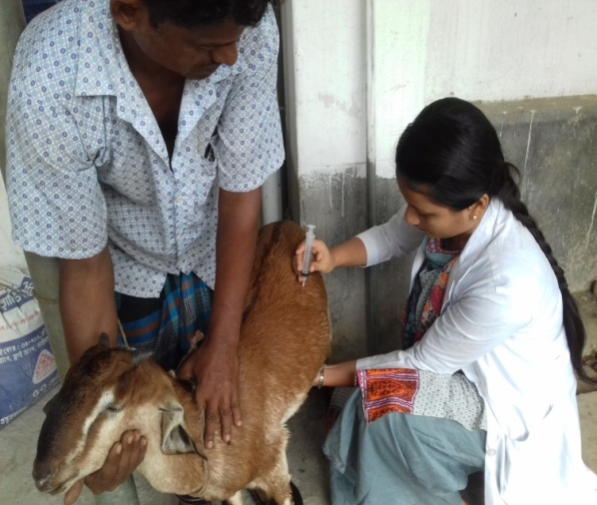
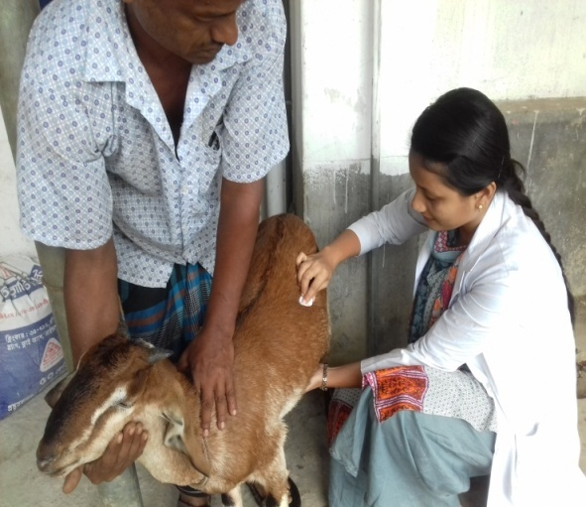

Fig-1 : patient preparation Fig-2 : Fluid collection
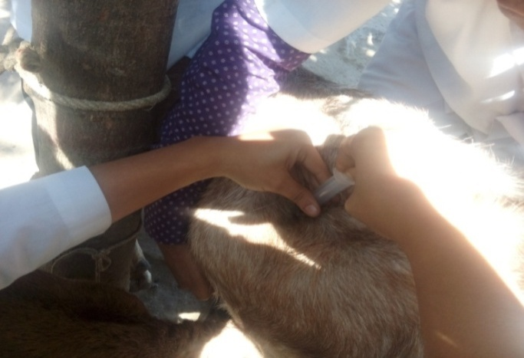

Fig- 2: Rumen fluid collection
Rumen fluid was collected by using a 14 gauge, 5 inch long needle attached to a 10ml disposable syringe. A 2x2cm area was marked on the left paralumbar fossa,avoiding the major muscle masses. The selected area was shaved and sterilized with 70% alcohol or 10% povidone iodine solution and the sampling needle was inserted firmly through into the rumen. Three ml of rumen fluid was collected by applying back pressure to the piston of syringe. The collected fluid was taken into a sample vial.

2.9 Examination of rumen fluid

Examination of rumen fluid pH and microflora movement
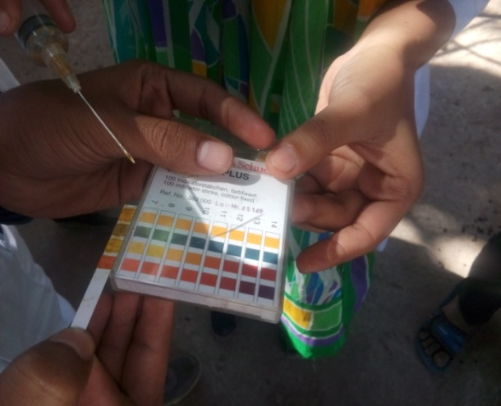
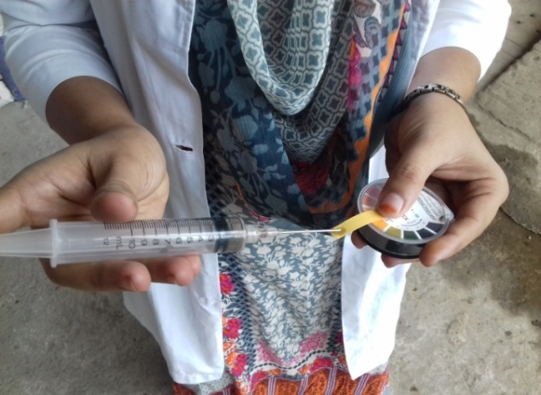

Fig -3: P^{H} measurement

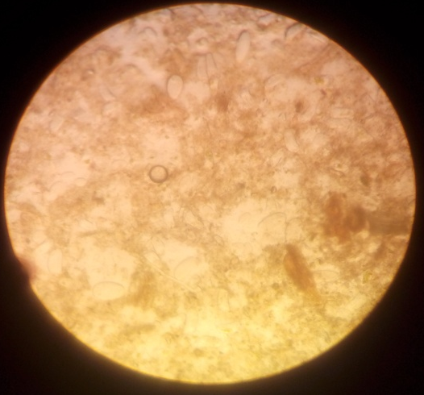

Fig-4: Observing Microfloral movement
Under microscope
One ml of collected rumen fluid was taken into a watch glass and a piece of pH indicator paper (Merck-universal indicator pH 1-10, Merck Limited, Worli, Mumbai-400 018) in
the fluid for a few seconds. Color change was observed in pH indicator paper. This color matched with the one of the different color of the color scale. The value of matched color was indicating the pH of the rumen fluid. To identify the motility of the rumen microflora a drop of fluid was taken into a clean glass slide and after putting a cover slip the content was observed under low power objective (10x).

Physical examination of rumen fluid
Physical characteristics (Color, consistency and odor) of rumen fluid were determined by using Organoleptic test.
2.10 Signalments and clinical parameters studied
The following signalments and clinical parameters were studied
- Breed
- Sex
- Age
- Temperature
- Rumen microflora movements
- Rumen fluid color
- Rumen fluid odor
- Rumen fluid consistency
- Rumen fluid p^{H}
2.11 Treatment protocol
Clinically 18 ruminal acidosis affected goats were selected and divided into four groups under four types of treatment:
Table1: Different treatments to different groups of animals
Groups | Animals | Treatment
A | 5 goats | Ruminal alkalizer
B | 4 goats | Ruminal alkalizer and purgatives
C | 5 goats | Systemic alkalizer + fluid therapy
D | 4 goats | Ruminal and systemic alkalizer + fluid therapy

Ruminal alkalizer: Powder sodium bicarbonate (Sodibicarb®, M. R. Chemicals, Bangladesh).
Ruminal alkalizer and purgatives: Powder sodium bicarbonate + Syrup magnesium hydroxide (Magvet®, Acme Pharmaceuticals, Bangladesh).
Systemic alkalizer + fluid therapy: Inj. 7.5% sodium bicarbonate (eg. Sodib®, Joyson Pharmaceutical, Bangladesh) + fluid therapy (Inj. 0.9% sodium chloride solution, Normal Saline®, Opso Saline Limited, Bangladesh ).
Ruminal and systemic alkalizer + fluid therapy: Powder sodium bicarbonate + Inj. 7.5% sodium bicarbonate + fluid therapy (Inj. 0.9% sodium chloride solution).
2.12 Follow up of the animals
After giving the treatment, cases were kept under close observation by active participation, mobile phoning and recurring cases are observed in hospital.
2.13 Statistical analysis
The obtained data were imported and stored in Excell-2007 and analyzed by using STATA/IC-11. The mean and SEM with 95% CI were calculated to express the results. The comparisons of variables goat, different breeds, male and female and different age groups were done by using online Epi info (http://www.openepi.com/OE2.3/Menu/OpenEpiMenu.htn.)

Chapter-3:
Result
3.1 In view of Epidemiology:-
During internship placement at Rangunia Upazilla Veterinary Hospital 415 goats were examined that came for treatment. Among them 18 animals are with lactic acidosis condition. Another many animals came with different conditions such as simple indigestion, anorexia, diarrhea etc. with different etiology but they are not calculated in my clinical report. Those animals feed more carbohydrates than normal level for few days or at a time resulting development of acidosis with showing signs & symptoms were counted in my report.
Table-2: Prevalence of ruminal acidosis in goat at Veterinary Hospital, Rangunia, Chittagong.
Veterinary Hospital | Number of animal recorded | Number of animals affected with lactic acidosis | Frequency (%)
Upazilla livestock office, Rangunia, Chittagong. | 415 | 18 | 4.33 %

The percentage of lactic acidosis condition indicates the frequency is more than normal. The data shows that in all cases animal are supplied wheat bran, rice polish, cooked rice, rice gruel etc in large amount. Farmer are preferably supply this to animal instead of supplying green grass which are their main food item. But it’s real that they supply this in very few amounts due to very poor availability. Animals are not habituated with these food items also rumen conditions can’t support these carbohydrates overload resulting development of this condition.
3.2 Prevalence of lactic acidosis also varies from sex to sex:-
Table-3: Distribution of acidosis among different sex groups (total case:18)
Veterinary Hospital | Buck | % | Doe | %
Upazilla livestock office, Rangunia, Chittagong. | 9 | 50% | 9 | 50%
The table shows that the incidence of lactic acidosis is same in both sexes. But the conditions are different.
3.3 Prevalence of ruminal acidosis based on breeds of goat
Table-4:There were found higher prevalence of ruminal acidosis in Non descriptive (ND) goat than Bengal Goat(BG) and Jamunapari
Goat
Total cases | 18
No. of ND goat | 10
Prevalence in ND goat (%) | 55
No. of BBG | 2
Prevalence in BG(%) | 12
No. of Jamunapari goat | 6
Prevalence in Jamunapari(%) | 33
3.4 Prevalence of ruminal acidosis in different age group of goat
Table-5: There were found higher prevalence of ruminal acidosis in 1 – 2 years goat and above 2 years and 6 month respectively.
Age | No. of affected animal | Prevalence(%)
6 month | 3 | 17
1 – 2 year | 9 | 50
Above 2 year | 6 | 33

3.5 Analysis of different parameters on ruminal acidosis
Analysis of temperature, rumen motility, ruminal fluid pH
The mean, temperature, rumen motility per 5 minutes, rumen fluid pH of the goat affected with ruminal acidosis were 103.01±1.14$℉$, $4±2.2$ per 5 minutes, 4.9$±$0.63 and 7.16$±$0.2 respectively with range (Min-Max) 101-105$℉, 1-7$per 5 minutes, 4-5.8.
Table- 6: Analysis of different parameter of goat
Species | Goat | Goat
Variables | Mean ±Std. | Range (Min – Max)
Temperature ( F) | 103.01±1.14 | 101 – 105
Rumen motility(per 5 minuts) | 4±2.20 | 1 – 7
Ruminal fluid P^{H} | 4.9±0.63 | 4 – 5.8

3.6Analysis of risk factors involved in ruminal acidosis
Goats are at highest prevalent risk factor if feeding of cooked rice. Cooked rice was a risk factor in 50% cases in cattle and 62.5% cases in goat
Table-7: Risk factor analysis
Species | Variables | Categories | No. of cases | Percentage (%)
Goat | Feed that predispose the Ruminal acidosis | Cooked rice | 12 | 62.5
 |  | Rice gruel | 4 | 25
 |  | Bread | 2 | 12.5

3.7 Analysis of clinical signs of ruminal acidosis
In terms of clinical signs, there were found mild dehydration in most of the cases (67%) and in few cases there were found moderate dehydration, the lowest percentage showed severe dehydration in goat.About 33% cases the abdomen size was normal and 67% cases the abdomen was distended.27% cases have nasal discharge. No lameness was found in goat.

Table-8: clinical signs analysis
 | Variables | Categories |  | No. of cases |  | Percentage (%)
Goat | Feeding habit |  | Anorexia | 8 | 44
 |  |  | Off fed | 10 | 55
 | Dehydration |  | Mild | 12 | 67
 |  |  | Moderate | 5 | 27
 |  |  | Severe | 1 | 6
 | Diarrhea |  | Present | 14 | 78
 |  |  | Absent | 4 | 22
 | Urination |  | Present | 18 | 100
 |  |  | Absent | 0 | 0
 | Abdomen size |  | Normal | 6 | 33
 |  |  | Distended | 12 | 67
 | Nasal discharge |  | Present | 5 | 27
 |  |  | Absent | 13 | 72
 | Lameness |  | Present | 0 | 0
 |  |  | Absent | 18 | 100
3.8 Analysis of rumen fluid in ruminal acidosis
In terms of rumen fluid examination, there was found rumen microflora movement dramatically reduced. In most of cases the color of rumen fluid was greenish 67%. The consistency of rumen fluid watery in 50%.Most of the cases (83%) the odor of the rumen fluid were sour.
Table-9: Rumen fiuid analysis
Species |  | Variables | Categories | No. of cases |  | Percentage (%)
Goat | Rumen microflora movement |  | Present |  | 6 | 33
 |  |  | Absent |  | 12 | 67
 | Color of Rumen fluid |  | Greenish |  | 12 | 67
 |  |  | Greenish brown |  | 6 | 33
 |  |  | Milky grey |  | 0 | 0
 | Consistency of Rumen fluid |  | Watery |  | 9 | 50
 |  |  | Thick watery |  | 4 | 22
 |  |  | Gruel like |  | 5 | 28
 | Odor of Rumen fluid |  | Sour |  | 15 | 83
 |  |  | Pungent |  | 3 | 17

Chapter-4:
Discussion
4.1 Prevalence of ruminal acidosis
In present study the overall prevalence of ruminal acidosis was found 4.33%.A number of researcher showed nearly similar prevalence (Bramley, 2007) found a herd prevalence of at least 3% in a survey of 100 goat population.In goat, the prevalence found in present study was lower (1.9%), this is may be due to the present study was conducted on the cases that are taken into hospital.But showed 0.2% prevalence; this is probably not a reliable indication (Enemark and Jorgensen, 2001).
A number of researcher showed higher prevalence of subacute ruminal acidosis, i.e(Bramley, 2007) found 10%,(Garret et al., 1997) found 19% in early lactation and 26% in mid lactation, (Kleen et al.,2004) found 11% in early and 18% in mid lactation and (Radostits et al., 2006) found up to 20% prevalence in subacute ruminal acidosis. The prevalence of subacute ruminal acidosis is higher than that is found in present study, this is because in this study all are clinically affected animals that’s taken to hospital are considered. Some of the subacute cases may not be suspected by owner as sick or might not take into hospital for treatment. These findings agree with (Radostits et al., 2006) who reported that all types of ruminant are susceptible to ruminal acidosis.
4.2 Risk factors
It was revealed in the present study that sudden ingestion of large amount of easily digestible carbohydrates eg,feeding of cooked rice predispose the ruminal acidosis in most of the cases. Other carbohydrate source like- potato, jackfruit residue, bread, palm also predispose the condition in some cases. Several researchers also comment the predisposing factor of ruminal acidosis as easily digestible carbohydrates or grain (Penner et al., 2007; Beauchemin and Penner, 2009).
4.3 Clinical signs
The clinical signs observed in animals with ruminal acidosis were very similar to that in other experimental models, where different kinds of substrates and animal species were used. Typical symptoms of ruminal acidosis as anorexia, decreased rumen motility, dehydration, oligouria and diarrhoea. Such demonstrations coincided with decreasing pH of the rumen fluid, especially when values ​​were below 5.0.(Metkari et al., 2001), who reported this manifestations are, due to the increased concentration of lactic acid, and the elevation of ruminal osmolarity of the medium in relation to the bloodstream, which unleashed by these clinical changes.
In this study, there were found moderate dehydration in most of the cases and some also severe dehydration.The anuria or oligouria is due to severe dehydration resulting reduced perfusion.There were found anorexia and inappetance because of an elevation of osmotic pressure in the rumen is sensed by the wall of reticuloruminal to inhibit feed intake.(Krause and Oetzel, 2006) found anorexia in acute case of ruminal acidosis.( Underwood, 1992) also reported inappetance is a clinical sign of ruminal acidosis.
Diarrhoea found as a clinical sign of ruminal acidosis. As lactate passes from the abomasum into the intestinal tract, further absorption occurs, promoting an osmotic gradient. The resultant increase in fluid in the lumen is responsible for the profuse diarrhoea and subsequent dehydration seen in clinical acidosis. Increased proportions of undigested feed resulting from reduced microbial cellulolytic activity at a lower ruminal pH also contribute to diarrhoea (Bolton and Pass, 1988). However (Kleen et al., 2003) and (Nordlund et al., 1995) reported that the fecal alterations are usually transient and only a few animals have loose feces.

Lameness is found in goat affected with ruminal acidosis. Lameness is due to laminitis in ruminal acidosis .Laminitis is due to elevated histamine concentrations and blood vessel damage due to uncontrolled elevations in blood pressure inside the hoof (Vermunt and Greenough, 1994). and also found lameness in ruminal acidosis. But (Stone, 2004) reported that the exact relationship between SARA and laminitis is not known.(Nordlund et al., 1995;Enemark et al., 2002) noticed subacute and chronic laminitis in SARA affected cow.
Changes in microbial fauna of the rumen fluid of animal studied with respect to decreased motility or absence of motility. According to(Krogh, 1959), protozoa lose their activity when the pH drops to values ​​between 5.5 and 5.0, disintegrating or suffering rumen lysis occurs when an increase in acidity of the medium, and pH reaches values ​​below 5.0;(Ahuja et al., 1990) also reported that increasing the osmotic pressure in the environment causes changes in rumen protozoa population. In present study, it was noticed that in some of the animal in delayed cases there were appear microflora movement, which is consistent with the information (Basak et al., 1993) who reported this event, synchronized with the improvement of the condition in the rumen environment.
4.4 Characteristics of rumen fluid
In most of the cases a remarkable changes the physical characteristics of ruminal fluid observed during the period of rumen acidosis, such as becoming milky color, watery consistency and souring odor. These findings were in agreement with those reported by some authors that relate changes with decreasing pH in the rumen caused by excessive rise in the concentration of VFA and lactic acid, which increases the osmolarity of the medium, making it hypertonic in relation to plasma, causing a greater flow of water from the intracellular and extracellular compartments into the digestive tract, especially the rumen (Dunlop, 1972; Dougherty et al., 1975). These changes were similar to events observed in goats with rumen acidosis studied by(Cao et al., 1987).
4.5 Rumen fluid pH
In the present study, the rumen fluid pH were found between minimum value of 4.2 and 5.8 respectively in goat.(Nocek, 1997; Owens et al., 1998) showed the diagnostic ruminal fluid pH for acute acidosis is < 5 – 5.2 and for subacute acidosis is between 5 – 5.2 (Nagaraja and Titgemeyer, 2007). In present study, the cases that showed clinical sign among them 7 goat fall in this pH range, remaining 1 goat (pH is higher but not above 6) also in acidotic condition because(Plaizier et al., 2008) reported that ruminal pH below 6.16 for more than 5.2 hours per 24 hours also consider as ruminal acidosis..
4.7 Response to treatment
The recovery time was variable in clinical animals.(Kezar and Church, 1979) and(Afonso et al., 2002) reported, to be clinical recovery of animals, it is necessary to pH above six levels into the rumen. In present study it was revealed that use of ruminal and systemic alkalizer is more effective treatment in ruminal acidosis. These findings have similarity with(Khafipour et al., 2009), they use ruminal alkalizer (Sodium bicarbonate) and intravenous hypertonic sodium bicarbonate (5%) in severe cases in an induced acidosis and observed all the animal recovered. (Redostits et al., 2006) suggested to use ruminal antacids orally to neutralize the ruminal acids and intravenous hypertonic sodium bicarbonate to neutralize systemic acidosis and correction of dehydration.
The recovery of the animals is due to full utilization of the acids and the gradual modification of the microbial population of the rumen fluid, where there was a reduction or disappearance of agents considered harmful, acid producers lactic flora and the restoration of Gram-negative considered as the main fermentative lactate. Creating an improvement in rumen environment, especially for pH, thus favoring the return of appetite, with this improved buffering and facilitated the restoration of the microbial population that facilitated this way clinical recovery (Goad et al., 2009)

Chapter-5:
Conclusions
Ruminal acidosis is an important nutritional problem in ruminants in terms of economic point of view and as a substantial health problem. From present study, it is found that overall prevalence of ruminal acidosis in ruminant was 4.33%. Prevalence of ruminal acidosis in goat were 1.9%.The cause of ruminal acidosis is not a pathogen, but self created complication by owner. In present study, there were found the major predisposing factor is malpractice in feeding. This study indicate feeding of large amount of easily digestible carbohydrate like – cooked rice , rice gruel, jackfruit residue, palm, bread, potato etc. predispose the ruminal acidosis. In present study, the rumen fluid color, consistency, odor, disappearance of ruminal flora movement, pH of the rumen fluid that gives clues for diagnosis. In the initial stage of the acidotic process the rumen pH decrease and after certain duration the pH increase. This study shows the use of ruminal and systemic alkalizer along with fluid in treatment of ruminal acidosis is more effective and has a rapid resolution. This study also shows correct feeding practice can reduce change of ruminal acidosis.

Limitations/Shortfalls

During study this report I have faced many problems:-
- Shortage of the time is the main constrains, because it reduces the case number of study,
- Reduced case number,
- Improper co-operation of owner,

References
Basak, D.N., Span, S. and Chakrabarti, A. 1993. Physicochemical and microbial changes in rumen liquor of experimentally induced lactic acidosis in goats. Indian Journal of Animal Science, 63: 263-267.
Bolton, J. R. and Pass, D.A. 1988. Clinicopathologic principles for veterinary medicine: The alimentary tract. Robinson, W. F. and Huxtable, C. R. R., Cambridge, Cambridge University Press, 52: 99-121.

Bramley, E., Annison, E. P.F., Browning, G., Cusack, P., Farquharson, B., Little, S. and Nandapi, D. 2007. Ruminal Acidosis – understandings, prevention and treatment: A review for veterinarians and nutritional professionals. Reference Advisory Group on Fermentative Acidosis of Ruminants, 22: 12-17.

Cao, G.R., English, P.B., Filippich, L.J. and Inglis, S. 1987.Experimentally induced lactic acidosis in the goat. Australian Veterinary Journal, 64: 367-370.

Carter, R. R., and Grovum,W. L.1990. A review of the physiological significance of hypertonic body fluids on feed intake and ruminal function: Salivation, motility and microbes. Journal of Animal Science, 68:252-267

Department of Livestock Service 2009.Ministry of Fisheries and Livestock. Government of
People’s Republic of Bangladesh,Dhaka, Bangladesh.

Dunlop, R.H. 1972.Pathogenesis of ruminant lactic acidosis. Advances in Veterinary Science
And Comparative Medicine, 16: 259-302.

Enemark, J.M.D 2008. The monitoring, prevention and treatment of sub-acute ruminal acidosis
(SARA): A review. Veterinary Journal, 176: 32-43.

Enemark, J.M.D., Jorgensen, R.J. and Enemark, P.S. 2002. Rumen acidosis with special
emphasis on diagnosis aspects of subclinical rumen acidosis: A review. Veterinarija ir Zootechnika, 42: 16-29.

Gozho, G.N., Plaizier, J.C., Krause, D.O., Kennedy, A.D. and Wittenberg, K.M. 2005. Subacute
ruminal acidosis induces ruminal lipopolysaccharide endotoxin release and triggers an

inflammatory response. Journal of Dairy Science, 88: 1399-1403.

Kezar, W.W. and Church, D.C. 1979 Ruminal changes during the onset and recovery of lactic acidosis induced in goat. Journal of Animal Science, 49: 1161-1167

Khafipour, E., Shucong, L., Plaizier, J.C. and Krause, D.O. 2009. Rumen microbiome composition determined using two nutritional models of subacute ruminal acidosis. Applied and Environmental Microbiology, 75: 7115-7124.

Kleen, J.L., Hooijer,G.A., Rehage, J. and Noordhuizen, J.P.T. 2003. Subacute ruminal acidosis (SARA): A review. Journal of Veterinary Medicine, 50: 406-414.

Metkari, S.M., Salabat, A., Rajguru, D.N. and Saleem, M. 2001.Management of experimentally induced lactic acidosis in goats. Indian Veterinary Journal, 78: 692-694.

Scott, D. 1975. Changes in mineral, water and acid-base balance associated with feeding and diet. In: McDonald, I.W. and Warner, A.C.I., Digestion and Metabolism in the Ruminant, University of New England Printing Unit, Armidale, Australia, 11: 205-215.

Tufani, N.A., Makhdoomi, D.M. and Hafiz, A .2013 .Rumen acidosis in small ruminants and its Therapeutic Management. Iranian Journal of Applied Animal Science, 3: 19-24.

Underwood, W. J. 1992. Rumen Lactic Acidosis, Clinical Signs, diagnosis, treatment, and prevention. Food animal compendium, 14: 1265-1270.

Blood,D.C. &Radostits,O.M.(1989):Acute carbohydrate engorgement in ruminants;In veterinary medicine, 23: 246-53.
Radostits, O.M., C.C. Gay, K.W. Hinchcliff and P.D. Constable (2007). Veterinary Medicine, A textbook of the diseases of cattle, horses, sheep, pigs, and goats. Saunders-Elsevier (USA), 29: 898
composition determined using two nutritional models of subacute ruminal acidosis. Applied Environ Khafipour, E., L. Shucong, J.C. Plaizier and D.O. Krause (2009). Rumen Microbiology 75: 7115-7124
Redostits, O.M., Gay, C.C., Blood, D.C., Hinchcliff, K.W. and Constable, P.D. (2006) Diseases of the alimentary tract. In Veterinary Medicine, Saunders,Edinburg, 22: 169-250

Acknowledgement
All praises are due to the Almighty Allah, the creator and supreme authority of the universe, who empowers me to strength and opportunity to complete the report successfully.
I would like to extend my gratitude to my supervisor, Associate Professor, Dr. Pankaj Chakraborty , Dept. of Medicine and Surgery, Chittagong Veterinary and Animal Sciences University. My heartfelt thanks to him for valuable guidance, suggestion, supervision and encouragements during the entire period of this study to complete this clinica report.
I would like to express my deep sense of gratitude and thanks to Professor Dr. Md. Abdul Halim, Dean, Faculty of Veterinary Medicine, CVASU.
I express my sincere gratitude and thanks to Professor Dr. A. K. M. Saifuddin, Director of External Affairs, and for his supervision and kind co-operation during the period of internship.
Special thanks to DR. Harun ar Rashid, Veterinary Surgeon of Upazila Livestock Office, Rangunia, Chittagong for his constructive guidelines and admirable co-operation for performing this work.
Thanks to owners of animals and attendance that have helped me in collecting data for this study.
Last but not least, I am profoundly grateful to my family members for their endless sympathies ,and kind co-operation.

The Author
November, 2017

Biography
I am Tahmina Sultana, daughter of Babul Islam and Laila Begum. I have passed Secondary School Certificate (SSC) examination in 2008 followed by Higher Secondary Certificate (HSC) examination in 2010. Now I am an intern veterinarian under the Faculty of Veterinary Medicine in Chittagong Veterinary and Animal Sciences University (CVASU). In future, I would like to work as a veterinary practitioner and do research on infectious diseases of large animals in Bangladesh.

