CHAPTER I
INTRODUCTION
Antioxidants may be defined as compounds that inhibit or delay the oxidation of other molecules by inhibiting the initiationor propagation of oxidizing chain reactions (Velioglu et al.,1998). Antioxidants can also protect the human body from freeradicals and ROS effects. They retard the progress of many chronic diseases as well as lipid peroxidation (Kinsella et al., 1993). Also, antioxidants have been widely used as food additives to provide protection against oxidative degradation of foods (Gülcin et al.,2005).The human body has a complex system of natural enzymaticand non-enzymatic antioxidant defenses which counteractthe harmful effects of free radicals and other oxidants. Freeradicals are responsible for causing a large number of diseases including cancer (Kinnula et al.,2004), cardiovasculardisease (Singh et al.,2006), neural disorders (Sas et al.,2007), Alzheimer’s disease (Smith et al., 2000), mild cognitive impairment (Guidi et al., 2006), Parkinson’s disease (Boltonet al., 2000), alcohol induced liver disease (Arteel et al., 2003), ulcerative colitis (Ramakrishna et al., 1997), aging (Hyun et al.,2006) and atherosclerosis (Upston et al., 2003). All aerobic organisms have antioxidant defense systems to offset harmful effects caused by free radicals. In the case of failureof the antioxidant defense system, antioxidants need to be supplemented from outside sources.An organism’s metabolism fights against oxidative effectswith its own antioxidant defense systems. Elimination andneutralization of reactive oxygen species is handled by bothenzymatic and non-enzymatic antioxidant mechanisms. In practice, total antioxidant status (TAS) represents all of these compounds (Halliwell,1994). Antioxidants can be found naturally in foods (Kedare et al., 2011).A majority ofantioxidants naturally present in foods occur in phenolic structures and especially in flavonoid structures. In addition, antioxidants are added to nutrients to prevent deterioration intheir taste, smell, and color. Butylated hydroxyanisole (BHA), butylated hydroxytoluene (BHT), and propyl gallate (PG) can be included in this group, which are known as synthetic antioxidants (Koksal et al., 2008).Various methods are used to investigate the antioxidantproperty of samples (diets, plant extracts, commercial antioxidants etc.).Two review articles have been published earlier (Chanda and Dave, 2009 and Badarinath et al., 2010) in vitro evaluation of antioxidant activity.In this article, attempts have been taken toinclude in vitro method to analyze the antioxidant activity of three plants Ocimum tenuiflorum (Holy Basil), Curcuma longa (Turmeric) and Camellia sinensis (Tea leaves). Holy Basil is an important symbol of the Hindu religioustradition. Found in most of the Indian homes andworshipped .Holy Basil belongs to plant family Lamiaceae. Holy Basil extracts are used in Ayurvedic remedies for common colds, headaches, stomach disorders, inflammation, heartdisease, various forms of poisoning and malaria (D.Peerbasha et al., 2014).
Generally in vitro antioxidanttests using free radical traps are relatively straightforward toperform. Among free radical scavenging methods, DPPHmethod is furthermore rapid, simple (i.e. not involved withmany steps and reagents) and inexpensive in comparison toother test models.In this study, total antioxidant status (TAS), radical scavenging effect, and the amounts of phenoliccompounds as well as the total oxidant status were determined. Free radical scavenging activities of solutions of the plant extracts used in the studywere determined in accordance with the Shimada (1992) method, which is based on the principle of scavenging the DPPH (1,1-diphenyl-2-picrylhydrazyl) radical.
However, so far, very limited research was found with a view to explore the antioxidant activities of mostly available plant ingredients used commonly for some remedies to meet benefit both human and domesticated animals in Bangladesh. So, I was influenced to design this study to make an effort to identify the antioxidant activity of these plant sources.
Objectives of this study was-
- To estimate the antioxidant properties of Ocimum tenuiflorum(Holy Basil), Curcuma longa (Turmeric) and Camellia sinensis (Tea leaves) in compare to ascorbic acid.

CHAPTER II
MATERIAL AND METHODS

2.1 Preparation of extracts:
To conduct the study a study design was prepared to meet the objective. The study was designed to show the antioxidant activity of leaves of plants. Three plants Ocimum tenuiflorum (Holy Basil), Curcuma longa (Turmeric) and Camellia sinensis (Tea leaves) were selected to perform the study. At first healthy plants were selected randomly to collect leaves sample. 500gm of each sample were obtained from the plants at March 20, 2017 from Saghata Upazilla under Gaibandha district in Rangpur Division.
After collection of the leaves the undesirable leaves were removed to avoid false interpretation during further chemical processing of the samples that may show effects on the result. The samples were dried to avoid decomposition during transportation to the laboratory. The leaves were taken in a polybag and then sealed to ensure the presence of no moisture within the container and then the samples were transported to the laboratory.
The samples i.e. Ocimum tenuiflorum (Holy Basil), Curcuma longa (Turmeric) and Camellia sinensis (Tea leaves) were brought to the laboratory and air dried at room temperature (25±2°C). The dried samples were powdered using mortar and pestle.
About 15gm of powdered Ocimum tenuiflorum and 20gm of powdered Curcuma longa were placed in amber color bottles and added ethanol 10 times more than samples and then kept these in dark place. After filtering, the sample's solution was extracted by using rotatory evaporator at 170 rpm and 50°C water temperature.
About 20 gm powdered Camellia sinensis was mixed with 200 ml distilled water and boiled for 2 hours at 80°C using electric heater and filtered it. The extraction then made moisture free using rotatory evaporator at 170 rpm and 80°C.
About 20 gmCamelliasinensis was mixed with 200 ml distilled water.
Samples are air dried at room temperature (25±2ºC).
The extraction then made moisture free using rotatory evaporator at 170 rpm and 80°C
After filtering, the sample's solution was extracted by using rotatory evaporator at 170 rpm and 50°C water temperature.
Added ethanol 10 times more than samples
Boiled for 2 hours at 80°C using electric heater
Filtered the boiled sample
About 15gm of Ocimumtenuiflorum and 20gm of Curcuma longa were placed in amber color bottles
The dried samples were powdered using mortar and pestle.
Procedures followed during the study
Collection of Samples
Leaves of Ocimum tenuiflorum (Holy basil)
Roots of Curcuma longa (Turmeric)
Leaves of Camellia sinensis (Tea )

Samples are air dried at room temperature (25±2°C).

The dried samples were powdered using mortar and pestle.

About 20 gm Camellia sinensis was mixed with 200 ml distilled water.
About 15gm of Ocimum tenuiflorum and 20gm of Curcuma longa were placed in amber color bottles

Boiled for 2 hours at 80°C using electric heater
Added ethanol 10 times more than samples

Filtered the boiled sample
Then kept these in dark place

The extraction then made moisture free using rotatory evaporator at 170 rpm and 80°C
After filtering, the sample's solution was extracted by using rotatory evaporator at 170 rpm and 50°C water temperature.
Figure 1: Demonstration of the procedures followed during the study.
2.2 In-vitro antioxidant activity
A good numbers of abstracts and research articles published so far for evaluating antioxidant activity of various samples of research interest were gone through. These were classified in vitro and in vivo methods. Due to the lack of opportunity to perform the study in vivo, in vitro method for antioxidant activity evaluation was selected. DPPH method was found to be used mostly for the in vitro antioxidant activity evaluation purpose. Among free radical scavenging methods, DPPH method is furthermore rapid, simple and inexpensive in comparison other test models. Simple steps and only a few reagents are involved in DPPH method so we selected DPPH free radical scavenging activity to evaluate the antioxidant activity in vitro.
DPPH free radical scavenging activity
The molecule 1, 1-diphenyl-2-picrylhydrazyl (DPPH) is characterized as a stable free radicalby virtue of the delocalization of the spare electron over themolecule as a whole, so that the molecule does not dimerize, as would be the case with most other free radicals. The delocalization of electron also gives rise to the deep violet color, characterized by an absorption band in ethanol solution centeredat about 517 nm. When a solution of DPPH is mixed with thatof a substrate (AH) that can donate a hydrogen atom, then thisgives rise to the reduced form with the loss of this violet color.In order to evaluate the antioxidant potential through freeradical scavenging by the test samples, the change in opticaldensity of DPPH radicals is monitored.
Phenolic compounds andpolyphenols are the most abundant structures in plants. Antioxidant compounds are usuallyin the phenolic form. The antioxidant properties of ethanolic compounds originate from their properties of proton loss, chelate formation, and dismutation of radicals. In fact, in somestudies, theoretical methods have been proposed to estimatethe antioxidant activities of phenolic substances. Their structure–activity relationships are examined for this purpose. Ethanols are compounds that have the ability to destroy radicals because they contain hydroxyl groups. These important plant components give up hydrogen atoms from their hydroxyl groups to radicals and form stable phenoxyl radicals; hence, they play an important role in antioxidant activity. Therefore, determination of the quantity of phenolic compounds is very important in order to determine the antioxidant capacity of plant extracts (De Gaulejac et al.,1999;).
2.2.1 Preparation of standard solution
Required quantity of Ascorbic acid was dissolved in ethanol to give the concentration of 5mg /5 ml or 1mg /ml or 1µg /µl.
2.2.2 Preparation of test sample
Stock solutions (plant extracts) of samples were prepared by dissolving 5mg of dried ethanolic extract in 5ml of ethanol to give concentration of 1mg/ml.
2.2.3 Preparation of DPPH
4.3 mg of DPPH was dissolved in 3.3 ml of ethanol. It was protected from light by covering the test tube with aluminum foil.
2.3 Test Protocol
- Absorbance was taken at 516 nm in UV-visible spectrophotometer after 30 minutes using ethanol as a blank.
- 150µl DPPH solution was added to 3ml of ethanol and absorbance was taken immediately at 516nm for control reading.
- 100µl, 200µl, 400µl and 800µl of Ascorbic acids were dissolved separately in each 3ml of ethanol test tube and then added 150µl of DPPH solution in each test tube and incubated for 30 minutes.
- Absorbance was taken at 516 nm in UV-spectrophotometer after incubation.
- 100µl, 200µl, 400µl and 800µl of test samples were dissolved separately in each 3ml of ethanol test tube and added 150µl of DPPH solution in each tube and incubated for 30 minutes.
- Absorbance was measured at 516 nm.
- The % reduction and IC₅₀ were calculated as follows
- The free radical scavenging activity (FRSA) (%antiradical activity) was calculated using the following equation:
$$\% antiradical activity =\frac{Control absorbance-Sample absorbance}{Control absorbance}×100$$
- Each experiment was carried out in triplicate and results are expressed as mean % antiradical activity ± SD¹⁰

Figure: Root of Turmeric
Figure: Holy basil leaf
Figure: Leaf o Tea
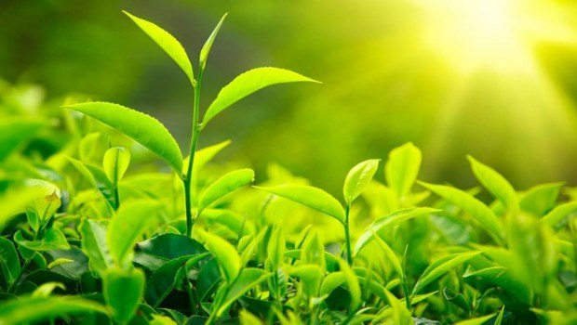
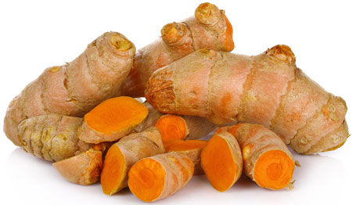
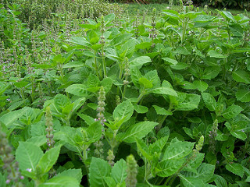
Pictures related to the study
Pictures related to the study

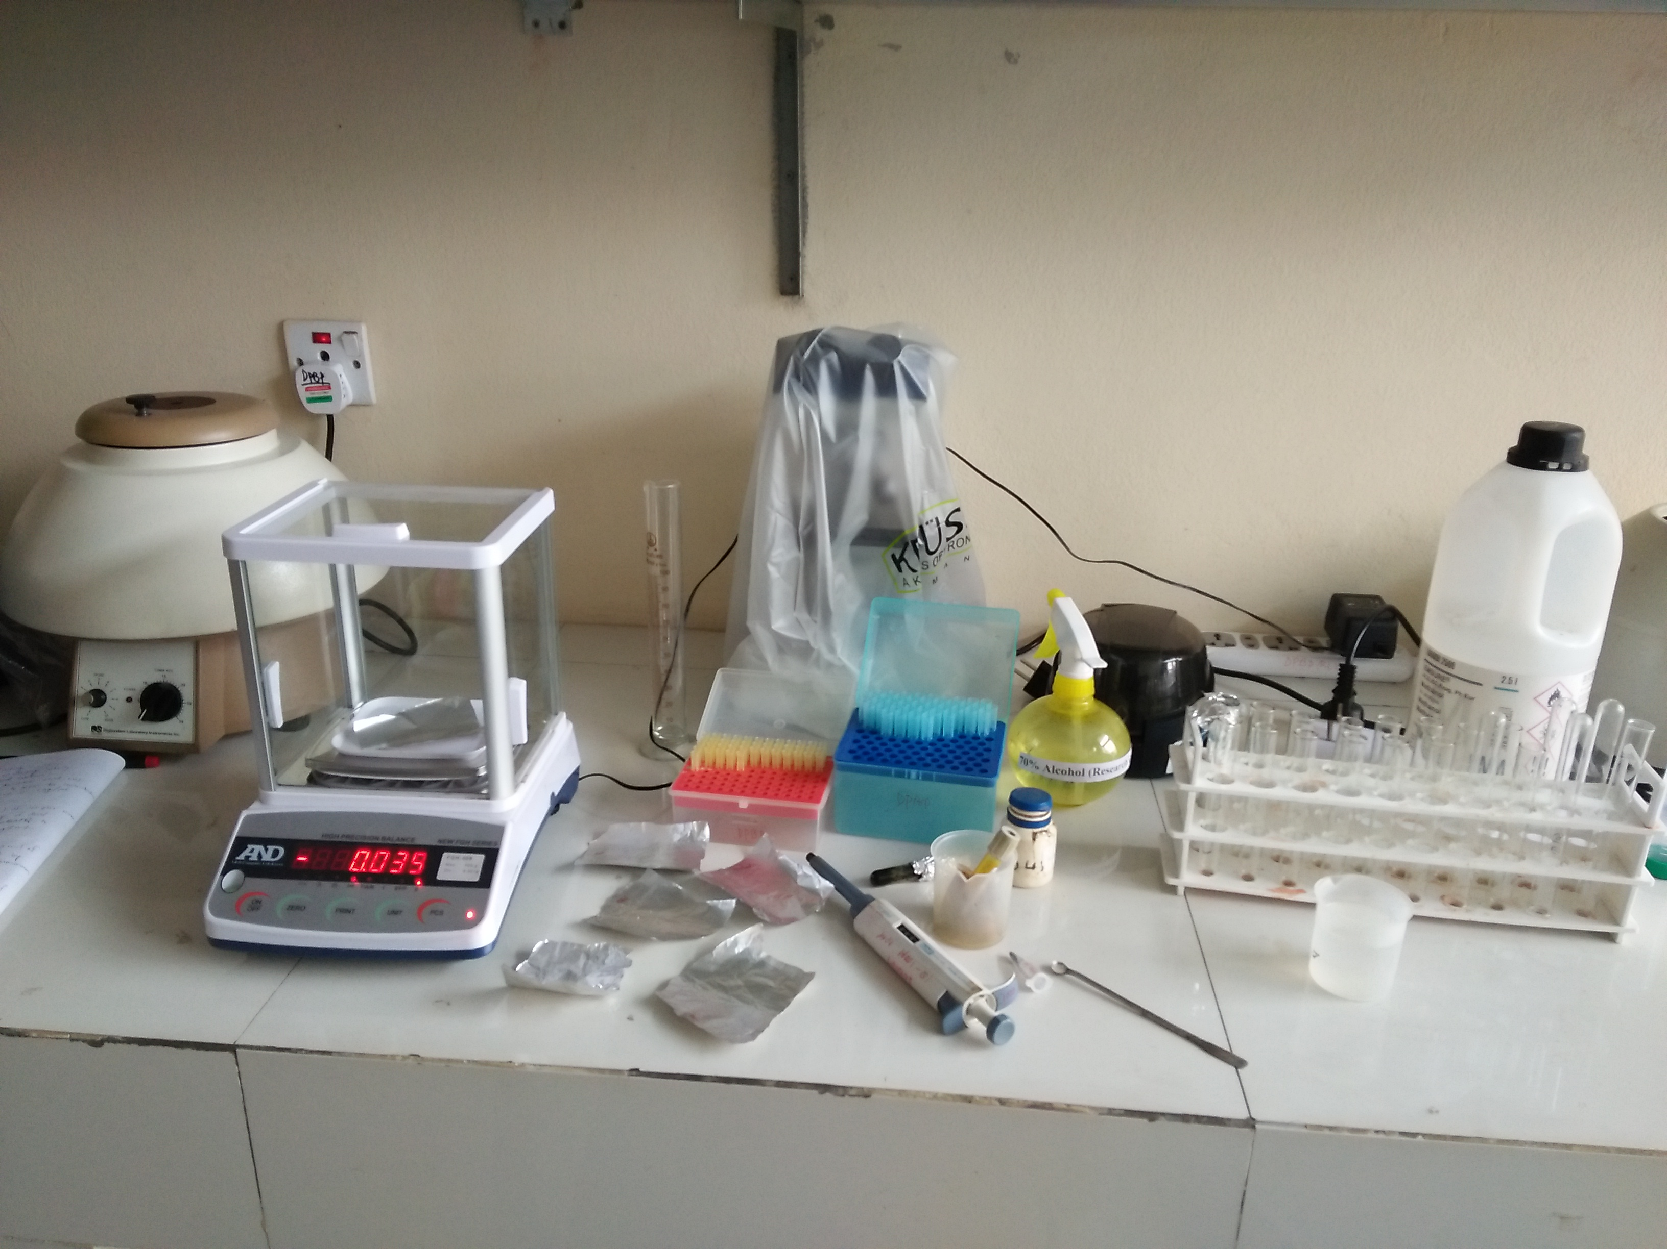
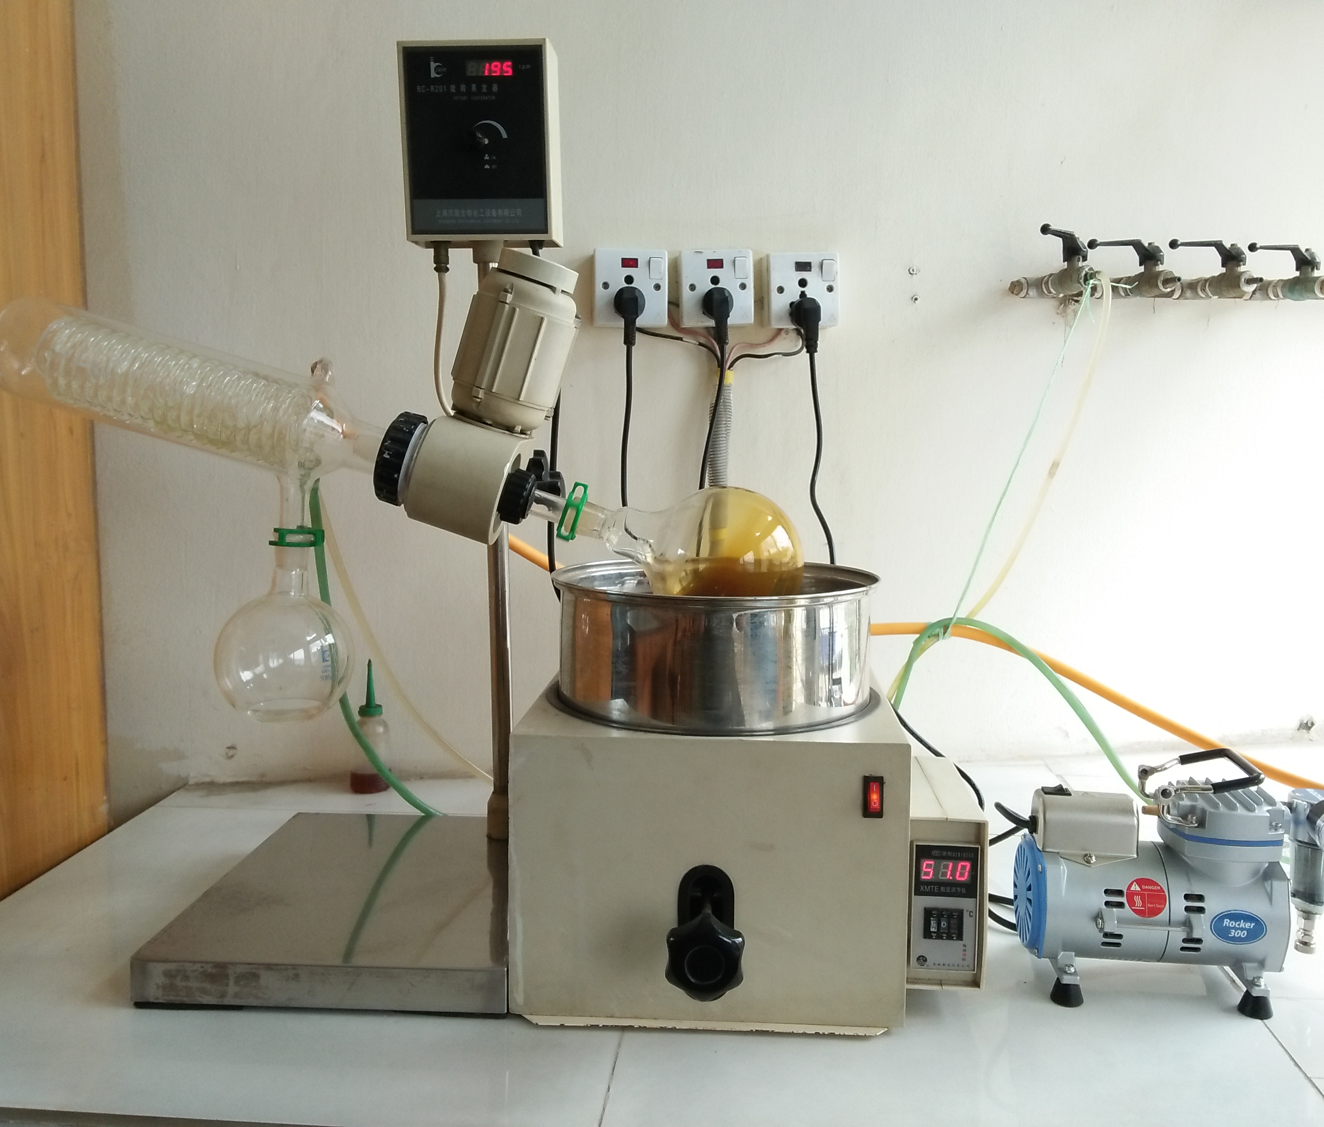
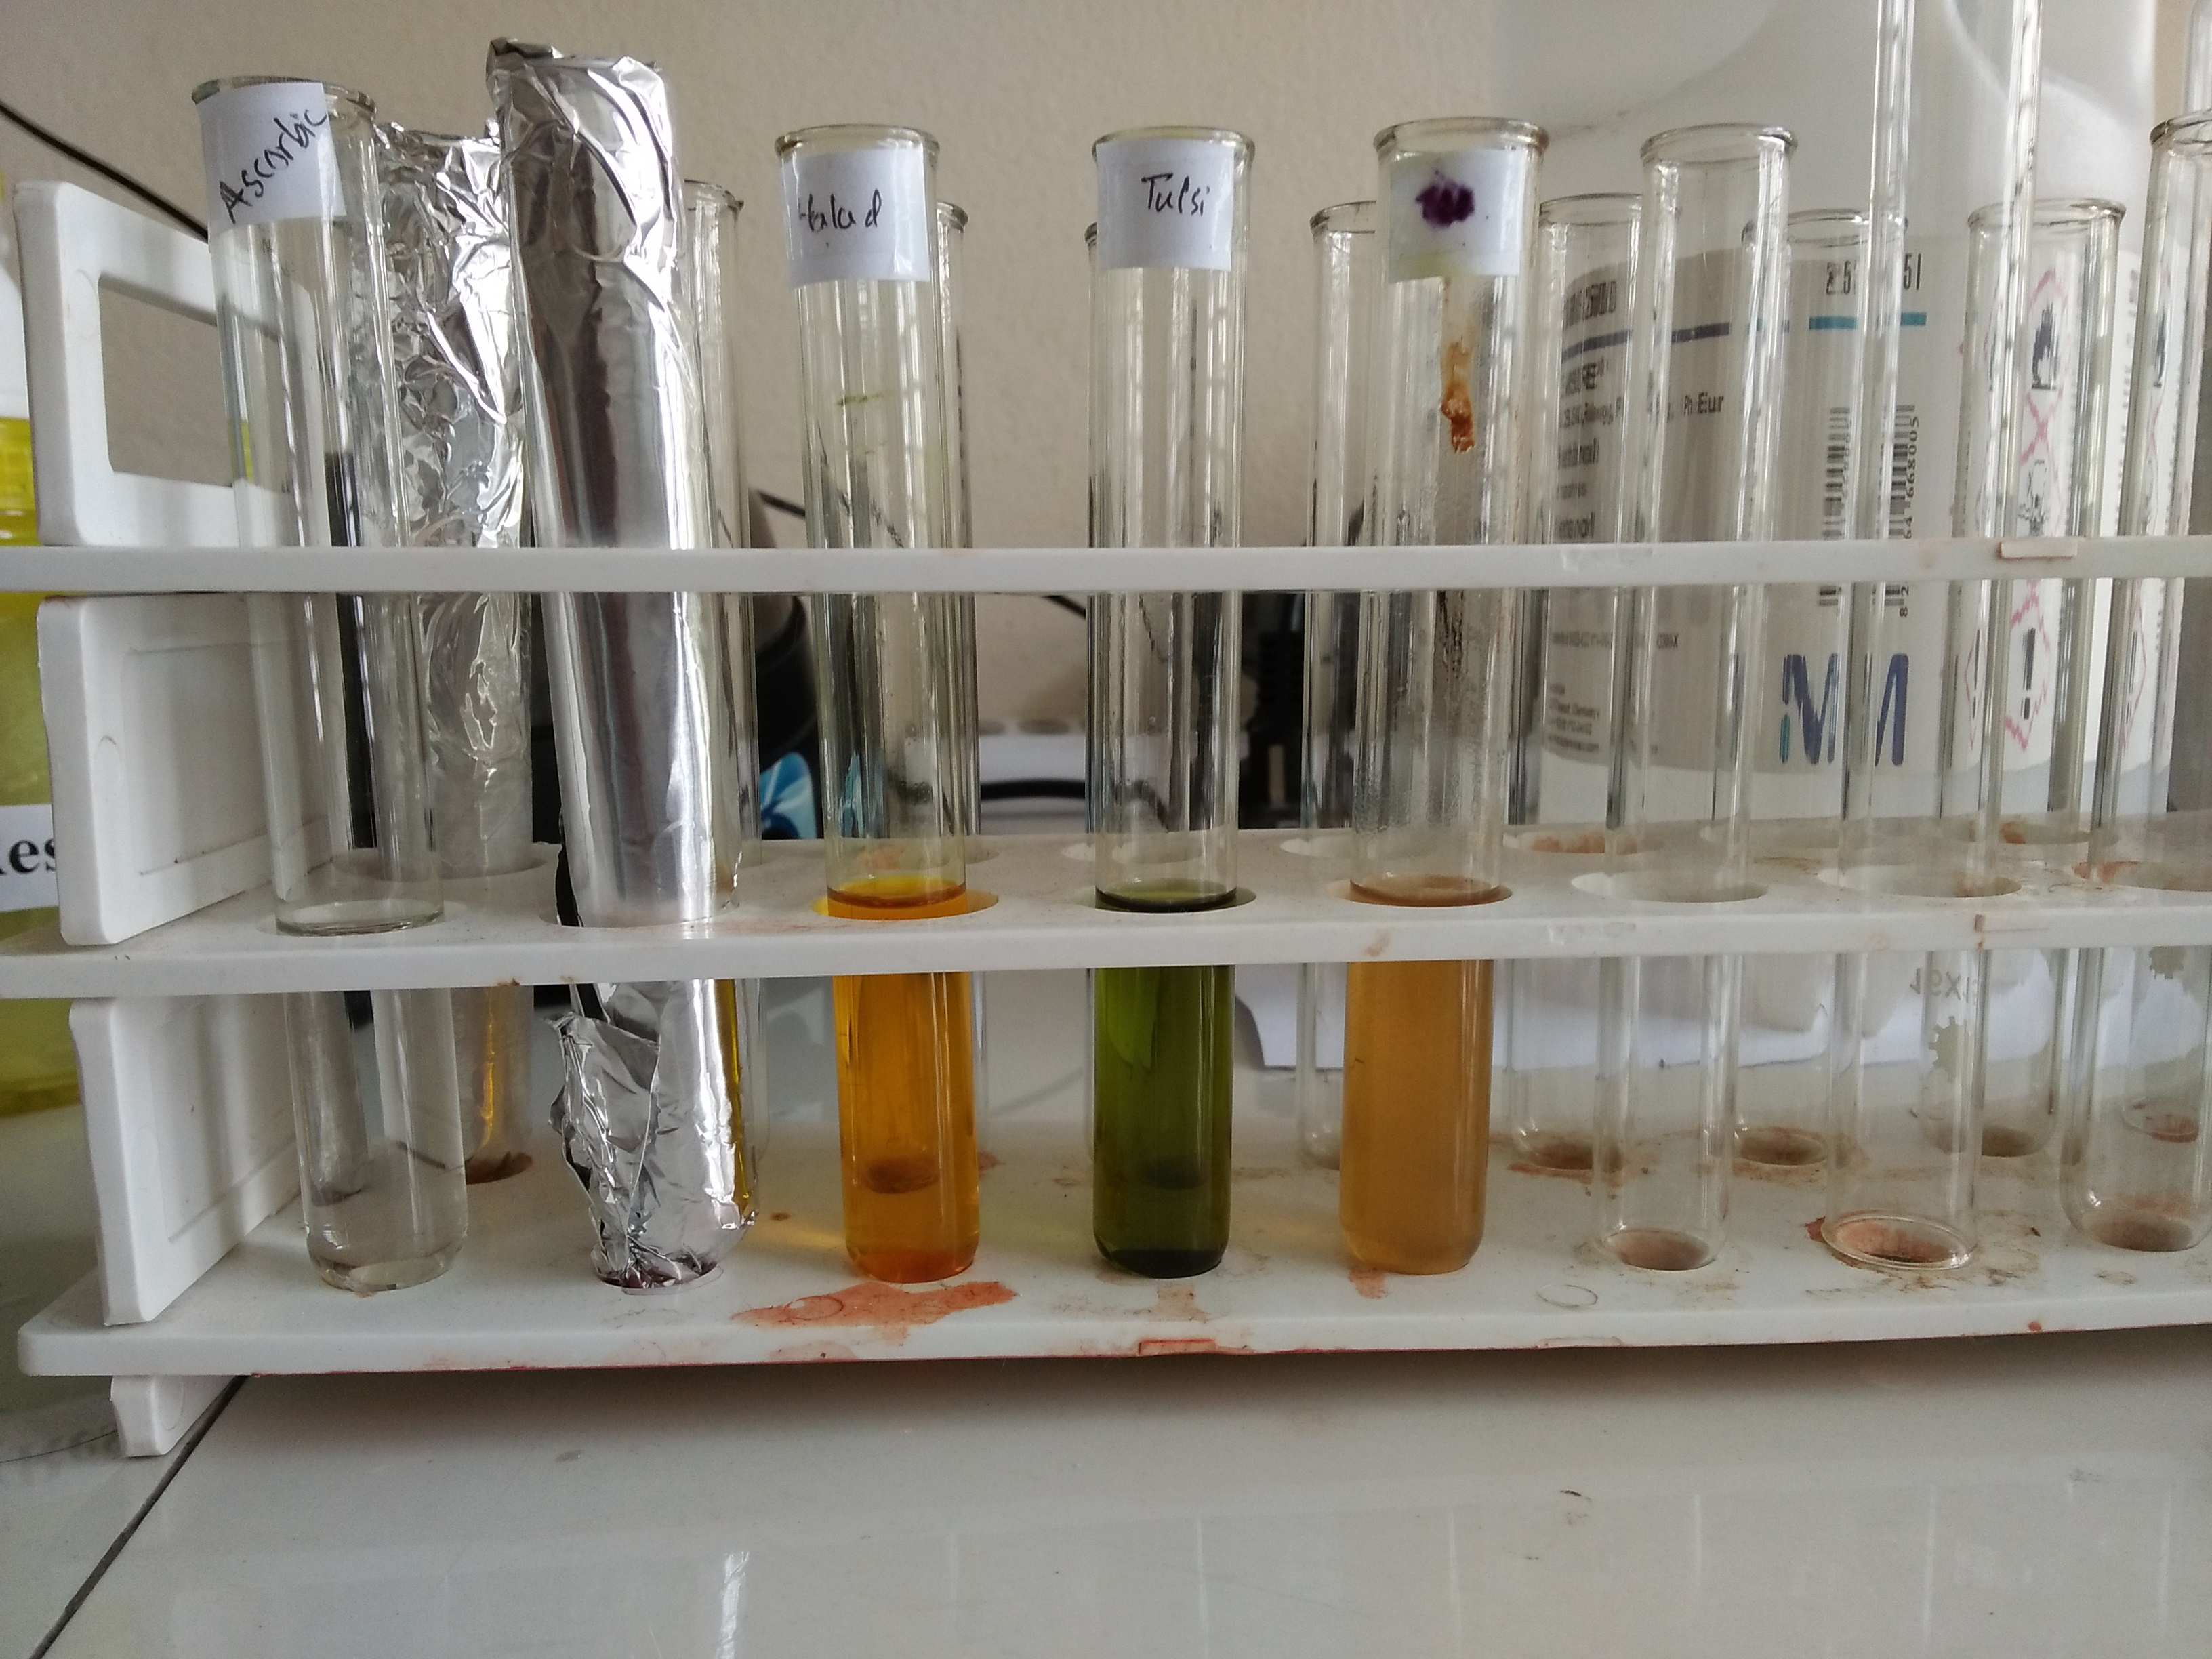
Fig: Extracted the sample by Rotatory evaporator

Fig: Measured with electric balance and micro pipette

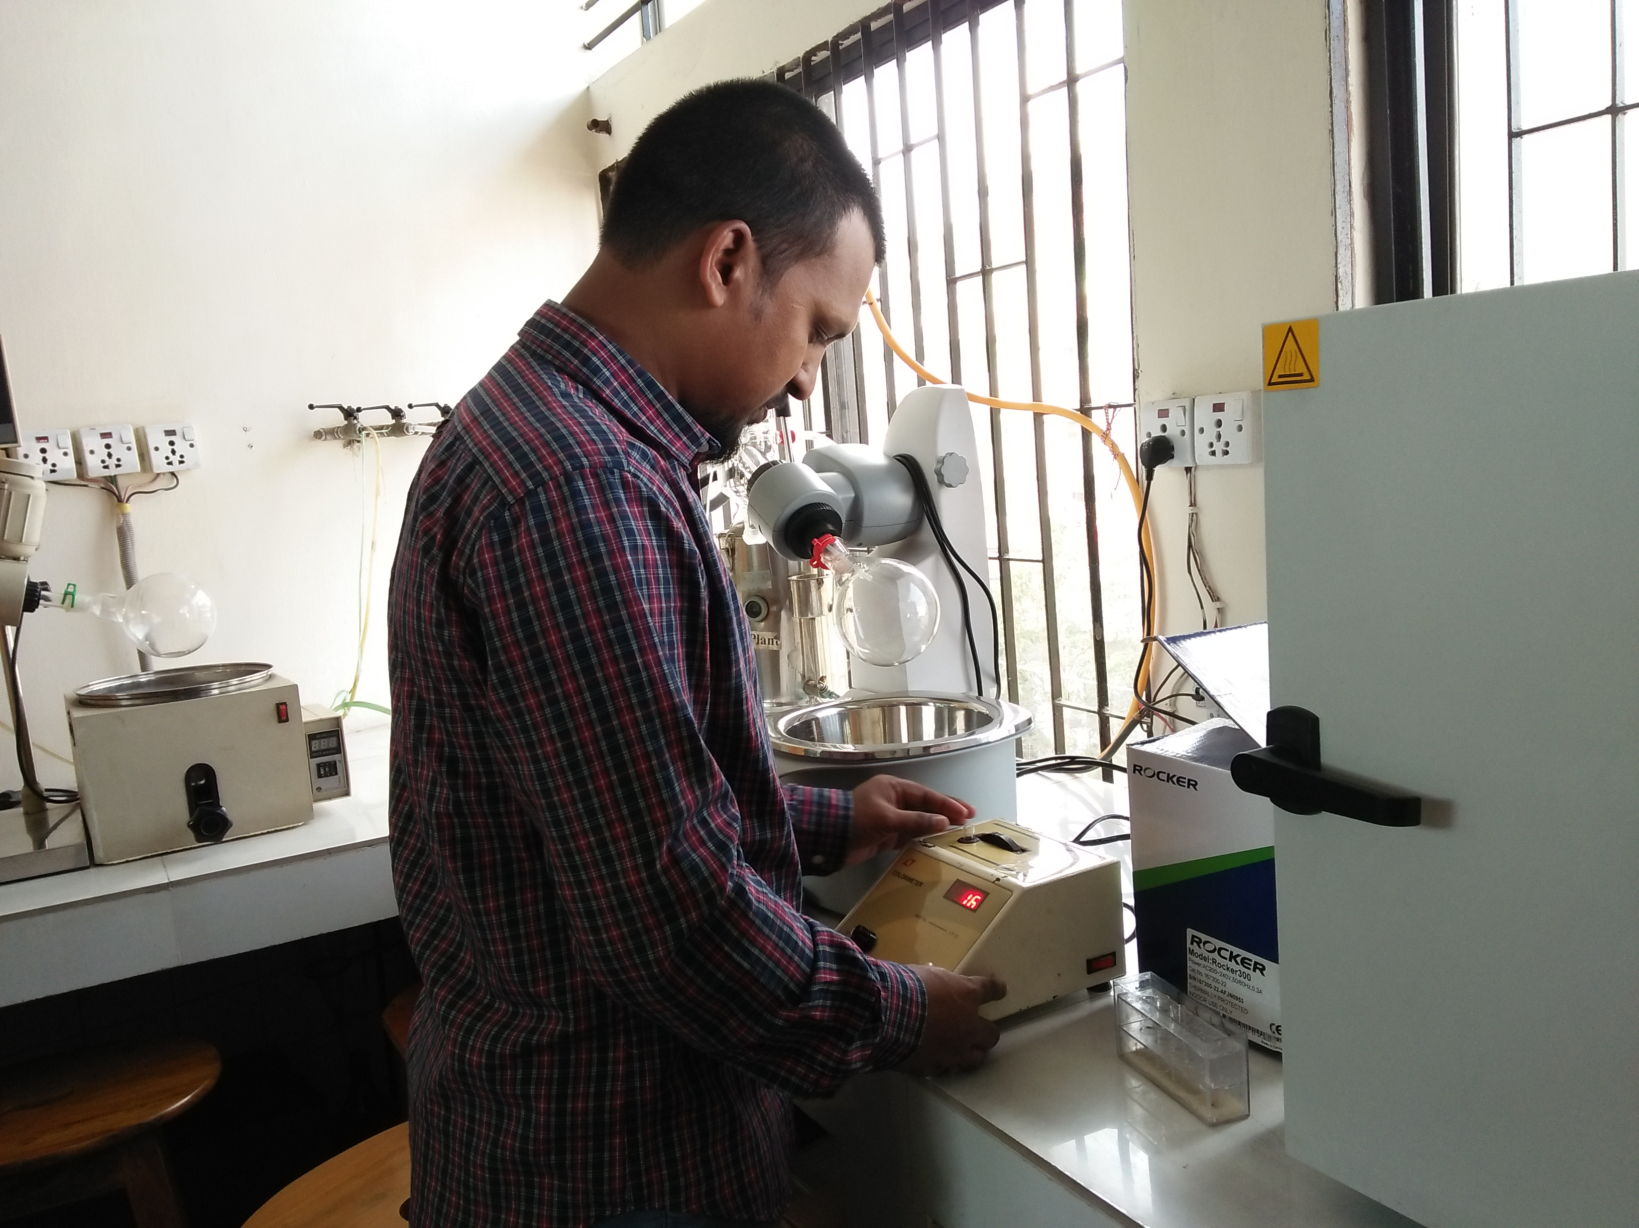

Fig: Absorbance was measured with Spectrophotometer
Fig: Preparation of samples and standard solution

CHAPTER III
RESULT
The free radical scavenging activity of Ocimum tenuiflorum, Curcuma longa and Camellia sinensis were studied by its ability to reduce the DPPH, a stable free radical. The reduction capability if the DPPH radical is determined by the decrease in its absorbance at 516nm induced by antioxidants. The absorption maximum of a stable DPPH radical in ethanol was at 516nm. The % antiradical activity of standard antioxidant (Ascorbic acid) is shown in table 1.
The control absorbance estimated for DPPH is 0.72 in respect of the value of concentration of 150µl.
The absorbance was revealed in the spectrophotometer in relation to concentration in case of Ascorbic acid that was used in the study as a standard. Ascorbic acid is supposed to have 100% antioxidant property. So, the antioxidant properties of the extracts used in the study may be estimated in comparison with the value of Ascorbic Acid.
Variable | Concentration | Absorbance
Ascorbic acid | 100µl | 0.03
 | 200µl | 0.02
 | 400µl | 0.01
 | 800µl | 0
Table 1: Concentration and absorbance of Ascorbic acid

The absorbance found in case of ascorbic acid 0.03, 0.02, 0.01 and 0 in respect of the concentration value with 100µl, 200µl, 400µl and 800µl.
The absorbance was revealed in the spectrophotometer in relation to concentration in case of Holy Basil that are described in Table 2:
Variable | Concentration | Absorbance
Holy Basil | 100µl | 0.51
 | 200µl | 0.42
 | 400µl | 0.40
 | 800µl | 0.28
Table 2: Concentration and absorbance of Holy Basil

The absorbance found in case of Holy Basil 0.51, 0.42, 0.40 and 0.28 in respect of the concentration value with 100µl, 200µl, 400µl and 800µl.
The absorbance was revealed in the spectrophotometer in relation to concentration in case of Turmeric that are described in Table 3:
Variable | Concentration | Absorbance
Turmeric | 100µl | 0.62
 | 200µl | 0.20
 | 400µl | 0.14
 | 800µl | 0.13
Table 3: Concentration and absorbance of Turmeric

The absorbance found in case of Turmeric 0.62, 0.20, 0.14 and 0.13 in respect of the concentration value with 100µl, 200µl, 400µl and 800µl.
The absorbance was revealed in the spectrophotometer in relation to concentration in case of Tea that is described in Table 4:
Table 4: Concentration and absorbance of Tea

Variable | Concentration | Absorbance
Tea | 100µl | 0.28
 | 200µl | 0.19
 | 400µl | 0.17
 | 800µl | 0.16

The absorbance found in case of Tea 0.28, 0.19, 0.17 and 0.16 in respect of the concentration value with 100µl, 200µl, 400µl and 800µl.
Now, the % Antiradical activity is estimated from the equation below which is an indicator of the antioxidant activity.
$$\% antiradical activity =\frac{Control absorbance-Sample absorbance}{Control absorbance}×100$$
The antiradical activity of the extracts is given from the calculation below:
Variables | Concentration | % antiradical activity
Ascorbic acid | 100µl | 95.83
 | 200µl | 97.22
 | 400µl | 98.61
 | 800µl | 100
Holy Basil | 100µl | 29.16
 | 200µl | 41.67
 | 400µl | 44.44
 | 800µl | 61.11
Turmeric | 100µl | 13.89
 | 200µl | 72.22
 | 400µl | 80.55
 | 800µl | 81.94
Tea | 100µl | 61.11
 | 200µl | 73.61
 | 400µl | 76.39
 | 800µl | 77.78
Table 5: Antiradical activity of the extracts

- The highest and lowest % Antiradical activity of Ascorbic acid is 100% and 95.83% in respect of the value of the concentration at 800µl and 100µl.
- The highest and lowest % Antiradical activity of Holy Basil is 61.11% and 29.16% in respect of the value of the concentration at 800µl and 100µl.
- The highest and lowest % Antiradical activity of Turmeric is 81.94% and 13.89% in respect of the value of the concentration at 800µl and 100µl.
- The highest and lowest % Antiradical activity of Tea is 77.78% and 61.11% in respect of the value of the concentration at 800µl and 100µl.
The decrease in absorbance of DPPH radical caused by antioxidants, because of the reaction between antioxidant molecules and radical progresses, which results in the scavenging of the radical by hydrogen donation. Figure- 1,2,3,4 illustrates increase scavenging of DPPH radicals in dose dependent manner due to the scavenging ability of these ethanolic extracts. In case of Tea the average % antiradical activity is higher and % antiradical activity is lower in case of Holy Basil.
The highest % antiradical activity is found in Turmeric (81.94%) in compare to Holy Basil and Tea in same concentration (800µl). This study reveals antiradical activity of holy basil and turmeric were almost similar in different concentration.

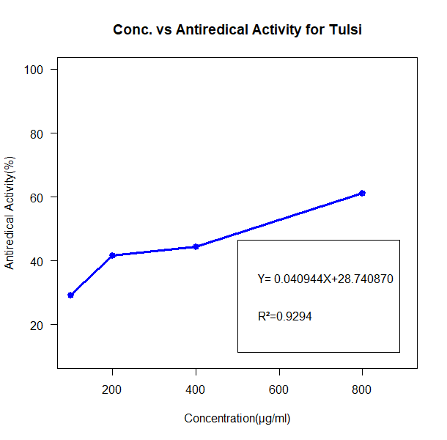

Figure 1: Concentration VS Antiradical Activity For Holy Basil
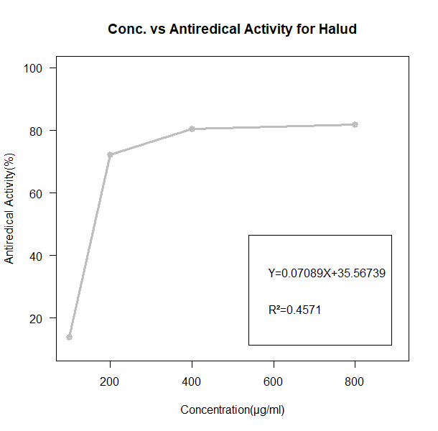

Figure 2:Concentration VS Antiradical Activity For Turmeric

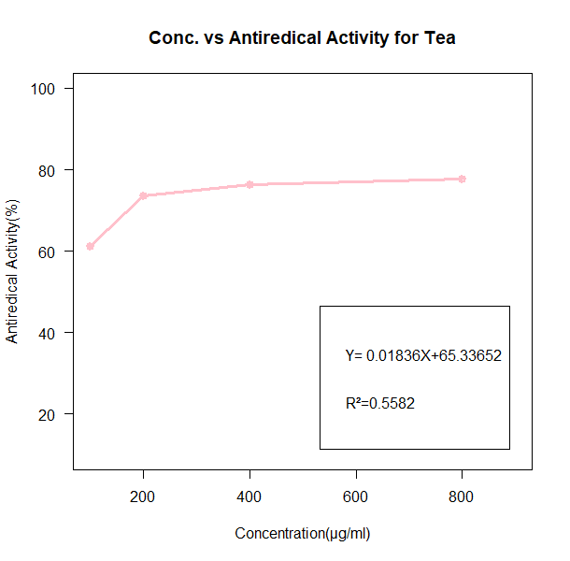

Figure3:Concentration VS Antiradical Activity For Tea
Figure 5:Concentration VS Antiradical Activity For The Extracts In Comparison.

Figure 3: Concentration VS Antiradical Activity For Tea

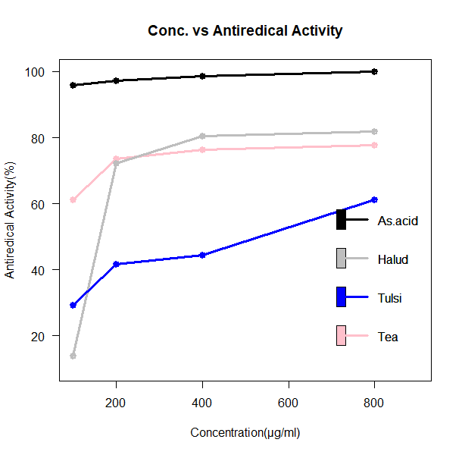

Figure4: Concentration VS Antiradical Activity For Comparison
Figure 4: Concentration VS Antiradical Activity For Comparison

CHAPTER IV
DISCUSSION
The results indicated that ethanolic extracts of Ocimum tenuiflorum (Holy Basil), Curcuma longa (Turmeric) and Camellia sinensis (Tea leaves) has a noticeable effect of scavenging free radicals revealed at DPPH free radical scavenging activity.
In this study, Ocimum tenuiflorum showed high inhibition of DPPH activity shows that 61.11% and 29.16% in respect of the value of the concentration at 800µl and 100µl in leaf extract which differs according to Girijaa rivazhagan et al., 2008 found Ocimum tenuiflorum (Holy Basil) extract was the most potent scavenger (81.1%) while O. americanum, O .minimum, O. citriodorum, O. kilimandscharicum, O. grandiflorum, O. lamiifolium and O. selloi had significantly lower scavenger activity as 77.4 %, 70.1 %, 60.6 % 56.2 %, 51.3 %, 46.2 % and 42.4 % respectively.
During the study Curcuma longa (Turmeric) also showed marked inhibition of DPPH activity shows that81.94% and 13.89% in respect of the value of the concentration at 800µl and 100µl in stem extract which also shows some dissimilarity with an article reported by E. M. Tanvir et al., 2017 that the ethanolic extract of Curcuma longa (Turmeric) contained the highest concentrations of polyphenols (16.07%), ﬂavonoids (9.66%) and ascorbic acid (0.09 mg/100 g) resulted in high yields (17.39%). Our findings strongly suggest that the turmeric (Turmeric) varieties from Bangladesh are promising sources of natural antioxidantsby their considerable DPPH free radical-scavenging activities.
Camellia sinensis (Tea leaves) was identified in the study as highest average inhibition of DPPH activity that was reflected from 77.78% and 61.11% in respect of the value of the concentration at 800µl and 100µl with the average value of 72.22% which could not be compared to any other research works to draw conclusion about the possibility with the similarity or difference with the results of present study.

The cause of the variation may be due to ethanolic extracts were found with the highest frequency for antioxidant study in the present study but in the referral research works some other methods were used to draw a conclusion of antiradical activities of the plant extracts. DPPH is the most easy, simple and reasonably costly method to estimate the antiradical activities but it doesn’t ensure maximum precision and the samples were not maximum to conclude the result as fruitful for further advanced research works relation to the present study. This research has addressed some available natural source of antioxidants in Bangladesh and in Chittagong, in particular. Further extensive studies are recommended with maximum sample of extracts as molecular identification of antiradical activity analysis to make the research fruitful.

CHAPTER V
CONCLUSION
The present study of Ocimum tenuiflorum, Curcuma longa and Camellia sinensis might be useful to supplement information in regarding to its identification parameters assumed significantly in the way of acceptability of herbal drugs in present scenario of lack of regulatory laws to control quality of herbal drugs. The DPPH free radical scavenging activity of ethanolic extract was determined which show significant in-vitro antioxidant activity in a higher dose than standard antioxidant.

CHAPTER VI
REFERENCES
Hyun, D.H., Hernandez, J.O., Mattson, M.P. and de Cabo, R., 2006. The plasma membrane redox system in aging. Ageing research reviews, 5(2), pp.209-220.
Ito, N., Fukushima, S., Haqlwara, A., Shibata, M. and Ogiso, T., 1983. Carcinogenicity of ButylatedHydroxyanisole in F344 Rats 2 3 4. Journal of the National Cancer Institute, 70(2), pp.343-352.
McDonald, S., Prenzler, P.D., Antolovich, M. and Robards, K., 2001. Phenolic content and antioxidant activity of olive extracts. Food chemistry, 73(1), pp.73-84.
McFarland, J., 1987. Standardization of bacterial culture for the disc diffusion assay. Journal of American Medical Association, 49, pp.1176-1178.
Miliauskas, G., Venskutonis, P.R. and Van Beek, T.A., 2004. Screening of radical scavenging activity of some medicinal and aromatic plant extracts. Food chemistry, 85(2), pp.231-237.
Piyanuch, R., Sukhthankar, M., Wandee, G. and Baek, S.J., 2007. Berberine, a natural isoquinoline alkaloid, induces NAG-1 and ATF3 expression in human colorectal cancer cells. Cancer letters, 258(2), pp.230-240.
Prior, R.L. and Cao, G., 2000. Antioxidant phytochemicals in fruits and vegetables: diet and health implications. HortScience, 35(4), pp.588-592.
Prior, R.L., Wu, X. and Schaich, K., 2005. Standardized methods for the determination of antioxidant capacity and phenolics in foods and dietary supplements. Journal of agricultural and food chemistry, 53(10), pp.4290-4302.
Punitha, I.R., Rajendran, K., Shirwaikar, A. and Shirwaikar, A., 2005. Alcoholic stem extract of Cosciniumfenestratum regulates carbohydrate metabolism and improves antioxidant status in streptozotocin–nicotinamide induced diabetic rats. Evidence-Based Complementary and Alternative Medicine, 2(3), pp.375-381.
Re, R., Pellegrini, N., Proteggente, A., Pannala, A., Yang, M. and Rice-Evans, C., 1999. Antioxidant activity applying an improved ABTS radical cationdecolorization assay. Free radical biology and medicine, 26(9), pp.1231-1237.
Remashree, A.B., Jayanthi, A., Thushar, K.V., Ravindran, P.N. and Balachandran, I., 2005. Anatomy of Cosciniumfenestratum (Gaertn.) Colebr.-a critically endangered medicinal plant from Western Ghats. Phytomorphology, 55, pp.249-258.
Rice-Evans, C., Miller, N. and Paganga, G., 1997. Antioxidant properties of phenolic compounds. Trends in plant science, 2(4), pp.152-159.
Sas K, Robotka H, Toldi J, Vecsei L .Mitochondrial, metabolic disturbances,Oxidativestress and kynurenine system, with focus on neurodegenerative disorders. Journal of theNeurological Sciences.2007;257: 221-239.
Shirwaikar, A., Shirwaikar, A. and Punitha, I.S.R., 2007. Antioxidant studies on the methanol stem extract of Cosciniumfenestratum. Natural product sciences, 13(1), p.40.

ACKNOWLEDGEMENTS

the author consider it his utmost obligation to express his gratitude to Almighty, the omnipresent, kind and merciful who gave him the health, thoughtsand the opportunity to complete this task.

In the completion of this work, the author was fortunate in having the generous advice and encouragement of my learned supervisor, DR. Jabin Sultana, Lecturer, Department of Physiology, Biochemistry and Pharmacology, Faculty of Veterinary Medicine, Chittagong Veterinary and Animal Sciences University in selecting the research topic, inspiring scholastic guidance, simultaneous inspiration, constructive criticism, enormous suggestions, sympathetic and unstinted help at every step right from research synopsis to final manuscript writing.

Special thanks to Dr. Shah Jalal and Shuvo Singha for their kind co-operation.
Last but not the least, the author is very grateful to the respondents of the study areas, who were co-operatives and helpful during collection of samples, reagent and extraction to the author.
Finally, the author expresses his deepest sense of gratitude and sincere thanks to all of his well wishers, friends, kith and kins for their blessing throughout the academic life.

The Author
Biography

Name: Tuhin Miah
Student
Doctor of Veterinary Medicine (DVM)
Chittagong Veterinary and Animal Sciences University (CVASU)
Chittagong, Bangladesh

Tuhin Miah, is now an ongoing student of Faculty of Veterinary Medicine (DVM) in the session of 2010-2011. He already completed 8 semesters and now he in his last academic semester. Till now he has a good academic record. The anticipated date of completion of his academic semesters is November, 2017. After completion of academic semesters he has been in 1 (one) year duration internship and externship programme to complete DVM at the end of 2017. Previously he passed secondary school certificate (SSC) and higher secondary school certificate (HSC) examinations with superior performance. He has immense interest to work for animal treatment and welfare.

