Chapter-I

Introduction

In Bangladesh livestock is an essential component of crop cultivation and post harvest operation. Our country is an agricultural dependent country with a high population density and per capital income is very low. In our country, one of the most potential sub-sectors of agriculture is livestock which plays a great role in promoting human health and national economy of the country. About 98 percent of livestock, reared by the landless and marginal farmers in rural areas to provide income (Alam, 1993). Livestock not only assists to upgrade the financial condition but also makes a substantial contribution to human nutrition. However, livestock is an integral part of farming system which has a better contribution to enhance the economy of Bangladesh. Large ruminants (Cattle and Buffalo) and small ruminants (sheep and goat) constitute the major portion of livestock. The present population of livestock is 23.95 million cattle, 1.39 million Buffalo, 24.15 million goat and 3.07 million sheep (DLS, 2011). The total contribution of livestock sub-sector to Gross Domestic Product (GDP) in Bangladesh is approximately 2.9 % (DLS, 2011). It also generates 13% of foreign currency and provides 20% fulltime employment and 50% partial employment of rural population (Alam, 1993). The annual milk production is 50.67 million ton, meat production 36.20 million ton in our country (DLS, 2011).

In Bangladesh 80% rural people rear indigenous cattle (Siddiki et al. 2009).But many people are also involved with urban and rural dairy farming. Most animals are reared in houses under the traditional husbandry practices .Now a days, dairy farming in rural and urban areas is increasing with modern husbandry practices (Sardar et al. 2006) where cattle are mainly reared for several reasons including meat and milk production (Lako et al. 2007).But the production system is compounded by deficiencies in feeding and breeding; with further aggravate the effects of diseased and parasitism.

Gastrointestinal parasitism is a worldwide problem (Regassa et al. 2006). It is thought to be one of the major constraints that hinders the development of livestock population (Kakar et al.2008 and Jabber and Green.1983) and it also adversely affect the health and productivity of animal(Irfan.1984).The losses caused by parasitic infestation are in the form of lowered general health condition, retarded growth rate, diminishing the working efficiency , decrease milk and meat production, abortion, cost associated with preventive measures and reduces the disease resistance capability which may ultimately lead to higher mortality (Chavan et al 2008,Silvestre et al 2000 and Radostits et al 1994). However, the geo-climatic condition of the country also favours the growth, development and survival of various parasites. It has been estimated that about 10% animal die annually due to parasitic disease. Gastro-intestinal parasitic infestations are widely prevalent in Bangladesh and produce a substantial economic loss. Some GI parasites may cause death in calves in heavy infestations. Prevalence of helminthes parasitic infestation in cattle in some areas of Bangladesh has been reported earlier (Rahman et al. 1971; Rahman and Razzak, 1973).

In Bangladesh, parasitic infestation is the major cause of hindering the development of livestock population (Jabber and Green, 1983). The climate of Bangladesh is suitable for the parasites, which are to great extent responsible for calf mortality in this country. The mortality rate of crossbred calves is more than that of indigenous ones (Haque, 1986).

Occurences of gastrointestinal parasitic infestations in different areas varies greatly depending upon the diverse intrinsic and extrinsic epidemiological and biological factors associated with them (Sardar et al. 2006).

Most cattle population in Bangladesh comes from primitive and low productive breeds. Most animals are reared in house under the age old traditional husbandry practices. Many cattle are over worked and most of them are under fed or half fed during most of the time of the years. They are not supplied with adequate balanced ration. As a result the general nutritional status of most of the cattle is in subnormal level which greatly increases susceptibility to parasitic diseases (Blood et al. 1990).Infections caused by gastrointestinal parasites especially nematodes are one of the major causes of calf mortality and act as a big threat for dairy industry of this country. Earlier reports revealed that 50% calves up to 1 year of age died due to gastrointestinal parasitism (Debnath et al. 1995).On the other hand, the adult cattle also severely affect by parasitism as they are kept for a longer period of time in breeding or milk production purposes and often supply insufficient feed against their high demand (Sardar et al., 2006)resulting enormous economic losses. The total annual loss due to gastrointestinal parasites was 25-30 million sterling pounds reported by Rahman (1997). Despite significant losses by gastrointestinal parasitism, the problems are often neglected and overlooked as majority of the infected animals show a number of little obvious clinical signs throughout their productive life and their effects are gradual and chronic (Raza et al., 2010). Epidemiological pattern of the parasitic diseases in the different agro-climatic zones of the country usually provides a basis for developing strategic and tactical control systems against them. In different regions of Bangladesh, several research on gastrointestinal parasitic diseases have been conducted but in Chittagong region (Siddiki et al., 2009 and Alim et al., 2011), it was very meager. Considering the above facts, the present study was undertaken to fulfill the following objectives:

- To investigate the prevalence of gastrointestinal parasitic infestation in FaridpurSadar,Faridpur.

- To determine the effect of different factors such as breed, age, sex, body score, body weight etc. in the occurrences of such diseases.

Chapter-II

Materials and Methods

2.1 Materials and Methodology for prevalence study

2.1.1 Study Area and period
The study was conducted in the Upazilla Veterinary Hospital, FaridpurSadar in Faridpur. The investigation was conducted for a period of 1 months staring from 5 March to 6 April,2017.

2.1.2 Selection of animals and Survey Design
Different cattle breed were selected for this study. Mainly,Indigenous Cattle and Holstein Friesian (HF) crossbred cattle were selected for this study.
A total of 30 fecal samples were collected from 30 individuals, were brought for examination in Upazilla Veterinary Hospital (UVH) during the study period. The cattle were suspected to be affected with gastro-intestinal parasitic infestation on the basis of owner complaint, clinical history- emaciation and gastro-intestinal disturbances; clinical signs- diarrhoea, inappetite, unthriftiness; and physical examination.The description of each patient age, sex & date etc. was recorded to assess their influence on the prevalence of the GI parasitic infestation.
Random sampling was followed during sample collection.A prototype questionnaire was used to record the information like owner’s name and address, animal Identification (ID), farm size, breed, age, sex, deworming history.

2.1.3 sample collection and preservation
Only onebiological sample; feces samples were collected during this study where an individual animal was considered as a sampling unit. approximately 5-10gm of fecal sample from each individual animal was collected directly from rectum. However, freshly voided fecal samples were also considered and subsequently the collected samples were stored in plastic containers. Then, the container was filled with formalin (10%) and refrigerated at 4⁰C temperature. During sample collection, labeling of the samples were strictly maintained to prevent the misinterpretation.
2.1.4 examination of samples
In addition to gross examination of faecalsamples (color, consistency, blood or mucus, etc.), three different types of qualitative tests, namely direct smear, flotation and sedimentation techniques were used to examine the fecal samples (Hendrix, 2006). Zinc Sulphate solution was used as floatation fluid. At least, two smears were prepared from each sample for each test to identify the morphological characteristics of eggs, cyst, Oocysts etc. (Hendrix, 2006 and Soulsby, 1982).
sample

Feces

Qualitative tests

Direct smear Floatation Sedimentation

Fig. 1: Experimental Design (at a glance)

Fig-2 :Preparation of fecal smear & detection of egg on microscope:

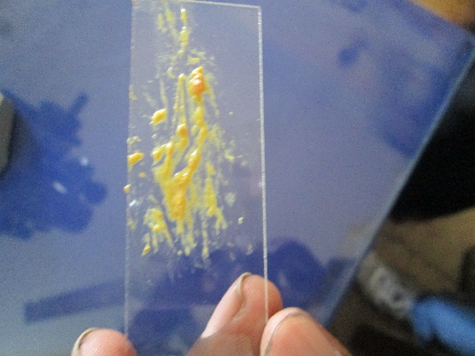 | 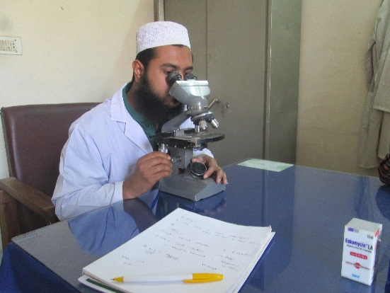
Fig: Preparation of direct smear | Fig: Microscopic examination of fecal smear

Fig-3 :Observation after examination of slides under microscope:

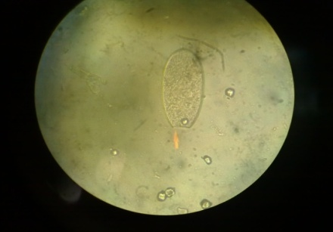  Fig: Paramphistomum cervi | Fig: Fasciola gigantica | 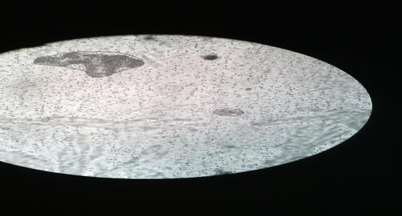  Fig: Paramphistomum spp
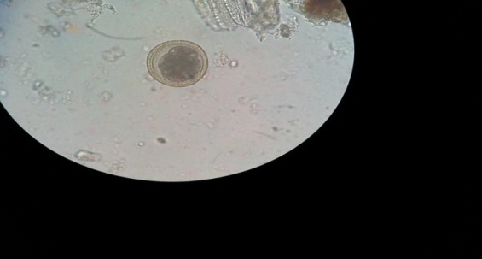  Fig: Toxocara vitulorum | 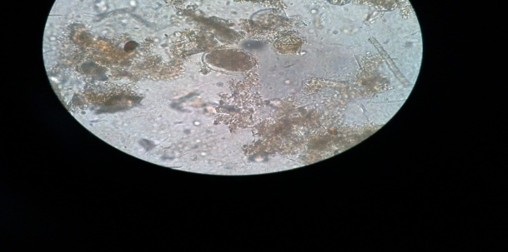  Fig: Oesophagostomum spp | 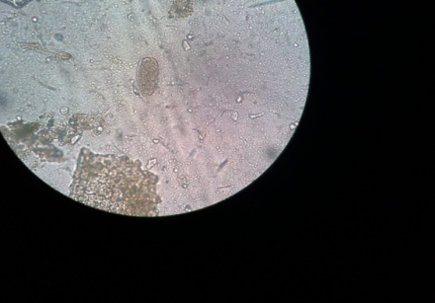  Fig: Trichostrongylu sspp

Chapter-III
Results
3.1 Overall prevalence of gastrointestinal parasites in cattle:
During the current investigation, an approach was taken to determine the status of gastrointestinal parasitic infestation in cattle. It was revealed 7 helminthes species as 1 Cestodes, 2 Trematodes and 3 species of Nematodes in cattle population. The overall prevalence of gastrointestinal parasitic infestations (either single or mixed infestations) was 64% in study population.

Table 1: Association of different variables with overall parasite positive samples

Variables | Level | Total observation | Samples positive to parasites (%)
Breed | Cross | 12 | 9 (75)
 | Local | 18 | 10 (55)
Sex | Female | 16 | 10(62)
 | Male | 14 | 9(64)
BCS | Cachectic | 6 | 6(100)
 | Healthy | 10 | 3 (30)
 | Medium | 14 | 8 (57)
Deworming | Yes | 15 | 8 (53)
 | No | 15 | 12 (80)

The above table showing association of different variables with overall parasite positive samples.The study population consists of 2 cattle breeds;crossbreed of Holstein Friesian (HF), local breeds. Among these 3 breeds prevalence of gastrointestinal parasitic infestation is highest in crossbred cattle (75%) and lowest in indigenous cattle (55%)
In the study population no of female is 16 and male is 14. The prevalence of gastrointestinal parasitic infestation is slightly higher in male (64%) than female (62%)
The study population was categorized into 3 group according to BCS, these are cachectic, healthy and medium. The prevalence of parasitic infestation is highest in cachectic animal (100%) and lowest in healthy animal (30%)
The prevalence of parasitic infestation is higher innot dewormed animal (80%) thandewormed animal (53%)

Chapter-IV

Discussion
4.1 Overall prevalence of gastrointestinal parasitic infections:
The overall prevalence of gastrointestinal parasitic infestations in cattle of this study showed somewhat similarity with the report of M.A. et al. (2001) who recorded 63.32% had single parasitic infestation in Bangladesh. The observation greatly varied from the report of Alim et al., (2011) who recorded 39.75% and 46.25% in crossbred and local cattle, respectively. The report is also varied from Khan et al (2010), Saravana et al (2009) and Rahman and Razzak (1973) who recorded 33.68% in Pakistan, 30.0% in India and37% in Comilla district in Bangladesh. Variation in the occurrence of gastrointestinal parasites infestation might be due to geo-climatic conditions, sample size, breed, age, sex, plane of nutrition, stress, availability of intermediate host, grazing pattern, rearing and husbandry measures, anthelmintic therapy, genetic resistenceetc (Hansen and Perry, 1993).

4.2 Age wise prevalence of gastrointestinal parasites:
In current study, influences of age on the prevalence of gastrointestinal parasitic diseases were observed.Theprevalence of GI parasitic infestations especially, Fasciolaspp, Paramphistomumspp, Oesophagostomumspp and Toxocaraspp were found more in young cattle than adult and calf. Prevalence of Paramphistomumsppwere found more in young cattle which was similar with the observation of Reza et al.,(2007), Regassa et al.(2006),Shah–Fischer (1989) and Dunn (1978), who recorded higher prevalence of helminth in younger animals than adult. In this study, higher prevalence of parasitic infestation in young cattle might be due to sudden exposure to grassland containing egg of parasites and lack of immunity against these infestations

4.3 Sex-specific prevalence of gastrointestinal parasitic infestation:
In the present study, infection caused by GI parasites was found predominant in female than male cattle. Findings of this study was found in accordance with the reports of Davila et al.(2010), Raza et al.(2010) and Al- Shaibani et al.(2008) who also reported higher prevalence of helminthes in female cattle. In this study, variation in occurrence of such helminthes in male and female cattle might be due to variation in sample size (Bachalet al., 2002), stress, genetic resistance of host and insufficient/imbalanced feed against higher needs (Raza et al., 2010 and Hansen and Perry, 1993).

CHAPTER-V

LIMITATIONS

- The study period was short.
- Sample size was short.
- Farmers were not cooperative during the study.
- No follow up done in the study period.
- This study was carried out to determine the prevalence of gastrointestinal parasites but study doesn’t reveal why some parasites were more predominant and others were not.
- This study is limited to certain parameters and some of the parts of the study were left untouched due to time and cost factors so that future researchers can elaborate this study by approaching the untouched portion.

REFERENCES
Akoyl, C.V. 1993.Epidemiology of Toxocaravitulorum in cattle around Bursa,Turkey.J.Helminthol.,67:73-77
Alam, J. 1993. Livestock sector for more investment in Bangladesh.Asian Livestock,18: 77-78.
Alim, M.A., Das, S., Roy, K., Sikder, S., Mohiuddin, Masuduzzaman, M., and Hossain, M.A. 2012. Prevalence of Gastrointestinal Parasites in cattle of Chittagong Division, Bangladesh, Wayamba J. Anim. Sci.,4: 1-8. ISSN: 2012-578X.
Al-Shaibani, I.R.M., Phulan, M.S., Arijo, A. and Qureshi, T.A. 2008. Epidemiology of ovine gastrointestinal nematodes in Hyderabad distinct, Pakistan. Pak. Vet. J., 28 (3): 125-130.
Bachal, B., Phullan, M.S., Rind, R. and Soomro, A.H. 2002. Prevalence of Gastrointestinal Helminths in Buffalo Calves. Online J. Bio. Sci., 2(1): 43-45.
Chavhan, P.B., Khan,L.A.,Raut, P.A.,Maske,D.K., Rahman,S.,Podchalwar, K.S., and Siddiqui,M.F.M.F., .2008. Prevalence of Nematode parasites of Ruminants at Nagpur. Vet. World., 1(5): 140.
Chowdhury, S., Hossain, M.A., Barua, S.R. and Islam S. 2006. Occurrence of common Blood Parasites of Cattle in SirajgongSadar Area of Bangladesh. Bangl. J. Vet. Med., 4(2): 143-145.
D.L.S. 2011. Livestock and poultry profile Bangladesh, Sunil Chandra Ghosh, D.G., and DLS.
Davila, G., Irsik, M. and Greiner, E.C. 2010. Toxocaravitulorum in beef calves in North Central Florida. Vet. Parasitol., 168: 261-263.
Devnath, N.C., Taimur, M.J.F.A., Saha, A.K., Ersaduzzaman, M., Helaluddin, M., Rahman, M.I., Roy, D.K. and Islam, M.I. 1995. A retrospective study of calf losses on the central dairy cattle breeding station in Bangladesh. Prev. Vet. Med.,24:43-53.
Dunn, A.M. 1978. Veterinary Helminthology. 2nd edn, William Heinemann Medical Books, London.p.184
Hansen J. and Perry B. 1990. A Handbook: The Epidemiology, Diagnosis and Control of Gastro-lntestinal Parasites of Ruminants in Africa.I.L.R.A.D (International Laboratory for Research on Animal Diseases), Nairobi, Kenya., 20-22.
Hendrix &Sirois. 2006. Laboratory Procedures for Veterinary Technicians, 5th Ed., 812-814.
Irfan, M., 1984. Key note address on effect of parasitism in lowering livestock population. Pak., Vet., J., 4: 25-27.
Jabbar, M.A. and Green, H.A.G. 1983. The status and potential of livestock within the context of agricultural development policy in Bangladesh. The University of Wales, Aberystwyth, p.113.
Kakar, M.N., and Kakarsulemankhel,J.K., .2008. Prevalence of endo (trematodes) and ecto-parasites in cows and buffaloes of Quetta, Pakistan. Pak. Vet. J., 28(1): 34, 34-36.
Khan, M.N., Sajid, M.S., Khan, M.K, Iqbal, Z. and Hussain, A. 2010. Gastrointestinal helminthiasis: prevalence and associated determinants in domestic ruminants of district Toba Tek Singh, Punjab, Pak. Parasitol.Res., 107(4): 787-794.
Khan, M.Q., Zahoor, A., M. and Jahangir Ashraf Mirza, M. 2010. Prevalence of Blood Parasites in Cattle and Buffaloes. Pak.Vet. J., 24(4):193-195.
Lako, N.J., Tchoumboue, J., Payne, V.K., Njiokou, F., Abdoulamouminim. andAwah-Ndukum, J. 2007. Prevalence of Trypanosomosis and Babesiosis among domestic ruminants in the Western Highlands of Cameroon.Proc of the 12th International conference of the Association of Institutions of Tropical Veterinary Medicine, Montpellier, France.pp. 405-410.
Radostits, O.M., Blood, D.C., and Gay, C.C., .1994. Diseases caused by helminth parasites. Veterinary Medicine: A textbook of diseases of cattle, sheep, pigs, goats and horses, 8th edn. BalliereTindall Publication, London. 1223-1230.
Rahman, M.H. 1970. Taxonomic studies on helminth parasites encounters in the abomasums of ruminants in East Pakistan. M.Sc. Thesis, Dept. of Parasitology, East Pak. Agri. Univ., Mymensingh.
Rahman, M.H. 1997. Deworm your livestock to increase their productivity. Agribusiness Bulletin, 33:14-15.
Rahman, M.H. and Razzak, A. 1973. Incidence of helminth parasites infecting cattle in the Kotwalithana of Comilla. Proceedings of First Bangladesh Veterinary conference, Bangladesh Agricultural University,Mymensingh. p.25.
Raza, A.M., Murtaza, S., Bachaya,H.A.Qayyum, A., and Zaman, M.A.2010. Point prevalence of Toxocaravitulorum in Large Ruminants Slaughtered at Multan Abattoir.Pak.Vet.j., 30(4): 242-244
Regassa,F.Sori, T. Dhuguma, R., and Kiros,Y.2004. Epidemiology of Gastrointestinal Parasites of Ruminants in Western Oromia, Ethiopia. Intern. J. Appl. Res. Vet. Med., 4(1): 51-57.
Saravanan, S.Dinakaran, A.M.Muralidharan, J.Geetha, M.Selvaraju, G. 2009. Prevalence of sub-clinical gastrointestinal parasitic infection in dairy animals. Ind. J. Field Vet., 5(2): 45-46.
Sardar, S.A., Ehsan, M.A., Anower, A.K.M.M., Rahman, M.M. and. Islam, M.A. 2006. Incidence of liver flukes and gastro-intestinal parasites in cattle. Bangl. J. Vet. Med.,4 (1): 39-42.
Shah-Fischer, M. and Say, R. 1989. Manual of Tropical Veterinary Parasitology. CAB International; TheTechnical Center for Agricultural and Rural Cooperation(CTA).
Siddiki, A.Z., Uddin, M.B., Hasan, M.B., Hossain, M. F., Rahman M. M., Das, B. C., Sarker, M. S. and Hossain, M.A., 2009. Coproscopic and Haematological Approaches to Determine the Prevalence of Helminthiasis and Protozoan Diseases of Red Chittagong.Pak. Vet. J., 30(1): 1-6.
Soulsby, E.J.L., .1982. Helminths, Arthropods and Protozoa of Domesticated Animals, 7thedn. Baillere Tin

Brief Biodata of the Student

Rakibul Hasan is a student of the degree of Doctor of Veterinary Medicine (DVM) under the Faculty of Veterinary Medicine, Chittagong Veterinary and Animal Sciences University (CVASU). I passed the Secondary School Certificate Examination (SSC) in 2008 from Faridpur ZillaSchool, Faridpur and then Higher Secondary Certificate Examination (HSC) in 2010 from Govt. Rajendra CollegeI admitted at CVASU in 2012. I have a great interest in Large Animal Medicine.

