CHAPTER-I
Introduction

Bangladesh is an agriculture based country in the world where livestock has been an important part of the various farming system practiced in Bangladesh. Livestock plays an important role in the agricultural economy of Bangladesh. The non-crop agriculture sector has registered significantly higher growth rate over the last few years. The crop sector showed an annual growth rate of 1.2% while fisheries, livestock and forestry sub-sectors experienced 5.3%, 5.6% and 4.0% growth rate respectively (Mondal, 1999). The share of the livestock sub-sector in GDP at constant prices was 2.92%, which was 17.2% of agriculture and forestry sector in FY- 2005-2006. The share of this sector is projected at 2.95% of GDP, which would be 17.7% of agriculture and forestry sector in FY- 2006-2007. Among the sub-sectors of the broad agriculture sector, the growth of the livestock sector is the highest. The value of livestock industry is enormous. It is reported to be the fasted growing agriculture sector, with livestock now being the world’s largest land user. In Bangladesh at present, there are about 22.90 million cattle, 1.26 million buffaloes, 21.56 million goats, 2.78 million sheep, 212.47 million chickens, 39.84 million duck (Anon, 2009).
In recent year, this sector has been playing an increasingly important role in the economy uplift effort of Bangladesh. It is a labor intensive and quick yielding sector which augments growth and alleviates poverty. In spite of its substantial importance much less attention has been given in the development of this sectors compared to the crop sector most probably due to the lack of proper knowledge about the methods and problems of production and utilization of livestock in our country. In addition, livestock disease is one of the main important hindrances towards the development of the livestock. As a result the direct impact of animal disease includes loss in productivity through the death or slaughter of the animals, reduce production of milk, meat & reduce reproductive capacity (Afazuddin, 1985). Estimated TK. 1,08,067.75 as an annual economic loss due to various parasitic diseases at Savar military farm. Parasitism claims to be the main obstructer in livestock rearing in Bangladesh (Jabber and Green, 1983). Besides, parasitic diseases some other important infectious diseases like FMD, PPR, mastitis and non-infectious diseases like milk fever, dystocia, acidosis, pregnancy toxemia etc. causes great loss in the economy of Bangladesh.
Dog bite in different animals commonly occurs; the measures of dog bite frequency in animal are rarely performed in Bangladesh. However, the occurrence of rabies caused by Lyssa virus belonging to the family rhabdoviridae in animal and human due to rabid dog bite is common in Bangladesh (Hossain et al., 2011). There are 40,000 to 70,000 estimated deaths worldwide due to rabies yearly and an estimated 10 million people receive prophylaxis (Jackson et al., 2003). After India and China
this country ranks the third in the number of rabies cases of livestock and humans (Hossain et al., 2013). Rabies is a fatal neurologic illness transmitted to animal and human by direct contact with the saliva of a rabid animal, normally through bite; however, transmission through saliva contact with mucous membranes or fresh wound is possible (OIE T Manual, France, 2013).
The virus will generally remain at the entry site for a period of time before travelling along the nerves to the brain. In the brain, the virus multiplies quickly, resulting in clinical signs (OIE T Manual, France; 2013). The incubation period of rabies is 6 days to 6 months depending on the site of biting in the animal. The initial onset of rabies begins with fever, muscle weakness, tingling and burning at the bite site. As the virus continues to attack central nervous system, the following symptoms like insomnia, anxiety, confusion, partial paralysis, agitation, hallucinations, excess salivation, problems in swallowing and fear of water occurs (Hossain et al., 2011). However, once symptoms appear, rabies is 100% fatal in animals. In Bangladesh many commercially post-exposure rabies vaccines are available in different name like Rabisin®, Ravix-VC®, Fabirab®, Rabix-IG®, Rabipur®, Verorab®, Imovax™, Rabies Vero™, TRC Verorab™. Post exposure vaccine should be followed as-three doses should be administered ondays 0 (at the time of exposure), 7 and 21 in all animals. On day 0 an amount of 4ml vaccine is required for large animal, 3ml for calf and 2 ml for small animals (dog, cat, sheep and goat). On day7 and day 21 an amount of 3 ml vaccine is required for large animal, 2ml for calf and 1ml for small animals (dog, cat, sheep and goat)are recommended (Hossain et al.,2010).The route of administration is often intramuscular.
Indirect impact includes loss of export market, effect on human health, effect on social status etc. Rangamati district is one of the important sites for livestock population and the most of the common livestock diseases are frequently found in this region. This study was conducted at the district veterinary hospital for two months during internship training program with the following objectives:
- To determine the prevalence of different diseases and disorders of livestock (cattle, buffalo, goat, sheep, swine and poultry).
- To study the infection with different demographic variable (age, sex, species).

CHAPTER-II
Materials and Methods

The study was conducted in District Veterinary Hospital, Rangamati to determine the general clinical prevalence of diseases and disorders in cattle, goat, sheep, swine, buffalo and poultry. The materials and methods which were applied to perform this work is given below:
2.1: Study area and duration
Different species of domestic animal including cattle, goat, sheep, swine, buffalo, poultry and dog affected with clinical diseases were studied during the Period of 2 months (March 1 to April 6 and July 5 to August 3, 2017) in District Veterinary Hospital, Rangamati, Chittagong, Bangladesh. In addition to clinical cases, other cases in cattle, goat, sheep, buffalo, swine, poultry and dog were also recorded to study this report.
2.2: Reference population:
All the cattle, goat, sheep, dog, swine, buffalo and poultry that were brought in District Veterinary Hospital were considered to be reference population.
2.3.: Source and study population:
Clinical history and clinical sign of diseases were considered to study population at the time of my internship program at Rangamati. Cattle, goat, sheep, swine, dog, buffalo and poultry were recorded during that period. All the sick animals are brought to this hospital for the treatment and registered in the patient registered book. There are two ways to have attended those patients; one was hospital at where farmers eagerly came with their patients and another was at field where me along with Veterinary surgeon went to the field for registration & treatment of diseased animals. The age and other clinical history of sick animals were collected by asking the owner. A total of 157 cases (57cases were cattle, 52 cases were goat, 31 cases were poultry, 6 cases were swine, 6 cases were sheep, 4 cases were buffalo, 1 case of dog) were available during my UVH placement period and the general clinical examinations were conducted according to the merit of the case.
2.4: Clinical and physical examination:
Clinical and physical examination was carried out for each case. All the symptoms were recorded during the examination. Suspects were diagnosed according to clinical history and signs taken from farmers’ interview. Aggression, salivation, fever, high respiration and heart rate high, inappetance were found as the main key signs of animals. Information on management of cattle, goat, sheep, swine, buffalo, poultry and dog were also noted down in details. The age of the animals were collected from owner.
2.5: Data collection:
The species, age, sex, breed, and frequency site with drugs and vaccination history were recorded. Information about diseased animals and knowledge about disease signs and management of animals were also obtained from the farmers who brought their animals to the veterinary hospital during the study period. A face to face interview with farmer was performed to record the information using a separate questionnaire. The questionnaire included the following information.
2.6: Entry of data:
All the data obtained from the study areas were entered into Microsoft Excel 2007 according to the selective parameters.
2.7: Statistical analysis:
All the collected data were inputted to the Microsoft Office Excel-2007 and transferred to the software Graph Pad for analysis. Statistics was done by using the Graph Pad software and expressed as percentage for different variables. To estimate the association between a categorical explanatory variable by chi square test (Quickcalcs).
Registration Form:
Type of  patient | Address | Species | Sex | Age | Body  wt. | Owner’s  complain | Condition | Prognosis | Remarks

2.8: Photography
All the images related to this study were taken from study sites during handling the clinical cases of different species. The images were slightly modified by using Photoshop software for better illustration of the study.

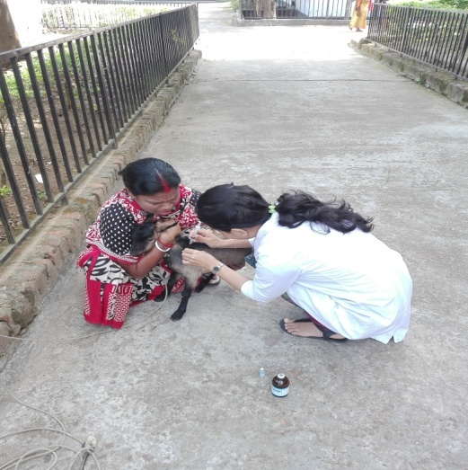
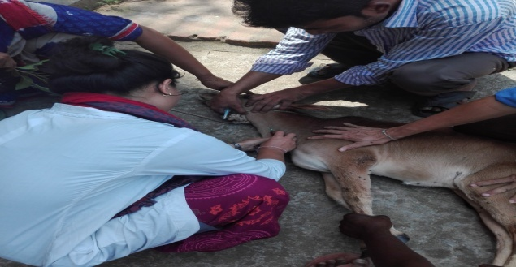

Fig: 2.1; Vaccination in goat Fig: 2.2; I/V in cattle
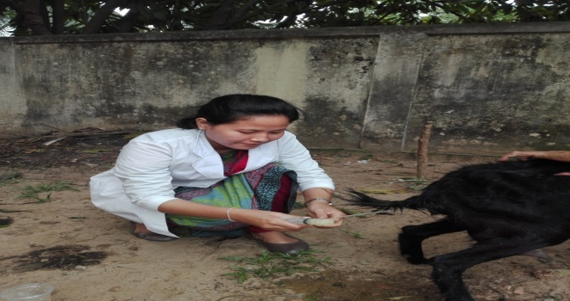
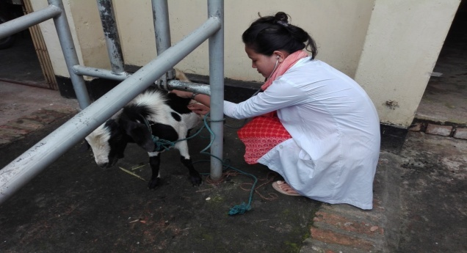

Fig: 2.3; Washing Vagina Fig: 2.4; Physical Examination
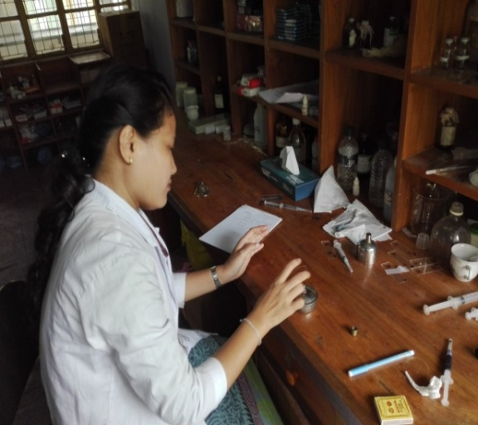

Fig: 2.5; Vaccination in poultry Fig: 2.6; Thick smearing

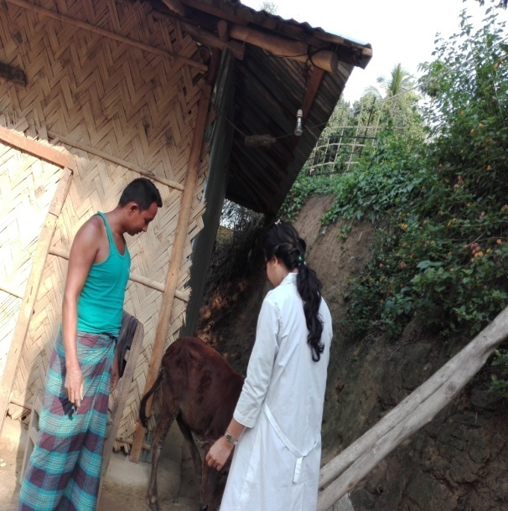
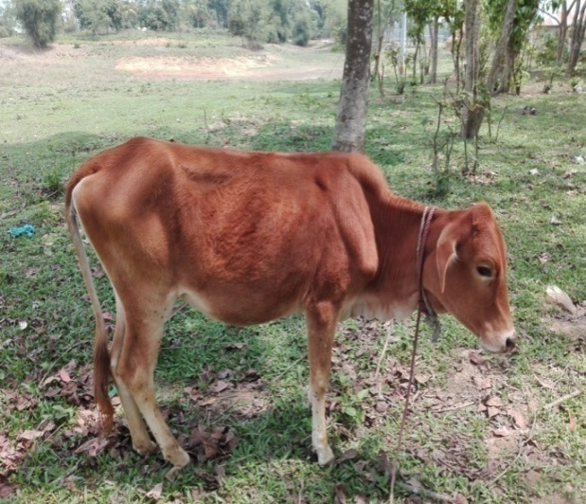

Fig: 2.8; Bovine ephemeral fever
Fig: 2.7; Taking anamnesis from owner
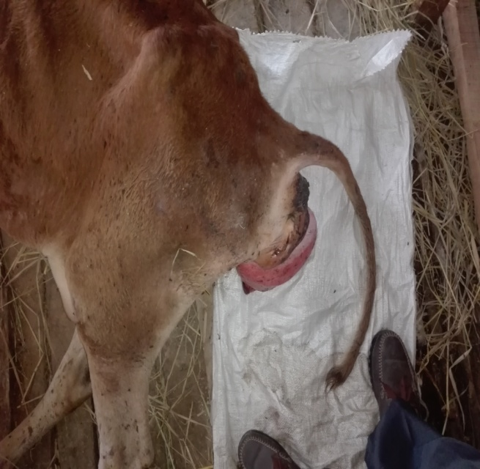
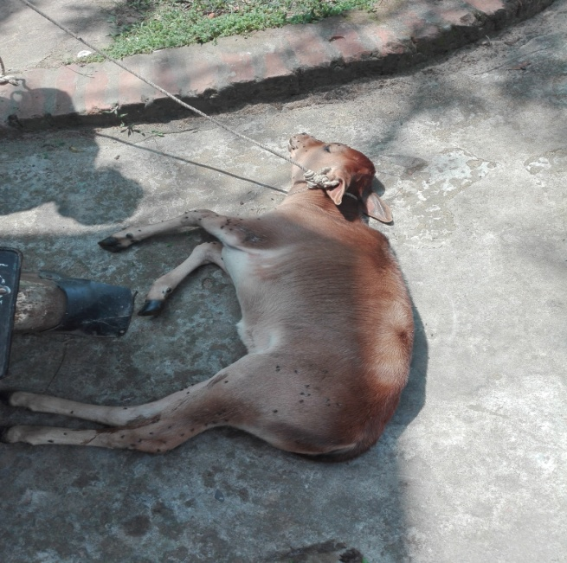
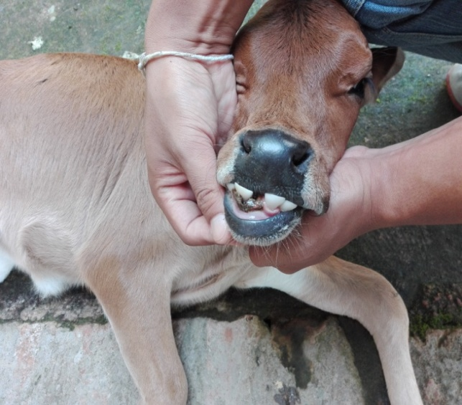
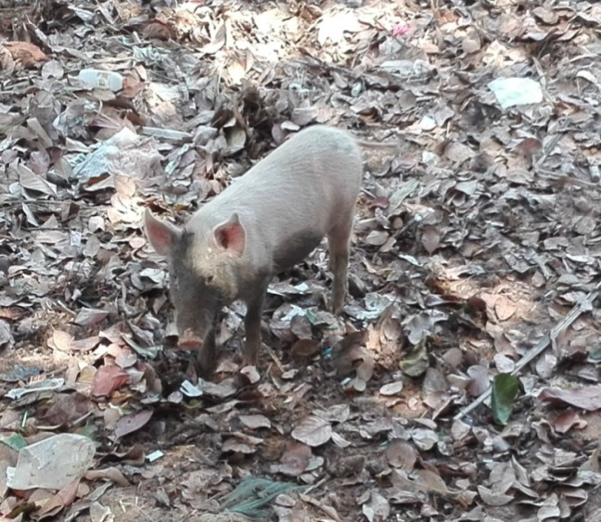
Fig: 2.12; Myiasis in calf
Fig: 2.10; Swine erysipelas
Fig: 2.11; Uterine prolapse in cow
Fig: 2.9; Pneumonia in calf

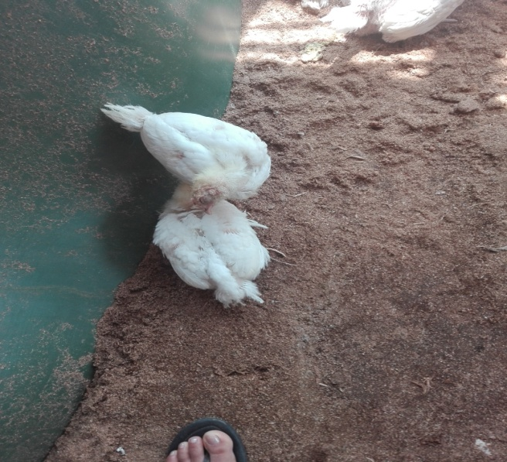
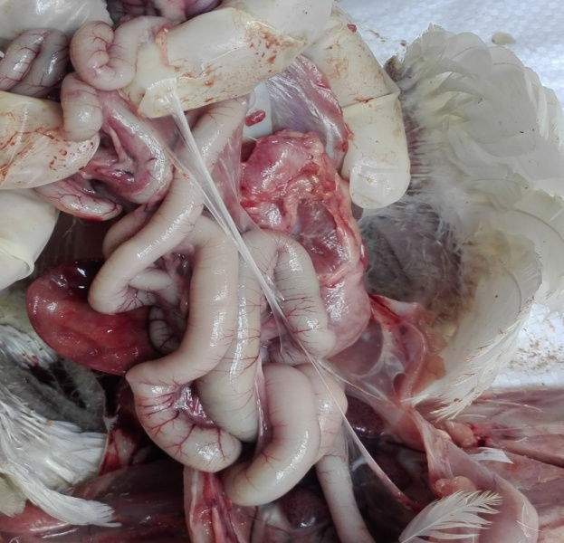

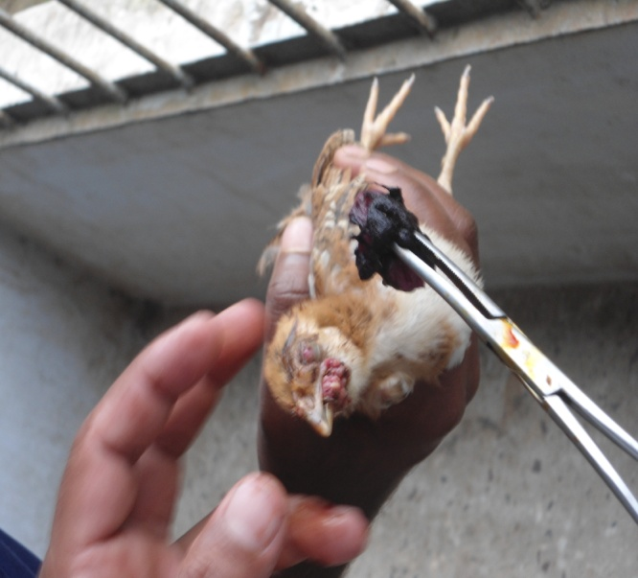

Fig: 2.14; Enteritis in poultry
Fig: 2.13; New castle disease in poultry

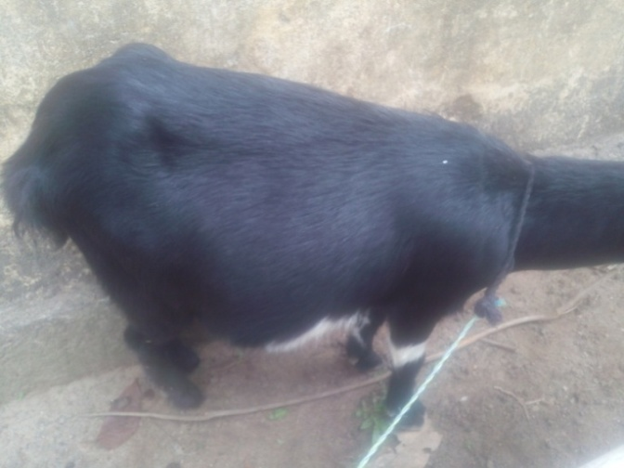

Fig: 2.15; Acidosis in goat
Fig: 2.16; Chicken pox

CHAPTER-III
Results

Clinical investigations were conducted to determine the general clinical prevalence of diseases in cattle, goat, sheep, swine, buffalo and poultry at March 1 to April 6 and July 5 to August 3, 2017. The number and percentage of cases each of the major groups of diseases with their prevalence rate are presented here
Table 3.1: Cases handled in District Veterinary Hospital.

Type of Cases | Cattle | Buffalo | Goat | Sheep | Poultry
Medicinal Cases | Bovine ephemeral fever  Dehydration  Diarrhoea  Parasitic infestation  Mastitis  Pneumonia  Anaplasmosis  Babesiosis  Lumpy Skin disease  Foot and mouth disesase | Parasitic Infestation | PPR  Aspiration Pneumonia Indigestion Parasitic infestation  Mastitis | Nutritional deficiency | Newcastle disease  Coccidiosis  Mycoplasmosis  Gumboro  Necrotic enteritis
Surgical Cases | Naval ill  Myiasis  Dog bite |  | Castration  Dog Bite | Dog Bite | Haematoma in wing of Pigeon
Gynaecology and Obstetrics | Uterine prolapse  Retained placenta | Pregnancy diagnosis | Dystocia

Table 3.2: Prevalence of different diseases and disorders of animals (n=157) studied in DVH.

Disease and disorders | Number of cases | Prevalence (%)
Bovine Ephemeral Fever | 20 | 12.7%
Anaplasmosis | 2 | 1.3%
Babesiosis | 2 | 1.3%
Dystocia | 1 | 0.64%
Uterine Prolapse | 2 | 1.3%
Pneumonia | 6 | 3.8%
Mastitis | 2 | 1.3%
Navel ill | 2 | 1.3%
Myiasis | 2 | 1.3%
Parasitic infection | 41 | 26.1%
PPR | 7 | 4.5%
Tetanus | 1 | 0.64%
Retained placenta | 1 | 0.64%
Simple indigestion | 13 | 8.3%
Castration | 3 | 1.9%
Abscess | 1 | 0.64%
Swine Erysipelas | 7 | 4.5%
IBD | 9 | 5.75
ND | 3 | 1.9%
Enteritis | 5 | 3.2%
Coccidiosis | 7 | 4.5%
CRD | 1 | 0.64%
Common cold | 10 | 6.4%
Dog Bite | 5 | 3.2%
BQ | 2 | 1.3%
Pox | 2 | 1.3%
Total | 157 | 100%

157 sick animals examined during the period of study and results are presented in table number 1. It is evident that 12.7% (n=20) were affected with bovine ephemeral fever, 1.3% (n=2) were affected with anaplasmosis, 0.64% (n=1) with dystocia, 1.3% (n=2) with uterine prolapse, 3.8% (n=6) with pneumonia, 1.3% (n=2) with mastitis, 1.3% (n=2) with navel ill, 1.35% (n=2) with myiasis, 26.1% (n=41) with parasitic infection, 4.5% (n=7) with peste des petis ruminants, 0.64% (n=1) with Tetanus, 0.645% (n=1) with actinomycosis, 8.3% (n=13) with simple indigestion, 1.9% (n=3) castration, 0.64% (n=1) with abscess, 4.5% (n=7) with swine erysipelas, 5.7% (n=9) with infectious bursal disease, 1.91% (n=3) with new castle disease, 3.2% (n=5) with enteritis, 4.5% (n=7) with coccidiosis, 0.64% (n=1) with chronic respiratory disease, 6.4% (n=10) with common cold, 3.2% (n=5) with dog bite, 1.3% (n=2) with black quarter, 1.3% (n=2) with pox, 1.3%(n=2) with babesiosis, 0.64% (n=1) retained placenta, respectively.

Table 3.3: Frequency of drugs used according to affected various systems of animals.
Affected  System | Antibiotics | Anthelmintics | Nutritional | Others
Digestive | 18 | 14 | 5 | 18
Respiratory | 15 | 1 | 1 | 2
Urogenital | 9 | 30 | 6 | 14
Integumentary | 6 | 15 | 1 | 2
Total | 48 | 60 | 13 | 36

The whole recorded diseases were classified into 4 groups like digestive, respiratory, urogenital and integumentary systems which were treated with antibiotics, anthelmintics, nutritional and others. The prevalence of antibiotics used in digestive system is 18, respiratory system 15, urogenital system 9, integumentary system 6. On the other hand, anthelmintics used in digestive system 14, respiratory system 1, urogenital system 30, integumentary system 15. Nutritional drugs used in digestive system 5, respiratory system 1, urogenital system 6, integumentary system 1, and other drugs used in digestive system 18, respiratory system 2, urogenital system 14, integumentary system 2.

Fig: 3.1: Frequency of drugs used according to various affected systems of animals

Table 3.4: Frequency of antibiotics used according to various affected systems of animals.
Antibiotics Name | Frequency | Percentage (%)
Streptopen | 20 | 41.7%
Moxacil vet | 04 | 8%
Renamycin | 15 | 31.3%
Genacyn vet | 02 | 4.2%
Tylochem | 05 | 10.4%
Diadin | 03 | 6.3%
Total | 48 | 100%

The most commonly used antibiotics were Streptopen 41.7%, Moxacil vet 8%, Renamycin 31.3%, Genacyn vet 4.2%, Tylochem 10.4%, Diadin 6.3%, respectively.

Table 3.5: Frequency of anthelmentics used according to various affected systems of animals.
Anthelmentics Name | Frequency | Percentage (%)
Vermic | 20 | 33%
Piper vet | 15 | 25%
Albencid | 13 | 22%
Peraclear | 7 | 12%
Trisol | 5 | 8%
Total | 60 | 100%

The commonly used anthelmentics were Vermic 33.3%, Piper vet 25%, Albencid 21.7%, Peraclear 11.7%, Trisol 8.3%, respectively.

Fig: 3.2: Frequency of anthelmentics used according to various affected systems of animals

Table 3.6: Frequency of diseases according to age.
Variable category | Age(m= month, y= year) |  |  | P value
 | <6m | >6m-2y | >2y
Digestive | 18 | 6 | 3 | 0.0004
Respiratory | 8 | 4 | 5 | 0.513
Urogenital | 37 | 6 | 14 | 0.0001
Integumentary | 15 | 6 | 5 | 0.0468

Here, the relationship between ages significantly associated as the p value of chi square test was 0.0004, 0.513, 0.0001 and 0.0468 respectively where (p>0.01) in maximum.

Fig: 3.3: Frequency of diseases according to age

Table 3.7: Frequency of diseases according to sex.
Disease type | Male | Female | P value
Digestive | 18 | 32 | 0.009
Respiratory | 9 | 12 | 0.53
Urogenital | 36 | 27 | 0.15
Integumentary | 15 | 14 | 1.00

Here, the relationship between sex was significantly associated as the p value of chi square test was 0.009, 0.53, 0.15, 1.00, respectively where (p<0.01) in maximum.

Fig: 3.4: Frequency of disease according to sex

Table 3.8: Frequency of diseases according to species (n=157).
SL NO | Species | Frequency | Percentage (%)
01 | Cattle | 57 | 36%
02 | Goat | 52 | 33%
03 | Poultry | 31 | 20%
04 | Swine | 6 | 4%
05 | Sheep | 6 | 4%
06 | Buffalo | 4 | 2%
07 | Dog | 1 | 1%

Here, percentage of disease occurrence according to species were cattle 36%, goat 33%, poultry 20%, swine 4%, sheep 4%, buffalo 2%, dog 1% respectively.

Fig: 3.5: Frequency of diseases in various species

Table 3.9: General perception knowledge of farmers about different diseases.
Attributes | Number |  | Percentage (%)
Preliminary knowledge about fever | Yes | No
 | 60 | 97 | 38.22% | 61.78%
Knowledge about AI | Yes | No
 | 30 | 0 | 100% | 0%
Knowledge about vaccination of poultry | Yes | No
 | 20 | 5 | 80% | 20%
Knowledge about vaccination of ruminants | Yes | No
 | 78 | 31 | 71.56% | 28.44%
Knowledge about source of drug | Yes | No
 | 157 | 0 | 100% | 0%
Amount willing to pay for vaccine | Yes | No
 | 75 | 25 | 75% | 25%
Knowledge about zoonotic diseases | Yes | No
 | 10 | 147 | 6.35% | 93.65%

About 60% farmers responded that they had preliminary knowledge about disease occurrence. Most of the respondents (about 57%) said that they were not aware about how many days animal is suffering from disease. Around 78% farmers had knowledge about vaccine and 100% thought Government Veterinary Hospital was the main source of vaccine. About 31% responded that they are not willing to give vaccine. About 75% owners have willed to pay for vaccine. Most of the dairy farm owners have knowledge about AI. It was evident that most of the farmers have no knowledge about the zoonotic significant diseases and other diseases.

CHAPTER-IV
Discussion

The different clinical examination techniques and methods were used to determine the prevalence of diseases and disorders in cattle, goat, sheep, swine, buffalo, poultry and dog during this two months period of internship program in District Veterinary Hospital, Rangamati. A total no. of 157 cases was examined clinically and the samples considered significant for the diagnostic purposes were utilized for laboratory investigation. The results of these recorded diseases and disorders are discussed as follows:
A. Bacterial diseases:
1. Clinical mastitis:
Clinical mastitis was recorded in cows 1 (0.64%) during this 8 weeks investigation period. The clinical occurrences of mastitis in cow and goats have been reported from Bangladesh (Rahman and samad, 1984) but a systemic study on this disease has not yet been in Bangladesh. In India, mastitis causes great financial loss and has been estimated as Rs. 52.9 cores of rupees every year (Singhand Baxi, 1982). Epidemiological studies on mastitis reveal that mastitogenic agents are widespread on different body sites of cows and goats, milks hands, milking cows and in the milk samples. Moreover, teat a pieces the most common site from when these organisms have been isolated (Malhotra and kapur, 1982). The losses/cow/year has been estimated to exceed US $ 100.00 In USA. Therefore To control this disease in Bangladesh research would be needed.
2. Swine Erysipelas:
Swine erysipelas was recorded 7 (4.5%) during this 8 weeks investigation period. The clinical occurrences of swine erysipelas caused by Erysipelothrix rhusiopathiae seen mainly in growing pigs and characterized by sudden death, fever, arthritis and skin lesions. Skin discoloration may vary from widespread diamond shaped skin lesions may occur in the lateral and dorsal parts of abdomen (Ahrne S, et al., 1995).
B. Viral Diseases:
1. Bovine ephemeral fever:
Non contagious, arthropod transmission of cattle and water buffalo caused by rhabdovirus and characterized by sudden onset of fever on short duration (3-5days) depression, stiffness and lameness with high morbidity and low mortality (Walker, Peter J; Klement, Eyal, 28 october, 2015)Epidemiology and control of bovine ephemeral fever. vet research. I had handled 20 cases during 2 months UVH placement.
2. Pox:
Pox was recorded only 2 (1.3%) in goat and poultry. It is very highly infectious and contagious viral zoonotic disease of goat and poultry which is characterized by sequential skin lesion - macule >papule>vesicle>pustule>scar. Prognosis of goat pox was recorded to be grave (Rao et al., 2000).
3. PPR (Peste des petis ruminants):
PPR was recorded 7 (4.5%) from 157 cases. It is very common and fetal diseases of goat which is caused by Morbilli virus characterized by high fever, necrotic erosion with ulceration on the lips and tongue, nasal discharge and respiratory distress with profuse diarrhea (Balamurugan et al., 2006, 2014 review; Albino 2013).

C. Parasitic Diseases:
Out of 157 animals most of the animals were affected with parasitic diseases 41 (26.1%).
1. Gastro-intestinal infection:
Gastro-intestinal infection includes nematodes, trematodes and cystodes in cattle, goat, sheep and poultry 41 (26.1%). It is a very common disease to all class of ruminants. About 10.98% diarrheic cattle had one or more groups of nematode infection (Amin and Samad, 1987).
2. Babesiosis:
Babesiosis was recorded in only 2 (1.3%) cattle during my study period. It is a protozoan disease and caused by Babesia bigemina. However, comparatively lower prevalence rate (0.16%) of clinical babesiosis in cattle has been reported from other parts of Bangladesh by (Samad, 1988 b). The clinical prevalence of babesiosis in cattle had been recorded in all four seasons of the year in this study but comparatively higher prevalence rates recorded during summer and autumn (1.23%) in comparison to winter (1.02%) and Spring (1.10%) months. These finding are in conformity with the easier report of (Samad and Shahidullah, 1984) who reported highest prevalence of clinical babesiosis in cattle during summer and lowest in winter season correlates with the prevalence of large number of ticks in summer and less in winter months.

D. Other diseases (Multi factorial):
1. Reproductive diseases:
Retained placenta was recorded in only 1 (.64%) cows, during the study period. However, the highest incidence rate of 24.23% and 39.15% retained placenta has been reported in Savar Dairy cows complicated with brucellosis (Dewan and Rahman,1987), (Samad et al., 1989). It is usually associated with infections of hormones, vitamin and trace elements (Jooster et al., 1988).Uterine prolapse were recorded only in 2 (1.27%). However, the incidence of 14.30% uterovaginal prolapses in cow (Mayeed et al., 1988), 3.35% in cows (Sheklaand pasekh, 1987). It is one of the major reproductive diseases causing great economic loss in farm animals.
2. Respiratory diseases:
Pneumonia was recognized as the major respiratory disease of ruminants was recorded as 6 (3.8%) in cattle and goats during my study period. It was recorded though pneumonia was recorded in all seasons but highest prevalence were obsessed during winter season (Ali et al.,1987), recorded 2.17 incidence of respiratory disorders in black- bengal goats and (Leoul et al., 1988)recorded 24.24% mortality in Black –Bengal goats due to pneumonia.
3. Abscess:
Abscess was recorded only in 1 (0.68%) calves. There is no published report on the incidence of abscess in animals, though it is commonly encountered in veterinary practices in Bangladesh. However, both subcutaneous and internal abscesses have been reported in animals elsewhere (Ramakrishna et al., 1982 Singh et al., 1988)
4. Dog bite:
Dog bite case recorded in cattle, goat and dog was 5 (3.2%). The majority were inflicted on extremities especially hind quarter and hind leg of cattle, goat and dog were found most defenseless part for dog bite which is well supported by (Rumana et al.,2013 and Harris et al.,1974) as dog always target the hind quarter. Because it is easier to get access to the hind quarter when the animal is running and the predator always try to attack the prey from behind. Frequently vaccinated animals (84.93%)are not affected by rabies. But something differences is found in this study. A little portion of vaccinated animals (15.07%)were affected by rabies may be due to vaccine failure or due to a wrong timing of vaccination or dog have vaccinated after appearing clinical signs. As the known, non-vaccinated animals (10.8%) are exposed to rabies whose are bitten by rabid dog and is completely supported by this study (Shankar et al., 2014). Some animals were non-vaccinated (89.2%) but were not affected by rabies, this is because the biting dog was might not be the carrier of rabies virus (Haque et al., 2011) and biting wound is cured with the application of antibiotic. Aggression was treated out as a major clinical syndromes (37.4%) in rabid animals by the majority of the respondents followed by tail down, open mouth and salvation which are established by the previous study of (Digafe et al.,2015). By the history information found that instead of being grouped, rabid dog singly (32.2%) bites other animals.

CHAPTER-V
LIMITATIONS

1. The study was conducted at District Veterinary Hospital in a short time period.
2. The study was conducted in a small scale.
3. Information was collected by passive surveillance which might not be the representative.

CHAPTER-VI
CONCLUSION

In conclusion, the parasitic infestation in cattle was very high in the study period. Animals (cattle, goat, sheep, swine, buffalo, dog and poultry) were also suffered from simple indigestion, common cold, malnutrition, bloat and diarrhea whereas the bovine ephemeral fever was the major bacterial disease in cattle, pneumonia was the major in goat, infectious bursal disease was the major in poultry, swine erysipelas was the major in swine, black quater in buffalo. Among the bacterial diseases, clinical mastitis was more common in both cows but for the multi-factorial diseases, parasitic infestation was common. The prevalence of these parasitic, bacterial, viral and multi-factorial diseases occurs due to the lack of deworming & vaccination, lack of proper nutrition in feed and poor management of animals. The knowledge of proper husbandry, awareness of vaccination and practices of proper hygienic management is malignant to reduce the frequency of different diseases for maintaining the productivity.

CHAPTER-VII
REFERENCES

Anon. (1986). Statistical Pocketbook of Bangladesh, Statistics Division, Ministry of Planning, Government of the Peoples’ Republic of Bangladesh, Dhaka, 258 pp.
Amin, M.R. and Samad, M.A.(1987). Clinico-therapeutic studies on gastrointestinal nematode infection in diarrhoeic cattle. Bangl. Vet: 4: 25-28.
Albino E et al(2013).Peste des petits ruminants, the next eradicated animal disease.vet Microbiol165(1-2).
Ahrne S, Sternstrom I, Jensen NE, Pettersson B, Uhlen M, Molin G. (1995). Classification of Erysipelothrix strains on the basis of restriction fragment length polymorphisms. Int J Syst Bacteriol; 45: 382-385.
Afazuddin, M. 1985. General incidence and therapeutic measures of parasitic diseases in cattle of saver Military Dairy Farm. M. S. Thesis. Submitted to the Department of Medicine, Bangladesh Agricultural University, Mymensigh.
Ahmed Nawsher Alam 2013. Rabies control in Bangladesh: human Behaviors following dog bites; South Asia Regional One Health Symposium. Apple by DL, Bradsaw LW, Casey RA. 2002. Relationship between aggressive and avoidance behavior by dogs and their experience in the first six months in life.Vet. Rec., 150: 434-438.
Baruah, P.K., Singh, R.P. and Bali,M.K.( 1981). Relationship between presence of 3rd stage larvae of Neoascaris vitulorum and Strongyloides papillosus in colostrums/milk of buffaloes and appearance of eggs in the faecal samples of their calves. Indian Journal of Dairy Science, 34:76-78.
Balamurugan V et al(2006).One step multiplex RT-PCR assay for the detection of Peste-des- petits ruminants virus in clinical samples;Vet Res Commun655-666.
Das, U. S., Moitra, S.L and Chakroborty, M.K. (1992). Investigation of incidence of bovine foot disorders in West Bengal-An abattoir study. Indian Vet. J. 69:180-181.
Estoepangestie, I. Willyanto, I. K. G. Natakesuma, I. P. Sumantra, D. Grace, F. Unger and J. Gilbert. (2015); On dogs, people and a rabies epidemic: results from a socio cultural study in Bali, Indonesia; DOI: 10.1186/s40249-015-0061-1France; 2013. World Organization for Animal Health: Rabies: OIE Terrestrial Manual.Geneva; 2005. Expert consultation on rabies first report. WHO Technical Report Series 931.
Hossain, M. M. and Hossam, M. I. (1989). Pathological observation on pneumonic lesion of bovine calves. Bangl. Vet. 6: 27-30.
Jooster, I., Stelwagen, J. and Dijklmizen, A.A. (1988). Economic and reproductive consequences of retained placenta in dairy cattle. Vet. Rec. 123: 53-57.
Jabber, M. and Green, D.A.G. (1983). The status and potential of livestock within the context of agricultural development policy in Bangladesh. The University of wales. Aberystwyth, United Kingdom. 113.
Khajura,J. K. and Kapoor, P.R.(2003).Prevalence of parasites in sheep and goats in India. Kathua-Jammu. J.Vet. Parasitol. 17:121-126.
Kuttler, K. L., Zaugg, J. L., and Yunker, C.E. (1988). The pathogenicity and immunogenic relationship of virulent and tissue culture adapted Babesia bovis.Vet. Parasite, 27: 239-244.
Malhotra, B.D., and Kapur, M.P. (1982). Epizootiological studies on bacterial bovine mastits. Indian Veterinary Journal 59: 921-926.
Mondal, S. K., and D. T. Pal.(1999).Mithun: Historical perspective.Asian Agri –Hist.3(4):245-260.
Manna, A.K. Pramanik, S. and Mukherjee, G.S. (1994). Incidence of paramphistomiasis in west Bengal. Indian Journal of Animal Health. 33: 87-89.
Nema et al (2003).Studies on simple indigestion in goats and its treatment with Appevet. Indian veterinary Journal,80(6), 564-566.
Nadia,N.(2006).Study on castration and its effects on body weight in goat (Doctoral dissertation,Chittagong Veterinary and Animal Sciences University.
Pande, P.G. (1935). In the identify of the nematode worm recovered from hump sore of cattle in India. Indian J. Vet. Sei. Anim. Husband. 6: 346-351.
Rahman, A. and Ramage, J.C. (1969). The range of leukocytic response and the persistence of Staphylococci organism in bovine mastitis udder. Pak. J. Vet.Sci. 3: 105-109.
Rahman, M. Introduction of Helminthes parasites of animal and birds in Bangladesh(First edition). 55, 56.
Rahman, A., and Ramage, J.C. (1969). The range of leukocytic response and the persistence of Staphylococci organism in bovine mastitis udder. Pak. J.. Vet.Sci. 3: 150-109.
Rumana, AA Sayeed, A Basher, Z Islam, MR Rahman and MA Faiz (2013) . Perceptions And treatment seeking behavior for dog bites in rural Bangladesh, Southeast Asian J Trop Med Public Healt., Vol 44 No. 2.
Rahman,A., JoshiH. And Shibnary, G.A.(2000).Prevalence of gastrointestinal parasite in association with Strongyloide infection of Bengal goats in geographic location.Bang.Vet.J.20; 11-45.
Rao T.V.S. and S.K. Bandyopadhyay (2000).A comprehensive review of goat pox and sheep pox and their diagnosis, Animal Health Research Reviews,Cambridge Journal, Vol 1.Cambridge Journal online.
Rahman, M.H. and Mandal, M.H. 1983. Helminths parasites of cattle (Bos indicus) in Bangladesh.Indian Journal of Parasitology. 7:173-174.
Samad,M.A. and Shahidullah (1984). Bovine Babesiosis in Bangladesh. I. Clinicohaematological features under field conditions. Int. J. Trop. Agri. 2:355-359.
Walker, Peter J.; Klement, Eyal (2015). "Epidemiology and control of bovine ephemeral fever". Veterinary Research. 46: 124.

CHAPTER-VIII
APPENDIX

Case No: …………
1. Nature of case: Fresh/Repeat 2. Category of case: Medicine/Surgery/ Gynecology
3. Name of the owner: .………………….………………………..… Mobile:….…………………………...
Address: ………………………………………….… Occupation: Farming/ Business/……………..……
4. Patient identification data
Species: Cattle/Buffalo/Sheep/Goat/others Breed: Local/Cross/…………. Age: ………... Sex: Male/Female Weight: ………Kg Milk yield: ………...L/day Physiological status: Pubertal heifer/ Non-pubertal heifer/ Milch/ Dry/ Open/ Estrus/ Metaestrus/ Di-estrus/ Recently Calved/ Pregnant/ others.
5. Source/ Target population:
Source of patient: Farm Livestock/ Domestic Pet/ Family livestock Size of farm: ……………………. Animal
6. Owner’s complain: ……………………………………………………………………………………………………………………………………………………………………………………………………………………
7. Clinical history (Anamnesis):
Onset: Sudden/ Gradual Duration of illness: ………… Weakness: No/ Yes Fedding History: Normal/ Loss of appetite/ Off fed Rumination: Present/ Absent Salivation: No/ Yes Lacrimation: No/ Yes Defecation: No/ Yes Feces: Nornal/ Diarrhoea Urination: Normal/ Frequent/ Dribbled Cough: Yes/No Vaccination history: No/ Yes Last Vaccination: ……………… Any major infections outbreak in last 6 months: No/ Yes
8. Clinical examination:
Rectal temperature: ……….˚ F/C Respiration rate: ……….../minute Pulse rate: …………/minute Visible mucous membrane: Pink/ Pale/ Icterous/ Cyanotic/ Hair coat: Shiny/ Rough/ Lesion/ Others Skin: Normal/ Ecto-Parasite/ Alopecia/ Dematitis Dehydration: Normal/ Mild/ Moderate/ Severe Posture: Normal/ Defective Gate: Normal/ Lameness Foot lesion: No/ Yes Feces: Visible worm/ Bloody/ Mucous/ Foul odor/ Others Abdomen size: Normal/ Distended/squeezed Lymphnode: Normal/ Enlarged Mouth lesion: Yes/No Biting Wound: Present/Absent Wound area: Ear/Neck/Abdomen/Thigh/Tail Frequency of Biting: ………..
9. System affected: Digestive/ Respiratory/ Urinary/ Nervous/ Musculo-skeletal/ Integumentary/ Reproductive
10. Additional findings: ………………………………………………………………………………………….
11. Referred for: Lab Diagnostic Test/ Surgery/ Post mortem Examination/ Gynecological Examination
12. Diagnosis:
Presumptive: ……………………….………. Confirmatory: ………………………………..
13. Prognosis: Good/ Fair/ Favorable/ Grave
14. Welfare Issue:
I Freedom from hunger and thirst
Type of Feeding: Concentrate/roughage Feeding Nature: Free Grazing/ Tethering/ Zero Grazing
Amount of concentrate:………Kg/day Amount of roughage:……Kg/day Amount of water:…….L/day
II Freedom from discomfort:
Space requirement: …………feet²/animal Floor of shed: Concrete/ Brick/ Sandy/ Muddy Types of Housing: Concrete/ Semi-concrete Ventilation system: Open/ Moderate/ Close
III Freedom from pain, injury and disease
Injury Lesion: Present/Absent Concern with Vet.: Yes/ No Previous Disease History: ………………………
Anesthesia During Operation | Yes/ No
Types of Anesthesia | Local/ General/ Regional
Anesthesia Performed by | VS/ VFA/Compounder/
Anesthesia Technique
Anesthetic Agents

IV Freedom to behave normally:
Rearing System: Free/ Semi-intensive/ Intensive Breeding Nature: Natural/ Artificial Company with other Animal: Yes/No
V Freedom from fear and distress:
Mental suffering during treatment: Yes/ No General attitude: Alert/ dull/ Depressed/ Others Beating to control animal: Yes/ No
15. Treatment:
Date | Observation(s) | Treatment

CHAPTER-IX
ACKNOWLEDGEMENT

The author wishes to acknowledge the immeasurable grace and profound kindness to the creator and the supreme ruler of the universe Almighty “GOD” who empowers the author to complete the research work successfully.

The author feels proud in expressing her deep sense of gratitude and indebtedness to internship tutor Professor Dr. Mohammad Rashedul Alam, Head of the Department of Physiology, Pharmacology and Biochemistry, Chittagong Veterinary and Animal Sciences University for his trustworthy and scholastic supervision to make this report. The author also would like to express her deepest sense of respect and appreciation to DR. Debaraj Chakma, Veterinary Surgeon, zilla Veterinary Hospital, Rangamati for his close supervision.

The author is ever grateful to Professor Dr. Goutam Buddha Das, Honorable Vice-Chancellor of Chittagong Veterinary and Animal Sciences University, Professor Md. Abdul Halim, Honorable Dean, Faculty of Veterinary Medicine, Chittagong Veterinary and Animal Sciences University and Professor Dr. A.K.M. Saifuddin, Director, External Affairs, Chittagong Veterinary and Animal Sciences University, for arranging such type of research work as a compulsory part this internship programme and providing kind support in this regard.

The author expresses thanks and warmest sense of gratitude to her parents and all well-wishers.

The Author,
October, 2017

CHAPTER-X
BIOGRAPHY

I am KALPANA CHAKMA daughter of Mr. Chiranjit Chakma and Mrs. Ranjita Chakma. I completed my Secondary School Certificate (SSC) examination in 2009 from Sapchari High School, Rangamati, Chittagong and Higher Secondary Certificate (HSC) examination in 2011 with from Rangamati Women College, Chittagong. Currently I have been studying Veterinary Science at the Chittagong Veterinary and Animal Sciences University, Chittagong, Bangladesh. At present I am doing my Internship Programme which is compulsory for awarding my degree of Doctor of Veterinary Medicine (DVM) from Chittagong Veterinary and Animal Sciences University. My favorite hobby is book reading and exploring the unexplored. I feel much comfort and pleasure on voluntary community works for the betterment of society as well as for the nation. I feel massive interest in the research of wildlife medicine and conservation of nature and animal welfare.

