PRESENT BACKWARD SYSTEM OF DUCK REARING AT MITHAPUKUR SADAR OF RANGPUR OF BANGLADESH
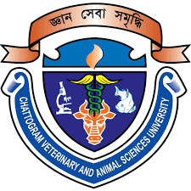

A Production Report Presented in Partial Fulfillment of the Requirement for the Degree of Doctor of Veterinary Medicine

A Report submitted by
Roll. No: 16/48
Reg. No: 01666
Intern ID: 43
Session: 2015-2016

Faculty of Veterinary Medicine

Chattogram Veterinary and Animal Sciences University

KHULSHI-4225, CHATTOGRAM

