Preparation of Lactoferrin from a Tuberculosis free cow’s Colostrum.

Signature of Author
Faria Afrin
Roll No. 16/03
Intern ID: 03
Registration No:01603
Session: 2015-2016

Faculty of Veterinary Medicine,
Chattogram Veterinary and Animal Sciences University,
Khulsi, Chittagong-4225

Preparation of Lactoferrin from a Tuberculosis free cow’s Colostrum

Faria Afrin
Roll No. 16/03
Intern ID: 03
Registration No:01603
Session: 2015-2016

Prof. Dr. Ashraf Ali Biswas
Supervisor
Department of Animal Science and Nutrition, CVASU

Faculty of Veterinary Medicine,
Chattogram Veterinary and Animal Sciences University,
Khulsi, Chittagong-4225

Table of Contents

SL No | Content | Page No
1 | Abstract | 4
2 | Introduction | 5-6
3 | Review literature  3.1.Structure  3.2.Biological functions of lactoferrin | 7-12
4 | Materials and Methodology  4.1.Collection of Sample  4.2.Microbial count  4.3.Preservation of Sample  4.4.Biochemical test for identification of Lf | 13-16
5 | Result and discussion | 17-18
6 | Acknowledgements | 19
7 | References | 20

Chapter 1
Abstract

COVID-19 is considered an ongoing international global health problem which already caused 219 million confirmed cases. No specific effective treatment has been identified so far, and available supportive therapies are intended just tosevere patients. Asymptomatic and mildly symptomatic patients remain a transmission reservoir, with possible evolution to the most severe disease form, without a clear treatment indication. Lactoferrin is an iron binding protein. Its main function is non immune protection. The main objective is to establish a standard protocol for isolation of lactoferrin. We have collected colostrum from a tuberculosis free cow. Then, we have performed SPC (Standard plate count) to check microbial load of colostrum. After extraction of lactoferrin, we have performed nanodrop technology for biochemical analysis of lactoferrin, which was 634.554mg/ml in colostrum.

Chapter 2
Introduction

Lactoferrin is a protein found in cow milk and human milk. Colostrum, the first milk produced after a baby is born, contains about seven times more lactoferrin than is found in milk produced later on. Lactoferrin (Lf, formerly known as lactotransferrin) is an iron-binding glycoprotein, belonging to the transferrin protein family, together with serum transferrin (sTf), ovotransferrin (Otrf), melanotransferrin and the inhibitor of carbonic anhydrase. Lf was first isolated by Sorensen and Sorensen from bovine milk in 1939 and after two decades it was determined to be the main iron- binding protein in human milk.Lf is produced and released by mucosal epithelial cells and neutrophils in various mammalian species, including humans, bovines, cows, goats, horses, dogs and several rodents. More recentlyshowed that Lf is also expressed in fishes.

Lf has been shown to be involved in several physiological and protective functions, including regulation of iron absorption in the bowel; antioxidant, anticancer, anti-inflammatory and antimicrobial activities, which are the most widely studied function to date. Interestingly, a great number of Lf activities are present also in ovotransferrin, an avian homologue of mammalian Lf, indicating that they have been conserved during evolution. Beside mammalian milk and colostrum, where Lf, present at a concentration of 7g/L, is the second most abundant protein after caseins, Lf is primarily found in mucosal secretions; in particular it is present in tears, saliva, vaginal fluids, semen,nasal and bronchial secretions, bile, gastrointestinal fluids and urine. The concentration in tears is as high as 2mg/ml while that in blood is typically just as high as 1g/ml, in spite of the fact that it can ascend as high as 200g/ml in the inflammatory circumstance (Farnaud and Evans et al., 2003). It is also found in considerable amounts in secondary neutrophil granules (15 µg/10⁶ neutrophils), where it plays a significant physiological role and it can also be found in bodily fluids such as blood plasma and amniotic fluid.

Lf is an 80 kDa glycosylated protein of about 700 aminoacids (711 aa for human Lf (hLf) and 689 aa for bovine Lf (bLf)) with high homology among species and is able to reversibly chelate two Fe(III) per molecule with high affinity (Kd ~ 10−20 M) retaining ferric iron to pH values as low as 3.0, whereas transferrin retains iron at pH of about 5.5 (Berlutti et al., 2011).The most astounding substance among amino acids build ups has alanine (~10%), leucine (~9%) and glycine (~7%), the minimal tryptophan (~1.5%), histidine (~1.3%) and methionine (~0.6%)(Adam et al., 2008).Its three dimensional structure consists of a single polypeptide chain folded into two symmetrical lobes (N and C lobes), which are highly homologous with one another (33%–41% homology).

Lactoferrin helps regulate how well iron is absorbed into the body from the intestine Lf is now known to be a multifunctional ormultitasking protein. It is a major component of innate immune system of mammals. Its protective effects range from direct antimicrobial activities against a large panel of microorganisms including bacteria, viruses, fungi and parasites, to anti-inflammatory and anticancer activities.

Very few researches have been done with Lf so far in Bangladesh and this is the first work regarding Lf in our university laboratory. The main objective was to highlight the potential benefits of Lf. One of these benefits is its antimicrobial ability. As it shows antimicrobial activities, it can be used as the alternative of antibiotics for curing many diseases.

Objectives
The main objectives of the study are:
1. To isolate Lf from colostrum and raw milk.
2. To establish a standard protocol for the isolation of Lf.
3. To observe the microbial load of prepared Lf.

Chapter 3
Review Literature

Lactoferrin (LF) or lactotransferrin has recently come under the spotlight, particularly with regards to the new coronavirus pandemic that started in 2019 (COVID-19). Diet and supplements support a well-functioning immune system, and favorably influence the body's ability to fight infection. Although LF is produced by the body itself, as a secretion by exocrine glands (such as maternal milk or tears) and secondary granules of human neutrophils,it can also be taken as a supplement, where it then acts as nutraceutical or functional food. Our particular focus is on its role as an oral supplement. Here we also collate some of the evidence that shows how LF may be an important nutrient to support host immunity, including as an antibacterial and antiviral agent, but particularly with the current COVID-19 pandemic in mind.

We summarize what is already known about LF, including its immunological properties, as well as its antibacterial and antiviral activities. LF uses Heparan Sulfate Proteoglycans (HSPGs) on cell surfaces to facilitate entry. This is of particular importance to coronaviruses, as these viruses are considered to bind to the host cell by attaching first to HSPGs using them as preliminary docking sites on the host cell surface. LF is known to interfere with some of the receptors used by coronavirus, it may thus contribute usefully to the prevention and treatment of SARS CoV-2 infections. In COVID-19 infection, LF may therefore have a role to play, not only sequestering iron and inflammatory molecules that are severely increased during the cytokine burst, but also possibly in assisting by occupying receptors and HSPGs. LF might also prevent virus accumulation by the host cell, as well as rolling activity and entering of the virus via the host receptor angiotensin-converting enzyme 2 (ACE2). It has been 20 years since the discovery of ACE2, and since its discovery it has been found to be expressed in numerous tissues, including the lungs and the cardiovascular system (Gheblawi M et al 2020). During 2020, there has been a renewed interest in this receptor, due to the interactions of novel coronaviruses and their interactions with ACE2,South and co-workers in 2020 also investigated whether ACE2 blockade is a suitable option to attenuate COVID-19 (South AM et al 2020).The use of recombinant human ACE2(rhACE2) as ACE receptor competitor for binding has also been investigated.There is also interest in the therapeutic targeting of HSPGs, and is seems an easy way to inhibit SARS-Cov-2 infectivity. Here we also suggest that LF might be used as both a preventive and therapeutic supplement in the COVID-19 pandemic, by preventing interactions between the virus and both HSPGs and possibly ACE2.
3.1.Structure
3.1.1.Iron-Binding Sites
The two lobes of Lf are additionally separated into two domains (N1 and N2, C1 and C2) and each projection ties one Fe (III) ion in a profound split between two areas 14 (Berlutti et al., 2011). The iron locales are exceedingly conserved in all iron-binding proteins, recommending a typical transformative source. The ligands for Fe (III) are the same in both projections: one aspartic corrosive, two tyrosines, and one histidine (Asp-60, Tyr-92, Tyr-192, and His-253 in the N-projection and Asp395, Tyr-433, Tyr-526, and His-595 in the C-projection), together with two oxygen from the CO3 2− anion (Steijns and Hooijdonk., 2000)
Spectroscopic reviews and the 3D structure recommend that the CO3 2− ion ties to start with, along these lines neutralizing the positive charge of the arginine build-up (Arg121 in the N-lobe and Arg-465 in the C-lobe) (Berluttiet al.,2011). The participation of the CO3 2− particle in the iron coordination binding has all the earmarks of being perfect for iron reversible binding since the protonation of CO3 2− ion is a possible initial phase in the separation of the iron site at low pH (Adam et al., 2008).
3.1.2. Binding with other Metals
Lf is delegated as an iron binding protein, however can likewise tie other metal particles including Cu2+, Mn2+, Zn2+, regardless of the possibility that with lower affinity. Metal binding can be tested by an expansion in adsorption at 240–280 nm as outcome of ionization of the tyrosine ligands which tie to the metal ions. The crystal structures of Lf immersed with Mn2+ or Zn2+ have all indicated shut shapes, in this manner recommending that Lf could have a part in binding other metal particles (Farnaud and Evans et al., 2003). In addition, it has been exhibited that Mn2+-or Zn2+- soaked structures keep up some physiological elements of Lf, disconnected to its iron binding ability yet presumably identified with its three striking groupings of positive charge: Residues 1–7, 13–30 and between lobe area, near the connecting helix (Berlutti et al., 2011).

3.1.3. Genes of Lf
At least 60 gene sequences of Lf have been characterized in 11 species of mammals. In most species, stop codon is TAA and TGA. Deletions, insertions and mutations of stop codons affect the coding part and its length varies between 2,055 and 2,190 nucleotide pairs (Baker et al., 2002).In human, Lf gene LTF is situated on the third chromosome in the locus 3q21-q23. In oxen, the coding grouping comprises of 17 exons and has a length of around 34,500 nucleotide sets. Exons of the Lf quality in bulls have a comparable size to the exons of different qualities of the transferrin family, while the sizes of introns contrast inside the family. Comparability in the measure of exons and their circulation in the areas of the protein atom demonstrates that the transformative improvement of Lf quality happened by duplication (Baker et al., 2002; Berlutti et al., 2011).
3.1.4. Glycosylation
Lf is a glycosylated protein, having distinctive number and area of putative glycosylation destinations, as per distinctive species (Berlutti et al., 2011). Human Lf contains three potential N-glycosylation sites: asparagine (Asn) 138, Asn479, Asn624; caprine, bovine and ovine Lf have five sites: Asn233, 281, 368, 476 and 545 whereas murine Lf has only one potential N-glycosylation site: Asn476 (Karavet al., 2017). Among these glycosylation sites, only two sites are commonly glycosylated in hLF: Asn138 and Asn479, and four sites are glycosylated in blF: Asn233, Asn368, Asn476, and Asn545 (Karav et al., 2017).The nature and the area of the glycosylation destinations don't impact the polypeptide folding or iron and different molecule binding properties. On the other hand, the loss of carbohydrate or sialic acid builds its affectability to proteolysis or impacts some physiological capacities (Moradian et al., 2014).
3.2.Biological Functions of Lf
The biological significance of Lf is as yet not completely clear. Its antiphlogistic, bacteriostatic and bactericidal impacts are assumed (Adam et al., 2008). Numerous parts have been proposed, and keep on being proposed for Lf. Although some of these are unmistakably identified with its iron-restricting properties, for instance its ability to provide bacteria with a source of iron and therefore act as a “promicrobial” whereas others appear to be independent of iron binding (Farnaud and Evans., 2003).

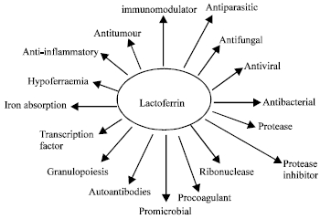

Figure: Proposed roles of Lf
It has been widely accepted for many years that Lf displays antimicrobial activity against many different infectious agents. This activity was originally attributed to its ability, in common with transferrin, to sequester iron with a high affinity and unlike transferrin, retain its bound iron under acidic conditions.More recently it has become apparent that some of the antimicrobial properties of Lf are independent of iron binding.
3.2.1.Antibacterial Activity
The anti-bacterial activity of Lf was initially ascribed to its ability to bind and sequester environmental iron, thereby depriving potential pathogens of this essential nutrient(Arnold et al.,1980).The capacity of Lf to restrain bacterial development in vitro was without a doubt one of the soonest capacities depicted for the protein (Farnaud and Evans., 2003). The antimicrobial action of Lf was exhibited towards a number of microscopic organisms and Lf was observed to be bactericidal for Streptococcus mutans and Vibrio cholerae, however not for Escherichia coli (Naidu and Arnold., 1997).Additionally examines have demonstrated that Lf was bactericidal just when in its iron state and that iron-immersed Lf has a diminished antimicrobial movement (Arnold et al., 1980;Naidu and Arnold., 1997;Yamauchi et al., 1993).
Mechanism of antibacterial action of Lf. (A) Gram-positive bacteria: Lf is bound to negatively charged molecules of the cell membrane such as lipoteichoic acid, neutralizing wall charge and allowing the action of other antibacterial compounds such as lysozyme. (B) Gram-negative bacteria: Lf can bind to lipid A of lipopolysaccharide, causing liberation of this lipid with consequent damage to the cell membrane.
3.2.2.Antiviral Activity
The antiviral activity of Lf has been investigated in great detail. Pioneer work demonstrated that only enveloped viruses were affected, and that this activity was due to either inhibition of virus host interaction e.g. hepatitis B virus (HBV), herpes simplex virus (HSV) and human cytomegalovirus (HCMV) or direct interaction 18 between Lf and the viral particle e.g.; feline herpes virus (FHV-1), hepatitis C virus (HCV), hepatitis G virus (HGV) and human immunodeficiency virus (HIV) (Jenssen and Hancock., 2008). However, recently it has also been demonstrated that naked viruses like rota-, polio-, adeno- and entero virus are susceptible to inhibition by Lf. In all cases studied, it appears that Lf exhibits its antiviral activity at an early phase of the infection process (Karav et al., 2017). In vitro studies also demonstrated that Lf exhibits synergy, in combination with zidovudine, against HIV-1. A synergistic antiviral activity was also observed for HSV-1 and HSV-2 when acyclovir was used in combination with Lf (Karav et al., 2017). In clinical trials on a limited set of HCV patients, it was demonstrated that Lf significantly reduces the HCV RNA titre, and contributes to the effectiveness of a combined therapy with interferon and ribavirin. Oral administration of Lf has also led to promising improvement in the immune responses of antiretroviral therapy-naive children suffering from HIV (Jenssenand Hancock., 2008).
Mechanism of antiviral action of Lf, LF can be linked to the viral particle and to glycosaminoglycans, specific viral receptors or heparan sulfate to prevent internalisation of the virus into the host cell.
3.2.3. Antifungal Activity:
Lf was first reported to have anti-fungal activity by Kirkpatrick (1971), (Farnaud and Evans., 2003). Lf restrains in vitro development of Trichophyton mentagrophytes, which are in charge of a few skin maladies, for example, ringworm. Lf likewise acts against the Candida albicans – a diploid organism (a type of yeast) that causes crafty oral and genital diseases in humans. Fluconazole has been utilized against Candida albicans, which brought about development of strains impervious to this medication (Actor et al., 2009).Be that as it may, a blend of Lf with fluconazole can act against fluconazole-safe strains of Candida albicans and additionally different sorts of Candida: C. glabrata, C. krusei, C. parapsilosis and C. Tropicalis (Actor et al., 2009). Antifungal action is watched for successive brooding of Candida with Lf and after that with fluconazole, however not the other way around. Organization of Lf through drinking water to mice with debilitated insusceptible frameworks and side effects of aphthous ulcer lessened the quantity of Candida albicans strains in the mouth and the span of the harmed ranges in the tongue (Jenssen and Hancock., 2008).Oral organization of Lf to creatures additionally diminished the quantity of pathogenic living beings in the tissues near the gastrointestinal tract.

Chapter 4
Materials and Methodology

4.1.Collection of Sample:
350 ml of colostrum is collected from tuberculosis free cow. After collection we have kept it at 4⁰C for further analysis.

To detect possible carriers of bovine tuberculosis is the Caudal Fold Tuberculin (CFT) test, in which a small amount of purified protein derivative (PPD) tuberculin is injected into the fold of skin at the base of the tail. The CFT is read 72 +/- 6 hours later. If negative, no further action is required. If positive, the animal is classified as a responder and requires further testing.

Lactoferrin is not available in UHT and pasteurized milk. So, rawmilk or colostrum should be kept at 55⁰C for overnight in hot air oven. A dried form of milk powder including lactoferrin is found in this way.
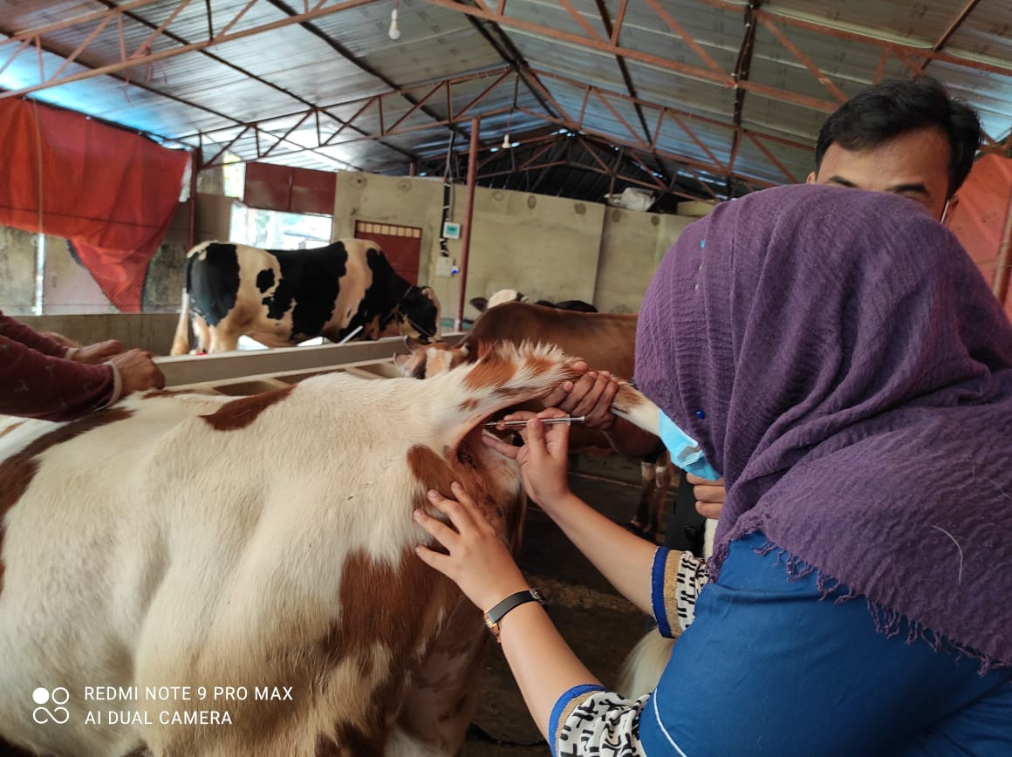

Figure: Tuberculosis Test

4.2.Microbial Test
The term standard plate count gives that estimation of viable bacterial count the standard method has been established using a convenient temperature of the culture is incubated.

Apparatus & Reagent
➢ Agar medium
➢ Dilution blank (99)
➢ 1 ml pipette
➢ Petri dish
➢ Water bath
➢ Autoclave
➢ Incubator
➢ Spirit lamp
➢ Glass marking pencil
➢ Colony counter

Procedure:
Step 1: Preparation of dilution blank
1litter distilled water was taken.
1.25 ml of sodium citrate buffer solution PH-7.2 was added.
The bottle was sterilized in autoclave at 121⁰C for 15 minutes.
Dispensed 99ml in each dilution blank bottle.

Step 2: Preparation of agar media
Required amount of agar powder will be measured.
Mixing with required amount of distilled water (Agar powder 24g and distilled water 1000ml).
Heat upto dissolved.
Autoclave
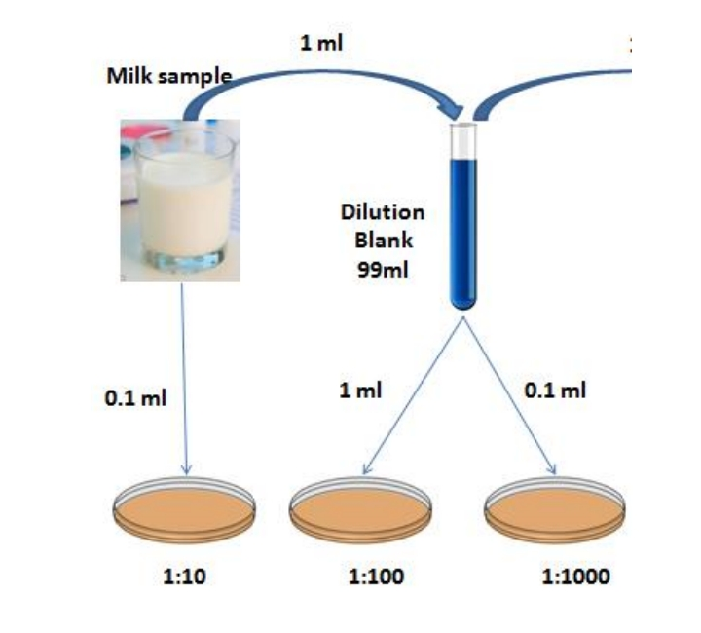

Step 3: Preparation of sample
Step 4: Preparation of agar media
Pouring of agar 2/3rd of the petridish
Gentle rotation
Incubation at 37°C for 48 hours
Step 5: Counting of bacterial colony
By using colony counter, selection of petridish having 30-300 colonies of bacteria.

4.3.Preservation of collected samples
The collected colostrum milk (powder) from Chittagong was stored at 4°C.

Isolation of Lf from milk samples
Lf can be isolated from milk sample by using centrifugation method followed by acidic-basic pH adjustment (Moradian et al., 2014). The isolation of Lf from milk sample was done in two steps. Initially casein was separated from milk and then the casein separated sample was treated to isolate Lf. The total days of three were needed to complete the full isolation process of Lf for each sample.

Separation of casein
40 mL of each sample was subjected to centrifugation for 10 minutes at 4000 rpm at 4⁰C. Then fat layer (top most) obtained was separated using a spatula and discarded. The volume of all defatted milk samples was noted and an equal volume of distilled water was added. After that, initial pH of each sample was recorded using the pH meter. 1N HCl was added slowly with constant stirring to each sample until pH was reached to 4.6 to precipitate casein, followed by centrifugation at 2000 rpm for 10 minutes at 4⁰C. Supernatants from each sample were stored in a refrigerator at 4⁰C for further analysis. Sometimes it was seen that only one time centrifugation was not enough to defat milk. Thus 2/3 times more centrifugation had to be done to obtain defat milk.

Lf extraction from stored supernatants and preservation
1N NaOH was added slowly with constant stirring to all the supernatants collected from the previous treatment till pH 6.0 was reached. Each sample’s volume was noted and an equal volume of 45% ammonium sulphate solution was added to all samples with constant magnetic stirring at 100 rpm. Then stirring was gradually increased to 420 rpm after whole addition of 45% ammonium sulphate solution and was kept for 1 hour at room temperature. All samples were then subjected to the addition of 1N HCl slowly with constant stirring till pH 4.0 was reached, followed by addition of 1N NaOH slowly till pH 8.0. At pH 8.0, an equal volume of 80% ammonium sulphate solution was added with constant magnetic stirring at 100 rpm and gradually increased to 420 rpm for 1 hour after whole addition of ammonium sulphate solution. After these, all samples were incubated at 4⁰C overnight to precipitate Lf, followed by centrifugation at 4000 rpm for 10 minutes at 4⁰C. Lf precipitate obtained was then dissolved and re-suspended in 1mL 1x PBS buffer (pH 7.4) and stored in a refrigerator at 4⁰C in the respective tubes for further analysis.

4.4.Biochemical tests for identification of Lf
According to the National Human Genome Research Institute, a biochemical test is performed for assessing the level of protein or enzyme activity in a sample. There are many experiments available for the identification of protein like Lf. Some of these are ELISA, nanodrop assay, SDS-PAGE, different chromatography techniques etc (Adam et al., 2008). All of these experiments could not be done due to laboratory limitations. Among these, nanodrop assay was done to identify and quantify the protein Lf.

Protein quantification by using nanodrop technology
Nanodrop technology is used to quantify the amount of protein present in a sample. 1- 2µL of sample can be quantified in seconds using this method (Armanian et al., 2013). The results are very accurate and reproducible. With the arm open, a sample is pipetted directly onto the pedestal. After the arm is closed, a sample column is formed. The pedestal then moves to automatically adjust for an optimal path length (0.05–1mm). When the measurement is complete, the surfaces are simply wiped with a lint-free lab wipe before going on to the next sample. This experiment was done by the help of BSA was used as standard protein for the measurement. Firstly, small amount of TE buffer was put onto the pedestal of nanodrop machine with the help of pipette to make it blank. Then BSA was quantified. The results were shown on the monitor connected to the machine. Thus the colostrum sample was quantified. The nanodrop well was cleared every time to prevent contamination. For better accuracy, each sample was quantified more than one time.

Chapter 5
Result and Discussion
Table 1: Microbial count from whey
No. of petridish | No. of colony | DF | No. of colony×DF
1 | 5 | 10 | 50
2 | 3 | 100 | 300
3 | 3 | 1000 | 3000
Average= 1116.67 CFU/ml
Table 2: Microbial count from wet milk solid
No. of petridish | No of colony | DF | No of colony×DF
1 | 5 | 10 | 50
2 | 2 | 100 | 200
3 | 3 | 1000 | 3000
Average= 1083 CFU/gm
Table 3: Microbial count from Lactoferrin
No. of petridish | No. of colony | DF | No of colony×DF
1 | 2 | 10 | 20
2 | 1 | 100 | 100
3 | 1 | 1000 | 1000
Average= 373 CFU/gm
Table 4: Comparison between microbial count of raw milk and Colostrum
Traits | Colostrum | Raw Milk
Liquid(CFU/ml) | - | 440
Whey(CFU/ml) | 1116.67 | 1006.7
We tmilk solid(CFU/gm) | 1083 | 146.67
Lactoferrin(CFU/gm) | 373 | 37

Table 5: Quantification of Lactoferrin of colostrum through Nanodrop Technology

Sample | mg/ml | A280 | A260/A280
BSA | 181.890 | 1.82 | 1.67
Colostrum | 634.554 | 6.35 | 0.90
(BSA= Bovine Serum Albumin)
In commercial milk samples, presence of lactoferrin ranges from 122.4 to 598.3 mg/ml. In colostrum, lactoferrin is in higher portion, which is 634.554mg/ml, which is a satisfactory result. We have detected the lactoferrin level in colostrum which is higher than raw milk and commercial milk powder samples.

Acknowledgements

The author feels proud in expressing his deepest gratitude and indebtedness to his respected teacher and supervisor Prof. Dr. Goutam Buddha Das, Department of Animal Science and Nutrition, Chattogram Veterinary and Animal Sciences University for his trustworthy and scholastic supervision and untiring assistance throughout the work. The author also thanks the respected teacherProf. Dr. Ashraf Ali Biswas, Department of Animal Science and Nutrition, Chattogram Veterinary and Animal Sciences University for his guidanceand workers of the working area for their co-operation during this study.

I would respectfully acknowledge to my report committee: Dean Prof. Dr. Mohammad Alamgir Hossain and Prof. Dr. A K M Saifuddin for their Insightful comments and encouragements. I express my deepest gratitude to the Almighty to have allowed and enabled me to perform this work. I would also like to thank my family for their unconditional support.

Chapter 6
References

Actor, J. K., Hwang, S. A., and Krunzel, M. L. (2009).Lactoferrin as a Natural Immune Modulator.Curr Pharm Das, 15(17), 1956-1973.

Adam, V., Zitka, O., Dolezal, P., Zeman, L., Horna, A., Hubalek, J., Siley, J.,Krizkova, S., Trnkova, L., and Kizek, R. (2008).Lactoferrin Isolation Using Monolithic Column Coupled with Spectrometric or Micro-AmperometricDetector. Sensors, 8, 464-487.

Armanian AM, Kazemipur S, Mirbod SM, Hassanzade A (2013). Comparison of prolonged low volume milk and routine volume milk on incidence of necrotizing enterocolities in very low birth weight neonates. Pak J Med Sci 2013; 29 (1) Suppl:312-316

Arnold, R.R., Brewer, M., Gauthier, J.J., (1980). Bactericidal activity of human lactoferrin: sensitivity of a variety of microorganisms. Infect. Immun., 28, 893–898.

Baker, E.N., Baker, H.M., and Kidd, R.D. (2002).Lactoferrin and transferrin:Functional variations on a common structural framework.Biochem. Cell Biol., 80, 27-34.

Berlutti, F., Pantanella, F., Natalizi, T., Frioni, A., Paesano, R., Polimeni, A., and Valenti, P. (2011).Antiviral Properties of Lactoferrin-A Natural Immunity Molecule. Molecules, 16, 6992-7018.

Farnaud, S. J. C., and Evans, R. W. (2003).Lactoferrin- A Multifunctional Proteinwith Antimicrobial Properties. Molecular Immunology, 40, 395-405

Gheblawi M, Wang K, Viveiros A, Nguyen Q, Zhong JC, Turner AJ, et al. converting enzyme 2: SARS-CoV-2 receptor and regulator of the renin-angiotensin system: celebrating the 20th anniversary of the discovery of ACE2. Circ Res. (2020) 126:1456–74

Jenssen, H., and Hancock, R. E. W. (2008).Antimicrobial Properties oflactoferrin..Biochimie, 91, 19-29.

Karav, S.,German, J.B., Rouquie, C., Parc, A. L., and Barile, D. (2017).StudyingLactoferrin N-Glycosylation. International Journal of Molecular Sciences, 11, 110-124.

Moradian, F.,Sharbafi, R., and Rafiei, A. (2014).LactoferrinIsolation,Purification and Antimicrobial Effects. Journal of Medical and Bioengineering, 3(3), 407-410.

Naidu, A.S., and Arnold, R.R. (1997). Influence of lactoferrin on host microbe interactions.

South AM, Diz DI, Chappell MC. COVID-19, ACE2, and the cardio-vascularconsequences. Am J Physiol Heart Circ Physiol. (2020) 318:H1084–90.

Steijins, J. M., and Hooijdonk, A.C.M.V. (2000).Occurrence, Structure, BiochemicalProperties and Technological Characteristics of Lactoferrin. British Journal of Nutrition, 84(1), 511-517.

Yamauchi, K., Tomita, M., Giehl, T.J., Ellison III, R.T., (1993). Antibacterial activity of lactoferrin and a pepsin-derived lactoferrin peptide fragment. Immun., 61, 719–728.

