A STUDY ON PHENOTYPIC CHARACTERISTICS OF INDIGENOUS DUCK IN GAIBANDHA SADAR UPAZILA OF GAIBANDHA DISTRICT.
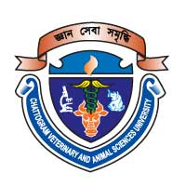

By
Kamrun nahar Shimu

Roll No: 15/45

Reg. NO: 01462

Internship ID: 59
Session: 2014-2015

A production report submitted in fulfillment of the requirements for the degree of Doctor of Veterinary Medicine ( DVM)

ChAttogram Veterinary and Animal Sciences University
khulshi, chAttogram-4225.

A STUDY ON PHENOTYPIC CHARACTERISTICS OF INDIGENOUS DUCK IN GAIBANDHA SADAR UPAZILA OF GAIBANDHA DISTRICT.

A production report submitted as per approved style and content by

Signature of the Author
Kamrun nahar Shimu

Roll No: 15/45

Reg. NO: 01462

Internship ID: 59
Session: 2014-2015

Signature of the Supervisor

Professor Dr. Omar Faruk Miazi
Department of Genetics and Animal Breeding
Faculty of Veterinary Medicine
Chattogram Veterinary and Animal Sciences University

ChAttogram Veterinary and Animal Sciences University
khulshi, chAttogram-4225.

