SL. NO | NAME OF THE CONTENTS | PAGE NO.
1 | Acknowledgement  Abstract | 1-2
2 | Chapter 1  Introduction | 3-4
3 | Chapter 2  Review Of Literature | 5-7
4 | Chapter 3  Materials and methods  3.1. Study area  3.2. Study period  3.3. Animals  3.3. Diet  3.4. Test enclosure design, habituation and treatments | 8-12
5 | Chapter 4  Results and Discussion  4.1. Treatment effects  4.1.2. Flight  4.1.3. Other treatment effects  4.2. Day effects  4.3. Combined day and treatment differences  4.4. Behaviors unaffected by treatment or day  4.5. Discussion | 12-15
6 | Chapter 5  Conclusion | 15
7 | Chapter 6  Reference | 16-17

ACKNOWLEDGEMENT
All praises are due to “Almighty Allah” who enabled the author to complete this report successfully.
The author express his deep sense of gratitude, heartfelt respect and immense indebtness to his beloved teacher & supervisor Professor Dr. Omar Faruk Miazi, Department of Genetics and Animal Breeding , Chattogram Veterinary and Animal sciences University for his valuable advice, scholastic guidance, suggestions, inspiration and who was involved with this report through its inception.
I would like to express my deep sense of gratitude and thanks to Professor Dr. Abdul Ahad, Dean, Faculty of Veterinary Medicine, Chattogram Veterinary and Animal Sciences University for his valuable suggestion & inspiration.
The author wishes to express his gratitude to the Director of External Affairs Professor Dr. A.K.M Saifuddin, Chattogram Veterinary and Animal Sciences University, for his supervision and kind co-operation during the period of internship
I also express thank to my friends for their help and co-operation during the tenure of writing of this report. The author is immensely grateful to all of them, although it is not possible to mention every one by name.

The Author
July, 2020

Abstract
Budgerigars usually reared as a pet bird in the world. They are reared in conventional cages where they cannot have the opportunity for showing normal behaviours, particular flight, and develop stereotyped behaviours. Nowadays Large cages are used for groups of budgerigars but the minimum space requirement to support the normal behaviour is unknown. The study was performed to compare the behaviour of budgerigars which are reared in three different size of cages, with 0, 24% and 48% increases in space above the minimum size. Groups of four birds were accommodated in each cage and behaviour was observed over 21 day periods in a changeover design. Flight distance increased with space allowance and more flights were initiated at the start of each period in the largest cages which is evidence of thwarted motivation for flying in the smaller cages. After budgerigars had spent a period in the small cages, they had increased flight times if they were in the larger cage in the subsequent period. Budgerigars with low space allowance flapped their wings and tail wagged more and scratched less at the start of each period. It is concluded that there are benefits to the behaviour of budgerigars by providing increased space in cages above that specified in standards.

Keywords: Pet bird, Stereotyped behaviour, Budgerigar, Cage, Flight

Chapter 1
Introduction
The budgerigar (Melopsittacus undulatus) is a long-tailed, seed-eating parrot usually nicknamed the budgie, or in American English, the parakeet. Budgies are the only species in the genus Melopsittacus. The origin of the budgie's name is unclear. First recorded in 1805, budgerigars are popular pets around the world due to their small size, low cost, and ability to mimic human speech. They are the third most popular pet in the world, after the domesticated dog and cat. As companion animals, they are housed in a variety of enclosures, such as aviaries, cages and boxes, all available in a variety of sizes. Key requirements for space include an opportunity to exercise, to engage in social interactions, and to utilise environmental enrichment (Hawkins, 2010). When kept in a restricted space, budgerigars demonstrate stereotypic behaviours involving repeated locomotion, especially pacing, object-directed behaviours, such as screaming and pecking, and abnormal oral behaviours, in particular sham chewing (Polverino et al., 2015). In a domestic and experimental environment, the importance of space for these birds is not well understood. Birds that are housed in small cages are prone to obesity, stereotypies and altered mentation (Gebhardt-Henrich and Steiger, 2006; van Hoek and Ten Cate, 1998). Obesity is common in captive budgerigars because they are fed an energy dense diet and they lack the ability to fly long distances, compared to their wild counterparts who do this when foraging for food (van Hoek and Ten Cate, 1998). Obese birds are prone to many diseases, such as degenerative joint disease, pododermatitis, cardiac and reproductive diseases, and hepatic lipidosis (Sakas, 2002). In caged birds, stereotypic weaving has been demonstrated in parrots, especially cockatoos and maccaws, and route tracing demonstrated in canaries (van Hoek and Ten Cate, 1998). These behaviours closely resemble the pacing behaviour that is seen in caged mammals, and are more prominent in animals that are wild caught compared to ones that are bred for laboratory purposes (van Hoek and Ten Cate, 1998). The prevalence of route tracing and weaving behaviour is a welfare concern as it is correlated with spacial restriction by improper housing conditions (van Hoek and Ten Cate, 1998).
In budgerigars, stereotypies are mainly associated with housing in small cages (Polverino et al., 2012). Previous studies that have detailed the effects of different cage sizes compared to each other and to aviaries suggest that as well

as a decrease in stereotypies in birds housed in larger enclosures, flying speeds of birds housed in large cages are faster than those in small cages (Gebhardt-Henrich and Steiger, 2006). In an aviary setting budgerigars that are housed in groups fly more than those housed alone, leading to the hypothesis that either the increased space or the disturbance by other birds may have stimulated this increase in activity (Nicol and Pope, 1993). Flight is most common during courtship and can be encouraged in aviaries by placing food low down (Nicol and Pope, 1993). It has a high energy cost but little is known about the needs for budgerigars to fly and what space allowance will satiate this need. Currently, the general guidelines for space allowance for budgerigars as pets rarely specify exact cage sizes, most requiring a size related to the wingspan and height of the bird. In intensive breeding facilities the standard cages are 28 × 28 × 34 cm high per pair of budgerigars (Polverino et al., 2012), allowing 0.013 m3 /bird. Standards that do specify minimum size for budgerigars. The solution to the behaviour problems caused by housing budgerigars in small cages may be to accommodate them in large cages, which is increasingly common. Little is known about the minimum space requirements for cages, but it was hypothesised that an increase in cage size would increase flying distance, flight times, reduce stereotypies, and overall, provide for a better welfare environment. The author tested this hypothesis by investigating the behaviour of budgerigars in a standard sized cage and two larger cages providing 24% and 48% more space.

CHAPTER-2
REVIEW OF LITERATURE
The most popular caged parakeet is the budgerigar, or shell parakeet (Melopsittacus undulatus;). Mistakenly called lovebird, this 19-cm (7.5-inch) parakeet has hundreds of colour mutations from the green and yellow basic stock; but cheek spots and close barring on the upper parts usually persist. Sexes look alike but may differ seasonally in colour of the cere, the bare skin at the base of the bill. Budgerigars are seed eaters; in the wild, they form large flocks in Australia’s grasslands. They breed colonially, in tree holes, laying six to eight eggs twice a year. Most budgerigars are hardy, surviving for 5 to 10 years.
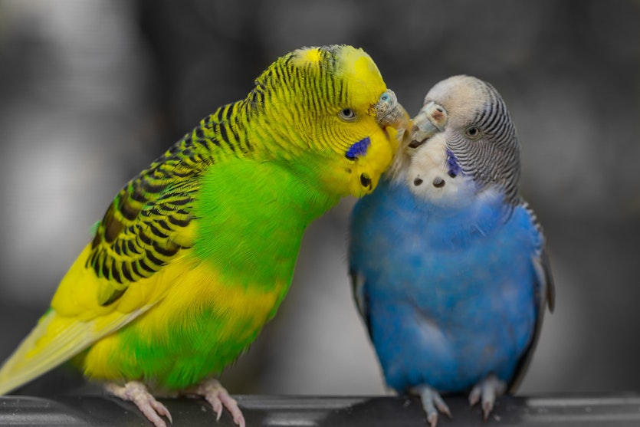

Appearance
Budgerigars are about 18 cm (7 inches) long and weigh 23-32 grams (0.8 to 1.1 ounces). Wild budgerigars are noticeably smaller than those in captivity. Like all parrots, budgerigar have zygodactyl toes, with two toes at the front of each foot and two at the back. All parrot eggs are white in color.
Budgerigars have been bred in many other colors in captivity, such as white, blue, and even purple, although they are mostly found in pet stores in blue, green, and occasionally white. Budgerigar plumage is known to fluoresce under ultraviolet light, a phenomenon possibly related to courtship and mate selection.
The color of the cere (the area containing the nostrils) differs between the sexes; royal blue in males, pale-brown to white (non-breeding) or brown (breeding) in females, and pink in immatures of both sexes (usually of a more even purplish-pink colour in young males).
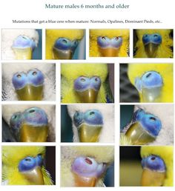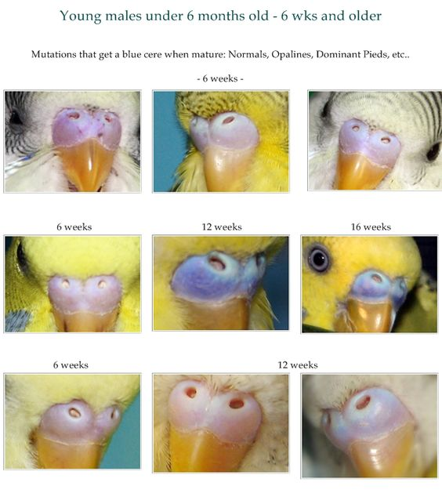
Personality
Budgerigars are, very generally speaking, accepting of humans and other birds, but should never be housed with a bird other than another budgerigar. Care should be taken even when placing two budgies together, as they can do serious harm to one another if they do not get along. They are relatively easily tamed.
Bird lovers often comment on the differences in personality in each individual bird. Budgies each have their own unique ideas about how much they like to be handled, which toys are their favorites, and even what music they like or to which they are indifferent.
Habitat and behavior
Wild budgerigars are nomadic birds found in open habitats, primarily in Australian scrubland, open woodland, and grassland. Although capable of surviving long periods without water, they are normally not far from surface water, and favor eucalyptus bordering ephemeral watercourses. The birds are normally found in small flocks of 10 up to 100 birds, but can form very large flocks, with even thousands of birds, under favorable conditions . The species is extremely nomadic and the movement of the flocks is tied to the availability of food and water. Drought can drive flocks into more wooded habitat or coastal areas. note that the flocks can fly swiftly and erratically yet with remarkable precision, with all budgerigars turning and twisting "in perfect unision."
Bugerigars feed on the seeds of spinifex, grass weeds, and sometimes ripening wheat. Seeds are all taken on the ground or within reach from the ground. Peak feeding times are in the morning and afternoon, and the birds display pre-roosting aerobatics prior to returning at dusk to roost for the night.

Reproduction
Domesticated budgerigars are easily bred. While in the wild they require a hollow tree or a hollow log, domesticated birds use breeding boxes. A hen will lay her eggs on alternate days; after the first one, there is usually a two-day gap until the next. She will usually lay between four to eight eggs, which she will incubate for 17 to 20 days.When the eggs start to hatch, the hatchlings are usually very helpless. During the second or third week, the hatchlings' eyes will open, and they will start to develop feather down, which typically indicates best-time for close-banding the chicks. After three weeks, the hatchlings will develop feathers of their genetic color.

Captivity
The budgerigar has been bred in captivity since the 1850s. Breeders have worked over the decades to produce a wide range of color and feather mutations. These include yellow, blue, white, violet, olive, albino, and lutino (yellow), clearwing, and spangled, and feather mutations can produce crests or overly long shaggy feathers known as "feather dusters."
Modern show budgerigars also called English budgerigars and Standard-Type Budgerigars, are larger than their wild-type (natural form) counterparts, with puffy head feathers, giving them an exaggerated look. The eyes and beak can be almost totally obscured by feathers. Such birds are reported to be more prone to genetic mutations because of inbreeding.

Chapter 3
Materials and methods
3.1. Study Area
The study was performed at Halishahar Chotopol and Shantibag area of Chattogram city, Bangladesh.

3.2. Study period:
The study was conducted for 21 days from 24th June to 14th July of the year 2020.The author personally observed the behavioral changes of budgerigars at his home. During the total period of the study the author also tried to collect data from local breeder in one week interval.

3.3. Animals
Twelve adult male budgerigars (Melopsittacus undulates) held in captivity which were utilized for the study. Birds were sourced from a local breeder .
An initial health assessment was performed and some vitamin such as Thiamin & Calcium supliment are administered over a 5 days period at a concentration of 1 g/L of drinking water.

3.4. Diet
The budgerigars were fed a proprietary millet grain feed ad libitum in hanging food bowls, boiled egg & carrot once in a week and water was provided ad libitum.

Figure 1: weekly diet
3.5. Test enclosure design, habituation and treatments
Immediately after arrival, animals were housed in three groups of four by randomly selecting one bird of each colour to facilitate animal identification. The initial housing enclosures were 150 cm wide, 150 cm long and 180 cm high (Absco Flat Roof Aviaries, Zincalume with wide mesh; Cheap Sheds Pty Ltd; Brisbane, Australia). After a week of habituation, two of the cages were reduced in size using colorbond fence panels (Neetascreen Colorbond Fencing, Lysaght, Rocklea, Australia) and mesh (White Wires Mouse and Snake Mesh, Whites Group, Richlands, Australia) to create false walls identical to the colourbond wall and mesh wall on the back and side, respectively, of the original cage .Thus, three space allowances were generated: a low space allowance treatment (low; 120 cm wide, 120 cm long and 180 cm high, equivalent to the Queensland Government standard, DEHP, 2010), a medium space allowance treatment (medium; 136 cm wide, 136 cm long and 180 cm high) and a high space allowance treatment (High; 150 cm wide, 150 cm long and 180 cm high; unmodified cage), providing 0.65, 0.83 and 1.01 m3 /bird, respectively. Treatments medium and high represented increases of 24% and 48% in available space, respectively. The three bird groups experienced all three treatments in 21 day experimental periods in a balanced changeover design. In the first period, treatment medium was allocated to bird group 1, treatment low to group 2 and treatment high to group 3 (Table 1). After periods one and two, one day was taken to rearrange the cages, with each bird group being held in a small cage on this day. Cages were portable and were rotated anticlockwise between three positions while bird groups remained in the same location (to eliminate any confounding of treatment differences those in the environment at the three cage locations)

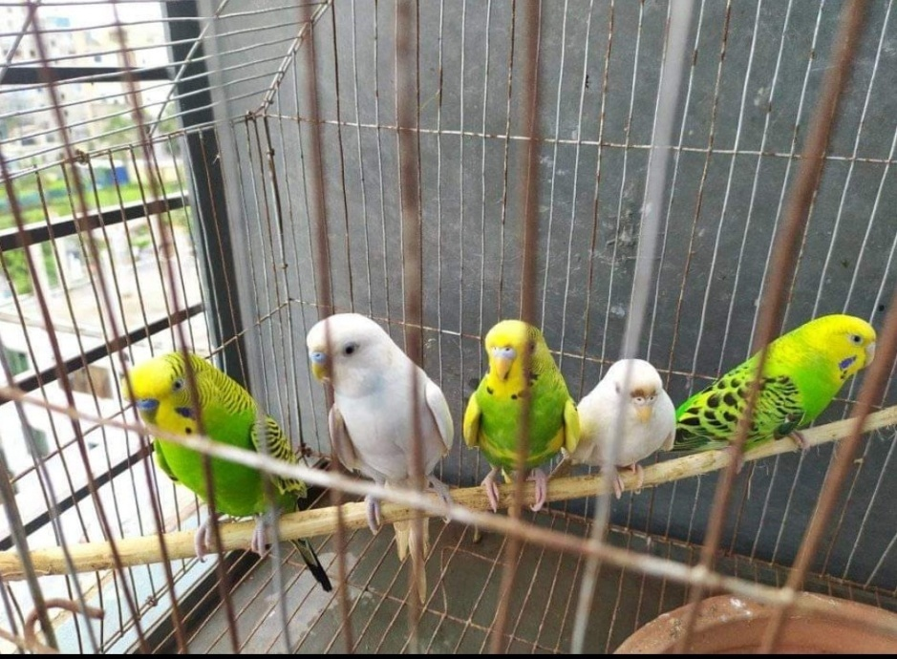
Figure 2: Allocation of budgerigar to low Spacious cage

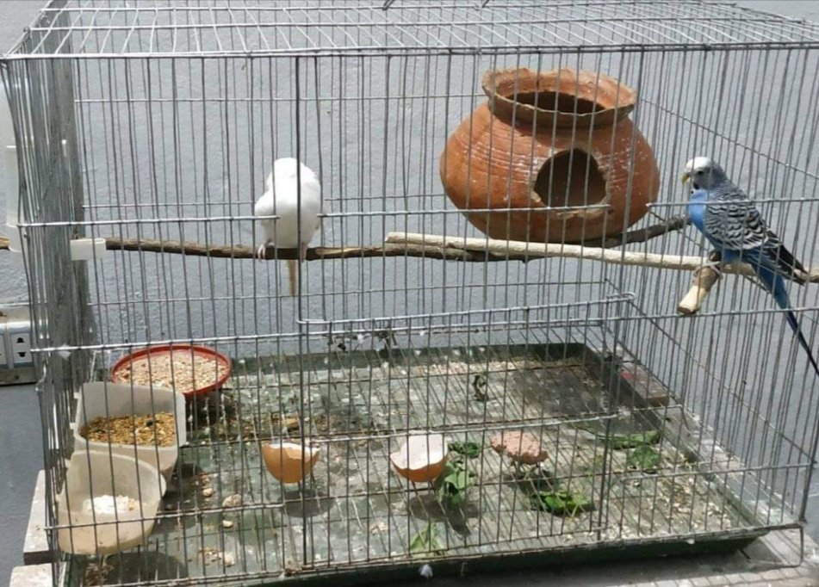
Figure 1: Allocation of budgerigar to medium Spacious cage

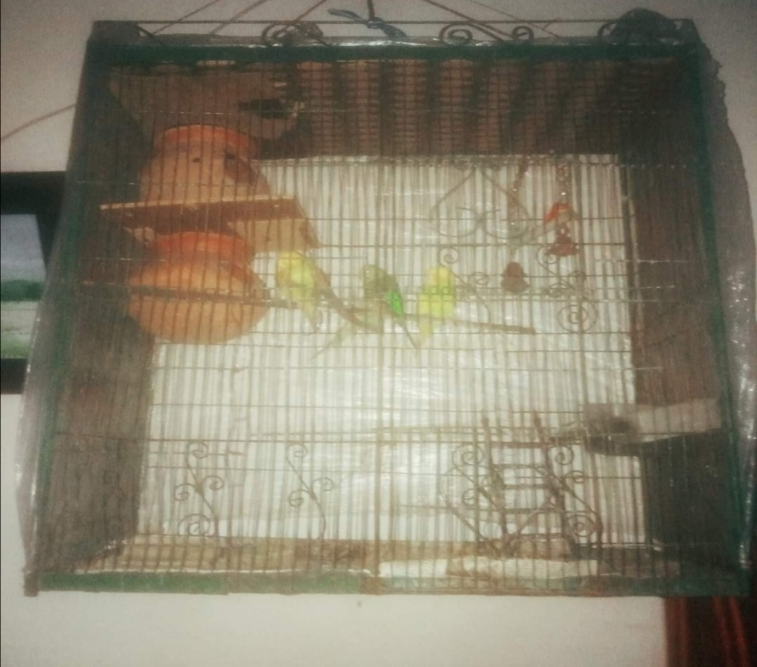
Figure 2: Allocation of budgerigar to high Spacious cage

Table 3.5: Allocation of budgerigars to treatment cages with low, medium and high space allowances during each period.
Period | Group 1 | Group 2 | Group 3
1 | Medium | Low | High
2 | Low | High | Medium
3 | High | Medium | Low

Cages were moved between periods to achieve these space differences, with budgerigars remaining at the same location.The following arrangement was used to assess the frequencies of behaviours for each bird during all experimental periods.

1) Flight-related behaviours: starting a flight, wing flapping (vigorously flapping wings while hanging onto a perch).

2) Oral behaviours: eating, drinking, biting, chewing (masticating food), beak grinding (opening the beak slightly and gently grind it close)

3) Self-maintenance behaviours: preening (cleaning self or other bird’s feathers with preen gland oil, presented as self-preening or all preening), poofing (straightening feathers out), scratching (self, with beak or foot), stretching (expanding wings and extending legs), tail wagging.

4) locomotory behaviours: Climbing on mesh, and walking (moving on perch).
Flights were classified as straight, circular (returning to the same perch), waveform (more than one direction change), curved or random, and it was observed whether the flight ended in another bird being displaced.

Chapter 4
Results & Discussion
4.1. Treatment effects

4.1.1. Flight
Budgerigars initiated flight more frequently on day 1 in the high treatment, compared to medium on the same day and on day 21. Median flight distances were 84.4, 110.1 and 115.2 cm for treatments low, medium and high, respectively. Mean flight times did not differ between treatments . If the preceding treatment was low space allowance, flight time in the subsequent period was increased. Flight times were longer for unidentifiable types of flights compared to all identified flight types. Budgerigars that displaced others had longer flights compared to those that did not . Flight type did not differ according to treatment.The identified flight types there were 16 straight, 11 circular, 3 waveform, and 6 curved flights observed, and on four occasions (2 curved and 2 random) the flight ended in another budgerigar being displaced.

4.1.2. Other treatment effects
Tail wagging was less frequent for budgerigars kept in medium and high compared to low while walking was less frequent in animals kept in medium when compared to low, with high as intermediate.

4.2. Day effects
Budgerigars ate most and had more bouts of mutual preening and poofing on day 1 in all treatments. All preening declined over the duration of each period Flight was most commonly initiated on day 7 compared to day 21, with day 1 as intermediate and budgerigars walked more in day 7 when compared to day 1 with day 21 as intermediate Budgerigars bit and climbed more on day 7 compared to day 1, with day 21 as intermediate.

4.3. Combined day and treatment differences
Chewing decreased in frequency in the high space allowance treatment at day 21 when compared to day 1 . Wing flapping was more frequent on day 1 in the low allowance treatment. Tail wagging was more frequent for animals kept in the low space allowance on day 1 compared to both later in the period and the other treatments.Scratching was reduced on day 1 at the low and medium space allowance, but not at the high allowance. Budgerigars were observed grinding their beak fewer times when kept in the medium space allowance on day 1 compared to day 21.

4.4. Behaviors unaffected by treatment or day
Drinking and stretching were not affected by treatment or day .

4.5 Discussion
The increase in flight initiation in treatment high on day 1 suggests that there was a demand that was not satiated in the low space allowance treatments. On a broader scale of cage size, budgerigars in aviaries have been found to fly more frequently (Nicol and Pope, 1993; Schnegg et al., 2007) and wing stretch more than those alone in small cages (Nicol and Pope, 1993). On the first day, wing flapping appeared to be increased in the low Treatment, suggesting compensation for a thwarted behavioural intention. Wing flapping in chickens occurs in response to stress, for example during exposure to noxious gases (McKeegan et al., 2013), but may also be considered part of the bird’s normal behavioural repertoire, for example for balance correction (Lien et al., 2012). It is restricted in caged broiler chickens, compared to those in floor pens, but this relates to the limitation on space to extend the wings in the cages (Fortomaris et al., 2007), which would not have been restrictive in this study even in the low space allowance treatment. Chickens tend to overestimate the amount of space required for wing flapping, which Hawkins speculates is likely to be common in other bird species (Hawkins, 2010). The limited amount of work investigating the motivation behind wing flapping in captive birds is restricted to determining that heat stress increases it in cockatiels (Carvalho et al., 2015) and that in ostriches it is a response to human presence (Bonato et al., 2013).
Scratching tended to be surpressed in this study in the low and medium space allowances at the start of each period, but not in the high allowance. Self-scratching is a normal behaviour in captive birds, which other author confirm to be decreased at low space allowances (Reiter and Bessei, 2000).
As birds in the high space allowances flew further but did not spend longer flying, this suggests that they flew faster in this treatment. Thus their optimal flight speed may be thwarted in the lower space allowances. In the small enclosures more skill in negotiating flight paths would have been required, but budgerigars are able to judge such requirements and modify their flight accordingly, by wing closures and planning their height, for example by anticipating loss in height whilst flying slower (Vo et al., 2016).

These flight speeds are about one half of those expected in budgerigars involved in long flights (500–1000 cm/s, Schiffner and Srinivasan, 2016). In confined spaces budgerigars reduce their speed of flight (Schiffner and Srinivasan, 2016), hence the large enclosures may have enabled them to get closer to their normal speed for flight in the wild. Evidence of at least partial satiation of their flight needs in increased space allowances was provided by the reduction in flight times following previous treatments providing increased space allowances. The changes over days suggested birds experienced some stress after the changeover, as they ate and poofed more on day 1 of the treatment, and that they recovered from this and exercised more in the middle of each period, flying and walking most on day 7. Increased preening after the changeover may reflect the human handling during the changeover period. We attempted to protect birds from disruption during treatment changes by transferring them to a separate small cage in their groups, but the change in environment still appears to have had an adverse effect. Chewing is normally reserved for comminuting food particles, but in the case of budgerigars fed a proprietary seed product as in our study, it is likely that it included fake (sham) chewing or chewing inanimate objects, as has been observed for pair-house budgerigars compared to those in social housing (Polverino et al., 2012).

Chapter 5
Conclusions
Budgerigars with cages space above that normally recommended showed evidence of benefitting from the extra space by increasing their flying behaviour, which was apparently constrained by enclosure size. Those in the low space allowance treatment showed evidence of restrictions on their behaviour, with more wing flapping and less scratching at the start of the period, compared to those in the large space allowance. There was evidence of habituation to small space allowances, with less chewing over time. The changes in behavioural response to space allowances over 21 day time periods observed in this experiment suggests that longer term studies are needed to identify permanent effects of space allowance on the behaviour and welfare of budgerigars.

References
1. Bonato, M., Malecki, I.A., Wang, M.D., Cloete, S.W.P., 2013. Extensive human presence at an early age of ostriches improves the docility of birds at a later stage of life. Appl. Anim. Behav. Sci. 148, 232–249 (Accessed 3 July 2020).
2. Carvalho, T.S.G., Zangeronimo, M.G., Saad, C.E.P., Alvarenga, R.R., Assis, V.D.L., Pereira, V.M., Scalon, J.D., Silva, J.P., 2015. Behaviour of cockatiels (Nymphicus hollandicus) at two temperatures in captivity. Arquivo Bras. Med. Vet. Zootech. 67, 1669–1674 (Accessed 3 July 2020).
3 . Department of Environment and Heritage Protection, 2010. Code of Practice. Wildlife Management, Aviculture pp. 12, ((Accessed 5 July 2020).
4. Fortomaris, P., Arsenos, G., Tserveni-Gousi, A., 2007. Performance and behaviour of broiler chickens as affected by the housing system. Archiv. Geflugelkunde 71, 97–104 (Accessed 10 July 2020).
5. Gebhardt-Henrich, S.G., Steiger, A., 2006. Effects of aviary and box sizes on body mass and behaviour of domesticated budgerigars (Melopsittacus undulatus). Anim. Welfare 15, 353–358 (Accessed 12 July 2020).
6. Hanninen, L., Pastell, M., 2009. CowLog: open-source software for coding behaviors from digital video. Behav. Res. Meth. 41, 472–476 (Accessed 15 July 2020).
7. Hawkins, P., 2010. The welfare implications of housing captive wild and domesticated birds. In: Duncan, I.J.H., Hawkins, P. (Eds.), The Welfare of Domestic Fowl and Other Captive Birds. Springer, Dordrecht, pp. 53–102 (Accessed 17 July 2020).
8. Lien, R.J., Bilgili, S.F., Hess, J.B., 2012. Induction of deep pectoral myopathy in broiler chickens via encouraged wing flapping. J. Appl. Poultry Res. 21, 556–562 (Accessed 18 July 2020).
9. McKeegan, D.E.F., Reimert, H.G.M., Hindle, V.A., Boulcott, P., Sparrey, J.M., Wathes, C.M., Demmers, T.G.M., Gerritzen, M.A., 2013. Physiological and behavioral responses of poultry exposed to gas-filled high expansion foam. Poultry Sci. 92, 1145–1154 (Accessed 20 July 2020).
10. Nicol, C.J., Pope, S.J., 1993. A comparison of the behaviour of solitary and group-housed budgerigars. Anim. Welfare 2, 269–277 (Accessed 20 July 2020).

11. Polverino, G., Manciocco, A., Alleva, E., 2012. Effects of spatial and social restrictions on the presence of stereotypies in the budgerigar (Melopsittacus undulatus): a pilot study. Eth. Ecol. Evol. 24, 39–53 (Accessed 21 July 2020).
12. Polverino, G., Manciocco, A., Vitale, A., Alleva, E., 2015. Stereotypic behaviours in Melopsittacus undulatus: behavioural consequences of social and spatial limitations. Appl. Anim. Behav. Sci. 165, 143–155 (Accessed 21 July 2020).
13. Reiter, K., Bessei, W., 2000. The behaviour of broilers in response to group size and stocking density. Archiv. Geflugelkunde 64, 93–98 (Accessed 23 July 2020).
14. Sakas, P.S., 2002. Essentials of Avian Medicine: A Guide for Practitioners, second edition. American Animal Hospital Association Press, Colorado (Accessed 23 July 2020).
15. Schiffner, I., Srinivasan, M.V., 2016. Budgerigar flight in a varying environment: flight at distinct speeds? Biol. Lett. 12 (Accessed 23 July 2020).
16. Schnegg, A., Gebhardt-Henrich, S.G., Keller, P., Visser, G.H., Steiger, A., 2007. Feeding behaviour and daily energy expenditure of domesticated budgerigars (Melopsittacus undulatus) (Accessed 24 July 2020).
17. Influence of type of housing and vertical position of the feeder. Appl. Anim. Behav. Sci. 108, 302–312 (Accessed 24 July 2020).
18. van Hoek, C.S., Ten Cate, C., 1998. Abnormal behavior in caged birds kept as pets. J. Appl. Anim. Welfare Sci. 1, 51–64 (Accessed 25 July 2020).
19. Victorian State Government, 2017. Code of Practice for the Housing of Caged Birds (Accessed 25 July 2020).
20. Vo, H.D., Schiffner, I., Srinivasan, M.V., 2016. Anticipatory manoeuvres in bird flight. Sci. Rep. 6. (Accessed 27 July 2020).

