Evaluation of Some Chemical & Microbiological Parameters of powder Milk Available in Chittagong Town.
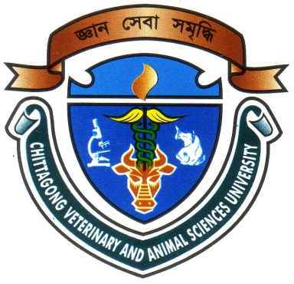

Report Presented in Partial Fulfillment of the Requirement for the Degree of Doctor of Veterinary Medicine
A Report Submitted by Roll no: 07/34
Intern ID No: C-30
Reg. No:320
Session:2006-2007

Faculty of Veterinary Medicine
Chittagong Veterinary and Animal Sciences University
Khulshi, Chittagong-4225

February 2013

Evaluation of Some Chemical & Microbiological Parameters of powder Milk Available in Chittagong Town.

A Production Report Submitted as per approved style and content
….........................................  Signature of Author  Shubho Sutra Dhar  Roll No. 2007/34  Reg. No. 320  Internship ID: C-30  Session: 2006-2007  Date: | ….......................................  Signature of Supervisor  Goutam Kumar Debnath Professor  Dept. of Dairy & Poultry Science  Chittagong Veterinary and Animal  Sciences University,  Khulshi, Chittagong – 4225  Date:
Faculty of Veterinary Medicine
Chittagong Veterinary and Animal Sciences University
Khulshi, Chittagong-4225
February 2013.

ACKNOWLEDGEMENT
At first, the author would like to express his ever gratefulness to Almighty God.
The author would like to express his deep sense of gratitude and thanks to Professor Dr. A. S. Mahfuzul Bari , Vice Chancellor of Chittagong Veterinary and Animal sciences university.
The author would like to express his deep sense of gratitude and heartfelt appreciation to Professor Dr. Masuduzzaman , Dean, faculty of Veterinary Medicine, Chittagong Veterinary and Animal sciences University.
The author extends his gratefulness to his supervisor Goutam Kumar Debnath, Associate Professor, Dept. of Dairy & Poultry science, Faculty of Veterinary Medicine, Chittagong Veterinary and Animal Sciences University for his scholastic guidance and supervision of the report work and write up of the dissertation.
The author is expressing his heartfelt gratification to his respectable teacher, Dr. Md. Saiful Bari, Lecturer, Dept. of Dairy and Poultry Science, Chittagong Veterinary & Animal Sciences University for his inspiration, important advice and kind co-operation during the study period.
The author highly express his sincere gratitude and gratefulness to the internship coordinator Dr. Bibek Chandra Sutradhar, Professor, Dept. of veterinary Medicine and Surgery, Chittagong veterinary And Animal sciences university for his constant inspiration, cordial co-operation.
Finally, the author is expressing ever indebtedness to his beloved family members, friends and well wishers.

The author

INDEX

CHAPTER | CONTENTS | PAGE NO
 | Abstract
1 | Introduction
2 | Review of literature
3 | Materials and methods
4 | Results and discussion
5 | Conclusion
6 | References

ABSTRACT

The present study was conducted in Dairy Science laboratory at Chittagong Veterinary & Animal Sciences University for last two months. It was based on chemical and microbiological parameters of different standards of different full cream milk powders available in Chittagong town. In my work, my attempt was to show how much the manufacturers maintain their standards.
Powder milk samples of six different brands namely Aarong, Marks, Fresh, Today, Dano & Goalini were collected from local market. Powder samples were analyzed to know the chemical (acidity, fat, moisture,) and microbiological (SPC, Coliform count) characteristics. Acidity of all samples was almost similar to the cow milk when the dried milk was reconstituted. PH ranged from 6.6-6.8, acidity from 0.11-0.14, fat from 2.4-4.0%, moisture from 3.90-5.15, among the brands of powder milk. Chemical parameters in all brands of milk powder were found as per recommended standard.

Keywords: Chemical and microbiological parameters, Powder milk, Evaluation

