**Molecular Epidemiology of *Cryptosporidium* and *Giardia* as waterborne zoonoses**



**Zebunnahar Yasmin**

**Registration No.: 0014**

**The thesis submitted in the fulfillment of the requirements for the degree of Doctor of Philosophy from the Department of Pathology and Parasitology**

**Department of Pathology and Parasitology**

**Faculty of Veterinary Medicine**

**Chattogram Veterinary and Animal Sciences University**

**Chattogram-4225, Bangladesh,**

**September, 2023**

**Authorization**

I do hereby declare that the work presented in this thesis, entitled, **“Molecular Epidemiology of *Cryptosporidium* and *Giardia* as waterborne zoonoses”** is the result of my investigation. I further declare that I am the one and only author of this thesis and no part of it has been submitted anywhere in any form for any academic degree. I also declare that the electronic copy of this thesis provided to the **Chattogram Veterinary and Animal Sciences University** central library is an accurate copy of the printed thesis.

--------------------------------------------

**Zebunnahar Yasmin**

**Molecular Epidemiology of *Cryptosporidium* and *Giardia* as waterborne zoonoses**

**Zebunnahar Yasmin**

Registration No.: 0014

This is to certify that we have examined the above PhD thesis and have found that is complete and satisfactory in all respects and that all revisions required by the thesis examination committee have been made

……………………………..…………………….

**(Prof. Dr. Mohammad Alamgir Hossain)**

**Supervisor**

Department of Pathology and Parasitology

Chattogram Veterinary and Animal Sciences University

|  |  |
| --- | --- |
| ……………………………..…………….  **(Prof. Dr. AMAM Zonaed Siddiki)**  **Co-Supervisor**  Department of Pathology and Parasitology  Chattogram Veterinary and Animal  Sciences University | ……………………………..…………….  **(Prof. Dr. Sharmin Chowdhury)**  **Co-Supervisor**  Department of Pathology and Parasitology  Chattogram Veterinary and Animal  Sciences University |

………………………………………….

**(Prof. Dr. Md. Masuduzzaman)**

**Chairman of the Examination Committee**

Department of Pathology and Parasitology

Faculty of Veterinary Medicine

Chattogram Veterinary and Animal Sciences University

Chattogram – 4225, Bangladesh.

**September, 2023**

**Acknowledgments**

First and foremost, praises and thanks to Almighty Allah, for giving me an opportunity, blessing, and strength to complete my thesis work successfully with care and precision.

Then debt of gratitude must be to my parents, who have patiently supported me.

I owe a great deal to my supervisor, Prof. Dr. Mohammad Alamgir Hossain, Department of Pathology and Parasitology, Chattogram Veterinary and Animal Sciences University, not only for sharing his tremendous breadth of knowledge and insight but more importantly for helping me with his excellent guidance and enthusiastic encouragement to complete this work successfully.

It’s my pleasure to convey my profound gratitude to my co-supervisors, Prof. Dr. AMAM Zonaed Siddiki and Prof. Dr. Sharmin Chowdhury, Department of Pathology and Parasitology (DPP), CVASU for their valuable advice, scholastic guidance, and cordial inspiration. Moreover, I feel honored to show my gratitude to Prof. Dr. Masuduzzaman, Department of Pathology and Parasitology (DPP), CVASU for his constructive advice to complete the research on time.

It is my privilege to acknowledge the United States Department of Agriculture (USDA) for the financial support provided through the project “**Molecular characterization and identification of important zoonotic and infectious diseases of livestock and poultry in Bangladesh”** of the Department of Pathology and Parasitology, CVASU.

I am also grateful to Prof. Dr. Md. Abdul Alim, Prof. Dr. Mohammad Mahbubur Rahman, Dr. Md. Shafiqul Islam, Associate Professor, Tofazzal Md. Rakib, Associate Professor, Department of Pathology and Parasitology (DPP), CVASU for their kind suggestions during the whole tenure of the PhD work.

I would like to convey a special thanks to DR. Jahan Ara, Lecturer, Department of Pathology and Parasitology (DPP), CVASU for her cordial and scholastic contribution to data analysis in my PhD work. I also cordially thank DR. Towhida Kamal, Assistant Professor, DR. Homaira Pervin Heema, Lecturer, DR. Farnaz Kader Nova, Lecturer, Department of Pathology and Parasitology (DPP), CVASU for their sincere cooperation, and utmost support during laboratory work.

Special thanks to Dr. Nazmul Hoque, Molecular Biology and Bioinformatics Laboratory, Department of Gynecology, Obstetrics, and Reproductive Health, Bangabandhu Sheikh Mujibur Rahman Agricultural University for his valuable support in bioinformatics analysis for molecular works. Also thanks to Md. Habib Ullah Masum, Nextgen Informatics Ltd.,Bangladesh.

Thanks to my fellow PhD students, DR. Rehana Pervin, MS. fellow students, DR. Md. Sirazul Islam, DR. Aklima Akhter and DR. Aysha Sultana for making my PhD a great time. I would like to thank all the teaching and technical staff of Department of Pathology and Parasitology (DPP), CVASU for their cooperation and encouragement during the research work.

Special thanks to Chattogram Medical College Hospital (humans) and also to Chattogram Military Dairy farm for their cooperation in providing samples. And I am immensely grateful to the farm owners involved in this study.

Finally, I am thankful to my parents, in-laws, and family, especially my beloved husband Md. Anisur Rahman (DO, BFRI), for his constant support and motivation, and also to my precious son Abrar Wasi, who always encouraged me to complete my research successfully.

**Zebunnahar Yasmin**

Chattogram, Bangladesh

**Dedicated**

**To**

**My Beloved Parents**

**Table of Contents**

| **SN** | **Title** | | **Page No.** |
| --- | --- | --- | --- |
| Authorization | | | i |
| Signature page | | | ii |
| Acknowledgment | | | iii |
| Dedication | | | v |
| Table of Contents | | | vi |
| List of Tables | | | x |
| List of Figures | | | xi |
| List of Annexure | | | xiv |
| List of abbreviations and symbols | | | xv |
| Summary | | | xvii |
| **CHAPTER 1**  **Introduction** | | | |
| 1.1. | General Introduction | | 1 |
| 1.2. | Aim of the study | | 6 |
|  | 1.2.1. Rationale for Objective I | | 6 |
|  | 1.2.2. Rationale for Objective II | | 7 |
|  | 1.2.3. Rationale for Objective III | | 8 |
| **CHAPTER 2**  **Review of Literature** | | | |
| 2.1. | The etiology of diarrhoea | | 9 |
| 2.2. | Cryptosporidiosis | | 10 |
|  | 2.2.1. | Etiology and taxonomy | 11 |
|  | 2.2.2. | Life cycle | 13 |
|  | 2.2.3. | Epidemiology | 14 |
|  |  | 2.2.3.1. Geographical distribution | 14 |
|  |  | 2.2.3.2. Host range | 15 |
|  |  | 2.2.3.3. Transmission and source of *Cryptosporidium* | 16 |
|  | 2.2.4. | Risk factors of *Cryptosporidium* | 17 |
|  |  | 2.2.4.1. Age | 17 |
|  |  | 2.2.4.2. Pathogen risk factors | 18 |
|  |  | 2.2.4.3. Concurrent infections | 18 |
|  |  | 2.2.4.4. Immune status | 18 |
|  |  | 2.2.4.5. Morbidity and mortality | 19 |
|  | 2.2.5. | Pathogenesis of *Cryptosporidium* | 19 |
|  | 2.2.6. | Clinical signs of cryptosporidiosis | 19 |
|  | 2.2.7. | Diagnosis of *Cryptosporidium* | 20 |
|  |  | 2.2.7.1. Parasitological diagnosis | 20 |
|  |  | 2.2.7.2. Serologic diagnosis | 21 |
|  |  | 2.2.7.3. Molecular detection of *Cryptosporidium* | 21 |
| 2.3. | *Giardia* | | 21 |
|  | 2.3.1. | Etiology and taxonomy | 22 |
|  | 2.3.2 | Life cycle | 23 |
| 2.4. | Epidemiology | | 24 |
|  | 2.4.1. | Geographical distribution | 24 |
|  | 2.4.2. | Transmission of giardiasis | 25 |
|  | 2.4.3. | Host-specificity | 25 |
|  | 2.4.4. | Risk factors of giardiasis | 25 |
|  | 2.4.5. | Age | 26 |
|  | 2..4.6. | Management practices | 26 |
|  | 2.4.7. | Pathogen risk factors | 26 |
| 2.5. | Clinical sign | | 26 |
| 2.6. | Pathogenesis | | 27 |
| 2.7. | Diagnosis of giardiasis | | 27 |
|  | 2.7.1. Microscopic examination | | 27 |
|  | 2.7.2. Antigen detection | | 28 |
|  | 2.7.3. Molecular typing | | 28 |
| 2.8. | Epidemiological prevalence of *Cryptosporidium* and *Giardia* | | 29 |
| 2.9. | Molecular prevalence of *Cryptosporidium* and *Giardia* | | 29 |
| 2.10. | Real-time -PCR (qPCR) for the detection of *Cryptosporidium* and *Giardia* | | 31 |
| 2.11. | Microbiome characterization in fecal sample | | 31 |
| **CHAPTER 3**  **Prevalence of *Cryptosporidium* and *Giardia* infections among children and calves in Chattogram, Bangladesh** | | | |
|  | Abstract | | 33 |
| 3.1. | Introduction | | 34 |
| 3.2. | Materials and methods | | 35 |
|  | 3.2.1. | Description of the study area | 35 |
|  | 3.2.2. | Ethics approval | 37 |
|  | 3.2.3. | Sample design | 37 |
|  | 3.2.4. | Identification by microscopy | 38 |
|  | 3.2.5. | DNA extraction and PCR analysis | 38 |
|  | 3.2.6. | Statistical analysis | 39 |
| 3.3. | Results | | 39 |
| 3.4. | Discussion | | 51 |
| 3.5. | Conclusion | | 53 |
| **CHAPTER 4**  **Molecular characterization of *Cryptosporidium* and *Giardia* from diarrhoeic children and cattle calves** | | | |
|  | Abstract | | 54 |
| 4.1. | Introduction | | 55 |
| 4.2. | Materials and methods | | 56 |
|  | 4.2.1. | Sample design | 56 |
|  | 4.2.2. | Identification by microscopy | 56 |
|  | 4.2.3. | DNA extraction and nested PCR assay | 56 |
|  | 4.2.4. | Real-time (qPCR) PCR analysis | 57 |
|  | 4.2.5 | Purification of PCR amplicons | 58 |
| 4.3. | Sequencing and phylogenetic analysis | | 58 |
| 4.4. | Results | | 59 |
|  | 4.4.1. Nested-PCR for detection of *Cryptosporidium* and *Giardia* | | 59 |
|  | 4.4.2. Real-time PCR for detection of *Cryptosporidium* and *Giardia* | | 62 |
|  | 4.4.3. | Sanger sequencing | 64 |
|  | 4.4.4. | Phylogenetic reconstruction & comparative genomics | 66 |
| 4.6. | Discussion | | 72 |
| 4.7. | Conclusion | | 74 |
| **CHAPTER 5**  **Comparison of fecal microbiome of diarrhoeic and non-diarrhoeic calves through metagenomics approach** | | | |
|  | Abstract | | 75 |
| 5.1. | Introduction | | 76 |
| 5.2. | Materials and methods | | 77 |
|  | 5.2.1. | Participants | 77 |
|  | 5.2.2. | Fecal sample collection, DNA extraction and 16S rRNA gene amplicon sequencing | 78 |
|  | 5.2.3. | Bioinformatic analysis | 78 |
|  | 5.2.4. | Statistical analysis | 79 |
| 5.3. | Results | | 79 |
|  | 5.3.1. | Microbiome diversity and composition in diarrhoeic feces (DF) and non-diarrhoeic feces (NDF) of calves | 79 |
|  | 5.3.2. | Taxonomic composition of bacteriomes in the gut of DF and NDF of calves | 83 |
| 5.4. | Discussion | | 89 |
| 5.5. | Conclusion | | 92 |
| **CHAPTER 6**  **Conclusions** | | | |
| 6.1. | Conclusions | | 93 |
| 6.2. | Future perspectives and limitation | | 94 |
|  | **CHAPTER 7**  **References** | |  |
|  | References | | 97-126 |
|  | Appendices | | 127-172 |

**List of Tables**

| **Table No.** | **Title** | **Page No.** |
| --- | --- | --- |
| **Table 2.1:** | Lists of major *Cryptosporidium* species and genotypes *(*Source: Fayer and Xiao, 2007; Chalmers and Davies, 2010; Slapeta, 2013) | 12 |
| **Table 2.2:** | Currently recognized species of *Giardia* and genetic groupings (assemblages) within *Giardia duodenalis* of adopted from (Abeywardena *et al.,* 2015) | 23 |
| **Table 2.3.** | Molecular prevalence of *Cryptosporidium a*nd *Giardia* infection in calves and human in worldwide | 30 |
| **Table 3.1:** | Descriptive statistics and association of different variables with cryptosporidiosis and giardiasis in the human population diagnosed by PCR | 43 |
| **Table 3.2:** | Description of clinical findings in cryptosporidiosis and giardiasis in the human population diagnosed by PCR | 45 |
| **Table 3.3:** | Descriptive statistics and association of different variables with *Cryptosporidium* at the animal level diagnosed by PCR | 45 |
| **Table 3.4:** | Descriptive statistics and association of different variables with *Cryptosporidium* at the animal level diagnosed by PCR | 46 |
| **Table 3.5.** | Descriptive statistics and association of different variables with *Giardia* at farm level diagnosed by PCR | 48 |
| **Table 3.6.** | Descriptive statistics and association of different variables with *Giardia* at animal level diagnosed by PCR | 50 |
| **Table 4.1:** | The prevalence of *Cryptosporidium* (*gp60, SSU*)and *Giardia* (*TPI*) based on approach nested PCR for detection of *Cryptosporidium* and *Giardia* | 59 |
| **Table 4.2.** | The prevalence of *Cryptosporidium* and *Giardia* based on real-time PCR approach | 62 |
| **Table 4.3.** | The isolates applied for Sanger sequencing and their repository IDs | 64 |
| **Table 5.1.** | Study sample information, SRA accession numbers of the 16S rRNA amplicon sequences, and OTUs (operational taxonomic units) mapped against bacterial taxa | 79 |

**List of Figures**

| **Fig. No.** | **Title** | **Page No.** |
| --- | --- | --- |
| Fig. 2.1: | Life cycle of *Cryptosporidium* sppin farm animals (Adopted from [Smith *et al*., 2007](https://scialert.net/fulltext/?doi=aje.2015.48.63)) | 14 |
| Fig. 2.2: | The life cycle of *Giardia* spp (Adopted from Bridle, 2021) | 24 |
| Fig. 3.1: | Map with the location of Chattogram Metropolitan area | 36 |
| Fig. 3.2: | The prevalence of cryptosporidiosis and giardiasis in human and animal populations | 40 |
| Fig. 3.3. | Oocysts of *Cryptospodium* spp*.* in Ziehl-Neelsen staining under microscope | 41 |
| Fig. 3.4. | Trophozoite and cyst of *Giardia* spp. in trichrome staining under microscope | 41 |
| Fig. 3.5: | PCR amplification *of Cryptosporidium and Giardia* gene | 42 |
| Fig. 4.1. | PCR amplification of gene *Cryptosporidium (*g*p60* and *SSU*) | 60 |
| Fig. 4.2. | PCR amplification of gene *Giardia (TPI* and *beta-giardian*) | 61 |
| Fig.4.3. | Amplification of cyclic reaction in real-time PCR of *Cryptosporidium* | 63 |
| Fig.4.4 | Amplification of cyclic reaction in real-time PCR of *Giardia* | 63 |
| Fig. 4.5 | Phylogenetic tree of C*ryptosporidium* sp. especially *Cryptosporidium hominis* and *Cryptosporidium parvum (SSU) gene* isolated from diarrheic children and calves of Chattogram and isolated from global distribution constructed by maximum likelihood method | 66 |
| Fig. 4.6. | Phylogenetic tree of C*ryptosporidium* sp. especially *Cryptosporidium parvum* and *Cryptosporidium hominis (gp60)* isolated from diarrheic calves and children of Chattogram and isolated from global distribution constructed by maximum likelihood method | 68 |
| Fig. 4.7. | Phylogenetic tree of *Giardia* sp. especially *Giardia intestinalis (TPI)* isolated from diarrheic children of Chattogram and isolated from global distribution constructed by maximum likelihood method | 69 |
| Fig. 4.8. | The phylogenetic analysis of *gp60* gene-based *Cryptosporidium* in both humans and animals identified by metagenomics screening using MePic pipeline | 71 |
| Fig. 4.9. | The phylogenetic analysis of *SSU* gene-based *Cryptosporidium* in both humans and animals in both human and animal identified by metagenomics screening using MePic pipeline | 71 |
| Fig. 5.1. | Bacteriome diversity. (a-b) Within-subject (Alpha) diversity measure. Observed, Chao1, Shannon, Simpson, InvSimpson, and Fisher indices estimated within sample bacterial diversity in (a) diarrhoeic feces (DF) and non-diarrhoeic feces (NDF) of calves | 81 |
| Fig. 5.2. | Taxonomic composition of bacteriomes:Venn diagrams representing the unique and shared bacterial (a) phylum, (b) class, (c) order, (d) family, (e) genus, and (f) species identified in diarrhoeic feces (DF) and non-diarrhoeic feces (NDF) of calves | 82 |
| Fig. 5.3. | The phylum-level taxonomic abundance of bacteria in diarrhoeic feces (DF) and non-diarrhoeic (NDF) calves | 83 |
| Fig. 5.4. | Taxonomic profile of microbiomes at the class level. Heatmap showing the average relative abundances and hierarchical clustering of the bacterial classes (n = 31) in the study samples | 84 |
| Fig. 5.5. | The order-level taxonomic profile of microbiomes: The bar plots representing the relative abundance of the top abundant 25 bacterial orders in diarrhoeic feces (DF1 – DF5) and non-diarrhoeic (NDF1 – NDF5) of calves | 85 |
| Fig. 5.6. | Taxonomic profile of microbiomes at the family level. Heatmap showing the average relative abundances and hierarchical clustering of the families of bacteria (25 top abundant) in the study samples | 86 |
| Fig. 5.7. | The genus-level taxonomic profile of microbiomes. The bar plots representing the relative abundance of top abundant 30 bacterial genera in diarrhoeic feces (DF1 – DF5) and non-diarrhoeic (NDF1 – NDF5) of calves | 87 |
| Fig. 5.8. | Taxonomic profile of microbiomes at the species level: Heatmap showing the average relative abundances and hierarchical clustering of the bacterial species (50 top abundant) in the study samples | 88 |

**List of Appendices**

|  |  |  |
| --- | --- | --- |
| **Annex No.** | **Title** | **Page No.** |
| Annex-1: | Questionnaire used to collect the information about farms and farm management | 127 |
| Annex-2: | Questionnaire used to collect the information about children and their socio economic condition | 130 |
| Annex-3: | SRA accession numbers of the 16S rRNA amplicon sequences | 132 |
| Annex-4: | Taxonomic information on the diarrhoeic feces (DF) and non-diarrhoeic (NDF) of calves | 139 |
| Annex-5: | Participation in different national and international conference | 171 |
| Annex-6: | Manuscripts published and prepared from this research work | 172 |
| Annex-7: | Brief bio-data of Zebunnahar Yasmin | 172 |

**LIST OF DATA**

|  |  |  |
| --- | --- | --- |
| **Plate No.** | **Title** | **Page No.** |
| **Data 1.** | **Data S1**: Taxonomic information of microbiomes in diarrhoeic feces (DF) and non-diarrhoeic (NDF) of calves | 139 |

**List of Abbreviations and Symbols**

| **Abbreviations and symbols** | **Elaboration** |
| --- | --- |
| % | Percentage |
| µl | Microliter |
| µM | Micromolar |
| AIDS | Acquired immunodeficiency syndrome |
| Bp | Base pair |
| G | Gram |
| HIV | Human immunodeficiency virus |
| Ml | Milliliter |
| mM | Millimolar |
| μM | Micromolar |
| NJ | Neighbor-Joining |
| °C | Degree celcius |
| *P* value | Level of significance |
| UV | Ultraviolet |
| PP | Posterior probabilities |
| NCD | Newborn calf diarrhea |
| NCBI | National center for biotechnology information |
| OUT | Operational taxonomic unit |
| PCR | Polymerase chain reaction |
| 16S rRNA | Small subunit 16S ribosomal RNA |
| Gp60 | 60kDa glycoprotein |
| SSU rRNA gene | Small subunit ribosomal RNA |
| PCoA | Principal co-ordinate analyses |
| bg | *Βeta-giardin* |
| bp | Base pair |
| CDC | Centre for Disease Control |
| NGS | Next-generation sequencing |
| spp | Species |
| tpi | Triosephosphate isomerase |
| WHO | World Health Organisation |
| Blast | Basic local alignment search tool |
| CLUSTUL X | Program allowing multiple alignment of nucleic acid and protein sequences |
| COWP | *Cryptosporidium* Oocyst Wall Protein |
| SPSS (Version 7) | Statistical package for the social science |
| RNA | Ribonucleic Acid |
| rRNA | Ribosomal Ribonucleic Acid |
| Pmol | Pico mole |
| MZN | Modified Ziehl- Neelsen |
| USDA | United States Department of Agriculture |
| Min | Minute (s) |
| DPP | Department of Pathology and Parasitology |
| CMA | Charrogram Metropolitan area |
| CMCH | Chattogram Medical College Hospital |

**Summary**

*Cryptosporidium* spp. and *Giardia* spp. are two of the leading causal agents of parasitic diarrhoea in humans and calves. Both of the pathogens are host-adapted.There is a critical need to understand factors potentially associated with the risk and prevalence of infection due to *Cryptosporidium* spp.and *Giardia* spp. in humans and calves. Furthermore, molecular characterization of human and calves isolates may identify zoonotic genotypes and provide further information concerning the transmission routes between humans and calves. Thus, this study aimed to understand the epidemiology and molecular characterization of *Cryptosporidium* and *Giardia* in humans and animals in Chattogram, Bangladesh. In Chapter 2, a review of the literature regarding *Cryptosporidium* spp. and *Giardia* spp. in children and animals (calves) was conducted. The review involves a brief description of the two pathogens’ current taxonomy, epidemiology, transmission, and diagnostic methods.

The thesis was organized with three objectives based on the epidemiological, molecular (nested PCR and real-time PCR) study of *Cryptosporidium* and *Giardia* from children and calves feces samples and metagenomics study was the comparison of the fecal microbiome of diarrhoeic and nondiarrhoeic calves samples and comparing the pathogens to see if there were any differences in the bacteriome community among them. The study was executed in the Chattogram Metropolitan area, which is situated in the south-eastern part of Bangladesh namely Chattogram, in districts denoted as plain and hilly regions, respectively, from January 2019 to January 2022, in different stages.

A cross-sectional survey was conducted in Chapter 3 to approximate the prevalence and associated risk factors of *Cryptosporidium* and *Giardia* species infections in children and calves in Chattogram. The study's primary goal was to ascertain the prevalence of these infections among these animals. A total of 437 (n = 437) fecal deposits from diarrheal people and calves were used in this investigation. 200 (n = 200) human fecal samples were taken from pediatric patients (ages 1 month to 12) who were referred to the Chattogram Medical College Hospital and had gastrointestinal distress, including diarrhea, dehydration, abdominal pain, nausea, and vomiting. Meanwhile, 237 (n = 237) fecal samples were also taken from calves ranging in age from one to six months, coming from various nearby farms in the Chattogram Metropolitan area.

All samples were stained with a modified Ziehl-Neelsen acid-fast for *Cryptosporidia* and Trichrome stain for *Giardia*. From the result of the fecal analyses to the modified Z-N stain, the prevalence of *Cryptosporidium* infection among hospitalized diarrheic children and infected calves was 13.5% and 23.63%, respectively. However, in *SSUr RNA* gene-based PCR, the prevalence of *Cryptosporidium* infection among hospitalized diarrheic children and infected calves was 9.5% and 19.41%, respectively. Additionally, trichrome staining revealed that the prevalence of *Giardia* in children and calves was 9.5% and 19.41%, respectively. While *TPI* gene-based PCR showed that 9% *Giardia* infection prevalence in children and 10.55% in calves. In humans, gender-based distributions for cryptosporidiosis and giardiasis indicated that males in cryptosporidiosis and giardiasis were at a higher risk for infection than females in cryptosporidiosis and giardiasis. Cryptosporidiosis was more prevalent in children aged 11-15 months, where as giardiasis was more frequent in children more than >35 months. The variation of seasons significantly influences the prevalence and incidence of cryptosporidiosis and giardiasis in the human population. Giardiasis was shown to be more likely to spread during the winter months, while cryptosporidiosis was more predominant in summer. In all scenarios, children residing in rural areas were more susceptible to infection in cryptosporidiosis and giardiasis than others residing in urban areas, including city and slum environments. Additionally, children who were deprived of proper sanitation were more susceptible to cryptosporidiosis and giardiasis. Water sources were also impacted on both kinds of infections, where children who consumed pond water rather than supplied and tube well water, were more prone to cryptosporidiosis and giardiasis. Children without a history of being breastfed are more susceptible to both types of infections. Nevertheless, there is no evidence to suggest that the historical record of pet ownership and exposure to anthelmintics has any influence on the occurrence of cryptosporidiosis and giardiasis in humans.The correlations between clinical characteristics and disease prevalence were also investigated and analyzed. The condition was not shown to be associated with a history of nausea, abdominal pain, anorexia, vomiting, or dehydration. Different variables with C*ryptosporidium* at the animal level were diagnosed by PCR and the frequency of cryptosporidiosis was found to be much higher in female calves compared to their male counterparts. The frequency of cryptosporidiosis was found to be relatively high in calves aged between 31 and 60 days. At the farm level, the frequency of cryptosporidiosis was shown to be independent of many factors, including the education level of owners, topography, types of calf housing, and floor type. Nevertheless, a substantial incidence of cryptosporidiosis was seen in calves residing in hilly regions and calves housed in enclosed barns with rubber pad flooring. Furthermore, it was shown that the incidence of cryptosporidiosis was comparatively elevated in calves that were exposed to ground water as opposed to pond or supply water sources. There was also an increase in the frequency of cryptosporidiosis among calves that did not share feeding utensils. Moreover, the frequency of cryptosporidiosis was higher in calves that were hand-fed compared to suckling-feeed.

In chapter 4, the second objective was to molecularly characterize of *Cryptosporidium* and *Giardia* in human and animal populations in the study area. The molecular prevalence of *Cryptosporidium,* among hospitalized diarrheic children and infected calves was found to be 9% (n=18) and 4.22% (n=10), respectively. On the other hand, the molecular prevalence of *Giardia* among hospitalized diarrheic children and infected calves was found to be 14% (n=28) and 10.55% (n=25), respectively. In terms of *Cryptosporidium*, the prevalence of the *gp60* gene was determined to be 10% (n = 20) in hospitalized diarrheic youngsters and 11.39% (n = 27) in infected calves*.* The *SSU* gene was reported to be 6% (n=12) in hospitalized diarrheic children and 10.13% (n = 24) in infected calves. In the instance of *Giardia,* the prevalence of the *TPI* gene among hospitalized diarrhoeic children was reported to be 10.5% (n = 21), with no *TPI* gene detected in calves but *bita-gardian* found in calves only after PCR amplification. Quantitative real-time PCR (qPCR) was performed using an assay for detection of all *Cryptosporidium* and *Giardia.* A total number of 28 isolates were sequenced through Sanger sequencing approaches for both human and animal *Cryptosporidium* (*gp60* = 14; *SSU* = 7) and *Giardia* (*TPI* = 7) isolates. The purified PCR products were applied for Sanger sequencing. Sequence quality was verified by comparison with corresponding electropherograms using the program Geneious v.8. Sequences were aligned using the program MUSCLE and alignments were adjusted manually using the program Mesquite v.2.7**5.** Sequences were then compared with those available in the GenBank database using BLASTn. Firstly, the selected sequences were aligned using the Mafft algorithm, Phylogenetic analyses of the *Cryptosporidium* and *Giardia* were carried out based on gene-specific sequences such as (*gp60,* *SSU,* and *TPI*). Sequences were then validated in the GenBank database using BLASTn. However, after quality analysis, the sequences were stored in the NCBI nucleotide database through the following accession, OM665388.1 - OM665390.1, MT071440.1 - MT071443.1, OM877297.1 - OM877302.1, MT185587.1 - MT185589.1, OM877303.1 - OM877314.1.

Chapter-5: the third objective was the comparison of the fecal microbiome of diarrhoeic and non-diarrhoeic calvesthrough metagenomics approach. This study was designed to unveil the gut bacteriome signatures and diversity by analyzing 10 samples including 5 diarrhoeic feces (DF) and 5 non-diarrhoeic feces (NDF) samples obtained from 10 individual calves through 16S rRNA (V4 region) gene-based amplicon sequencing. A total of 358 operational taxonomic units (OTUs) including 217 and 162 in DF and NDF samples, were identified. Findings revealed substantial taxonomic variability between sample categories (i.e., DF and NDF; *p* = 0.0127; Kruskal Wallis test) of the calves, indicated by their higher degree of shared microbiota. Of the identified genera, *Gallibacterium* (37.48%), *Veillonella* (14.53%), and *Bacteroides* (11.61%) were the major bacterial genera detected in the gut of calves. Importantly, we detected 44 genera including *Sedimentibacter*, *Lonepinella*, *Sulfurospirillum*, *Haemophilus*, *Enterobacter*, *Citrobacter,* etc. seem to be specific to calf diarrhea. Both the DF and NDF samples included 358 distinct bacterial species, of which 32.18% species were found to be shared between sample categories, and 25.14% and 11.73% species were found solely in DF and NDF, respectively. Moreover, *Gallibacterium salpingitidis* was found as the most prevalent species (43.37%) in DF samples followed by *Gallibacterium anatis* (17.56%), *Bacteroides* sp. (6.2%). In contrast, *Veillonella magna* had the highest prevalence (19.21%) in NDF samples followed by *Bacteroides* sp. (18.00%), *Veillonella* sp. (13.09%), and *Ruminococcus* sp. (7.23%). The findings suggested that diarrhoea affects the gut bacteriome in calves, with different microbial taxa associated with diarrhoea. Our data provided evidence for the existence of both unique and shared bacteriomes with pathogenic potentials in the gut of calves which might be taken into consideration for undertaking future microbiome studies in diarrhoeic calves.

As a whole, this PhD project provides new data on information of *Cryptosporidium parvum* infections in calves and *Cryptosporidium hominis* inchildren and also *Giardia intestinalis* in children. Results indicate that ruminants (calves) and children in Bangladesh shed potentially zoonotic pathogens in the environment and may contribute to the contamination of surface water. Our research in Bangladesh reveals a high prevalence of *Cryptosporidium* and *Giardia*, particularly affecting children and calves those are associated poor sanitation conditions. Molecular diagnostic techniques, such as PCR and Real-time PCR, have enhanced the identification and differentiation of these pathogens. Metagenomics studies have uncovered significant genetic diversity and multiple co-infections**,** offering deep insights into pathogen dynamics. Despite the advanced research tools, integrating these methods into public health practice remains challenging but we hope it paving the way for more effective control and prevention measures for the diarrheal diseases in our country.

**CHAPTER 1**

**Introduction**

**1.1 General Introduction:**

Waterborne diseases are a major concern of human and animal morbidity and mortality worldwide and Bangladesh is one of the most common sufferers (WHO, 2004; Hrudey and Hrudey, 2007a; 2007b). Although Bangladesh is a riverine country, consisting of more than hundreds of large and small rivers, with 97% of the total population having access to water sources, the quality of drinking water is always questionable ([WHO, 2018](https://www.sciencedirect.com/science/article/pii/S2405844019358050#bib219)). Bangladeshi people are at high risk for waterborne diseases because of the dense population and lack of awareness. Nevertheless, waterborne diseases persist as one of the major problems in both developed and developing countries, causing more than 3.4 million deaths every year (Gleick, 2002; WHO, 2004; 2011).Death due to waterborne diseases is widespread in Bangladesh, particularly among children (Hasan *et al.,* 2019. Approximately, 243 of the 616 livestock pathogens (39%) are currently known to infect humans and a few of these pathogens are associated with waterborne transmission routes (Cleaveland *et al.,* 2001). Some of the common waterborne diseases that Bangladesh people suffer from are diarrhea, cholera, dysentery, hepatitis etc. Diarrhoea is the most common waterborne disease. About 80% of the deaths from diarrhea among children happen in the African and South-East Asian region including Bangladesh (Liu *et al.*, 2012). Another study reported that 6.9% of deaths of children under five years were related to diarrhoea ([Halder, 2009](https://www.sciencedirect.com/science/article/pii/S2405844019358050#bib76)). However, more than 45,000 under-five youngsters die each year in Bangladesh from diarrhea brought about by sullied water ([WHO, 2017](https://www.sciencedirect.com/science/article/pii/S2405844019358050#bib217)).

Diarrhea refers to a disease complex characterized by acute, undifferentiated diarrhea and caused by several infectious (bacteria, viruses, parasites) pathogens (Izzo*et al.,* 2011). Waterborne diseases are caused by many pathogens and the most important and common group is protozoa. Several other waterborne diseases such as typhoid,cryptosporidiosis*,* giardiasis and campylobacteriosis have been described and detected worldwide, indicating that water can be contaminated with a variety of pathogenic microorganisms (Mackenzie *et al.,* 1994; O’Connor, 2002; Okun, 1996). Multiple enteric pathogens and co-infections are involved in producing frequent diarrhea in calves. Water-borne protozoan disease, which can be endemic in many developing countries, is caused predominantly by *Cryptosporidium parvum*, *Entamoeba histolytica* and *Giardia duodenalis* (Woodall, 2009). Several genera are capable of causing water and food-borne illnesses, but the two most important protozoa in the world are *Cryptosporidium* and *Giardia*. *Cryptosporidium spp.* and *Giardia spp.* have been ranked as the 6th and 11th most important food-borne parasites globally (Plutzer *et al.,* 2018). Protozoa are microscopic single-celled organisms, some of which are parasites of animals, including humans.

*Cryptosporidium* and *Giardia* parasites have been associated with sporadic and outbreak cases of diarrhea and nutritional disorders in both humans and animals including cattle and goats (Slapeta, 2013). Both parasites are considered significant waterborne pathogens due to their ubiquitous nature, frequent association with waterborne outbreaks and their resistance to most of the disinfectants used in water treatment ([Savioli *et al.,* 2006)](https://www.sciencedirect.com/science/article/pii/S0065308X1500010X?via%3Dihub#bib342). *Cryptosporidium* and *Giardia* are monoxenous: and are capable of completing their life cycle within a single host, resulting in cyst or oocyst stages that are excreted in the feces. (Pozio *et al.,* 2008). *Cryptosporidium* oocysts and *Giardia* cysts are infective at the time they are excreted from the host and the cysts/oocysts are environmentally robust and can survive for long periods outside the host, particularly in moist environments (Olson *et al.,* 2004). Infected calves can excrete large numbers of cysts/ oocysts, up to 108 per gram of feces (Uga *et al*., 2000). Transmission from one host to another is achieved by ingestion of oocysts for *Cryptosporidium* or cysts for *Giardia*. Transmission can be direct from host to host, or by ingestion of fecal-contaminated food or water. As with other faecal transmitted parasites, mechanical insect vectors are likely to play a role in transmission (Graczyk *et al.,* 2003).

*C.parvum* and *C.hominis* are considered to be major causes of cryptosporidiosis in people all over the world (Bouzid*et al*., 2013). It was found that the oocysts were transmitted from cattle infected with *C. parvum* (Anderson *et al.,* 1982; Levine *et al.,* 1988). In the late 1990’s, genetic analysis of *C. parvum* identified type I which is considered human exclusive (now named *C. hominis*) and type II *C. parvum* that infects both humans and cattle (Hunter and Thompson, 2005; Peng *et al.,* 1997; Hira *et al.,* 2011). Most research focused on *C. parvum*, which has been identified in a wide range of hosts, including man. Izoenzyme and molecular analysis indicated the existence of at least two distinct genotypes within *C. parvum*: the human genotype (genotype 1 or H) and the zoonotic bovine genotype (genotype 2 or C). The human genotype was shown to be largely human specific and was reclassified as *C. homini****s* (**Morgan-Ryan *et al.*, 2002**).** The bovine genotype is referred to as *C. parvum*. Recently, *C. pestis* was proposed as a new species name, although still not formerly accepted (Slapeta, 2006**;** Xiao *et al*., 2007).

Giardiasis, caused by the protozoan *Giardia lamblia* (synonymous with *Giardia duodenalis* and *Giardia intestinalis*) is a common cause of sporadic, endemic, and epidemic diarrhea throughout the world (Ankarklev *et al.,* 2010). Infected persons can have self-limited acute to persistent acute or persistent diarrhea (>14 days and lasting for at least 1 year), accompanied by malabsorption with many other complications. Asymptomatic infection is most common in children, particularly in low-income settings, and may contribute to poor nutrition (Katz *et al.,* 2006). However, among all these animal hosts, only beavers, dogs, and humans have been implicated as a source of infection in different waterborne epidemics and outbreaks of giardiasis in humans. Additionally, it is important to highlight the key role of “reverse zoonotic transmission” (zooanthroponotic) in the epidemiology of *Giardia* infections, which means that humans have been identified as the source of infection in animals (Thompson *et al.,* 2009). Studies done in Spain, UK, Turkey, Egypt, Bangladesh, Australia and Peru demonstrated that the majority of symptomatic cases were associated with *G. duodenalis* Assemblage A (especially AII), whereas other studies done in the Netherlands, UK, Spain, Saudi Arabia, Egypt, Ethiopia, Malaysia and Cuba demonstrated that most symptomatic infections were associated with Assemblage B (Cacciò *et al.,* 2018; Feng and Xiao, 2011; Xiao and Feng, 2017). Intra-assemblage variation is thought to account for some of the differences (Feng and Xiao, 2011; Xiao and Feng, 2017).

Most studies on the epidemiology of human cryptosporidiosis and giardiasis, have been carried out in developed countries. The high prevalence of both parasites was in humans and cattle in rural Bangladesh and the common use of water ponds by village inhabitants and their animals suggest a potential for zoonotic transmission. Young calves are considered a reservoir for these parasites, and transmission of *Cryptosporidium* and *Giardia* from cattle to cattle handlers has been suggested in Bangladesh (Khan *et al.,* 2011). Recent studies have revealed that some genotypes are genetically diverse, host-restricted, and comprise a zoonotic or anthroponotic reservoir. For instance, *C*. *parvum* subtype families IIc and IIe are considered anthroponotic and IIa is predominant in humans and other animals worldwide whilst *G*. *intestinalis* genotypes A and B are the only assemblages found in humans (Garcia *et al.,* 2017).

Epidemiological studies have focused on the transmission routes of *Cryptosporidium* and *Giardia* and have sought to determine their zoonotic potential (Robertson, 2009). Humans can become infected by a wide range of *Cryptosporidium* and *Giardia* species and genotypes, and cattle are considered to be a major contributor to zoonotic transmission (Fayer, 2004, Kifleyohannes et *al.,* 2022). According to an estimation by the Centers for Disease Control and Prevention (CDC), the number of giardiasis cases in the USA is ∼2 million per year ([Yoder and Beach, 2007](https://www.sciencedirect.com/science/article/pii/S0065308X1500010X?via%3Dihub#bib416)). It has been estimated that ∼200 million people have symptomatic giardiasis in Asia, Africa, and Latin America, with some 500,000 new cases reported each year ([Cacciò and Sprong, 2011](https://www.sciencedirect.com/science/article/pii/S0065308X1500010X?via%3Dihub#bib53)). Cryptosporidiosis is also global in distribution. It has been suggested that cryptosporidiosis is responsible for up to 20% of all cases of childhood diarrhea in developing countries ([Robertson and Robertson, 2014](https://www.sciencedirect.com/science/article/pii/S0065308X1500010X?via%3Dihub#bib312)).

In a One Health context, the estimates of disease burden would address that in humans and that in animals, including reduced human and animal health, environmental contamination, and the impact on biodiversity (Plutzer *et al.,* 2018). Cryptosporidiosis in livestock is becoming the significant problems for animal health (both subclinical and clinical) and economic losses because of increasing veterinary services and labor costs, increasing animal healthcare cost, and decreasing a growth rate and mortality of severely infected animals (Pumipuntu *et al.,* 2018). Previous reports of cryptosporidiosis in livestock in Thailand were 31.5%, 5.7%, and 8.7% in dairy farms, individual animals, and dairy herd, respectively (Jittapalapong *et al.,* 2006).

Improved detection methods of cryptosporidiosis and giardiasis in calves and children are urgently needed that are very sensitive, accurate and rapid. Real-time PCR assay is a powerful molecular technique used to quantify the amount of DNA present in a sample and qPCR can be particularly useful due to its sensitivity, specificity and rapid results (Verweij *et al.,* 2003). Metagenomics is a powerful approach that can help monitor for the emergence of novel strains of *Cryptosporidium* and *Giardia* and as well as the spread of drug-resistance markers within parasite populations. Metagenomics approaches can identify cryptic species or genotypes that may not be detected using traditional diagnostic methods, providing insights into the diversity and epidemiology of these parasites (Xiao *et al.,* 2004). The analysis conducted in this dissertation provided an evaluation of potential risk factors associated with cryptosporidiosis and giardiasis in calves and children. The results of this research also enhanced the understanding of the disease prevalence of *Cryptosporidium* spp. and *Giardia* spp. The analysis of the survey provided an evaluation of potential risk factors associated with the risk of infection in calves and children. Molecular analysis of isolates of calves and human origin helped in differentiating between and *Cryptosporidium* spp. and *G. duodenalis.*

Microbiome studies are conducted on a wide range of animals and human, and some of these studies have yielded novel insights (Douglas, 2019). The rumen microbiome is a key mediator of nutrient production in cattle but much is still unknown about the ability to manipulate the microbiome (Clemmons *et al.,* 2019). Murine models have been widely used in biomedical research. Extensive similarities in anatomy, physiology and genetics have allowed numerous inferences about dairy animal biology to be drawn from murine experimentation. Newly developed, “next-generation” DNA sequencers can determine >100 mega bases of DNA sequences per run (Service, 2006). These new technologies eliminate the bacterial cloning step used in traditional Sanger sequencing; instead, they amplify single isolated DNA molecules and analyze them with massively parallel processing. Currently, high-throughput sequencing analysis of the amplified 16S rDNA gene allows us to detect known and unknown pathogens (Nakamura *et al.,* 2008). However, cohort studies of detecting pathogens by metagenomics are relatively lacking, and strategies for cohort metagenomics data analysis for diagnosis purposes haven’t been fully developed, which may impede the application of 16S rDNA gene sequencing in clinical bacterial diagnosis. There is a wealth of data that examines the calf fecal microbiome with health and diarrhoeal disease. Here, we show an example study of the amplicon-sequencing-based detection of pathogens in individuals from an infantile infectious diarrhea cohort. In this study, we analyzed the potential pathogen in the patients by comparing their gut microbial compositions with those of local, healthy infants. To develop a new system to promptly detect and identify various infectious pathogens, we tapped into the potential of these novel sequencers. We directly detected the causative pathogenic microbe in the calf sample (diarrheic feces) using unbiased high-throughput DNA sequencing. Unlike traditional culture methods, this is a comprehensive, non-cultivable, non-targeted, quantitative detection strategy (Bobnoff, 2008). In addition, conventional examination protocols usually require much labor, time, and skill, thus forming an obstacle to a prompt diagnosis (Lim *et al.,* 2005).However, because the progress of DNA sequencing technology has been rapid (Service, 2006), the cost, time, and labor for sequencing have been greatly reduced, and this trend will likely continue for the foreseeable future (Bubnoff,2008).

**1.2. Aim of the study**

The aim of the study was to understanding the epidemiology and molecular characterization of *Cryptosporidium* and *Giardia* in human and animal population from Chattogram, Bangladesh through an active surveillance using conventional and advanced molecular diagnostic techniques.

Thus, the objectives of the study were:

**Objective I:** Prevalence of *Cryptosporidium* and *Giardia* infections among children and calves in Chattogram, Bangladesh

**Objective II:** Molecular characterization of *Cryptosporidium* and *Giardia* from diarrhoeic children and cattle calves

**Objective III:** Comparison of fecal microbiome of diarrhoeic and non-diarrhoeic calves through metagenomics approach

**1.2.1. Rationale for Objective I:**

In many developed countries, a genuine database concerning the prevalence and epidemiological aspects of *Cryptosporidium* and *Giardia* infection in calves and children is updated on a regular basis. However, due to a lack of sufficient and trustworthy data, the epidemiology and disease burden of *Cryptosporidium* and *Giardia* are mostly unknown in developing countries, such as Bangladesh. Reliable data on *Cryptosporidium* and *Giardia* infections are essential because the nation needs precise data to pinpoint key elements in the local epidemiology of the illness in order to take additional preventive measures. Practitioners working with calves and children might benefit from up-to-date knowledge on the current situation in order to treat and manage diarrhea caused by *Cryptosporidium* and *Giardia* in young calves and children. The estimations of the burden of disease will raise awareness among policy makers and specialists providing healthcare to both humans and animals. These findings will be useful in developing the nation's illness prevention system's initiatives. In the southeast of Bangladesh, this is the first epidemiological study on *Cryptosporidium* and *Giardia* infections in newborn calves. Reliable diagnostic tests, standard advanced statistical analysis, and an epidemiologically standard study design and sampling method were used to quantify the disease Very few previous studies in Bangladesh followed the approach and assessed the factors associated with it. Before to this one, the current study's findings might be more confidently applied to future research projects and preventative measures.

**1.2.2. Rationale for Objective II:**

Since neonatal diarrhea in calves and children is a multifactorial illness, confirmatory diagnostic instruments for particular agents are required. Numerous tests are frequently used in diagnostic laboratories to identify cryptosporiodiosis and giardiasisin fecal samples in various nations when it comes to the diagnosis of *Cryptosporidium* and *Giardia* infection. It involves finding the oocysts in the stool by employing certain stains on fecal smears. While immunofluorescent antibody-based (IFA) procedures have a high sensitivity, most clinical laboratories currently use modified Ziehl-Neelsen staining for *Cryptosporidium* and Tricrome staining for *Giardia* under light microscopy. Despite their lower sensitivity, traditional staining methods like Ziehl-Neelsen stain are still widely used because they are simpler and less expensive. Standard or nested PCR techniques can be used to amplify DNA isolated from oocysts. Using restriction enzymes to break down PCR products into fragments of varying sizes (PCR Restriction Fragment Length Polymorphism (RFLP), there are several ways to accomplish species differentiation using molecular methods. These methods start with DNA extraction from oocysts and PCR amplification of the gene(s) of interest. Real-time PCR is another molecular technique that can be used to identify and separate *Cryptosporidium* and *Giardia* parasites. Because it is the most sensitive nature, real-time PCR is regarded as the "gold-standard" for *Cryptosporidium* and *Giardia* identification. This study aims to assess the three widely used diagnostic tests: modified Ziehl-Neelsen staining for *Cryptosporidium* and Trichrome staining for *Giardia,* nested PCR methods and real-time PCR to detect *Cryptosporidium* and *Giardia* in calves and human feces in Bangladesh. The findings of the study will be helpful for selecting the more reliable, time efficient and economic diagnostic tools for confirmatory diagnosis of *Cryptosporidium* and *Giardia* infection in calves and human diarrhoeic feces.

**1.2.3. Rationale for Objective III:**

Diagnosis of etiology as well as estimation of microbiome alterations could be important aids to proper diagnosis, treatment and control of diseases. The consequences of neonatal calf diarrhoea (NCD) may also have an adverse effect on an animal's ability to grow and thrive, as well as its capacity for breeding and milk production in the later stages of lactation. Diarrhoeic calves have been shown to have altered gut microbial communities and a narrow diversity of bacteria compared to healthy calves (Fan *et al.,* 2021). The aim of this research is to explore the microbial communities in neonatal calves that are healthy as well as those who is having diarrhoea. Also, the contribution of gut microbiota in warding off diarrhoea in neonatal calves was investigated as part of this research. Consequently, we utilized a 16sRNA metagenomics approach to identify the bacterial community in both healthy and diarrhoeal neonatal calves. This research may increase our understanding on the microbial composition and potential causes of diarrhoeal illness in neonatal calves.

**CHAPTER 2**

**Review of Literature**

**2.1. The etiology of diarrhoea**

Diarrhea is caused by a wide range of pathogens including viruses, bacteria and protozoa. Among them, *Cryptosporidium* and *Giardia* are two most important parasitic protozoa that infect not only humans but also domestic animals and wildlife (Caccio *et al.,* 2005; Haque, 2007). Both protozoa are included in the WHO “Neglected Diseases Initiative” (Savioli *et al.,* 2006). *Cryptosporidium* is considered as **t**he second common cause of diarrhea and is associated with prolonged diarrhea (7–14 days) and persistent diarrhea (≥14 days) and death in children in developing countries (Kotloff *et al.,* 2013). *Cryptosporidium* (60%) and *Giardia* (35%) were the main etiological agents of several waterborne parasitic outbreaks (Baldursson and Karanis, 2011). In livestock, *Cryptosporidium* and *Giardia* cause high morbidity and mortality, especially in young animals, leading to significant economic loss. Infection in humans may be acquired through direct contact with infected persons (person-to-person transmission) or animals (zoonotic transmission), or through ingestion of contaminated food (foodborne transmission) (Squire *et al.,* 2017). *Cryptosporidium* was identified as a cause of human infection in 1976 and during the early 1980s, cryptosporidiosis was recognized as the major cause of chronic diarrhea in patients with AIDS, as a zoonotic and waterborne outbreaks of diarrhea, as well as a cause of diarrhea in children (Checkley *et al*., 2015).

Globally, there are nearly 1.7 billion reported cases of diarrhoeal diseases every year and about 760,000 deaths occurred in children at very early age (Keusch *et al.,* 2006). In Africa, Asia, and South America, diarrhoea accounts for one in eight deaths among children younger than 5 years per annum (Kotloff, 2017). Childhood diarrhoea affecting children five years old and below accounts for approximately 63% of the global diarrhoea burden (Walker *et al.,* 2012; Zhang *et al.,* 2016), and is the second significant cause of infant mortality in developing nations including Bangladesh where poor sanitation and insufficient potable water supply are key factors (Chakravarty *et al.,* 2017; Squire and Ryan, 2017).

*Cryptosporidium* and *Giardia* are ubiquitous in the aquatic environment, while rain is an important driver of pathogen transport, and streambed may be an important repository of *Cryptosporidium* and *Giardia* (Chuah *et al* 2016). Cattle farming management strategies may influence parasitic infection. Rural communities are especially at risk of *g*iardiasis and cryptosporidiosis (Chuah *et al.,* 2016). Two early reviews (Karanis *et al.,* 2007; Baldursson and Karanis, 2011) discloses several important findings. Firstly, *Cryptosporidium* and *Giardia* are dominant causative agents of waterborne disease outbreaks, compared with other protozoan parasites. Secondly, even first-world nations with reliable and modern water treatment systems and technology are susceptible to parasitic outbreaks. Marked progress has been made in the detection and diagnostic methods, which in turn has resulted in the improvement in surveillance and reporting systems.

**2.2. Cryptosporidiosis:**

Earnest Edward Tyzzer (1875-1965), an American parasitologist, was the first to identify and describe the genus *Cryptosporidium* in 1907 (Tyzzer, 1907). He identified [life cycle stages](https://www.sciencedirect.com/topics/immunology-and-microbiology/life-cycle-stage) of a [parasitic protist](https://www.sciencedirect.com/topics/immunology-and-microbiology/parasitic-protists) in the gastric glands of laboratory mice and proposed the name [*Cryptosporidium muris*](https://www.sciencedirect.com/topics/immunology-and-microbiology/cryptosporidium-muris) for this new species ([Tyzzer,1910](https://www.sciencedirect.com/science/article/pii/S0065308X1500010X#bib384)). Subsequently, another new species, called [*Cryptosporidium parvum*](https://www.sciencedirect.com/topics/immunology-and-microbiology/cryptosporidium-parvum), was described by [Tyzzer in 1912](https://www.sciencedirect.com/science/article/pii/S0065308X1500010X#bib385), infected the small intestine. For the next 50 years following Tyzzer's initial discovery of *Cryptosporidium*, the parasite was not acknowledged as a significant economic or medical parasite. When it was isolated from turkeys that had diarrhea, it was first recognized as a potential disease-causing agent in 1955 (Slavin, 1955). In 1971, *Cryptosporidium* was reported to be associated with diarrhoea in young calves, for the first time ([Panciera *et al.,* 1971](https://www.sciencedirect.com/science/article/pii/S0065308X1500010X#bib277)).

*Cryptosporidium* was identified as a cause of human infection in 1976. (Clinton, 2010). Historically, the first cases of reported cryptosporidiosis were from a 3-year-old child and a 39-year-old immunosuppressed patient who were living on a farm with cattle and a dog, and from the 9-year-old boy and a 52-year-old man with immunosuppressive conditions who were not in contact with animals (Nime *et al.,* 1976; Lasser *et al.,* 1979). Cryptosporidiosis is often a self-limiting illness characterized by watery diarrhea and a variety of other symptoms including cramping, abdominal pain, weight loss, nausea, vomiting, fever, and headache (Chalmers *et al.,* 2010). Symptoms can be severe, or even life-threatening, in immunocompromised individuals, and chronic intestinal cryptosporidiosis is an AIDS-defining illness (Bouzid *et al.,* 2013).

**2.2.1. Etiology and taxonomy:**

*Cryptosporidia* were considered as protozoan parasites due to great similarities and are classified in the Coccidia class of the phylum Apicomplex, class Sporozoasida, subclass Coccidiasina, order Eucooccidiida, suborder Eimeriina, family Cryptospordiidae (Ramirez *et al.,* 2004). Although *Cryptosporidia* show features which differ them from all other Coccidia and concluded a closer affinity of *Cryptosporidia* with the gregarines (Apicomplexa: Gregarinasina) (Hijjawi *et al.,* 2004). It is associated with gastrointestinal diseases with a wide host range affecting all classes of vertebrates including mammals, reptiles, birds and fish (Chen *et al.,* 2002).

However, there are currently more than 26 valid species of *Cryptosporidium* and greater than 40 distinct genotypes that have not yet been formally recognized as species ([Ryan and Xiao, 201](https://www.sciencedirect.com/science/article/pii/S0065308X1500010X#bib330)3), because of a lack of sufficient morphological, biological and molecular data to comply with the International Code for Zoological Nomenclature (ICZN) rules of describing new species **(**[**Table 2.1**](https://www.sciencedirect.com/science/article/pii/S0065308X1500010X#t0010)**)** ([Ryan and Xiao, 201](https://www.sciencedirect.com/science/article/pii/S0065308X1500010X#bib330)3). However, 90% or more of human infections involve *C. hominis*, which is found primarily in humans, and *C. parvum* which is an important zoonotic species (Bouzid *et al.,* 2013). Several other species of *Cryptosporidium*, as well as several genotypes, have also been reported in humans (Chalmers *et al.,* 2010).

**Table 2.1. Recognised species of** [***Cryptosporidium***](https://www.sciencedirect.com/topics/immunology-and-microbiology/cryptosporidium) **adopted from (Source: Fayer and Xiao, 2007; Chalmers and Davies, 2010; Slapeta, 2013).**

| **Species name** | **Genotype**  **designation** | **Public health**  **importance** | **Hosts** | **Identified**  **in Cattle** |
| --- | --- | --- | --- | --- |
| *Cryptosporidium hominis* | Human (I)  genotype | Major (sporadic,  outbreaks) | Humans | Yes |
| *Cryptosporidium parvum* | Bovine (II)  genotype | Major (sporadic,  outbreaks) | Humans, mammals | Yes |
| *Cryptosporidium eleagridis* | - | Moderate  (sporadic) | Homoeo-thermic  birds; mammals | Yes |
| *Cryptosporidium cuniculus* | Rabbit genotype | Moderate (sporadic, outbreaks) | Rabbit and  Humans | - |
| *Cryptosporidium felis* | Cat genotype | Moderate (sporadic) | Cat | Yes |
| *Cryptosporidium viatorum* | - | Moderate (sporadic | Various mammals | - |
| *Cryptosporidium muris* | *C. muris* B  genotype | Minor (rarely) | Rodents | - |
| *Cryptosporidium tyzzeri* | Mouse I genotype | Minor (rarely) | Mice | - |
| *Cryptosporidium andersoni* | *C. muris* A  genotype | Minor (rarely) | Cattle | Yes |
| *Cryptosporidium suis* | Pig genotype II | Minor (rarely) | Pig | Yes |
| *Cryptosporidium fayeri* | Marsupial  genotype I | Minor (rarely) | Marsupial | - |
| *Cryptosporidium scrofarum* | Pig genotype II | Minor (rarely) | Pig | Yes |
| *Cryptosporidium canis* | Dog genotype | Minor (sporadic) | Dog | Yes |
| *Cryptosporidium ubiquitum* | Deer genotype | Minor (sporadic) | Deer | Yes |
| *Cryptosporidium viatorum* | - | Minor (sporadic) | Humans | Yes |
| *Cryptosporidium bovis* | Bovine B genotype | Minor (sporadic) | Cattle | Yes |

**2.2.2. Life cycle**

*Cryptosporidium* has a complex life cycle involving both sexual (meiosis) and asexual replication (mitosis) but a monoxenous cycle (Bouzid *et al*., 2013). It needs many morphology formations to complete the life cycle. Oocysts are excreted in the environment from humans and animals through the feces, when the host ingests infective oocysts, excystation will occur to release four sporozoites. The sporozoites differentiate, intracellularly, into trophozoites (uni nucleatemeronts) that undergo asexual multiplication by nuclear division leaving behind type I and type II meronts. Type Ι meronts produce six to eight merozoites, which in turn invade epithelium cells and form type ΙΙ meronts. Type Ι merozoites can either go to a type ΙΙ meront or return to form another generation of type Ι. The type ΙΙ meront produces merozoites. They will initiate sexual multiplication as they differentiate into either male micro-gamonts or female macro-gamonts (Rimhanen-Finne, 2006). The fertilized macrogametes develop into thick-walled oocysts. Oocysts exist in two forms: A thin wall will reinfect the gastrointestinal tract and a thick wall will excrete in the environment through feces which is shown in **Fig. 1.** A detailed account of the life cycle starts from sporulated oocyst (which rarely has morphometric differences among different species) released by the infected host. After that, the vertebrate host ingests sporulated oocyst through the consumption of contaminated food or drink, and the process of excystation will occur to release 4 infectious sporozoites (Pumipuntu *et al*., 2018).

The prepatent period in experimental or accidental infections with the different *Cryptosporidium* species varies from 2 to 14 days in various animal hosts and from 5 to 28 days in humans. The patent period in domestic and companion animals varies from one day to two to four weeks. Two morphologically different species of *Cryptosporidium* are identified in cattle. The first, found in the small intestine, is *C. parvum* and the second, the stomach infecting larger species, is named *C. andersoni* (Lindsay *et al.,* 2000).

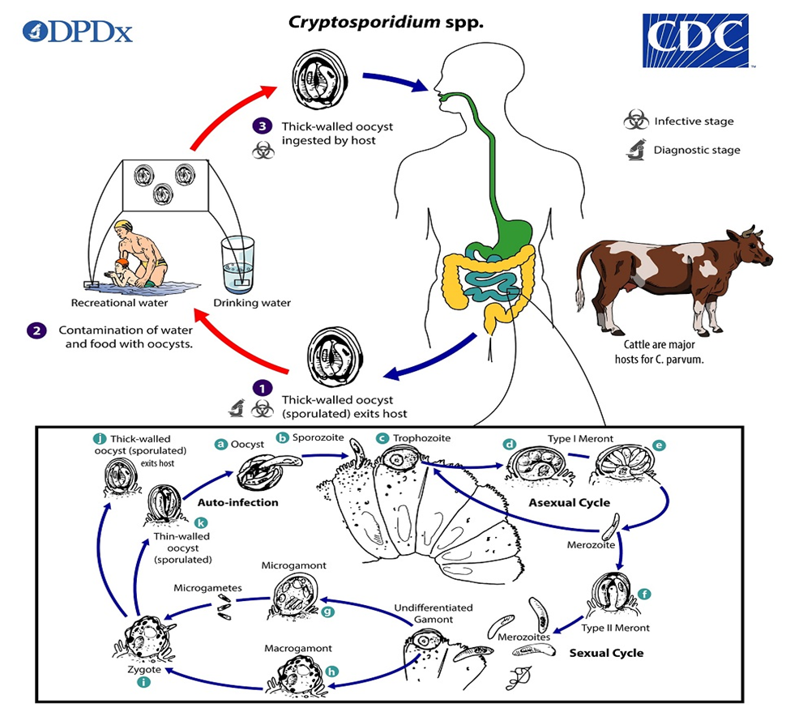

**Fig. 2.1.** Life cycle of *Cryptosporidium* spp.in farm animals (Adapted from [Smith](https://scialert.net/fulltext/?doi=aje.2015.48.63) [*et al*., 2007](https://scialert.net/fulltext/?doi=aje.2015.48.63))

**2.2.3. Epidemiology**

**2.2.3.1. Geographical distribution**

Cryptosporidiosis has been recognized worldwide, primarily in neonatal calves, but also in lambs, goat kids, foals, and piglets. People from both developed and developing countries are vulnerable to this important opportunistic protozoa (Casemore *et al.,* 1985). However; the prevalence of these species varies in different regions of the world*. C. hominis* is by far more prevalent in North and South America, Australia and Africa, while *C. parvum* causes more human infections in Europe, especially in the UK. Geographic variation occurs also within a country and molecular epidemiological studies indicate that the proportion of *C. parvum* infections in humans is much higher in rural than in urban areas (Learmonth *et al.,* 2004). The oocysts of the *Cryptosporidium* can survive for several months and retain infectivity in a latent form outside the host, despite adverse environmental factors, including salinity and chemicals (Smith *et al.,* 2007).

Cryptosporidiosis has long been considered as an important pathogen causing diarrhea in Bangladesh (Shahid *et al.,* 1987). The very first report of cryptosporidiosis in Bangladesh indicates possible zoonotic transmission as reported from calves, animal handlers and associated family members at a dairy farm in Savar (Rahman *et al.,* 1984). In one such study by Khan *et al.,* 2011, *Cryptosporidium* spp. infection was found to occur most commonly in those children who are less than two years of age and was accompanied by watery diarrhea and vomiting. A prospective study on the urban slum in Dhaka reported that malnutrition significantly increases the risk of cryptosporidiosis along with some entero-pathogen (Mondal *et al.,* 2009). Enteric protozoan-associated diarrheal illness with that of the nutritional status and growth of pre-school children in Bangladesh was investigated. (Mondal *et al.,* 2006). A study also indicated that *E. histolytica, C. hominis, C. parvum, and G. lamblia assemblage A* infections are important causes of diarrheal illness (Huttly *et al.,* 1989) which is considered a leading public health problem, particularly in children in Bangladesh (Lima and Guirrent, 1992). *Cryptosporidium* is reported to infect people in at least 106 countries (Fayer, 2004).

**2.2.3.2. Host Range**

In animals, it was found that different species of *Cryptosporidium* infect farm animals while fish, poultry, amphibians and reptiles are also susceptible (Thomson, 2016). Currently, 26 morphologically, biologically and molecular-biologically confirmed different *Cryptosporidium* species are listed (Fayer and Santin, 2007; Elwin *et al.,* 2012; and Adamu *et al.,* 2014), having mammals (primates, bovidae, equidae, carnivora, hares, rabbits, tapiridae and rhinocerotidae), amphibians, reptiles and birds as hosts.

Major species found in mammals are *C. andersoni, C. bovis, C. canis, C. fayeri, C. felis, C. hominis, C. macropodum, C. muris, C. parvum, C. ryanae, C. suis and C. wrairi.* In humans there are two species which are routinely diagnosed in clinical cases of cryptosporidiosis; these are *C. parvum*, also have to be considered potentially zoonotic (Helmy *et al..,* 2013) and *C. hominis* (Morgan-Ryan *et al.,* 2002). Cryptosporidiosis is highly dependent on the immune status of the host and thus, immunocompromised individuals can develop a chronic and life-threatening diarrheal disease while immunocompetent individuals most commonly develop acute self-limiting gastroenteritis (Mohammed *et al.,* 2017). It was estimated that 1 to 10% of the populations in developing countries were infected with *Cryptosporidium*, wherein 1-to-9-year-old children and toddlers were the most affected groups (Chen *et al*., 2003).

There are four species of *Cryptosporidium* which are commonly found in cattle; *C. parvum, C. bovis, C. ryanae and C. andersoni.* Sheep and goats are predominantly infected with *C. parvum*, *C. xiaoi*, *C. bovis* and *C. ubiquitum* although rare occurrences of other species have been reported. The predominant species of *Cryptosporidium* detected in pigs are *C. suis* and *C. scruforum; C. suis* is prevalent in pigs worldwide but causes few clinical signs (Enemark *et al.,* 2003). Avian cryptosporidiosis was first described in 1929 but was not formally recognized until 1955 when *C. meleagridis* was reported in turkeys (Thomson and Ash, 2016). Three species of *Cryptosporidium* are currently known to infect birds; *C. meleagridis*, *C. baileyi*and *C. galli* (Fayer and Santin, 2007).

In fish, three species have been reported and the first species in fish to be described was *C. molnari, which* infect the stomach of gilthead sea bream and European sea bass with few clinical signs (Alvarez-Pellitero and Sitja-Bobadilla, 2002). The other reported species of *Cryptosporidium* infecting fish is *C. scophthalmi* which is found in the intestinal epithelium of turbot (Thomson and Ash, 2016). In amphibians, four species of *Cryptosporidium* have been reported and reptiles, *C. fragile*, *C. varanii*, *C. serpentis* and *C. ducismarci*.

**2.2.3.3. Transmission and Source of *Cryptosporidium***

*Cryptosporidium* oocysts are transmitted between hosts via the fecal-oral route, either directly from contact with the faeces of infected animals or indirectly through environmental contamination or from ingestion of contaminated food or water (Mohammed *et al.,* 2017). *Cryptosporidium* can be transmitted from animals to humans through direct contact. *Cryptosporidium parvum* is highly infectious for young livestock and humans; older livestock can remain infected and excrete oocysts that can be transmitted to other susceptible hosts. Transmission of *C. hominis* is considered to be anthroponotic (Flores and Okhuysen, 2009; Yang *et al.,* 2010). Oocysts can be transmitted following direct contact with feces from an infected individual, or contact with contaminated fomites, or by ingestion of contaminated food or water. Oocysts can survive for long periods (>6 months) in cool, moist environments, and on fomites such as farm gates, buildings and utensils (Mohammed *et al.,* 2017). Calves usually become infected by the oral uptake of oocysts from the environment. Possible major sources of infection, next to infected and shedding neighbor animals, are contaminated stables, feces and dirty teats and udders of suckling cows (Mohamed, 2014).

There are some reports of veterinary students, infected with *C. parvum* when they start working with farm livestock (usually calves) during their studies (Preiser *et al.,* 2003;; Gait *et al.,* 2008) as well as outbreaks amongst members of the public associated with petting zoos or farm visits (Gormley *et al.,* 2011). Retrospective analysis of samples collected at the time of the outbreak has infected hosts can shed huge numbers of oocysts per day, which are immediately infective to other susceptible hosts meaning that infection can pass very quickly between animals kept in close contact to one another (Nydam *et al.,* 2001; Zambriski *et al.,* 2013).

In a review of worldwide waterborne protozoan parasitic illness outbreaks from 2011 to 2016, (Efstratiou *et al.,* 2017) determined that, of the 381 outbreaks documented, with the majority (63%, 239) being associated with *Cryptosporidium* spp. and occurred almost exclusively in the U.S. and New Zealand.

**2.2.4. Risk Factors of *Cryptosporidium:***

**2.2.4.1. Age**

There is a significant association between age and the risk of infection with *Cryptosporidium* (Nguyen *et al.,* 2007). The calves under 3 months are at higher risk of infection compared to the older ones due to the immature immune system of the animal at an early age (Radostits *et al.,* 2006). Cryptosporidiosis due to *C. parvum* is predominantly a problem of neonate animals between the age of 4 and 21 days. A single infected calf can excrete up to 10 billion oocysts during a 2 weeks infection (Clark, 1999).

**2.2.4.2. Pathogen risk factors**

Oocysts are resistant to most disinfectants and can reportedly remain viable for about 18 months in a cool, damp or wet environment, can survive for several months in soil and slurry, but are susceptible to desiccation and temperatures above 60°c. The infectivity of the oocysts can be destroyed by ammonia, formalin, freeze-drying and exposure to temperatures below O°C (32°F) and above 65°C (149°F). Ammonium hydroxide, hydrogen peroxide, chlorine dioxide, 10% formol saline and 5% ammonia are effective in destroying the infectivity of the oocysts. The infectivity of oocysts in calf feces is reduced after 1-4 days of drying. An investigation of the efﬁcacy of different treatments used in food processing (i.e. chlorine, blanching, blast freezing and microwave heating) on the viability of *C. parvum* has showed that oocysts can be destroyed by heat and, to some extent, by freezing, but not by safe concentrations of chlorine (Duhain *et al.,* 2012).

**2.2.4.3. Concurrent infections**

Mixed infections are the most common, but *Cryptosporidium* infection can be significant in its own right. Concurrent infections with other enteropathogens, especially rotavirus and coronavirus, are common and epidemiological investigation suggests that diarrhea is more severe with mixed infections. Immunologically compromised animals are more susceptible to clinical disease than immunocompetent animals (Suleiman and Xiao, 2002).

**2.2.4.4. Immune Status**

Undeveloped immune systems are usually seen in young livestock and human infants. Elderly humans and malnourished persons who are receiving chemotherapy or corticosteroid therapy and HIV positive individuals (Suleiman and Xiao, 2002). These individuals experience increased mortality, decreased weight gain or weight loss and generally poorer performance overall when compared to healthy animals. Cryptosporidiosis infections may develop in immunosuppressed individuals, particularly AIDS patients; these infections may be debilitating and contribute to death. Estimated infection rates in AIDS patients range from 3 to 20% in the United States and 50 to 60% in Africa and Haiti (CFSPH, 2005).

**2.2.4.5 Morbidity and Mortality**

Morbidity and Mortality in North America, approximately 2% of the population is infected and 80% has been exposed at some time. Worldwide; the prevalence is 1 to 4.5% in developed countries and 3 to 20% in developing countries (Mohammed *et al.,* 2017).

**2.2.5. Pathogenesis of *Cryptosporidium***

*Cryptosporidium* infections in calves often occur between one and four weeks of age, and the illness only lasts for a maximum of two weeks (Fayer *et al.,* 2000; Ralston *et al.,* 2003). Oocysts can shed by calves as early as two days of age. At 14 days of age, the peak shedding happens (Olson *et al.,* 2004). According to (deGraaf *et al.,*1999), the pathophysiology of diarrhea caused by *Cryptosporidium* is thought to be caused by parasite invasion and epithelial degradation, which results in mild to severe villus atrophy as well as microvilli shortening and destruction. This will result in decreased transportation and absorption of nutrients. . In cattle, diarrhea, depression, anorexia, and abdominal pain are the most common clinical symptoms of C. parvum (Ralston *et al.,* 2003; Fayer *et al.,* 2000). Clinical cryptosporidiosis is typically seen in calves between the ages of 7 and 30 days. It lasts between four and fourteen days. Calves differ greatly in the severity and length of the condition (Olson *et al.,* 2004). Calves that experience diarrhea may be lethargic, anorexic, and dehydrated for up to two weeks. The diarrhea is a pale yellow color with mucous. Calves that suffer from severe cases of dehydration and cardiovascular collapse pass away. Aside from Rotavirus, *Escherichia coli*, and coccidia, other bacterial, viral, and parasitic diseases can also be seen in calves during their first four weeks of life. The severity of cryptosporidiosis is overstated in this way (Joachim *et al.,* 2003).

**2.2.6. Clinical signs of cryptosporidiosis**

The severity of the infection is also related to the age of the patient. Diarrhoea is a leading cause of illness and death among children aged <5 years in developing countries due to *Cryptosporidium* (Shirley *et al.,* 2012). The duration and the severity of the symptoms and the outcome may vary with host factors such as the immune status of the person (Mohammed *et al.,* 2017). The most common clinical feature of cryptosporidiosis is diarrhea. Characteristically, the diarrhoea is profuse and watery; it may contain mucus but rarely blood and leucocytes and it is often associated with weight loss (Ehsan *et al.,* 2016).

The clinical symptoms may also depend on the parasite species involved. Infections with *C. hominis* are associated with diarrhoea, nausea, vomiting, malaise and non-intestinal sequelae such as joint pain, eye pain, recurrent headache and fatigue, whereas infections with *C. parvum, C. meleagridis, C. canis and C. felis* cause only diarrhoea (Bouzid *et al.,* 2013). The severity of a *Cryptosporidium* infection can vary from an asymptomatic shedding of oocysts to a severe and life-threatening disease (Ehsan *et al.,* 2016). Most immunocompetent persons experience a short-term illness with complete and spontaneous recovery (Current and Garcia, 1991).

**2.2.7. Diagnosis of *Cryptosporidium***

Fecal oocyst identification has historically been the basis for the diagnosis of Cryptosporidiosis. By using specific stains on fecal smears, fecal flotation, or immunologically aided techniques, the oocysts can be found in the feces. The majority of clinical laboratories currently use immunofluorescent assay imaging of fecal oocysts as one of their diagnostic procedures.

**2.2.7.1. Parasitological diagnosis**

Morphological determination of cryptosporidiosis has been the cornerstone of routine laboratory diagnosis (Khan *et al.,* 2018). Several methods exist to detect *Cryptosporidium* in fecal samples. Among them the most common method is microscopy for the detection of oocysts. Fecal samples can be examined directly on slides or after concentration either by flotation or sedimentation to remove fecal debris or to concentrate the number of oocysts; the detection of oocysts in animals with low numbers of oocysts is facilitated (Fayer and Xiao, 2007).The modified Ziehl-Neelsen technique and wet mount preparation methods are often sufficient to detect most *Cryptosporidium* species that have high prevalence rates (Chalmers and Katzer, 2013). Modified acid-fast (MAF) stains followed by microscopic examinations are well known to increase sensitivity (54.8%) (Alles *et al.,* 1995). Visualization of *Cryptosporidium* oocysts by microscopy most commonly done by direct smear and without any staining and by the modified Ziehl-Neelsen stain under light microscopy, whereby the oocysts stain purple with blue background.

**2.2.7.2. Serological diagnosis**

Serological methods are particularly useful tools for screening of large numbers of samples, like in epidemiological surveys. Most serological tests used to identify exposure/infection are enzyme linked immunosorbent assays (ELISA) or enzyme-linked immunoelectro transfer blots (EITB; Western blot) employing various aqueous extracts of *C. parvum* oocysts. Enzyme immunoassay (EIA) methods are fast, inexpensive, easy to be performed, and show sensitivity comparable to that of the immunofluorescence methods. Rapid immune chromatographic (strip) tests can be also used. These tests rely on the detection of cell wall proteins of the oocysts using monoclonal antibodies (Papini and Cardini, 2006).

**2.2.7.3. Molecular detection of *Cryptosporidium***

Several nucleic acid detection techniques are described for the detection of *Cryptosporidium*, some of which may be able to distinguish viable from nonviable oocysts (Egyed *et al*., 2002). Species differentiation using molecular methods can be done in a few different ways; these begin with DNA extraction from oocysts and PCR amplification of the gene(s) of interest. DNA extracted from oocysts can be amplified using standard or nested PCR methods. This is useful if the sample only contains a small amount of DNA as it results in more DNA copies than standard PCR. The real-time PCR is considered as the “gold-standard” for *Cryptosporidium* detection as this method is the most sensitive and can detect as few as 2 oocysts per PCR.

**2.3. *Giardia***

*Giardia duodenalis* (*G. lamblia, G. intestinalis*) is a flagellate protozoan parasite infecting the upper intestinal tract of humans and a wide range of other mammals worldwide. It has a direct life cycle consisting of an environmentally resistant transmission stage known as a cyst. The genus name *Giardia* was established by Kunstler (1882) for a flagellate (*Giardia agilis*) found in the intestine of anuran tadpoles, although several other species, including *Giardia intestinalis*, *Giardia duodenalis* and *Giardia muris*, were described prior to it under other generic names (Dau *et al.,* 1882).

*Giardia duodenalis* was initially described by van Leeuwenhoek in 1681, he made this first observation of *Giardia duodenalis* on the examination of his own diarrheal stools under the microscope (Dobell, 1920).

**2.3.1. Etiology and taxonomy**

*Giardia* is an entero-pathogen, non-cell-invasive which causes *g*iardiasis. In the widely used 1980 classification the protozoa is considered as a subkingdom with seven phyla (Ryan *et al.,* 2021), belong to the Kingdom, Protista; Subkingdom, Protozoa; Phylum, Sarcomastigophora; Subplylum, Mastigophora; Class, Zoomastigophora; Order, Diplomonadida; Family, Hexamitidae (Ryan *et al.,* 2021). This molecular data shows a number of assemblages (similar to genotypes) of *G. duodenalis*, although they are morphologically identical (Thompson, 2016).

There are currently eight recognized genotypes within the *G. duodenalis* species complex, known as Assemblages A to H and There are three recognized sub-assemblages within Assemblage A (AI, AII, AIII) (Ryan and Cacciò, 2013). While Assemblages A and B have been reported in humans and mammalian hosts, Assemblages C and D being found mainly in canines, Assemblage E in hoofed livestock and wildlife, Assemblage F in cats, Assemblage G in rodents, and Assemblage H in seals (Xiao and Feng, 2017). In addition to humans, these two assemblages are also infective to many domestic and wild animals, and are considered to be potentially zoonotic. While Assemblage E predominates in cattle, sheep and pigs, Assemblage A is also frequently reported, and is likely more widespread in cattle than previously thought (Santin, 2020).

**Table 2.2.** Currently recognized species of *Giardia* and genetic groupings (assemblages) within *Giardia duodenalis* of adopted from (Abeywardena *et al.,* 2015)

|  |  |
| --- | --- |
| **Species/assemblages** | **Hosts** |
| *Giardia duodenalis* | |
| Assemblage A | Humans, primates, dogs, cats, livestock, rodents, wild mammals |
| Assemblage B | Humans, primates, dogs, cattle, some species of wild mammals |
| Assemblage C | Dogs, other canids |
| Assemblage D | Dogs, other canids |
| Assemblage E | Cattle and other hoofed livestock |
| Assemblage F | Cats |
| Assemblage G | Rodents |
| Assemblage H | Marine vertebrates |
| *Giardia agilis* | Amphibians |
| *Giardia ardeae* | Birds |
| *Giardia microti* | Rodents |
| *Giardia muris* | Rodents |
| *Giardia psittaci* | Birds |

**2.3.2. Life cycle**

The life cycle begins with the infection by the ingestion of the cyst and the excystation starts at the stomach triggered by the exposure of the cyst to gastric acid, the presence of bile and trypsin in the duodenum and/or the alkaline, protease-rich milieu, duodenum. Excystation ends at the proximal small intestine where the emerging parasites (excyzoites) quickly transform into trophozoites that attach to the intestinal epithelia cells using the adhesive disc. The adhesive disc is essential for attachment and appears to play a major role in the virulence of *Giardia*. At the jejunum, the trophozoites start to encyst forming the wall that enables the parasite to survive outside the host for several weeks in cold water. This process is triggered by a particular composition of biliary secretions, possibly by the deprivation of cholesterol. Regulatory factors are encystation-specific transcription factors, chromatin remodeling enzymes, and post translational modifications, which vary their expression in correlation with the variation of antigens on the parasite surface. Finally, trophozoites and cysts are released with the stool, with cysts continuing the transmission of the disease when ingested by another host (Rodriguez-Morales *et al.,* 2017). Reservoir hosts include humans, as well as a variety of animals, including cats, dogs, dairy cattle, beavers, and other farms, wild and domestic animals such as horses, pigs, cows, chinchillas, alpacas, lemurs, sheep, guinea pigs, monkeys, goats, and rats (Gilman *et al.,* 1985).

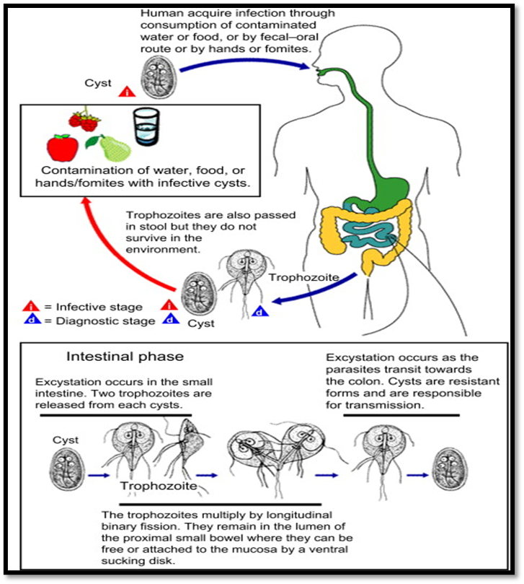

**Fig. 2.2. The life cycle of *Giardia* spp.** (Adapted from Bridle, 2021).

**2.4. Epidemiology**

**2.4.1. Geographical distribution**

Although *Giardia* is well recognized as endemic throughout the world, most cases are reported from both temperate and tropical countries with regular outbreaks commonly reported from developed countries. It is more prevalent in North and South America, Australia and Africa, Iran and causes more human infections in Europe, especially in the UK (Feng and Xiao, 2011). It continues to be the most frequently identified human protozoal enteropathogen. Infection rates are as high as 7 % in the [developed world](https://en.wikipedia.org/wiki/Developed_world) and 30 % in the [developing world](https://en.wikipedia.org/wiki/Developing_world) (Minetti *et al.,* 2016). In 2013, there were approximately 280 million people worldwide with symptomatic cases of giardiasis (Esch and Petersen, 2013). It is popularly known as beaver fever in North America.

**2.4.2. Transmission of giardiasis**

Transmission of giardiasis occurs through the faecal-oral route, and may be either direct (i.e., person-to-person, animal-to-animal or zoonotic) or indirect (i.e., waterborne or foodborne). Person-to-person transmission is a major source of infection has been widely documented (Adam *et al.,* 2016). Sexual transmission of giardiasis has also been documented (Escobedo *et al.,* 2014).While considerably less common than other routes, foodborne transmission of giardiasis has become more widely recognized in recent years.

The waterborne route is probably the most widely recognized means of transmission of giardiasis, with numerous outbreaks being associated with cyst contaminated drinking water (Ryan *et al.,* 2019). Relatively few foodborne outbreaks of giardiasis have been reported worldwide, almost all in the U.S., where a total of 38 outbreaks were reported from 1971 to 2011 (Adam *et al.,* 2016). Direct contamination may also occur through the application of animal faeces or human faeces as fertilizer to crop lands. Indirect contamination of produce at the farm level may occur through the use of faecally contaminated water in irrigation, mixing of pesticides, or washing of produce, hands or equipment (Dixon, 2015).

**2.4.3. Host-specificity**

Many species were named or suggested in the following decades based on presumed host specificity, including *Giardia microti* in voles, *Giardia enterica* in humans, *Giardia equi* in horses, *Giardia bovis* in cattle, *Giardia canis* in dogs, *Giardia cati* and *Giardia felis* in cats, *Giardia ardeae* in birds, and *Giardia varani* in lizards (Thompson and Monis, 2004). In addition to *G. duodenalis* have high specificity to human and have zoonotic recurrence (Feng and Xiao, 2011). However, seven other species of *Giardia* are currently accepted as valid (Ryan and Zahedi, 2019), but are not thought to be infectious to humans.

**2.4.4. Risk factors of giardiasis**

High risk groups include infants and young children, the elderly, institutionalized individuals, travelers, and immunocompromised individuals (Caccio *et al.,* 2018; Leung *et al.,* 2019).*Giardia duodenalis* is also very commonly reported in domestic animals and wildlife, and numerous prevalence studies have been reported worldwide, particularly on livestock (Feng and Xiao, 2011).

**2.4.5. Age**

There are marked variations in reported infection rates in cattle, pigs, sheep and goats, likely due to the age of the animals (Feng and Xiao, 2011; Santin, 2020). In several studies reported young animals demonstrate higher prevalence rates than adults (Santin, 2020). Distribution of *Giardia* assemblages in cattle has been reported as age specific in which Assemblage A predominating in pre-weaned calves and Assemblage E in older animals (Ryan and Cacciò, 2013). *Giardia* has been mostly recorded in calves of 1–6 months of age, rather than animals of >6 months of age reviewed in ([Geurden *et al.,* 2010](https://www.sciencedirect.com/science/article/pii/S0065308X1500010X?via%3Dihub#bib134)). The prevalence of *Giardia* in calves of <6 months has been reported to be 20–73 % globally ([Geurden *et al.,* 2008](https://www.sciencedirect.com/science/article/pii/S0065308X1500010X?via%3Dihub#bib131)).

**2.4.6. Management practices**

The infection rate is also high and variable in companion animals, especially dogs and cats (Ballweber *et al.,* 2010; Bouzid *et al.,* 2013). Assemblage B is less commonly reported in farm animals. Most studies doing molecular characterization of *Giardia* isolates from dogs and cats have reported the presence of Assemblages C and D, although Assemblage A and, to a lesser extent, Assemblage B have also been reported in dogs (Feng and Xiao, 2011).

**2.4.7. Pathogen risk factors**

Usually, *Giardia* cysts are more susceptible to chlorine disinfection than *Cryptosporidium* oocysts (Sterling, 1990).*Giardia* cysts tend to have shorter longevity in the environment. In one study, *Giardia* cysts were shown to survive at - 4° C in water and soil for <1 week, whereas *Cryptosporidium* oocysts survived for >12 weeks (Olson *et al.,* 1999).

**2.5. Clinical sign**

In symptomatic patients are mostly children, the severity of symptoms and the duration of *Giardia* infection are highly variable. In some patients, symptoms last for only 3 or 4 days, while in others the symptoms last for months (Ehsan *et al.,* 2016). Young children are most susceptible to symptoms (Thompson and Ash, 2019). The most prominent clinical signs of the disease are abdominal pain, nausea, followed by severe watery diarrhea, dehydration, malabsorption (particularly lipids and lipid soluble vitamins) and weight loss (Nash *et al.,* 1987). Chronic infections result in malnutrition, micronutrient deficiencies, malabsorption and weight loss, and are associated with impaired growth and cognitive development in young children (Allain and Buret, 2020; Certad *et al.,* 2017; Farthing, 1996).

**2.6. Pathogenesis**

*Giardia* is a non-invasive parasite which infects the small intestine and colonizes the lumen and epithelial surface (Certad *et al.,* 2017). The attachment of trophozoites to the epithelial cells lining the small intestine results in shortening of microvilli, and targets specific signalling networks that can activate apoptosis, leading to the loss of intercellular junctions, cytoskeletal rearrangement, and barrier dysfunction, which contribute to diarrhea (Allain and Buret, 2020;Certad *et al.,* 2017).While *G. duodenalis* trophozoites are generally localized in the proximal small intestine, they have also been identified in the stomach, distal small intestine, caecum, and pancreas (Halliez and Buret, 2013). An acute phase of giardiasis generally lasts for 1–3 weeks, although symptoms may last for months. Most infections are self-limiting, but recurrence is common (Dixon*,* 2021). The mechanisms linking these extra-intestinal complications with giardiasis have yet to be established, but they are not associated with the direct invasion by the parasite (Halliez and Buret, 2013).

**2.7. Diagnosis of giardiasis**

The diagnosis of *Giardia* infections is difficult in that the clinical signs are not specific to the disease. Therefore, finding the parasite in fecal samples confirms the clinical diagnosis. Even in cases when infection incidence is low, the amount of cysts excreted by infected animals—typically up to 106–107 cysts per gram of feces-can seriously contaminate the environment (Thompson and Smith, 2011).

**2.7.1. Microscopic examination**

Giardiasis can be definitively diagnosed by permanent staining with trichrome or iron hematoxylin stains (Hooshyar *et al.,* 2019; Leung *et al.,* 2019) or by microscopically examining wet mounts or concentrated samples to look for cysts or trophozoites (Dixon, 2021). It is well acknowledged that Trichrome staining is the most effective method for examining stool for intestinal protozoa. The permanently stained smear provides a lasting record of the protozoa encountered and aids in the identification and detection of cysts and trophozoites. On the stained smear, tiny protozoa that are frequently overlooked by wet mount analyses of concentrated or unconcentrated materials can be seen. The original gomori tissue staining method was modified into the Wheatley Trichrome approach for fecal materials. It's a quick and easy process that yields well-stained smears of intestinal protozoa, human cells, yeast, and artifact material consistently.

The primary benefit of microscopic inspection is its reduced test cost. Its main drawbacks are the requirement for a qualified and experienced microscopist, the test's poorer sensitivity, and the assay's lengthy processing time. Additionally, because other particles or pseudoparasites can be misdiagnosed as *giardia* cysts, the test has poorer specificity). Visualization of *Giardia* cysts and trophozoite by microscopy most commonly done by direct smear and Trichrome staining under light microscopy, whereby the oocysts stain oval to ellipsoid in shape and background is greenish –blue / yellowish /might be brown in color.

**2.7.2: Antigen detection**

Antigen detection tests include commercially available methods include quick solid-phase qualitative immune chromatography assays, enzyme-linked immunosorbent assays (ELISA), and immunofluorescence assays (IFA). The development and widespread use of the enzyme-linked immunosorbent test (ELISA) for giardiasis diagnosis (Hooshyar *et al.,* 2019).

**2.7.3. Molecular typing**

Molecular methods are now very commonly used in developed countries for the detection of *Giardia* in humans and animals for more accuracy (Thompson and Ash, 2016). PCR-based methods can provide a better understanding of the zoonotic potential and patterns of transmission of the isolations (Ryan *et al.,* 2017; Xiao and Feng, 2017). Understanding the taxonomy, epidemiology, and public health implications of this significant pathogen is hampered by the absence of morphological distinction among *Giardia* spp. isolates (Savioli *et al.,* 2006).

Molecular techniques, however, have improved our comprehension of the differences across parasite isolates (Caccio *et al.,* 2005). Without the necessity for laboratory culture, the PCR-based techniques enable immediate characterization of the parasite isolates from fecal and environmental samples. The detection of genotype and numerous species is also made easier by advanced molecular techniques including multiplexing, real-time PCR, and melting curve analysis. According to Hunter and Thompson (2005), the value of sub-genotyping or strain characterization techniques is to aid in the definition of the transmission map during an epidemic analysis. PCR inhibitors, which are known to exist in DNA isolated from fecal samples, are one of the assay's drawbacks. Another drawback is that certain veterinary diagnostic laboratories may find it to be too costly and labor-intensive (Da Silva *et al.,* 1999).

**2.8. Epidemiological prevalence of *Cryptosporidium* and *Giardia***

Marked seasonal patterns of *Cryptosporidium* and *Giardia* infections have been observed in a number of developed countries, including Australia, Canada, New Zealand, the UK and the USA. A recent review, which analyzed information on patterns of important human enteric zoonotic diseases in temperate climatic zones in developed countries, reported that there is a clear (bimodal) peak of cryptosporidiosis cases in spring and summer seasons. In contrast, giardiasis showed a relatively small peak in summer (Abeywardena *et al.,* 2015). Interestingly, most of the outbreaks associated with drinking and recreational waters have been reported from developed countries (Dixon, 2021).

**2.9. Molecular prevalence of *Cryptosporidium* and *Giardia***

Recent studies suggest that variability among parasite strains, host nutritional status, the composition of gut microbiota, coinfection with other enteropathogens, mucosal immune responses, and immune modulation are relevant factors that inﬂuence disease (Certad *et al.,* 2019).

Results of recent studies with PCR and antigen detection suggest that previous studies underestimated the frequency of infection, identifying *Cryptosporidium* in 15–25 % of children with diarrhea (Samie *et al.,* 2006; Ajjampur *et al.,* 2008). Malnutrition in early childhood also increases the risk of diarrhea with *Cryptosporidium.* In a birth cohort in Bangladesh, stunting at birth was associated with subsequent *Cryptosporidium* infection (Mondal *et al.,* 2012). A review of *gp60* sequence data for *Cryptosporidium,* conducted in developing countries showed *C. hominis* is responsible for 70–90% of human infections (Xiao and Fayer, 2008). Recently, molecular tools using markers in the 60 kDa glycoprotein (*gp60*) gene have improved the ability to identify and differentiate zoonotic *Cryptosporidium* at the genotypic and sub genotypic levels. Such tools can be applied to investigate the distribution of *C. parvum gp60* variants in cattle and human populations in different geographical regions which indicates *C. parvum* is responsible for zoonotic transmission ([Robertson *et al.,* 2014](https://www.sciencedirect.com/science/article/pii/S0065308X1500010X#bib313)).

**Table 2.3.** Molecular prevalence of *Cryptosporidium a*nd *Giardia* infection in calves and human in worldwide

| **Species** | **Molecular prevalence % of *Cryptosporidium* and *Giardia*** | **Reference** | **Country** |
| --- | --- | --- | --- |
| Human and Calves | The Prevalence of *Giardia* and *Cryptosporidium* in calves was (22%) and (5%) and in human it was (11.2%) and (3.2%) | (Ehsan *et al.,* 2015) | Bangladesh |
| Human | *Cryptosporidium* and *Giardia* -infected children less than six months of age was (9%) and (2%) | (Khan *et al.,*2004) | Bangladesh |
| Human | Prevalence of cryptosporidiosisin human was (3%) | (Rahman *et al.,*1990) | Bangladesh |
| Human | The prevalence of cryptosporidiosis was (4.2-6.7%) and (44%) patients who were giardiasis positive. | (Yakoob *et al.,* 2010) | Pakistan |
| Human and calves | The prevalence of *Cryptosporidium* rate in human was reported to be (5.7%).and in calves (7-7.7%) | (Sirisena *et al.,* 2014) | Sri-Lanka |
| Children and calves | The prevalence of cryptosporidiosis and *giardiasis* was (12%) in children and in calves (0 to 35%) for *Cryptosporidium* and (0% to 67% ) for *Giardia* | (Daniels *et al.,* 2015) | India |
| Calves | (22.3%) and (26.9%) respectively for *Cryptosporidium* and *Giardia.* | (Ng *et al.,* 2011) | Australia |
| Calves | (14.4%) were positive for *Cryptosporidium* spp. (9.4%) were positive for *G. duodenalis* | (Zhong *et al.,* 2018) | China |
| Children and cattle | *Cryptosporidium* and *Giardia* infection prevalences was (1.0%) and (3.1%) in children and (3.0%) and (1.4%) in cattle. | (Cardona *et al.,* 2011) | Spain |
| Calves | Prevalence of *G. duodenalis* (42.0%) and *Cryptosporidium* spp. were (27.3%). | (Coklin *et al.,* 2007) | Canada |
| Calves | *Cryptosporidium* oocysts (6.90% ) were in calves | (Mahfouz *et al.,* 2014) | Egypt |

**2.10. Real Time -PCR (qPCR) for detection of *Cryptosporidium* and *Giardia***

Real - time PCR was developed in the early 1990s **(**Higuchi *et al.,* 1992**).** It allows the amplification in PCR to be monitored in real time. There are real - time PCR approaches using TaqMan probes described targeting *Cryptosporidium* and *Giardia* genes. In 2001 and 2003 some author developed probes targeting the Cp11 and 18S rRNA gene of *Cryptosporidium* (Keegan *et al.,* 2003), and in 2002 the β-tubulin gene of *Cryptosporidium* (Tanriverdi *et al.,* 2002**)**. In 2004 some authors targeted the SSUr RNA (Verweij *et al.,* 2004) and the elongation factor 1 (ef1) (Bertrand *et al.,* 2004) of *Giardia*. TaqMan probes are one of the most widely used real - time PCR chemistries mainly because the assay design is easy and the assays are robust. TaqMan assays can be multiplexed by using probes with different colored fluorophores (Monis *et al.,* 2005).

**2.11. Microbiome characterization in fecal sample**

There were nine study participants, all of them were young children, ages two to three. The average amount of time it took for the cholera to stop for all of the study children, who had severe dehydrating diarrhea that was largely diagnosed as the disease, was 72 hours. These cholera patients had varying lengths of hospital admissions, ranging from five to seven days (Monira *et al.,* 2013). It was shown that *V. cholerae* sequences made up 35 % of the patients' entire gut microbiota in terms of relative abundance. The relative abundances that were highest and lowest were 63 % and 5 %, respectively. The vast array of bacteria found in the human gut, referred to as the microbiota, constitute a complex ecosystem. The gut microbiota, also known as commensal microbiota, is made up of a varied community of prokaryotic (eubacteria and archaea) and eukaryotic microbes that coexist harmoniously within their human host (Mai and Draganov, 2009). At least 17 families of bacteria, resulting in 400–500 distinct microbial species, are acquired by the adult gastrointestinal system, with the bacterial composition of the gastrointestinal tract varying depending on the area. From the stomach to the colon, there is typically a qualitative and quantitative increase in complexity. These commensal bacteria govern a number of host functions, including immunological responses, nutrition, and development (Yan and Polk, 2004; Jumpertz *et al.,* 2011). As a result, they effectively control both health and sickness. When compared to healthy calves, diarrheagenic calves showed significant alterations in the content of their feces and a decreased diversity of their gut flora. Diarrheic calves clearly exhibit dysbiosis (Gomez *et al.,* 2017).

Neonatal calf diarrhea (NCD) is a multifaceted symptomatic condition with numerous possible underlying causes. Although changes in the gut microbiota have been linked to diarrhea, not enough research has been done on how diarrhea affects gut communities. And used the 16S rRNA gene to profile the fecal microbial community of 21 calves with different health issues in order to investigate these impacts and identify important bacteria involved. Diarrheic calves showed significantly lower variety and evenness indices as compared to healthy calves. *Proteobacteria* and *Actinobacteriota* showed a noteworthy increase in relative abundance, while Bacteroidetes showed a large reduction in relative abundance. *Escherichia-Shigella* and *Lactobacillus* showed higher relative abundances at the genus level. Notably, *Lactobacillus* was more abundant as the patient recovered from diarrhea. Fecal microbiome dysbiosis was identified as a key feature of non-communicable diseases (NCDs) by clinical observation and bacterial type investigation. This study shows that dysbiosis, which is typified by a low-diversity microbiome, is a major factor contributing to diarrhea in neonatal calves. It's possible that Lactobacillus's greater abundance is responsible for diarrhea's healing effects (Li *et al.,* 2023).

**CHAPTER 3**

**Prevalence of *Cryptosporidium* and *Giardia* Infections among Children and Calves in Chattogram, Bangladesh**

**Abstract**

Cryptosporidiosis and giardiasis are parasitic diseases that may significantly affect human and animal populations, notably cattle and goats. The zoonotic potential and modes of transmission of these diseases have been the subject of several epidemiological studies. A total of 437 fecal specimens were collected in order to determine the prevalence of cryptosporidiosis and giardiasis among both human and animal populations in Bangladesh. Hence, 200 fecal samples from symptomatic children and 237 samples from calves were gathered from healthcare facilities and farms in the Chattogram region. To identify *Cryptosporidium* oocysts and *Giardia* cysts, all samples were stained with a modified Ziehl-Neelsen acid-fast staining protocol (Z-N stain) for *Cryptosporidium* and Trichrome stain for *Giardia*, followed by a polymerase chain reaction (PCR) with partial amplification of *gp60*, *SSU* and *TPI* gene, respectively. Based on the findings of the modified Z-N stain, the prevalence of *Cryptosporidium* infection was determined to be 13.5% among hospitalized children with diarrhea, whereas infected calves exhibited a frequency of 23.63%. However, the *SSU* gene-based polymerase chain reaction (PCR) method revealed that the frequency of *Cryptosporidium* infection was 9.5% among hospitalized children with diarrhea and 19.41% among infected calves. Furthermore, Trichrome staining techniques indicated that the occurrence of *Giardia* in children and calves was 9.5% and 19.41%, respectively. The results obtained from *TPI gene*-based PCR analysis revealed a prevalence rate of 9.00% for *Giardia* infection in children and 10.55% in calves. The study also estimated prevalence’s according to multiple variables such as sex, age, season, breastfeeding etc. However, findings of history of breast feeding and feeding of milk in both cases were statistically significant with the presence of *g*iardiasis but these other findings have no statistical significance (*p*<0.05). The findings from this study can be used as baseline for other researchers to perform extensive research on cryptosporidiosis and giardiasis in both human and animal populations.

**3.1. Introduction**

Cryptosporidiosis and *g*iardiasis are parasitic diseases that may substantially impact humans and animals, particularly cattle and goats. These diseases are often caused by two distinct parasites, *Cryptosporidium* and *Giardia*, and have been attributed to sporadic and outbreak episodes of diarrhea and malnutrition (Šlapeta, 2013). These parasites are important waterborne pathogens due to their high prevalence rate, positive correlation with waterborne outbreaks, and their resistant pattern to multiple disinfectants (Savioli *et al.*, 2006). However, several epidemiological studies have investigated *Giardia* and *Cryptosporidium's* transmission routes and zoonotic potential (Robertson, 2009). There are many different species and genotypes of *Cryptosporidium* and *Giardia* that may infect humans, while cattle are considered to be the primary source of zoonotic transmission of these parasites (Kifleyohannes *et al.,* 2022; Ryan *et al.*, 2021). Giardiasis is a prevalent disease in the United States, with approximately 2 million reported cases annually, as mentioned by the Centers for Disease Control and Prevention (CDC) (Yoder and Beach, 2007). In Asia, Africa, and Latin America, it is estimated that there are over 200 million individuals who have symptomatic giardiasis, with approximately 500,000 new cases being recorded each year (Cacciò and Sprong, 2011). Alongside this, the distribution of cryptosporidiosis is also ubiquitous. According to reports, around 20% of events of pediatric diarrhea in underdeveloped nations are caused by cryptosporidiosis (Ryan *et al.,* 2018; Ryan and Zahedi, 2019).

Currently, there are more than 26 recognized species of *Cryptosporidium*, with more than 40 distinct genotypes that have not been classified as species yet (Ryan *et al.,* 2014a; Ryan *et al.,* 2014b). Over 15 species of *Cryptosporidium* have been associated with human cryptosporidiosis, although *C. hominis* and *C. parvum* account for most cases worldwide. *C hominis* was shown to be the most common species responsible for diarrhea in children in research conducted in Bangladesh, Peru, Brazil, and India (Hira *et al.,* 2011; Mbae *et al.,* 2015; Xiao *et al.,* 2001). A comprehensive analysis of *gp60* sequencing data regarding *Cryptosporidium*, especially in developing countries, suggested that *C. hominis* accounts for around 70-90% of human infections (Thompson, 2008; Xiao and Fayer, 2008). The current study aimed to elucidate the prevalence of cryptosporidiosis and giardiasis in both the human and animal population of Chattogram by utilizing staining and polymerase chain reaction (PCR) approaches. The study also aimed to evaluate the association of different variables with the presence of water borne cryptosporidiosis and giardiasis in human and animal populations.

**3.2. Materials and Methods**

**3.2.1. Description of the study area**

Chittagong, now known as Chattogram is a major coastal city and financial center in southeastern Bangladesh. The district has a total area of 5282.92 square kilometers (2039.74 square miles), of which 1700 square kilometers (456.37 square miles) are coastal. Its estimated population is still over 5 million people, with a population density of 1527 people per square kilometer. Chattogram is situated between 22°14´N and 22°24´N and between 91°46´ E and 91°53´E (Mitra *et al.,* 1994) on the right bank of the river Karnaphuli. Chattogram Metropolitan area (CMA) is located in the Chittagong district sharing a boundary with the Hindu Kush Himalayan region. CMA is situated between approximate 22°06' and 22°34' N, and 91°40' and 92°2' E. Karnafuli River runs from the east towards the south-west, and the Halda River runs from north to south direction and joins the Karnafuli River before it flows into the Bay of Bengal **(Fig. 3.1).** CMA accommodates about 5 million people in approximately 720 km2 areas (BBS, 2012). Chattagram peoples are mostly engaged with business and they are also involved in farming. Chattogram Metropolitan Area was selected for this study using probability sampling.

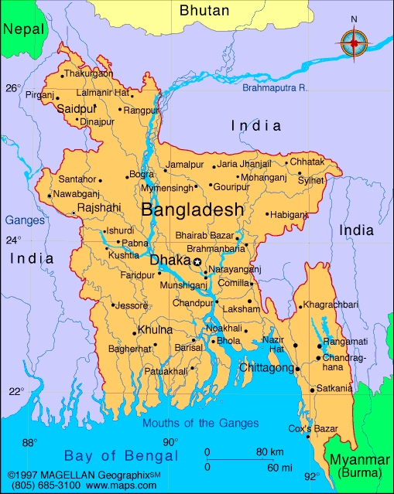

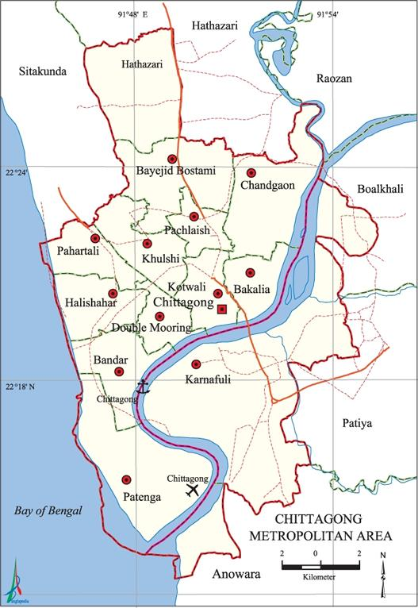

**Fig. 3.1. Map with the location of Chattogram Metropolitan Area**

**(Map Bangladesh|Infoplease)**

**3.2.2. Ethics approval**

In this study, faecal samples were collected from the children and animals, therefore, it was necessary to seek approval from ethics committee. However, notification’ was submitted to the Chattogram Veterinary and Animal sciences University Ethics Committee, because of the collection of personal information using the questionnaire, including information on human illnesses potentially caused by any of the two organisms analysed (CVASU/Dir ( R& E) EC/2019/39(2/10), Date:15/05/2019). Participating farmers signed a written consent form before the delivery of the questionnaire and it was explained to them that they were free to choose whether to answer a question or not. The invitation letter to participate in the research and consent forms is shown in annex-1 and annex-2.

**3.2.3. Sample design**

This study was conducted on a total of 437 (*n* = 437) fecal deposits collected from both humans and cattle suffering from diarrhea. A total of 200 (*n*= 200) human fecal samples were collected from the child patients (1 month to 12 years of age) with gastrointestinal discomfort, such as diarrhea, dehydration, abdominal pain, nausea, and vomiting, referring to the Chattogram Medical College Hospital, Chattogram. In the meantime, 237(*n* = 237) fecal samples were also collected from calves (1 to 6 months of age) originating from different Chattogram metropolitan area's local farms, all having diarrheagenic symptoms. Samples were obtained from the rectum of calves using gloved fingers and were placed in sterile containers with screw caps. A stool specimen weighing between five and ten grams from child patients was collected. Preventive measures were implemented to minimize the risk of cross-contamination between specimens. The samples were promptly moved to a container with an ice bag and kept at a temperature of -20°C. For further examination, the samples were forwarded to the Department of Pathology and Parasitology (DPP), Faculty of Veterinary Medicine, Chattogram Veterinary and Animal Sciences University (CVASU), Chattogram. Data on different demographic and epidemiological variables such as age, gender, clinical manifestations, symptoms, and date of specimen collection were documented on standard pre-tested questionnaire.

**3.2.4. Identification by microscopy**

Before molecular testing, feces samples were examined microscopically for *Cryptosporidium* oocysts and *Giardia* cysts. All samples were stained with modified Ziehl-Neelsen acid-fast (Modified Z-N stain) (Putt, 1951) for *Cryptosporidia* and Trichrome staining (Siwila, 2017) for *Giardia* to detect the presence of *Cryptosporidium* oocysts and *Giardia* cysts, respectively. The microscopic slides were then examined at Leica DM750 Binocular (Wetzlar, Germany) to confirm their presence.

**3.2.5. DNA extraction and PCR analysis**

Genomic DNA from the suspected stool samples was extracted by PureLink™ Microbiome DNA Purification Kit (Catalog Number A29790) following the manufacturer’s instruction. The extracted DNA samples were then subjected to nested polymerase chain reaction (PCR) analysis for molecular-based identification. The PCR-based identification of *Cryptosporidium* and *Giardia* was carried out by a fragment of the *SSU* gene (240 bp) (Nolan *et al.,* 2013) and the *TPI* gene (530 bp) (Sulaiman *et al.,* 2003), respectively. Therefore, the primary amplification of *SSU* was performed by using primers XF2 (forward: 5'-GGAAGGGTTGTATTTATTAGATAAAG-3') and XR2 (reverse: 5'-AAGGAGTAAGGAACAACCTCCA-3') (Koehler *et al.,* 2016), followed by nested amplification of *SSU* using the internal primers pSSUf (forward: 5'-AAAGCTCGTAGTTGGATTTCTGTT-3') and pSSUr (reverse: 5'-ACCTCTGACTGTTAAATACRAATGC-3') (Nolan *et al.,* 2010). For the primary amplification, a cycling protocol of 94 °C for 5 min (initial denaturation), followed by 30 cycles of 94 °C for 45 s (denaturation), 45 °C for 2 min (annealing), and 72 °C for 1.5 min (extension), with a final extension of 72 °C for 10 min was employed. At the same time, the secondary amplification was achieved by employing a cycling protocol of 94 °C for 5 min, followed by 35 cycles of 94 °C for 30 s, 55 °C for 30 s, and 72 °C for 30 s, with a final extension of 72 °C for 10 min (Koehler *et al.,* 2016).

The *TPI* locus was amplified using primers AL3543 (forward: 5'-AAATTATGCCTGCTCGTCG-3') and AL3546 (reverse: 5'-CAAACCTTTTCCGCAAACC-3’), followed by a nested amplification of tpi employing primers AL3544 (forward: 5'-CCCTTCATCGGTGGTAACTT-3') and AL3545 (reverse: 5'-GTGGCCACCACTCCCGTGCC-3') (Sulaiman *et al.,* 2003). For the primary amplification, the cycling protocol was 94 °C for 5 min (initial denaturation), followed by 30 cycles of 94 °C for 45 s (denaturation), 50 °C for 45 s (annealing), and 72 °C for 1 min (extension) and a final extension of 72 °C for 10 min. The secondary amplification of *TPI* was achieved employing 94 °C for 5 min, followed by 30 cycles of 94 °C for 45 s, 55 °C for 30 s, and 72 °C for 1 min, with a final extension at 72 °C for 10 min (Koehler *et al.,* 2016).

**3.2.6. Statistical analysis**

Descriptive and analytic statistics were performed in STATA (2013) after the data was input in Microsoft Excel 2019. The Chi-square test was used to assess and compare *Giardia* and *Cryptosporidium* infection rates with different variables in both children and calves. The graphical demonstration of the data was carried out by Microsoft Excel 2019.Values of *p* < 0.05 were considered statistically significant.

**3.3. Results**

A total of 437 fecal specimens were examined to determine the prevalence of *Cryptosporidium* and *Giardia* infection within human and animal populations in Bangladesh. Therefore, 200 human fecal samples of symptomatic children and 237 calve samples were collected from local hospitals and farms of Chattogram, respectively. According to the modified Z-N stain, the prevalence of *Cryptosporidium* infection among hospitalized diarrheic children and infected calves was 13.5% and 23.63%, respectively **(Fig. 3.2)**. However, in *SSU* gene-based PCR, the prevalence of *Cryptosporidium* infection among hospitalized diarrheic children and infected calves was 9.5% and 19.41%, respectively **(Fig. 3.2)**. Additionally, Trichrome staining revealed that the prevalence of *Giardia* in children and calves was 9.5% and 19.41%, respectively. While *TPI* gene-based PCR showed a 9% *Giardia* infection prevalence in children and 10.55% in calves **(Fig. 3.2)**.

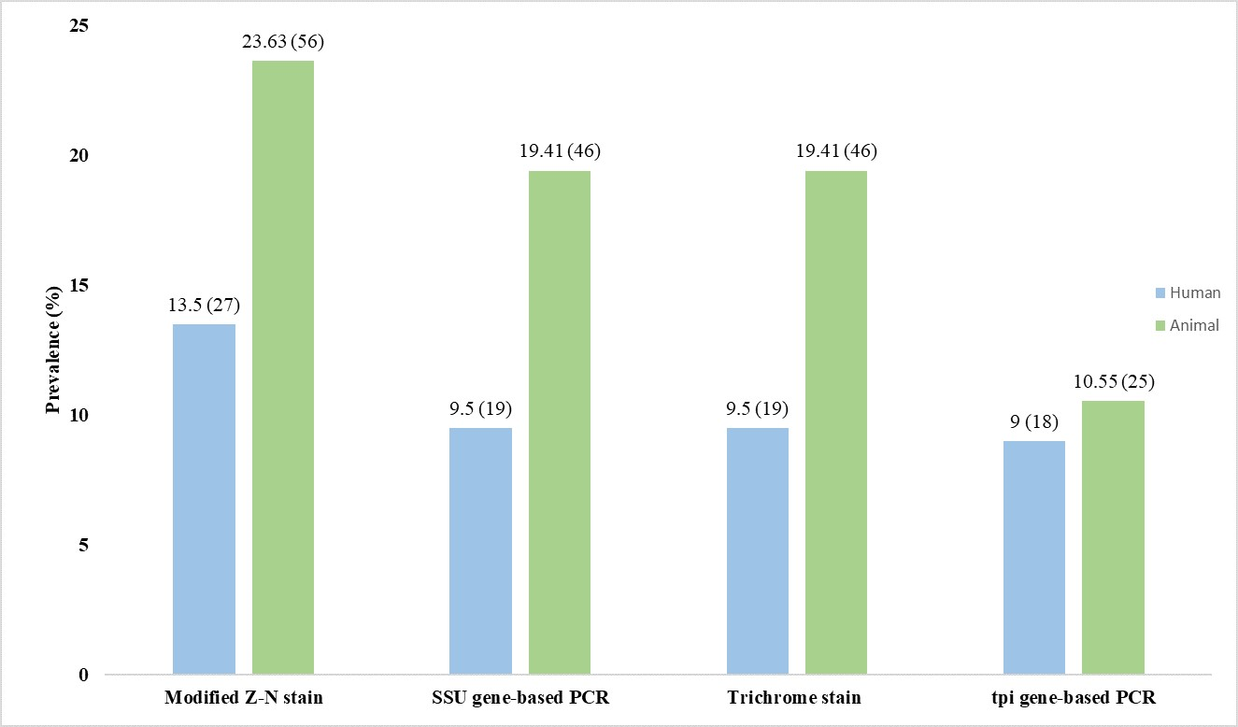

**Fig. 3.2.** The prevalence of cryptosporidiosis and giardiasis in human and animal populations.

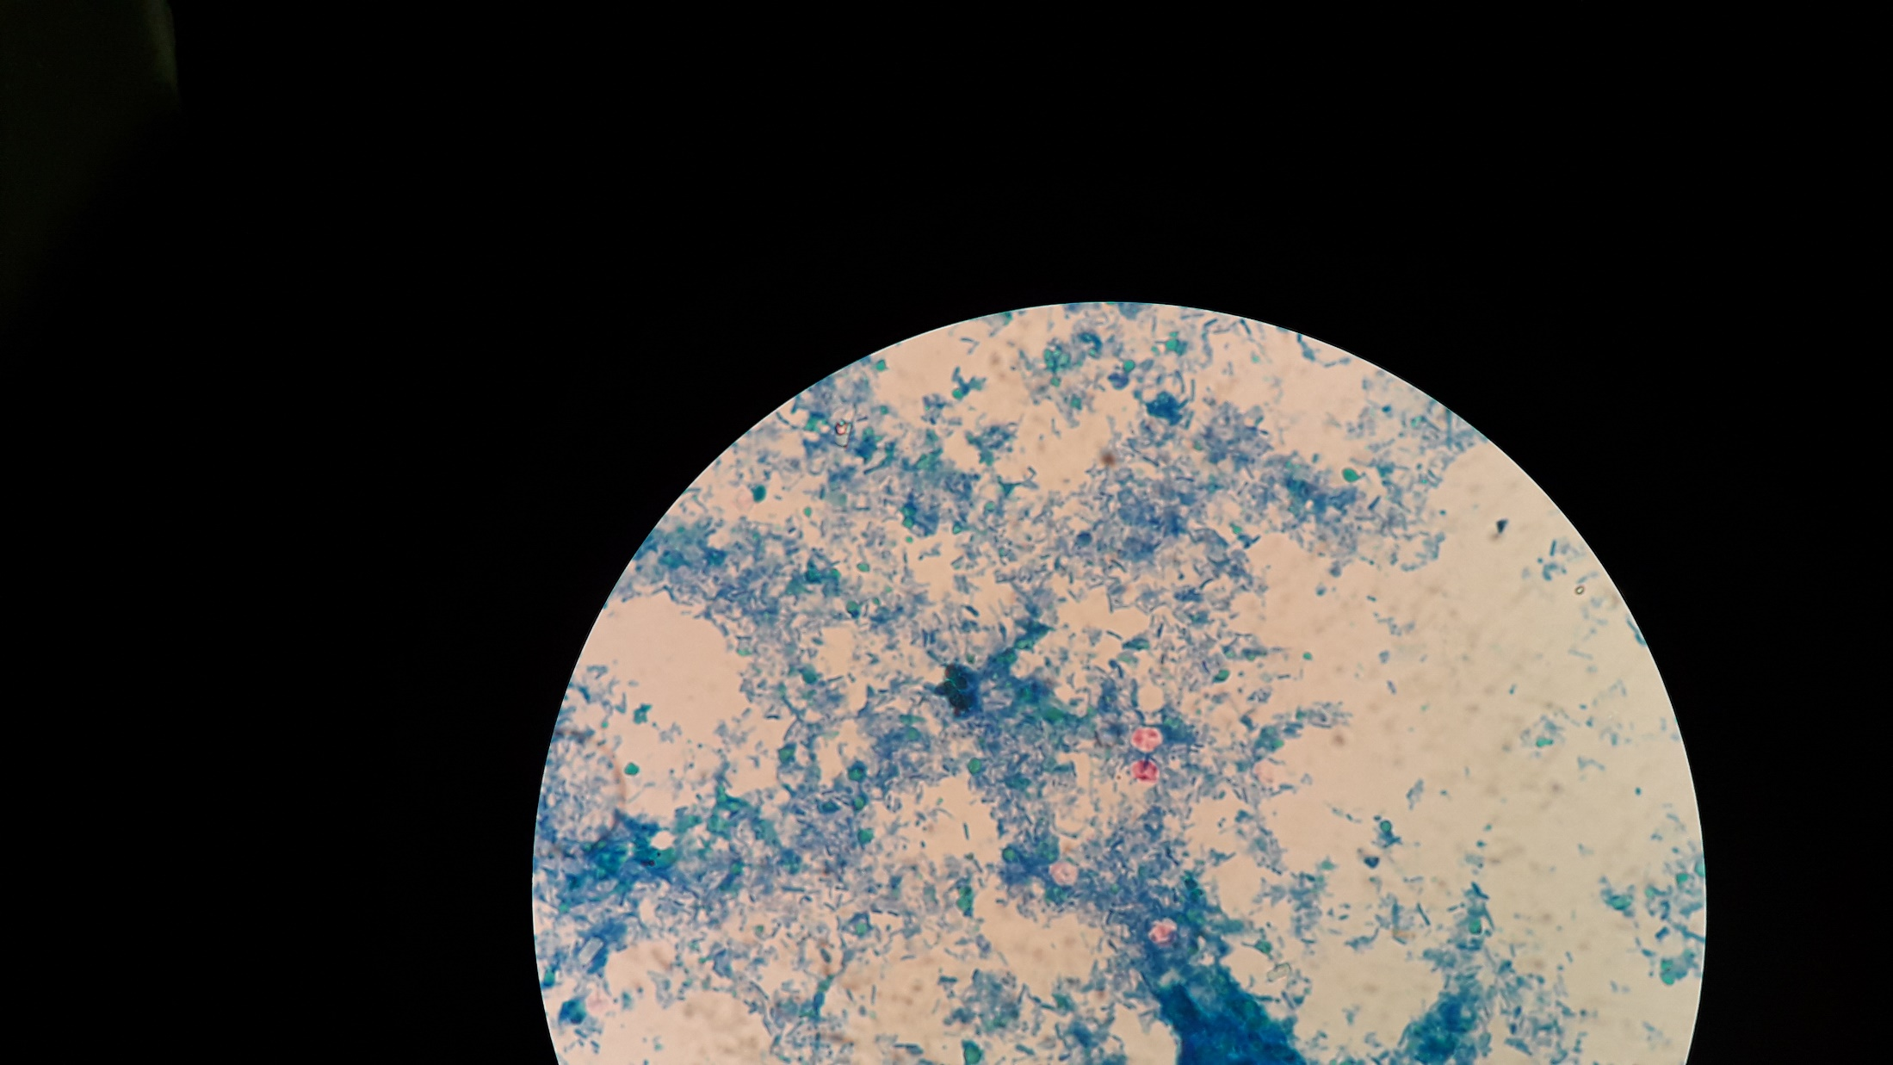

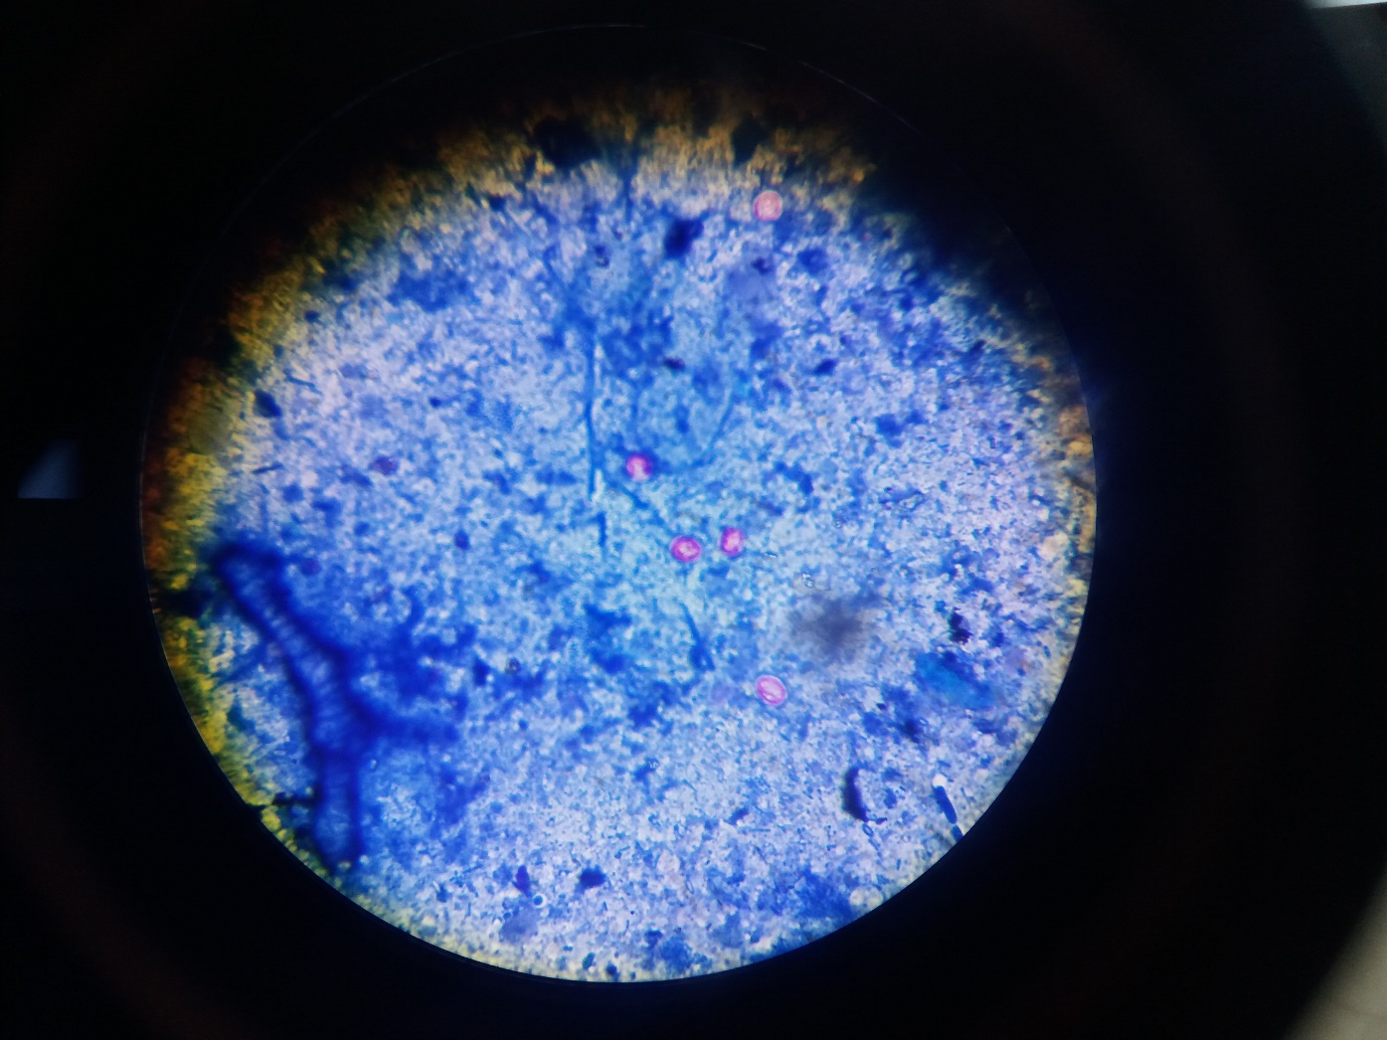

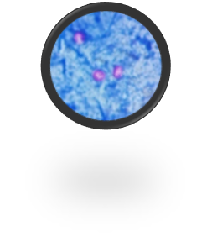

**Oocyst**

**Fig. 3.3.** Oocysts of *Cryptospodium* spp*.* in Ziehl-Neelsen staining under microscop

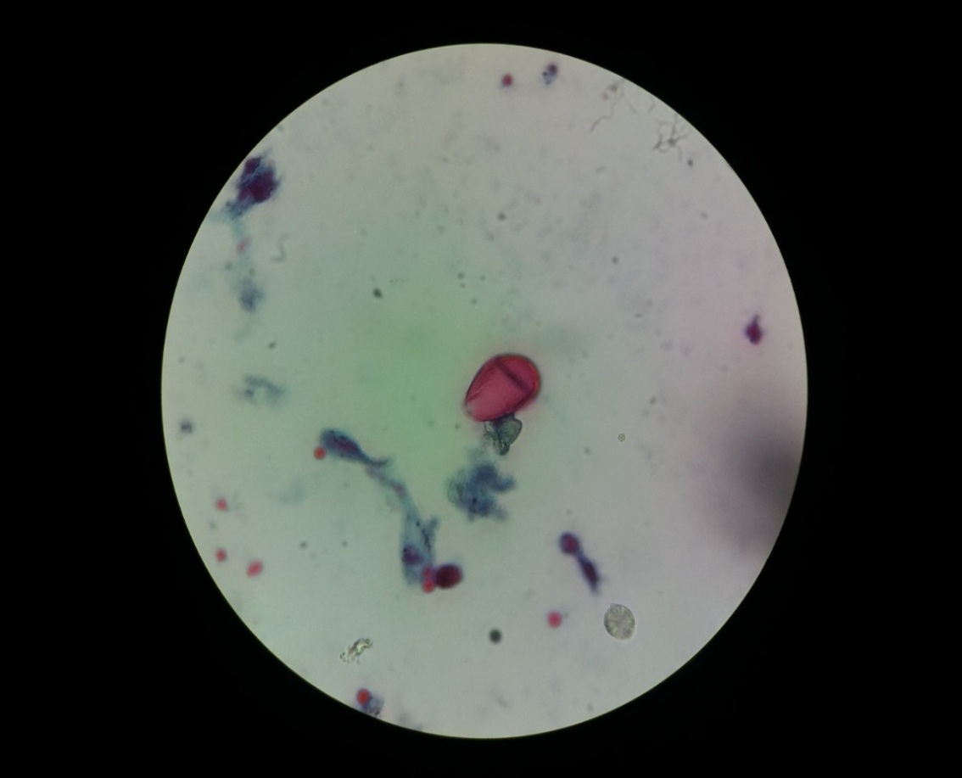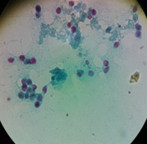

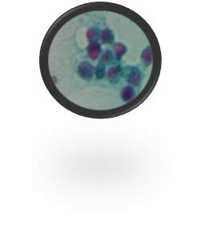

**Cyst**

**Trophozoite**

**Fig. 3.4.** Trophozoite and cyst of *Giardia* spp. in trichrome staining under microscope

M N P 1 2 3 4 5 6

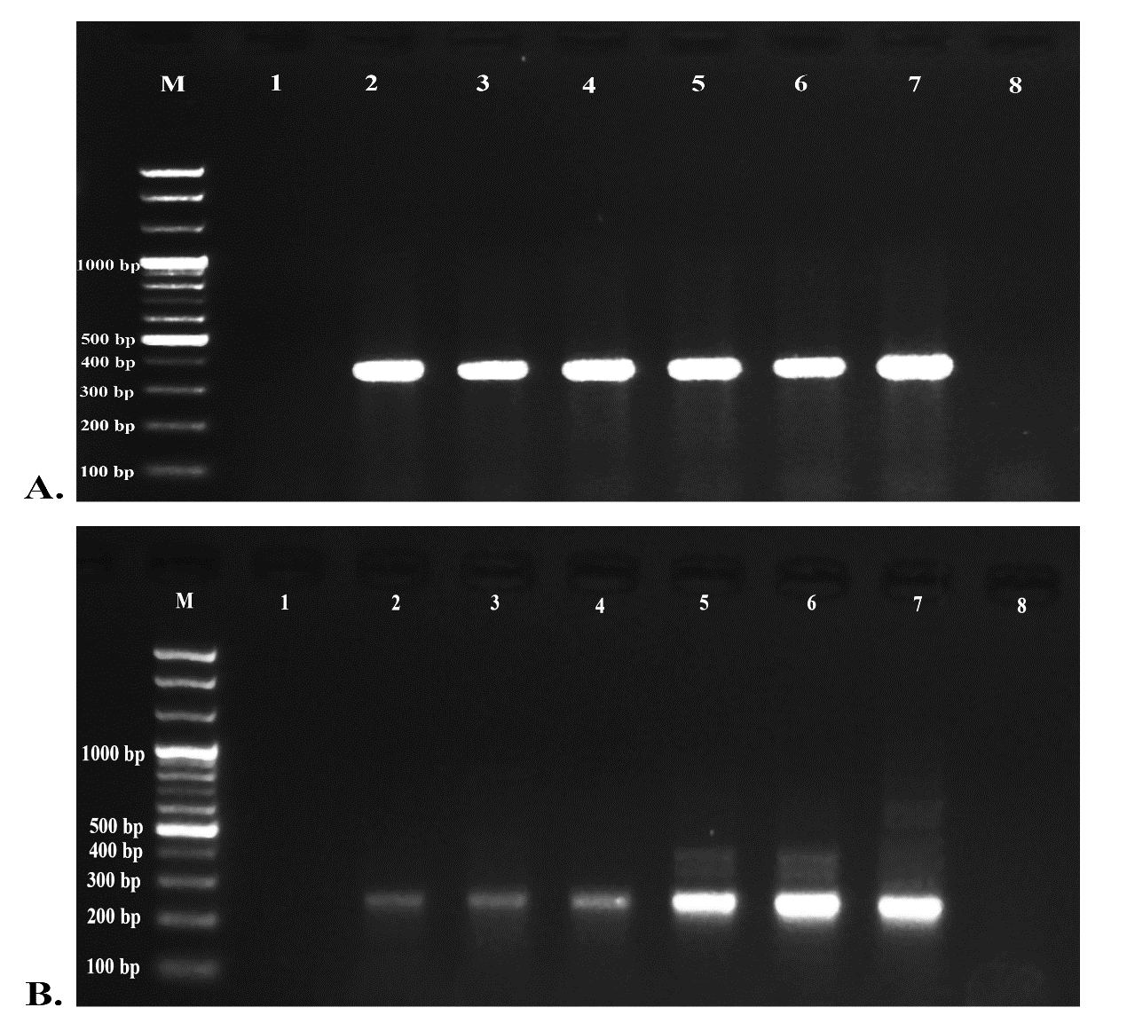

**A.**

M P 1 2 N 4 5 6 7

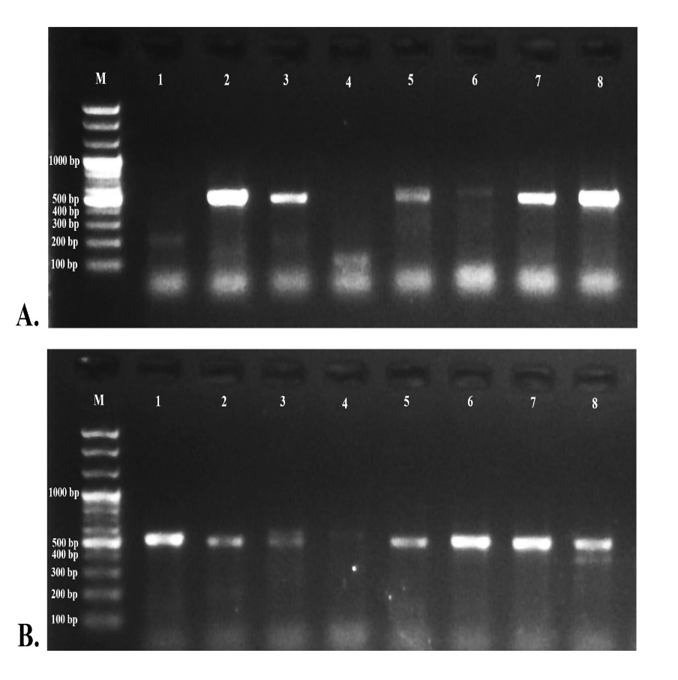

**B.**

**Fig. 3.5.** PCR amplification *of Cryptosporidium and Giardia* gene

**Legend:** PCR amplification of gene *Cryptosporidium* and *Giardia* .**A.** showing positive amplicons at (*SSU)* 240bpand

**B.** showing positive amplicons at (*TPI*) 530bp*.* M: DNA size marker (100–1000 bp*)*, Lane N: Negative control, Lane P: Positive control, Lane (1-5): gene positive isolates.

**Table 3.1.** Descriptive statistics and association of different variables with cryptosporidiosis and giardiasis in the human population diagnosed by PCR

|  |  |  |  |  |  |  |
| --- | --- | --- | --- | --- | --- | --- |
| Variable | Level | Total observation (%) | No. positive for *Cryptosporidium* (%) | *p*-value for χ2 test | No. positive for *Giardia* (%) | *p*-value  for χ2 test |
| Patient type | Outdoor | 81 (40.50) | 6 (7.41) | 0.07 | 10 (12.35) | 0.82 |
| Indoor | 119 (59.50) | 19 (15.97) | 16 (13.45) |
| Gender | Female | 95 (47.50) | 10 (10.53) | 0.42 | 12 (12.63) | 0.88 |
| Male | 105 (52.50) | 15 (14.29) | 14 (13.33) |
| Age (months) | 1 to 10 | 55 (27.50) | 7 (12.73) | 0.24 | 6 (10.19) | 0.85 |
| 11 to 15 | 45 (22.50) | 9 (20.00) | 5 (11.11) |
| 16 to 35 | 50 (25.00) | 6 (12.00) | 7 (14.00) |
| >35 | 50 (25.00) | 3 (6.00) | 8 (16.00) |
| Socio-economic status | Lower income | 56 (28.00) | 4 (7.14) | 0.22 | 10 (17.86) | 0.23 |
| Lower middle income | 141 (70.50) | 20 (14.18) | 15 (10.64) |
| Upper middle income | 3 (1.50) | 1 (33.33) | 1 (33.33) |
| Season of sample collection | Summer | 54 (27.55) | 8 (14.81) | 0.59 | 3 (5.56) | 0.06 |
| Winter | 142 (72.45) | 17 (11.97) | 22 (15.49) |
| Residence | City | 76 (38.00) | 9 (11.84) | 0.56 | 10 (13.16) | 0.92 |
| Slum | 28 (14.00) | 2 (7.14) | 3 (10.71) |
| Village | 96 (48.00) | 14 (14.58) | 13 (13.54) |
| Type of latrine | Sanitary | 118 (59.00) | 11 (9.32) | 0.10 | 13 (11.02) | 0.31 |
| Non-sanitary | 82 (41.00) | 17 (17.07) | 13 (15.85) |
| Source of water | Pond | 7 (3.52) | 1 (14.29) | 0.73 | 3 (42.86) | 0.06 |
| Supply | 98 (49.25) | 10 (10.20) | 11 (11.22) |
| Tube well | 94 (47.24) | 13 (13.83) | 12 (12.77) |
| History of Breast feeding | Yes | 115 (57.50) | 14 (12.17) | 0.55 | 14 (12.17) | 0.02* |
| No | 82 (41.00) | 10 (12.20) | 10 (12.20) |
| Mix | 3 (1.50) | 1 (33.33) | 2 (66.67) |
| History of pet  rearing | Yes | 96 (48.00) | 14 (14.58) | 0.39 | 10 (10.42) | 0.30 |
| No | 104 (52.00) | 11 (10.58) | 16 (15.38) |
| History of anthelmintics | Yes | 57 (28.50) | 5 (8.77) | 0.31 | 5 (8.77) | 0.26 |
| No | 143 (71.50) | 20 (13.99) | 21 (14.69) |

*Significant

Legend: Variables showing the significant (*p*<0.05) association of different factors with the presence of *Cryptosporidium* and *Giardia* in the human population

**Table 3.1**. Summarises the descriptive statistics and associations between various variables with occurrences of cryptosporidiosis and giardiasis in the human population, as identified by the PCR method. In humans, gender-based distributions for cryptosporidiosis and giardiasis showed that males (14.29% in cryptosporidiosis and 13.33% in giardiasis) were at a higher risk of infection than females (10.53% in cryptosporidiosis and 12.63% in giardiasis), but the difference was not statistically significant (*p*> 0.05). Cryptosporidiosis was more prevalent in children aged 11-15 months, whereas giardiasis was more frequent in children older than 35 months. Nevertheless, none of the associations find any statistically significant associations except history of breast feeding with the presence of giardiasis. The variation of seasons influences the prevalence of cryptosporidiosis and giardiasis in the human population. Giardiasis (15.49%) was shown to be more likely to spread during the winter months, while cryptosporidiosis (14.81%) was more prevalent in the summer. However, no statistically significant differences (*p* > 0.05) were found across the seasons. In all scenarios, children residing in rural areas were more susceptible to infection (14.58% in cryptosporidiosis and 13.54% in giardiasis) than their counterparts residing in urban areas, including city and slum environments. Additionally, children who were deprived of proper sanitation were more susceptible to both kinds of infections (17.07% in cryptosporidiosis and 15.85% in giardiasis). Water sources were also impacted by both kinds of infections, where children who consumed pond water rather than supplied with tube-well water, were more prone to cryptosporidiosis (14.29%) and giardiasis (42.86%). No statistically significant (*p*> 0.05) changes were identified in both circumstances. Children without a history of being breastfed are more susceptible to both types of infections, where no significant differences were observed *(p* > 0.05).

The correlations between clinical characteristics and disease prevalence were also investigated and analyzed. The condition was not shown to be associated with a history of nausea, abdominal pain, anorexia, vomiting, or dehydration **(Table 3.2).**

**Table 3.2.** Description of clinical findings in cryptosporidiosis and giardiasis in the human population diagnosed by PCR

|  |  |  |  |  |  |  |
| --- | --- | --- | --- | --- | --- | --- |
| Clinical findings | Level | Total observation (%) | No. positive for *Cryptosporidium* (%) | *p*-value  for χ2 test | No. positive for *Giardia* (%) | *p*-value  for χ2 test |
| History of nausea | Yes | 68 (34) | 6 (8.82) | 0.26 | 8 (11.76) | 0.71 |
| No | 132 (66) | 19 (14.39) | 18 (13.64) |
| Abdominal discomfort | Yes | 76 (38.00) | 10 (13.16) | 0.82 | 7 (9.21) | 0.21 |
| No | 124 (62.00) | 15 (12.10) | 19 (15.32) |
| Anorexia | Yes | 15 (7.50) | 2 (13.33) | 0.91 | 2 (13.33) | 0.97 |
| No | 185 (92.50) | 23 (12.43) | 24 (12.97) |
| Vomiting | Yes | 68 (34.0) | 13 (19.12) | 0.04 | 11 (16.18) | 0.34 |
| No | 132 (66.0) | 12 (9.09) | 15 (11.36) |
| Dehydration | Yes | 103 (51.50) | 15 (14.56) | 0.36 | 15 (14.56) | 0.50 |
| No | 97 (48.50) | 10 (10.31) | 11 (11.34) |

*Significant

Legend: Variables showing the significant (*p* < 0.05) association of clinical findings with the presence of *Cryptosporidium* and *Giardia* in the human population

**Table 3.3.** Descriptive statistics and association of different variables with *Cryptosporidium* at the animal level diagnosed by PCR

|  |  |  |  |  |
| --- | --- | --- | --- | --- |
| **Variable** | **Level** | **Total observation**  **(%)** | **No. positive for**  ***Cryptosporidium* (%)** | ***p*-value**  **for χ2 test** |
| Sex | Female | 144 (60.76) | 19 (13.19) | 0.58 |
| Male | 93 (39.24) | 10 (10.75) |
| Age (days) | 1 to 15 | 49 (20.68) | 6 (12.24) | 0.35 |
| 16 to 30 | 58 (24.47) | 7 (12.07) |
| 31 to 60 | 70 (29.54) | 12 (17.14) |
| >60 to 180 | 60 (25.32) | 4 (6.67) |
| Feces consistency | Liquid | 158 (66.67) | 19 (12.03) | 0.87 |
| Semi liquid | 74 (31.22) | 9 (12.16) |
| Solid | 5 (2.11) | 1 (20.00) |
| Feces color | Yellowish | 168 (70.89) | 21 (12.50) | 0.20 |
| Bloody | 9 (3.80) | 3 (33.33) |
| Greenish | 50 (21.10) | 4 (8.0) |
| Normal | 10 (4.22) | 1 (10.0) |

*Borderline Significant, **Significant

Legend: Variables showing the significant (*p* < 0.05) association of animal level factors with the presence of *Cryptosporidium*

**Table 3.4.** Descriptive statistics and association of different variables with *Cryptosporidium* at farm level diagnosed by PCR

| Variable | Level | Total  observation  (%) | No. positive for  *Cryptosporidium*  (%) | *p*-value  for χ2 test |
| --- | --- | --- | --- | --- |
| Owners’ education | Illiterate | 7 (3.93) | 0 | 0.16 |
| Primary | 24 (13.48) | 3 (12.50) |
| Secondary | 42 (23.60) | 7 (16.67) |
| Higher secondary | 32 (17.98) | 8 (25.00) |
| Graduation | 44 (24.58) | 3 (6.82) |
| Post-graduation | 30 (16.85) | 5 (16.67) |
| Topography | Hilly | 34 (18.89) | 6 (17.65) | 0.55 |
| Plain land | 146 (81.11) | 20 (13.70) |
| Herd size | 1 to 10 | 31 (17.22) | 2 (6.45) | 0.38 |
| 11 to 20 | 50 (27.78) | 10 (20.00) |
| 21 to 50 | 58 (32.22) | 9 (15.52) |
| >50 | 41 (22.78) | 5 (12.20) |
| Calf population | 1 to 5 | 76 (42.22) | 13 (17.11) | 0.70 |
| 6 to 10 | 57 (31.67) | 6 (10.53) |
| 11 to 20 | 37 (20.56) | 5 (13.51) |
| >20 | 10 (5.56) | 2 (20) |
| Types of calf house | Closed barn | 116 (64.44) | 17 (14.66) | 0.99 |
| Open barn | 15 (8.33) | 2 (13.33) |
| Partial open | 49 (27.22) | 7 (14.29) |
| Floor type | Brick | 92 (51.11) | 13 (14.13) | 0.97 |
| Concrete | 73 (40.56) | 11 (15.07) |
| Muddy/jute/wood | 15 (8.33) | 2 (13.33) |
| Type of litter in calf pen | None | 93 (51.67) | 10 (10.75) | 0.21 |
| Rubber pad | 58 (32.22) | 12 (20.69) |
| Jute bag | 22 (12.22) | 2 (9.09) |
| Others | 7 (3.89) | 2 (28.57) |
| Drainage system | Good | 72 (40.0) | 12 (16.67) | 0.66 |
| Moderate | 77 (42.78) | 9 (11.69) |
| Bad | 31 (17.22) | 5 (16.13) |
| Source of drinking water | Ground | 126 (70.0) | 20 (15.87) | 0.64 |
| Pond or stream | 2 (1.11) | 0 |
| Supply | 52 (28.89) | 6 (11.54) |
| Disinfection of drinking water | Yes | 0 | 0 | - |
| No | 180 (100) | 26 (14.44) |
| Type of drainage system | None | 32 (17.78) | 5 (15.63) | 0.75 |
| Open | 118 (65.56) | 18 (15.25) |
| Sub-surface | 30 (16.67) | 3 (10.00) |
| Flooding/failure in drainage system | Yes | 22 (12.22) | 1 (4.55) | 0.24 |
| No | 158 (87.78) | 21 (13.29) |
| Animals graze around water ways | Yes | 38 (21.11) | 5 (13.16) | 0.80 |
| No | 142 (78.89) | 21 (14.79) |
| Number of animals had diarrhea in last 30 days | None | 69 (38.33) | 10 (14.44) | 0.95 |
| 1 to 2 | 62 (34.44) | 10 (16.13) |
| 3 to 5 | 42 (23.33) | 5 (11.90) |
| 6 to 20 | 7 (3.89) | 1 (14.29) |
| Animal death due to diarrhea in last 30 days | No | 177 (98.33) | 25 (14.12) | 0.35 |
| Yes | 3 (1.67) | 1 (33.33) |
| Separation of diseased stock | Yes | 69 (38.33) | 10 (14.49) | 0.98 |
| No | 111 (61.67) | 16 (14.41) |
| Change of bedding before introducing newborns | Yes | 100 (55.56) | 19 (19.0) | 0.05* |
| No | 80 (44.44) | 7 (8.75) |
| Frequency of bedding change | Never | 18 (10.0) | 2 (11.11) | 0.72 |
| Weekly | 111 (61.67) | 16 (14.41) |
| Fortnightly | 46 (25.56) | 8 (17.39) |
| Monthly | 5 (2.78) | 0 |
| Newly introduced calves | Yes | 3 (1.67) | 0 | 0.47 |
| No | 177 (98.33) | 26 (14.69) |
| Hygiene of calf feeding utensils | Not shared | 25 (13.89) | 7 (28.0) | 0.11 |
| Shared and disinfected | 45 (25.0) | 6 (13.33) |
| Shared and washed with water | 110 (61.11) | 13 (11.82) |
| Feeding of milk | Hand feeding | 3 (1.67) | 2 (66.67) | 0.01** |
| Suckling | 177 (98.33) | 24 (13.56) |

*Significant

Legend: Variables showing the significant (*p* < 0.05) association of farm level factors with the presence of *Cryptosporidium*

**Table 3.5.** Descriptive statistics and association of different variables with *Giardia* at farm level diagnosed by PCR

|  |  |  |  |  |
| --- | --- | --- | --- | --- |
| Variable | Level | Total observation (%) | No. positive for *Giardia* (%) | *p*-value  for χ2 test |
| Owners’ education | Illiterate | 7 (3.93) | 0 | 0.55 |
| Primary | 24 (13.48) | 0 |
| Secondary | 42 (23.60) | 2 (4.76) |
| Higher secondary | 32 (17.98) | 1 (3.13) |
| Graduation | 44 (24.58) | 3 (6.82) |
| Post-graduation | 30 (16.85) | 0 |
| Topography | Hilly | 34 (18.89) | 4(5.88) | 0.35 |
| Plain land | 146 (81.11) | 2 (2.47) |
| Herd size | 1 to 10 | 31 (17.22) | 2 (6.45) | 0.25 |
| 11 to 20 | 50 (27.78) | 3 (6.00) |
| 21 to 50 | 58 (32.22) | 0 |
| >50 | 41 (22.78) | 1 (2.44) |
| Calf population | 1 to 5 | 76 (42.22) | 4 (5.26) | 0.26 |
| 6 to 10 | 57 (31.67) | 1 (1.75) |
| 11 to 20 | 37 (20.56) | 0 |
| >20 | 10 (5.56) | 1 (10.0) |
| Types of calf house | Closed barn | 116 (64.44) | 4 (3.45) | 0.74 |
| Open barn | 15 (8.33) | 0 |
| Partial open | 49 (27.22) | 2 (4.08) |
| Floor type | Brick | 92 (51.11) | 3 (3.26) | 0.06 |
| Concrete | 73 (40.56) | 1 (1.37) |
| Muddy/jute/wood | 15 (8.33) | 2 (13.33) |
| Type of litter in calf pen | None | 93 (51.67) | 2 (2.15) | 0.13 |
| Rubber pad | 58 (32.22) | 1 (1.72) |
| Jute bag | 22 (12.22) | 2 (9.09) |
| Others | 7 (3.89) | 1 (14.29) |
| Drainage system | Good | 72 (40.0) | 1 (1.39) | 0.40 |
| Moderate | 77 (42.78) | 3 (3.90) |
| Bad | 31 (17.22) | 2 (6.45) |
| Source of drinking water | Ground | 126 (70.0) | 4 (3.17) | 0.94 |
| Pond or stream | 2 (1.11) | 0 |
| Supply | 52 (28.89) | 2 (3.85) |
| Disinfection of drinking water | Yes | 0 | 0 | 0.71 |
| No | 180 (100) | 6 (3.41) |
| Type of drainage system | None | 32 (17.78) | 2 (6.25) | 0.59 |
| Open | 118 (65.56) | 3 (2.54) |
| Sub-surface | 30 (16.67) | 1 (3.33) |
| Flooding/failure in drainage system | Yes | 22 (12.22) | 1 (4.55) | 0.74 |
| No | 158 (87.78) | 5 (3.16) |
| Animals graze around water ways | Yes | 38 (21.11) | 1 (5.26) | 0.46 |
| No | 142 (78.89) | 4 (2.82) |
| Number of animals had diarrhea in last 30 days | None | 69 (38.33) | 3 (4.35) | 0.23 |
| 1 to 2 | 62 (34.44) | 2 (2.23) |
| 3 to 5 | 42 (23.33) | 0 |
| 6 to 20 | 7 (3.89) | 1 (14.29) |
| Animal death due to diarrhea in last 30 days | No | 177 (98.33) | 6 (3.39) | 0.75 |
| Yes | 3 (1.67) | 0 |
| Separation of diseased stock | Yes | 69 (38.33) | 2 (2.90) | 0.80 |
| No | 111 (61.67) | 4 (3.60) |
| Change of bedding before introducing newborns | Yes | 100 (55.56) | 2 (2.00) | 0.27 |
| No | 80 (44.44) | 4 (5.00) |
| Frequency of bedding change | Never | 18 (10.0) | 1 (5.56) | 0.18 |
| Weekly | 111 (61.67) | 3 (2.70) |
| Fortnightly | 46 (25.56) | 1 (2.17) |
| Monthly | 5 (2.78) | 1 (20.00) |
| Newly introduced calves | Yes | 3 (1.67) | 1 (33.33) | 0.004* |
| No | 177 (98.33) | 5 (2.82)) |
| Hygiene of calf feeding utensils | Not shared | 25 (13.89) | 1 (4.00) | 0.35 |
| Shared and disinfected | 45 (25.0) | 0 |
| Shared and washed with water | 110 (61.11) | 5 (4.55) |
| Feeding of milk | Hand feeding | 3 (1.67) | 1 (33.33) | 0.004* |
| Suckling | 177 (98.33) | 5 (2.82) |

*Significant

Legend: Variables showing the significant (*p* < 0.05) association of farm level factors with the presence of *Giardia*

**Table 3.6.** Descriptive statistics and association of different variables with *Giardia* at animal level diagnosed by PCR

|  |  |  |  |  |
| --- | --- | --- | --- | --- |
| Variable | Level | Total observation (%) | No. positive for *Giardia* (%) | *p*-value  for χ2 test |
| Sex | Female | 144 (60.76) | 4 (2.78) | 0.77 |
| Male | 93 (39.24) | 2 (2.15) |
| Age (days) | 1 to 15 | 49 (20.68) | 1 (2.04)) | 0.30 |
| 16 to 30 | 58 (24.47) | 3 (5.17) |
| 31 to 60 | 70 (29.54) | 0 |
| >60 to 180 | 60 (25.32) | 2 (3.33) |
| Feces consistency | Liquid | 158 (66.67) | 3 (1.90) | 0.87 |
| Semi liquid | 74 (31.22) | 3 (4.05) |
| Solid | 5 (2.11) | 0 |
| Feces color | Yellowish | 168 (70.89) | 5 (2.98) | 0.88 |
| Bloody | 9 (3.80) | 0 |
| Greenish | 50 (21.10) | 1 (2.00) |
| Normal | 10 (4.22) | 0 |

*Significant

Legend: Variables showing the significant (*p* < 0.05) association of animal level factors with the presence of *Giardia*

Although the frequency was found to be much higher in female (13.19%) cryptosporidiosis and (2.78 %) giardiasis and in male (10.75%) cryptosporidiosis and (2.15%) giardiasis in case of calves, the association had no significant differences (*p* > 0.05). The frequency of cryptosporidiosis was found to be relatively high in calves aged between 31 and 60 days; and in case of *Giardia* it was higher in calves aged between 16-31 days, though the association was not significant across the age groups(*p* > 0.05) **(Table 3.3 and 3.6).** In case of feces consistency cryptosporidiosis was found to be (12.03%) high in liquid feces and in giardiasis it was high in semi-liquid feces (4.05%) and no statistically significance difference was seen. In both cases cryptosporidiosis and giardiasis was more in yellowish color feces without achieving statistical significance (*p* > 0.05).

At the farm level, the frequency of cryptosporidiosis and giardiasis was shown to be independent of many factors, including the education level of owners, topography, types of calf housing, and floor type (*p* > 0.05) **(Table 3.4 and Table 3.5).** Nevertheless, a substantial prevalence of cryptosporidiosis was seen in calves residing in hilly regions (17.65%) and giardiasis was seen (5.88%). Furthermore, it was shown that the incidence of Cryptosporidiosis was comparatively elevated in calves that were exposed to groundwater (15.87%) as opposed to pond (0.00%) or supply water (11.54%) and also in giardiasis it was high in ground water sources. However, no statistically significant difference was seen between these variables (*p* > 0.05).

Despite this, a farm's drainage system does not affect cryptosporidiosis and giardiasis prevalence. Notably, calves that had fortnightly bedding changes had a higher frequency (17.39%) of cryptosporidiosis but not in giardiasis although this difference was not statistically significant (*p* > 0.05). There was also an increase in the frequency (28.0%) of cryptosporidiosis among calves that did not share feeding utensils but not in giardiasis. Cryptosporidiosis was present in newly introduced calves and there was no any significance differences between those variable but in case of giardiasis it was (33.33%) positive and had a higher significance frequency. However, there were no other significant differences (*p* > 0.05) between the two feeding methods **(Table 3.4 and Table 3.5).**

**3.4. Discussion**

Cryptosporidiosis and giardiasis are gastrointestinal (GI) diseases caused by parasitic protozoa such *Cryptosporidium* and *Giardia*, respectively (Ehsan *et al.,* 2015). Understanding the factors that influence the prevalence of these infections is essential for public health efforts. However, the present study delves into gender-based distributions, age, season, urban-rural residence, water sources, breastfeeding, and pet ownership/exposure to anthelmintics, analyzing their potential impact on the prevalence of cryptosporidiosis and giardiasis in the human population. The data suggests a slight gender-based difference in infection rates, with males showing a marginally higher risk for both cryptosporidiosis (14.29%) and giardiasis (13.33%) compared to females (10.53% and 12.63%, respectively). However, these differences were not statistically significant (*p* > 0.05). It is important to note that gender alone may not be a primary determinant of infection risk, and other factors may play a more significant role. Regarding giardiasis, the findings are similar to the previous study (Suman *et al.,* 2011). Additionally, research conducted in India and Nigeria has shown a higher prevalence of giardiasis infection in males than females (Dwivedi *et al.,* 2007).The data also indicates that cryptosporidiosis is more prevalent in children aged 11-15 months, whereas giardiasis is more frequent in children older than 35 months. The prevalence of giardiasis is analogous to other previous studies (Haque *et al.,* 2003) and (Suman *et al.,* 2011). However, the potential factors contributing to this age-dependent trend are likely associated with the behaviors of children. Another potential factor contributing to the increased incidence of infections in children might be the insufficient development of efficient immunity (Suman *et al.,* 2011). However, no statistically significant differences were found. This suggests that while age may contribute to susceptibility, it is not a sole determinant of infection risk. Seasonal variation substantially impacts the prevalence and incidence of cryptosporidiosis and giardiasis, where the summer season was found to be more feasible for *Cryptosporidium* and winter for *Giardia* infections. Children residing in rural areas appear to be more susceptible to infection (14.58% in cryptosporidiosis and 13.54% in giardiasis) than their urban counterparts. However, the lack of statistical significance (*p* > 0.05) suggests that while residence may play a role, other factors are at play, too, including access to healthcare and sanitation facilities. Notably, children lack of proper sanitation were more susceptible to both kind infections. *Cryptosporidium* and *Giardia* are often spread by contaminated water; hence, it was interesting to see whether the water source affected the likelihood of infection. In this study, no statistically significant was seen in the water source, though, children who had consumed pond water, were more prone to cryptosporidiosis and giardiasis. Two other studies conducted in urban and semi-urban regions in Brazil (Pereira *et al.,* 2002) and Guinea Bissau (Mølbak *et al.,* 1994) have also similarly shown no significant correlation between cryptosporidiosis and either the source or type of water supply. Children without a history of being breastfed were found to be more susceptible to both types of infections, yet no significant differences were observed (*p* > 0.05). Additionally, there was no evidence to suggest that historical pet ownership and exposure to anthelmintics had any influence on the occurrence of cryptosporidiosis and giardiasis in humans. These data suggests that while there are trends in gender, age, seasonal variations, urban-rural residence, water sources and breastfeeding that may contribute to the prevalence of cryptosporidiosis and giardiasis, none of these factors alone achieve statistical significance (*p* > 0.05). This highlights the complexity of these infections and indicates that multiple factors likely interact to determine susceptibility.

According to this study, cryptosporidiosis was more prevalent in calves than children. The present study also showed that cryptosporidiosis was expected in 31–60-day-old calves, which is supported by other previous studies by (Gow and Waldner, 2006; Khai*r et al.*, 2014; Maldonado-Camargo *et al.,* 1998; Paul *et al.,* 2009; Swai and Schoonman, 2010). As a forementioned, the prevalence of cryptosporidiosis in males was high (13.19%), which is opposite to the study conducted ( Nouri and Toroghi,1991), it was shown that male diarrheic calves had a greater incidence of infection compared to female calves (Nouri and Toroghi, 1991). However, the prevalence of cryptosporidiosis did not exhibit a statistically significant difference based on the gender of calves, which is consistent with findings reported by previous studies ( Khair *et al.,* 2014; Rahaman *et al.,*1984).

This study provides significant findings about the prevalence and potential factors associated with cryptosporidiosis and giardiasis, emphasizing the intricate nature of these diseases. A number of factors, including gender, age, season, residence, water sources, and breastfeeding, all contribute to disease susceptibility, hence making it challenging to identify a single, decisive factor.  Further research is necessary to unravel the intricate web of factors influencing these parasitic infections, ultimately contributing to more effective prevention and control strategies.

**3.5. Conclusion**

Our research in Bangladesh reveals a high prevalenceof *Cryptosporidium* and *Giardia*, particularly affecting children and calves those are associated poor sanitation conditions. The epidemiology of cryptosporidiosis and giardiasis in Bangladesh highlights the urgent need for extensive public health efforts to combat these enduring and disabling parasitic illnesses. The well-being and contentment of the people will improve, and the entire country will move closer to its long-term aim of sustainable development if this objective is met.

**CHAPTER 4**

**Molecular characterization of *Cryptosporidium* and *Giardia* from diarrhoeic children and cattle calves**

**Abstract:**

Cryptosporidiosis and giardiasis are two important protozoa causing diarrhoeal illness in both people and animals.Transmission of these protozoa is thought to be waterborne and cattle feces are important source of oocysts and cysts that contaminates the environment before humans get the infection. During this study, we examined 437 fecal specimens from hospitalized diarrheic children and infected calves from selected areas of Chattogram. *Cryptosporidium* and *Giardia* were frequently reported in Bangladeshi calves under six months old and children under twelve years old who are suffering from diarrhea, emphasizing their potential roles in gastrointestinal diseases. Analyses using molecular tools like real-time PCR (RT-PCR) in this study indicated as high as 9% prevalence of *Cryptosporidium* in diarrhoeic children while only 4.22% in diarrhoeic calves. For *Giardia spp.*, the prevalence was recorded as 14% and 10.55% in diarrhoeic childrens and calves respectively. The higher prevalence of *Giardia* in both groups suggests a potential zoonotic transmission between human and calves. Molecular characterization and phylogenetic analyses of selected gene fragments (*gp60, SSU, TPI*), highlighted genetic diversity within these parasites. The sequencing of 28 isolates *(gp60* = 14; *SSU* = 7) and *Giardia* (*TPI* = 7) further explored the diversity of the samples though collected from Chattogram region of Bangladesh.The findings are crucial to identifying the source of cysts and oocysts of protozoan parasites and the data can be used for continued surveillance of these diseases in any specific area. Eventually, the study has increased our understanding of the possible zoonotic transmission of these diseases in Chattogram and highlighted the need for effective control and prevention.

**4.1. Introduction**

Cryptosporidiosis and giardiasis are two parasitic diseases that can have significant effects on both humans and animals, with a particular impact on cattle and goats. These diseases are caused by parasites known as *Cryptosporidium* and *Giardia*, respectively (Ryan and Zahedi, 2019). Both sporadic and epidemic episodes of diarrhoea and malnutrition have been associated with these illness diseases (Šlapeta, 2013). Both parasites are regarded as significant waterborne pathogens due to their high incidence rate, strong association with waterborne outbreaks, and resistance to a multitude of disinfectants (Savioli *et al.,* 2006). However, several epidemiological researches have been carried out to investigate the routes of transmission and zoonotic potential of *Giardia* and *Cryptosporidium* (Robertson, 2009).There are many different species and genotypes of *Cryptosporidium* and *Giardia* that may infect humans, while cattle are considered to be the primary source of zoonotic transmission of these parasites (Ryan *et al.,* 2021., Kifleyohannes *et al.,* 2022., Fayer, 2004). In the United States, giardiasis is a prevalent disease, with approximately 2 million reported cases annually, as mentioned by the Centers for Disease Control and Prevention (CDC) (Yoder and Beach, 2007). In Asia, Africa, and Latin America, it is estimated that there are over 200 million individuals who have symptomatic giardiasis, with approximately 500,000 new cases being recorded each year (Cacciò and Sprong, 2011). Alongside, the distribution of cryptosporidiosis is also ubiquitous. According to reports, around 20% of events of pediatric diarrhea in underdeveloped nations are caused by cryptosporidiosis (Ryan and Zahedi, 2019, Ryan *et al.,* 2018).

This Chapter aimed to elucidate the prevalence of cryptosporidiosis and giardiasis in both human and animal population of Chattogram Metropolitan area by utilizing classical staining, polymerase chain reaction (PCR), Real-time PCR (qPCR) and bioinformatics analysis approaches.

**4.2. Materials and methods**

**4.2.1. Sample design**

This study was conducted on a total of 437 (*n* = 437) faecal deposits were collected from both human and cattle suffering from diarrhea. A total 200 (*n* = 200) human stool samples were collected from the child patients (1 month to 12 years of age) with gastrointestinal discomfort, referring to the Chattogram Medical College Hospital, Chattogram. In the meantime, 237 (*n* = 237) faecal samples were collected from calves (1 to 6 months of age) originating different local farms of Chattogram Metropolitan area all having diarrhea genic symptoms. All other procedure were used in the present study was same as used in chapter-3.

**4.2.2. Identification by microscopy**

Prior to molecular testing, both human and calves’ feces samples were examined microscopically for the presence of *Cryptosporidium* oocysts and *Giardia* cysts. All experimental procedures were in accordance as same as chapter-3 mentioned.

**4.2.3. DNA extraction and Nested PCR assay**

Genomic DNA from the suspected stools samples were extracted by PureLink™ Microbiome DNA Purification Kit (Catalog Number A29790) following the manufacturer’s instruction. The extracted DNA samples were then subjected to nested PCR analysis for the molecular-based identification.

The PCR- based identification of *Cryptosporidium* and *Giardia* was carried out by a portion of the *SSU* gene (240 bp) (Nolan et al., 2013) and the *TPI* gene (530 bp) **(**Sulaiman *et al.,* 2003) respectively and all experimental procedures were in accordance as same as chapter-3 mentioned.

Further and precise identification of *Cryptosporidium* was conducted using the *gp60* (*350 bp*) gene with the aid of specific primers, namely gp15-ATG (forward: 5'-ATGAGATTGTCGCCTCATTATC-3') and gp15-STOP (reverse: 5'-TTACAACACGAATAAGGCTGC-3') (Koehler *et al.,* 2016; Strong *et al.,* 2000), followed by a PCR using primers gp15-15A (forward: 5'-GCCGTTCCACTCAGAGGAAC-3') and gp15-15E (reverse: 5'-CCACATTACAAATGAAGTGCCGC-3') **(**Mallon *et al.,* 2003)**.** Subsequently, *gp60* was amplified first by cycling at 94 °C for 5 minutes (initial denaturation), 55°C for 45 seconds (annealing), and 72°C for 1 minute (extension), with a final extension at 72°C for 10 minutes. For the secondary amplification of *gp60,* a cycling protocol of 94 °C for 5 min, followed by 30 cycles of 94 °C for 30 s, 55 °C for 30 s, and 72 °C for 30 s, with a final extension at 72 °C for 10 min was conducted.

The identification of *Giardia* was carried out by *TPI* gene. The *TPI* locus was amplified using as same as chapter-3 used.

Further and precise identification of *Giardia* was conducted using the *beta-giardian* gene (512 bp) with the aid of specific primers, namely G7 (forward: 5'- AG CCC GAC GAC CTC ACC CGC AGT GC-3') and G759 (reverse: 5'-GAG GCC GCC CTG GAT CTT CGA GAC GA -3') (Koehler *et al.,* 2016; Strong *et al.,* 2000), followed by a PCR using primers G7n (forward:5'-GAA CGA GAT CGA GGT CC-3') and G759n (reverse: 5'-CTC GAC GAG CTT CGT GTT-3')  **(**Mallon *et al.,* 2003) **.** Subsequently, *bita-giardin* was amplified first by cycling at 94 °C for 5 minutes (initial denaturation), 65°C for 30seconds (annealing), and 72°C for 1 minute (extension), with a final extension at 72°C for 10 minutes. For the secondary amplification of *beta-giardian*, a cycling protocol of 95°C for 15 min, followed by 30 cycles of 95 °C for 30 s, 55 °C for 30 s, and 72 °C for 1 min with a final extension at 72 °C for 10 min was conducted.

**4.2.4. Real -time (qPCR)) PCR analysis**

Quantitative real-time PCR (qPCR) was performed using an assay for detection of all *Cryptosporidium* using their forward and reverse primers as described previously (Guy *et al.,* 2022, Stroup *et al.,* 2006) (F: 5′-GGTTGTATTTATTAGATAAAGAAC-3′; R: 5′-AGGCCAATACCCTACCGTCT-3′). The probe sequence was modified to include the FAM reporter dye and Iowa Black FQ quencher (5′FAM-GTGACATATCATTCAAGTTTCTGAC-3′ABkFQ).The targets amplified by the primers were151 bp for *Cryptosporidium* spp. The primers and probe were used at 1.2 μM and 300 nM, respectively, and were purchased from IDT (Coralville, IA, USA). The Agilent Brilliant III Ultra-Fast QPCR Master Mix (Agilent Technologies, Canada) was used and each 25 μl reaction included 5 μl of DNA template and 300 ng/μl BSA (Sigma, St. Louis, MO, USA). Amplification was performed on the Rotor-Gene Q (Qiagen, Germany) under the following cycling conditions: 95 °C for 3 min; 40 cycles of 95 °C for 15 s, and 60 °C for 20 s. Each sample was run in triplicate and a no template control was included.

Molecular detection of *Giardia* was initially carried out by using HotStarTaqplus Master Mix Kit (Qiagen, Germany). In a total reaction volume of 20 μl, 3 μl of DNA were added to 0.3 μM of forward primer (*G. intestinalis* F: 5’ GACGGCTCAGGACAACGGTT 3’), 0.3 μM of reverse primer (*G. intestinalis* R: 5’ TTGCCAGCGGTGTCCG 3’) and 0.03 μM of probe (6-FAM)-5’-CCCGCGGCGGTCCCTGCTAG-3’ (BHQ1)) targeting a 62 bp region of the small-subunit ribosomal RNA (*SSU rRNA*) of the parasite ( Abu-Madi *et al.,*2017, Chourabi *et al.,*2021) . The PCR cycles have an initial hold step of 2 min at 72°C and 10 min at 95°C, followed by 40 cycles of 15 sec at 95°C, 33 sec at 60°C and 30 sec at 72°C and ended by a final extension of 2 min at 72°C. Positive and negative controls were included.

**4.2.5. Purification of PCR amplicons**

PCR products were purified by PCR purification kit (AddPrep PCR Purification kit, catno: 10078, Korea) according to the manufacturer’s instructions before Sanger sequencing.

**4.3. Sequencing and phylogenetic analysis**

Partial sequences from different genes (*SSU, gp60* and *TPI*) in Bangladeshi isolates, the purified PCR products were applied for Sanger sequencing with BigDye terminator v3.1 sequencing kit and a 3730xl automated sequencer (Applied Biosystems, Foster City, CA). Sequence quality was verified by comparison with corresponding electropherograms using the program Geneious v.8 (Kearse *et al.,* 2012)**.** Sequences were aligned using the program MUSCLE (Kearse *et al.,* 2012) and alignments were adjusted manually using the program Mesquite v.2.75(Edgar, 2004)**.** Sequences were then compared with those available in the GenBank database using BLASTn. Firstly, the selected sequences were aligned using the Mafft algorithm **(**Katoh and Toh, 2008) followed by the construction of a maximum likelihood phylogenetic tree using the IQ-TREE tool with a bootstrap value of 1000 **(**Katoh, 2019). We then annotated the reconstructed tree with geography information and visualized it using the iTOL server (Minh *et al.,* 2020).

**4.4. Results**

**4.4.1. Nested PCR for detection of *Cryptosporidium* and *Giardia***

A total of 437 faecal specimens were examined to determine the nested PCR based prevalence of *Cryptosporidium* and *Giardia* infection within human and animal population in Bangladesh. The nested PCR based prevalence of *Cryptosporidium* (*gp60*) geneswas reported to be 10.00 % (n = 20) in hospitalized diarrheic children and 11.39 % (n = 27) in infected calves. The nested PCR based prevalence of *Cryptosporidium* (*SSU*) geneswas reported to be 6.00 % (n = 12) in hospitalized diarrheic children and 10.13 % (n = 24) in infected calves. In contrast, the prevalence of nested PCR based *Giardia* (*TPI*) genesamong hospitalized diarrheic children and sick calves was reported to be 10.5 % (n = 28) and 00.0% (n = 25), respectively. But *beta- giardian* gene*s* based nested PCR prevalence it was in calves 2.10% (n = 5).

**Table 4.1.** The prevalence of *Cryptosporidium* (*gp60, SSU*)and *Giardia* (*TPI*) based on approach nested PCR for detection of *Cryptosporidium* and *Giardia*

|  |  |  |  |  |  |  |
| --- | --- | --- | --- | --- | --- | --- |
|  | ***Cryptosporidium*** | | | | ***Giardia*** | |
| ***gp60*** | | ***SSU*** | | ***TPI*** | |
| % Positive  (n) | % Negative  (n) | % Positive  (n) | % Negative  (n) | % Positive  (n) | % Negative  (n) |
| **Human** | 10(20) | 90(180) | 6(12) | 94(188) | 10.5(21) | 89.5(179) |
| **Animal** | 11.39(27) | 88.61(173) | 10.13(24) | 89.87(176) | 0.00 | 0.00 |

M N P 1 2 3 4 5 6



**Fig. 4.1.** PCR amplification of gene Cryptosporidium. **A**, showing positive amplicons at (gp60) 350 bp and **B**. (SSU) 240 bp. M: DNA size marker (100–1000 bp), Lane N: Negative control, Lane P: Positive control, Lane (1-5): gene positive isolates

M P 1 2 N 4 5 6 7

|  |
| --- |
| A.  B. |

**Fig. 4.2.** PCR amplification of gene *Giardia.* **A**. showing positive amplicons at (*TPI)* 530 bp and **B**. (*bita-giardian)* 511bp.**M:** DNA size marker (100–1000 bp), Lane N: Negative control, Lane P: Positive control, Lane (1-5): gene positive isolates

**4.4.2. Real- time PCR for detection of *Cryptosporidium* and *Giardia***

A total of 437 faecal specimens were examined to determine the prevalence of *Cryptosporidium* and *Giardia* infection within human and animal population in Bangladesh. The prevalence of *Cryptosporidium* was reported to be 9.00% (n=18) in hospitalized diarrheic children and 4.22% (n=10) in infected calves.

In contrast, the prevalence of *Giardia* among hospitalized diarrheic children and sick calves was reported to be 14.00% (n=28) and 10.55% (n=25), respectively. In terms of *Cryptosporidium*, the prevalence of *gp60* was determined to be 10.00% (n=20) in hospitalized diarrheic youngsters and 11.39% (n=27) in infected calves. *SSU* was reported to be 6% (n=12) in hospitalized diarrheic children and 10.13% (n=24) in infected calves. In the instance of *Giardia,* the prevalence of the *TPI* gene among hospitalized diarrhoeic children was reported to be 10.5% (n=21), with no *TPI* gene detected in calves but *bita-gardian* found in calves only after PCR amplification.

**Table 4.2.** The prevalence of *Cryptosporidium* and *Giardia* based on real time PCR approach.

|  |  |  |  |  |
| --- | --- | --- | --- | --- |
|  | *Cryptosporidium* | | *Giardia* | |
| % Positive (n) | % Negative (n) | % Positive (n) | % Negative (n) |
| Human | 9 (18) | 91 (182) | 14 (28) | 86 (172) |
| Animal | 4.22 (10) | 95.78 (227) | 10.55 (25) | 89.45 (212) |

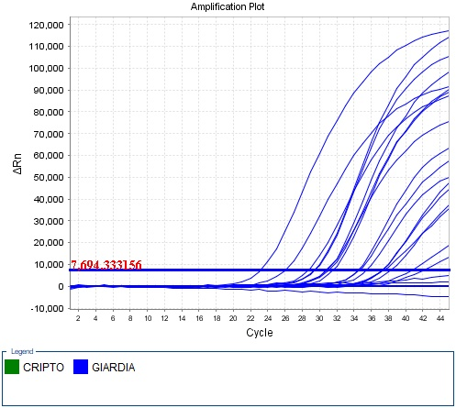

**Fig. 4.3.** Amplification of cyclic reaction in real-time PCR of *Giardia* (After analysis)

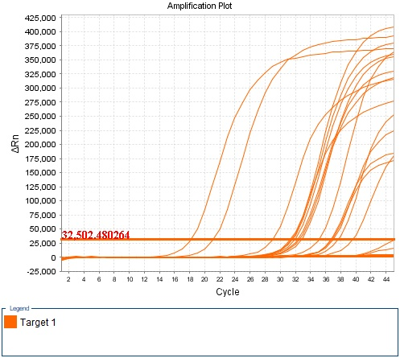

**Fig. 4.4.** Amplification of cyclic reaction in real-time PCR of *Cryptosporidi*a (After analysis)

**4.4.3. Sanger sequencing:** A total number of 28 isolates were sequenced through Sanger sequencing approaches for both human and animal *Cryptosporidium* (*gp60* = 14; *SSU* = 7) and *Giardia* (*TPI*= 7) isolates **(Table 4.3.).** Sequences were then validated by in the GenBank database using BLASTn. However, after quality analysis, the sequences were stored in NCBI nucleotide database through following accession, OM665388.1 - OM665390.1, MT071440.1 - MT071443.1, OM877297.1 -OM877302.1, MT185587.1 - MT185589.1, OM877303.1 - OM877307.1, OM877308.1 - OM877314.1.

**Table 4.3.** The isolates applied for Sanger sequencing and their repository IDs.

| **Sample**  **code** | **Host** | **Sample**  **collection**  **year** | **Organism** | **Typing** | **Method** | **GenBank**  **accession**  **no.** |
| --- | --- | --- | --- | --- | --- | --- |
| 2. | *Homo sapiens* | 2019 | *Cryptosporidium hominis* | *SSU* | Sanger dideoxy sequencing | OM665388.1 |
| 4. | *Homo sapiens* | 2019 | *Cryptosporidium hominis* | *SSU* | Sanger dideoxy sequencing | OM665389.1 |
| 7. | *Homo sapiens* | 2019 | *Cryptosporidium hominis* | *SSU* | Sanger dideoxy sequencing | OM665390.1 |
| 1. | Calf | 2018 | *Cryptosporidium parvum* | *SSU* | Sanger dideoxy sequencing | MT071440.1 |
| 3. | Calf | 2018 | *Cryptosporidium parvum* | *SSU* | Sanger dideoxy sequencing | MT071441.1 |
| 17. | Calf | 2019 | *Cryptosporidium parvum* | *SSU* | Sanger dideoxy sequencing | MT071442.1 |
| 56. | Calf | 2019 | *Cryptosporidium parvum* | *SSU* | Sanger dideoxy sequencing | MT071443.1 |
| 1. | Calf | 2020 | *Cryptosporidium parvum* | *gp60* | Sanger dideoxy sequencing | OM877297.1 |
| 6. | Calf | 2020 | *Cryptosporidium parvum* | *gp60* | Sanger dideoxy sequencing | OM877298.1 |
| 8. | Calf | 2020 | *Cryptosporidium parvum* | *gp60* | Sanger dideoxy sequencing | OM877299.1 |
| 9. | Calf | 2020 | *Cryptosporidium parvum* | *gp60* | Sanger dideoxy sequencing | OM877300.1 |
| 25. | Calf | 2020 | *Cryptosporidium parvum* | *gp60* | Sanger dideoxy sequencing | OM877301.1 |
| 27. | Calf | 2020 | *Cryptosporidium parvum* | *gp60* | Sanger dideoxy sequencing | OM877302.1 |
| 1. | Calf | 2018 | *Cryptosporidium parvum* | *gp60* | Sanger dideoxy sequencing | MT185587.1 |
| 3. | Calf | 2019 | *Cryptosporidium parvum* | *gp60* | Sanger dideoxy sequencing | MT185588.1 |
| 7. | Calf | 2019 | *Cryptosporidium parvum* | *gp60* | Sanger dideoxy sequencing | MT185589.1 |
| 1. | *Homo sapiens* | 2020 | *Cryptosporidium hominis* | *gp60* | Sanger dideoxy sequencing | OM877303.1 |
| 4. | *Homo sapiens* | 2020 | *Cryptosporidium hominis* | *gp60* | Sanger dideoxy sequencing | OM877304.1 |
| 7. | *Homo sapiens* | 2020 | *Cryptosporidium hominis* | *gp60* | Sanger dideoxy sequencing | OM877305.1 |
| 38. | *Homo sapiens* | 2019 | *Cryptosporidium hominis* | *gp60* | Sanger dideoxy sequencing | OM877306.1 |
| 71. | *Homo sapiens* | 2019 | *Cryptosporidium hominis* | gp60 | Sanger dideoxy sequencing | OM877307.1 |
| 37. | *Homo sapiens* | 2020 | *Giardia intestinalis* | *tpi* | Sanger dideoxy sequencing | OM877308.1 |
| 38. | *Homo sapiens* | 2020 | *Giardia intestinalis* | *tpi* | Sanger dideoxy sequencing | OM877309.1 |
| 45. | *Homo sapiens* | 2020 | *Giardia intestinalis* | *tpi* | Sanger dideoxy sequencing | OM877310.1 |
| 51. | *Homo sapiens* | 2020 | *Giardia intestinalis* | *tpi* | Sanger dideoxy sequencing | OM877311.1 |
| 73. | *Homo sapiens* | 2020 | *Giardia intestinalis* | *tpi* | Sanger dideoxy sequencing | OM877312.1 |
| 75. | *Homo sapiens* | 2019 | *Giardia intestinalis* | *tpi* | Sanger dideoxy sequencing | OM877313.1 |
| 78. | *Homo sapiens* | 2020 | *Giardia intestinalis* | *tpi* | Sanger dideoxy sequencing | OM877314.1 |

**4.4.4. Phylogenetic reconstruction and comparative genomics**

The relative closeness of the newly assembled *Cryptosporidium* and *Giardia* was compared and alignment results were generated and visualized with closely related genome constellations identified in calves and human sample in Bangladesh and other countries.

The evolutionary history was inferred by using the Maximum Likelihood method based on the Tamura-Nei model (Saitou and Nei, 1087). The tree with the highest log likelihood (-1595.81) is shown. The percentage of trees in which the associated taxa clustered together is shown next to the branches. Initial tree(s) for the heuristic search were obtained automatically by applying Neighbor-Join and BioNJ algorithms to a matrix of pairwise distances estimated using the Maximum Composite Likelihood (MCL) approach, and then selecting the topology with superior log likelihood value. The tree is drawn to scale, with branch lengths measured in the number of substitutions per site. The analysis involved 25 nucleotide sequences. There were a total of 830 positions in the final dataset. Evolutionary analyses were conducted in MEGA7 (Felsenstein, 1985).

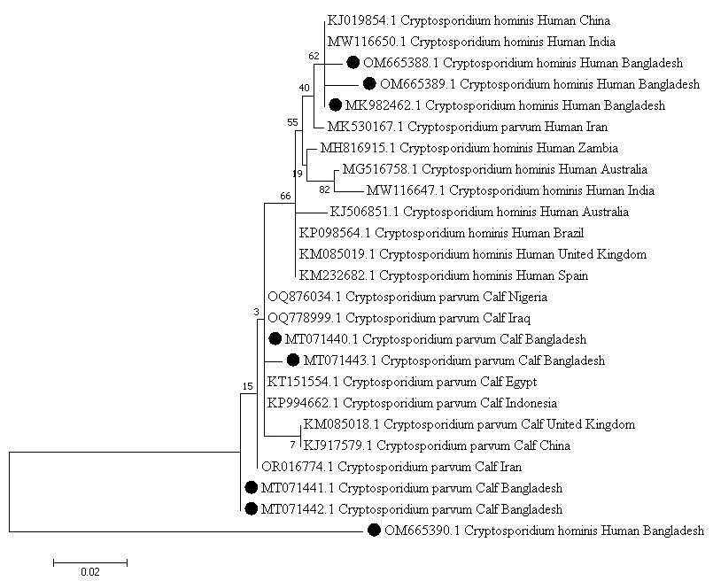

**Fig. 4.5.** Phylogenetic tree of *Cryptosporidium* sp. especially *Cryptosporidium hominis* and *Cryptosporidium parvum, small* subunit of ribosomal RNA *(SSU)* isolated from diarrheic children and calves of Chattogram and isolated from global distribution.

**Legend*:*** *Cryptosporidium hominis* and *Cryptosporidium parvum* of the study and other global isolate in NCBI and NR database. The numbers below and above the branch points denote the confidence levels of the relationship of the paired sequences determined by boot strap statistical analysis. The tree is drawn to scale, with branch lengths measured in the number of substitutions per site. The GenBank accession numbers for *(SSU)* gene OM665388.1, OM665389.1 and OM665390.1 indicate isolates CVASU_DPP_7_Human_2019, CVASU_DPP_8_Human_2019 and CVASU_DPP_9_Human_2019 small subunit ribosomal RNA gene. *C. parvum* MT071440.1 - MT071443.1.The GenBank accession numbers for *(SSU)* gene isolates CVASU1, CVASU2, CVASU3 and CVASU4 small subunit ribosomal RNA gene.For each taxon level, the following data are noted: accession number/ species / genotype / country origin.

The phylogenetic analyses of the *Cryptosporidium* and *Giardia* were carried out based on gene specific sequence such as *SSU*, *gp60,* and *TPI.* The partial segments of genes were used for phylogenetic inference.

**Caption:** Indicate Bangladeshi stain respectively.

The GenBank accession numbers for *(SSU)* gene OM665388.1, OM665389.1 and OM665390.1 indicate isolates CVASU_DPP_7_Human_2019, CVASU_DPP_8_Human_2019 and CVASU_DPP_9_Human_2019 small subunit ribosomal RNA gene. *Cryptosporidium hominis* of the study isolated from diarrheic children and other global isolate in NCBI and NR database.The numbers below and above the branch points denote the confidence levels of the relationship of the paired sequences determined by boot strap statistical analysis. The tree is drawn to scale, with branch lengths measured in the number of substitutions per site.The phylogenetic tree analysis based on (*SSU*) gene **(Fig. 4.5.**) revealed that Bangladeshi strains were clustered with Indian China and Iran strains and distantly related with other countries United Kingdom, Brazil, Australia and Spain.

Similarly, Phylogenetic tree of *Cryptosporidium* sp, especially *Cryptosporidium parvum,* small subunit of ribosomal RNA *(SSU)* isolated from diarrheic calves **(Fig. 4.5)** demonstrated that Bangladeshi strains are clustered in the same lineage with Indonesia and Egypt and distantly related with Nigeria, Iran and China.

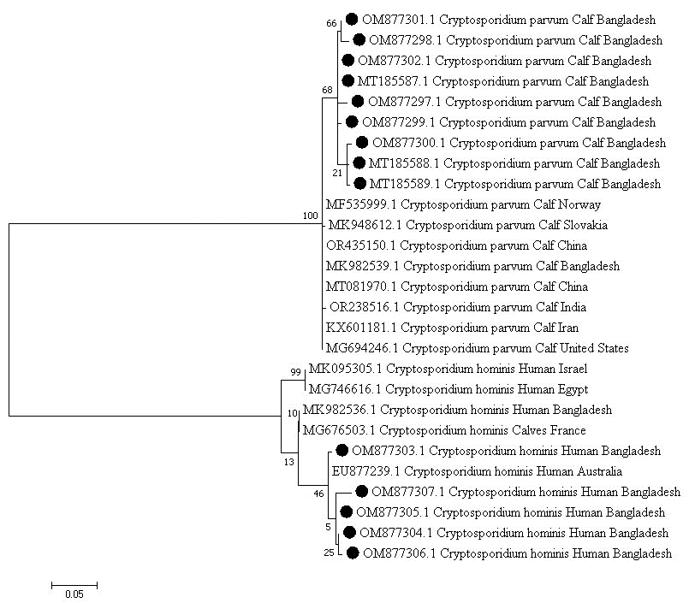

**Fig. 4.6.** Phylogenetic tree of *Cryptosporidium* sp, especially *Cryptosporidium parvum* and *Cryptosporidium hominis,* 60kDa glycoprotein *(gp60)* isolated from diarrheic calves and children of Chattogram and isolated from global distribution.

**Legend:** *Cryptosporidium parvum* and *Cryptosporidium hominis* of the study and other global isolate in NCBI and NR database constructed by maximum likelihood method based on the Tamura-Nei model. The tree with the highest log likelihood (-2790.62) is shown.The tree is drawn to scale, with branch lengths measured in the number of substitutions per site. The percentage of trees in which the associated taxa clustered together is shown next to the branches. **OM877297.1 -OM877302.1**,The GenBank accession numbers for *((gp60)* gene isolatesCVASU_DPP_17_ Calf_2020,CVASU_DPP_12_ Calf_2020, CVASU_DPP_13_ Calf_2020, CVASU_DPP_14_ Calf_2020, CVASU_DPP_15_Calf_2020, CVASU_DPP_16_ Calf_2020, 60 kDa glycoprotein *(gp60)* gene. **OM877303.1 - OM877307.1**, the GenBank accession numbers for *((gp60)* gene isolates CVASU_DPP_9_ Human_2020, CVASU_DPP_10_ Human_2020, CVASU_DPP_11_ Human_2020, CVASU_DPP_8_ Human_2019 and CVASU_DPP_7_ Human_2019, 60kDa glycoprotein *(gp60)* gene. For each taxon level, the following data are noted: accession number/ species / genotype / country origin.

**Caption:** Indicate Bangladeshi stain respectively.

Phylogenetic tree of *Cryptosporidium* sp, **(Fig. 4.6)** especially *Cryptosporidium parvum,* 60kDa glycoprotein *(gp60)* isolated from diarrheic calves in Bangladesh with branch lengths measured in the number of substitutions per site.OM877297.1 -OM877302.1,The GenBank accession numbers for *(gp60)* gene isolates CVASU_DPP_17_Calf_2020,CVASU_DPP_12_Calf_2020, CVASU_DPP_13_ Calf_2020, CVASU_DPP_14_Calf_2020, CVASU_DPP_15_Calf_2020, CVASU_DPP_16_Calf_2020, 60 kDa glycoprotein *(gp60)* gene were found closely related to India, China, Iran , Noway and United States.

Similarly, **(Fig. 4.6.)** Bangladeshi isolates Phylogenetic tree of *Cryptosporidium* sp. especially *Cryptosporidium hominis,* 60kDa *glycoprotein (gp60)* isolated from diarrheic children of Chattogram demonstrated maximum homology with United States, Egypt and United Kingdom with Australia, France , Bangladesh Agricultural University, and Egypt.

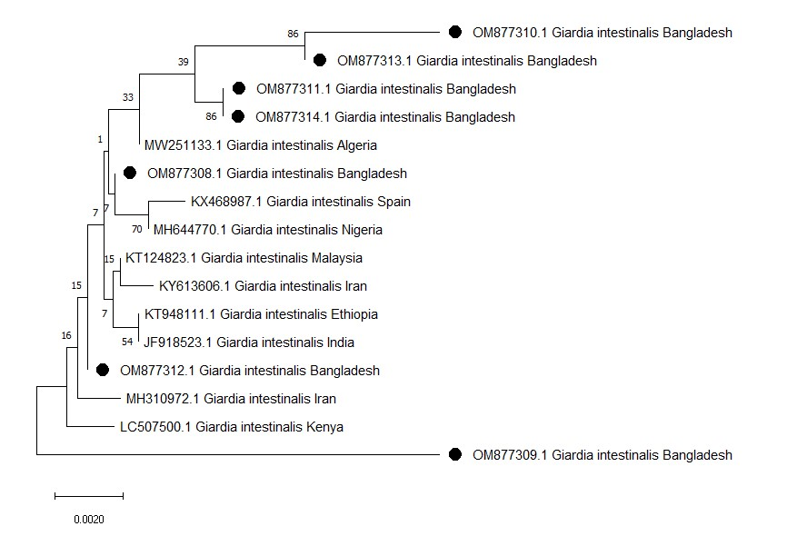

**Fig. 4.7.** Phylogenetic tree of *Giardia* sp. especially *Giardia intestinalis,* triose- phosphate isomerase *(TPI)* isolated from diarrheic children of Chattogram and isolated from global distribution.

**Legend:** *Giardia intestinalis* of the study and other global isolate in NCBI and NR database constructed by maximum likelihood method. The numbers below and above the branch points denote the confidence levels of the relationship of the paired sequences determined by boot strap statistical analysis. The tree is drawn to scale, with branch lengths measured in the number of substitutions per site. OM877308.1- OM877314.1, TheGenBank accession numbers for *((TPI)* gene isolatesCVASU_DPP_7_Human_2020,CVASU_DPP_8_Human_2020, CVASU_DPP_4_Human_2020, CVASU_DPP_5_Human_2020, CVASU_DPP_6_Human_2020, CVASU_DPP_1_Human_2019 and CVASU_DPP_3_Human_2020,triose- phosphate isomerase *(tpi)* gene. For each taxon level, the following data are noted: accession number/ species/genotype/country origin.

**Caption:** Indicate Bangladeshi stain respectively.

The evolutionary history was inferred using the Neighbor-Joining method (Saitou and Nei, 1987). The optimal tree is shown. The percentage of replicate trees in which the associated taxa clustered together in the bootstrap test (1000 replicates) are shown next to the branches (Felsenstein, 1985). The tree is drawn to scale, with branch lengths in the same units as those of the evolutionary distances used to infer them phylogenetic tree. The evolutionary distances were computed using the Maximum Composite Likelihood method (Tamura *et al.,* 2004) and are in the units of the number of base substitutions per site. Allmambiguous positions were removed for each sequence pair (pairwise deletion option).Evolutionary analyses were conducted in MEGA11 (Tamura, 2021)

Bangladeshi isolate **(Fig. 4.7)** *Giardia* sp. especially *Giardia intestinalis,* triose- phosphate isomerase *(TPI)* isolated from diarrheic children showed maximum identity in Spain, Algeria , Spain, Iran , India with Nigeria and Malysia accordingly.

The three genes sequences from Bangladeshi isolates were found closely related to each other. Similarly, Bangladeshi isolates demonstrated maximum homology with Indian.The similarity revealed that Bangladesh strains show more closely related to Indian isolates than isolates from other parts of world .The genes of three isolates from three different catagory was also analyzed for estimation of zoonotic potentiality using phylogenetic tree analysis. Bovine isolates of our study were clustered with zoonotic isolates. Similarly, in similarity analysis clades bovine isolates of our study showed homology with zoonotic strains, whereas human strains homology.

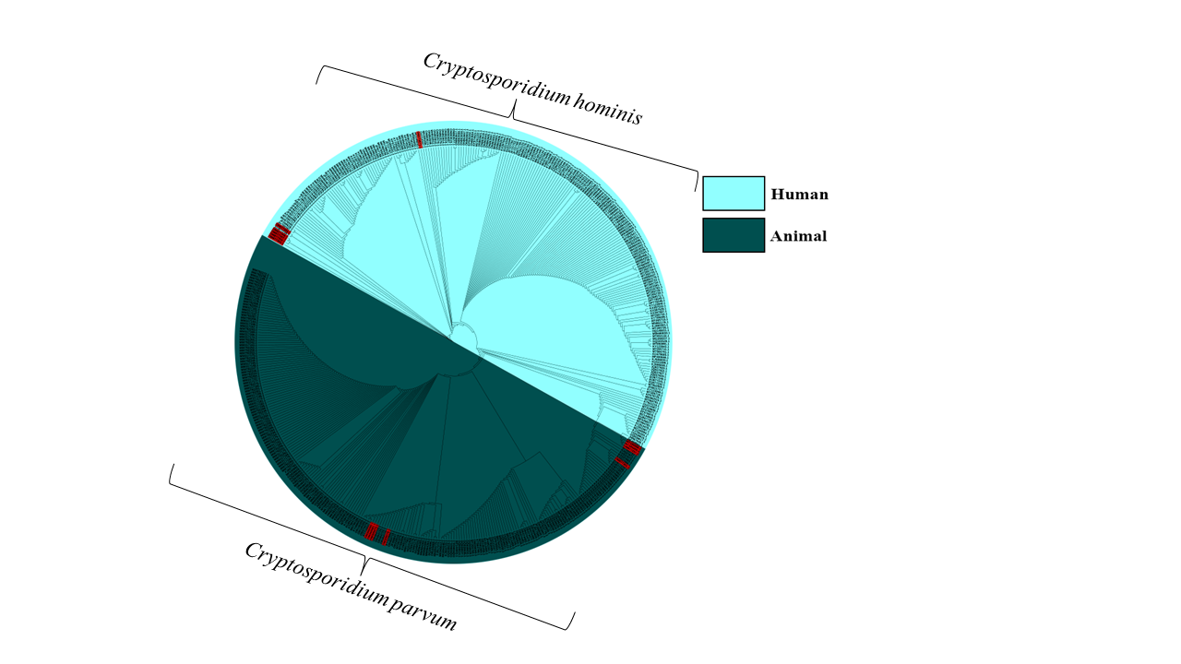

**Fig. 4.8.** The phylogenetic analysis of 60kDa glycoprotein *(gp60)* gene-based *Cryptosporidium* in both human and animal identified by metagenomics screening using MePic pipeline. The sequences of this study are depicted in red color mark, where the human and animal isolates are presented by cyan and purple color, respectively.

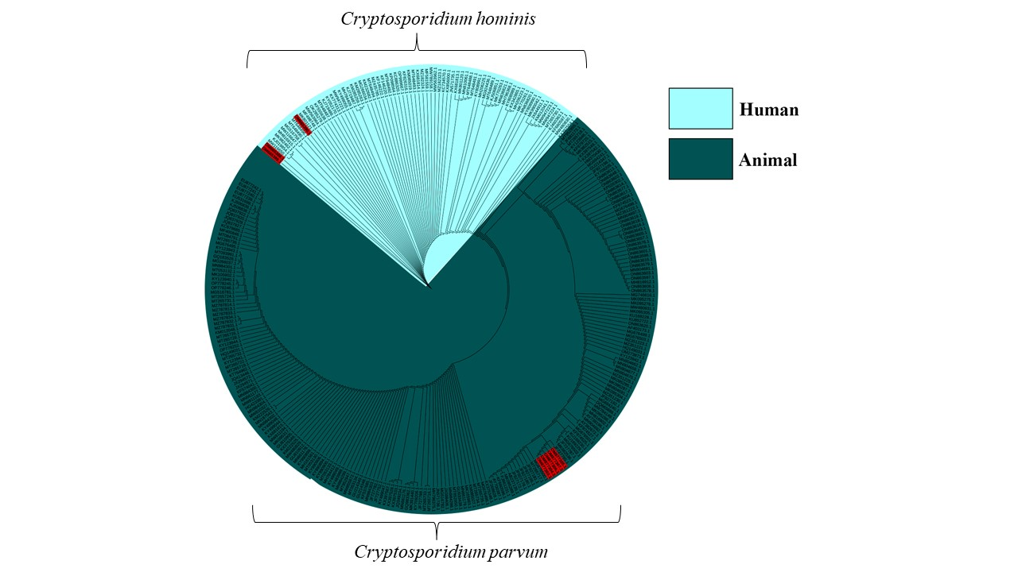

**Fig. 4.9.** The phylogenetic analysis of small subunit of ribosomal RNA *(SSU) gene*-based *Cryptosporidium* in both human and animal identified by metagenomics screening using MePic pipeline. The sequences of this study are depicted in red color mark, where the human and animal isolates are presented by cyan and purple color, respectively.

**4.6. Discussion:**

The present study included the examination of 437 fecal specimens from hospitalized diarrheic children and infected calves allowed for a detailed assessment of the prevalence rates and molecular characteristics of the identified strains. In this study, *Cryptosporidium* and *Giardia* are frequently found in Bangladeshi calves under six month’s old suffering from diarrhea. These protozoa should therefore be considered as potential causes of gastrointestinal disease in calves of this age group. Also, children under twelve years old suffering from diarrhoea, were reported to have *Cryptosporidium* and *Giardia*. Therefore, this study highlights the significant prevalence of *Cryptosporidium* and *Giardia* infections in both human and animal populations in Bangladesh. The higher prevalence of *Giardia* in both diarrheic children and infected calves compared to *Cryptosporidium* suggests a potential zoonotic transmission pathway. However, it is important to note that co-infections with other enteropathogens, such as *Escherichia coli*, *Clostridium perfringens*, bovine rotavirus, or bovine coronavirus, cannot be excluded. The molecular characterization results provide valuable insights into the genetic diversity of *Cryptosporidium* and *Giardia* strains circulating in these populations. The variation in gene prevalence, such as *gp60* and *SSU* for *Cryptosporidium* and *TPI* for *Giardia,* underscores the importance of understanding the genetic makeup of these parasites for effective control and prevention strategies. According to real- time PCR analyses, the prevalence of *Cryptosporidium* among hospitalized diarrheic children and infected calves was found to be 9% (n = 18) and 4.22% (n = 10), respectively. In contrast, the prevalence of *Giardia* among hospitalized diarrheic children and infected calves was 14% (n = 28) and 10.55% (n = 25), respectively.

Regarding *Cryptosporidium*, the prevalence of the *gp60* gene among hospitalized diarrheic children and infected calves was found to be 10% (n = 20) and 11.39% (n = 27), respectively. On the other hand, the prevalence of *SSU* among in case of *Cryptosporidium* hospitalized diarrheic children and infected calves was found to be 6% (n = 12) and 10.13% (n = 24), respectively. However, the previous study by Ehsan *et al., (*2015) suggested that the prevalence of the *gp60* and *SSU* gene were found to be 5% each in calves infected with *Giardia* infection, though they only applied *gp60* gene for the positive *SSU* isolates (Letunic and Bork, 2019). For *Giardia*, the prevalence of the *TPI* gene among hospitalized diarrheic children was found to be 10.5% (n = 21), while no *TPI* gene was found in infected calves. Contrarily, the previous study by Ehsan *et al.,* (2015) reported that the prevalence of the *TPI* gene was found to be 21.7% in calves infected with *Giardia* infection (Letunic and Bork, 2019).

This disparity may indicate differences in *Giardia* genotypes circulating between human and animal populations in Bangladesh. The absence of the *TPI* gene in infected calves suggests the need for further investigation into the genetic diversity of *Giardia* strains in animal reservoirs and potential implications for zoonotic transmission.

The utilization of Sanger sequencing approaches for the sequencing of 28 isolates, comprising both human and animal *Cryptosporidium (gp60* = 14; *SSU* = 7) and *Giardia* (*TPI* = 7) isolates, represents a significant step towards understanding the genetic diversity and evolutionary relationships within these parasitic populations. The subsequent validation of the obtained sequences against the GenBank database using BLASTn ensures the accuracy and reliability of the generated data. However, the sequence quality was rigorously assessed prior to submission to the NCBI nucleotide database, ensuring the integrity and fidelity of the deposited genetic information.

The observed prevalence rates, along with the molecular characterization results, highlight the complexity of the epidemiology of *Cryptosporidium* and *Giardia* in Bangladesh.The coexistence of different genotypes and potential variations in transmission pathways emphasize the necessity of a multidisciplinary approach for effective control and prevention strategies. Furthermore, these findings underscore the importance of continued surveillance and research to monitor changes in prevalence rates and genetic diversity over time, ultimately aiding in the development of targeted interventions to reduce the burden of these parasitic infections in both human and animal populations.

**4.7. Conclusion**

This study contributes to the understanding of the prevalence and genetic diversity of *Cryptosporidium* and *Giardia* infections in Bangladesh. The results emphasize the need for comprehensive surveillance and control measures to mitigate the impact of these parasites on both human and animal health. Further research is warranted to explore the potential zoonotic transmission and assess the risk factors associated with the prevalence of these infections in the region.

**Chapter 5**

**Comparison of fecal microbiome of diarrhoeic and non-diarrhoeic calves through metagenomics approach**

**Abstract**

The maintenance of a healthy gut microbiota is of the utmost significance when it comes to combating gastrointestinal disorders like diarrhoea. This study was designed to unveil the gut bacteriome signature and diversity by analysing ten samples including five diarrhoeic feces (DF) and five non-diarrhoeic feces (NDF) samples obtained from 10 individual calf through 16S rRNA (V4 region) gene-based amplicon sequencing. A total of 358 operational taxonomic units (OTUs) including 217 and 162 in DF and NDF samples, respectively were identified. Findings revealed substantial taxonomic variability between sample categories (i.e., DF and NDF; *p* = 0.0127; Kruskal Wallis test) of the calves, indicated by their higher degree of shared microbiota. Of the identified genera, *Gallibacterium* (37.48%), *Veillonella* (14.53%) and *Bacteroides* (11.61%) were the major bacterial genera detected in gut of calves, with marked discrepancy in their relative abundances in DF and NDF calves. Importantly, we detected 44 genera including *Sedimentibacter*, *Lonepinella*, *Sulfurospirillum*, *Haemophilus*, *Enterobacter*, *Citrobacter* etc. seem to be specific to calf diarrhoea. Both the DF and NDF samples included 358 distinct bacterial species, of which 32.18% species were found to be shared between sample categories, and 25.14% and 11.73% species were found solely in DF and NDF, respectively. Moreover, *Gallibacterium salpingitidis* was found as the most prevalent species (43.37%) in DF samples followed by *G. anatis* (17.56%), *Bacteroides* sp. (6.2%). In contrast, *Veillonella magna* had the highest prevalence (19.21%) in NDF samples followed by *Bacteroides* sp. (18.00%), *Veillonella* sp. (13.09%), and *Ruminococcus* sp. (7.23%). The findings suggested that diarrhoea affects the gut bacteriome in calves, with different microbial taxa associated with diarrhoea. Our data provided evidence for the existence of both unique and shared bacteriomes with pathogenic potentials in the gut of calves, which might be taken into consideration for undertaking future microbiome study in diarrhoeic calf.

**5.1. Introduction**

Diarrhoea in calves, also known as neonatal calf diarrhoea (NCD), is the primary cause of morbidity and mortality in dairy calves worldwide. This disease is widely reported and causes significant financial losses for the cattle and dairy industry (Schild *et al.,* 2020; Urie *et al.,* 2018; Caffarena *et al.,* 2021). This condition predominantly affected calves that were less than one month old. Furthermore, the study revealed that a 20% mortality rate among the calves might lead to a substantial reduction of 38 % in net revenue **(**Fentie*et al.,* 2020). In 2012, another report of NAHMS suggested that 85.7 % of pre-weaned dairy calves were found to have diarrhoea, while just 5.7% were determined to be unaffected (USDA, 2012; Whon *et al.,* 2021). Recent reports from Korea indicate a mortality rate of 53.4 % in dairy calves caused by calf diarrhoea (Hur *et al.,*2013;Cho and Yoon, 2014). In Norway, where 280,000 calves have been raised annually, the economic loss incurred on by calves dying due to diarrhoea was estimated to be over 10 million US dollars in 2006 (Cho and Yoon, 2014; Østerås *et al,.* 2007).

The consequences of NCD may also have an adverse effect on an animal's ability to grow and thrive, as well as its capacity for breeding and milk production in the later stages of lactation (Aghakeshmiri *et al.,* 2017; Du *et al.,* 2023).Mitigating such kind of NCD poses a significant challenge due to their multifaceted origin, including both infectious and non-infectious components (Cho and Yoon , 2014; Whon *et al. ,* 2021)**.** Infectious agents such as viruses, bacteria, and protozoa are usually accountable for NCD. Bovine rotavirus group A, bovine coronavirus, *Salmonella* spp., *Enterotoxigenic Escherichia coli* (ETEC), *Clostridium perfringens* type C, and *Cryptosporidium parvum* and *Giardia* sp.are the most common causes of diarrhoea in calves (Gomez *et al. ,* 2022; Gomez and Weese, 2017). However, diarrhoea in calves has been associated with an increase in taxa belonging to the phylum Proteobacteria, specifically an increased abundance of Enterobacteria (Youanes and Herdt ,1987; Isaacson *et al.,* 1979; Smith and Orcutt, 1925) and reduced numbers of butyrate-producing bacteria including *Bifidobacterium* and *Fecalobacterium* (Gomez *et al.,* 2022;Gomez *et al.,* 2017; Oikonomou *et al.,* 2013). Co-infection is a common occurrence in calves experiencing diarrhoea, although there are instances where a single causative agent can be solely responsible for the condition (Bartels *et al.,* 2010; Izzo *et al.,* 2011). The abundance of normal gut microbiota is of the utmost importance in preventing the colonization of foreign microorganisms **(**Fan *et al.,* 2021; Pickard*et al.,* 2017;Fan *et al.,* 2020;Fan *et al.,* 2019; Fan *et al.,* 2021) and enhancing the immunological responses of hosts via interactions between antigens and immune cells throughout the first phases of life (Fan*et al.,*2020; Zhao and Elson , 2018;Gomez*et al.,* 2019;Kim *et al.,* 2023)**.** Furthermore, there have been reports indicating the indispensability of gut microbiota in the preservation of intestinal homeostasis and alterations in the microbial community structure, have been associated with several diseases (Hennessy *et al.,* 2021). Diarrhoeic calves have been shown to have altered gut microbial communities and a narrow diversity of bacteria compared to healthy calves (Gomez *et al.,* 2022; Gomez *et al.,* 2017; Kim *et al.,* 2023; Slanzon *et al.,* 2022; Hennessy *et al.,* 2020; Ma *et al.,* 2019). Pathogen-induced there have been a few research that has explored the difference in gut microbial composition between healthy dairy calves and calves who have diarrhoea. These studies have revealed the vital role of microbiota in regulating gut health (Hur *et al.,* 2013; Gomez*et al.,* 2017; Hennessy *et al.,* 2021). However, much remains unexplained regarding the gut microbiota of healthy and neonatal diarrhoeal calves. Moreover, the significance of intestinal commensals in preventing diarrhoea in neonatal calves, especially those fed on pasture, is not well understood (Fan *et al.,* 2021).

The aim of this research is to explore the microbial communities in neonatal calves that are healthy as well as those who have diarrhoea. Also, the contribution of gut microbiota in warding off diarrhoea in neonatal calves was investigated as part of this research. Consequently, we utilized a 16sRNA metagenomics approach to identify the bacterial community in both healthy and diarrhoeal neonatal calves. This research may hold significant importance as it can help shed light on the microbial composition and potential causes of diarrhoeal episodes in neonatal calves.

**5.2. Materials and methods**

**5.2.1. Participants**

Five diarrhoeic and five non-diarrhoeic (control) calves (between the ages of 1 and 45 days) were enrolled from one farm of Chattogram, Bangladesh. All the diarrhoeic calves enrolled in this study were diagnosed as bacterial enteritis. In the study, a healthy control group consisting of five calves was included. These calves were chosen to have a similar age range as the calves in the patient group. The farmer owner signed in the consent forms regarding this research.

**5.2.2. Fecal sample collection, DNA extraction and 16S rRNA gene amplicon sequencing**

Fresh fecal samples of diarrhoeic and non-diarrhoic calves were collected in sterile fecal collection tubes and frozen at -20 °C. Genomic DNA from the collected fecal samples was extracted by PureLink™ Microbiome DNA Purification Kit (Catalog Number A29790) following the manufacturer’s instruction. The V4 region of 16S rDNA from each sample was amplified by PCR using the bacterial universal primer pair 341F (5′- CCTAYG GGRBGCASCAG - 3′)/806R (5′- GGA CTACNNGGGTATCTAAT - 3′) (Kozich *et al.,* 2013). The PCR amplification reaction included 1μl of forward index primer (10mM), 1μl reverse index primer (10mM), 1μl of 10ng/μl DNA template, and 17μl Pfx AccuPrime master mix (Invitrogen, United States). Amplification was initiated with denaturation for 5 min at 95 °C, followed by 30 cycles of 95 °C for 30 s, annealing at 55 °C for 30s and extension at 72 °C for 1 min, with a final elongation for 5min at 72 °C. The amplicons were then purified and normalized using the SequalPrep plate normalization kit (Invitrogen, United States). The same amount of barcoded V4 amplicons from each sample was pooled to construct the DNA library. The library was constructed using a TruSeq ® DNA PCR-Free Sample Preparation Kit (Illumina, San Diego, USA) and high through put sequencing was conducted using a HiSeq 2500 platform according to the manufacturer’s instructions.

**5.2.3. Bioinformatics analysis**

FastQC v0.11.9 (Andrews, 2010) and Trimmomatic v0.39 (Bolger *et al.,* 2014) (set parameters- leading: 20, slidingwindow: 4:20:20, trailing: 20, minlen = 36) (Hoque *et al.,* 2023;Hoque *et al.,*2019) were used to check and remove Illumina adapters, known Illumina artifacts, and phiX reads, respectively. We used QIIME 2 (2023.2.0) and associated plugins (Bolyen *et al.,* 2019) to process the demultiplexed sequences.and the SILVA database v.138 (Quast *et al.,* 2012) assigned these processed sequences (with ≥ 98% identity) into operational taxonomic units (OTUs). Default parameters were used for bioinformatic analyses except where otherwise stated.

**5.2.4. Statistical analysis**

R programming language (v4.1.1) was used for the downstream analysis including alpha-beta diversity, microbial composition and statistical comparison. To estimate the within sample diversity (α-diversity), the observed OTUs, Shannon, Simpson InvSimpson, Fisher and ACE diversity indices were calculated in microbiomeSeq (http://www.github.com/umerijaz/microbiomeSeq) and visualized using phyloseq R package (v1.34.0) (McMurdie and Holmes ,2013). Non-parametric Kruskal Wallis test was used to estimate the differences in bacterial diversity between the sample categories, gender and breed of the calves.

**5.3.** **Results**

**5.3.1. Microbiome diversity and composition in diarrhoeic faeces (DF) and non-diarrhoeic faeces (NDF) of calf**

In order to unveil the bacteriome signature and diversity in the gut of diarrhoeic (DF) and non-diarrhoeic (NDF) calves belonged to two sex groups (male = 6 and female = 4), we analysed 10 fecal samples through 16S rRNA amplicon sequencing. The study sampling information, gender, breeds, amplicon sequence related data, assigned operational taxonomic units (OTUs) per sample and SRA (sequence read archives) accession numbers of the study subjects are summarized in **Table 5.2**.

**Table 5.1.**Taxonomic information of microbiomes in diarrhoeic feces (DF) and non-diarrhoeic (NDF) of calves.

|  |  |  |
| --- | --- | --- |
| **Taxa** | **DF** | **NDF** |
| Phylum (n = 18) | 18 | 17 |
| Class (n = 31) | 30 | 21 |
| Order (n = 65) | 59 | 53 |
| Family (n = 87) | 67 | 57 |
| Genus (n = 188) | 131 | 101 |
| Species (n = 358) | 217 | 162 |

**Data S1**: Taxonomic information of microbiomes in diarrhoeic feces (DF) and non-diarrhoeic (NDF) of calves (See srpporting information page.

**Table 5.2.** Study sample information, SRA accession numbers of the 16S rRNA amplicon sequences, and OTUs (operational taxonomic units) mapped against bacterial taxa

|  |  |  |  |  |  |  |  |  |
| --- | --- | --- | --- | --- | --- | --- | --- | --- |
| **Sample**  **ID** | **Collection**  **site** | **Coordinate** | **Category** | **Source** | **No. of reads (paired-end)** | **No. of mapped reads** | **No. of observed OTUs** | **SRA**  **accessions** |
| DF1 | Chattogram, Bangladesh | 22.37° N, 91.83° E | Diarrhoeic | Feces | 741,200 | 54,202 | 163 | SAMN38124867 |
| DF2 | Chattogram, Bangladesh | 22.37° N, 91.83° E | Diarrhoeic | Feces | 890,344 | 118,893 | 150 | SAMN38125613 |
| DF3 | Chattogram, Bangladesh | 22.37° N, 91.83° E | Diarrhoeic | Feces | 546,528 | 59,597 | 174 | SAMN38125614 |
| DF4 | Chattogram, Bangladesh | 22.37° N, 91.83° E | Diarrhoeic | Feces | 1,015,032 | 123,246 | 205 | SAMN38125615 |
| DF5 | Chattogram, Bangladesh | 22.37° N, 91.83° E | Diarrhoeic | Feces | 857,472 | 37,834 | 177 | SAMN38125616 |
| NDF1 | Chattogram, Bangladesh | 22.37° N, 91.83° E | Non-Diarrhoeic | Feces | 485,272 | 35,574 | 151 | SAMN38125617 |
| NDF2 | Chattogram, Bangladesh | 22.37° N, 91.83° E | Non-Diarrhoeic | Feces | 498,424 | 19,061 | 159 | SAMN38125618 |
| NDF3 | Chattogram, Bangladesh | 22.37° N, 91.83° E | Non-Diarrhoeic | Feces | 1,096,592 | 65,590 | 179 | SAMN38125619 |
| NDF4 | Chattogram, Bangladesh | 22.37° N, 91.83° E | Non-Diarrhoeic | Feces | 849,096 | 113,860 | 201 | SAMN38125620 |
| NDF5 | Chattogram, Bangladesh | 22.37° N, 91.83° E | Non-Diarrhoeic | Feces | 1,088,704 | 28,641 | 154 | SAMN38125621 |

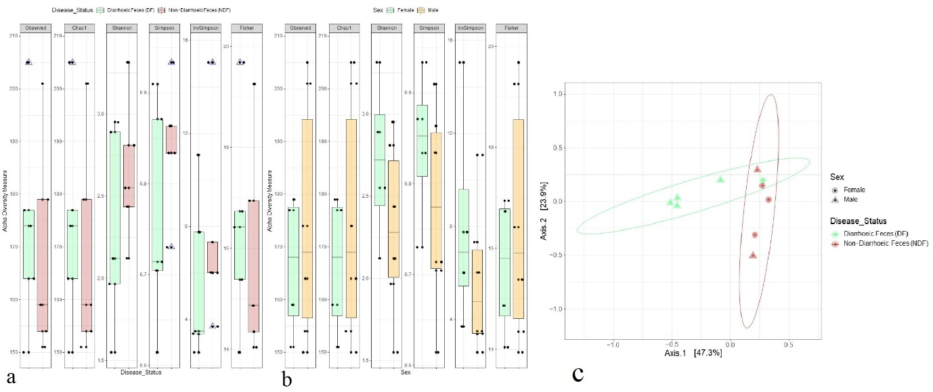

**Fig. 5.1. Bacteriome diversity.** (a - b) Within subject (Alpha) diversity measure. Observed, Chao1, Shannon, Simpson, InvSimpson and Fisher indices estimated within sample bacterial diversity in (a) diarrhoeic feces (DF) and non-diarrhoeic feces (NDF) of calves, and (b) in the gut of male and female calves. Samples are plotted on boxplots and comparisons are made with pairwise Wilcoxon rank sum tests. (c) Between subject (Beta) diversity measure according to sample categories (i.e., DF and NDF) and sex of the calves (e.g., male and female). Bacterial beta diversity was calculated using Bray-Curtis dissimilarity distance method, and visualized on principal coordinate analysis (PCoA) plots. The samples are coloured according to categories (e.g., DF: green and NDF: purple) and joined with the respective ellipses. Pairwise comparisons on a distance matrix using PERMANOVA test under reduced model shows significant bacterial community differences between sample categories (p = 0.042, R2 = 0.70) and across the habitats (*p* = 0.05, R2 = 0.54).

In this study, a total of 358 operational taxonomic units (OTUs) including 217 and 162 in DF and NDF samples, respectively were identified. To elucidate whether gut bacteriome diversity of the calves varies according to sample categories (e.g., DF and NDF), and sex (e.g. male and female) we examined both within sample (alpha) and across the samples (beta) diversities of the detected bacterial communities (**Fig. 5.1.**). The alpha diversity measured using Observed species, Chao1, Shannon, Simpson, InvSimpson and Fisher indices did not show significant differences in bacterial community richness (*p* > 0.05, Wilcoxon rank sum tests) two sample groups (e.g., DF and NDF) (**Fig. 5.1a**) and according to sex of the calves (e.g., male and female) (**Fig. 5.1b**). The Bray–Curtis dissimilarity distance estimated principal coordinate analysis (PCoA) plot showed that bacteriome composition in the gut differed significantly according to sample categories (DF versus NDF, *p* = 0.042, R2 = 0.70, PERMANOVA test) (**Fig. 5.1c**). Moreover, the beta diversity of the bacteriomes also varied significantly according to the host gender (*p* = 0.05, R2 = 0.54, PERMANOVA test) (**Fig. 5.1c**). The observed OTUs were represented by 18 phyla, 31 classes, 65 orders, 87 families, 188 genera and 358 species of bacteria (**Table 5.1.**).

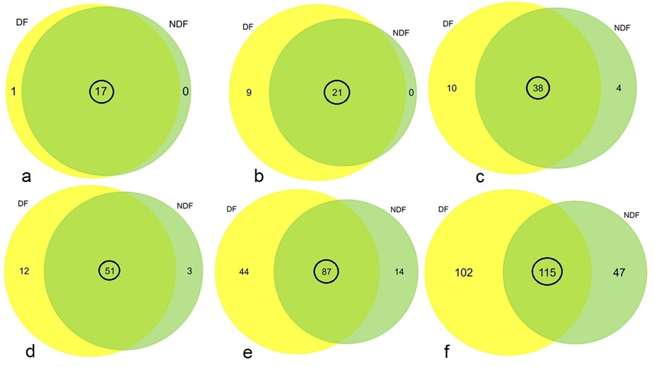

**Fig. 5.2. Taxonomic composition of bacteriomes.** Venn diagrams representing the unique and shared bacterial (a) phylum, (b) class, (c) order, (d) family, (e) genus and (f) species identified in diarrhoeic feces (DF) and non-diarrhoeic feces (NDF) of calves. Shared genera (highlighted in black circles) were found to be shared between sample types.

The unique and shared distribution of bacterial taxa found in DF and NDF samples is represented in Venn diagrams (**Fig.5.2**). We detected 18 bacterial phyla, of which 94.44% (17/18) were found to be shared between DF and NDF samples (**Fig. 5.2a**). However, one particular phylum, Tenericutes was found to be unique to the DF group (**Fig. 5.2a, Data S1**). The bacteriome profiling at the class level suggested that a total of 30 bacterial classes were identified across the two sample groups, including 30 and 21 in DF and NDF calves’ samples, respectively (**Fig. 5.2b, Data S1**). Approximately, 70.0 % (21/30) of the identified bacterial classes were found to be shared across DF and NDF samples, while 30.0 % (9/30) of the bacterial classes exhibited a unique association only with DF samples (**Fig. 5.2b, Data S1**). Similarly, we identified 52 orders of bacteria, of which 73.1% (38/52) orders (**Fig. 5.2c**) were found to be shared between the sample categories. Interestingly, there were also some bacterial orders that showed a unique association with either DF or NDF. About 15.38 % (10/58) of the orders were exclusively associated with DF, while 6.15 % (4/58) were solely associated with NDF (**Fig. 5.2c, Data S1**). We also detected 66 families (**Fig. 5.2d**), 145 genera (**Fig. 5.2e**) and 264 species (**Fig. 5.2f**) of bacteria, and of them, 77.27 % (51/66), 60.0 % (87/145) and 43.56 % (115/264) families, genera and species, respectively remained shared between DF and NDF samples. Moreover, we observed that 13.79 % (12/66) of the families were exclusively associated with DF, while 3.45 % (3/66) were unique to NDF sample group (**Fig. 5.2d, Data S1**). Additionally, a considerable number of genera were found uniquely in each sample group, with 23.40 % (44/145) unique to the DF and 7.45 % (14/145) unique to the NDF sample (**Fig. 5.2e, Data S1**). Furthermore, 28.51 % (102/264) and 13.19 % (47/264) of the identified bacterial species had unique association in the gut of DF and NDF calves, respectively (**Fig. 5.2f, Data S1**).

**5.3.2. Taxonomic composition of bacteriomes in the gut of DF and NDF calves**

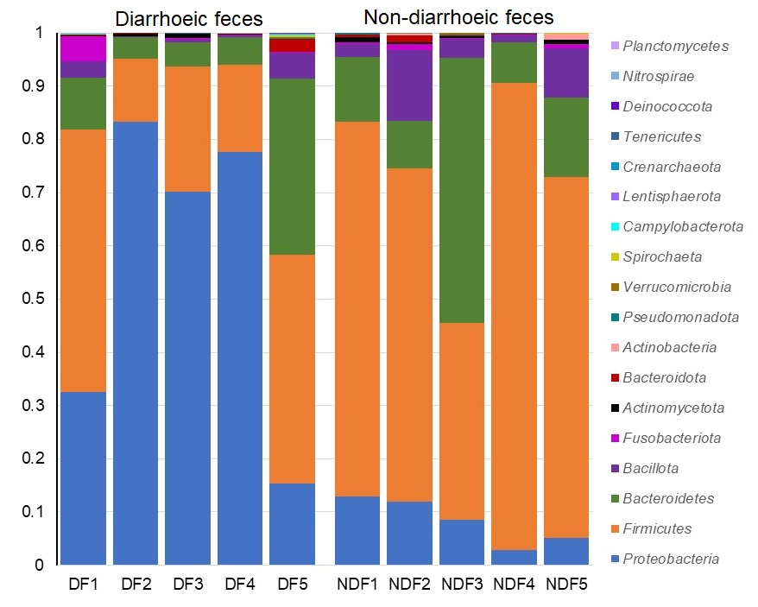

**Fig. 5.3.** The phylum-level taxonomic abundance of bacteria in diarrhoeic feces (DF) and non-diarrhoeic (NDF) of calves. Each stacked bar plot represents the abundance of bacterial phyla in each sample of the corresponding category.

At phylum level, Proteobacteria (42.23 %), Firmicutes (41.37 %), and Bacteroidetes (12.72 %) were the predominating bacterial phyla (comprising > 96.0 % of the total abundances) in the gut of both DF and NDF claves (**Fig. 5.3. Data S1)**. By comparing the bacterial phyla according to sample categories, we found that DF claves gut bacteriome was dominated by Proteobacteria (66.05 %) while Firmicutes (68.72 %), and Bacteroidetes (19.63 %) were the predominating phyla in the gut of NDF calves (**Fig. 5.3. Data S1**). Even more, Bacillota was found to be the fourth most prevalent phylum in the gut of both DF (1.12 %) and NDF (3.80 %) calves (**Data S1**). Rest of the bacterial phyla (with less than 1% relative abundances) also differed significantly in their relative Abundances between two sample categories (**Fig. 5.3. Data S1**).

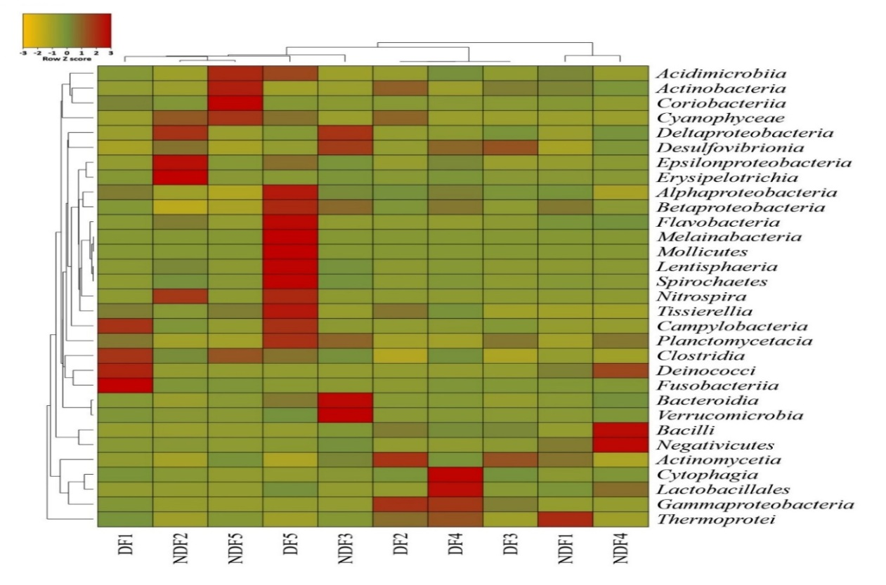

**Fig. 5.4.** Taxonomic profile of microbiomes at the class level.Heatmap showing the average relative abundances and hierarchical clustering of the bacterial classes (n = 31) in the study samples. The colour bar (row Z score) at the top represents the relative abundance of the bacterial classes in the corresponding samples. The colour codes indicate the presence and completeness of each bacterial class, expressed as a value between =3 (lowest abundance) and 3 (highest abundance). The red colour indicates the more abundant patterns, while yellow cells account for less abundant orders in that particular sample.

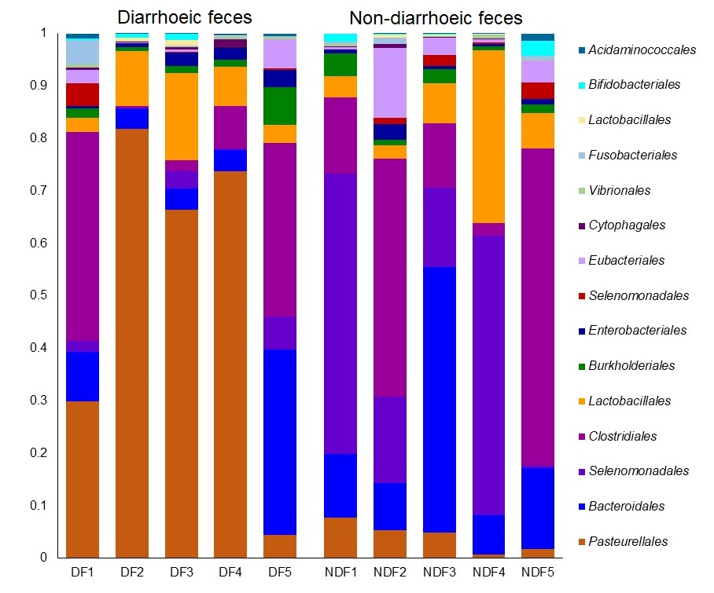At Class level collectively, *Gammaproteobacteria* made up 40.26 % of all bacterial classes in both sample groups, followed by *Negativicutes* (15.88 %), *Clostridia* (14.79 %), *Bacilli* (12.59 %), and *Bacteroidia* (12.34 %) as the most prevalent bacterial classes. In DF, we identified *Gammaproteobacteria* as the most predominantly abundant (64.18 %) bacterial class, followed by *Clostridia* (12.53 %), *Bacilli* (9.11 %), *Bacteroidia* (7.56 %), *Negativicutes* (2.40 %), and *Betaproteobacteria* (1,79 %). Contrarily, *Negativicutes* (36.10 %) was found to be most abundant class in NDF, followed by *Bacteroidia* (19.52 %), *Clostridia* (18.19 %), *Bacilli* (17.81%), *Gammaproteobacteria* (4.40 %) and *Betaproteobacteria* (1.83 %) (**Fig. 5.4. Data S1**). The prevalence of all other classes, however, remained below 1% and different between two sample groups (**Data S1**).



**Fig. 5.5.** The order-level taxonomic profile of microbiomes. The bar plots representing the relative abundance of top abundant 25 bacterial orders in diarrhoeic feces (DF1 – DF5) and non-diarrhoeic (NDF1 – NDF5) of calves. Each stacked bar plot represents the abundance of bacterial orders in each sample of the corresponding category. Notable differences in bacterial orders are those where the taxon is abundant in DF samples, and effectively not detected in the NDF samples. The distribution and relative abundance of the bacterial genera in the study metagenomes are also available in Data S1.

By comparing the bacterial taxa at order level, we found that *Pasteurellales*, *Selenomonadales*, *Clostridiales*, *Bacteroidales*, *Lactobacillales*, *Burkholderiales*, *Eubacteriales* and *Enterobacteriales* (> 95% of total abundances) were the mostly prevalent orders in the gut of both DF and NDF calves. Among these orders of bacteria, *Pasteurellales* (62.0 %) and *Enterobacteriales* (1.74 %) were the most abundant orders in the gut of DF calves while *Selenomonadales* (34.85%), *Bacteroidales* (19.52 %), *Lactobacillales* (17.41%), *Clostridiales* (15.46 %), and *Eubacteriales* (2.46 %) were found as the predominating bacterial orders in the gut of NDF calves. Despite, having had relatively lower abundances (< 2.0%), rest of the bacterial orders also showed discriminations according to sample groups (**Fig. 5.5. Data S1**).

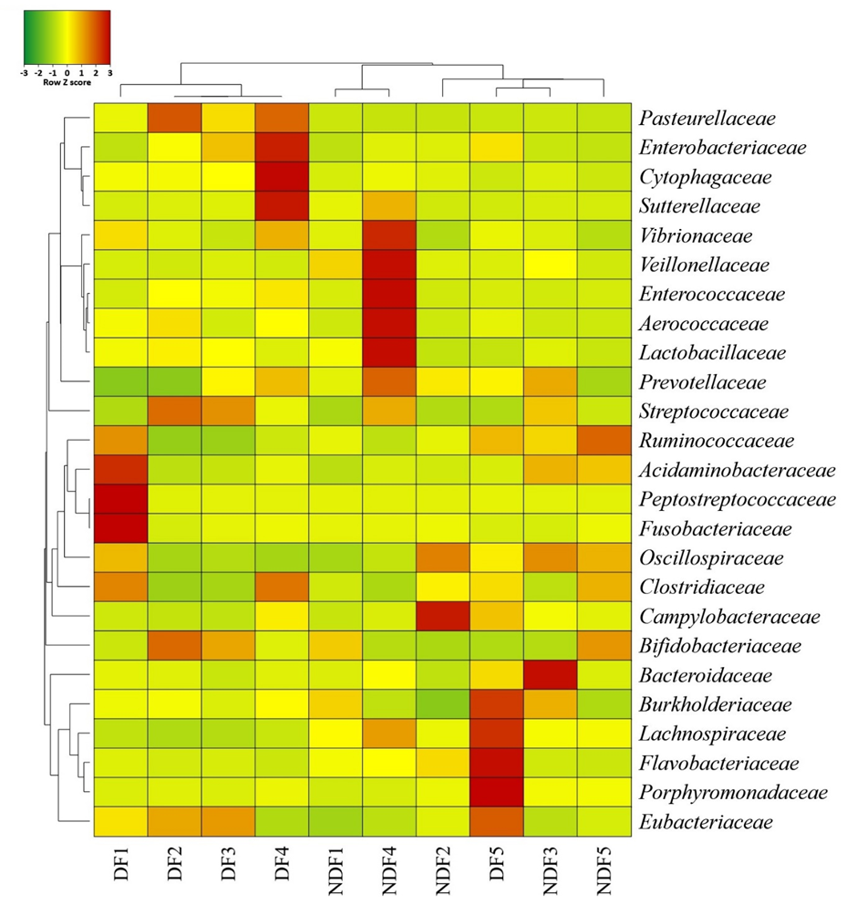

**Fig. 5.6.** Taxonomic profile of microbiomes at the family level.Heatmap showing the average relative abundances and hierarchical clustering of the families of bacteria (25 top abundant) in the study samples. The colour bar (row Z score) at the top represents the relative abundance of the bacterial orders in the corresponding samples. The colour codes indicate the presence and completeness of each bacterial family, expressed as a value between =3 (lowest abundance) and 3 (highest abundance). The red colour indicates the more abundant patterns, while green cells account for less abundant orders in that particular sample.

The family level bacteriome composition and abundances were also found to be varied in the gut of DF and NDF calves. In DF, *Pasteurellaceae* (61.94 %) was found to be most abundant family followed by *Bacteroidaceae* (7.00 %), *Clostridiaceae* (5.11 %), *Ruminococcaceae* (4.25 %), *Streptococcaceae* (4.19 %) and *Enterococcaceae* (4.04 %). Likewise, *Veillonellaceae* (33.77 %) was found to be most abundant family in NDF, followed by *Bacteroidaceae* (18.89 %), *Enterococcaceae* (11.17%), *Ruminococcaceae* (8.54%), *Clostridiaceae* (5.12 %), *Streptococcaceae* (4.46 %), *Oscillospiraceae* (3.62 %) and *Pasteurellaceae* (3.11 %) (**Fig. 5.6. Data S1**). The remaining families were found to have a relatively low abundance, with an average of less than 2 % (**Data S1**).

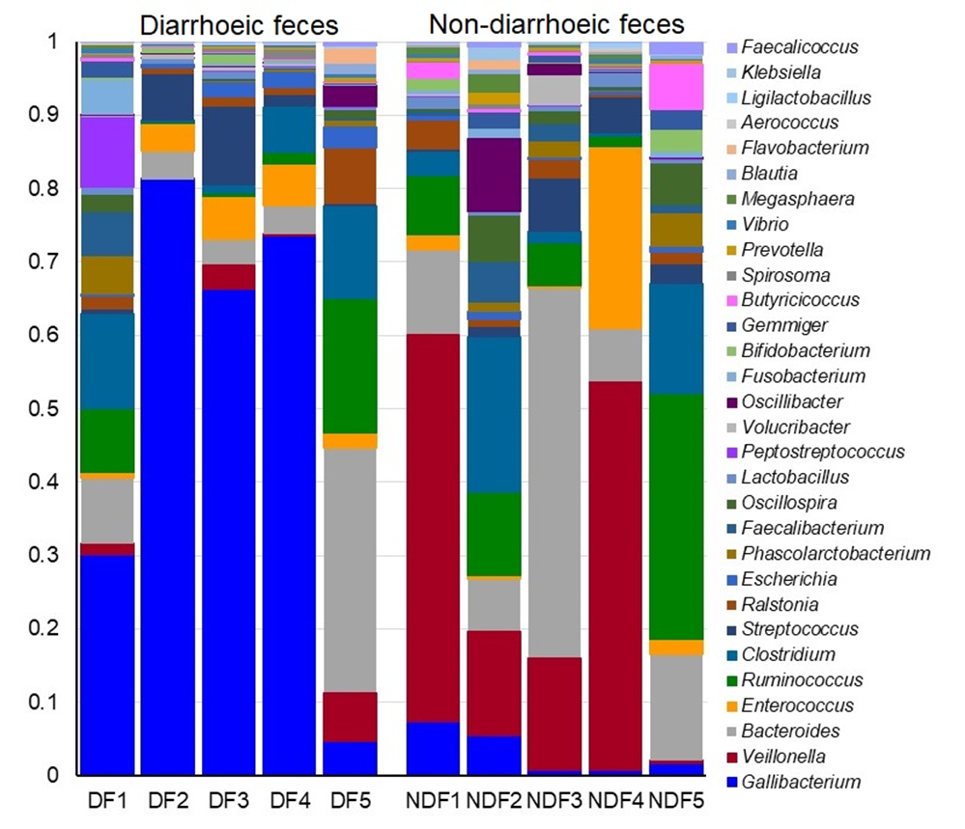

**Fig. 5.7.** The genus-level taxonomic profile of microbiomes. The bar plots representing the relative abundance of top abundant 30 bacterial genera in diarrhoeic feces (DF1 – DF5) and non-diarrhoeic (NDF1 – NDF5) of calves. Each stacked bar plot represents the abundance of bacterial genera in each sample of the corresponding category. Notable differences in bacterial genera are those where the taxon is abundant in DF samples, and effectively not detected in the NDF samples. The distribution and relative abundance of the bacterial genera in the study metagenomes are also available in Data S1.

We also demonstrated noteworthy differences in both composition and the relative abundances of bacterial taxa at genus-level according to sample categories (DF and NDF; p = 0.0127; KruskalWallis test) of the claves. The top abundant genus identified in DF was *Gallibacterium* (61.20 %), followed by *Bacteroides* (68.80 %), *Clostridium* (4.94 %), *Streptococcus* (4.09 %), *Enterococcus* (4.04 %) and *Ruminococcus* (3.32 %). Conversely, *Veillonella* (34.32 %) was found to be most abundant genus in NDF, followed by *Bacteroides* (18.74 %), *Enterococcus* (11.16 %), *Ruminococcus* (7.26 %), *Streptococcus* (4.21 %) and *Clostridium* (3.92 %) (**Fig. 5.7. Data S1**).

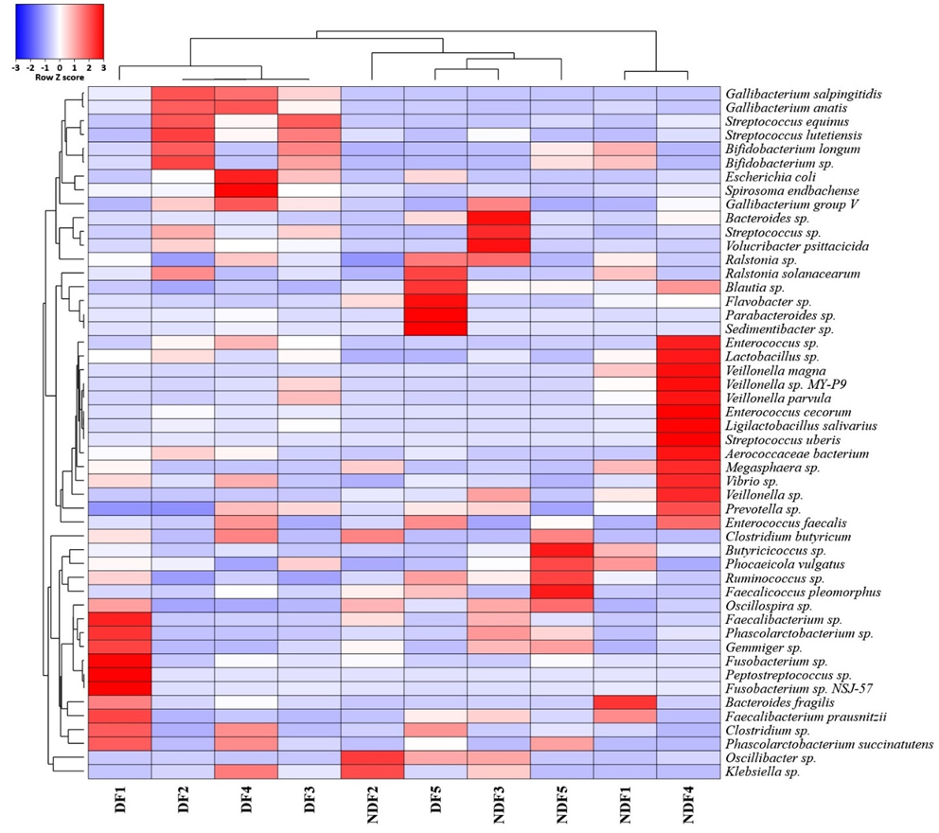

**Fig. 5.8.** Taxonomic profile of microbiomes in at the species level. Heatmap showing the average relative abundances and hierarchical clustering of the bacterial species (50 top abundant) in the study samples. The colour bar (row Z score) at the top represents the relative abundance of the bacterial species in the corresponding samples. The colour codes indicate the presence and completeness of each bacterial taxa, expressed as a value between =3 (lowest abundance) and 3 (highest abundance). The red colour indicates the more abundant patterns, while blue cells account for less abundant species in that particular sample.

By comparing the bacterial taxa at species level, we found that most prevalent species in DF was *Gallibacteriumsalpingitidis* (43.37 %), followed by *Gallibacteriumanatis* (17.56 %), *Bacteroides* sp. (6.22 %), *Clostridium* sp. (3.81 %), *Ruminococcus* sp. (3.24 %), *Enterococcus* sp. (3.08 %) and *Streptococcus equinus* (2.30 %). On the other hand, *Veillonella magna* (19.21 %) was top abundant bacterial species in the gut of NDF calves followed by *Bacteroides* sp. (18.0 %), *Veillonella* sp. (13.09 %), *Ruminococcus* sp. (7.23 %), *Enterococcus cecorum* (5.59 %), *Enterococcus* sp. (5.25 %) and *Clostridium butyricum* (2.04 %) (**Fig. 5.8. Data S1**). Despite, having had relatively lower abundances (< 2.0 %), rest of the bacterial species showed discriminations according to sample groups (**Data S1**).

**5.4. Discussion**

Diarrhoea is a prominent factor contributing to mortality rates in dairy calves during the first month of their life (Caffarena *et al.,* 2021; Fan *et al.,* 2021). Understanding the fecal microbiota in both diarrhoeic and non-diarrhoeic calves is crucial for developing more effective treatment and prevention strategies. By gaining insights into the microbial composition of the gut, researchers and veterinarians can better address the challenges associated with calf diarrhoea. Also, such understanding can pave the way for targeted interventions that promote healthier gut microbiota and reduce the incidence of diarrhoea in calves (Chen *et al.,* 2022). Still, there are few studies that reveal associations between the gut microbiota of calves and diarrhoea. However, with the development of culture-independent molecular-based approaches, it is now possible to do more studies on the gut bacteria of dairy calves (Malmuthuge and Guan, 2017). Next-generation sequencing (NGS), for example, has become more affordable for researchers who desire to employ it for researching the microbiota of calves' gastrointestinal tract. Microbiota and microbiome are two terms that are frequently used interchangeably; however, microbiota refers to the composition of a microbial community and is typically identified by targeted sequencing of the 16S rRNA gene using amplicon sequencing, whereas microbiome refers to the total genetic information of a microbial community (microbiota) and can be identified through whole-genome sequencing (WGS) of the metagenome (Malmuthuge, 2017**).** A recent study by Fan *et al.,* (2021) has identified several types of bacteria that are commonly found in diarrhoeic calves’ feces. These bacteria include Negativicutes, Tyzzerella, and (Ruminococcus) torques group, Parasutterella, Veillonella, Lachnospiraceae_UCG-004, *Lachnoclostridium*, *Butyricicoccus*, *Fusobacterium*, and *Campylobacter*. They also found a group of potentially beneficial microorganisms that were more common in healthy calves' feces including Christensenellaceae, Oscillospiraceae, Barnesiella, Parabacteroides, and *Lactobacillus* (Malmuthuge, 2017).

This research aimed to examine the makeup of the fecal microbiota in one-month-old calves, comparing those with diarrhoea to those without diarrhoea. Numerous bacterial strains were found in order to differentiate between fecal samples from individuals with diarrhoea and those without and to determine their correlation with diarrhoeagenic pathogens. The assessment of bacterial community diversity in both calves suffering from DF and those without NDF revealed significant differences in the composition of their gut microbiomes. Various diversity indices and statistical analyses were applied to explore the alpha and beta diversity of these microbial communities. The alpha diversity, which measures the diversity within each sample, was significantly affected by the occurrence of diarrhoea, as indicated by a *p*-value of 0.036. This suggests that an episode of diarrhoea led to alterations in the microbial taxa present in the GI tracts of the calves. The beta diversity, assessing the differences between microbial communities across samples, also exhibited a statistically significant effect (*p*-value of 0.021) of diarrhoea on the microbiome composition of the calves' gastrointestinal tracts. This highlights the distinct microbial communities in response to diarrhoea. Of the 18 phyla identified, 17 were found in both the DF and NDF samples. The phylum Tenericutes stood out as being unique to the DF group, although it appeared at a relative abundance of less than 1%. Bacteria belonging to the phyla Proteobacteria, Firmicutes, Bacteroidetes, and Bacillota were found in the highest abundance across both sample sets. Proteobacteria comprised the largest phylum in DF (66.05 %), whereas Firmicutes were the most numerous in NDF (68.72 %). Furthermore, at the class level, 31 bacterial classes were identified, with 30 in DF and 21 in NDF samples. Gammaproteobacteria was the most prevalent class in both groups, followed by Negativicutes, Clostridia, Bacilli, and Bacteroidia. Gammaproteobacteria (40.26 %) was most abundant in DF, while Negativicutes (15.88 %) dominated in NDF. Based on taxonomical profiling at the class level, it was observed that a total of 31 bacterial classes were identified in the two sample groups. Specifically, the DF calves' samples exhibited an abundance of 30 bacterial classes, while the NDF calves' samples comprised 21 bacterial classes. A total of 21 bacterial classes, which is about 67.74 % of the identified classes, were found to be shared across DF and NDF samples. Conversely, approximately 29.03 % of the total number of classes identified, showed a unique association with DF samples. Nevertheless, these distinctive classes were shown to be present in only a small number, which is < 1 %. Moreover, it was determined that Gammaproteobacteria accounted for the highest proportion (64.18 %) of the detected bacterial class in DF, while Negativicutes was shown to be the most abundant class (36.10 %) in NDF. Besides, the two samples comprised 65 bacterial orders: 59 in DF calves and 53 in NDF calves. Also, the two sample groups shared 58.46 % of the bacterial order. Interestingly, certain bacterial orders have a unique association with DF or NDF, while 15.38 % and 6.15 % were solely reported in DF and NDF sample groups, respectively. Nevertheless, these distinct bacterial orders exhibited very low abundance in both sample groups. In DF samples, Pasteurellales (61.99 %) was the most prevalent order (61.99 %), while Selenomonadales (34.85%) was the most abundant order in NDF samples. Furthermore, 87 different bacterial families were identified within the two sample groups when comparing taxonomic relative abundance at the family level. Consequently, the DF samples had 67 bacterial families, whereas the NDF samples contained 57 bacterial families. Of the total number of bacterial families identified, around 58.62% existed in both the DF and NDF samples, where, 13.79 % of the families were found to be unique to DF and 3.45% were found to be unique to the NDF sample group. Therefore, Pasteurellaceae was found to be the most abundant family in DF, comprising 61.94 %, whereas Veillonellaceae constituted 33.77 % of the total bacterial family in NDF. Both the DF and NDF samples were assessed for the taxonomical relative abundance of bacteria at the genus level, and the results showed that both groups included 188 different bacterial genera. The NDF samples included 101 distinct bacterial genera, whereas the DF samples had 131 distinct bacterial genera. In addition, 46.28 % of the bacterial taxa were reported as common genera in both the DF and NDF samples. However, each set of samples has a significant number of unique genera, with 23.40 % of them genera being unique to the DF and 7.45% to the NDF. Though, these unique genera were present at relatively low abundance in both sample group. Also, *Gallibacterium* was found to be the most common genus in DF (61.20 %), whereas *Veillonella* was the most abundant genus found in NDF (34.32 %). A total of 358 distinct bacterial species were observed in both DF and NDF sample groups. Specifically, 217 bacterial species were identified in the DF, while 162 bacterial species were found in the NDF calf samples. From the total number of bacterial species, 32.18 % existed in both DF and NDF, whereas 28.51% and 13.19% were uniquely found in DF or NDF, respectively. The predominant species in DF was identified as *Gallibacterium salpingitidis*, encompassing 43.37% of the bacterial population. Conversely, in NDF, *Veillonella magna* exhibited the highest prevalence, including 19.21 % of the total bacterial population.

**5.5. Conclusion**

In this study, diarrhoeic calves had a significantly different gut microbiome composition compared to non-diarrhoeic calves, as measured by the alpha diversity (p-value of 0.036) and beta diversity (*p*-value of 0.021) analysis. A notable disparity in taxonomical abundance between DF and NDF was also observed. Among the identified genera, *Gallibacterium* (37.48%), *Veillonella* (14.53%), and *Bacteroides* (11.61%) were found to be the predominant bacterial genera in the calves' gut of calves, however, a significant difference in the relative abundances of these between DF and NDF calves was observed. Consequently, *Gallibacteriumsalpingitidis* (43.37 %) was found as the most prevalent species in DF, whereas *Veillonella magna* (19.21%) predominated in NDF. These findings additionally reveal the impact of diarrhoea on microbial prevalence. Finally, this research emphasizes how the presence or absence of diarrhoea corresponds to specific microbial taxa, highlighting the importance of understanding the composition and diversity of the gut microbiome in calves. Understanding the differences in microbial communities is crucial for advancing research on gastrointestinal health in livestock. These differences can offer valuable insights that have implications for animal husbandry and veterinary practices.

**Chapter 6**

**Conclusions**

**6.1. Conclusions**

*Cryptosporidium* spp. and *Giardia* spp. are the leading causal agents of parasitic diarrhea in humans and calves. Our studies highlighted that these two protozoans can be transmitted between both populations. Both pathogens contain host-adapted and zoonotic strains and ubiquitous in nature. Human and animal can be infected with same species and strains. The epidemiology of cryptosporidiosis and giardiasis revealed the exposure factors that are associated with the increased probability of infection to these two pathogens. Conventional staining based and modern DNA based molecular identification and characterization of the isolates that infect calves and humans could help in understanding which factors are significantly associated with the infection. The information will eventually aid in disease management, prevention and control. Furthermore, molecular characterization of the human and calves fecal isolates identifies zoonotic genotypes which may point out to the transmission routes of infection or disease transmission routes among humans. Interestingly, our results showed that all *Giardia intestinalis* assemblages were host-adapted in humans and was not identified in calves. Use of metagenomics tools for comprehensive identification of microbial populations in diarrhoeic and non-diarrhoeic calves is also unique attempt and first of its type in the country. The list of novel pathogens are crucial when planning effective treatment plans to combat diarrhoeal illness in both animals and human.

The importance of the timely processing of fecal samples was noted to reserve as much pathogen DNA as possible for detection. Another technique followed for diagnostic tests conducted in this dissertation, the PCR assay was applied to all samples regardless whether they are tested positive or negative to the real-time PCR assay that is the gold standard. Because real-time PCR is more sensitivityand specificity and also quantitative analysisreal-time PCR provides results rapidly compared to other nucleic acid detection methods. Additionally, it is recommended to use multilocus PCR protocol to characterize *Giardia* spp. isolates due to the divergent agreement between genes in the *Giardia* genome. Our research in Bangladesh reveals a high prevalence of *Cryptosporidium* and *Giardia*, particularly affecting children and calves those are associated poor sanitation conditions. Molecular diagnostic techniques, such as PCR and real-time PCR, have enhanced the identification and differentiation of these pathogens. Metagenomic studies have uncovered significant genetic diversity and multiple co-infections, offering deep insights into pathogen dynamics. Despite the advanced research tools, integrating these methods into public health practice remains challenging but we hope it paving the way for more effective control and prevention measures for the diarrheal diseases in our country.

**6.2. Future perspectives and limitation**

The research was carried out in a limited region (only Chattogram) in Bangladesh.

Shotgun metagenome sequencing could provide a better understanding on fecal microbiome including viral, parasitic and fungal biome and their association with the disease complications. The association of comorbidities with the disease complications were not evaluated.Although, giardiasis and cryptosporidiosis are zoonotic in nature, and the research holds several promising prospects. Embracing a One Health approach is crucial for addressing the complex challenges posed by *Giardia* and *Cryptosporidium* infections, which involve interactions between humans, animals, and the environment. Future research may focus on integrating data from diverse disciplines, including human and veterinary medicine, environmental science, and microbiology, to develop holistic strategies for disease prevention and control. Research efforts are likely to continue towards the development of novel therapeutics for *Giardia* and *Cryptosporidium* infections. This includes identifying new drug targets, screening of compound libraries, and exploring alternative treatment strategies such as immunotherapies and phage therapy. Despite challenges, vaccine development for *Giardia* and *Cryptosporidium* remains a priority. Future research may focus on identifying suitable vaccine candidates, optimizing vaccine formulations and delivery systems, and assessing vaccine efficacy in clinical trials, particularly in high-risk populations such as children and immunocompromised individuals. Whole genome sequencing (WGS) has been instrumental in advancing our understanding of the parasite's biology, evolution, and pathogenesis. Future research may explore the development of point-of-care diagnostics, multiplex assays for simultaneous detection of multiple pathogens, and innovative techniques and nanotechnology-based approaches.

To continue investigating potential risk factors that can associate with the infection *Cryptosporidium* spp. and *Giardia duodenalis* in children and calves, research is needed to identify those factors. This will allow for a larger sample size and to compare the risk in these two segments of populations. In addition, it will be helpful to identify a baseline exposure of that work on large animal rotations. More particularly, it is helpful to determine zoonotic or anthroponotic transmission of *Cryptosporidium* spp. in large animal track veterinarians, those who have worked or are working on a dairy farm. As a follow up of research conducted in Chapter 4 of this dissertation, an evaluation for zoonotic transmission was determined. This evaluation can be conducted for associations of positive test results tested by the PCR assays with the clinical findings and determine the probability of human and calves carrying the zoonotic species of *Giardia* and *Cryptosporidium.*

Cryptosporidiosis and giardiasis are often considered as neglected diseases in developing countries including Bangladesh, with limited awareness among healthcare providers, policymakers, and the general public. As a result, there may be underreporting of cases, inadequate surveillance systems, and insufficient funding allocated for research and control efforts. Diagnosing giardiosis and cryptosporidiosis in Bangladesh can be challenging due to the lack of sensitive and specific diagnostic tools, particularly in resource-limited settings. Traditional microscopy-based methods may have limitations in sensitivity and specificity, leading to misdiagnosis or underestimation of the true burden of disease. Bangladesh may have limited research infrastructure and laboratory facilities for conducting molecular and epidemiological studies on giardiasis and cryptosporidiosis. This includes a lack of trained personnel, inadequate laboratory equipment and supplies, and limited access to advanced molecular diagnostic techniques such as PCR and whole genome sequencing. Environmental and socioeconomic factors, such as poor sanitation, inadequate access to clean water, overcrowding, and poverty, contribute to the transmission and persistence of *Giardia* and *Cryptosporidium* infections in Bangladesh. These factors may pose challenges for implementing effective control measures and conducting research studies to understand transmission dynamics.

Research on giardiasis and cryptosporidiosis in Bangladesh may lack an integrated One Health approach, which considers the interconnectedness of human, animal, and environmental health. Collaborative efforts between human and veterinary health sectors, as well as environmental and public health authorities, are essential for addressing the complex transmission pathways and implementing comprehensive control strategies. There may be significant gaps in epidemiological data and scientific knowledge regarding the prevalence, distribution, and genetic diversity of *Giardia* and *Cryptosporidium* strains in Bangladesh. Further research is needed to fill these gaps and inform evidence-based interventions for disease prevention and control.WGS can provide insights into transmission dynamics, identify emerging genotypes, and track the spread of drug resistance Understanding host-parasite interactions to facilitate the development of targeted interventions and vaccines. Environmental surveillance programs such as monitoring water and food sources will help in preventing pathogen transmission. Adopting a One Health approach to study the inter-connection of human, animal, and environmental reservoirs investigating zoonotic transmission.

**CHAPTER 7**

**Reference**

Abeywardena, H., Jex, A. R., & Gasser, R. B. (2015). A perspective on *Cryptosporidium* and *Giardia*, with an emphasis on bovines and recent epidemiological findings. *Advances in parasitology*, *88*, 243-301.

Abu-Madi, M., Boughattas, S., Behnke, J. M., Sharma, A., & Ismail, A. (2017). Coproscopy and molecular screening for detection of intestinal protozoa. *Parasites & vectors*, *10*, 1-10.

Adam, E. A., Yoder, J. S., Gould, L. H., Hlavsa, M. C., & Gargano, J. (2016). *Giardiasis* outbreaks in the United States, 1971–2011. *Epidemiology & Infection*, *144*(13), 2790-2801.

Adamu, H., Petros, B., Zhang, G., Kassa, H., Amer, S., Ye, J., ...& Xiao, L. (2014). Distribution and clinical manifestations of *Cryptosporidium* species and subtypes in HIV/AIDS patients in Ethiopia. *PLoS Neglected Tropical Diseases*, *8*(4), e2831.

Aghakeshmiri, F., Azizzadeh, M., Farzaneh, N., & Gorjidooz, M. (2017). Effects of neonatal diarrhea and other conditions on subsequent productive and reproductive performance of heifer calves. Veterinary research communications, 41, 107-112.

Ajjampur, S. S. R., Rajendran, P., Ramani, S., Banerjee, I., Monica, B., Sankaran, P., Rosario V, Arumugam R, Sarkar R, Ward H, Kang, G. (2008). Closing the diarrhoea diagnostic gap in Indian children by the application of molecular techniques. *Journal of medical microbiology*, *57*(11), 1364-1368.

Allain, T., & Buret, A. G. (2020). Pathogenesis and post-infectious complications in *Giardiasis*. *Advances in parasitology*, *107*, 173-199.

Alles, A. J., Waldron, M. A., Sierra, L. S., & Mattia, A. R. (1995). Prospective comparison of direct immunofluorescence and conventional staining methods for detection of *Giardia* and *Cryptosporidium* spp. in human fecal specimens. *Journal of clinical microbiology*, *33*(6), 1632-1634.

Alvarez-Pellitero, P., & Sitjà-Bobadilla, A. (2002). *Cryptosporidium* molnari n. sp.(Apicomplexa: Cryptosporidiidae) infecting two marine fish species, Sparus aurata L. and Dicentrarchus labrax L. *International journal for parasitology*, *32*(8), 1007-1021.

Anderson, B. C., Donndelinger, T., Wilkins, R. M., & Smith, J. (1982). Cryptosporidiosis in a veterinary student. 408-409.

Andrews S. FastQC(2017). A quality control tool for high throughput sequence data. 2010.

Ankarklev, J., Jerlström-Hultqvist, J., Ringqvist, E., Troell, K., & Svärd, S. G. (2010). Behind the smile: cell biology and disease mechanisms of *Giardia* species. *Nature reviews microbiology*, *8*(6), 413-422.

Arroyo‐López, F. N., Bautista Gallego, J., Valero, A., García‐Gimeno, R. M., & Garrido Fernández, A. (2014). Predictive microbiology: a valuable tool in food safety and microbiological risk assessments. *Practical Food Safety: Contemporary Issues and Future Directions*, 517-534.

Aurrecoechea, C., Barreto, A., Brestelli, J., Brunk, B. P., Cade, S., Doherty, R., ...& Warrenfeltz, S. (2012). EuPathDB: the eukaryotic pathogen database. *Nucleic acids research*, *41*(D1), D684-D691.

Baldursson, S., & Karanis, P. (2011). Waterborne transmission of protozoan parasites: review of worldwide outbreaks–an update 2004–2010. *Water research*, *45*(20), 6603-6614.

Ballweber, L. R., Xiao, L., Bowman, D. D., Kahn, G., & Cama, V. A. (2010). *Giardiasis* in dogs and cats: update on epidemiology and public health significance. *Trends in parasitology*, *26*(4), 180-189.

Bartels, C. J., Holzhauer, M., Jorritsma, R., Swart, W. A., & Lam, T. J. (2010). Prevalence, prediction and risk factors of enteropathogens in normal and non-normal faeces of young Dutch dairy calves. *Preventive veterinary medicine, 93(2-3), 162-169.*

Beer, K. D., Gargano, J. W., Roberts, V. A., Hill, V. R., Garrison, L. E., Kutty, P. K., ... & Yoder, J. S. (2015). Surveillance for waterborne disease outbreaks associated with drinking water—United States, 2011–2012. *Morbidity and Mortality Weekly Report*, *64*(31), 842.

Bertrand, I., Gantzer, C., Chesnot, T., & Schwartzbrod, J. (2004). Improved specificity for *Giardia* *lamblia* cyst quantification in wastewater by development of a real-time PCR method. *Journal of Microbiological Methods*, *57*(1), 41-53.

Bialek, R., Binder, N., Dietz, K., Joachim, A., Knobloch, J., & Zelck, U. E. (2002). Comparison of fluorescence, antigen and PCR assays to detect *Cryptosporidium parvum* in fecal specimens. *Diagnostic microbiology and infectious disease*, *43*(4), 283-288.

Blackburn, B. G., Craun, G. F., Yoder, J. S., Hill, V., Calderon, R. L., Chen, N., ... & Beach, M. J. (2004). Surveillance for waterborne-disease outbreaks associated with drinking water--United States, 2001-2002. *MMWR surveillance summaries*, *53*(8), 23.

Blanchard, R. (1888). *Remarques sur le megastome intestinal*.

Bolger, A. M., Lohse, M., & Usadel, B. (2014). Trimmomatic: a flexible trimmer for Illumina sequence data. *Bioinformatics,* 30(15), 2114-2120.

Bolyen, E., Rideout, J. R., Dillon, M. R., Bokulich, N. A., Abnet, C. C., Al-Ghalith, G. A., ... & Caporaso, J. G. (2019). Reproducible, interactive, scalable and extensible microbiome data science using QIIME 2. *Nature biotechnology*, 37(8), 852-857.

Bouzid, M., Hunter, P. R., Chalmers, R. M., & Tyler, K. M. (2013). *Cryptosporidium* pathogenicity and virulence. *Clinical microbiology reviews*, *26*(1), 115-134.

Bremner, J., Frost, A., Haub, C., Mather, M., Ringheim, K., & Zuehlke, E. (2010). World population highlights: Key findings from PRB’s 2010 world population data sheet. *Population Bulletin*, *65*(2), 1-12.

Bridle, H. (2021). Overview of waterborne pathogens. *In Waterborne Pathogens* (pp. 9-40). *Academic Press.*

Bubnoff, A.V. (2008). Next-generation sequencing*: the race is on. Cell*, *132*(5), 721-723.

Budu-Amoako, E., Greenwood, S. J., Dixon, B. R., Barkema, H. W., & McClure, J. T. (2012). Occurrence of *Cryptosporidium* and *Giardia* on beef farms and water sources within the vicinity of the farms on Prince Edward Island, Canada. *Veterinary Parasitology*, *184*(1), 1-9.

Cacciò, S. M., & Sprong, H. (2011). Epidemiology of *Giardiasis* in humans.  In: *Giardia*: A Model Organism,(ed.) .H.D.Lujan,S.Svard, *Springer Vienna*,Vienna, 17-28pp

Cacciò, S. M., & Widmer, G. (Eds.). (2013). *Cryptosporidium*: parasite and disease. *Springer Science& Business Media*.

Cacciò, S. M., De Giacomo, M., Aulicino, F. A., & Pozio, E. (2003). *Giardia* cysts in wastewater treatment plants in Italy. *Applied and environmental microbiology*, *69*(6), 3393-3398.

Cacciò, S. M., Lalle, M., & Svärd, S. G. (2018). Host specificity in the *Giardia duodenalis* species complex. *Infection, Genetics and Evolution*, *66*, 335-345.

Cacciò, S. M., Thompson, R. A., McLauchlin, J., & Smith, H. V. (2005). Unravelling *Cryptosporidium* and *Giardia* epidemiology. *Trends in parasitology*, *21*(9), 430-437.

Caffarena, R. D., Casaux, M. L., Schild, C. O., Fraga, M., Castells, M., Colina, R., ... & Giannitti, F. (2021). Causes of neonatal calf diarrhea and mortality in pasture-based dairy herds in Uruguay: A farm-matched case-control study. *Brazilian Journal of Microbiology*, 52(2), 977-988.

Cardona, G. A., Carabin, H., Goñi, P., Arriola, L., Robinson, G., Fernández-Crespo, J. C., ... & Carmena, D. (2011). Identification and molecular characterization of *Cryptosporidium* and *Giardia* in children and cattle populations from the province of Álava, North of Spain. *Science of the total environment*, *412*, 101-108.

Casemore, D. P., Sands, R. L., & Curry, A. (1985). *Cryptosporidium* species a" new" human pathogen. *Journal of Clinical Pathology*, *38*(12), 1321.

Certad, G., Viscogliosi, E., Chabé, M., & Cacciò, S. M. (2017). Pathogenic mechanisms of *Cryptosporidium* and *Giardia*. *Trends in Parasitology*, *33*(7), 561-576.

CFSPH (2005): Cryptosporidiosis - The Center for Food Security and Public Health, Lowa State university, https://www.cfsph.iastate.edu/DiseaseInfo/notes/ Cryptosporidiosis.pdf

Chakravarty, I., Bhattacharya, A., & Das, S. K. (2017). Water, sanitation and hygiene: the unfinished agenda in the World Health Organization South-East Asia Region. *WHO South-East Asia journal of public health*, *6*(2), 22-26.

Chalmers, J. D., Singanayagam, A., Akram, A. R., Mandal, P., Short, P. M., Choudhury, G., ... & Hill, A. T. (2010). Severity assessment tools for predicting mortality in hospitalised patients with community-acquired pneumonia. Systematic review and meta-analysis. *Thorax, thx*-2009. **65**(10): p. 878-83.

Chalmers, R. M., & Davies, A. P. (2010). Minireview: clinical cryptosporidiosis. *Experimental parasitology*, *124*(1), 138-146.

Chalmers, R. M., & Katzer, F. (2013). Looking for *Cryptosporidium*: the application of advances in detection and diagnosis. *Trends in parasitology*, *29*(5), 237-251.

Chalmers, R. M., Campbell, B. M., Crouch, N., Charlett, A., & Davies, A. P. (2011). Comparison of diagnostic sensitivity and specificity of seven *Cryptosporidium* assays used in the UK. *Journal of medical microbiology*, *60*(11), 1598-1604.

Checkley, W., White, A. C., Jaganath, D., Arrowood, M. J., Chalmers, R. M., Chen, X. M., ...& Houpt, E. R. (2015). A review of the global burden, novel diagnostics, therapeutics, and vaccine targets for *Cryptosporidium*. *The Lancet Infectious Diseases*, *15*(1), 85-94.

Chen, H., Liu, Y., Huang, K., Yang, B., Zhang, Y., Yu, Z., & Wang, J. (2022). Fecal microbiota dynamics and its relationship to diarrhea and health in dairy calves. *Journal of animal science and biotechnology, 13(1), 1-20.*

Chen, W., Harp, J. A., & Harmsen, A. G. (2003). *Cryptosporidium* parvum Infection in Gene-Targeted B Cell–Deficient Mice. *Journal of Parasitology*, *89*(2), 391-393.

Chen, X. M., Keithly, J. S., Paya, C. V., & LaRusso, N. F. (2002). Cryptosporidiosis. *New England Journal of Medicine*, *346*(22), 1723-1731.

Cho, Y. I., & Yoon, K. J. (2014). An overview of calf diarrhea-infectious etiology, diagnosis, and intervention. *Journal of veterinary science*, 15(1), 1-17.

Chourabi, M., Boughattas, S., Abdallah, A. M., Ismail, A., Behnke, J. M., Al-Mekhlafi, H. M., & Abu-Madi, M. (2021). Genetic diversity and prevalence of *Giardia* *duodenalis* in Qatar. *Frontiers in Cellular and Infection Microbiology*, *11*, 652946.

Chuah, C. J., Mukhaidin, N., Choy, S. H., Smith, G. J., Mendenhall, I. H., Lim, Y. A., & Ziegler, A. D. (2016). Prevalence of *Cryptosporidium* and *Giardia* in the water resources of the Kuang River catchment, Northern Thailand. *Science of the Total Environment*, *562*, 701-713.

Clark, D. P. (1999). New insights into human *cryptosporidiosis*. *Clinical Microbiology Reviews*, *12*(4), 554-563.

Cleaveland, S., Laurenson, M. K., & Taylor, L. H. (2001). Diseases of humans and their domestic mammals: pathogen characteristics, host range and the risk of emergence. *Philosophical Transactions of the Royal Society of London. Series B: Biological Sciences*, *356*(1411), 991-999.

Clemmons, B. A., Voy, B. H., & Myer, P. R. (2019). Altering the gut microbiome of cattle: considerations of host-microbiome interactions for persistent microbiome manipulation. *Microbial ecology*, *77*, 523-536.

Clinton White Jr, A. (2010). Cryptosporidiosis and the ears of the hippopotamus. *Clinical Infectious Diseases*, *50*(10), 1373-1374.

Coklin, T., Farber, J., Parrington, L., & Dixon, B. (2007). Prevalence and molecular characterization of *Giardia duodenalis* and *Cryptosporidium spp.* in dairy cattle in Ontario, Canada. *Veterinary parasitology*, *150*(4), 297-305.

Current, W. L., & Garcia, L. S. (1991). Cryptosporidiosis. *Clinical microbiology reviews*, *4*(3), 325-358.

Current, W. L., Reese, N. C., Ernst, J. V., Bailey, W. S., Heyman, M. B., & Weinstein, W. M. (1983). Human cryptosporidiosisin immunocompetent and immune deficient persons: studies of an outbreak and experimental transmission. *New England journal of medicine*, *308*(21), 1252-1257.

D. A. (2003). Detection of *Cryptosporidium* *parvum* and *Giardia* *lamblia* carried by synanthropic flies by combined fluorescent in situ hybridization and a monoclonal antibody. *The American journal of tropical medicine and hygiene*, *68*(2), 228-232.*nv. Institute, Oxford Univ. Press. 473p*, *9*, 1051-0761.

Daniels, M. E., Shrivastava, A., Smith, W. A., Sahu, P., Odagiri, M., Misra, P. R., ... & Jenkins, M. W. (2015). *Cryptosporidium* and *Giardia* in humans, domestic animals, and village water sources in rural India. *The American journal of tropical medicine and hygiene*, *93*(3), 596.

Dau, J. (1981). Levine, N.D. 1973. *Giardia* Kunstler, 1882. pp. 118-122. In: Protozoan Parasites of Domestic Animals and of Man. Bur-gess Pub. Co., Minneapolis, MN. *Alaskan Wildlife Diseases*, 171.

de Graaf, D. C., Vanopdenbosch, E., Ortega-Mora, L. M., Abbassi, H., & Peeters, J. E. (1999). A review of the importance of *cryptosporidiosis* in farm animals. *International Journal for parasitology*, *29*(8), 1269-1287.

Dixon, B. R. (2015). Transmission dynamics of foodborne parasites on fresh produce. In *Foodborne parasites in the food supply web* (pp. 317-353). Woodhead Publishing.

Dixon, B. R. (2021). *Giardia* duodenalis in humans and animals–Transmission and disease. *Research in veterinary science*, *135*, 283-289.

Dobell, C. (1920). The discovery of the intestinal protozoa of man. *Proceedings of the Royal Society of Medicine*, *13*(Sect_Hist_Med), 1-15.

Douglas, A. E. (2019). Simple animal models for microbiome research. *Nature Reviews Microbiology*, *17*(12), 764-775.

Du, W., Wang, X., Hu, M., Hou, J., Du, Y., Si, W., ... & Xu, Q. (2023). Modulating gastrointestinal microbiota to alleviate diarrhea in calves. *Frontiers in Microbiology*, 14, 1181545.

Duhain, G. L. M. C., Minnaar, A., & Buys, E. M. (2012). Effect of chlorine, blanching, freezing, and microwave heating on *Cryptosporidium* *parvum* viability inoculated on green peppers. *Journal of food protection*, *75*(5), 936-941.

Dunning, John B. Jr., ed. (2008). CRC Handbook of Avian Body Masses (2nded.). *CRC Press*. [ISBN](https://en.wikipedia.org/wiki/ISBN_(identifier))[978-1-4200-6444-5](https://en.wikipedia.org/wiki/Special:BookSources/978-1-4200-6444-5).

Dwivedi, K. K., Prasad, G., Saini, S., Mahajan, S., Lal, S., & Baveja, U. K. (2007). Enteric opportunistic parasites among HIV infected individuals: associated risk factors and immune status. *Japanese journal of infectious diseases*, *60*(2/3), 76.

Ekici, A., Yılmaz, H., & Beyhan, Y. E. (2022). Prevalence of cryptosporidiosis in humans and calves, and molecular detection of *Cryptosporidium parvum*. *MVZ Córdoba*, *27*(2), e2447.

Edgar, R. C. (2004). MUSCLE: multiple sequence alignment with high accuracy and high throughput. *Nucleic acids research*, *32*(5), 1792-1797.

Efstratiou, A., Ongerth, J. E., & Karanis, P. (2017a). Waterborne transmission of protozoan parasites: review of worldwide outbreaks-an update 2011–2016. *Water research*, *114*, 14-22.

Egyed, Z., Sréter, T., Széll, Z., Beszteri, B., Dobos-Kovács, M., Márialigeti, K., ...& Varga, I. (2002). Polyphasic typing of *Cryptosporidium* *baileyi:* a suggested model for characterization of *cryptosporidia*. *Journal of parasitology*, *88*(2), 237-243.

Ehsan, A.M., Geurden, T., Casaert, S., Parvin, S.M., Islam, T.M., Ahmed, U.M., Levecke, B., Vercruysse, J., Claerebout, E. (2015). Assessment of Zoonotic Transmission of *Giardia* and *Cryptosporidium* between Cattle and Humans in Rural Villages in Bangladesh. *PLOS ONE,* 10:0118239.

Ehsan, M. A., Akter, M., Ahammed, M., Ali, M. A., Ahmed, M. U., Leveck, B., & Claerebout, E. (2016). Prevalence and clinical importance of *Cryptosporidium* and *Giardia* in human and animals. *Bangladesh Journal of Veterinary Medicine*, *14*(2).

Elwin, K., Hadfield, S. J., Robinson, G., & Chalmers, R. M. (2012). The epidemiology of sporadic human infections with unusual *cryptosporidia* detected during routine typing in England and Wales, 2000–2008. *Epidemiology & Infection*, *140*(4), 673-683.

Elwin, K., Hadfield, S. J., Robinson, G., Crouch, N. D., & Chalmers, R. M. (2012). *Cryptosporidium* *viatorumn. sp.(*Apicomplexa: Cryptosporidiidae) among travellers returning to Great Britain from the Indian subcontinent, 2007–2011. *International journal for parasitology*, *42*(7), 675-682.

Enemark, H. L., Ahrens, P., Bille-Hansen, V., Heegaard, P. M., Vigre, H., Thamsborg, S. M., & Lind, P. (2003). *Cryptosporidium* *parvum:* infectivity and pathogenicity of the ‘porcine’genotype. *Parasitology*, *126*(5), 407-416.

Erlandsen, S. L., & Bemrick, W. J. (1987). SEM evidence for a new species, *Giardia* *psittaci*. *The Journal of Parasitology*, 623-629.

Esch, K. J., & Petersen, C. A. (2013). Transmission and epidemiology of zoonotic protozoal diseases of companion animals. *Clinical microbiology reviews*, *26*(1), 58-85.

Escobedo, A. A., Almirall, P., Alfonso, M., Cimerman, S., & Chacín-Bonilla, L. (2014). Sexual transmission of *Giardiasis*: a neglected route of spread?. *Acta Tropica*, *132*, 106-111.

Fan, P., Bian, B., Teng, L., Nelson, C. D., Driver, J., Elzo, M. A., & Jeong, K. C. (2020). Host genetic effects upon the early gut microbiota in a bovine model with graduated spectrum of genetic variation. *The ISME Journal,* 14(1), 302-317.

Fan, P., Kim, M., Liu, G., Zhai, Y., Liu, T., Driver, J. D., & Jeong, K. C. (2021). The gut microbiota of newborn calves and influence of potential probiotics on reducing diarrheic disease by inhibition of pathogen colonization. *Frontiers in Microbiology*, 12, 772863.

Fan, P., Nelson, C. D., Driver, J. D., Elzo, M. A., & Jeong, K. C. (2019). Animal breed composition is associated with the hindgut microbiota structure and β-lactam resistance in the multibreed Angus-Brahman herd. *Frontiers in Microbiology*, 10, 1846.

Fan, P., Nelson, C. D., Driver, J. D., Elzo, M. A., Peñagaricano, F., & Jeong, K. C. (2021). Host genetics exerts lifelong effects upon hindgut microbiota and its association with bovine growth and immunity. *The ISME Journal*, 15(8), 2306-2321.

FAO (2014). ‘Food and Agriculture Organization of the United Nations, FAOSTAT database.https://www.feedipedia.org/node/19498

FAO, R. (2006). Prospects for food, nutrition, agriculture and major commodity groups. https://www.fao.org/3/a0607e/a0607e03.pdf

FAO, W. (2014). Multicriteria-based ranking for risk management of food-borne parasites. *Rome: Food and Agriculture Organization*. https://www.fao.org/ documents/card/en? details=ee07c6ae-b86c-4d5f-915c-94c93ded7d9e

Farthing, M. J. (1996). *Giardiasis*. *Gastroenterology Clinics*, *25*(3), 493-515.

Fayer, R. (1990). General biology of *Cryptosporidium* in *Cryptosporidiosis* of man and animals (ed. Dubey, JP, Speer, CA & Fayer, R.) 1–29. *CRC Press*, Boca Raton, Florida, pp. 51e58.

Fayer, R. (2004 ) *Cryptosporidium*: a water-borne zoonotic parasite. *Veterinary parasitology*. 126:37-56.

Fayer, R., & Xiao, L. (Eds.). (2007). *Cryptosporidium* and cryptosporidiosis. *CRC press.*

Fayer, R., Morgan, U. M., & Upton, S. J. (2000). *Cryptosporidium* as a parasitic zoonotic. *Int. J. Parasitol. Special*, (30), 1305-1321.

Fayer, R., Santin, M., & Trout, J. M. (2007). Prevalence of *Cryptosporidium* species and genotypes in mature dairy cattle on farms in eastern United States compared with younger cattle from the same locations. *Veterinary Parasitology*, *145*(3-4), 260-266.

Felsenstein, J. (1985). Confidence limits on phylogenies: an approach using the bootstrap. *Evolution*, *39*(4), 783-791.

Feng, Y., & Xiao, L. (2011). Zoonotic potential and molecular epidemiology of *Giardia* species and *Giardiasis*. *Clinical microbiology reviews*, *24*(1), 110-140.

Feng, Y., Alderisio, K. A., Yang, W., Blancero, L. A., Kuhne, W. G., Nadareski, C. A., ... & Xiao, L. (2007). *Cryptosporidium* genotypes in wildlife from a New York watershed. *Applied and Environmental Microbiology*, *73*(20), 6475-6483.

Fentie, T., Guta, S., Mekonen, G., Temesgen, W., Melaku, A., Asefa, G., ... & Worku, Z. (2020). Assessment of major causes of calf mortality in urban and periurban dairy production system of Ethiopia. *Veterinary Medicine International*, 2020.

Filice, F. P. (1952). Studies on the cytology and life history of a *Giardia* from the laboratory rat. *Univ Calif Publ Zool*, *57*, 53-146.

Fischer Walker, C. L., Aryee, M. J., Boschi-Pinto, C., & Black, R. E. (2012). Estimating diarrhea mortality among young children in low and middle income countries. *PloS one*, *7*(1), e29151.

Flanagan, P. A. (1992). *Giardia*--diagnosis, clinical course and epidemiology. A review. *Epidemiology and infection*, *109*(1), 1.

Fletcher, S. M., Stark, D., Harkness, J., & Ellis, J. (2012). Enteric protozoa in the developed world: a public health perspective. *Clinical microbiology reviews*, *25*(3), 420-449. doi:10.1128/cmr.05038-11

Flores, J., & Okhuysen, P. C. (2009). Genetics of susceptibility to infection with enteric pathogens. *Current opinion in infectious diseases*, *22*(5), 471.

Gait, R., Soutar, R. H., Hanson, M., Fraser, C., & Chalmers, R. (2008). Outbreak of cryptosporidiosis among veterinary students. *Veterinary Record*, *162*(26), 843-845.

Garcia, L. S., & Shimizu, R. Y. (1997). Evaluation of nine immunoassay kits (enzyme immunoassay and direct fluorescence) for detection of *Giardia* lamblia and *Cryptosporidium* *parvum* in human fecal specimens. *Journal of clinical microbiology*, *35*(6), 1526-1529.

Garcia–R, J. C., French, N., Pita, A., Velathanthiri, N., Shrestha, R., & Hayman, D. (2017). Local and global genetic diversity of protozoan parasites: spatial distribution of *Cryptosporidium* and *Giardia* genotypes. *PLoS Neglected Tropical Diseases*, *11*(7), e0005736.

Geurden, T., Geldhof, P., Levecke, B., Martens, C., Berkvens, D., Casaert, S. Vercruysse J, Claerebout, E. (2008). Mixed *Giardia* *duodenalis* assemblage A and E infections in calves. *International Journal for Parasitology*, *38*(2), 259-264.

Geurden, T., Vercruysse, J., & Claerebout, E. (2010). Is *Giardia* a significant pathogen in production animals?. *Experimental Parasitology*, *124*(1), 98-106.

Ghazy AA, Abdel-Shafy S, Shaapan RM.(2015). *Cryptosporidiosis* in animals and man: 1. Taxonomic classification, life cycle, epidemiology and zoonotic importance. *Asian Journal of Epidemiology*. 1;8(3):48.

Gilman, R. H., Brown, K. H., Visvesvara, G. S., Mondal, G., Greenberg, B., Sack, R. B., ... & Khan, M. U. (1985). Epidemiology and serology of *Giardia* *lamblia* in a developing country: Bangladesh. *Transactions of the Royal Society of Tropical Medicine and Hygiene*, *79*(4), 469-473.

Gleick, P. H. (1993). Water in crisis. *Pacific Institute for Studies in Dev., Environment & Security. Stockholm Env. Institute, Oxford Univ. Press. 473p*, *9*, 1051-0761.

Gomez, D. E., & Weese, J. S. (2017). Viral enteritis in calves. *The Canadian veterinary journal*, *58*(12), 1267.

Gomez, D. E., Arroyo, L. G., Costa, M. C., Viel, L., & Weese, J. S. (2017). Characterization of the fecal bacterial microbiota of healthy and diarrheic dairy calves. *Journal of veterinary internal medicine*, *31*(3), 928-939.

Gomez, D. E., Galvão, K. N., Rodriguez-Lecompte, J. C., & Costa, M. C. (2019). The cattle microbiota and the immune system: An evolving field. Veterinary Clinics: *Food Animal Practice,* 35(3), 485-505.

Gomez, D. E., Li, L., Goetz, H., MacNicol, J., Gamsjaeger, L., & Renaud, D. L. (2022). Calf diarrhea is associated with a shift from obligated to facultative anaerobes and expansion of lactate-producing bacteria. *Frontiers in Veterinary Science*, 9, 846383.

Gormley, F. J., Little, C. L., Chalmers, R. M., Rawal, N., & Adak, G. K. (2011). Zoonotic cryptosporidiosis from petting farms, England and Wales, 1992–2009. *Emerging infectious diseases*, *17*(1), 151.

Gow, S., Waldner, C. 2006. An examination of the prevalence of and risk factors for shedding of *Cryptosporidium* spp. and *Giardia* spp. in cows and calves from western Canadian cow-calf herds. *Veterinary parasitology*, 137:50-61.

Graczyk, T. K., Grimes, B. H., Knight, R., Da Silva, A. J., Pieniazek, N. J., & Veal, D. A. (2003). Detection of *Cryptosporidium* *parvum* and *Giardia* *lamblia* carried by synanthropic flies by combined fluorescent in situ hybridization and a monoclonal antibody. *The American journal of tropical medicine and hygiene*, *68*(2), 228-232.

Guy, R. A., Yanta, C. A., & Bauman, C. A. (2022). Molecular identification of *Cryptosporidium* species in Canadian post-weaned calves and adult dairy cattle. *Veterinary Parasitology: Regional Studies and Reports*, *34*, 100777.

Hadfield, S. J., Robinson, G., Elwin, K., & Chalmers, R. M. (2011). Detection and differentiation of *Cryptosporidium* spp. in human clinical samples by use of real-time PCR. *Journal of clinical microbiology*, *49*(3), 918-924.

Halder, A. K., Gurley, E. S., Naheed, A., Saha, S. K., Brooks, W. A., Arifeen, S. E., ... & Luby, S. P. (2009). Causes of early childhood deaths in urban Dhaka, Bangladesh. *PLoS One*, *4*(12), e8145.

Halliez, M. C., & Buret, A. G. (2013). Extra-intestinal and long term consequences of *Giardia* *duodenalis* infections. *World journal of gastroenterology: WJG*, *19*(47), 8974.

Haque, R. (2007). Human intestinal parasites. *Journal of health, population, and nutrition*, *25*(4), 387.

Haque, R., Mondal, D., Kirkpatrick, B. D., Akther, S., Farr, B. M., Sack, R. B., & Petri, W. A. (2003). Epidemiologic and clinical characteristics of acute diarrhea with emphasis on *Entamoeba histolytica* infections in preschool children in an urban slum of Dhaka, Bangladesh. *The American journal of tropical medicine and hygiene*, *69*(4), 398-405.

Hasan, M. K., Shahriar, A., & Jim, K. U. (2019). Water pollution in Bangladesh and its impact on public health. *Heliyon*, *5*(8).

Helmy, Y. A., Krücken, J., Nöckler, K., von Samson-Himmelstjerna, G., & Zessin, K. H. (2013). Molecular epidemiology of *Cryptosporidium* in livestock animals and humans in the Ismailia province of Egypt. *Veterinary parasitology*, *193*(1-3), 15-24.doi:10.1016/j.vetpar.2012.12.015

Hennessy, M. L., Indugu, N., Vecchiarelli, B., Bender, J., Pappalardo, C., Leibstein, M., ... & Pitta, D. (2020). Temporal changes in the fecal bacterial community in Holstein dairy calves from birth through the transition to a solid diet. *PloS one*, 15(9), e0238882.

Hennessy,M., Indugu, N., &Vecchiarelli, B. (2021). Comparison of the fecal bacterial communities in Diarrhoeic and nonDiarrhoeic dairy calves from multiple farms in southeastern Pennsylvania. *Journal of Dairy Science*,104(6):7225-7232.

Higgins, J. A., Fayer, R., Trout, J. M., Xiao, L., Lal, A. A., Kerby, S., & Jenkins, M. C. (2001). Real-time PCR for the detection of *Cryptosporidium* *parvum*. *Journal of Microbiological Methods*, *47*(3), 323-337.

Higuchi, R., Dollinger, G., Walsh, P. S., & Griffith, R. (1992). Simultaneous amplification and detection of specific DNA sequences. *Bio/technology*, *10*(4), 413-417.

Higuchi, R., Fockler, C., Dollinger, G., & Watson, R. (1993). Kinetic PCR analysis: real-time monitoring of DNA amplification reactions. *Bio/technology*, *11*(9), 1026-1030.

Hijjawi, N. S., Meloni, B. P., Ng'Anzo, M., Ryan, U. M., Olson, M. E., Cox, P. T., Monis P.T, Thompson, R. C. A. (2004). Complete development of *Cryptosporidium* *parvum* in host cell-free culture. *International journal for parasitology*, *34*(7), 769-777.

Hira, K. G., Mackay, M. R., Hempstead, A. D., Ahmed, S., Karim, M. M., O’Connor, R. M., … Ward, H. D. (2011). Genetic Diversity of *Cryptosporidium* spp. from Bangladeshi Children*. Journal of Clinical Microbiology, 49(6), 2307–2310.* doi:10.1128/jcm.00164-11

Hooshyar, H., Rostamkhani, P., Arbabi, M., & Delavari, M. (2019). *Giardia* *lamblia* infection: review of current diagnostic strategies. *Gastroenterology and Hepatology from bed to Bench*, *12*(1), 3.

Hoque, M. N., Istiaq, A., Clement, R. A., Sultana, M., Crandall, K. A., Siddiki, A. Z., & Hossain, M. A. (2019). Metagenomic deep sequencing reveals association of microbiome signature with functional biases in bovine mastitis. *Scientific reports*, *9*(1), 13536.

Hoque, M. N., Moyna, Z., Faisal, G. M., & Das, Z. C. (2023). Whole-Genome Sequence of the Multidrug-Resistant Staphylococcus warneri Strain G1M1F, Isolated from Mice with Mastitis. *Microbiology Resource Announcements*, 12(5), e00275-23.

Hrudey, S. E., & Hrudey, E. J. (2007a). A nose for trouble–the role of off-flavours in assuring safe drinking water. *Water science and technology*, *55*(5), 239-247.doi:10.2166/wst.2007.185

Hrudey, S. E., & Hrudey, E. J. (2007b). Published case studies of waterborne disease outbreaks-evidence of a recurrent threat. *Water Environment Research*, *79*(3), 233-245.doi:10.2175/106143006x95483

Huetink, R. E. C., Van der Giessen, J. W. B., Noordhuizen, J. P. T. M., & Ploeger, H. W. (2001). Epidemiology of *Cryptosporidium* spp. and *Giardia* *duodenalis* on a dairy farm. *Veterinary Parasitology*, *102*(1-2), 53-67.

Hunter, P. R., & Nichols, G. (2002). Epidemiology and clinical features of *Cryptosporidium* infection in immunocompromised patients. *Clinical microbiology reviews*, *15*(1), 145-154.

Hunter, P. R., & Thompson, R. A. (2005). The zoonotic transmission of *Giardia* and *Cryptosporidium*. *International journal for parasitology*, *35*(11-12), 1181-1190.

Hur, T. Y., Jung, Y. H., Choe, C. Y., Cho, Y. I., Kang, S. J., Lee, H. J., ... & Suh, G. H. (2013). The dairy calf mortality: the causes of calf death during ten years at a large dairy farm in Korea. Korean *Journal of Veterinary Research,* 53(2), 103-108.

Huttly, S. R. A., Hoque, B. A., Aziz, K. M. A., Hasan, K. Z., Patwary, M. Y., Rahaman, M. M., & Feachem, R. G. (1989). Persistent diarrhoea in a rural area of Bangladesh: a community-based longitudinal study. *International journal of epidemiology*, *18*(4), 964-969.

Isaacson, R. E., Moon, H. W., & Schneider, R. A. (1979). Distribution and virulence of *Escherichia coli* in the small intestines of calves with and without diarrhoea. 39(11):1750-1755.

Izzo, M. M., Kirkland, P. D., Mohler, V. L., Perkins, N. R., Gunn, A. A., & House, J. K. (2011). Prevalence of major enteric pathogens in Australian dairy calves with diarrhoea. *Australian veterinary journal*, *89*(5), 167-173.

Jittapalapong, S., Pinyopanuwat, N., Chimnoi, W., Siripanth, C., & Stich, R. W. (2006). Prevalence of *Cryptosporidium* among dairy cows in Thailand. *Annals of the New York Academy of Sciences*, *1081*(1), 328-335.

Joachim, A., Krull, T., Schwarzkopf, J., & Daugschies, A. (2003). Prevalence and control of bovine *cryptosporidiosis* in German dairy herds. *Veterinary Parasitology*, *112*(4), 277-288.

Juranek, D. D. (1995). *Cryptosporidiosis*: sources of infection and guidelines for prevention. *Clinical Infectious Diseases*, *21*(Supplement_1), S57-S61.

Karanis, P., Kourenti, C., & Smith, H. (2007). Waterborne transmission of protozoan parasites: a worldwide review of outbreaks and lessons learnt. *Journal of water and health*, *5*(1), 1-38.

Katoh, K., & Toh, H. (2008). Recent developments in the MAFFT multiple sequence alignment program. *Briefings in bioinformatics*, *9*(4), 286-298.

Katoh, K., Rozewicki, J., & Yamada, K. D. (2019). MAFFT online service: multiple sequence alignment, interactive sequence choice and visualization. *Briefings in bioinformatics*, *20*(4), 1160-1166.

Katz, D. E., Heisey-Grove, D., Beach, M., Dicker, R. C., & Matyas, B. T. (2006). Prolonged outbreak of Giardiasis with two modes of transmission. *Epidemiology & Infection*, *134*(5), 935-941.

Kearse, M., Moir, R., Wilson, A., Stones-Havas, S., Cheung, M., Sturrock, S., ...& Drummond, A. (2012). Geneious Basic: an integrated and extendable desktop software platform for the organization and analysis of sequence data. *Bioinformatics*, *28*(12), 1647-1649.

Keegan, A. R., Fanok, S., Monis, P. T., & Saint, C. P. (2003). Cell culture-Taqman PCR assay for evaluation of *Cryptosporidium* *parvum* disinfection. *Applied and Environmental Microbiology*, *69*(5), 2505-2511.

Keusch, G. T., Fontaine, O., Bhargava, A., Boschi-Pinto, C., Bhutta, Z. A., Gotuzzo, E., ...& Laxminarayan, R. (2006). Diarrheal diseases. *Disease control priorities in developing countries*, *2*, 371-388.

Khair, A., Alam, M.M., Rahman, A.K.M.A., Shahiduzzaman, M., Parvej, M., Chowdhury, E.H. (2014). Prevalence of Cryptosporidiosis in Crossbred Calves in Two Selected Areas of Bangladesh. *Bangladesh Journal of Veterinary Medicine*, 12:185-190.

Khan, A., Shaik, J. S., & Grigg, M. E. (2018). Genomics and molecular epidemiology of *Cryptosporidium* species. *Acta Tropica*, *184*, 1-14.

Khan, S. M., Debnath, C., Pramanik, A. K., Xiao, L., Nozaki, T., & Ganguly, S. (2011). Molecular evidence for zoonotic transmission of *Giardia* *duodenalis* among dairy farm workers in West Bengal, India. *Veterinary Parasitology*, *178*(3-4), 342-345.

Khan, W. A., Rogers, K. A., Karim, M. M., Ahmed, S., Hibberd, P. L., Calderwood, S. B., ... & Ward, H. D. (2004). Cryptosporidiosis among Bangladeshi children with diarrhea: a prospective, matched, case-control study of clinical features, epidemiology and systemic antibody responses. *American Journal of Tropical Medicine and Hygiene*, *71*(4), 412-419.

Kifleyohannes, T., Nødtvedt, A., Debenham, J. J., Terefe, G., & Robertson, L. J. (2022). *Cryptosporidium* and *Giardia* in Livestock in Tigray, Northern Ethiopia and associated risk factors for infection: a cross-sectional study. *Frontiers in veterinary science*, *8*, 825940.

Kifleyohannes, T., Nødtvedt, A., Debenham, J.J., Tysnes, K.R., Terefe, G., Robertson, L.J. (2022). *Cryptosporidium* and *Giardia* infections in humans in Tigray, Northern Ethiopia: an unexpectedly low occurrence of anthropozoonotic transmission. *Acta Tropica,* 231:106450.

Kim, S. H., Choi, Y., Miguel, M. A., Lee, S. J., Lee, S. S., & Lee, S. S. (2023). Analysis of Fecal Microbial Changes in Young Calves Following Bovine Rotavirus Infection*. Veterinary Sciences,* 10(8), 496.

Koehler, A. V., Haydon, S. R., Jex, A. R., & Gasser, R. B. (2016). *Cryptosporidium* and *Giardia* taxa in faecal samples from animals in catchments supplying the city of Melbourne with drinking water (2011 to 2015). *Parasites & Vectors*, *9*, 1-14.

Kofoid, C. A., & Christiansen, E. B. (1915). On binary and multiple fission in *Giardia muris* (Grassi). *Univiversity of California Publications in Zoology*, *16*(2).

Kofoid, C. A., & Christiansen, E. B. (1915). On the Life-History of *Giardia. Proceedings of the National Academy of Sciences, 1(11), 547–552.* doi:10.1073/pnas.1.11.547

Kotloff, K. L. (2017). The burden and etiology of diarrheal illness in developing countries. *Pediatric Clinics*, *64*(4), 799-814.

Kotloff, K. L., Nataro, J. P., Blackwelder, W. C., Nasrin, D., Farag, T. H., Panchalingam, S., ... & Levine, M. M. (2013). Burden and aetiology of diarrhoeal disease in infants and young children in developing countries (the Global Enteric Multicenter Study, GEMS): a prospective, case-control study. *The Lancet*, *382*(9888), 209-222.

Kozich, J. J., Westcott, S. L., Baxter, N. T., Highlander, S. K., & Schloss, P. D. (2013). Development of a dual-index sequencing strategy and curation pipeline for analyzing amplicon sequence data on the MiSeq Illumina sequencing platform. *Applied and environmental microbiology*, *79*(17), 5112-5120.

Lambl, W. (1859). Mikroskopische Untersuchungen der Darm-Excrete: Beitrag zur Pathologie des Darms und zur Diagnostik am Krankenbette. *Vierteljahrschrift für die praktische Heilkunde*, *61*, 1-58.

Lasser, K. H., Lewin, K. J., & Ryning, F. W. (1979). Cryptosporidial enteritis in a patient with congenital hypogammaglobulinemia. *Human pathology*, *10*(2), 234-240.

Learmonth, J. J., Ionas, G., Ebbett, K. A., & Kwan, E. S. (2004). Genetic characterization and transmission cycles of *Cryptosporidium* species isolated from humans in New Zealand. *Applied and Environmental Microbiology*, *70*(7), 3973-3978.

Letunic, I., & Bork, P. (2019). Interactive Tree Of Life (iTOL) v4: recent updates and new developments. *Nucleic acids research*, *47*(W1), W256-W259.

Leung, A. K., Leung, A. A., Wong, A. H., Sergi, C. M., & Kam, J. K. (2019). *Giardiasis*: an overview. *Recent patents on inflammation & allergy drug discovery*, *13*(2), 134-143.

Levine, J. F., Levy, M. G., Walker, R. L., & Crittenden, S. (1988). Cryptosporidiosis in veterinary students. *Journal of the American Veterinary Medical Association*, *193*(11), 1413-1414.

Li, W., Yi, X., Wu, B., Li, X., Ye, B., Deng, Z., ...& Zhou, Z. (2023). Neonatal Calf Diarrhea Is Associated with Decreased Bacterial Diversity and Altered Gut Microbiome Profiles. *Fermentation*, *9*(9), 827.

Lim, D. V., Simpson, J. M., Kearns, E. A., & Kramer, M. F. (2005). Current and developing technologies for monitoring agents of bioterrorism and biowarfare. *Clinical microbiology reviews*, *18*(4), 583-607.

Lima, A. A., & Guerrant, R. L. (1992). Persistent diarrhea in children: epidemiology, risk factors, pathophysiology, nutritional impact, and management. *Epidemiologic reviews*, *14*(1), 222-242.

Lindsay, D. S., Upton, S. J., Owens, D. S., Morgan, U. M., Mead, J. R., & Blagburn, B. L. (2000). *Cryptosporidium andersoni* n. sp.(Apicomplexa: Cryptosporiidae) from cattle, Bos taurus. *Journal of Eukaryotic Microbiology*, *47*(1), 91-95.

Ma, T., O'hara, E., Song, Y., Fischer, A. J., He, Z., Steele, M. A., & Guan, L. L. (2019). Altered mucosa-associated microbiota in the ileum and colon of neonatal calves in response to delayed first colostrum feeding*. Journal of dairy science,* 102(8), 7073-7086.

Mac Kenzie, W. R., Hoxie, N. J., Proctor, M. E., Gradus, M. S., Blair, K. A., Peterson, D. E., ... & Davis, J. P. (1994). A massive outbreak in Milwaukee of *Cryptosporidium* infection transmitted through the public water supply. *New England journal of medicine*, *331*(3), 161-167.

Maddison, W. P. (2008). Mesquite: a modular system for evolutionary analysis. *Evolution*, *62*, 1103-1118.

Mahfouz, M. E., Mira, N., & Amer, S. (2014). Prevalence and genotyping of *Cryptosporidium spp*. in farm animals in Egypt. *Journal of Veterinary Medical Science*, *76*(12), 1569-1575.

Mai, V., & Draganov, P. V. (2009). Recent advances and remaining gaps in our knowledge of associations between gut microbiota and human health. *World journal of gastroenterology: WJG*, *15*(1), 81.

Maldonado-Camargo, S., Atwill, E.R., Saltijeral-Oaxaca, J.A., Herrera-Alonso, L.C.(1998). Prevalence of and risk factors for shedding of *Cryptosporidium parvum* in Holstein Freisian dairy calves in central México. *Preventive veterinary medicine*, 36:95-107.

Mallon, M. E., MacLeod, A., Wastling, J. M., Smith, H., & Tait, A. (2003). Multilocus genotyping of *Cryptosporidium parvum* Type 2: population genetics and sub-structuring. *Infection, Genetics and Evolution*, *3*(3), 207-218.

Malmuthuge, N. (2017). Understanding the gut microbiome of dairy calves: Opportunities to improve early-life gut health. *Journal of Dairy Science,* 100(7), 5996-6005.

Manabe, Y. C., Clark, D. P., Moore, R. D., Lumadue, Dahlman, H. R., Belitsos, P. C., ... & Sears, C. L. (1998). *Cryptosporidiosis* in patients with AIDS: correlates of disease and survival. *Clinical Infectious Diseases*, *27*(3), 536-542.

Mayrhofer, G., Andrews, R. H., Ey, P. L., & Chilton, N. B. (1995). Division of *Giardia* isolates from humans into two genetically distinct assemblages by electrophoretic analysis of enzymes encoded at 27 loci and comparison with *Giardia* muris. *Parasitology*, *111*(1), 11-17.

Mbae, C., Mulinge, E., Waruru, A., Ngugi, B., Wainaina, J., & Kariuki, S. (2015). Genetic diversity of *Cryptosporidium* in children in an urban informal settlement of Nairobi, Kenya. *PLoS One*, *10*(12), e0142055.

McLauchlin, J., Amar, C., Pedraza-Diaz, S., & Nichols, G. L. (2000). Molecular epidemiological analysis of *Cryptosporidium* spp. in the United Kingdom: results of genotyping *Cryptosporidium* spp. in 1,705 fecal samples from humans and 105 fecal samples from livestock animals. *Journal of clinical microbiology*, *38*(11), 3984-3990.

McMurdie, P. J., & Holmes, S. (2013). phyloseq: an R package for reproducible interactive analysis and graphics of microbiome census data. *PloS one,* 8(4), e61217.

Medema, G. J. (1999). *Cryptosporidium and Giardia: new challenges to the water industry* (Doctoral dissertation).

Meisel, J. L., Perera, D. R., Meligro, C., & Rubin, C. E. (1976). Overwhelming watery diarrhea associated with a *Cryptosporidium* in an immunosuppressed patient. *Gastroenterology*, *70*(6), 1156-1160.

Mekonnen, M. M., & Hoekstra, A. Y. (2016). Four billion people facing severe water scarcity. *Science advances*, *2*(2), e1500323.

Minetti, C., Chalmers, R. M., Beeching, N. J., Probert, C., & Lamden, K. (2016). *Giardiasis. BmJ*, *355*.

Minh, B. Q., Schmidt, H. A., Chernomor, O., Schrempf, D., Woodhams, M. D., Von Haeseler, A., & Lanfear, R. (2020). IQ-TREE 2: new models and efficient methods for phylogenetic inference in the genomic era. *Molecular biology and evolution*, *37*(5), 1530-1534.

Mohamed, Y. A. H. A. (2014). *Epidemiological investigations on the public health significance of Cryptosporidium parasites in livestock and people in the Ismailia Canal Zone of Egypt* (Doctoral dissertation).

Mohammed, A., Degefu, H., & Jilo, K. (2017). *Cryptosporidium* and its public health importance: review. *International Journal of Research Studies in Microbiology and Biotechnology*, *3*(4), 12-31.

Mølbak, K., Aaby, P., Højlyng, N., da Silva, A.P. (1994.) Risk factors for *Cryptosporidium* diarrhea in early childhood: a case-control study from Guinea-Bissau, West Africa. *American journal of epidemiology,* 139:734-740.

Mondal, D., Haque, R., Sack, R. B., Kirkpatrick, B. D., & Petri Jr, W. A. (2009). Attribution of malnutrition to cause-specific diarrheal illness: evidence from a prospective study of preschool children in Mirpur, Dhaka, Bangladesh. *The American journal of tropical medicine and hygiene*, *80*(5), 824.

Mondal, D., Minak, J., Alam, M., Liu, Y., Dai, J., Korpe, P., ...& Petri Jr, W. A. (2012). Contribution of enteric infection, altered intestinal barrier function, and maternal malnutrition to infant malnutrition in Bangladesh. *Clinical Infectious Diseases*, *54*(2), 185-192.

Mondal, D., Petri Jr, W. A., Sack, R. B., Kirkpatrick, B. D., & Haque, R. (2006). *Entamoeba histolytica*-associated diarrheal illness is negatively associated with the growth of preschool children: evidence from a prospective study. *Transactions of the Royal society of tropical Medicine and Hygiene*, *100*(11), 1032-1038.

Monira, S., Nakamura, S., Gotoh, K., Izutsu, K., Watanabe, H., Alam, N. H., ...& Alam, M. (2013). Metagenomic profile of gut microbiota in children during cholera and recovery. *Gut pathogens*, *5*, 1-9.

Monis, P. T., Giglio, S., Keegan, A. R., & Thompson, R. A. (2005). Emerging technologies for the detection and genetic characterization of protozoan parasites. *Trends in parasitology*, *21*(7), 340-346.

Mørch, K., Hanevik, K., Rivenes, A. C., Bødtker, J. E., Næss, H., Stubhaug, B., ... & Langeland, N. (2013). Chronic fatigue syndrome 5 years after *Giardiasis*: differential diagnoses, characteristics and natural course. *BMC gastroenterology*, *13*, 1-9.

Morgan-Ryan, U. M., Fall, A., Ward, L. A., Hijjawi, N., Sulaiman, I., PAYER, R., ...& Xiao, L. (2002). *Cryptosporidium* *hominis* n. sp.(Apicomplexa: Cryptosporidiidae) from Homo sapiens. *Journal of Eukaryotic Microbiology*, *49*(6), 433-440.

Nakamura, S., Maeda, N., Miron, I. M., Yoh, M., Izutsu, K., Kataoka, C., ...& Iida, T. (2008). Metagenomic diagnosis of bacterial infections. *Emerging infectious diseases*, *14*(11), 1784.

Nash, T. E., Herrington, D. A., Losonsky, G. A., & Levine, M. M. (1987). Experimental human infections with *Giardia* lamblia. *Journal of Infectious Diseases*, *156*(6), 974-984.

Ng, J., Yang, R., McCarthy, S., Gordon, C., Hijjawi, N., & Ryan, U. (2011). Molecular characterization of Cryptosporidium and Giardia in pre-weaned calves in Western Australia and New South Wales. *Veterinary Parasitology*, *176*(2-3), 145-150.

Nguyen, S. T., Nguyen, D. T., Le, D. Q., Le Hua, L. N., Van Nguyen, T., Honma, H., & Nakai, Y. (2007). Prevalence and first genetic identification of *Cryptosporidium* spp. in cattle in central Viet Nam. *Veterinary Parasitology*, *150*(4), 357-361.

Nime, F. A., Burek, J. D., Page, D. L., Holscher, M. A., & Yardley, J. H. (1976). Acute enterocolitis in a human being infected with the protozoan *Cryptosporidium*. *Gastroenterology*, *70*(4), 592-598.

Nolan, M. J., Jex, A. R., Koehler, A. V., Haydon, S. R., Stevens, M. A., & Gasser, R. B. (2013). Molecular-based investigation of *Cryptosporidium* and *Giardia* from animals in water catchments in southeastern Australia. *Water Research*, *47*(5), 1726-1740.

Nolan, M. J., Jex, A. R., Pangasa, A., Young, N. D., Campbell, A. J., Stevens, M., & Gasser, R. B. (2010). Analysis of nucleotide variation within the triose‐phosphate isomerase gene of *Giardia* *duodenalis* from sheep and its zoonotic implications. *Electrophoresis*, *31*(2), 287-298.

Nouri, M., Toroghi, R. (1991). Asymptomatic *cryptosporidiosis* in cattle and humans in Iran. *The Veterinary record,* 128:358-359.

Nydam, D. V., Wade, S. E., Schaaf, S. L., & Mohammed, H. O. (2001). Number of *Cryptosporidium* *parvum* oocysts or *Giardia* spp cysts shed by dairy calves after natural infection. *American journal of veterinary research*, *62*(10), 1612-1615.

O'Connor, D. R. (2002). Part one: a summary: report of the Walkerton Inquiry: the events of May 2000 and related issues.

O'Donoghue, P. J. (1995). *Cryptosporidium* and cryptosporidiosis in man and animals. *International journal for parasitology*, *25*(2), 139-195.

O'Handley, R. M., & Olson, M. E. (2006). Giardiasis and cryptosporidiosis in ruminants. *Veterinary Clinics: Food Animal Practice*, *22*(3), 623-643.

Oikonomou, G., Teixeira, A. G. V., Foditsch, C., Bicalho, M. L., Machado, V. S., & Bicalho, R. C. (2013). Fecal microbial diversity in pre-weaned dairy calves as described by pyrosequencing of metagenomic 16S rDNA. Associations of Faecalibacterium species with health and growth. *PloS one,* 8(4), e63157.

Okun, D. A. (1996). From cholera to cancer to cryptosporidiosis. *Journal of Environmental engineering*, *122*(6), 453-458.

Olson, L. J., & Moulton, H. J. (2004). Occupational therapists' reported experiences using weighted vests with children with specific developmental disorders. *Occupational therapy international*, *11*(1), 52-66.

Olson, M. E., Goh, J., Phillips, M., Guselle, N., & McAllister, T. A. (1999). *Giardia* cyst and *Cryptosporidium* oocyst survival in water, soil, and cattle feces *American Society of Agronomy, Crop Science Society of America, and Soil Science Society of America,* (Vol. 28, No. 6, pp. 1991-1996).

Olson, M. E., O'Handley, R. M., Ralston, B. J., McAllister, T. A., & Thompson, R. A. (2004). Update on *Cryptosporidium* and *Giardia* infections in cattle. *TRENDS in Parasitology*, *20*(4), 185-191.

Østerås, O., Gjestvang, M. S., Vatn, S., & Sølverød, L. (2007). Perinatal death in production animals in the Nordic countries–incidence and costs. *Acta Veterinaria Scandinavica*, 49(1), 1-4.

Panciera, R. J., Thomassen, R. W., & Garner, F. M. (1971). Cryptosporidial infection in a calf. *Veterinary Pathology*, *8*(5-6), 479-484.

Papini, R. A., & Cardini, G. (2006). Evaluation of a rapid *Cryptosporidium*/*Giardia* immunochromatographic test for diagnosis of *Giardiasis* in dogs. *Revue de médecine vétérinaire*, *157*(10), 490-493.

Paul, S., Chandra, D., Tewari, A., Banerjee, P.s., Ray, D., Raina, O., Rao, J. (2009). Prevalence of *Cryptosporidium* *andersoni*: A molecular epidemiological survey among cattle in India*. Veterinary parasitology,* 161:31-35.

Peng, M. M., Xiao, L., Freeman, A. R., Arrowood, M. J., Escalante, A. A., Weltman, A. C., ... & Beard, C. B. (1997). Genetic polymorphism among *Cryptosporidium* *parvum* isolates: evidence of two distinct human transmission cycles. *Emerging infectious diseases*, *3*(4), 567-573. doi: 10.3201/eid0304.970423.

Pereira, M.D., Atwill, E.R., Barbosa, A.P., Silva, S.A., García-Zapata, M.T. (2002). Intra-familial and extra-familial risk factors associated with *Cryptosporidium* *parvum* infection among children hospitalized for diarrhea in Goiânia, Goiás, Brazil. *The American journal of tropical medicine and hygiene,* 66:787-793.

Pickard, J. M., Zeng, M. Y., Caruso, R., & Núñez, G. (2017). Gut microbiota: Role in pathogen colonization, immune responses, and inflammatory disease. *Immunological reviews,* 279(1), 70-89.

Platts-Mills, J. A., Babji, S., Bodhidatta, L., Gratz, J., Haque, R., Havt, A., ...& Houpt, E. R. (2015). Pathogen-specific burdens of community diarrhoea in developing countries: a multisite birth cohort study (MAL-ED). *The Lancet Global Health*, *3*(9), e564-e575.

Plutzer, J., Lassen, B., Jokelainen, P., Djurković-Djaković, O., Kucsera, I., Dorbek-Kolin, E., ...& Karanis, P. (2018). Review of *Cryptosporidium* and *Giardia* in the eastern part of Europe, 2016. *Eurosurveillance*, *23*(4), 16-00825.

Pozio, E. (2008). Epidemiology and control prospects of foodborne parasitic zoonoses in the European Union. *Parassitologia*, *50*(1/2), 17-24.

Preiser, G., Preiser, L., & Madeo, L. (2003). An outbreak of cryptosporidiosis among veterinary science students who work with calves. *Journal of American College Health*, *51*(5), 213-215.

Pumipuntu, N., & Piratae, S. (2018). Cryptosporidiosis: A zoonotic disease concern. *Veterinary world*, *11*(5), 681.

Putt, F. A. (1951). A modified Ziehl-Neelsen method: for demonstration of leprosy bacilli and other acid-fast organisms. *American journal of clinical pathology*, *21*(1_ts), 92-95.

Quast, C., Pruesse, E., Yilmaz, P., Gerken, J., Schweer, T., Yarza, P., ... & Glöckner, F. O. (2012). The SILVA ribosomal RNA gene database project: improved data processing and web-based tools. *Nucleic acids research*, 41(D1), D590-D596.

Radostits, O.M.,Gay, C.C., Hinchcliff, K.W., Constable, P.D., (2007). Veterinary Medicine-A textbook of the diseases of cattle, horses, sheep, pigs and goats (10thed.).Elsevier Saunders. pp(2065). ISBN: 9780-7020-2777-2.

Rahman, M., Shahid, N. S., Rahman, H., Sack, D. A., Rahman, N., & Hossain, S. (1990). Cryptosporidiosis: a cause of diarrhea in Bangladesh. *The American journal of tropical medicine and hygiene*, *42*(2), 127-130.

Rahaman, A. S. M. H., Sanyal, S. C., Al-Mahmud, K. A., Sobhan, A., Hossain, K. S., & Anderson, B. C. (1984). Cryptosporidiosis in calves and their handlers in Bangladesh.*The Lancet, 324(8396), 221.*

Ralston, B. J., McAllister, T. A., & Olson, M. E. (2003). Prevalence and infection pattern of naturally acquired Giardiasis and cryptosporidiosis in range beef calves and their dams. *Veterinary parasitology*, *114*(2), 113-122.

Ramirez, N. E., Ward, L. A., & Sreevatsan, S. (2004). A review of the biology and epidemiology of cryptosporidiosis in humans and animals. *Microbes and infection*, *6*(8), 773-785.

Rana, A. K. M. M. (2009). Effect of water, sanitation and hygiene intervention in reducing self-reported waterborne diseases in rural Bangladesh. *RED research report: Online*.

Renaud, D. L., Kelton, D. F., Weese, J. S., Noble, C., & Duffield, T. F. (2019). Evaluation of a multispecies probiotic as a supportive treatment for diarrhea in dairy calves: A randomized clinical trial. *Journal of dairy science*, 102(5), 4498-4505.

Rimhanen-Finne, R. (2006). *Cryptosporidium* and *Giardia*: detection in environmental and faecal samples.

Robertson, L. J. (2009). *Giardia* and *Cryptosporidium* infections in sheep and goats: a review of the potential for transmission to humans via environmental contamination. *Epidemiology & Infection*, *137*(7), 913-921.

Robertson, L. J., & Robertson, L. J. (2014). Introduction to *Cryptosporidium*: the parasite and the disease. *Cryptosporidium as a Foodborne Pathogen*, 1-10.

Robertson, L. J., Björkman, C., Axén, C., & Fayer, R. (2014). Cryptosporidiosis in farmed animals. *Cryptosporidium: parasite and disease*, 149-235.

Rodriguez-Morales, A. J. (ed.). (2017). *Current Topics in Giardiasis*. BoD–Books on Demand.ISBN 978-953-51-3654-5.

Ryan, U. M., Feng, Y., Fayer, R., & Xiao, L. (2021). Taxonomy and molecular epidemiology of *Cryptosporidium* and *Giardia*–a 50 year perspective (1971–2021). *International Journal for Parasitology*, *51*(13-14), 1099-1119.

Ryan, U. N. A., Fayer, R., & Xiao, L. (2014). *Cryptosporidium* species in humans and animals: current understanding and research needs. *Parasitology*, 141(13), 1667-1685.

Ryan, U., & Cacciò, S. M. (2013). Zoonotic potential of *Giardia*. *International journal for parasitology, 43(12*-13), 943-956.

Ryan, U., & Xiao, L. (2013). Taxonomy and molecular taxonomy. In *Cryptosporidium: parasite and disease* (pp. 3-41). Vienna: Springer Vienna.

Ryan, U., & Zahedi, A. (2019). Molecular epidemiology of Giardiasis from a veterinary perspective. *Advances in parasitology*, *106*, 209-254.

Ryan, U., Hijjawi, N., & Xiao, L. (2018). Foodborne cryptosporidiosis. *International journal for parasitology*, *48*(1), 1-12.

Ryan, U., Hijjawi, N., Feng, Y., & Xiao, L. (2019). *Giardia*: an under-reported foodborne parasite. *International Journal for Parasitology*, *49*(1), 1-11.

Ryan, U., Paparini, A., & Oskam, C. (2017). New technologies for detection of enteric parasites. *Trends in parasitology*, *33*(7), 532-546.

Ryan, U., Xiao, L., Cacciò, S., Widmer, G., (2014a). *Cryptosporidium*: parasite and disease, 1st ed., Springer, Vienna, 564p.

Ryan, U., Zahedi, A., (2019.) Chapter Six - Molecular epidemiology of *Giardiasis* from a veterinary perspective. *Advances in Parasitology*, 106:209-254.

Ryan, U., Zahedi, A., Feng, Y., & Xiao, L. (2021). An update on zoonotic *Cryptosporidium* species and genotypes in humans. *Animals*, *11*(11), 3307.

Ryan, U.N.A., Fayer, R., Xiao, L., (2014b). *Cryptosporidium* species in humans and animals: current understanding and research needs. Parasitology, 141:1667-1685.

Saitou, N., & Nei, M. (1987). The neighbor-joining method: a new method for reconstructing phylogenetic trees. *Molecular biology and evolution*, *4*(4), 406-425.

Samie, A., Bessong, P. O., Obi, C. L., Sevilleja, J. E. A. D., Stroup, S., Houpt, E., & Guerrant, R. L. (2006). *Cryptosporidium* species: preliminary descriptions of the prevalence and genotype distribution among school children and hospital patients in the Venda region, Limpopo Province, South Africa. *Experimental parasitology*, *114*(4), 314-322.

Santin, M. (2020). *Cryptosporidium* and *Giardia* in ruminants. *Veterinary Clinics of North America: Food Animal Practice*, *36*(1), 223-238.

Santín, M., Trout, J. M., & Fayer, R. (2007). Prevalence and molecular characterization of *Cryptosporidium* and *Giardia* species and genotypes in sheep in Maryland. *Veterinary Parasitology*, *146*(1-2), 17-24.

Savioli, L., Smith, H., & Thompson, A. (2006). *Giardia* and *Cryptosporidium* join the ‘neglected diseases initiative’. *Trends in parasitology*, *22*(5), 203-208.

Schild, C. O., Caffarena, R. D., Gil, A., Sánchez, J., Riet-Correa, F., & Giannitti, F. (2020). A survey of management practices that influence calf welfare and an estimation of the annual calf mortality risk in pastured dairy herds in Uruguay. *Journal of dairy science*, *103*(10), 9418-9429.

Service, R. F. (2006). Gene Sequencing: The Race for the $1000 Genome. *Science,* 311(5767), 1544–1546*.*

Shahid, N. S., Rahman, A. S., & Sanyal, S. C. (1987). *Cryptosporidium* as a pathogen for diarrhoea in Bangladesh. *Tropical and geographical medicine*, *39*(3), 265-270.

Shiklomanov, I. A., & Rodda, J. C. (Eds.). (2003). *World water resources at the beginning of the twenty-first century*. *Cambridge University Press.*

Shiklomanov, Igor A. (2000). Appraisal and Assessment of World Water Resources*. Water International, 25(1), 11–32.*

Shirley, D. A. T., Moonah, S. N., & Kotloff, K. L. (2012). Burden of disease from cryptosporidiosis. *Current opinion in infectious diseases*, *25*(5), 555.

Sirisena, U. M., Iddawela, W. M. D. R., Noorden, F., & Wickramasinghe, S. (2014). Prevalence and identification of Cryptosporidium species in paediatric patients with diarrhoea. *Ceylon Medical Journal*, *59*(3).

Siwila, J., 2017. Giardiasis: Livestock and Companion Animals. In: Current Topics in Giardiasis, (ed.). A.J. Rodriguez-Morales, IntechOpen, United Kingdom, 70874p.

Slanzon, G. S., Ridenhour, B. J., Moore, D. A., Sischo, W. M., Parrish, L. M., Trombetta, S. C., & McConnel, C. S. (2022). Fecal microbiome profiles of neonatal dairy calves with varying severities of gastrointestinal disease. *PloS one,* 17(1), e0262317.

Šlapeta, J. (2013). Cryptosporidiosis and *Cryptosporidium* species in animals and humans: a thirty colour rainbow?. *International Journal for Parasitology*, *43*(12-13), 957-970.

Slapeta, J., (2006), *Cryptosporidium* species found in cattle: a proposal for a new species. *Trends Parasitol* 22, 469-474.

Slavin, D. (1955). *Cryptosporidium* *meleagridis* (sp. nov.). *Journal of comparative pathology and therapeutics.* 1;65:262-IN23

Smith, H. V., Caccio, S. M., Cook, N., Nichols, R. A. B., & Tait, A. (2007). *Cryptosporidium* and *Giardia* as foodborne zoonoses. *Veterinary parasitology*, *149*(1-2), 29-40.

Smith, T., & Orcutt, M. L. (1925). The bacteriology of the intestinal tract of young calves with special reference to the early diarrhea (" scours"). *The Journal of Experimental Medicine,* 41(1), 89-106.

Squire, S. A., & Ryan, U. (2017). *Cryptosporidium* and *Giardia* in Africa: current and future challenges. *Parasites & vectors*, *10*, 1-32.

Squire, S. A., Yang, R., Robertson, I., Ayi, I., & Ryan, U. (2017). Molecular characterization of *Cryptosporidium* and *Giardia* in farmers and their ruminant livestock from the Coastal Savannah zone of Ghana. *Infection, Genetics and Evolution*, *55*, 236-243.

Strong, W. B., Gut, J., & Nelson, R. G. (2000). Cloning and sequence analysis of a highly polymorphic *Cryptosporidium* *parvum* gene encoding a 60-kilodalton glycoprotein and characterization of its 15-and 45-kilodalton zoite surface antigen products. *Infection and immunity*, *68*(7), 4117-4134.

Stroup, S. E., Roy, S., Mchele, J., Maro, V., Ntabaguzi, S., Siddique, A., ... & Houpt, E. R. (2006). Real-time PCR detection and speciation of *Cryptosporidium* infection using Scorpion probes. *Journal of medical microbiology*, *55*(9), 1217-1222.

Sulaiman, I. M., Fayer, R., Bern, C., Gilman, R. H., Trout, J. M., Schantz, P. M., ... & Xiao, L. (2003). Triosephosphate isomerase gene characterization and potential zoonotic transmission of *Giardia* duodenalis. *Emerging infectious diseases*, *9*(11), 1444.

Sulaiman, I. M., Lal, A. A., & Xiao, L. I. H. U. A. (2002). A population genetic study of the *Cryptosporidium* parvum human genotype parasites. *Journal of Eukaryotic Microbiology.*48:24s-7s

Sulaiman, I. M., Xiao, L., & Lal, A. A. (1999). Evaluation of *Cryptosporidium* *parvum* genotyping techniques. *Applied and Environmental Microbiology*, *65*(10), 4431-4435.

Suman, M. S. H., Alam, M. M., Pun, S. B., Khair, A., Ahmed, S., & Uchida, R. Y. (2011). Prevalence of *Giardia* *lamblia* infection in children and calves in Bangladesh. *Bangladesh Journal of Veterinary Medicine*, *9*(2), 177-182.

Swai, E. S., & Schoonman, L. (2010). Investigation into the Prevalence of *Cryptosporidium* Infection in Calves among Small-Holder Dairy and Traditional Herds in Tanzania. *Veterinary Medicine International,* 2010, 1–5

Tamura, K., Stecher, G., & Kumar, S. (2021). MEGA11: molecular evolutionary genetics analysis version 11. *Molecular biology and evolution*, *38*(7), 3022-3027.

Tamura, K., Nei, M., & Kumar, S. (2004). Prospects for inferring very large phylogenies by using the neighbor-joining method. *Proceedings of the National Academy of Sciences*, *101*(30), 11030-11035.

Tanrıverdi, S., Tanyeli, A., Baslamıslı, F., Köksal, F., Kılınç, Y., Feng, X., ...& Widmer, G. (2002). Detection and genotyping of oocysts of *Cryptosporidium* *parvum* by real-time PCR and melting curve analysis. *Journal of Clinical Microbiology*, *40*(9), 3237-3244.

Thompson, R. A., Colwell, D. D., Shury, T., Appelbee, A. J., Read, C., Njiru, Z., & Olson, M. E. (2009). The molecular epidemiology of *Cryptosporidium* and *Giardia* infections in coyotes from Alberta, Canada, and observations on some cohabiting parasites. *Veterinary parasitology*, *159*(2), 167-170.

Thompson, R. C. A., & Ash, A. (2016). Molecular epidemiology of *Giardia* and *Cryptosporidium* infections. *Infection, Genetics and Evolution*, *40*, 315-323.

Thompson, R. C. A., & Ash, A. (2019). Molecular epidemiology of *Giardia* and *Cryptosporidium* infections–What's new?. *Infection, Genetics and Evolution*, *75*, 103951.

Thompson, R. C. A., & Monis, P. T. (2004). Variation in *Giardia*: implications for taxonomy and epidemiology. *Adv Parasitol*, *58*(95), 69.

Thompson, R. C. A., & Smith, A. (2011). Zoonotic enteric protozoa. *Veterinary parasitology*, *182*(1), 70-78.

Thompson, R.C., Fayer R, Xiao L, ( 2008). (eds): *Cryptosporidium* and cryptosporidiosis. Parasites & Vector*s* - *Parasites Vectors* 1:47

Thomson, S. (2016). *Cryptosporidiosis* in farm livestock (Doctoral dissertation, University of Glasgow).

Torgerson, P. R., Devleesschauwer, B., Praet, N., Speybroeck, N., Willingham, A. L., Kasuga, F., ...& de Silva, N. (2015). World Health Organization estimates of the global and regional disease burden of 11 foodborne parasitic diseases, 2010: a data synthesis. *PLoS medicine*, *12*(12), e1001920.

Tyzzer, E. (1912). *Cryptosporidium parvum* (sp. nov.), a Coccidium. *Archiv für Protistenkunde*, *26*, 394.

Tyzzer, E. E. (1907). A sporozoan found in the peptic glands of the common mouse. *Proceedings of the Society for Experimental Biology and Medicine*, *5*(1), 12-13.

Tyzzer, E. E. (1910). An extracellular coccidium, *Cryptosporidium muris* (gen. et sp. nov.), of the gastric glands of the common mouse. *The Journal of medical research*, *23*(3), 487.

Uehlinger, F. D., Barkema, H. W., Dixon, B. R., Coklin, T., & O’Handley, R. M. (2006). *Giardia* *duodenalis* and *Cryptosporidium* spp. in a veterinary college bovine teaching herd. *Veterinary parasitology*, *142*(3-4), 231-237.

Uga, S., Matsuo, J., Kono, E., Kimura, K., Inoue, M., Rai, S. K., & Ono, K. (2000). Prevalence of *Cryptosporidium* *parvum* infection and pattern of oocyst shedding in calves in Japan. *Veterinary parasitology*, *94*(1-2), 27-32.

UNICEF/WHO (2009) Diarrhoea: Why children are still dying and what can be done.

Urie, N. J., Lombard, J. E., Shivley, C. B., Kopral, C. A., Adams, A. E., Earleywine, T. J., ... & Garry, F. B. (2018). Preweaned heifer management on US dairy operations: Part V. Factors associated with morbidity and mortality in preweaned dairy heifer calves. *Journal of dairy science*, *101*(10), 9229-9244.

USDA.(2011) Dairy heifer raiser, Animal and Plant Health Inspection Service, National Animal Health. Available from https://www.aphis.usda.gov/animal_ health/nahms/dairy/downloads/dairyheifer11/HeiferRaiser_1.pdf

Verweij, J. J., Blange, R. A., Templeton, K., Schinkel, J., Brienen, E. A., van Rooyen, M. A., ... & Polderman, A. M. (2004). Simultaneous detection of *Entamoeba histolytica*, *Giardia lamblia*, and *Cryptosporidium parvum* in fecal samples by using multiplex real-time PCR. *Journal of clinical microbiology*, *42*(3), 1220-1223.

Verweij, J. J., Schinkel, J., Laeijendecker, D., van Rooyen, M. A., van Lieshout, L., & Polderman, A. M. (2003). Real-time PCR for the detection of *Giardia* *lamblia*. *Molecular and cellular probes*, *17*(5), 223-225.

Wensaas, K. A., Langeland, N., Hanevik, K., Mørch, K., Eide, G. E., & Rortveit, G. (2012). Irritable bowel syndrome and chronic fatigue 3 years after acute *Giardiasis*: historic cohort study. *Gut*, gutjnl-2011.

WHO (2014) Multicriteria-based ranking for risk management of food-borne parasites: report of a Joint FAO/WH expert meeting, https://www.who.int /publications/i/item/9789241564700

WHO (2014). Multicriteria-based ranking for risk management of food-born parasites. *Microbiological Risk Assessment Series*, (23).

WHO (2018) Sustainable Development & Healthy Environment. https://www.who.int/europe/about-us/our-work/sustainable-development-goals

WHO(2004).Waterbornezoonoses:identification,causesandcontrol. https://www.who.int/publications/i/item/9241562730

WHO(2017) Drinking-water Fact Sheets, https://reliefweb.int/report/world/drinking-water-fact-sheet-reviewed-november-2016

Whon, T. W., Kim, H. S., Shin, N. R., Sung, H., Kim, M. S., Kim, J. Y., ... & Bae, J. W. (2021). Calf diarrhea caused by prolonged expansion of autochthonous gut Enterobacteriaceae and their lytic bacteriophages. *Msystems,* 6(2), 10-1128.

Woodall, C. J. (2009). Waterborne diseases–What are the primary killers?. *Desalination*, *248*(1-3), 616-621.

World Health Organization. (2009). Diarrhoea: why children are still dying and what can be done.

Xiao, L., & Fayer, R. (2008). Molecular characterisation of species and genotypes of *Cryptosporidium* and *Giardia* and assessment of zoonotic transmission. *International journal for parasitology*, *38*(11), 1239-1255.

Xiao, L., & Feng, Y. (2017). Molecular epidemiologic tools for waterborne pathogens *Cryptosporidium* spp. and *Giardia* *duodenalis*. *Food and Waterborne Parasitology*, *8*, 14-32.

Xiao, L., Bern, C., Limor, J., Sulaiman, I., Roberts, J., Checkley, W., Cabrera, L., Gilman, R.H., Lal, A.A., (2001). Identification of 5 types of *Cryptosporidium* parasites in children in Lima, Peru. *The Journal of infectious diseases* 183, 492-497.

Xiao, L., Fayer, R., (2008). Molecular characterisation of species and genotypes of *Cryptosporidium* and *Giardia* and assessment of zoonotic transmission. *Int J Parasitol* 38, 1239-1255.

Xiao, L., Fayer, R., Ryan, U., & Upton, S. J. (2007). Response to the newly proposed species *Cryptosporidium* *pestis.* *Trends in parasitology*, *23*(2), 41-42.

Xiao, L., Ryan, U. M., Graczyk, T. K., Limor, J., Li, L., Kombert, M., ...& Lal, A. A. (2004). Genetic diversity of *Cryptosporidium* spp. in captive reptiles. *Applied and Environmental Microbiology*, *70*(2), 891-899.

Yakoob, J., Abbas, Z., Beg, M. A., Naz, S., Khan, R., Islam, M., & Jafri, W. (2010). Prevalences of Giardia lamblia and Cryptosporidium parvum infection in adults presenting with chronic diarrhoea. *Annals of Tropical Medicine & Parasitology*, *104*(6), 505-510.

Yan, F., & Polk, D. B. (2004). Commensal bacteria in the gut: learning who our friends are. *Current opinion in gastroenterology*, *20*(6), 565-571.

Yang, Y. L., Buck, G. A., & Widmer, G. (2010). Cell sorting-assisted microarray profiling of host cell response to *Cryptosporidium* *parvum* infection. *Infection and immunity*, *78*(3), 1040-1048.

Yoder, J. S., Beach, M. J., & Centers for Disease Control and Prevention (CDC). (2007). cryptosporidiosis surveillance–United States, 2003–2005. *MMWR Surveill Summ*, *56*(7), 1-10.

Youanes, Y. D., & Herdt, T. H. (1987). Changes in small intestinal morphology and flora associated with decreased energy digestibility in calves with naturally occurring diarrhea. *American journal of veterinary research,* 48(4), 719-725.

Zambriski, J. A., Nydam, D. V., Bowman, D. D., Bellosa, M. L., Burton, A. J., Linden, T. C., ... & Mohammed, H. O. (2013). Description of fecal shedding of *Cryptosporidium parvum* oocysts in experimentally challenged dairy calves. *Parasitology research*, *112*, 1247-1254.

Zhong, Zhijun, Jiaming Dan, Guangwen Yan, Rui Tu, Yinan Tian, Suizhong Cao, Liuhong Shen et al. "Occurrence and genotyping of *Giardia* duodenalis and *Cryptosporidium* in pre-weaned dairy calves in central Sichuan province, China." *Parasite* 25 (2018).

Zhang, S. X., Zhou, Y. M., Xu, W., Tian, L. G., Chen, J. X., Chen, S. H., ... & Zhou, X. N. (2016). Impact of co-infections with enteric pathogens on children suffering from acute diarrhea in southwest China. *Infectious Diseases of Poverty*, *5*(1), 1-13.

Zhao, Q., & Elson, C. O. (2018). Adaptive immune education by gut microbiota antigens. *Immunology,* 154(1), 28-37.

**APPENDICES**

**Annex-1: Questionnaire used to collect the information about farms** and farm management

**Farm Questionnaire**

**A.** General Information

1. Serial no: …… Date:____/____/2019 Town:____________________
2. Name of the farm and owner: ……
3. Educational Status………..
4. District: …….…
5. Region of location: Plain Hilly Coastal Other
6. Herd size: 5-10 11-20 21-50 >50 (Numbers
7. Number of Calves: ……………
8. Species:
9. Sex: Male Female
10. Breed of dam: Local cross
11. Age:
12. Body weight:
13. What ages of animals are present on your farm? Months

<3 3-12 >12

 Dairy

 Beef

 Goat

 Other (please specify)

1. What types of housing are used for calves or lambs (for newborn up to 3 months)?

Closed barn Open barn Partial open area No housing

15. Flooring type in calving area: Concrete Muddy Brick Grass wood

16. Type of litter in calf pen: Straw Rubber pad Litter less Jute bag

17. Drainage system: Good Moderate Bad

**B. Management**

18. What are the main sources of drinking water for your livestock?

Town supply Ground water Stream or pond

Other (please specify):____________________________________________

19. Is drinking water disinfected or sanitized before it is provided to the livestock?

Yes No

20. What types of drainage system are present on your farm?

Sub-surface drain Open drain other

21. Do you have experience of flooding or failure in your drainage system?

Yes No

22. Do animals graze on the paddocks next to waterways?

Yes No

**C. Disease**

23. How many animals would you estimate had scours or diarrhea in the last 30 days?

No

Calves (up to 45 days old) ………………………………….........

Male adult………..................................................................................

Female adult……………………………………………………………....

24. Did any animals die in the last 30 daysthat had had diarrhea or scours?

Yes No

25. Any member of your family or workers on your farm had diarrhea in the last 30 days?

Yes No

26. If calves/lambs get scours, do you separate the diseased animals from the stock?

Yes No

27. Do you change the bedding of the pen where all newborns are kept?

Yes No

28. How often do you change the bedding?

Fortnightly Weekly Monthly Not at all

29. History of calf death within -----days/months: Yes No; if yes, mention number:

Clinical signs: Respiratory Digestive Still birth

30. Feces consistency: Liquid Semi-liquid semi-solid solid

31. Feces color: Yellow White Green Bloody Other

32. Dehydration (Skin fold test): 2 second 2-6 second > 6 sec

33. Newly introduced calves from other farms within----days/months: Yes No

34. Hygiene of calf feeding utensils: Not shared Shared Shared & rinsed with water Shared and disinfected

35. Floor disinfection system: Yes No, If yes, Frequency: ------/month; Name of agent using now:

Signature of interviewer

Annex-2: **Questionnaire used to collect the information about Children and their socio economic condition**

**General information:**

Identification no. Date:

Particulars of the patient:

Name: Age: Sex: Male/ Female

Father/ Guardians name:

Outdoor/indoor Admitted patients: Ward no. Bed no.

Reg. no:

Date of admission:

Parmanent address:

Present address:

Contact no:

**A.Socio demographic information**

1. Age

2. Sex: Male/Female

3. Socio-economic stastus: Low income (GNI per capita 6834 or less)

Lower middle income (GNI per capita 6834-26900)

Upper middle income (GNI per capita 26900-83166)

High income (GNI per capita more than 83166)

4. Risidence: City/Village/ Slum area

5. Latrin: Sanitary/ non sanitary (Kacha/paka/open)

6. Source of drinking water: Supply/tubewell/river/pond

7. House of owner of breast feeding

8. House of owner of pet

9. House of owner of anthelmintics

**B. Present Complaints:**

1. Duration of diarrhea for---days.

2. Onset

3. Nausea/Abdominal discomfort/Anorexia/Vomiting

4. History of antibioticintake: Yes/No, If yes name of the antibiotic

**C. On examination**

Dehydration: No dehydration/some dehydration/severe dehydration

**D. Microscopic Examination:**

**a. Wet mount preparation:**

1. Pus cells: Present/Absent

2. *Entamoeba hystolytica*: Not found (Cyst/ Trophozoite)

3. *Giardia intestinalis*: Not found (Cyst/ Trophozoite)

4. *Cryptosporidium:* Not found (Oocyst/ Trophozoite)

5. Helminthic ova: found/not found

6. Others: *Entamoeba coli*--------

**b. Modified Z-N stain:**

*Cryptosporidium:* Found/Not found

**c. Trichrome stain:**

***Giardia*:** Found/Not found

**E. PCR result:**

1. Detection of *SSU* gene and *gp60* gene for *Cryptosporidia*

2. Detection of *tpi* gene for *Giardia*

Signature of interviewer

**Annex-3: SRA accession numbers of the 16S rRNA amplicon sequences**

[**SRX22390920**](https://www.ncbi.nlm.nih.gov/sra/SRX22390920%5baccn%5d)**: 16s metagenome:DF1**  
1 ILLUMINA (Illumina MiSeq) run: 92,650 spots, 27.8M bases, 8.5Mb downloads

**Design:**DNA extraction from calf feces by PureLink Microbiome DNA Purification Kit

**Submitted by:**Chattogram Veterinary and Animal Sciences University

**Study:**Comparison of fecal microbiome of diarrheic and non-diarrheic calves revealed unique community structure of the calf intestine through metagenomics approach

[PRJNA1036396](https://www.ncbi.nlm.nih.gov/bioproject/PRJNA1036396) • [SRP470478](https://trace.ncbi.nlm.nih.gov/Traces?study=SRP470478) • [All experiments](https://www.ncbi.nlm.nih.gov/sra?term=SRP470478) • [All runs](https://www.ncbi.nlm.nih.gov/Traces/study?acc=SRP470478)

[show Abstract](https://www.ncbi.nlm.nih.gov/sra/?term=SAMN38124867)

**Sample:**Metagenome sample from Bovine gut metagenome

[SAMN38124867](https://www.ncbi.nlm.nih.gov/biosample/SAMN38124867) • SRS19434659 • [All experiments](https://www.ncbi.nlm.nih.gov/sra?term=SAMN38124867) • [All runs](https://www.ncbi.nlm.nih.gov/Traces/study?acc=SAMN38124867)

*Organism:*[bovine gut metagenome](https://www.ncbi.nlm.nih.gov/Taxonomy/Browser/wwwtax.cgi?mode=Info&id=506599)

**Library:**

*Name:*CVDF1

*Instrument:*Illumina MiSeq

*Strategy:*AMPLICON

*Source:*METAGENOMIC

*Selection:*PCR

*Layout:*PAIRED

**Runs:**1 run, 92,650 spots, 27.8M bases, [8.5Mb](https://www.ncbi.nlm.nih.gov/Traces/study?acc=SRX22390920)

| **Run** | **# of Spots** | **# of Bases** | **Size** | **Published** |
| --- | --- | --- | --- | --- |
| [SRR26691159](https://trace.ncbi.nlm.nih.gov/Traces?run=SRR26691159) | 92,650 | 27.8M | 8.5Mb | 2023-11-07 |

ID:30373281

[**SRX22394794**](https://www.ncbi.nlm.nih.gov/sra/SRX22394794%5baccn%5d)**: 16s metagenome:DF2**  
1 ILLUMINA (Illumina MiSeq) run: 111,293 spots, 33.3M bases, 10.3Mb downloads

**Design:**DNA extraction from calf feces by PureLink Microbiome DNA Purification Kit

**Submitted by:**Chattogram Veterinary and Animal Sciences University

**Study:**Comparison of fecal microbiome of diarrheic and non-diarrheic calves revealed unique community structure of the calf intestine through metagenomics approach

[PRJNA1036396](https://www.ncbi.nlm.nih.gov/bioproject/PRJNA1036396) • [SRP470478](https://trace.ncbi.nlm.nih.gov/Traces?study=SRP470478) • [All experiments](https://www.ncbi.nlm.nih.gov/sra?term=SRP470478) • [All runs](https://www.ncbi.nlm.nih.gov/Traces/study?acc=SRP470478)

[show Abstract](https://www.ncbi.nlm.nih.gov/sra/?term=SAMN38125613+)

**Sample:**Feces

[SAMN38125613](https://www.ncbi.nlm.nih.gov/biosample/SAMN38125613) • SRS19434698 • [All experiments](https://www.ncbi.nlm.nih.gov/sra?term=SAMN38125613) • [All runs](https://www.ncbi.nlm.nih.gov/Traces/study?acc=SAMN38125613)

*Organism:*[bovine gut metagenome](https://www.ncbi.nlm.nih.gov/Taxonomy/Browser/wwwtax.cgi?mode=Info&id=506599)

**Library:**

*Name:*CVDF2

*Instrument:*Illumina MiSeq

*Strategy:*AMPLICON

*Source:*METAGENOMIC

*Selection:*PCR

*Layout:*PAIRED

**Runs:**1 run, 111,293 spots, 33.3M bases, [10.3Mb](https://www.ncbi.nlm.nih.gov/Traces/study?acc=SRX22394794)

| **Run** | **# of Spots** | **# of Bases** | **Size** | **Published** |
| --- | --- | --- | --- | --- |
| [SRR26695033](https://trace.ncbi.nlm.nih.gov/Traces?run=SRR26695033) | 111,293 | 33.3M | 10.3Mb | 2023-11-07 |

ID:30377155

[**SRX22393239**](https://www.ncbi.nlm.nih.gov/sra/SRX22393239%5baccn%5d)**: 16s metagenome:DF3**  
1 ILLUMINA (Illumina MiSeq) run: 68,316 spots, 20.5M bases, 6.4Mb downloads

**Design:**DNA extraction from calf feces by PureLink Microbiome DNA Purification Kit

**Submitted by:**Chattogram Veterinary and Animal Sciences University

**Study:**Comparison of fecal microbiome of diarrheic and non-diarrheic calves revealed unique community structure of the calf intestine through metagenomics approach

[PRJNA1036396](https://www.ncbi.nlm.nih.gov/bioproject/PRJNA1036396) • [SRP470478](https://trace.ncbi.nlm.nih.gov/Traces?study=SRP470478) • [All experiments](https://www.ncbi.nlm.nih.gov/sra?term=SRP470478) • [All runs](https://www.ncbi.nlm.nih.gov/Traces/study?acc=SRP470478)

[show Abstract](https://www.ncbi.nlm.nih.gov/sra/?term=SAMN38125614)

**Sample:**Feces

[SAMN38125614](https://www.ncbi.nlm.nih.gov/biosample/SAMN38125614) • SRS19434676 • [All experiments](https://www.ncbi.nlm.nih.gov/sra?term=SAMN38125614) • [All runs](https://www.ncbi.nlm.nih.gov/Traces/study?acc=SAMN38125614)

*Organism:*[bovine gut metagenome](https://www.ncbi.nlm.nih.gov/Taxonomy/Browser/wwwtax.cgi?mode=Info&id=506599)

**Library:**

*Name:*CVDF3

*Instrument:*Illumina MiSeq

*Strategy:*AMPLICON

*Source:*METAGENOMIC

*Selection:*PCR

*Layout:*PAIRED

**Runs:**1 run, 68,316 spots, 20.5M bases, [6.4Mb](https://www.ncbi.nlm.nih.gov/Traces/study?acc=SRX22393239)

| **Run** | **# of Spots** | **# of Bases** | **Size** | **Published** |
| --- | --- | --- | --- | --- |
| [SRR26693478](https://trace.ncbi.nlm.nih.gov/Traces?run=SRR26693478) | 68,316 | 20.5M | 6.4Mb | 2023-11-07 |

ID:30375600

[**SRX22393239**](https://www.ncbi.nlm.nih.gov/sra/SRX22393239%5baccn%5d)**: 16s metagenome:DF3**  
1 ILLUMINA (Illumina MiSeq) run: 68,316 spots, 20.5M bases, 6.4Mb downloads

**Design:**DNA extraction from calf feces by PureLink Microbiome DNA Purification Kit

**Submitted by:**Chattogram Veterinary and Animal Sciences University

**Study:**Comparison of fecal microbiome of diarrheic and non-diarrheic calves revealed unique community structure of the calf intestine through metagenomics approach

[PRJNA1036396](https://www.ncbi.nlm.nih.gov/bioproject/PRJNA1036396) • [SRP470478](https://trace.ncbi.nlm.nih.gov/Traces?study=SRP470478) • [All experiments](https://www.ncbi.nlm.nih.gov/sra?term=SRP470478) • [All runs](https://www.ncbi.nlm.nih.gov/Traces/study?acc=SRP470478)

[show Abstract](https://www.ncbi.nlm.nih.gov/sra/?term=SAMN38125614)

**Sample:**Feces

[SAMN38125614](https://www.ncbi.nlm.nih.gov/biosample/SAMN38125614) • SRS19434676 • [All experiments](https://www.ncbi.nlm.nih.gov/sra?term=SAMN38125614) • [All runs](https://www.ncbi.nlm.nih.gov/Traces/study?acc=SAMN38125614)

*Organism:*[bovine gut metagenome](https://www.ncbi.nlm.nih.gov/Taxonomy/Browser/wwwtax.cgi?mode=Info&id=506599)

**Library:**

*Name:*CVDF3

*Instrument:*Illumina MiSeq

*Strategy:*AMPLICON

*Source:*METAGENOMIC

*Selection:*PCR

*Layout:*PAIRED

**Runs:**1 run, 68,316 spots, 20.5M bases, [6.4Mb](https://www.ncbi.nlm.nih.gov/Traces/study?acc=SRX22393239)

| **Run** | **# of Spots** | **# of Bases** | **Size** | **Published** |
| --- | --- | --- | --- | --- |
| [SRR26693478](https://trace.ncbi.nlm.nih.gov/Traces?run=SRR26693478) | 68,316 | 20.5M | 6.4Mb | 2023-11-07 |

ID:30375600

[**SRX22394797**](https://www.ncbi.nlm.nih.gov/sra/SRX22394797%5baccn%5d)**: 16s metagenome:DF4**  
1 ILLUMINA (Illumina MiSeq) run: 126,879 spots, 38M bases, 11.9Mb downloads

**Design:**DNA extraction from calf feces by PureLink Microbiome DNA Purification Kit

**Submitted by:**Chattogram Veterinary and Animal Sciences University

**Study:**Comparison of fecal microbiome of diarrheic and non-diarrheic calves revealed unique community structure of the calf intestine through metagenomics approach

[PRJNA1036396](https://www.ncbi.nlm.nih.gov/bioproject/PRJNA1036396) • [SRP470478](https://trace.ncbi.nlm.nih.gov/Traces?study=SRP470478) • [All experiments](https://www.ncbi.nlm.nih.gov/sra?term=SRP470478) • [All runs](https://www.ncbi.nlm.nih.gov/Traces/study?acc=SRP470478)

[show Abstract](https://www.ncbi.nlm.nih.gov/sra/?term=SAMN38125615)

**Sample:**Feces

[SAMN38125615](https://www.ncbi.nlm.nih.gov/biosample/SAMN38125615) • SRS19434702 • [All experiments](https://www.ncbi.nlm.nih.gov/sra?term=SAMN38125615) • [All runs](https://www.ncbi.nlm.nih.gov/Traces/study?acc=SAMN38125615)

*Organism:*[bovine gut metagenome](https://www.ncbi.nlm.nih.gov/Taxonomy/Browser/wwwtax.cgi?mode=Info&id=506599)

**Library:**

*Name:*CVDF4

*Instrument:*Illumina MiSeq

*Strategy:*AMPLICON

*Source:*METAGENOMIC

*Selection:*PCR

*Layout:*PAIRED

**Runs:**1 run, 126,879 spots, 38M bases, [11.9Mb](https://www.ncbi.nlm.nih.gov/Traces/study?acc=SRX22394797)

| **Run** | **# of Spots** | **# of Bases** | **Size** | **Published** |
| --- | --- | --- | --- | --- |
| [SRR26695036](https://trace.ncbi.nlm.nih.gov/Traces?run=SRR26695036) | 126,879 | 38M | 11.9Mb | 2023-11-07 |

ID:30377158

[**SRX22394796**](https://www.ncbi.nlm.nih.gov/sra/SRX22394796%5baccn%5d)**: 16s metagenome:DF5**  
1 ILLUMINA (Illumina MiSeq) run: 107,184 spots, 32.2M bases, 10.1Mb downloads

**Design:**DNA extraction from calf feces by PureLink Microbiome DNA Purification Kit

**Submitted by:**Chattogram Veterinary and Animal Sciences University

**Study:**Comparison of fecal microbiome of diarrheic and non-diarrheic calves revealed unique community structure of the calf intestine through metagenomics approach

[PRJNA1036396](https://www.ncbi.nlm.nih.gov/bioproject/PRJNA1036396) • [SRP470478](https://trace.ncbi.nlm.nih.gov/Traces?study=SRP470478) • [All experiments](https://www.ncbi.nlm.nih.gov/sra?term=SRP470478) • [All runs](https://www.ncbi.nlm.nih.gov/Traces/study?acc=SRP470478)

[show Abstract](https://www.ncbi.nlm.nih.gov/sra/?term=SAMN38125616)

**Sample:**Feces

[SAMN38125616](https://www.ncbi.nlm.nih.gov/biosample/SAMN38125616) • SRS19434701 • [All experiments](https://www.ncbi.nlm.nih.gov/sra?term=SAMN38125616) • [All runs](https://www.ncbi.nlm.nih.gov/Traces/study?acc=SAMN38125616)

*Organism:*[bovine gut metagenome](https://www.ncbi.nlm.nih.gov/Taxonomy/Browser/wwwtax.cgi?mode=Info&id=506599)

**Library:**

*Name:*CVDF5

*Instrument:*Illumina MiSeq

*Strategy:*AMPLICON

*Source:*METAGENOMIC

*Selection:*PCR

*Layout:*PAIRED

**Runs:**1 run, 107,184 spots, 32.2M bases, [10.1Mb](https://www.ncbi.nlm.nih.gov/Traces/study?acc=SRX22394796)

| **Run** | **# of Spots** | **# of Bases** | **Size** | **Published** |
| --- | --- | --- | --- | --- |
| [SRR26695035](https://trace.ncbi.nlm.nih.gov/Traces?run=SRR26695035) | 107,184 | 32.2M | 10.1Mb | 2023-11-07 |

ID:30377157

[**RX22394793**](https://www.ncbi.nlm.nih.gov/sra/SRX22394793%5baccn%5d)**: 16s metagenome:DF6**  
1 ILLUMINA (Illumina MiSeq) run: 60,659 spots, 18.2M bases, 5.7Mb downloads

**Design:**DNA extraction from calf feces by PureLink Microbiome DNA Purification Kit

**Submitted by:**Chattogram Veterinary and Animal Sciences University

**Study:**Comparison of fecal microbiome of diarrheic and non-diarrheic calves revealed unique community structure of the calf intestine through metagenomics approach

[PRJNA1036396](https://www.ncbi.nlm.nih.gov/bioproject/PRJNA1036396) • [SRP470478](https://trace.ncbi.nlm.nih.gov/Traces?study=SRP470478) • [All experiments](https://www.ncbi.nlm.nih.gov/sra?term=SRP470478) • [All runs](https://www.ncbi.nlm.nih.gov/Traces/study?acc=SRP470478)

[show Abstract](https://www.ncbi.nlm.nih.gov/sra/?term=SAMN38125617)

**Sample:**Feces

[SAMN38125617](https://www.ncbi.nlm.nih.gov/biosample/SAMN38125617) • SRS19434699 • [All experiments](https://www.ncbi.nlm.nih.gov/sra?term=SAMN38125617) • [All runs](https://www.ncbi.nlm.nih.gov/Traces/study?acc=SAMN38125617)

*Organism:*[bovine gut metagenome](https://www.ncbi.nlm.nih.gov/Taxonomy/Browser/wwwtax.cgi?mode=Info&id=506599)

**Library:**

*Name:*CVDF6

*Instrument:*Illumina MiSeq

*Strategy:*AMPLICON

*Source:*METAGENOMIC

*Selection:*PCR

*Layout:*PAIRED

**Runs:**1 run, 60,659 spots, 18.2M bases, [5.7Mb](https://www.ncbi.nlm.nih.gov/Traces/study?acc=SRX22394793)

| **Run** | **# of Spots** | **# of Bases** | **Size** | **Published** |
| --- | --- | --- | --- | --- |
| [SRR26695032](https://trace.ncbi.nlm.nih.gov/Traces?run=SRR26695032) | 60,659 | 18.2M | 5.7Mb | 2023-11-07 |

ID:30377154

[**SRX22394798**](https://www.ncbi.nlm.nih.gov/sra/SRX22394798%5baccn%5d)**: 16s metagenome:DF7**  
1 ILLUMINA (Illumina MiSeq) run: 62,303 spots, 18.7M bases, 5.8Mb downloads

**Design:**DNA extraction from calf feces by PureLink Microbiome DNA Purification Kit

**Submitted by:**Chattogram Veterinary and Animal Sciences University

**Study:**Comparison of fecal microbiome of diarrheic and non-diarrheic calves revealed unique community structure of the calf intestine through metagenomics approach

[PRJNA1036396](https://www.ncbi.nlm.nih.gov/bioproject/PRJNA1036396) • [SRP470478](https://trace.ncbi.nlm.nih.gov/Traces?study=SRP470478) • [All experiments](https://www.ncbi.nlm.nih.gov/sra?term=SRP470478) • [All runs](https://www.ncbi.nlm.nih.gov/Traces/study?acc=SRP470478)

[show Abstract](https://www.ncbi.nlm.nih.gov/sra/?term=SAMN38125618)

**Sample:**Feces

[SAMN38125618](https://www.ncbi.nlm.nih.gov/biosample/SAMN38125618) • SRS19434703 • [All experiments](https://www.ncbi.nlm.nih.gov/sra?term=SAMN38125618) • [All runs](https://www.ncbi.nlm.nih.gov/Traces/study?acc=SAMN38125618)

*Organism:*[bovine gut metagenome](https://www.ncbi.nlm.nih.gov/Taxonomy/Browser/wwwtax.cgi?mode=Info&id=506599)

**Library:**

*Name:*CVDF7

*Instrument:*Illumina MiSeq

*Strategy:*AMPLICON

*Source:*METAGENOMIC

*Selection:*PCR

*Layout:*PAIRED

**Runs:**1 run, 62,303 spots, 18.7M bases, [5.8Mb](https://www.ncbi.nlm.nih.gov/Traces/study?acc=SRX22394798)

| **Run** | **# of Spots** | **# of Bases** | **Size** | **Published** |
| --- | --- | --- | --- | --- |
| [SRR26695037](https://trace.ncbi.nlm.nih.gov/Traces?run=SRR26695037) | 62,303 | 18.7M | 5.8Mb | 2023-11-07 |

ID:30377159

[**SRX22394854**](https://www.ncbi.nlm.nih.gov/sra/SRX22394854%5baccn%5d)**: 16s metagenome:DF8**  
1 ILLUMINA (Illumina MiSeq) run: 137,074 spots, 40.5M bases, 12.7Mb downloads

**Design:**DNA extraction from calf feces by PureLink Microbiome DNA Purification Kit

**Submitted by:**Chattogram Veterinary and Animal Sciences University

**Study:**Comparison of fecal microbiome of diarrheic and non-diarrheic calves revealed unique community structure of the calf intestine through metagenomics approach

[PRJNA1036396](https://www.ncbi.nlm.nih.gov/bioproject/PRJNA1036396) • [SRP470478](https://trace.ncbi.nlm.nih.gov/Traces?study=SRP470478) • [All experiments](https://www.ncbi.nlm.nih.gov/sra?term=SRP470478) • [All runs](https://www.ncbi.nlm.nih.gov/Traces/study?acc=SRP470478)

[show Abstract](https://www.ncbi.nlm.nih.gov/sra/?term=SAMN38125619)

**Sample:**Feces

[SAMN38125619](https://www.ncbi.nlm.nih.gov/biosample/SAMN38125619) • SRS19434757 • [All experiments](https://www.ncbi.nlm.nih.gov/sra?term=SAMN38125619) • [All runs](https://www.ncbi.nlm.nih.gov/Traces/study?acc=SAMN38125619)

*Organism:*[bovine gut metagenome](https://www.ncbi.nlm.nih.gov/Taxonomy/Browser/wwwtax.cgi?mode=Info&id=506599)

**Library:**

*Name:*CVDF8

*Instrument:*Illumina MiSeq

*Strategy:*AMPLICON

*Source:*METAGENOMIC

*Selection:*PCR

*Layout:*PAIRED

**Runs:**1 run, 137,074 spots, 40.5M bases, [12.7Mb](https://www.ncbi.nlm.nih.gov/Traces/study?acc=SRX22394854)

| **Run** | **# of Spots** | **# of Bases** | **Size** | **Published** |
| --- | --- | --- | --- | --- |
| [SRR26695093](https://trace.ncbi.nlm.nih.gov/Traces?run=SRR26695093) | 137,074 | 40.5M | 12.7Mb | 2023-11-07 |

ID:30377215

[**SRX22394860**](https://www.ncbi.nlm.nih.gov/sra/SRX22394860%5baccn%5d)**: 16s metagenome:DF9**  
1 ILLUMINA (Illumina MiSeq) run: 106,137 spots, 31.8M bases, 9.8Mb downloads

**Design:**DNA extraction from calf feces by PureLink Microbiome DNA Purification Kit

**Submitted by:**Chattogram Veterinary and Animal Sciences University

**Study:**Comparison of fecal microbiome of diarrheic and non-diarrheic calves revealed unique community structure of the calf intestine through metagenomics approach

[PRJNA1036396](https://www.ncbi.nlm.nih.gov/bioproject/PRJNA1036396) • [SRP470478](https://trace.ncbi.nlm.nih.gov/Traces?study=SRP470478) • [All experiments](https://www.ncbi.nlm.nih.gov/sra?term=SRP470478) • [All runs](https://www.ncbi.nlm.nih.gov/Traces/study?acc=SRP470478)

[show Abstract](https://www.ncbi.nlm.nih.gov/sra/?term=SAMN38125620)

**Sample:**Feces

[SAMN38125620](https://www.ncbi.nlm.nih.gov/biosample/SAMN38125620) • SRS19434763 • [All experiments](https://www.ncbi.nlm.nih.gov/sra?term=SAMN38125620) • [All runs](https://www.ncbi.nlm.nih.gov/Traces/study?acc=SAMN38125620)

*Organism:*[bovine gut metagenome](https://www.ncbi.nlm.nih.gov/Taxonomy/Browser/wwwtax.cgi?mode=Info&id=506599)

**Library:**

*Name:*CVDF9

*Instrument:*Illumina MiSeq

*Strategy:*AMPLICON

*Source:*METAGENOMIC

*Selection:*PCR

*Layout:*PAIRED

**Runs:**1 run, 106,137 spots, 31.8M bases, [9.8Mb](https://www.ncbi.nlm.nih.gov/Traces/study?acc=SRX22394860)

| **Run** | **# of Spots** | **# of Bases** | **Size** | **Published** |
| --- | --- | --- | --- | --- |
| [SRR26695099](https://trace.ncbi.nlm.nih.gov/Traces?run=SRR26695099) | 106,137 | 31.8M | 9.8Mb | 2023-11-07 |

ID:30377221

[**SRX22394859**](https://www.ncbi.nlm.nih.gov/sra/SRX22394859%5baccn%5d)**: 16s metagenome:DF10**  
1 ILLUMINA (Illumina MiniSeq) run: 136,088 spots, 40.8M bases, 12.6Mb downloads

**Design:**DNA extraction from calf feces by PureLink Microbiome DNA Purification Kit

**Submitted by:**Chattogram Veterinary and Animal Sciences University

**Study:**Comparison of fecal microbiome of diarrheic and non-diarrheic calves revealed unique community structure of the calf intestine through metagenomics approach

[PRJNA1036396](https://www.ncbi.nlm.nih.gov/bioproject/PRJNA1036396) • [SRP470478](https://trace.ncbi.nlm.nih.gov/Traces?study=SRP470478) • [All experiments](https://www.ncbi.nlm.nih.gov/sra?term=SRP470478) • [All runs](https://www.ncbi.nlm.nih.gov/Traces/study?acc=SRP470478)

[show Abstract](https://www.ncbi.nlm.nih.gov/sra/?term=SAMN38125621)

**Sample:**Feces

[SAMN38125621](https://www.ncbi.nlm.nih.gov/biosample/SAMN38125621) • SRS19434762 • [All experiments](https://www.ncbi.nlm.nih.gov/sra?term=SAMN38125621) • [All runs](https://www.ncbi.nlm.nih.gov/Traces/study?acc=SAMN38125621)

*Organism:*[bovine gut metagenome](https://www.ncbi.nlm.nih.gov/Taxonomy/Browser/wwwtax.cgi?mode=Info&id=506599)

**Library:**

*Name:*CVDF10

*Instrument:*Illumina MiniSeq

*Strategy:*AMPLICON

*Source:*METAGENOMIC

*Selection:*PCR

*Layout:*PAIRED

**Runs:**1 run, 136,088 spots, 40.8M bases, [12.6Mb](https://www.ncbi.nlm.nih.gov/Traces/study?acc=SRX22394859)

| **Run** | **# of Spots** | **# of Bases** | **Size** | **Published** |
| --- | --- | --- | --- | --- |
| [SRR26695098](https://trace.ncbi.nlm.nih.gov/Traces?run=SRR26695098) | 136,088 | 40.8M | 12.6Mb | 2023-11-07 |

ID:30377220

**Annex-4: Data S1. Taxonomic information on the diarrhoeic feces (DF) and non-diarrhoeic (NDF) of calves**

**Phyla**

| **Phyla** | **Rel_Abund** | **Phyla_DF** | **Rel_Abund** | **Phyla_NDF** | **Rel_Abund** | **Sole/Unique DF** |
| --- | --- | --- | --- | --- | --- | --- |
| Proteobacteria | 42.237 | Proteobacteria | 66.0491 | Firmicutes | 68.71988 | Tenericutes |
| Firmicutes | 41.374 | Firmicutes | 23.1275 | Bacteroidetes | 19.62843 |  |
| Bacteroidetes | 12.722 | Bacteroidetes | 8.1143 | Proteobacteria | 6.54789 |  |
| Bacillota | 2.193 | Bacillota | 1.1212 | Bacillota | 3.79825 |  |
| Fusobacteriota | 0.567 | Fusobacteriota | 0.7492 | Actinomycetota | 0.37149 |  |
| Actinomycetota | 0.372 | Actinomycetota | 0.3718 | Fusobacteriota | 0.29308 |  |
| Bacteroidota | 0.249 | Bacteroidota | 0.2560 | Bacteroidota | 0.23903 |  |
| Actinobacteria | 0.111 | Actinobacteria | 0.0513 | Actinobacteria | 0.20097 |  |
| Pseudomonadota | 0.048 | Pseudomonadota | 0.0363 | Verrucomicrobia | 0.08260 |  |
| Verrucomicrobia | 0.040 | Verrucomicrobia | 0.0114 | Pseudomonadota | 0.06547 |  |
| Spirochaeta | 0.033 | Spirochaeta | 0.0391 | Spirochaeta | 0.02284 |  |
| Campylobacterota | 0.022 | Campylobacterota | 0.0328 | Lentisphaerota | 0.01028 |  |
| Lentisphaerota | 0.016 | Lentisphaerota | 0.0198 | Campylobacterota | 0.00571 |  |
| Crenarchaeota | 0.005 | Crenarchaeota | 0.0056 | Crenarchaeota | 0.00495 |  |
| Tenericutes | 0.004 | Tenericutes | 0.0074 | Deinococcota | 0.00495 |  |
| Deinococcota | 0.004 | Deinococcota | 0.0030 | Nitrospirae | 0.00266 |  |
| Nitrospirae | 0.002 | Nitrospirae | 0.0020 | Planctomycetes | 0.00152 |  |
| Planctomycetes | 0.002 | Planctomycetes | 0.0020 |  |  |  |

**Class**

| **Class** | **Rel_Abund** | **Class_DF** | **Rel_Abund** | **Class_NDF** | **Rel_Abund** | **Sole/Unique DF** |
| --- | --- | --- | --- | --- | --- | --- |
| Gammaproteobacteria | 40.2574 | Gammaproteobacteria | 64.1802 | Negativicutes | 36.103 | Campylobacteria |
| Negativicutes | 15.8820 | Clostridia | 12.5282 | Bacteroidia | 19.518 | Tissierellia |
| Clostridia | 14.7946 | Bacilli | 9.1074 | Clostridia | 18.199 | Lactobacillales |
| Bacilli | 12.5854 | Bacteroidia | 7.5596 | Bacilli | 17.806 | Mollicutes |
| Bacteroidia | 12.3416 | Negativicutes | 2.4010 | Gammaproteobacteria | 4.403 | Thermoprotei |
| Betaproteobacteria | 1.8025 | Betaproteobacteria | 1.7860 | Betaproteobacteria | 1.828 | Planctomycetacia |
| Fusobacteriia | 0.5666 | Fusobacteriia | 0.7491 | Actinobacteria | 0.458 | Melainabacteria |
| Cytophagia | 0.4301 | Cytophagia | 0.5972 | Actinomycetia | 0.358 | Cyanophyceae |
| Actinomycetia | 0.3608 | Actinomycetia | 0.3631 | Fusobacteriia | 0.293 | Deinococci |
| Actinobacteria | 0.3089 | Actinobacteria | 0.2097 | Cytophagia | 0.180 |  |
| Flavobacteria | 0.1873 | Flavobacteria | 0.1986 | Epsilonproteobacteria | 0.172 |  |
| Epsilonproteobacteria | 0.1065 | Epsilonproteobacteria | 0.0627 | Flavobacteria | 0.171 |  |
| Coriobacteriia | 0.0795 | Spirochaetes | 0.0391 | Coriobacteriia | 0.142 |  |
| Deltaproteobacteria | 0.0685 | Coriobacteriia | 0.0378 | Deltaproteobacteria | 0.140 |  |
| Verrucomicrobia | 0.0399 | Campylobacteria | 0.0328 | Verrucomicrobia | 0.083 |  |
| Spirochaetes | 0.0326 | Alphaproteobacteria | 0.0239 | Erysipelotrichia | 0.071 |  |
| Erysipelotrichia | 0.0315 | Deltaproteobacteria | 0.0206 | Spirochaetes | 0.023 |  |
| Campylobacteria | 0.0219 | Lentisphaeria | 0.0198 | Acidimicrobiia | 0.021 |  |
| Alphaproteobacteria | 0.0192 | Acidimicrobiia | 0.0142 | Alphaproteobacteria | 0.012 |  |
| Acidimicrobiia | 0.0169 | Verrucomicrobia | 0.0114 | Lentisphaeria | 0.010 |  |
| Lentisphaeria | 0.0160 | Tissierellia | 0.0109 | Desulfovibrionia | 0.010 |  |
| Tissierellia | 0.0084 | Lactobacillales | 0.0096 |  |  |  |
| Lactobacillales | 0.0082 | Mollicutes | 0.0074 |  |  |  |
| Desulfovibrionia | 0.0075 | Desulfovibrionia | 0.0061 |  |  |  |
| Cyanophyceae | 0.0049 | Erysipelotrichia | 0.0053 |  |  |  |
| Thermoprotei | 0.0049 | Thermoprotei | 0.0043 |  |  |  |
| Mollicutes | 0.0044 | Planctomycetacia | 0.0041 |  |  |  |
| Deinococci | 0.0038 | Melainabacteria | 0.0036 |  |  |  |
| Planctomycetacia | 0.0038 | Cyanophyceae | 0.0033 |  |  |  |
| Nitrospira | 0.0023 | Deinococci | 0.0030 |  |  |  |
| Melainabacteria | 0.0021 |  |  |  |  |  |

**Order**

| **Order** | **Rel_Abund** | **Order_DF** | **Rel_Abund** | **Order_NDF** | **Rel_Abund** | **Sole/Unique_DF** | **Sole/Unique_NDF** |
| --- | --- | --- | --- | --- | --- | --- | --- |
| *Pasteurellales* | 38.426 | *Pasteurellales* | 61.9943 | *Selenomonadales* | 34.845 | *Enterobacterales* | *Veillonellales* |
| *Selenomonadales* | 14.815 | *Clostridiales* | 11.4402 | *Bacteroidales* | 19.515 | *Acholeplasmatales* | *Nostocales* |
| *Clostridiales* | 13.049 | *Lactobacillales* | 8.6306 | *Lactobacillales* | 17.409 | *Vampirovibrionales* | *Vellionellales* |
| *Bacteroidales* | 12.345 | *Bacteroidales* | 7.5621 | *Clostridiales* | 15.462 | *Unclassified* | *Propionibacteriales* |
| *Lactobacillales* | 12.143 | *Burkholderiales* | 1.7679 | *Pasteurellales* | 3.106 | *Sphingomonadales* |  |
| *Burkholderiales* | 1.785 | *Enterobacteriales* | 1.7374 | *Eubacteriales* | 2.457 | *Isosphaerales* |  |
| *Eubacteriales* | 1.580 | *Selenomonadales* | 1.4517 | *Burkholderiales* | 1.810 | *Desulfurococcales* |  |
| *Enterobacteriales* | 1.344 | *Eubacteriales* | 0.9945 | *Selenomonadales* | 1.051 | *Neisseriales* |  |
| *Selenomonadales* | 0.803 | *Fusobacteriales* | 0.7492 | *Enterobacteriales* | 0.754 | *Alteromonadales* |  |
| *Fusobacteriales* | 0.567 | *Selenomonadales* | 0.6385 | *Bifidobacteriales* | 0.566 | *Sutterellaceae* |  |
| *Bifidobacteriales* | 0.502 | *Cytophagales* | 0.5973 | *Vibrionales* | 0.392 |  |  |
| *Cytophagales* | 0.430 | *Bifidobacteriales* | 0.4602 | *Fusobacteriales* | 0.293 |  |  |
| *Vibrionales* | 0.317 | *Lactobacillales* | 0.4020 | *Bacillales* | 0.205 |  |  |
| *Lactobacillales* | 0.308 | *Acidaminococcales* | 0.2943 | *Cytophagales* | 0.180 |  |  |
| *Acidaminococcales* | 0.246 | *Vibrionales* | 0.2672 | *Coriobacteriales* | 0.178 |  |  |
| *Flavobacteriales* | 0.187 | *Flavobacteriales* | 0.1986 | *Campylobacterales* | 0.178 |  |  |
| *Campylobacterales* | 0.128 | *Pseudomonadales* | 0.1181 | *Acidaminococcales* | 0.174 |  |  |
| *Bacillales* | 0.120 | *Campylobacterales* | 0.0955 | *Flavobacteriales* | 0.171 |  |  |
| *Pseudomonadales* | 0.104 | *Bifidobacteriales* | 0.0767 | *Lactobacillales* | 0.168 |  |  |
| *Clostridiales* | 0.085 | *Bacillales* | 0.0627 | *Desulfovibrionales* | 0.140 |  |  |
| *Coriobacteriales* | 0.084 | *Clostridiales* | 0.0523 | *Clostridiales* | 0.134 |  |  |
| *Desulfovibrionales* | 0.069 | *Enterobacteriales* | 0.0472 | *Mycobacteriales* | 0.134 |  |  |
| *Mycobacteriales* | 0.061 | *Spirochaetales* | 0.0391 | *Thermoanaerobacterales* | 0.095 |  |  |
| *Enterobacteriales* | 0.060 | *Lactobacillaceae* | 0.0236 | *Pseudomonadales* | 0.083 |  |  |
| *Thermoanaerobacterales* | 0.049 | *Coriobacteriales* | 0.0216 | *Verrucomicrobiales* | 0.083 |  |  |
| *Bifidobacteriales* | 0.048 | *Desulfovibrionales* | 0.0206 | *Enterobacteriales* | 0.080 |  |  |
| *Verrucomicrobiales* | 0.040 | *Victivallales* | 0.0198 | *Erysipelotrichales* | 0.071 |  |  |
| *Spirochaetales* | 0.033 | *Thermoanaerobacterales* | 0.0188 | *Actinomycetales* | 0.044 |  |  |
| *Erysipelotrichales* | 0.031 | *Eggerthellales* | 0.0188 | *Lactobacillaceae* | 0.026 |  |  |
| *Lactobacillaceae* | 0.025 | *Hyphomicrobiales* | 0.0185 | *Spirochaetales* | 0.023 |  |  |
| *Actinomycetales* | 0.020 | *Enterobacterales* | 0.0173 | *Acidimicrobiales* | 0.021 |  |  |
| *Eggerthellales* | 0.017 | *Veillonellaceae* | 0.0170 | *Eggerthellales* | 0.015 |  |  |
| *Acidimicrobiales* | 0.017 | *Acidimicrobiales* | 0.0142 | *Aeromonadales* | 0.013 |  |  |
| *Victivallales* | 0.016 | *Micrococcales* | 0.0132 | *Burkholderiales* | 0.012 |  |  |
| *Veillonellaceae* | 0.014 | *Mycobacteriales* | 0.0122 | *Veillonellaceae* | 0.011 |  |  |
| *Hyphomicrobiales* | 0.014 | *Lysobacterales* | 0.0117 | *Veillonellales* | 0.011 |  |  |
| *Micrococcales* | 0.011 | *Verrucomicrobiales* | 0.0114 | *Victivallales* | 0.010 |  |  |
| *Burkholderiales* | 0.010 | *Burkholderiales* | 0.0091 | *Desulfovibrionales* | 0.010 |  |  |
| *Enterobacterales* | 0.010 | *Eubacteriales* | 0.0081 | *Hyphomicrobiales* | 0.008 |  |  |
| *Lysobacterales* | 0.009 | *Acholeplasmatales* | 0.0074 | *Micrococcales* | 0.007 |  |  |
| *Aeromonadales* | 0.009 | *Aeromonadales* | 0.0061 | *Lachnospiraceae* | 0.006 |  |  |
| *Eubacteriales* | 0.006 | *Tissierellales* | 0.0053 | *Actinomycetales* | 0.006 |  |  |
| *Tissierellales* | 0.005 | *Enterobacterales* | 0.0053 | *Lysobacterales* | 0.005 |  |  |
| *Acholeplasmatales* | 0.004 | *Bacteroidales* | 0.0043 | *Eubacteriales* | 0.005 |  |  |
| *Veillonellales* | 0.004 | *Actinomycetales* | 0.0041 | *Thermales* | 0.005 |  |  |
| *Desulfovibrionales* | 0.004 | *Erysipelotrichales* | 0.0038 | *Bifidobacteriales* | 0.005 |  |  |
| *Actinomycetales* | 0.004 | *Vampirovibrionales* | 0.0036 | *Tissierellales* | 0.005 |  |  |
| *Thermales* | 0.0038 | *Thermales* | 0.0030 | *Hyphomicrobiales* | 0.005 |  |  |
| *Lachnospiraceae* | 0.0037 | *Actinomycetales* | 0.0028 | *Nostocales* | 0.004 |  |  |
| *Enterobacterales* | 0.0035 | *Unclassified* | 0.0025 | *Vellionellales* | 0.004 |  |  |
| *Eubacteriales* | 0.0032 | *Sphingomonadales* | 0.0023 | *Eubacteriales* | 0.003 |  |  |
| *Bacteroidales* | 0.0026 | *Nitrospirales* | 0.0020 | *Propionibacteriales* | 0.003 |  |  |
| *Nitrospirales* | 0.0023 | *Isosphaerales* | 0.0020 | *Nitrospirales* | 0.003 |  |  |
| *Vampirovibrionales* | 0.0021 | *Desulfurococcales* | 0.0020 |  |  |  |  |
| *Hyphomicrobiales* | 0.0021 | *Neisseriales* | 0.0020 |  |  |  |  |
| *Propionibacteriales* | 0.0020 | *Alteromonadales* | 0.0020 |  |  |  |  |
| *Sutterellaceae* | 0.0020 | *Sutterellaceae* | 0.0020 |  |  |  |  |
| *Isosphaerales* | 0.0018 | *Lachnospiraceae* | 0.0018 |  |  |  |  |
| *Nostocales* | 0.0017 | *Eubacteriales* | 0.0018 |  |  |  |  |
| *Unclassified* | 0.0015 |  |  |  |  |  |  |
| *Desulfurococcales* | 0.0015 |  |  |  |  |  |  |
| *Vellionellales* | 0.0015 |  |  |  |  |  |  |
| *Neisseriales* | 0.0015 |  |  |  |  |  |  |
| *Sphingomonadales* | 0.0014 |  |  |  |  |  |  |
| *Alteromonadales* | 0.0012 |  |  |  |  |  |  |

**Family**

| **Family** | **Rel_Abund** | **Family_DF** | **Rel_Abund** | **Family_NDF** | **Rel_Abund** | **Sole/Unique_DF** | **Sole/Unique_NDF** |
| --- | --- | --- | --- | --- | --- | --- | --- |
| *Pasteurellaceae* | 38.4612 | *Pasteurellaceae* | 61.9351 | *Veillonellaceae* | 33.7682 | *Sulfurospirillaceae* | *Peptoniphilaceae* |
| *Veillonellaceae* | 14.8817 | *Bacteroidaceae* | 7.0011 | *Bacteroidaceae* | 18.8912 | *Paludibacteraceae* | *Corynebacteriaceae* |
| *Bacteroidaceae* | 11.7514 | *Clostridiaceae* | 5.1123 | *Enterococcaceae* | 11.1673 | *Victivallaceae* | *Incertae* |
| *Enterococcaceae* | 6.9216 | *Ruminococcaceae* | 4.2473 | *Ruminococcaceae* | 8.5377 | *Syntrophomonadceae* |  |
| *Ruminococcaceae* | 5.9638 | *Streptococcaceae* | 4.1982 | *Clostridiaceae* | 5.1197 | *Devosiaceae* |  |
| *Clostridiaceae* | 5.1212 | *Enterococcaceae* | 4.0467 | *Streptococcaceae* | 4.4557 | *Nitrobacteraceae* |  |
| *Streptococcaceae* | 4.3053 | *Enterobacteriaceae* | 1.7956 | *Oscillospiraceae* | 3.6247 | *Syntrophomonadaceae* |  |
| *Oscillospiraceae* | 2.2295 | *Peptostreptococcaceae* | 1.3350 | *Pasteurellaceae* | 3.1094 | *Marinilabiliaceae* |  |
| *Burkholderiaceae* | 1.6570 | *Veillonellaceae* | 1.2748 | *Lactobacillaceae* | 1.4008 | *Succinivibrionaceae* |  |
| *Enterobacteriaceae* | 1.3976 | *Oscillospiraceae* | 1.2178 | *Burkholderiaceae* | 1.3406 | *Tissierellaceae* |  |
| *Lactobacillaceae* | 1.0755 | *Burkholderiaceae* | 1.0623 | *Acidaminococcaceae* | 1.2014 | *Treponemataceae.* |  |
| *Acidaminobacteraceae* | 1.0198 | *Acidaminococcaceae* | 0.8927 | *Veillonellanceae* | 1.1823 | *Paenibacillaceae* |  |
| *Peptostreptococcaceae* | 0.8190 | *Fusobacteriaceae* | 0.7499 | *Enterobacteriaceae* | 0.7998 |  |  |
| *Fusobacteriaceae* | 0.5672 | *Lactobacillaceae* | 0.6263 | *Bifidobacteriaceae* | 0.5713 |  |  |
| *Bifidobacteriaceae* | 0.5507 | *Cytophagaceae* | 0.5979 | *Prevotellaceae* | 0.4702 |  |  |
| *Cytophagaceae* | 0.4306 | *Burkholderiaceae.* | 0.5928 | *Vibrionaceae* | 0.3932 |  |  |
| *Prevotellaceae* | 0.3179 | *Bifidobacteriaceae* | 0.5374 | *Lachnospiraceae* | 0.3917 |  |  |
| *Vibrionaceae* | 0.3176 | *Vibrionaceae* | 0.2674 | *Burkholderiaceae.* | 0.3211 |  |  |
| *Lachnospiraceae* | 0.2770 | *Veillonellanceae* | 0.2361 | *Fusobacteriaceae* | 0.2937 |  |  |
| *Flavobacteriaceae* | 0.1875 | *Prevotellaceae* | 0.2140 | *Lactobacillaceae.* | 0.2899 |  |  |
| *Aerococcaceae* | 0.1851 | *Lachnospiraceae* | 0.2008 | *Aerococcaceae* | 0.2639 |  |  |
| *Porphyromonadaceae* | 0.1564 | *Flavobacteriaceae* | 0.1988 | *Coriobacteriaceae* | 0.1823 |  |  |
| *Eubacteriaceae* | 0.1159 | *Porphyromonadaceae* | 0.1978 | *Cytophagaceae* | 0.1800 |  |  |
| *Campylobacteraceae* | 0.1066 | *Eubacteriaceae* | 0.1581 | *Campylobacteraceae* | 0.1724 |  |  |
| *Sutterellaceae* | 0.0945 | *incertae sedis* | 0.1502 | *Flavobacteriaceae* | 0.1709 |  |  |
| *Coriobacteriaceae* | 0.0935 | *Aerococcaceae* | 0.1271 | *Bacillaceae* | 0.1373 |  |  |
| *Gracilibacteraceae* | 0.0747 | *Pasteurellaceae* | 0.1134 | *Desulfovibrionaceae* | 0.1362 |  |  |
| *Desulfovibrionaceae* | 0.0727 | *Sutterellaceae* | 0.1055 | *Gordoniaceae* | 0.1339 |  |  |
| *Rikenellaceae* | 0.0691 | *Rikenellaceae* | 0.0900 | *Oscillospiraceae* | 0.1228 |  |  |
| *Moraxellaceae* | 0.0617 | *Moraxellaceae* | 0.0646 | *Gracilibacteraceae* | 0.1163 |  |  |
| *Gordoniaceae* | 0.0608 | *Campylobacteraceae* | 0.0628 | *Verrucomicrobiaceae* | 0.0828 |  |  |
| *Bacillaceae* | 0.0601 | *Pseudomonadaceae* | 0.0536 | *Sutterellaceae* | 0.0782 |  |  |
| *Staphylococcaceae* | 0.0547 | *Staphylococcaceae* | 0.0516 | *Thermoanaerobacteraceae.* | 0.0736 |  |  |
| *Propionibacteriaceae* | 0.0482 | *Gracilibacteraceae* | 0.0470 | *Staphylococcaceae* | 0.0595 |  |  |
| *Thermoanaerobacteraceae* | 0.0403 | *Lactobacillaceae.* | 0.0399 | *Moraxellaceae* | 0.0576 |  |  |
| *Verrucomicrobiaceae* | 0.0399 | *Spirochaetaceae* | 0.0356 | *Porphyromonadaceae* | 0.0553 |  |  |
| *Spirochaetaceae* | 0.0262 | *Coriobacteriaceae* | 0.0343 | *Eubacteriaceae* | 0.0526 |  |  |
| *Alcaligenaceae* | 0.0261 | *Sulfurospirillaceae* | 0.0323 | *Alcaligenaceae* | 0.0507 |  |  |
| *Barnesiellaceae* | 0.0258 | *Paludibacteraceae* | 0.0302 | *Enterococcaceae* | 0.0473 |  |  |
| *Turicibacteraceae* | 0.0239 | *Victivallaceae* | 0.0198 | *Peptostreptococcaceae* | 0.0458 |  |  |
| *Peptoniphilaceae* | 0.0215 | *Enterococcaceae* | 0.0186 | *Peptoniphilaceae* | 0.0450 |  |  |
| *Sulfurospirillaceae* | 0.0207 | *Thermoanaerobacteraceae.* | 0.0180 | *Turicibacteraceae* | 0.0435 |  |  |
| *Desulfurisporaceae* | 0.0203 | *Barnesiellaceae* | 0.0178 | *Corynebacteriaceae* | 0.0416 |  |  |
| *Peptococcaceae* | 0.0186 | *Desulfurisporaceae* | 0.0132 | *Barnesiellaceae* | 0.0378 |  |  |
| *Corynebacteriaceae* | 0.0175 | *Syntrophomonadceae* | 0.0130 | *Comamonadaceae* | 0.0370 |  |  |
| *Comamonadaceae* | 0.0165 | *Gordoniaceae* | 0.0122 | *Rikenellaceae* | 0.0355 |  |  |
| *Victivallaceae* | 0.0160 | *Acidimicrobiaceae* | 0.0117 | *Porphyromonoadaceae* | 0.0332 |  |  |
| *Acidimicrobiaceae* | 0.0142 | *Verrucomicrobiaceae* | 0.0114 | *Desulfurisporaceae* | 0.0309 |  |  |
| *Syntrophomonadaceae* | 0.0136 | *Desulfovibrionaceae* | 0.0107 | *Pseudomonadaceae* | 0.0252 |  |  |
| *Marinilabiliaceae* | 0.0085 | *Peptococcaceae* | 0.0107 | *Peptococcaceae* | 0.0214 |  |  |
| *Eggerthellaceae* | 0.0082 | *Desulfovibrionaceae* | 0.0104 | *Incertae sedis* | 0.0214 |  |  |
| *Nitrobacteraceae* | 0.0082 | *Devosiaceae* | 0.0099 | *Acidimicrobiaceae* | 0.0179 |  |  |
| *Paenibacillaceae* | 0.0081 | *Alcaligenaceae* | 0.0097 | *Desulfovibrionaceae* | 0.0141 |  |  |
| *Succinivibrionaceae* | 0.0075 | *Bacillaceae* | 0.0086 | *Spirochaetaceae* | 0.0122 |  |  |
| *Paludibacteraceae* | 0.0070 | *Nitrobacteraceae* | 0.0086 | *incertae sedis* | 0.0114 |  |  |
| *Acholeplasmataceae* | 0.0067 | *Syntrophomonadaceae* | 0.0081 | *Eggerthellaceae* | 0.0114 |  |  |
| *Treponemataceae* | 0.0064 | *Marinilabiliaceae* | 0.0076 | *Turicibacteraceae* | 0.0114 |  |  |
| *Devosiaceae* | 0.0059 | *Streptococcaceae* | 0.0074 |  |  |  |  |
| *Odoribacteraceae* | 0.0059 | *Succinivibrionaceae* | 0.0061 |  |  |  |  |
| *Nitrospiraceae* | 0.0056 | *Eggerthellaceae* | 0.0061 |  |  |  |  |
| *Neisseriaceae* | 0.0052 | *Tissierellaceae* | 0.0053 |  |  |  |  |
| *Tissierellaceae* | 0.0050 | *Clostridiaceae* | 0.0046 |  |  |  |  |
| *Dysgonomonadaceae* | 0.0047 | *Porphyromonoadaceae* | 0.0041 |  |  |  |  |
| *Erysipelotrichidae* | 0.0047 | *Treponemataceae.* | 0.0036 |  |  |  |  |
| *Micrococcaceae* | 0.0046 | *Turicibacteraceae* | 0.0033 |  |  |  |  |
| *Thermaceae* | 0.0038 | *Comamonadaceae* | 0.0028 |  |  |  |  |
| *Aphanizomenonaceae* | 0.0035 | *Paenibacillaceae* | 0.0025 |  |  |  |  |
| *Microbacteriaceae* | 0.0032 |  |  |  |  |  |  |
| *Sphaerotilaceae* | 0.0032 |  |  |  |  |  |  |
| *Oxalobacteraceae* | 0.0030 |  |  |  |  |  |  |
| *Aeromonadaceae* | 0.0029 |  |  |  |  |  |  |
| *Microthrixaceae* | 0.0027 |  |  |  |  |  |  |
| *Muribaculaceae* | 0.0027 |  |  |  |  |  |  |
| *Streptomycetaceae* | 0.0026 |  |  |  |  |  |  |
| *Dermabacteraceae* | 0.0021 |  |  |  |  |  |  |
| *Hyphomicrobiaceae* | 0.0021 |  |  |  |  |  |  |
| *Vampirovibrionaceae* | 0.0021 |  |  |  |  |  |  |
| *Erysipelotrichaceae* | 0.0020 |  |  |  |  |  |  |
| *Isosphaeraceae* | 0.0018 |  |  |  |  |  |  |
| *Selenomonadaceae* | 0.0017 |  |  |  |  |  |  |
| *Bogoriellaceae* | 0.0015 |  |  |  |  |  |  |
| *Cellulomonadaceae* | 0.0015 |  |  |  |  |  |  |
| *Desulfurococcaceae* | 0.0015 |  |  |  |  |  |  |
| *Sphingomonadaceae* | 0.0014 |  |  |  |  |  |  |
| *Helicobacteraceae* | 0.0012 |  |  |  |  |  |  |
| *Shewanellaceae* | 0.0012 |  |  |  |  |  |  |
| *Yersiniaceae* | 0.0012 |  |  |  |  |  |  |

**Genus**

| **Genus** | **Rel_Abund** | **Genus_DF** | **Rel_Abund** | **Genus_NDF** | **Rel_Abund** | **Sole/Unique_DF** | **Sole/Unique_NDF** |
| --- | --- | --- | --- | --- | --- | --- | --- |
| *Gallibacterium* | 37.4817 | *Gallibacterium* | 61.1991 | *Veillonella* | 34.3193 | *Sedimentibacter* | *Intestinimonas* |
| *Veillonella* | 14.5269 | *Bacteroides* | 6.8785 | *Bacteroides* | 18.7409 | *Lonepinella* | *Helcococcus* |
| *Bacteroides* | 11.6079 | *Clostridium* | 4.9434 | *Enterococcus* | 11.1596 | *Allisonella* | *Corynebacterium* |
| *Enterococcus* | 6.8781 | *Streptococcus* | 4.0932 | *Ruminococcus* | 7.2689 | *Sulfurospirillum* | *Abiotrophia* |
| *Ruminococcus* | 4.8944 | *Enterococcus* | 4.0393 | *Streptococcus* | 4.2122 | *Fusibacter* | *Vagococcus* |
| *Clostridium* | 4.5284 | *Ruminococcus* | 3.3220 | *Clostridium* | 3.9184 | *Haemophilus* | *Syntrophaceticus* |
| *Streptococcus* | 4.1360 | *Ralstonia* | 1.6539 | *Gallibacterium* | 1.9865 | *Enterobacter* | *Globicatella* |
| *Ralstonia* | 1.6512 | *Escherichia* | 1.4229 | *Ralstonia* | 1.6520 | *Arsenophonus* | *Intestinibacillus* |
| *Escherichia* | 1.0180 | *Veillonella* | 1.3701 | *Oscillospira* | 1.5925 | *Citrobacter* | *Coprobacter* |
| *Phascolarctobacterium* | 0.9980 | *Peptostreptococcus* | 1.3035 | *Lactobacillus* | 1.3404 | *Syntrophomonas* | *Alloprevotella* |
| *Faecalibacterium* | 0.9929 | *Phascolarctobacterium* | 0.8883 | *Faecalibacterium* | 1.1706 | *Wohlfahrtiimonas* | *Catenibacterium* |
| *Oscillospira* | 0.9100 | *Faecalibacterium* | 0.8764 | *Phascolarctobacterium* | 1.1657 | *Megamonas* | *Cupriavidus* |
| *Lactobacillus* | 0.9080 | *Fusobacterium* | 0.7496 | *Butyricicoccus* | 1.1065 | *Actinobacillus* | *Arcobacter* |
| *Peptostreptococcus* | 0.7988 | *Lactobacillus* | 0.6218 | *Oscillibacter* | 1.0852 | *Cronobacter* | *Negativicoccus* |
| *Volucribacter* | 0.7101 | *Spirosoma* | 0.5976 | *Volucribacter* | 1.0569 | *Bilophila* |  |
| *Oscillibacter* | 0.6041 | *Bifidobacterium* | 0.5372 | *Gemmiger* | 0.7716 | *Devosia* |  |
| *Fusobacterium* | 0.5667 | *Volucribacter* | 0.4805 | *Megasphaera* | 0.5931 | *Tetragenococcus* |  |
| *Bifidobacterium* | 0.5487 | *Oscillospira* | 0.4571 | *Bifidobacterium* | 0.5676 | *Acetivibrio* |  |
| *Gemmiger* | 0.5411 | *Gemmiger* | 0.3885 | *Prevotella* | 0.5001 | *Acetoanaerobium* |  |
| *Butyricicoccus* | 0.5066 | *Oscillibacter* | 0.2848 | *Escherichia* | 0.4131 | *Mobilitalea* |  |
| *Spirosoma* | 0.4302 | *Vibrio* | 0.2673 | *Vibrio* | 0.3933 | *Herbinix* |  |
| *Prevotella* | 0.3365 | *Prevotella* | 0.2282 | *Ligilactobacillus* | 0.3345 | *Dethiobacter* |  |
| *Vibrio* | 0.3173 | *Flavobacterium* | 0.1987 | *Blautia* | 0.3254 | *Acholeplasma* |  |
| *Megasphaera* | 0.2792 | *Parabacteroides* | 0.1809 | *Fusobacterium* | 0.2937 | *Acidaminobacter* |  |
| *Blautia* | 0.2273 | *Blautia* | 0.1624 | *Faecalicoccus* | 0.2357 | *Conservatibacter* |  |
| *Flavobacterium* | 0.1874 | *Sedimentibacter* | 0.1385 | *Aerococcus* | 0.2231 | *Garciella* |  |
| *Aerococcus* | 0.1653 | *Avibacterium* | 0.1372 | *Klebsiella* | 0.2102 | *Thermotalea* |  |
| *Ligilactobacillus* | 0.1575 | *Shigella* | 0.1352 | *Spirosoma* | 0.1800 | *Dysgonomonas* |  |
| *Klebsiella* | 0.1545 | *Aerococcus* | 0.1270 | *Flavobacterium* | 0.1709 | *Sporanaerobacter* |  |
| *Faecalicoccus* | 0.1523 | *Phocaeicola* | 0.1199 | *Collinsella* | 0.1686 | *Shimwellia* |  |
| *Phocaeicola* | 0.1328 | *Klebsiella* | 0.1176 | *Campylobacter* | 0.1636 | *Piscinibacter* |  |
| *Parabacteroides* | 0.1202 | *Lonepinella* | 0.1133 | *Phocaeicola* | 0.1526 | *Akkermansia* |  |
| *Campylobacter* | 0.1024 | *Butyricicoccus* | 0.1080 | *Desulfovibrio* | 0.1457 | *Geosporobacter* |  |
| *Shigella* | 0.0979 | *Sutterella* | 0.1054 | *Gordonia* | 0.1339 | *Dehalobacter* |  |
| *Sutterella* | 0.0944 | *Faecalicoccus* | 0.0971 | *Intestinimonas* | 0.1228 | *Caloramator* |  |
| *Avibacterium* | 0.0864 | *Eubacterium* | 0.0971 | *Bacillus* | 0.1217 | *Brachybacterium* |  |
| *Sedimentibacter* | 0.0855 | *Alistipes* | 0.0899 | *Gracilibacter* | 0.1018 | *Vampirovibrio* |  |
| *Collinsella* | 0.0800 | *Megasphaera* | 0.0706 | *Verrucomicrobia* | 0.0828 | *Leucobacter* |  |
| *Eubacterium* | 0.0692 | *Acinetobacter* | 0.0645 | *Serratia* | 0.0790 | *Thermus* |  |
| *Lonepinella* | 0.0689 | *Campylobacter* | 0.0617 | *Sutterella* | 0.0782 | *Histophilus* |  |
| *Alistipes* | 0.0681 | *Anaerovorax* | 0.0549 | *Gelria* | 0.0736 | *Propionicimonas* |  |
| *Desulfovibrio* | 0.0649 | *Pseudomonas* | 0.0536 | *Saccharofermentans* | 0.0717 | *Microthrix* |  |
| *Acinetobacter* | 0.0617 | *Pasteurella* | 0.0534 | *Lutispora* | 0.0606 | *Streptomyces* |  |
| *Gordonia* | 0.0608 | *Macrococcus* | 0.0434 | *Acinetobacter* | 0.0576 | *Proteobacterium* |  |
| *Gracilibacter* | 0.0585 | *Ligilactobacillus* | 0.0399 | *Turicibacter* | 0.0549 |  |  |
| *Serratia* | 0.0536 | *Treponema* | 0.0391 | *Anaerotruncus* | 0.0526 |  |  |
| *Bacillus* | 0.0532 | *Allisonella* | 0.0371 | *Alcaligenes* | 0.0507 |  |  |
| *Pasteurella* | 0.0507 | *Serratia* | 0.0368 | *Salmonella* | 0.0496 |  |  |
| *Intestinimonas* | 0.0500 | *Anaerotruncus* | 0.0330 | *Pasteurella* | 0.0469 |  |  |
| *Saccharofermentans* | 0.0457 | *Sulfurospirillum* | 0.0323 | *Macrococcus* | 0.0462 |  |  |
| *Macrococcus* | 0.0445 | *Paludibacter* | 0.0302 | *Helcococcus* | 0.0450 |  |  |
| *Anaerovorax* | 0.0427 | *Gracilibacter* | 0.0297 | *Fastidiosipila* | 0.0442 |  |  |
| *Pseudomonas* | 0.0422 | *Saccharofermentans* | 0.0285 | *Peptostreptococcus* | 0.0435 |  |  |
| *Anaerotruncus* | 0.0408 | *Dehalobacterium* | 0.0234 | *Shigella* | 0.0423 |  |  |
| *Gelria* | 0.0402 | *Fastidiosipila* | 0.0231 | *Corynebacterium* | 0.0416 |  |  |
| *Verrucomicrobia* | 0.0370 | *Fusibacter* | 0.0224 | *Odoribacter* | 0.0393 |  |  |
| *Lutispora* | 0.0329 | *Collinsella* | 0.0211 | *Comamonas* | 0.0370 |  |  |
| *Treponema* | 0.0326 | *Dialister* | 0.0208 | *Acidaminococcus* | 0.0359 |  |  |
| *Fastidiosipila* | 0.0315 | *Haemophilus* | 0.0206 | *Alistipes* | 0.0355 |  |  |
| *Alcaligenes* | 0.0260 | *Ethanoligenens* | 0.0203 | *Dialister* | 0.0336 |  |  |
| *Dialister* | 0.0259 | *Enterobacter* | 0.0203 | *Abiotrophia* | 0.0336 |  |  |
| *Salmonella* | 0.0241 | *Arsenophonus* | 0.0203 | *Flavonifractor* | 0.0320 |  |  |
| *Turicibacter* | 0.0239 | *Victivallis* | 0.0198 | *Vagococcus* | 0.0320 |  |  |
| *Barnesiella* | 0.0225 | *Gelria* | 0.0180 | *Desulfurispora* | 0.0309 |  |  |
| *Allisonella* | 0.0222 | *Barnesiella* | 0.0178 | *Barnesiella* | 0.0298 |  |  |
| *Dehalobacterium* | 0.0222 | *Oxobacter* | 0.0175 | *Parabacteroides* | 0.0294 |  |  |
| *Paludibacter* | 0.0216 | *Citrobacter* | 0.0173 | *Howardella* | 0.0282 |  |  |
| *Sulfurospirillum* | 0.0207 | *Butyricimonas* | 0.0168 | *Eubacterium* | 0.0275 |  |  |
| *Desulfurispora* | 0.0203 | *Lutispora* | 0.0145 | *Pseudomonas* | 0.0252 |  |  |
| *Howardella* | 0.0192 | *Lactococcus* | 0.0137 | *Anaerovorax* | 0.0244 |  |  |
| *Butyricimonas* | 0.0181 | *Desulfurispora* | 0.0132 | *Treponema* | 0.0229 |  |  |
| *Odoribacter* | 0.0181 | *Howardella* | 0.0132 | *Desulfotomaculum* | 0.0214 |  |  |
| *Helcococcus* | 0.0180 | *Eggerthella* | 0.0132 | *Syntrophaceticus* | 0.0214 |  |  |
| *Corynebacterium* | 0.0175 | *Melissococcus* | 0.0132 | *Dehalobacterium* | 0.0206 |  |  |
| *Acidaminococcus* | 0.0168 | *Syntrophomonas* | 0.0130 | *Butyricimonas* | 0.0202 |  |  |
| *Comamonas* | 0.0165 | *Proteiniclasticum* | 0.0125 | *Acidimicrobium* | 0.0179 |  |  |
| *Oxobacter* | 0.0161 | *Gordonia* | 0.0122 | *Globicatella* | 0.0156 |  |  |
| *Victivallis* | 0.0160 | *Acidimicrobium* | 0.0117 | *Anaerostipes* | 0.0149 |  |  |
| *Ethanoligenens* | 0.0152 | *Wohlfahrtiimonas* | 0.0117 | *Intestinibacillus* | 0.0145 |  |  |
| *Desulfotomaculum* | 0.0149 | *Desulfovibrio* | 0.0112 | *Oxobacter* | 0.0141 |  |  |
| *Flavonifractor* | 0.0146 | *Megamonas* | 0.0112 | *Eggerthella* | 0.0137 |  |  |
| *Fusibacter* | 0.0143 | *Actinobacillus* | 0.0109 | *Coprobacter* | 0.0137 |  |  |
| *Acidimicrobium* | 0.0142 | *Desulfotomaculum* | 0.0107 | *Staphylococcus* | 0.0134 |  |  |
| *Enterobacter* | 0.0139 | *Cronobacter* | 0.0104 | *Lactiplantibacillus* | 0.0130 |  |  |
| *Haemophilus* | 0.0136 | *Bilophila* | 0.0099 | *Melissococcus* | 0.0126 |  |  |
| *Abiotrophia* | 0.0134 | *Devosia* | 0.0099 | *Lactococcus* | 0.0122 |  |  |
| *Eggerthella* | 0.0134 | *Alcaligenes* | 0.0097 | *Proteiniclasticum* | 0.0114 |  |  |
| *Lactococcus* | 0.0131 | *Tetragenococcus* | 0.0097 | *Alloprevotella* | 0.0114 |  |  |
| *Melissococcus* | 0.0129 | *Acetivibrio* | 0.0094 | *Catenibacterium* | 0.0111 |  |  |
| *Vagococcus* | 0.0128 | *Bradyrhizobium* | 0.0086 | *Anaerofilum* | 0.0107 |  |  |
| *Arsenophonus* | 0.0122 | *Acetoanaerobium* | 0.0086 | *Avibacterium* | 0.0103 |  |  |
| *Proteiniclasticum* | 0.0120 | *Mobilitalea* | 0.0084 | *Victivallis* | 0.0103 |  |  |
| *Citrobacter* | 0.0104 | *Staphylococcus* | 0.0081 | *Alkaliflexus* | 0.0099 |  |  |
| *Staphylococcus* | 0.0102 | *Herbinix* | 0.0081 | *Cupriavidus* | 0.0099 |  |  |
| *Megamonas* | 0.0093 | *Dethiobacter* | 0.0081 | *Succinivibrio* | 0.0095 |  |  |
| *Wohlfahrtiimonas* | 0.0091 | *Bacillus* | 0.0076 | *Paludibacter* | 0.0088 |  |  |
| *Actinobacillus* | 0.0090 | *Alkaliflexus* | 0.0076 | *Arcobacter* | 0.0088 |  |  |
| *Anaerostipes* | 0.0090 | *Acholeplasma* | 0.0074 | *Paenibacillus* | 0.0084 |  |  |
| *Syntrophaceticus* | 0.0090 | *Salmonella* | 0.0071 | *Negativicoccus* | 0.0084 |  |  |
| *Alkaliflexus* | 0.0085 | *Verrucomicrobia* | 0.0066 | *Ethanoligenens* | 0.0076 |  |  |
| *Bradyrhizobium* | 0.0082 | *Acidaminobacter* | 0.0066 | *Bradyrhizobium* | 0.0076 |  |  |
| *Tetragenococcus* | 0.0082 | *Conservatibacter* | 0.0066 |  |  |  |  |
| *Cronobacter* | 0.0078 | *Succinivibrio* | 0.0061 |  |  |  |  |
| *Syntrophomonas* | 0.0078 | *Garciella* | 0.0061 |  |  |  |  |
| *Acetivibrio* | 0.0075 | *Thermotalea* | 0.0056 |  |  |  |  |
| *Mobilitalea* | 0.0075 | *Dysgonomonas* | 0.0056 |  |  |  |  |
| *Succinivibrio* | 0.0075 | *Sporanaerobacter* | 0.0053 |  |  |  |  |
| *Lactiplantibacillus* | 0.0069 | *Shimwellia* | 0.0053 |  |  |  |  |
| *Globicatella* | 0.0062 | *Piscinibacter* | 0.0053 |  |  |  |  |
| *Herbinix* | 0.0062 | *Anaerostipes* | 0.0051 |  |  |  |  |
| *Anaerofilum* | 0.0061 | *Akkermansia* | 0.0048 |  |  |  |  |
| *Bilophila* | 0.0059 | *Geosporobacter* | 0.0046 |  |  |  |  |
| *Devosia* | 0.0059 | *Dehalobacter* | 0.0046 |  |  |  |  |
| *Dethiobacter* | 0.0058 | *Caloramator* | 0.0046 |  |  |  |  |
| *Intestinibacillus* | 0.0058 | *Odoribacter* | 0.0041 |  |  |  |  |
| *Coprobacter* | 0.0055 | *Acidaminococcus* | 0.0041 |  |  |  |  |
| *Geosporobacter* | 0.0055 | *Brachybacterium* | 0.0036 |  |  |  |  |
| *Acetoanaerobium* | 0.0052 | *Vampirovibrio* | 0.0036 |  |  |  |  |
| *Sporanaerobacter* | 0.0050 | *Turicibacter* | 0.0033 |  |  |  |  |
| *Paenibacillus* | 0.0049 | *Leucobacter* | 0.0033 |  |  |  |  |
| *Catenibacterium* | 0.0047 | *Flavonifractor* | 0.0030 |  |  |  |  |
| *Alloprevotella* | 0.0046 | *Anaerofilum* | 0.0030 |  |  |  |  |
| *Acholeplasma* | 0.0044 | *Thermus* | 0.0030 |  |  |  |  |
| *Cupriavidus* | 0.0043 | *Histophilus* | 0.0030 |  |  |  |  |
| *Acidaminobacter* | 0.0041 | *Comamonas* | 0.0028 |  |  |  |  |
| *Arcobacter* | 0.0041 | *Lactiplantibacillus* | 0.0028 |  |  |  |  |
| *Conservatibacter* | 0.0040 | *Propionicimonas* | 0.0028 |  |  |  |  |
| *Coprococcus* | 0.0040 | *Paenibacillus* | 0.0025 |  |  |  |  |
| *Garciella* | 0.0040 | *Microthrix* | 0.0025 |  |  |  |  |
| *Propionicimonas* | 0.0040 | *Streptomyces* | 0.0025 |  |  |  |  |
| *Thermotalea* | 0.0038 | *Proteobacterium* | 0.0025 |  |  |  |  |
| *Thermus* | 0.0038 |  |  |  |  |  |  |
| *Alkaliphilus* | 0.0037 |  |  |  |  |  |  |
| *Dehalobacter* | 0.0037 |  |  |  |  |  |  |
| *Roseburia* | 0.0037 |  |  |  |  |  |  |
| *Shimwellia* | 0.0035 |  |  |  |  |  |  |
| *Dysgonomonas* | 0.0034 |  |  |  |  |  |  |
| *Negativicoccus* | 0.0034 |  |  |  |  |  |  |
| *Leucobacter* | 0.0032 |  |  |  |  |  |  |
| *Piscinibacter* | 0.0032 |  |  |  |  |  |  |
| *Subdoligranulum* | 0.0032 |  |  |  |  |  |  |
| *Akkermansia* | 0.0029 |  |  |  |  |  |  |
| *Caloramator* | 0.0027 |  |  |  |  |  |  |
| *Microthrix* | 0.0027 |  |  |  |  |  |  |
| *Streptomyces* | 0.0026 |  |  |  |  |  |  |
| *Thermodesulfovibrio* | 0.0023 |  |  |  |  |  |  |
| *Brachybacterium* | 0.0021 |  |  |  |  |  |  |
| *Hyphomicrobium* | 0.0021 |  |  |  |  |  |  |
| *Paraprevotella* | 0.0021 |  |  |  |  |  |  |
| *Pediococcus* | 0.0021 |  |  |  |  |  |  |
| *Slackia* | 0.0021 |  |  |  |  |  |  |
| *Vampirovibrio* | 0.0021 |  |  |  |  |  |  |
| *Massilimicrobiota* | 0.0020 |  |  |  |  |  |  |
| *Micropruina* | 0.0020 |  |  |  |  |  |  |
| *Histophilus* | 0.0018 |  |  |  |  |  |  |
| *Isosphaera* | 0.0018 |  |  |  |  |  |  |
| *Mailhella* | 0.0018 |  |  |  |  |  |  |
| *Anaerovibrio* | 0.0017 |  |  |  |  |  |  |
| *Dolichospermum* | 0.0017 |  |  |  |  |  |  |
| *Pilibacter* | 0.0017 |  |  |  |  |  |  |
| *Actinotalea* | 0.0015 |  |  |  |  |  |  |
| *Catellicoccus* | 0.0015 |  |  |  |  |  |  |
| *Desulfurococcus* | 0.0015 |  |  |  |  |  |  |
| *Duganella* | 0.0015 |  |  |  |  |  |  |
| *Gardnerella* | 0.0015 |  |  |  |  |  |  |
| *Georgenia* | 0.0015 |  |  |  |  |  |  |
| *Kingella* | 0.0015 |  |  |  |  |  |  |
| *proteobacterium* | 0.0015 |  |  |  |  |  |  |
| *Harryflintia* | 0.0014 |  |  |  |  |  |  |
| *Natronincola* | 0.0014 |  |  |  |  |  |  |
| *Proteiniphilum* | 0.0014 |  |  |  |  |  |  |
| *Sphingomonas* | 0.0014 |  |  |  |  |  |  |
| *Tissierella* | 0.0014 |  |  |  |  |  |  |
| *Aeromonas* | 0.0012 |  |  |  |  |  |  |
| *Anaerobranca* | 0.0012 |  |  |  |  |  |  |
| *Nesterenkonia* | 0.0012 |  |  |  |  |  |  |
| *Selenomonas* | 0.0012 |  |  |  |  |  |  |
| *Shewanella* | 0.0012 |  |  |  |  |  |  |
| *Sulfuricurvum* | 0.0012 |  |  |  |  |  |  |
| *Kocuria* | 0.0011 |  |  |  |  |  |  |
| *Muribaculum* | 0.0011 |  |  |  |  |  |  |
| *Sediminibacillus* | 0.0011 |  |  |  |  |  |  |
| *Candidatus* | 0.0009 |  |  |  |  |  |  |
| *Edwardsiella* | 0.0009 |  |  |  |  |  |  |
| *Pseudoflavonifractor* | 0.0009 |  |  |  |  |  |  |
| *Rikenellaceae* | 0.0009 |  |  |  |  |  |  |
| *Ruminiclostridium* | 0.0009 |  |  |  |  |  |  |
| *Hungatella* | 0.0008 |  |  |  |  |  |  |

**Species**

| **Species** | **Rel**  **Abund** | **Species DF** | **Rel**  **Abund** | **Species NDF** | **Rel**  **Abund** | **Sole/Unique DF** | **Sole/Unique NDF** | **Shared DF_NDF** |
| --- | --- | --- | --- | --- | --- | --- | --- | --- |
| *Gallibacterium salpingitidis* | 26.0906 | *Gallibacterium salpingitidis* | 43.3655 | *Veillonella magna* | 19.2134 | *Denitrobacterium sp.* | *Syntrophaceticus sp.* | *Desulfurispora sp.* |
| *Gallibacterium anatis* | 11.1038 | *Gallibacterium anatis* | 17.5616 | *Bacteroides sp.* | 18.0051 | *Vampirovibrio sp.* | *Helcococcus sp.* | *Lutispora sp.* |
| *Bacteroides sp.* | 10.8970 | *Bacteroides sp.* | 6.2200 | *Veillonella sp.* | 13.0863 | *Alistipes dispar* | *Flavonifractor sp.* | *Verrucomicrobia bacterium* |
| *Veillonella magna* | 7.8855 | *Clostridium sp.* | 3.8066 | *Ruminococcus sp.* | 7.2322 | *Lonepinella sp.* | *Catenibacterium sp.* | *Saccharofermentans sp.* |
| *Veillonella sp.* | 5.5156 | *Ruminococcus sp.* | 3.2427 | *Enterococcus cecorum* | 5.4984 | *Dethiobacter sp.* | *Bacteroides cutis* | *Gracilibacter sp.* |
| *Ruminococcus sp.* | 4.8230 | *Enterococcus sp.* | 3.0769 | *Enterococcus sp.* | 5.2532 | *Syntrophomonas sp.* | *Parabacteroides*  *provencensis* | *Fusobacterium hominis* |
| *Enterococcus sp.* | 3.9355 | *Streptococcus equinus* | 2.3040 | *Clostridium butyricum* | 2.0379 | *Sulfurospirillum sp.* | *Eggerthella sp.* | *Gelria sp.* |
| *Clostridium sp.* | 3.0164 | *Escherichia coli* | 1.4083 | *Streptococcus sp.* | 1.9423 | *Fusibacter sp.* | *Intestinibacillus sp.* | *Spirosoma endbachense* |
| *Enterococcus cecorum* | 2.5827 | *Peptostreptococcus sp.* | 1.3043 | *Clostridium sp.* | 1.8474 | *Tetragenococcus sp.* | *Cupriavidus sp.* | *Flintibacter sp. KGMB00164* |
| *Streptococcus equinus* | 1.5460 | *Streptococcus sp.* | 1.2324 | *Oscillospira sp.* | 1.5969 | *Geosporobacter sp.* | *Arcobacter sp.* | *Alistipes communis* |
| *Streptococcus sp.* | 1.5118 | *Ralstonia sp.* | 1.0620 | *Streptococcus uberis* | 1.5078 | *Volucribacter sp.* | *Alloprevotella sp.* | *Sutterella megalosphaeroides* |
| *Clostridium butyricum* | 1.4253 | *Clostridium butyricum* | 1.0244 | *Gallibacterium anatis* | 1.4623 | *Mobilitalea sp.* | *Collinsella phocaeensis* | *Acidimicrobiales bacterium* |
| *Ralstonia sp.* | 1.1677 | *Faecalibacterium sp.* | 0.7757 | *Ralstonia sp.* | 1.3345 | *Dehalobacter sp.* | *Turicibacter sp. H121* | *Proteiniclasticum sp.* |
| *Escherichia coli* | 1.0073 | *Enterococcus cecorum* | 0.6560 | *Veillonella sp. MY-P9* | 1.1857 | *Sedimentibacter sp.* | *Negativicoccus*  *massiliensis* | *Aerococcaceae bacterium* |
| *Oscillospira sp.* | 0.9100 | *Spirosoma endbachense* | 0.5980 | *Butyricicoccus sp.* | 1.1096 | *Propionicimonas sp.* | *Intestinimonas timonensis* | *Turicibacter sp.* |
| *Faecalibacterium sp.* | 0.8728 | *Phascolarctobacterium sp.* | 0.5977 | *Oscillibacter sp.* | 1.0882 | *Herbinix sp.* | *Enterococcus*  *alishanensis* | *Phascolarctobacterium sp.* |
| *Peptostreptococcus sp.* | 0.7988 | *Ralstonia solanacearum* | 0.5929 | *Volucribacter psittacicida* | 1.0599 | *Bilophila sp.* | *Alistipes senegalensis* | *Gemmiger sp.* |
| *Phascolarctobacterium sp.* | 0.7653 | *Veillonella sp.* | 0.5075 | *Faecalibacterium sp.* | 1.0247 | *Piscinibacter sp.* | *Coprobacter fastidiosus* | *Butyricicoccus sp.* |
| *Volucribacter psittacicida* | 0.7047 | *Lactobacillus sp.* | 0.4790 | *Phascolarctobacterium sp.* | 1.0224 | *Leucobacter sp.* | *Clostridium sp.*  *AUH-JLC235* | *Victivallis sp.* |
| *Lactobacillus sp.* | 0.6878 | *Volucribacter psittacicida* | 0.4716 | *Lactobacillus sp.* | 1.0063 | *Citrobacter sp.* | *Phocaeicola salanitronis* | *Barnesiella sp.* |
| *Streptococcus uberis* | 0.6273 | *Oscillospira sp.* | 0.4574 | *Veillonella parvula* | 0.9157 | *Dysgonomonas sp.* | *Limosilactobacillus*  *coleohominis* | *Megasphaera sp.* |
| *Veillonella sp. MY-P9* | 0.6137 | *Streptococcus lutetiensis* | 0.4025 | *Gemmiger sp.* | 0.7738 | *Arsenophonus sp.* | *Enterococcus gilvus* | *Sutterella sp.* |
| *Oscillibacter sp.* | 0.6041 | *Bacteroides fragilis* | 0.3971 | *Bacteroides fragilis* | 0.6170 | *Acidaminobacter sp.* | *Limosilactobacillus*  *ingluviei* | *Faecalibacterium sp.* |
| *Gemmiger sp.* | 0.5411 | *Veillonella magna* | 0.3903 | *Megasphaera sp.* | 0.5099 | *Acetoanaerobium sp.* | *Globicatella*  *sulfidifaciens* | *Collinsella sp.* |
| *Butyricicoccus sp.* | 0.5066 | *Gemmiger sp.* | 0.3887 | *Streptococcus equinus* | 0.4158 | *Acetivibrio sp.* | *Lactobacillus sp.*  *KC45b* | *Odoribacter sp.* |
| *Veillonella parvula* | 0.5066 | *Fusobacterium sp. NSJ-57* | 0.3819 | *Escherichia coli* | 0.4108 | *Caloramator sp.* | *Lactobacillus jensenii* | *Dialister sp.* |
| *Bacteroides fragilis* | 0.4836 | *Fusobacterium sp.* | 0.3682 | *Vibrio sp.* | 0.3924 | *Devosia sp.* | *Vagococcus lutrae* | *Blautia sp.* |
| *Ralstonia solanacearum* | 0.4835 | *Phascolarctobacterium*  *succinatutens* | 0.2906 | *Prevotella sp.* | 0.3787 | *Enterococcus*  *diestrammenae* | *Abiotrophia sp.* | *Oscillibacter sp.* |
| *Spirosoma endbachense* | 0.4302 | *Oscillibacter sp.* | 0.2850 | *Blautia sp.* | 0.3263 | *Clostridium sp.*  *mbf_VZ 132* | *Lactobacillus*  *gallinarum* | *Fastidiosipila sp.* |
| *Vibrio sp.* | 0.3162 | *Vibrio sp.* | 0.2670 | *Ralstonia solanacearum* | 0.3221 | *Parabacteroides*  *chinchillae* | *Helcococcus kunzii* | *Veillonella sp.* |
| *Fusobacterium sp.* | 0.3101 | *Bifidobacterium longum* | 0.2634 | *Ligilactobacillus salivarius* | 0.2907 | *Bacteroides faecis* | *Bifidobacterium*  *choerinum* | *Paludibacter sp.* |
| *Streptococcus lutetiensis* | 0.3004 | *Gallibacterium group V* | 0.2596 | *Gallibacterium*  *salpingitidis* | 0.2750 | *Avibacterium sp. HP321* | *Prevotella*  *melaninogenica* | *Anaerovorax sp.* |
| *Prevotella sp.* | 0.2684 | *Veillonella parvula* | 0.2370 | *Gallibacterium group V* | 0.2456 | *Gallibacterium*  *melopsittaci* | *Bacteroides*  *heparinolyticus* | *Anaerotruncus sp.* |
| *Fusobacterium sp. NSJ-57* | 0.2565 | *Veillonella sp. MY-P9* | 0.2362 | *Faecalicoccus*  *pleomorphus* | 0.2364 | *Bifidobacterium bombi* | *Bifidobacterium animalis* | *Anaerostipes sp.* |
| *Gallibacterium group V* | 0.2533 | *Flavobacter sp.* | 0.1988 | *Fusobacterium sp.* | 0.2249 | *Megamonas funiformis* | *Vagococcus fluvialis* | *Anaerofilum sp.* |
| *Bifidobacterium longum* | 0.2413 | *Prevotella sp.* | 0.1963 | *Aerococcaceae bacterium* | 0.2238 | *Wohlfahrtiimonas*  *chitiniclastica* | *Corynebacterium sp.* | *Alkaliflexus sp.* |
| *Megasphaera sp.* | 0.2337 | *Bifidobacterium sp.* | 0.1841 | *Klebsiella sp.* | 0.2108 | *Brachybacterium*  *phenoliresistens* | *Bifidobacterium*  *pseudolongum* | *Alistipes sp.* |
| *Phascolarctobacterium*  *succinatutens* | 0.2314 | *Parabacteroides sp.* | 0.1706 | *Bifidobacterium longum* | 0.2096 | *Bacteroides xylanisolvens* | *Ligilactobacillus agilis* | *Acidaminococcus sp.* |
| *Blautia sp.* | 0.2273 | *Blautia sp.* | 0.1625 | *Enterococcus faecalis* | 0.1870 | *Phocaeicola dorei* | *Streptococcus*  *parauberis* | *Macrococcus sp.* |
| *Flavobacter sp.* | 0.1860 | *Enterococcus faecalis* | 0.1526 | *Spirosoma endbachense* | 0.1805 | *Alistipes onderdonkii* | *Streptococcus iniae* | *Parabacteroides sp.* |
| *Bifidobacterium sp.* | 0.1674 | *Sedimentibacter sp.* | 0.1386 | *Flavobacter sp.* | 0.1679 | *Streptococcus*  *gallolyticus* | *Streptococcus*  *porcinus* | *Butyricimonas phoceensis* |
| *Enterococcus faecalis* | 0.1659 | *Aerococcaceae bacterium* | 0.1271 | *Faecalibacterium*  *prausnitzii* | 0.1492 | *Bacteroides nordii* | *Desulfovibrio piger* | *Campylobacter sp. RM8964* |
| *Aerococcaceae bacterium* | 0.1653 | *Klebsiella sp.* | 0.1177 | *Streptococcus lutetiensis* | 0.1488 | *Bacteroides*  *helcogenes* |  | *Phascolarctobacterium succinatutens* |
| *Klebsiella sp.* | 0.1545 | *Lonepinella sp.* | 0.1134 | *Phascolarctobacterium*  *succinatutens* | 0.1438 | *Treponema porcinum* |  | *Gallibacterium genomosp. 3* |
| *Faecalicoccus pleomorphus* | 0.1523 | *Butyricicoccus sp.* | 0.1081 | *Bifidobacterium sp.* | 0.1434 | *Bacteroides*  *cellulosilyticus* |  | *Gallibacterium salpingitidis* |
| *Ligilactobacillus salivarius* | 0.1397 | *Bacteroides cellulosilyticus* | 0.1037 | *Phocaeicola vulgatus* | 0.1385 | *Akkermansia*  *muciniphila* |  | *Gallibacterium group V* |
| *Faecalibacterium prausnitzii* | 0.1200 | *Faecalibacterium prausnitzii* | 0.1012 | *Desulfovibrio sp.* | 0.1366 | *Alistipes finegoldii* |  | *Veillonella magna* |
| *Parabacteroides sp.* | 0.1071 | *Faecalicoccus pleomorphus* | 0.0971 | *Gordonia sp.* | 0.1343 | *Allisonella*  *histaminiformans* |  | *Veillonella sp. MY-P9* |
| *Phocaeicola vulgatus* | 0.0891 | *Avibacterium sp. HP321* | 0.0936 | *Intestinimonas timonensis* | 0.1232 | *Escherichia albertii* |  | *Howardella ureilytica* |
| *Sedimentibacter sp.* | 0.0855 | *Sutterella megalosphaeroides* | 0.0928 | *Bacillus sp.* | 0.1197 | *proteobacterium*  *BHI80-20* |  | *Treponema berlinense* |
| *Sutterella megalosphaeroides* | 0.0812 | *Eubacterium sp.* | 0.0877 | *Streptococcus iniae* | 0.1182 | *Clostridium isatidis* |  | *Bifidobacterium longum* |
| *Bacteroides uniformis* | 0.0788 | *Ruminococcus gnavus* | 0.0814 | *Collinsella sp.* | 0.1174 | *Segatella copri* |  | *Volucribacter psittacicida* |
| *Ruminococcus gnavus* | 0.0714 | *Bifidobacterium bifidum* | 0.0768 | *Bifidobacterium choerinum* | 0.1117 | *Bacteroides*  *acidifaciens* |  | *Streptococcus lutetiensis* |
| *Lonepinella sp.* | 0.0689 | *Alistipes sp.* | 0.0747 | *Bacteroides uniformis* | 0.1075 | *Eggerthella lenta* |  | *Eubacterium sp.* |
| *Bacteroides cellulosilyticus* | 0.0621 | *Shigella sonnei* | 0.0676 | *Gracilibacter sp.* | 0.1021 | *Streptococcus*  *macedonicus* |  | *Limosilactobacillus mucosae* |
| *Limosilactobacillus reuteri* | 0.0618 | *Streptococcus gallolyticus* | 0.0664 | *Lactobacillus ingluviei* | 0.0968 | *Tetragenococcus*  *halophilus* |  | *Gordonia sp. (in: high G+C Gram-positive bacteria)* |
| *Acinetobacter sp.* | 0.0617 | *Acinetobacter sp.* | 0.0646 | *Limosilactobacillus reuteri* | 0.0952 | *Clostridium chauvoei* |  | *Succinivibrio dextrinosolvens* |
| *Eubacterium sp.* | 0.0614 | *Phocaeicola dorei* | 0.0618 | *Bifidobacterium pseudolongum* | 0.0857 | *Lactococcus sp.* |  | *Campylobacter lanienae* |
| *Gordonia sp.* | 0.0608 | *Bacteroides uniformis* | 0.0600 | *Enterococcus faecium* | 0.0849 | *Actinobacillus sp.* |  | *Fusobacterium sp.* |
| *Desulfovibrio sp.* | 0.0608 | *Bacteroides xylanisolvens* | 0.0590 | *Verrucomicrobia bacterium*  *Marseille-Q1082* | 0.0830 | *Dialister pneumosintes* |  | *Prevotella sp.* |
| *Enterococcus faecium* | 0.0599 | *Clostridium sp. mbf_VZ 132* | 0.0585 | *Serratia sp.* | 0.0761 | *[Eubacterium] siraeum* |  | *Paenibacillus sp.* |
| *Avibacterium sp. HP321* | 0.0590 | *Phocaeicola vulgatus* | 0.0567 | *Gelria sp.* | 0.0738 | *Acholeplasma sp.* |  | *Ralstonia sp.* |
| *Gracilibacter sp.* | 0.0585 | *Enterococcus columbae* | 0.0567 | *Megasphaera elsdenii* | 0.0727 | *Conservatibacter*  *flavescens* |  | *Enterococcus cecorum* |
| *Collinsella sp.* | 0.0579 | *Anaerovorax sp.* | 0.0549 | *Saccharofermentans sp.* | 0.0719 | *Cronobacter sakazakii* |  | *Ruminococcus sp.* |
| *Serratia sp.* | 0.0524 | *Pseudomonas sp.* | 0.0536 | *Fusobacterium sp. NSJ-57* | 0.0696 | *Prevotella oris* |  | *Desulfotomaculum sp.* |
| *Bacillus sp.* | 0.0522 | *Megasphaera sp.* | 0.0511 | *Sutterella*  *megalosphaeroides* | 0.0643 | *Bacteroides ovatus* |  | *Bifidobacterium sp.* |
| *Intestinimonas timonensis* | 0.0500 | *Shigella flexneri* | 0.0475 | *Prevotella melaninogenica* | 0.0643 | *Streptomyces sp.* |  | *Enterococcus casseliflavus* |
| *Alistipes sp.* | 0.0492 | *Gallibacterium genomosp. 3* | 0.0475 | *Campylobacter lanienae* | 0.0631 | *Eubacterium limosum* |  | *Enterococcus sp.* |
| *Bifidobacterium bifidum* | 0.0478 | *Streptococcus uberis* | 0.0447 | *Lutispora sp.* | 0.0608 | *Bifidobacterium breve* |  | *Comamonas sp.* |
| *Streptococcus iniae* | 0.0471 | *Enterococcus faecium* | 0.0435 | *Acinetobacter sp.* | 0.0578 | *Bifidobacterium bifidum* |  | *Lactobacillus johnsonii* |
| *Saccharofermentans sp.* | 0.0457 | *Macrococcus sp.* | 0.0435 | *Campylobacter sp.* | 0.0574 | *Lactobacillus amylovorus* |  | *Enterococcus avium* |
| *Bifidobacterium choerinum* | 0.0445 | *Ligilactobacillus salivarius* | 0.0399 | *Ruminococcus gnavus* | 0.0570 | *Lactobacillus delbrueckii* |  | *[Ruminococcus] gnavus* |
| *Macrococcus sp.* | 0.0445 | *Limosilactobacillus reuteri* | 0.0399 | *Anaerotruncus sp.* | 0.0528 | *Clostridium perfringens* |  | *Bacteroides sp.* |
| *Campylobacter sp.* | 0.0437 | *Allisonella histaminiformans* | 0.0371 | *Alcaligenes faecalis* | 0.0509 | *Streptococcus mutans* |  | *Veillonella parvula* |
| *Enterococcus columbae* | 0.0430 | *Serratia sp.* | 0.0369 | *Salmonella enterica* | 0.0474 | *Streptococcus sanguinis* |  | *Staphylococcus sp.* |
| *Shigella sonnei* | 0.0427 | *Lactobacillus vaginalis* | 0.0361 | *Collinsella phocaeensis* | 0.0467 | *Parabacteroides distasonis* |  | *Salmonella enterica* |
| *Anaerovorax sp.* | 0.0427 | *Clostridium chauvoei* | 0.0361 | *Macrococcus sp.* | 0.0463 | *Bacteroides thetaiotaomicron* | | *Limosilactobacillus vaginalis* |
| *Pseudomonas sp.* | 0.0422 | *Campylobacter sp.* | 0.0348 | *Pasteurella multocida* | 0.0463 | *Pasteurella mairii* |  | *Ligilactobacillus salivarius* |
| *Anaerotruncus sp.* | 0.0408 | *Anaerotruncus sp.* | 0.0331 | *Enterococcus avium* | 0.0451 | *Avibacterium gallinarum* |  | *Limosilactobacillus reuteri* |
| *Shigella flexneri* | 0.0408 | *Sulfurospirillum sp.* | 0.0323 | *Ligilactobacillus agilis* | 0.0448 | *Avibacterium avium* |  | *Lactobacillus sp.* |
| *Megasphaera elsdenii* | 0.0404 | *Lactobacillus johnsonii* | 0.0310 | *Fastidiosipila sp.* | 0.0444 | *Haemophilus parainfluenzae* | | *Lactiplantibacillus plantarum* |
| *Streptococcus gallolyticus* | 0.0404 | *Paludibacter sp.* | 0.0303 | *Streptococcus porcinus* | 0.0444 | *Avibacterium paragallinarum* | | *Lactobacillus helveticus* |
| *Gelria sp.* | 0.0402 | *Gracilibacter sp.* | 0.0297 | *Peptostreptococcus sp.* | 0.0436 | *Shigella sp.* |  | *Clostridium sp.* |
| *Phocaeicola dorei* | 0.0396 | *Avibacterium paragallinarum* | 0.0292 | *Flintibacter sp. KGMB00164* | 0.0436 | *Shigella sonnei* |  | *Clostridium butyricum* |
| *Lactobacillus ingluviei* | 0.0385 | *Pasteurella multocida* | 0.0290 | *Turicibacter sp.* | 0.0436 | *Shigella dysenteriae* |  | *Bacillus sp. (in: firmicutes)* |
| *Bacteroides xylanisolvens* | 0.0373 | *Saccharofermentans sp.* | 0.0285 | *Campylobacter sp.*  *RM8964* | 0.0425 | *Shigella boydii* |  | *Lactococcus lactis* |
| *Verrucomicrobia bacterium*  *Marseille-Q1082* | 0.0370 | *Pasteurella mairii* | 0.0244 | *Corynebacterium sp.* | 0.0417 | *Escherichia fergusonii* |  | *Enterococcus columbae* |
| *Campylobacter lanienae* | 0.0366 | *Streptococcus suis* | 0.0242 | *Comamonas sp.* | 0.0371 | *Enterobacter cloacae* |  | *Enterococcus gallinarum* |
| *Pasteurella multocida* | 0.0358 | *Lactobacillus mucosae* | 0.0236 | *Clostridium sp.*  *AUH-JLC235* | 0.0352 | *Bradyrhizobium sp.* |  | *Enterococcus faecium* |
| *Clostridium sp. mbf_VZ 132* | 0.0353 | *Fastidiosipila sp.* | 0.0231 | *Enterococcus gilvus* | 0.0340 | *Thermus sp.* |  | *Enterococcus faecalis* |
| *Bifidobacterium pseudolongum* | 0.0350 | *Fusibacter sp.* | 0.0224 | *Abiotrophia sp.* | 0.0337 |  |  | *Streptococcus uberis* |
| *Lutispora sp.* | 0.0329 | *Treponema sp.* | 0.0221 | *Odoribacter sp.* | 0.0333 |  |  | *Streptococcus equinus* |
| *Lactobacillus vaginalis* | 0.0324 | *Enterococcus avium* | 0.0216 | *Shigella flexneri* | 0.0310 |  |  | *Faecalicoccus pleomorphus* |
| *Gallibacterium genomosp. 3* | 0.0318 | *Ethanoligenens sp.* | 0.0203 | *Desulfurispora sp.* | 0.0310 |  |  | *Streptococcus suis* |
| *Fastidiosipila sp.* | 0.0315 | *Arsenophonus sp.* | 0.0203 | *Acidaminococcus sp.* | 0.0310 |  |  | *Streptococcus sp.* |
| *Enterococcus avium* | 0.0309 | *Megasphaera elsdenii* | 0.0191 | *Dialister sp.* | 0.0306 |  |  | *Peptostreptococcus sp.* |
| *Alcaligenes faecalis* | 0.0260 | *Campylobacter lanienae* | 0.0191 | *Howardella ureilytica* | 0.0283 |  |  | *Megasphaera elsdenii* |
| *Prevotella melaninogenica* | 0.0259 | *Victivallis sp.* | 0.0188 | *Enterococcus gallinarum* | 0.0275 |  |  | *Desulfovibrio sp.* |
| *Flintibacter sp. KGMB00164* | 0.0256 | *Collinsella sp.* | 0.0186 | *Lactobacillus vaginalis* | 0.0272 |  |  | *Faecalibacterium prausnitzii* |
| *Lactobacillus johnsonii* | 0.0256 | *Enterococcus gallinarum* | 0.0186 | *Helcococcus sp.* | 0.0272 |  |  | *Phocaeicola vulgatus* |
| *Lactobacillus mucosae* | 0.0245 | *Enterobacter cloacae* | 0.0183 | *Lactobacillus mucosae* | 0.0260 |  |  | *Bacteroides uniformis* |
| *Salmonella enterica* | 0.0228 | *Haemophilus parainfluenzae* | 0.0183 | *Pseudomonas sp.* | 0.0252 |  |  | *Bacteroides fragilis* |
| *Allisonella histaminiformans* | 0.0222 | *Gelria sp.* | 0.0181 | *Flavonifractor sp.* | 0.0252 |  |  | *Gallibacterium anatis* |
| *Enterococcus gallinarum* | 0.0221 | *Barnesiella sp.* | 0.0178 | *Anaerovorax sp.* | 0.0245 |  |  | *Pasteurella multocida* |
| *Clostridium chauvoei* | 0.0216 | *Oxobacter sp.* | 0.0175 | *Barnesiella sp.* | 0.0241 |  |  | *Vibrio sp.* |
| *Paludibacter sp.* | 0.0216 | *Dehalobacterium sp.* | 0.0173 | *Enterococcus columbae* | 0.0226 |  |  | *Shigella flexneri* |
| *Streptococcus suis* | 0.0215 | *Citrobacter sp.* | 0.0173 | *Eubacterium sp.* | 0.0222 |  |  | *Serratia sp. (in: enterobacteria)* |
| *Campylobacter sp. RM8964* | 0.0212 | *Dialister pneumosintes* | 0.0170 | *Bacteroides*  *heparinolyticus* | 0.0218 |  |  | *Klebsiella sp.* |
| *Sulfurospirillum sp.* | 0.0207 | *Butyricimonas phoceensis* | 0.0168 | *Desulfotomaculum sp.* | 0.0214 |  |  | *Escherichia coli* |
| *Desulfurispora sp.* | 0.0203 | *Lutispora sp.* | 0.0145 | *Syntrophaceticus sp.* | 0.0214 |  |  | *Alcaligenes faecalis* |
| *Barnesiella sp.* | 0.0203 | *Flintibacter sp. KGMB00164* | 0.0137 | *Butyricimonas phoceensis* | 0.0203 |  |  | *Acinetobacter sp.* |
| *Collinsella phocaeensis* | 0.0198 | *Treponema porcinum* | 0.0135 | *Enterococcus sp. ALS3* | 0.0203 |  |  | *Pseudomonas sp.* |
| *Turicibacter sp.* | 0.0193 | *Desulfurispora sp.* | 0.0132 | *Vagococcus fluvialis* | 0.0199 |  |  | *Ralstonia solanacearum* |
| *Howardella ureilytica* | 0.0192 | *Howardella ureilytica* | 0.0132 | *Lactobacillus sp. KC45b* | 0.0184 |  |  | *Campylobacter sp.* |
| *Avibacterium paragallinarum* | 0.0184 | *Melissococcus sp.* | 0.0132 | *Acidimicrobiales*  *bacterium* | 0.0180 |  |  | *Treponema sp.* |
| *Butyricimonas phoceensis* | 0.0181 | *Syntrophomonas sp.* | 0.0130 | *Helcococcus kunzii* | 0.0180 |  |  |  |
| *Ligilactobacillus agilis* | 0.0178 | *Eggerthella lenta* | 0.0127 | *Lactobacillus johnsonii* | 0.0176 |  |  |  |
| *Streptococcus porcinus* | 0.0177 | *Clostridium perfringens* | 0.0127 | *Streptococcus suis* | 0.0176 |  |  |  |
| *Corynebacterium sp.* | 0.0175 | *Proteiniclasticum sp.* | 0.0125 | *Anaerostipes sp.* | 0.0149 |  |  |  |
| *Comamonas sp.* | 0.0165 | *Gordonia sp.* | 0.0122 | *Dehalobacterium sp.* | 0.0145 |  |  |  |
| *Treponema sp.* | 0.0165 | *Acidimicrobiales bacterium* | 0.0117 | *Intestinibacillus sp.* | 0.0145 |  |  |  |
| *Oxobacter sp.* | 0.0161 | *Wohlfahrtiimonas chitiniclastica* | 0.0117 | *Oxobacter sp.* | 0.0142 |  |  |  |
| *Dehalobacterium sp.* | 0.0161 | *Megamonas funiformis* | 0.0112 | *Streptococcus parauberis* | 0.0138 |  |  |  |
| *Odoribacter sp.* | 0.0157 | *Bacteroides thetaiotaomicron* | 0.0112 | *Coprobacter fastidiosus* | 0.0138 |  |  |  |
| *Ethanoligenens sp.* | 0.0152 | *Desulfovibrio sp.* | 0.0107 | *Lactobacillus jensenii* | 0.0134 |  |  |  |
| *Pasteurella mairii* | 0.0149 | *Desulfotomaculum sp.* | 0.0107 | *Lactiplantibacillus*  *plantarum* | 0.0130 |  |  |  |
| *Desulfotomaculum sp.* | 0.0149 | *Cronobacter sakazakii* | 0.0104 | *Melissococcus sp.* | 0.0126 |  |  |  |
| *Acidaminococcus sp.* | 0.0148 | *Enterococcus diestrammenae* | 0.0099 | *Parabacteroides sp.* | 0.0122 |  |  |  |
| *Victivallis sp.* | 0.0146 | *Bilophila sp.* | 0.0099 | *Sutterella sp.* | 0.0122 |  |  |  |
| *Dialister sp.* | 0.0145 | *Devosia sp.* | 0.0099 | *Staphylococcus sp.* | 0.0122 |  |  |  |
| *Fusibacter sp.* | 0.0143 | *Alcaligenes faecalis* | 0.0097 | *Lactobacillus helveticus* | 0.0122 |  |  |  |
| *Acidimicrobiales bacterium* | 0.0142 | *Acetivibrio sp.* | 0.0094 | *Proteiniclasticum sp.* | 0.0115 |  |  |  |
| *Clostridium sp. AUH-JLC235* | 0.0140 | *Sutterella sp.* | 0.0092 | *Turicibacter sp. H121* | 0.0115 |  |  |  |
| *Enterococcus gilvus* | 0.0136 | *Prevotella oris* | 0.0092 | *Alloprevotella sp.* | 0.0115 |  |  |  |
| *Abiotrophia sp.* | 0.0134 | *Volucribacter sp.* | 0.0092 | *Alistipes sp.* | 0.0111 |  |  |  |
| *Melissococcus sp.* | 0.0129 | *Actinobacillus sp.* | 0.0089 | *Catenibacterium sp.* | 0.0111 |  |  |  |
| *Enterobacter cloacae* | 0.0126 | *Shigella sp.* | 0.0089 | *Treponema berlinense* | 0.0107 |  |  |  |
| *Arsenophonus sp.* | 0.0122 | *Escherichia albertii* | 0.0089 | *Enterococcus casseliflavus* | 0.0107 |  |  |  |
| *Proteiniclasticum sp.* | 0.0120 | *Bradyrhizobium sp.* | 0.0086 | *Anaerofilum sp.* | 0.0107 |  |  |  |
| *Haemophilus parainfluenzae* | 0.0119 | *Acetoanaerobium sp.* | 0.0086 | *Lactococcus lactis* | 0.0103 |  |  |  |
| *Dialister pneumosintes* | 0.0114 | *Mobilitalea sp.* | 0.0084 | *Alkaliflexus sp.* | 0.0099 |  |  |  |
| *Flavonifractor sp.* | 0.0113 | *Herbinix sp.* | 0.0081 | *Cupriavidus sp.* | 0.0099 |  |  |  |
| *Helcococcus sp.* | 0.0108 | *Dethiobacter sp.* | 0.0081 | *Eggerthella sp.* | 0.0099 |  |  |  |
| *Sutterella sp.* | 0.0104 | *Bacillus sp.* | 0.0076 | *Vagococcus lutrae* | 0.0099 |  |  |  |
| *Citrobacter sp.* | 0.0104 | *Alkaliflexus sp.* | 0.0076 | *Succinivibrio*  *dextrinosolvens* | 0.0096 |  |  |  |
| *Treponema porcinum* | 0.0097 | *Bacteroides ovatus* | 0.0076 | *Desulfovibrio piger* | 0.0096 |  |  |  |
| *Megamonas funiformis* | 0.0093 | *Bifidobacterium breve* | 0.0074 | *Bacteroides cutis* | 0.0092 |  |  |  |
| *Wohlfahrtiimonas chitiniclastica* | 0.0091 | *Streptococcus macedonicus* | 0.0074 | *Paludibacter sp.* | 0.0088 |  |  |  |
| *Staphylococcus sp.* | 0.0091 | *Acholeplasma sp.* | 0.0074 | *Alistipes communis* | 0.0088 |  |  |  |
| *Eggerthella lenta* | 0.0091 | *Campylobacter sp. RM8964* | 0.0071 | *Lactobacillus gallinarum* | 0.0088 |  |  |  |
| *Anaerostipes sp.* | 0.0090 | *Staphylococcus sp.* | 0.0071 | *Arcobacter sp.* | 0.0088 |  |  |  |
| *Syntrophaceticus sp.* | 0.0090 | *Lactococcus lactis* | 0.0071 | *Gallibacterium*  *genomosp. 3* | 0.0084 |  |  |  |
| *Bacteroides heparinolyticus* | 0.0090 | *Verrucomicrobia bacterium*  *Marseille-Q1082* | 0.0066 | *Victivallis sp.* | 0.0084 |  |  |  |
| *Enterococcus sp. ALS3* | 0.0087 | *Salmonella enterica* | 0.0066 | *Paenibacillus sp.* | 0.0084 |  |  |  |
| *Alkaliflexus sp.* | 0.0085 | *Lactococcus sp.* | 0.0066 | *Parabacteroides*  *provencensis* | 0.0084 |  |  |  |
| *Lactococcus lactis* | 0.0084 | *Escherichia fergusonii* | 0.0066 | *Globicatella sulfidifaciens* | 0.0084 |  |  |  |
| *Bradyrhizobium sp.* | 0.0082 | *Acidaminobacter sp.* | 0.0066 | *Negativicoccus*  *massiliensis* | 0.0084 |  |  |  |
| *Bacteroides thetaiotaomicron* | 0.0079 | *Conservatibacter flavescens* | 0.0066 | *Lactobacillus*  *coleohominis* | 0.0084 |  |  |  |
| *Vagococcus fluvialis* | 0.0079 | *Bacteroides nordii* | 0.0064 | *Treponema sp.* | 0.0080 |  |  |  |
| *Syntrophomonas sp.* | 0.0078 | *Streptococcus mutans* | 0.0064 | *Phocaeicola salanitronis* | 0.0080 |  |  |  |
| *Cronobacter sakazakii* | 0.0078 | *Avibacterium avium* | 0.0064 | *Alistipes senegalensis* | 0.0080 |  |  |  |
| *Enterococcus diestrammenae* | 0.0078 | *Succinivibrio dextrinosolvens* | 0.0061 | *Bifidobacterium animalis* | 0.0080 |  |  |  |
| *Actinobacillus sp.* | 0.0078 | *Denitrobacterium sp.* | 0.0061 |  |  |  |  |  |
| *Clostridium perfringens* | 0.0076 | *Garciella sp.* | 0.0061 |  |  |  |  |  |
| *Lactobacillus sp. KC45b* | 0.0076 | *Shigella boydii* | 0.0061 |  |  |  |  |  |
| *Acetivibrio sp.* | 0.0075 | *Thermotalea sp.* | 0.0056 |  |  |  |  |  |
| *Succinivibrio dextrinosolvens* | 0.0075 | *Sporanaerobacter sp.* | 0.0053 |  |  |  |  |  |
| *Mobilitalea sp.* | 0.0075 | *Piscinibacter sp.* | 0.0053 |  |  |  |  |  |
| *Prevotella oris* | 0.0073 | *Anaerostipes sp.* | 0.0051 |  |  |  |  |  |
| *Helcococcus kunzii* | 0.0072 | *Bacteroides helcogenes* | 0.0051 |  |  |  |  |  |
| *Lactiplantibacillus plantarum* | 0.0069 | *Tetragenococcus halophilus* | 0.0051 |  |  |  |  |  |
| *Lactobacillus helveticus* | 0.0069 | *Eubacterium siraeum* | 0.0051 |  |  |  |  |  |
| *Bacteroides ovatus* | 0.0067 | *Parabacteroides chinchillae* | 0.0048 |  |  |  |  |  |
| *Bifidobacterium breve* | 0.0066 | *Streptococcus sanguinis* | 0.0048 |  |  |  |  |  |
| *Treponema berlinense* | 0.0064 | *Bacteroides faecis* | 0.0048 |  |  |  |  |  |
| *Enterococcus casseliflavus* | 0.0062 | *Akkermansia muciniphila* | 0.0048 |  |  |  |  |  |
| *Herbinix sp.* | 0.0062 | *Geosporobacter sp.* | 0.0046 |  |  |  |  |  |
| *Anaerofilum sp.* | 0.0061 | *Tetragenococcus sp.* | 0.0046 |  |  |  |  |  |
| *Shigella sp.* | 0.0061 | *Dehalobacter sp.* | 0.0046 |  |  |  |  |  |
| *Denitrobacterium sp.* | 0.0061 | *Caloramator sp.* | 0.0046 |  |  |  |  |  |
| *Escherichia albertii* | 0.0061 | *Dysgonomonas sp.* | 0.0043 |  |  |  |  |  |
| *Bilophila sp.* | 0.0059 | *Odoribacter sp.* | 0.0041 |  |  |  |  |  |
| *Streptococcus macedonicus* | 0.0059 | *Acidaminococcus sp.* | 0.0041 |  |  |  |  |  |
| *Devosia sp.* | 0.0059 | *Parabacteroides distasonis* | 0.0041 |  |  |  |  |  |
| *Dethiobacter sp.* | 0.0058 | *Prevotella copri* | 0.0041 |  |  |  |  |  |
| *Intestinibacillus sp.* | 0.0058 | *Bifidobacterium bombi* | 0.0041 |  |  |  |  |  |
| *Bacteroides helcogenes* | 0.0056 | *Alistipes finegoldii* | 0.0041 |  |  |  |  |  |
| *Alistipes communis* | 0.0056 | *Dialister sp.* | 0.0038 |  |  |  |  |  |
| *Lactobacillus jensenii* | 0.0055 | *Bacteroides acidifaciens* | 0.0038 |  |  |  |  |  |
| *Geosporobacter sp.* | 0.0055 | *Clostridium isatidis* | 0.0038 |  |  |  |  |  |
| *Streptococcus parauberis* | 0.0055 | *Treponema berlinense* | 0.0036 |  |  |  |  |  |
| *Volucribacter sp.* | 0.0055 | *Alistipes communis* | 0.0036 |  |  |  |  |  |
| *Coprobacter fastidiosus* | 0.0055 | *Alistipes dispar* | 0.0036 |  |  |  |  |  |
| *Bacteroides nordii* | 0.0053 | *Shimwellia sp.* | 0.0036 |  |  |  |  |  |
| *Acetoanaerobium sp.* | 0.0052 | *Brachybacterium phenoliresistens* | 0.0036 |  |  |  |  |  |
| *Sporanaerobacter sp.* | 0.0050 | *Vampirovibrio sp.* | 0.0036 |  |  |  |  |  |
| *Paenibacillus sp.* | 0.0049 | *Turicibacter sp.* | 0.0033 |  |  |  |  |  |
| *Lactococcus sp.* | 0.0047 | *Lactobacillus helveticus* | 0.0033 |  |  |  |  |  |
| *Catenibacterium sp.* | 0.0047 | *Enterococcus casseliflavus* | 0.0033 |  |  |  |  |  |
| *Tetragenococcus sp.* | 0.0046 | *Leucobacter sp.* | 0.0033 |  |  |  |  |  |
| *Turicibacter sp. H121* | 0.0046 | *Avibacterium gallinarum* | 0.0033 |  |  |  |  |  |
| *Alloprevotella sp.* | 0.0046 | *Anaerofilum sp.* | 0.0031 |  |  |  |  |  |
| *Escherichia fergusonii* | 0.0046 | *Thermus sp.* | 0.0031 |  |  |  |  |  |
| *Parabacteroides distasonis* | 0.0044 | *Shigella dysenteriae* | 0.0031 |  |  |  |  |  |
| *Prevotella copri* | 0.0044 | *Gallibacterium melopsittaci* | 0.0031 |  |  |  |  |  |
| *Alistipes dispar* | 0.0044 | *Eubacterium limosum* | 0.0031 |  |  |  |  |  |
| *Acholeplasma sp.* | 0.0044 | *Histophilus sp.* | 0.0031 |  |  |  |  |  |
| *Parabacteroides chinchillae* | 0.0044 | *Comamonas sp.* | 0.0028 |  |  |  |  |  |
| *Streptococcus mutans* | 0.0044 | *Lactiplantibacillus plantarum* | 0.0028 |  |  |  |  |  |
| *Lactobacillus gallinarum* | 0.0044 | *Propionicimonas sp.* | 0.0028 |  |  |  |  |  |
| *Cupriavidus sp.* | 0.0043 | *Paenibacillus sp.* | 0.0025 |  |  |  |  |  |
| *Parabacteroides provencensis* | 0.0043 | *Lactobacillus amylovorus* | 0.0025 |  |  |  |  |  |
| *Eggerthella sp.* | 0.0043 | *Microthrix sp.* | 0.0025 |  |  |  |  |  |
| *Arcobacter sp.* | 0.0041 | *Streptomyces sp.* | 0.0025 |  |  |  |  |  |
| *Phocaeicola salanitronis* | 0.0041 | *Alistipes onderdonkii* | 0.0025 |  |  |  |  |  |
| *Acidaminobacter sp.* | 0.0041 | *Proteobacterium BHI80-20* | 0.0025 |  |  |  |  |  |
| *Alistipes senegalensis* | 0.0041 | *Lactobacillus delbrueckii* | 0.0025 |  |  |  |  |  |
| *Desulfovibrio piger* | 0.0041 |  |  |  |  |  |  |  |
| *Propionicimonas sp.* | 0.0040 |  |  |  |  |  |  |  |
| *Conservatibacter flavescens* | 0.0040 |  |  |  |  |  |  |  |
| *Vagococcus lutrae* | 0.0040 |  |  |  |  |  |  |  |
| *Garciella sp.* | 0.0040 |  |  |  |  |  |  |  |
| *Coprococcus sp.* | 0.0040 |  |  |  |  |  |  |  |
| *Shigella boydii* | 0.0038 |  |  |  |  |  |  |  |
| *Streptococcus sanguinis* | 0.0038 |  |  |  |  |  |  |  |
| *Thermotalea sp.* | 0.0038 |  |  |  |  |  |  |  |
| *Avibacterium avium* | 0.0038 |  |  |  |  |  |  |  |
| *Thermus sp.* | 0.0038 |  |  |  |  |  |  |  |
| *Lactobacillus amylovorus* | 0.0037 |  |  |  |  |  |  |  |
| *Tetragenococcus halophilus* | 0.0037 |  |  |  |  |  |  |  |
| *Alkaliphilus sp.* | 0.0037 |  |  |  |  |  |  |  |
| *Roseburia sp.* | 0.0037 |  |  |  |  |  |  |  |
| *Bacteroides cutis* | 0.0037 |  |  |  |  |  |  |  |
| *Dehalobacter sp.* | 0.0037 |  |  |  |  |  |  |  |
| *Bacteroides faecis* | 0.0035 |  |  |  |  |  |  |  |
| *Shigella dysenteriae* | 0.0034 |  |  |  |  |  |  |  |
| *Bifidobacterium animalis* | 0.0034 |  |  |  |  |  |  |  |
| *Flavonifractor plautii* | 0.0034 |  |  |  |  |  |  |  |
| *Globicatella sulfidifaciens* | 0.0034 |  |  |  |  |  |  |  |
| *Negativicoccus massiliensis* | 0.0034 |  |  |  |  |  |  |  |
| *Lactobacillus coleohominis* | 0.0034 |  |  |  |  |  |  |  |
| *Subdoligranulum sp.* | 0.0032 |  |  |  |  |  |  |  |
| *Leucobacter sp.* | 0.0032 |  |  |  |  |  |  |  |
| *Piscinibacter sp.* | 0.0032 |  |  |  |  |  |  |  |
| *Megasphaera stantonii* | 0.0032 |  |  |  |  |  |  |  |
| *Eubacterium siraeum* | 0.0030 |  |  |  |  |  |  |  |
| *Veillonella rodentium* | 0.0030 |  |  |  |  |  |  |  |
| *Akkermansia muciniphila* | 0.0029 |  |  |  |  |  |  |  |
| *Globicatella sanguinis* | 0.0029 |  |  |  |  |  |  |  |
| *Caloramator sp.* | 0.0027 |  |  |  |  |  |  |  |
| *Bifidobacterium bombi* | 0.0027 |  |  |  |  |  |  |  |
| *Microthrix sp.* | 0.0027 |  |  |  |  |  |  |  |
| *Streptomyces sp.* | 0.0026 |  |  |  |  |  |  |  |
| *Dysgonomonas sp.* | 0.0026 |  |  |  |  |  |  |  |
| *Alistipes finegoldii* | 0.0026 |  |  |  |  |  |  |  |
| *Bacteroides acidifaciens* | 0.0026 |  |  |  |  |  |  |  |
| *Odoribacter splanchnicus* | 0.0024 |  |  |  |  |  |  |  |
| *Lactobacillus pontis* | 0.0024 |  |  |  |  |  |  |  |
| *Collinsella aerofaciens* | 0.0023 |  |  |  |  |  |  |  |
| *Thermodesulfovibrio sp.* | 0.0023 |  |  |  |  |  |  |  |
| *Barnesiella viscericola* | 0.0023 |  |  |  |  |  |  |  |
| *Clostridium isatidis* | 0.0023 |  |  |  |  |  |  |  |
| *Gallibacterium melopsittaci* | 0.0021 |  |  |  |  |  |  |  |
| *Eubacterium limosum* | 0.0021 |  |  |  |  |  |  |  |
| *Shimwellia sp.* | 0.0021 |  |  |  |  |  |  |  |
| *Brachybacterium phenoliresistens* | 0.0021 |  |  |  |  |  |  |  |
| *Vampirovibrio sp.* | 0.0021 |  |  |  |  |  |  |  |
| *Paraprevotella sp.* | 0.0021 |  |  |  |  |  |  |  |
| *Hyphomicrobium sp.* | 0.0021 |  |  |  |  |  |  |  |
| *Slackia piriformis* | 0.0021 |  |  |  |  |  |  |  |
| *Alistipes onderdonkii* | 0.0021 |  |  |  |  |  |  |  |
| *Avibacterium gallinarum* | 0.0020 |  |  |  |  |  |  |  |
| *Lactobacillus crispatus* | 0.0020 |  |  |  |  |  |  |  |
| *Micropruina sp.* | 0.0020 |  |  |  |  |  |  |  |
| *Acidaminococcus fermentans* | 0.0020 |  |  |  |  |  |  |  |
| *Massilimicrobiota sp.* | 0.0020 |  |  |  |  |  |  |  |
| *Megasphaera hexanoica* | 0.0020 |  |  |  |  |  |  |  |
| *Isosphaera sp.* | 0.0018 |  |  |  |  |  |  |  |
| *Histophilus sp.* | 0.0018 |  |  |  |  |  |  |  |
| *Mailhella massiliensis* | 0.0018 |  |  |  |  |  |  |  |
| *Streptococcus ferus* | 0.0018 |  |  |  |  |  |  |  |
| *Haemophilus ducreyi* | 0.0017 |  |  |  |  |  |  |  |
| *Clostridium taeniosporum* | 0.0017 |  |  |  |  |  |  |  |
| *Pilibacter termitis* | 0.0017 |  |  |  |  |  |  |  |
| *Anaerovibrio sp.* | 0.0017 |  |  |  |  |  |  |  |
| *Dolichospermum planctonicum* | 0.0017 |  |  |  |  |  |  |  |
| *Bacteroides caecimuris* | 0.0017 |  |  |  |  |  |  |  |
| *proteobacterium BHI80-20* | 0.0015 |  |  |  |  |  |  |  |
| *Duganella sp.* | 0.0015 |  |  |  |  |  |  |  |
| *Actinotalea sp.* | 0.0015 |  |  |  |  |  |  |  |
| *Lactobacillus delbrueckii* | 0.0015 |  |  |  |  |  |  |  |
| *Georgenia sp.* | 0.0015 |  |  |  |  |  |  |  |
| *Desulfurococcus sp.* | 0.0015 |  |  |  |  |  |  |  |
| *Prevotella buccalis* | 0.0015 |  |  |  |  |  |  |  |
| *Prevotella denticola* | 0.0015 |  |  |  |  |  |  |  |
| *Eubacterium callanderi* | 0.0015 |  |  |  |  |  |  |  |
| *Gardnerella vaginalis* | 0.0015 |  |  |  |  |  |  |  |
| *Veillonella atypica* | 0.0015 |  |  |  |  |  |  |  |
| *Catellicoccus sp.* | 0.0015 |  |  |  |  |  |  |  |
| *Kingella negevensis* | 0.0015 |  |  |  |  |  |  |  |
| *Bacteroides faecichinchillae* | 0.0014 |  |  |  |  |  |  |  |
| *Phascolarctobacterium faecium* | 0.0014 |  |  |  |  |  |  |  |
| *Proteiniphilum sp.* | 0.0014 |  |  |  |  |  |  |  |
| *Avibacterium endocarditidis* | 0.0014 |  |  |  |  |  |  |  |
| *Shimwellia blattae* | 0.0014 |  |  |  |  |  |  |  |
| *Sphingomonas sp.* | 0.0014 |  |  |  |  |  |  |  |
| *Natronincola sp.* | 0.0014 |  |  |  |  |  |  |  |
| *Victivallis vadensis* | 0.0014 |  |  |  |  |  |  |  |
| *Flavobacterium sp.* | 0.0014 |  |  |  |  |  |  |  |
| *Harryflintia acetispora* | 0.0014 |  |  |  |  |  |  |  |
| *Tissierella sp.* | 0.0014 |  |  |  |  |  |  |  |
| *Nesterenkonia sp.* | 0.0012 |  |  |  |  |  |  |  |
| *Anaerobranca sp.* | 0.0012 |  |  |  |  |  |  |  |
| *Actinobacillus sp. 4070* | 0.0012 |  |  |  |  |  |  |  |
| *Streptococcus pasteurianus* | 0.0012 |  |  |  |  |  |  |  |
| *Pediococcus stilesii* | 0.0012 |  |  |  |  |  |  |  |
| *Streptococcus danieliae* | 0.0012 |  |  |  |  |  |  |  |
| *Shewanella sp.* | 0.0012 |  |  |  |  |  |  |  |
| *Shigella sp. BBDP81* | 0.0012 |  |  |  |  |  |  |  |
| *Enterobacter sp.* | 0.0012 |  |  |  |  |  |  |  |
| *Selenomonas sp.* | 0.0012 |  |  |  |  |  |  |  |
| *Salmonella sp. HNK130* | 0.0012 |  |  |  |  |  |  |  |
| *Sulfuricurvum sp.* | 0.0012 |  |  |  |  |  |  |  |
| *Serratia rubidaea* | 0.0012 |  |  |  |  |  |  |  |
| *Clostridium pascui* | 0.0012 |  |  |  |  |  |  |  |
| *Aeromonas hydrophila* | 0.0012 |  |  |  |  |  |  |  |
| *Kocuria oceani* | 0.0011 |  |  |  |  |  |  |  |
| *Muribaculum intestinale* | 0.0011 |  |  |  |  |  |  |  |
| *Clostridium acetobutylicum* | 0.0011 |  |  |  |  |  |  |  |
| *Enterococcus saigonensis* | 0.0011 |  |  |  |  |  |  |  |
| *Staphylococcus gallinarum* | 0.0011 |  |  |  |  |  |  |  |
| *Vibrio brasiliensis* | 0.0011 |  |  |  |  |  |  |  |
| *Sediminibacillus albus* | 0.0011 |  |  |  |  |  |  |  |
| *Sutterella sanguinus* | 0.0011 |  |  |  |  |  |  |  |
| *Eubacterium rectale* | 0.0011 |  |  |  |  |  |  |  |
| *Clostridium saccharobutylicum* | 0.0009 |  |  |  |  |  |  |  |
| *Avibacterium sp. 46671* | 0.0009 |  |  |  |  |  |  |  |
| *Sutterella faecalis* | 0.0009 |  |  |  |  |  |  |  |
| *Bacteroides caecicola* | 0.0009 |  |  |  |  |  |  |  |
| *Pediococcus sp. L-2* | 0.0009 |  |  |  |  |  |  |  |
| *Avibacterium volantium* | 0.0009 |  |  |  |  |  |  |  |
| *Clostridium baratii* | 0.0009 |  |  |  |  |  |  |  |
| *Sutterella morbirenis* | 0.0009 |  |  |  |  |  |  |  |
| *Campylobacter hyointestinalis* | 0.0009 |  |  |  |  |  |  |  |
| *Prevotella jejuni* | 0.0009 |  |  |  |  |  |  |  |
| *Candidatus Izimaplasma sp. HR1* | 0.0009 |  |  |  |  |  |  |  |
| *Rikenellaceae bacterium* | 0.0009 |  |  |  |  |  |  |  |
| *Ruminiclostridium papyrosolvens* | 0.0009 |  |  |  |  |  |  |  |
| *Prevotella dentasini* | 0.0009 |  |  |  |  |  |  |  |
| *Pseudoflavonifractor capillosus* | 0.0009 |  |  |  |  |  |  |  |
| *Edwardsiella tarda* | 0.0009 |  |  |  |  |  |  |  |
| *Bacillus safensis* | 0.0009 |  |  |  |  |  |  |  |
| *Vagococcus carniphilus* | 0.0009 |  |  |  |  |  |  |  |
| *Enterococcus hirae* | 0.0009 |  |  |  |  |  |  |  |
| *Veillonella sp. oral clone X042* | 0.0009 |  |  |  |  |  |  |  |
| *Hungatella hathewayi* | 0.0008 |  |  |  |  |  |  |  |
| *Bacteroides pyogenes* | 0.0008 |  |  |  |  |  |  |  |
| *Dysgonomonas sp.* | 0.0008 |  |  |  |  |  |  |  |

**Annex-5: Participation in different national and international conferences**

**Poster presentation:**

1. Z.Yasmin1, M.A. Hossain1, S. Chowdhury1, S. Islam1, N. J.Nipa 2, and AMAM.Z. Siddiki1,3**Molecular characterization of *Cryptosporidium* and *Giardia* in human and cattle in Chattogram, Preceedings of the 16th International scientific Conference of CVASU, Bangladesh, 19-20 October,2019.**

**2.** Z. Yasmin1, M.A. Hossain1, S. Chowdhury1, S. Islam1, Nipa N2, and AMAM.Z. Siddiki1,3 **Molecular characterization of *Cryptosporidium* and *Giardia* in human and cattle in Chattogram, Bangladesh.** 15thAsian Conference on Diarrhoeal Disease and Nutrition (ASCODD) , 28th - 30th January , 2020 in Dhaka, Bangladesh

3. Yasmin. Z 1, HossainM.A. 1. ChowdhuryS1, S. Islam1, N. J.Nipa 2, and AMAM.Z. Siddiki1,3 **Prevalence of *Cryptosporidium* and *Giardia* species infections among children and calves in Chattogram, Bangladesh.MPM** XXXIII **2022,**18-22 **Sept** molecular parasitology meeting marine biological laboratory woods hole.254. Page no.399

**Oral presentation:**

1. Yasmin Z 1, HossainM.A. 1,. ChowdhuryS1, S. Islam1, N. J.Nipa 2, and AMAM.Z. Siddiki1,3

**Molecular characterization of *Cryptosporidium* and *Giardia* in human and cattle in Chattogram, Bangladesh. 9th National Conference on Tropical Medicine and Toxicology.18-19 December, 2020.**

2.Zebunnahar Yasmin1, Mohammad Alamgir Hossain1, Sharmin Chowdhury1, Rehana Parvin1, Md Hamed Hussain2, Md. Habib Ullah Masum3, Md. Nazmul Hoque2 and AMAM. Zonaed Siddiki1,2 **Comparison of fecal microbiome of diarrheic and nondiarrheic calves revealed unique community structure of the calf intestine through metagenomics approach. International Conference on Biotechnology In Sustainable Development.**7-8 October, 2023, Khulna University , Khulna, Bangladesh.

3.Zebunnahar Yasmin1, Mohammad Alamgir Hossain1, Sharmin Chowdhury1, Rehana Parvin1, Md Hamed Hussain2, Md. Habib Ullah Masum3, Md. Nazmul Hoque2 and AMAM. Zonaed Siddiki1,2 **Prevalence of *Cryptosporidium* and *Giardia* infections among children and calves in Chattogram, Bangladesh. The 29th BSVER International Annual Scientific Conference-2023.**

**Annex-6: Manuscripts published and prepared from this research work**

**Manuscripts prepared from this research work for publication:**

**1.***Zebunnahar Yasmin1, Mohammad Alamgir Hossain1, Sharmin Chowdhury1, Md. Sirazul Islam1, Nusrat JahanNipa 2, Md. Habib Ullah Masum3 and AMAMZonaed Siddiki1,3\****“Prevalence of *Cryptosporidium* and *Giardia* species infections among children and calves in Chattogram, Bangladesh.** .” Under review at *Bangladesh Journal of Veterinary and Animal Sciences..*

**2.***Zebunnahar Yasmin1, Mohammad Alamgir Hossain1, Sharmin Chowdhury1, Md. Sirazul Islam1, Nusrat JahanNipa 2, Md. Habib Ullah Masum3 and AMAMZonaed Siddiki1,3\**

**“Molecular characterization, quantitative and bioinformatic analysis of *Cryptosporidium* and *Giardia* species in ruminant and human faeces”**.Under review at *International Journal of Infectious Diseases, - Elsevier*.

3..Zebunnahar Yasmin1, Mohammad Alamgir Hossain1, Sharmin Chowdhury1, Rehana Parvin1, Md Hamed Hussain2, Md. Habib Ullah Masum1, Md. Nazmul Hoque 3 and AMAM. Zonaed Siddiki1,2\***Comparison of fecal microbiome of diarrheic and non-diarrheic calves revealed unique community structure of the calf intestine through metagenomics approach.” Under** review at *Veterinary Parasitology.*

**Annex-7: Brief bio-data of Zebunnahar Yasmin**

I am Zebunnahar Yasmin, the daughter of Md. Ali Asgar and Mrs. Delowara Begum. I was born on 1st January, 1982, in Narsingdi, Bangladesh. I passed the Secondary School Certificate (SSC) in 1996 and Higher Secondary School Certificate (HSC) in 1998. I completed my undergraduate degree in Doctor of Veterinary Medicine (DVM) from Sylhet Agricultural University in 2004 (held in 2007) and my Master of Science (MS) in Pharmacology from Bangladesh Agricultural University, Mymensing (BAU) in 2010. I have also completed Master of Philosophy (M.Phil), under the Department of Zoology at the University of Chittagong from 2015 to 2020. I have five years of experienced in the livestock sector, including clinical, extension and research areas. I am very confident that I can work independently and in a team.