ACKNOWLEDGEMENT

The author is very grateful and indebted to the Almighty Allah, without whose grace she could have never been able to persue her study in this field of science and to complete my production report writing successfully.

Having a great faith to the bless of the omnipotent creator the author is pleased to express her deepest sense of gratitude and heartful respect, best regards and immense indebt ness to her relavent supervisor Prof. Dr. Gauranga Ch. Chanda, Head, Department of Dairy and Poultry Science, Chittagong Veterinary and Animal Sciences University, for his scholastic guidance, cordial consistence, valuable time, constant inspiration and necessary suggestions for successful completion of the study work in the preparation of this report.

The author expresses her deep sense of appreciation and gratitude to her respected teachers, parents, sisters and friends for their blessing, sacrifice and constant inspiration in her education.

The Author

ABSTRACT
The study on “Characteristics of Indigenous Rats” was done to know the breeds, varieties of rats in Bangladesh, their behavioral & physiological characters ;and their common diseases,treatment & prevention.There are about 64 species of rats found in the world. . The best-known rat species are the black rat /roof rat-Rattus rattus and the brown rat/ Norway -Rattus norvegicus. But there is no study or literature were found in relation to indigenous Bangladeshi rats. Bangladeshi rats are commonly Rattus rattus . The study found that rats are truly domesticated mammals that have been selectively bred in captivity for hundreds of generations. They have been bred to be gentle and affectionate. Wild rats are as different from laboratory rats . They rarely bite and stay clean by grooming themselves like a cat several times a day. Each rat is an individual with his or her own personality. Some rats are very intelligent but some rats aren't so smart. But even these awkward blockhead rats are affectionate and make gorgeous loving pets. Rats are nocturnal animals, the pet ones are happy to sleep during the day while their owner is at work or school. Then they are ready to come out to play in the morning or evening. Rats are omnivorous animals and eat a mixture of plant and animal matter in order to get all the right nutrients. Rats eat nearly anything, but they prefer fresh grain and meat. Rats require at least 1/2 to 1 ounce of fluid each day. If this is not attained through moisture in foods that it eats, the rat must have water to drink. Rats are sexually dimorphic ,more than 70% rats can begin breeding themselves within three months of birth. Spring is the most active season for rat breeding. Rats are fast breeders and give birth to large litters of baby rats like 12 litters with a range of 2 to 22 young (8 or 9 is usual) per year . Milk lactation period is19-20 days. Weaning period of rat is 14-35 day. Now-a-days, rats are commonly kept as pets all over the world. Pet rats pretence the same health risks to humans as other household animals so. They are commonly not seen to carry harmful diseases.

Key words: Rats, Domestication, Nocturnal, Omnivorous animal, Sexually dimorphic,Weaning period, Milk lactation period.

CHAPTER – 1
INTRODUCTION

Rats are various medium-sized, long-tailed rodents of the superfamily Muroidea. "True rats" are members of the genus Rattus. . The muroid family is very large and complex, and the common terms rat are not taxonomically specific. Generally, when someone discovers a large muroid, its common name includes the term rat .Scientifically, the terms are not confined to members of the Rattus genera. For example, the pack rat . The common rats are known as Mus maximus among Romans, which is known as Rata to Spaniards.
Scientific classification:
Kingdom : Animalia
Phylum: Chordata
Class : Mammalia
Order : Rodentia
Superfamily: Muroidea
Family :Muridae
Subfamily : Murinae
Genus : Rattus (Fischer de Waldheim,1803)
Species : 64
Synonyms: Stenomys Thomas, 1910

- Wild rats:
Information about the evolutionary history of the genus is scanty; fossils from the Pleistocene Epoch (2,600,000 to 11,700 years ago) in Asia, Java, and Australia represent the oldest extinct species of Rattus. Original rodents were themselves descended from rodent-like ancestors called anagalids, which also gave rise to the Lagomorpha, or rabbit group. The species R. norvegicus, originated in the grasslands of China and spread to Europe and eventually, in 1775, to the New World. There are about 11 species whose relationships are unresolved. These have endemic ranges from peninsular India through Southeast Asia to the Philippines. Most now live, or once lived, in tropical rainforests; two species are extinct. The xanthurus group comprises five species indigenous to Sulawesi and nearby Peleng Island, where they inhabit tropical rainforest formations at all elevations. The 19 species in the “Australia–New Guinea” group are native to Australia, New Guinea and adjacent islands, and the Moluccan and Lesser Sunda Islands between Australia–New Guinea and continental Southeast Asia. Most of the 20 species in the rattus group are indigenous to subtropical and tropical Asia from peninsular India to southeastern China, Southeast Asia, Taiwan, some islands in the Philippines, and Sulawesi. In addition to the house rat, the distributions of four other species (R. argentiventer, R. nitidus, R. exulans, and R. tanezumi) extend outside continental Southeast Asia, from the Sunda Shelf to New Guinea and beyond to some Pacific islands, and most likely represent introductions facilitated by human activities.The black and brown rats diverged from other Old World rats during the beginning of the Pleistocene in the forests of Asia. Specially bred rats have been kept as pets at least since the late 19th century. Pet rats are typically variants of the species brown rat but black rats and giant pouched rats are also known to be kept. 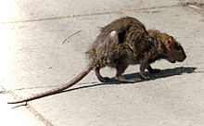 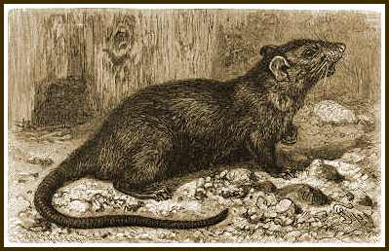 Picture : 01 , A rat in a city street ; Picture : 02 , In19th century engraving of a Black rat
- Laboratory rats:
A laboratory rat strain, known as a Zucker rat, is bred to be genetically prone to diabetes, the same metabolic disorder found among humans.In 1895, Clark University in Worcester, Massachusetts ,USA established a population of domestic albino brown rats to study the effects of diet and for other physiological studies. Over the years, rats have been used in many experimental studies, which have added to our understanding of genetics, diseases, the effects of drugs, and other topics that have provided a great benefit for the health and well-being of humankind. Laboratory rats have also proved valuable in psychological studies of learning and other mental processes (Barnett, 2002), as well as to understand group behavior and overcrowding (with the work of John B. Calhoun on behavioral sink). A 2007 study found rats to possess metacognition, a mental ability previously only documented in humans and some primates. Wild rats that were used in rat-baiting were eventually bred domestically, producing the albino white lab rat known today.
Picture : 03 , Statue of a rat in Patan (Nepal) & Picture of Rat in Hindu Mythology
The Objective of the study are :
-To know the breeds and varieties present in Bangladesh ;
-To know their different behavioral and physiological characteristics ; and
-To know their diseases , treatment and prevention.

CHAPTER – 2
REVIEW OF LITERATURE
Rats are various medium-sized, long-tailed rodents of the superfamily Muroidea. "True rats" are members of the genus Rattus, the most important of which to humans are the black rat, Rattus rattus, and the brown rat, Rattus norvegicus. Many members of other rodent genera and families are also referred to as rats, and share many characteristics with true rats (WWW.Wikipedia, the free encyclopedia)
Scientists have bred many strains or "lines" of rats specifically for experimentation. Most are derived from the albino Wistar rat, which is still widely used. Other common strains are the Sprague Dawley, Fischer 344(43rd Annual Pathology of Laboratory Animals Course).
Specially bred rats have been kept as pets at least since the late 19th century. Pet rats are typically variants of the species brown rat, but black rats and giant pouched rats are also known to be kept. Pet rats behave differently from their wild counterparts depending on how many generations they have been kept as pets (WWW.Ratbehaviour.org. Retrieved 2009-07-04).
The Lewis rat was developed by Dr. Lewis from Wistar stock in the early 1950s. The strain's characteristics include albino coloring, a docile behavior, and low fertility. Obese Zucker rats have high levels of lipids and cholesterol in their bloodstream, are resistant to insulin without being hyperglycemic, and gain weight from an increase in both the size and number of fat cells(Kava et al.1990)
One of the oldest and most historic stories about rats is The Pied Piper of Hamelin, in which a rat-catcher leads away an infestation with enchanted music—the piper is later refused payment, so he in turn leads away the town's children. This tale, placed in Germany around the late 13th century, has inspired the realms of film, theatre, literature, and even opera. The subject of much research, some theories have intertwined the tale with events related to the Black Plague, in which black rats may have played an important role. Fictional works based on the tale that focus heavily on the rat aspect include Pratchett's The Amazing Maurice and his Educated Rodents, and Belgian graphic novel Le Bal du Rat Mort (The Ball of the Dead Rat).
In Indian tradition, rats are seen as the vehicle of Ganesha, and a rat's statue is always found in a temple of Ganesh. In the northwestern Indian city of Deshnoke, the rats at the Karni Mata Temple are held to be destined for reincarnation as Sadhus (Hindu holy men). The attending priests feed milk and grain to the rats, of which the pilgrims also partake(WWW. Rat zodiac)
Most urban areas battle rat infestations. Rats in New York City are famous for their size and prevalence. The urban legend that the rat population in Manhattan equals that of its human population (a myth definitively refuted by Robert Sullivan in his book "Rats") speaks volumes about New Yorkers' awareness of the presence, and on occasion boldness and cleverness, of the rodents(Sullivan et al.2004)
Domestic rats differ from wild rats in many ways. They are calmer and less likely to bite; they can tolerate greater crowding; they breed earlier and produce more offspring; and their brains, livers, kidneys, adrenal glands, and hearts are smaller (Barnett et al.2002).
Brown rats are often used as model organisms for scientific research. Since the publication of the rat genome sequence (Gibbs RA et al. 2004 )
Wild rodents, including rats, can carry many different zoonotic pathogens, such as Leptospira, Toxoplasma gondii, and Campylobacter(Meerburg et al.2009)
Rats are serious problem in crop field of Bangladesh. Rat also damage buildings, households’
goods and electrical wire etc. and also are potential threats to both human and animal health as
vector of diseases (Wang et al., 1996).

Rats are the serious pest of wheat crop throughout southern Asia causing damage from 3.5 to 12% . Rat cause 5.7% losses to deep water rice. Rats are major problem in the poultry sector too(Ahmed et al. 1986) .
Rats are damaging the floor of the farm by extensive burrowing and also attack the young birds (Roy et al, 1987).
Burrowing rat hoards a large quantity of food in its burrows (Parrack, 1969; Roy, 1974).
Mortality of wild animals in captivity can be severe during those first few generations. For example, Blus (1971) established a breeding colony of short-tailed shrews in captivity and found that only 11% of his wild-caught shrews, and 9% of his captive-born shrews, survived for 12 months. The mean age at death was only 5 months (WWW.ratbehavior.org 2002).
Reproductive failure is common in wild and early generation animals in captivity. Only 49% of first-generation wild Norway rats copulate successfully in captivity (Price 1980). Of rats who do give birth, only 43% successfully raised some offspring to weaning age -- the rest were cannibalized or abandoned (Clark and Price 1981). Trut (1999) found that only 14% of field-trapped Norway rats produced offspring that survived to adulthood (WWW.ratbehavior.org 2002).
Litters are generally smaller (averaging 6 offspring) in these first-generation wild rats (Clark and Price 1981). In contrast, wild rats in the wild, and domestic rats in captivity, produced similarly-sized large litters, averaging about 10 offspring (Davis 1951, Boice 1972). It takes about 20 generations in captivity for rat litter sizes to come back to normal (King et. al 1929, 1939).

CHAPTER – 3
METHODS AND MATERIALS

- Study area:
The study was conducted in many area in Bangladesh as per convenience. As a intern student I was visited many areas, like Mymensingh, shirajganj, Bogra, Chittagong, Pabna etc. So there was a great chance for study and getting a chance for creating a informable, successful report writing.
- Taking photographs for knowing phenotypic and behavioral characteristics of rats:
It was a very difficult task to taking photographs of a rats. Because they are not staying any place for a moment. They are speedy racer , intelligent and sometimes afraid of a slight sound because there hearing capability is more then other animal. Moreover they are nocturnal in native.

- Browsing internet & webs:
There are many web sites is available about rats. Some journals also available with various study or experiment on rats . There are some books on rats also written by some interested author .

- Direct observation on rats:
By observation I found many interesting information about rats, like their body characteristics habitats, feeds and feeding, breeding, diseases, treatment etc.

CHAPTER – 4
RESULT AND DISCUSSION

- Breeds, Varieties and Species of rats:
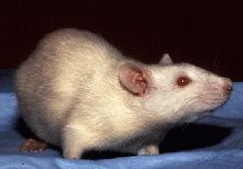
A breed, according to Webster's Dictionary again, is a group of animals presumably related by descent from common ancestors and visibly similar in most characteristics.There are no separate breeds of rats, there are no purebred rats in the pet world. There are, however, many different strains of rats in laboratories, and a rat from one of those strains could conceivably be called purebred. However, "purebred" is a term that is never used in laboratory rat breeding. This kaleidoscope of rat variation is loosely divided into varieties or types (e.g. RMCA and AFRMA). A variety is arbitrarily defined as a group of rats that share a single physical trait. For example, rats with curly fur belong to the "rex" variety, rats with low-set ears are called "dumbo," rats without hair are called "hairless." . Also, a single rat may belong to more than one variety, such "dumbo" and "rex." A variety is therefore a purely descriptive category, it says nothing about the biological relationship between rats. The classic definition of a species is a group of related individuals or populations which are potentially capable of interbreeding and producing fertile offspring.

Picture :04 , Albino white rat

- Wild rats:
Wild rats belong to many different species . The best-known rat species are the black rat /roof rat-Rattus rattus and the brown rat/ Norway -Rattus norvegicus. The group is generally known as the Old World rats or true rats which weigh over 500 grams (1.1 lb) in the wild. There are many different species of rodent in the wild that bear the common name "rat such as, Naked mole rats, wood rats/pack rats, Merriam's kangaroo rats-Dipodomys merriami, cotton rat/sigmodon rat -Sigmodon hispidus, ,African pouched rats, Polynesian rats, . rice-field rat -R. argentiventer and Malayan field rat -R. tiomanicus and many others. These different rodent species may not be closely related to each other at all! . A tiny number of black rats -Rattus rattus are also kept as pets, but yet they are extremely rare in the pet trade.
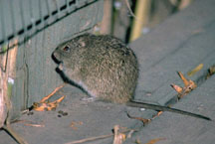
Genus: Rattus - Typical rats
- R. incertae sedis
- Annandale's rat (Rattus annandalei) – Indonesia, Malaysia, and Singapore
- Enggano rat (Rattus enganus) – Indonesia
- Philippine forest rat (Rattus everetti) – the Philippines
- Polynesian rat (Rattus exulans) – Fiji and most Picture : 05 ,cotton rat
Polynesian islands, New Zealand, Easter Island, and Hawaii
- Hainald's rat (Rattus hainaldi) – Indonesia
- Hoogerwerf's rat (Rattus hoogerwerfi) – Indonesia
- Korinch's rat (Rattus korinchi) – Indonesia
- Maclear's rat (Rattus macleari) – Christmas Island
- Nillu rat (Rattus montanus) – Sri Lanka
- Molaccan prehensile-tailed rat (Rattus morotaiensis) – Indonesia
- Bulldog rat (Rattus nativitatis) – Christmas Island
- Kerala rat (Rattus ranjiniae) – India
- New Ireland forest rat (Rattus sanila)
- Andaman rat (Rattus stoicus) – Andaman Islands
- Timor rat (Rattus timorensis) – Timor
- R. norvegicus group :
- Himalayan field rat (Rattus nitidus) – Bangladesh, Bhutan, China, India, Indonesia, Laos, Myanmar, Nepal, Palau, the Philippines, Thailand, and Vietnam
- Brown rat or Norway rat (Rattus norvegicus) – worldwide except Antarctica
- Turkestan rat (Rattus pyctoris; obs. Rattus turkestanicus) – Afghanistan, China, India, Iran, Kyrgyzstan, Nepal, and Pakistan
- R. rattus group :
- Sunburned rat (Rattus adustus) – Enggano Island, Indonesia
- Sikkim rat (Rattus andamanensis) – Bhutan, Cambodia, China, India, Laos, Myanmar, Nepal, Thailand, and Vietnam
- Rice-field rat (Rattus argentiventer) – Southeast Asia
- Summit rat (Rattus baluensis) – Malaysia
- Aceh rat (Rattus blangorum)
- Nonsense rat (Rattus burrus) – India
- Hoffmann's rat (Rattus hoffmanni) – Indonesia
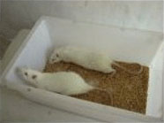
- Koopman's rat (Rattus koopmani) – Indonesia
- Lesser rice-field rat (Rattus losea) – China, Laos
- Mentawai rat (Rattus lugens) – Indonesia
- Mindoro black rat (Rattus mindorensis) – the Philippines
- Little soft-furred rat (Rattus mollicomulus) – Indonesia
- Osgood's rat (Rattus osgoodi) – Vietnam Picture : 06,Sprague- Dawley rats
- Palm rat (Rattus palmarum) – India
- Black rat (Rattus rattus) – worldwide except Antarctica
- Sahyadris forest rat (Rattus satarae)
- Simalur rat (Rattus simalurensis) – Indonesia
- Tanezumi rat (Rattus tanezumi) – Afghanistan, Bangladesh, Cambodia, China, Cocos (Keeling) Islands, Fiji, India, Indonesia, Japan, North Korea, South Korea, Laos, Malaysia, Myanmar, Nepal, Pakistan, the Philippines, Taiwan, Thailand, and Vietnam
- Tawi-tawi forest rat (Rattus tawitawiensis) – the Philippines
- Malayan field rat (Rattus tiomanicus) – Indonesia, Malaysia, the Philippines, and Thailand
- R. xanthurus group :
- Bonthain rat (Rattus bontanus; obs. Rattus foramineus) – Indonesia
- Opossum rat (Rattus marmosurus) – Indonesia
- Peleng rat (Rattus pelurus) – Indonesia
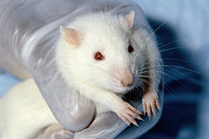
- Southeastern xanthurus rat (Rattus salocco) – Indonesia
- Yellow-tailed rat (Rattus xanthurus) – Indonesia
- R. leucopus group (New Guinean group) :
- Arfak rat (Vogelkop mountain rat) (Rattus arfakiensis)
- Western New Guinea mountain rat (Rattus arrogans)
- Sula rat (Rattus elaphinus) – Indonesia
- Spiny Ceram rat (Rattus feliceus) – Indonesia Picture : 07 , Wister rat
- Giluwe rat (Rattus giluwensis) – Papua New Guinea
- Japen rat (Rattus jobiensis) – Indonesia
- Cape York rat (Rattus leucopus) – Australia, Indonesia, and Papua New Guinea
- Eastern rat (Rattus mordax) – Papua New Guinea
- Moss-forest rat (Rattus niobe) – Papua New Guinea, Indonesia
- New Guinean rat (Rattus novaeguineae) – Papua New Guinea
- Arianus's rat (Rattus omichlodes)
- Pocock's highland rat (Rattus pococki)
- Large New Guinea spiny rat (Rattus praetor) – Indonesia, Papua New Guinea, and Solomon Islands
- Glacier rat (Rattus richardsoni) – Indonesia
- Stein's rat (Rattus steini) – Indonesia and Papua New Guinea
- Van Deusen's rat (Rattus vandeuseni) – Papua New Guinea
- Slender rat (Rattus verecundus) – Indonesia and Papua New Guinea
- R. fuscipes group (Australian group)
- Dusky rat (Rattus colletti) – Australia
- Bush rat (Rattus fuscipes) – Australia
- Australian swamp rat (Rattus lutreolus) – Australia
- Dusky field rat (Rattus sordidus) – Australia, Indonesia, and Papua New Guinea
- Pale field rat (Rattus tunneyi) – Australia
- Long-haired rat (Rattus villosissimus) – Australia
Laboratory rats:
Brown rats are often used as model organisms for scientific research. Lab rats belong to a single species called Norway rats -Rattus norvegicus. The albino white rats are also known as laboratory rats today. Laboratory rats share their origins with their cousin rats in domestication like, the fancy rats, Wistar and Fisher and Sprague Dawley rats. Since the publication of the rat genome sequenceand other advances, such as the creation of a rat SNP chip, and the production of knockout rats, the laboratory rat has become a useful genetic tool. Entirely new breeds or "lines" of brown rats, such as the Wistar rat, have been bred for use in laboratories.
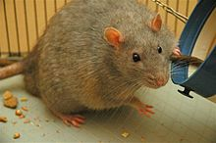

Picture : 08 , Diabetic rat
- Strain of rats:
Rat strains refer to laboratory rats that have been bred in isolation for generations. A rat strain is created through breeding to produce rats that are similar to each other and can therefore be used in research.
According to Webster's, Strain is a group of individuals which share a presumed common ancestry and have clear-cut physiological but not usually morphological distinctions (e.g. a strain of winter wheat).
- Wild rats:
There is no actual strain of wild rats because strain only develop for laboratory research.
- Laboratory rats:
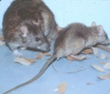
Most laboratory rat strains descend from a colony of rats established at the Wistar Institute in 1906. Wistar rats are an outbred strain of albino rats belonging to the species Rattus norvegicus. This strain was developed at the Wistar Institute in 1906 for use in biological and medical research, and is notably the first rat strain developed to serve as a model organism. The Sprague-Dawley strain came from crosses between Wistar females and a "hybrid" male whose origins are unknown. Long-Evans rats are thought to come from crosses between Wistar females and a wild Norway rat (Pass and Freeth 1993).
Picture : 09, Roof rats

As an example of a substrain with an established genetic difference is Zucker rats. Zucker rats are used in research as models for obesity, diabetes and heart disease. The Lewis rat was developed by Dr. Lewis from Wistar stock in the early 1950s. The strain's characteristics include albino coloring, a docile behavior, and low fertility. Biobreeding Diabetes Prone (or BBDP rat) rat is an inbred rat strain that spontaneously develops autoimmune Type 1 Diabetes. Like NOD mice, BB rats are used as an animal model for Type 1 diabetes.Other rat strains are Rowett nudes, Fuzzy rats ,Shorn rats ,Hairless rats, Royal College of Surgeons (RCS) rat,shaking rat Kawasaki, giant pouched rats.

There are also some laboratory rat strains commonly being used in research laboratories. These are stated below in tabular form:
Table:1.1 ;Common Inbreed Rat Strains
Strain Designation | Strain Name
ACI | August Copenhagen Irish
BB/WOR | Biobreeding Wooster
BN | Brown Norway
BUF | Buffalo
F344 | Fischer 344
LEW | Lewis
Lou/C | Louvain
SHR | Spontaneous Hypertensive
WF | Wistar Furth
WKY | Wister Kyoto
ZF | Zucker Obese ( Fatty )
Table : 1.2 ;Common Outbreed Rat Strains
Strain Designation | Strain Name
LE | Long Evans
SD | Sprague-Dawley
WIST | Wistar
Table : 1.3 ;Common Mutant Rat Strains
Strain Designation | Strain Name
 | Brattleboro
 | Gunn
RNU | Athymic Nude
ZDF | Zucker Diabetic Fatty
- Body characteristics & Physiological Parameters of rats:

- Wild rats:
The body characteristics & physiological parameters of wild rats are stated below in an enumerative form:
Genetic Structure: 21 chromosome pairs & 2.75 million base pairs.
Head Attributes: Short, stubby, broad, large relative to body .
Muzzle Attributes: Large and blunt with wide muzzle .
Ears: Ears are small relative to the head.
Life Span: Avg. 2-3 Years
Life Span: Avg. 2-3 Years .
Tail: A rat is bigger and has a thicker tail.
Digging burrows: Rats dig deep and long burrows.
Eyes: Small compared to eye .
Size: 20-50cm (7.8-19.7in)/ longer than 12 cm (5 inches).
Weight: 200-900g (0.4-2lbs)/ weigh over 500 grams/ avg. 1 pound .
Top speed: 13km/h (8mph) .
Life Span: 2-5 years/av. 3 years
Lifestyle: Solitary
Color: Grey, Black, White, Brown
Skin type: Fur .
Special Features: Large, sharp front teeth and long, thin tail.
Teats : Usually 12 (3 pair abdominal and 3 pair pectoral).
Heart rate : About 300-500 beats per minute .
Respirations: About 85 breaths per minute
R. rattus (Black rats) and R. norvegicus (Brown rats):
The difference between R. rattus (Black rats) and R. norvegicus (Brown rats) are shown in figure below:
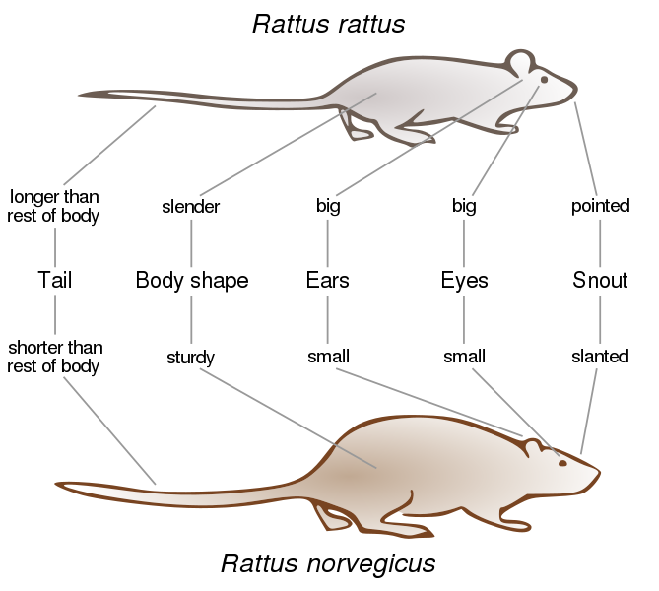
( Black rat )
(Brown rat)
Picture: 10 , Difference between Black rats and Brown rat

- Laboratory rats:
It is characterized by its wide head, long ears, and having a tail length that is always less than its body length. The Sprague Dawley rat and Long-Evans rat strains were developed from Wistar rats. Wistar rats are more active than other strains like Sprague Dawley rats.The Spontaneously hypertensive rat and the Lewis rat are other well-known strains developed from Wistar rats.
- Habitats:

- Wild rats:
In their natural habitats rats are primarily nocturnal, have very poor eyesight, rats have a very strong sense of small, taste and hearing. The brown rat is a prominent exception, being active day and night in both urban and rural environments. All rats are terrestrial, and many are also arboreal. The Sulawesian white-tailed rat is an excellent climber and exhibits the classic combination of arboreal traits within Rattus. This rodent dense among the roots of large trees (generally strangler figs) and forages high in the crowns of understory and canopy trees. Most rats can swim; species with thick and somewhat woolly fur generally swim well, and some are adept swimmers that forage in aquatic environments. The brown rat, for example, has a terrestrial rat’s characteristic morphology and is a comparatively poor climber. The house rat, on the other hand, is extremely agile above the ground, being able to climb and run along narrow
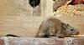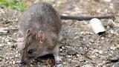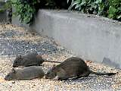
branches and wires. Norway rats are common in dense areas of human settlement, and live in eighteen inch deep burrows underground or in lumber piles or similar environments. Black rats are excellent climbers and live higher off of the ground, usually in the upper levels of buildings
Picture: 11 , Different Living Area Of Wild Rats
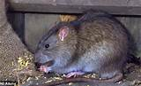
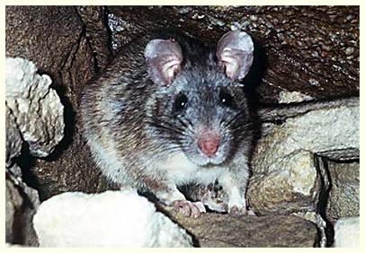
or nesting in trees or vines. Some rats excavate burrows or build their nests beneath boulders, rotting tree trunks, or other kinds of shelter on the forest floor; they may also shelter in deep rock crevices or caves and in dwellings from small village huts to large city buildings. They may live in grainfields during the summer. But the vast majority of wild rats prefer to live where the going is good, the food is free, and the predators are scarce, in granaries, garbage dumps, back alleys, farms, and your attic. Rats can enter a building through a gap as small as 1/2 inch in diameter.
- Laboratory rats:
Laboratory rats are docile, very adaptable, curious animals, that sleep during the day and are active during the dark cycles. Frequent handling will increase docility, whereas infrequent or rough handling will evoke fear responses. In general, males are less likely to fight when housed together than are male mice. There is no open area is allotted for laboratory rats. Mostly they are rear in a cage or nest. Rat-baiting was a popular way which involved filling a pit with rats and timing how long it took for a terrier to kill them all for research purpose. Rats are housed in a relatively spacious, tri-compartment habitat. Each house/nest/cage habitat consisted of a larger nesting area (27 X 32 x 35.5 high cm) and two feeding compartment (27 x 16 x 35.5 high cm). An opening (4 x 2.5 high cm) at the base of the wall . An opening (16 x5 high cm) at the top of the wall. The two external end walls and the wall between the nesting area and the feeding compartments were constructed of galvanized steels. The cage lid was constructed of ¼ hardware cloth.Feeding compartment contained a food tray, covered by an aluminum lid with 5 holes (2.5 cm diameter) and a 1-cm raised lip to prevent food spillage.
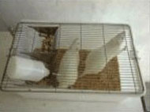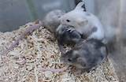
Picture : 12 , Laboratory Rats With in a Cages
Space requirement for laboratory rats:
The commonly used space requirement for laboratory rats cages is stated below in tabular form:
Weight | Floor area / Animal | Height
<100 | 109.60cm² (17 in² ) | 17.8cm(7 in)
Up to 200g | 148.35cm²(23 in² ) | „
Up to 300g | 187.05cm² (29 in² ) | „
Up to 400g | 258.00cm²( 40in²) | „
Up to 500g | 387.00cm²(60in² ) | „
>500g | ≥451.50cm²(≥70 in² ) | „
Female Litter | 800.00cm²(124in² ) | „

- Feeds and feeding of rats:
- Wild rats:
Rats are omnivorous animals and eat a mixture of plant and animal matter in order to get all the right nutrients. Rats are thought to eat everything but diet actually differs according to species and habitat. Where it lives with humans, the house rat does consume nearly anything digestible, especially stored grains. The brown rat is basically omnivorous but prefers a carnivorous diet, aggressively pursuing a wide variety of prey including shrimp, snails, mussels, insects, bird eggs and young amphibians, eels, fish, pheasant, pigeons, poultry, rabbits, and carrion. Many rainforest species, including the Sulawesian white-tailed rat and Hoffman’s rat, eat only fruit and the seeds within, but some, such as the Philippine forest rat (R. everetti), also eat insects and worms. Other tropical species, such as the rice-field rat (R. argentiventer) and Malayan field rat (R. tiomanicus), primarily consume the insects, snails, slugs, and other invertebrates found in habitats of forest patches, secondary growth, scrubby and fallow fields, palm plantations, and rice fields. Rats will eat nearly anything, but they prefer fresh grain and meat. Rats require at least 1/2 to 1 ounce of fluid each day. If this is not attained through moisture in foods that it eats, the rat must have water to drink.
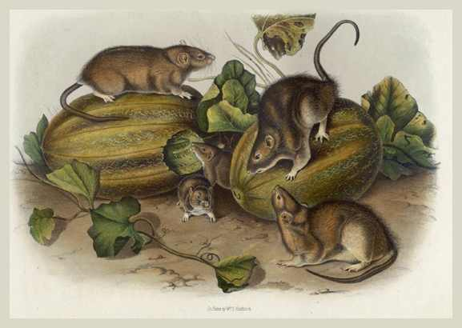

Picture : 13 , Feeding of Brown Rats painted by John James Audubon 1852.
- Laboratory rats:
laboratory rats subsist only on specially prepared blocks of food, sometimes referred to as lab blocks or rat blocks. To get the nutrition they need the bulk of the block is generally corn and soy, with additional nutrients added. Because of the low cost and simplicity of rodent blocks, many laboratories provide only this type of sustenance. sometimes fed mixed grains to add variety to their diet. Commonly used grains are barley, oats and whole-wheat flakes. Fresh fruit, like blueberries, has been proven to prevent illness laboratory in rats. Fruits are given in moderation, as they are high in natural sugars. Rats will eat most vegetables: kale, broccoli, tomatoes and cabbage are staples in the diet of a typical rat. Cookie bits or commercially available treats are also added in the nutritional component of the rat diet with a bit of fun.
- Breeding:
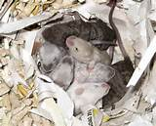
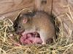
Rats are sexually dimorphic . This prolific rats are reaches puberty at about 50-60 days of age (6-8 weeks) with some inbred strains maturing sexually at 3-4 months of age and may produce up to 12 litters with a range of 2 to 22 young (8 or 9 is usual) per year, with peaks in the spring and autumn. A female rat can have 6 litters of up to 12 young per year. These more than 70% rats can begin breeding themselves within three months of birth. The female’s first estrus occurs at about 5 weeks (35 days) of age. So rats are able to start having babies at around 5 weeks of age. Allowing the female to fully mature (100-120 days) before breeding usually means better reproductive performance and healthier offspring. Rats don’t exhibit the Bruce Effect (pheromones from strange male or strain can prevent implantation) or the Whitten Effect (disputed? or less pronounced than mice). The gestation period is 21 to 26 days( Avg. 21 days). Breeding occurs throughout the year in many tropical species but in others may be restricted to wet seasons or summer months. Litter sizes in tropical forest species tend to be much smaller (one to six), and seasonal breeders, particularly in Australian habitats, produce significantly fewer annual litters. Spring is the most active season for rat breeding. Rats are fast breeders and give birth to large litters of baby rats meaning that pet rats of different sexes should be separated at around a month old. Rats can live until they are 4 or 5 years old, female rats can no longer have babies after they are about 18 months old. Weaning period is 14-35days. Milk lactation period is19-20 days.Dams released milk about 90 times/day.

Picture : 14, Rats pups
Rat pups are born (4.5-6 g, affected by litter size), eyes will open at 14-17 days and ears at 2.5-3.5 days. They are hairless (fully haired 7-10 days), and with no erupted teeth (incisor erupt at 8-10 days). Anogenital space is used to differentiate newborns sex.
- Rats as a pests:
Rats have long been considered deadly pests. Rats are serious problem in crop field of Bangladesh. Rat also damage buildings, households’ goods and electrical wire etc. and also are potential threats to both human and animal health as vector of diseases (Wang, 1996). Rats are the serious pest of wheat crop throughout southern Asia causing damage from 3.5 to 12% (Bindra and Sagar, 1968; Sood and Guraya, 1976; Ahmad, 1986). According to Ahmed et al. (1986) rat cause 5.7% losses to deep water rice. Rats are major problem in the poultry sector too. They damage the floor of the farm by extensive burrowing and also attack the young birds (Roy et al, 1987). Burrowing rat hoards a large quantity of food in its burrows (Parrack, 1969; Roy, 1974).
Prevention of rat from crop field, house by baiting, traping or use of repellants like peppermint oil, worm wood oil.
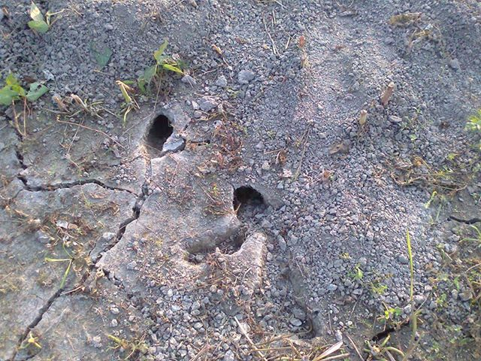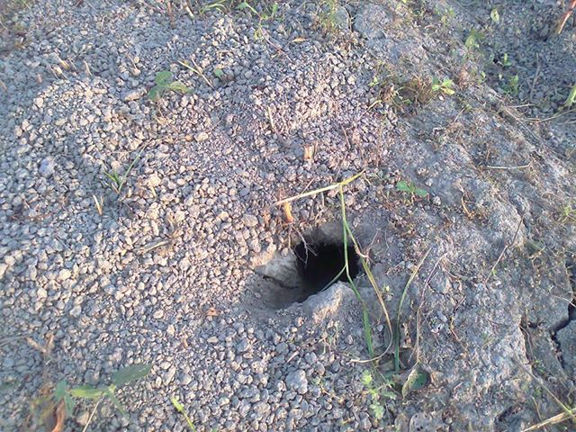
Picture : 15 , Habitat of rats Baghabari (Shirajgonj) crop (paddy) field.
- Rats as a prey:
In urban dwellings, the rat’s primary enemy is the human. Domestic cats also prove a menace to rats. More commonly rats predators, domesticated felines are likely to pursue and attack rats when they are discovered within the home. Outdoors, rats face a variety of predators. In these environments, large birds of prey — including hawks, falcons and owls — feed regularly on rats. Owls are particularly formidable predators, as their nocturnal behavior ensures that they are most active when rats go out in search of food. Various snake species also prey upon rats. Rats are a food for raptorsand other birds of prey.

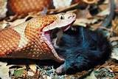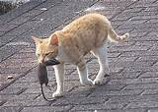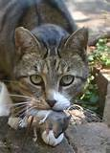
Picture : 16 , Rats are Pray Of Pythons And Cats
- Intelligence:
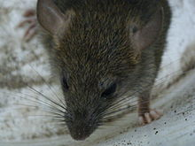
Hearing capability of rats is highly developed. Rats can hear up to 80 kHz in the ultrasonic range as opposed to people that can hear up to 17 kHz. The maximum sensitivity occurs from 15 to 25 kHz. Sight is poor, with the retina composed almost entirely of rods. They are blind to long wavelength (red) light and have no color vision.
Picture: 17 , A rat in a suburb of Vancouver
They can see adequately in dim light. Smell is highly developed (rats possess large olfactory bulbs)because pheromones play an important role for smelling. Because of the ability to learn, rats were early on investigated to see whether they may exhibit general intelligence, expressed by the presence of a g factor, like larger or more complex animals. A 1929 study did not find a “g” factor, nor did a 1990 work ; a 1935 study did: Robert Thorndike, for example, provided strong evidence for “g” in rats by the use of a variety of tests such as mazes, problem-solving tasks, and simple avoidance conditioning (Thorndike 1935). Thorndike (1935) also reviewed a dozen earlier studies which also suggested that the highest correlations are found between more complex problem-solving tasks.However, it should be noted that there were other contemporary studies that found split or near zero-order correlation matrices for other populations of rats across cognitive batteries ( Royce 1950). In 1993, Anderson measured rat performance and factor analysis produced a g, and also correlations with rat brain size (as in humans and primates). Locurto & Scanlon 1998, Matzel et al. 2003, Matzel et al. 2004, Kolata et al. 2009 and Matzel et al. 2011 replicated the factor (but did not investigate brain size); 2003 Locurto et al., 2006 Locurto et al. in contrast found their factor analysis giving 4 factors rather than 1.
Social intelligence:
A 2011 controlled study found that rats are actively prosocial. They demonstrate altruistic behaviour to other rats in experiments, including freeing them from cages. When presented with readily available chocolate chips, test subjects would first free the caged rat, and then share the food. All female rats in the study displayed this behaviour, while 30% of the males did not.
- Temperament:
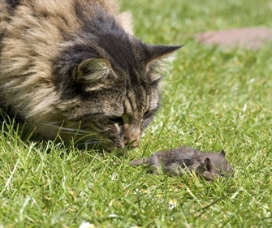
Temperament is an individual's way of responding to the world. Shy, bold, cautious, irritable, docile, reactive, and passive are all examples of temperament. An individual's temperament tends to be consistent between situations and over an individual's lifetime.
Picture : 18,Cats are Playing With Rats
One of the most striking differences between wild animals and laboratory animals is the difference in their temperaments. Wild animals tend to be highly reactive to their environment. When excited they tend to react strongly, even violently. Wild animals in captivity respond stressfully to things like unexpected movement, sounds, transportation, and proximity to humans (Keeler et al. 1970). Laboratory animals, in contrast, are more passive toward their environment. They are not stressed by unexpected movement, sounds, or the proximity to humans. Laboratory animals tend to be docile and placid when compared to their wild counterparts. Rats are extremely social and personable animals that bond strongly to their owners. They are smart enough to learn their names and will come when you call them. They beg to come out of their cage to play and interact with their owners. Rats love to be petted. They enjoy being rubbed behind their ears or scratched on their shoulders. Some rats will roll over on their back so their owner can rub their tummy. Many rats will lick their owners to show affection just like a dog. Rats are very playful and will wrestle with your hand the same way a kitten will. Rats will play games with their owners, including tug-o' war, hide-n-seek, and peek-a-boo. Rats can learn many tricks just like dogs. They can learn to sit up, fetch, walk a tightrope, pull up a basket on a string and jump through a hoop. Some rats are smart enough to learn a trick after only two lessons.

- Common Diseases of rats and theirTreatment & Prevention:
- Diseases of Rat’s:
- Wild rats:
Similar to other rodents, rats may carry a number of pathogens, which can result in disease, including Weil's disease, rat bite fever, cryptosporidiosis, viral hemorrhagic fever, Q fever and hantavirus pulmonary syndrome. In the United Kingdom, rats are an important reservoir for Coxiella burnetii, the bacterium that causes Q fever, with seroprevalence for the bacteria found to be as high as 53% in some wild populations. This species can also serve as a reservoir for Toxoplasma gondii, the parasite that causes toxoplasmosis, though the disease usually spreads from rats to humans when domestic cats feed on infected rats. There are indications that the parasite has evolved to alter an infected rat's perception to cat predation, making it more susceptible to predation and increasing the likelihood of transmission. Other parasitic diseases are trichinosis by Trichinella larvae -Trichinella pseudospiralis. Spreading of 40 diseases among humans, including bubonic plague, food poisoning, schistosomiasis, murine typhus, tularemia, hantavirus and salmonellosis and leptospirosis is occurred by rats , a small number of rabid rats (39 rats) were found in the United States. It is important to clean areas with a mild bleach solution that have come into contact with rat droppings, and to see a doctor if ever bitten by a rat.

- Laboratory rats:
Laboratory rats are suffer some difficult problems. Hereditary abnormalities of the jaw bones or teeth, abscessation of the incisor teeth, or injury to the jaw may result in malocclusion (improper meeting of the upper and lower incisors). Rats with this problem must have their overgrown incisors trimmed periodically by an experienced veterinarian or veterinary technician .Rats over 2 years of age are reported, have an 87% chance of developing one or more types of tumors. Both male and female rats develop benign mammary (breast) tumors, and females develop benign tumors of the uterine and vaginal linings.
Skin Disease: There are many causes of skin disease in laboratory rats. Numerous infectious agents, including bacteria, viruses, fungi and parasites may be involved. Cagemates may be responsible for hair loss and/or wounds to the skin. Allergies are also a suspected cause of skin.

Other diseases of rats like, Rat eyes/Porphyrin, Eye trouble/Cataracts, Eye trouble/Enucleation, Mycoplasmosis, Pneumonia, Abscesses, Bumble foot, Sprained Ankles/torn toenails, Tail Degloving, Ear Hematoma, Mega colon.
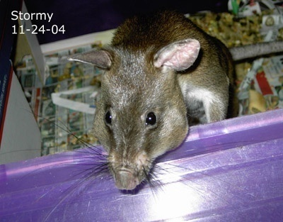 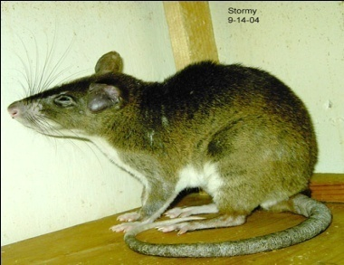 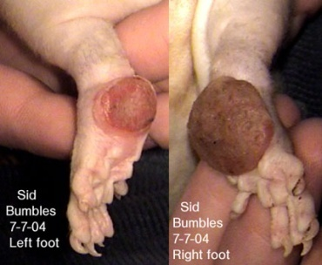
Picture: 19, Mega colon Ear hematoma Bumble foot

Treatment of rats:

- Wild rats:
The disease is treated with antibiotics, and if caught early, the prognosis is excellent.
- Laboratory rats:
Medication can come in many forms, such as concentrated liquid, tablet form and reconstituted liquid. Liquid medications are the easiest method to administer. Baytril & Doxycycline are two of the most commonly prescribed medications for rats. Lots of vets will add flavoring to medicine to help it taste better, most commonly cherry or banana flavoring. Doxycycline (Generic name) (Brand name) Vibramycin -Can come in injection form needing to be injected into the rat (most commonly in the tail or back area) and can also come in oral form. Doxycycline/Vibramycin can be used in conjunction with Baytril. DO NOT let Pregnant rats or rats under 4 months old take Doxycycline/Vibramycin and beware of using any medication in the tetracycline family on rats under 4 months old. It can cause fetal development problems, retardation, adversely effect bone and tooth growth & other serious problems. If the rat is under 4 months old that needs medication, Zithromax a less well known drug is safe to use for young rats. Zithromax can be used to treat respiratory problems with the recommended doses being 4 mg per lb. twice daily for two weeks. Than once daily for another two weeks. Ivermectin horse wormer paste can be used to get rid of mites, body mites & ear mites. Dose Of ivermectin is small grain of rice size for an adult size rat. For smaller rats use a slightly smaller dose. Treat the rat on day 1, day 8 and day 15. Routes of administration of injections in laboratory rats are mainly subcutaneous, intraperitoneal, intravenous and intramuscular.
Picture : 20 , Ivermectin syringe and Bath stuff for rats .
- Prevention of rats diseases:
There is no actual method for prevention is present for rat diseases but some vaccine is available for some specific diseses. Like feeding of trichinella infected larvae by gavage(630) or by i/m (0.1 larvae/g), for Yoshida ascites sarcoma intracaecal inj. (.5ml ascities fluid) Or laparotomy is done under ether anaesthesia, for rodent hookworms (Nippostrongy brasiliensis) is by protected soperoxide dismutase, Hartz flea and tick shampoo & sebolux shampoo is used for tick and flea.

CHAPTER-5
CONCLUSION
The genus Rattus emerged from the Murid family about 3.5 million years ago .Bangladeshi rat’s are commonly Rattus rattus. Rats live in human cities, suburbs, and agricultural areas in a human-dependent relationship called commensalism. . Wild rats live in colonies . Female rats, usually related to each other, live in little groups of one to six in a little burrow system of their own. They each have their own nest chamber, but they may share the burrow and may raise their young together (called communal nesting). Rats don't live long in the wild the average lifespan is probably less than a year. In one study, the researcher found that 95% of rats living at a farm were no longer alive a year later. So rats suffer very high mortality in the wild. The rat is a small scavenger mammal that has proved to be a pest in both urban and rural areas where rats are normally present due to an abundance of food. Rats are known to kill smaller livestock on farms. The rat can also carry and spread disease to a devastating effect although diseases carried by rats are generally not passed on to humans. However, in the middle ages, the black plague wiped out nearly two thirds of the European population. The disease was not caused by the rats directly but was actually caused by infected fleas carried on rats. Today, rats are commonly kept as pets all over the world and are thought to have been bred as pets since the 1800s. Pet rats pretence the same health risks to humans as other household animals so are not seen to carry harmful diseases. When tame, rats can be extremely friendly and can be taught to perform selective tasks such as doing certain actions in order to get food. They are especially good pets for apartment dwellers with limited space, and busy people, as long as you can spend at least 1/2 to 1 hour a day with your rats.

CHAPTER-6
REFERRENCES
Bibliography:
- A. T. M. HASANUZZAMAN , M. S. ALAM2 & M. M. BAZZAZ , June 2009 Comparative Efficiency of Some Indigenous Traps to Capture Rats in the Wheat Field of Bangladesh Journal of Agriculture & Rural Development - 7(1&2), 121-125, ISSN 1810-1860 .
- H. J. Smith july 1987, Canadian journal of vet. Research, vol. 51(3), page no. 370-372.
- Helge J. C. Lund 1957 ,Yoshida ascities sarcoma, British journal of cancer,vol. 11(3) , page no.475-477.
- Glyn ball, Dave P. Knox September 2009, Rodent hookworm with a recombinant superoxide dismutase fails to protect against infection, Journal of Acta parasitologicia, vol. 54, Issue 3, Page no. 281-287.
- Horatiu V.Vinerean DVM DACLAM Director , Laboratory Animal Research Attending Veterinarian, Rats- Biology & Husbandry, Florida International University.
- Meerburg BG, Singleton GR, Leirs H (2009).The Year of the Rat ends: time to fight hunger. Pest Manag Sci 65 (4): 351–2. doi:10.1002/ps.1718. PMID 19206089.
- Foote, Allison L.; Jonathon D. Crystal (20 March 2007). Metacognition in the rat. Current Biology 17 (6): 551–555. doi:10.1016/j.cub.2007.01.061. PMC 1861845. PMID 17346969.
- Krinke, George J. (June 15, 2000). History, Strains and Models. The Laboratory Rat (Handbook of Experimental Animals). Gillian R. Bullock (series ed.), Tracie bunton (series ed.). Academic Press. pp. 3–16. ISBN 0-12-426400-X.
- Merk Veterinary Manual Global Zoonoses Table. Merckvetmanual.com. Retrieved 2006-11-24.
- Susan-wang, Feb 25, 2013, Facts about mice – physical characteristics and behavior.
- Thompson, R., Crinella, F. and Yu, J., Brain Mechanisms in Problem Solving and Intelligence. A Lesion Survey of the Rat Brain, Plenum, New York, 1990, 237 pp.
- Thorndike, R., Organization of behavior in the albino rat, Genet. Psychol. Monogr., 17 (1935) 1-70 .
- Wild Rats in Captivity and Domestic Rats in the Wild. Ratbehaviour.org. Retrieved 2009-07-04.
- Sean Wilsey reviews ‘Rats’ by Robert Sullivan · LRB 17 March 2005. Lrb.co.uk. Retrieved 2013-03-15.
- Gibbs RA et al: Genome sequence of the Brown Norway rat yields insights into mammalian evolution.: Nature. 2004 April 1; 428(6982):475-6.
- Meerburg BG, Singleton GR, Kijlstra A (2009). Rodent-borne diseases and their risks for public health. Crit Rev Microbiol 35 (3): 221–70. doi:10.1080/10408410902989837. PMID 19548807.
- Research Animal Models. Charles River. Retrieved 5 August 2012.
- Kava, Ruth; M. R. C. Greenwood and P. R. Johnson (1990). Zucker (fa/fa) Rat. ILAR Journal (Institute for Laboratory Animal Research) 32 (3). Retrieved 2008-12-06 .
- Sullivan, Robert (2004). Rats: A Year with New York's Most Unwanted Inhabitants. Granta Books, London.
- Ahmed, E., Hussain, I. and Brooks, J.E. 1995. Losses of stored foods due to rats at grain markets in Pakistan. International Biodeterioration and Biodegration. 36, 125-133.
- Bindra, O. S. and Sagar, P. 1968. Study on the losses to wheat, groundnut and sugarcane crops by the field rats in Punjab. Proceedings of the International Symposium on Bionomics and Control of Rodents, pp.28-31.Kanpur, India.
- Parrack, D.W. 1969. A note on the loss of food to the lesser bandicoot rat, Bandicota bengalensis. Curr. sci.38, 93-94.
- Wang, C.X. 1996. Rodent control and public health. In: Wang, Z.W. and Zhang, Z.B., ed., Theory practice of rodent pest management. Beijing, Science Press, 38-52 (in Chinese, with English abstract).
- Z.Roy, L.G., Singh, R.K.T. and Singh, K.D. 1987. Rodent control in Poultry farm near lmphal, Monipur, India, using Bromadiolne. Rodent Newsletter. 11(1-4), 8.
- Roy, S.K. 1974. Pre-harvest loss of rice due to field rodents, Economics and political weekly.9, 66-67.
- Sood, M. L. and Guraya, S.S. 1976. Rats and Their Control. Punjab Agricultural University, Ludhiana: press Publication.
Websites:
- Copyright © 2003, 2004, x@y.org (where x = webmaster, y = ratbehavior)
http://www.ratbehavior.org .
- Journal of Agriculture& Rural Development. Available online at http://www.banglajol.info/index.php/jar.
- http://www.ehow.com/about_6518459_laboratory_rat-diet.html#ixzz2mEYFdKwz
- http://www.infoplease.com/encyclopedia/science/mouse-types-mice.html#ixzz2lkDEKX1q.
- http://www.rataway.com .
- http://www.info.com/ Rat+infestation .
- http://www.branadom.com/example .
- http://www.pestworldforkids.org/rats.html .
- http://www.do your own pestcontrol.com/rats.htm .
- http://www.ratbehaviour.org
- http://www.ipon.Ucdavis.edu/PMG/PESTNOTES/pr74106.html .
- Copyright ©2001-2010 by WWW.rat-rodents.com.
- En.Wikipedia.org/wiki/Brown- rats .
- En.Wikipedia.org/wiki/Rat .
- The pet wiki.com/wiki/rats .
- Petwebsite.com/rats.asp .

