STUDY ON PRODUCTIVE AND REPRODUCTIVE PERFORMANCES OF LOCAL AND CROSSBREED COWS IN RAMGATI UPAZILA IN LAKHIPUR

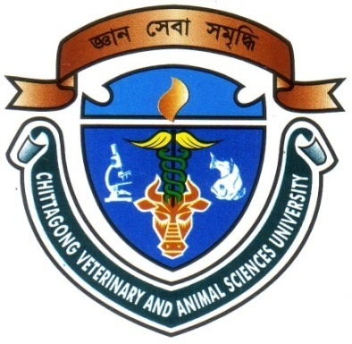

Submitted To:
Dr. Md. Kobirul Islam Khan
Designation: Professor
Department of Animal Breeding & Genetics

Submitted By-
Roll no: 08/18
Reg. No: 361
Intern ID No: B-11
Session: 2007-2008

Faculty of Veterinary Medicine
Chittagong Veterinary and Animal Sciences University
Khulshi, Chittagong-4225.

A Production Report Submitted as per Approved Style & Content

Signature of the Author Signature of the Supervisor

Dr. Md. Kabirul Islam Khan
Designation: Professor
Department of Animal Breeding & Genetics
Signature:………………….

Name: Md. Jahirul Islam
Roll: 08/18 Reg: 361
Intern ID No: B-11
Session: 2007-2008
Signature:………………

CHITTAGONG VETERINARY AND ANIMAL SCIENCES UNIVERSITY

KHULSHI, CHITTAGONG-4225
December, 2014.

