MANAGEMENT PRACTICES AND PRODUCTION PERFORMANCE OF JINDING DUCK UNDER SEMI-SCAVENGING SYSTEM AT NAOGAON
ABSTRACT
The study was conducted in three different semi scavenging duck farms in Sapahar Thana at Naogaon Districts from 10 May, 2013 to 6 September 2013. The aim of the study understands the management practices and production performance of Jinding duck in the semi scavenging farming system. The management conditions of the studied farms was observed by frequent visit the farms and data on live weight gain and egg production data were collected through a structured questionnaire and face to face interview of the farmer. The live weight gain of ducklings was recorded after 7 days interval by random sampling of 15 ducklings from a flock of 500. The egg production data was recorded on daily basis in farm record sheet. The study shows that the duckling obtains from rice husk hatchery attain 588.33 gm body weight within 35 days while fed broiler starter feed. Better egg production percentage of 61% was observed at 31 weeks of ages in farm 2 while poor production of 51% is recorded as the age of 39 weeks at farm 3. A clear indication of seasonal variability in duck production is observed in the study. Farmers do not vaccinate their flocks and little veterinary care was provided in the studied flocks. The egg production percentage is below to the standard but the body weight gain of ducklings was at standard level during the study period.

Keywords: Management practices, Duck, Jinding, live weight, semi scavenging

CHAPTER II
INTRODUCTION
Poultry production is an effective tool to bridge the gap between supply and demand of animal protein in developing countries (Alders and Pym, 2009). Among the other species of poultry duck can be a potential source of meat and eggs in rural area of Bangladesh (Hoque et al., 2010). Chicken, and duck or both rearing practiced are reported in Bangladesh. Majority portion of farmers raise 77.29% chickens and 84.41% duck respectively of the total population in Bangladesh (Huque et al., 2001). However the duck production is increasing steadily in Bangladesh it’s increased from 25.8 million in 2001 to 38.1 million in 2006 (BBS, 2007).
Bangladesh has the third largest population of duck after china and Indonesia with a population of 41.5 million (Dolberg, 2008). Recent estimates of duck population are varying from 8% to 20% of the total population of chicken (DLS, 2007). The variation also clearly indicates the house hold and small scale duck production in Bangladesh. There are different types of duck rearing system is available in Bangladesh. It can be classified as house hold (Scavenging), Semi Intensive (semi scavenging) and Intensive duck farming (Khan, 2012).

House hold duck farming or scavenging system provides no feed to the duck while semi scavenging system provides little of supplementary feed. However, at least the first two duck rearing system are greatly influenced by present of large water body like beel, Hawor. The intensive farming of duck is less and mostly operated by the government to facilitate the small scale farmer (Hoque et al., 2011). The house hold duck scavenge in nearby large water bodies for snail, duck weed, fish and algae The availability of feed is varies on season to season.

The distribution of duck population is varies in district to district in Bangladesh. The pick pocket area of duck production are Char Fasson on the Island of Bhola in Barisal division, the sub-districts of Burichang in Chittagong division; Tarail and Netrakona in Dhaka division and Kalia in Khulna division. The Rajshahi division has moderate population of duck (Doelberg et al., 2009).

Naogaon districts have some big wetlands and haors. During last five years the duck production is remarkably increased in the division beyond to the household duck farming. There are many small scale duck farmers establish their duck farm near to water bodies. The management system of duck is moderate of semi scavenging duck farming system. The farm size varies from 500 to 3000 number of duck. There are more than 300 registered duck farm in Sapahar Thana of the Naogan districts (Doelberg, 2004). Unfortunately the performance and profitability of the semi scavenging farming system is not yet evaluated in this area. Little study was conducted mainly in the Haor area of Noakhali and Sylhet. So, the current study was conducted to understand the management and production performance of duck in semi scavenging system of this farm.

The objectives of the study are as follows:
- To understand the management system of small holder commercial duck farming in Noagon.
- To find the production performance of duck.
- To identify the major constrains and prospect of duck farming.

CHAPTER II
LITERATURE OF REVIEW
2.1 Duck production in Bangladesh
Duck farming in south East Asian countries, mostly consist of large number of small and house holding farming. In Bangladesh duck rearing is one of the most traditional poultry industries in the rural economy (Das et al., 2008). The ducks are raised by mainly landless, marginal and small farmers to supplement the family income similar to the rearing of indigenous chicken throughout the Indian subcontinent (Ahuja and Sen, 20007). Bangladesh has blessed with many wetland and agricultural resource. So scavenging duck rearing is considered to have potential both for poverty alleviation and food production. Duck rearing is also suitable for widespread implementation as it is low cost required little skills, is highly productive can be incorporated with family income (Akteruzzaman et al., 2008).
Dixon et al., (2001) cited that, smallholder poultry keeping does contribute to poverty reduction and tends in itself to target poor women, due to the social and production characteristics of the poultry sub-sector. While absolute income increases are fairly marginal, poultry nevertheless facilitates improvements in social status and can together with other factors have a catalyzing effect, assisting farmers to graduate out of poverty.

There are 42.5 million ducks in Bangladesh with an average of 4.16 ducks per household (BBS, 2007), of which 95 per cent are of indigenous (Hoque et al., 2010). Doelberg et al., (2009) cited the overall duck and chicken ration in Bangladesh as 1:5. The proportion of ducks within the poultry population is high in the divisions of Barisal and Sylhet. In both divisions there is a large number of ponds and water bodies suitable for duck production. However, the Rajshahi and Chittagong division have the moderate population of duck while Dhaka and Khulna has lowest duck production population.

There are some pocket area of high duck production within each division like Char fassion and Bhola Island in Barishal divison, Tarail and Netrokona in Dhaka division, Kalia in Khulna division and Naogaon in Rajshahi division. (Pervin et al., 2012)

2.2 Management and systems of duck production in Bangladesh:

The climate and environment conditions of Bangladesh are very good for duck habitation. Innumerable water bodies and marshy riverside, beeels and haor are very important for duck rearing and better performance of duck (Khan, 2010). Duck production is mainly based on natural resource low laying area having snail, fish and crops residue. There are mainly three duck production systems in Bangladesh. The duck production system can be divided as Scavenging, semi scavenging and intensive duck farming in Bangladesh. (Khan et al., 2012)
Scavenging duck production system is most frequent and practiced system of duck production in Bangladesh. It can be defined as backyard farming system too (Khanum et al., 2005). The system mainly influence and depends on availability of natural feed resources for duck. The density of the farming system based on availability of vast agricultural resource and wetlands. No supplementary feed is allowed to the duck in the system (Huque et al.2001). Semi scavenging duck farming system is a moderated system of scavenging duck farming system. Here the duck population depends on both natural resources and complementary feed. Later different small scale commercial farming is grows up based on the semi scavenging system. Intensive farming is mainly practiced by the government and NGO. The intensive farm mainly establish with an aim to support the small holder duck farmer. It is very few in number and less profitable in nature. (Houque et al., 2010)

2.3 Duck breed and variety in Bangladesh

There are two types of duck breed sin Bangladesh mainly local varieties (non descriptive) and improved breeds. The non descriptive breeds represent more than 90% of the total duck population. The non descriptive breeds are mainly Nageswari, Muscoovy, Sylhet Mete, Desh black and deshi white. The production performance of this non descriptive vries is very poor in comparison to developed breeds. (Bhuiyan et al., 2005)
Among the developed performance breed the Jinding, Khaki Campbell, Indian runner and Pekin can be found in Bangladesh. However, in the rural area this breeds either brought by government farm or local Non government organization (NGO). Small scale farmers procure the day old duck from either the Government farm or NGO. (Hoque et al., 2011)The rice husk hatcheries also produced nearby 1.5 million of duck per year which directly given to the small holder farmer. (Khandaker etal., 2007)
2.4 Feeding and Nutrition

The production of first two systems are greatly influenced by season and feed supplementation. During the July to October rainy season, there will be plenty of feed for ducks to scavenge. In the winter season - November to February – there is moderate feed supply, while the summer March to June produces little duck feed according to crop and gizzard studies in his survey of 500 households in Chittagong, Dhaka, Dinajpur, Khulna and Sylhet districts used slightly different seasonal divisions, but found that the season October to December produced no ducklings, while ducklings constituted 19%, 23% and 28% of the duck flocks during July-September, January-March and April-June, respectively (Kabir et al., 2007).
It was reported that the total number of ducks, including ducklings, was 56% higher in the season April-June, compared to the season with the lowest number from October to December, implying that there is, indeed, a seasonal dimension to duck production, but the same applies apparently even more markedly to chicken production, where the study found chicks to constitute as much as 72% of the total chicken flock in an average household of the survey during January to March. This reflects a much more pronounced seasonality than in the case of ducks. However, in none of the four seasons did the ducks constitute less than 19% of the total chicken population of the surveyed households (Chowdhury et al., 2004).
In the marshy wetland area the main feed in snail, duckweed and small fish (Islam and Wahab, 2005). The duck are scavenging in paddy field to for the crop residue. Separate feed supplement was not given in the scavenging system but feed supplement is given in semi scavenging system. The supplement feed ingredients are paddy, rice wheat etc (Ghosh et al., 2013).

2.5 Egg Production and Body weight gain:
Duck attain the sexual maturity in 23 to 25 weeks of age in the scavenging system while 20- 23 weeks of age in semi scavenging farming system (Ghosh et al., 2013, Etuk et al., 2007). A relative short sexual maturity was reported 18 weeks in India (Tai and Tai, 2001). However, breed specific variation in attains sexual maturity in Khaki Campbell and Jinding duck also reported. The provision of supplementary feed along with scavenges feed reduced the time of attaining sexual maturity. The exotic breeds attain faster sexual maturity than local breed with low consumption of feed.
Ghosh et al., (2012) reported the average egg production of Jinding, and local breeds of deshi black, deshi mix as 150 and 90 respectively per year. The study was carried out in six different villages of Companiganj Upazila under Noakhali district of Bangladesh on scavenging ducks. Khan, (2012) observe the higher egg production in Jinding duck in scavenging farming system but lowest body weight gain in comparison to intensive farming system. The study explains it’s due to unavailability of feed in scavenging system in seasonal variation. Hoque et al., (2010) reported the average number of eggs produced per layer per household farm per year was 79 (22–200), egg weight 48 g (40–60). Bhuiyan et al., (2007) reported the live weight gain The total feed consumption up to the brooding period in three breeds were 2047.00, 1652.06 and 1430.05 g/ducklings respectively and the respective feed conversion ratios were 2.40, 2.91 and 3.05. Mortality was non- significant among the breeds of ducks.
2.6 Health and diseases:
Hoque et al., (2010) reported duck plague the highest rank of importance, followed by duck cholera, botulism, and duck viral hepatitis. Only 28% of the farmers said they vaccinated their ducks against duck diseases. Ghosh et al., (2011) cited the diseases were more common during winter (63%) than other seasons of the year. The author also suggests duck plague, duck cholera or both as the main constrains of duck rearing.
Farmers’ lack of knowledge of diseases of ducks leads to high mortality rates and thus lowering household income. Mortality rates of ducks due to disease outbreak (primarily due to duck plague and duck cholera) are around 30 percent at the Haor region. Farmers that are lacking sufficient knowledge of disease management; prevention and control are always threatened by the risk of disease outbreak. Middlemen were dominating the vaccine supply chain and due to lack of knowledge many farmers were administering vaccines at a higher dose than required. They thus wasted vaccines while at the same time many more farmers’ were not getting the required vaccines for their farms. (Hoque et al., 2011)

CHAPTER III
MATERIALS AND METHODS
3.1 Study area:
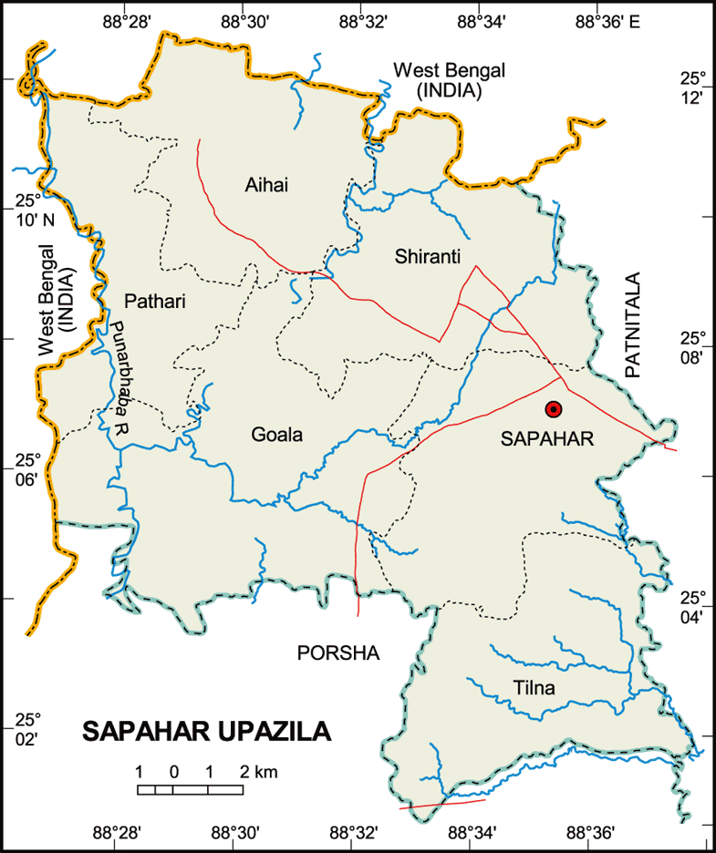
The study includes the Sapahar Thana (The smallest administrative unit) of Naogaon districts under Rajshahi division. The Thana is located in North West region of Bangladesh. Geographically the area is a plane land having more than four large water source (Beel). The peoples of this area mainly earn their livelihood on agriculture. Most of the family raised duck under backyard system but some young people take the initiative of small scale duck farming.
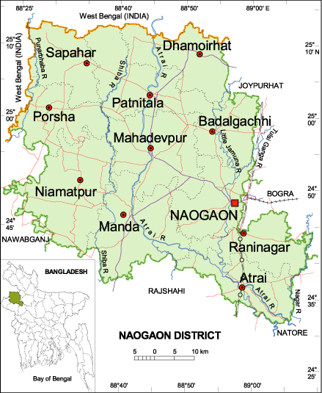
3.2 Study Period and Study population and Experimental design:
The study was conducted from10 May, 2013 to 6 September 2013 in semi scavenging duck production system in Naogoan. The Jinding duck obtain from rice husk hatchery was considered as the study population. Three duck farm from Sapahar thana adjacent to Jobai beel was taken having 500, 500 and 800 duck respectively. The ages of the duck were 1 day, 25 weeks and 35 weeks respectively. The farm were identified as farm 1 (Bulbul duck farm), Farm 2 (Jahangir Duck farm) and Farm 3 (Swapon Duck farm).
3.3 Data collection and management:
Production data:
For the farm 1 The live weight gain and feed consumption was recorded by the farmer for a period of 35 days. The random sampling of ducks (n=15) in each week was recorded. A portable weight machine was used to determine the live weight of duckling. The feed consumption was also recorded in daily basis. Finally the data were inputted in Microsoft excel®. The average data and mean, standard deviation was calculated by using Microsoft Excel 2007®
For farm 2 and 3 the egg production data were recorded in a printed sheet by the attendance of the farm on daily basis. The data were collected during the study period after subsequent visit in the selected farm after each 7 days. The diseases and mortality of duck also recorded by the farmer and disease were suspected on the basis of clinical sign in the studied farm.
Managemental data:
The basic information of duck farmer and management practices are collected through a structured questionnaire. Face to face interviewed method is followed during collection of data. Data also recorded through frequent visiting in the field studied area on observational basis. The purpose of the study and objective was briefed to the farmer. The ecology of the foraging area and managemental procedure was collected through observation. The studied duck farm management can divide in three stages. These are a) management of ducklings, b) management of yearling and c) management of laying duck.
Identifying the major constrains:
The daily mortality of duck was recorded and later the diseases were suspected on the basis of clinical sign. Opportunistically postmortem for diagnosis of diseases also performed. Different problem and limitation that are faced by the farmers also noted as descriptive data.

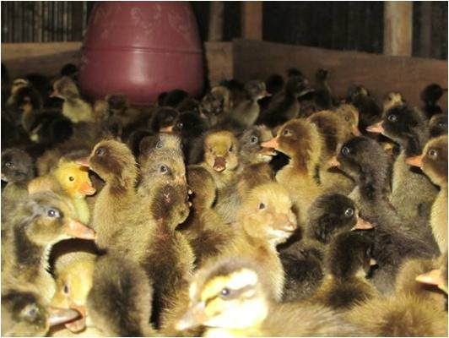  Fig 1: Rearing of ducklings up to 35 days | 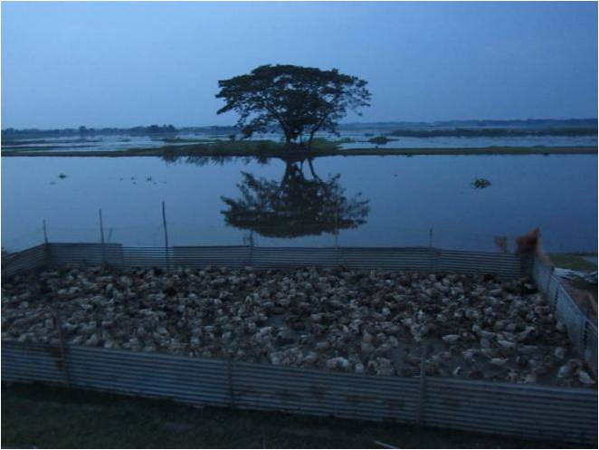  Fig 2: Temporary house near the water body
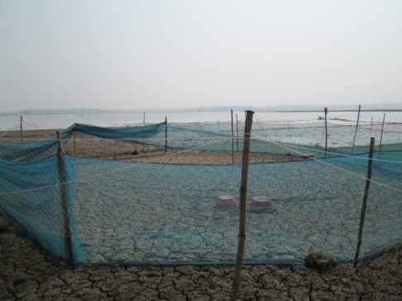  Fig 3: Fencing around the temporary house | 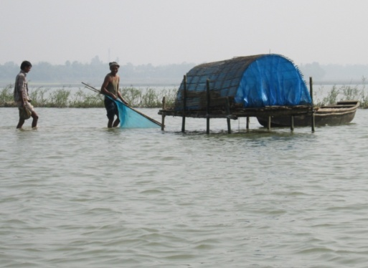  Fig 4 : House for the personnel
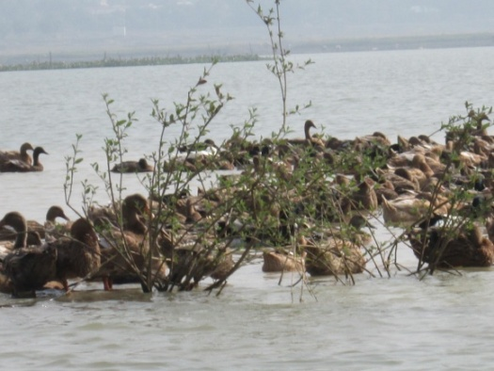  Fig 5 : Scavenging of duck in the Beel | 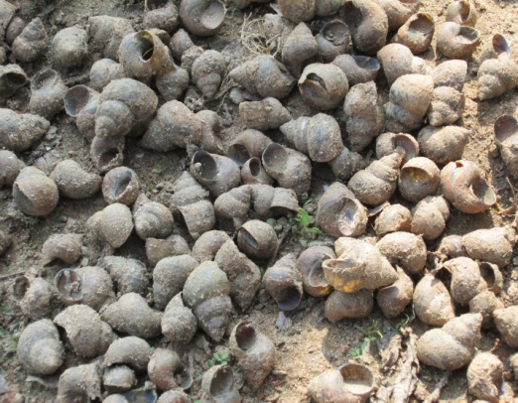  Fig 6: Snail as the major natural feed of duck
Picture of semi scavenging duck farming system
CHAPTER IV
RESULT AND DISCUSSION

4.1 Management of Ducklings: (1 to 35 days)
The day old duckling was collected from Rice husk hatcheries which are operating discretely at duck farming potential areas in the country. Under the rice husk hatchery technology, an incubation box and two (or three) cylinders all made of bamboo are required to be set up in a dark room (incubation room), possibly well insulated. The cylinders are placed in central points in the incubation box and the incubation chamber is then filled up with rice husk. A kerosene (hurricane) lamp is kept in one cylinder alternately during the entire hatching period to keep the chamber warm up to 98-1000F or 37-38C (Khalequzzaman et al., 2006). The small holder farmers reared the procured day old duckling as like of broiler chicken. They follow the intensive farming system and provide the broiler grower feed up to 28 days. Commercially available chicken feeds are used for the ducklings rearing at this stage. Then the duck was given paddy, rice crush, wheat bran and wheat up to 35 days. During the 35 days period the duckling gain desired body weight, the farmers shift them to the free range near vast water bodies.
4.2 Performance of ducklings:
The live body weight gain of the ducklings up to 35 days in intensive farming are represented in Table: 1 and the rate of weight gain (time, week vs live weight) are shown in fig.:1

Age | Average body weight gain | ST Dev | SE
1 | 39.53 | 2.50333 | 0.64636
7 | 125.13 | 6.10464 | 1.57621
14 | 238.60 | 4.57946 | 1.18241
21 | 349.20 | 10.1433 | 2.61898
28 | 442.53 | 10.239 | 2.64371
35 | 588.33 | 9.9403 | 2.56657

Table 1: Table for average body weight gain in Jinding ducklings at different ages

Fig1: Relationship between time with live weight gain (gm)
From the table 1 it is shown that the duckling gain 442.53 gm live weight in 28 days while fed with only broiler starter feed. The body weight gain attain at 588.33 gm in 35 day while fed supplementary feed. The supplementary feeds contain boiled rice, paddy, boiled potato and other crops residue. It was also seen that body weight gain increase with the increase of ages. It indicates with the increasing of age the ducklings consume higher amounts of feed. The R² value is very high which indicates the body weight gain of broiler is steady and good fitted with the liner regression. The body weight gain of Jinding duck is similar to the study of Khan et al., 2012 of 462 gm at 30 days in Chatkhil. But the body weight gain is little lower than the study of Bhuyan et al. 2011 of 835 gm in Pekin ducks. The variation may be due to provided ration or breed (Owen and Cook, 1977).
4.3 Management of yearling duck (5- 24 weeks)
The 5 weeks ages duck were transported to near the water bodies like beel, haor or large ponds. A small area is fenced with tin or bamboo near the water body for holding the duck at night time. During the day time the ducks were allowed to scavenge for their food. The ecology of the wetland has different flora and fauna which is taken by duck. Snail, duckweeds, small fish and crops residue is the main feed during scavenging in the water source. No additional feed was given during this period. One attendance guides the duck during foraging in the wetlands.

4.4 Management of yearling duck (5- 24 weeks)
The 5 weeks ages duck were transported to near the water bodies like beel, haor or large ponds. A small area is fenced with tin or bamboo near the water body for holding the duck at night time. During the day time the ducks were allowed to scavenge for their food. The ecology of the wetland has different flora and fauna which is taken by duck. Snail, duckweeds, small fish and crops residue is the main feed during scavenging in the water source. No additional feed was given during this period. One attendance guides the duck during foraging in the wetlands.
4.5 Management of laying duck:
The duck attain sexual maturity at 24-26 weeks of age. At the age of first laying, the farmers start to supply additional feed to the duck. The additional feeds were supplied to the flock at the morning before allowing them in grazing. The ingredients and quantity of supplementary feed varies from farmer to farmer. The feed is mainly given on the basis of source and availability of seasonal crops. The additional feed ingredients are rice polish, boiled potatoes, rice grains etc. Ducks lay egg between its two moulting (feather changing) periods, February to March and September to October. During the two peaks laying seasons the production is high but farmers get a lower price for eggs during the hot season from March to July. The egg was collected by the attendance frequently and marketed in the local market. The farmers move the flock routinely from one place to another, the frequency of moving and distance from home depends on the availability of natural feeds for the ducks. Farmers move with their flocks toward deep seats of Haors and stay there from January until May. Sometimes between March and April the natural feeds become scarce and additional feeds would be required, which often hampers egg productions. During the period from June until August when Haors become flooded the farmers move back towards Haor peripheries, as natural feeds become available there. In search of natural feeds farmers sometimes move 20 to 30 kilometers from their house to stay beside the local water bodies. Starting about mid September until mid December natural feeds for ducks become extremely scarce and additional feed supplementation is required. During this period egg production almost stops and farmers who are not able to supply additional feed to their ducks due to financial limitations are compelled to sell their flocks and again buy pullets or laying ducks at the beginning of the next season.

4.6 Egg production performance: (Farm 2)
The daily egg production performance of ducks in farm 2 is representing below of table 2. The data collection period is 10 June to 10 July, 2013.
Ages (weeks) | Day | Egg production | % Daily egg production | % Weekly egg production
28 | 1 | 224 | 51 | 52.5
 | 2 | 225 | 51
 | 3 | 233 | 53
 | 4 | 229 | 52
 | 5 | 233 | 53
 | 6 | 237 | 54
 | 7 | 238 | 54
29 | 8 | 242 | 55 | 55
 | 9 | 242 | 55
 | 10 | 242 | 55
 | 11 | 246 | 56
 | 12 | 245 | 55
 | 13 | 246 | 56
30 | 14 | 238 | 54
 | 15 | 245 | 55 | 54
 | 16 | 211 | 48
 | 17 | 224 | 51
 | 18 | 233 | 53
 | 19 | 242 | 55
 | 20 | 255 | 58
 | 21 | 246 | 56
31 | 22 | 260 | 59 | 61
 | 23 | 260 | 59
 | 24 | 268 | 61
 | 25 | 281 | 64
 | 26 | 268 | 61
 | 27 | 273 | 62
 | 28 | 277 | 63

Table 2: For weekly egg production performance of Jinding duck at Farm 2

The table 2 shown the highest egg production percentage is 61% and the lowest is 52.5% /week. The egg production is gradually increasing with the increase of ages. The pick production is recorded at 32 weeks of age. During the period there are plenty natural feed is available (Hoque et al., 2011). The production is increasing due to foraging in the wetland and having proper nutrition. The egg production is somewhat less than the report of Sultana et al., 2008 but more or less same with Doelberg et al., (2009) and Kabir et al., 2007

4.7 Egg production performance: (Farm 3)
The daily egg production data in farm 2 is represented in Table: 3. Data collection period is 15 August to 6 November, 2014
Ages (weeks) | Day | Egg production | % Daily egg production | % Weekly egg production
37 | 1 | 358 | 49 | 48
 | 2 | 365 | 50
 | 3 | 358 | 49
 | 4 | 350 | 48
 | 5 | 350 | 48
 | 6 | 335 | 46
 | 7 | 328 | 45
38 | 8 | 341 | 47 | 46
 | 9 | 334 | 46
 | 10 | 328 | 45
 | 11 | 335 | 46
 | 12 | 321 | 43
 | 13 | 327 | 45
 | 14 | 335 | 46
39 | 15 | 332 | 46 | 45
 | 16 | 315 | 44
 | 17 | 326 | 45
 | 18 | 332 | 46
 | 19 | 314 | 43
 | 20 | 327 | 45
 | 21 | 328 | 45

Table 3: For weekly egg production performance of Jinding duck at Farm 3

From the table 3 it is shows that the egg production becomes decreasing with the increase of ages. . And the lowest egg production percentage is 45% in 37 weeks of ages. The decline trend is due to increased ages and scarcity of natural feed prior to inter season (Das et al., 2005). It also cited that the more population in a flock and less egg production in semi intensive farming system of duck. Flock density and availability of natural in a define area is responsible for the lower egg production (El-Hanoun et al., 2012). The egg production performance is decreasing at 36 to later weeks of ages. The farmers mainly sold the duck for meat purpose due to low egg production and scarcity of feed during this period. Farmers have inability to provide the supplementary feed to the duck for their economic constrain.
4.8 Diseases and constrains of duck farming:
Duck farmers in the Haor region did not have sufficient knowledge of disease management. They did not know the symptoms of duck diseases and were unable to decide what to do and had to contact the Upazila Livestock Hospital for advice. The survey found no local medicine manufacturer producing any vaccines. The government allots vaccine to Upazilas based on the requisition of the Upazila Livestock Officer. However, the supply from the central depot is always insufficient to meet the demand in the Haor region. In particularly the Duck Plague vaccine become short in supply from March to July. Considering the existing scenarios, BRAC made contacts with the Department of Livestock Services (DLS) and District Livestock Offices to prioritize the selected areas for vaccine supply as these are intensive duck farming areas and made partnerships to provide on time vaccine delivery through the Upazila Livestock Offices. After one year of BRAC interventions it was found that the supply of duck vaccines to the Haor region increased and farmers were getting the required vaccines.
Limited veterinary services are provided to the farmers. They take advice from the experienced farmer for medication. They frequently use different antibiotics and feed supplement by the advice of feed sellers or experienced farmer. The antibiotics are Enrofloxacin (Enrosin), Ciprofloxacin (Ciprovet), Saulphonamides (Renatrim), Renamycin (Renamycin), Azithromycin, and cephtriaxone (Eracef vet). They use the antibiotics and tablets as direction of the feed seller.

CHAPTER V
CONCLUSION
The study revealed that the management system of laying duck is not scientific and farmers have limited knowledge on scientific management practices. Poor management and biosecurity measures hinder the optimum production. The body weight gain of ducklings from Rice husk hatchery is in satisfactory level. The duck attains sexual maturity in the satisfactory ages. The egg production is little bit poor in large flock in comparison to small flock. The feed scarcity is the main cause to interrupt the farming during winter season. The farmers are bound to sell their laying duck due to inability too provide supplementary feed. Proper vaccination of different disease and veterinary care is not in sufficient. So, it is recommended to provide sufficient veterinary support and farmers training to strengthen the production. However, the study was conducted with a short period of One month in the study area as part of undergraduate internship program. Therefore, long term monitoring and data collection should do to evaluate the actual production performance of duck in this area.

CHAPTER VI
REFERENCES
Ahuja, V., & Sen, A. (2007). Scope and space for small scale poultry production in developing countries. Indian Institute of Management.

Akteruzzaman, M., Miah, M. A. M., Hossain, M. M., Fattah, K. A., & Rahman, R. (2008). Impact of training on transferring livestock technology for improvement of livelihoods of the rural farmers. Bangladesh Journal of Animal Science, 37(2), 106-115.

Alders, R. G., & Pym, R. A. E. (2009). Village poultry: still important to millions, eight thousand years after domestication. World's Poultry Science Journal, 65(02), 181-190.

BBS. 2007. Bangladesh Bureau of Statistics. Statistical Year book of Bangladesh. Ministry of Planning, Government of the People’s Republic of Bangladesh, Dhaka. (pp. 33–34).

Bhuiyan, M. M., Khan, M. H., Khan, M. A. H., Das, B. C., Lucky, N. S., & Uddin, M. B. (2005). A Study on the Comparative Performance of Different Breeds of Broiler Ducks Under Farmer's Condition at Farming System Research and Development (FSRD) Site, Sylhet, Bangladesh. International Journal of Poultry Science, 4(8), 596-599.

Chowdhury, M. M. I., Ashraf, A., Mondal, S. P., Mondol, N. M. A. A. M., & Hasan, M. M. (2004). Effect of season on the hatchability of duck eggs.International Journal of Poultry Science, 3(6), 419-421.

Das, S. C., Chowdhury, S. D., Khatun, M. A., Nishibori, M., Isobe, N., & Yoshimura, Y. (2008). Poultry production profile and expected future projection in Bangladesh. World's Poultry Science Journal, 64(01), 99-118.

Dixon, J. A., Gibbon, D. P., & Gulliver, A. (2001). Farming systems and poverty: improving farmers' livelihoods in a changing world. FAO.

DLS. 2007. Annual Progress Report. Department of Livestock Services. Farm gate, Dhaka.

Dolberg, F. (2008). Poultry sector country review: Bangladesh. Food and Agriculture Organization of the United Nations, Rome. Available:ftp://ftp.fao.org/docrep/fao/011/ai319e/​ai319e00.pdf. Accessed: January 10, 2012
Dolberg, F. (2004). Review of household poultry production as a tool in poverty reduction with focus on Bangladesh and India. Livestock and livelihoods: challenges and opportunities for Asia in the emerging market environment. India, National Dairy Development Board, and Rome, FAO, Pro-Poor Livestock Policy Facility (South Asia Hub).

El-Hanoun, A. M., Rizk, R. E., Shahein, E. H. A., Hassan, N. S., & Brake, J. (2012). Effect of incubation humidity and flock age on hatchability traits and posthatch growth in Pekin ducks. Poultry Science, 91(9), 2390-2397.

Etuk, I. F., Abasiekong, S. F., Ojewola, G. S., & Akomas, S. C. (2006). Carcass and organ characteristics of muscovy ducks reared under three management systems in South Eastern Nigeria. International Journal of Poultry Science, 5(6), 534-537.

Ghosh, S., Haider, N., & Khan, M. K. I. (2013). Status of Household’s Ducks and their Associated Factors under Scavenging System in a Southern Area of Bangladesh. International Journal of Natural Sciences, 2(4), 108-111.

Hoque, M. A., Skerratt, L. F., Cook, A. J. C., Khan, S. A., Grace, D., Alam, M. R., & Debnath, N. C. (2011). Factors limiting the health of semi-scavenging ducks in Bangladesh. Tropical animal health and production, 43(2), 441-450.

Hoque, M. A., Skerratt, L. F., Rahman, M. A., Beg, A. R. A., & Debnath, N. C. (2010). Factors limiting traditional household duck production in Bangladesh.Tropical animal health and production, 42(7), 1579-1587.

Huque, K. S., Sarker, M. S. K., Huque, Q. M. E., & Islam, M. N. (2001). Duck production in the Sylhet basin of Bangladesh prospects and problems. In Proceedings of WPSA. 2nd International Poultry Show and Seminar (pp. 16-17).

Huque, K. S., Sarker, M. S. K., Huque, Q. M. E., & Islam, M. N. (2001). Duck production in the Sylhet basin of Bangladesh prospects and problems. In Proceedings of WPSA. 2nd International Poultry Show and Seminar (pp. 16-17).

Islam, M. S., & Wahab, M. A. (2005). A review on the present status and management of mangrove wetland habitat resources in Bangladesh with emphasis on mangrove fisheries and aquaculture. In Aquatic Biodiversity II (pp. 165-190). Springer Netherlands.

Kabir, F., Sultana, M. S., Mustafa, G., Rashid, M. M. O., Khan, M. S. I., & Asgar, M. A. (2007). Study on production system of existing ducks at Potuakhali district of Bangladesh and development of a self-sustainable ducks rearing model under semi-scavenging system at farmer’s condition. Journal of Biological Sciences, 7(2), 327-332.
Khalequzzaman, M., Mahdi, S. H. A., & Rahman, M. M. (2006). Effect of the traditional parched rice husk incubation techniques on the hatchability of duck eggs. University Journal of Zoology, Rajshahi University, 25, 37-40.

Khan S.A (2010). Production performance of duck with their nutritional, health and preventive determinants under the model at chatkihil in Noakhali districts(Mphil dissertation, The University of Chittagong)

Khan, S. A., Alauddin, M., Hassan, M. M., Islam, S. K. M. A., Hossain, M. B., Shaikat, A. H., & Hoque, M. A. (2012). Comparative Performance and Hemato-Biochemical Profile of Jinding Ducks in Different Production Systems of Bangladesh. Pakistan Veterinary Journal, 33.

Khandaker, T., Khan, M. J., Shahjalal, M., & Rahman, M. M. (2007). Use of duckweed (Lemna perpusilla) as a protein source feed item in the diet of semi-scavenging jinding layer ducks. The Journal of Poultry Science, 44(3), 314-321.

Khanum, J., Chwalibog, A., & Huque, K. S. (2005). Study on rural duck production systems in selected areas of Bangladesh. Livestock Research for Rural Development, 22(4), 100.

Owen, M., & Cook, W. A. (1977). Variations in body weight, wing length and condition of Mallard Anas platyrhynchos platyrhynchos and their relationship to environmental changes. Journal of Zoology, 183(3), 377-395.

Pervin, W., Chowdhury, S. D., Hasnath, M. R., Khan, M. J., Ali, M. A., & Raha, S. K. (2013). Duck production strategy and profile of duck farmers in the coastal areas of Bangladesh. Livestock Research for Rural Development, 25, 7.

Rahman, M. M., Khan, M. J., Chowdhury, S. D., & Akbar, M. A. (2009). Duck rearing system in southern coastal districts of Bangladesh. Bangladesh Journal of Animal Science, 38(1-2), 132-141.

Rahman, M. M., Khan, M. J., Chowdhury, S. D., & Akbar, M. A. (2010). Effect of feed supplementation on chemical composition of duck eggs in coastal areas of Bangladesh. Bangladesh Journal of Animal Science, 39(1-2), 163-169.

Salahuddin, A. (2005). Integrated Rice-Duck A new farming system for Bangladesh. Innovations In Rural Extension: Case Studies From Bangladesh, 143.

Tai, C., & Tai, J. J. L. (2001). Future prospects of duck production in Asia. The Journal of Poultry Science, 38(1), 99-112.

