Abstract

This study assees the Economic efficiency of beef cattle fattening in selected upazilas of Kushtia districts in Bangladesh. Data were collected using a structured questionnaire which was administered to 46 randomly selected cattle fatteners from about 400 cattle fattening farmers in the Kushtia district. The socio-economic determinants of the respondents were assessed by age, sex, education, experience, extension services and ethnicity. The result shows the maximum female are involves in beef fattening (42%). The inputs used for cow fattening were feeder cow, feed, drugs / vaccines, labour, water and potash/salt. The maximum inputs are given at the rate for per cow 450tk /month (6%). In this study out of 46 respondents 24% were illiterate, 46% primary levels, 14% SSC level. The farmer had own capital about 42%, and 46%% respondents takes bank loan. Most of the respondents (46%) fattened cattle for 2-3 months and rest fattened for a prolonged period. About 40% respondents were used cross breeds for cattle fattening and rest fatteners are used local, pabna, nepali etc. About 74% Respondents are not taking any training on beef fattening. About 82% respondents used deworming, 10% respondents used urea molasses straw (UMS) and 8% followed conventional feeding. About 24% vaccinate the cattle by themselves and about 76% not vaccinate. The results of this study will be useful for farmers and researchers to identify the overall problems and their remedies on feeding, management and marketing related to small scale cattle fattening practices in Bangladesh.

Key words: Economic efficiency, Beef fattening, Farmers, UMS

CHAPTER I
Introduction

In Bangladesh, livestock is one of the most potential sub-sectors of agriculture which plays an indispensable role in promoting human health and national economy of the country. Livestock is an integral part of farming system which has a better contribution to enhance the economy of Bangladesh. large ruminants (Cattle and Buffalo) and small ruminants (sheep and goat) constitute the major portion of livestock. The present population of livestock is 23.12 million cattle, 1.39 million Buffalo, 24.15 million goat and 3.07 million sheep (DLS, 2010-11).
Bangladesh is a low-lying densely populated country with more than 150 million people where about 75% live in rural areas and the rural poverty rate is 63%, of which 36% are extreme (Hodson R. 2006). Kushtia region is currently working hard to develop its agribusiness potential mainly cattle fattening. Cattle fattening simply refers to the preparation of the cattle for marketing (Jean, 1993; Uza et al., 1999). Indonesia’s domestic production provides approximately 80% of the beef consumed. Imported meat covers the other 20 %. In 2000, for West Java, the 80% was slightly over 300,000 head (TomyPerdana, Research Institute, 2003). Farmers use rice straw of traditional varieties, green grass, sugarcane tops, wheat and rice bran, molasses, pulse bran and locally available resources such as pumpkin, carrot, banana,Vegetable by products, rice gruel, boiled rice bran, oil cakes etc for beef fattening. Urea molasses straw treatment in beef cattle resulted higher body weight, dressing percentage and also in better carcass quality than untreated straw. The acute shortage of feeds and fodder has long been identified as a serious constraint to optimum livestock production in Bangladesh (Saadullah.1995). During the holy Eid-Al Azha festival Muslims always go for Kurbani (sacrificing slaughtered livestock). Animals including cows, goats, camels and sheep are slaughtered each year to mark the festival. The meat is then distributed, with one-third meat by the immediate family and relatives, one-third given away to friends, and one-third donated to the poor. Bangladesh has the world's third largest Muslim-majority population. Bangladeshi Muslims celebrate the Eid in every year. About 1.8 million cattle are sacrificed at this time each year (Sujan et. al. 2011). So, the demand for cattle especially beef cattle increases several times higher during the holy Eid-Al Azha festival. The price of cattle is also increased in this time.
A large number of farmers are involved in bull fattening just before 3 or 4 months of Eid-Ul-Azha (Muslim festival), when they sell the animals with profitable prices. A cattle farming is a way of rearing cattle for profitable production of meat. Cattle fattening package is a four-steps rearing programme of male and/or infertile female emaciated cattle for harvesting their compensatory growth within a period of 60 to 120 days. Collection of animals considering their body characteristics followed by deworming and feeding cost effectively up to a profitable rate of live weight gain and marketing them readily are the four major factors to make the fattening package profitable. It is an easy and profitable system of cattle rearing to alleviate poverty, unemployment and generate income both for the rural people. So far we are aware a few literatures are available regarding socioeconomic status of cattle fattening farmers in Kustia district. Therefore, the present study has been undertaken to fulfill the following objectives:

- To assess the socioeconomic status of cattle fattening farmers of the study areas.
- To determine the economic efficiency of cattle fattening farms in the study area.

CHAPTER II
Review of Literature

Cattle fattening for beef production have become an important business of the small farmers in Bangladesh. In some areas of Bangladesh a small scale commercial cattle fattening program has already been started. Cattle fattening package is a four-steps rearing programmer of male and/or infertile female emaciated cattle for harvesting their compensatory growth within a period of 60 to 120 days. The sector is undergoing a massive transformation fuelled by high demand for meat, which is likely to double in the near future, the major forces behind this, is the combination of population growth, urbanization and income growth (FAO/IAEA, 2006).

Collection of animals considering their body characteristics followed by deworming and feeding cost effectively up to a profitable rate of live weight gain and marketing them readily are the four major factors to make the fattening package profitable. In the recent past, there is a greater emphasis on sustainable beef production through backyard beef fattening which has its focus on the long-term health of the environment while maintaining the economic viability of the farm and addressing consumers’ concern about beef they eat (Fanatico et al., 1999).

In recent years the women farmers of Bangladesh have been involved and sustained beef fattening program in rural areas of the country. The information available in the literature on cattle fattening by small farmers in rural areas are few and sporadic (Hossain, 1986; Hossain et al., 1996a; Huq et al., 1997 and Hashem et al., 1999).

Then find out the economic efficiency of the respective farms enough to meet more than 60% of the actual demand (Mbanasor, 2000).

Oni (2006) reported that the economic viability of cow fattening enterprises is not in doubt. This is because raw materials needed for the venture can be sourced at ease. Also, the production technology is simple and the man power requirement can be met with family labour.

Oni, O. (2006). Investing in cattle fattening, An article presented on the Internet by Business Day Media Ltd.
(http://www.business day on line com/5089-5140)

CHAPTER III
Materials and Methods

3.1 Study area

The present study was conducted at Mirpur and Kushtia sadar Upazila of Kushtia district.

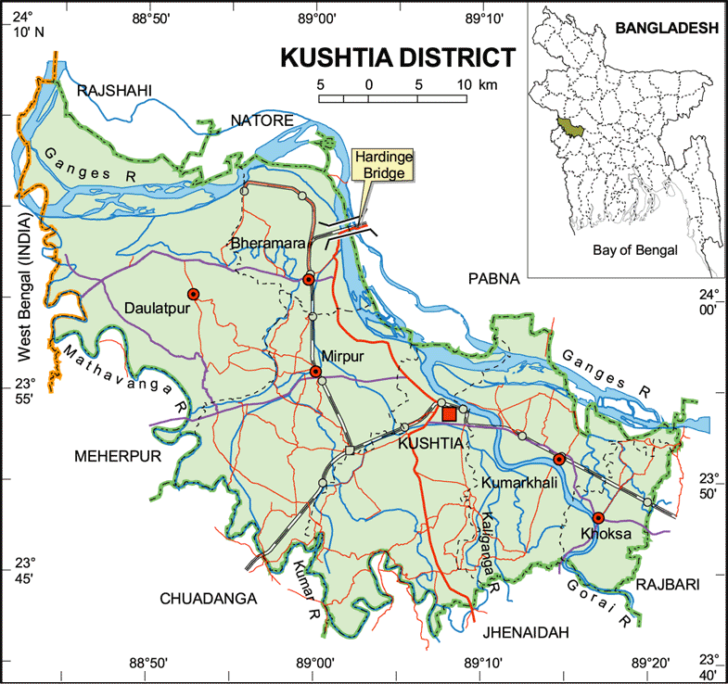
Study area
Fig: Study area

3.2 Study period
The study was conducted during August to September 2013 covering 50 small scale cattle fattening farm.

3.3 Data collection
Data was collected from respondents of Mirpur and Kushtia sadar Upazila of Kushtia district. A pre-set structured questionnaire was prepared for required data collection. Informations were collected from respondents by face to face interview. Just prior to data collection the objective of the study was clearly described to the respondents. The data was basically taken regarding the farmers sex, age, education, farm size, Social status, Supply in market, Expenditure and household size as well as some factors associated with cattle fattening such as breed, source of money, feeding and nutrition, deworming and treatment.

3.4 Data analysis

The data obtained were imported, stored and coded according to recorded information in the questionnaire regarding beef fattening in the data sheet using the Microsoft Excel-2007 program. Simple analysis of the data was done to calculate frequencies of different variables.

Data gathered include information on socio-economic variables of the entrepreneurs such as age, education, household size, location, experience, access to credit and extension services. In this study 50 respondents were interviewed to find out the socio economic condition of them. The selected characteristics included age, family size, land size and occupation.

3.5 Measurement of Economic Efficiency

Economic efficiency is a term typically used in microeconomics when discussing product. It is the study of cattle fattening entrepreneur maximizes the use of their socioeconomic inputs so as to maximize the production of goods and services. Production of a unit of good is considered to be economically efficient when that unit of good is produced at the lowest possible cost. In the present study, the determinants of economic efficiency were modeled in terms of socioeconomics variables of the cattle fattening farmers and other factors. The economic efficiency in the model was simultaneously estimated with their determinants (Okoye et.al. 2007)

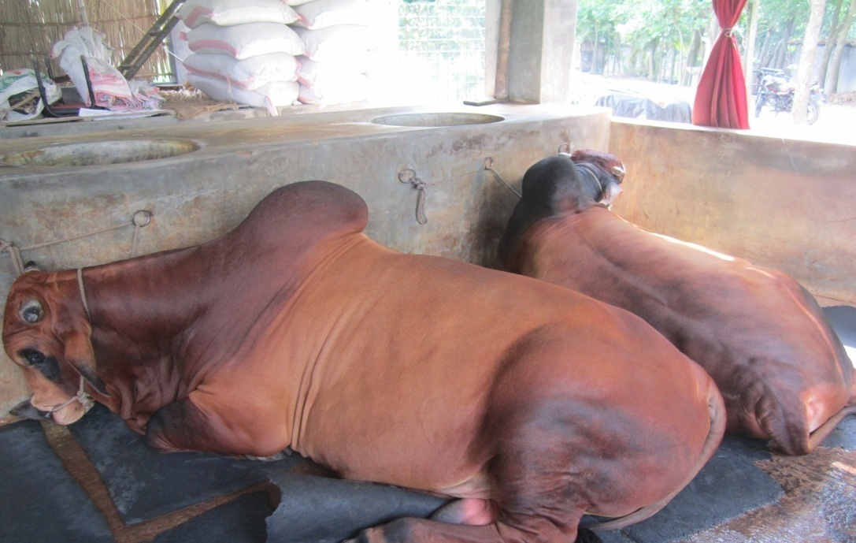

Fig: Beef fattening farm

CHAPTER IV
Results and Discussion

4.1. Socioeconomic Characteristics of Cattle fattening farmers of the study areas
From the obtained data, the frequency of different variables was calculated as percentage. The study reveals that the female are more involved (42%) than males 24% as stated in table 1. Both male & female are involved in beef fattening program about 34% of total respondents.

Table: 1. Distribution of Cattle Farmers according to their sex, age, education, farm size, Social status, Supply in market, Expenditure and household size
Variables | Frequency | Percentage (%)
Gender
Male  Female  Both  Total | 12 persons  21 persons  17 persons  50 persons | 24  42  34
Education level
Illiterate  Primary  S.S.C  H.S.C  Others  Totals | 12 persons  23 persons  07 persons  06 persons  02 persons | 24  46  14  12  04
Social status
Poor  Moderate  Rich | 10 Farmers  26 Farmers  14 farmers | 20  52  28
Farm size
01-05  05-10  10-15  15-20 | 034 farms  08 farms  05 farms  03 farms | 68  16  10  06
Expenditure (Tk/day/animal)
200-250  250-300  300-350  350-400  >450 | 26 farms  12 farms  03 farms  06 farms  03 farms | 52  25  06  11  06
Supply in market
Locally  Chittagong  Dhaka  Bepari | 18 families  07 families  21 families  04 families | 36  14  42  08

Among the involved respondents persons educated up to primary education are more interested (46%) whereas the respondents about HSC level are the least (4%). It is stated that the farmers of moderate class are more interested (52%) but the poor farmers are less interested (20%) in beef fattening program, rich people are also involved about 28% in the same program. In the beef fattening program the small sizes farm containing 1-5 cattle are found more prevalent than the other categories. Farm sizes containing 15-20 beef cattle are found less prevalent (6%). The farmers expedite about 200-250 take /day/ cattle are found the most (52%) whereas the farmers group expending > 450 taka/ day/ animal are found the least (6%). Most of the farmers are supply their animals in Dhaka market (42%), least of them to bepari.
It implies that cattle fattening enterprise is profitable alternative income opportunities in rural areas. Most of the participating farms were satisfied with the supplemental net income earning from cattle fattening with short duration.

4.2. Factors associated with cattle fattening

Several factors are associated in beef fattening program are also considered in this study and the frequency of different parameters are stated in table 2. The farmers continue their program for 2-3 months are found in highest frequency (46%) of the respondents whereas the fattening period for >7 months is found at lowest frequency 6%.

Table: 2. Factors associated with cattle fattening

Parameters | Catagories | No. of Respondents | Percentage
Beef fattening period | 2-3 months  4-5 months  6-7 months  Over 7months | 23 farms  16 farms  08 farms  03 farms | 46  32  16  06
Source of money | Bank loan  Own capital  Lending | 23 farms  21 farms  06 farms | 46  42  11.8
Breed | Local  Cross  Pabna  Nepali  Hariana  Others | 05 farms  20 farms  06 farms  16 farms  02 farms  01 farms | 10  40  12  32  04  02
Training on cattle fattening | Taken training  Not taken | 13 farmers  37 farmers | 26  74
Technology used for fattening | UMS  Deworming  Beef fattening tablets  No technology | 05 farmers  41 farmers  04 farmers | 10  82  08
Vaccination | Regularly  Irregularly | 12 farms  38 farms | 24  76
Treatment of cattle | By vet. Surgeon  By Quack | 28 farms  22 farms | 56  44

Maximum respondents are found to collect their money for beef fattening from bank loan 46% and minimum found lending money from others . The farmers are found using crossbreed cattle mostly (40%), whereas they are using non descriptive breed (2%) at least no of farmers.
Training for beef cattle rearing is done for the duration of 4-5 months (32%) is found highest whereas for less period 2-3 months is found at lowest frequency(46%) .

CHAPTER V
Conclusion and Recommendation
Cattle fattening enterprise is a potential and effective option for poor and extreme poor and gained prominence as an important agribusiness sector of agriculture in Bangladesh. It gives the farmer year round work and provides him with extra income. In the study area, cattle fattening could play a vital role in poverty reduction, creation of self employment opportunities in rural areas and animal protein supply. The small scale cattle fattening enterprise is a profitable venture in the study area. The major findings and recommendation of the study could be summarized and presented as follow;
1. There were no competition between the cattle fattening activity and major crop production in using family labour and land resources. The major farm output like sugar cane and rice were not affected by the introduction of backyard cattle fattening operation.
2. Cattle fattening was able to additional income and generate the employment for farm household members, especially the unemployed family members like housewife and old persons. These enterprises increased the labour productivity and employment of family members in rural area.
3. The major constraint for the participating farm households to continue the cattle fattening by their own support or browning money with high interest rate from NGOs due to shortage of investment fund due to a relatively high investment cost of cattle fattening as compared to their annual income.
4. The important factors indirectly related to economic efficiency are age, education, farm size, farm experience and fertilizer use. These results call for policies aimed at encouraging new entrants especially the entrepreneur of cattle fattening farms.
5. Cattle fattening entrepreneur should be enlighten on how to access credit in order to increase their capital base to expand their scale of production.
6. Cattle farmer is a need to enlighten fatteners on the importance of weighting their animals at purchase and at regular interval until they are finally disposed.
7. To have effective agribusiness strategies that provides guidance to steer the agribusiness development process. Such support services and establishment policy and legislation mobilize stakeholders in the agribusiness of cattle fattening sector and deliver market driven agro-food products through an accreditation process.
8. To have dynamic public and private finance and investment programs that help to stimulate growth and expansion of the agribusiness of Cattle fattening sector of Bangladesh.

References
Fanatico, M. A., Morrow, R. and Wells, A. 1999. Sustainable beef production. NCAT Publication htt/www.att.or/attar-pub/PDF/sust beef - paf , pp.1-15.
FAO, 2004. Selected indicators of Food and Agriculture Development in Asia- pacific region, 1993-2003. Food and Agriculture Organization of the United Nations. Bangkok, Thailand. pp.119-121.
Hashem, M. A., Moniruzzaman, M., Akhter S. and Hossain, M. M. 1999. Cattle fattening by rural farmers in different districts of Bangladesh. Bang. J. Anim. Sci., 28(1-2): 81-88.
Hodson, R. 2006. “The Char Livelihood Programme, the story and strategy so far. CLP Secretariat, RDA Campus, Bogra.
Hossain, S. 2002. Socio-economic upliftment of rural poor through cattle fattening. M. S. Thesis, Department of Animal Science, BAU, Mymensingh, Bangladesh.
Huq, M. A., Mondal, M. M. H., Collard, R. V. and M. A. Huq. 1997. Integrated Farming Development project in Bangladesh. First Annual Report (1995-96). pp. 18-19.
Jean, P. 1930. “Animal production in thetropic and sub-tropic”. First edition, Macmillian Press Ltd., London.
Mbanasor, J. A. 2000. “The future of livestock in Nigeria” in: ukachukwu, S.N., Ibeawuchi, J.A., Ibe, S.N, Ezekwe, A.G. and Abasiekong S.F. (ed.). Animal Production in the New Millennium Challenges and Options, pp 8-16. Proceedings of the 25th Animal Conference held at the Michael Okpara University of Agriculture Umudike, Nigeria, March 2000.
Neuman, L. 1997. Beef Cattle. Seventh edition, John Wiley and Sons Inc. New York, USA, pp. 8-11.
Okoye, B. C., Okorji, E.C. and Asumugha, G.N. 2007.”Economic efficiency of small-holder Cocoyam farmers in Anambra State Nigeria. Agricultural Journal Vol.2. pp 535-542.
Oleke, J. M. and Isinika, A. C. 2008. Assessing the technical efficiency of Commercial egg production in Tanzania for improved livelihoods. J.
Pandit, Arun. 2005. Efficiency of Dairy Cattle Markets in Central Alluvial Plains of West Bengal. Journal of Agril. Marketing Vol. (5-1): pp. 44-50.
Saadullah, M. 1995. “Integrated farming system for rural poor (Livestock based)”. Journal of Biological Sciences 3 (10): pp. 898-902.
Sujan, O.F., Siddque, M.A.B. and Karim, M.F. 2011. “Study on cattle fattening practices of some selected areas of Rangpur district in Bangladesh” Bangladesh Research Publications Journal. Vol. 5(2). pp 125-132.
Uza, D.V., Avibodo, S.O., Abubakar, A. and Ahmed, U. H. 1999. “Transferable technology for enhancing smallholder livestock production”. Onairi Publisher Ltd., Makurdi.

