A REPORT ON EFFECTS OF DIFFERENT TYPES OF CONTAINERS ON THE KEEPING QUALITY OF MILK WITH OR WITHOUT BORAX

Intern ID: C-29
Roll No: 2008/44
Registration No: 386
Session: 2007-2008

Report Presented In Partial Fulfillment for the Degree of Veterinary Medicine.

Chittagong Veterinary and Animal Sciences University
Khulshi, Chittagong.

A REPORT ON EFFECTS OF DIFFERENT TYPES OF CONTAINERS ON THE KEEPING QUALITY OF MILK WITH OR WITHOUT BORAX

A PRODUCTION REPORT SUBMITTED

BY
Intern ID: C-29
Roll No: 2008/44
Registration No: 386
Session: 2007-2008

Approved as to style and content by
………………………………….
Signature of Supervisor
Name: Dr. A. K. M. Humayun Kober
Designation: Associate Professor
Dept. of Dairy and Poultry science
Chittagong Veterinary and Animal Sciences University

……………………………..
Signature of Author
Name: Bijay Mallick
Intern ID: C-29
Roll No: 2008/44
Reg. No: 386
Session: 2007-2008
Date of submission: 12-01-2014

CONTENTS
Chapter | Subject | Page no.
 | Acknowledgement
 | Abstract | 1
Chapter-I | Introduction | 2
Chapter-II | Materials and methods | 3-4
 | 2.1 Sampling procedure
 | 2.2 Testing methods for sample evaluation | 3
 | 2.2.1:Acidity test | 4
 | 2.2.2:COB test | 4
Chapter-III | Result and discussion | 5-9
 | 3.1: Effect of containers on keeping quality of milk | 5
 | 3.1.1: Acidity test | 5
 | 3.1.2:Clot-on boiling (COB) test | 6
 | 3.2:Effects of borax on keeping quality of milk | 8
 | 3.2.1:Acidity test | 8
 | 3.2.2:COB test | 8
Chapter-IV | Conclusion | 10
 | References | 11

LIST OF TABLES
Table no. | Title | Page no.
1 | Acidity of farm produced milk stored in different containers at room temperature | 5
2 | Acidity of vendor's milk stored in different containers at room temperature | 6
3 | COB test of farm produced milk in different containers | 6
4 | COB test of vendor’s milk in different containers | 7
5 | Changes of acidity of milk with different concentration of borax | 8
6 | Changes in Clot-on-boiling test (COB) with different concentration of borax | 9

LIST OF FIGURES
Figure no. | Title
1 | Pouring of the sample milk into different containers.
2 | The milk samples were taken into four different types of containers.
3 | 0.1N Na2CO3 was mixed drop by drop.
4 | Pink color of milk indicates the end point of titration.
5 | Weighing of borax.
6 | Milk samples with different concentration of borax.
7 | Clot-on-Boiling (COB) test.

ACKNOWLEDGEMENT
All praises are due to the Almighty God, the creator and supreme authority of the universe, who empowers the author to complete the research work successfully.
The author wishes to express his deepest sense of gratitude, sincere appreciation, indebtedness and profound regards to his respected teacher and reverend supervisor, Dr. A. K. M. Humayun Kober, Associate Professor, Department of Dairy and Poultry Science, Faculty of Veterinary Science, Chittagong Veterinary and Animal Sciences University, for his constructive and constant guidance in planning and execution of this research work, continuous encouragement, scholastic guidance, and affectionate feelings throughout the course of research work.
The author is deeply owe, Professor Dr. Gourango Chandro Cnandh, Head of The Department, Department of Dairy and Poultry Science, Chittagong Veterinary and Animal Sciences University, for his constant help and valuable advice during research work.
The author whishes to express his gratitude to the Dr. Bibek Chandra Sutradhar, Associate professor and Director External Affairs, Chittagong Veterinary and Animal Sciences University, for his supervision and kind co-operation during the period of internship.
The author also would like to express his thanks to Faruk Bhai for continuous help in laboratory work
Finally, the author wishes to express his sincere gratefulness to his parents for their blessing throughout his academic life.

The Author
January,2014

PHOTO GALLERY
Fig.1: Pouring of the sample milk into different containers.
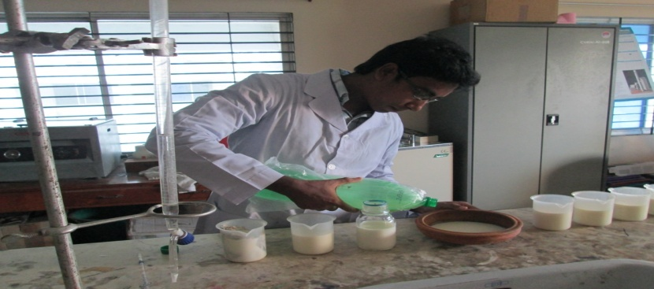

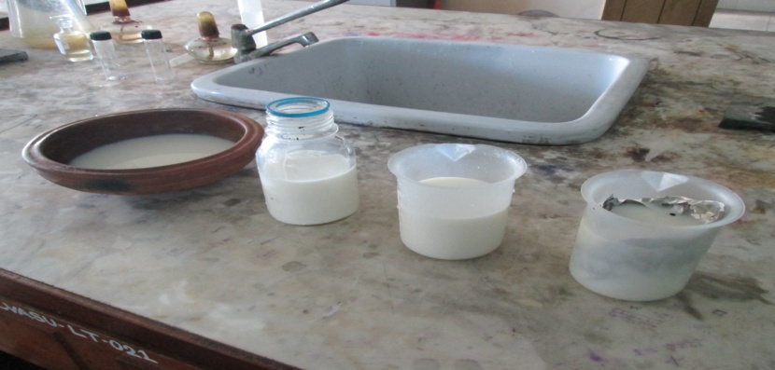
Fig.2: The milk samples were taken into four different types of containers.

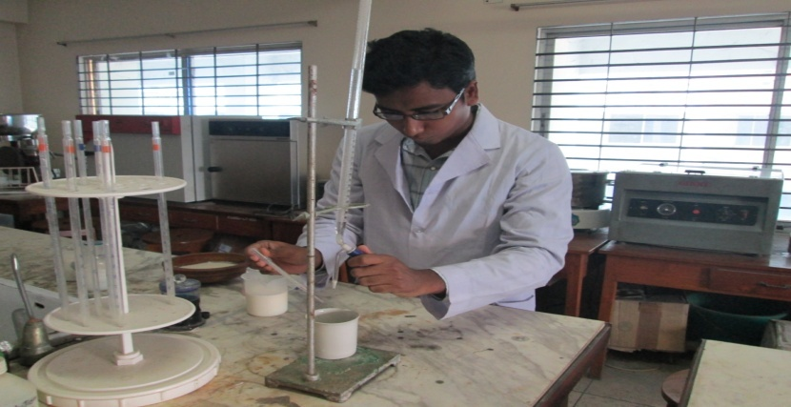
Fig.3: 0.1N Na2CO3 was mixed drop by drop.

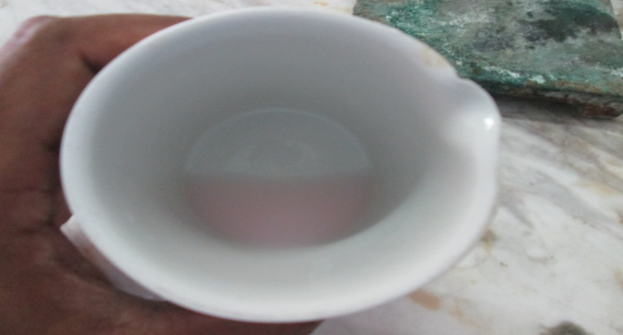
Fig.4: Pink color of milk indicates the end point of titration
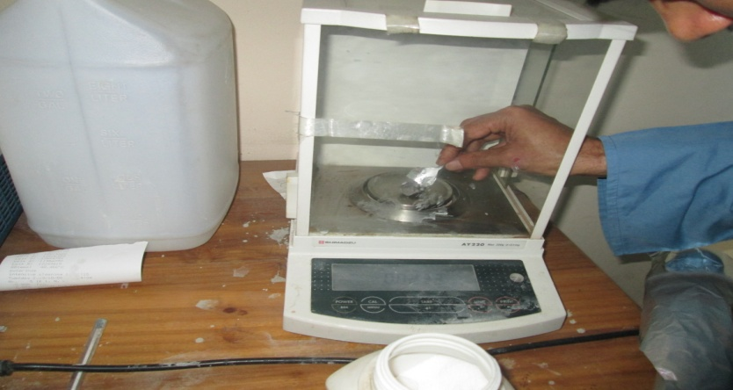
Fig.5: Weighing of borax

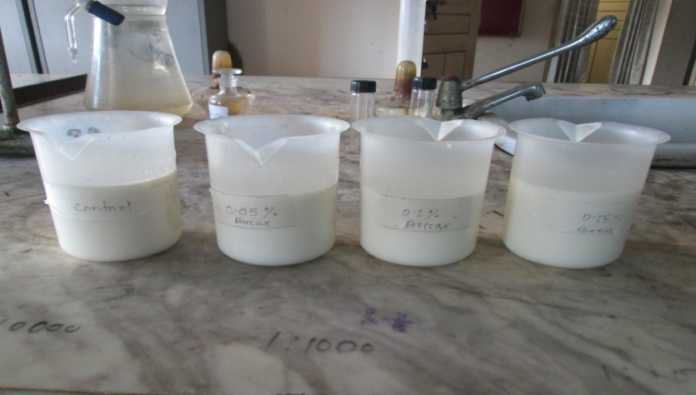
Fig.6:Milk samples with different concentration of borax

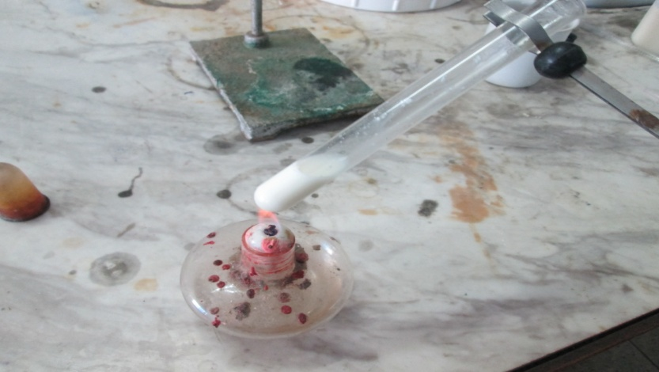
Fig.7: Clot-on-Boiling (COB) test

