CHAPTER-I
Introduction

The effects of varying dietary energy and protein contents on intestinal function are less well understood than the growth response of birds. It is generally assumed that the changes in productivity observed are moderated by nutrient metabolism at the internal body tissues and alteration to the processing of energy and nutrients, including protein. Nutrient processing by the gastrointestinal tract (GIT) determines the amount of nutrient that is available to the internal tissues for metabolism. The GIT also utilizes an enormous amount of nutrients for self-renewal (Webster, 1980; Reynolds et a/., 1991). In addition, the efficiency of nutrient supply to internal tissues would be dependent on dietary factors, including dietary energy and protein contents. The GIT of the chicken is anatomically complete in the embryonic phase (Moran, 1985). However, it develops functionally to a peak within a few days after hatching (Nitsan et al, 1991; Iji et a/.,2001a,b). Sulistiyanto et a/. (1999) indicated that the intestinal villi, which are known to play a crucial role in digestion and absorption, are underdeveloped at hatching. Tlie growth of villi is partly genetically dependent, and is stimulated by the presence of external factors, including dietary nutrients, to attain maximum capacity at about 10 d after hatching (Moran, 1985; Noy and Sklan,1995). Noy and Sklan (1995) suggested that nutrient availability in chicks developed concomitantly with the growth of digestive organs and the increase in enzyme activities. To ensure maximum growth thereof, the utilization of balanced amounts of nutrient:energy ratios are a prerequisite to allow the GIT to reach optimum capacity during the early growth period (viz: 1-21d) in the chick. The objective of this study was to examine the capacity of the broiler chick to utilize diets varying in energy and protein content and to determine the response of the GIT to dietary treatments.
Nutrition and husbandry management during the past half century have resulted in a phenomenal improvement in productivity. Grower feed diet consists of highly concentrated feedstuffs providing the flow of nutrients for efficient digestion and utilization. However, cereals and legumes, the bulk of modern commercial poultry diets, contain a significant amount of fibre. Their effects on digestibility, gut functions and bird behavior are largely unknown (Hetland B. et al., 2004). The current use of highly processed ingredients in poultry diets has negative effects on the development of the digestive tract of poultry.
It has been shown that the presence of crude fiber improves growth and feed efficiency and gives beneficial effects on feathering and on protection from cannibalism in chicks (Hetland H. et al., 2003, Davis F. et al., 1947, Hill F. W. et al., 1954, Saito M. et al., 1959). However, crude fiber is poorly digested in poultry (Dymsza H. et al., 1955, Tasaki I. et al., 1959). Indeed, insoluble fibre itself has shown beneficial effects on nutrient digestion and gizzard activities (Hetland et al., 2003; Rogel et al., 1987).
Poultry meat is an excellent source of protein and other nutrients. Due to improve digestibility, broiler meat is now worldwide accepted food for all kind of people. Poultry farming provides not only economic benefits to the poor farmers but also help to improve the health of their family. Approximately 20% of the protein consumed in Bangladesh originates from poultry (Das. et. al, 2008).
According to FAO statistics, Bangladesh produced 104000 tones hen eggs and 111000 tones chicken meat giving world position of 46 and 52 respectively in 1998. The latest information available from Poultry International Anon, (2000) also showed that per capita poultry meat and egg consumption is around 1 kg and 20 eggs/respectively. This data clearly indicate that the availability of poultry meat and egg is still very much lower in Bangladesh in spite of the significant development in the commercial poultry sector during the last 10 years.
By increasing the productivity of poultry meat and eggs, the existing gap between supply and demand of animal protein can be ridged. Though presently only 15% of the total poultry products are coming from commercial farms, poultry industry has established its position as the fastest growing segment in the agricultural sector. Profitable poultry farming is a highly specialized job in which a lot of factors may be responsible to offset the profit amount (Khan et al., 2008).The most possible ways of improving the profits are increasing the output or reduce the inputs. Feed is the single; largest input in poultry farming, constituting about 60-70% of the production costs. The ideal approach will be to derive maximum benefit out of this single input.

CHAPTER-II
Objectives of experiment

- To calculate the bacterial load in caecum fed with basal diet (Aga grower ration).

- To asses the effects of basal feed (Aga grower ration) on digestive Organs (weight of liver, gizzard & pancreas).

- To determine the P^{H} of Caecal & Colonal fluids. .

CHAPTER-III
Review of literature

The following literatures were reviewed related to experiment undertaken and parameters that were studied.

(J. VAAHTOVUO1, M. KORKEAMAKI1 , E. MUNUKKA1 , J. VALAJA2)
Gastrointestinal microbiota is a complex ecosystem with a huge bacterial density and diversity. Despite the vast microbial burden and the close contact between the microbes and the host’s cells, normal intestinal microbiota is considered to be beneficial. The aim of the Finnish Research Programme is to characterise intestinal microbiota of broiler and learn to modulate intrinsic microbiota in order to support productivity and broiler health. For a simplified and better description of the complex microbiota, Microbial Balance Index (MBI) counted from the proportion of several bacterial groups present in intestinal samples was developed. Cecal samples of the broiler chickens participating in the feed basal diet energy evaluation trial were collected.

Swatson et.al. The weight of liver was significantly (p<0.05) decreased, while those of intestines, kidneys and gizzards significantly (p<0.05) increased. The digestibility (% nutrient retention) of dry matter, crude protein, ash, crudefat and nitrogen free extractives was significantly (p<0.05) reduced by 25, 29, 23, 24, 14 and 25%, respectively with increasing levels of CFC. Results suggest that CFC meal does have a potential for replacing the expensive wheat bran as a fibre source in broiler feeding. High levels (>136.50 g/kg) in the diets of broilers elicit reduced nutrient digestibility, reduced weight and accretion of intestinal and visceral organs.
Wyatt G.M. et al., (1988) concluded that caecal and colonic enlargement is due to tissue hypertrophy in response to increased bulk of contents, irrespective of the nature of that bulk which varies with diet; it is unlikely that short-chain fatty acids or other microbial metabolites are the stimulus for the trophic response seen when non-digestible dietary polysaccharides are fed to rats. All polysaccharide-containing diets led to enlargement of the caecum and colon, associated with increased weight of contents, and of tissue. Carboxymethylcellulose (CMC) had the most marked effect and animals given this also had watery faeces. The density of bacteria in the caecum and colon varied significantly with diet and the proportion of aerobic bacteria in the flora was increased by the CMC diet. In vitro, CMC and hydroxypropylmethylcellulose were poorly fermented. There was a high correlation (caecum r 0.93; colon r 0.94) between tissue weight and wet weight of organ contents but no correlation with bacterial density, number of bacteria per organ, moisture content or short-chain fatty acid content.

Swatson et al. The effects of varying dietary energy and protein (E:P) ratios on the development of the gastrointestinal tract and biological performance of broiler chickens (10-24d) were evaluated. Changes in dietary protein level significantly (P<0.001) influenced feed intake, body weight gain and feed conversion efficiency, this being most profound at dietary energy levels of 11, 12 and 13 MJ/kg. Body eight was reduced (P<0.001) as dietary E:P ratios decreased at constant dietary energy level. The weights of some visceral organs were also affected by dietary treatment. These included a reduction (P<0.05) in the weight of the proventriculus/gizzard with an increase in dietary protein and energy contents. At a dietary energy level of 12 MJ/kg, the weight of the pancreas rose (P<0.001) with an increase in dietary protein content. The jejunal protein content was affected (P<0.01) by dietary protein level and interactions between dietary energy and protein. Mucosal protein was lowest at the highest dietary E:P ratios within the 11, 12 and 13 ME series. Maltase activity in the jejunum was influenced (P<0.05) by dietary energy, being lowest (P<0.05) in chicks that were fed diets containing 14 MJ ME/kg. An increase in dietary E:P ratio resulted in an increase in the activity of sucrase (P<0.001) and AP (P<0.05) for birds fed diets in the 11, 12 and 13 ME series. Overall, our findings suggest that the differences in biological performance of chicks fed diets varying in energy and protein contents may be traceable to a lack of energy for metabolic function. The higher the amount of mucosal protein the greater may be the bird's digestive function and absorptive capacity. Some of the effects of varying dietary E:P ratio also appear to be linked to changes in intestinal digestive function.

CHAPTER-IV
Materials and Methods

The experiment was conducted under 3 broiler chickens (30 days old, same sex, same weight app: 1200gm and healthy chicken)
The chickens were purchased from local market & had been kept into same cage.
- Cleaning the house:
Necessary cages were made by tin, wood and wirenet. Brush was used to remove the dust and dirt and any kinds of unexpected material. There was few limitations of proper management.
- Feeder and waterer :
Adlibitum feed and water was supplied to the bird throughout the experimental period. Fresh clean and cool drinking water was supplied all times in drinker.
For each cage given one feeder and one waterer.Before giving these cleaning and washing were done. Feed and water was supplied daily.
- Ventilation:
Ventilation is required to maintain good air quality for poultry and appropriate litter moisture for a healthy environment. Air exchange is necessary to remove carbon dioxide and ammonia from poultry houses and to bring in oxygen; however, removal of heat and moisture from litter houses usually requires greater air exchange than required for carbon dioxide and ammonia removal. Long term ammonia exposure of birds should not exceed 10-20 ppm. If this limit is consistently exceeded, damage will occur to lungs, trachea and eyes; young birds are more sensitive than older birds. Ideal moisture levels for litter are25 to 35 percent. Lower levels result in excessive dust which is detrimental to the respiratory system. Higher moisture levels result in excessive caking of litter which can contribute to breast blisters, disease problems. There were some limitations in ventilation.
(4) Sanitation:
Proper hygienic measure and sanitation program was followed during the experimental period.
(5) Experimental feed:
Basal feed: Aga grower ration (pellet).
(6) Sample Collection:
Three broilers (30 days old) were observed total 7 days for these experiment. During those days ,the chicken were fed the basal feed (Aga grower feed). In the shed the feces colour was reddish and consistency was semisolid . After 7 days rearing those broilers were slaughtered. Then Liver, gizzard, and pancreas were separated from each chicken and given title Sample –A,B,& C. Organs were weighed separately by using the balance and compared them.
P^{H} of the content of caecal & colonal fluid were determined by collecting the fluid from caecum & colon. Fluid from caecum were collected for knowing the bacterial load in the gut by preparation of slide with Giemsa’s stain and counted the bacteria under microscope.

PICTURE GALLERY
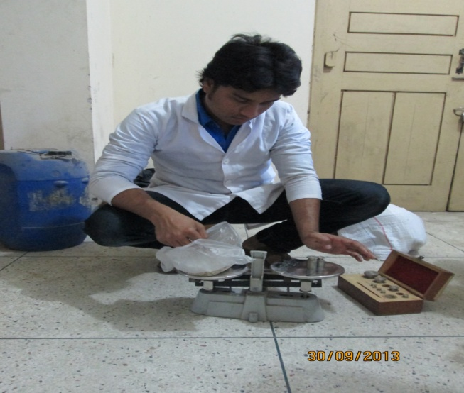
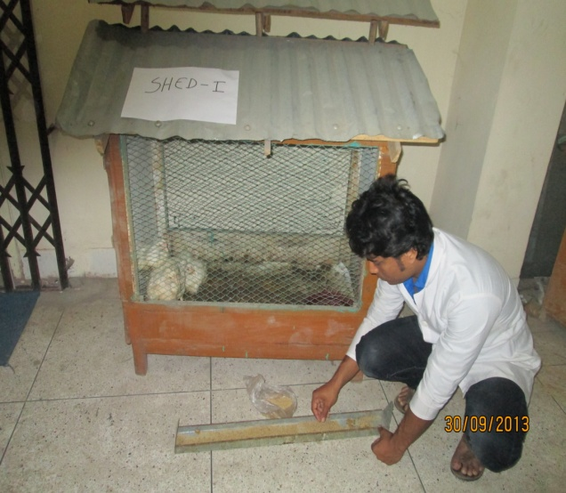
WEIGHING OF FEED FEEDING OF BROILER

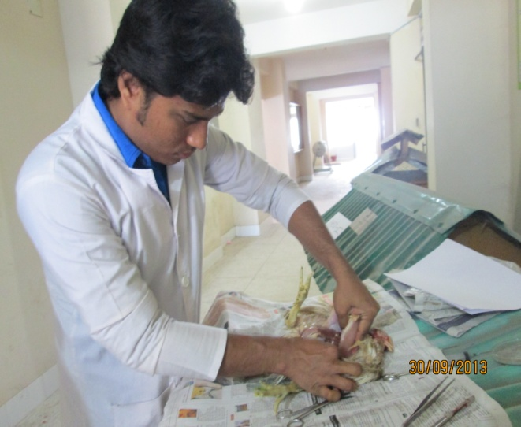
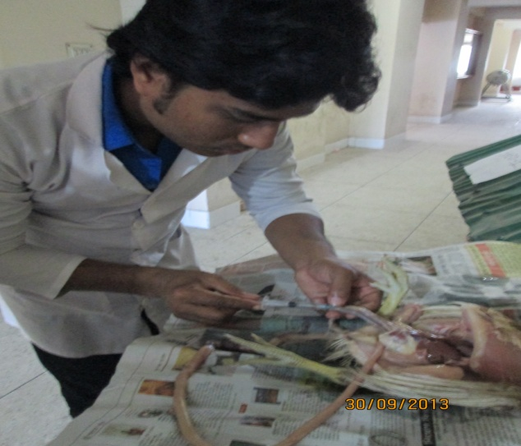
DISSECTION OF BROILER COLLECTION OF CAECAL & COLONAL FLUID

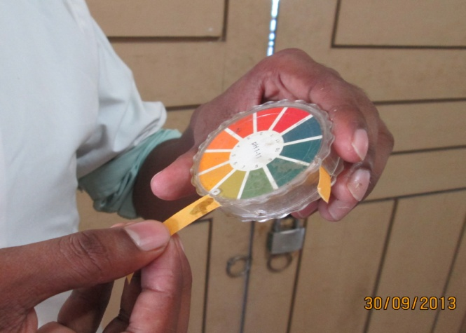
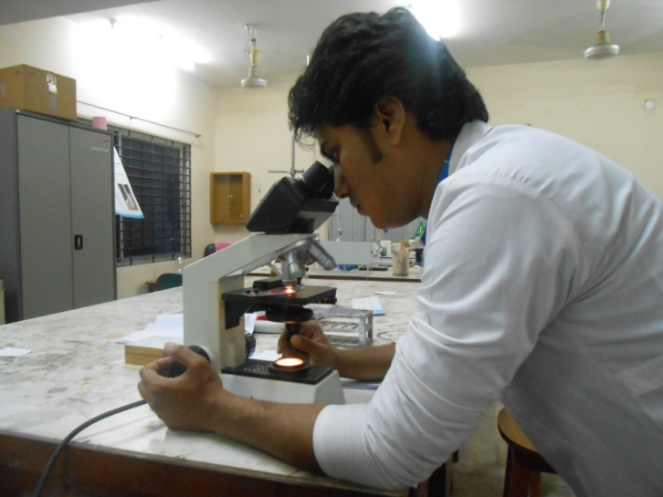
MEASUREMENT OF P^{H} OF FLUID COUNTING OF BACTERIAL COLONY

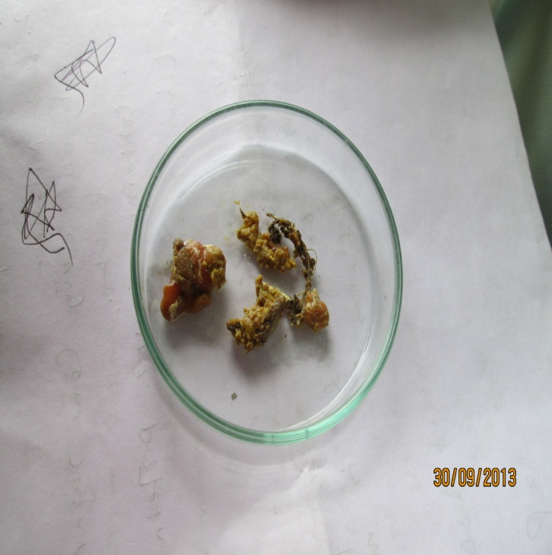
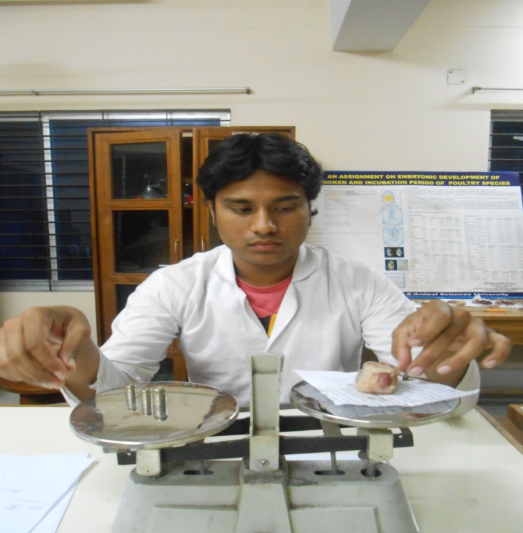
WEIGH OF DIGESTIVE ORGANS FAECES OF BROILERS

CHAPTER-V
Results & Discussions

TABLE -01: Bacterial colonies(Caecum), Consistency & color of digesta, Consistency of faeces:
Parameters | Description
Bacterial colonies (Caecum) | 1054 colony (30 focus)
Consistency of digesta | Sticky
Color of feces | Reddish
Consistency of faeces | Semisolid

In sample, fed with Pellet diet (Aga grower ration) caecal bacterial colony under the microscope was 1054 colony under 30 focus. Consistency of digesta was sticky. Color of feces was reddish indicates the flock was affected by coccidiosis. Consistency of faeces was semisolid.

TABLE-02: Weight of Digestive Organs:
Organs Weight(gm) | Gizzard | Liver | Pancreas
Sample A | 40.35gm | 30.9 gm | 2.83 gm
Sample B | 40 gm | 30.35 gm | 2.83 gm
Sample C | 30.15 gm | 29.25 gm | 2.50 gm
Average Weight | 36.83 gm | 30.16 gm | 2.72gm

In sample, fed with basal diet (Aga grower diet), gizzard weight of sample(A,B,C ) was 40.35gm, 40gm, 30.15 gm respectively & average weight was 36.83 gm . Liver weight of sample ( A,B,C) was 30.9gm, 30.35gm, 29.25 gm respectively & average weight was 30.16 gm. Pancreas weight of sample (A,B,C) was 2.83gm, 2.83gm, 2.50gm respectively & average weight was 2.72 g. So we can say average weight of gizzard, liver & pancreas of 30 days old broiler were 36.83gm , 30.16gm & 2.72gm respectively, which were widely deviated from standard weight 42.04gm, 39.3gm & 4.8 gm respectively (Swatson et al.). The reason behind this variation may be the differences of age and body weight of the experimental broilers.

Table -3 : P^{H} of Caecal & Colonal fluid:
Traits | Caecum | Colon
P^{H} | 6.67 | 6.33

Here, the P^{H} of caecal & colonal fluid were 6.67 & 6.33 respectively . According to the actual result the examination result was slightly different from it. The experimental P^{H} of caecal & colonal fluid were 6.67 & 6.33, as well as the standard P^{H} of caecal & colonal fluid is 6.84 & 6.70 respectively( Král M. et. Al, 2012, 45 (1) ). There is slight variation between experimental & standard P^{H} . The reason behind this variation may be the differences of age and body weight of the experimental broilers.

CHAPTER-VI
Conclusion

Broilers fed with Pellet diet (Aga grower ration) caecal bacterial colony under the microscope was 1054 colony under 30 focus. Consistency of digesta was sticky, color of digesta was reddish, consistency of faeces was semisolid. Average Liver weight was significantly in Aga Grower ration diet was 30.16 gm, average Gizzard weight was in Aga Grower ration diet was 36.83 gm. Average Pancreas weight was significantly in Aga Grower ration diet was 2.830 gm. Average P^{H} of caecal and colonal fluid were 6.67 & 6.33 respectively. Here there is wide variation in the weight of different organ (Gizzard, Liver, Pancreas) than the standard result & there is also slight variation in P^{H} of Caecal & Colonal fluid than the standard result. The fluctuation of results occurred may be due to age, sex, body weight etc. The flock was affected by coccidia, which can be the cause of increasing caecal bacterial load. It is revealed that proper husbandry management could reduce the variation of the result.

CHAPTER-VII
Referances

N. Kocabag˘lı, M. Alp, N. Acar and R. Kahraman (2002). The Effects of
Dietary Humate Supplementation on Broiler Growth and Carcass Yield. Poultry Science. 81:227–230.

Swatson et al.: Body growth, visceral organ weight and intestinal
digestive enzyme Of chickens.

Menge, H., Littlefield, L. H., Frobish, L. T. & Weinland, B. T. (1974) Effect
of cellulose and cholesterol on blood and yolk lipids and reproductive efficiency of the hen. J. Nutr. 104, 1554-1566.

Král M. et. al./Scientific Papers: Animal Sciences and Biotechnologies,
2012, 45 (1). Slovak University of Agriculture in Nitra, Faculty of Biotechnology and Food Sciences, Department of Food Hygiene and Safety, 949 76-Nitra, Tr. A. Hlinku, 2, Slovakia.

J. VAAHTOVUO1*†, M. KORKEAMAKI1†, E. MUNUKKA1†, J. VALAJA2, E.

VENALAINEN2, J. VUORENMAA3, P. HAMEENOJA3 and
E. HELANDER3,1CyFlo, Itainen Pitkakatu 4 B, 20520 Turku, 2MTT Animal Production Research, 31600. Jokioinen, 3Suomen Rehu, Upseerinkatu 1, 02601 Espoo, Finland.

Hill, F. W. & Dansky, L. M. (1954) Studies of the energy requirement of
chickens. 1. The effect of dietary energy level on growth and feed consumption. Poultry Sci. 33, 112-119.

Hetland, H., B. Svihus and Å. Krogdahl. (2003) Effects of oat hulls and
wood shavings on digestion in broilers and layers fed diets based on whole or ground wheat. British Poultry Science, 44: 275-282.

Heaton, K. W. (1976) Fiber, blood lipids, and heart disease. Am. J. Clin.
Nutr. 29, 125-126.

H. Hetland, M. Choct and B. Svihus (2004). Role of insoluble non-starch
polysaccharides in poultry nutrition. World's Poultry Science Journal (2004), 60:415-422.

H. Hetland, B. Svihus & M. Choct (2004) Inclusion of dust bathing materials
in housing systems for layers can affect performance and functionality.

Grimminger, P. & Fisher, H. (1966) Antihyper cholesterolemic action of
scleroglucan and pectin in chickens. Proc. Soc. Exp. Biol. Med. 122, 551-553.

Gous, R. M. G.C. Emmans, L.A. Broadbent and C. Fisher 81990).
Nutritional effects on the growth and fatness of broilers. Br. Poult. Sci. 31: 495-505.

Gary E. Duke, Practical advancements in Digestive physiology and futuristic
Research needs in poultry, J. Appl. Poultry Res. 5:81-85.

Fisher, H., Siller, W. G. & Grimminger, P. (1966) The retardation by pectin
of cholesterol-induced atherosclerosis in the fowl. J. Atheroscler. Res. 6, 292-298.

FAO (1998). The output of meat & egg of Bangladesh. Food out look, No. 4,
Rome, Italy Felton, K.E.(1976).

Ewing, W. R. (1963) Fiber in the poultry ration. In: Poultry Nutrition (5th
Ã©d.), pp. 548-557. The Ray Ewing Company, California.

E. A. Iyayi and F. K. Fayoyin (2004). Expanding rural poultry production
through the use of low cost Cassava fruit coat as alternative fibre source for broilers. Conference on International Agricultural Research for Development. Berlin, October 5-7, 2004.

Dymsza, H., Boucher, R. V. & McCartney, M. G. (1955) Investigation of
crude fiber digestion in 12-week old turkeys. Poultry Sci. 34, 240-242.

Davis, F. & Briggs, G. M. (1947) The growth-promoting action of cellulose
in purified diets for chicks. J. Nutr. 34, 295-300.

Das, S. C., Chowdhury, S.D., Khatun, M.A., Nishibori, M.; Isobe, N. And
Yoshimura, Y. (2008). Poultry production profile and expected future projection in Bangladesh. World's Poultry Science Journal, 64:99-118.

Cummings, J. H. (1973) Dietary fiber. Gut 14, 69-81.

C. D. Bennett, H. L. Classen and C. Riddell (2002). Feeding BroilerChickens
Wheat and Barley Diets Containing Whole, Ground and Pelleted Grain. Poultry Science 81:995–1003.

B. Tamir and W. Tsega (2009).Effects of different levels of dried sweet
potato (Ipomoea batatas) leaves inclusion in finisher ration on feed intake, growth, and carcass yield performance of Ross broiler chicks. Trop. Anim. Health and Prod. Vol. 42, Num. 4, 687-695, DOI: 10.1007/s11250-009-9476-7.

Anon (2000). Poultry International. August 2000, P-10.

AM Amerah, V Ravindran, RG Lentle, DG Thomas (2007) Effects of fibre
source and whole wheat inclusion on the performance, starch digestibility and gut parameters of broiler chickens, Asia Pac J Clin Nutr, 16 (Suppl 3): S59.

