Chapter-1
INTRODUCTION
Bangladesh mainly subsists on a straw based diet with limited green fodder and little or no concentrate. Out of total dry matter (DM), about 70% constitutes dry roughage, about 90% of which is rice straw. Rice straw is very low digestibility and highly deficient in protein and micronutrients. Animal productivity can be improved by efficient utilization of straw. Nutritive value of straw can be improved by physical, chemical and biological means by supplementation with energy. In Bangladesh cattle feed mainly on low quality roughage including natural grazing and agro-industrial by products such as straw, sugarcane by-products and other similar feeds. These feeds are deficient in protein, energy, minerals and vitamins. At certain time of the year, quality of grazing deteriorates due to seasonal influence. Thus livestock productivity consequently declines and in this case lactation cease unless supplements are offered. Livestock feed decrease in day by day in Bangladesh due to the shortage of grazing area. In such cases any unconventional sources may act as an alternative. The very common and locally available water hyacinth can be the options in livestock feed as an unconventional source to overcome the feed.
Water hyacinth has been widely introduced in North America, Asia, Australia, Africa and New Zealand as well as Kerala Backwaters in India. It was first introduced to North America in 1884, an estimated 50 kilograms per square metre of hyacinth once choked in Florida's waterways, although the problem there has since been mitigated. Directly blamed for starving subsistence farmers in Papua New Guinea, water hyacinth remains a major problem where effective controlprograms are not in place. Eichhorniacrassipes, the Common water hyacinth, has become aninvasive plant species on Lake Victoria in Africa after it was introduced into the area in the1980. Despite management and control efforts since then, a significant seed bank stillremains across the region. In Bangladesh it is commonly used as forage for cattle which could be used as a supplement to a basal diet of sugarcane, molasses and possibly also cereal straws.
In Bangladesh a large amount of water hyacinth are produced due to large number of rivers and ponds. Due to huge production in some areas (especially in Feni district) it is not utilized properly. About 60% or more ponds and rivers are covered by water hyacinth in Feni district. Most of them are not used by farmers due to lack of knowledge of farmers on water hyacinth. In addition, most of the farmers are not known about the nutritive value of water hyacinth at all. If the nutritive value and potentiality of water hyacinth discover, farmers of that area can utilize water hyacinth as an unconventional feed in livestock sector to minimize feed cost and maximize production. A very few work has been done on using water hyacinth to cattle, hence, the current study was undertaken with the following objectives:
- To determine the nutritive value of water hyacinth
- To evaluate the digestibility of water hyacinth
- To compare nutritive quality of fresh and digested water hyacinth.

Chapter-2
REVIEW OF LITERATURE
The origin of Water hyacinth is believed to be Amazonia, Brazil, with natural spread throughout Brazil and to other Central and South American countries. It infests rivers, dams, lakes and irrigation channels on every continent except Antarctica. It devastates aquatic environments and costs billions of dollars every year in control costs and economic losses. It is perennial, herbaceous, aquatic plant of the family Pontederiaceae. The genus Eichhornia contains number of other species all of which are aquatic, but only Eichhorniacrassipes has become a serious weed. The leaves of water hyacinth are compressed of a smooth, glossy,circular to kidney shaped lamina and a swollen spongy petiole. It has been reported as a weed in 56 countries.
Water hyacinth possesses specialized growth habits physiological characteristics and reproductive strategies that allow for rapid growth and expansion in freshwater environments and has spread rapidly throughout the tropics and subtropics. Eichnoriacrassipes forms large free floating, mono-specific mats that complete with other aquatic species for light nutrient and oxygen. As biomass from mats decomposes, organic input to sediments increases dramatically. Eichorniacrassipes grows in shallow temporary ponds, wetlands and marshes, sluggish flowing waters and large lakes reservoirs and rivers plants can tolerate extreme of water level fluctuation and seasonal variations in flow velocity and extreme of nutrient availability, pH, temperature and toxic substances. It was introduced into many countries during late 19th and 20th centuries, where it spread and degraded aquatic ecosystems. Eichhorniacrassipes remains the world’s most problematic water weed despite wide spreads and various approaches for its control.
N, CherlyAntoFrezina reported that water hyacinth is justifiably called the world’s worst aquatic weed due to its ability to rapidly cover whole waterways. When not controlled, water hyacinth will cover lakes and ponds entirely; this dramatically impacts water flow, blocks sunlight from reaching native aquatic plants, and starves the water of oxygen, often killing fish. The plants also create a prime habitat for mosquitos, the classic vectors of disease, and a species of snail known to host a parasitic flatworm which causes schistosomiasis (snail fever). Water hyacinth is often problematic in man-made ponds if uncontrolled. Water hyacinth invades bodies of water that have been impacted by human activities. For example, these plants can unbalance natural lifecycles in artificial reservoirs or in eutrophied lakes that receive large amounts of nutrients1. Some of the problems associated with Water Hyacinth are elaborated below.
Hindrance to water transport - Access to harbours and docking areas can be seriously hindered by mats of water hyacinth. Canals and freshwater rivers can become impassable as they clog up with densely intertwined carpets of the weed. It is also becoming a serious hazard to lake transport on Lake Victoria as large floating islands of water hyacinth form, while many of the inland waterways of South East Asia have been clogging of intakes of irrigation, hydropower and water supply systems. Many large hydropower schemes are suffering from the effects of water hyacinth. The Owen Falls hydropower scheme at Jinja on Lake Victoria is a victim of the weeds rapid reproduction rates and an increasing amount of time and money has to be invested in clearing the weed to prevent it entering the turbine and causing damage and power interruptions.
Blockage of canals and rivers causing flooding -Water hyacinth can grow so densely that a human being can walk on it. When it takes hold in rivers and canals it can become so dense that it forms a herbivorous barrage and can cause damaging and dangerous flooding.
Micro-habitat for a variety of disease vectors -The diseases associated with the presence of aquatic weeds in tropical developing countries are among those that cause the major public health problems: malaria, schistosomiasis and lymphatic filariasis3. Some species of mosquito larvae thrive on the environment created by the presence of aquatic weeds, while the link between schistosomiasis (bilharzia) and aquatic weed presence is well known. Although the statistical link is not well defined between the presence of aquatic weeds and malaria andschistosomiasis, it can be shown that the brughian type of filariasis (which is responsible for a minor share of lymphatic filariasis in South Asia) is entirely linked to the presence of aquatic weeds.
Increased evapotranspiration - Various studies have been carried out to ascertain the relationship between aquatic plants and the rate of evapotranspiration compared with evaporation from an open-surfaced water body.Saelthun (1994) suggests that the rate ofwater loss due to evapotranspiration can be as much as 1.8 times that of evaporation from the same surface but free of plants. This has great implications where water is already scarce. It is estimated that the flow of water in the Nile could be reduced by up to one tenth due to increased losses in Lake Victoria from water hyacinth.
N, CherlyAntoFrezina also reported thatwater hyacinth can present many problems for the fisherman. Access to sites becomes difficult when weed infestation is present, loss of fishing equipment often results when nets or lines become tangled in the root systems of the weed and the result of these problems is more often than not a reduction in catch and subsequent loss of livelihood. In areas where fishermenmeagre living from their trade, this can present serious socio-economic problems. Fishermen on Lake Victoria have also noted that, in areas where there is much water hyacinth infestation, the water is ‘still and warm and the fish disappear. They also complain that crocodiles and snakes have become more prevalent.
In addition to all this they also block irrigation channels and rivers, restrict livestock access to water, destroy natural wetlands, eliminate native aquatic plants, reduce infiltration of sunlight, change the temperature, pH and oxygen levels of water, reduce gas exchange at the water surface, increase water loss through transpiration, alter the habitats of aquatic organisms, restrict recreational use of waterways, a serious threat to biodiversity, reduce aesthetic values of waterways, reduce water quality from decomposing plants and destroy pastures and crops when large floating rafts settle over paddocks after flood events. Water hyacinth will rapidly take over an entire waterway. Under favourable conditions it can double its mass every 5 days, forming new plants on the ends of stolons. It also grows from seed which can remain viable for 20 years or longer. This enormous reproductive capacity causes annual reinfestation from seed and rapid coverage of previously treated areas, making ongoing control necessary. With these characteristics, the water hyacinth has become a major ecological and economic problem in this century in the tropics and subtropics.
Igbinosum et al (1988) reported that proximate composition of water hyacinth (Eichhorniacrassipes) are shown below:
Table-1: Proximate composition of water hyacinth
Parts | DM(%) | Ash(%) | CP(%) | CF(%) | Lipid(%)
Leaves | 14.70 | 12.40 | 22.75 | 15.00 | 4.82
Petioles | 7.00 | 19.85 | 9.60 | 22.00 | 1.29

Igbinosum et al (1988) reported that mineral composition of water hyacinth(Eichhorniacrassipes) are shown below:
Table-2: Mineral composition of water hyacinth
Parts | P(%) | K(%) | Na(%) | Ca(%) | Mg(ppm) | Mn(ppm) | Zn(ppm) | Fe(ppm)
Leaves | 0.44 | 4.28 | 0.02 | 2.63 | 190.50 | 77.30 | 77.30 | 161.10
petioles | 0.37 | 9.70 | 1.56 | 0.64 | 199.50 | 69.00 | 69.00 | 151.00

Chapter-3
MATERIALS & METHODS
The study was conducted at the laboratory of animal science and animal nutrition,Chittagong Veterinary and Animal Sciences University,Khulshi, Chittagong from July 2013 to December 2013.
3.1. Scientific classification:
Kingdom: Plantae
Order: Commelinids
Family: Pontederiaceae
Genus: Eichhoria
Species: Eichhorniacrassipes

3.2. Objective of the study:
The report has been done as a part of the internship program.The report is based on determination of proximate analysis & digestibility trial of water Hyacinth and also know the economic value of water hyacinth.
  - Study area:
As water hyacinth are available in Bangladesh but it mostly available in Feni district hence, Porshuramupazilla in Feni district was selected as study area. The study sample was collected from different ponds as well as Muhuririver at Porshuramupazilla under Feni district.

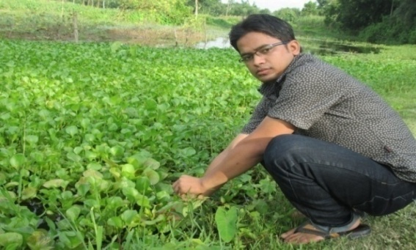
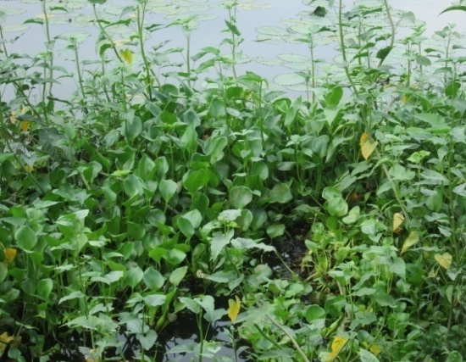

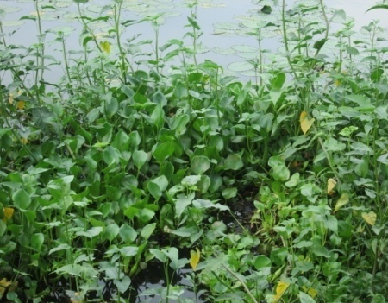
Fig-1: Sample in river Fig-2: Collection of water hyacinth

3.4. Collection of water hyacinth:
Water hyacinth (E. crassipes) was collected from 5 ponds and muhuri river in Parashuram, Feni of Bangladesh. After collection of water hyacinth from water, roots were cut-off and discarded thinking that it is not convenient feed, the stalks and leaves were chopped to 3cm in length and sundried homogenously for about 7 days at an environmental temperature. Approximately 500gm of samples were collected by separation from root.
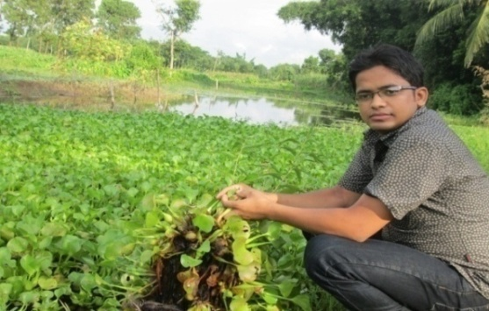
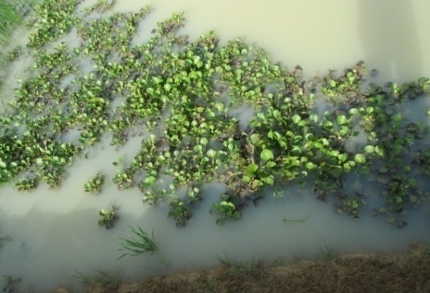

Fig-3: Sample in pond Fig-4: Collection of water hyacinth

3.5. Preparation and processing of experimental sample:
Homogenous samples were prepared by chopping and proper mixing. Prepared sample was kept for determination of proximate composition and digestibility study.
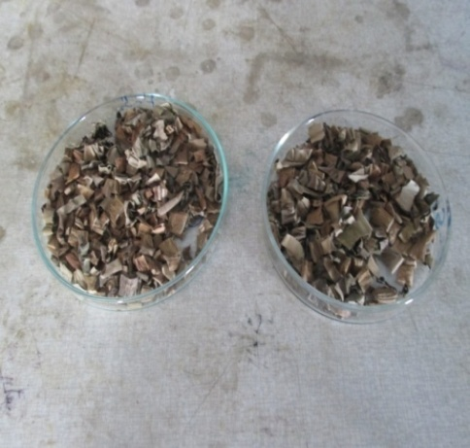
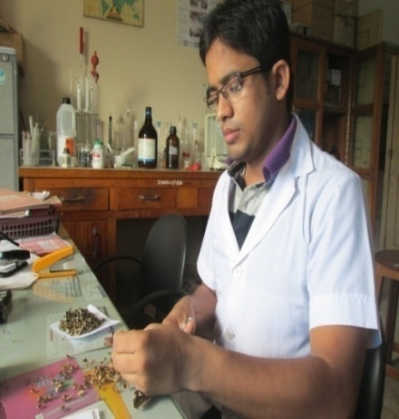

Fig-5: Preparation of sample Fig-6: Prepared sample

3.6. Proximate analysis:
Dried samples are analyzed for dry matter (residue after drying to constant weight), ash (residue after ignition at 600º c), crude protein (Kjeldhal N X 6.25), ether extract and crude fibre (Goering and Van Soest).

3.7.Proximate composition: The parts of collected water hyacinth was analyzed for proximate composition viz., moisture, crude protein, ether extract, crude fibre and total mineral matter and expressed in percentage.

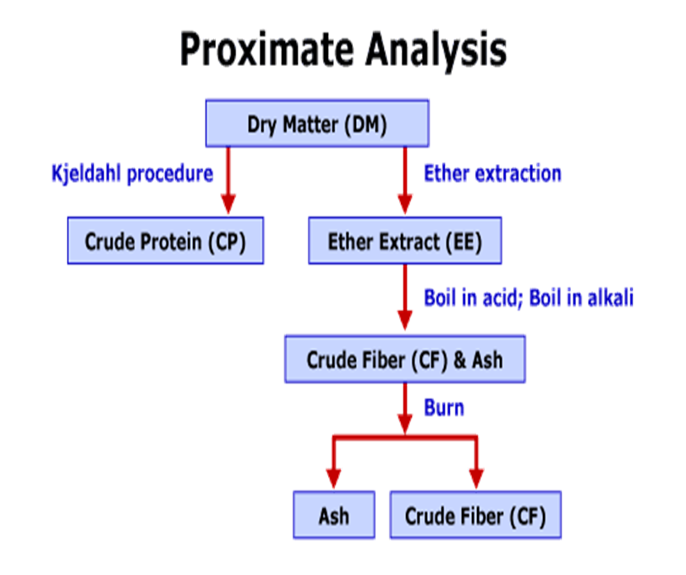
Fig: Proximate analysis in sketch form

3.8.Moisture:
Five grams of sample was weighed into a previously weighed petridish and dried in an oven at 105°C till a constant weight was attained.The moisture content was calculated by using following formula.

Initial weight (g) – Final weight (g)
Moisture % = ------------------------------------------× 100
Sample weight (g)

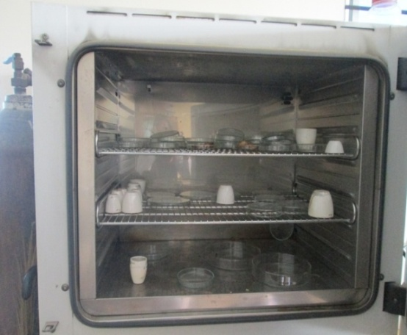
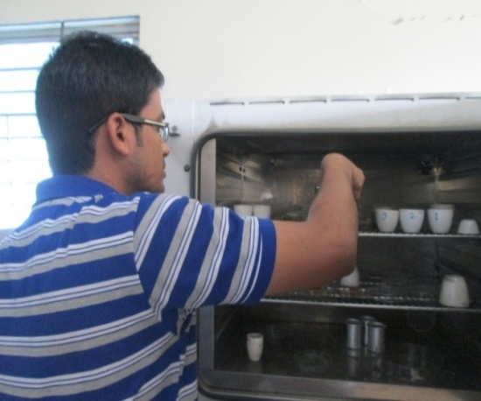

Fig-7: Estimation of DM Fig-8: Estimation of DM

3.9. Crude protein:
The nitrogen content of water hyacinth was estimated by kjeldahl method in Parnas and Wagner apparatus . The crude protein content was calculated by multiplying with factor 6.25 and expressed on per cent basis.
(Initial reading-Final reading) × Normality of HCL ×meqweight of N₂
N₂% = ------------------------------------------------------------------------------------× 100
Sample weight (g)

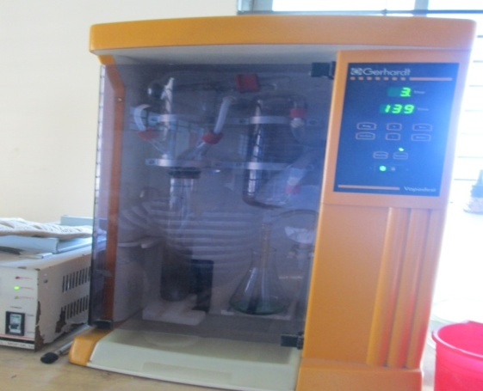
Crude protein% = Nitrogen% × 6.25
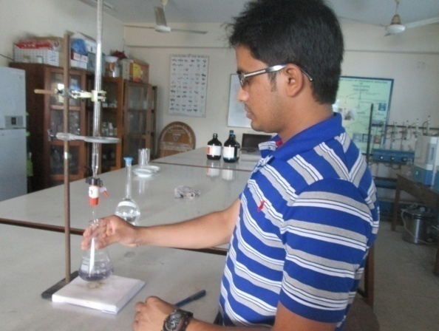

Fig-9: Titration Fig-10: Distillation

3.10. Total mineral matter (ash):
Total mineral matter ( ash ) was determined by igniting samples in muffle furnace at 600°c for 3 - 4 hours . The total mineral matter was expressed as per cent.

Weight of crucible with ash (g)
Total mineral matter % = -------------------------------------------- × 100
Weight of crucible with sample (g)

3.11. Calculation of NFE:
The NFE content was calculated by deducting the sum of the values for moisture, crude protein, crude fibre and total mineral matter in 100( Raghuramulu et al., 1983 ).

3.12. Metabolizable energy (ME):
The metabolizable energy (ME) content was calculated by using the following formula (Lodhiet al, 1976).

ME=32.95(% CP + % EE × 2.25 +% NFE) -29.20

Chapter-4

RESULTS AND DISCUSSIONS

4.1.Proximate analysis of water hyacinth:
Estimation of nutrient components of water hyacinth was performed at the animal nutrition laboratory,Chittagong veterinary and Animal Sciences University. Nutrient component of water hyacinth was found as follows:

4.2.Dry matter: The DM content of the supplied sample was found as 12.37% (table-3& Graph-1)) which was not supported byIgbinosum et al (1988) study. He estimated the DM content of water hyacinth as 14.70%.That is greater than my current study because he estimated the DM content of water hyacinth including leaves and root.Here in current study water hyacinth was estimated without root that may be the reason for lower DM content of the current study.

Table-3. Nutrient composition of water hyacinth:

 | DM  (Mean±SD) | CP  (Mean±SD) | CF  (Mean±SD) | Ash  (Mean±SD) | EE  (Mean±SD)
Nutrients (%) | 12.37±0.7637 | 11.06±0.3493 | 22±0.4950 | 12.82±0.3538 | 1.01±0.10

4.3.Crude protein: The CP content of supplied sample was found as 11.06% ( Table-3& Graph-1) The CP content found of this study lower than the findings of Igbinosumet al. (1988) study. He estimated the CP content of water hyacinth as 22.75%. Here in current study water hyacinth was estimated without root that may be the reason for lower CP of the current study.

Graph-1: Graphical representation of proximate components

4.4.Crude fibre: From above table it was found that crude fibre content of water hyacinth as 11.06% ( Table-3 & Graph-1). The CF content found of this study was not in close agreement with the findings of supported byIgbinosumet al (1988) where the CF content of water hyacinth was found as 15%.Here in current study water hyacinth was estimated without root that may be the reason for lower CP of the current study.

4.5.Eather extract: The ether extract content of water hyacinth was found as 1.01% ( Table-3 & Graph-1) which was almost similar of all available perennial grasses of Bangladesh.

4.6.Total Ash:The total ash content of water hyacinth was found as11.06%( table-3& Graph-1) which was similar as most of the available perennial grasses in Bangladesh. The total ash content of water hyacinth found of this study was positively supported byIgbinosum et al (1988 ) study. He estimated the ash content of water hyacinthas 12.40% .That is almost similar to current study.

4.7.Digestibility percentage:
The in vitro digestibility of water hyacinth was performed at the animal nutrition lab. The digestibility per cent of water hyacinth are given below.

Table-4.Digestibility percentage of water hyacinth:

Nutrient component | Digestibility (%)
DM ( Mean ±SD) | 19.16±0.4833
CP ( Mean ± SD) | 45.62±0.3808
CF( Mean ±SD) | 18.63±0.92
Ash( Mean ±SD) | 42.27±0.4618
EE( Mean ±SD) | 35.29±3.97

Chapter – 5

CONCLUSION

The nutritional composition and digestibility trial was done in this study. It was revealed that the proximate composition of water hyacinth was almost similar to other perennial grasses available in Bangladesh. It also observed that water hyacinth has a positive effect on ruminant and it can assist farmers in ensuring sustainable production of least cost diets for cattle.The sustainability of the least cost diet is expected to eventually translate into successful management of the weed in our water ways and ensure protection of biodiversity. Feni has many rivers, lakes and many other water bodies including ponds, canals and irrigation ways. More than 60 % of these water bodies are infested by Water Hyacinth. If these plants can be put to good use, a lot of profitable products can be obtained out of this underutilized product.

No strong decision can be done by this sort of short study. Hence, further study would be recommended to make the water hyacinth convenient for cattle to our country though it has a provision in our country to feed water hyacinth as cattle feed during scarce.

Chapter-6

REFERENCES

Harley K.L.S. The role of biological control in the management of water hyacinth,
Eichhorniacrassipes. Biocontr.News Info.1990; 11: 11-22.

Harris, p.,.Effects, constraints and future of weed bio control. Agric. Ecosyst.
Environ. 1993; 46: 289-303.

Heard, T.A and S.L. Winterton. Interactions between nutrient status and weevil
herbivory in the biological control of water hyacinth. J. Appl. Ecol. 2000;
37: 117-127.

Holm, L., J. Pancho, J. Herberger, and D. Plucknett. A Geographical Atlas of
World Weeds. John Wiley and Sons, New York. Xlix; 1979; 391.

Jafari N. Ecological and Socio-economic utilization of water hyacinth(Eichhornia
crassipesMart Solms).J. Appl.iedSci.Environ.mentalManag., 2010; 14:
43-49.

Jayanth K.P. Successful biological control of water hyacinth (Eichhornia
crassipes) by Neochetinaeichhorniae (Coleoptera: Curculionidae) in
Bangalore, India. Trop. Pest Manage. 1988.; 34: 263-266.

Julien M.H. 2001. Biological control of water hyacinth with Arthropods: a review.
In: “Biological and integrated control of water hyacinth, Eichhorniacrassipes” . Proceeding of Second Meeting of the Global Working Grouping for the Biological and Integrated control of water hyacinth.

Julien, M.H. and Griffiths, M.W. and Wright, A.D. Biological control of water
hyacinth: the weevils Neochetinabruchi and N. eichhorniae, biologies, host
ranges and rearing, releasing and monitoring techniques for biological
control of Eichhorniacrassipes. Canberra, Australian Centre for
International Agricultural Research, ACIAR.1999; .60: 87.

Ntiba, M.J., Kudoja, W.M., &Mukasa, C.T..Management issues in Lake Victoria
watershed. Lake.Reserve. Manage. 2001; 6, 211-216.

Pemberton, R.W., Turner, C.E., Biological control of Seneciojacobaea in northen
California, an enduring success.Entomophaga.1990; 35.71-77.

Perkins B.D. Potential for water hyacinth management with biological agents.p.
53-64. In: Proceeding of the Tall Timbers Conference on Ecology. Animal contr. Habitat Manage. Project directorate of biological control (PDBC). 1994. Fifteen years of AICRP on biological control, Bangalore, 1973; 320 .

