Chapter-I
INTRODUCTION
Fodder is any agricultural feedstuff used specifically to feed domesticated livestock, such as cattle, goats, sheep, horses and pigs. Most animal feed is come from plants. "Fodder" refers particularly to food given to the animals (including plants cut and carried to them) or fodder are those feed for livestock which are cultivated and yield more nutrient per area and are supplied to the animal by cutting and processing. It includes hay, straw, silage (Zhou and Yiqin, 2011). Fodder play pivotal role in the agricultural economy by providing cheapest source of feed for livestock. Livestock is a major sub-sector of agriculture in Bangladesh and plays a key role in the economy of the country particularly in rural economy. The performance of dairy animals depends on the consistent availability of quality fodder in adequate amount (Islam et al., 2001).
Limpograss (Hemarthria altissima ) is currently the commonly grown grass in Bangladesh where it is known as Baksha grass. It is the most persistent under grazing and is best adapted to wet soils. Limpograss is highly productive when well fertilized and competes well with broadleaf and grassy weeds (Sultana et al., 2010). It is a warm season perennial grass adapted to soils with good moisture. Mature Limpograss is more digestible than many other grasses are at maturity, but crude protein can be low in accumulated or stockpiled Limpograss. As a result, animals fed stockpiled Limpograss need protein supplementation (Sollenberger et al., 2011). It has several advantages including higher forage production which supports a higher stocking rate, higher forage production in spring, winter and fall when temperatures are cooler, higher digestibility at similar maturities, accumulated forage has higher quality and cattle have better performance when grazing this forage (Newman et al., 2009). It keeps the animal in good health and improves reproductive efficiency. It is palatable and easy for digestion. It has cooling effect on the body. It is mild laxative, hence prevents constipation. It provides fresh nutrients in their natural form. It doesn’t put any stress on body or organ and leads to efficient utilization of feed nutrients (Lima et al., 1999; Lacerda et al., 2004).
In Bangladesh high scarcity of fodder is observed during winter. Due to the shortage of forage in winter production performance of cattle become decreased. This scenario may be overcome by adding Limpograss as it has higher digestibility and higher productivity in spring, winter and fall. In this circumastance, if we use Limpograss as a cattle feed in scarcity period it will minimize the shortage of feed especially forage and, production performance of cattle can be increased. Therefore, the study was done on the basis of the following objectives:
- To assess the physical and nutritional qualities of Limpograss.
- To determine the nutrient composition of Limpograss.
- To compare nutritional quality of fresh and digested Limpograss.
- To evaluate the digestibility of Limpograss.

Chapter-II
REVIEW OF LETERATURE

2.1. Biological classification of Limpograss
Biological classification is based on shared descent from their nearest common ancestor. Accordingly, the important attributes or traits for biological classification are 'homologous', i.e., inherited from common ancestors. The genus Hemarthria R. Br. belong to order Cyperales, Poaceae family hundreds of Hemarthria altissima cultivars are distributed throughout the world (Catalogue of New World Grasses, 2009).
Kingdom | Plantae
Subkingdom | Tracheobionta
Super division | Spermatophyta
Division | Magnoliophyta
Class | Liliopsida
Subclass | Commelinidae
Order | Cyperales
Family | Poaceae
Genus | Hemarthria
Species | Hemarthria altissima

2.2. Common names
Batavian quick grass, halt grass, limpograss, red quick, red swamp grass, snake grass, swamp couch, Red vlei grass, rooikweek, perdegras (southern Africa); limpo grass (Florida); halt grass (Panama); capim gamalote (Brazil); pasto clavel, gramilla canita (Argentina); baksha, panisharu (India subcontinent) (Royal Botanic Gardens, Kew, 2013; Cook et al., 2005).

2.3. Morphological description
Limpograss is a vegetatively propagated grass with large, thick stems. It is a perennial creeping grass with short rhizomes and long spreading stolons, decumbent at first, but ascending to 30-80 cm (Chambliss, 1999). Leaves green, developing red coloration mostly on tips and sheaths, largely glabrous except for fringe on sheath of some genotypes; blades linear or linear lanceolate, 5-15 cm long and 6 mm wide, usually folded. Inflorescence comprising single spike, or a panicle of several spikes arising inconspicuously from axils of upper leaves; spikes 5-12 cm long, ovate-keeled in section (1.5 x 3 mm), tapering toward the apex; spikelets 5-8 mm long (Nation, 2006; Anton et al., 2003).

2.4. Distribution
Hemarthria altissima originated from tropical Africa and is now found in most tropical and subtropical wetlands, along river banks, seasonally flooded areas, swamps and lakes (Ecocrop, 2011; Cook et al., 2005).
Southern Europe: Greece (incl. Crete), Italy (incl. Sicily), Spain (incl. Balearic Islands).
Africa: Algeria, Botswana, Canary Islands, Chad, Egypt, Ethiopia, Lesotho, Malawi, Mali, Mozambique, Nigeria, Senegal, South Africa, Swaziland, Tanzania, Tunisia, Zambia, Zimbabwe.
Indian Ocean: Madagascar, Mauritius, Reunion.
Western Asia: Georgia, Lebanon, Saudi Arabia, Turkey.
Southern Asia: India (Tamil Nadu), Bangladesh (Munshiganj, Dhaka, Sirajganj, Nator, Sunamganj, Netrokona according to Islam et al., 2001).
South-east Asia: Indonesia (Kalimantan), southern Myanmar, northern Thailand, southern Vietnam.

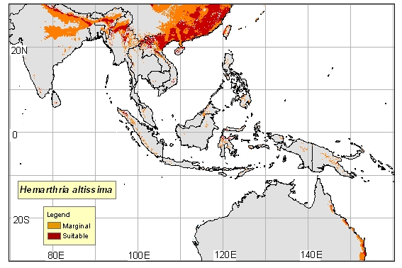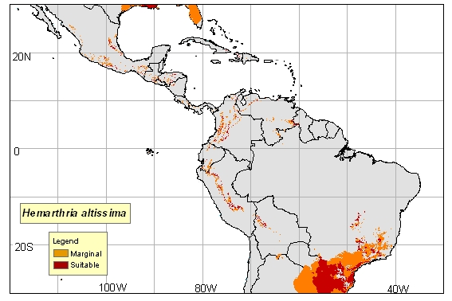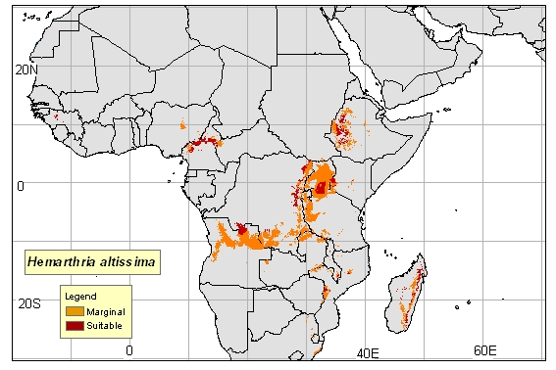
Figure 1. World distribution map

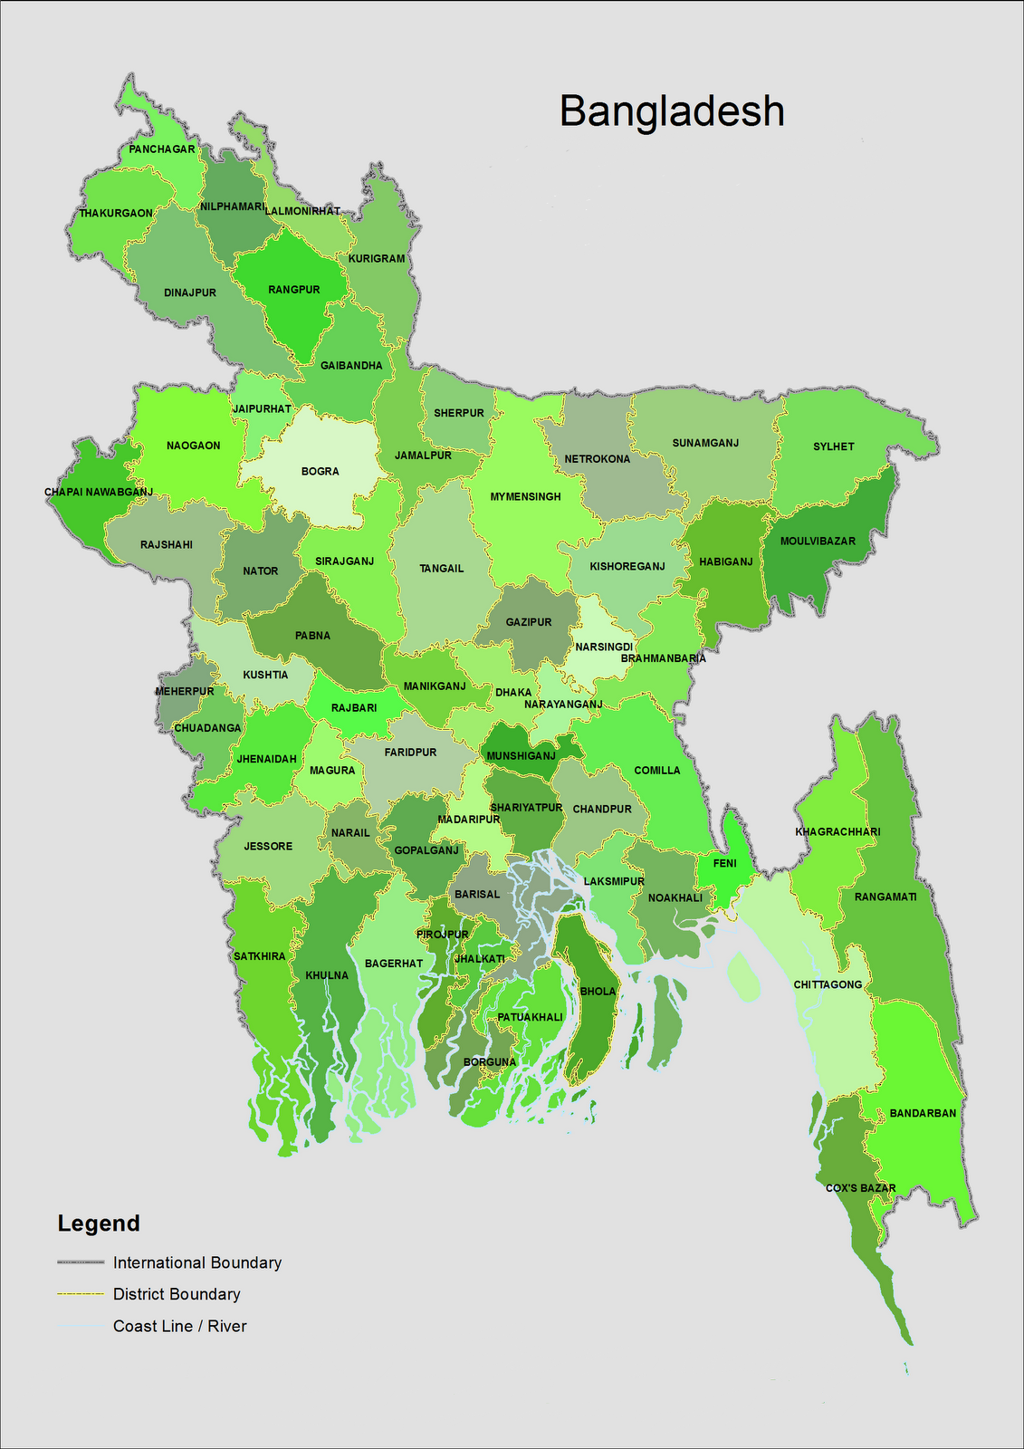
Srinagar (Radhikhal, Bolashpur, Vaggakul, Churaine, Modonkhali, Barikhali, Ghadighat, Sottorvog)

Hemarthria altissima

Takerhat
Baghabari

Savar(Oalia,Monmohonpur)
Chowhali

Figure 2.Country (Bangladesh) distribution map

2.5. Ecology
2.5.1. Soil requirements
Grows in soils of any texture, providing moisture is adequate. It tolerates acid soils down to pH 4.5, but is best between 5.5 and 6.5 (Newman et al., 2009).

2.5.2. Moisture
Found in flooded areas, swamps and lakes. It can withstand short, seasonal dry periods, but does not tolerate long droughts (Ecocrop, 2011).

2.5.3. Temperature
The average annual temperature from 16-27ºC. The optimum temperature for growth is 31-35°C, with growth declining rapidly above 38°C (Henriques et al., 2007).

2.5.4. Light
Limpograss maintains the functionality of the photosynthetic apparatus through rapid acclimation to changing O₂ and light conditions. The ability for photosynthetic acclimation may be essential for adaptation to wetland habitats in which water levels fluctuate (Luo et al., 2009).

2.5.5. Reproductive development
Flowers come out October to June but set very little seed (Cook et al., 2005).
2.6. Agronomy
2.6.1. Establishment
Seed is not commercially available due to generally poor seed-set. It is therefore propagated by cuttings planted into wet soil. It appears more successful establishment results if the cutting nursery is fertilized with nitrogen 2-3 weeks before harvest. Freshly mowed stems and stolons of two to three month old grass are spread over a well prepared seedbed, partially covered with a disk harrow and rolled to compact the soil around the cuttings. Planting rates of 1 t/ha vegetative material is recommended on ground (Nation, 2006).

2.6.2. Fertilizer Recommendations

Establishment fertilizer should be low in nitrogen to encourage root development without promoting excess weed growth. If cuttings have been harvested from fertilized ground, it is best to apply nitrogen and any other nutrients, particularly phosphorus and potassium, once the cuttings have started to grow. For grazed established stands, maintenance dressings of 50-100 kg/ha N (and 40-60 kg/ha each of P and K if required) can be applied at the beginning of the season, with a similar N dressing later in the season. For conserved stands, where nutrient is removed from paddocks, similar N rates are used, but higher rates of P and K may be necessary (Anton et al., 2003).

2.6.3. Weed Control
Due to poor seed set and limited adaptation range, H. altissima poses little or no weed threat. If Limpograss pastures are closely grazed or overgrazed, opportunistic weed plants may invade Limpograss stands and pastures. It should be kept isolated from wetlands. Limpograss has shown more tolerance to dicamba than to 2, 4-D. Therefore, dicamba is recommended for control of broadleaf weeds in Limpograss (Sellers and Ferrell 2009).
2.6.4. Pests and diseases
No major insect problems have been observed. The yellow sugar-cane aphid (Sipha flava) attacks some accessions, but other accessions exhibit a degree of resistance. Spittlebugs may be more of a problem if the grass is not grazed. Occasionally, damage from chinchbugs (Blissus insularis) and caterpillars — such as fall army worms (Spodoptera) and loopers (Moscis). Drought-stressed plants may be attacked by a blight characterized by browning of the new growth. This condition has been diagnosed as 'Take-all Root Rot' (Gaeumannomyces graminis) (Luo et al., 2009).

2.7. Forage yields

Under good fertility and moisture conditions, Limpograss produces 8–10 tons of hay per acre. Under grazing, Limpograss forage mass is variable and increases with increasing grazing height. For example, grazing to a stubble height of 8 inches allows for a grazing-forage mass of 2,500–2,800 lb/acre. When Limpograss is grazed to a 16-inch stubble, the forage mass available is approximately 4,000–4,500 lb/acre (Adjei et al., 1998).

Average DM yields range between 11 and 25 t/ha/year (Carvalho et al., 1996). Limpo grass responds positively to N fertilization as it enhances DM yield and decreases cell wall fibre content (Henriques et al., 2007). Application of 125 kg/ha N can increase yields from 10.5 to 17.5 t/ha DM, and at 480 kg/ha N, to nearly 30 t/ha DM (Cook et al., 2005).

2.8. Nutritive value of Limpograss
Organic matter digestibility of young grass may be as high as 70% but drops to as low as 40% in mature grass. CP levels in grass less than 6 weeks old is usually >7%, but in 3-4 month re-growth, levels may be as low as 3%. Although crude protein levels are relatively low, OM digestibility and intake tend to remain higher than many other warm season grasses at a similar stage of growth. (Arthington et al., 2005; Campos et al., 2010; CIRAD, 1991; Lacerda et al., 2004).
Table: Chemical composition and nutritive values of Limpograss
Main analysis | Unit | Avg | SD | Min | Max
Dry matter | % as fed | 20.2 | 5.8 | 10.2 | 27.1
Crude protein | % DM | 9.3 | 2.5 | 6.1 | 14.7
Crude fiber | % DM | 32.6 | 1.6 | 25.4 | 32.6 | *
NDF | % DM | 73.2 | 5.9 | 56.9 | 84.7
ADF | % DM | 38.1 | 3.1 | 34.2 | 45.2
Lignin | % DM | 5.7 | 1.0 | 4.6 | 7.9
Ether extract | % DM | 2.3 | 0.7 | 1.7 | 4.0
Ash | % DM | 8.6 | 1.1 | 6.5 | 10.5
Gross energy | MJ/kg DM | 18.3 |  |  |  | *
Minerals | Unit | Avg | SD | Min | Max
Calcium | g/kg DM | 2.5 | 0.9 | 1.5 | 5.0
Phosphorus | g/kg DM | 2.0 | 0.3 | 1.6 | 2.6
Potassium | g/kg DM | 25.9 | 5.3 | 19.1 | 37.7
Sodium | g/kg DM | 0.2 | 0.1 | 0.1 | 0.4
Zinc | mg/kg DM | 26 | 6 | 19 | 40
Copper | mg/kg DM | 10 | 2 | 5 | 13
Ruminant nutritive values | Unit | Avg | SD | Min | Max
OM digestibility, Ruminant | % | 61.6 | 9.4 | 46.0 | 73.0 | *
Energy digestibility, ruminants | % | 58.9 |  |  |  | *
DE ruminants | MJ/kg DM | 10.7 |  |  |  | *
ME ruminants | MJ/kg DM | 8.7 |  |  |  | *
Nitrogen digestibility, ruminants | % | 54.0 |  | 44.0 | 64.0
The asterisk * indicates that the average value was obtained by an equation (Arthington et al., 2005; Campos et al., 2010; CIRAD, 1991; Lacerda et al., 2004).

2.9. Digestibility of Limpograss
Several experiments in Florida reported in vitro OM digestibility values ranging from 40 to 70 %, which were found to be higher than that of other summer grasses, OM digestibility of young Limpograss may be as high as 70 %, but can drop to as low as 40 % in mature, stockpiled grass (Lacerda et al., 2004).
Eight to ten week old Limpograss regrowth has a higher digestibility (TDN). Limpograss stems and leaves have similar digestibility, but the crude protein concentration in the stems is about one-half of the crude protein concentration in the leaves. However it maintained its digestibility with advancing maturity better than other grasses (Newman et al., 2009; Sollenberger et al., 1989).
A similar conclusion was reported by Arthington et al. (2005) that the in vivo OM digestibility of Hemarthria altissima forage was maintained (57-58%) or increased (46 to 58%) between 4 and 10 weeks.

Chapter-III
METERIALS AND METHOD

The study was conducted in the Animal Nutrition field laboratory under the department of Animal Science and Nutrition, Chittagong Veterinary and Animal Sciences University, Khulshi, Chittagong, Bangladesh from July 2013 to December 2013.

3.1. Study area
Limpograss grass is well adapted to flat woods sites and to similar these areas that are characterized by a flat to gently-sloping topography and poorly drained, sandy soils, where standing water is common during wet weather. In Bangladesh Limpograss is mostly available in low land & milk based area mainly in Srinagar, Munshiganj district. Also grow in Baghabari & Shirajganj district, in an around the Milk Vita zones. The study sample was collected from Baghabari station of Milk Vita.

3.2. Cultivation and collection of sample
Two (02) pots were made available with soil and organic fertilizer. Collected stem of grasses were cultivated into those two pots. Watering and management was performed of the new growing grasses regularly. When the grass spreaded over a well prepared plots and became mature then approximately 500 grams of green Limpograss was collected from each pot and cultivated to a small scale agricultural land at CVASU. At the same time some samples were preserved by sun drying for further analysis.

3.3. Preparation of sample
Samples for proximate analysis were subjected to chop and mix to make a homogenous sample. The prepared sample was kept separately for determination of nutritive value and digestibility.

3.4. Analysis of nutrient composition of Limpograss
Chemical analyses of the samples were carried out by using the equations suggested by AOAC (2005) in triplicate for moisture, dry matter (DM), crude protein (CP), crude fiber (CF), nitrogen free extracts (NFE), ether extracts (EE) and total ash in the Animal Nutrition laboratory, Chittagong Veterinary and Animal Sciences University, Chittagong, Bangladesh. The following analyses were performed at that lab.

3.4.1. Moisture
Five grams of raw sample was weighed into a previously weighed petridish and dried in an oven at 105°C till a constant weight was attained. The moisture content of the sample was calculated by using following formula:

Initial weight (g) – Final weight (g)
Moisture % = ------------------------------------------× 100
Sample weight (g)

3.4.2. Crude protein
The nitrogen content of sample was estimated by Kjeldahl method. The crude protein content was calculated by multiplying the determined nitrogen with factor 6.25 and expressed on per cent basis as follows:

(Initial reading – Final reading)×Normality of HCL×Miliequivalent of Nitrogen N₂%=------------------------------------------------------------------------------------------×100
Sample weight (g)

CP %= N₂% × 6.25

3.4.3. Crude fat
Moisture free sample was weighed in moisture free thimbles and crude fat was extracted by refluxing in Soxhlet apparatus using petroleum ether as solvent. Per cent crude fat was calculated by difference.

Initial weight (g) – Weight after extraction (g)
Crude fat % = --------------------------------------------------------- × 100
Sample weight (g)

3.4.4. Crude fiber
Fat free sample was hydrolyzed with dilute sulphuric acid (1.25%) and diluted alkali (1.25%) to estimate crude fibre by employing the methods of Mayanard (1970).

Weight residue with crucible (g) – Weight of ash with crucible
Crude fiber %=-------------------------------------------------------------------- ×100
Weight of fat free sample (g)

3.4.5. Total mineral matter
Total mineral matter (ash) was determined by igniting samples in muffle furnace at 600°c for 3 - 4 hours. The total mineral matter was calculated by the following formula and was expressed as per cent.

Weight of crucible with ash (g)
Total mineral matter % = -------------------------------------------- × 100
Weight of crucible with sample (g)

3.5. Digestibility trial

In vitro digestibility trial was performed. Approximately 500 ml ruminal fluid was collected from slaughtered animal for digestibility trial. In vitro organic matter digestibility (Moore and Mott, 1974) analyses were conducted on hand-plucked samples. After 24 hours, weight and sub-sample was taken and analysed.

3.6. Data analysis
All data were collected from laboratory analysis & average values were calculated using Microsoft Excel 2007.
3.7. Images of different activities
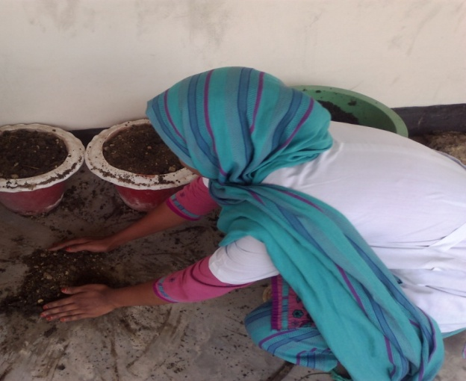
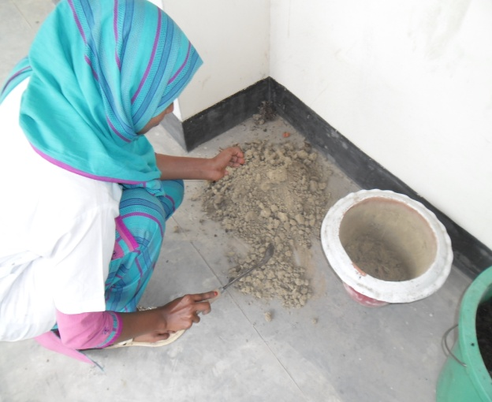

Figure 2. Mixing of fertilizer and soil
Figure 1. Preparation of soil

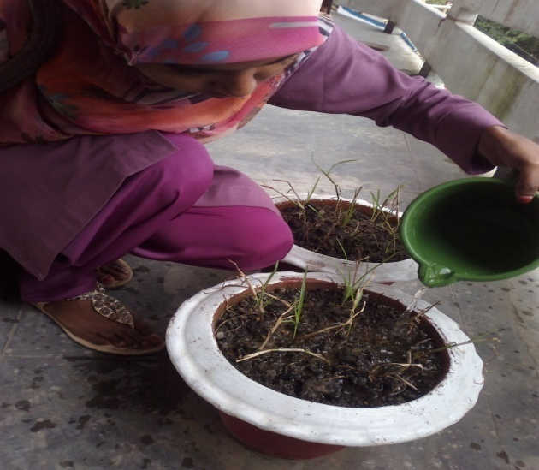
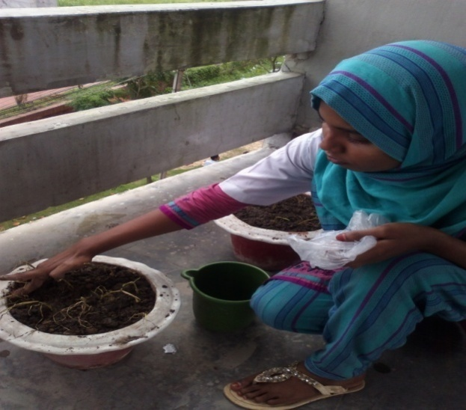

Figure 4. Daily watering the growing grass

Figure3. Plantation of stem of Limpograss

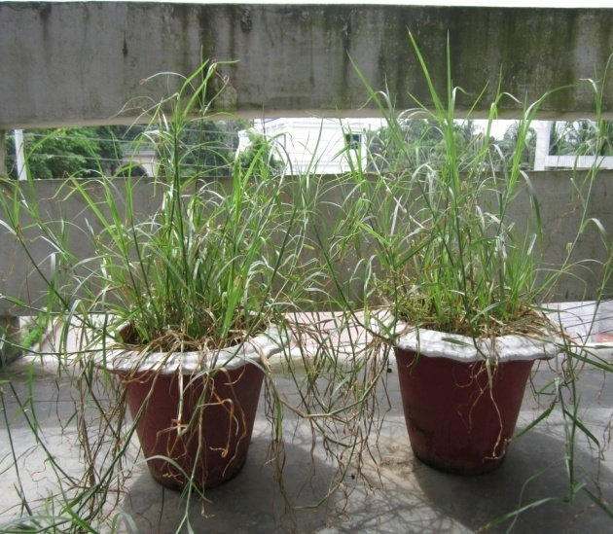
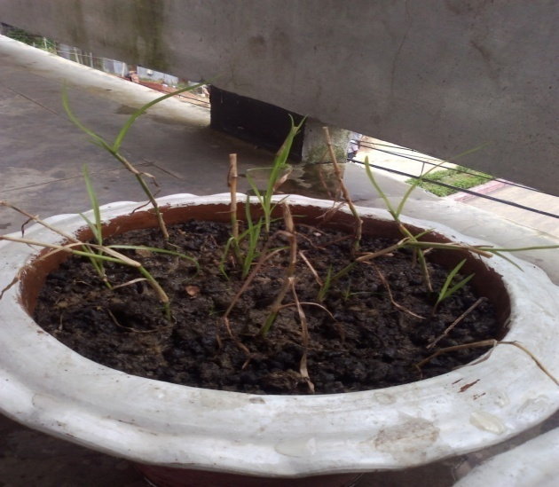

Figure 6. Mature grass

Figure 5. Growing of grass

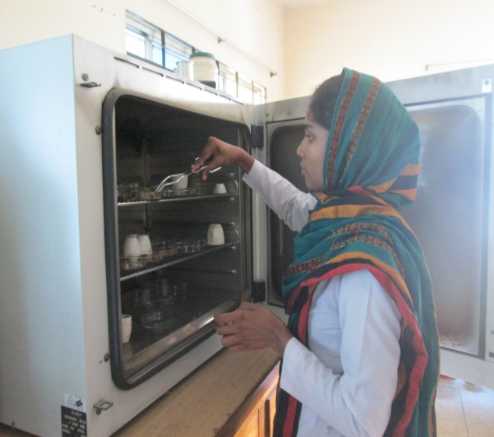
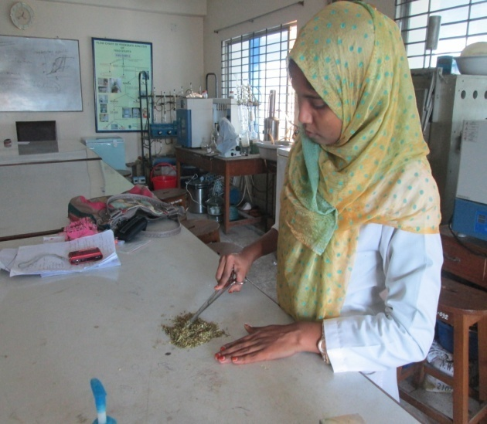

Figure 8. Estimation of DM
Figure 7. Sample preparation

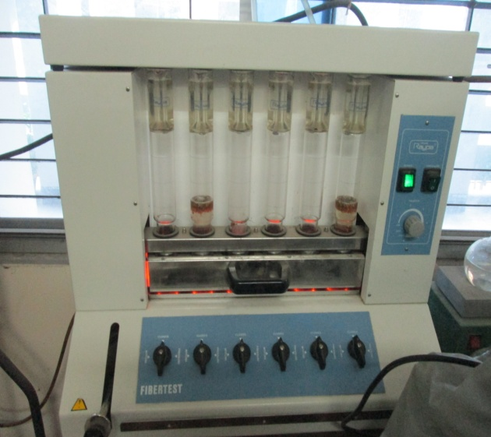
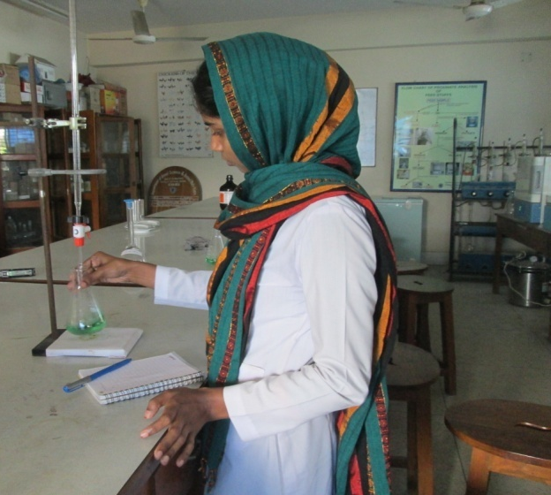

Figure 9. Estimation of CP
Figure 10. Estimation of EE.

Chapter-IV
RESULTS AND DISCUSSIONS

The results found in different aspects along with digestibility trial and their discussions have been presented in this chapter.

4.1. Nutritional composition
The nutritional/chemical composition of Limpograss was performed at the lab. The chemical composition of Limpograss is given bellow:

4.1.1. Dry matter (DM): The DM content of the grass was found as 30% (table-4.1) which was similar to most of the perennial grasses available in Bangladesh. The DM content found of this study was supported by Arthington et al. (2005); Campos et al. (2010); CIRAD (1991) and Lacerda et al. (2004) where almost similar DM (27.1%) of limprograss was found at different studies.
4.1.2. Crude protein (CP): The CP content of the collected grass was found as 8.75% (table-4.1). This was agreed by Arthington et al. (2005); Campos et al. (2010); CIRAD (1991) and Lacerda et al. (2004) where almost similar CP (9.3%) of limprograss was found.
4.1.3. Crude fiber (CF): The CF content of the studied grass was 31.75% (table-4.1) which was almost similar as most of the perennial grasses available in Bangladesh. The CF content of the sample of this study was closely related with the findings of Arthington et al. (2005); Campos et al. (2010); CIRAD (1991) and Lacerda et al. (2004) there almost similar CF (32.6%) was observed at their studies.
4.1.4. Mineral (Ash): The total ash content of limprograss was found as 11.3% (table-4.1) which was similar as most of the available perennial grasses in Bangladesh. The total ash content of limprograss found of this study was positively supported by Arthington et al. (2005); Campos et al. (2010); CIRAD (1991) and Lacerda et al. (2004) where 10.5% CF was found at their studies.
4.1.5. Ether extract (EE): The EE content of the grass was found as 2.04% (table-4.1) which was almost similar to most of the perennial grasses that are available in Bangladesh. The EE content found of this study was closely related with Arthington et al. (2005); Campos et al. (2010); CIRAD (1991) and Lacerda et al. (2004) where EE found (2.3%) that are almost similar with their studies.
Table 4.1: Nutritional composition of Limpograss
 | DM  (Mean ± SD) | CP  (Mean ± SD) | CF  (Mean ± SD) | Ash  (Mean ± SD) | EE  (Mean ± SD)
Nutrient (%) | 30 ± 0.5 | 8.75 ± 0.25 | 31.75 ±0.05 | 11.3 ± 0.03 | 2.04 ± 0.01

4.2. Digestibility study
The in vitro digestibility study of Limpograss was performed at the animal nutrition lab. The digestibility per cent of Limpograss found as follows:

Table 4.2: digestibility percentage of Limpograss
Nutrient component | Digestibility (%)
DM (Mean ± SD) | 52.5 ± 1.63
CP (Mean ± SD) | 46.63 ± 1.35
CF (Mean ± SD) | 34.33 ± 0.41
Ash (Mean ± SD) | 23.84 ± 1.02
EE (Mean ± SD) | 69.9± 0.25

4.2.1. Dry Matter digestibility (DMD) of Limpograss
Dry matter digestibility of Limpograss shown in Table 4.2. DM content of Limpograss after digestion was 14.25± 0.25% as well as the digestibility per cent of it was 52.5 ± 1.63 (table-4.2). No significant work was found on this regards.

Graph 1: Dry matter content of Limpograss (%).

4.2.2. Crude protein digestibility (CPD) of Limpograss
The crude protein content of Limprograss after digestion was 4.67 ± 0.03% and the digestibility of crude protein is 46.63 ± 1.35 that was shown in table 4.2. No significant work was found on this regards.

Graph 2: Crude of protein content limpoggrass (%)

4.2.3. Crude fiber digestibility (CFD) of Limpograss
The average crude fiber of Limpograss after digestion was 20.85 ± 0.13% as well as the digestibility per cent of it was 34.33 ± 0.41(Table-4.2). No significant work was found on this regards.

Graph 3: Crude fiber content of Limpograss (%).

4.2.4. Mineral digestibility of Limpograss
In present study, the ash content of Limpograss after digestion was 8.58 ± 0.09% and the digestibility of ash was 23.84 ± 1.02 that was shown in table 4.2. No significant work was found on this regards.

Graph 4: Ash content of Limpograss (%).

4.2.5. Ether extract digestibility (EED) of Limpograss
The Ether extract content of Limpograss after digestion was 0.61 ± 0.001% and the digestibility per cent was However, there was 69.9± 0.25 (Table-4.2). No significant work was found on this regards.

Graph 5: Ether extract content of Limpograss (%).

Chapter -V
CONCLUSION
Limpograss is a warm-season plant adapted to areas of high moisture that are poorly drained. Limpograss is highly productive when well fertilized and competes well with broadleaf and grassy weeds. The DM, CP, CF, Ash and EE contents of Limpograss were 30, 8.75, 31.75, 11.25 and 2.04per cent respectively. The DM, CP, CF, Ash and EE digestibility per cent of Limpograss were 52.5, 46.63, 34.33, 23.84 and 69.90 per cent respectively. It was also observed that mature Limpograss was more digestible than many other grasses at maturity, though crude protein was lower in this grass. As a result, animals fed Limpograss need protein supplementation. Therefore, to formulate least cost balanced ration using Limpograss, nitrogenous substances should be incorporated into the practical ration.
As this was the initial stages of work on Limpograss and no more works were conducted on it, future trial and repeatation of the same work could be performed to make a firm decision on Limpograss to offer it to the cattle as the sole roughage feed.

CHAPTER VI
REFERENCES

Adjei, M. B.; Rechcigl, J. E.; Kalmbacher, R. S. 1998. Fertilization effects on the yield and chemical composition of Limpograss pasture. Soil and Crop Sci. Soc. Florida Proc., 57: 66-73.
Anonymous. 1990. Official methods of Analysis of the association of official analytical chemists. 20th Edn., AOAC, Washington, D.C.
Anton, T. E.; Arthington, J. D.; Pate, F. M. 2003. The use of stockpiled Limpograss as a winter forage supplement for beef cows in south Florida. J. Anim. Sci., 81 (2): 2.
Arthington, J. D.; Brown, W. F. 2005. Estimation of feeding value of four tropical forage species at two stages of maturity. J. Anim. Sci., 83 (7): 1726-1731.
Brown, W. F. and Adjei, M. B. 2001. Urea and (or) feather meal supplementation for yearling steers grazing Limpograss (Hemarthria altissima var. ‘Floralta’) pasture. J. Anim. Sci. 79: 3170-3176.
Campos, P. R. D. S.; Silva, J. F. C. da; Vasquez, H. M.; Vittori, A.; Silva, M. D. E. 2010. Fractions of carbohydrates and of nitrogenous compounds of tropical grasses at different cutting ages. Rev. Bras. Zoot., 39 (7): 1538-1547.
Carvalho, D. D.; Goncalez, D. D.; Ghisi, O. M. A. A. 1996. Agronomic evaluation of seven accessions of Hemarthria altissima (Poir.) Stapf. et C.E. Hubb. in Pindamonhangaba, Sao Paulo. Rev. Soc. Bras. Zootec., 25 (5): 825-836.
Catalogue of New World Grasses (Poaceae) - 11/2009, database (version 24/11/2009)

Chambliss, C. G. 1999. Florida Forage Handbook. Univ. of Florida, Inst. of Food and Agric. Sci., Coop. Ext. Service, Gainesville. Document No. SP 253.
CIRAD, 1991. Laboratory data 1963-1991. CIRAD

Cook, B. G.; Pengelly, B. C.; Brown, S. D.; Donnelly, J. L.; Eagles, D. A.; Franco, M. A.; Hanson, J.; Mullen, B. F.; Partridge, I. J.; Peters, M.; Schultze-Kraft, R., 2005. Tropical Forages. CSIRO, DPI&F(Qld), CIAT and ILRI, Brisbane, Australia.
Ecocrop. 2011. Ecocrop database. FAO http://ecocrop.fao.org/ecocrop/srv/en/home
Henriques, L. T.; Silva, J. F. C. da; Detmann, E.; Vasquez, H. M.; Pereira, O. G. 2007. Carbohydrate fractions of tropical grasses at different cutting ages and under nitrogen fertilization. Arq. Bras. Med. Vet. Zootec., 59 (3): 730-739.
Islam, M. R.; Chowdhury, S. A.; Hasanuzzaman, M.; Huque, K. H. and Jalil, M.A. 2001. Report on Production performance of different high biomass yielding grasses as affected by salinity and establishment of a germplasm bank. Animal Production Research Division, BLRI, Savar, Dhaka-1341.
Lacerda, P. D. de; Malafaia, P.; Vieira, R. A. M.; Henrique, D. S.; van der Made, I. E.; Faria , A. R. G. 2004. Variation on the annual nutritive value of two grasses cropped in the litoral lowlands of the State of Rio de Janeiro, Brazil. Cienc. Rural, 34 (2): 523-529.
Lima, G.F. da C., Sollenberger L.E., Kunkle W.E., Moore J.E. and Hammond A.C. 1999. Nitrogen fertilization and supplementation effects on performance of beef heifers grazing Limpograss. Crop Science, 39: 1853-1858.
Luo, F.L.; Nagel K. A.; Zeng B.; Schurr, U.; Matsubara, S. 2009. Photosynthetic acclimation is important for post-submergence recovery of photosynthesis and growth in two riparian species. Ann Bot., 104 (7): 1435-1444.
Maynard, A.J. 1970, Methods in Food Analysis. Academic Press, New York, p. 176

Moore, J. E. and Mott, G. O. 1974. Recovery of residual organic matter from in vitro digestion of forages. Journal of Dairy Science, 57: 1258-1259.
Nation, A. 2006. South Florida ranches have a $250 advantage in cow-calf costs. The stockman grass farmer. Crop Science, 59: 1317-1352.
Newman Y. C.; Vendramini, J.; Sollenberger, L. E.; Quesenberry, K. 2009. Limpograss (Hemarthria altissima) overview and management. University of Florida, IFAS, SSAGR320, Florida Cooperative Extension Service, USA.
Raghuramulu, N.; Nair, M. K. and Kalyansundaram, S. 1983, In: A Manual of Laboratory Techniques, NIN, ICMR, Hyderabad, India.
Royal Botanic Gardens, Kew, 2013. Hemarthria altissima (Poir.) Stapf & C.E.Hubb. In: Survey of Economic Plants for Arid and Semi-Arid Lands (SEPASAL) database, Royal Botanic Gardens, Kew.
Sellers, B. A., and Ferrell, J. A. 2009. Weed Management in Pastures and Rangeland. Department of Agronomy, Institute of Food and Agricultural Sciences, University of Florida, Gainesville, FL.
Sollenberger, L. E. and Vanzant, E.S. 2011. Interrelationships among forage nutritive value and quantity and individual animal performance. Crop Sci., 51:420-432.
Sollenberger, L. E; Rusland, G. A.; Jones, C. S. Jr.; Albrecht, K. A.; Gieger, K. L., 1989. Animal and forage responses on rotationally grazed Floralta Limpograss and Pensacola bahiagrass pastures. Agronomy J., 81 (5): 760–764.
Sultana, N.; Rahman, M.Z.; Hossain, S. M. J. and Talukdar, M. A. I. 2010. The nutritional evaluation of different forage. Proceedings of the Annual Research Review Workshop 2009-2010.
Zhou and Yiqin. 2011. Comparison of Fresh or Ensiled Fodders (e.g., Grass, Legume, Corn) on the Production of Greenhouse Gases Following Enteric Fermentation in Beef Cattle. J. Anim. Sci., 26 (3): 1632-1640.

