CHAPTER-I
INTRDUCTION
Dairying is one of the most effective instruments for supplementing farmer’s income and generating employment in rural sector (Bedi, 1989). Dairy cows are the major livestock in Bangladesh and play very crucial role to our national economy. Apart from their role in milk production, they also contribute a huge quantity of organic manure on our agricultural field, which is one of the major inputs in our agriculture.
Bangladesh has 24 million cattle, out of which 6 million are dairy cattle of local and crossbreds (DLS 2008). The majority of the dairy cattle are in the hands of smallholder dairy producers. The country has one of the highest cattle densities of 145 large ruminants/square kilo meter (sq.km) compared with 90 for India, 30 for Ethiopia, and 20 for Brazil (Karim 1997). The numbers of dairy farms are estimated at about 1.4 million with an average herd size of 1-3 cows (Hemme 2008). Also dairying is part of the mixed farming systems in Bangladesh (Saadullah 2001) and a predominant source of income, nutrition and jobs (Miyan 1996; Haque 2009). Dairying is also considered a strong tool to develop a village micro economy of Bangladesh (Shamsuddin et al 2007) in order to improve rural livelihoods and to alleviate rural poverty. More regular cash income can be generated through market-oriented dairies and more employment per value added unit has been observed in dairying than in crops (Asaduzzaman 2000; Omore et al 2002).
Milk production growth has increased from 4.1% to 7.4% per annum in 2000-2005 and 2005-2008, respectively (Hemme 2008). Even with this faster growth the per capita milk availability in 2008 was only 19 kg (Hussain et al 2008), which was far below the requirements (92 kg/person/year) as indicated by the World Health Organization (WHO). The growth of consumption increases at a rate of 4% per year (Hemme 2008). This means that in future the dairy industry of Bangladesh will be ‘demand-’ or ‘market-driven’ which corresponds to the doubling of demand for milk and milk products in 2020 in all developing countries including Bangladesh (Delgado et al 1999, Ndambi et al 2007). The key drivers for this increased market demand for dairy products are the rapid urbanization, increased population growth, and rise in absolute income (Delgado et al 1999). According to Bangladesh Economic Review (2006), the per annum growth rate of 7.23% in GDP in 2004-05 for livestock was the highest of all sub-sectors. This increase in demand has created an enormous market opportunity that can be exploited by the smallholder livestock owners who represent 70-80% of the total milk produced in the country (Jabbar et al 2005). In order to take advantage of emerging market demands for reducing their poverty, smallholders have to face challenges to improve production costs and productivity (Uddin et al 2009b). But small scale dairy farming in the rural areas of Bangladesh where only rice straw, green grass and limited concentrate are available. Housing system, feeding, breeding care and management are not properly maintained. So the performance of dairy cow are lower than their capability of producing milk and other. As well as the recent historical rise in world food prices has further aggravated the situation of dairy input prices (e.g. higher price for feed, artificial insemination, veterinary services and medicine) which has also increased farm costs and ultimately affects farm profitability. This increasing input price coupling with recent historic fall of milk price push the dairy farmers in more difficult situation. The economic situation of the dairy farmers is aggravated by lack of basic infrastructure, poor access to artificial insemination and veterinary services, disorganised market structure and lack of access to technological facilities. This also limits dairy farmers’ access to inputs and support services.
Therefore, there is a growing need for information about detail economic production parameters to enhance competitiveness of both the factor market and product market, locally and internationally. While farmers need to know more about the economic indicators such as cost and profitability, research on this aspect is very limited and controversial (Saadullah 2001; Alam 1994; Rao and Odermatt 2006; Khan 2007). Moreover, there is a lack of knowledge on detailed economic parameters of milk production systems especially at farm level (Ndambi et al 2008) which is also true in the case of Bangladesh dairying. Studies show that the present situation of dairy farming in the study area and the problems and gives strategies that ensure low cost milk production and as well as high returns from dairying are the key incentives for farmers to continue their business (Ndambi and Hemme 2009).
A study concerned with economics of commercial dairy farming in relatively a new area in Bangladesh. Moreover to evaluate the economics of the suitable sizes of commercial dairy farming at the urban and semi urban area in Chittagong district an attempt was made by the research study entitled as “Comparative Economic Analysis of Small scale Dairy farming in some selected areas of Chittagong District.”
OBJECTIVES
The overall objectives are to examine the economic profitability of dairy farming practices in some selected areas of Chittagong district.
The specific objectives of the study are as follows:
- To estimate the comparative costs of dairy farming in Chittagong metropolitan area & Patiya.
- To estimate the comparative return and profitability of dairy farming in study area.
- To identify and reveal the problems of dairy farming and give suggestions for improving dairy farming in Chittagong district.

CHAPTER-II
REVIEW OF LITERATURE
Review of literature gives the guidelines from the past researchers and provides a foundation to the theoretical framework for present investigation. The review of past literature makes the investigator to get an insight into the methods and procedures to be followed. The following discussion that studies conducted so far mostly focused on cost and returns, in some areas with productivity, re-productivity and some management aspects of raising dairy cows. Commercial dairy farming is relatively not a new area in Bangladesh and researches dealing with performance of such farming are limited in number. However some of the studies, which are more relevant to the present study are given below:
Alam et al. (1992) conducted a broad based socio-economic survey in Bangladesh and found that the proportion of cross breed cattle was 11.69%. the returns were higher by 91% for cross breed cows. Return over cash cost per lactation for cross breed cows were 158% higher than local ones.
Ashrafuzzaman (1995) conducted a study to investigate the socio-economic characteristics of indigenous and cross breed dairy cows owners to analyze the relative profitability. The per day total cost of raising a cross breed cow (tk. 35.05) was a little higher over an indigenous cow 6.65 litres for a cross-bred cow which was about double the average milk yield per day of 3.62 litres tk 15.64 and tk. 45.83 for indigenous and cross-bred dairy cow respectively indicating about three times higher net return from a cross bred dairy over indigenous cows.
Hemme et al.(2004) conduct a study to assess the economics of dairy farming in Bangladesh and the prospects for improving the dairy income for small-scale producers, which currently form the backbone of the dairy industry. The document begins with a general overview of milk production in the country, followed by a detailed study of dairy farming in the in the northern district of Sirajganj. The study applies a method of farm-level economic analysis developed by the International Farm Comparison Network (IFCN) which is based on the concept of ‘'typical farms’'. The study concludes that milk production from bovines in Bangladesh is not competitive internationally and that under a liberal trade regime for dairy products dairy farmers in Bangladesh are unlikely to fully benefit from the vast increase in milk demand predicted to occur over the next ten years unless productivity is significantly improved.
Kabir (1995) conducted a study to anlyze the economic performance of subsidized dairy farming in Tangail districts. The net return per farm was found Tk 14463, tk 21773 and tk 58173 annually for local, cross and cross-bred farm respectively. The investments per taka return were tk. 1.19, tk. 1.27 and tk. 1.37 respectively for local, and cross and cross-bred farms. Overall performance of cross bred dairy cattle was higher than local bred cows.
Karim And Begum (1988) conducted a study to know the prevalent situation of women’s involvement in milch cow rearing in two villages of Comilla district. They found that 42% of the total number of cattle owned by all the house holds was milch cow of which only 14% was of improved type. Average quantity of milk yield per milch cow was 2.77 litres. The average annual cost of feed, treatment and AI per cows Tk. 3972 of which feed cost constitutes about 98%. The annual gross return per milch cow from milk, cowdung and ploughin was tk. 6674 while the net return was estimated at tk. 2763.
M. A. Halim et al.(2010) carried out a study in 5 Upazilas under Chittagong district with a view to analyze the present socio-economic status of RCC farming practices on 100 RCC rearers (Potiya, Raujan, Chandanaish, Anowara and Satkania Upazila).. The cost of rearing RCC per cattle per year was found to be Tk. 17503.76, Tk. 15540.27, and Tk. 33044.03 as cash cost, non cash cost and total cost respectively. The study also revealed that, average daily milk yield, lactation yield and lactation length of RCC were found to be 2.71 liters, 581.61 liters and 215.41 days, respectively. The average per year per cattle gross return of RCC was found Tk. 25390.41. The gross returns over cash cost and full cost basis of rearing per lactation per cattle of RCC were found at Tk 8058.642 and Tk.-7501.53, respectively. The benefit cost ratio on the basis of cash cost and full costs per year per cattle was found 1.47 and 0.77, respectively.The study also revealed that, the rural farmers prefer RCC farming than other breeds due to high conception rate,each year calving, disease resistance, high milk fat per cent and cost effective farming.

M.M. Hossain et al.(2005) was assigned a study to determine the present status including general information, feeding breeding housing milking etc. and costs & returns of small dairy farms, to compare the productive and reproductive performance of crossbred and indigenous cows and to make recommendation for development of small scales dairy farm. The study was conducted at 8 thanas in Rangpur district, and four months-long survey was diminished on thirty small dairy owners. Daily milkyield/cow/farmwas 4.27 and 1.78 liters for a crossbred and indigenous dairy cow, respectively. It was estimated that the rearing cost of dairy cow was Tk. 67.5/cow/day and return from rearing dairy cow was Tk.85.2/cow/day.The net return was Tk. 17.7/cow/day from crossbred in the study area and cost benefit ratio was 1: 1.26.

R K Mondal et al.(2010) undertaken a study to investigate and compare the socio-economic characteristics and relative profitability of local breed and cross breed dairy cow rearing farmers. The focus of the study was to quantify the costs and returns and to explore the interrelationship of factors affecting yield, cost and net return for the local and cross breed cows and also compare these with each other. On an average, local and cross breed dairy cow owners possessed 4.93 and 4.76 animals per household respectively. Per day total costs of rearing per local and cross breed cow were Tk.32.85 and Tk.71.23 respectively. Feed cost constituted about 58 percent of total cost for local breed cows while it was 62 percent for cross breed cows. The average milk yield per day per cow was 1.89 litres and 7.68 litres for local breed and cross breed dairy cows respectively while the total return per day per cow was estimated at Tk.58.27 and Tk.224.76 for the same and the net returns per day per cow were Tk.25.42 and Tk.153.53.
Rahman (1993) conducted as study at Kalihati and Takerhat areas under Tangail and Madaripur districts to quantify the costs and returns, to explore the interrelationship of factors affecting yield and to examine the rural employment and income generation potentials of dairy enterprise. The gross cost per cow per day were tk. 20.22 at kalihati and tk. 29.34 and 4.91 at takerhat areas.
Rahman and Akteruzzaman (1994) showed that the milk yield per animal per day in small, medium and large herd size were 3.87, 3.37 and 2.38 litres respectively while the cost of production per liter amounted to tk. 8.70, 9.22, and 12.33 respectively. The net returns per cow per day were tk. 8.07 and tk 4.65 respectively for small and medium herd size and the net loss estimated was tk. 3.14 in case of large herd size.
Rahman and Raman (1991) conducted a study on economic analysis of dairy enterprise in four selected villages of Mymensingh district in Bangladesh. The findings showed that feed cost was higher in the urban and milk pocket areas than in the rural and semi-urban areas. In Buffalo area (Ahmen Bari) feed cost is highest. The gross return per animals were positive for all types of cow. Net returns was also positive and higher for the HYV of cows and Buffaloes.
Rajapurehit (1979) showed that the cost of milk per litre was 0.95 rupee for crossbred cows. The total milk yield per lactation were 2077 for cross breed cows. They also observed that the net returns from crossbreed cows were higher.

CHAPTER-III
MATERIALS AND METHODS
Livestock rearing usually involves collection of data from individual farmers. There are various methods of data collection for agricultural economics research. Selection of a particular method depends on many considerations. The present study was performed by the collection of data by a questionnaire, because it was considered to have some advantages over other methods.
3.1 Selection of a study area:
Selection of a study area is an important step for the study to achieve the objectives. The present study was conducted in two areas of Chittagong district viz Chittagong metropolitan area and patiya. Under the study the following consideration taken as vital point:
- The area is blessed with the better communication facilities.
- Availability of dairy farm in that particular area.
- Expectation of co operation from the respondents so that reliable data might be obtained.
3.2 Duration of study:
The study on comparative economic analysis of small scale dairy farming in different areas of Chittagong district were conducted actually from 24 September to 24 November in the study area.
3.3 Selection of sample and sampling procedure:
Larger the sample size greater is likely to be the extent of accuracy and usefulness of the results. But in reality the inclusion of all farms was not possible due to time and resource constraints .So selection of the representative sample was one of the crucial aspects for the study. Purposive sampling technique was used for selecting the sample. In total 40 dairy farms were taken from the study area.

3.4 Preparation of questionnaire and pretesting:
The requisite primary data for this study were collected through survey method. For collecting the necessary data questionnaire/interview schedule was prepared in the light to the objectives of the study. The questionnaire was pretested and then finalized. The respondents were given information related to the objectives of the study as well as their role. If any item overlooked and misunderstood or found contradictory, there was corrected through re interviewing on the spot.
3.5 Methods of data collection:
Reliable data are directly related to the success and validity of the study. By using questionnaire/interview schedule most of the data are collected by the researcher herself. To obtain the reasonable and accurate data, the researcher should visit several times in the study area. During data collection the objectives of the study were clearly explained to the respondents so that they could respond freely. Question was asked systematically and explanation was given wherever necessary.
3.6 Problems of data collection:
- Most of the dairy farm owner thought that the investigator was an agent of the government authority and therefore they initially did not want to co operate with the researcher. In fact they hesitated to answer some questions relating to income and asset, because they were afraid of tax imposition or tax increase.
- Farmers usually did not keep records of their day to day transactions of farm activities. So that it was very difficult to collect actual data and the researcher had to rely on the memory of the farmers.
- Literacy of the respondents was great hindrances of data collection. Sometimes they could not answer the question accurately and to the point.
3.7 Statistical Analysis:
After data collection from selected farms data were organized, structured and analyzed by using both tabular and graphical method as well as using simple descriptive statistical tools and techniques by using Microsoft Excel.

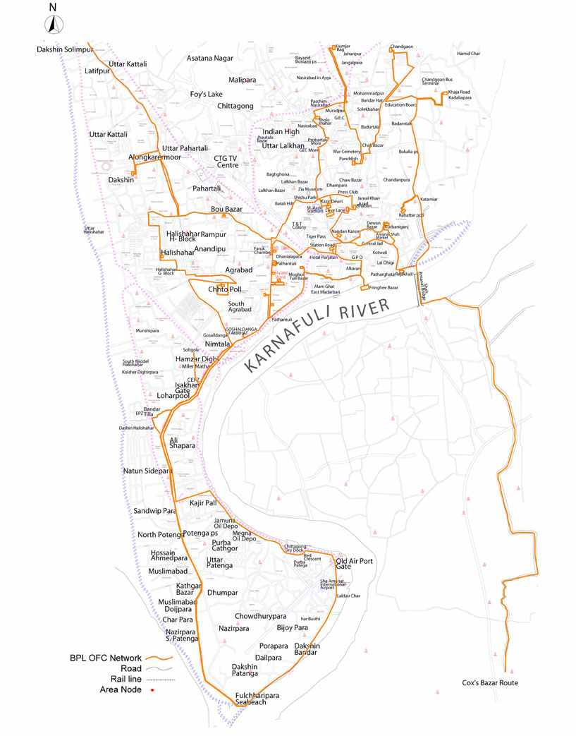
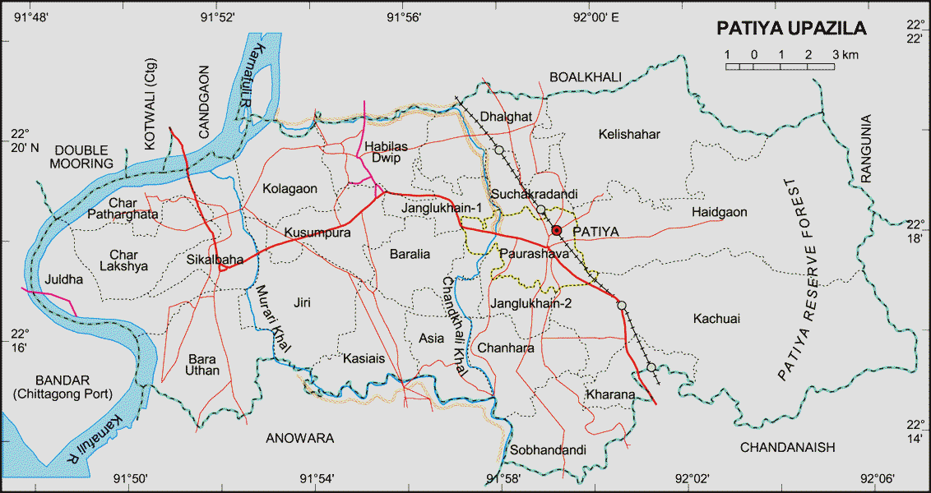
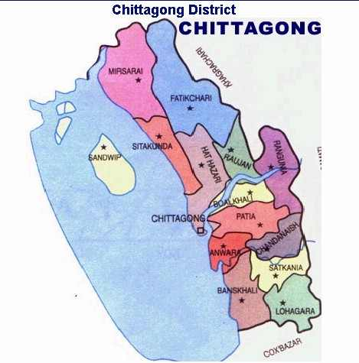
Fig: Location of studied area
Patiya Upazila
Chittagong Metropolitan Area
CHAPTER – IV
RESULTS AND DISCUSSIONS
4.0: COSTS AND RETURNS OF DAIRY FARMING
4.1. Yearly Cost of Dairy Farming in Chittagong Metropolitan area & Potiya.
The cost and return is a very important component of dairy farming at rural areas. Cost may be classified as cash cost where direct cash expenditure incurred are calculated from daily records and non- cash costs are fixed and family supplied input costs. The cost and return were estimated from the collected data from two areas under Chittagong district. The estimated yearly approximate costs of the studied farm households were discussed as follows:
Per year per cow cost of dairy farmers on full cost basis is shown in Table 1. The average full cost per cow Tk 82256.2 which ranged from Tk 74829.20 in Patiya to Tk 89683.2 in Chittagong metropolitan area .The average proportion of cash cost and non cash cost was 43.87% and 56.13% of the total cost respectively. Feed cost was classified into two categories in which purchase feed cost was under cash cost and family supplied feed cost was under non cash cost. The average purchased feed cost was 38.22% which varied from 40.73% in Chittagong metropolitan area and 35.72 % in Patiya. Labor cost was classified into two categories, Permanent labor and hired labor. Hired labor represents in cash cost while permanent labor in non cash cost. Under cash cost, the average hired labor was 1.96%, followed by 2.89 % in Chittagong metropolitan area and 1.04 % in Patiya. The cost of Vet care occupied the third position in cash cost by contributing 1.53% of the total cost of production which highest in Patiya1.56% compared to 1.50% in Chittagong metropolitan area. The average cost of electricity bill contributes 0.80% of the total cost which is higher in Chittagong metropolitan area 0.99% than 0.60% in Patiya. The average AI cost was 0.46% of the total cost which varied from 0.47% in Chittagong metropolitan area and 0.45% in Patiya. Home supplied feed cost was the highest among all non cash cost which is on an average 39.65% of the total cost and it is higher in potiya 42.79% than Chittagong metropolitan area 36.52%.Under non cash cost, the average permanent labor was 8.60%, followed by 8.14% in Chittagong metropolitan area and 9.05% in Patiya.

Table-1: Per Year per Cow rearing Cost of dairy farmers
Particulars | Area Wise Per Year Per Cow rearing Cost
 | Chittagong Metropoliton area  (n=20) |  | Patiya  (n=20) |  | All average (N=40)
 | In taka | % | In taka | % | In taka %
Cash cost/ variable cost
Labor cost(hired) | 2587.5 | 2.89 | 776 | 1.04 | 1681.75 | 1.96
Feed cost | 36528.10 | 40.73 | 26730.79 | 35.72 | 31629.45 | 38.22
Vet. Care | 1344.1 | 1.50 | 1170 | 1.56 | 1257.05 | 1.53
A.I Cost | 424 | 0.47 | 334.50 | 0.45 | 379.25 | 0.46
Electricity bill | 890 | 0.99 | 452.50 | 0.60 | 671.25 | 0.80
Others | 728 | 0.81 | 730 | 0.98 | 729 | 0.90
Total  (cash cost) | 42501.70 | 47.39 | 30193.79 | 40.35 | 36347.75 | 43.87
Non-cash cost/Fixed cost
Family labor(permanent) | 7304 | 8.14 | 6775 | 9.05 | 7039.5 | 8.60
Feed cost (family supplied) | 32752.49 | 36.52 | 32018.91 | 42.79 | 32385.7 | 39.65
10% depreciation on housing | 6825 | 7.61 | 5545 | 7.41 | 6185 | 7.51
10% depreciation in equipment | 300 | 0.34 | 296.5 | 0.40 | 298.25 | 0.37
Total (Non cash cost) | 47181.49 | 52.61 | 44635.41 | 59.65 | 45908.45 | 56.13
Full cost | 89683.2 | 100 | 74829.2 | 100.00 | 82256.2 | 100.00
Source: Field survey, 2013
The third highest non cash cost is housing cost which is about 7.51% of the total cost. Equipment cost is the lowest in non cash cost which is about0.37% of the total cost followed by 0.34% in Chittagong metropolitan area and 0.40% in Patiya..

Figure-1: Comparative costs of dairy farming in Chittagong metropolitan area and Patiya

4.2 Comparative Productive and Reproductive Performance of Different Breeds of Cows
The productive and reproductive performances of dairy cows are highly depended on management and farming systems. Better management increases the productive and reproductive performances. Jalil et al. (1995) found much higher milk yield in exotic breed (7.57 liters per day per cow) in comparison with the local breed (2.13 liters per day per cow). In the study area farmers do not offer any balance diet to cross-bred lactating cows which is very essential for their milk production potentiality. Most cases they give a little amount of concentrate without any protein supplement which ranges from 0.5 to 1 kg. So as a result of under feeding, lack of protein supplement in the feed and also rough rural condition, cross-bred lactating cows can not show satisfactory performance as they should be. Bhuiyan and Sultan (1994) showed that the total lactation yield of exotic breed was almost four times higher than the local breed.
Table-02. Productive and reproductive performance of crossbreds and local dairy cows in study area
Parameters | Cross breed | Local breed
Milk production /day/cow | 7.57 ± 1.70 | 2.13 ± 0.73
Lactation period (day) | 229.37 ± 6.39 | 227.8 ± 7.50
Age at first calving (month) | 34.12 ± 3.78 | 40.48 ± 4.54
Service per conception | 1.84 ± 0.80 | 2.05 ± 0.91
Birth weight of calf (kg) | 17.8 ± 3.17 | 15.0 ± 0.36

Figure-2: Productive and reproductive performance of crossbreds and local dairy cows in study area.

4.3 Returns per lactation per Cow
Yearly Returns from dairy farming as per cow per Lactation period
Total estimated return of rearing cow per year in Chittagong metropolitan area and Patiya were Tk. 104876.75 and Tk. 81639.1 respectively.
The return from per dairy cow per year was derived from three sources such as return from milk, return from selling of calf and selling of cow dung. The highest return per cow was achieved from milk which was on an average 80.53% varied from 78.07% in Chittagong metropolitan area and 82.99% in patiya. Then return from selling of calf which was higher in Chittagong metropolitan area 17.52% than patiya 14.25%. The average return from selling of cow dung was on an average 3.58% compared to 4.41% in Chittagong metropolitan area and 2.76% in patiya.

Figure-3: Comparative return from dairy farming in Chittagong metropolitan area and Patiya

Table-03: Yearly Returns of Rearing cow per lactation period:
Particulars  of Return | Area wise per cow per lactation Returns
 | Chittagong Metropolitan area (n=20) |  | Patiya (n=20) |  | All average (N =40)
 | In taka | % | In taka | % | In taka | %
Income from milk | 81876.75 | 78.07 | 67749.1 | 82.99 | 74812.93 | 80.53
Income from calf | 18375 | 17.52 | 11635 | 14.25 | 15005 | 15.89
Income from cow dung. | 4625 | 4.41 | 2255 | 2.76 | 3440 | 3.58
Total return | 104876.75 | 100 | 81639.1 | 100.00 | 93257.93 | 100
Net return | 15193.55 | - | 6809.9 | - | 11001.73 | -
Gross return | 62375.05 | - | 51445.31 | - | 56910.18 | -
BCR  (Cash cost basis) | 2.46 | - | 2.70 | - | 2.57 | -
BCR  (Full cost basis) | 1.17 | - | 1.09 | - | 1.13 | -
Source: Field survey, 2013
Estimated BCR on the basis of cash cost for Chittagong metropolitan area and patiya were 2.46 and 2.70 respectively. BCR on the basis of full cost for Chittagong metropolitan area and patiya were 1.17, 1.09 respectively. BCR>1 means the dairy farming in the study area is profitable. BCR was found to be higher in Chittagong metropolitan area than Patiya. That means if the dairy farmers of Chittagong metropolitan area invest Tk 1 they could be get 1.17 on full cost basis while it was Tk1.09 in Patiya.
CHAPTER-V
PROBLEMS RELATED TO REARING DAIRY COWS
The purposes of this section of the study is to identify the problems of raising dairy cows in the selected area of Chittagong district and to make suggestion with a view to solving these problems for expanding rearing of dairy cow owners as a tools of poverty alleviation at rural areas in Bangladesh. The problems are listed in following table and discussed below:
Table-4: Problems faced by dairy farm owners in study area.
Problems | Extend of Problems faced by the Respondent |  |  |  | Percent (%)of total farm(40)
 | Low | Medium | High | Total respondents
High feed price | 2 | 6 | 24 | 32 | 80
Scarcity of quality feeds and fodder | 3 | 11 | 13 | 27 | 67.5
Low prices of milk | 5 | 9 | 20 | 34 | 85
Inadequate veterinary care and service | 4 | 12 | 8 | 24 | 60
Distance of AI centre | 2 | 6 | 15 | 23 | 57.5
Lack of credit | 5 | 11 | 14 | 30 | 75
Lack of technology | 3 | 8 | 11 | 22 | 55

Figure-4: Problems faced by dairy farm owners (Source-Field survey at Patiya and Chittagong metropolitan area in 2013 )
High prices of feed: This is the most important problem of rearing dairy cows Animal feed price is increasing day by day. It is becoming very difficult for small scale farm owners to adjust their cost due to increasing feed price. About 80 percent farm owners complained about this problem. (Table-04), 24 of them gave it highest priority (Figure-4).
Scarcity of quality feeds and fodder: It is also an important constraint of rearing dairy cows. This problem faced about 67.5 percent of the farm owners (Table-04).The cause of scarcity of fodder is rapid urbanization. 13of them mention it as a highest priority (Figure-04).
Low prices of milk: The prices of milk in the study area were low specially in Patiya. The average price of milk per liter in the study area was estimated at taka 35, which was lower than the prices prevailed in many other areas of Bangladesh. The problem of low prices milk was reported by the 85 percent of farm owners (Table-04). 20 of them gave it highest priority (Figure-04).
Inadequate veterinary care and service: It was the important problem of rising rearing dairy cows in the study area. Most of the dairy farm owners reported that the availability of the veterinary services was inadequate in the study area. About 60 percent of the farm owners mention this problem (Table-04).8 of them claims it as the major problem.

Distance of AI centre: AI is one of the most important methods used for the improvement of breeds. It was found that 57.5 percent of dairy farm owners faced the problems of distance of AI centre. 15 of them gave it highest priority (Figure-04).

Lack of credit: It is one of the important constraints for improvement of dairy enterprises. About 75 percent farm owners could not developed their dairy farm due to the lack of credit.

Lack of technology: This is also an important point for development of dairy farming. If proper technological knowledge spread among farmer the farming system will developed rapidly. About 55 percent farmer responded in favor of that problem (Table-04).

CHAPTER- VI
CONCLUSION AND RECOMMENDATIONS
6.1 Conclusion
It can be concluded from the study that, though dairying faced some constraints, but it was a profitable enterprise. If proper remedial measures could be taken, dairy farming could be a viable commercial enterprise which in turn could play a vital role to overcome the problems of low income, unemployment, under nutrition and unfavorable balance of payment situation of the country. The studies also revealed that, BCR on the basis of full cost per year per cattle in Chittagong metropolitan area and Patiya were 1.17 and 1.09 respectively which shows that dairy farming is profitable here. The policy maker should, therefore, extend more policy supports, which will encourage expansion of dairying and thereby, will contribute to increase milk production in the area and in the country as a whole.

6.2 Recommendation
The following recommendations are made for sound dairy development in the study area:
- The government should provide necessary assistance for establishment of feed mill in the private sector for making quality feed available in the market.
- The government should make arrangement for leasing khas lands to dairy farmers for fodder production wherever possible.
- Milk marketing facilities should be improved either by establishing milk processing plant in the area or by making provision for collection of milk through well organized marketing bodies.
- The Directorate of Livestock Services (DLS) should take steps to issue veterinary card to the registered dairy farmers to ensure timely supply of veterinary services and medicines at reasonable cost.
- The existing AI services should be extended from the upazila level to the union level and village levels for improving the breed type. Facilities of AI centers and sub-centers should be improved.
- Mini commercial dairy farms may be encouraged by lowering the rate of interest. For disbursing credit properly and adequately the government may establish “Livestock Bank”
- The government should emphasize on education and manpower training in dairy activities.
- The shortage of feeds and fodder may partially be overcome by introducing HYV fodder cultivation. The government and non-government organizations should play a vital role in disseminating the technology of HYV fodder cultivation in rural areas.
- The price of milk should be fixed at a reasonable level and milk-marketing system should be improved through the intervention by the government.

CHAPTER- VII
REFERENCES
Asaduzzaman M 2000 Livestock sector, economic development and poverty alleviation in Bangaldesh. In: M A S Mandal (editor), Changing rural economy of Bangladesh (Bangladesh Economic Association, Dhaka), 42-53.
Bangladesh Economic Review 2006 Quarterly update of economic views. Ministry of Finance, Government of the people Republic of Bangladesh.
Bedi, M.S. 1989. Dairy development, marketing and economic growth, P: 10-17.
Delgado C, Rosegrant M, Ehui S and Courbois C 1999 Livestock to 2020: The next Food Revolution. Food, Agriculture and Environment Discussion Paper 28, IFPRI/FAO/ILRI, IFPRI Washington DC
DLS 2008 Annual report on livestock, Division of Livestock Statistics, Ministry of Fisheries and Livestock, Farmgate, Dhaka, Bangladesh Economic and Political Weekly, Vol. 14 (12-13): A9-A24.
Haque S A M 2009 Bangladesh: Social gains from dairy development. In: Animal Production and Health Commission for Asia and the Pacific and Food and Agriculture Organization (APHCA-FAO) publication on smallholder dairy development: Lessons learned in Asia, RAP publication 2009/2.
Hemme T 2008 IFCN Dairy Report. International Farm Comparison Network. IFCN Dairy Research Center. Kiel Germany.
Hossain M M, Alam M M, Rashid, M M Assaduzzaman M and Rahman M M 2005 Small Scale Dairy Farming Practice in a selective Area of Bangladesh. Pakistan Journal of Nutrition 4(4): 215-221
Hussain M M, Ser-Od T and Dugdill B 2008 Selected smallholder dairying experiences from Bangladesh and Mongolia. Proceedings of Asia-Pacific smallholder dairy strategy workshop, Chiangmai, Thailand 25-29 February 2008.
Jabbar M A, Islam S M E, Delgado C, Ehui S, Akanda M A I, Khan M I and Kamruzzaman M M 2005 Policy and Scale factors influencing efficiency in dairy and poultry producers in Bangladesh. Joint working paper by ILRI/SLP/BSMRAU
Jalil, M.A., Sarkar, N., Paul, D.C. & Khan, A.A. 1995. Status of existing Husbandry Practices of dairy Cattle at Manikganj, Bangladesh. Bang. J. Anim. Sci. 24:71-80.
Kabir M H and Talukder P K 1997 Returns from investment in dairying in a selected area of Bangladesh-a comparative financial analysis of local and crossbred dairy farms. Bangladesh Journal of Agricultural Economics 20(1):67-84
Karim Z 1997 Agriculture for 21st century in Bangladesh. In: A final draft policy report on National Livestock Development Policy, Ministry of Fisheries and Livestock, Dhaka, Bangladesh.
Miyan H A 1996 Towards sustainable development: The national conservation strategy of Bangladesh. Consultancy report on the livestock sector. Ministry of Environment and Forestry, Dhaka, Bangladesh.
Ndambi O A and Hemme T 2009 An economic comparison of typical dairy farming systems in South Africa, Morocco, Uganda and Cameroon. Tropical Animal Health and Production 41: 979-994
Ndambi O A, Garcia O, Balikowa D, Kiconco D, Hemme T and Latacz-Lohmann U 2008 Milk production systems in Central Uganda: a farm economic analysis. Tropical Animal Health and Production 40: 269-279.
Ndambi O A, Garcia O, Hemme T, Balikowa D and Latach-Lohmann U 2009 Application of the TIPI-CAL model in analysing policy impacts on African dairy Farms. Quarterly Journal of International Agriculture 48(2): 135-154.
Rajapurohit, A. R., 1979. "Crossbreeding of Indian Cattle : An Evaluation",
Rao C K and Odermatt P 2006 Value chain analysis report of the milk market in Bangladesh. Intercooperation-LEAF (Livelihoods, Empowerment and Agroforestry Project) for sustainable land use programme, Bangladesh.
Saadullah M 2001 Smallholder dairy production and marketing in Bangladesh. In: Smallholder dairy production and marketing-opportunities and constraints; Proceedings of a South- South workshop held at National Dairy Development Board (NDDB) Anand, India, 13- 16 March 2001.
Shamsuddin M, Alam M M, Hossein M S, Goodger W J, Bari F Y, Ahmed T U, Hossain M M and Khan A H M S I 2007 Participatory rural appraisal to identify needs and prospects of market-oriented dairy industries in Bangladesh. Tropical Animal Health and Production 39:567-581.
Uddin M M, Sultana M N, O A, Ndambi O A, Alqaisi O, Hemme T and Peters K J 2009b Socio-ecnomic Sustainability of Dairy Production Systems in Bangladesh. Tropentage 2009. Biophysical and Socio-economic Frame Conditions for the Sustainable Management of Natural Resources, Hamburg, Germany.

