A STUDY ON POSSIBLE CAUSES OF GOAT MORTALITY AT KHULSHI THANA IN CHITTAGONG DISTRICT
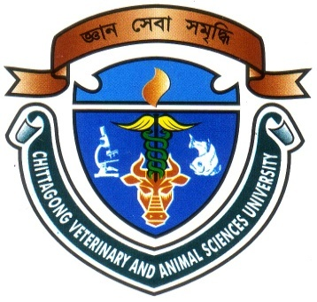

A production report submitted by
INTERN ID.: D-37

Roll No: 08/55

Reg. No: 397
Session: 2007-2008

Submitted to the Faculty of Veterinary Medicine, Chittagong Veterinary and Animal Sciences University in partial of the requirement for the fulfillment of the degree of Doctor of Veterinary Medicine (DVM)

Chittagong Veterinary & Animal Sciences University Khulshi, Chittagong- 4225.

January, 2014

A STUDY ON POSSIBLE CAUSES OF GOAT MORTALITY AT KHULSHI THANA IN CHITTAGONG DISTRICT

A production report

Submitted as per approved style and contents
MD. JALAL UDDIN RUMI  Internship ID: D-37  Roll No: 08/55  Reg. No.: 397  Session: 2007-2008 | Md. Emran Hossain  Associate Professor  Department of Animal Science and Nutrition  Chittagong Veterinary & Animal Sciences University.

January, 2014
ACKNOWLEDGEMENT

All praises are due to Almighty “God” who has created everything of the nature and who enable the author to complete this report. The author likes to give his best compliments to his parents. The author does not have adequate words to express his heartfelt sense of gratification sincere appreciation to his benevolent teacher and report supervisor. The author expresses his sincere gratitude, heartfelt respect and immense indebtedness to his supervisor Md. Emran Hossain, Associate professor, Dept. of Animal Science and Animal Nutrition, Chittagong Veterinary and Animal Sciences University for his guidance, valuable suggestions, inspiration and involvement. I would like to give special thanks to Dr. Bibek Chandra Sutradar, Associate professor, Director (External affairs), Department of Medicine and surgery for giving valuable advice about report writing. I would like to express my deep sense of gratitude and thanks to Vice Chancellor, Dr. A. S. Mahfuzul Bari and Dr. Kabirul Islam Khan, Professor Dean, Faculty of Veterinary Medicine, Chittagong Veterinary and Animal Sciences University.
Supervisors’ help and co-operation have been received from many persons during the tenure of this place of report. The author is immensely grateful to all of them, although it is not possible to mention every one by name.
My sincere thanks also goes to the Dr Md. Al Amran (CVASU graduate) and Dr M.S. Bari Lecturer, Dept. of Dairy and Poultry Science for their cordial help and left no stone unturned during data analysis.

The author
January, 2014.

Contents

Chapter | Contents | Page No.
 | Abstract | 1
Chapter I | Introduction | 2 - 3
Chapter II | Review of Literature | 4 - 5
Chapter III | Materials and Methods | 6 – 7
 | 4.1 Selection of study area | 6
 | 4.2 Duration of work | 6
 | 4.3 Sources of information | 6
 | 4.4 Methods of data collection  4.5 Category of causes | 6  6
 | 4.6 Statistical analysis | 7
Chapter IV | Results and Discussion | 8-13
 | 5.1 Mortality of goat with different risk factors | 8
 | 5.2 Mortality percentage due to different causes | 10
 | 5.3 Causes of mortality in different variable Area | 11
Chapter V | Conclusion | 14
 | References | 16-18

