INTRODUCTION

Livestock is recognized as an integral component of crop based agricultural production in Bangladesh. The economy of the country are largely depends on agriculture. Livestock being one of the components of agriculture which plays a vital role in national economy, it contributes about 2.95% Gross domestic product. The farmers mainly farm cows for milk purpose and beef production is very small. Livestock are rearing as a source of milk and meat. It also creates employment opportunity for the poor and landless peoples. Although the milks breeds and their crossbreds are available in Bangladesh however the meat type cattle breeds are not found.
Bangladesh is the world's third largest Muslim country in context of cattle population in the world. About 1.8 million cattle are sacrificed at Eid-ul-Azha in each year (Sujan et. al. 2011). Cattle fattening for beef production have become an important business of the small farmers in Bangladesh. Some landless people carry fattening program year round as a way of their livelihoods. They use traditional feeding practices with some treated feed staff.

Liver diseases have become one of the major causes of morbidity and mortality and animals all over globe and hepatotoxicity due to drugs appears to be the most common contributing factor. The use of remedies for the treatment of liver diseases has a long history and Liver tonic used all over the world in one form or the other for this purpose. Scientific evaluation of liver extract has often shown that active principles in these are responsible for therapeutic success. (Kanokwan Jarukamjorn et al. 2008).

Hepatic disease (Liver disease) is a term for a collection of conditions, diseases, and infections that affect the cells, tissues, structures, or functions of the liver. Liver has a wide range of functions, including detoxification, protein synthesis, and production of biochemical necessary for digestion and synthesis as well as breakdown of small and complex molecules, many of which are necessary for normal vital functions. (Kanokwan Jarukamjorn et al. 2008.)

There are no specific medicines uses as hepatoprotective, although different research works are going on some drug.In the current review, it had been tried to redefine the use of important hepatoprotective drugs like Liva vit liquid,Hepamin fort, Toxol liquid etc that consist of specific chemical constituents who have their specific hepatoprotective activity against hepatotoxicant like ethanol, chemicals and others. These Liver extract have shown the ability to maintain the normal functional statues of the liver with or without fewer side effects. These are the reason that’s why Liver extract hepatoprotectives are mostly preferred by medical practitioners, as well as over the counter.

Liver tonic is a useful source of vitamins, which could be used for beef fattening. The liver tonics are derived from beef liver extract. For raising beef industry in Bangladesh liver extract can be used as vitamin source economically. However the information about liver extract and liver tonic are very limited. Therefore, the current study was designed with the under objectives (i) to know the beef production system of Bangladesh; and (ii) to prepare liver extract as it widely used as hepatoprotectives.

REVIEW OF LITERATURE

The livestock production in Bangladesh is dairy based however beef is coming with the sideline of dairying. Although there are huge number of beef breed are available in the world but in Bangladesh unfortunately we have no beef breed. Some Indian breeds such as Brown swiss, Brahman, Nelore, Hariana, Amrit Mahal, Deoni (cattle), Gyr (cattle), Jaffrabadi, Kankrej cattle, Guzerat cattle, Kathiawadi , Khillari cattle, Mahesana (cattle), Malwa (cattle), Murha, Nagori, Nagpuri (cattle) and some of the Zebu breeds of India such as Tharparkar and Ongole Cattle could be adopted as beef production in Bangladesh.
There are three main stages in beef production: cow-calf operations, back grounding, and feedlot operations.
Cow-Calf Operation: A cow-calf operation is a method of raising beef cattle in which a permanent herd of cows is kept by a farmer to produce calves for later sale. The goal of a cow-calf operation is to produce young beef cattle, which are usually sold. Some operations may raise their calves until slaughter weight; others sell them as weaned calves. Cattle from a cow-calf operation may be sold after they have been weaned to be matured such as at a feedlot, or may be raised to near-slaughter weight and sold at the age of 1–2 years. Auctions are a common for sale or some prospective buyers buy calves from the producers with the price negotiated by their weight. When a calf is born, it weighs 60 to 100 pounds. Over the next few months, each calf will live off its mother’s milk and graze grass in pasture.
Weaning: Weaning is the removal of calf from its dam and herd-mates. The goal of weaning is raising productive calves moving on to the next stage of beef production. Beef calves are weaned at six to 10 months of age when they weigh between 450 and 700 pounds. These calves are grass-fed in pasture. . Pasture weaning minimizes environmental and nutritional stress by keeping calves in an environment and on a diet that they are provided. Pasture weaning offers a low-stress alternative to conventional dry lot weaning programs.
Stockers and Backgrounders: After weaning, cattle continue to grow and thrive by grazing during the stocker and backgrounder phase. Back grounding is a beef production system that involves maximum use of pasture and forages from the weaning to feedlot. An optimal back grounding weight gain is up to 800 pounds. The weight gain from back grounding comes primarily in the form of muscle and from fattening. These gains are accomplished maximum use of forages such as hay and silage in addition to pasture feeding. Grain is also used in most back grounding programs. Generally, calves less than 8 months of age in above-average body condition are not suitable because they lose weight and condition rapidly when fed high roughage rations are given. The system is suitable for a cow-calf operation where back grounding heifer calves would allow for a better selection of replacement heifers. Steer calves weighing 400-600 pounds are best suited for most back grounding programs. These calves are ready for finishing when they reach 850-1,000 pounds and usually are in high demand by cattle feeders.
Feedyard: The next step in beef production is when mature calves are moved to feed yards (also called feedlots). Here, they spend four to six months (Explore beef). Beef cattle production ranges from the beef cow herds that typically graze on pastureland or graze on the land after grain harvest to growing and finishing young cattle in feedlots. The feedlot-housing systems used in beef cattle production typically varies by climate and can range from open earthen lots with very little shelter to open shed and lot or an enclosed confinement building.

There is some beef production system used in the world such as:

Grazing systems: Animals grazing in rangelands, pastures, and grasslands and with little or no integration of crops involved. About 60% of the world's pasture land is covered by grazing systems. Grazing systems supply approximately 9 percent of the world's production of beef ( FAO statistics)

Integrated farming systems: An integrated farming system consists of a range of resource-saving practices that aim to achieve acceptable profits and high and sustained production levels.

Industrial production systems: Intensive or industrial factory farming of animals originated in the United States in the late 1930s. This has resulted in an integrated model of production, where large corporations control most aspects of animal husbandry in the food industry, processing of animals into food products, and sales to the consumer market.

Industrial production systems differ from grazing systems and integrated livestock-crop farming systems by their inclusions of various substances such as veterinary drugs, growth hormones, feed additives or nutraceuticals to improve livestock production effectiveness.
There are so many problems of beef cattle production in Bangladesh. The land for pasture/fodder production becomes gradually squished. So, there is shortage of animal feed. Lack of credit of poor farmers is the major problem for cattle fattening .Another problem is rearing hybrid cattle in our local atmosphere and weather. Marketing problem has also a negative effect on beef production in our country. Beef products are entirely in the hands of private sector. The shortage of livestock products, prices of beef were relatively high, transportation cost particularly in relation to average income levels and minimum basic rates of pay. Illiteracy is also a problem in our country.
Sarma et al. (2011) reported on Commercial Cattle fattening in small scale in Bangladesh by traditional feeding by poor farmers.
Beef production has several distinct and significant impacts on the human health and environment. Persistent organic pollutants such as dioxins, furans and polychlorinated bromides enter the human food chain through the diets of food animals. The source of these organic compounds for food animals is contaminated forage and soils. Ingestion of the dioxins and other compounds are absorbed and stored in the fat of the animal. By continually re-feeding fat from such animals, the dioxins are concentrated more and more, a process called bioaccumulation. When humans consume animal fat in meat and dairy products, they are exposed to these pollutants that are carcinogenic and toxic to the developing nervous system of the foetus and to young children.
Cattle are one of the most significant contributors to water pollution and soil degradation, and are a major source of greenhouse gas emissions which is threaten for human health. Finally, processing cattle into meat, meat by-products and leather is a major source of pollution in our countries. Disposal of organic cattle production waste without proper treatment leads to the pollution of water resources. As the global cattle industry has expanded, the beef slaughter and leather industries have grown vigorously. The waste from both slaughterhouses and tanneries—rich in organic matter, heavy metals and caustic solutions—is highly polluting without appropriate treatment. Beef production has an effect on climate change due to emissions of greenhouse gases such as methane, nitrous oxide and carbon dioxide. Research shows that methane produced by ruminant livestock accounts for between 7% and 18% which is threatened for human health.

Polly Walker et al. (2005) reported on public health implications of meat production and consumption. Ebinuma et al. (2004) reported that Additive therapeutic effects of the liver extract preparation mixture for chronic hepatitis. Baset et al. (2002) reported on cattle fattening for beef production in Bangladesh by feeding traditional feeds (green grasses, vegetable by product etc) and chemical treated straw.

Yokochi et al. (1997) reported that Stimulation of antiviral activities of interferon by a liver extract preparation. Preziosi et al. (1975) studied of a total liver extract in patients with hepatic dysfunction. Nappi et al. (1979) reported that Clinico-statistical findings on the effectiveness of the combination of iron, liver extract and vitamin B in anemias in obstetrico-gynecological disorders.

METHODOLOGY
The methodology of this study are done by two phage
Phage 1: Beef production:
The study was done in Sadar Thana at Dinazpur district from May to July during the internship placement. Five beef producers house was frequently visited to observe the feeding, vaccination and overall management of beef production system. The data was recorded.
Phage 2: Preparation and preservation of liver extract
For preparation of liver extract the required materials are-
- Pipette
- Beaker
- cheese-cloth
- Meat grinder
- Stirrer
The required solutions are-
- 95% alcohol
- 60% alcohol
- Ether
- Distilled water

The steps followed for the preparation of 60% alcohol
For preparation of 100ml 60% alcohol solution 60ml alcohol mix with 40ml water .
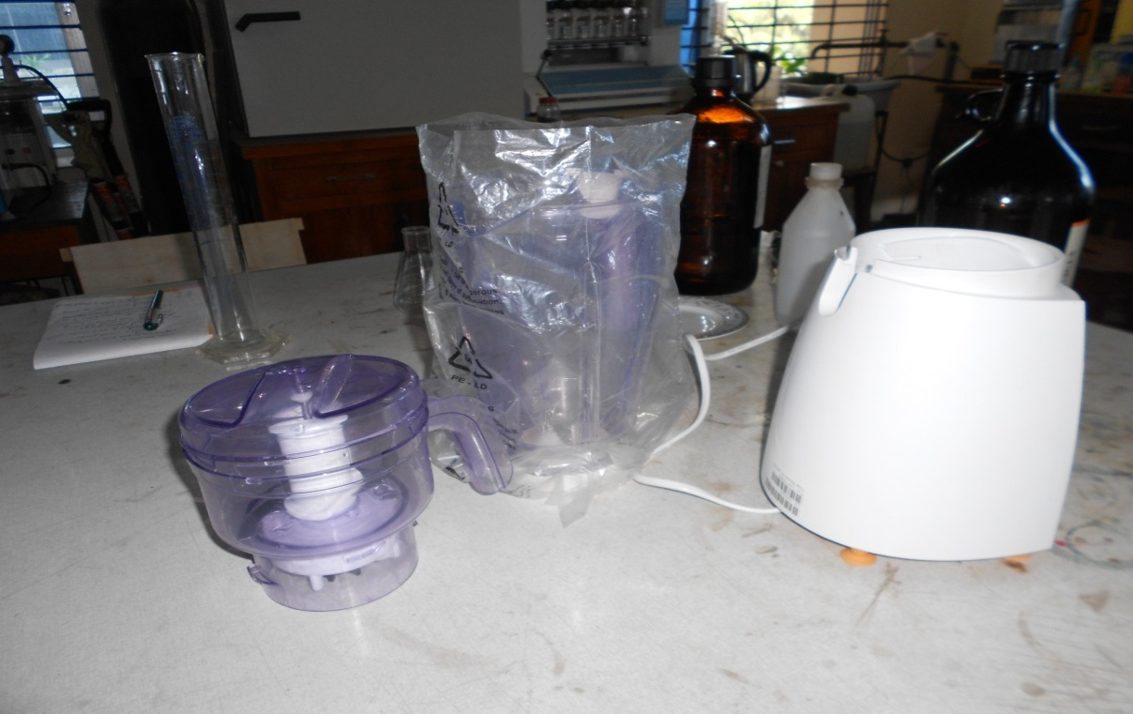

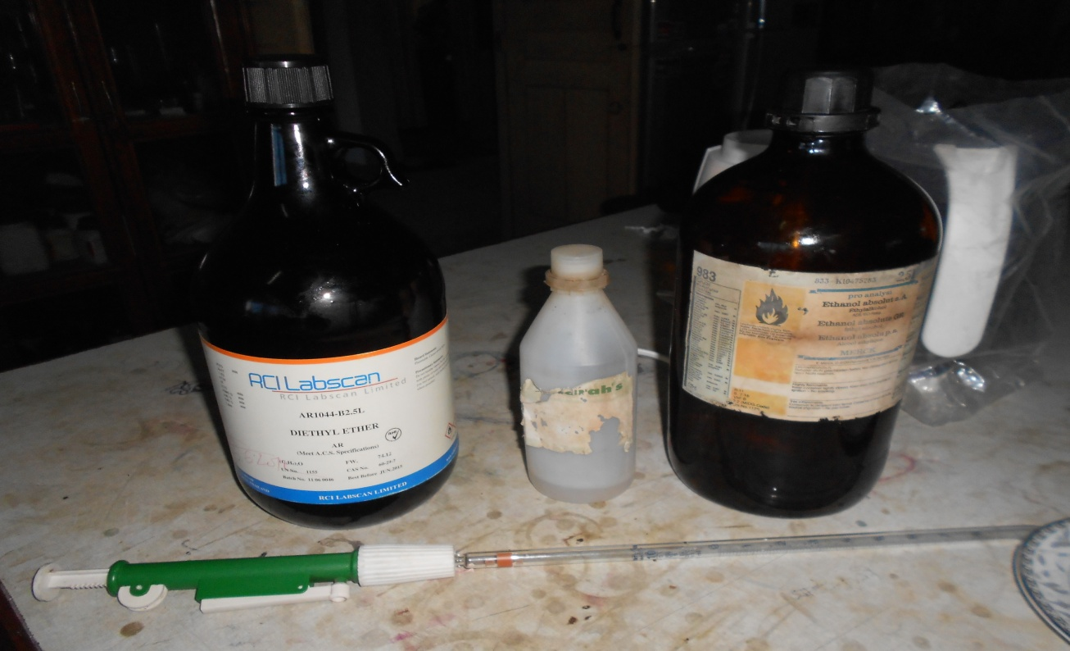
PREPARATION OF LIVER EXTRACT
Fig : Grinder Machine
Fig : 95% Alcohol, 60% Alcohol, Ether, Pipette
1kilo of fresh beef liver was ground in a meat grinder and mixed with 2 liters of 95 per cent alcoh The mixture was filtered through cheese-cloth and the material remaining in the cloth was pressed in a filter press. The residue was treated twice with lliter of 60 per cent alcohol, filtered, and pressed. The combined filtrates were distilled under reduced pressure to a volume of 100 ml, extracted three times with ether, and filtered. Traces of ether were removed by distillation under reduced pressure.
The steps followed for the preparation of Liver extract for the trail-
100gm beef liver
↓
Grinding in a meat grinder
↓
Mixed with 200ml of 95%alcohol
↓
The mixture was filtered through cheese cloth & the remaining materials was pressed
↓
The residue was treated twice with 100ml of 60%alcohol & filtered & pressed
↓
Distilled with 100ml of water
↓
Treated 3 times with 100ml of ether & filtered
↓
Trace amount of ether were removed by 100ml of distilled water under reduced pressure.
↓
Production of liver extract
PRESERVATION
For preservation of Liver extract it was preserved half in the Refrigerator & half in the Hot Air Oven.

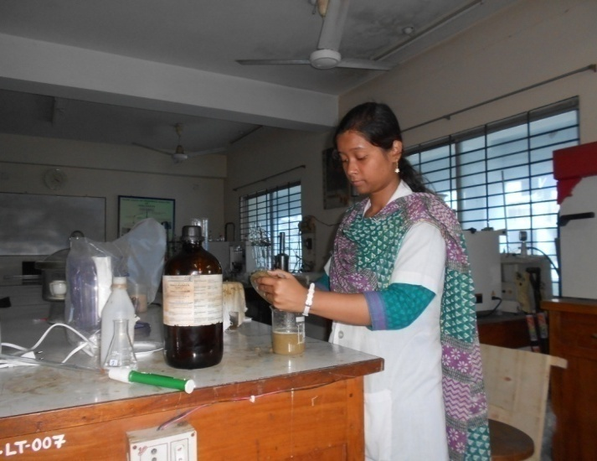
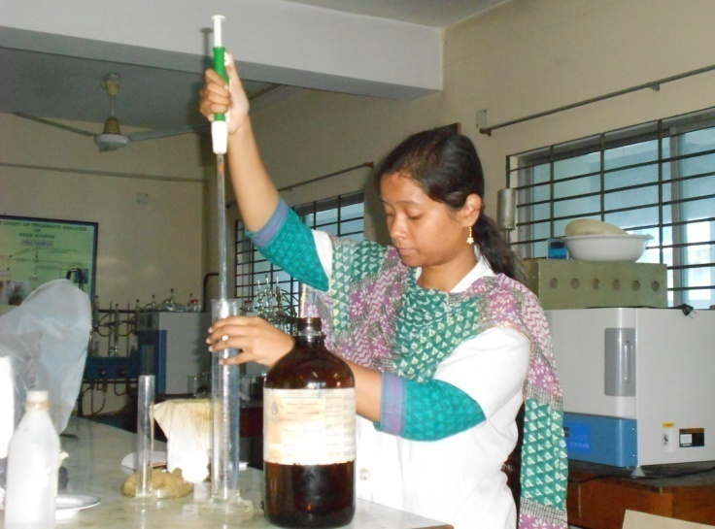
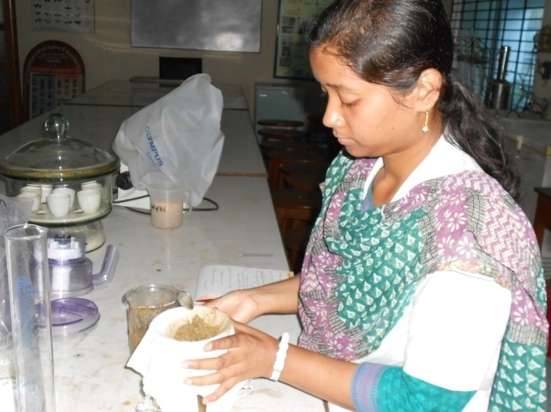
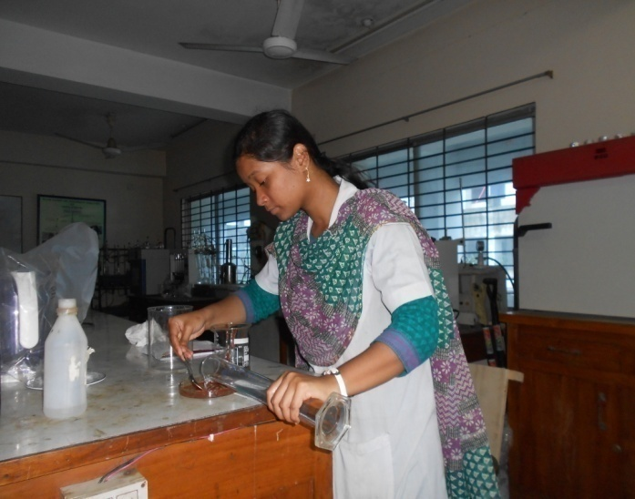
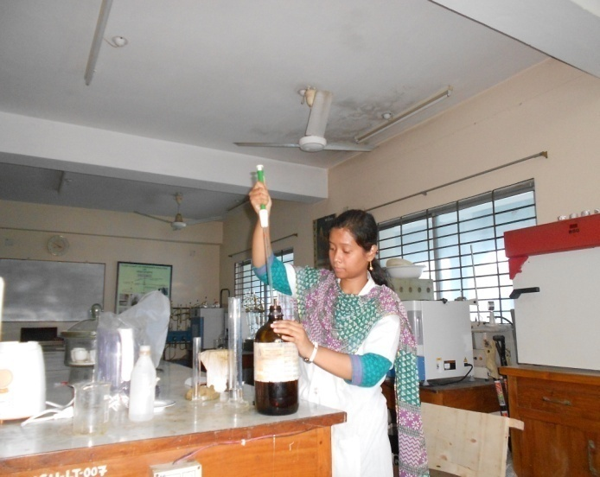
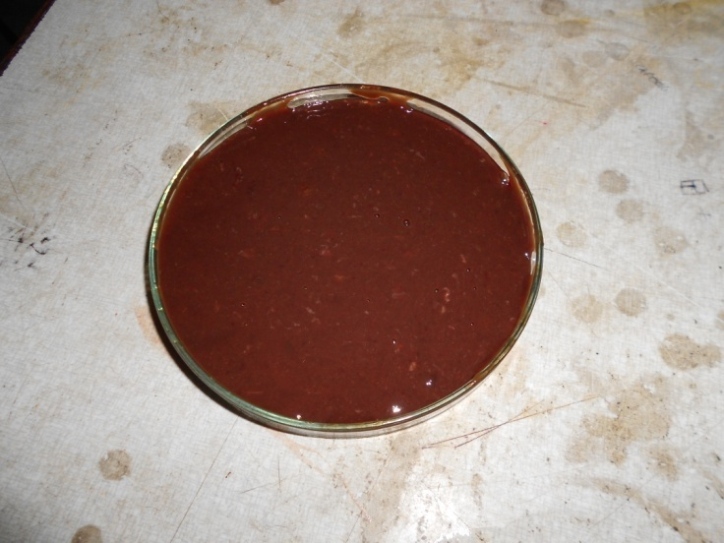
Fig : 60% alcohol mix with grinding liver
Fig : Filter the mixture
Fig : 100gm Grinding Liver
Fig : Taken 200ml 95% alcohol
Fig : Taken 100 ml 60% alcohol
Fig : Alcohol mixed with grinding liver
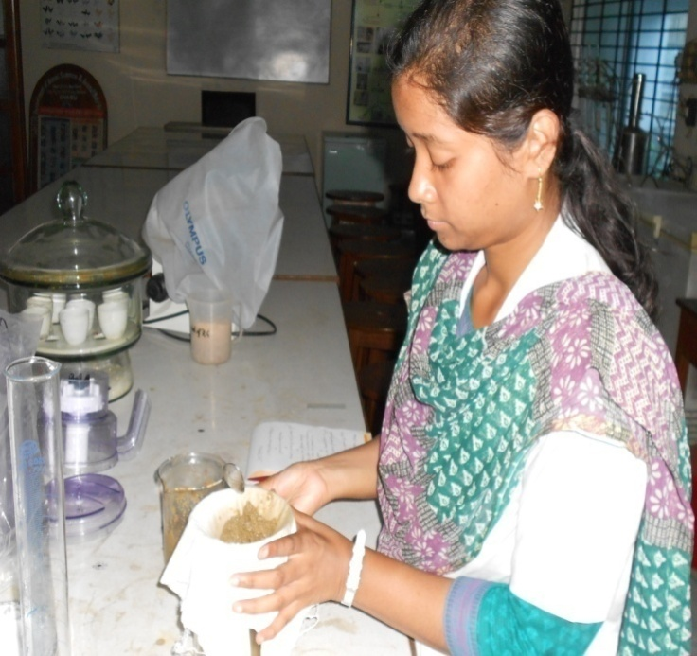
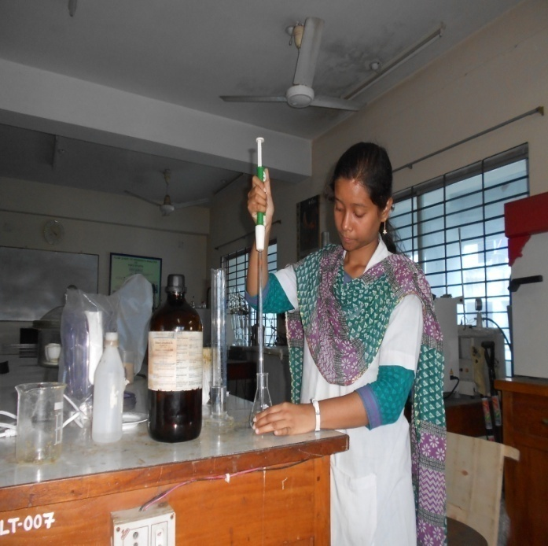
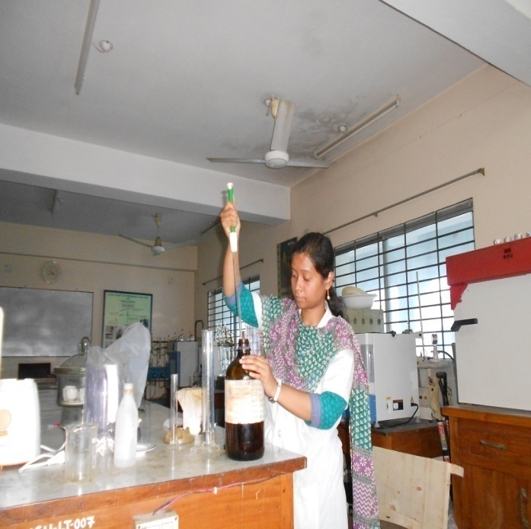
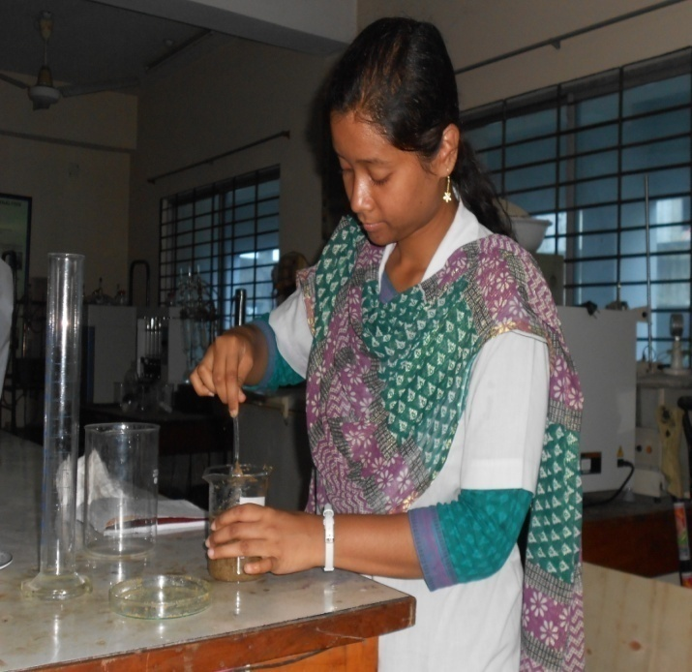
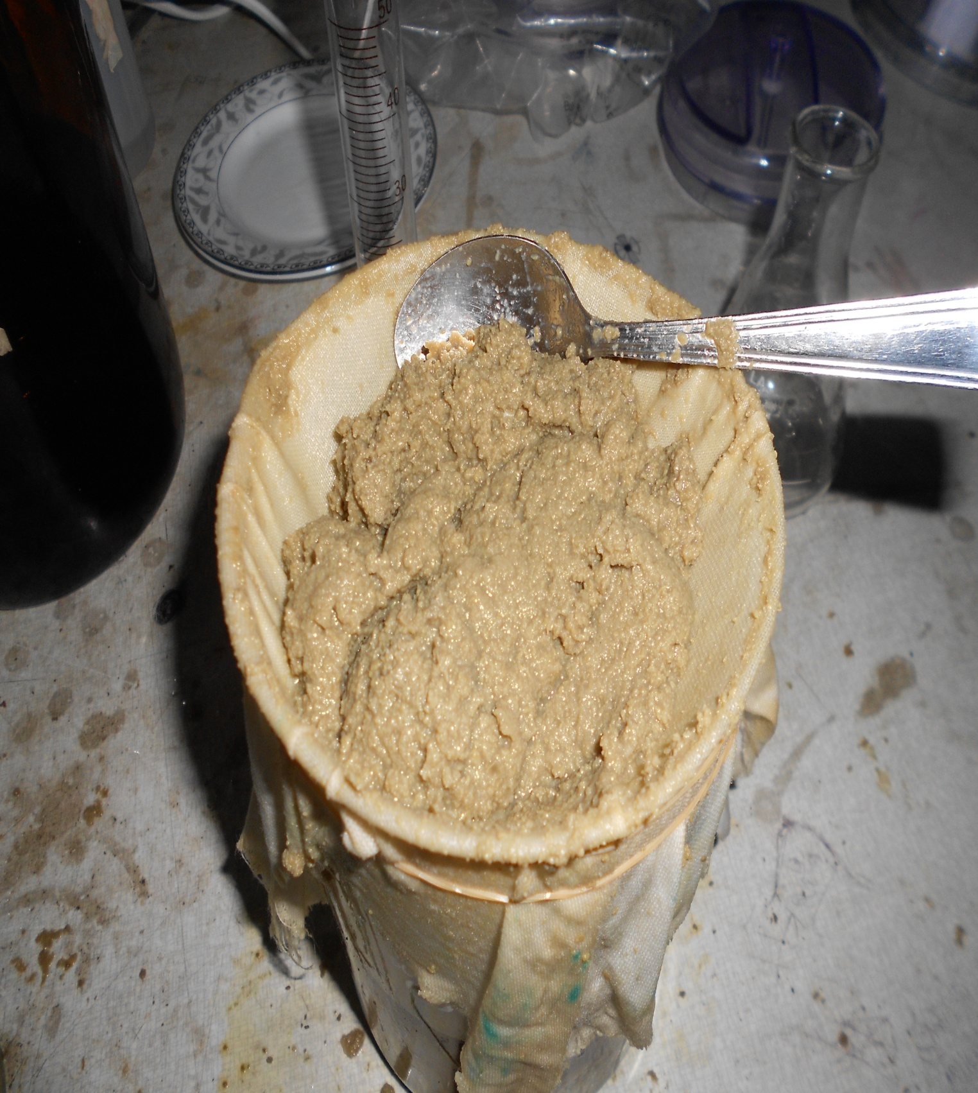
Fig : Mixed with ether and filtered.
Fig : Distillation the liverextract.
Fig : Taken 100ml ether.
Fig : Filter the mixture
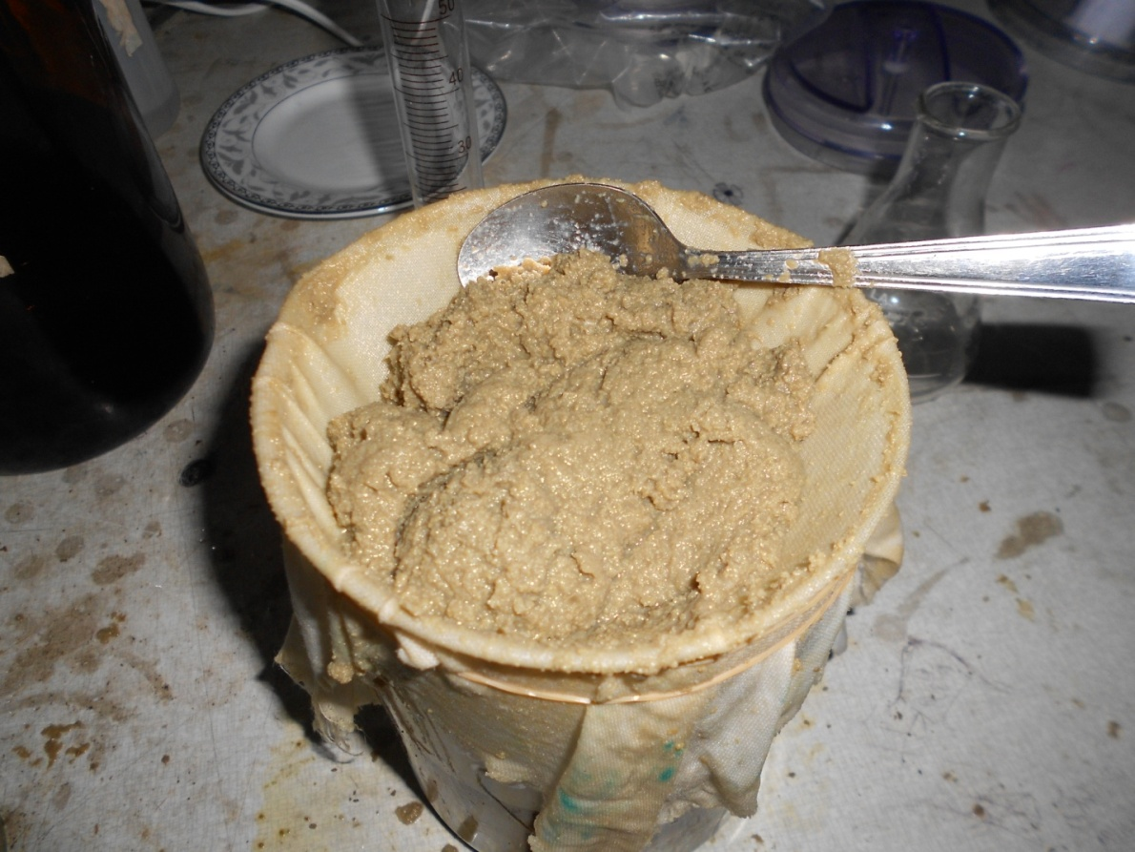

Fig : Preparation of liver extract

RESULT AND DISCUSSION

Generally the beef producers started their programme before 2-3 month of Eid-ul-Azha (Muslim festival). However, some farmers carry fattening program year round as a way of their livelihoods. They use traditional feeding practices with some treated feed. They use rice straw of traditional varieties, green grass (road sides and weeds), sugarcane tops, wheat and rice bran, molasses, pulses bran and locally available resources such as pumpkin, carrot, banana, and vegetable by products, rice gruel, boiled rice bran etc for beef fattening. Farmers also use concentrates which consists of rice bran wheat bran, oil cakes, pulse bran, molasses and some cases fish meal and contribute 6.8% of the total dry matter. The improved feeding such as urea treated of straw and urea molasses block (UMB) supplement were used by the farmers. There are also advantages; the rural farmer use locally available cattle feed resources. Family members of the farmer are involved in feed processing and offering feed daily.
For faster growth of cattle some growth hormones are used for improving feed efficiency, carcass quality and muscle development. There are three natural hormones (estradiol or estrogen, progesterone and testosterone) and their synthetic alternatives (zeranol, melengestrol acetate, and trenbolone acetate) and some steroid drugs have been approved for beef fattening. Estrogen, progesterone and testosterone are naturally present in beef cattle whether or not they have been treated with hormones. . Current scientific evidence does not support the hormonal substance use in animals because of development of human cancer.
Castration has a negative effect on growth rate and carcass characteristics of cattle. Some farmers used cattle of 2-3 years of age and some farmers used cattle of 1-2 years age. Separate houses for cattle fattening were provided by the farmers. Farmers dewormed their cattle before starting the fattening programs .Women is involved in rural areas in our country.
Liver extract was prepared from beef liver, which is the composition of Liver Tonic. Liver Tonic could be produced from liver extract, which increased the growth rate, body weight and feed consumption rate.
CONCLUSION

It can be concluded that the beef production systems of Bangladesh is almost new and it is simply the cattle fattening by feeding the growing cattle with improve feed is becoming a livelihood programme.
Liver extract was prepared from beef cattle which can compete with the liver disorders. The impact of the prepared Liver extract is better than the plant extract available in the market. So we can easily prepare it in our country in large amount to make it available in market, which will be a strong Liver tonic for animal body.
In this study there were some limitations such as study period, number of studied beef farm and cattle population. If more farm could be selected and the study period would increased then a valid conclusion could be drown. Although beef industry can be established with minimum support and it will become a viable industry for livelihood in Bangladesh.

IMPLICATION OF LIVER EXTRACT

Liver extract is used for improving liver function treating chronic liver diseases, preventing liver damage, and regenerating liver tissue. It is also used for allergies; chronic fatigue syndrome (CFS); enhancing muscle development in bodybuilders; improving stamina, strength, and physical endurance; removing chemicals from the body (detoxification); and as an aid to recovery from chemical addiction or poisoning.
Liver extract contains vitamin B12, folic acid, and iron. In animals, it seems to increase the number of liver cells.
Liver extract and desiccated liver have been marketed as iron supplements for over a century. The extract is processed cow liver that may either be a freeze-dried brownish powder or a concentrated liquid that has had most of the fat and cholesterol removed. Medically, liver extract was initially used by doctors in the 1920s to treat pernicious anemia in patients. After its success in treating pernicious anemia, liver extract was used for other forms of anemia, strengthening liver function, and even body building ( Natural Standard-Liver extract,2013)
Preliminary clinical studies indicated that liver extract may be helpful in treating hepatic dysfunction. In addition, liver extract seems to work synergistically with interferon in treating hepatitis C and other viral infections ( Natural Standard-Liver extract,2013).
Laboratory studies indicated that liver extract may have some effects that could be useful in treating certain forms of cancer, such as the ability to direct migration of metastasizing cells and the inhibition of DNA, RNA, and protein formation ( Natural Standard-Liver extract,2013).
COMPOSITION OF SOME LIVER TONICS
FROM LIVER EXTRACT

Composition:
Liva vit Liquid
Each Litre contains-
Vitamin B₁ 5,000 mg.
Vitamin B₂ 2,000 mg.
Vitamin B₆ 2,000 mg.
Vitamin B₁₂ 10,000 mcg.
Vitamin K₃ 650 mg.
Folic Acid 300 mg.
Nicotinamide 60,000 mg.
Liver extract 200 mg.
Vitamin B5 11,000 mg.
Inositol 1,000 mg.
Cholin Chloride 50,000 mg.
D L Methionine 50,000 mg.

Hepamin Fort
Colin Chloride Yeast Extract
VitaminB1,12
Liver extract
Niacin DL-Panthel
Innositol
Impro-Liv
Colin Chloride
FeCl
LysineInnositol
Liver Extract
Metheionin
Nicotinamide
Pantothenic acid Biotin
VitB1,B12
Toxol Liquid
Cholin
Metheionin
Innositol
B12
Live r Extract
Amino-Nitrogen

REFERENCES

Beef Production –US Environmental Protection Agency. www .epa.gov/ oecaagct / ag 101 / printbeef.html. Agency.

CSIR, 1952. The Wealth of India - Raw Materials. Vol. III,pp.127. CSIR, New Delhi.

Hoffman,B.R. and Atlas,H.D.and Blanco.k. and Wiederhold,N. Lewis,R.E. Williams,L. 2004.Pharm.J, Biol.

Jarukamjorn ,k.et al. 2008. Journal of health science.

Jaffet,W.G. and Elvehjem,C.A. July,1947. The Journal Biological Cbemibty..

Jim Gerrish, Weaning on Pasture for Low-stress Beef Production , Forage Systems Update Vol 7, No. 4 October 1, 1998

Kambizi, L. and Afolayan, A. J. 2008. African Journal of Biotechnology.

Kaslow JE.and Rucker, L.and Onishi, R. 1989. Liver extract-folic acid-cyanocobalamin vs placebo for chronic fatigue syndrome.

Natural Standard - Liver extract,2013. www.naturalstandard.com/.../liv

P. K. Sarma and J. U. Ahmed ,An economic study of small scale cattle fattening enterprise of Rajbari district Bangladesh Agricultural University Research System (BAURES), Bangladesh Agril. Univ. 9(1): 141–146, 2011

Speedy AW. Global production and consumption of animal source foods. Journal of Nutrition 2003; 133,4048S–53S.

Sujan, O.F., Siddque, M.A.B. and Karim, M.F. 2011. “Study on cattle fattening practices of some selected areas of Rangpur district in Bangladesh” Bangladesh Research Publications Journal. Vol. 5(2). pp 125-132.

Zucker, F. and Zucker, L. M.1946 .Abstracts, American Chemical Society, 1l0th
meeting, Chicago.

