Chapter-1

1. Introduction

Livestock has been considered as an important component of the mixed farming system, practiced in Bangladesh. For centuries Bangladesh has 24 million cattle, out of which 6 million are dairy cattle of local and crossbreds (DLS, 2008) and maintain the highest cattle densities of 145 large ruminants per square kilometer compared with 90 for India, 30 for Ethiopia, and 20 for Brazil (Karim, 1997). The numbers of dairy farms are estimated to be 1.4 million with an average small herd size of 1-3 cows (Hemme, 2008) which is an integral part of the mixed farming systems in Bangladesh (Saadullah, 2001) and a predominant source of income, nutrition and jobs (Haque, 2009). In Bangladesh the best local cattle are available in some selected areas like Pabna, Sirajgonj, Chittagong and Munshigonj areas. In Chittagong, a beautiful Red cattle with some distinct characteristics are seen known as Red Chittagong Cattle (RCC) (Khan et al. 2000). Beside those, we have some crossbred animals that provide higher amount of meat and milk and better performance but they are prone to suffer from various diseases (Samad, 1988). Milk production of both local and exotic breed depends not only on the genetics, but also its interaction with the environment, and some other managemental factors. Harris and Winkelman (2000) and Verkerk et al. (2000) reported significant differences between cows
of New Zealand origin and those of North American origin for conception rate, services per conception, and days to first service. Environmental factors, such as season of calving affected the milk yield. There are many factors which affect on milk yield, lactation length is one of the main factors affecting milk yield and itself is influenced by other factors (Bajaw et al., 2004). The phenotypic correlation between milk production and calving interval is the highest producers within the herd have longer calving intervals than their contemporaries producing less milk (Miller et al., 1967). Early maturity is considered as a character of great importance as from birth to the date of first calving. The crossbred cows reached the peak level of milk production in third lactation whereas the native cattle reached this level in their fourth lactation (Khan et al., 1989). Maize silage is the most economic and common forage produced in the world, and is used very commonly in the dairy cattle breeding by enriching it with protein in USA, Netherlands, Germany and France. The maize silage has an important effect on the milk yield (Aktürk et al., 2010).
In India as a whole, the disease causes a milk loss about 3,508 million liters which is about 6.5% of total annual milk output in the national level (Saxerm, 1994). Mastitis is the most prevalent production disease in dairy herds world-wide and is responsible for several production effects (Seegers et al., 2003). Good animal health is vital for maximum production since cattle must be healthy to reach their performance potential (The Merck Veterinary Manual, 2005).

Objectives

The objectives of this study were
- To know the descriptive statistics of different studied variables
- To study the factors that affects the milk production considering multiple regression models

Chapter-2

2. Review of Literature

A lot of genetical, environmental and managemental factors associated with milk production.
Cross-Breeding of local cows with Australian, Shahiwal, Holstein Frieisian, Jersy are often seen in rural areas and these cross breeds give higher yield in terms of milk. The average milk yield per day per cow was 1.89 litres and 7.68 litres for local breed and cross breed dairy cows respectively and total costs per day of rearing per local and cross breed cow were Tk.32.85 and Tk.71.23 respectively (Mondal et al., 2010). The average lactation period of indigenous cows was 228 days observed by Zafar et al. (2008). A studied by Habib et al. (2010) reported that lactation order significantly (P<0.05) affected production except lactation length. Cows in 5th lactation produced highest total (604.3 ± 69.3 kg) and daily milk yield (2.17 ± 1.8 kg). Cows aged 6 – 7 years has best lactation yield (576.8 ± 60.5 kg). The relationship between age at first calving and milk yield in first lactation was found statistically non-significant (Khan et al., 1989; Patil et al. 1980). There is a direct relationship between milk produced in the first lactation and a longer calving interval (Millar et al., 1967) and found that the highest producers within the herd have longer calving intervals than their contemporaries producing less milk. Tahir et al. (1989) reported that, milk yield is maximum in 5th lactation of Sahiwal cows. Dahlin (1998) and Ahmad (1999) also reported increase in milk yield towards third parity. Javed (1999) reported that lowest milk yield of 1st parity and increase in milk yield towards 5th parity and decline thereafter to 12th parity. In an Indian study on Sahiwal cattle (Deshpande and Sakhare, 1984), maximum milk yield was also reported for the 5th parity. A contradictory report that parity had no significant effect on milk yield (Dhumal et al., 1989). Milk yield gradually increased towards 4th and 5th parity and declined thereafter Bajaw et al. (2004). A study of Bajaw et al. (2004) stated that season of calving is significantly (P<0.01) affected milk yield and lactation length. Winter calvers produced more milk (1546 kg) as compared to summer calvers (1362 kg). Dahlin (1998) also reported that Sahiwal cows calving in winter season produced more milk than those calving in other seasons. Supply of abundant green fodder in winter as compared to summer season was given a plausible cause. Iqbal (1996), Talbott (1994), and Ahmad et al. (1978) also reported higher milk yield for Sahiwal cows calving in winter months than those calving in other seasons. Area of farm also affects the milk yield.

A study observed by (Aktürk et al., 2010), while analyzing the effects of the feeds used in dairy cattle breeding in the research region on the milk yield it has been found out that maize silage and barley have the highest effect on the milk yield, the direct effect of barley and maize silage on the variation of milk production is 13.99%. and 20.35% respectively. A study revealed in Chittagong that, Red Chittagong cattle has some distinct characteristics and produced 2.0 ± 0.65 kg milk in farm condition and 1.80 ± 0.87 kg in rural condition per day (Khan et al. 2000). Rahman et al. (2009) observed that the prevalence of mastitis is higher (P<0.01) in wet than in dry season. On average, 18.7% quarters has mastitis during the wet season and 6.9% in the dry season dairy farms of Bangladesh (Weiss et al., 1997).

Chapter-3

3. Materials and Methods

3.1 Data
A cross-sectional study was carried out to investigate the factors affecting on milk production. A total of 96 cows of different ages and breeds were randomly selected and data on different parameters on milk production were collected through questionnaire during the period from 6 May to 6 July 2013.

3.2 Variables description

In this study some covariates listed in Table 1 were used to explain the response variable.
Table 1: Description of different variables for the study of milk production
Variables | Description | Type of variables
ID | Cows identification code | Categorical
Daily milk production | Milk production measured in liters | Quantitative
Lactation period | Lactation period measured in months | Quantitative
Age of first calving | The age of cows at first child measured in months | Quantitative
Parity | Number of parities | Categorical
Calving interval | The interval between two successive calving measured in months | Quantitative
Type of food | Indicates different food categories Roughage (R), Green grass (G), Concentrate (C). The coding was G, RG, GC, RGC | Categorical
Mastitis | Indicates mastitis absent or present | Categorical
FMD | Indicates FMD absent or present | Categorical
Vaccination use | Indicates Vaccination use (Yes or No) | Categorical
Anthelmentics use | Indicates Anthelmentics use (Yes or No) | Categorical

Since the data set contains categorical and quantitative variables. In the regression model, the (c-1) dummy variable needs to be created for each categorical variable, where c is defined as the number of levels for each categorical variable. The predictors are therefore defined as follows

Breed $X_{1}=\left\{\begin{aligned}1, Local \\ 0, Cross\end{aligned}\right.$
Lactation period ($X_{2}$)
Age of first calving ($X_{3}$)
Parity  $$X_{4_1}=\left\{\begin{aligned}1, if parity=1 \\ 0, parity=6\end{aligned}\right.$$ | $$X_{4_2}=\left\{\begin{aligned}2, if parity=2 \\ 0, parity=6\end{aligned}\right.$$ | $$X_{4_3}=\left\{\begin{aligned}1, if parity=3 \\ 0, parity=6\end{aligned}\right.$$
$$X_{4_4}=\left\{\begin{aligned}1, if parity=4 \\ 0, parity=6\end{aligned}\right.$$ | $$X_{4_5}=\left\{\begin{aligned}1, if parity=5 \\ 0, parity=6\end{aligned}\right.$$
Calving interval ($X_{5}$)
Mastitis  $$X_{6}=\left\{\begin{aligned}1, Yes \\ 0, No\end{aligned}\right.$$ | FMD  $$X_{7}=\left\{\begin{aligned}1, Yes \\ 0, No\end{aligned}\right.$$
Type of food  $$X_{8}=\left\{\begin{aligned}1, G \\ 0, RGC \\ \end{aligned}\right.$$ | $$X_{9}=\left\{\begin{aligned}1, RG \\ 0, RGC\end{aligned}\right.$$ | $$X_{10}=\left\{\begin{aligned}1, GC \\ 0, RGC\end{aligned}\right.$$
Vaccination
$$X_{11}=\left\{\begin{aligned}1, Yes \\ 0, No\end{aligned}\right.$$
Anthelmentics use  $$X_{12}=\left\{\begin{aligned}1, At times \\ 0, No\end{aligned}\right.$$ | $$X_{13}=\left\{\begin{aligned}1, Regular \\ 0, No\end{aligned}\right.$$

3.3 Methodology

3.3.1 Exploratory data analysis

Exploratory data analysis (EDA) is an approach for data analysis that employs a variety of techniques of graphical, statistical summarizes (Tukey, 1977). The variables mentioned in this study were quantitative and qualitative. Since the proper statistical tools used to describe and analyze the data will depend on the type of data (Mendenhall and Sincich, 2007).

3.3.2 Multiple Regression Model

Multiple regression analysis is one of the most widely used of all statistical methods which is an extension of univariate regression model where accumulates more than one predictors. Cohen (1968) and Hardy (1993) proposed that any combination of categorical and continuous variables can be analyzed within a multiple regression model framework simply through the dummy coding of the categorical variables. In general, a multiple regression model is:
$$Y_{i}=β_{0}+β_{1}X_{i1}+β_{2}X_{i2}+⋯⋯⋯⋯⋯⋯+β_{p}X_{ip}+ε_{i} ;i=1,2,………,96$$
Where every terms express:
$Y_{i}$ denotes the response (daily milk production) in the i^{th} trial. $β_{0},β_{1},β_{2},….,β_{p}$ are the parameters of the model $X_{i1},{ X}_{i2,}………, X_{ip}$ are the predictors of the ith observation and $ε_{i}$ is the error term. The important assumptions of regression model are:
- The regression function is linear
- The error terms are normally distributed
- The error terms have constant variance
- The error terms are independent

3.4 Software

SAS 9.2, SPSS 16.0 and R 2.12.0 version were used during analysis and 5% level of significance was considered.

Chapter-4

4. Result

4.1 Exploratory data analysis

Among the total 96 cows, 83 were local and 13 were cross breed. Table 2 presents the summary statistics of continuous variable where the average milk production was 2.23 liters, and the maximum and minimum was 12 and 1 liters respectively. The mean lactation period was 6.71 months, while minimum and maximum were 5 and 9 months respectively. The average age of first calving was 41.33 months with the range between 39 and 45 months. The average calving interval was 13.22 months with the range between 12 and 14 months.

Table 2: Summary statistics of some continuous variables
Variables | Mean | Std Dev | Minimum | Maximum
Daily milk production | 2.23 | 2.07 | 1 | 12
Lactation period | 6.71 | 0.87 | 5 | 9
Age of first calving | 41.33 | 1.18 | 39 | 45
Calving interval | 13.22 | 0.68 | 12 | 14

The prevalence of mastitis in this study was about 16% and the chance of having mastitis of local and cross breed 15.7% and 15.4% respectively in Figure 1a. The prevalence of FMD was about 17% and the proportion of FMD of local and cross breed were 18.1% and 7.7% respectively in Figure 1b. It was observed that the local breed were more susceptible to affect FMD.
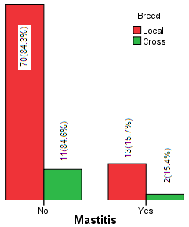 | 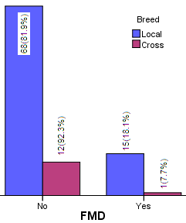
Fig1a: Proportion of Mastitis across Breed | Fig 1b: Proportion of FMD across Breed
Figure 1: Proportion of mastitis and FMD across breed
The daily milk production was higher for cross breed cows than local breed. 50% of cows produce 5 liters milk daily for crossbreed whereas 50% of local breed cows produced 1.5 liters Figure 2a. It was observed that milk production decreases after second parity and it was peak at second parity accounted by 2.5 liters Figure 2b. Milk production was higher when roughage, green grass and concentrate were given as a food comparatively other foods and amounted by 2 liters Figure 2c. Lactation period was moderately higher (8 months) for cross breed cows as compare to local breed (7 months) Figure 2d. It was to be seen that calving interval for two breeds were same as 13 months Figure 2e. The median first calving age was for cross breed 43 months and for local breed 41 months Figure 2f.

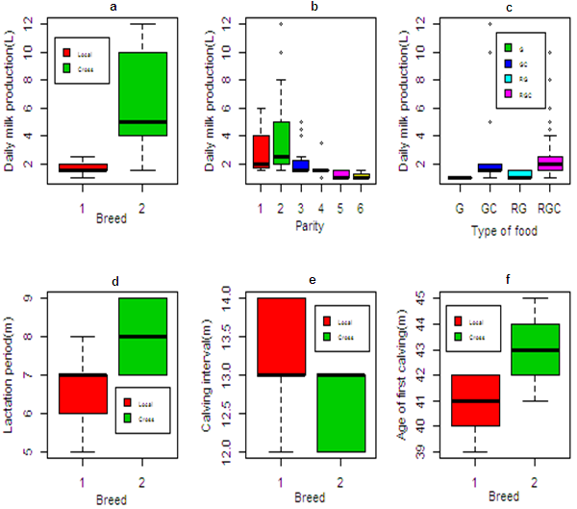

Figure 2: Different box plot across breed, parity and type of food

A total of 83 local breed cows, 70 cows used no vaccination which was 84.3% and only 13 (15.7%) cows used vaccination. On the contrary, among 13 cross breed cows, only 2(15.4%) used no vaccination but 11 cows used vaccination which was 84.6% Figure 3a. For local breed, 63 (75.9%), 2(2.4%) and 18 (21.7%) cows used anthelmentics at times, no, regular respectively. In contrast, for cross breed, only 2(15.4%) and 11(84.6%) used anthementics at times and regular basis respectively, no cows were found without anthelmentics Figure 3b.
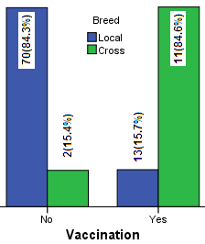 | 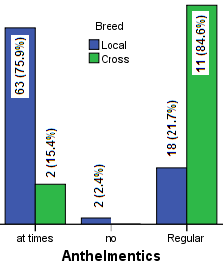
Fig 3a. Vaccination use across breed | Fig 3b. Anthelmentics use across breed

Figure 3: Vaccination and anthelmentics use across breed
The histogram of daily milk production denoted as Y was not normal after taking inverse transformation it was almost normal Figure 4.
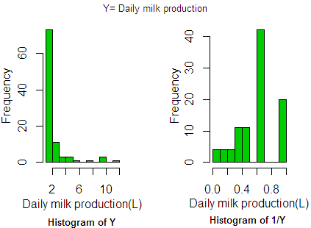
Figure 4: Histogram of Y and 1/Y

4.2 Multiple Regression Model

A multiple regreesion model was employed to explain or predict the values of response by covariates. A model was selected based on model selection criteria of $R_{a,p}^{2}$ , C(P) and AIC. The seleced model was:
$$Inverse\left(Y\right)=β_{0}+β_{1}X_{1}+β_{2}X_{2}+β_{3}{X_{4}}_{_1}+β_{4}X_{4_2}+β_{5}X_{4_3}+β_{6}X_{4_4}+β_{7}X_{4_5}+β_{8}X_{5}+β_{9}X_{8}+β_{10}X_{9}+β_{11}X_{10}+β_{12}X_{13}+β_{13}X_{14}+ε_{i}$$
It was observed that the variables $X_{13}$ and $X_{14}$ were highly correlated, consequently we deleted those variables from the model due to multicollinearity. After fitting the model all assumptions were checked. Taking original response variable the model was not normally distributed, after inverse transformation the model was satistfied all aforesaid assumption. The final refined model is:
$$Inverse\left(Y\right)=β_{0}+β_{1}X_{1}+β_{2}X_{2}+β_{3}{X_{4}}_{_1}+β_{4}X_{4_2}+β_{5}X_{4_3}+β_{6}X_{4_4}+β_{7}X_{4_5}+β_{8}X_{5}+β_{9}X_{8}+β_{10}X_{9}+β_{5}X_{10}+ε_{i}$$

Where $X_{1}=$ Breed , $X_{2}=$ Lactation period , $X_{4_1}=$ 1 when Parity=1, $X_{4_2}=$2 when Parity=2, $X_{4_3}=$1 when Parity=3, $X_{4_4}=$1 when Parity=4, $X_{4_5}=$1 when Parity=5, $X_{5}=$Calving interval, $X_{8}=$Type of food (G), $X_{9}=$Type of food (RG), $X_{10}=$ Type of food (GC). There was no multicolinearity among the predictors tested by variance inflation factor (VIF), all VIF’s were less than 10 indicates colinearity absent. Graphical representation of normality, constancy of variance and independence of residuals were shown in appendix Figure 5. The Shapiro-Wilk test was employed for testing the normality of error terms by analyzing the residuals. This test showed that the error terms were normal with statistic w = 0.984, p-value = 0.308, which gave strong evidence that the residuals were normally distributed. To check the constancy of variance, Levene test was performed which gave a test statistic of t= 1.43 with p-value=0.155, thus giving evidence in favor of constancy of variance. The lack of fit test confirmed that a linear function was a good fit for the data (F=0.47; P-value=0.959).
The analysis of variance model shows in Table 3 that all predictors were significantly associated with the model. The selected fitted model explains 82.60 percent of the total variability in inverse(Y).

Table 3: Analysis of variance (ANOVA) table
Source | DF | Sum of Squares | Mean Square | F Value | Pr > F
Model | 11 | 5.17371 | 0.47034 | 42 | <.0001
Error | 84 | 0.94064 | 0.0112
Corrected Total | 95 | 6.11436

Table 4 presents the parameter estimates of daily milk production. It was observed that breed, lactation period, parity, calving interval, type of food were significantly related with milk production p-value<0.05, meaning that all predictors were significantly different from zero. It was observed from regression parameter estimates Table 4 that the expected inverse of daily milk production was positively associated with breed. For local breed the expected value of milk production was 1.81and for cross breed it was 3.30 so, the expected value of milk production was higher for cross breed while other variables kept constant. The expected inverse of milk production was negatively associated with lactation period. The expected of daily milk production 4.135 of one unit increase lactation period. Parity was negatively associated with milk production. It was seen that second parity was significantly associated and third parity was borderline significant. In second parity, the expected milk production was about 15 as compared to reference group (6th parity). In 3rd parity, it was 5.22 as compared to reference group. The coefficient of parity 1, parity 4 and parity 5 were not significantly different from zero. The expected milk production 1.76 when food was given only green grass, 2.36 for roughage and green grass, 2.58 for green grass and concentrate, when all other terms were fixed the expected milk production was 3.30 when food was given roughage, green grass and concentrate.
Table 4: Parameter estimates from multiple regression model
Parameters | Estimates | Standard Error | t Value | Pr > |t| | VIF
Intercept | 0.3034 | 0.3523 | 0.86 | 0.3915 | 0
Breed | 0.2477 | 0.0386 | 6.42 | <.0001 | 1.4962
Lactation period | -0.0616 | 0.0193 | -3.19 | 0.002 | 2.3954
Parity (1) | -0.1333 | 0.0773 | -1.72 | 0.0883 | 2.045
Parity (2) | -0.2352 | 0.059 | -3.99 | 0.0001 | 5.2682
Parity (3) | -0.1119 | 0.0563 | -1.99 | 0.0503 | 4.9523
Parity (4) | -0.0801 | 0.0512 | -1.57 | 0.1213 | 4.0894
Parity (5) | 0.0682 | 0.0518 | 1.32 | 0.192 | 3.3552
Calving interval | 0.0427 | 0.021 | 2.03 | 0.0455 | 1.753
Type of food (G) | 0.2635 | 0.1184 | 2.23 | 0.0287 | 1.2387
Type of food (RG) | 0.1198 | 0.032 | 3.75 | 0.0003 | 1.6873
Type of food (GC) | 0.0832 | 0.0323 | 2.57 | 0.0119 | 1.3663

Chapter-5
5. Discussion and Conclusion

5.1 Discussion

A total of 96 cows was randomly selected from 6 May to 6 July 2013 during the period of UVH placement. An exploratory data analysis was conducted to get insight the view of data. The average milk production was 2.23 liters with range between 1 and 12 liters. Grossly the prevalence of mastitis was about 16% whereabout local breed (15.7) and cross breed (15.4).
The prevalence of FMD of local and cross breed was 18.1% and 7.7% respectively. The daily milk production was higher for cross breed cows as compared to local breed. The age of first calving for local and cross breed was 41 and 43 months respectively. Almost all cross breed cows used vaccination and anthelmentics.
A multiple regression model was fitted with this original response but the residuals violated the all assumptions. After that an inverse transformation was taken of response and a multiple regression model was fitted with inverse response variable (daily milk production) or (1/Y) based on model selection criteria $R_{a,p}^{2}$ , C(P) and AIC. All assumptions were checked and satisfied regarding the validity of used model. the expected milk production was higher for cross breed than local while other variables kept constant. Lactation period was one month higher for cross breed as compare to local breed. The expected daily milk production was 4.135 of one unit increase lactation period, Bajwa (2004) showed that lactation length is one of the main factors affecting milk yield. Milk production decreases with parity increases except at the time of second parity. Milk production was peaked for second parity. Javed (1999) reported that the milk yield increase towards 5th parity and decline thereafter to 12th parity. An Indian study on Sahiwal cattle (Deshpande and Sakhare, 1984) showed that maximum milk yield was also reported for the 5th parity. A contradictory report that parity had no significant effect on milk yield (Dhumal et al., 1989). Calving interval was same for both breeds. The expected milk production was 2.88 liters when one unit increase of calving interval. There is a direct relationship between milk produced with longer calving interval (Millar et al. 1967). The milk production was higher for giving roughage, green grass and concentrate (RGC) as compared to other types of food. A similar study was found by (Aktürk et al., 2010) where barley and maize silage were directly related on milk yield.

5.2 Conclusion

From this study it may be concluded that breed, lactation period, parity, calving interval, types of food were significantly associated with milk production. In spite of some pit falls of the study like small sample size and short time, the findings will certainly help the future researcher for conduct more specific research in the study area.

References

Ahmad, M. (1999) Genetic evaluation of native and crossbred dairy cattle in Pakistan. Ph. D. Thesis, Univ. New England, Australia.
Aktürk, D., Bayramoğlu, Z., Savran, F. and Tatlidil F. F. (2010) The Factors Affecting Milk Production and Milk Production Cost: Çanakkale Case – Biga. Kafkas Univ Vet Fak Derg, 16(2), 329-335.
Ahmad, Z., Ahmad, M.D., Qureshi, A.W. Gill, R.A. and Fahmy, S.K. (1978) Genetic progress through selection in performance traits of Sahiwal cattle. Agric. Res. Rev., (Cairo) 56, 1-6.
Bajwa, I.R., Khan, M.S., Khan, M.A. and Gondal, K.Z. (2004) Environmental factors affecting milk yield and lactation length in Sahiwal cattle. Pakistan Veterinary Journal, 24(1), 23-27.

Cohen, J. (1968) Multiple regression as a general data-analytic system. Psychological Bulletin, 70, 426-443
Dahlin, A., Khan, U.N., Zafar, A.H., Saleem, M., Chaudray, M.A. and Philipsson, J. (1998) Genetic and environmental causes of variation in milk production traits of Sahiwal cattle in Pakistan. Animal Science, 66(2), 307-318.

Deshpande, K.S. and Sakhare, P.G. (1984) Milk producing ability in Red Kandhari cows and its crosses. Cherion., 13, 271-273.

Dhumal, M.V., Salhare, P.G. and Deshpande, K.S. (1989) Factors affecting l actation milk yield and lactation length in Red Kandhari and crossbred cows. Indian J. Dairy Sci., 42, 102-104.
DLS 2008 Annual report on livestock, Division of Livestock Statistics, Ministry of Fisheries and Livestock, Farmgate, Dhaka, Bangladesh.

Gaur, G.K., Kaushik, S.N. and Garg, R.C. (2002) Ongole cattle status in India. Anim. Genet. Res. Info., 32, 27-34.
Habib, M.A., Afroz, M.A. and Bhuiyan, K.F.H. (2010) Lactation performance of Red Chittagong Cattle and effects of environmental factors. The Bangladesh Veterinarian 27(1), 18 – 25
Haque, S.A.M. (2009) Bangladesh: Social gains from dairy development. In Animal Production and Health Commission for Asia and the Pacific and Food and Agriculture Organization (APHCA-FAO) publication on smallholder dairy development: Lessons learned in Asia , RAP publication 2009/2.
Hemme, T. (2008) IFCN Dairy Report. International Farm Comparison Network. IFCN Dairy Research Center. Kiel Germany. 25-29.
Hardy, M.A. (1993) Regression with dummy variables. London: Sage Publications.
Harris, B.L. and Winkelman, A.M. (2000) Influence of North American Holstein genetics on dairy cattle performance in New Zealand. Proceedings of the New Zealand Large Herds Conference, 6, 122-136.

Iqbal, J. (1996) Sire evaluation on partial records in Sahiwal cattle and Nili-Ravi buffaloes. Ph.D. Thesis, Univ. Agric., Faisalabad.
Javed, K. (1999) Genetic and phenotypic aspects of some performance traits in a pure bred herd of Sahiwal cattle in Pakistan. Ph.D. Thesis, Univ. Agric., Faisalabad.
Karim, Z. (1997) Agriculture for 21st century in Bangladesh. In: A final draft policy report on National Livestock Development Policy, Ministry of Fisheries and Livestock, Dhaka, Bangladesh.
Khan, M.K.I., Huque, K.S., Miah, A.G. and Khatun, M.J. (2000) Study on the performance of Red Chittagong Cows under different production system. Pakistan J. Bio. Sci., 3(2), 318-319.
Khan, U.N., Benyshek, L.L., Ahmad, M.D., Chaudhary, M.Z. and Athar, S.M. (1989) Influence of age at first calving on the milk production of native and crossbred dairy cows. AJAS, 2(4), 565-570.
Miller, P., Van Vleck, L. Dale and Henderson, C.R., (1967) Relationships Among Herd Life, Milk Production, and Calving Interval. Faculty Papers and Publications in Animal Science. Paper 418.
Mendenhall. W and Sincich. T. (2007) Statistics for Engineering and the Sciences, 5th ed. New Jersey: Prentice Hall.

Mondal, R.K., Sen, S. and Rayhan, S.J. (2010) A comparative economic analysis of local breed and cross breed milk cow in a selected area of Bangladesh. J. Sci. Foundation, 8(1 & 2), 23-29.

Patil, R.R., Singh, G., Parshad, M., Sharma, R.K. and Dhaka, B.S. (1980) Milk yield of crossbred (Friesian × Sahiwal) cows in relation to age at first calving, lactation length, service and dry period. Indian J. Dairy Sci., 33(4), 519-521.

Rahman, M.A., Bhuiyan, M.M.U., Kamal, M.M. and Shamsuddin, M. (2009) Prevalence and risk factors of mastitis in dairy cows. The Bangladesh Veterinarian 26(2), 54 – 60.
Saadullah, M. (2001) Smallholder Dairy Production and Marketing in Bangladesh. Paper presented at South-South Workshop on Smallholder Dairy Production and Marketing. NDDB-ILBS, Ahmedabad, India., I. L a, 13-16.
Samad (1988) Gross and histological studies on bovine babesiosis in Bangladesh. Indian J. Anim. Sci. 58, 926.
Saxerm, R. (1994). Economic value of milk loss caused by foot-and-mouth disease (FMD) in India.

Seegers, H., Fourichon, C. and Beaudeau, F. (2003). Production effects related to mastitis and mastitis economics in dairy cattle herds. Veterinary research, 34(5), 475-491.

Singh, G., Gaur, G.K., Nivsarkar, A.E., Patil, G.R. and Mitkari, K.R. (2002) Deoni cattle breed of India. A study on population dynamics and morphometric characteristics. Anim. Genet. Res. Info., 32, 35-43.
Tahir, M., Qureshi, M.R. and Ahmad, W. (1989) Some of the environmental factors influencing milk yield in Sahiwal cows. Pakistan Vet. J., 9: 173-175.
Talbott, C. W., 1994. Potential to increase milk production in tropical countries. PhD Thesis, North Carolina State University, Raleigh, USA.

Tukey, J. (1977) Exploratory Data Analysis. Addison-Wesley.

The Merck Veterinary Manual (2005) Ninth Edition. Merck and Company, Inc., Whitehouse Station, NJ.
Verkerk, G.A., Morgan, S. and Kolver, S. (2000) Comparison of selected reproductive characteristics in Overseas and New Zealand Holstein-Friesian cows grazing pasture or fed a total mixed ration. Proceedings of the New Zealand Society of Animal Production, 60, 270-274
Weiss, W. P., Hogan, J. S., Todhunter, D. A. and Smith, K. L. (1997) Effect of vitamin E
supplementation in diets with a low concentration of selenium on mammary gland health
of dairy cows. J. Dairy Sci., 80, 1728-1737.
Zafar, A.H., Ahmad, M. and Rehman, S.U. (2008) Study of some performance traits in Sahiwal cows during different periods. Pakistan Vet. J., 28(2), 84-88.

Appendix
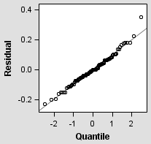 | 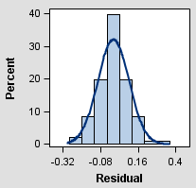
Fig. 5a. Normal probability plot | Fig.5b. Normal probability plot with histogram
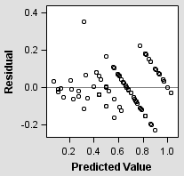 | 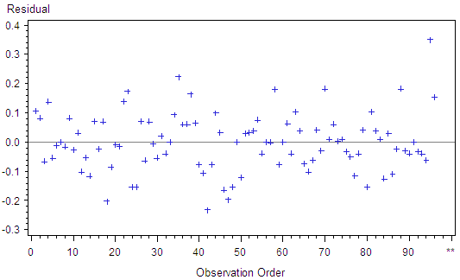
Fig. 5c. Plot of constant variance of residual | Fig. 5d. Plot of independence of residual

Figure 5: Diagnostic plots of normality, constant variance and independence of residual

