Surgical Correction of Aural Hematoma in a Cat: A Case Report

A clinical report submitted in partial satisfaction of the requirement for the Degree of Doctor of Veterinary Medicine (DVM)

By:
Khan Shahoria Rifat
Roll No: 18/55
Reg No: 03019
Intern ID: 51
Session: 2017-18

Faculty of Veterinary Medicine
Chattogram Veterinary and Animal Sciences University
Khulshi, Chattogram – 4225, Bangladesh

Surgical Correction of Aural Hematoma in a Cat: A Case Report

Approved by:

(Sharmin Chowdhury)
Professor
Department of Pathology and Parasitology

Faculty of Veterinary Medicine
Chattogram Veterinary and Animal Sciences University
Khulshi, Chattogram – 4225, Bangladesh

Statement of Author

I, Khan Shahoria Rifat, certify unequivocally that I have performed all the tasks detailed in this report. The data was gathered from books, national and international periodicals, and other sources. All citations have been properly acknowledged. Consequently, I am solely responsible for collecting, manipulating, preserving, and publishing all data compiled in this report.

The Author

Acknowledgements

The author wishes to acknowledge the immeasurable mercy of Almighty ‘God’, the foremost authority and supreme ruler of the universe, who permits the author to complete this work successfully. The author expresses his deepest perception of gratitude, respect, and immense gratefulness to his honourable teacher and supervisor, DR. Sharmin Chowdhury, Professor, Department of Pathology and Parasitology, Faculty of Veterinary Medicine, Chattogram Veterinary and Animal Sciences University for his academic guidance, generous supervision, precious advice, constant inspiration, radical investigation and effective judgment in all steps of the study.
The author would also like to thank DR. Mohammad Bayazid Bostami, assistant professor, and Dr. Abdul Mannan, Deputy chief veterinary officer and director in charge, Teaching and Training Pet Hospital and Research Center, Purbachal, Dhaka.
The author expresses his genuine gratitude and respect to the honourable teacher Prof. Dr. Mohammad Lutfur Rahman, Dean, Faculty of Veterinary Medicine, and Prof. Dr. A. K. M. Saifuddin, Director of External Affairs, Chattogram Veterinary and Animal Sciences University, for proceeding with this internship program.

Table of Contents
Statement of Author ii
Acknowledgements iii
List of Figures v
Abstract vi
1. Introduction 1
1.1 Goals and objective of the study 2
2. Materials and Method 3
2.1 Study area: 3
2.2 Case description: 3
2.3 Clinical examination: 3
2.4 Diagnostic protocol: 4
2.5 Treatment procedure: 4
2.6 Surgical procedure: 5
2.7 Post operative medication: 8
3. Result and Discussion 9
4. Conclusion 11
5. Limitations of the study: 12
6. References 13
Biography of Author 15
Appendix 16

List of Figures
Figure 1: A Persian Cat presented to the TTPHRC with Aural Hematoma (clinical examination) 4
Figure 2: Drainage of Blood from Hematoma with the help of Butterfly needle and syringe 5
Figure 3: After preparation of the surgical site 6
Figure 4: S shaped incision at the surface of the surgical site 6
Figure 5: Flushing out remaining debris with normal saline 7
Figure 6: After successful surgical correction 7
Figure 7: During follow up period (after 7 days of surgery) 8

Abstract
Aural hematomas in cats represent a challenging concern in feline veterinary medicine due to their multifactorial etiology and potential for recurrence. This case study documents the diagnosis and treatment of a 3-year-old male Persian cat with a recurring aural hematoma. The cat initially underwent non-surgical intervention involving needle drainage and corticosteroid therapy, which offered symptomatic relief but failed to prevent recurrence. Subsequently, a surgical approach was employed, involving incisions to drain accumulated blood and 'through and through mattress' sutures for wound closure. Post-operative care included antibiotics and corticosteroid therapy. The case emphasizes the importance of a comprehensive approach, considering non-surgical and surgical interventions based on the condition's severity and recurrence. Findings align with previous research highlighting the value of advanced diagnostic tools, such as ultrasound, in diagnosis and the significance of vigilant monitoring to address recurrence. Tailored post-operative care, including nutritional support and psychological enrichment, contributed to the cat's recovery. This study contributes to the collective understanding of aural hematoma management in feline patients, emphasizing the need for individualized treatment and ongoing research to refine and enhance treatment modalities.

Keywords: aural hematoma; persian cat; surgical correction; recurring hematoma.

1. Introduction
Aural hematoma, a condition characterized by the accumulation of blood within the ear flap's layers (auricle), represents a significant concern in feline veterinary medicine (Hewitt & Bajwa, 2020). Cats, known for their unique ear anatomy featuring a dense network of small, fragile blood vessels, are particularly susceptible to this condition (Seibert & Tobias, 2013). Aural hematoma typically arises from a combination of factors, including underlying ear infections, infestations such as ear mites, allergies, or irritations (Kennis, 2013). Trauma plays a pivotal role in this condition, often initiated by the cat's vigorous scratching or head shaking in response to discomfort, itching, or irritation (Kennis, 2013). This persistent self-inflicted injury leads to damage to the delicate blood vessels within the ear tissue, culminating in the accumulation of blood and ultimately resulting in a hematoma (Ghate et al., 2022). If left untreated, aural hematomas can have several detrimental effects on the affected feline. One of the most apparent consequences is chronic pain and discomfort. Cats with aural hematomas may exhibit signs of head tilting, ear drooping, or reluctance to allow their ears to be touched (Kennis, 2013). Furthermore, the increased pressure from the hematoma can lead to ear disfigurement, affecting both the cosmetic appearance and functionality of the ear (Itoh et al., 2022). The resultant ear deformity is not only aesthetically distressing but also potentially impacts the cat's ability to hear, adding to its overall discomfort and distress. Additionally, the accumulated blood within the ear creates a favorable environment for secondary bacterial infections. These infections can exacerbate the cat's discomfort and may require additional treatment, including antibiotic therapy (Jithil & Amrutha, 2023). The psychological toll on the cat, alongside the financial burden on the owner, underscores the necessity of prompt and effective treatment for aural hematomas (Larem et al., 2021; Palagiano et al., 2023). The management of aural hematomas in cats encompasses various treatment approaches, with medical and surgical interventions being the primary options. Medical treatment typically involves draining and aspirating the hematoma, often combined with corticosteroid therapy to reduce inflammation. This approach is sometimes chosen for milder cases or for feline patients that are not surgical candidates (Folk et al., 2022). However, surgical correction is frequently favored, particularly in cases where the underlying cause, such as an ear infection, has not been fully addressed. Surgical techniques for correcting aural hematomas include incision and drainage, where a small incision is made to allow the accumulated blood to drain, and the insertion of drainage devices that facilitate the gradual removal of blood from the ear tissue (Canpolat et al., 2022). Surgical correction offers several advantages over medical treatment. It addresses the root cause of the hematoma by removing the accumulated blood and repairing the damaged blood vessels. This approach not only provides more immediate relief but also significantly reduces the risk of hematoma recurrence. The overall success rate of surgical correction is high, making it a preferred choice for veterinarians in managing aural hematomas in cats (Chadzimisios et al., 2019).

In this case study, we delve into a surgical approach to aural hematoma correction in a feline patient, providing in-depth insights into the intricacies of the surgical procedure, postoperative care, and outcomes. The case presented here exemplifies the critical role of timely surgical intervention in mitigating suffering and significantly improving the quality of life for cats afflicted with aural hematomas.

1.1 Goals and objective of the study
1. Describe the pre-operative, operative and post-operative procedures for aural hematoma correction in a cat.
2. Offer evidence-based recommendations to the veterinary community to effectively manage and prevent aural hematomas in cats.

2. Materials and Method

2.1 Study area:
The study was conducted in Teaching & Training Pet Hospital and Research Centre, Purbachal, Dhaka. The hospital is governed by Chattogram University of Veterinary and Animal Sciences (CVASU).

2.2 Case description:
A 3-year-old male Persian cat, weighing 6 kg, was brought to Teaching & Training Pet Hospital and Research Centre (TTPHRC) with a visibly swollen right ear that had been bothering him for a few days. with the aim to better understand the situation, the veterinary staff discovered that the cat belonged to a Noman group, Gulshan which comprised of over 30 cats. Upon further inquiry, the owner did not report any episodes of fighting or any signs of infection among the cats. The cat's diet consisted of commercial cat food, boiled chicken, and vegetables, and its feed intake remained the same. The concerned owner had been closely monitoring the cat's condition for two days before finally seeking medical attention at the hospital.

2.3 Clinical examination:
During the clinical examination, the veterinarian noted several significant findings that helped in diagnosing the cat's condition. The cat's temperature was recorded as 102 degrees Fahrenheit, which is normal temperature. Moreover, all other vital signs, including heart rate, respiration rate, and mucous membrane colour, were found to be normal.
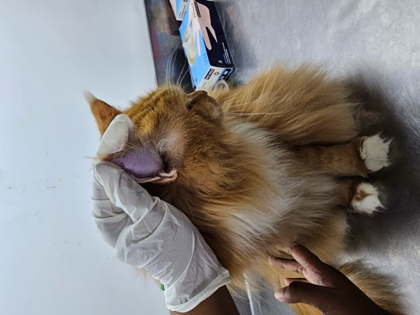
Figure 1: A Persian Cat presented to the TTPHRC with Aural Hematoma (clinical examination)

It was observed that the cat had been regularly dewormed and vaccinated as per the schedule. The vet also noticed that the cat had a swollen ear pina, which was causing the cat discomfort and pain. Further examination revealed a hematoma in the ear, which was causing pressure and pain. A needle puncture was performed to extract the accumulated blood. Additionally, ear mites were found in the ear wax sample, indicating the presence of an infestation, which was contributing to the cat's overall health issues. Overall, these findings were crucial in helping the veterinarian accurately diagnose and treat the cat's condition.

2.4 Diagnostic protocol:
During the examination, only inspection and palpation were used as diagnostic techniques without any other tools. A needle puncture was performed to confirm the hematoma.

2.5 Treatment procedure:
The skilled veterinarian chose to take a non-surgical approach to treat the hematoma. The first step involved a thorough cleaning of the affected area using povidone-iodine. Then, a delicate butterfly needle was carefully inserted into the hematoma to drain out all the accumulated blood. Afterwards, cotton and Savlon solution were applied to the ear with firm pressure to halt any bleeding. The owner was given clear instructions to administer medication and closely monitor the pet's condition.
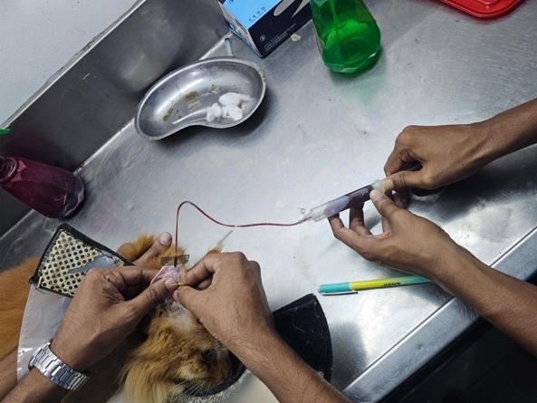
Figure 2: Drainage of Blood from Hematoma with the help of Butterfly needle and syringe

In order to prevent infections, the cat was prescribed Syrup Cef-3 (third generation of Cephalosporin – 15 to 25 mg per kg body weight) twice a day, at a dose of 3.5ml after meals for 7 days. Additionally, the cat was prescribed Syrup Cortisol (Prednisolone – 0.5 to 1mg per kg body weight) at two different dosages: 3ml in the morning and night for the first 5 days, and 1.5ml in the morning and night for the next 5 days. Finally, the veterinarian recommended bringing the cat back to the clinic immediately if any blood accumulation was observed in the area again.

2.6 Surgical procedure:
The patient was brought to hospital again after 7 days with swollen ear again. Then the vet decided to approach with the surgical procedure. Xylazine (1.2mg per kg body weight) as 0.36ml was administered to the cat as intramuscular injection as preanesthetic.
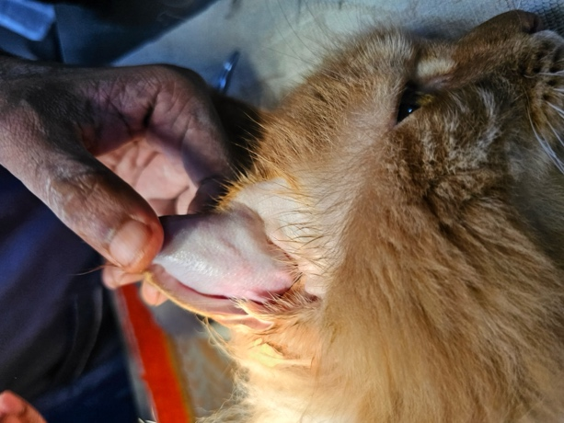
Figure 3: After preparation of the surgical site
Then carefully the ear pina was shaved. Then disinfection protocol was maintained: first washing the area with savlon, then rubbing with povidone iodine and finally application of 70% alcohol cleaned the area. Then ketamine (8mg per kg body weight) 0.9ml administered intravenously.
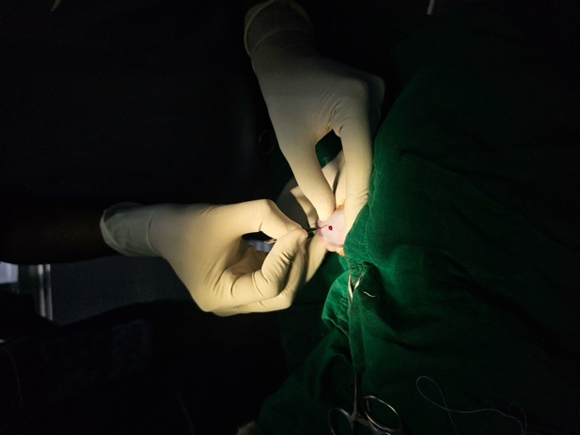
Figure 4: S shaped incision at the surface of the surgical site
A normal saline was administered intravenously as 1 drop per 4 seconds to prevent the fluid loss during the surgical procedure. With the help of a sharp scalpel, few small ‘S’ shaped incision was made at the earlobe skin to drain accumulated blood. Firm pressure was applied to ear to expel out all the debris and clotted blood.
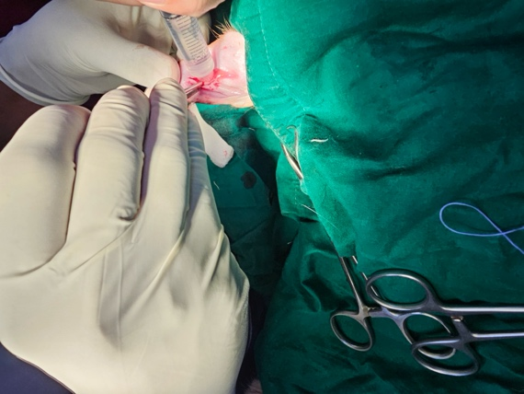
Figure 5: Flushing out remaining debris with normal saline
The wound was first washed with normal saline prior to povidone iodine to clean thoroughly and expel remaining debris. The swollen ear drastically reduced but the ear was in hanging condition. Then ample number of ‘through and through mattress’ suture were applied to close the open wound and secure further bleeding.
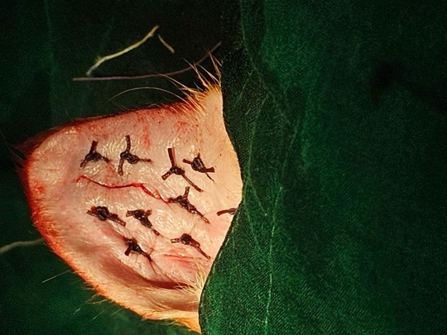
Figure 6: After successful surgical correction

2.7 Post operative medication:
The previous treatment was advised to continue for 10 more days. The team advised the owner to provide complete rest, close supervision, and nutritious liquid/semi-liquid feeding for a few days. After seven days, the owner was instructed to bring the cat for a follow-up. After one-week, clinical examination showed all the vital signs were normal, but the cat was still a bit depressed. Psychological support, such as giving more time, walking, playing was suggested rather than using any medication.
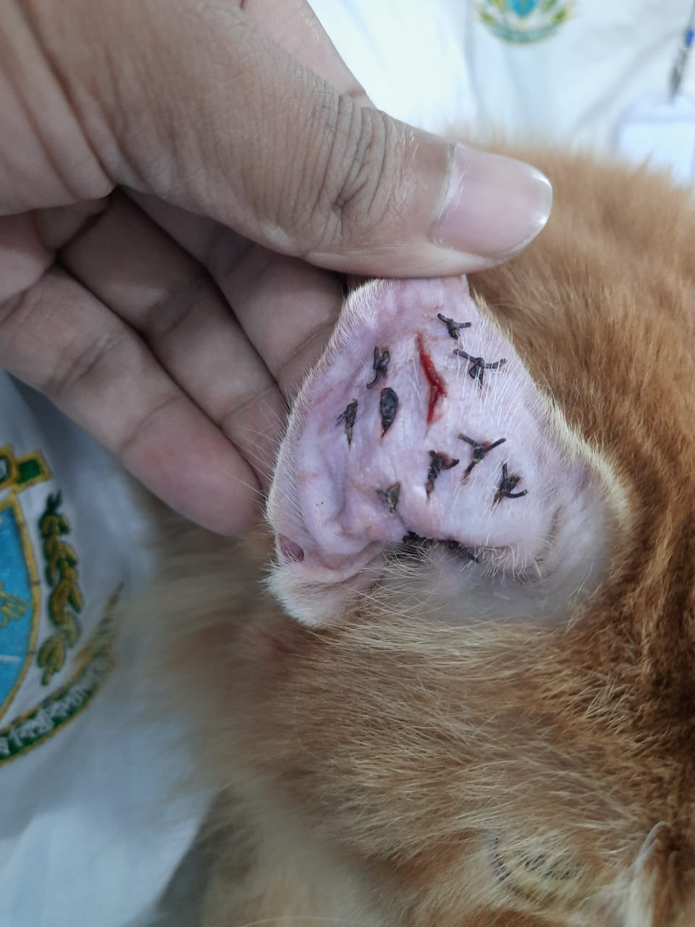
Figure 7: During follow up period (after 7 days of surgery)

3. Result and Discussion
In the present case study, a 3-year-old male Persian cat with a visibly swollen right ear was successfully treated for an aural hematoma. The cat was brought to Teaching & Training Pet Hospital and Research Centre (TTPHRC) due to this condition, which had been causing discomfort for several days. The veterinary examination revealed that the cat had an elevated body temperature but exhibited normal vital signs. The diagnosis confirmed the presence of a hematoma in the ear, which was further exacerbated by the discovery of ear mites infestation. The initial treatment involved a non-surgical approach, with needle puncture to drain the accumulated blood. Post-drainage, the cat was prescribed antibiotics and corticosteroids to manage infection risk and inflammation. However, after a week, the hematoma reoccurred, necessitating a surgical intervention. The surgical procedure involved incisions to drain accumulated blood and 'through and through mattress' sutures to close the wound. Post-operative care included the continuation of antibiotics and corticosteroids. Subsequent follow-up revealed normalized vital signs, although the cat displayed some residual depression. The case underscores the importance of considering both non-surgical and surgical treatment options in managing aural hematomas in cats, depending on the condition's severity and recurrence, emphasising comprehensive diagnosis and thorough post-operative care.
In parallel studies conducted by other veterinary professionals, similar approaches to the management of aural hematomas in cats have been observed, although variations in techniques and outcomes exist (Chadzimisios et al., 2019; Hamad & Abdulgafor, 2023; Little & Cortinas, 2023). For instance, a study by (Millis & Bergh, 2023) evaluated non-surgical interventions such as needle drainage and corticosteroid therapy, reporting a significant reduction in the size of hematomas with minimal complications. Conversely, they advocated for a surgical approach in their research, highlighting a lower risk of hematoma recurrence and improved cosmetic outcomes compared to non-surgical methods. The study by Kennis, (2013) explored diagnostic protocols, emphasizing the value of advanced diagnostic tools, such as ultrasound, in confirming hematoma diagnosis and assessing underlying causes.
In terms of post-operative care, Klintip et al, (2022) emphasized the importance of a tailored rehabilitation plan, incorporating nutritional support and psychological enrichment, similar to the approach suggested in the presented case study. Additionally, Pennington et al., (2023) documented cases of hematoma recurrence in feline patients, underscoring the need for vigilant monitoring and prompt intervention in such instances. These studies collectively highlight the multifaceted nature of aural hematoma management in cats, underscoring the significance of a comprehensive approach tailored to individual cases and the importance of ongoing research to refine treatment modalities and outcomes in feline patients. The study underscores the importance of individualized treatment approaches based on the severity and recurrence of aural hematomas. Non-surgical interventions, such as needle drainage and corticosteroid therapy, can provide symptomatic relief in mild cases, but it is imperative to monitor for potential reoccurrence. Surgical correction emerges as a more definitive approach for recurrent or severe cases, with its higher success rate in preventing hematoma reappearance. Furthermore, the importance of advanced diagnostic tools, such as ultrasound, is emphasized in confirming hematoma diagnosis and identifying underlying causes. A thorough diagnosis not only guides treatment decisions but also aids in addressing the root causes of aural hematomas, including infections, parasitic infestations, or allergies. Addressing these underlying factors can significantly reduce the risk of hematoma recurrence. The gap between research findings and practical recommendations for the veterinary community. The insights provided in this study, in combination with existing knowledge in the field, offer a comprehensive guide for veterinarians and cat owners in managing and preventing aural hematomas, ultimately enhancing the quality of life for feline patients.

4. Conclusion
Aural hematoma is a painful medical condition that is commonly diagnosed in cats, dogs, and pigs. It occurs when the blood collects in the ear flap due to various factors such as parasites, trauma, inflammation, immune-mediated disease, and foreign bodies. The condition can cause discomfort and irritation to the animal, leading to scratching and further damage to the ear. Although non-surgical methods can be used to treat aural hematomas, surgical intervention has been found to be more effective in reducing the risk of recurrence. Among different surgical techniques, the approach detailed in this report stands out due to its affordability, cosmetic benefits, and lower risk of complications. Nonetheless, more research is needed to develop advanced techniques for treating aural hematomas.

5. Limitations of the study:
- The study is based on a single case, which may limit the generalizability of the findings to a broader feline population.
- The diagnostic protocol used in this study primarily relied on inspection and palpation without incorporating advanced diagnostic tools, such as ultrasound.
- The follow-up period in this study was relatively short, and the cat's condition was assessed after one-week post-surgery.
- Individual patient factors, such as age, breed, and overall health, may have influenced the cat's response to treatment.

6. References
Canpolat, I., Tanrisever, M., & BAŞER, S. (2022). The Prevalance of Ear Diseases in Cat and Dogs in Kocaeli Provinces. Turkish Journal of Veterinary Research, 6(2), 53–60.
Chadzimisios, K., Papazoglou, L. G., Tsioli, V., Kouti, V., Basdani, Ε., Farmaki, O., & Anagnostou, T. (2019). Management of aural haematoma with Penrose drainage in dogs and cats: a retrospective study of 53 cases (1996-2016). Hellenic Journal of Companion Animal Medicine, 8(2), 162–170.
Folk, C. A., Lux, C. N., Sun, X., & Fryer, K. J. (2022). Effect of empirical versus definitive antimicrobial selection on postoperative complications in dogs and cats undergoing total ear canal ablation with lateral bulla osteotomy: 120 cases (2009–2019). Journal of the American Veterinary Medical Association, 260(8), 899–910.
Ghate, S. K., Kalambe, A., & Maldhure, S. (2022). Auricular haematoma an avoidable cosmetic deformity: A chance or negligence. American Journal of Otolaryngology, 43(1), 103232.
Hamad, M. A., & Abdulgafor, A. B. (2023). Molecular Detection of Pseudomonas aeruginosa in Feline Otitis Externa. Al-Qadisiyah Journal of Veterinary Medicine Sciences, 22(1. Supplement I).
Hewitt, J., & Bajwa, J. (2020). Aural hematoma and it’s treatment: a review. The Canadian Veterinary Journal, 61(3), 313.
Itoh, T., Kojimoto, A., Kojima, K., Mikawa, K., & Shii, H. (2022). Surgical creation of multiple drainage holes versus local injection of corticosteroids for treatment of aural hematomas in dogs: 51 dogs with 71 aural hematomas (2000–2017). Journal of the American Veterinary Medical Association, 260(S1), S15–S23.
Jithil, V. R., & Amrutha, V. S. (2023). Therapeutic management of Otodectes cynotis induced aural haematoma in a Persian cat.
Kennis, R. A. (2013). Feline otitis: diagnosis and treatment. Veterinary Clinics: Small Animal Practice, 43(1), 51–56.
Klintip, W., Jarudecha, T., Rattanatumhi, K., Ritchoo, S., Muikaew, R., Wangsud, S., & Sussadee, M. (2022). First study on stress evaluation and reduction in hospitalized cats after neutering surgery. Veterinary World, 15(9), 2111.
Larem, A., Aljariri, A., & Altamimi, Z. (2021). The External Ear. Textbook of Clinical Otolaryngology, 45–56.
Little, S. E., & Cortinas, R. (2023). Mites [of Dogs and Cats].
Millis, D. L., & Bergh, A. (2023). A Systematic Literature Review of Complementary and Alternative Veterinary Medicine: Laser Therapy. Animals, 13(4), 667.
Palagiano, P., Graziano, L., Scarabello, W., Berni, P., Andreoli, V., & Grolli, S. (2023). Platelet-Rich Plasma Treatment Supported by Ultrasound Detection of Septa in Recurrent Canine Aural Hematoma: A Case Series. Animals, 13(15), 2456.
Pennington, E., Springer, C., Albright, J., & Castel, A. (2023). Evaluation of different methods of environmental enrichment to control anxiety in dogs undergoing hemilaminectomy after acute intervertebral disc extrusion: a randomized double-blinded study. Frontiers in Veterinary Science, 10, 1124982.
Seibert, R., & Tobias, K. M. (2013). Surgical treatment for aural hematoma. NAVC Clinician’s Brief, March, 29–32.

Biography of Author
Meet Khan Shahoria Rifat - the accomplished eldest child of Md. Abdul Karim Khan and Farhana Tajnin. Author is currently pursuing a Doctor of Veterinary Medicine (DVM) degree at Chattogram Veterinary and Animal Sciences University, Faculty of Veterinary Medicine. He is a high achiever, having earned a GPA of 4.88 in the Secondary School Certificate Examination (SSC) in 2014 from Mohangonj Pilot Govt. High School, Netrakona, and a perfect score of 5.00 in the Higher Secondary Certificate Examination (HSC) in 2016 from Royal Media College, Mymensingh. Currently in his year-long internship, he is passionate about his field of study and strives to acquire practical skills and knowledge to thrive in the modern era of science.

Appendix
