CHAPTER - I
Introduction
Dahi, a fermented milk product, is the most popular and delicious food produced in Bangladesh that is consumed by our people either as a part of diet or as a refreshing beverage. It is highly nutritious and easily digestible diet due to the predigested nutrients by bacterial starters (Durga et al., 1986). It is believed that dahi has valuable therapeutic properties and helps curing gastrointestinal disorders like constipation, diarrhea, dysentery, etc (Athar, 1986; Gandhi and Nambudripad, 1975).
With the advent of health foods, dahi is valued for controlling the growth of intestinal bacteria and incurring intestinal diseases like constipation, diarrhoea and dysentery. Dahi is also found effective in lowering blood cholesterol. Dahi is not only popular for its therapeutic value but its nutritive value is also unique. It contains all the nutrients present in milk except a little variation in lactose content. Lactose content of dahi is about 30 % (per cent) lower than milk as because some portion of lactose is fermented for the formation of lactic acid (Akter et al., 2010). People who has lactose intolerance syndrome can easily digest dahi. Dahi has also a special social value as being served and consumed in all festival and occasions.
About 4% of the milk produced in Bangladesh is used for dahi preparation (Mostafa, 1997). Mainly two types of dahi are available in local markets here, sweetened / misti dahi (sugar added) and sour dahi and both are prepared by a traditional method using previously made dahi (starter). Traditional method invariably involves production on a small scale, either in the consumer’s household or in the sweetmeat-maker’s shop in urban areas. In the household , milk is heated to boiling temperature until volume is reduced up to 15-20% and 8-10% sugar added (sweetened dahi), cooled down to body temperature, inoculated 2-3% starter and poured into earthenware and kept for curd formation overnight by wrapping woolen cloth or straw or jute bag to maintain warmth. In the shops, the method is more or less the same and dahi is usually set in suitable containers (earthenware/ glass bottles/plastic cups) of the required capacity (Dey et al., 2011). Most of the producers are used earthenware for setting dahi to firmness rather than glass bottles/ plastic cups. Earthenware is assisting to absorb and evaporate a little amount of moisture from the dahi resulted more firmness. The quality and color of dahi are varies from shop to shop and area to area depending by using the different proportions and compositional milk and color improving agents. Various means and methods are adopted in its preparation so there can be seen a lot of variations among the quality of products. Though, dahi is prepared without any care of quality control and hygienic conditions and contain a lot of contaminants, which may be health hazardous spontaneously. In Bangladesh, dahi are sold almost in open markets and kept on shelf at ambient temperature without cover on products. A few sellers of city areas are kept their products in refrigerators for prolonging storage and other kept their products at room temperature which is prone to deterioration of both chemical and microbial quality of dahi. A few literatures are available regarding evaluation of chemical and microbiological quality of market dahi.

In this context, the present study was conducted to assess the chemical and microbiological quality (the abundance of representative food-borne pathogens such as Coliform and Salmonella sp.) of market dahi. This study will aid in the evaluation of the general sanitary practices prevailing during processing and handling of dahi and determination of the potential source(s) of contamination.

CHAPTER - II
Review of literature
2.1. Definition of dahi
According to the PFA rules (1976), “dahi or curd is the product obtained from pasteurized or boiled milk by souring, natural or otherwise, by a harmless lactic acid or other bacterial culture.” Dahi may contain additional cane sugar. It should have same percentage of fat and solid-not-fat as the milk from which it is prepared.
2.2. Classification of dahi
- According to the purpose of use:
- For direct consumption
- Whole milk dahi
- Skim milk dahi
- For manufacturing other products
- According to the sweetness:
- Sweet dahi (mildly sour)
- Sour dahi
- Sweetened dahi
2.3. Food and nutritive value of dahi
It has been established that fermented milk products including dahi increases food and nutritive value as compared to the original milk.
- Dahi is more palatable and those who usually do not like drinking milk can consume it readily.
- Dahi is easily digested and assimilated than milk.
- Dahi seems to exert a possible therapeutic value in the stomach.

2.4. Composition of whole milk dahi
The composition of dahi depends upon the type of milk used and the manufacturing conditions. The average composition of dahi from whole milk is as follows: water 85 to 88%, fat 5.00 to 8.00%, protein 3.20 to 3.40%, lactose 4.60 to 5.20%, ash 0.70 to 0.75%, lactic acid 0.50 to 1.10%, calcium 0.12 to 0.14%, and phosphorus 0.09 to 0.11% (Laxminarayana et al., 1952).
2.5. Characteristics of good quality dahi
- Colour: Yellowish creamy, white for cow and creamy white for buffalo milk; free from browning.
- Appearance: Smooth glossy surface; creamy layer on top (with whole milk product); free from extraneous matter.
- Flavour: Mild, pleasant smell, clean acid taste, free from off-flavours.
- Body: Soft and firm, free from gas holes and whey pockets.
- Acidity: 0.75 – 0.85 (%lactic).
Dahi is the curd resulting from lactic acid fermentation of milk. Dahi is the simplest way of preserving milk for human consumption in a tropical condition. The lactic acid produced during fermentation checks putrefactive changes while giving it an acid type pleasant aromatic taste, which is particularly refreshing in a hot climate (Akter et al., 2010).

CHAPTER - III
Materials and methods
3.1. Study area
This experimental attempt was made to evaluate the quality of dahi available in local market of Chittagong city.
3.2. Study period
The experiment was conducted for a period of 2 months starting from November to December, 2013. Samples were collected from shops at weekly basis.
3.3. Collection of dahi
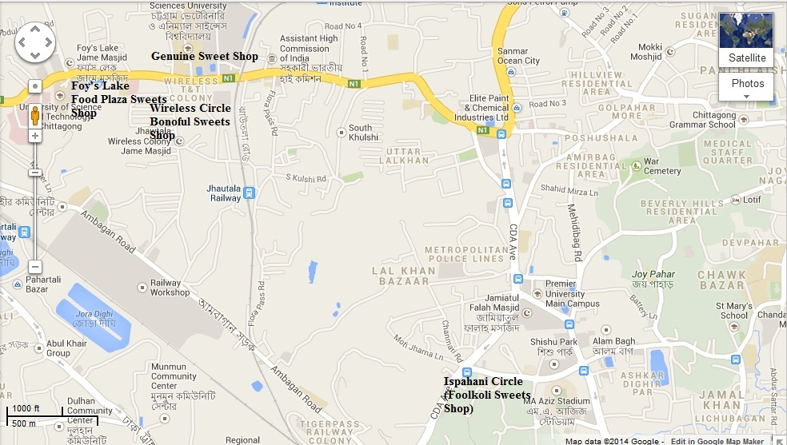
Thirty two (32) samples of four different dahi brands (Fulkoli, Banoful, Food plaza and Genuine) were collected randomly from four different sweetmeat shops of the local markets under stringent hygienic conditions. Samples were brought to experimental site with the help of a large wide mouthed ice-pot, maintaining the temperature 4-5°C. The size of the samples ranged from 100-200g packet in small size plastic pots. After collection, samples were stored in refrigerator at 4°C until analyzing.
Figure 1: Map of Chittagong metropolitan city showing study area

3.4. Chemical Analysis
Acidity percentage was determined by titrating with N/10 sodium hydroxide solution using the procedure of Aggarwala & Sharma (1961). Moisture percentage was determined by using Moisture analyzer (Model- ADAM, PMB-202). Fat percentage was determined by Gerber method.
3.5. Bacteriological analysis
Bacteriological parameters (Salmonella and E. coli) were determined by the methods as described in the "Standard Methods for examination of Dairy Products" by APHA (1967). Brilliant Green Agar (BGA) and Violet Red Bile (VRB) agar were used for Salmonella and E. coli count respectively. Firstly both agars were autoclaved by autoclave machine (Model- STURDY, SA-300VP) then the samples (1g) were measured by using electric balance (Model- SHIMADZU CORPORATION, AY-220) and then put into plate and poured agar (10-15ml) and observed for solidification. After solidification, the plates were kept in incubator at 39º C for 48 hours. The colonies were enumerated by using colony counter (Model-STUART, SC-5) and counted the number of total viable bacterial colonies.
3.6. Statistical analysis
The data obtained were imported, stored and coded according to recorded information in the data sheet using the Microsoft Excel – 2007 program and then exported to SPSS 16.0 computer software for statistical analysis. A descriptive statistics was performed for chemical and microbial parameters according to different samples. The result was presented as mean with the standard error and p-value <0.05 was considered significant.

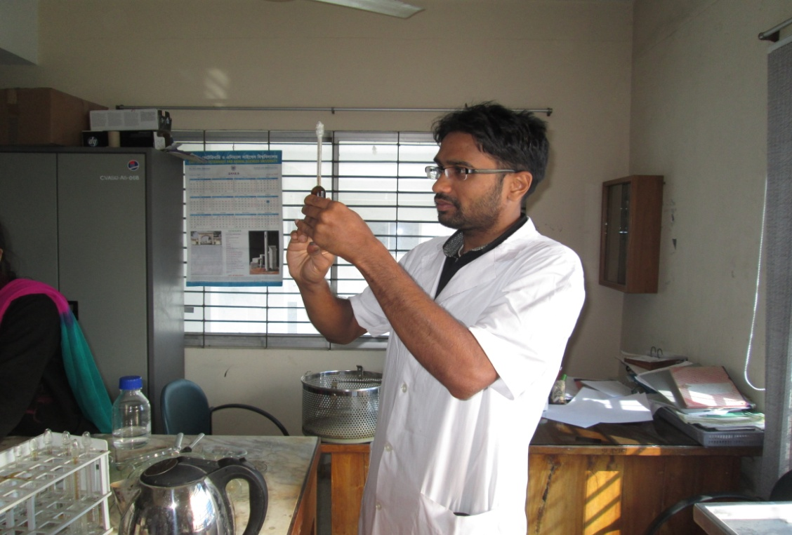
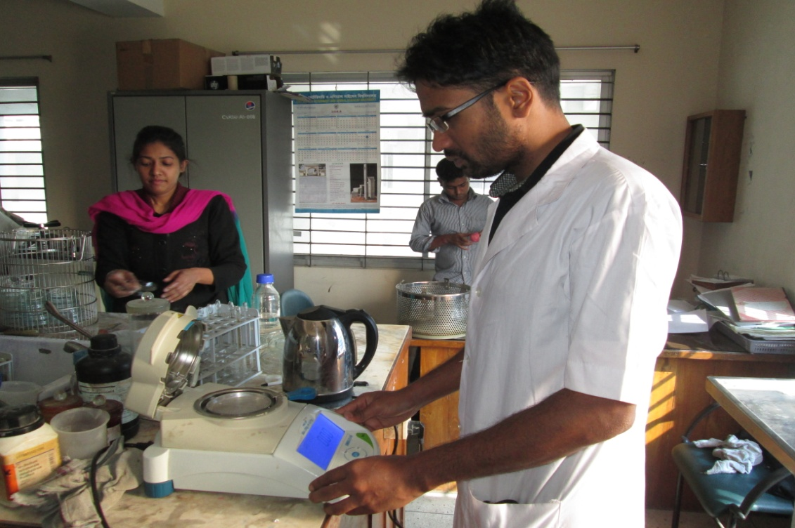
Figure 2: Moisture (%) testing in the laboratory
Figure 3: Fat (%) testing in the laboratory
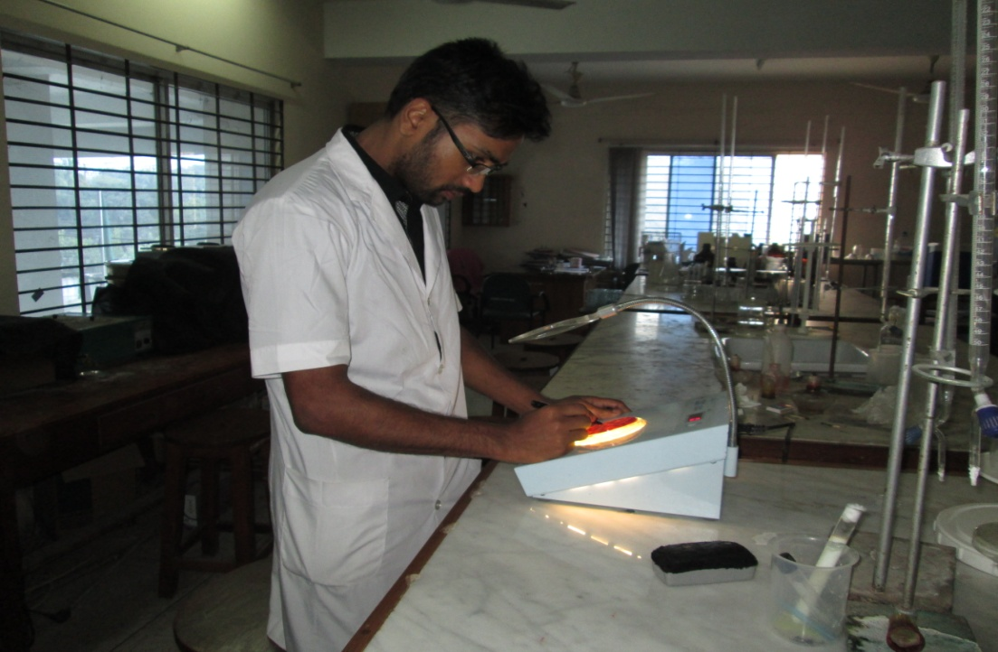
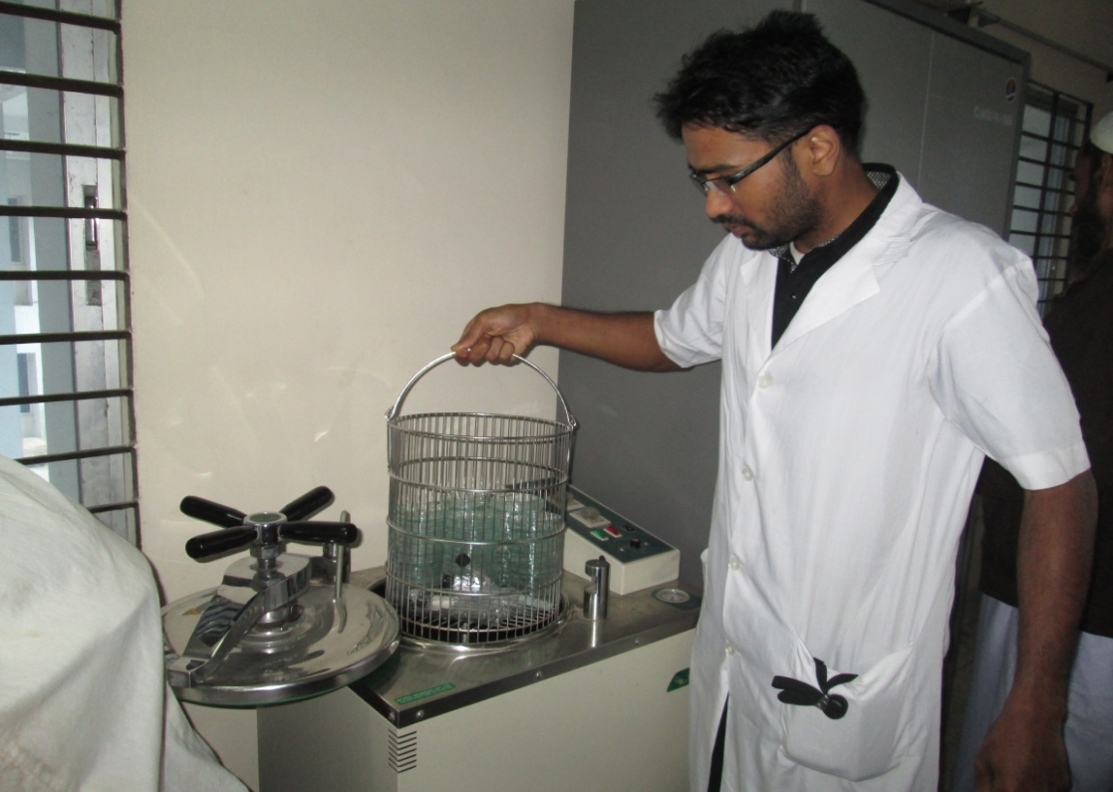
Figure 4: Autoclaving glass wares for sterilization
Figure 5: Bacterial count by using colony counter at laboratory
CHAPTER - IV
Results and Discussion
4.1. Chemical analysis
4.1.1. Moisture
The results of moisture content of different samples of dahi collected from Chittagong Metropolitan city are depicted in Table 1. The percentage of moisture of Food plaza, Fulkoli, Banoful and Genuine sweetmeat shops made dahi were 57.87 ± 1.34, 55.88 ± 0.75, 57.22 ± 1.03 and 60.83 ± 0.98 respectively (Table 1).
Table1. Chemical analysis of dahi collected from Chittagong Metropolitan City.
Parameters | Brand | Mean ± SE | Range |  | P – value
 |  |  | Minimum | Maximum
Moisture (%) | Food plaza | 57.87 ± 1.34 | 54.40 | 63.30 | 0.023
 | Fulkoli | 55.88 ± 0.75 | 53.09 | 58.90
 | Banoful | 57.22 ± 1.03 | 54.55 | 60.20
 | Genuine | 60.83 ± 0.98 | 57.05 | 63.65
Fat (%) | Food plaza | 3.43 ± 0.18 | 3.00 | 3.90 | 0.661
 | Fulkoli | 3.55 ± 0.20 | 2.90 | 4.10
 | Banoful | 3.75 ± 0.19 | 3.00 | 4.20
 | Genuine | 3.58 ± 0.11 | 3.10 | 3.90
Acidity (%) | Food plaza | 0.87 ± 0.02 | 0.80 | 0.95 | 0.00
 | Fulkoli | 1.02 ± 0.03 | 0.92 | 1.14
 | Banoful | 1.18 ± 0.06 | 0.97 | 1.40
 | Genuine | 0.75 ± 0.03 | 0.63 | 0.85

Maximum moisture percentage was seen in Genuine dahi (60.83 ± 0.98) and minimum moisture percent was found in Fulkoli sweetmeat shop made dahi (55.88 ± 0.75). The moisture percentage should be 85-88% for whole milk dahi (Laxminarayana et al., 1952) but during production of dahi producers added milk powder to increase the concentration of dahi which gives more firmness in dahi. The variation in moisture content between different dahi samples might be caused by lacking of quality control or standardization of milk for dahi production, adulteration of milk etc. Long storage period might be results in variation of moisture content among dahi samples of different local dahi Brands.

4.1.2. Fat
The percentage of fat of Food plaza, Fulkoli, Banoful and Genuine Sweetmeat shops made dahi were 3.43 ± 0.18, 3.55 ± 0.20, 3.75 ± 0.19 and 3.58 ± 0.11 respectively (Table 1). Statistically analysis showed that fat content of different dahi samples differ significantly (p<0.05). Maximum fat percentage was seen in Banoful dahi (3.75 ± 0.19) and minimum fat percent was found in Food plaza sweetmeat shop made dahi (3.43 ± 0.18). The current finding is agreed by Rashid and Miyamoto, 2005 that the fat percentage of dahi of Bangladesh was ranged from 3.00 to 4.75%. Although, the fat percentage should be higher because during heating it loses some moisture but as they are using skim milk powder to increase the concentration, so, total percentage of fat is not increasing. The variation in fat content between different dahi samples might be caused by lacking of quality control or standardization of milk for dahi production, adulteration of milk etc.

4.1.3. Acidity
Acidity percentage for dahi samples of Food plaza, Fulkoli, Banoful and Genuine dahi were 0.87 ± 0.02, 1.02 ± 0.03, 1.18 ± 0.06, 0.75 ± 0.03 respectively (Table 1). Significant differences were found (p<0.05) in respect of acidity content of the samples. The highest acidity was that of Banoful brand dahi at 1.18 ± 0.06% and the lowest acidity was that of Genuine brand dahi at 0.75 ± 0.03%. The Highest acidity of Banoful brand dahi might be due to uncontrolled incubation, postproduction handling and prolonging storage while Genuine brand dahi samples might be produced under controlled incubation and temperature or maintained a low temperature after production.
4.2. Microbial count
4.2.1. Salmonella Count
The total Salmonella count per ml. for Food plaza, Fulkoli, Banoful and Genuine shops made dahi were 0.00, 0.00, 2.00 and 0.00 (cfu/ml) respectively (Table 2). Average highest total Salmonella count for dahi samples of Banoful shop was recorded as 2.00 and lowest total Salmonella count for dahi samples of Food plaza, Fulkoli and Genuine sweetmeat shop was recorded as 0.00. The variations in total Salmonella count in different dahi samples might be due to the use of undefined wild starter culture in improper ratio and amount. The possible sources of contamination of product are uncleaned hands of manufacturers, poor quality milk, poor quality of water used to clean earthen pots and exposure of the product to open air during setting of curd.
Table: 2. Microbial profiles of dahi samples collected from Chittagong Metropolitan City.
Parameters | Brand | Mean ± SE | Range |  | P – value
 |  |  | Minimum | Maximum
Salmonella | Food plaza | 0.00 | 0.00 | 0.00 | 0.00
 | Fulkoli | 0.00 | 0.00 | 0.00
 | Banoful | 2.00 | 0.00 | 2.00
 | Genuine | 0.00 | 0.00 | 0.00
Coliform | Food plaza | 6.66 ± 1.99 | 2.00 | 16.00 | 0.00
 | Fulkoli | 7.50 ± 2.59 | 2.00 | 20.00
 | Banoful | 54.66 ± 6.82 | 33.00 | 79.00
 | Genuine | 20.33 ± 3.40 | 11.00 | 33.00

4.2.2. Coliform count
The average Coliform count per ml. of Food plaza, Fulkoli, Banoful and Genuine sweetmeat shop made dahi were 6.66 ± 1.99, 7.50 ± 2.59, 54.66 ± 6.82 and 20.33 ± 3.40 respectively (Table 2). Average highest Coliform count per ml. (54.66 ± 6.82) was found in Banoful sweetmeat shop made dahi and lowest Coliform count per ml. (6.66 ± 1.99) was found in Food Plaza sweetmeat shop made dahi. Coliform count differs significantly (P<0.05) in different brands. The existence of Coliform bacteria is the indication of contamination in dahi samples. This might be result of the poor hygienic condition of the production period. The possible sources of contamination of product are uncleaned hands of manufacturers, poor quality of water used to clean earthen pots and exposure of the product to open air during setting of curd. The findings of this experiment partially support the findings of Islam (1999) and Alam (1999). Islam (1999) reported that Coliform count per ml. of laboratory made dahi was (144.02 to 400.66), log value (2.64 ± 2.05). Alam (1999) found that the Coliform count in dahi made from cow milk was (100 to 500), log value (1.81 ±1.14).

CHAPTER - V
Conclusion
From the present study it can be concluded that the dahi available in Chittagong city is not maintained the proper quality. Products might be contaminated by poor quality milk, contaminated water and utensils; adulteration and high temperature during storage period. A comprehensive research work is still required to set a standard for commercial production of dahi in Bangladesh to have uniformity and superiority in its organoleptic, chemical and microbiological quality. Also, Government should take proper step by the help of BSTI to increase the quality of dahi all over the Bangladesh.

References
A.O.A.C. 2003. Official methods of analysis of the Association of Official Analytical Chemists. 15th edition. Washington, DC, Association of Official Analytical Chemists.
Adeyl, F.M. 1998. Studies on the physical, chemical and microbiological qualities of misti Dahi of different districts of Bangladesh. M.S. Thesis, Department of Dairy Science, Bangladesh Agricultural University, Mymensingh.
Aggawala, A.C. and Sharma, 1961. A Laboratory Manual of Milk Inspection. Bombay, Calcutta, New Delhi, India.
Akter,N., Nahar, A., Islam, M.N. and Al-Amin, M. 2010. Effects of different level of starter culture and sugar on manufacturing characteristics of Misti Dahi (Sweet Yoghurt). J. Bangladesh Agril. Univ. 8(2): 245–252.
Alam, K. 1999. Quality evaluation of dahi made from cow, goat and buffalo milk. M .S. Thesis, Department of Dairy Science, Bangladesh Agricultural University, Mymensingh.
Ali, M.Y., Islam, M.A., Alam, M.J. and Islam, M.N. 2002. Quality evaluation of laboratory made Dahi and Dahi available in local market in Mymensingh of Bangladesh. Pakistan J. of Biological Sci. 5(3): 343-345.
Antunes, A.E.C., Antunes, A. J. and Cardello, H.M.A.B. 2004. Chemical, physical microstructural and sensory properties of set fatfree yoghurts stabilized with protein concentrate. Milchwissenschaft, 59 (3/4): 161-165.
Dey, S., Iqbal, A., Ara, A. and Rashid, M. H. 2011. Evaluation of the quality of Dahi available in Sylhet Metropolitan City. J. Bangladesh Agril. Univ. 9(1): 79–83.
Duitschaver, C.L. and Arnott, D.R. 1972. Quality evaluation of yoghurt produced commercially in Ontario. J. Milk Food Technology, 35(3): 173-175.
Haj, H.M., Osman, A.O., Owni, El. and Ibtisam, E.M. El. 2007. Assessment of Chemical and Microbiological Quality of Stirred Yoghurt in Khartoum State, Sudan. Research Journal of Animal and Veterinary Sciences, 2: 56-60.
Islam, M.D.S. 1999. A comparative study on the quality of Laboratory prepared and Local Village Market Dahi. A M.S. Thesis, Dept. of Dairy Science, Bangladesh Agricultural University, Mymensingh.
Mostafa, MD. 1997. A study on the preparation of fruit Dahi (yogurt). A M.S. Thesis. Dept. of Dairy Sci, Mymensingh Agricultural University, Mymensingh. Bangladesh.
Rashid, M.H. and Miyamoto, T. 2005. Quality evaluation of traditional fermented milk “Dahi” in Bangladesh. Milk Science., 54(1): 29-36.
Shanley, M.K. 1973. Analysis of free sugars in yoghurt. Aust. J. Dairy Technology, 28(2): 58-60.
Tamime, A.Y. and Deeth, H.C. 1980. Yoghurt: technology and biochemistry. J. Food Prot., 43: 939-977.
Tarakçi, Z. and Küçüköner, E. 2003. Physical, Chemical, Microbiological and Sensory Characteristics of Some Fruit-Flavored Yoghurt. YYÜ Vet Fak Derg 2003, 14 (2):10-14.
Younus, S., Masud, T. and Aziz, T. 2002. Quality Evaluation of Market Yoghurt /Dahi. Pakistan Journal of Nutrition, 1 (5): 226-230.

