CHAPTER-I
INTRODUCTION
Bangladesh is small developing country, situated in South Asia and its economy is mainly based upon agriculture especially one of its major wing livestock. The livestock sector occupies a significant position both as a source of providing animal protein, poverty alleviation through solving unemployment problem and earning foreign exchange. As a sub sector of agriculture, the share of livestock in the GDP comprises around at constant prices was 2.92% which was 17.2% of the GDP contributed by agriculture sector where as its contribution to the total GDP is 5.23% in fiscal year 2005-06. The share of this sector is projected at 2.90% of GDP, which would be 17.7% of agriculture in fiscal year 2006-2007. Among the sub-sectors of the broad agriculture sector, the growth of the livestock sub-sector is the highest. In fiscal year 2005-06, the growth of this sub-sector was 6.15% which was projected at 5.85% in the fiscal year 2006-07 (Economic Census, 2007).

Poultry is a major sub-sector of livestock. Poultry rearing has emerged as an integral part of agribusiness of the farming community in Bangladesh. Poultry is now one of the most prospective sectors for development in our country. It is a quick returnable enterprise that needs relatively small initial investment (Raha, 2007). The expansion of poultry sector depends among other thing, on the profitability of poultry rearing and egg production at farmer’s level (Alam, et. al. 1998). There has been a tremendous development of this sector in recent years in the country (Rahman, 2003).

Bangladesh has a long historical record of poultry rearing under backyard farming. The revolution of commercial poultry rearing starts from before the emergence of Bangladesh and the first commercial poultry farm “The Egg and Hen Ltd.” was established in 1964 may be recognized as the mother poultry farm. In 1968-69 the Department of Poultry Science of Bangladesh Agricultural University (BAU), Mymensingh brought DOC of broiler chicks from Pakistan International Airlines and started producing broiler experimentally in the University poultry farm. During late 1980s the Department of Livestock Services (DLS), Bangladesh imported “Arbor Acres” broiler parent stock. At the same time BIMAN, Bangladesh Airlines started commercial poultry farm called ‘Biman Poultry Complex’ with a contractual agreement with “Shaver Poultry Breeding Company” of Canada. The farm supplied DOC of Broiler and layer to small farmers (Pervin, 2004). In the beginning of early 1990’s the production of broiler and layer emerged as an industry.

Approximately 37% of total animal protein supplied by poultry meat in our country (Rahman, et. al. 1998). At present chicken contributes 51% of total meat production of the country through the share of broiler is not separated. Per capita annual consumption of meat in the country is 5.9 kg which is only 7.38% of the universal standard (MoFL, 2006). The International Food Policy Research Institute has estimated that by the year of 2015 poultry will account for 40% of all animal protein (Anon.2000 a).

Normal requirement of animal protein as meat for a man is about 62.5 gm per day, while people of our country get only 6.90 gm per day (Jabbar, 1983). Poultry meat can efficiently and rapidly fulfilled the shortage of protein requirement since poultry meat can be produced at a least possible time as compared with the meat of other ruminant animals. Now a day’s poultry sector is an integral part of the farming system in Bangladesh. According to the estimate by the Ministry of Fisheries and Livestock, the poultry production has been constantly increasing over the past decades and it raised to 24 core 60 lakh in fiscal year 2006-07. There are about 206.89 million chickens and 39.08 million ducks estimated in the fiscal year 2006-07 (BBS, 2008). Following table-1 shows the poultry population increases in the recent years.

Table 1.1 : Poultry Population in Bangladesh (In millions)-

Species | 2000-01 | 01-02 | 02-03 | 03-04 | 04-05 | 05-06 | 06-07 | 07-08
Chicken | 142.63 | 152.24 | 162.44 | 172.63 | 183.45 | 194.82 | 206.89 | 212.47
Ducks | 33.83 | 34.67 | 35.54 | 36.40 | 37.28 | 38.17 | 39.08 | 39.48
(Department of Livestock Services, Ministry of Fisheries & Livestock).
In Bangladesh the existing native breed are Aseel, Sarail, Nacked neck, Yasin etc. Their productive performance is not sufficient. So the commercial poultry industry uses some exotic broiler breed such as Cobb 500, Cobb100, Hubbard classic, Hybro-PN, Hybro-PG, Ross (Saleque, 2006).

A few years ago the eggs of the parent stock and also day old chicks of broiler and layer were imported in our country, but now the demand of commercial layer and broiler DOC are fulfilled by our own parent stock breeder farm and they produce broiler parent stock DOC in their hatchery (Saleque, 2006). There are about 130 farms involved in producing DOC of which 52.3% are in the operation. Now in the country there are 5 breeder farms that have started rearing grandparent. The number of broiler parent stock was 2292 thousand in 2004-05 and the number of DOC produced was 192528 thousand in 2004-05 (Raha, 2007). Following table-2 shows the broiler parent stock population and day old chick’s production in our country in recent years.

Table 1.2 : Broiler parent stock population and day old chick’s production in our country-

Type | 2003 (thou) | 2004 (thou) | 2005 (thou)
Broiler Parent Stock | 1952 | 2299 | 2292
DOC per year | 163968 | 164148 | 192528
DOC per week | 3153 | 3156 | 3702
(DLS, 2005 and BRAC report, 2006).
Cobb 500 is an English strain which shows an excellent production & reproduction performance in standard condition. It has a worldwide reputation for the lowest cost of producing chicken meat. Cobb geneticists have developed this breed by the research of more than 30 years progress using a combination of both traditional pedigree selection and new technology. They have developed a very high breeder performance of Cobb 500 .Such as Cobb 500 starts laying at 18 weeks of age .Age at 5% egg production is 24 weeks of age .At 65 weeks of age - total eggs/hen housed is 175, hatching eggs/hen housed is170, peak hatchability 91 %, broiler chicks/hen housed 144 (Cobb breeder management guide, 2009). For such high breeder performance CP Bangladesh choose Cobb 500 as a broiler parent stock for rearing.

Therefore the present study was undertaken at CP Bangladesh, Rangpur-2, Brommochari, Fulbari, Dinajpur to observe the parent stock management practices with the following objectives.

- To know the management of broiler parent stocks.
- To compare the achieved performance with the standard.

CHAPTER-II
REVIEW OF LITERATURE
Management is the art and science of combining ideas, facilities, processes, materials and labor to produce and market a worthwhile product or service successfully. Only the efficient management can give the return as per aspect. Scientific breeding, feeding, management and disease control are the key points of success in poultry improvement farming (Rahman, 2003).

The exotic broiler parent stocks reared in open-sided house under Bangladesh conditions, in general, able to achieve expected body weight through they were found to be very sensitive to environmental stresses (Chowdhury, et. al. 2003).

An accurate body weight is a critical part of the process of rearing replacement broiler breeder pullets and managing breeder hens and males. From the first few weeks of age in the pullet house, all feed allocations are determined by the bird’s weekly weight gains. Obtaining accurate body weights is very important to maintaining uniformity, body conformation and the overall development of pullets and young cockerels. Research has shown that accurately and uniformly controlling body weight of both replacement breeders and breeders in the hen house will result in improved performance parameters (Bramwell, 1999)

Restricted lighting management program for broiler breeder can helps to achieve the sexual maturity during 18 to 22 wks of age (Robinson and Wilson, 1999). Feed restriction during growth (7-22 weeks) significantly reduced body weight, increase the age of sexual maturity and also increases the egg production (Krishnappa, et. al. 1992).

The production cycle may be conveniently divided into three stages or phases. Phase І (22nd week to 42nd week)- egg production 0-85%, increase body weight to mature body weight, eggs of gradually increasing size; phase П (43rd week to 62nd week)- egg production declines up to 65% and phase Ш (63rd week to 72nd week)- egg production less than 65% (Banerjee, 2007).

Sudden excessive heat or cold lowered the egg production. Due to quick temperature change in the reproductive tract egg formed very slowly. Normally it takes about 23 hours to form an egg in the reproductive tract. Remedy of the problem is temperature, controlled by thermometer and application of Vit-C in hot season (Ahmed, 2008).

Poultry Parent stock Management:
2.1 Bio-security
Bio-security can be defined as a comprehensive range of clear procedures aiming to minimize the possibility of introduction of undesirable pathogens into a poultry operation. The extent of such bio-security rules depends mainly on the prevalence of diseases in the area, the value of the birds, short and long-term company goals, customers’ expectations, level of commitment and availability of resources.

One of the most important factors to establish an effective bio-security program is to understand how the diseases are transmitted. Based on it, clear procedures can be set up and they must be followed by everyone involved in the production, without exceptions (Anon. 2013 b).

For breeder operations, a comprehensive bio-security program comprises several different procedures which main objective is to limit the risk of exposing the parent stock (PS) birds to pathogens that can threat their own health and also to those microorganisms that can cause problems to the offspring. This bio-security program has some key components such as construction of the farm, disease transmission by human and animals and vaccination.

2.1.1 Farm location and construction

  - It is best to build up the farm in an isolated area, at least 2-km distance from the nearest poultry farm.
  - Should fence the perimeter of the farm to prevent unwanted visitors.
  - The design and construction of the houses should be in a manner that does not provide openings for wild birds and animals to enter the buildings.

2.1.2 Preventing disease transmitted by humans

- Restriction of the movement of visitors to the poultry farms.
- If supervisory personnel must visit, they should make an effort to visit the youngest flock first.
- Should visits flock with disease problems last.
- All people entering the farm should follow a bio-security procedure. All workers and visitors should shower and use clean & calendared farm clothes.

2.1.3 Preventing disease transmitted by animals

- Whenever possible, all in all out placement cycle of birds should be followed.
- A minimum downtime of two weeks between flock is recommended.
- Should provide an entry barrier to rodents and wild animal.
- Should keep wild birds out of all buildings.
- Should maintain an effective rodent control program.

2.2 Vaccination

Vaccination can be considered as a biological barrier against some pathogens as it can effectively protect against some negative effects of these microorganisms. Generally, the vaccination of the breeder flocks has three major objectives: to protect the own birds’ health during their lifespan, to provide maternally derived antibodies (MDA) to their progeny and to prevent (or reduce) the vertical transmission of some microorganisms to the offspring.

Vaccination against Marek’s Disease, Infectious Laryngotracheitis, Coccidiosis and Pox virus are carried out essentially to protect the Parent Stocks birds from the negative impact of these diseases as the humoral immunity eventually passed through the yolk is not important to protect the progeny. Additionally, there are other vaccines used to protect the source flock’s health and simultaneously to provide humoral antibodies to the offspring. Vaccination against Infectious Bursal Disease, Newcastle Disease and Infectious Bronchitis are among them (Anon. 2013 b).

Alternatively, the main reason to vaccinate breeder flocks against Chicken Infectious Anemia and Avian Encephalomyelitis is to transfer high and homogeneous level of maternal derived antibodies to the offspring in order to protect it during the first weeks of life.

It is a common sense that Salmonella enteritidis (SE) and Salmonella typhimurium (ST) do not affect the performance of the Parent Stock birds. So it is not feasible to keep the breeder flocks free of these infections, the vaccination against these diseases is advisable and it aims to reduce significantly the contamination of the progeny by reducing dramatically the shedding of these bacteria to the environment. This vaccination could even be used as part of an eradication program (Anon. 2013 b).

So, a comprehensive vaccination program for breeders has to take into consideration not only the epidemiology of the diseases, but the requirements of the poultry producers and the concerns of the consumers. Moreover, it is important be in accordance with the regulations in force in each country (Anon. 2013 b).

2.3 Housing management

2.3.1 Before arrival of chicks

- Checking that everything is in good working order.
- Distribution of feed and water in the house.
- Warming up the house in good time.

2.3.2 On arrival of chicks

- Unloading of all chick boxes and distribution of them in the house.
- Feeding of the chicks 5% glucose solution and vitamin C for stress relief.
- Quickly placing of the chicks near feeders and drinkers.
- After placing the chicks, again checking of the equipment and temperature of the house.

According to Vencobb-broiler-management-guide the floor space to be allocated per bird will be determined by a combination of following factors:
- The size of the bird.
- Type of housing
- Climatic conditions and weather the farm is open sided or environment controlled.

2.4 Water Management
A chicken comprises of 60 – 70 percent of water and is present in all cells of the body. A 10 percent loss through dehydration and/or excretion results in serious physical disorder.

2.4.1 Water Quality
Water samples should be periodically analysed for coliform count. If bacterial count is above permissible level, it is advisable to sanitize the water. Take the water samples from their sources like wells, water tanks, and from pipelines before and after sanitization. Get water tested from the laboratory. Use a sterile bottle for collecting water sample for microbial test (Vencobb-broiler-management-guide).

Table 2.4.1: Drinking water supplying standard for Broiler parent stock.
Drinking Water Standards
Particulars | Maximum Permissible Limits
No. of coliform bacteria/mL | 10 – 15
No. of E.coli/mL | 0
Hydrometric Level | - 30Â°
Organic Substances | 1 | mg/L
Nitrates | 0 – 15 | mg/L
Ammonia | 0 | mg/L
Cloudiness/Turbidity | 5 U
Iron | 0.3 | mg/L
Manganese | 0.1 | mg/L
Copper | 0.1 | mg/L
Zinc | 5 | mg/L
Calcium | 75 | mg/L
Magnesium | 50 | mg/L
Sulphates | 200 | mg/L
Chlorides | 200 | mg/L
Fluoride | 1 | mg/L
pH | 6.8 – 7.5

2.5 Litter Management
The type of litter used will depend upon availability, suitability and economics. Types of litter most commonly used include wood shavings, sawdust, rice husk, straw, corncobs and groundnut hulls. When using rice husk it is advisable to use thin layer of paper on top of the litter to prevent the feeders and fountains from getting filled with husk (Vencobb-broiler-management-guide). The objective is to maintain litter in a dry condition. Normal dry litter usually contains 20 to 25% moisture. Whenever it holds more moisture it becomes caked. Therefore additional ventilation and removing wet or caked litter is important, so as to maintain litter quality. Addition of fresh litter will help in maintaining proper litter condition. Please ensure that litter is not dusty (Vencobb-broiler-management-guide).
2.6 Brooder Management
Types of brooding depends upon the season, brooding practices vary in tropical countries where large conventional open housing is normally practiced. During winter – 1/3 area of the house should be used for brooding and during summer – 1/2 area of the house should be used for brooding. Even though efforts are made to conserve heat, it is often noticed that ventilation is not given due importance. In view of fast growth and high rate of metabolism, the commercial broilers need special attention for provision of enough ventilation. The brooder stoves should be adjusted at 24 hours before the arrival of chicks to ensure their working efficiency.
Temperature should be adjusted to 95Â°F (35Â°C) at the edge of the brooder 2 inches (5cm) above the litter and lowering the temperature by 5Â°F (2.8Â°C) each week until it reaches 70Â°F.

Table 2.6.1: Requirement of area per bird during brooding period.

Age(Day) | Brooding areas (bird/ m²)
1-3  4-7  8-14  15-28 | 30  20-30  15-20  8-10

Heater
♀ = Chick brooder for females ♂ = Chick brooder for males
Fig: 2.6.1: Schematic diagram of brooding

2.7 Beak trimming
Objectives:

- Prevent pinch hit in the chicken house with the same sex.
- Prevent injury when females will be in a fertile period during breeding male and females together.
- To improve the feed conversion efficiency for male.

The following points should be considered during beak trimming:

- Should trim bird’s beaks at 8 to 10 days of age of both sexes and should provide 24 hours of supplemental vitamin k prior to beak trimming.
- Second beak trimming is done only for female at 10 to 12 weeks of age.
- The Worker must have expertise.
- Cutter machine and equipment are ready to use.
- Should work slowly and carefully.
2.8 Feeding Management
Feeding Management is the simplest method to ensure adequate nutrient intake in hot climate, and it is effective to combat acute heat stress. In the summer season it is beneficial to feed birds during the cool hours of the day/night. At intervals, fresh addition of feed or running the feeder at frequent intervals will stimulate interest in feeding and may help to increase feed intake. It is advisable to withdraw feed during the hottest parts of the day. If the birds have finished digesting their last meal before hot hours, their metabolic heat production will be reduced.
Chick age 1 – 3 day- Feeding 3 times per day. At morning 50% of the total food of each day then 25% at mid day and 25% at noon.
Food handling range 5-15 week old chickens- In this phase of growth of chicken will continue to evolve, especially the muscles and structures in the age range 16-24 weeks to develop a system of reproduction. These will need to be accumulated for use in protein and energy. Therefore it requires adjustment to food management.
Table 2.8.1: Standard feeding process of broiler parent stock.
Sex | Age (wk) | How to feed
Female  Male | 5 – 15  6 – 15 | Everyday, 4 skip 3  Everyday, 4 skip 3
Female  Male | 16 – 20 | Everyday, 5 skip 2  Everyday, 5 skip 2
Female  Male | 21 – 22 | Everyday, 6 skip 1  Everyday, 6 skip 1
Female  Male | 23 – up | Everyday

2.9 Management during production

To obtain the maximum numbers and size of hatching eggs through the entire production period female management is important.

2.9.1 Weighing birds

- Pullets and males should weighed weekly until 40 weeks thereafter through the end of the production period.
- The supervisor should examine each bird carefully for body condition and sexual activity.

2.9.2 Feeding

- Feeding for egg production
- Provide cool water-cold weather feeding.

2.9.3 Managing a very high producing flock

    - Should calculate the production percentage of egg
    - By correlation of body weight gain with production percentage the amount of feed have to be determined.

2.9.4 Feeding the male breeder

- Ration formulation of male breeder should be different from female birds.
- Germinated grain should be given at the matured age for improvement of semen quality.

Male: Female ratio: Maximum Male: Female = 1: 10

2.10 Molting

In birds, molting is the periodic replacement of feathers by shedding old feathers while producing new ones. Feathers are dead structures at maturity which are gradually abraded and need to be replaced. Adult birds molt at least once a year, although many molt twice and a few three times each year (Terres, 1980).

Sometimes flocks of commercial layer hens should be force molted to reinvigorate egg-laying. This usually involves complete withdrawal of their food and sometimes water for 7–14 days or up to 28 days under experimental conditions (Molino, et. al. 2009) which presumably reflect standard farming practice in some countries. This causes a body weight loss of 25 to 35% (Webster, 2003) which stimulates the hen to lose her feathers, but also reinvigorates egg- production. Some flocks may be force molted several times. Other methods of inducing a molt include low-density diets (e.g. grape pomace, cotton seed meal, alfalfa meal) (Patwardhan, et. al. 2011) or dietary manipulation to create an imbalance of a particular nutrient(s). The most important among these include manipulation of minerals including sodium (Na), calcium (Ca), iodine (I) and zinc (Zn), with full or partially reduced dietary intakes (Khan et. al. 2011).
2.11 Record keeping
- Breed of male and female.
- Date received.
- Vaccination completed at the hatchery.
- Vaccination completed at the farm.
- Feed, water consumption.
- Egg production.
- Mortality, body weight, egg weight.
- Fertility percentage.
- Hatchability percentage.
- Production cost.
CHAPTER-III
MATERIALS AND METHODS

3.1 The study area
The study was performed at breeder farm of CP (Charoen Pokphand) Bangladesh, Rangpur-2, Bormochari, Dinajpur where popular broiler parent stock Cobb 500 was reared in Environmentally Controlled House.

3.2 Study Period

The study was conducted for four weeks of time from 23th November to 20th December, 2013 during my internship placement.

3.3 Study Population

The study population was 59459 where female was 53475 and male was 5984.

3.4 Data collection
Data are collected from record of the computer and register book also by asking question to the manager, supervisor and workers. Management data was taken from observation and getting information from the responsible supervisors.
  - Parameters
The parameters of poultry are given below.
- Age of the birds
- Mortality percentage
- Egg production
- Hatching eggs
- Feed percentage
3.6 Housing System
There were two stored concrete made tower which were also two in number. Each tower contains four houses. Each tower was 428 ft in length and 130ft in width .Each tower standing on 55640 sq. ft area. Whereas 44226 sq ft was for building and 11414 sq ft for premises area.

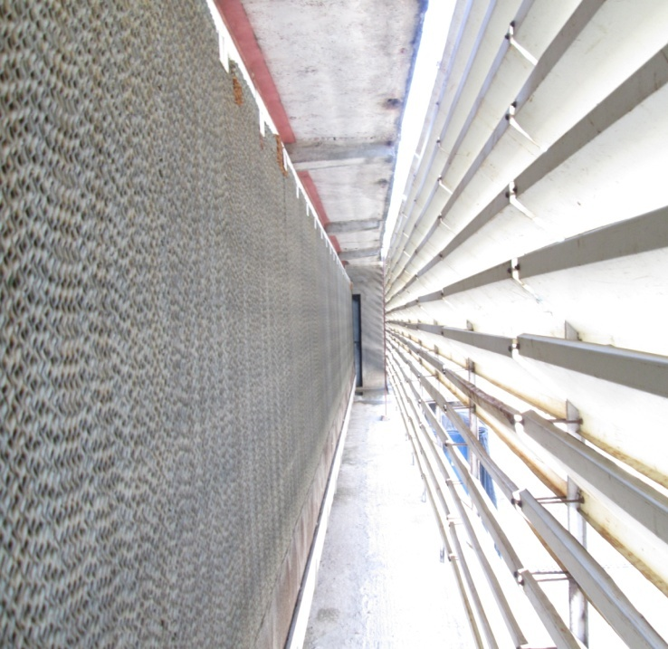
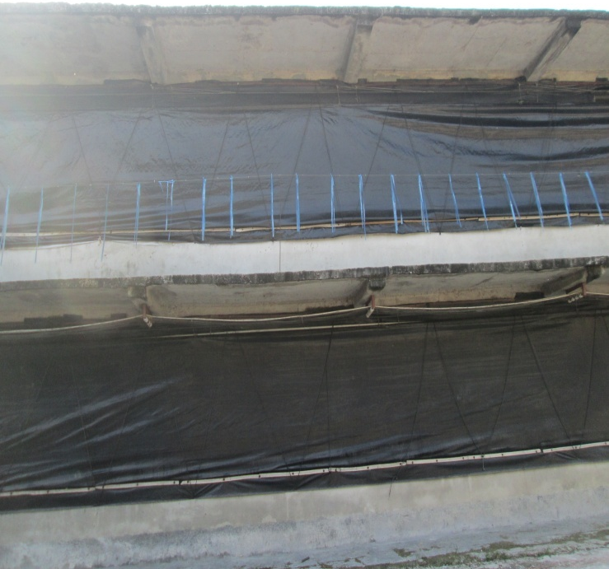
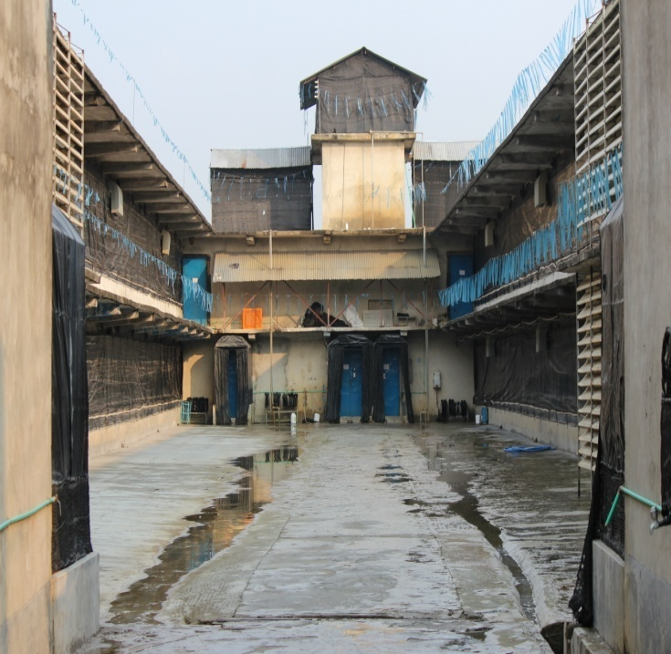
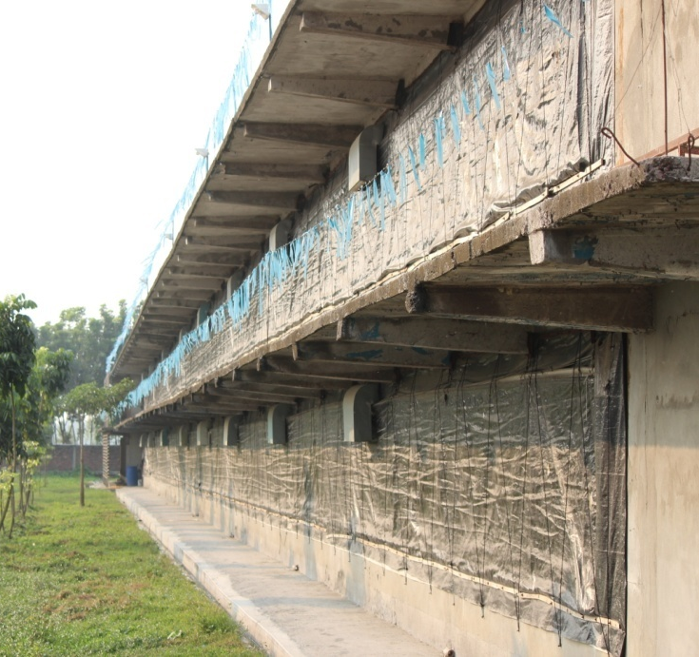
Fig: 3.6.3: Distance between two portion of each tower

Fig: 3.6.4: Shed with cooling pad

Fig: 3.6.2: Shed is covered by polythene

Fig: 3.6.1: Outside view of farm

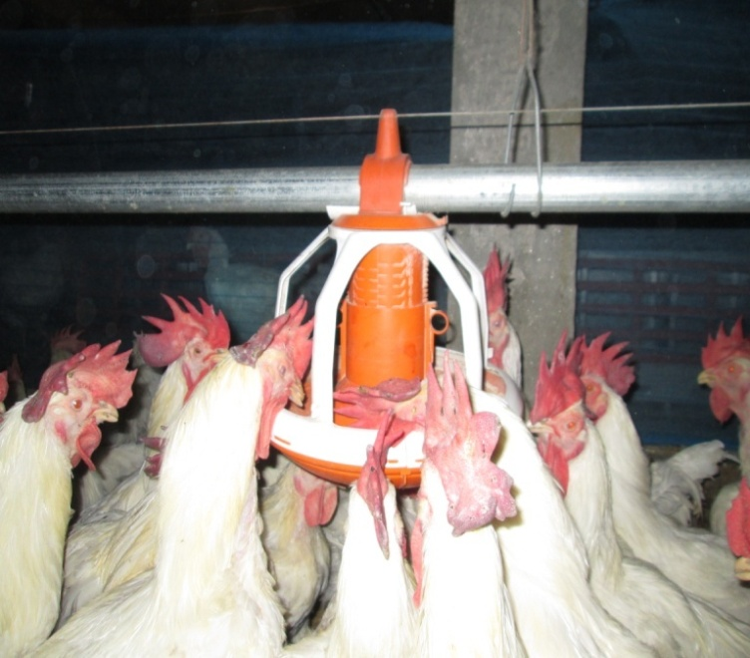
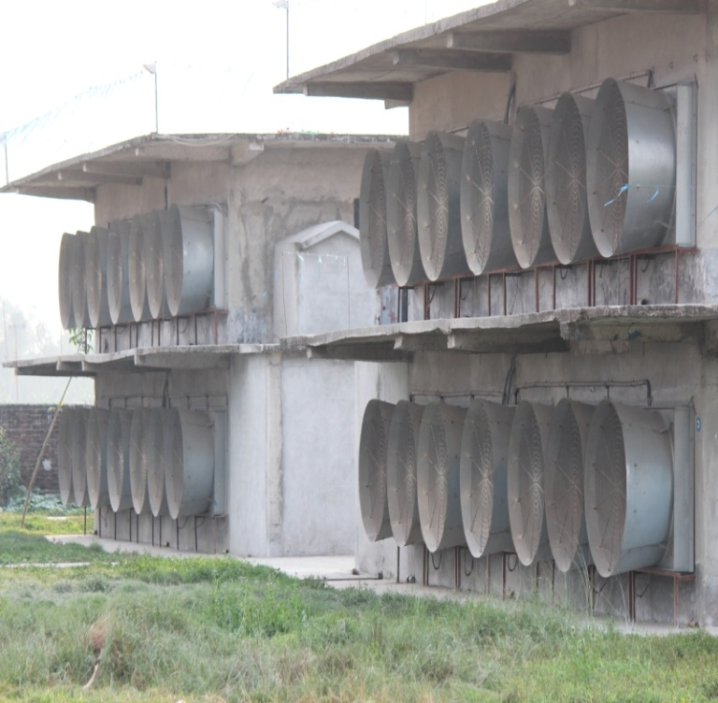
Fig: 3.6.6: Feeder used in shed
Fig: 3.6.5: Exhaust fans of shed
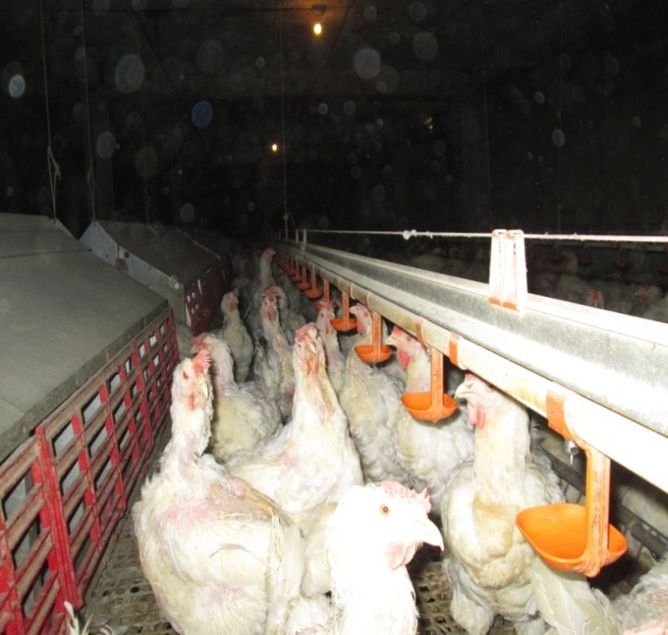
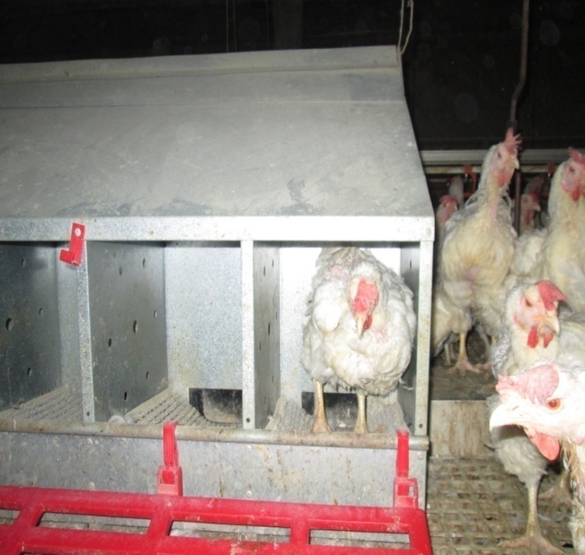
Fig: 3.6.8: Auto nest for hen

Fig: 3.6.7: Water Supply system

3.6.1 House establishment
Each 16230.9 sq ft house was 413 ft in length and 39.3 ft in width containing 463.74 sq ft for feed and temporary egg store area and 463.74 sq ft for droppings collection area. Each house was divided into two area, one was litter area and another was slate area. The height at the litter area was 8.1 ft and at the slate area was 7 ft. The litter area was 4322.34 sq ft and the slate area was 10981.08 sq ft. Each house contained 20 air inlets (10 in one side and 10 in other side). Each air inlet was situated at 9.43 ft height from the ground. Air inlets were 3.6 ft in length and 10 inch in width. Again there were two cooling pad on both side which were 49.4 ft in length and 5.10 ft in width. There were 7 exhaust fans in a house with four doors and four foot baths.

3.6.2 House equipments
Each house had the capacity to contain around 10000 birds at the ratio of 10:1 (Female: Male).
Auto nests were 62 in number. Each gable type auto nest was 10 ft in length and 3 ft in width containing 24 separate small nests. A 9 inch wide egg collection tape was passed through the floor of the auto nest.
There were 12 hooper in a house. Each hooper was 4 ft in length and 1.7 ft in width with the ability to contain around 75 kg of feed. The total length of the female feeder was 697.96 meter and width was 0.11 meter. Distance between two feeders was 1 meter. Nipple drinkers were installed in a house and the distance between two nipple drinkers was 6 ft. Male feeders were 114 in number where as distance between two feeder were 3.4 ft.

3.7 Ventilation system

Actually temperature and ventilation was maintained their according to the condition of the birds. During brooding when the chicks were gathered in the periphery then the hover was placed somewhat above from the previous height. But when the chicks gathered under the hover, then the hover placed down .The ventilation was basically maintained automatically with the help of TC5 machine, exhaust fan, cooling pad and air inlet.

Table3.7.1: Automatic air circulation maintaining system through TC5 machine.
Temp | Relative Humidity % |  |  |  | Air speed m/s
( C ) | 30% | 50% | 70% | 80% | 0 m/s | 0.5 m/s | 1.1 m/s | 1.5 m/s | 2 m/s | 2.5 m/s
 |  |  |  |  | (0 ft/min) | (100 ft/min) | (200 ft/min) | (300 ft/min) | (400 ft/min) | (500 ft/min)
35 | 30% |  |  |  | 35 | 31.6 | 26.1 | 23.8 | 22.7 | 22.2
35 |  | 50% |  |  | 35 | 32.2 | 26.6 | 24.4 | 23.3 | 22.2
35 |  |  | 70% |  | 38.3 | 35.5 | 30.5 | 28.8 | 26.1 | 25
35 |  |  |  | 80% | 40 | 37.2 | 31.1 | 30 | 27.2 | 25.2
32.2 | 30% |  |  |  | 32.2 | 28.8 | 25 | 22.7 | 21.6 | 20
32.2 |  | 50% |  |  | 32.2 | 29.4 | 25.5 | 23.8 | 22.7 | 21.1
32.2 |  |  | 70% |  | 35 | 32.7 | 28.8 | 27.2 | 25.5 | 23.3
32.2 |  |  |  | 80% | 37.2 | 35 | 30 | 27.7 | 27.2 | 26.1
29.4 | 30% |  |  |  | 29.4 | 26.1 | 23.8 | 22.2 | 20.5 | 19.4
29.4 |  | 50% |  |  | 29.4 | 26.6 | 24.4 | 22.8 | 21.1 | 20
29.4 |  |  | 70% |  | 31.6 | 30 | 27.2 | 25.5 | 24.4 | 23.3
29.4 |  |  |  | 80% | 33.3 | 31.6 | 28.8 | 26.1 | 25 | 23.8
26.6 | 30% |  |  |  | 26.6 | 23.8 | 21.6 | 20.5 | 17.7 | 17.7
26.6 |  | 50% |  |  | 26.6 | 24.4 | 22.2 | 21.1 | 18.9 | 18.3
26.6 |  |  | 70% |  | 28.3 | 26.1 | 24.4 | 23.3 | 20.5 | 19.4
26.6 |  |  |  | 80% | 29.4 | 27.2 | 25.5 | 23.8 | 21.1 | 20.5
23.9 | 30% |  |  |  | 23.8 | 22.2 | 20.5 | 19.4 | 16.6 | 16.6
23.9 |  | 50% |  |  | 23.9 | 22.8 | 21.1 | 20 | 17.7 | 16.6
23.9 |  |  | 70% |  | 25.5 | 24.4 | 23.3 | 22.2 | 20 | 18.8
23.9 |  |  |  | 80% | 26.1 | 25 | 23.8 | 22.7 | 20.5 | 20
21.1 | 30% |  |  |  | 21.1 | 18.9 | 17.7 | 17.2 | 16.6 | 15.5
21.1 |  | 50% |  |  | 21.1 | 18.9 | 18.3 | 17.7 | 16.6 | 16.1
21.1 |  |  | 70% |  | 23.3 | 20.5 | 19.4 | 18.8 | 18.3 | 17.2
21.1 |  |  |  | 80% | 24.4 | 21.6 | 20 | 18.8 | 18.8 | 18.3

As for example; if the temperature is 35ºC with 30% relative humidity then in absence of ventilation the temperature will remain same but if the air speeded up gradually within the house from 0 to 0.5, 1.1, 1.5, 2, 2.5 m/s then the temperature will gradually reduced to 35, 31.6, 26.1, 23. 8, 22.7, 22.2⁰C.In that farm the air speed was maintained by using fan, inlet box, cooling pad and curtain.

3.8 Temperature maintaining system

The temperature maintaining system which was followed in CP is given below.

Table 3.8.1: Temperature maintaining system.
Fan |  | Inlet Box |  | Curtain Adjust
 |  | Open/Close | CM | Left | Right
 | On/Off | Open | 5/10 | Off | Off
23.8 | 01 Fan | Open | 15 | Off | Off
24.5 | 02 Fan | Open | 20 | 1/2 Setup | 1/2 Setup
26 | 3 Fan | Open | 25 full | 2 Setup | 2 Setup
27.5 | 4 Fan | Close |  | 3-4 Setup | 3-4 Setup
29 | 5 Fan | Close |  | 4-5 Setup | 4-5 Setup
30.5 | 6 & 7 Fan | Close |  | 5-6 Setup | 5-6 Setup

As for example; if the temperature of the house is 23.8⁰ C then only one fan will be activated, inlet box will be opened at only 15cm and curtain will remain off. But when the temperature will be 30.5⁰ C then all 6th and 7th fans will be activated, air inlet box will be closed and 5/6th part of the curtain will be opened.
3.9 Cooling pad maintaining system
There were two cooling pad in a house. One fan can maintain 20000 F air flows per min. So, one fan need 10000 F air flow from each cooling pad. But for maintaining 10000F/M air flow 15sq. ft area of each cooling pad should remain open.
So, 1 fan need = 15F²×2= 30F² area. (15sq ft from right and 15sq ft from left)
Now, Cooling Pad Length in House is

Side= 13.52 meter
Front=3.2 meter
So, the total length occupied by each pad cooling pad in the house is,
13.522 + 3.2 meter =30.24 meter = 90.81F
Now We Know that one fan required = 30 F²
Each Fan need = 30 F² 90.81 F = 0.33 F = 0.33 33.3 cm (1 F = 30 cm) = 11 cm
So, we found that each fan required 11 cm air space in the cooling pad in the other word when only one fan will run then the curtain of the cooling pad should be minimized at 11cm.
3.10 Vaccination system
The vaccination system which was followed in CP is given below.

Table 3.10.1: Vaccination system in CP.
Day | Vaccine
7 day | ND+IB(Ma5+Clone-30) & Reo(S1133).
9 Day | Salmonella Vac E.
14 Day | IBD LZ 228E. & Immucox.
21 Day | ND+IB(Ma5+Clone-30), Avipro Pox & ND Killed-1Dose.
6 Wks | Coryza, Bivalent Reo(1733+2408) & Salmonella Vac E.
8 Wks | MG Killed & ND+IB(Ma5+Clone-30).
10 Wks | ILT & FP+AE.
15 Wks | ND+IB+EDS Killed, MG Bacterin & Coryza.
18 Wks | Salmonella Vac E & ND+IB(Ma5+Clone-30).
20 Wks | IB+G+ND+Reo.
30 Wks | ND+IB(Ma5+Clone-30).

3.11 Bio-security
- Spray room for human in front of the farm.
- Cars spray system at the main gate of the farm.
- Shower room including uniform, shoe and UV box.
- Foot dipping box.
- Rodent and other animals like dog, cat control program.
- Control access-out of workers in the farm.
- Feed go down protection system.
- Fencing system of the farm.
- Litter sprays system using disinfectant.

3.12 Dipping
The dipping system for egg box and trays which was followed in CP is given below.
Table 3.12.1: Dipping system in CP for egg box and trays.
Egg Box and Egg trays dipping
As for example:
Capacity of the dipping pond: Length X Width X Depth = 13 M. X 6 M. X 4 M.= 312Q or 312000 liters.
Maintained Formalin and Water ratio is 1 cc. Per 200 Liters
So the pond contained 1560 cc of formalin in 312000 liters of water.
Or Use Formaline 1.5 litre per 312 QM.
3.13 Fumigation
Fumigation of egg was done by mixing 200 ml formalin (40% solution in water of formaldehyde gas) and 100 ml potassium permanganate. Fumigation of hatching eggs was done thrice with single strength for thirty minutes.

Table 3.13.1: Fumigation system used in CP.

Fumigation Place | PPM + Formalin | Time (min)
Egg store room | 100gm+200ml | 20
Egg box and egg trays store room | 100gm+200ml | 30

3.14 Brooding temperature management
Table 3.14.1: Temperature maintaining system in CP during brooding period.
Age  (day) | Temperature for Heater (⁰C) |  | Temperature for activation of fan (⁰C) |  |  |  |  |  |  |  | Cooling pad  Activation temp.(⁰C) | Fan on/off  (min) | Cooling pad on/off (min)
 |  | 1 | 2 | 3 | 4 | 5 | 6 | 7
1 | 33/32 | 34 |  |  |  |  |  |  |  | 38/35 |  | 1:20 | 1:20
2-3 | 32/31 | 33 | 35/32.5 |  |  |  |  |  |  | 36/34 |  | 1:15 | 1:20
4-5 | 31/30 | 32 | 34/31.5 |  |  |  |  |  |  | 35/33 |  | 1:10 | 1:20
6-7 | 30/29 | 31 | 33/30.5 |  |  |  |  |  |  | 34/32 |  | 2:05 | 1:20
8-10 | 29/28 | 30/28 | 32/30 |  |  |  |  |  |  | 33/32 |  | 2:05 | 1:20
11-14 | 26 | 29/27 | 31/29 |  |  |  |  |  |  | 32 |  | 2:05 | 1:20
15-21 | 26 | 28/26 | 30/28 |  |  |  |  |  |  | 32 |  | 2:03 | 1:15

3.15 Body weight gain & uniformity monitoring

The Body weights of 10% birds were taken from each flock once weekly at the weekend in empty stomach. When flock uniformity became low, then the higher and heavier birds were placed in separate pan. The lighter birds were given extra feed for achieving weight and feeding restriction were maintained for the heavier birds till reduces the weight. Although the uniformity of a flock denotes the state of management and production of the farm. So uniformity was calculated by using the given formula.
No. of birds at ± 10 % of average body weight
Uniformity % = No. of total birds weighed ×100

3.16 Lighting management
The lighting program was maintained for allowing a better control of age at sexual maturity in both males and females also for obtaining the optimum number of fertile hatching age, of the correct size because the consequence of too early onset of productions are often more detrimental than a slight delay. Too early light stimulation may cause egg bound of hen and death. At the study farm the brooding period lighting was 24 hours and after brooding, by gradual decreasing way the lighting was 15 hours from when 5% of birds were come under productions.

Table 3.16.1: Lighting management system in CP.

Age (day) | Hours
1-3 | 24
4-6 | 23
7-14 | 23
14-21 | 22
21-28 | 18
28-35 | 16
35-42 | 14
42-70 | 13
70-126 | 12
126-140 | 13
140-155 | 12
156-159 | 13
160-164 | 14
165-PE (4.5%) | 15
Start Production (5.0%) | 15
Use lighting (max) | 15

3.17 Litter management
Rice husk was used as litter material. Before using the rice husk it was made disinfected by spraying with proper disinfectant like formalin (2/3 liter formalin + 10 water) at the rate of 300 ml solution /m² with concentration of 7 ml /liter. After making the litter materials properly disinfected it was used on the floor. In the brooder house the height of the litter was 4. But other then brooding period it was 6-8 inch height. It was tried always to maintain the litter dry. For that the litter was scratched and rolled ups and down by scratches at least once a week and cake was removed. A part from this, regular spraying was done over the litter with proper disinfectant. The culled litter was sold at the rate of 25 taka per bag.

3.18 Feeding
Table 3.18.1: Feeding system of birds from 1 week to 24 week in compare to standard.
Age  (wks) | Female feed intake (grm) |  |  | Male feed intake  (grm) |  |  |  | Standard body weight (kg) |  |  | Gained Body weight (kg)
 | STD | New | Difference  (+/-) | STD | New | Difference  (+/-) |  | Female | Male |  | Female | Male
1 | 20 | 25 |  | 30 | 25 |  |  | 0.16 | 0.15 |  | 0.14 | 0.14
2 | 35 | 36 | 11 | 48 | 50 | 25 |  | 0.29 | 0.33 |  | 0.30 | 0.32
3 | 36 | 39 | 3 | 56 | 70 | 20 |  | 0.41 | 0.52 |  | 0.42 | 0.54
4 | 42 | 42 | 3 | 60 | 90 | 20 |  | 0.54 | 0.69 |  | 0.52 | 0.72
5 | 45 | 45 | 3 | 62 | 95 | 5 |  | 0.65 | 0.90 |  | 0.71 | 1.09
6 | 48 | 48 | 3 | 65 | 95 | 0 |  | 0.75 | 1.10 |  | 0.81 | 1.28
7 | 51 | 50 | 2 | 68 | 50 | -45 |  | 0.85 | 1.20 |  | 0.99 | 1.45
8 | 52 | 52 | 2 | 70 | 52 | 2 |  | 0.95 | 1.30 |  | 1.04 | 1.47
9 | 54 | 54 | 2 | 72 | 54 | 2 |  | 1.05 | 1.40 |  | 1.16 | 1.51
10 | 56 | 56 | 2 | 74 | 56 | 2 |  | 1.16 | 1.52 |  | 1.28 | 1.60
11 | 57 | 58 | 2 | 76 | 58 | 2 |  | 1.25 | 1.65 |  | 1.38 | 1.73
12 | 58 | 60 | 2 | 78 | 60 | 2 |  | 1.34 | 1.78 |  | 1.51 | 1.85
13 | 59 | 62 | 2 | 80 | 62 | 2 |  | 1.42 | 1.92 |  | 1.58 | 1.94
14 | 61 | 65 | 3 | 82 | 65 | 3 |  | 1.51 | 2.06 |  | 1.65 | 2.08
15 | 65 | 68 | 3 | 85 | 68 | 3 |  | 1.59 | 2.21 |  | 1.75 | 2.13
16 | 71 | 74 | 6 | 87 | 74 | 6 |  | 1.68 | 2.35 |  | 1.84 | 2.36
17 | 78 | 80 | 6 | 89 | 80 | 6 |  | 1.79 | 2.50 |  | 2.02 | 2.52
18 | 86 | 87 | 7 | 91 | 87 | 7 |  | 1.93 | 2.64 |  | 2.15 | 2.66
19 | 94 | 94 | 7 | 93 | 94 | 7 |  | 2.09 | 2.80 |  | 2.38 | 2.83
20 | 102 | 101 | 7 | 99 | 101 | 7 |  | 2.25 | 2.96 |  | 2.46 | 2.97
21 | 107 | 104 | 3 | 106 | 104 | 3 |  | 2.51 | 3.25 |  | 2.63 | 3.32
22 | 110 | 107 | 3 | 110 | 107 | 3 |  | 2.68 | 3.36 |  | 2.81 | 3.45
23 | 112 | 110 | 3 | 115 | 110 | 3 |  | 2.85 | 3.47 |  | 2.96 | 3.52
24 | 115 | 113 | 3 | 120 | 111 | 1 |  | 3.01 | 3.59 |  | 3.10 | 3.65

Note: The table showing the feeding guide and actual gained weight for both male and female from 1-24 weeks of age comparing with standard.

Table 3.18.2: Feeding system of birds from 24-57 weeks.
Age (day) | Feed Increase | Feed Decrease
 | Start from 5 % (110 gm.) Female Feed | Age (wks) | Start from 150 gm.
1 | 110 |  | Female Feed
2 | 111 | 10 | 150
4 | 113 | 11-13 | 149
6 | 116 | 14-16 | 148
9 | 122 | 17-19 | 147
12 | 128 | 20-22 | 146
15 | 135 | 23-25 | 145
18 | 144 | 26-28 | 144
21 | 150 | 29-31 | 143
24 | 150 | 32-34 | 142
 |  | 35-37 | 141
 |  | 38-41 | 140
 |  | 41-58 | 139

Age(wks) | Start from 24-25 wks (111 gm.)
 | Male Feed
25 | 111
26 | 114
27 | 117
28 | 120
29 | 123
30 | 126
31 | 129
32 | 131
33 | 132
34 | 132
35 | 133
36 | 133
37 | 134
38 | 134
39 | 135
40 | 135
41 | 136
42 | 136
43 | 137
44 | 139
45 | 141
46 | 141
47 | 142
48 | 142
49 | 143
50 | 143
51 | 144
52 | 144
53 | 145
54 | 145
55 | 146
56 | 146
57 | 147

Note: Feed should be increased from 110-150 gm/day gradually day by day after 24 weeks and maintain it for 10 weeks then feed supply should be decreased gradually from 150-139 gm/day. The birds should be provided with 139 gm of feed up to molting.

Table 3.18.3: Actual body weight gained by both male and female from 25-58 weeks of age comparing with standard.
Age  ( wks) | Body weight gain  Grams  (Female)  Recommended | Body weight gain  Grams  (Female)  Achieved | Age  ( wks) | Body weight gain  Grams  (Male)  Recommended | Body weight gain  Grams  (Male)  Achieved
25 | 3105 | 3110 | 25 | 3700 | 3710
26 | 3200 | 3212 | 26 | 3790 | 3800
27 | 3290 | 3280 | 27 | 3880 | 3900
28 | 3385 | 3390 | 28 | 3960 | 3990
29 | 3480 | 3488 | 29 | 4030 | 4050
30 | 3570 | 3555 | 30 | 4090 | 4150
31 | 3595 | 3595 | 31 | 4140 | 4200
32 | 3615 | 3615 | 32 | 4180 | 4250
33 | 3635 | 3640 | 33 | 4210 | 4290
34 | 3655 | 3660 | 34 | 4235 | 4335
35 | 3675 | 3680 | 35 | 4260 | 4270
36 | 3695 | 3687 | 36 | 4285 | 4290
37 | 3715 | 3730 | 37 | 4310 | 4317
38 | 3735 | 3740 | 38 | 4335 | 4350
39 | 3755 | 3760 | 39 | 4360 | 4375
40 | 3770 | 3770 | 40 | 4385 | 4392
41 | 3785 | 3788 | 41 | 4410 | 4425
42 | 3800 | 3810 | 42 | 4435 | 4438
43 | 3815 | 3830 | 43 | 4460 | 4470
44 | 3830 | 3840 | 44 | 4485 | 4488
45 | 3845 | 3852 | 45 | 4510 | 4510
46 | 3860 | 3865 | 46 | 4535 | 4525
47 | 3875 | 3870 | 47 | 4560 | 4555
48 | 3890 | 3898 | 48 | 4585 | 4489
49 | 3905 | 3910 | 49 | 4610 | 4612
50 | 3915 | 3930 | 50 | 4635 | 4637
Age  ( wks) | Body weight gain  Grams  (Female)  Recommended | Body weight gain  Grams  (Female)  Achieved | Age  ( wks) | Body weight gain  Grams  (Male)  Recommended | Body weight gain  Grams  (Male)  Achieved
51 | 3925 | 3938 | 51 | 4660 | 4655
52 | 3935 | 3945 | 52 | 4685 | 4670
53 | 3945 | 3955 | 53 | 4710 | 4708
54 | 3955 | 3960 | 54 | 4735 | 4735
55 | 3965 | 3980 | 55 | 4760 | 4763
56 | 3975 | 4000 | 56 | 4785 | 4790
57 | 3985 | 4010 | 57 | 4785 | 4783
58 | 3995 | 4025 | 58 | 4810 | 4812

CHAPTER-IV
RESULTS AND DISCUSSION
The comparative study results are given below on different headings in different tables.
Table 4.1: Comparative study of recommended and achieved weekly egg production percentage (%).
Age  ( wks) | Weekly Egg Production  (%)
 | Recommended | Achieved
24 | 5 | 3
25 | 15 | 13
26 | 35 | 34
27 | 60 | 55
28 | 78 | 75
29 | 82.5 | 82
30 | 83.5 | 83
31 | 83.5 | 85
32 | 83 | 83
33 | 82 | 81
34 | 81 | 81
35 | 80 | 80
36 | 79 | 79
37 | 78 | 78
38 | 77 | 77
39 | 76 | 76
40 | 75 | 76
41 | 74 | 76
42 | 73 | 75
43 | 72 | 75
44 | 71 | 72
45 | 70 | 70
46 | 69 | 68
47 | 68 | 68
48 | 67 | 68
Age  ( wks) | Weekly Egg Production  (%)
 | Recommended | Achieved
49 | 66 | 67
50 | 65 | 67
51 | 64 | 66
52 | 63 | 66
53 | 62 | 65
54 | 60 | 62
55 | 59.5 | 60
56 | 58.3 | 58
57 | 57 | 57
58 | 55.8 | 54

The egg production achieved at 24 weeks of age was 3% which was lower than the recommended production i.e. 5%. The peak production was 85% achieved at 31 weeks of age which is higher than the recommended egg production i.e. 83.5%. The average egg production was somewhat lesser than the target production but as it was near about close to the target egg production percentage of that strain.

Table 4.2: Comparative study of recommended and achieved weekly Hatching egg production percentage (%).
Age  ( wks) | Weekly Hatching egg production  (%)
 | Recommended | Achieved
24 | 72 | 70
25 | 78 | 76
26 | 80 | 80
27 | 82 | 82.5
28 | 84 | 85
29 | 85 | 86
30 | 86 | 87
31 | 87 | 87
32 | 88 | 88.9
33 | 89 | 91
34 | 90 | 91.5
35 | 89.8 | 91
36 | 89.5 | 91
37 | 89.3 | 91
38 | 89 | 91
39 | 88.8 | 90
40 | 88.5 | 90
41 | 88.3 | 90
42 | 88 | 89.5
43 | 87.8 | 90
44 | 87.5 | 89.5
45 | 87 | 90
46 | 86.5 | 89
47 | 86 | 89
48 | 85.5 | 88
49 | 85 | 88
50 | 84.5 | 87.5
51 | 84 | 87.5
Age  ( wks) | Weekly Hatching egg production  (%)
 | Recommended | Achieved
52 | 83.5 | 86
53 | 83 | 86
54 | 82.5 | 86
55 | 82 | 86
56 | 81.5 | 85
57 | 81 | 86
58 | 80.5 | 85

The maximum hatching egg percent was observed 91.5% at 34 weeks of age which was somewhat higher than the starboard hatching egg percent that was 90% in that weeks. In all times the achieved hatching egg percentage were more than the recommended values.
Table 4.3: Comparative study of Standard and achieved weekly Mortality percent (%) of Cobb 500.
Age  ( wks) | Mortality  (%)
 | Standard | Actual
1 | 0.5 | 0.2
2 | 1 | 0.9
3 | 1.3 | 1.1
4 | 1.6 | 1.06
5 | 1.8 | 1.13
6 | 2 | 1.18
7 | 2.2 | 1.32
8 | 2.4 | 1.48
9 | 2.6 | 1.70
10 | 2.8 | 2.84
11 | 3 | 3.01
12 | 3.2 | 3.0
13 | 3.4 | 3.43
14 | 3.6 | 3.58
15 | 3.8 | 3.58
16 | 4 | 3.65
Age  ( wks) | Mortality  (%)
 | Standard | Actual
17 | 4.2 | 3.77
18 | 4.4 | 3.86
19 | 4.6 | 3.91
20 | 4.8 | 3.96
24 | 0.10 | 0
25 | 0.20 | 0.02
26 | 0.30 | 0.10
27 | 0.90 | 0.38
28 | 1.30 | 0.80
29 | 1.40 | 1.20
30 | 1.60 | 1.10
31 | 1.80 | 1.25
32 | 2.05 | 1.62
33 | 2.30 | 1.67
34 | 2.55 | 1.85
35 | 2.80 | 1.65
36 | 3.00 | 2.30
37 | 3.20 | 2.10
38 | 3.40 | 2.50
39 | 3.60 | 2.66
40 | 3.80 | 2.68
41 | 4.00 | 3.00
42 | 4.15 | 3.10
43 | 4.30 | 3.02
44 | 4.45 | 2.98
45 | 4.60 | 3.10
46 | 4.75 | 2.45
47 | 4.90 | 3.60
48 | 5.00 | 4.00
49 | 5.10 | 3.60
Age  ( wks) | Mortality  (%)
 | Standard | Actual
51 | 5.30 | 4.50
52 | 5.40 | 4.06
53 | 5.50 | 4.26
54 | 5.60 | 4.85
56 | 5.80 | 4.00
57 | 5.90 | 4.10
58 | 6.00 | 5.15

From the above data it is seen that mortality% of male & female in different weeks of age were variable than the standard value. Overall the mortality percentage was lower than the standard value.

CHAPTER-V
CONCLUSION

From the current study it may be concluded that it is possible to achieve target body weight, production, hatching percentage of egg of Cobb 500 in our country. The observed weekly average body weight gain of Cobb 500 female were slightly higher than the recommended body weight gain up to 30 weeks but at 31 weeks they are same (3595gm) and the weekly body weight gain of male were also slightly higher than the recommended body weight gain of Cobb 500 male up to 24 weeks but from 25 weeks it becomes lower which is near about the recommended value. However the average observed weekly egg production percentage was slightly lower up to 30 weeks than the recommended egg production percentage but at 31 weeks it becomes higher i.e. 85% whereas recommendation is 83.5% and from 32 weeks it becomes very close figure of the recommendation value. The average observed weekly hatchability percentage of egg of Cobb 500 is lower at 24th and 25th weeks of age than the recommended hatchability percentage but it becomes higher from 26th weeks of age. From the analysis of data it is clear that there are very insignificant amount of differences between the observed data and recommended data. Therefore it may be inferred that Cobb 500 performed well under the existing management system.

REFERENCES
Anon.2000 a. Retrieved 25/12/2013 from www.cgiar.org/IFPRI.
Anon. 2013 b. Bio-security For Breeder Farms ~ An Integral Part of the Modern Production

System. Retrieved 25/12/2013 from http//Ceva.asiapasific@ceva.com

Ahmed, F. (2008): Problems of egg production remedy of it, in poultry farms. Punashcha,
Reg.no- DA 1440, September-2008. pp- 14.
Alam, J., Sayed, A., Rahman, A., Yasmin, F., and Begum, J. (1994-1998): An economic
study on poultry farms in Bangladesh. Bangladesh journal of livestock research. Vol. 1 no 2 to Vol. 5 no 2. pp- 161-174.
BBS (1995), Year book of Agriculture statistics of Bangladesh, Bangladesh Bureau of
Statistics, Ministry of Planning, Dhaka.
Banarjee, G.C. (2007): Poultry, A Text Book of Animal Husbandry, 8th edition. pp- 837-931.
Bramwell, R.K. (1999): Sperm penetration assay steps and procedures. Proceeding of University of Arkansas Breeder Management Workshop, Fayettevile, Arkansas, November.
BRAC Report (2006): Report on BRAC Avian Influenza prevention program, November 2005 – August 2006.
Chowdhury, S.D., Das, C., Pramanik, H.A.M., Roy, C.R., and Saha, K.S. (2003): Broiler Parent Stock Production in Bangladesh: Is it possible to achieve target body weight and acceptable uniformity in open sided housed? 3rd WPSA International Poultry Show and Seminar. pp- 15-23.
Economic census, 2007.
Jabbar, M., and Green, D.A.G.(1983): The status and potential of livestock with context of
agricultural policy in Bangladesh. The University of Wales Aberystwyth, UK. pp- 113.
Krishnappa, P., Devagowda, G. R., and Ramappa, B.S. (1992): Effect of restricted feeding on
subsequent performances of broiler breeder dams. Indian Journal of Poultry Science 27:1, pp- 29-31.
Khan, R.U., Nikousefat, Z., Javdani, M., Tufarelli, V. and Laudadio, V. (2011). "Zinc-
induced moulting: production and physiology". World's Poultry Science Journal 67 (3): 497. doi :10.1017/S0043933911000547.
MoFL. (2006): Nutritional livestock policy and action plan, Department of livestock services, Dhaka.
Molino, A.B., Garcia, E.A., Berto, D.A., Pelícia, K., Silva, A.P. and Vercese F. (2009). "The effects of alternative forced-molting methods on the performance and egg quality of commercial layers". Revista Brasileira de Ciência Avícola 11 (2): 109–113. doi :10.1590/ S1516-635X2009000200006 .
Pervin, S. (2004): Broiler marketing in selected areas of Kishoreganj district, MS thesis
submitted to the Dept. of Cooperation and marketing, BAU, Mymensingh.
Patwardhan, D. and King, A. (2011). "Review: feed withdrawal and non feed withdrawal
moult". World's Poultry Science Journal 67 (2): 253–268. doi :10.1017/S0043933911000286 .
Robinson, FE, R.A.Renama, J.J.R feddes, M.J Zuidhof and Wilson J.L (1999) Egg
production and fertility traits of broiler breeder hens as influenced by strain and early feed allocation. Poultry science (Supp 11) 17.
Rahman, M. (2003): Growth of poultry industry in Bangladesh: Poverty alleviation and
employment opportunity. In: Proceedings of the 3rd international poultry show and seminar, the world’s poultry science association, Bangladesh branch, February 28 – March 2. At Bangladesh – China friendship center, Dhaka, Bangladesh. pp- 1-7.
Rahman, M.M., Rahman, M.M., Rahman, A., Islam, A.H.M.N., Miah, A.H., Mazumder, J.U., and Bhattacharjee, A.S. (1998): Observation on out breaks and sub-sequent control of Infectious bursal disease in the central poultry farm in Bangladesh. Bangladesh Veterinary Journal. Vol.- 30(1-2). pp- 13-17.

Saleque, M.A (2001). Poultry as a tool in poverty alleviation: A special programme for the
rural poor in Bangladesh, proc. 2^{°d} WPSA International poultry show and seminar.PP: 66-69.
Saleque, M.A. (2006): Poultry industry in Bangladesh - Current status and its future, Presented in the seminar organized by Chittagong Veterinary University; Proceedings of the fourth annual scientific conference.

Terres, J. K. (1980). The Audubon Society Encyclopedia of North American Birds . New
York, NY: Knopf. pp. 616–617. ISBN 0-394-46651-9.
Vencobb-broiler-management-guide.
Webster, A.B. (2003). "Physiology and behavior of the hen during induced moult". Poultry
Science 82 (6): 992–1002. PMID 12817455.

