Factors Affecting the Productive Parameters of Dairy Cattle at Gaibandha Sadar in Gaibandha District
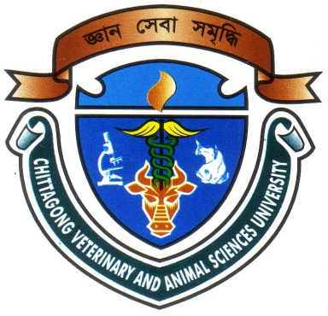

Report Presented in Partial Fulfillment of the Requirement for the Degree of Doctor of Veterinary Medicine
A Report Submitted by
Roll no: 08/63
Intern ID No: E-42
Reg. No: 405
Session:2007-2008

Faculty of Veterinary Medicine
Chittagong Veterinary and Animal Sciences University
Khulshi, Chittagong-4225

January 2014

Factors Affecting the Productive Parameters of Dairy Cattle at Gaibandha Sadar in Gaibandha District

A Production Report Submitted as per approved style and content

….........................................  Signature of Author  Md. Anaruzzaman  Roll No. 08/63  Reg. No. 405  Internship ID: E-42  Session: 2007-2008 | ….......................................  Signature of Supervisor  Musammet Rasheda Begum  Assistant Professor(Biostatistics)  Dept. of Agricultural Economics & Social Sciences  Chittagong Veterinary and Animal  Sciences University  Khulshi, Chittagong – 4225
Faculty of Veterinary Medicine
Chittagong Veterinary and Animal Sciences University
Khulshi, Chittagong-4225
January 2014

