Chapter-1

INTRODUCTION

Poultry is one of the vibrant sub-sectors of agriculture that plays a significant role in the development of agro-based economy of Bangladesh. The poultry population in Bangladesh comprises of 160 million chickens and 38 million ducks (Das et al., 2008). However, with increasing population and decreasing landholdings, the number of poultry is increasing at an annual rate of 5.9% (Anon, 2005). The total number of commercial farms is about 150000 (Paij, 2008). About 200 commercial broiler farms have established in Mirsarai upazilla ( DLS, 2013).
Poultry farming in the Bangladesh is now considered as a growing industry. But one of the major constraints in the development of poultry in Bangladesh is the outbreak of diseases, which cause about 30% mortality of chickens (Ali, 1994). Among them infectious bursal disease (IBD) is one of the major viral diseases which cause 80% mortality in field outbreak (Chowdhury et al., 1996).

Infectious bursal disease, popularly known as Gumboro disease, is a contagious disease of young chickens which cause damage to the lymphoid tissue with special predilection site for the bursa of fabricious. The name “Gumboro” disease was initially given to the condition because it was first recognized on the farm in the Gumboro district of Delawre, USA in 1962. The etiological agent of IBD, infectious bursal disease virus (IBDV), is a non-enveloped virus, belonging to the family Birnaviridae, with a bisegmented double stranded RNA genome (Kibenge et al., 1988). Since 1992, the poultry farms of Bangladesh have been experiencing the outbreaks of a disease resembling acute IBD. Now a day, IBDV has a worldwide distribution, occurring in all major poultry producing areas (Wit and Baxendale, 2000).

Major clinical signs of IBD have been studied in different studies such as :
Depression, inappetance, unsteady gait, huddling under equipment, vent pecking, diarrhoea with urates in mucus etc. (Rodriguez-Chavez et al., 2002; Paul McMullin, 2004 ; Butcher, Gary D (University of Florida); Dalgaard et al., 2002).
Swollen bursa and sometimes atrophied bursa, edematous and hyperemic bursa, gelatinous yellowish transudate covering the serosal surface and swollen kidney were observed in post mortem. Hemorrhage and areas of necrosis may be present in more severe cases of IBD. Hemorrhage may be seen in the thigh and pectoral muscles.( Butcher and Miles; 2001; Anku; 2003; Rodriguez-Chavez et al., 2002; Saif et al., 2001; Dybing et al., 1998; Butcher, Gary D(University of Florida); Paul McMullin ;2004).
The prevalence of IBD in broiler chicken varied across Bangladesh: 24% in Sylhet region (Islam et al., 2003), 10%, 16% in Dhaka and Mymensingh respectively ( Giasuddin et al.,2002; Talha et al.,2001). Studies on clinic-pathological assessment of IBD and estimating IBD prevalence have not been readily available in Chittagong.
Haematological evaluation has been carried out on IBD affected broiler chickens across the world.(Panigrahy B, RoweLD, corrier DE;1986; Can J Comp Med; Apr 1982) and some parts of Bangladesh ( Giasuddin et al.,2002; Talha et al.,2001). However such study is not availably found in broiler chickens in Chittagong.

Considering the above facts the present study was conducted with the following objectives:
- To estimate the frequency of clinico-pathological changes of Infectious Bursal Disease in commercial broiler chickens in Mirsarai.
- To estimate the frequency of histological changes of IBD in commercial broiler chickens.
- To measure the proportionate prevalence of IBD in commercial broiler chickens.

- To asses the haematological parameter of IBD affected commercial broiler chickens

Chapter-2

REVIEW OF LITERATURE

This chapter reviewed Available literatures on Gumboro disease in broiler chickens published.

The name “Gumboro” disease was initially given to the condition because it was first recognize on the farm in the Gumboro district of Delawre, USA in 1962. Initially the IBD was confused with a variant form of infectious bronchitis virus (IBV) accompamed by nephrosis (Winter and Hitchner, 1962; Cosgrove, 1962). Between 1960 and 1964, the disease affected most regions of the USA (Lasher et al., 1997).

Winter field et al., (1962) succeeded in isolating an agent in embryonating eggs and the isolate was referred to as “Infectious bursal agent”. Hyper virulent IBDV strains were first reported in Belgium and Netherlands in 1987. Presently IBDV has a worldwide distribution, occurring in all major poultry producing areas (Wit and Baxendale, 2004). Since 1992, the poultry farms of Bangladesh have been experiencing the outbreakso f a disease resembling acute IBD (Chowdhury et al., 1996).

Infectious Bursal Disease is an acute, highly contagious viral infection of growing chickens. It is caused by a double stranded, bisegmented RNA virus belonging to the genus Avibirna virus of the family Birnaviridae ( Cosgrove,1962 ; Dobos et al., 1979; Muller et al., 1979).This was followed by the emergence of a very virulent pathotypes of IBDV (vvIBDV) in western Europe, which caused an acute disease with very high mortality reaching up to 70% in natural infection and 100% in experimental infection (Berg et al., 1991). Within a couple of years the vvIBDV spread across Asia (Nunoya et al., 1992).

The etiological agent of IBD, infectious bursal disease virus (IBDV), is a non-enveloped virus, belonging to the family Birnaviridae, with a bisegmented dsRNA genome (Kibenge et al., 1988).Three subgenera of the family name, Avibirna virus, Acqua birna virus, and Entomo birna virus in which IBDV is placed under the subgenera Avibirna virus (Leong et al., 2000).

IBDV is a naked icosahedral, double-stranded RNA virus with a diameter of 55-60 nm (Hirai and Shimakura, 1974; Nick et al., 1976; Dobos et al., 1979; Jackwood et al., 1982). belonging to the family Birnaviridae (Kibenge et al., 1988). The prototype of the family is infectious pancreatic necrosis of virus (IPNV) of fish. Other members of the family can affect insects and mollusks.

Infectious bursal disease (IBD) has worldwide distribution. It usually occurs in birds having the age group of 3-6 weeks. The disease was first reported by Winterfield and Hitchner; 1962. The virus was first isolated in embryonating egg (Winterfield et al., 1962). Hitchner proposed the term infectious bursal disease as the name of the disease (Hitchner, 1970). The second serotype was reported in 1980 (McDonald, 1980).The presence of IBD was studied for the first time in Bangladesh during the period 1992-93. The work has carried out in CDIL, Dhaka and in the Laboratory of the Department of Microbiology and Hygiene, Bangladesh Agricultural University (BAU), Mymensingh (Rahman et al., 1996). The highest age of susceptibility is between 3 and 6 weeks, when the bursa of Fabricius is at its maximum development. This age susceptibility is broader in the case of IBDV strains (Berg et al., 1991; Nunoya et al., 1992).
The prevalence was reported to be 61-82% in chickens between 7 and 11 weeks old and 3-92% in chickens above 22 weeks of age ( Singh, 1992). Islam et al., (2003) who reported the proportion to be 24% in broiler chickens in Sylhet region. However there are reports in the other parts of the country which demonstrated the occurrence of this disease is lower (Giasuddin et al., 2002; Talha et al., 2001)
All breeds are affected but severe reactions with highest mortality rate were observed in White Leghorn (Lukert and Saif; 1997). Chowdhury et al., (1996) observed higher mortality rate70.80% in the Fayomi breed as compared to White Leghorn 40% in a limited number of field outbreaks, 13 to 85% mortality due to IBDV was found in different breeds of chickens in field outbreaks. Mortality due to IBD on various farms ranged from 1 to 40% in broilers and from 2 to 40% in layers (Kurade et al., 2000) and from 1.5 to 30% in native and broiler flocks respectively (Saif et al., 2000). However, Meroz (1966) found that there was no difference in mortality between heavy or light breeds. The disease spreads rapidly by direct contact because of the highly contagious nature (Benton et al., 1967). The Gumboro disease spread rapidly but mortality rate is low oniy 3.5% (Okoye and Uzokwn, 1981). In broiler mortality may peak up to 25% (Lukert et al., 1997). The morbidity following infection with classical strains of infectious bursal disease may be higher than 80% while mortality may be as low as 5-12% (Mohanty et al., 1971). Concomitant infections with Ranikhet disease, infectious laryngotracheitis, infectious bronchitis, Marek’s disease, colibacillosis, salmonellosis, coccidiosis, anemia, gangrenous dermatitis, have been recorded by McNulty et al., (1979). The initial outbreaks of IBD were characterized by high morbidity (80%) and correspondingly significant mortality attaining 25% in broilers (Chettle et al., 1980). Broiler flocks often experience mortality rates of 20% to 30%. There is no report of egg transmission of IBDV. Infected birds have excreted the virus in their droppings for at least 14 days (Baxendale; 2002).
Infectious bursal disease (IBD) is an acute highly contagious and the virus is persistent in the environment of poultry house. The water, feed and droppings of infected pens were infectious after 52 days of outbreak (Benton et al., 1967). IBDV is not transmitted through the egg and a true carrier state exists in recovered birds. Virus is resistant to heat and disinfectants sufficiently. So it survives in the environment between outbreaks (Calnek; 1997).
Rodriguez-Chavez et al., (2002) reported that the clinical signs of the infectious bursal disease include depression, reluctance to move, poor feed and water intake, watery diarrhea, ruffled feathers, reduced growth and prostration and dehydration in severely affected birds. Mortality is observed with a rapid increase at 3 days post infection and a sharp decrease at 5 days post infection. Dalgaard et al., (2002) observed that in the clinical disease, morbidity could be seen in nearly 100% of the flock and mortality could range from 0% to over 50% with some very virulent IBDV (vvIBDV) strains. Immuno-suppression is presumably transient in the clinical disease

Butcher and Miles (2001) found IBD occurred in two forms, sub-clinical and clinical forms, depending on the age at which chickens are infected. The sub-clinical form occurs in chickens less than 3weeks of age. Chickens presented no clinical signs of disease, but severe immuno-suppression can occur due to damage of bursa of Fabricius. The clinical form of infectious bursal disease occurs in chickens from 3 to 6 weeks of age. The clinical disease had a sudden onset and the mortality rate in the flock increases rapidly. Clinical signs of disease include dehydration, trembling, ruffled feathers, vent pecking and depression. Affected chickens experienced a transient immune-suppression. Cosgrove, (1962) reported that one of the earliest signs of infection in a flock was the tendency for some birds to peck at their own vent

Butcher and Miles, (2001); Rodriguez-Chavez et al., (2002) observed that initially the bursa of Fabricius is swollen (inflamed), appears edematous and hyperemic, and had a gelatinous, yellowish transudate covering the serosal surface. Anku (2003) found that the carcasses of birds dying from this infection were dehydrated, there were petechial hemorrhages in the leg and thigh muscles, and occasionally on the mucosa of the proventriculus, and increased mucus in the intestine. Saif et al., (2001) said that in some cases, however, no lesions were observed and the bursa shrinked in size.
Dybing et al., (1998) reported that on the 3 day of post-infection, the bursa began to increase in size and weight due to edema and hyperemia. It was approximately double its normal weight by the 4th day and then began recede in size. By the 5th day it had returned to its normal weight, but the bursa then continued to atrophy rapidly, and from the 8th day onward it was approximately 1/3 of its original weight.

The main microscopic findings in all the bursa examined was lymphoid necrosis of the follicle had a central necrosed mass with few or no lymphocytes giving an appearance of epithelial lined glandular structure. Extensive hemorrhages in inter-follicular areas were seen in most of the sections. The epithelial lining was much proliferated. Interfollicular tissue was infiltrated with mononuclear cells and occasionally heterophils (Sharma and benko, 1977; Butcher and Miles ;2001).Some necrosis of lymphoid cells in the spleen and caecal tonsils and there might be plasma cells depletion in the Harderian gland (Chettle et al., 1989).
Normal haematological parameters of poultry given by Dr. Mamtaj Ali, Bangladesh Agricultural University is TEC (10⁶/cu mm) 2.8-4.5; Hb (mg/dl) 8-13; PCV% 35.8; Lymphocyte 55-60; Monocyte 0-3; Heterophil 25-30; Eosinophil 3-8; Basophil 1-4. Panigrahy B, RoweLD, corrier DE;(1986) said that haematological and blood serum chemical changes were studied in two groups of specific pathogen free chickens infected at five weeks old with different field isolates of infectious bursal disease virus. Blood and serum components were determined five days after infection. There were significant decreases (P less than 0.05) in the total erythrocyte count, packed cell volume, haemoglobin concentration. Comp ; (1982) also said that hematological changes is increased numbers of circulating lymphocytes and monocytes in IBD infected chickens.

Double- sandwich ELISA, immunoperoxide (IP), fluorescent antibody (FA), and radial immunodiffusion (RID) test for the diagnosis of IBDV and these tests are equally sensitive and specific for detecting IBDV antigen (Rao and Kumer, 1994). Recent advance in molecular biology have resulted in the development of nucleic acid probes for the diagnostic assay (Tenover et al., 1988).

No specific treatment is available. Use of a multivitamin supplement and facilitating access to water may help. Antibiotic medication may be indicated if secondary bacterial infection occurs. (Paul McMullin, 2004)

Huang et al., (2002) found that effective control of IBD in commercial broilers required that field virus exposure be reduced by proper clean-up and disinfections between flocks and that traffic (people, equipment and vehicles) into the farm be controlled. The development and enforcement of a comprehensive biosecurity program is the most important factor in limiting losses due to IBD. Phenolic and formaldehyde compounds had been shown to be effective for disinfection of contaminated premises.

Saif et al., (2001) reported a third factor to consider in the infectious bursal disease prevention and control programme was vaccination of the broilers to prevent clinical infection. Butcher and Miles (2001) described that a comprehensive breeder vaccination program where subclinical IBD is a problem might have a vaccine schedule such as this: at 12 to 15 days of age -- IBD live; at 30 to 33 days of age -- IBD live; at 85 days of age -- IBD live or inactivated; and at 120 days of age --IBD inactivated. Revaccinate at 38 to 42 weeks of age with an inactivated IBD vaccine if breeder titers are low or of poor uniformity. Routinely monitor breeder IBD antibody titers to ensure vaccines are administered properly and that the chickens respond appropriately.

Chapter-3
MATERIALS AND METHODS
3.1. Study placement & clinical cases:
A study was carried out on 50 sick and death commercial broiler chickens at Mirsarai upazila Livestock office and commercial broiler farm during May-june 2013. Cases were undergone clinical examination followed by postmortem to diagnose Infectious Bursal Disease. Signs and symptoms, flock size, strain and age, rearing system, vaccination status were recorded in record keeping sheet detailed in (Appendix –I).

  - Postmortem and Histological examination :
Post mortem examination was performed according to protocol described by (Calnek, 1997) and lesions were recorded. Samples of bursa of fabricious, and kidney with typical lesions of IBD were taken for histopathology. Collected samples were then fixed in 10% neutral buffered formalin for histological analysis. Tissue processing, fixation, washing, dehydration, cleaning, impregnation, sectioning, drying, haematoxylin and eosin staining were performed according to published protocol (Jones et al., 1997)

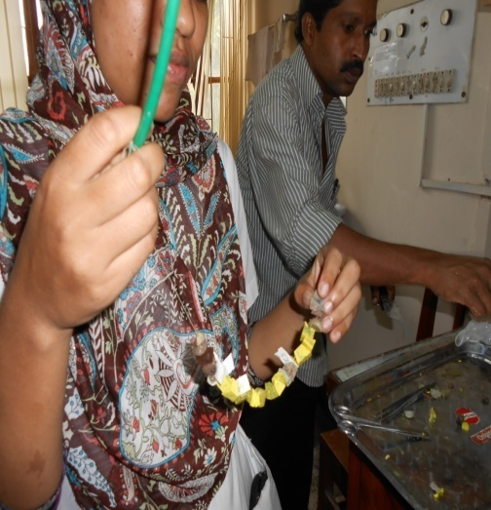
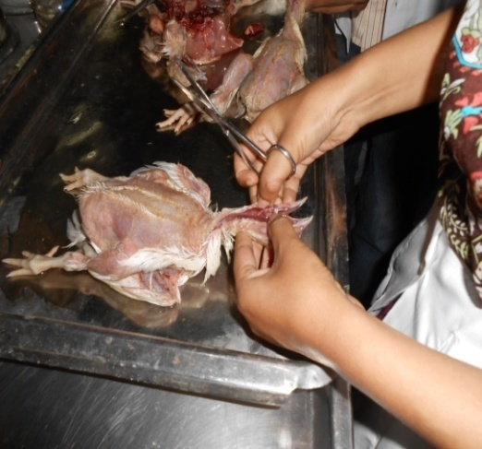

Fig.2- Garland making during slide preparation
Fig.1- Postmortem of Broiler

3.3 Collection of blood samples and haematological examinations:
Seven blood samples were collected from commercial broiler chickens in Mirsarai upazilla. One sample from an individual farm were taken. Blood samples were kept in sterile vials with anticoagulant EDTA. Haematological examinations was carried promptly after blood collection using haematological analyzer of Physiology laboratory.

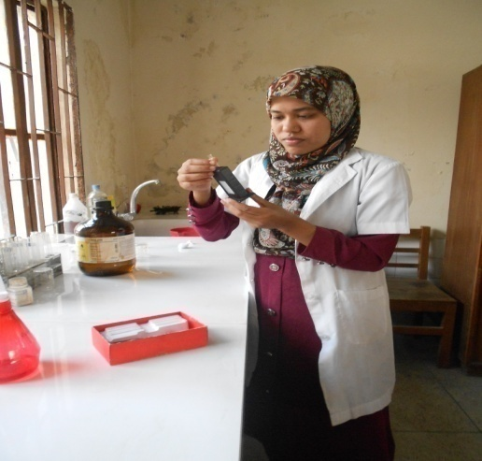
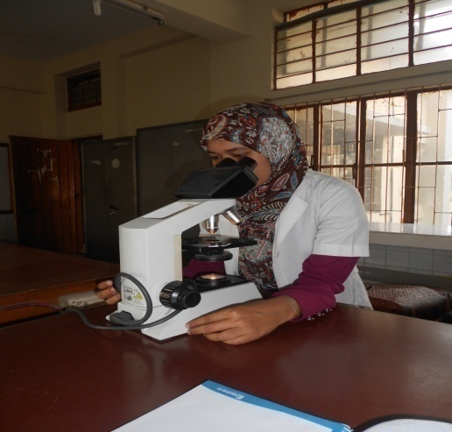

Fig.3 Differential leukocyte count
Fig.4- Hb estimation

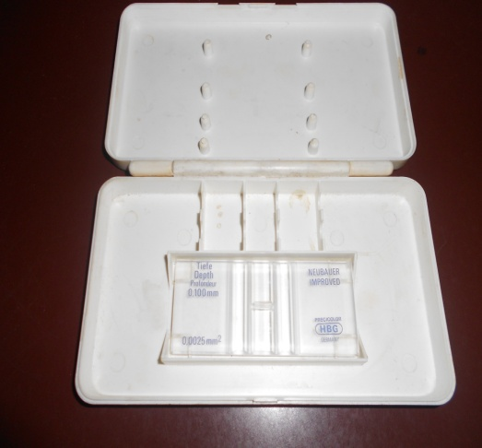
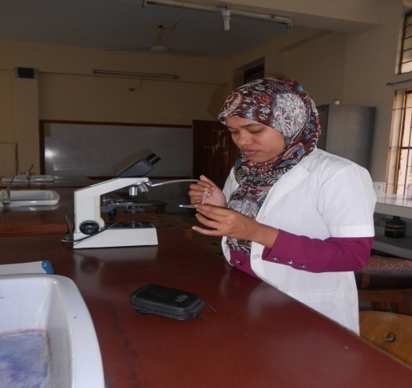

Fig.6 - TEC estimation
Fig.5- Neubeaur chamber for TEC

Chapter-4

RESULTS

4.1.Description of IBD affected broiler farms: Description of farms details was given in Table-1. Clinical cases assessed at Veterinary hospital were brought from 12 broiler farms in Mirsarai during the study period.

Table.1. Description of IBD affected commercial broiler farms in Mirsarai.
Farm  ID | Flock  size  (No.) | Age  (Days) | Strain | Rearing  system | No. of sick birds | No. of dead birds | No. of sick birds brought to clinic | No. of dead birds brought to clinic
1 | 1200 | 24 | Cobb500 | litter | 400 | 12 | 0 | 4
2 | 1000 | 16 | Cobb500 | ,, | 500 | 15 | 0 | 5
3 | 800 | 22 | Hubbardclassic | ,, | 200 | 10 | 2 | 5
4 | 1000 | 13 | Hybro PN | ,, | 500 | 10 | 2 | 4
5 | 1600 | 14 | Cobb-500 | ,, | 800 | 30 | 0 | 4
6 | 1500 | 21 | Cobb-500 | ,, | 500 | 12 | 0 | 3
7 | 2000 | 17 | Hubbard classic | ,, | 400 | 14 | 2 | 2
8 | 2500 | 28 | Hybro PN | ,, | 500 | 40 | 0 | 4
9 | 2000 | 18 | Cobb-500 | ,, | 400 | 25 | 1 | 3
10 | 2200 | 30 | Cobb-500 | ,, | 600 | 25 | 1 | 2
11 | 1600 | 29 | Cobb-500 | ,, | 400 | 20 | 0 | 3
12 | 1500 | 24 | Cobb-500 | ,, | 300 | 15 | 0 | 3
Total |  |  |  |  |  |  | 8 | 42

4.2. Clinical signs and symptoms: The clinical signs of the infectious bursal disease were observed depression, reluctance to move, poor feed and water intake, watery diarrhoea, ruffled feathers, reduced growth, trembling, vent pecking, prostration and dehydration in severely affected birds. Affected chickens experienced a transient immune-suppression. (Paul McMullin; 2004; Butcher, Gary D (University of Florida); Dalgaard et al., 2002; Butcher and Miles, 2001; Cosgrove, 1962; Rodriguez-Chavez et al., 2002). Among observable clinical signs of sick birds watery diarrhea (7) and clinical symptoms of dead birds ruffled feather (32) ranked the highest frequency . Details was given in Table-2.

Table.2. Frequency of clinical signs and symptoms of clinical cases of broiler chickens (N=50).
Clinical signs (8 sick birds) | Frequency no. |  | Clinical symptoms (42 dead birds) | Frequency no.
Inappetance | 5 |  | Ruffled feather | 32
Watery diarrhoea | 7 |  | Reduced growth | 25
Depression, reluctant to move | 4 |  | Watery diarrhea | 22
Dehydration | 4 |  | Trembling | 15
Ruffled feather | 5 |  | Gasping | 17
Vent pecking | 5

4.3. Gross lesions: Swollen bursa and sometimes atrophied bursa, edematous and hyperemic bursa, gelatinous yellowish transudate covering the serosal surface and swollen kidney were observed in post mortem. Hemorrhage and areas of necrosis may be present in more severe cases of IBD. Hemorrhage may be seen in the thigh and pectoral muscles ( Butcher and Miles; 2001; Anku; 2003; Rodriguez-Chavez et al., 2002; Saif et al., 2001; Dybing et al., 1998; Butcher, Gary D(University of Florida); Paul McMullin ;2004). Among observable gross lesions Swollen bursa (20) ranked the highest frequency . Details was given in Table-3.

Table. 3. Frequency of recorded gross lesions of commercial broiler chickens (N=50)
Lesions | Frequency no.
Swollen bursa | 20
Gelatinous fluid around bursa | 8
Pus in bursa | 15
Haemorrhagic bursa | 6
Caseous mass in bursa | 6
Atrophied bursa | 8
Haemorrhage in the junction of proventriculus and gizzard | 10
Mucous exudates in upper intestine | 14
Haemorrhagic lesions in breast and thigh muscle | 15

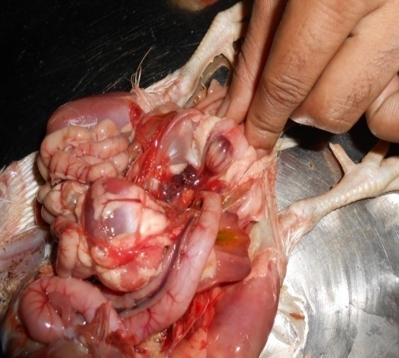
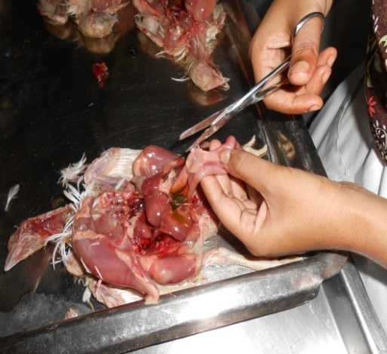

Fig 8- Atrophied bursa with Haemorrhage
Fig 7- Mucous in digestive tract
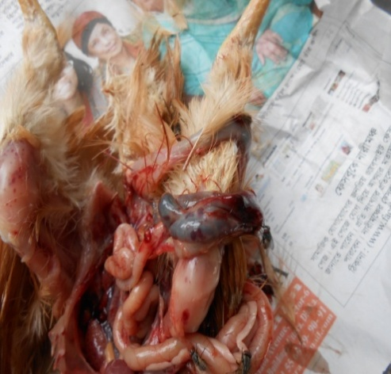
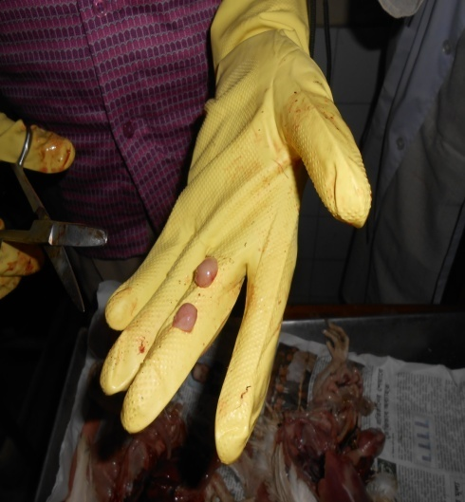

Fig 10- Concurrent infection with coccidiosis
Fig 9- Swollen Bursa with normal one

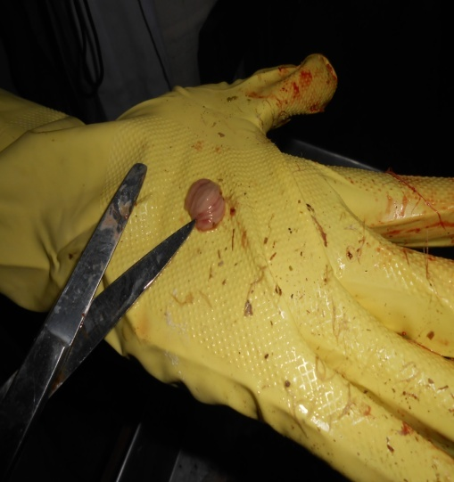
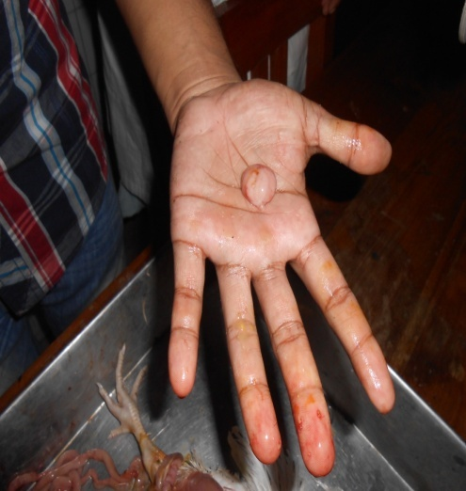
Fig 12- Swollen Bursal fold
Fig 11- Swollen BF
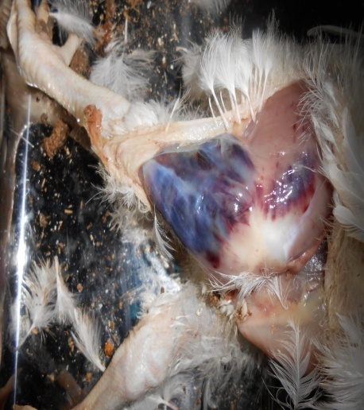

Swollen BF

Fig 13- Haemorrhage in thigh muscle

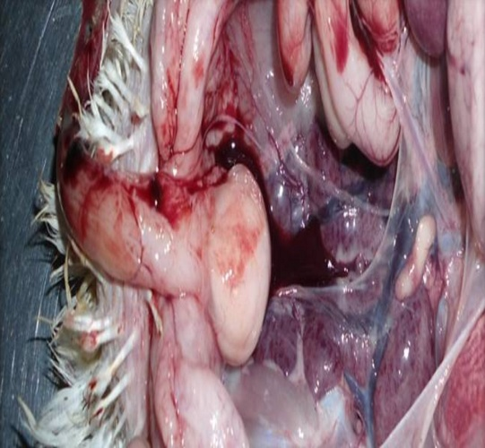

Fig 14- Gelatinous fluid around the bursa

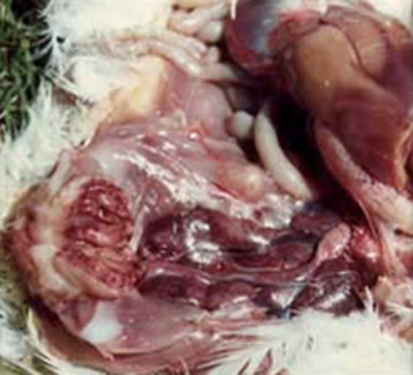

Fig 15- Swollen kidney

4.4. Histological changes: Section of bursa of fabricious showed loss of normal corticomedullary architecture of bursa. Degeneration and necrosis of lymphocytes replaced by neutrophils, tissue debris and hyperplastic reticulaendothelial (RE) cells. The bursa becomes enlarged due to edema and hyperemia. Fibroplasia is present in the interfollicular connective tissue ( Sharma and benko, 1977; Chettle et al., 1989; Butcher and Miles, 2001; Ignjatovic and Sapats, 2002; Rodriguez-Chavez et al., (2002); Butcher, Gary D(University of Florida); Paul McMullin, (2004). Details was given in Table-4.

Table.4. Frequency of histological changes observed in commercial broiler chickens (N=5)

Organ | Histological changes | n.
Bursa of fabricious (3) | Destruction of lymphatic follicle | 3
 | Vaculation in bursa of fabricious | 3
Kidney  (2) | Congestion in kidney | 2
 | Haemorrhage in the kidney | 2

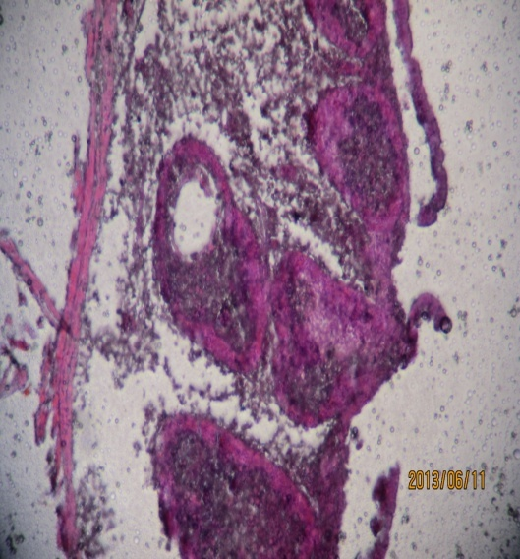
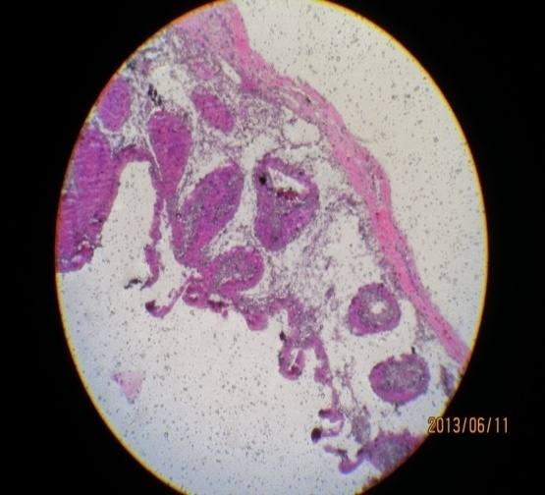

Fig 17- Vaculation in BF
Fig 16 - Destruction of lymphatic follicle in BF

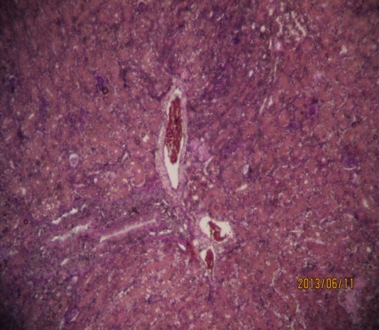
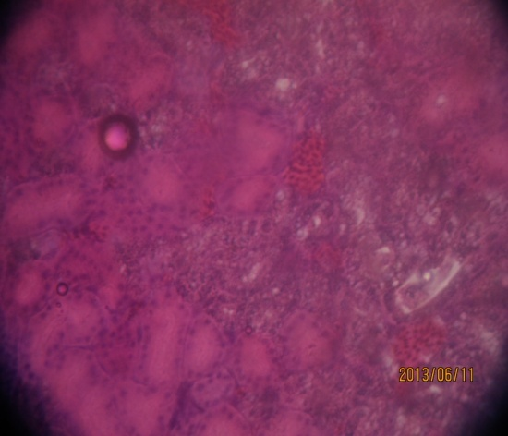

Fig 19- Haemorrhage in kidney
Fig 18 Congestion in kidney

4.5.Occurance of IBD and other diseases: In these study, IBD (alone) was found 36%, concurrent infection with ND was 14%, with coccidiosis 30%, with colibacillosis 20%. Details was given in Table-5.

Table.5. Frequency distribution of IBD alone or concurrent disease by Age & strain (N=50)
Name of the Diseases | no. of positive case (%) | Age (Days) | Strain
IBD | 18 (36%) | 15-28 | Cobb-500, Hubbard classic, Hybro PN
IBD with ND | 7(14%) | 15-28 | Cobb-500, Hubbard classic, Hybro PN
IBD with coccidiosis | 15(30%) | 29-42 | Cobb-500
IBD with colibacillosis | 10(20%) | 0-14 | Cobb-500, Hybro PN
Total | 50 | - | -

4.6. Haematological indices of IBD affected broiler chickens: In these study, blood parameters are, highest Hb (mg/dl) 14 in sample 5, PCV 32% in sample 2, ESR 2, TEC(10⁶/cu mm) 2.69 in sample 5, Lymphocyte 78 in sample 2, Monocyte 9 in sample 4, Heterophil 37 in sample 2, Eosinophil 11 in sample 4, Basophil 4 in sample 5. Details was given in Table-6.

Table.6. Haematological indices studied from samples samples obtained from IBD suspected sick broiler chickens (N=7)

 |  |  | Haematological indices
Sample No. | Flock size | Age  (Days) | Hb  (mg/dl) | PCV% | ESR | TEC  (10⁶/cu mm) | Lymp  hocyte | Mon  ocyte | Heterophil | Eosinophil | Basophil
1 | 1200 | 24 | 5 | 28 | 2 | 2.32 | 60 | 4 | 27 | 6 | 1
2 | 1500 | 21 | 9 | 32 | 1 | 2.4 | 78 | 7 | 37 | 2 | 2
3 | 1500 | 24 | 10 | 28 | 0 | 2.02 | 53 | 6 | 18 | 4 | 2
4 | 2000 | 18 | 9.4 | 18 | 2 | 2.42 | 53 | 9 | 23 | 11 | 2
5 | 1600 | 14 | 14 | 27 | 0.5 | 2.69 | 64 | 2 | 14 | 4 | 4
6 | 2000 | 17 | 9.8 | 25 | 0 | 2.65 | 63 | 7 | 24 | 8 | 3
7 | 2200 | 30 | 10.4 | 21 | 2 | 2.64 | 62 | 2 | 17 | 9 | 2

Chapter-5

DISCUSSION
The present reported work was performed for the diagnosis IBD case in broiler chicken of Mirsarai upazilla by clinical signs, necropsy, histopathological examination & estimation of haematological parameters to develop some hypothesis regarding IBD infection in broiler chicken of Mirsarai upazilla as well as study of other secondary bacterial and parasitological complication associated with it.
Infectious bursal disease is characterized by short incubation period of 2-3 days, and course of 5-6 days. In this study efforts had been made to identify IBD by post mortem examination. Those were haemorrhage in the thigh and pectoral muscles, increased mucous in intestine and swollen kidney. These changes found during necropsy come in agreement with (Cosgrove, 1962). Enlargement of the bursa of Fabricious that is one of the common lesion seen at post mortem by (Lukert and Saif, 1997). Haemorrhagic lesions in the bursa, atrophied bursa and thickening of bursal folds agree with (Cheville, 1967). Haemorrhage in the junction between proventriculus and gizzard, extensive haemorrhage throughout the bursa and dehydrated birds are closely related to the finding of (Calnek, 1997). In this report, the post mortem findings and death patterns observed were consistent with Gumboro disease. The diagnosis is confirmed by histopathology.

In this study, the histopathology of the IBD affected samples revealed that congestion of the vascular layer, lymphoid cell necrosis, hyperplasia of the reticuloendothelial cells and interfollicular tissue. These lesions were in agreement with those described by (Sun Ming et al., 2001).

Highest prevalence (36%) of IBD was found in the group of 15-28 days birds and lowest (20%) in the group of 0-14 days birds. (Lukert and Saif, 1997); (Chauhan and Roy,1996) reported that clinically infectious bursal disease mostly occur in the young chicken between 3-6 weeks of age but the disease has also been reported to occur between 9 days to 20 weeks of age.

(M.S. Rahman et al., 2010) found that the broilers of four weeks of old were highly susceptible to IBD (55%) whereas in third week 12.5% and in fifth week 32.5% and the broilers of two weeks of age were not affected with IBD.

In these study, blood parameters are, highest Hb (mg/dl) 14, PCV 32% , ESR 2, TEC(10⁶/cu mm) 2.69, Lymphocyte 78, Monocyte 9, Heterophil 37, Eosinophil 11, Basophil 4 which is variated with normal blood parameters of poultry given by DR.Mamtaj Ali (BAU) and accompanied with work of (Panigrahy B, RoweLD, corrier DE,1986; Can J Comp Med, 1982).

Chapter-6

CONCLUSION
IBD is one of the highly prevalent diseases in commercial broiler farm. The prevalence of IBD (alone) was found 36% in Mirsarai upazilla. Distribution of the disease varied according to different age groups with the highest proportion recorded in the age group of 15 — 28 days. Mixed infection with Newcastle disease, coccidiosis, E. coli infection increases the mortality rate. High prevalence of IBD in broiler chickens is a serious concern and urges the need for proper control measures to limit the spread of this disease.

Chapter-7

REFERENCES

ALl. M. J. 1994. Current status of veterinary biologics production in Bangladesh and their quality control proceeding of BSVER symposium held on july 28, 1994 at NIPSOM auditorium, Mohakhali, Dhaka, Bangladesh

ANKU, G. G. 2003. Gumboro hampers efforts to improve nutrition of Ghana’s growing population. Poultry international, 12: 32-36.

BENTON, W.J.COVER, M. S. and ROSENBERGER, J.K.1967.Studies of the
transmission of the infectious bursal disease agent (IBD), Avian disease,11:430-438

BHATTACHARJEE, P. S., KUNDU, R. L., BIS.WAS, R.K., MAZUMDER, 3. U., HOSSAIN, E. and MIAH, A.H. 1996. A retrospective analysis of chicken diseases diagnosed at Centre Disease Investigation Laboratory Dhaka, Bangladesh. Bangladesh veterinary journal, 30: 105-113.

BROWN, M. D. GREEN, P. AND SKINNER, M. A. 1994.The antigenic and pathogenic diversity of the IBDV. World poultry science, 8: 41. Peptide map comparison of the proteins of the infectious bursal disease virus.
Journal of virology, 32; 1046-4050.

BUTCHER, G. D. and MILES, R. D. 2001. Infectious bursal disease (Gumboro) in commercial broilers. University of Florida. pp 1-7.

CALNEK, B. W. 1997. Infectious bursal disease (LUKERT, P. D. and SAIF, Y. M.) of poultry, 10th edition. International publisher limited, pp 72 1-733.

CHETTLE, N., STUART, 3. C. and WYETH, P. 3. 1989. Outbreaks of virulent infectious bursal disease in East Anglia.
Veterinary record, 125: 27 1-272.

CHOWDHURY, E. H., RAHMAN and ISLAM, A. 1996. Observation of outbreaks and subsequent control of infectious bursal disease in the central poultry farm in Bangladesh. Bangladesh veterinary journal, 69(9).

COSGROVE. 1962. An apparently new disease of chiken avian nephritis. Avian disease, 6: 385-389.

DALGAARD, T. S. and NEILSEN, 0. L. 2002. Major histocompatibility complex-linked immune response of young chickens vaccinated with an attenuated live infectious bursal disease viral vaccine followed by an infection. Poultry science, 81: 649- 656.

DAS. S. C., CHOWDHURY. S. D., KHATUN. M. A., NISHIBORI. M., ISOBE. N., YOSHIMURA. Y. 2008. Poultry production profile and expected future projection in Bangladesh. World’s Poultry Science Journal, 64: 99-118.

DYBING, 3. K. and JACKWOOD D. J. 1998.Antigemc and Immunogenic properties of infectious bursal disease viral protein. Avian Disease, 42: 80-91.

GIASUDD1N.M., SIL. B. K., ALAM. 3., KOIKE. I., ISLAM. M. R. and RAHMAN. M. M. 2002. Prevalence of Poultry Diseases in Bangladesh. Indian Journal of Poultry Science, 2002 (Vol. 40) (No. 1)99-101

HITCHNER, S. B. 1970. Infectivity of Infectious bursal disease virus for embryonating eggs. Poultry science, 49: 511-516.

HUAANG, G. M. and QIA SULAN 2002.Early stages of infectious bursal disease virus infection in chicken detected by in situ reverse transcriptase polymerase chain reaction. Avian pathology, 31: 593-597.

ISLAM, M.R., KHAN, M. A., DAS, P. M. and BARI, A. S. M. 1998. Poultry diseases diagnosed at necropsy in 1997 and 1998 in the Department of pathology of Bangladesh Agricultural University, Mymensing. Proceeding of fifth BSVER Animal Science Conference, December 3-4, 1998.Bangladesh Agricultural University, Mymensing, Bangladesh.

JACKWOOD, D. J. and JACKWOOD, R. 3. 1997. Molecular identification of infectious virus strain. Avian disease, 41: 97-104.

KIM. Fl. 3., KONG. M. I., CHUNG. U. K., KANG. M. I. and CHUNG. U. I. 1996. Survey of enteric diseases in chickens. North Korean Journal of Veterinary Research. 36: 1007- 1012.

LUKERT, P. D. and SAIF, Y. M. 1997. Infectious bursal disease: Disease of poultry 9th edition, Wolfe publishing limited, pp 684-663.

MACDONALD, R. D. 1980. Immunofluorescent detection of double stranded RNA in cells infected with reovirus, infectious pancreatic necrosis virus, and infectious bursal disease virus. Canadian journal of microbiology, 26: 256-261.

MACNULTY, M. S., ALLAN, G. M. and McFERREN, J. B. 1979.Isolation of infectious bursal disease from turkey. Avian pathology, 8: 205-2 12.
MANDEVILLE, W.F. and COOK, F.K. 2002.Heat lability of five strain of infectious bursal disease virus. Poultry Science, 79: 838-842.

MOHANTY, 0. C., PANDEY, A. P. and SCHYNS, P. 1971. Infectious bursal disease of chicken .Current Science, 40: 181-184.

OZEL, M. and GELDERBLOM, H. 1985. Capsid symmetry of viruses of the proposed bima virus group. Archives of virology, 84: 149-161.
PAUL.R. 2008. Bird flu spreads in Bangladesh, compensation to rise.

RAHMAN, M. M., RAHMAN, A., ISLAM A. H. M. N., MIAH, A. H., MAZUMOER, J. U. and BHATTACHARJEE, P. S. 1996. Observations of outbreaks and subsequent control of infectious bursal disease in the central poultry farm in Bangladesh. Bangladesh veterinaiy journal, 30(1-2): 35-39,

RODRIGUEZ-CHAVEZ, R., ISSAC, W. S., CLOUD, S. and SANDRA, M. D. 2002.
Characterization of antigenic, immunogenic and pathogenic variant of infectious bursal disease virus due to propagation in different host systems ( Bursa, embryo and cell culture ). Avian pathology, 31: 4S5-492.

ROSENBERGER, J. K., CLOUD, S. S., GELB, J., ODOR Jr. E. and DOHMS, J. E. 1985. Sentinel bird survey of Delmarva broiler flocks. Proc 2OthNati meet poultry health condemn, ocean city, MD, pp 95-101.

SAIF, Y. M. 1984. Infectious bursal disease virus types. Prdceeding 19th Nati Meet Poultry Health Condemn, ocean city, pp 105-107.
SAIF, Y. M. and ABDEL-AMIN, G. A. 2001 .Pathogenecity of cell culture derived and bursa derived infectious bursal disease viruses in specific pathogen free chickens. Avian disease, 45: 844-852.
SEGAL, Y. 2002. Preventing Gumboro disease in poultry .International poultry production, pp 17.

STUART,J. C. 1989. Acute infectious bursal disease in poultry. Veterinary Record, pp 125-281.

TALHA A. F. S. M., HOSSAIN M. M., CHOWDURY E. H., BARI. A. S. M., ISLAM M. R. and DAS P. M. 20010. Poultry Diseases Occurring in Mymensingh District of Bangladesh, The Bangladesh veterinary journal, 18: 20-23.

WINTERFIELD, R. W., HITCHNER, G. S., APPLETON and COSGROVE. 1962. Avian nephrosis, nephritis and gumboro disease. L & M News and Views, 3: 103.

WYETH, P. J. 1980. Passive transferred immunity to IBD following live vaccination of parent chickens by two different routes. Veterinary record, 106: 289-2

APPENDIX

SHEET FOR DATA COLLECTION

- Owners name:…………………….Address……………………Date………….….….
- Species:………………………………………………………………………….
- Flock size:………….
- Age:……………
- Strain:…………
- Rearing system:………….
- Number of sick birds:………………….no. of birds brought to clinic………..
- Number of dead birds:………… no. of birds brought to clinic……………….
- Vaccination status……………….
- Clinical signs…………………..
- Postmortem lesions…………..
- Diagnosis……………………
- Treatment…………………..

Name of the interviewer…………….
Date…………..……………………....
Signature………………………………

