STUDY ON THE MARKETING SYSTEM OF COMMERCILLY PRODUCED EGGS IN SOME SELECTED AREAS OF NARSINGDI DISTRICT
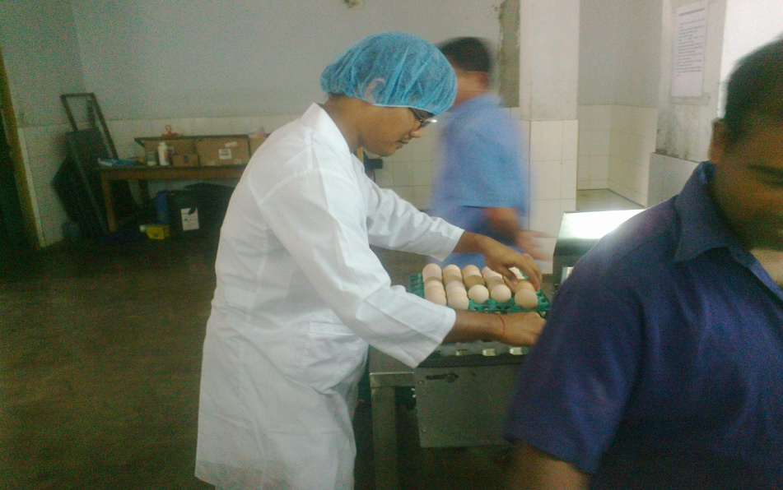

A production Report Submitted by

Roll No: 2008/24
Reg. No: 366
Intern ID: B-15
Session: 2007 - 2008

A Production Report Submitted in Partial Fulfillment of the Requirement for the Degree of Doctor of Veterinary Medicine (DVM).

Chittagong Veterinary and Animal Sciences University
Khulshi, Chittagong - 4225.

STUDY ON THE MARKETING SYSTEM OF COMMERCILLY PRODUCED EGGS IN SOME SELECTED AREAS OF NARSINGDI DISTRICT

A Production Report Submitted as per Approved Style and Content

Signature of Author  Jotan Kar  Roll No. 08/24  Intern ID: B-15  Reg No. 366  Session: 2007-2008 | Signature of Supervisor  MD Abdul Halim  Professor & Head  Dept. of Agricultural Economics and Social Science.

Chittagong Veterinary and Animal Sciences University
Khulshi, Chittagong - 4225.
INDEX
CHAPTER | CONTENTS | PAGE NO
 | Acknowledgement | i
 | Abstract | ii
I | Introduction | 1-8
II | Review of literature | 9-11
III | Methodology | 12-15
IV | Result and Discussion | 16-29
V | Marketing Cost and Margin of Eggs | 30-43
VI | Problems and Recommendations | 44-50
VII | Conclusion | 51
VIII | References | 52-53
 | Annex | 54-55

LIST OF TABLES
TABLES | Name of the Tables | PAGE N0.
1.1 | Year-wise establishments of commercial poultry farms private sector | 01
1.2 | List of poultry farms in Bangladesh | 02
1.3 | Poultry farms in dhaka Division | 02
1.4 | Year -wise production of eggs. | 03
1.5 | Requirement and production of eggs during Fourth five year plan | 04
1.6 | Projected Demand and Availability of Eggs | 04
1.7 | Production targets of egg during the fifth five-year plan (in million). | 05
1.8 | Projected demand of eggs during the Sixth five-year plan (in million). | 06
1.9 | Projected Supply of eggs during the Sixth five-year plan (in million). | 06
1.10 | Projected Demand Supply Gap of eggs during the Sixth five-year plan (in million). | 06
1.11 | Year -wise allocation of fund during fifth year plans.(At 1996/97 prices) | 07
1.12 | Annual development budget allocation to DLS and BLRI | 07
4.1 | Distribution of farm owners grading. | 19
4.2 | Distribution of farm owners by period of storage | 19
4.3 | Distribution of farm owners by source of market information | 20
4.4 | Distribution of farm owners by mode of transport | 20
4.5 | Distribution of farm owners by place of sale | 21
4.6 | Distribution of farm owners by mode of sale | 21
4.7 | Distribution of farm owners by interval of sale | 22
4.8 | Average volume of sale in different periods | 23
4.9 | Mode of payment be egg traders | 24
4.10 | Method of quality determination by the egg traders | 25

TABLES | Name of the Tables | PAGE N0.
4.11. | Method of price fixation at the time of purchase | 25
4.12 | Volume of transaction by eggs traders | 26
4.13. | Mode of sale used by traders | 27
4.14. | Method of price fixation at the time of sell | 27
4.15 | Mode of transportation used by the egg traders | 28
4.16 | Place, method and period of storage | 29
4.17 | Source of market information | 29
5.1 | Marketing Cost of Aratdar-com-wholesaler | 31
5.2 | Marketing Cost of Retailer | 33
5.3 | Marketing Cost of Suppliers | 36
5.4 | Marketing Margin and Profit of Aratdar -cum- wholesaler | 38
5.5 | Marketing Margin and Profit of Retailer | 39
5.6 | Marketing Margin and Profit of Supplier | 40
5.7 | Price Spreads and producer's share in consumer's price under two marketing channels | 42
6.1 | Marketing problems faced by the layer farm owners | 44
6.2 | Marketing problems faced by the egg traders | 46
6.3 | Measure suggested by the farm owners | 47
6.4 | Measures suggested by traders | 49

List of Figures
Figures | Contents | Page no.
1.1 | Percentage of poultry farms in seven farms | 02
4.1 | Marketing Channels of eggs. | 16
5.1 | Marketing margin, Marketing cost and Net marketing margin | 41
5.2 | Channel wise Price Spread and Share of Producer’s | 43

List of Abbreviations
Abbreviations | Elaborations
DLS | Directorate of Livestock Service
GDP | Gross Domestic Product
MOFL | Ministry of Livestock and Fisheries
TK | Taka
NOS. | Number
BBS | Bangladesh Bureau of Statistics
BLRI  CVASU  GMM  GMC  NM  WCR  R  SR  RP  PP  PS  SP  % | Bangladesh Livestock and Research Institute  Chittagong veterinary and animal sciences University  Gross marketing margin  Gross marketing cost  Net marketing margin  Whole-cum- Retailer  Retailer  Supplier  Retailer price  Producers net price  Price Spread  Share of Producer  Percentage

ACKNOWLEDGEMENT

The author expresses his deep sense of gratitude to the small scale commercial dairy farm owners, DLS personnel, project personnel and internship supervisor Prof. Md. A. Halim for his keen inspiration and suggestions to conduct the study.

I would like to give special thanks to Dr. Bibek Chandra Sutradhar, Director Research and Extension, Director Accounts and Finance of CVASU for their keen assistance during the research works.

I also gratitude to Professor Dr. A.S. Mahfuzul Bari, Vice-Chancellor, Chittagong Veterinary and Animal Sciences University, Khulshi, Chittagong for giving me inspiration and permission to pursue this study.

I also express my profound appreciation and heartfelt gratitude to Professor Dr Md. Kabirul Islam Khan, Dean, Faculty of Veterinary Medicine, CVASU, Chittagong-4225, Bangladesh for his incisive comments, suggestions, sincere co-operation and necessary correction in completing the final research report.

The Author

i
ABSTRACT

The study was under taken to analyze the existing egg marketing system of Commercially produced eggs in some selected areas of Narsingdi District to estimate cost and margin of egg traders and to identify problems and suggested measures to improve the existing marketing system of eggs. Total sample was 70 where farmers were 22 and 48 were egg traders. Farmers were selected conveniently while traders were selected both randomly and purposively. The study identified five different channels in present egg marketing system. The average gross return of Aratdars-cum-wholesaler, retailers and suppliers for 100 eggs are found TK. 42.50, TK.42.50 and TK.43.75respectively.The average cost of Aratders-cum-wholesaler, retailers and suppliers for 100 eggs were found TK.9.41,TK.7.51 and TK.10.74 respectively. The net margin of 100 eggs were calculated and found tk. 33.09, tk. 34.99 and tk. 33.01 respectively for Aratdars-cum-wholesaler, retailers and suppliers. So development of this enterprise is helpful in employment generation and poverty alleviation. Finally, the study also identified some problems associated with marketing of commercially produced eggs and there remedial measures for improving the existing marketing system.

Key words: Commercial eggs, Farm owners, Aratdars–cum-wholesaler, Retailers, suppliers, Consumers.

ii

